Independent Observer summary report on MV Maysora

Cattle and sheep exported to Israel and Jordan in May 2023
May 2024

Voyage summary
Livestock: Two consignments totalling 4,952 cattle and 38,895 sheep.
Vessel: MV Maysora
Loading location: Fremantle
Discharge location:
- Eilat, Israel
- Aqaba, Jordan
Voyage length: 25 days
Independent Observer (observer): Boarded at Fremantle and remained onboard until completion of discharge.
Voyage mortality rate: 0.1% (5 mortalities) for cattle and 0.054% (21 mortalities) for sheep. These mortalities are unlikely to be linked to any systemic failure by either exporter.
Notifiable mortality rate: 0.5% for cattle and 1.0% for sheep.

Summary of observations
This report summarises key observations of the implementation and effectiveness of exporter arrangements to ensure the health and welfare of livestock. The report has been approved by the observer who accompanied the voyage.

Exporter documentation
The observer reported no issues regarding exporter documentation.

Loading
- The observer identified that approximately 5% of sheep across all decks were loaded with wool or hair over the 25mm maximum set out in the Australian Standards for the Export of Livestock (ASEL) standard 3.7.3.
  - After loading, the regional veterinary officer raised the issue with the Accredited Veterinarian (AAV) and LiveCorp Accredited Stockperson (stockperson), who planned to redistribute sheep across the vessel to reduce the stocking density for affected sheep. The observer reported that this was completed by day 5 of the voyage.
- Other than the above issue, based on observations made, the exporter arrangements relating to loading were appropriate and effective in managing livestock health and welfare.

Personnel
Based on observations made during this voyage, the exporter arrangements relating to personnel were appropriate and effective in managing livestock health and welfare.

Daily routine
Based on observations made during this voyage, the exporter arrangements relating to daily routine were appropriate and effective in managing livestock health and welfare.

Feed and water
Based on observations made during the voyage, the exporter arrangements relating to feed and water were appropriate and effective in managing livestock health and welfare.

Ventilation
The observer reported that:
- Ventilation felt inadequate in an area under a stairwell not approved to house livestock. A cow hospitalised in this location for a dislocated limb appeared heat affected. No heat stress score was assigned to this animal as it was heavily sedated. Crew promptly installed portable fans to provide it with ventilation.
- There were no sheep or cattle observed as heat stressed (open mouth panting) for the duration of the voyage.
- The highest wet bulb temperatures occurred over days 16 to 19, with the highest recorded as 32.6°C on day 16. The longest continuous period above 31°C wet bulb temperature was 9 hours and 20 minutes. No adverse animal health or welfare effects were observed as a result of the high wet bulb temperatures.

Pen conditions
The observer reported that:
- On day 4, cattle and sheep were observed penned adjacent to each other and not separated by an impermeable barrier, as required by ASEL s5.1.1c. The observer alerted the AAV and stockperson and an effective barrier was installed to remedy this. No discernible negative health or welfare outcomes were observed on either species due to the inadequate separation.
- Animals were moved during the voyage and placed in makeshift pens constructed under stairwells and ramps on Deck 7 and Deck 8. These areas were not listed as approved to house livestock on the load plan (against ASEL s5.1.1e). The observer understood this was done by the AAV to facilitate easier discharge of recovered animals upon arrival. Designated hospital pens were observed to be used for healthy sheep on all sheep decks. No negative health or welfare outcomes were observed as a direct result of housing animals in these areas.
- On a number of occasions, sheep were observed caught in rails between pens, or having escaped from pens on Deck 7. The AAV and Chief Officer discussed the issue of identification of misadventure during daily meetings. The ends of alleys were closed off to stop the escaped sheep from moving further throughout open decks.
- On days 14 and 15, 2 pens on each of open decks 7 and 8 were affected by sea water spray from rough weather resulting in damp and isolated sloppy pad conditions. Sheep were promptly moved to share nearby unaffected pens and were returned to their original pens with sawdust applied after 24 to 48 hours. This was observed to be effective in managing the pen conditions for sheep.
  - The move resulted in temporary overstocking of sheep in pens with inter-pen gates opened to provide more space. No negative health or welfare issues were identified as a result of the temporary overstocking.

Health and welfare
The observer identified that:
- Approximately 5-10% of sheep destined to Israel and Jordan on decks 8, 9 and 10 were loaded with wool or hair over 25mm (ASEL s3.7.3). No sheep were observed with open mouth panting for the duration of the voyage.
- On Deck 7, one sheep observed to be stuck between a pen railing without access to feed or water. The sheep was eventually freed by the observer and recovered following treatment. Another sheep was observed moribund in an alleyway from misadventure and identified to crew. No treatments were observed and the animal was found deceased one and a half hours later.
- A cow with a dislocated limb was moved to a makeshift hospital pen and sedated for treatment. The animal was euthanased the following day.

Discharge
Based on observations made during this voyage, the exporter arrangements relating to discharge of cattle were appropriate and effective in managing their health and welfare.
For sheep, the observer reported that:
- During discharge of sheep at Aqaba, Jordan, inappropriate handling techniques by import crew, including use of movement aids on sheep faces, was observed. The stockperson intervened to halt the practice and educate the crew, however the actions continued while unsupervised.
- One pilot sheep was found deceased, believed by the observer to be because of smothering on the discharge ramp. The shipboard AAV was observed to temporarily halt discharge to rectify the situation.

Representative photographs of voyage
Day 3 Cattle in pen – no issues identified  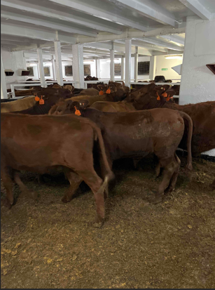 | Day 5 Sheep in pen – wool length variation  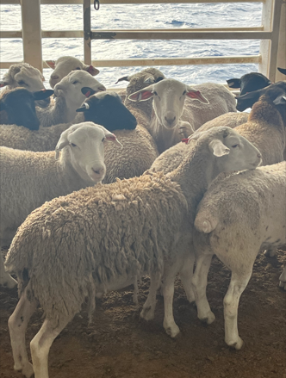
Day 9 Sheep in unapproved area of vessel  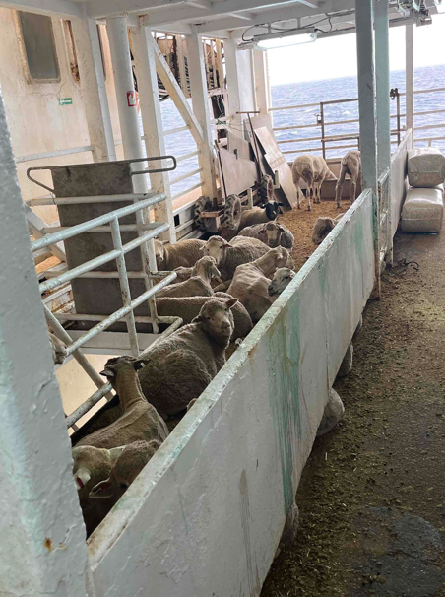 | Day 12 Cattle in pen — no issues identified  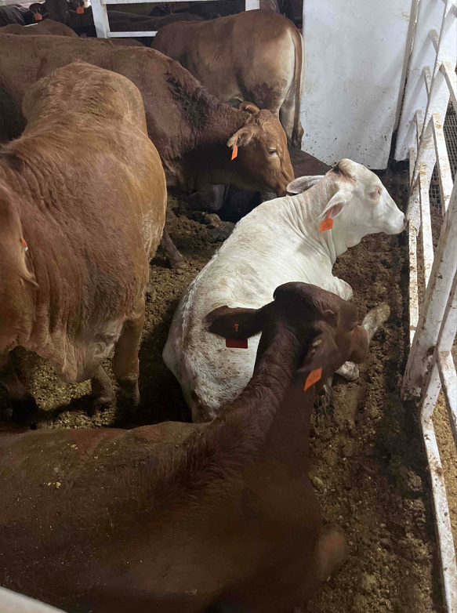
Day 18 Cattle in pen prior to washdown – no issues identified  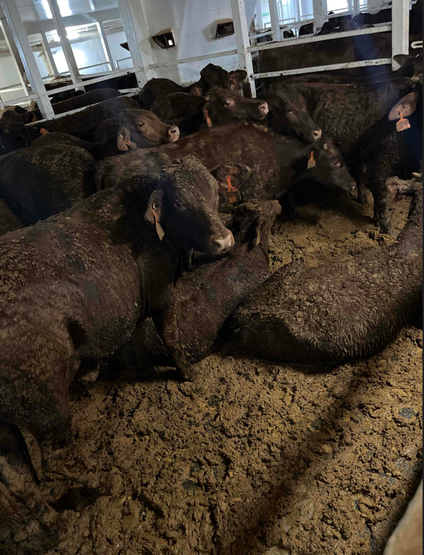 | Day 24 Sheep in pen — no issues identified  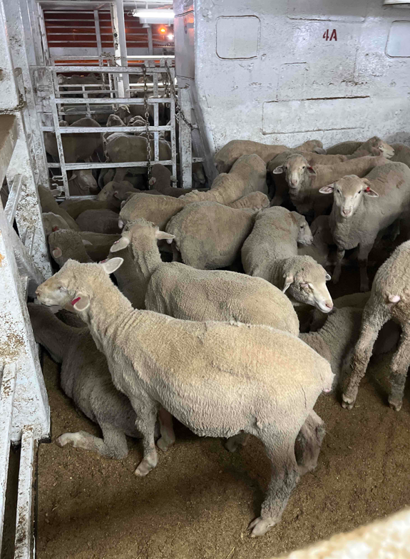
Acknowledgement of Country
We acknowledge the Traditional Custodians of Australia and their continuing connection to land and sea, waters, environment and community. We pay our respects to the Traditional Custodians of the lands we live and work on, their culture, and their Elders past and present.
© Commonwealth of Australia 2024
Unless otherwise noted, copyright (and any other intellectual property rights) in this publication is owned by the Commonwealth of Australia (referred to as the Commonwealth).
All material in this publication is licensed under a Creative Commons Attribution 4.0 International Licence except content supplied by third parties, logos and the Commonwealth Coat of Arms.
The Australian Government acting through the Department of Agriculture, Fisheries and Forestry has exercised due care and skill in preparing and compiling the information and data in this publication. Notwithstanding, the Department of Agriculture, Fisheries and Forestry, its employees and advisers disclaim all liability, including liability for negligence and for any loss, damage, injury, expense or cost incurred by any person as a result of accessing, using or relying on any of the information or data in this publication to the maximum extent permitted by law.

