**State Specific Guideline For**

***Queensland***

This guideline has been prepared by the Australian Government and the Queensland Government. It is intended to assist businesses who process raw logs grown in Queensland to better understand the regulatory framework covering the harvest of such logs in that jurisdiction. This information can be used to help the businesses satisfy their due diligence obligations, as set out in the *Illegal Logging Prohibition Act 2012* and associated *Illegal Logging Prohibition Regulation 2012*.

This guideline was co-endorsed by the Australian Government and the Queensland Government on 29 June 2022.

Contents

1. What is required under Australia’s Illegal Logging Laws? 3

1.1 Who is a processor? 3

2. How to use the State Specific Guideline (SSG) 4

3. Scope of the SSG for Queensland 4

4. Overview of Forest Management in Queensland 5

4.1 How is timber harvesting regulated in Queensland? 5

4.2 Commonly harvested tree species 6

4.3 Harvesting of restricted plant species listed under the Nature Conservation Act as threatened, near threatened or special least concern plants 6

4.4 Restrictions on harvesting in specific locations 7

5. Laws and regulations governing forestry in Queensland 7

5.1 Forestry Act 1959 8

5.2 Vegetation Management Act 1999 9

5.3 Nature Conservation Act 1992 9

5.4 Other relevant laws that relate to legal timber 11

6. Identifying legal raw logs from Queensland 11

6.1 State Land 11

6.2 Freehold land 12

6.3 Harvesting protected plants 12

6.4 Local government planning schemes 12

6.5 Raw logs sourced from interstate – New South Wales 12

7. Other relevant non-government resources 13

8. Who should I contact for further information? 14

Attachment A – Example of sales permit 16

Attachment B -Examples of [public native forest] accountable removal dockets 17

Attachment C - Example of [public native forest] Tax Invoice 19

Attachment D - Notification of intention to harvest under the Managing a native forest practice accepted development vegetation clearing code 20

Attachment E - Application form for a protected plant harvesting licence 22

# What is required under Australia’s Illegal Logging Laws?

The [Illegal Logging Prohibition Act 2012](https://www.legislation.gov.au/Details/C2021C00484) (the Act) seeks to ‘reduce the harmful environmental, social, and economic impacts of illegal logging by restricting the importation and sale of illegally logged timber products in Australia’.

The Act makes it a criminal offence to process raw logs that have been illegally logged. For the Act’s purposes, ‘illegally logged timber’ is defined as timber ‘harvested in contravention of laws in force in the place (whether or not in Australia) where the timber was harvested’.

The Act also requires ‘processors’ to actively assess and manage the risk that the raw logs may have been illegally harvested before processing them. This is known as undertaking ‘due diligence’, the specifics of which are set out in the [Illegal Logging Prohibition Regulation 2012](https://www.legislation.gov.au/Details/F2022C00209) (the Regulation).

The due diligence requirements for processors includes the following key steps:

**Step 1:** Establish and maintain a due diligence system

**Step 2:** Gather information about the raw log that is being processed

**Step 3:** Assess the risk (using one of the three methods outlined in the Regulation)

**Step 4:** Risk mitigation (if required)

**Step 5:** Keep records

Further information about the Regulation and the due diligence requirements is available at the Australian Government Department of Agriculture, Fisheries and Forestry’s website ([agriculture.gov.au/illegallogging](http://www.awe.gov.au/illegallogging)).

## 1.1 Who is a processor?

For the purposes of the Act, a processor is a person who processes Australian grown raw logs into something other than a raw log. This includes activities such as the processing of Australian grown raw logs into woodchips, sawlogs, pulp, or other timber products.

The Act also specifies that a processor needs to be a constitutional corporation, or a person processing the raw logs:

* on behalf of a constitutional corporation, the Commonwealth, or a Commonwealth authority
* for trade with other countries or between Australian states or territories; or in a State or territory.

Entities which are not constitutional corporations include:

* state authorities not established as a body corporate
* partnerships
* un-incorporated associations or individuals.

# How to use the State Specific Guideline (SSG)

This SSG is intended to assist a processor of raw logs grown in Queensland to comply with the Regulation’s due diligence requirements.

In accordance with section 19 of the Regulation, a processor must gather information about the raw log they are seeking to process, this includes gathering the information or evidence outlined in this SSG.

The information listed in this SSG is not meant to be an exhaustive list of the evidence or documentation required to satisfy the Regulation’s due diligence requirements.

The information gathered by applying this SSG, along with any other information gathered in accordance with the Regulation, needs to be assessed in accordance with the processes outlined in section 21 of the Regulation. This includes considering any other information that the processor knows, or ought reasonably to know, but is not contained in the SSG.

All data included in this document is the most current as available at the time of publishing.

# Scope of the SSG for Queensland

This SSG provides detailed information on the control of pathways for raw logs grown within Queensland and is intended to inform Australian processors of what is considered legal timber within that jurisdiction. It is only applicable for logs that were harvested within Queensland.

# Overview of Forest Management in Queensland

Queensland’s forest resources are characterised by large, highly productive softwood plantations and extensive areas of relatively slow-growing native forest comprising both hardwoods and cypress pine.

Queensland has the largest forested area of any Australian state or territory, with around 52 million hectares of native forest of which around 80% is owned by the state. Of that, 20 million hectares of state-owned native forests is potentially available for commercial timber production.

Queensland’s state-owned forests are established on a range of land tenures, including state forests, timber reserves, extensive areas of leasehold land and some areas of freehold land where the state has retained ownership of the forest products. State forests comprise approximately 3 million hectares of Queensland’s state-owned native forests, and these are generally more productive than native forests on other state-owned tenures.

The plantation estate comprises around 207,000 hectares of mostly softwood plantations, with the majority owned and managed by a private company, HQPlantations Pty Ltd.

Queensland is the largest domestic producer of native cypress sawlogs, accounting for almost three quarters of Australia’s production in 2016-2017.

## 4.1 How is timber harvesting regulated in Queensland?

Timber harvesting in Queensland is regulated by the [Forestry Act 1959](https://www.legislation.qld.gov.au/view/html/inforce/current/act-1959-058), the [Nature Conservation Act 1992](https://www.legislation.qld.gov.au/view/html/inforce/current/act-1992-020), and the [Vegetation Management Act 1999](https://www.legislation.qld.gov.au/view/html/inforce/current/act-1999-090) and associated policies and codes. The relevant government departments and the applicable laws they are responsible for are:

Under the [Forestry Act 1959](https://www.legislation.qld.gov.au/view/html/inforce/current/act-1959-058), the Department of Agriculture and Fisheries (DAF) manages the sale of state-owned forest products in Queensland through the Forest Products Unit. Most state-owned timber resources are sold to individual timber-processing companies under long-term sales permits, to provide planning certainty for the industry (which are granted under section 56 of the Act).

The harvesting of Queensland’s state-owned native forests is restricted to designated areas and must be carried out in a way that maintains the productive capacity of the forest and in full compliance with the associated operational harvesting plan for the designated area. Wood sourced from State forests is generally certified to the Australian Standard® for Sustainable Forest Management (generally known as Responsible Wood). Under DAF’s supervision, permit-holders organise the harvest and extraction of state-owned log timber using their own appropriately skilled and certified employees or contractors.

Timber harvesting of forests on freehold and Indigenous land, where the State does not hold rights to the timber, is regulated under the [Vegetation Management Act 1999](https://www.legislation.qld.gov.au/view/html/inforce/current/act-1999-090) in conjunction with the [Planning Act 2016](https://www.legislation.qld.gov.au/view/pdf/inforce/current/act-2016-025) and may also be subject to further requirements of applicable local government, State or Commonwealth laws.

## 4.2 Commonly harvested tree species

In Queensland’s native eucalypt forests the most commonly harvested species include spotted gum, broadleaved red ironbark, grey ironbark and blackbutt. Other commonly harvested native species include cypress pine, lancewood and small quantities of sandalwood.

In plantation forests commonly harvested species include hoop pine, Southern pine and in North Queensland small areas of African mahogany.

## 4.3 Harvesting of restricted plant species listed under the Nature Conservation Act as threatened, near threatened or special least concern plants

A protected plant harvesting licence from the Department of Environment and Science (DES) is required to harvest whole restricted plants or restricted plant parts from the wild. Whole restricted plants or restricted plant parts may be harvested under this licence for any use or purpose.

The protected plants framework applies in the same way to timber harvesting on both private land (freehold land) as well as state leasehold land, state forests and timber reserves.

Sandalwood is listed as a special least concern plant under the *Nature Conservation (Wildlife Management) Regulation 2006*, due to the commercial harvesting pressure on the species. For the harvest of sandalwood plants, only twigs and branches can be taken, as taking the trunk or main stem of the plant is considered to be taking the whole plant. A protected plant harvesting licence is required for any activity that involves the harvest of whole sandalwood plants.

## 4.4 Restrictions on harvesting in specific locations

Timber harvesting is not permitted in protected areas declared under the [Nature Conservation Act 1992](https://www.legislation.qld.gov.au/view/html/inforce/current/act-1992-020), such as national parks, conservation parks and resources reserves, or in any of Queensland’s five World Heritage Areas. Land tenure can be determined using [Queensland Globe](https://qldglobe.information.qld.gov.au/).

# Laws and regulations governing forestry in Queensland

Native forest timber production in Queensland’s state forests, timber reserves and other state-controlled lands, including the sale of log timber and other forest products, is managed by DAF under the [Forestry Act 1959](https://www.legislation.qld.gov.au/view/html/inforce/current/act-1959-058).

Other agencies are also responsible for functions related to forestry.

Queensland Parks and Wildlife Service & Partnerships (QPWS&P) in the [Department of Environment and Science](https://www.des.qld.gov.au/) (DES) is responsible for the custodial, regulatory and most non-commercial aspects of State forest management. This includes administering the[Code of practice for native forest timber production on Queensland’s State forest estate 2020](https://parks.des.qld.gov.au/managing/pdf/timber-production-qpws-estate.pdf) and auditing of native forest harvesting authorised by DAF.

Commercial activities undertaken in State forests are subject to operational standards set by the QPWS&P, which has the primary responsibility for the management of these tenures. Forest management activities on these tenures are also independently certified under the [Australian standard® for sustainable forest management (AS 4708)](https://www.responsiblewood.org.au/standards/australian/australian-standards-4708-forest-management).

DES also has responsibilities for protecting wildlife and habitats, protecting and conserving non-indigenous cultural heritage, and protecting environmental values from environmental harm under the [Nature Conservation Act 1992](https://www.legislation.qld.gov.au/view/html/inforce/current/act-1992-020), the [Queensland Heritage Act 1992](https://www.legislation.qld.gov.au/view/html/inforce/current/act-1992-009) and the [Environmental Protection Act 1994](https://www.legislation.qld.gov.au/view/html/inforce/current/act-1994-062).

The Department of Seniors, Disability Services and Aboriginal and Torres Strait Islander Partnerships has responsibilities for the protection and conservation of Aboriginal and Torres Strait Islander cultural heritage under the [Aboriginal Cultural Heritage Act 2003](https://www.legislation.qld.gov.au/view/html/inforce/current/act-2003-079) and the [Torres Strait Islander Cultural Heritage Act 2003](https://www.legislation.qld.gov.au/view/html/asmade/act-2003-080). In addition, the [Native Title (Queensland) Act 1993](https://www.legislation.qld.gov.au/view/html/inforce/current/act-1993-085) requires the recognition and protection of native title.

The Department of Resources (DoR) administers legislation relevant to forestry on leasehold land and privately-owned land under the [Land Act 1994](https://www.legislation.qld.gov.au/view/html/inforce/current/act-1994-081), the [Land Title Act 1994](https://www.legislation.qld.gov.au/view/html/inforce/current/act-1994-011) and the [Vegetation Management Act 1999](https://www.legislation.qld.gov.au/view/html/inforce/current/act-1999-090). Where the State does not hold rights to the timber the [Vegetation Management Act 1999](https://www.legislation.qld.gov.au/view/html/inforce/current/act-1999-090) regulates native forestry on freehold and Indigenous land under an [accepted development vegetation clearing code](https://www.dnrme.qld.gov.au/__data/assets/pdf_file/0007/1446919/managing-native-forest-practice-code.pdf).

[Workplace Health and Safety Queensland](https://www.worksafe.qld.gov.au/) is responsible for improving workplace health and safety under the [Work Health and Safety Act 2011](https://www.legislation.qld.gov.au/view/html/inforce/current/act-2011-018), which requires a person conducting a business to provide the highest level of health and safety protection from hazards arising from work. The [Forest Harvesting Code of Practice 2007](https://www.worksafe.qld.gov.au/laws-and-compliance/codes-of-practice#letter_F) sets out health and safety standards for forest harvesting activities.

New plantation developments are subject to the[Planning Act 2016](https://www.legislation.qld.gov.au/view/pdf/inforce/current/act-2016-025) and the relevant local government development assessment requirements. To determine which requirements apply, check with the appropriate [local government authority](https://www.qld.gov.au/about/how-government-works/local-government-directory).

Additional advice on regulatory obligations associated with plantations is provided in the [Timber plantation operations code of practice for Queensland](http://www.timberqueensland.com.au/Growing/Plantation-operations-code-of-practice.aspx).

## 5.1 *Forestry Act 1959*

**Native forests on State land**

The State owns the native forest timber on State land and can authorise the harvesting of State-owned timber under the *Forestry Act 1959*. State land includes State forests, timber reserves, forest entitlement areas, local government road reserves and various land leased under the *Land Act 1994.* DAF administers the *Forestry Act 1959* and is the principal provider of native timber sourced from State land.

Native forest timber on State land sold or provided to a log processor must be authorised under the provisions of the *Forestry Act 1959*. The authority will be in the form of a **sales permit**, which specifies the location, species, quantity and conditions under which the log timber can be harvested (see Attachment A). A record of the species, quality and quantity of log timber removed must be recorded on an **accountable docket** prior to being transported from the forest to the processor (see Attachment B). Accountable dockets are in triplicate, with one copy going to the processor, one copy to DAF and one remaining in the accountable docket book.

The State charges the processor for the value (royalty) of logs removed under an applicable sales permit and issues a tax invoice itemising the area from which the logs came from, the species, quality, quantity and value (see Attachment C). The State oversees, monitors and audits compliance with the terms and conditions of the sales permit and the *Code of practice for native forest timber production on Queensland’s State forest estate 2020*, and to verify the species, quality and quantity of logs removed from a specified location on State land.

**State-owned native forests on freehold land**

The State owns the native forest timber on some freehold land that contains a forest entitlement area or a forest consent area. A forest entitlement area is a reservation on title of the native forest timber and the land on which it stands within a parcel of freehold land. A forest consent area is an area within a parcel of freehold land where the ownership of listed species of native timber is reserved to the State through a profit à prendre registered on the land title.

The State through DAF can authorise the harvesting of State-owned timber on a forest entitlement area or forest consent area under the Forestry Act.

**Private plantations on State land**

Plantation forests on State land in Queensland are managed, grown and harvested by [HQPlantations Pty Ltd](http://www.hqplantations.com.au)(HQP), a private company, which was granted a 99-year plantation licence issued under the Forestry Act by the Queensland Government in 2010. This means that HQP now owns the plantation forests and log timber on the areas covered by the licence, although the land underlying these plantations and associated native forest buffer areas is still State land.

HQP sells plantation timber to domestic and export customers under commercial sale agreements.

A record of the date, species, product grade, quantity and compartment details are recorded on a **load docket** prior to being transported to the point of sale. HQP charges the customer for the value of logs supplied under the commercial sales agreement and issues a **tax invoice** itemising the harvesting location, the species, quality, quantity, value and, depending on the nature of agreed chain of custody arrangements with the customer, the relevant sustainable forest management certification(s).

Verification of the legality of logs sold by HQP is undertaken as part of regular, independent third party certification reviews to both the [Responsible Wood](https://www.responsiblewood.org.au/) (previously the Australian Forestry Standard) and [Forest Stewardship Council](http://au.fsc.org/) sustainable forest management standards. HQP also directly oversees, monitors and audits compliance with the terms and conditions of the commercial supply agreement to verify the species, quality and quantity of logs removed from the specified plantation forest.

## 5.2 *Vegetation Management Act 1999*

Under the *Vegetation Management Act 1999*, conducting native forest practice on freehold and Indigenous land, where the State does not hold rights to the timber, must comply with the practices in the [Managing a native forest practice accepted development vegetation clearing code](https://www.dnrme.qld.gov.au/__data/assets/pdf_file/0007/1446919/managing-native-forest-practice-code.pdf)(the code).  A forest practice means planting trees, or managing, felling and removing standing trees for an ongoing forestry business. The code applies to areas shown on the regulated vegetation management map as a category B (or remnant vegetation) area or a category C (or high-value regrowth) area (maps are available at resources.qld.gov.au).

The code provides for the selective harvesting of native timber on these tenures where the purpose is producing value-added products (other than woodchips for export) for an ongoing forestry business. The code specifically requires that landholders maintain documentary evidence of the sale of products.

Before harvesting commences, the owner of the land or a third party must notify the Department of Resources (DoR) using the **Notification of intention to harvest under the Managing a native forest practice accepted development vegetation clearing code** (see Attachment D) and receive confirmation of lodgement. Anyone who lodges the application, other than the landholder, will need to certify that they have the landholder’s consent to lodge the application.

For further information about undertaking a native forest practice under the code go to qld.gov.au/environment/land/management/vegetation/clearing-codes.

## 5.3 *Nature Conservation Act 1992*

The *Nature Conservation Act 1992* prohibits harvesting on the protected area estate (e.g., National Parks) and regulates the harvesting of restricted plant species (those species classified as endangered, vulnerable, near threatened and special least concern) on all other tenures in Queensland.

Harvesting of protected plant species prescribed as restricted plants (e.g., native sandalwood – *Santalum lanceolatum*) must satisfy the relevant legal requirements and be authorised under the *Nature Conservation Act 1992*. The authority is in the form of a **protected plant harvesting licence** (see Attachment E). The licence must be obtained prior to conducting any harvesting of restricted plants.

When a protected plant harvesting licence is granted, harvesting of whole plants or plant parts must comply with the [Code of Practice for the harvest and use of protected plants](https://www.qld.gov.au/__data/assets/pdf_file/0014/100670/code-of-practice-protected-plants.pdf). The code specifies how the harvesting will be carried out and how protected plant harvest records and protected plant harvest labels are to be kept and used.

Activities involved with the harvesting of protected plants in the wild for timber may be subject to certain requirements under the framework. These requirements are in addition to any timber harvesting code of practice requirements, such as the *Native Forest Practice Code* under the *Vegetation Management Act 1999* and the *Code of practice for native forest timber production* *on Queensland’s State forest estate 2020*.

More information on the legislative requirements concerning protected plants under the *Nature Conservation Act 1992* can be found at the Department of Environment and Science website at [des.qld.gov.au](http://www.des.qld.gov.au).

## 5.4 Other relevant laws that relate to legal timber

**Local government planning schemes**

Log timber sourced from privately owned native forest and plantations on freehold land may be subject to local government requirements implemented through planning schemes. Local government requirements are sourced from individual local governments. Local government boundaries are available on [Queensland Globe](https://qldglobe.information.qld.gov.au/).

# Identifying legal raw logs from Queensland

Processors sourcing domestically grown raw logs should maintain good business practices, and gather what information is available to assure themselves that the raw log has been harvested in compliance with the relevant state government laws. For example, all commercial transactions are subject to Australian consumer law, which requires suppliers of goods to provide a proof of transaction. A proof of transaction includes a receipt or tax invoice, a copy of which may assist processors in undertaking their due diligence obligations.

## 6.1 State Land

**Native forests on State land**

Documentation that may assist processors to undertake their due diligence requirements for native forest sourced logs from State land includes:

* A **sales permit** (Attachment A), which is identified by a unique number, issued under the Forestry Actspecifying who the sales permit has been issued to and the general area of harvesting supply zone, species, type, quality and quantity of logs to be harvested.
* A **tax invoice** (Attachment C) issued by the State of Queensland through the DAF for payment of a royalty owing for harvested native log timber, itemising the area from which the logs came from, the species, quality, quantity and value as well the sales permit, identified by its invoice number, under which the logs were lawfully sourced.

**Private plantations on State land**

Documentation that may assist processors to undertake their due diligence requirements for plantation log timber sourced from the HQP plantation licence area includes:

* A **commercial sales agreement** with HQP specifying the locations, species, quality and quantity of logs to be harvested
* The **defined area information** published on HQP’s website detailing all harvest areas from which plantation timber may be harvested.
* A **tax invoice** issued by HQP for the purchase of harvested plantation log timber specifying the area from which the logs came from, the species, quality, quantity, value and the relevant sustainable forest management certification number and removals docket number/s.

## 6.2 Freehold land

Documentation that may assist processors to undertake their due diligence requirements for native forest sourced logs from remnant forests on freehold land includes:

* For a notification under the *Managing a native forest practice accepted development vegetation clearing code*, the confirmation of lodgement including the lodgement reference number, received via email from DoR (Attachment D).
* Where the logs are sourced from a forest entitlement area, a **sales permit** (Attachment A), which is identified by a unique number, issued under the Forestry Act specifying who the sales permit has been issued to and the general area of harvesting supply zone, species, type, quality and quantity of logs to be harvested.
* Where the logs are sourced from within a forest consent area and the logs are a species listed in the profit à prendre registered on the land title, a **sales permit** (Attachment A), which is identified by a unique number, issued under the Forestry Act specifying who the sales permit has been issued to and the general area of harvesting supply zone, species, type, quality and quantity of logs to be harvested.

## 6.3 Harvesting protected plants

In addition to the legal requirements outlined above that relate to specific land tenure, if restricted plants (as defined by the *Nature Conservation Act 1992*) are harvested, whether it is from freehold or State land, further documentation will be required. The documentation that may assist processors to undertake their due diligence requirements for raw logs sourced from restricted plants is a **Protected plant harvesting licence** (see Attachment E) under the Nature Conservation Act, specifying the location, species and quantity to be harvested within the specified time period.

The processor may be required to keep a record of the details of the transaction. More information on the record-keeping requirements can be found in the *Nature Conservation (Wildlife Management) Regulation 2006* available at [legislation.qld.gov.au](http://www.legislation.qld.gov.au).

## 6.4 Local government planning schemes

The required evidence, if any, will depend on the local government planning requirements relevant to the area from which the logs are sourced. Processors are advised to contact the relevant local government.

## 6.5 Raw logs sourced from interstate – New South Wales

In Australia, each state or territory is responsible for regulating the timber industry to meet a range of Commonwealth and state legislative and policy requirements. Processors who source raw logs interstate have a responsibility to understand the laws in force in the place of harvest when undertaking their due diligence.

As with this Queensland SSG, the Australian Government has developed state specific guidelines for other states. Each state specific guideline contains relevant information to allow processors to identify the information they can obtain in order to establish that the raw logs they process have been legally harvested.

Queensland forestry regions are in close proximity to forestry regions in New South Wales, and there are important cross-border industry relationships for these States. For this reason, the State Specific Guideline for New South Wales should be read in conjunction with the State Specific Guideline for Queensland to understand and apply the due diligence requirements of the State where the raw log is sourced.

The State Specific Guidelines for New South Wales are available on the Department of Agriculture, Fisheries and Forestry’s website at [agriculture.gov.au/agriculture-land/forestry/policies/illegal-logging/processors/resources#state-specific-guidelines](https://www.agriculture.gov.au/agriculture-land/forestry/policies/illegal-logging/processors/resources#state-specific-guidelines)

# Other relevant non-government resources

**Forest Stewardship Council Australia**

Public certificate search: [info.fsc.org](https://fsc.org/en)

[**Responsible Wood Certification Scheme**](https://www.responsiblewood.org.au/)

Certification under the  [Australian standard® for Sustainable Forest Management (AS 4708)](https://www.responsiblewood.org.au/standards/australian/australian-standards-4708-forest-management) under the [Responsible Wood Certification Scheme](https://www.responsiblewood.org.au/) applies to forests within the forest growers [defined forest area](https://www.business.qld.gov.au/industries/farms-fishing-forestry/forests-wood/native-forests/defined-area). For more information regarding the Standard click on the Responsible Wood link below:

**Responsible Wood**

Find certified: [responsiblewood.org.au/responsible-wood/responsible-wood-certification-scheme](https://www.responsiblewood.org.au/responsible-wood/responsible-wood-certification-scheme/)

# Who should I contact for further information?

|  |  |  |
| --- | --- | --- |
| **Australian Government**  Department of Agriculture, Fisheries and Forestry  GPO Box 858  Canberra ACT 2601 Phone: +61 (0) 2 6272 3933  Website: [agriculture.gov.au/illegallogging](https://www.agriculture.gov.au/agriculture-land/forestry/policies/illegal-logging)  Email: [illegallogging@agriculture.gov.au](mailto:illegallogging@agriculture.gov.au) |  | **Logo of the Queensland Government Department of Agriculture, Fisheries and Forestry.**  **Queensland Government**  Department of Agriculture and Fisheries  GPO Box 46  Brisbane QLD 4001  Phone: 13 25 23  Website: [daf.qld.gov.au](http://www.daf.qld.gov.au)  Email: [forestproducts@daf.qld.gov.au](mailto:forestproducts@daf.qld.gov.au) |

**Disclaimer**

While reasonable efforts have been made to ensure that the contents of this guideline and the associated quick reference guide are factually correct, the Commonwealth of Australia does not accept responsibility for the accuracy or completeness of the contents and expressly disclaims liability for any loss or damage, however caused, that may be occasioned directly or indirectly through the use of, or reliance on, the contents of this guideline or associated quick reference guide.

This guideline and its associated quick reference guide is made available on the understanding that the Commonwealth of Australia is not providing professional advice. Before relying on this guideline or its associated quick reference guide, readers should obtain appropriate professional advice suitable to their particular circumstances.

Readers should also confirm that this is the most up-to-date available guideline by referring to the Department of Agriculture, Fisheries and Forestry website.

# 

# Attachment A – Example of sales permit

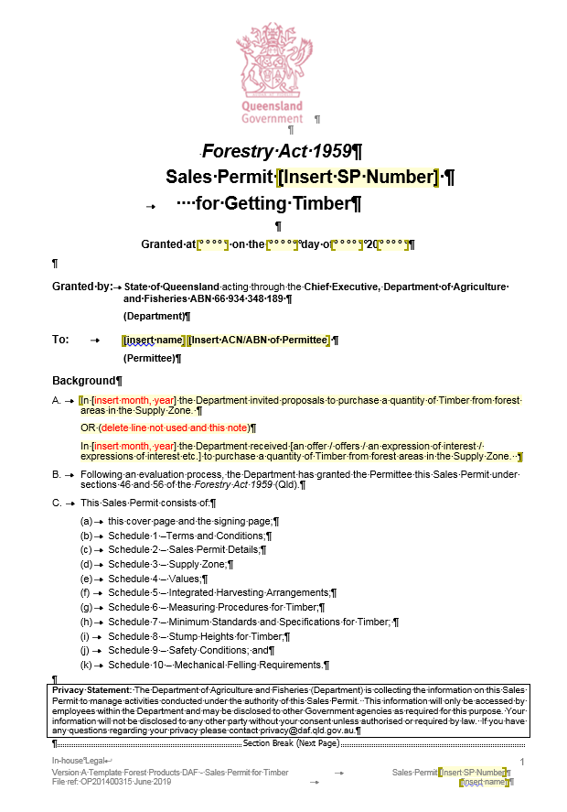

# Attachment B -Examples of [public native forest] accountable removal dockets

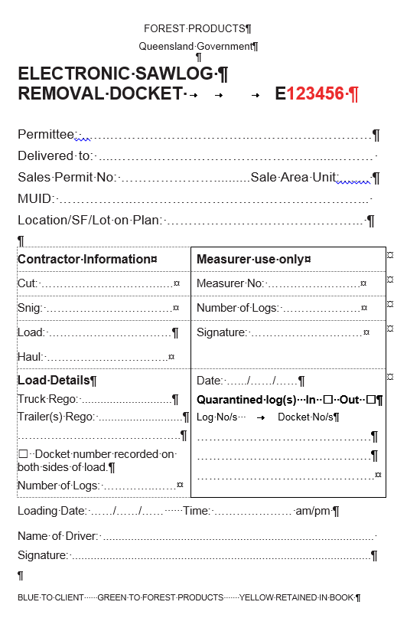

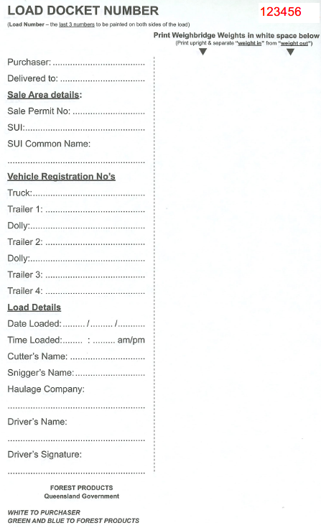

# Attachment C - Example of [public native forest] Tax Invoice

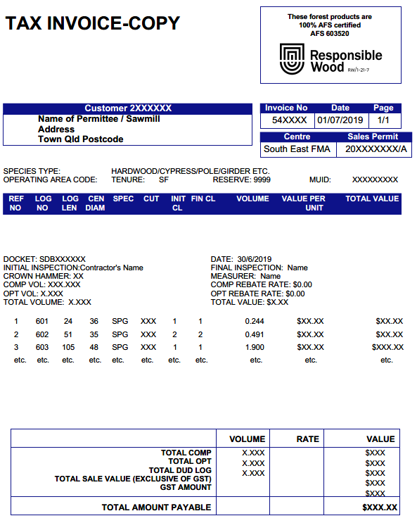

# Attachment D - Notification of intention to harvest under the Managing a native forest practice accepted development vegetation clearing code

A copy of the notification form is available for downloading from the Queensland Government website:   
[qld.gov.au/environment/land/management/vegetation/clearing-codes/notification](https://www.qld.gov.au/environment/land/management/vegetation/clearing-codes/notification)

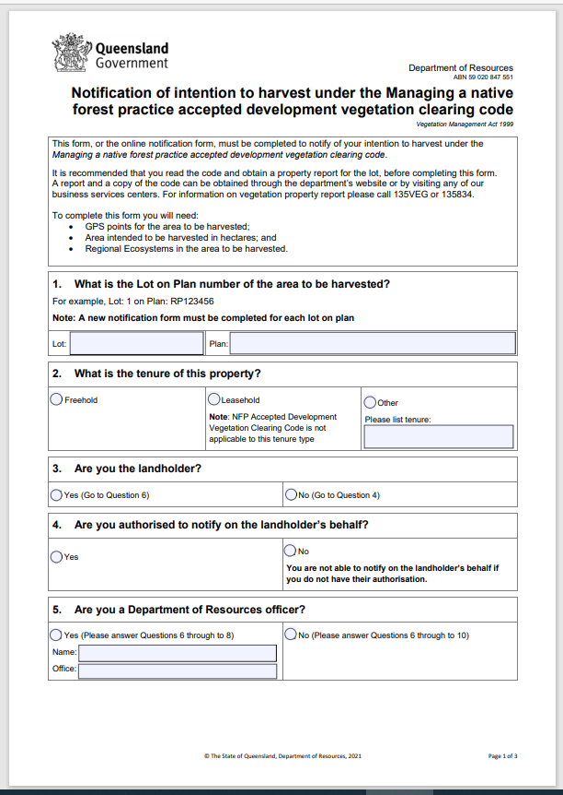

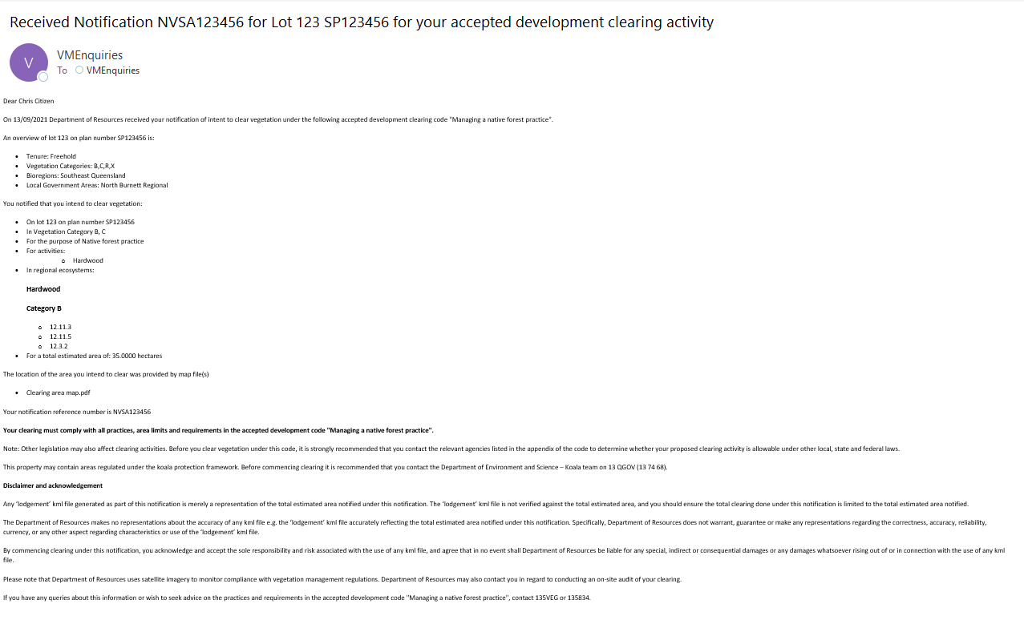

# Attachment E - Application form for a protected plant harvesting licence

A copy of the application form for a protected plants harvesting licence is available for downloading from the DEHP website:

<http://www.qld.gov.au/environment/plants-animals/plants/protected-plants/harvesting>