

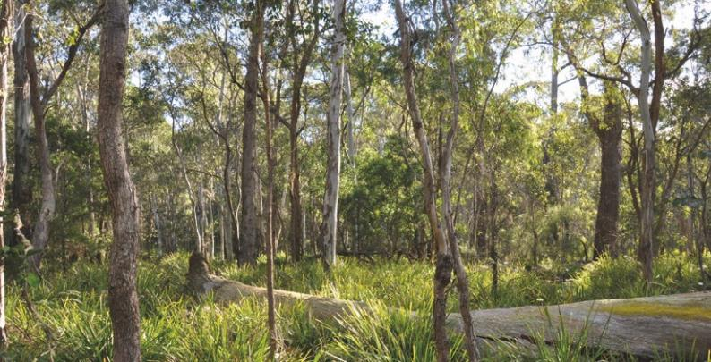The Southern Highlands Shale Forest and Woodland of the Sydney Basin Bioregion: A Nationally Significant Ecological Community

This guide is designed to assist land managers, owners and occupiers, as well as environmental assessment officers and consultants, to identify, protect and manage the Southern Highlands Shale Forest and Woodland ecological community; a threatened ecological community, listed as critically endangered under the *Environment Protection and Biodiversity Conservation Act 1999* (EPBC Act), Australia’s national environment law.

This guide is a companion document to the approved Conservation Advice, which can be found on the Australian Government’s species profile and threats (SPRAT) database at: [www.environment.gov.au/cgi-bin/sprat/public/](http://www.environment.gov.au/cgi-bin/sprat/public/publicshowcommunity.pl?id=62)  [publicshowcommunity.pl?id=62](http://www.environment.gov.au/cgi-bin/sprat/public/publicshowcommunity.pl?id=62). On this webpage, click on the details link—alongside the ecological community name—to download the documents and the map for the listed ecological community.

**© Copyright Commonwealth of Australia, 2017.**

*The Southern Highlands Shale Forest and Woodland of the Sydney Basin Bioregion: a nationally significant ecological community* is licensed by the Commonwealth of Australia, for use under a Creative Commons By Attribution

* 1. Australia licence with the exception of the Coat of Arms of the Commonwealth of Australia, the logo of the agency responsible for publishing the guide, content supplied by third parties, and any images depicting people. For licence conditions see: <http://creativecommons.org/licenses/by/4.0>/

This guide should be attributed as *‘The Southern Highlands Shale Forest and Woodland of the Sydney Basin Bioregion: a nationally significant ecological community, Commonwealth of Australia 2017’*.

The Commonwealth of Australia has made all reasonable efforts to identify content supplied by third parties using the following format ‘© [name of third party] ’.

**Disclaimer**

The views and opinions expressed in this publication are those of the authors and do not necessarily reflect those of the Australian Government or the Minister for the Environment and Energy.

While reasonable efforts have been made to ensure that the contents of this publication are factually correct, the Commonwealth does not accept responsibility for the accuracy or completeness of the contents, and shall not be liable for any loss or damage that may be occasioned directly or indirectly through the use of, or reliance on, the contents of this publication.

**Images**

Front cover — Southern Highlands Shale Forest and Woodland tall wet form, Upper Nepean State Conservation Area © Department of the Environment and Energy

Back cover — Canopy of Southern Highlands Shale Forest and Woodland © Department of the Environment and Energy

This guide is intended to assist the public to understand the national listing of the Southern Highlands Shale Forest and Woodland as a protected ecological community; to explain what it is, why it is threatened and what national protection means for people in the region.

In Summary

* + - Since non-Indigenous settlement of the Southern Highlands of New South Wales from the early 1800s, much of the native bush north of the sandstone gorges of Morton National Park was logged and cleared for forestry, agriculture, towns and roads.
    - The unique shale forests and woodlands that occurred on the plains and lower slopes were the main casualty of land clearance. This lead to many of the local native plants, animals and ecosystem functions and services being lost or placed under enormous stress.
    - Critical remnants of the increasingly rare shale forests and woodlands still persist in the region and are in need of protection from ongoing threats and new activities associated with regional population growth.
    - The Southern Highlands Shale Forest and Woodland ecological community was listed in August 2015 as critically endangered under Australian environment law, the *Environment Protection and Biodiversity Conservation Act 1999* (EPBC Act).
    - The national Threatened Species Scientific Committee found that this ecological community has undergone a severe decline, estimated to be up to 90 per cent of its original extent, resulting in a highly fragmented and restricted distribution. Of the estimated less than 6000 ha remaining, only about 1000 ha is of moderate or high condition and most of this is in scattered, small patches.
* National listing is an important step in securing the future of the Southern Highlands Shale Forest and Woodland by:
  + raising awareness of the ecological community and priority actions to combat threats
  + requiring consideration of the impact of new developments on the last remnants of this ecological community
  + encouraging priority support for managing threats, conservation and restoration efforts, including through Australian Government funding opportunities.
* The ecological community is predominately found in the Southern Highlands of the Sydney Basin, predominately in the Wingecarribee Local Government Area (as defined at June 2017), but also in adjacent local government areas. It is associated with clay soils derived from Wianamatta shale.
* The ecological community is dominated by eucalypt trees and typically has a herbaceous understorey, but is variable in vegetation structure, ranging from a tall wet sclerophyll forest to more open, grassy woodland. Reflecting this variation, three ‘forms’ of the ecological community are recognised: ‘typical’, ‘tall wet’ and ‘short dry’.
* The Southern Highlands Shale Forest and Woodland supports a diverse range of fauna— providing essential resources and refuge for wildlife in the region such as shelter (e.g. hollows, nesting materials, roosting), food (e.g. nectar from flowers or invertebrate prey) and migration routes. Included in this fauna are the threatened mammals, *Dasyurus maculatus*

*maculatus* (spotted-tailed quoll), *Potorous tridactylus tridactylus* (long-nosed potoroo) and *Phascolarctos cinereus* (koala), threatened birds such as *Petroica boodang* (scarlet robin), *Ninox strenua* (powerful owl) and *Anthochaera phrygia* (regent honeyeater) and threatened amphibians and reptiles such as *Heleioporus australiacus* (giant burrowing frog) and *Varanus rosenbergi* (Rosenberg’s goanna, heath goanna).

* The ecological community also provides ecosystem services and contributes to the health and wellbeing of local residents. For example, the forests and woodlands help cool temperatures in the surrounding region; store carbon; filter and maintain aquifers;

mitigate local flooding, soil loss, and pollution; and, provide amenity and recreation such as scenic areas for bushwalking. The ecological community also supports soil health, crop pollination and pest management.

* Remaining patches provide important wildlife corridors and refuges in a mostly fragmented landscape, including as stepping stones between Morton National Park, Nattai

National Park and the Upper Nepean State Conservation Area.

* A Conservation Advice is available that outlines a range of priority research and management actions that provide guidance on how to protect, manage and restore the ecological community.
* Routine property maintenance and land management practices, carried out in line with local laws and guidelines covering native vegetation, are typically unlikely to require consideration under the EPBC Act (e.g. most farming activities, roadside maintenance and managing fire breaks).
* Activities likely to have significant adverse impacts on the ecological community need to be considered under the EPBC Act to avoid or mitigate those impacts—activities such as large new developments, works or infrastructure. For example, permanently clearing areas of high-quality native vegetation for mining and energy infrastructure or residential subdivision

and development.

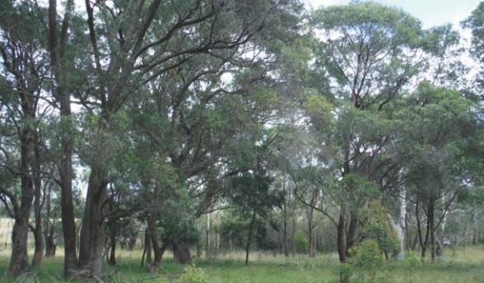

Southern Highlands Shale Forest and Woodland typical form © Greg Stone

# National ecological communities

Australia’s national environment law provides a legal framework to list, protect and manage Matters of National Environmental Significance (MNES), which include nationally threatened species and ecological communities.

The EPBC Act defines an ecological community as an assemblage of native species which inhabits a particular area in nature. In other words, ecological communities are groups of native plants, animals and other organisms that naturally occur together and interact in a unique habitat. They include forest, grassland, shrubland, wetland, woodland, ground spring, cave and marine communities.

The native plants and animals in an ecological community have different roles and relationships that, together, contribute to a healthy functioning natural environment.

Listed ecological communities may become extinct, through loss of extent, loss of characteristic species, and/or loss of natural function throughout their range, unless threats are removed or better managed. However, remnants retain important natural values and have the potential to provide more habitat and ecosystem services, if threats are eliminated or managed to reduce their impacts, and the natural composition and function of the ecological communities are restored.

Protecting ecological communities also protects ecosystem services such as clean air, healthy soils and water. These benefit people and society both within and beyond the local area and are essential to the greater productivity of our land and water.

National (EPBC Act) protection complements other conservation measures and is particularly vital for ecological communities such as the Southern Highlands Shale Forest and Woodland, as only a low proportion of remnants are protected in conservation reserves. Therefore, protecting and funding restoration of ecological communities on private land, is critical to maintain or enhance habitat and migration routes for wildlife in-between reserves.

# What is the Southern Highlands Shale Forest and Woodland ecological community?

The Southern Highlands Shale Forest and Woodland of the Sydney Basin Bioregion ecological community only occurs on the Southern Highlands plateau and is associated with clay soils derived from Wianamatta Group shales.

The nationally-listed ecological community encompasses the similarly named ecological community ‘Southern Highlands Shale Woodlands in the Sydney Basin Bioregion’ that is listed as threatened under New South Wales legislation, although minimum condition thresholds apply to the nationally-listed ecological community (see ‘Are all patches protected under the EPBC Act listing?’ section of this guide).

The Southern Highlands Shale Forest and Woodland has a tree canopy dominated by eucalypts and a typically herbaceous understorey. It shows some variation in structure and composition in different locations due to differences in the local physical environment, and/or past history of disturbance (natural or human-induced). Reflecting this variation, three ‘forms’ of the ecological community are recognised: ‘typical’, ‘tall wet’ and ‘short dry’.

The ‘typical’ form occurs in areas of more moderate rainfall and can be further differentiated into three variants: Penrose; Braemar; and Bundanoon ridges and exposed slopes. The ‘tall wet’ form typically occurs in areas with higher rainfall, soil moisture and fertility and in areas of sheltered topography. In areas of lower rainfall, more frost and in some cases more exposed locations, a ‘short dry’ form of the ecological community occurs.

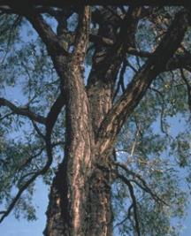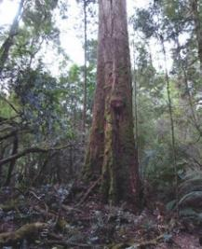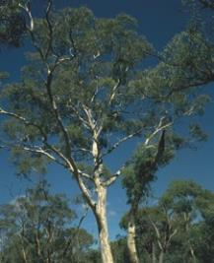

(from left) *Eucalyptus fibrosa* (red ironbark) © D. Greig, *Eucalyptus obliqua* (stringybark) © M. Fagg, *Eucalyptus mannifera* (brittle gum) © D. Kelly

## Canopy

Characteristic canopy species that may be found in all forms of the ecological community include: *Eucalyptus globoidea* (white stringybark), *Eucalyptus piperita* (Sydney peppermint) and *Eucalyptus radiata* (narrow- leaved peppermint).

In addition to these species, the ecological community may be dominated by one or more of the following canopy species:

* + In the **‘typical’** form - by *Eucalyptus macarthurii* (Paddy’s River box). *Eucalyptus pauciflora* (snow gum) may also be present but not as a dominant species. *Eucalyptus amplifolia* (cabbage gum) and/or *Eucalyptus tereticornis* (forest red gum) often occur. *Eucalyptus ovata* (swamp gum) is often present at poorly drained sites.

– In addition, a **Penrose variant** is dominated by *Eucalyptus blaxlandii* (Blaxland’s stringybark); a **Bundanoon variant** often includes *Angophora floribunda* (rough barked apple); and a **Braemar variant** is often dominated by *Eucalyptus fibrosa* (red ironbark) and *Eucalyptus punctata* (grey gum), reflecting a stronger sandstone influence.

* + In the **‘tall wet’** form - by *Eucalyptus cypellocarpa* (mountain grey gum), *Eucalyptus elata* (river peppermint), *Eucalyptus obliqua* (stringybark), *Eucalyptus ovata* (swamp gum), *Eucalyptus quadrangulata* (white-topped box), *Eucalyptus smithii* (gully peppermint, blackbutt peppermint) and/or *Eucalyptus viminalis* (manna gum,

ribbon gum).

* In the **‘short dry’** form - by *Eucalyptus cinerea* (Argyle apple, silver leaved stringybark), *Eucalyptus dives* (broad leaved peppermint), *Eucalyptus mannifera* (brittle gum) and/or *Eucalyptus rubida* (candlebark, ribbon gum). *Eucalyptus pauciflora* may also occur, and while not a dominant species, its frequency in this form reflects the increased exposure to frost and lower rainfall.

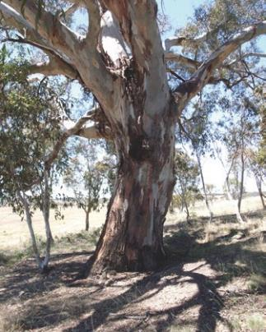

*Eucalyptus rubida* (candlebark) *©* M. Fagg

7

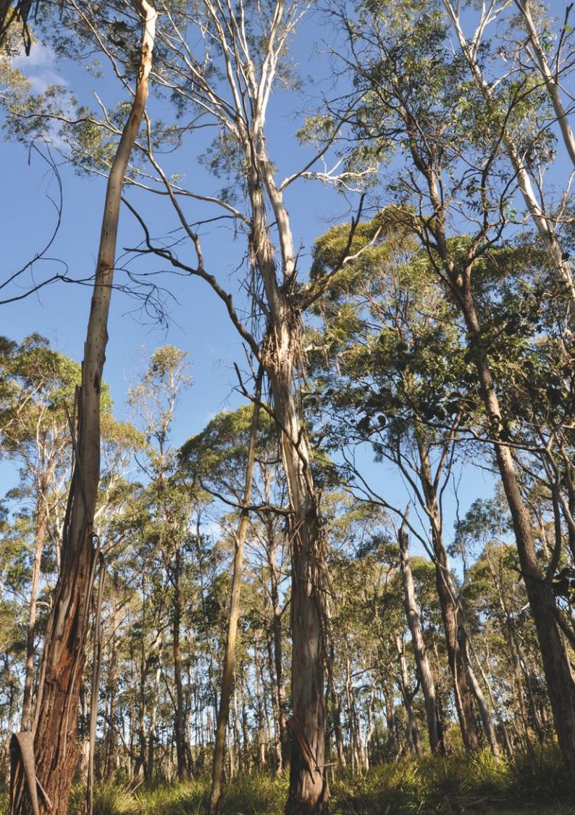

## Understorey

* + Where present, the shrub layer is typically sparse, although it may be dense in some parts of a patch. *Bursaria spinosa* (blackthorn, Kurwan (D’harawal)) typically occurs in all forms of the ecological community.
  + The ground layer is typically dense, dominated by grasses and herbs. Ground layer species typically occurring in all forms include: *Dichondra* spp. (kidney weed, Yilibili (D’harawal))*; Hardenbergia violacea* (purple coral pea, Waraburra); *Lomandra longifolia* (spiny-headed mat-rush); and *Poa labillardierei* (river tussock grass).
  + The typical form has a more evident grass and sclerophyll sub-shrub layer. A tall shrub layer may be present where disturbance has favoured large Acacias such as *Acacia mearnsii* (black wattle) and *A. melanoxylon* (blackwood). Typical mid layer species include: *Daviesia ulicifolia* (gorse bitter-pea); *Olearia viscidula* (daisy bush); *Oxylobium ilicifolium*. Typical ground layer species include: *Xerochrysum bracteatum* (golden everlasting); *Coronidium scorpioides* (button everlasting); *Hypericum gramineum* (small St. John’s wort); *Poranthera microphylla* (small-leaved poranthera); *Pteridium esculentum* (common bracken); *Themeda triandra* (kangaroo grass).
* The tall wet form can have rainforest understorey components, significant wetland components and can be a swamp forest with lots of sedges, rushes, graminoids and areas that are wetland at a small scale. Typical mid layer species in the tall wet form include: *Goodenia ovata* (hop

goodenia); *Leptospermum polygalifolium* (yellow tea-tree); *Melaleuca linariifolia* (tea-tree; flax leaved paperbark); *Pittosporum undulatum* (native daphne, sweet pittosporum) and *Rubus parvifolius* (native raspberry). At some sites *P. undulatum* is increasingly abundant and may be invasive. Common ground layer species include: *Blechnum cartilagineum* (gristle fern) *Eustrephus latifolius* (wombat berry); *Hibbertia scandens* (guinea flower); and *Viola betonicifolia* (showy violet).

* The short dry form has a predominantly grassy understorey. *Rytidosperma pallidum* (syn. *Joycea pallida*) (red-anther wallaby grass) is typically present in the dry form and largely absent from the tall wet and typical forms. *Olearia microphylla* is a common mid storey species.

**Opposite page:** (top row, from left) *Acacia implexa* (lightwood)

© C. Green, *Asperula conferta* (common woodruff) © M. Fagg,

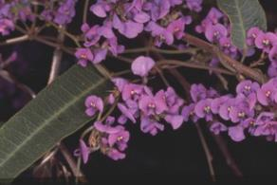(middle row, from left) *Exocarpos cupressiformis* (native cherry) © M. Fagg, *Indigofera australis* (Australian indigo) © M. Fagg, (bottom row, from left) *Rubus parvifolius,* (native raspberry) © M. Fagg, *Pratia purpurascens* (white root) © M. Fagg

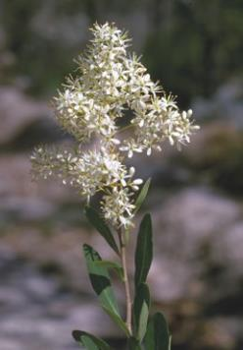

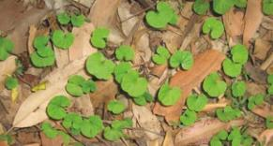(clockise) *Hardenbergia violacea* (purple coral pea, Waraburra) © M. Fagg, *Bursaria spinosa* (blackthorn, Kurwan (D’harawal)) © M. Fagg, *Dichondra repens* (kidney weed, Yilibili (D’harawal)) © Steve Lewer

9

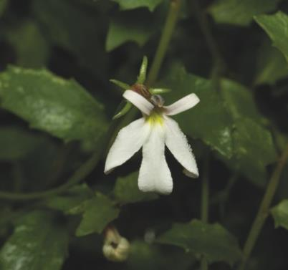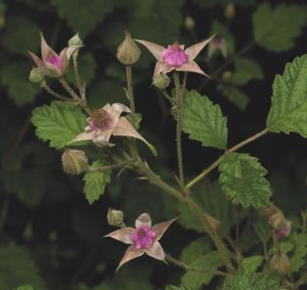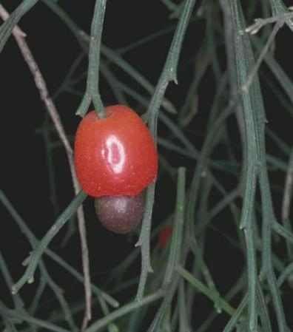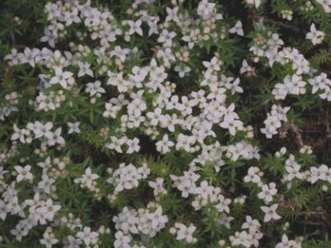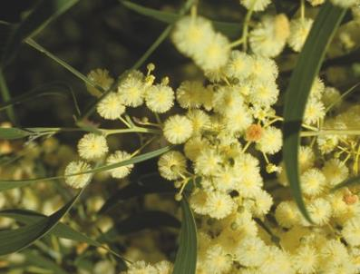

# Why is the Southern Highlands Shale Forest and Woodland ecological community important? Why is it important to protect it?

The ecological community provides habitat for a large number and variety of native plants and animals.

Remnant patches of the ecological community provide wildlife corridors and refuges in a fragmented landscape. They also provide feed and shelter for livestock, as well as natural beauty and amenity in parks and other land around local towns. The ecological community also contributes to the area’s air and water quality and helps prevent or reduce the impact of weeds and soil erosion.

When native vegetation is cleared, habitat which was once continuous becomes divided into smaller separate fragments. This makes it harder for animals to roam or migrate and for plants to disperse. In the Southern Highlands, many fragments of the ecological community are small islands—isolated from each other by grazing or agricultural land, or by roads, houses and other developments.

Connectivity between individual areas of the ecological community and with other areas of native vegetation is important for plants because it increases pollination rates and the spread of plant propagules—the parts of a plant that allow it to reproduce and spread.

For vertebrate fauna, diversity and abundance may depend on the connectivity of patches, more than on

the size of the patches (e.g. linear road reserves or small patches that act as stepping stones are important).

The Southern Highlands Shale Forest and Woodland sits within a patchwork of cleared land and intact native vegetation connecting Morton National Park to Nattai National Park and to the Upper Nepean State Conservation Area. It also occurs between the grasslands, grassy woodlands and forests of the Southern Tablelands and the Cumberland Plain. These corridors are important for the movement of fauna including nationally and regionally threatened species. Isolated remnants may also act as critical refuges for plants and animals.

By listing the ecological community, additional protection is given to national, state and regionally threatened native animals and plants. These include nationally-listed animal species such as: *Anthochaera phrygia* (regent honeyeater), *Heleioporus australiacus* (giant burrowing frog), *Chalinolobus dwyeri* (large-eared pied bat), *Dasyurus maculatus maculatus* (spotted-tailed quoll), *Phascolarctos cinereus* (koala), *Potorous tridactylus tridactylus* (long-nosed potoroo) and *Pteropus poliocephalus* (grey-headed flying-fox).

It is important to help prevent further decline of the ecological community by promoting recovery through landholder and community efforts. This, alongside the protection afforded by listing, reduces the risk of this unique and important part of the Southern Highland’s natural environment being lost to future generations.

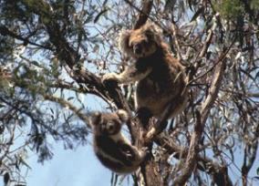 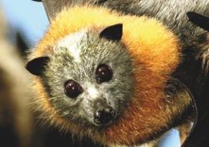

(from left) The vulnerable (EPBC Act, NSW TSC Act) *Phascolarctos cinereus* (koala*) ©* Robert Thorn, *Pteropus poliocephalus* (grey-headed flying fox)

© Vivien Jones

# Where does the Southern Highlands Shale Forest and Woodland ecological community occur?

The Southern Highlands Shale Forest and Woodland is endemic to New South Wales and is found on the Southern Highlands plateau of the Sydney Basin bioregion. It occurs predominately in the Wingecarribee Local Government Area (as defined at June 2017), but also in adjacent local government areas.

The eastern limit of the ecological community is the Illawarra escarpment where Wianamatta Shale is replaced by other geologies (younger basalts and older sedimentary geologies of the Hawkesbury, Narrabeen and Illawarra groups) near the towns of Kangaloon, Robertson and Fitzroy Falls; the southern limit is in the vicinity of the town of Penrose; it is currently known to extend north to near Braemar and Alymerton; and west to near Canyonleigh, High Range, Berrima and Medway. Note that property specific maps available from state agencies do not always identify nationally listed ecological communities.

This map is also available online at: [www.environment.gov.au/biodiversity/threatened/communities/maps/pubs/62-map.pdf](http://www.environment.gov.au/biodiversity/threatened/communities/maps/pubs/62-map.pdf)

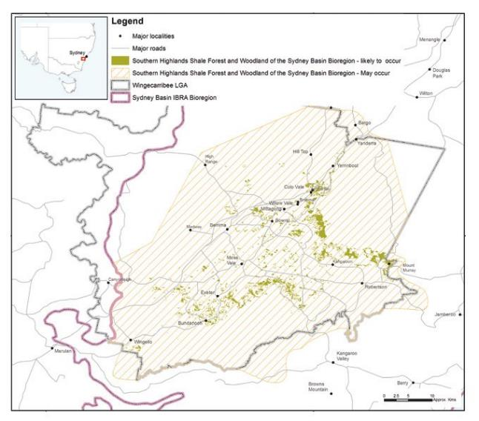

# Why does the ecological community need national protection?

Non-Indigenous settlement in the Southern Highlands began in the 1820s. The ecological community occurs on rich clay soils, often on relatively flat land which, historically, led to it being extensively cleared for agriculture and forestry and then for towns and roads. This has also resulted in very severe fragmentation, leaving mostly small and scattered remnants, many of which are in poor condition. Only one relatively large remnant is known to exist within a formal conservation area (Upper Nepean State Conservation Area).

In August 2015, the Australian Government Minister for the Environment listed the Southern Highlands Shale Forest and Woodland ecological community, after considering the advice of the Threatened Species Scientific Committee (the Committee). A rigorous assessment of the scientific evidence found that it met the eligibility criteria for listing as critically endangered under the EPBC Act, Australia’s national environment law.

The Committee found that:

* + the ecological community had undergone a decline of up to 90 per cent of its original pre-European extent
  + it now occurs as highly fragmented patches, with many less than 1 ha in size
* it has experienced a very severe reduction in its community integrity due to the combined effects of substantial clearing and fragmentation, invasive weeds and feral animals, changes to fire regimes, grazing and mowing, and other disturbances to remaining patches that make it less resilient to impacts from climate change.

This has led to direct loss of populations of native species in many parts of the range, and associated loss of key habitat features such as mature trees and their food resources; reduced capacity to support fauna and loss of key ecological functions dependent on fauna (e.g. pollination) and, reduced resilience to future disturbance.

Small and isolated fragments are less buffered from disturbance such as weed invasion, storm damage or impacts from surrounding agricultural and residential activities. Slow incremental loss of small remnants has a very significant cumulative effect, which is why all remnants of this ecological community are important particularly for regionally rare or significant plants and animals.

**Opposite page:** (top row, from left) Three vulnerable (NSW TSC Act) *Callocephalon fimbriatum* (gang-gang cockatoos) © Anthony Brady-Traynor, The vulnerable (NSW TSC Act) *Melanodryas cucullata* (hooded robin)

© Brian Furby, (middle row, from left) The vulnerable (NSW TSC Act) *Neophema pulchella* (turquoise parrot) © Brian Furby, The vulnerable (NSW TSC Act) *Daphoenositta chrysoptera* (varied sitella) © Brian Furby,

(bottom row, from left) The vulnerable (NSW TSC Act) *Climacteris picumnus* (brown tree creeper) © Brian Furby, The critically endangered (EPBC Act, NSW TSC Act) *Anthochaera phrygia* (regent honeyeater) © Graeme Chapman

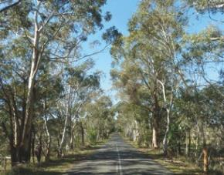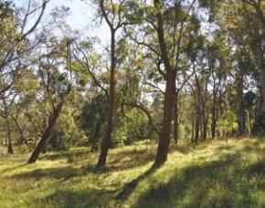

(from left) Patches of the ecological community on roadsides and private lands provide important habitat for native plants and animals, and corridors that support movement of wildlife. This enhances the biodiversity of the region and complements the larger reserves and national parks nearby. This roadside remnant (left) of the Southern Highlands Shale Forest and Woodland occurs near Exeter. Southern Highlands Shale Forest and Woodland, typical form, Bundanoon variant © Department of the Environment and Energy

13

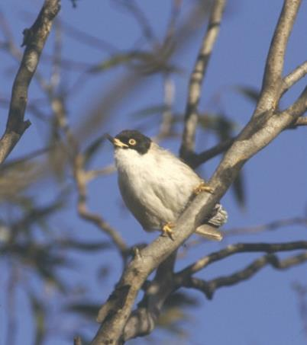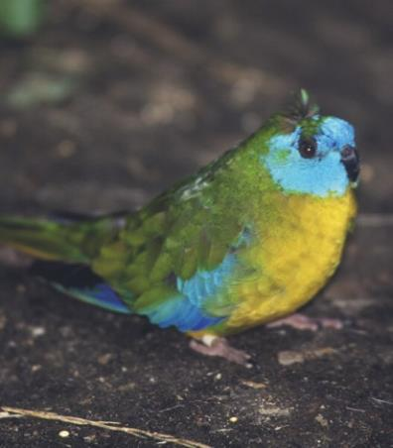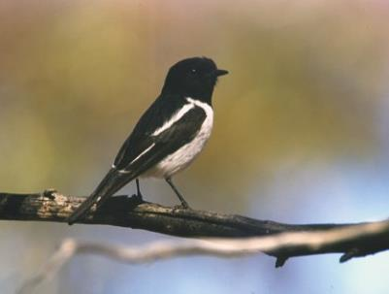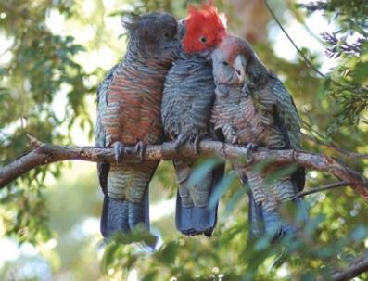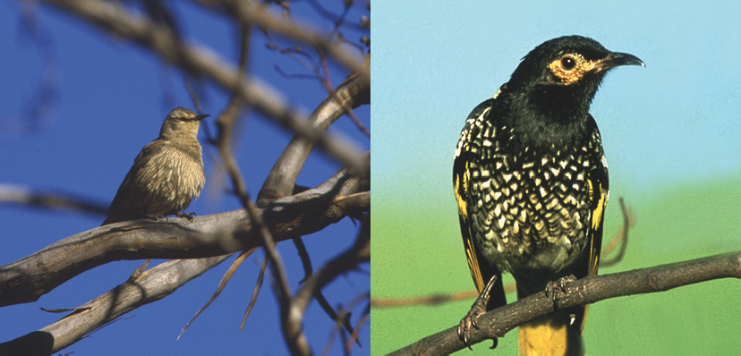

Some of the key weeds affecting this ecological community are moth vine (*Araujia sericifera*)*,* bridal creeper (*Asparagus asparagoides*)*,* Scotch broom (*Cytisus scoparius*)*,* African love grass (*Eragrostis curvula*)*,* privet (*Ligustrum* spp*.*)*,* blackberry (*Rubus fruticosus*)*,* willows (*Salix* spp.)*,* gorse (*Ulex europaeus*), hawthorn (*Crataegus* spp.) and trad (*Tradescantia fluminensis*)*.*

The overall aim of nationally listing the ecological community is to prevent its decline and support on-ground efforts to ensure its long-term survival. The Conservation Advice for the ecological community outlines a range of priority research and management actions that provide guidance on how to manage, restore and protect it. This Conservation Advice can be found on the Department’s website: [www.environment.gov.au/biodiversity/threatened/](http://www.environment.gov.au/biodiversity/threatened/communities/pubs/62-conservation-advice.pdf) [communities/pubs/62-conservation-advice.pdf](http://www.environment.gov.au/biodiversity/threatened/communities/pubs/62-conservation-advice.pdf)

# Are all patches protected under the EPBC Act listing?

No. National listings of ecological communities specify low or minimum condition thresholds that help to identify patches that are too degraded for the purposes of protection under national environment law. This allows national protection to focus on the best and most intact patches that remain of a listed ecological community.

## Condition thresholds

The minimum condition thresholds mean that small and degraded patches — such as individual paddock trees, or remnants where the understorey has been largely replaced by weeds—are excluded from a listed ecological community and any actions do not need to be considered under the national environment law.

## Protected patches

A patch should first be identified as being the ecological community, using the descriptive information above, and the key diagnostic characteristics listed in the [**Conservation Advice**](http://www.environment.gov.au/biodiversity/threatened/communities/pubs/62-conservation-advice.pdf)document on the Department’s website. Then, condition thresholds are applied—the ecological

community is only protected under national environment law when it remains in relatively good condition (of the Moderate or High condition class). The moderate condition class is the minimum threshold and illustrated in the flowchart in Figure 3. Further detail on the condition classes, including the High condition class, are specified in the Conservation Advice. The high condition category thresholds provide a benchmark to help guide conservation management recovery decisions.

## Unprotected patches

Although not part of the protected ecological community listed under the EPBC Act, it is recognised that any patches which do not meet the minimum condition thresholds for Moderate quality may still retain important natural values; particularly if they are near patches which do meet the minimum condition thresholds. As such, these patches should not be excluded from recovery and other management actions. They may also be protected under state and/or local laws or schemes.

## Further details

For further details of how to determine whether a patch of woodland or forest meets the definition and condition thresholds for the national ecological community see the Conservation Advice at: [www.environment.gov.au/biodiversity/threatened/](http://www.environment.gov.au/biodiversity/threatened/communities/pubs/62-conservation-advice.pdf)  [communities/pubs/62-conservation-advice.pdf](http://www.environment.gov.au/biodiversity/threatened/communities/pubs/62-conservation-advice.pdf)

The condition of an ecological community is best assessed when:

* + Many plant species are flowering or fruiting (to aid identification), which usually occurs from Spring to early Autumn; and
  + There has been no recent disturbance; which means allowing at least two months, preferably longer, for the ecological community to recover after any substantial disturbance (for example, at least 18 months post fire).

# What is a patch of the ecological community?

A patch is defined as a discrete and mostly continuous area of the ecological community. Permanent man-made structures, such as roads and buildings, are typically excluded from a patch. Patches may include small-scale disturbances, such as tracks or breaks, watercourses or small-scale variations in vegetation that do not significantly alter the overall functionality of the ecological community

(i.e. processes such as the movement of wildlife and pollinators, the dispersal of plant seeds and nuts).

Variation in canopy cover, quality or condition of vegetation across a patch does not necessarily mean it should be split into multiple patches. A patch can be spatially variable and is often characterised by one or more areas within the patch that meet the key diagnostic characteristics and condition threshold criteria amongst areas of lower condition (Figure 1a). Average canopy cover and quality across the broadest area that meets the general description of the ecological community should be used

initially in determining overall canopy cover and vegetation condition. Also note any areas that are either significantly higher or lower in quality, gaps in canopy cover and the condition categories that would apply across different parts of the site respectively.

Where the average canopy cover or quality of the patch falls below the minimum thresholds, the next largest area that meets the key diagnostics (including minimum canopy cover requirements) and minimum condition thresholds should be identified as a patch and protected (Figure 1b). This may result in multiple patches of the ecological community being identified within the overall area first considered.

Where native grassland/shrubland (natural or derived) connects discrete patches of the ecological community that are in close proximity (up to 100m apart), this should be considered a single patch of the ecological community rather than individual patches.

Patches often extend beyond site or property boundaries. The size of the patch, not just the area within a site, needs to be considered when applying the minimum patch size threshold of 0.5 ha (Figure 2).

### Figure 1: Two examples of how variation in condition occurs across a patch.

**1a) Where there is a mosaic of condition within the patch, for example variation in understorey quality.**

**This example shows how the patch of the ecological community (black dashed boundary) has areas that are below the minimum condition thresholds. Overall, on average this patch meets the minimum thresholds (moderate condition class).**

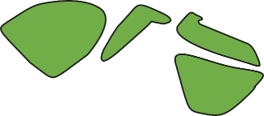

Vegetation that meets moderate (or high) condition class thresholds

Vegetation that is lower in quality than the moderate condition class thresholds Boundary of patch

### 1b) Where one end of the patch is of higher quality than other.

**This example shows how the boundary of the patch has been reduced to meet the maximum area that, on average, meets the minimum condition thresholds (moderate condition class).**

Vegetation that meets moderate (or high) condition class thresholds

Vegetation that is lower in quality than the moderate condition class thresholds Initial area under consideration as a patch of the ecological community Boundary of patch

### Figure 2: Illustration of how a patch of an ecological community may extend beyond a site or property boundary. When assessing an impact proposal on a property, the total area of the patch (which may extend past the property boundary) should be considered. Therefore the 0.4 ha area within this site is considered to be the nationally-listed ecological community because the total patch size of 2 ha (0.4 ha + 1.6 ha) is greater than 0.5 ha (the minimum size to qualify as the protected ecological community).

**0.4 ha**

**1.6 ha**

Site of proposed development or works

Site of proposed vegetation clearing = 0.4 ha

Patch of ecological community outside the site = 1.6 ha Total patch area = 2 ha (0.4 ha + 1.6 ha)

**(4) Is at least 30% of the perennial understorey vegetative cover* made up of**

**native plants?**

NO

YES

If below 30% native and below 15 native understorey species, the patch is not part of the protected ecological community

**The patch is part of the protected nationally listed ecological community**

The patch is not part of the protected ecological community

**Figure 3: Flowchart to help identify which areas (patches) of the Southern Highlands Shale Forest and Woodland ecological community meet the minimum condition thresholds for national protection**

The patch is too small to be part of the protected ecological community

**The patch is part of the protected nationally listed ecological community**

**(1) Is the patch at least 0.5 ha in size?**

YES

**(2) Is at least 50% of the perennial understorey vegetative cover* made up of**

**native plants?**

YES

NO

NO

**(3) Are there at least 15 native understorey species per 0.5ha?**

YES

NO

**The patch is part of the protected nationally listed ecological community**

|  |  |  |  |  |  |  |
| --- | --- | --- | --- | --- | --- | --- |
| **(5) Is the patch contiguous** with another type of native vegetation remnant (i.e. any native vegetation where cover in each layer**  **present is dominated by native species) that’s at least 1 ha in area?** | | | |  | | |
|  | YES |  |
|  |  |
|
|  | |  | | | | |
|  | NO | |  | | | |

**The patch is part of the protected nationally listed ecological community**

|  |  |  |  |
| --- | --- | --- | --- |
| **(6) Does the patch have at least one tree with hollows per 0.5 ha or at least one**  **large locally indigenous tree (at least 60cm dbh) per 0.5 ha?** |  | | |
|  | YES |  |
|  |  |
|  | | |
|  | NO |  |
|  |  |
|

dbh is diameter at breast height.

*Perennial understorey vegetative cover includes vascular plant species of the ground and shrub layers (where present) with a lifecycle of more than two growing seasons. The ground layer includes herbs (i.e. graminoids, forbs, and low shrubs [woody plants <0.5m high]). Measurements of perennial understorey vegetation cover exclude annuals, cryptogams, leaf litter or exposed soil.

**Contiguous means the patch of the ecological community is continuous with, or in close proximity (within 100 m) to, another area of vegetation that is dominated by native species in each vegetation layer present.

### Further detail on the condition classes, including thresholds for the High condition class, are specified in the [Conservation Advice](http://www.environment.gov.au/biodiversity/threatened/communities/pubs/62-conservation-advice.pdf)

**What are the benefits of listing the ecological community as nationally threatened?**

There are a number of benefits of listing and protecting ecological communities under Australia’s national environment law:

* + - It can help to maintain the ecological connections essential for the ecological function, health and biodiversity of the region’s landscapes. It can protect and recover habitat resources critical for refuge and recruitment of the native species of the region, including threatened species, other species under local pressure and species important for ecosystem function. In turn, this helps foster the ecosystem services associated with the ecological community.
    - It helps protect ecological communities from future significant human impacts causing further decline. The aim of the national environment law is to ensure the matters of national environmental significance are given due consideration, along with broader economic, social and other issues in the planning of any large projects. Where possible, significant adverse impacts to the environment should be avoided. If the impacts are unavoidable, they must be mitigated, reduced or, as a last resort, offset.
    - It encourages agencies and community groups to apply for funding opportunities for conservation and recovery works that will address threats to the ecological community. The Australian Government has a variety of funding programs to assist land managers to conserve biodiversity and ecosystem services.
    - A [**Conservation Advice**](http://www.environment.gov.au/biodiversity/threatened/communities/pubs/62-conservation-advice.pdf), published at the time of listing, provides guidance for environmental decision-making, including priority research, conservation management and restoration actions.
    - In the case of the Southern Highlands Shale Forest and Woodland ecological community, the listing aims to:

– raise awareness about the ecological community and the threats it faces

* provide landscape-scale protection that complements existing national and state protection for both threatened species that are found within the ecological community and nearby threatened ecological communities
* protect and restore the environmental values, including the ecosystem functions and services associated with the ecological community, contributing to the long-term productivity of the landscape.

# What does the listing mean for landholders?

Business as usual for most routine activities

It is important to note that the national environmental law is only triggered if a particular activity has, or will have, a significant impact on a Matter of National Environmental Significance—in this instance, a listed nationally threatened ecological community.

The normal activities of individual landholders, residents and councils will typically not be affected by a listing. Routine property maintenance and other established practices such as most farming activities and ongoing road maintenance works—particularly if carried out in line with state laws covering native vegetation—are unlikely to have a significant impact and so do not typically require referral or other consideration under national environment law.

For instance, the following actions are unlikely to trigger the EPBC Act:

* continuation of grazing, horticultural or cropping activities
* maintenance of existing roads, fences, access tracks and firebreaks
* maintenance of existing farm gardens, orchards, dams or water storages
* maintenance of existing pumps and clearing drainage lines
* replacement and maintenance of sheds, other buildings, yards and fences
* control of weeds and management of pest animals on individual properties or roadside verges.

In all these cases, landholders are encouraged to avoid any impacts on patches of the ecological community where possible and to help restore remnants. For example, landholders should try to avoid native vegetation clearance in the ecological community and create a minimum 50 m buffer zone to help protect the root zone of trees and other components at the edge of the ecological community from spray drift (fertiliser, pesticide or herbicide sprayed in adjacent land) and other damage.

Please note that human settlements and infrastructure where the ecological community formerly occurred do not form part of the natural environment and are therefore not considered to be part of the protected ecological community. This also applies to sites that have been replaced by crops and exotic pastures, or where the ecological community exists in a highly-degraded or unnatural state (see ‘Are all patches protected under the EPBC Act listing?’ section of this guide).

### The likelihood that an action will have a significant impact on the ecological community depends on local conditions, the quality of the patch, and upon the intensity, duration, magnitude and geographic extent of the impacts.

Fire management activities should seek to minimise impacts to the ecological community. Fires must be managed to ensure that where possible, prevailing fire regimes do not disrupt the life cycles of the component species of the ecological community (including avoiding management burning in flowering and nesting seasons, wherever possible), that they support rather than degrade the habitat necessary to the ecological community, that they do not promote invasion of exotic species, and that they do not increase impacts of other disturbances such as grazing or predation by feral predators.

Activities with national environment law approval prior to the listing of this ecological community, do not need to seek further approval.

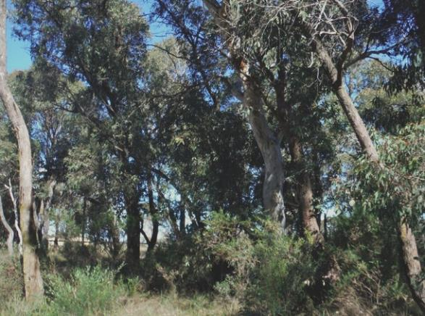

Southern Highlands Shale Forest and Woodland short dry form © Greg Stone

# Referral required for actions likely to have a significant impact

The EPBC Act is triggered if an action is likely to have a significant impact on the Southern Highlands Shale Forest and Woodland ecological community. If a proposed action would have such an impact, it would require:

* + a referral to determine whether the action is likely to have a significant impact on the ecological community
  + assessment (the scope of the assessment depends on the complexity of the proposed action

and impacts)

* + a decision by the Minister on approval and conditions. Through the EPBC Act approvals process, the Minister also considers social and economic matters relevant to individual projects that may have a significant impact on the ecological community.

Strict timeframes apply to assessments to ensure decisions are made as quickly as possible. For further information on referral,

assessment and approval processes, refer to the following website: [www.environment.](http://www.environment.gov.au/protection/environment-assessments/assessment-and-approval-process) [gov.au/protection/environment-assessments/assessment-and-approval-process](http://www.environment.gov.au/protection/environment-assessments/assessment-and-approval-process)

The key diagnostics and condition thresholds for the ecological community exclude many patches on

properties or along roadside verges that are considered too degraded for protection. In addition, the EPBC Act provides exemptions for continuing (routine) use or where legal permission has previously been given.

The major activity that is likely to have a significant impact on the ecological community is clearing large or otherwise important areas of intact or high-quality native vegetation. For example:

* mining, residential, commercial or other industrial development
* construction of new roads or projects to widen existing roads
* conversion of large areas into new pastures or cropping fields.

To help reduce the significance of actions and referral under the EPBC Act, avoidance and mitigation to reduce clearing and associated impacts is needed in the early planning stage.

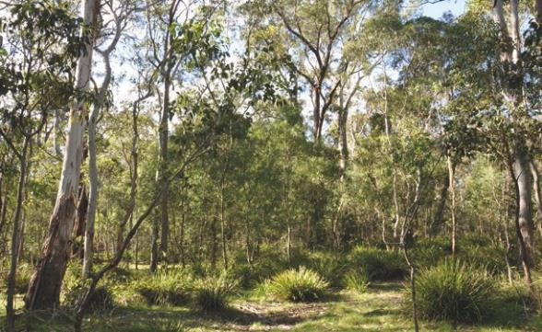

Southern Highlands Shale Forest and Woodland tall wet form, Upper Nepean State Conservation Area © Department of the Environment and Energy

# What can I do to look after the ecological community?

To protect and promote the recovery of bush remnants in your area you can:

* + avoid further clearance and fragmentation of the ecological community and surrounding native vegetation, with high-quality, relatively unmodified areas, wildlife refuges and areas supporting connectivity being particularly important
  + minimise unavoidable impacts from any developments or other activities adjacent to the ecological community that might result in further degradation—for example, by applying a minimum 50 m buffer zone around patches of the ecological community and avoiding hydrological and nutrient enrichment impacts
  + remove invasive species from your property, don’t plant or spread potential environmental weeds (e.g. avoid non-native grasses; check with your local authority) and don’t dump garden waste into or near remnants
  + avoid unnecessary mowing or ‘tidying’ of fallen branches and leaf litter that are essential to natural nutrient cycling
  + avoid fertilisers in or near bush remnants
  + retain dead trees, logs, large branches and rocks as fauna habitat in bushland areas
  + keep vehicles out of remnants and walk, ride or drive on established roads and paths, avoiding the removal or trampling of plants
  + report illegal or damaging behaviour (e.g. unauthorised fires or dumping) to appropriate authorities
  + exclude stock from remnants where possible, particularly during late spring and summer and use fencing to allow regenerating canopy trees to reach maturity
  + keep pets out of bushland, especially if it is known to contain koalas or other threatened species
  + on large properties undertake projects to restore the ecological community, including replanting and regeneration in areas linking with other patches in the landscape and areas that will buffer the ecological community from threats
* on smaller properties plant local native plants that occur in local threatened ecological communities
* support local efforts to conserve native vegetation and wildlife in your area (e.g. by joining or establishing a local organisation such as a Landcare or catchment care group, natural history or a ‘friends of ’ group; learn about the ecological community, and participate in activities such as tree planting, low impact rubbish removal and weeding)
* contact your local NRM Region body for support in bush management activities.

The Conservation Advice gives further details of priority conservation actions for the ecological community. This can be found on the Department’s website: [www.environment.gov.au/biodiversity/threatened/](http://www.environment.gov.au/biodiversity/threatened/communities/pubs/62-conservation-advice.pdf)  [communities/pubs/62-conservation-advice.pdf](http://www.environment.gov.au/biodiversity/threatened/communities/pubs/62-conservation-advice.pdf)

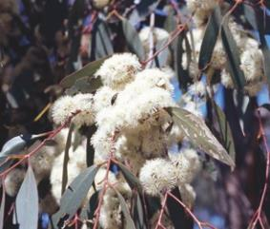

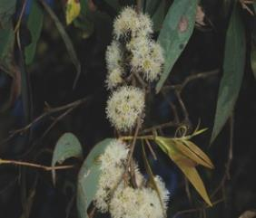

(Upper) *Eucalyptus dives* (broad-leaved peppermint) *© N. Lamb*, (Lower) *Eucalyptus radiata* (narrow-leaved peppermint) © M. Fagg

# Are there other nationally protected ecological communities within this area?

Within the Southern Highlands and surrounding regions there are a number of other ecological communities protected under national law including:

* + [Coastal Upland Swamps in the Sydney Basin Bioregion](http://www.environment.gov.au/cgi-bin/sprat/public/publicshowcommunity.pl?id=140&amp;status=Endangered)
  + [Natural Temperate Grassland of the South](http://www.environment.gov.au/cgi-bin/sprat/public/publicshowcommunity.pl?id=152) [Eastern Highlands](http://www.environment.gov.au/cgi-bin/sprat/public/publicshowcommunity.pl?id=152)
  + [Shale Sandstone Transition Forest of the Sydney](http://www.environment.gov.au/cgi-bin/sprat/public/publicshowcommunity.pl?id=146&amp;status=Critically%2BEndangered) [Basin Bioregion](http://www.environment.gov.au/cgi-bin/sprat/public/publicshowcommunity.pl?id=146&amp;status=Critically%2BEndangered)
  + Upland Basalt Eucalypt Forests of the Sydney [Basin Bioregion](http://www.environment.gov.au/cgi-bin/sprat/public/publicshowcommunity.pl?id=60)
  + [White Box-Yellow Box-Blakely’s Red Gum Grassy](http://www.environment.gov.au/cgi-bin/sprat/public/publicshowcommunity.pl?id=43)   [Woodland and Derived Native Grassland](http://www.environment.gov.au/cgi-bin/sprat/public/publicshowcommunity.pl?id=43)

For more information regarding these ecological communities, click on the links above, or visit: [www.environment.gov.au/cgi-bin/sprat/public/publiclookupcommunities.pl](http://www.environment.gov.au/cgi-bin/sprat/public/publiclookupcommunities.pl)

# Do state or local environment laws also apply?

Yes. State and local laws may also apply. Information about state-listed ecological communities and vegetation management laws are available from the following agencies:

* + NSW Office of Environment and Heritage [www.environment.nsw.gov.au/threatenedspecies/](http://www.environment.nsw.gov.au/threatenedspecies/)  [www.environment.nsw.gov.au/vegetation/](http://www.environment.nsw.gov.au/vegetation/)
  + Wingecarribee shire council [www.wsc.nsw.gov.au/environment](http://www.wsc.nsw.gov.au/environment)
  + South East Local Land Services NSW [www.southeast.lls.nsw.gov.au/](http://www.southeast.lls.nsw.gov.au/)

# Where can I get further information?

The Conservation Advice for the Southern Highlands Shale Forest and Woodland ecological community is the definitive source of information on the listing of this ecological community. For information about the development referral, assessment and approval process, please consult our environmental protection

webpages. These can be found on the Department’s website—along with additional information about the EPBC Act and Australian Government programs—as listed below:

* A statutory approved Conservation Advice for the ecological community is on the Department’s species profile and threats (SPRAT) database, at: [www.environment.gov.au/cgi-bin/sprat/public/](http://www.environment.gov.au/cgi-bin/sprat/public/publicshowcommunity.pl?id=62) [publicshowcommunity.pl?id=62](http://www.environment.gov.au/cgi-bin/sprat/public/publicshowcommunity.pl?id=62)
* EPBC listing process: [www.environment.gov.au/topics/threatened-species-ecological-communities](http://www.environment.gov.au/topics/threatened-species-ecological-communities)
* EPBC referral, assessment and approval process: [www.environment.gov.au/protection/](http://www.environment.gov.au/protection/environment-assessments)  [environment-assessments](http://www.environment.gov.au/protection/environment-assessments)
* EPBC environmental offsets policy: [www.environment.gov.au/epbc/publications/epbc-act-environmental-offsets-policy](https://www.environment.gov.au/epbc/publications/epbc-act-environmental-offsets-policy)
* Australian Government Natural Resource Management initiatives: [www.nrm.gov.au](http://www.nrm.gov.au/)
* A separate factsheet on farming and national environmental law at: [www.environment.gov.au/epbc/publications/factsheet-farming-and-national-environm](http://www.environment.gov.au/epbc/publications/factsheet-farming-and-national-environment-law-epbc-act) [ent-law-epbc-act](http://www.environment.gov.au/epbc/publications/factsheet-farming-and-national-environment-law-epbc-act)

A community-run website dedicated to providing information about Southern Highlands Shale Forest and Woodland—Wingecarribee’s natural heritage—is at: [www.shsfw.wordpress.com](http://www.shsfw.wordpress.com/)

If you need help to identify if Matters of National Environmental Significance may be present in your area of interest:

* Check the protected matters search tool at: [www.environment.gov.au/epbc/pmst/](http://www.environment.gov.au/epbc/pmst/)
* Check the species profile and threats (SPRAT) database at:

[www.environment.gov.au/cgi-bin/sprat/public/sprat.pl](http://www.environment.gov.au/cgi-bin/sprat/public/sprat.pl)

* Consult with relevant experts, such as an ecological consultant or local NRM agency (e.g. Local Land Services). They may be useful to help identify the ecological community and its condition, or
* Enquiries can also be made through the Department’s Community Information Unit, by phone on **1800 803 772** (freecall), or email to [ciu@environment.gov.au](mailto:ciu@environment.gov.au)

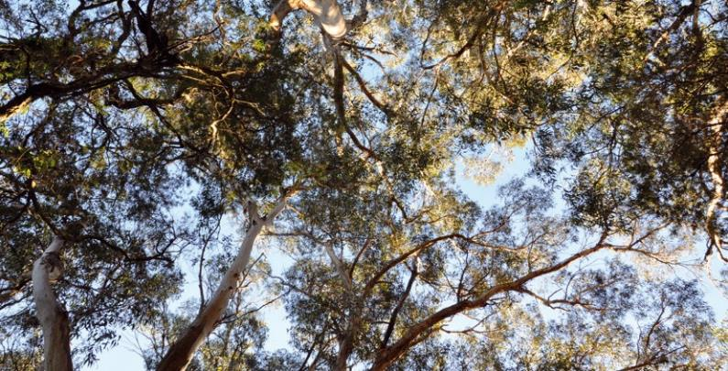

BIO585.0617

**environment**.gov.au