How do I submit a new lodgement?

This task card demonstrates how to submit a lodgement for Approved Arrangement Class 14.4 rural tailgate and external container inspection outcomes in the Biosecurity Portal.

*NOTE: Refer to “How do I login to the Biosecurity Portal?” on how to register and login to the Portal.*

*NOTE: The Portal works best with the latest version of Google Chrome, Safari and Microsoft Edge. Internet Explorer and Mozilla Firefox are not supported.*

*You must allow pop-ups on your browser before proceeding.*

New lodgement

Biosecurity Portal Landing Page

**Browse** to the Biosecurity Portal landing page – https://biosecurity.awe.gov.au/

Login using your myGovID digital identity. If you have not registered, refer to “How do I register to use the Biosecurity Portal?” task card.

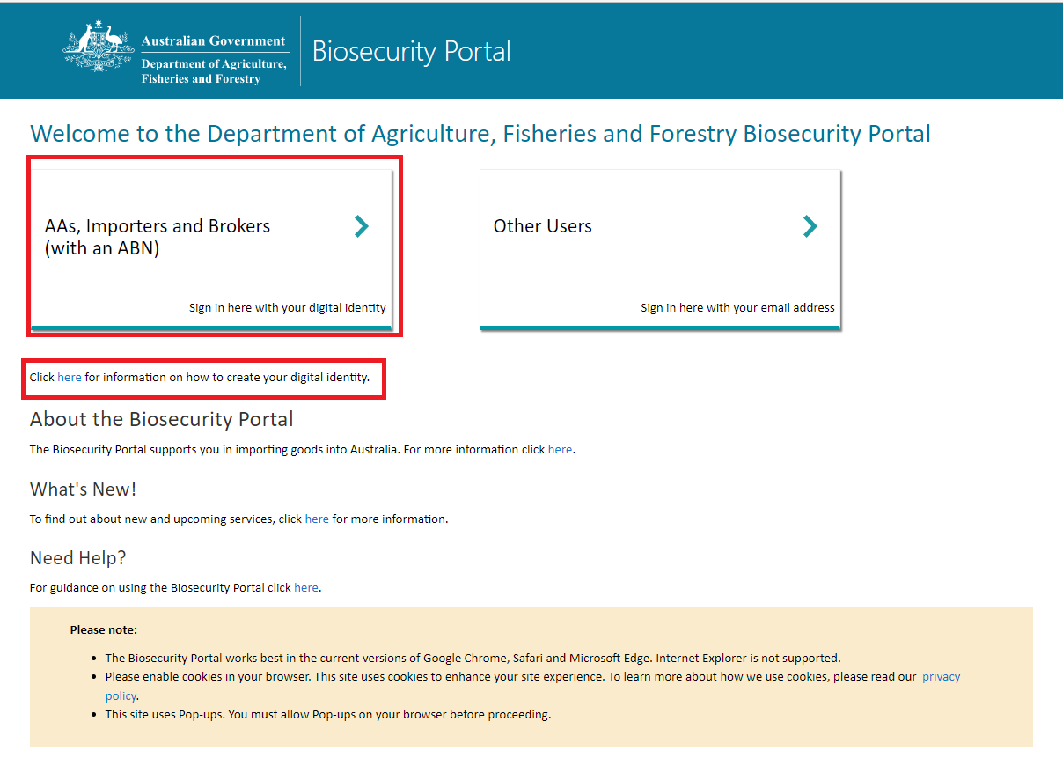

Figure 1: Biosecurity Portal Landing Page

Biosecurity Portal Home Page

Select **Approved Arrangement outcomes.**

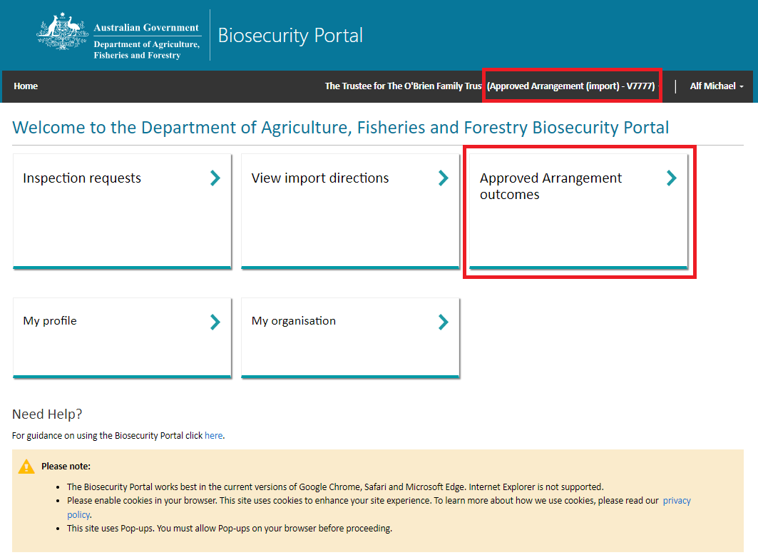

Figure 2: Biosecurity Portal Home Page

*Note: This tile will only be visible if you are logged in as an Approved Arrangement. Refer to “How do I set up my organisation profile in the Biosecurity Portal?”*

Select **Class 14.4 inspection outcomes**

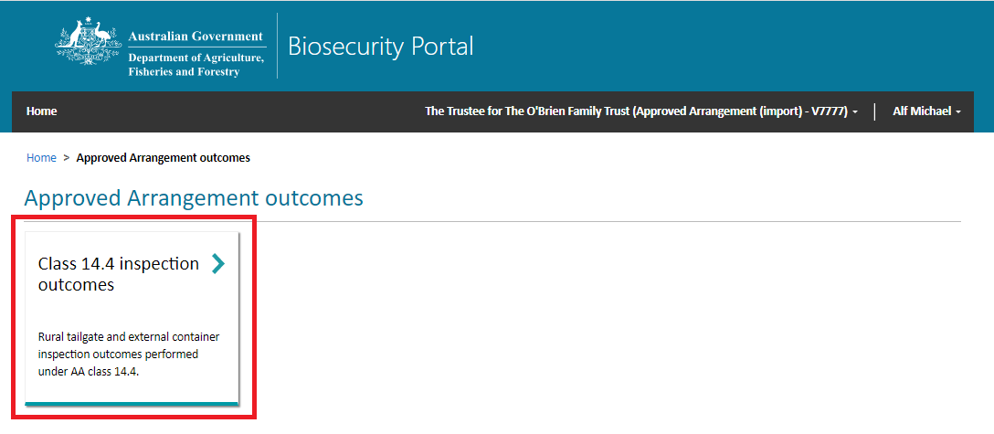

Figure 3: Approved Arrangement outcomes

Entry Id

Select an **Entry ID** or use the search option to find your Entry ID.

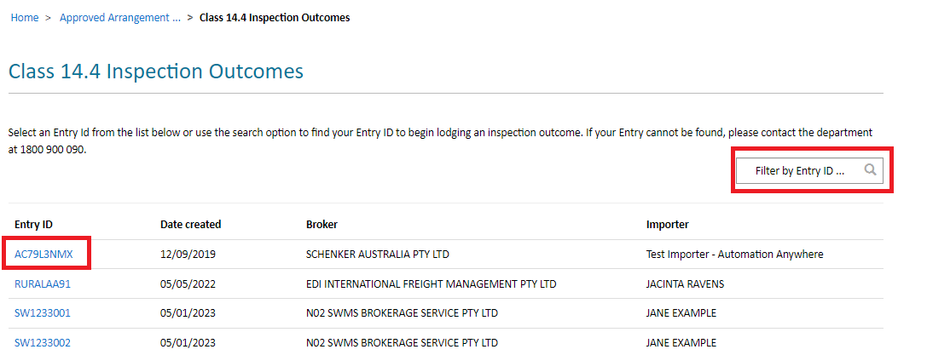

Figure 4: Select an Entry Id to view lines

*Note: Only active Entry IDs with an open direction ie: AA Rural Tailgate Inspection and the location specified for that direction matching your AA number in AIMS will be visible for selection.*

Outcome selection

Select the required **Line** and click **Start** to begin your outcome submission.

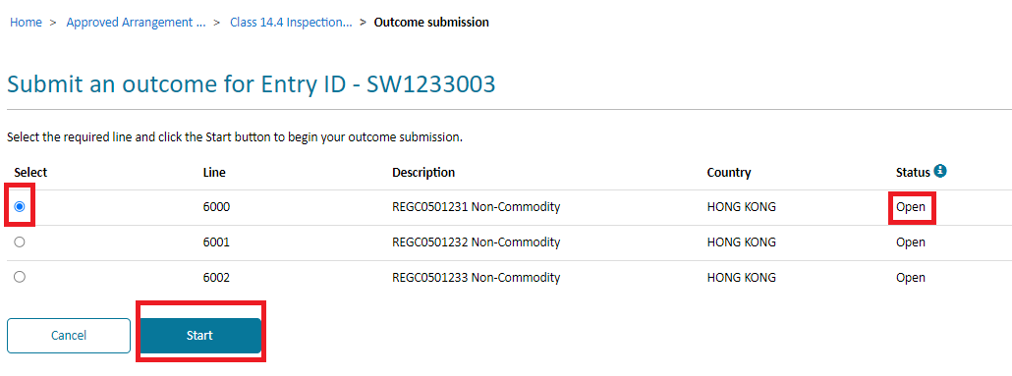

Figure 5: Select a line to commence your outcome submission

*Note: Only lines with the status of “Open” can be selected. If a line has a status of “Submitted”, an outcome for this line has already been submitted to the department.*

Completing the Outcome Form

The outcome form will display the Entry ID, Line and Container number.

The form is dynamic, with questions displayed dependant on selections made by you. For example, if you select “Nil BRM” to the Inspection outcome question then the BRM section of the form will not appear.

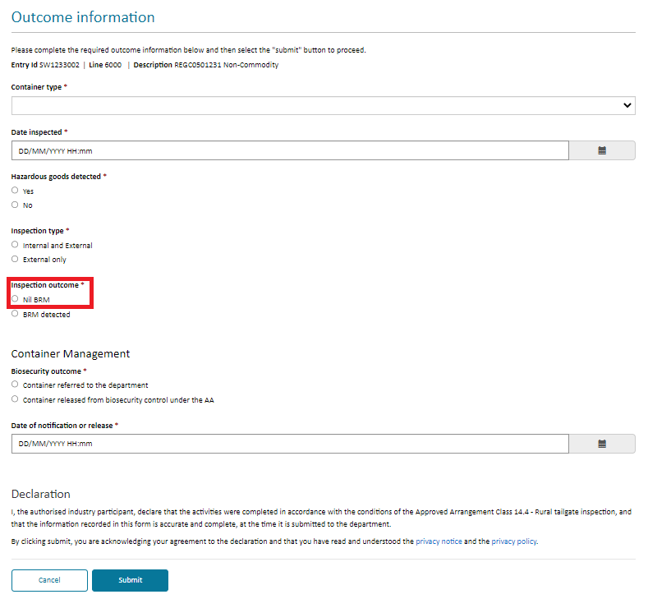

Figure 6: Outcome information – dynamic form selection

*Tip: In the Date inspected field, you can only enter a date in the past.*

If you select “BRM detected”, the BRM Details section will appear for you to record all relevant biosecurity risk material detected.

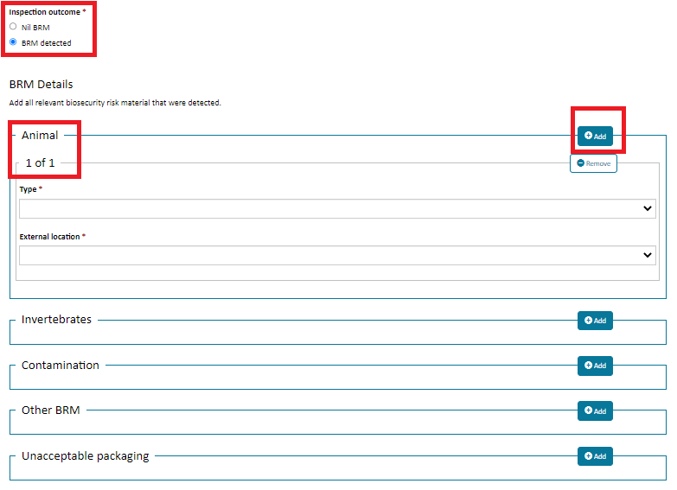

Figure 7: Outcome information – Reporting BRM detected

*Tip: You can add multiple categories to report all BRM detected by simply selecting the “Add” button for each occurrence.*

*NOTE: Mandatory questions are indicated by an Asterix (*) after the question. You must enter a response to each mandatory question, if not, you will be unable to submit the form. An error message will be displayed noting the mandatory question to be answered.*

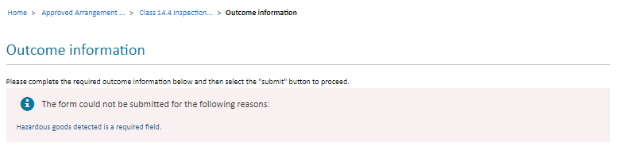

Figure 8: Outcome information – mandatory field error message

After you have completed all mandatory questions, lodge the form by clicking “Submit”. By submitting the form you are acknowledging your agreement to the declaration and that you have read and understood the privacy notice and the privacy policy. A summary page with a lodgement reference number is displayed. The summary page contains a unique reference number for each lodgement.

*NOTE: You can only submit one lodgement at a time. After clicking “Submit” select “Lodge another inspection outcome” or navigate back to the “Class 14.4 Inspections Outcomes”.*

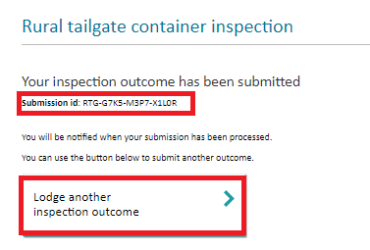

Figure 9: Outcome summary page