**Formatting guide for rice levy returns with levy payer information**

|  |  |
| --- | --- |
| **Who must lodge the levy return?** | A processor who has rice delivered for processing. |
| **Who is the levy payer for this return?** | The producer - the person who owns the rice immediately after it is harvested. |

All levy returns for rice transactions from 1 January 2023 onwards must include levy payer information in addition to information required under Schedule 32 of the Primary Industries Levies and Charges Collection Regulations 1991 (PILCC Regulations).

An upload file will be required from 1 January 2023 by Levies Online as part of your levy return. The upload file is required to calculate the levy amount payable and record levy payer information for each levy payer. The file must capture levy payer information in accordance with subregulation 10(4B) of the PILCC Regulations.

The upload file must be completed in a particular way to allow the Levies Online to capture information and calculate levy amount correctly. You can use the upload template provided by the department or alternatively you can create your own report, as long as it contains the same information as per the upload template and is formatted according to the requirements identified below. Files must be a .csv file to be uploaded to Levies Online.

This formatting guide is specific to rice and provides guidance on data variations accepted by Levies Online.

Figure 1 below provides formatting requirements specific to the rice upload template. Item tag and value are specific to each commodity and enable identification of the leviable product that the levy payer is dealing with and to calculate the levy amount.

Figure 2 provides information on accepted formatting variations for levy payer information. The headers for all information in the upload template must be replicated with the exact spelling and spacing as provided by the template.

**Figure 1: formatting requirements specific to the rice upload template**

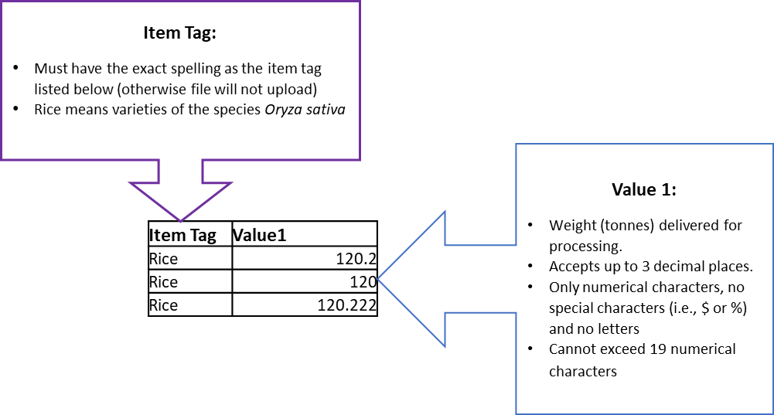

**Figure 2: formatting requirements for levy payer information**.

