|  |
| --- |
| Rice blast disease (*Magnaporthe oryzae*) |

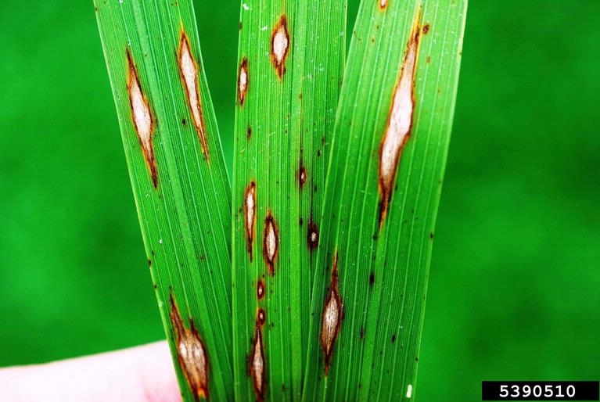

**Fig. 1** Characteristic diamond-shaped leaf lesions (known as blasts) on rice (Donald Groth, Louisiana State University AgCenter, Bugwood.org).

**Likely mode of entry**

This fungus can enter Australia in infected seed, rice straw, other grass hosts, and contaminated equipment including machinery.

**Symptoms (Figures 1–4)**

A key characteristic is oval or diamond-shaped leaf lesions (blasts) with pointed ends and greyish or white centres. On younger plants these are up to 1 cm long but on plants at flowering tend to be larger (up to 2 cm long). They may have dark green or reddish-brown margins sometimes with a yellow halo. Lesions rarely occur on the leaf sheath. Rotting leaf collars results in leaf fall, “white heads” (panicle blast) and partially filled grain. Infection of the basal node of the panicle causes “neck rot”. Infected nodes appear dark and dry, and often results in the stem breaking. Blue-grey fungal growth with spores can occur over infected tissue.

**Host range**

The major host is rice (*Oryza sativa*). Other hosts include wheat, millet, maize, and a number of grass species (Poaceae), including Italian ryegrass (*Lolium multiflorum*) and perennial ryegrass (*L. perenne*).

**Biology**

Rice blast is caused by a fungus that produces both sexual and asexual spores. The asexual stage (*Pyricularia oryzae*) produces spores from lesions on plant parts including seeds. These asexual spores are the most common type produced in the growing season; they become airborne and when deposited on other plants germinate to cause new infections. This cycle can occur many times in a growing season. Disease is promoted by moderate temperatures (25⁰C) and moist conditions, readily attainable in flooded rice fields. Sexual spores contribute to the seasonal carryover of the disease and to the development of new strains.

Rice blast is considered the most important disease of rice worldwide. The closely related and morphologically indistinguishable fungus *Magnaporthe grisea* has been recorded on several grass species throughout Australia.

**Distribution**

Present in Africa, Europe, Asia, North and South America, and islands in the Pacific Ocean. Strains of the pathogen have been recorded in Western Australia, the Northern Territory and Queensland, but it remains absent from the main rice growing regions of southeastern Australia.

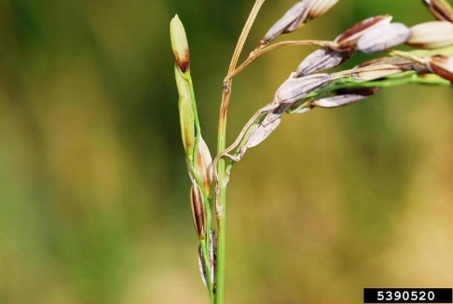

**Fig. 2** Rice head showing symptoms of panicle blast infections (Donald Groth, Louisiana State University AgCenter, Bugwood.org).

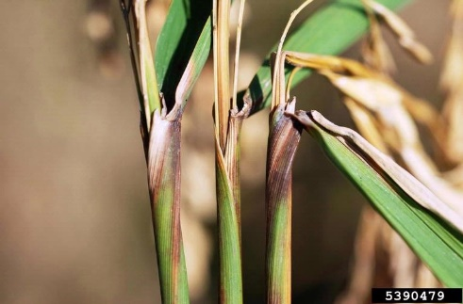

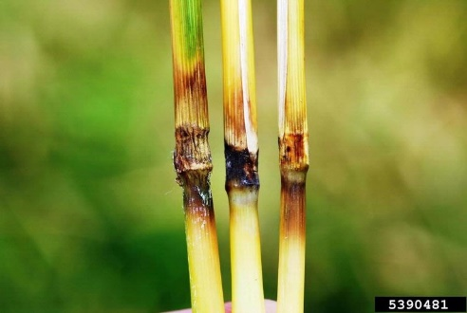

**What to do if you find suspect rice blast disease**

**Department officers:** Contain the risk, collect plant specimens double-bagged into zip-lock plastic bags and deliver to a department plant pathologist immediately.

**Industry and the public:** **SEE. SECURE. REPORT.**

Secure the goods to limit movement and immediately report your detection to the Department of Agriculture, Fisheries and Forestry on **1800 798 636**.

**Fig. 4** Rice stem nodes symptomatic of infection with rice blast pathogen (Donald Groth, Louisiana State University AgCenter, Bugwood.org).

**Fig. 3** Rice flag leaf collars exhibiting “collar rot” from infection with rice blast disease (Donald Groth, Louisiana State University AgCenter, Bugwood.org).