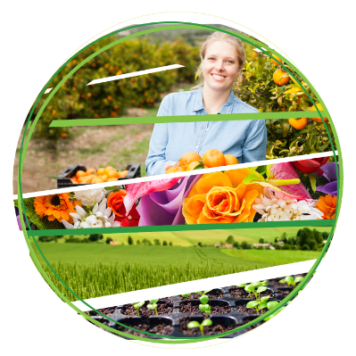

Revised import conditions for *Candidatus*

Liberibacter solanacearum (CaLso)

associated with apiaceous seed for planting

November 2021

Key points

* Effective 1 December 2021, specific measures for ‘*Candidatus* Liberibacter solanacearum’ (CaLso) on apiaceous seed for planting will be removed from carrot, celery/celeriac, chervil, fennel, parsley, and parsnip seed for planting.
* The need for a polymerase Chain Reaction (PCR) test or hot water treatment (HWT) will end.
* For tissue cultures, conditions will remain unchanged, should trade occur.

Background

CaLso was first reported affecting carrot production in Europe in 2010, a period of expansion in its distribution and reported host range followed, and the bacterium was reported as associated with the seed of several apiaceous species and claimed to be seed transmitted in carrot in 2014 (See Table 1 and Figure 1 for details).

In response, the Department of Agriculture, Water and the Environment implemented emergency measures in 2014 and early 2017. In 2017, the *Final pest risk analysis for* Candidatus *Liberibacter solanacearum associated with apiaceous crops* was also released. It recommended pest risk management measures (replacing emergency measures) for CaLso on seeds for planting and tissue cultures of 6 apiaceous species (*Anthriscus cerefolium*—chervil, *Apium graveolens*—celery, *Daucus carota*—carrot, *Foeniculum vulgare*—fennel, *Pastinaca sativa*—parsnip and *Petroselinum crispum*—parsley). In 2021, this policy was adopted in the ‘*Final review of import conditions for apiaceous vegetable seeds for sowing*’, noting at the time further consideration was required.

The department continually monitors relevant science and other information, and import conditions are revised when technically justified. Significant new scientific research has become available since the release of both policies that demonstrates that seed transmission of CaLso does not occur in apiaceous species. The department has therefore reconsidered the technical justification for the current measures applied for CaLso on apiaceous seed for planting.

Appraisal

Key evidence **for** retaining measures included

* CaLso is reported to significantly affect several apiaceous field crops: carrot (Munyaneza et al. 2010), celery/celeriac (Teresani et al. 2014), chervil, fennel, parsley and parsnip (Hajri et al. 2017) (See Figure 1).
* CaLso is reported, including using PCR-based diagnostic techniques, to be associated with the seed of these apiaceous species (Ilardi, Di Nicola & Tavazza 2016; Ministry for Primary Industries 2017; Monger & Jeffries 2016, 2018).
* CaLso seed-to-progeny (vertical) transmission was claimed for carrot (Bertolini et al. 2015).

Effectively, this evidence provided the technical justification for the recommended measures for CaLso on apiaceous seed for planting finalised in 2017 and adopted in later policy.

Key evidence **against** retaining measures included

* CaLso association with host crops in-field and with the seed of these species is upheld, the weight of evidence is that CaLso is not vertically or horizontally transmitted through or by the seed of these 6 apiaceous species:
  + Vertical (plant-seed-progeny) transmission of CaLso cannot be replicated in recent research:
    - since the original claim was made for seed transmission in carrot (Bertolini et al. 2015), this result has not been replicated in multiple independent trials/studies (Fujikawa et al. 2020; Haapalainen et al. 2020; Haapalainen et al. 2018; Loiseau et al. 2017a; Loiseau et al. 2017b; Mawassi et al. 2018; Monger & Jeffries 2018), and vertical transmission of CaLso has not been reported in any other species. Reported research includes additional research undertaken by a co-author of the original study (Loiseau et al. 2017a).
    - research demonstrates that although CaLso is detectable in seed it is non-viable (Loiseau et al. 2017a).
  + Results of independent research commissioned by the department (Kelly et al. 2021) assessing CaLso transmission through carrot seed is also consistent with these results; CaLso bacterial cells were found to be non-viable and vertical transmission was not observed.
* An introduced psyllid species (*Bactericera cockerelli*) known to transmit CaLso associated with solanaceous hosts is present in Australia (WA). However, even if CaLso were hypothetically considered to be vertically transmitted, this psyllid species is (i) not known to naturally associate with the 6 apiaceous host plant species or (ii) transmit the CaLso strains (‘haplotypes’) that infect apiaceous species.
* Australian psyllid species are not known to transmit CaLso, and *Trioza* psyllids that are present are not known to naturally feed on these apiaceous species.
* No secondary (horizontal) transmission pathways are known for CaLso to infect a host, possibly because it is unlikely to remain viable and persist in the external environment.
  + Considering the biology of CaLso as an obligate resident of plant phloem and insect alimentary tract, its existence is effectively limited to that of its host plant and psyllid vector environments.
  + Seed maturation processes are expected to result in loss of the connection with the vasculature system and limit CaLso access to phloem assimilates. During maturation seed desiccation also occurs. Conditions within mature seed are unlikely to be conducive to CaLso survival and persistence, and may well explain the empirical observations that CaLso is non-viable in mature seed and not vertically transmitted.
  + If CaLso were present as a contaminant on the seed surface, conditions are also unlikely to be conducive for its survival and persistence.
  + CaLso is not known to be mechanically transmitted by contact, or dispersed by wind or rain splash.
  + CaLso is not known to survive and persist in soil or water environments.

Conclusion

The department has re-appraised the risk posed by CaLso on the apiaceous seed for planting pathway. Based on the now available scientific research for CaLso and the 6 apiaceous species that were regulated (Table 1), it is concluded that:

* in-field (crop) association is **upheld**
* seed association is **upheld**
* seed (vertical and horizontal) transmission is **not upheld.**

Consequently, there is no technical justification for retaining the current measures for CaLso on apiaceous seed for planting.

Removing these measures for CaLso on this pathway will:

* ensure an appropriate level of protection (ALOP) for Australia is maintained, with the least trade restrictive measures
* be consistent with Australia’s rights and obligations under the SPS Agreement.

CaLso will remain as a quarantine pest for Australia, and be regulated on other propagative pathways, as appropriate.

Should new science or other relevant information become available at any time, the department will take this into consideration and take appropriate action.

Keep informed

Subscribe to Biosecurity Risk Analysis Plant via our online [subscription](https://subscribe.agriculture.gov.au/subscribe) service to receive notices about plant biosecurity policies.

Table 1. Chronology of reported evidence for CaLso association with apiaceous species and phytosanitary regulatory actions

| **Year** | **Host (observed)** | **Claimed seed association** | **Evidence** | **Reference** | **Action(s)** |
| --- | --- | --- | --- | --- | --- |
| 2010 | Carrot (in-field) |  | * First report (Finland) of CaLso suspected impact on carrot crops based on visual symptoms and psyllid presence. | Munyaneza et al. (2010) | - |
| 2012 | Carrot (in-field) |  | * First reports (Norway, Sweden, and mainland Spain) of CaLso suspected impact on carrot crops based on visual symptoms and psyllid presence. | (Munyaneza et al. 2012a; Munyaneza et al. 2012b) | - |
| 2014 | Carrot (experimental) | Seedborne  **Seed transmitted** | * May: CaLso detected in carrot seed based on PCR. Claimed CaLso was viable in carrot seed and vertically transmitted to progeny. | Bertolini et al. (2015)* | Emergency measures implemented (October 2014) on   * carrot seed for planting * carrot tissue cultures |
|  | Celery (in-field) |  | * July: First report of CaLso impact on celery crops based on visual symptoms, PCR, and electron microscopy of celery plant tissues. | Teresani et al. (2014) |  |
|  | Carrot (in-field) |  | * July: First report (Morocco) of CaLso on carrot * First report (France) of CaLso on carrot. | (Loiseau et al. 2014; Tahzima et al. 2014) |  |
| 2015 | Carrot (in-field) |  | * First report (Germany) of CaLso associated with psyllid-infested carrots. | Munyaneza et al. (2015) | - |
| 2016 | Carrot (seed) | Seedborne | * First report (Italy) of CaLso on carrot seed. | Ilardi, Di Nicola and Tavazza (2016) | - |
|  | Parsley (seed) | Seedborne | * First report (United Kingdom) of CaLso in parsley seed * CaLso was detected in parsley seed by PCR. | Monger and Jeffries (2016) |  |
|  | Carrot (in-field) |  | * First report (Morocco) of CaLso associated with psyllid-*Bactericera trigonica* on carrots. | Tahzima et al. (2017)* |  |
| 2017 | Carrot (experimental)  Celery/Celeriac (in-field)  Chervil (in-field)  Fennel (in-field)  Parsley (in-field)  Parsnip (in-field) |  | * May: PCR based detection of CaLso in carrot, celery/celeriac, chervil, fennel, parsley, and parsnip crops. | Hajri et al. (2017) and Loiseau et al. (2017a) | Emergency measures (April 2017) extended to   * celery/celeriac, parsley, and parsnip seed for planting * chervil, fennel, parsley, and parsnip tissue cultures.   Final pest risk analysis published (September 2017) and measures retained on   * carrot, celery/celeriac, chervil, fennel, parsley, and parsnip seed for planting. * carrot, celery/celeriac, chervil, fennel, parsley, and parsnip tissue cultures. |
|  | Carrot (experimental) | Seedborne  **Not seed transmitted** | * No seed transmission was observed. | Oishi et al. (2017) |  |
|  | Carrot (experimental) | Seedborne  **Not seed transmitted** | * June: No seed transmission was observed. | Loiseau et al. (2017b) |  |
|  | Carrot (experimental) | Seedborne  **Not seed transmitted** | * December: No seed transmission was observed. | Loiseau et al. (2017a) |  |
|  | Fennel (seed) | Seedborne | * July: CaLso was detected in fennel seeds originating from the Netherlands at the New Zealand border. * August: CaLso was detected in fennel seeds traded through Australia at the New Zealand border. | Ministry for Primary Industries (2017) |  |
|  | Celery/Celeriac (seed) | Seedborne | * September: The first finding of CaLso in celeriac seed. * CaLso was detected by real time PCR. | Monger and Jeffries (2018) * |  |
|  | Parsley (seed) | Seedborne | * September: CaLso was detected in parsley by real time PCR. | Monger and Jeffries (2018) * |  |
|  | Parsnip (seed) | Seedborne | * September: CaLso was detected in parsnip by real time PCR. | Monger and Jeffries (2018) * |  |
|  | Carrot (seed) | Seedborne  **Not seed transmitted** | * No seed transmission was observed. | Monger and Jeffries (2018) * |  |
| 2018 | Carrot (experimental) | Seedborne  **Not seed transmitted** | * CaLso was detected in carrot seed. * No seed transmission was observed. | Mawassi et al. (2018) | - |
|  | Carrot (experimental) | Seedborne  **Not seed transmitted** | * CaLso was detected in carrot seed. * No seed transmission was observed. | Haapalainen et al. (2018) | - |
| 2020 | Carrot (experimental) | Seedborne  **Not seed transmitted** | * CaLso was detected in carrot seed. * No seed transmission was observed. | (Fujikawa et al. 2020; Nissinen et al. 2021)* | - |
| 2021 | Carrot (experimental) | Seedborne  **Not seed transmitted** | * CaLso was non-viable in carrot seeds. * No seed transmission was observed. | DAWE commissioned research: Kelly et al. 2021 (unpublished) | - |

*Paper was published online in the previous year

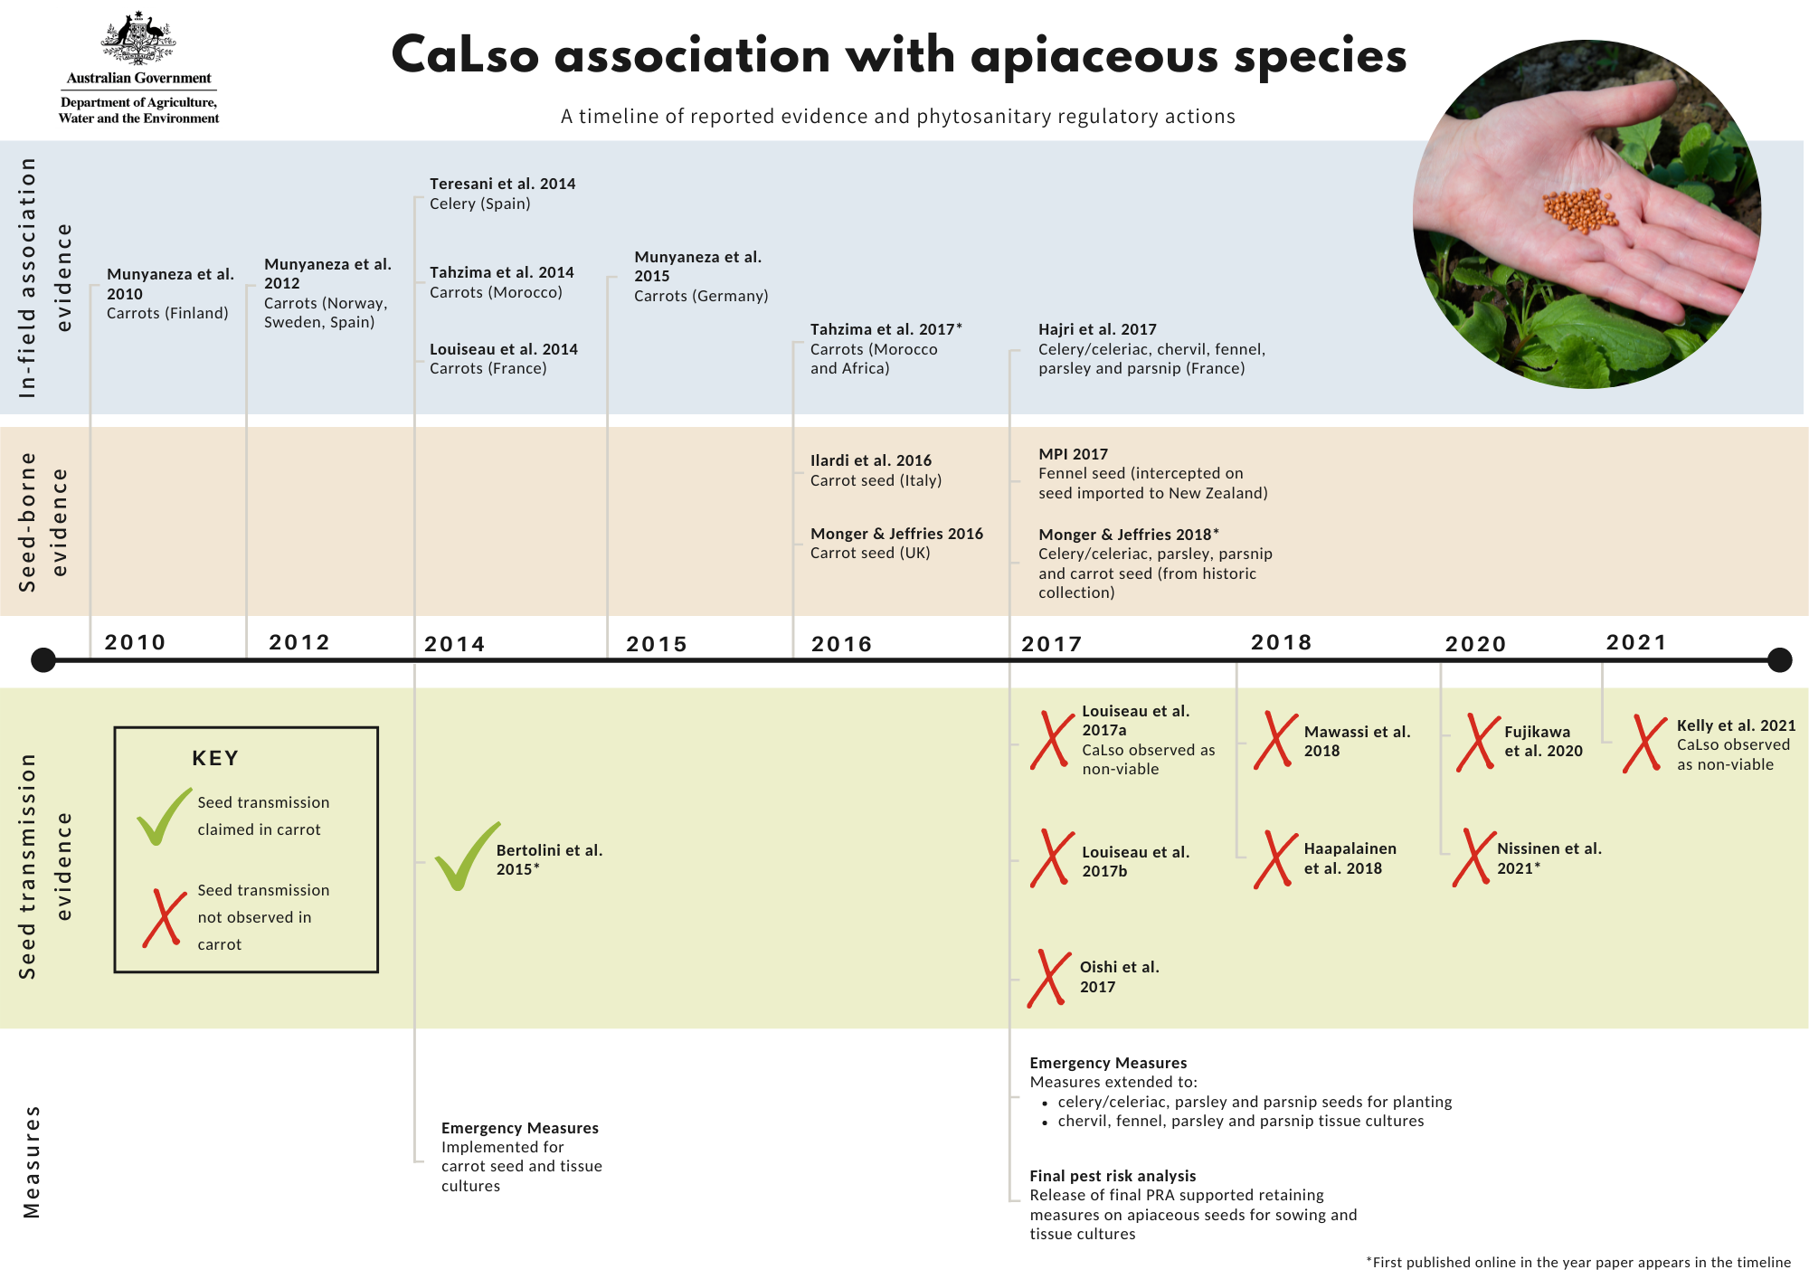

Figure 1. Timeline

Bibliography

Bertolini, E, Teresani, GR, Loiseau, M, Tanaka, FAO, Barbé, S, Martínez, C, Gentit, N, López, MM & Cambra, M 2015, ‘Transmission of '*Candidatus* Liberibacter solanacearum' in carrot seeds’, *Plant Pathology*, vol. 64, pp. 276-85.

Fujikawa, T, Yamamura, K, Osaki, K, Onozuka, N, Taguchi, M, Sasaki, A & Sato, M 2020, ‘Seed transmission of '*Candidatus* Liberibacter solanacearum' is unlikely in carrot’, *Journal of General Plant Pathology*, vol. 86, pp. 266-73.

Haapalainen, M, Latvala, S, Wickström, A, Wang, JH, Pirhonen, M & Nissinen, AI 2020, ‘A novel haplotype of '*Candidatus* Liberibacter solanacearum' found in Apiaceae and Polygonaceae family plants’, *European Journal of Plant Pathology*, vol. 156, pp. 413-23.

Haapalainen, M, Wang, J, Latvala, S, Lehtonen, MT, Pirhonen, M & Nissinen, AI 2018, ‘Genetic variation of '*Candidatus* Liberibacter solanacearum' haplotype C and identification of a novel haplotype from *Trioza urticae* and stinging nettle’, *Phytopathology*, vol. 108, no. 8, pp. 925-34.

Hajri, A, Loiseau, M, Cousseau-Suhard, P, Renaudin, I & Gentit, P 2017, ‘Genetic characterization of '*Candidatus* Liberibacter solanacearum' haplotypes associated with apiaceous crops in France’, *Plant Disease*, vol. 101, no. 8, pp. 1383-90.

Ilardi, V, Di Nicola, E & Tavazza, M 2016, ‘First report of *Candidatus* Liberibacter solanacearum in commercial carrot seeds in Italy’, *Journal of Plant Pathology*, vol. 98, no. 2, p. 374.

Kelly, G, Mann, R, Nogarotto, E, Timblin, D, Miyazaki, J, Perera, S, Chahal, S Lovelock, D, & Constable, F, 2021 'Transmission test of ‘Candidatus Liberibacter solanacearum’ by carrot seed Final Project Report' AgVic Research

Loiseau, M, Garnier, S, Boirin, V, Merieau, M, Leguay, A, Renaudin, I, Renvoisé, JP & Gentit, P 2014, ‘First report of *Candidatus* liberibacter solanacearum in carrot in France’, *Plant Disease*, vol. 98, p. 839.

Loiseau, M, Renaudin, I, Cousseau-Suhard, P, Lucas, P, Forveille, A & Gentit, P 2017a, ‘Lack of evidence of vertical transmission of *Candidatus* Liberibacter solanacearum by carrot seeds suggests that seed is not a major transmission pathway’, *Plant Disease*, vol. 101, no. 12, pp. 2104-9.

Loiseau, M, Renaudin, I, Cousseau-Suhard, P, Poliakoff, F & Gentit, P 2017b, ‘Transmission tests of ‘*Candidatus Liberibacter solanacearum*’ by carrot seeds’, paper presented at International Symposium on Carrot and Other Apiaceae, *Acta Horticulture* (ISHS) 1153: 41-46, France, September 17, 2014.

Mawassi, M, Dror, O, Bar-Joseph, M, Piasezky, A, Sjölund, JM, Levitzky, N, Shoshana, N, Meslenin, L, Haviv, S, Porat, C, Katsir, L, Kontsedalov, S, Ghanim, M, Zelinger-Reichert, E, Arnsdorf, YM, Gera, A & Bahar, O 2018, ‘'*Candidatus* Liberibacter solanacearum' is tightly associated with carrot yellows symptoms in Israel and transmitted by the prevalent psyllid vector *Bactericera trigonica*’, *Phytopathology*, vol. 108, pp. 1056-66.

Ministry for Primary Industries 2017, *Interception of 'Candidatus Liberibacter solancearum' haplotype D on an Australian consignment of fennel seeds*, Growing and Protecting New Zealand.

Monger, WA & Jeffries, CJ 2016, ‘First report of *Candidatus* Liberibacter solanacearum in parsley (*Petroselinum crispum*) seed’, *New Disease Reports*, vol. 34, p. 31.

-- -- 2018, ‘A survey of ‘*Candidatus* Liberibacter solanacearum’in historical seed from collections of carrot and related Apiaceae species’, *European Journal of Plant Pathology*, vol. 150, no. 3, pp. 803-15.

Munyaneza, JE, Fisher, TW, Sengoda, VG, F., GS, A., N & Lemmetty, A 2010, ‘First report of *Candidatus* Liberibacter solanacearum associated with psyllid-affected carrots in Europe’, *Plant Disease*, vol. 94, no. 5, p. 639.

Munyaneza, JE, Sengoda, VG, Stegmark, R, Arvidsson, AK, Anderbrant, O, Yuvaraj, JK, Rämert, B & Nissinen, A 2012a, ‘First report of "*Candidatus* Liberibacter solanacearum" associated with psyllid-affected carrots in Sweden’, *Plant Disease*, vol. 96, no. 3, pp. 453-.

Munyaneza, JE, Sengoda, VG, Sundheim, L & Meadow, R 2012b, ‘First report of "*Candidatus* Liberibacter solanacearum" associated with psyllid-affected carrots in Norway’, *Plant Disease*, vol. 96, no. 3, pp. 454-.

Munyaneza, JE, Swisher, KD, Hommes, M, Willhauck, A, Buck, H & Meadow, R 2015, ‘First report of '*Candidatus* Liberibacter solanacearum' associated with psyllid-infested carrots in Germany’, *Plant Disease*, vol. 99, no. 9, p. 1269.

Nissinen, AI, Haapalainen, M, Ojanen, H, Pirhonen, M & Jauhiainen, L 2021, ‘Spreading of *Trioza apicalis* and development of “*Candidatus* Liberibacter solanacearum” infection on carrot in the field conditions’, *Annals of Applied Biology*, vol. 178, pp. 39-50.

Oishi, M, Hoshino, S, Fujiwara, Y, Ushiki, S, Kobayashi, Y & Namba, I 2017, ‘A comparison of protocols to detect *Candidatus* Liberibacter solanacearum from carrot seeds, research on the effectiveness of Propidium monoazide treatment and evaluation of seed transmission in carrot seeds’ (in Japanese), *Research Bulletin of the Plant Protection Service, Japan*, vol. 53, pp. 111-7.

Tahzima, R, Maes, M, Achbani, EH, Swisher, KD, Munyaneza, JE & De Jonghe, K 2014, ‘First report of *Candidatus* Liberibacter solanacearum on carrot in Africa’, *Plant Disease*, vol. 98, no. 10, available at <https://doi.org/10.1094/PDIS-05-14-0509-PDN>.

Tahzima, R, Massart, S, Achbani, EH, Munyaneza, JE & Ouvrard, D 2017, ‘First report of *Candidatus* Liberibacter solanacearum associated with the psyllid *Bactericera trigonica* Hodkinson on carrots in Northern Africa’, *Plant Disease*, vol. 101, no. 1, available at <https://doi.org/10.1094/PDIS-07-16-0964-PDN>.

Teresani, GR, Bertolini, E, Alfaro-Fernandez, A, Martínez, C, Tanaka, FA, Kitajima, E, Rosello, M, Sanjuan, S, Ferrandiz, JC, López, MM, Cambra, M & Font-San-Ambrosio, MI 2014, ‘Association of *Candidatus* liberibacter solanacearum with a vegetative disorder of celery in Spain and development of a real-time PCR method for its detection’, *Phytopathology*, vol. 104, pp. 804-11.