April 2024

# Requesting Assessment Outside Business Hours – Request Form Trouble Shooting

This is a guide to help identify whether the using correct version of the “Request for Assessment Outside Business Hours” form is being used & whether the form has been completed correctly.

## Suggested errors to check for

## Check the version of the form.

## Check Adobe Acrobat reader (PDF reader) usage.

## Check time field on the request form.

## Check completion of Section D.

## Check for multiple attachments per email.

## Check mandatory field completion.

## Check submission method.

## Trickier troubleshooting.

## 1. Check the version of the form.

The top right corner displays the version number & date. Biosecurity Industry Participants must use the most recent version available on the website. At time of publication, this is ‘AGR021.0224’ dated on or after ‘February 2024’.

Solution: Biosecurity Industry Participants must download the most recent version of the form from the website.

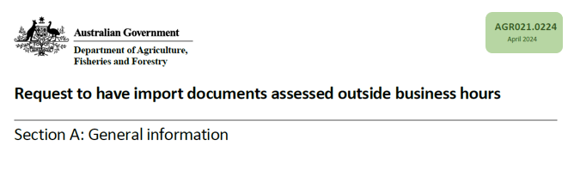

## 2. Check Adobe Acrobat reader (PDF reader) usage.

## Biosecurity Industry Participants must use a PDF reader (the department recommends Adobe Acrobat reader) to complete the form.

## If a PDF reader is used, the mandatory fields will appear outlined in red (see below).

## If a PDF reader is not used, the red outlines will not appear (see below). This generally indicates that the BIP has tried to complete the form on a web browser.

## If the form contains any handwritten fields, this indicates that the BIP has printed & scanned the form (see below).

## Solution: Biosecurity Industry Participants must open & complete the form using Adobe Acrobat reader.

## A close up of section B on the request form, showing the red highlights around the information box. This form has been correctly opened using Adobe Acrobat Reader.A close up of Section B showing no red highlights around the fields. This form has been opened incorrectly and will not be readable by our system.

## A close up of Section D showing hand written fields. This form will not be readable by our system if submitted.

## 3. Check time field on the request form.

This field is NOT mandatory & may be left blank. If left blank, the automation will default to 6.30pm for a weekday or TBA for a weekend.

There are 2 common errors:

1. Entering the time that the request was made.

2. Entering a time that falls within business hours.

## Solution: Biosecurity Industry Participants should request for assessment outside business hours at a time outside of business hours or leave the field blank.

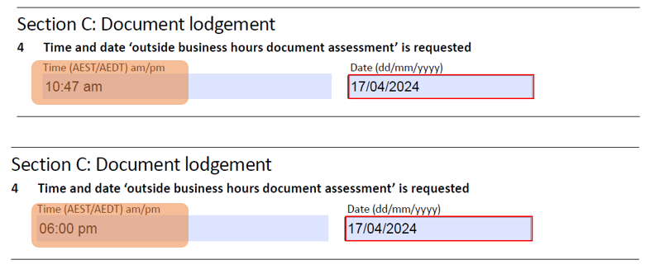

## 4. Check completion of Section D

Image 1: If required columns are left blank in Section D, the automation will identify an error.

Image 2: If the Entry Id is not known, select the radio button “Request Without Entry Number” & enter the number of entries.

**Solution:** For every row that the Biosecurity Industry Participantuses, they must complete EVERY column. Image 1

A close up of section D. Line one and two are incorrectly completed as one of the columns in each line has not been completed. This form will be rejected.
Line three is acceptable as no fields have been completed therefore it will not cause an error.



Image 2

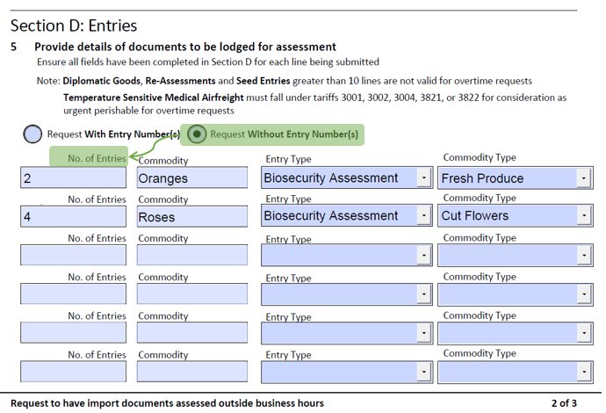

## 5. Check for multiple attachments per email.

If multiple requests for overtime requests or additional documents are attached to the email, the automation will identify an error.

**Solution**: Biosecurity Industry Participants must attach only ONE request for overtime per email. All other documents should be submitted through COLS. Additional requests for overtime must be submitted on a separate email.

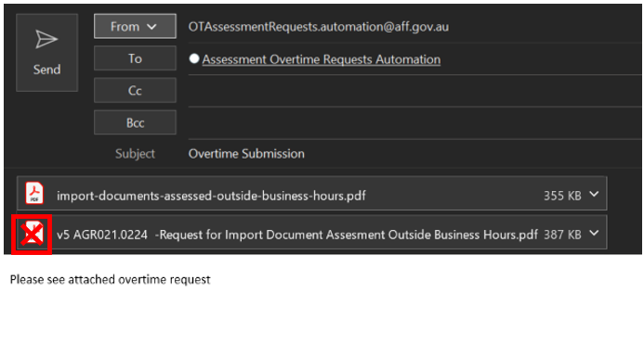

## 6. Check mandatory field completion

If any mandatory field is left blank, the submit button will alert the BIP.

If the BIP is using an incorrect version of the form or not using Adobe Acrobat reader, this feature may not work.

## Solution: All fields outlined in red MUST be completed to allow submission of the form. Biosecurity Industry Participants must open & complete the form using Adobe Acrobat reader.

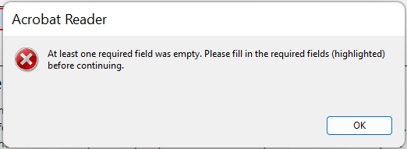

## 7. Check submission method.

If a pdf reader is used & all sections of the form are completed correctly, selecting the “submit” button will enable a prepopulated email to pop up.

**Solution**: Once the form is completed, select the ‘Submit’ button then select the ‘Send’ button on the pop-up email. Do not attach other documents to the email.

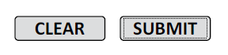

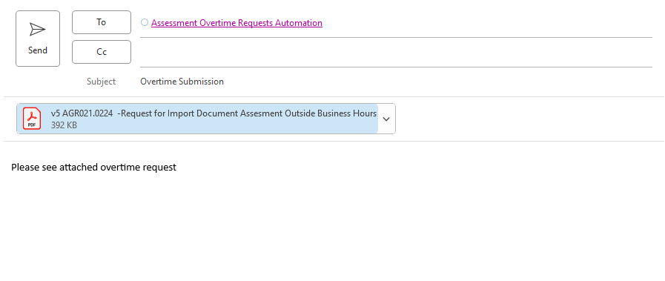

## 8. Trickier troubleshooting.

More subtle clues indicate the form has been opened in an incorrect format as described below:

When the ‘Request without entry number’ radio button is selected, the heading of the first column should change to ‘No. of Entries’. If it continues to read ‘Entry ID’, the form has been completed using a web browser.

**Solution**: Biosecurity Industry Participants must open & complete the form using Adobe Acrobat reader.

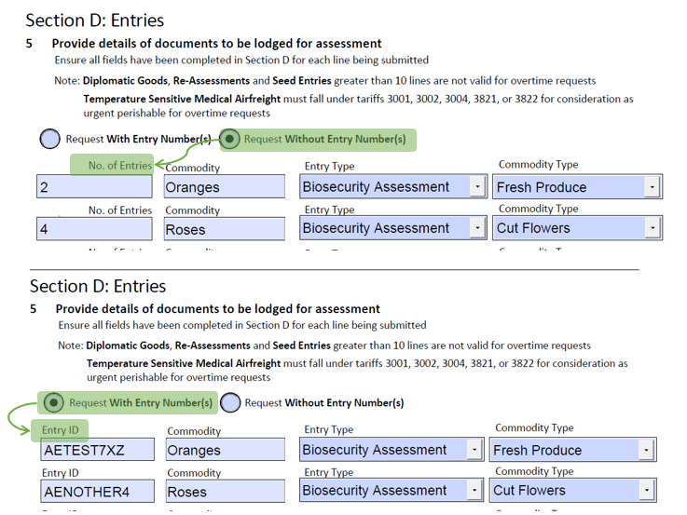

## More information

Learn more about [Documentary requirements for imported goods - DAFF (agriculture.gov.au)](https://www.agriculture.gov.au/biosecurity-trade/import/arrival/clearance-inspection/documentary-requirements)

Web [Lodgement of import documentation via email - DAFF (agriculture.gov.au)](https://www.agriculture.gov.au/biosecurity-trade/import/arrival/clearance-inspection/documentary-requirements/lodgement-import-documentation-email)

Inquiries: 1800 900 090

**Acknowledgement of Country**

We acknowledge the Traditional Custodians of Australia and their continuing connection to land and sea, waters, environment and community. We pay our respects to the Traditional Custodians of the lands we live and work on, their culture, and their Elders past and present.

© Commonwealth of Australia 2024

Unless otherwise noted, copyright (and any other intellectual property rights) in this publication is owned by the Commonwealth of Australia (referred to as the Commonwealth).

All material in this publication is licensed under a [Creative Commons Attribution 4.0 International Licence](https://creativecommons.org/licenses/by/4.0/legalcode) except content supplied by third parties, logos and the Commonwealth Coat of Arms.

The Australian Government acting through the Department of Agriculture, Fisheries and Forestry has exercised due care and skill in preparing and compiling the information and data in this publication. Notwithstanding, the Department of Agriculture, Fisheries and Forestry, its employees and advisers disclaim all liability, including liability for negligence and for any loss, damage, injury, expense or cost incurred by any person as a result of accessing, using or relying on any of the information or data in this publication to the maximum extent permitted by law.