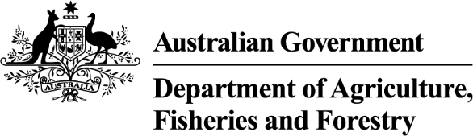
Exports work instruction

Requesting additional job functions in the Plant Exports Management System
Direction to authorised officers
This is official instructional material of the Department of Agriculture, Fisheries and Forestry (the department). Failure to comply with it may result in a breach of relevant legislation and/or the code of conduct under section 13(5) of the Public Service Act 1999.

Purpose of this document
This document details the procedure for appointed authorised officer (AO) to add more plant export AO job functions/s to their appointment using the Plant Exports Management System (PEMS).
__________________________________________________________________________________
In this document
This document contains the following topics.
Purpose of this document 1
Policy statement 1
Roles and responsibilities 1
Request additional job functions 2
Contact 7
Related material 7
Document information 7
Version history 8

Policy statement
The policy, definitions and legislation related to this work instruction can be found in the Exports Policy: Management of third party plant exports authorised officers.

Roles and responsibilities
The following table outlines the roles and responsibilities undertaken when requesting additional job functions.
Role | Responsibility
Applicant | Requesting additional job functions through PEMS.

Request additional job functions
The following table outlines how to request additional job functions.
Step | Action | Graphic
1. | Go to: https://online.agriculture.gov.au/selfservice  Note: The log in page will display.
2. | - Enter your User Login and Password.  - Check the ‘I accept the terms of use’ box.  - Click ‘Log in’.
3. | Click the ‘PEMS’ button to enter the PEMS home page. | 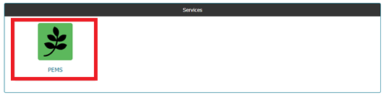
4. | Select your name in the top right corner.  Note: This will take you to your PEMS profile.
5. | Select My Application next to your Personal details section. | 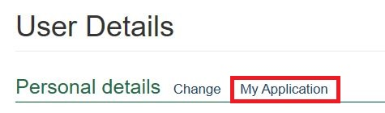
6. | - Select the Job Functions tab.  - Select the plus ‘+’ symbol next to the job function/s you wish to add.  Note: You can add up to 5 job functions per request. For each of those requests, the learning and assessment fee will apply at the time you request training, regardless of how many job functions you chose in that request.  Therefore, we recommend adding all your new job functions in the one request to avoid being charged multiple times.  If you have any issues or are unsure which job functions you require, please contact the Authorised Officer Program before adding any job functions within PEMS. | 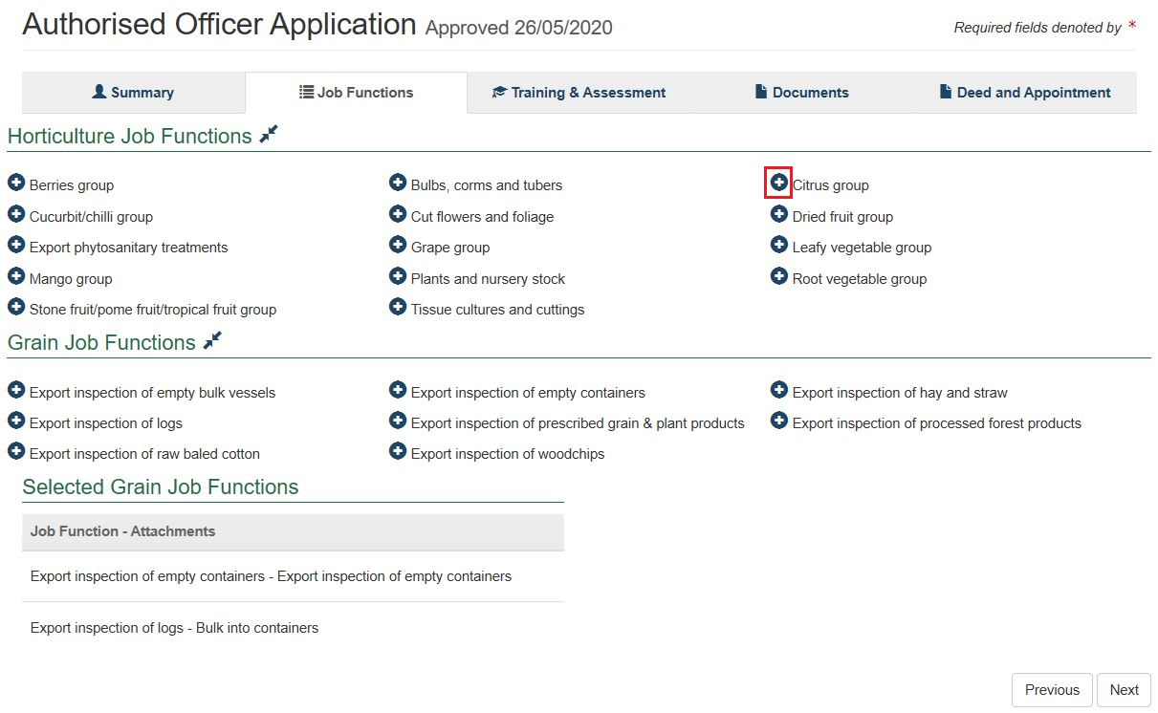
7. | - Choose a job function ‘group’ from the options, if applicable.  - Select ‘Save’.
Note: Go to Exports Work Instruction: Requesting Authorised Officer training using the Plant Exports Management System to request training in your new job function.

Contact
- Authorised Officer Program: PlantExportTraining@aff.gov.au
- Authorised Officer Hotline: 1800851305

Related material
The following related material is available online:
- Authorised Officer webpage
- Exports Policy: Management of third-party plant exports authorised officers
- Exports work instruction: Applying to become an Authorised Officer using the Plant Exports Management System
- Exports work instruction: Requesting Authorised Officer training using the Plant Exports Management System
- Exports work instruction: Requesting Authorised Officer assessment using the Plant Exports Management System
- Exports work instruction: Requesting an Authorised Officer Instrument of Appointment using the Plant Exports Management System
- Plant Exports Management System
- Plant Export Operations Manual
- Exports reference: Plant Exports Management System Authorised officer user guide
- Exports reference: Table of authorised officer job functions
- Fees and charges
- Privacy Policy

Document information
The following table contains administrative metadata.
Instructional Material Library document ID | IMLS-9-7546
Instructional material owner | Director, Authorised Officer Program
Risk rating | Low
Review period | Due for review within 4 years of the most recent approved date.

Version history
The following table details the published date and amendment details for this document.
Version | Date published | Date last approved | Review type | Summary of review
1.0 | 24/09/2020 | 24/09/2020 | New Document | First publication of this work instruction.
2.0 | 25/11/2020 | 25/11/2020 | Major Change | Added text “Go to Work Instruction: Requesting Authorised Officer training using the Plant Export Management System to request training in your new job function” to the end of the document.
3.0 | 22/04/2021 | 22/04/2021 | Major Change | Updates for the commencement of the Export Control Act 2020 and associated Export Control (Plants and Plant Products) Rules 2021.
4.0 | 03/11/2022 | 03/11/2022 | Major Change | Updated to reflect the current fees and charges.
5.0 | 28/02/2024 | 28/02/2024 | Major Change | - Updated department branding and contact information.  - Converted to new exports templates.
6 | 19/04/2024 | 19/04/2024 | Major Change | Updated screengrabs.

