# Australian and global HFC, PFC, Sulfur Hexafluoride, Nitrogen Trifluoride and Sulfuryl Fluoride Emissions

Australia’s National  
Science Agency

Bronwyn L. Dunse, Nada Derek, Paul J. Fraser, Paul B. Krummel, & L. Paul Steele,

CSIRO Oceans and Atmosphere, Climate Science Centre

June 2020

Report prepared for the Australian Government Department of Agriculture, Water and the Environment

**CSIRO Oceans and Atmosphere, Climate Science Centre**

**Citation**

Dunse, BL, Derek, N, Fraser, PJ, Krummel, PB & Steele, LP 2020. ‘Australian and global HFC, PFC, Sulfur Hexafluoride, Nitrogen Trifluoride and Sulfuryl Fluoride Emissions’. Report prepared for the Australian Government Department of Agriculture, Water and the Environment, CSIRO Oceans and Atmosphere, Climate Science Centre, Aspendale, Australia, vi, 42 p.

**Copyright**

© Commonwealth Scientific and Industrial Research Organisation 2020. To the extent permitted by law, all rights are reserved, and no part of this publication covered by copyright may be reproduced or copied in any form or by any means except with the written permission of CSIRO.

**Important disclaimer**

CSIRO advises that the information contained in this publication comprises general statements based on scientific research. The reader is advised, and needs to be aware, that such information may be incomplete or unable to be used in any specific situation. No reliance or actions must therefore be made on that information without seeking prior expert professional, scientific and technical advice. To the extent permitted by law, CSIRO (including its employees and consultants) excludes all liability to any person for any consequences, including but not limited to all losses, damages, costs, expenses and any other compensation, arising directly or indirectly from using this publication (in part or in whole) and any information or material contained in it.

CSIRO is committed to providing web accessible content wherever possible. If you are having difficulties with accessing this document please contact [csiroenquiries@csiro.au](mailto:csiroenquiries@csiro.au).

**Acknowledgments**

The authors would like to thank the Cape Grim staff for the maintenance and operation of the AGAGE (Advanced Global Atmospheric Gases Experiment) instruments at Cape Grim and for the collection of the Cape Grim Air Archive; Dr DJ Ivy (MIT USA), Dr BR Miller (SIO USA and NOAA USA), Dr DE Oram (UEA UK) and the late Mr LW, Porter (BoM) for gas chromatography-mass spectrometry analyses of the Cape Grim Air Archive; Dr AJ, Manning and Dr A Redington (UKMO) for synthetic greenhouse gas (SGG) emissions calculations (NAME-InTEM); Dr H Wang (Georgia Institute of Technology, USA) and Dr M Rigby (U. Bristol UK) for SGG emissions calculations (AGAGE 12-box model); Mr M Hunstone and Mr M Straton (Department, of Industry, Science, Energy and Resources) and Ms A Gabriel (Department of Agriculture, Water and the Environment) for SGG import and emissions data; Mr S Walsh (EPA Victoria) for Port Phillip carbon monoxide emission and concentration data; CSIRO, BoM, NASA/Massachusetts Institute of Technology, Department of Agriculture, Water and the Environment and RRA (Refrigerant Reclaim Australia) for funding in support of the Cape Grim AGAGE program.

Contents

Executive summary iv

Introduction 1

1 HFCs, PFCs, sulfur hexafluoride, nitrogen trifluoride, sulfuryl fluoride and trifluoromethyl sulfur pentafluoride measured at Cape Grim, Tasmania 3

2 Australian HFC, PFC and sulfur hexafluorid imports, banks and emissions 9

3 Australian HFC, PFC, sulfur hexafluoride and sulfuryl fluoride emissions from atmospheric data 15

3.1 HFC, sulfur hexafluoride and sulfuryl fluoride emissions 15

3.2 PFC-14 emissions 19

3.3 Other PFC emissions 23

4 Comparisons of NGA, ISC and InTEM emission estimates 24

4.1 HFC-134a 24

4.2 HFC-125 25

4.3 HFC-143a 25

4.4 HFC-32 26

4.5 HFC-152a 26

4.6 HFC-23 27

4.7 HFC-227ea 27

4.8 HFC-236fa, HFC-245fa, HFC-365mfc 28

4.9 Total HFCs 29

4.10 Sulfur hexafluoride 30

4.11 Sulfuryl fluoride 31

4.12 Total HFC, PFC and sulfur hexafluoride emissions 32

Appendix A 34

References 35

**Tables**

Table 1. Concentrations (2018, 2019) and growth rates (2018-2019) for HFCs, PFCs, sulfur hexafluoride, nitrogen trifluoride, sulfuryl fluoride and trifluoromethyl sulfur pentafluoride measured *in situ* at Cape Grim, Tasmania or on air samples collected at Cape Grim (Krummel *et al*. 2014; CSIRO unpublished Cape Grim Air Archive data). 5

Table 2. Australian HFC, PFC, sulfur hexafluoride imports (tonnes; calendar years 2018, 2019, A, Gabriel, Department of Environment and Energy, 2019); PCE = pre-charged equipment. 9

Table 3. Australian HFC, PFC and sulfur hexafluorideemissions (available from the UNFCCC website). HFC-23 emissions in 1995 from HCFC-22 production in Sydney. Note GWPs used are AR4. 13

Table 4. Australian HFC, PFC, sulfur hexafluoride and sulfuryl fluoride emissions (tonnes, 2005-2018) from atmospheric data, collected at Cape Grim, Tasmania - emissions calculated by interspecies correlation (ISC) and from the InTEM inversion model (InTEM 2019). The emissions are 3-year running averages, i.e. ‘2010’ = average of 2009, 2010, 2011 emissions. Australian HFC and sulfur hexafluoride emissions (ISC, InTEM) are scaled from regional emissions by population; GWPs (to calculate CO2-e emissions) are from the IPCC *Fourth Assessment Report* (Myre &Shindell 2013). PFC-14 emissions are the TAPM-InTEM average from Table 5. Australian PFC-116 emissions are from InTEM scaled by aluminium production; Australian PFC-218 and PFC-318 emissions are from InTEM and ISC scaled by population; Australian sulfuryl fluoride emissions are from ISC and InTEM estimates of SE Australian emissions scaled by grain production. 16

Table 5. Australian PFC-14, PFC-116, PFC-218, PFC-318 emissions (t: tonnes) and PFC-14, PFC-116 emission factors (g/t aluminium, 2005-2018) derived from atmospheric observations – remote (Portland, Pt Henry, Bell Bay) (3-yr averages, e.g. 2010 = average of 2009, 2010, 2011), using the TAPM and InTEM models, directly, at Kurri Kurri. 22

**Figures**

Figure 1. *In situ* observations of PFCs, HFCs, sulfur hexafluoride, nitrogen trifluoride, sulfuryl fluoride and trifluoromethyl sulfur pentafluoride (1998 – 2019) showing baseline monthly mean data (dark green, Medusa; purple, ADS; blue, ECD) and total data (light green, Medusa; pink, ADS; blue, ECD) obtained from the GC-MS-Medusa, GC-MS-ADS and GC-ECD (SF6) instruments at Cape Grim and from Medusa measurements at CSIRO and SIO on the Cape Grim Air Archive (orange). 2011 and 2012 nitrogen trifluoride annual means are derived from global data. 7

Figure 2. Australian HFC, PFC and sulfur hexafluoride emissions (M tonne CO2-e) in the Inventory (DISER 2020). Note the impact on the reduction in emissions due to the refurbishment of potline #1 at the Kurri Kurri aluminium smelter in 2005-2006. Dashed lines are exponential and linear best fits. 12

Figure 3. Australian HFC-32, -125, -134a, -143a, -152a, -365mfc, sulfur hexafluoride and sulfuryl fluoride emissions (NGA, orange: DISER 2020) compared to emissions calculated from Cape Grim data by interspecies correlation (ISC, blue) and from the UK Met. Office InTEM inversion model (light blue). In the ISC calculations of HFC and sulfur hexafluoride emissions, Australian emissions are scaled from Melbourne/Port Phillip emissions on a population basis (5.4, Australia/Port Phillip); for the InTEM inversions, Australian emissions are also scaled on a population basis. Also shown are Australian sulfuryl fluoride emissions from ISC and InTEM, scaled on a grain production basis. The data shown in red are emissions from the refrigerant bank (Brodribb & McCann 2015). 18

Figure 4. Monthly-mean PFC-14 concentrations observed *in situ* at Cape Grim (dark blue), 2004-2019 PFC-14 pollution episodes (light blue), typically lasting up to 12 hours in duration, are also seen at Cape Grim (Mühle *et al.* 2010). 19

Figure 5. Australian emissions of PFC-14 as recorded in the National Inventory Report 2018 (NGA: DISER 2020) and as obtained from TAPM (scaled from Vic/Tas emissions), NAME (scaled from Vic/Tas/NSW emissions) and InTEM (VextT; scaled from a domain that includes Victoria and Tasmania as well as southern and south western New South Wales and eastern South Australia) modelling. 21

Figure 6. Australian PFC-14 emission factors as reported in the National Inventory Report 2018 (NGA: DISER 2020) and as derived from atmospheric measurements at Cape Grim using TAPM/InTEM (to 2018). The grey band is the average (±1 sd) emission factor derived from TAPM/InTEM. The Kurri Kurri emission factor is based on direct PFC-14 measurements made at the Kurri Kurri smelter in 2009 (Fraser *et al.* 2013). 21

Figure 7. Australian PFC-116 emissions from the National Inventory Report 2018 (DISER, 2020) and Australian PFC-116, PFC-218 and PFC-318 from atmospheric measurements at Cape Grim using InTEM, TAPM and ISC modelling; error bars are ± sd. Australian PFC-116 (InTEM) are from the VextT domain data scaled by aluminium production, PFC-116 (TAPM) are from Australian TAPM PFC-14 emissions (Table 5) and the observed PFC-116/PFC-14 ratio (0.10±0.01) in Australian smelter plumes; PFC-218 and PFC-318 are from InTEM and ISC, with Australian emissions obtained from regional emissions by population scaling. 23

Figure 8. Australian emissions of HFCs (-125, -134a, -143a, -23) and other HFCs (-32, -152a, -227ea, -236fa, -245fa, -365mfc) estimated from atmospheric data (ISC) measured at Cape Grim, and in the Inventory (DISER 2020), expressed in units of M tonne CO2-e. 30

Figure 9. Australian and global sulfur hexafluoride imports and emissions (tonnes) from Cape Grim data using ISC and InTEM (Ganesan *et al.* 2014; Rigby *et al.* 2014) and from the Inventory (NGA: DISER 2020). 31

Figure 10. Australian sulfuryl fluoride emissions (tonnes), scaled from SE Australian emissions based on grain production, derived from Cape Grim *in situ* data, using ISC and InTEM techniques; global emissions (tonnes) are from Rigby *et al.* 2014; Rigby, unpublished data. 31

Figure 11. Australian HFC, PFC, sulfur hexafluoride emissions calculated from Cape Grim observations (ISC) and the Inventory (available at the NGA website) in M tonne CO2-e. 33

Figure 12. Global HFC, PFC, sulfur hexafluoride and nitrogen trifluoride emissions (left: k tonnes; right: M tonnes CO2-e) from global AGAGE atmospheric measurements (Rigby *et al.* 2014 and unpublished data 2019). CO2-e emission estimates use GWPs from the IPCC 4th Climate Assessment (AR4 GWPs). 33

## Executive summary

CSIRO monitors and reports annually on synthetic greenhouse gases in the background atmosphere at Cape Grim. This reporting of atmospheric concentrations, temporal trends and estimated emissions of synthetic greenhouse gases is part of the global Advanced Global Atmospheric Gases Experiment (AGAGE) program.

The SGGs covered are eleven hydrofluorocarbons or HFCs (-23, -32, -125, -134a, -143a, -152a, -227ea, -236fa, -245fa, -365mfc, -43-10mee), nine perfluorocarbons or PFCs (-14, -116, -218, -c318, -31-10, -41-12, -51-14, -61-16, -71-18), sulfur hexafluoride, nitrogen trifluoride, trifluoromethyl sulfur pentafluoride and sulfuryl fluoride.

Atmospheric concentrations measured at Cape Grim

All of the HFCs listed above, the first four PFCs listed above, sulfur hexafluoride and sulfuryl fluoride, show increasing concentrations in the background atmosphere at Cape Grim, which is consistent with global background atmospheric changes.

* Significantly increased concentrations from 2018 to 2019 are seen in HFC-134a, HFC-125, HFC-143a, HFC-32, HFC-23, PFC-14, sulfur hexafluoride and sulfuryl fluoride.
* Total HFCs are growing at 7.2% per year, total anthropogenic PFCs at 1.8% per year, sulfur hexafluoride at 3.6% per year and sulfuryl fluorideat 3.0% per year.

Global estimated emissions

Total estimated emissions of HFC, PFC, sulfur hexafluoride and nitrogen trifluoride have risen from about 30 k tonnes per year in the late-1970s to around 519 k tonnes per year in 2018 based on atmospheric concentrations measured at Cape Grim.

* Emissions decreased by 0.4% from 2017-2018, the first decrease since the early 1990s. Further data will be needed to determine if this is a sustained decline.

Australian emissions of all synthetic greenhouse gases

The *National Greenhouse Accounts (Inventory)* estimates significant Australian annual emissions of HFCs, PFCs and sulfur hexafluoride as part of Australia’s international reporting commitments under the UN Framework Convention on Climate Change.

The *Inventory* emissions calculations for HFCs have been revised using CSIRO data to calibrate leakage rates and to modify the species percentages, however there are still some differences between estimations in the *Inventory* and those estimated by CSIRO from atmospheric concentrations, which will be further investigated in the future.

* Total Australian HFC, PFC and sulfur hexafluoride emissions estimated from Cape Grim data of 77 Mt CO2-e over the period 2009-2018 are about 28% lower than the same emissions estimated in the *Inventory* (107 Mt CO2-e).
* Total Australian HFC, PFC and sulfur hexafluoride emissions estimated from Cape Grim data have declined by around 2% per year since 2005, however, the *Inventory* estimates that overall, they have grown at 6% per year since 2005.
* Average Australian HFC, PFC and sulfur hexafluoride emissions estimated from Cape Grim data in metric tonnes over the period 2009-2018 are 40% lower than those estimated in the *Inventory*.

Australian HFC emissions

Based on Cape Grim data and estimated using interspecies correlation (ISC), Australian total HFC emissions decreased in 2018-2019 by 11% from the 2017-2018 period.

* Emissions of the major HFCs decreased by 9% overall.
  + Decreases were seen in HFC-134a (15%), HFC-143a (14%), HFC-152a (22%).
  + Increases were seen in HFC-32 (19%), HFC-125 (0.2%) and HFC-23 (4%).
* Emissions of three of the minor HFCs decreased with HFC-227ea decreasing by 13%, HFC-245fa decreasing by 46% and HFC-365mfc decreasing by 46%.
  + A few episodes of HFC-43-10mee have been detected, but not enough to estimate emissions.

Australian total HFC emissions in 2018 of around 2000 tonnes (estimated using ISC) are about 62% lower than in the Inventory.

* Total HFC emissions have grown from about 1,900 tonnes in 2005 to a peak of 3,200 tonnes in 2015, dropping to around 2,000 tonnes in 2018. This may represent a stabilization in emissions.
* In climate terms, total HFC emissions in 2018 (estimated using ISC) were around 4.7 Mt CO2-e, around 60% lower than emissions provided in the Inventory of 12 Mt CO2-e.

Over the period 2005-2018, total HFC emissions in metric tonnes (estimated using ISC) are 45% lower than those in the *Inventory*.

* For the same time period and in climate terms, total HFC emissions of 91 Mt CO2-e estimated from Cape Grim data (ISC) are 38% lower than those in the *Inventory* (126 Mt CO2-e).

Australian sulfur hexafluoride and sulfuryl fluoride emissions

Over the period 2009 – 2018, Cape Grim data (ISC) indicate that sulfur hexafluoride emissions have declined overall by 50%, however the estimated *Inventory* sulfur hexafluoride emissions have increased by 56% from 2009-2018.

Over the period 2005 – 2009, Cape Grim data (ISC) indicate that sulfuryl fluoride emissions averaged 13 tonnes per year, increased to 163 tonnes in 2013 and subsequently declined to 75 tonnes [in 2018], perhaps suggesting a shift away from sulfuryl fluoride use for fumigation practices.

Australian PFC emissions

From 2009 to 2018, total PFC emissions varied from 77 - 127 tonnes per year, with emissions in 2018 estimated at 104 tonnes. Total Australian PFC emissions in the *Inventory* have declined by 33% over the same period, with 2018 emissions estimated at 30 tonnes.

PFC-14 and PFC-116 emissions from the aluminium industry have been estimated from Cape Grim data using The Air Pollution Model (TAPM).

* Annual PFC-14 emissions have averaged around 75 tonnes per year for the last 6 years. By contrast, PFC-14 emissions from the Inventory range from 20-30 tonnes per year over the same period.
* Over the period 2009-2018, total PFC-14 emissions in the *Inventory* are about 62% lower than PFC-14 emissions estimated from Cape Grim data (TAPM).
  + The fraction of Australian PFC-14 emissions seen at Cape Grim has declined significantly since the closure of the Point Henry smelter in 2014, however the 2016 increase in PFC-14 emissions is largely due to increases in emissions seen at the Bell Bay smelter. This increase isn’t seen in other estimates.
* Australian PFC-116 emissions are estimated indirectly from PFC-14 emissions (TAPM).
  + PFC-116 emissions estimated using this method averaged around 7 tonnes per year over the period 2009-2018. Over the same time period, PFC-116 emissions in the *Inventory* (assumed only from the aluminium industry) average 3.5 tonnes per year and are on average about 50% lower than PFC-116 emissions estimated from Cape Grim data (TAPM).
* PFC-218 emissions vary from 5-7 tonnes over the last 5 years, with 2018 emissions for PFC-218 estimated at about 5 tonnes using Cape Grim data (TAPM).
* PFC-318 emissions vary from 8-11 tonnes over the last 5 years using Cape Grim data (TAPM).

**This page was left blank intentionally**

## Introduction

Hydrofluorocarbons (HFCs), perfluorocarbons (PFCs), sulfur hexafluoride (SF6) and nitrogen trifluoride (NF3) are potent greenhouse gases (GHGs), collectively described as synthetic GHGs (SGGs). SGGs are covered by Australia’s emission reduction targets under the Kyoto Protocol (2013-2020) and the Paris Agreement (2021-2030). Both the Kyoto Protocol and the Paris Agreement are legally binding instruments under the United Nations Framework Convention on Climate Change (UNFCCC).

HFCs are used extensively in Australia, largely in air conditioning and refrigeration, initially as ‘ozone-friendly’ replacements for chlorofluorocarbons (CFCs) and hydrochlorofluorocarbons (HCFCs). Minor uses of HFCs in Australia are as aerosol propellants, including metered dose inhalers (MDIs), as foam blowing agents, solvents, in fire extinguishers and others.

* Increasing HFC emissions are seen as a significant driver of climate change over the next 50 years (Velders *et al.* 2007, 2009, 2012, 2014, 2015; Estrada *et al.* 2013; Harris & Wuebbles, 2014; Myhre & Shindell 2014; Rigby *et al.* 2014; Montzka & Velders 2018). The Kigali Amendment to the Montreal Protocol entered into force 1 January 2019 and mandates a phase-down schedule for HFC production and consumption. With global adherence to this Amendment, radiative forcing from HFCs is expected to reduce from 0.22-0.25 W m-2 in the baseline scenario from Velders *et al.* 2015 to 0.13 W m-2 in 2050 (Montzka & Velders 2018).

Perfluorocarbons are a by-product of the production of aluminium in Australia and overseas and, in addition, are used overseas in the electronics industry during the manufacture of integrated circuits and plasma screens. Refrigeration represents a very minor use of PFCs in Australia and overseas.

Sulfur hexafluoride is used extensively in the electricity distribution industry, both in Australia and overseas, for dielectric insulation and current interruption in circuit breakers, switchgear, and other electrical equipment, and as a cover gas in metal production, for example magnesium.

Nitrogen trifluoride is used internationally in the semi-conductor production industry, initially as a replacement for PFCs. DoEE (2019) has identified a small amount of specialty electronic components manufacturing, consuming around 20 kg of nitrogen trifluoride, which is destroyed in the process. Negligible amounts of electronics cooling fluids containing nitrogen trifluoride are consumed in Australia.

Sulfuryl fluoride (SO2F2) and trifluoromethyl sulfur pentafluoride (CF3SF5) are potent synthetic greenhouse gases that are not part of the Kyoto Protocol/Paris Agreement suite of SGGs. Sulfuryl fluoride use in Australia is growing, largely as a replacement for phosphine (PH3) in grain fumigation at the farm level and at regional grain storage locations. While global emissions have been detected at Cape Grim, it is unlikely that trifluoromethyl sulfur pentafluoride is imported into Australia.

Australia’s mandated HFC production and import phase down began on 1 January 2018 and will reach an 85% reduction in 2036. In early 2010, the Australian Government made a commitment, in light of the Kyoto Protocol/Doha Amendment, to reduce its total GHG emissions by 5 per cent below 2000 levels by 2020. GHG emission reduction targets for implementation post-2020 have been announced by the Australian government: 26%-28% reduction from 2005 emissions by 2030. This includes the commitment to phase down Australian HFC imports by 85% by 2036. There are no global or Australian targets to phase-down sulfuryl fluoride or trifluoromethyl sulfur pentafluoride emissions, as these gases are not controlled in the Kyoto Protocol, or the subsequent Paris Agreement, due to their relatively low emissions.

The Australian National Inventory reported a total of 537.4 million tonnes (Mt) CO2-e emitted from all GHG sources in 2018 (including land-use change), which was an increase from 2017 emissions (529.5 Mt) of 1.5% (DISER 2020). HFC emissions were estimated to be 11.9 Mt (11,982 k tonnes) CO2-e in 2018, 3% below 2017 emissions, while the sum of HFC, PFC and sulfur hexafluoride emissions was 12.4 Mt (12,447 k tonnes, Table 3) CO2-e, 1.6% below 2017 emissions. Although the total emission of Kyoto Protocol SGGs is only 2.3% of total Australian greenhouse gas emissions (DISER 2020) and despite the small decline from 2017 to 2018, it is the fastest growing emissions sector (on a percentage basis) in the *Australian National GHG Inventory* (referred to subsequently as the *Inventory*).

In this Report, we estimate Australian emissions of HFCs, PFCs, sulfur hexafluoride and sulfuryl fluoride derived by inter-species correlation (ISC), inverse and forward atmospheric modelling techniques, using Cape Grim atmospheric observations. These so-called ‘top-down’ estimates are compared to estimates of HFCs, PFCs and sulfur hexafluoride emissions submitted by the Australian Government to the UNFCCC (DoEE 2019), based on Intergovernmental Panel on Climate Change (IPCC)-recommended ‘bottom-up’ methodologies (modified for Australian conditions where better data is available) for estimating national GHG. Australian HFC, PFC and sulfur hexafluoride emissions are compared to global emissions estimated from AGAGE (Advanced Global Atmospheric Gases Experiment; Prinn *et al.* 2000 2018; Rigby *et al.* 2014 and updates) atmospheric observations.

Cape Grim *in situ* measurements of nitrogen trifluoride commenced in February 2015 and trifluoromethyl sulfur pentafluoride in late-2010. Preliminary inspections of the data suggest that there are no significant Australian emissions of these species.

## HFCs, PFCs, sulfur hexafluoride, nitrogen trifluoride, sulfuryl fluoride and trifluoromethyl sulfur pentafluoride measured at Cape Grim, Tasmania

Concentrations of HFCs, PFCs, sulfur hexafluoride, nitrogen trifluoride, sulfuryl fluoride and trifluoromethyl sulfur pentafluoride have been measured *in situ* in the Southern Hemisphere atmosphere at Cape Grim, Tasmania, as part of the AGAGE program (Prinn *et al.* 2000, 2018) and/or in the Cape Grim Air Archive (1978-2019) at CSIRO (Aspendale), at the Scripps Institution for Oceanography (SIO, USA), and on a sub-set of the Cape Grim Air Archive at the University of East Anglia (UEA, UK) (Fraser *et al.* 2016). Other flask air samples from Cape Grim have been analysed at CSIRO, at SIO, at UEA and at the University of Heidelberg (Germany). The SGGs have been measured by CSIRO *in situ* in the atmosphere (baseline and non-baseline) at Cape Grim, Tasmania, since the late-1990s (HFCs, PFC-116: CF3CF3) and the mid-2000s (other PFCs, sulfur hexafluoride, sulfuryl fluoride).Nitrogen trifluoride (up to 2013) and trifluromethyl sulfur pentafluoride (up to 2008) have beenmeasured on the Cape Grim Air Archive. *In situ* measurements of nitrogen trifluoride and trifluoromethyl sulfur pentafluoridehave recently become available (February 2015 for nitrogen trifluoride and recently calibrated trifluoromethyl sulfur pentafluoride going back to late 2010). These data are used, in conjunction with similar data collected from other Northern and Southern Hemispheric sites, to estimate global and regional concentration trends, atmospheric lifetimes, emissions and radiative forcings for these species:

HFCs Oram *et al*. 1996, 1998; Oram 1999; O’Doherty *et al*. 2004, 2009, 2014; Greally *et al*. 2007; Stohl *et al*. 2009; Miller *et al*. 2010; Vollmer *et al*. 2011; Arnold *et al*. 2014; Fraser *et al*. 2014a 2016; Krummel *et al*. 2014; Rigby *et al*. 2014; Fortems-Cheney *et al*. 2015; Lunt *et al*. 2015; Simmonds *et al*. 2015, 2016, 2017, 2018; Meinshausen *et al*. 2017; Leedham Elvidge *et al*. 2018; Liang *et al*. 2017; Montzka & Velders 2018; Li *et al*. 2019; Yao *et al*. 2019; Stanley *et al*. 2020

PFCs Oram 1999; Fraser *et al.* 2007, 2011, 2013, 2016; Mühle *et al.* 2010; Ivy 2012; Ivy *et al.* 2012; Laube *et al.* 2012; Oram *et al.* 2012; Kim *et al.* 2014; Krummel *et al.* 2014; Rigby *et al.* 2014; Wong *et al.* 2015; Trudinger *et al.* 2016; Meinshausen *et al.* 2017; Leedham Elvidge *et al.* 2018; Droste *et al.* 2018; Engel & Rigby 2018; Li *et al.* 2019

SF6 Maiss *et al.* 1996; Oram 1999; Fraser *et al.* 2004, 2014a, 2016; Levin *et al.* 2010; Rigby *et al.* 2010, 2014; Sturges *et al*. 2012; Ganesan *et al.* 2014; Krummel *et al.* 2014; Meinshausen *et al.* 2017; Leedham Elvidge *et al.* 2018; Engel & Rigby 2018

NF3 Weiss *et al.* 2008; Arnold *et al.* 2013; Rigby *et al.* 2014; Meinshausen *et al.* 2017

SO2F2 Mühle *et al.* 2009; Krummel *et al.* 2014; Meinshausen *et al.* 2017

CF3SF5 Sturges *et al.* 2012

The abundances and trends of HFCs, PFCs, sulfur hexafluoride, nitrogen trifluoride, sulfuryl fluoride and trifluoromethyl sulfur pentafluoride in the global background atmosphere, as measured at Cape Grim, Tasmania, or in the Cape Grim air archive, are shown in Table 1 (2018-2019) and Figure 1 (1998-2018).

The major HFC in the background atmosphere at Cape Grim (and around the globe) is HFC-134a (101.1 ppt in 2019), followed by HFC-23 (31.6 ppt), HFC-125 (27.7 ppt), HFC-143a (23.2 ppt), HFC-32 (18.1 ppt) and HFC-152a (4.8 ppt).

* The global annual rate of increase of HFC-134a has decreased from 6.2 ppt (2017-2018) to 5.5 ppt (2018-2019);
* the HFC-23 growth rate (1.21 ppt, 2017-2018) has increased slightly to 1.22 ppt (2018-2019);
* the HFC-143a annual increase (1.7 ppt, 2017-2018) has declined to 1.6 ppt (2018-2019);
* the HFC-125 annual increase (3.0 ppt, 2017-2018) has remained steady at 3.0 ppt/yr (2018-2019).
* the HFC-152a annual increase (0.0174 ppt, 2017-2018) has declined to 0.076 ppt (2018-2019);
* the HFC-32 increase (2.7 ppt, 2017-2018) has increased to 2.9 ppt (2018-2019).

The annual growth in total HFCs of 15 ppt/yr (2017-2018) has remained the same in 2018-2019. Total HFCs in the atmosphere are growing currently (2018-2019) at 7.2%/yr. Total fluorine from HFCs reached 786 ppt in 2019 and growing at 7%/yr (2018-2019).

The cumulative concentration of the minor HFCs (HFC-245fa, HFC-227ea, HFC-236fa, HFC-365mfc, HFC-4310mee) is 5.7 ppt (2019), 2.7% of the total HFC concentration in the background atmosphere (212 ppt, 2019). The minor HFCs are growing in the background atmosphere with a cumulative annual growth rate of 0.41 ppt (2018-2019).

Global HFC data have shown that the total level of HFCs in the background atmosphere is consistent with total emissions from ‘bottom-up’ inventories, but there are significant differences between atmospheric data and emissions inventories for individual HFCs.

* For HFC-134a, global emissions from atmospheric observations are seasonal (NH summer maximum, Fortems-Cheiney *et al*. 2015) and 20%-30% lower than inventory estimates of emissions (2007-2012, Fortems-Cheiney *et al*. 2015, Lunt *et al.* 2015), whereas HFC-31, HFC-125, HFC-143a global emissions are 20%-30% higher than inventory estimates (Lunt *et al*. 2015).
* The global growth rate of HFC-23 emissions slowed significantly, reaching a minimum in 2009, when resources under the Kyoto Protocol (the Clean Development Mechanism - CDM) were used to improve HCFC-22 (CHClF2) production methods and capture the co-produced but waste HFC-23. The cessation of CDM funding has resulted in global HFC-23 emissions growing again (Simmonds *et al*. 2018).

Table 1. Concentrations (2018, 2019) and growth rates (2018-2019) for HFCs, PFCs, sulfur hexafluoride, nitrogen trifluoride, sulfuryl fluoride and trifluoromethyl sulfur pentafluoride measured *in situ* at Cape Grim, Tasmania or on air samples collected at Cape Grim (Krummel *et al*. 2014; CSIRO unpublished Cape Grim Air Archive data).

|  |  |  |  |  |  |  |  |  |  |  |  |
| --- | --- | --- | --- | --- | --- | --- | --- | --- | --- | --- | --- |
| Species | Formula | Concentration | | Growth | | Species | Formula | Concentration | | Growth | |
| HFCs |  | 2018 | 2019 | ppt/yr | %/yr | PFCs |  | 2018 | 2019 | ppt/yr | %/yr |
| HFC-134a | CH2FCF3 | 95.6 | 101.1 | 5.5 | 5.6 | PFC-14 | CF4 | 84.0 | 84.9 | 0.84 | 1.0 |
| HFC-23 | CHF3 | 30.4 | 31.6 | 1.22 | 3.9 | PFC-14(a)1 | CF4 | 49.9 | 50.8 | 0.84 | 1.7 |
| HFC-143a | CH3CF3 | 21.6 | 23.2 | 1.6 | 7.2 | PFC-116 | C2F6 | 4.7 | 4.8 | 0.089 | 1.9 |
| HFC-125 | CHF2CF3 | 24.7 | 27.7 | 3.0 | 11.5 | PFC-318 | c-C4F8 | 1.6 | 1.7 | 0.069 | 4.1 |
| HFC-32 | CH2F2 | 15.2 | 18.1 | 2.9 | 17.3 | PFC-218 | C3F8 | 0.66 | 0.68 | 0.022 | 3.3 |
| HFC-152a | CH3CHF2 | 4.7 | 4.8 | 0.076 | 1.6 | PFC-5114 | C6F14 | 0.31 | 0.31 | 0.004 | 1.1 |
| HFC-245fa | CHF2CH2CF3 | 2.5 | 2.7 | 0.22 | 8.4 | PFC-3110 | C4F10 | 0.19 | 0.19 | 0.001 | 0.5 |
| HFC-227ea | CF3CHFCF3 | 1.4 | 1.5 | 0.13 | 8.9 | PFC-41122 | C5F12 | 0.12 | 0.12 | 0.0 | 0.0 |
| HFC-365mfc | CH3CF2CH2CF3 | 1.00 | 1.04 | 0.040 | 4.0 | PFC-61162 | C7F16 | 0.12 | 0.12 | 0.0 | 0.0 |
| HFC-43-10mee | C5H2F10 | 0.27 | 0.28 | 0.006 | 2.3 | PFC-71182 | C8F18 | 0.09 | 0.09 | 0.0 | 0.0 |
| HFC-236fa | CF3CH2CF3 | 0.17 | 0.19 | 0.014 | 7.6 | total PFCs |  | 91.8 | 92.9 | 1.0 | 1.1 |
| total HFCs |  | 197 | 212 | 15 | 7.2 | total PFC(a) |  | 57.7 | 58.8 | 1.0 | 1.8 |
| HFC fluorine |  | 732 | 786 | 54 | 7.1 | PFC fluorine |  | 394 | 399 | 4.7 | 1.2 |
| sulfur hexafluoride | SF6 | 9.4 | 9.7 | 0.35 | 3.6 | nitrogen trifluoride | NF3 | 1.7 | 1.9 | 0.22 | 12.0 |
| sulfuryl fluoride | SO2F2 | 2.3 | 2.4 | 0.07 | 3.0 | total fluorine |  | 1190 | 1251 | 61 | 5.0 |
| trifluoromethyl sulfur pentafluoride | CF3SF5 | 0.17 | 0.17 | -0.001 | -0.691 |  |  |  |  |  |  |

1 PFC-14 (a) = CF4 (anthropogenic) = total CF4 – natural CF4 (= 34.1 ppt, Trudinger *et al*. 2016)

2 extrapolated from 2011 data (Ivy *et al*. 2012)

3 estimated from Cape Grim and global data; assumed = 2011-2012 growth rate (Arnold *et al*. 2013)

Regional inverse studies have shown that the growing levels of HFCs in the background global atmosphere result from growing emissions from China/East Asia (Fortems-Cheiney *et al*. 2015), somewhat offset by declining HFC emissions from developed countries (USA, Europe).

HFC replacement chemicals (HFC-1234yf – CF3CFCH2, HFC-1234ze - CF3CHCHF) have been detected in urban and background atmospheres in Europe (Switzerland: Dubendorf and Jungfraujoch, Vollmer *et al*. 2015) since 2013-2014 at the sub-ppt level and have recently been measured in Cape Grim air.

The total PFC concentration in the background atmosphere at Cape Grim is 92.9 ppt (2019), currently growing at 1.0 ppt/yr (1.1%/yr). The total anthropogenic PFC concentration in the background atmosphere is 58.8 ppt growing at 1.8%/yr.

* The major PFC in the background atmosphere is PFC-14 (CF4: 84.9 ppt in 2019, about 40% of which is naturally-occurring), followed by PFC-116 (4.8 ppt), PFC-318 (1.7 ppt), PFC-218 (0.68 ppt), PFC-5114 (0.31 ppt) and PFC-3110 (0.19 ppt).
* The cumulative concentration of three minor PFCs (PFC-4112, PFC-6116, PFC-7118) observed at Cape Grim is 0.33 ppt (2019, extrapolated from 2011 data).

The annual rate of increase of PFC-14 in the atmosphere (0.84 ppt, 2017-2018) has remained steady at 0.84 ppt (2018-2019), 0.07 ppt higher than the decadal average annual increase of 0.77 ppt (2010-2019). The anthropogenic component (from aluminium production and the electronics industries) of atmospheric PFC-14 is growing at 1.7%/yr.

* The annual rate of increase of PFC-116 (CF3CF3) is 0.089 ppt (2018-2019), slightly higher than the decadal average annual increase (0.083 ppt, 2010-2019);
* the PFC-218 annual increase (0.022 ppt, 2018-2019) is higher than the decadal annual average (0.017 ppt, 2010-2019);
* the PFC-318 annual increase (0.069 ppt, 2018-2019) is higher than the decadal average annual increase (0.053 ppt, 2010-2019).
* The minor PFCs (PFC-3110, PFC-4112, PFC-5114, PFC-6116, PFC-7118) are growing in the background atmosphere with a cumulative annual growth rate likely to be of the order 0.01-0.02 ppt (2013-2019). Total fluorine from PFCs reached 399 ppt in 2019, growing at 1.2%/yr (2018-2019).

There appears to have been significant under-reporting of emissions by the semiconductor industry over the past decades and a recent under-reporting of emissions by the aluminium industry, possibly associated with the rapid growth in aluminium production in China (Kim *et al.* 2014). PFC-14 emissions have been shown to respond to economic/industrial activity, with enhanced emissions during WWII due to the demand for aluminium for aircraft, and reduced emissions during the 2009 GFC (Trudinger *et al.* 2016).

Annual mean sulfur hexafluoride levels reached 9.7 ppt in 2019 at Cape Grim, growing at 0.35 ppt/yr (3.6%/yr, 2018-2019), similar to the 2017-2018 annual average growth rate. The decadal annual average growth rate is much lower at 0.32 ppt/yr (2010-2019).

Annual mean sulfuryl fluoride levels reached 2.4 ppt in 2019 at Cape Grim, growing at 0.07 ppt/yr (3%/yr), lower than the 10-yr average growth rate (0.09 ppt/yr, 2010-2019).

Trifluoromethyl sulfur pentafluoride stopped growing in the Cape Grim atmosphere in 2007 (0.16 ppt), as seen in UEA Cape Grim Air Archive measurements (Sturges *et al.* 2012), following 3M’s decision to cease PFOS production. *In situ* measurements at Cape Grim have recently been calibrated (SIO-14 scale) and show annual mean concentrations of 0.17 ppt in 2018 and in 2019. The current measurement precision is (±0.004 ppt, 1 standard deviation).

* If there is no further production/release of trifluoromethyl sulfur pentafluoride, its concentration in the atmosphere should remain effectively constant due to its very long atmospheric lifetime (800 yr).
* With zero emissions, atmospheric concentrations should decline by only 0.05% (<0.001 ppt)/yr. Given the uncertainty in the measurements, a longer record is required to define a possible trend in this species.

Nitrogen trifluoride is growing rapidly in the background atmosphere. In February 2015, *in situ* measurements of nitrogen trifluoride began at Cape Grim. The mean concentration of nitrogen trifluoride is 1.7 ppt for 2018 and 1.9 ppt for 2019, growing at 0.22 ppt/yr (12%/yr). Following the inclusion of nitrogen trifluoride through the Doha Amendment to the Kyoto Protocol in 2012 and into the post-Kyoto Protocol ‘basket’ of GHGs (Paris Agreement), it is anticipated that the current rapid growth rate will decline as alternatives are introduced into the semiconductor manufacturing industry.

Figure 1. *In situ* observations of PFCs, HFCs, sulfur hexafluoride, nitrogen trifluoride, sulfuryl fluoride and trifluoromethyl sulfur pentafluoride (1998 – 2019) showing baseline monthly mean data (dark green, Medusa; purple, ADS; blue, ECD) and total data (light green, Medusa; pink, ADS; blue, ECD) obtained from the GC-MS-Medusa, GC-MS-ADS and GC-ECD (SF6) instruments at Cape Grim and from Medusa measurements at CSIRO and SIO on the Cape Grim Air Archive (orange). 2011 and 2012 nitrogen trifluoride annual means are derived from global data.

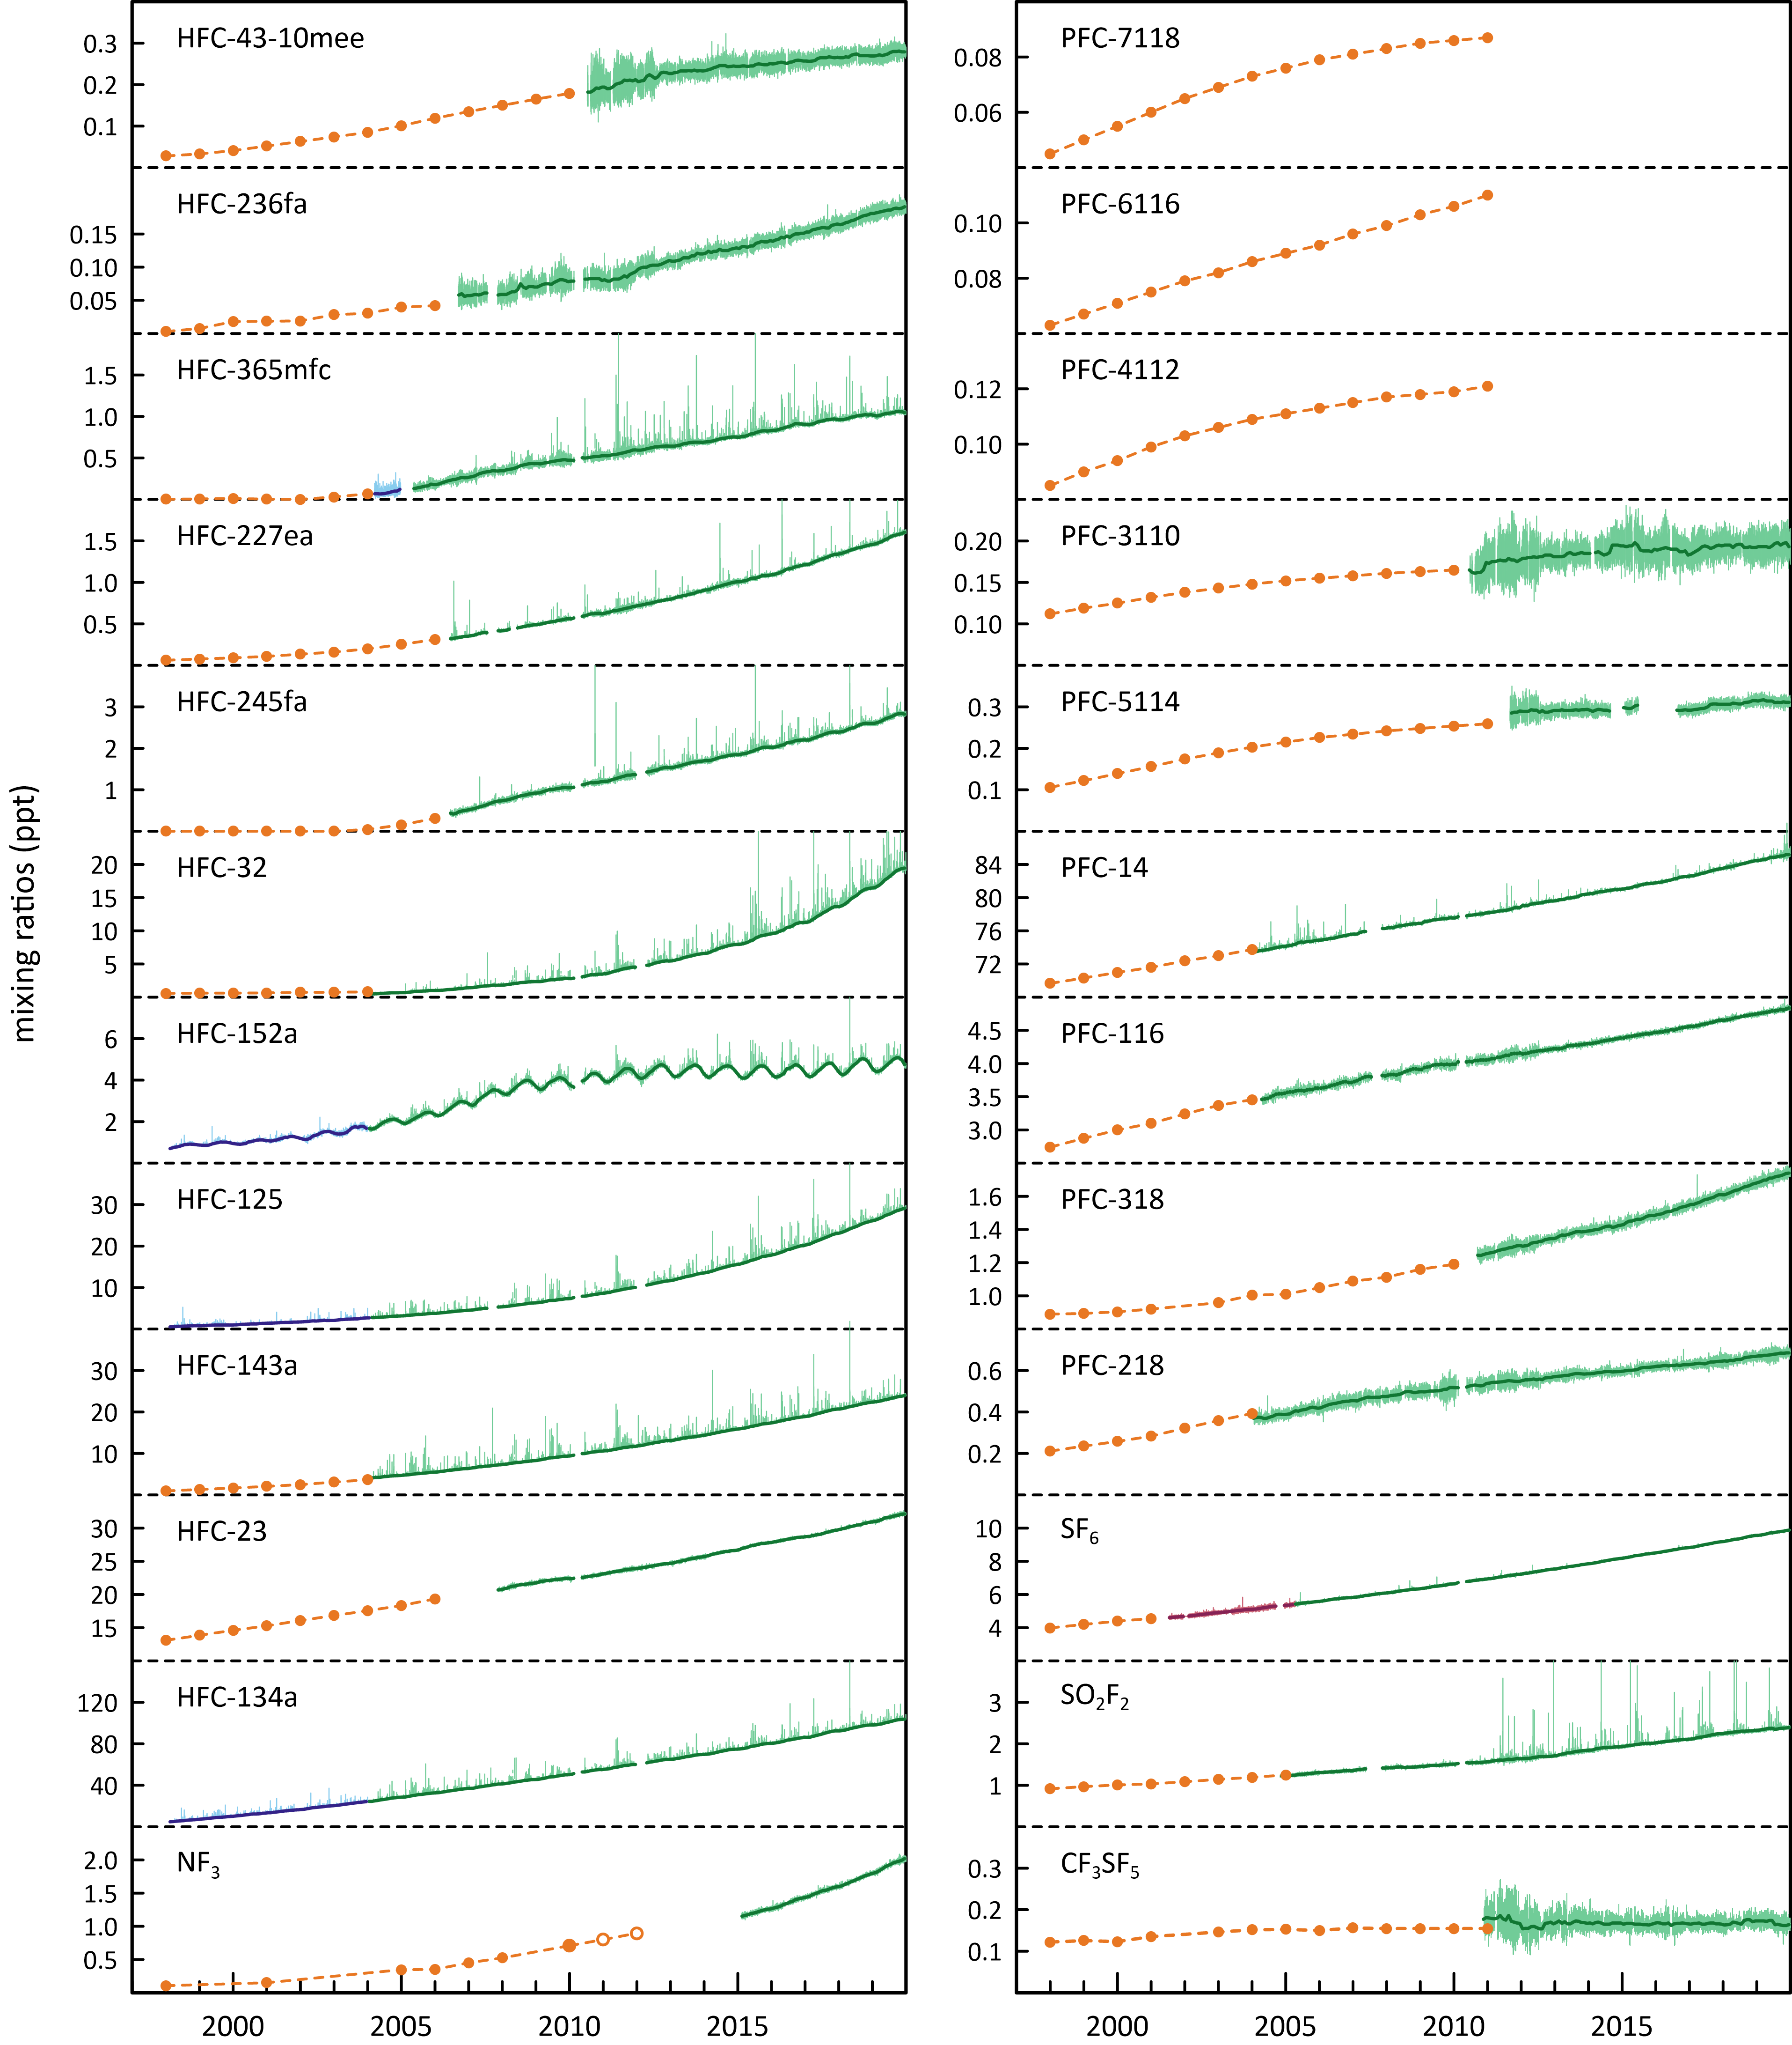

## Australian HFC, PFC and sulfur hexafluorid imports, banks and emissions

HFCs and sulfur hexafluoride are not manufactured in Australia and estimates of Australian HFC and sulfur hexafluoride emissions, reported annually to the UNFCCC (Table 3), are based on import data (Table 2). HFCs and sulfur hexafluoride are imported as bulk chemicals or in pre-charged equipment (PCE), leading to estimates of ‘banks’ of HFCs and sulfur hexafluoride stored in equipment or products such as refrigerators, air conditioners, fire extinguishers, foams, aerosols and electrical equipment. Only small amounts of PFCs are imported into Australia (Table 2) and these are not considered to be a significant source of PFC emissions; Australian PFC emissions are assumed to originate almost exclusively from aluminium production (Table 5).

Table 2. Australian HFC, PFC, sulfur hexafluoride imports (tonnes; calendar years 2018, 2019, A, Gabriel, Department of Environment and Energy, 2019); PCE = pre-charged equipment.

|  |  |  |  |  |  |  |  |  |  |  |  |  |  |  |
| --- | --- | --- | --- | --- | --- | --- | --- | --- | --- | --- | --- | --- | --- | --- |
| Species | bulk | | PCE | | bulk | | Total | | Total | | Total  Imports | | Total Imp-Exp | |
|  | Imports | | Imports | | Exports | | Imports | | Imp-Exp | | Mt CO2-e | | Mt CO2-e | |
|  | 2018 | 2019 | 2018 | 2019 | 2018 | 2019 | 2018 | 2019 | 2018 | 2019 | 2018 | 2019 | 2018 | 2019 |
| HFC-23 | 0.07 | 0.01 | 8.7 | 2.4 | 0.02 |  | 8.8 | 2.4 | 8.8 | 2.4 | 0.13 | 0.04 | 0.13 | 0.04 |
| HFC-32 | 620 | 567 | 1697 | 1585 | 0.09 |  | 2317 | 2152 | 2317 | 2152 | 1.6 | 1.5 | 1.6 | 1.5 |
| HFC-125 | 1029 | 917 | 998 | 709 | 86 |  | 2027 | 1626 | 1940 | 1626 | 7.1 | 5.7 | 6.8 | 5.7 |
| HFC-134a | 1706 | 1520 | 957 | 903 | 0.06 |  | 2663 | 2423 | 2663 | 2423 | 3.8 | 3.5 | 3.8 | 3.5 |
| HFC-143a | 366 | 439 | 11 | 10 | 0.84 |  | 377 | 449 | 376 | 449 | 1.7 | 2.0 | 1.7 | 2.0 |
| HFC-152a |  |  | 21 | 34 | 0.31 |  | 21 | 34 | 21 | 34 | 0 | 0 | 0 | 0 |
| HFC-227ea | 20 | 9 | 0.05 | 0 | 0.58 | 0.48 | 20 | 9 | 20 | 9 | 0.07 | 0.03 | 0.06 | 0.03 |
| HFC-236fa |  |  | 0.08 | 0 |  |  | 0.08 | 0.05 | 0.08 | 0.05 | 0 | 0 | 0 | 0 |
| HFC-245fa | 31 | 45 | 0 | 0 | 2.7 | 3.6 | 31 | 45 | 29 | 41 | 0.03 | 0.05 | 0.02 | 0.03 |
| HFC-365mfc | 34 | 46 |  |  | 2.79 | 3.7 | 34 | 46 | 31 | 42 | 0.03 | 0.04 | 0.02 | 0.03 |
| HFC-43-10mee |  |  | 0 | 0 |  |  | 0 | 0 | 0 | 0 | 0 | 0 | 0 | 0 |
| total HFCs | 3805 | 3542 | 3692 | 3245 | 94 | 8 | 7498 | 6787 | 7404 | 6779 | 14 | 13 | 14 | 13 |
| PFC-14 | 0.31 | 0.05 | 0.01 | 0.01 |  |  | 0.32 | 0.06 | 0.32 | 0.06 | 0 | 0 | 0 | 0 |
| PFC-116 |  |  | 0.02 | 0.02 |  |  | 0.02 | 0.02 | 0.02 | 0.02 | 0 | 0 | 0 | 0 |
| PFC-218 | 0.04 |  |  | 0.23 |  |  | 0.04 | 0.23 | 0.04 | 0.23 | 0 | 0 | 0 | 0 |
| PFC-318 | 0.09 | 0.03 |  |  |  |  | 0.09 | 0.03 | 0.09 | 0.03 | 0 | 0 | 0 | 0 |
| total PFCs | 0.44 | 0.08 | 0.03 | 0.26 | 0 | 0 | 0.47 | 0.35 | 0.47 | 0.35 | 0.004 | 0.003 | 0 | 0 |
| SF6 | 2.4 | 6.0 | 9.6 | 18.4 |  | 0.29 | 12 | 24 | 12 | 24 | 0.27 | 0.56 | 0.27 | 0.55 |
| total HFCs, PFCs, SF6 | 3808 | 3548 | 3702 | 3263 | 94 | 8 | 7510 | 6811 | 7417 | 6803 | 15 | 13 | 14 | 13 |

Australia’s mandated HFC production and import phase down began on 1 January 2018. HFC imports in 2019 were 6787 metric tonnes, similar to imports in 2018. HFC imports had previously grown by 10% per year over the period 2008-2017. PFC imports in 2018 and 2019 were about 0.47 and 0.35 tonnes respectively.

Sulfur hexafluoride imports in 2019 were 24 tonnes, double 2018 imports. Sulfur hexafluoride imports vary significantly year-to-year. Thirty-four (34) tonnes of sulfur hexafluoride were re-exported in 2016, but none exported in 2017 to 2019. Since 2012, sulfur hexafluoride imports have totalled 156 tonnes and exports 37 tonnes.

The *National Greenhouse Gas Inventory* (NGGI: ageis.climatechange.gov.au) published in 2020 contains estimates of Australian emissions of HFC-23, HFC-32, HFC-125, HFC-134 (CHF2CHF2, not measured currently at Cape Grim), HFC-134a, HFC-143a, HFC-152a, HFC-227ea, HFC-236fa, HFC-4310mee, PFC-14, PFC-116 and sulfur hexafluoride, up to 2018, which form part of the *National Inventory Report 2018* (DISER, 2020). The *Inventory* is the Australian government submission to the UNFCCC and which forms a part of the *Australian National Greenhouse Accounts* (NGA). Note the annual emissions in the NGGI and in the *National Inventory Report* are for fiscal years, i.e. ‘2013’ emissions are emissions for July 2012 to June 2013.

The HFC emissions (Table 3) are based on HFC import data (Table2), as bulk HFCs or HFC imported in pre-charged equipment (PCE), leading to an estimate of ‘banks’ of HFCs stored in equipment or products (refrigerators, air conditioners, fire extinguishers, foams, aerosols - largely metered-dose inhalers) and appropriate application-dependent emission factors from those ‘banks’, which allow for estimation of emissions during the lifetime of the application, as well as of emissions from initial charging/re-charging of equipment and equipment disposal.

In the *National Inventory Report 2018* (DISER 2020), two significant changes have been implemented for determining Australian estimated HFC emissions. The first change is that the annual leak rates are calibrated to the CSIRO HFC emissions estimates for all equipment types from 2006 onwards. The second change to the method is CSIRO species data is used to modify the species percentages each year from 2006 onwards.

Australian HFC emissions were about 110 tonnes in 1995, rising to 5,338 tonnes (11982 CO2-e ktonnes) in 2018. HFC-134a emissions increased by about 70 tonnes (2.5%) from 2017 to 2018, all other HFCs by about 60 tonnes (2.5%). Emissions of total HFCs (in CO2-e terms) in 2018 were 2.5% higher than in 2017.

In the Australian GHG emission inventory, PFC (PFC-14, PFC-116) emissions only arise from aluminium production, with total PFC emissions in 2018 of 30 tonnes (0.24 Mt CO2-e, DISER, 2020).

* About 0.35-0.47 tonnes of PFCs (PFC-14, PFC-116) were imported into Australia in 2018-2019 as refrigerant blends in bulk and PCE (Table 2). It is not clear whether these PFC imports are used to calculate corresponding contributions to PFC emissions – if they are, they are very small compared to PFC emissions from the aluminium industry (30 tonnes in 2018, Table 3).
* PFC emissions in the *Inventory* fell from 37 tonnes in 2012 to 24 tonnes in 2013 due to the closure of the Kurri Kurri smelter in NSW and from 24 tonnes in 2014 to 22 tonnes in 2015 due to the closure of the Point Henry smelter in Victoria.
* PFC emissions in the *Inventory* in 2018 are about 25% higher compared to 2017. This increase is due to the PFC-14 emission factor from DISER (2020) which has increased by 40%.

Australian sulfur hexafluoride emissions are largely (90%) from the electricity supply and distribution network, with 10% from electrical supply equipment manufacture. Emissions (1975-2018) are estimated as leakages from sulfur hexafluoride ‘banks’ in the electricity supply and distribution network and leakages from Australian manufacture of electricity supply equipment, using a combination of default IPCC and Australian-specific emissions factors (DISER 2020).

* Australian emission factors for electrical equipment stock are global IPCC default factors: 0.05 tonne (t) emitted per year per tonne (t) of stock (1975-1995), 0.02 t/t (2000); an Australian-specific base emission factor (0.0089 t/t) has been estimated for 2010 (DISER 2020) and then scaled in subsequent years by the estimates of Australian sulfur hexafluoride emissions from Cape Grim atmospheric observations (DISER, 2020). For 1995-2000-2009 periods, emission factors are linearly interpolated. The 2010 emission factor (0.0089 t/t) is based on emission estimates from 15 utilities (the major consumers of sulfur hexafluoride in Australia) using their own data on sulfur hexafluoride consumption (consumption = emissions, not defaulting to the IPCC method). The 2017 and 2018 emission factors (after scaling by Cape Grim data) are 0.0088 tonne sulfur hexafluoride per tonne sulfur hexafluoride banked i.e. 0.88% (DISER 2020).
* The sulfur hexafluoride emission factors assumed for Australian equipment manufacture (0.15 t/t, 1975-1995; 0.085 t/t, 1996-2017) are IPCC default factors for Europe. The original global IPCC default factor for manufacturing (0.74 t/t) was significantly higher and currently IPCC recommends 0.30-0.35 t/t (prior to 1995) and 0.12 t/t after 1995, both significantly higher than the assumed Australian emission factor for equipment manufacture. These IPCC factors are for gas insulated switchgear (GIS); higher factors are recommended for circuit breakers (0.55 t/t prior to 1995, 0.29 t/t after 1995). Circuit breakers are used extensively in the USA, GIS in Europe. The Australian inventory assumed GIS values, presumably because Australia uses largely GIS equipment in its electricity distribution networks. Since the equipment manufacture sector emits only 10% of Australia’s sulfur hexafluoride, total sulfur hexafluoride emissions are relatively insensitive to the choice of emission factors for this sector.
* Australian sulfur hexafluoride emissions from tracer gas studies, eye surgery etc. have been estimated at 1 kg of sulfur hexafluoride as CO2-e per person per year or a total of 1.1 tonnes of sulfur hexafluoride per year (DISER 2020).
* In total, Australian emissions of sulfur hexafluoride in 2018 (electrical equipment and other uses) was estimated at 10 tonnes.

The quantity of sulfuryl fluoride imported each year into Australia depends, in part, on the annual grain harvest. Before 2007, Australian sulfuryl fluoride imports were significantly less than 50 tonnes per year, reaching current levels of imports (~150 tonnes per year) by 2011-12, continuing at about this level until 2015-16, with 2016-17 imports higher due to a record grain harvest (M. Stein, A-Gas, personal communication).

* Mühle *et al*. (2009) estimate that approximately two-thirds of sulfuryl fluoride used in fumigation escapes to the atmosphere, so current Australian sulfuryl fluoride emissions are likely to be about 100 tonnes per year (~0.5 M tonnes CO2-e), 2-3 times larger than the CO2-e emissions due to sulfur hexafluoride (0.23 M tonnes CO2-e in 2018).
* Globally, the reverse is the case, with the CO2-e emissions of sulfur hexafluoride (200 M tonnes, 2018) being significantly higher than for sulfuryl fluoride (14 M tonnes, 2018).

The HFC, PFC and sulfur hexafluoride contributions to total emissions from this sector in the Inventory are shown in Figure 2. The significant effect on total emissions in 2005-2006 due to reduced PFC emissions (the Kurri Kurri aluminium smelter upgrade) can be clearly seen. Prior to the significant reduction in PFC emissions at Kurri Kurri in 2005, Australian HFC/PFC/sulfur hexafluoride emissions grew at about 12%/yr (Figure 2). After the Kurri Kurri upgrade, these combined emissions grew at about 7%/yr. The Australian Kyoto Protocol/Paris Agreement-SGG emissions are 97% HFCs, 2% PFCs and 1% sulfur hexafluoride.

Figure 2. Australian HFC, PFC and sulfur hexafluoride emissions (M tonne CO2-e) in the Inventory (DISER 2020). Note the impact on the reduction in emissions due to the refurbishment of potline #1 at the Kurri Kurri aluminium smelter in 2005-2006. Dashed lines are exponential and linear best fits.

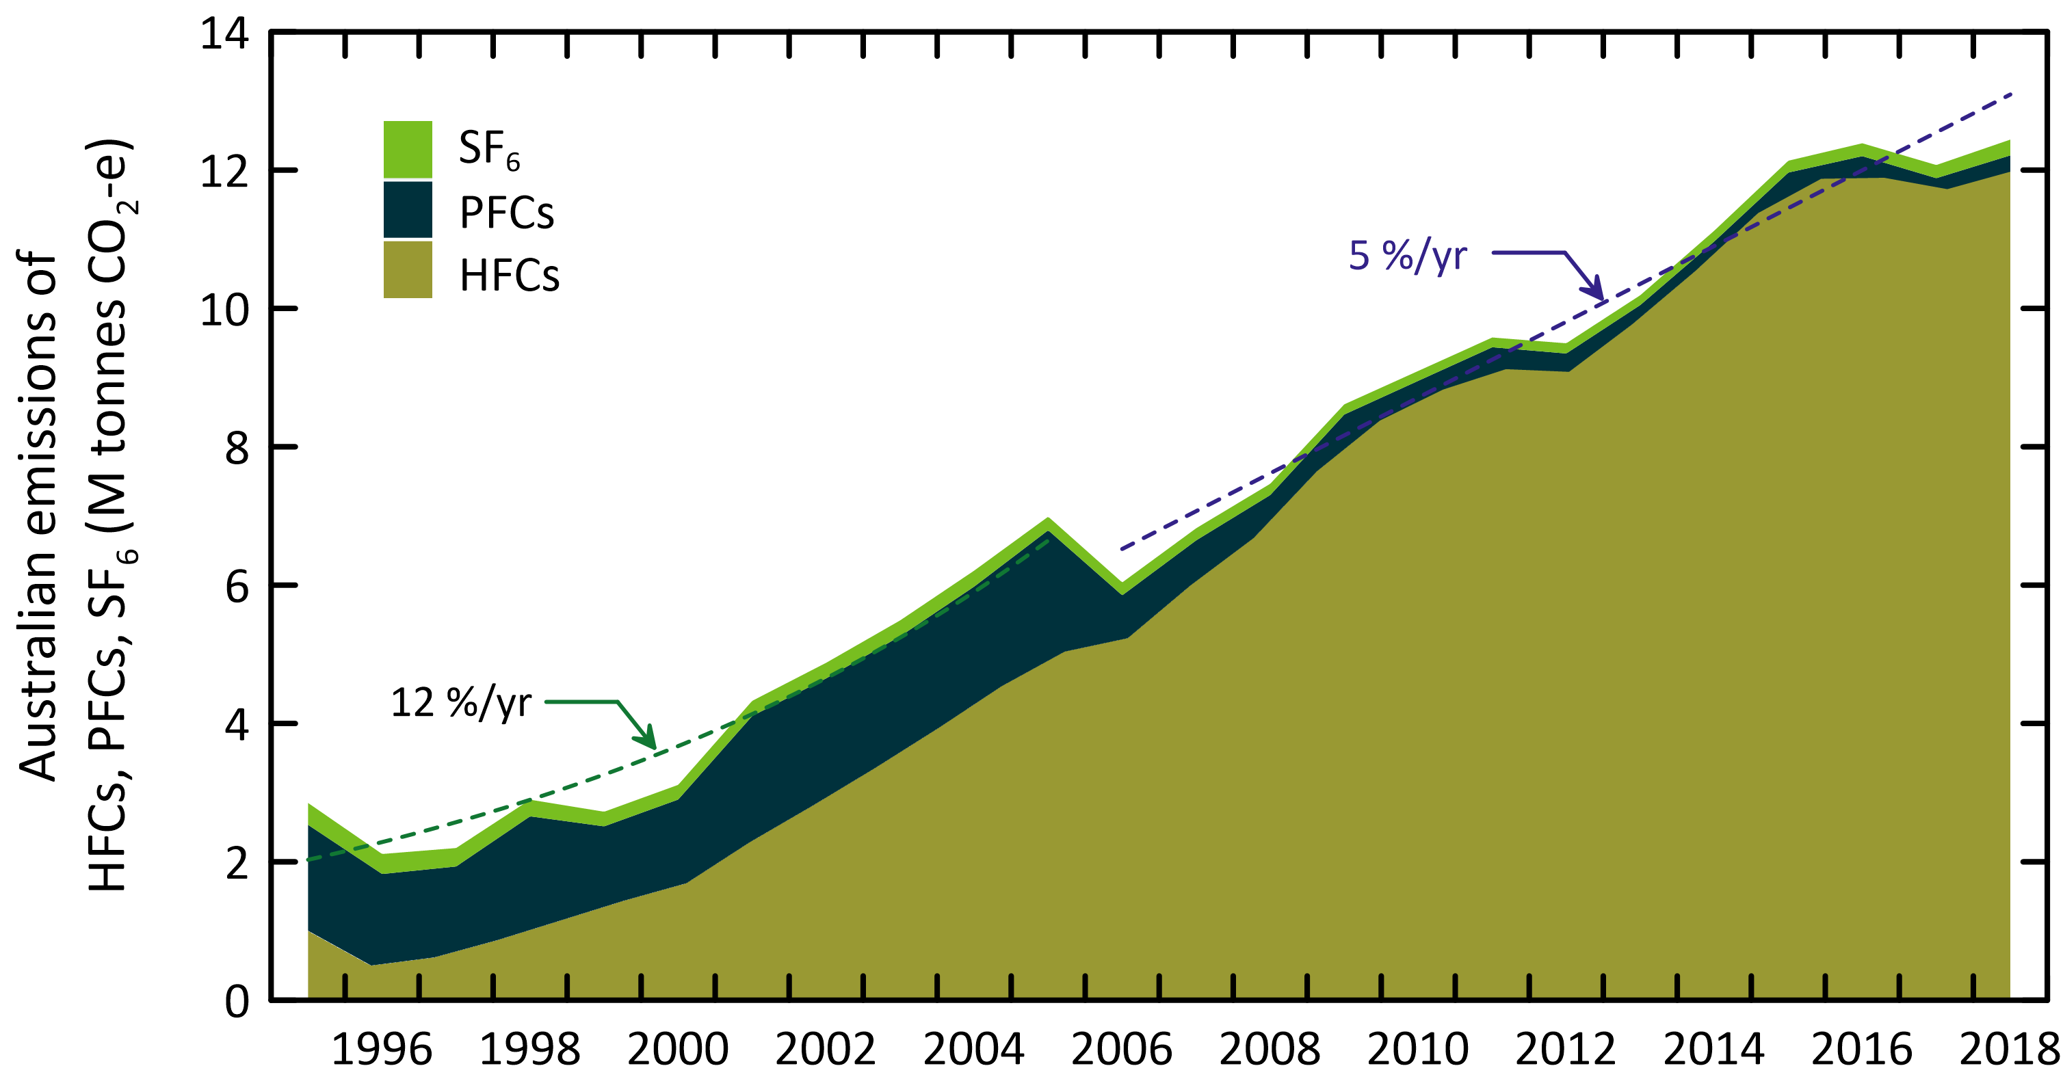

Table 3. Australian HFC, PFC and sulfur hexafluorideemissions ([available from the UNFCCC website](https://unfccc.int/ghg-inventories-annex-i-parties/2020)). HFC-23 emissions in 1995 from HCFC-22 production in Sydney. Note GWPs used are AR4.

| Year | HFC-134a | HFC-125 | HFC-143a | HFC-32 | HFC-245fa | HFC-152a | HFC-365mfc | HFC-23 | HFC-227ea | HFC-236fa | HFC-134 | HFC-43-10mee | total HFCs | PFC-14 | PFC-116 | total PFCs | SF6 | total  HFC,PFC,SF6 |
| --- | --- | --- | --- | --- | --- | --- | --- | --- | --- | --- | --- | --- | --- | --- | --- | --- | --- | --- |
|  | Tonnes | | | | | | | | | | | | | | | | | |
| 1995 | 33 | 12 | 1.1 | 0.6 |  |  |  | 61 | 0.4 | 0.0 | 0.0 | 0.0 | 108 | 171 | 22 | 193 | 14 | 315 |
| 1996 | 145 | 51 | 4.9 | 2.8 |  |  |  | 0.0 | 1.7 | 0.0 | 0.1 | 0.0 | 205 | 157 | 20 | 178 | 13 | 395 |
| 1997 | 247 | 86 | 8.3 | 4.8 |  |  |  | 0.0 | 2.9 | 0.0 | 0.1 | 0.1 | 349 | 137 | 18 | 155 | 12 | 516 |
| 1998 | 349 | 122 | 12 | 6.8 |  |  |  | 0.0 | 4.1 | 0.0 | 0.1 | 0.1 | 494 | 185 | 24 | 209 | 11 | 714 |
| 1999 | 481 | 168 | 16 | 9.3 |  |  |  | 0.1 | 5.7 | 0.0 | 0.2 | 0.1 | 681 | 127 | 16 | 143 | 9.3 | 833 |
| 2000 | 565 | 198 | 19 | 11 |  |  |  | 0.1 | 6.7 | 0.0 | 0.2 | 0.2 | 799 | 143 | 19 | 162 | 9.3 | 971 |
| 2001 | 807 | 282 | 27 | 16 |  |  |  | 0.1 | 10 | 0.0 | 0.3 | 0.2 | 1143 | 201 | 26 | 227 | 9.6 | 1379 |
| 2002 | 1024 | 358 | 34 | 20 |  |  |  | 0.1 | 12 | 0.0 | 0.4 | 0.3 | 1449 | 193 | 25 | 218 | 9.9 | 1676 |
| 2003 | 1252 | 438 | 42 | 24 |  |  |  | 0.2 | 15 | 0.0 | 0.5 | 0.4 | 1772 | 188 | 24 | 212 | 10.0 | 1994 |
| 2004 | 1493 | 522 | 50 | 29 |  |  |  | 0.2 | 18 | 0.0 | 0.6 | 0.4 | 2113 | 191 | 25 | 216 | 10.1 | 2339 |
| 2005 | 1365 | 332 | 356 | 28 | 31 | 26 | 8 |  | 14 | 20 | 0.6 |  | 2180 | 200 | 26 | 226 | 8.6 | 2414 |
| 2006 | 1476 | 345 | 370 | 50 | 35 | 32 | 25 |  | 13 | 5.7 | 0.7 |  | 2353 | 77 | 10 | 87 | 8.2 | 2447 |
| 2007 | 1456 | 406 | 385 | 93 | 31 | 41 | 27 | 42 | 16 | 5.0 | 0.8 |  | 2503 | 65 | 8.4 | 73 | 7.7 | 2584 |
| 2008 | 1576 | 490 | 431 | 110 | 27 | 42 | 46 | 47 | 21 | 5.3 | 1.0 |  | 2796 | 50 | 6.4 | 56 | 7.2 | 2859 |
| 2009 | 1829 | 591 | 529 | 144 | 29 | 44 | 58 | 48 | 34 | 5.8 | 1.1 |  | 3312 | 40 | 4.9 | 45 | 6.4 | 3364 |
| 2010 | 1990 | 640 | 553 | 182 | 41 | 55 | 81 | 46 | 37 | 7.6 | 1.6 |  | 3634 | 32 | 3.5 | 36 | 6.3 | 3676 |
| 2011 | 2218 | 696 | 527 | 217 | 60 | 59 | 82 | 49 | 32 | 6.8 | 1.7 |  | 3948 | 35 | 3.8 | 38 | 6.2 | 3993 |
| 2012 | 2066 | 666 | 584 | 224 | 62 | 85 | 78 | 50 | 22 | 5.8 | 1.8 |  | 3844 | 34 | 3.7 | 37 | 6.5 | 3888 |
| 2013 | 2063 | 744 | 669 | 231 | 69 | 87 | 75 | 55 | 48 | 4.3 | 2.0 |  | 4047 | 22 | 2.4 | 24 | 6.2 | 4078 |
| 2014 | 2448 | 926 | 634 | 391 | 99 | 91 | 74 | 41 | 38 | 3.1 | 2.0 |  | 4748 | 22 | 2.4 | 24 | 6.8 | 4779 |
| 2015 | 2760 | 1016 | 664 | 435 | 116 | 100 | 81 | 45 | 41 | 3.4 | 2.2 |  | 5263 | 19 | 2.3 | 22 | 7.5 | 5292 |
| 2016 | 2900 | 1037 | 644 | 462 | 121 | 106 | 79 | 45 | 31 | 4.4 | 2.6 |  | 5432 | 26 | 2.9 | 29 | 8.2 | 5469 |
| 2017 | 2772 | 965 | 646 | 423 | 108 | 117 | 74 | 55 | 35 | 5.9 | 5.1 |  | 5206 | 18 | 5.6 | 24 | 8.3 | 5238 |
| 2018 | 2842 | 989 | 662 | 434 | 110 | 120 | 76 | 56 | 36 | 6.0 | 5.2 |  | 5338 | 26 | 3.3 | 30 | 10.0 | 5378 |

|  |  |  |  |  |  |  |  |  |  |  |  |  |  |  |  |  |  |  |
| --- | --- | --- | --- | --- | --- | --- | --- | --- | --- | --- | --- | --- | --- | --- | --- | --- | --- | --- |
| Year | HFC-134a | HFC-125 | HFC-143a | HFC-32 | HFC-245fa | HFC-152a | HFC-365mfc | HFC-23 | HFC-227ea | HFC-236fa | HFC-134 | HFC-43-10mee | total HFCs | PFC-14 | PFC-116 | total PFCs | SF6 | total  HFC,PFC,SF6 |
|  | kt CO2-e | | | | | | | | | | | | | | | | | |
| 1995 | 47 | 41 | 5.0 | 0.4 |  |  |  | 909 | 1.3 | 0.0 | 0.0 | 0.0 | 1004 | 1261 | 270 | 1531 | 316 | 2851 |
| 1996 | 207 | 177 | 22 | 1.9 |  |  |  | 0.3 | 5.5 | 0.0 | 0.1 | 0.1 | 414 | 1161 | 249 | 1410 | 289 | 2114 |
| 1997 | 353 | 302 | 37 | 3.2 |  |  |  | 0.5 | 9.4 | 0.0 | 0.1 | 0.1 | 705 | 1011 | 217 | 1228 | 267 | 2200 |
| 1998 | 500 | 428 | 52 | 4.6 |  |  |  | 0.6 | 13 | 0.0 | 0.2 | 0.2 | 998 | 1367 | 293 | 1661 | 240 | 2899 |
| 1999 | 688 | 589 | 72 | 6.3 |  |  |  | 0.9 | 18 | 0.0 | 0.2 | 0.2 | 1375 | 938 | 201 | 1139 | 211 | 2725 |
| 2000 | 808 | 691 | 85 | 7.4 |  |  |  | 1.0 | 22 | 0.0 | 0.2 | 0.3 | 1614 | 1060 | 227 | 1287 | 212 | 3113 |
| 2001 | 1154 | 988 | 121 | 11 |  |  |  | 1.5 | 31 | 0.0 | 0.3 | 0.4 | 2307 | 1484 | 318 | 1802 | 219 | 4328 |
| 2002 | 1464 | 1253 | 153 | 13 |  |  |  | 1.9 | 39 | 0.0 | 0.4 | 0.5 | 2926 | 1423 | 305 | 1728 | 225 | 4879 |
| 2003 | 1791 | 1533 | 187 | 16 |  |  |  | 2.3 | 48 | 0.0 | 0.5 | 0.6 | 3579 | 1387 | 297 | 1684 | 229 | 5492 |
| 2004 | 2135 | 1828 | 223 | 19 |  |  |  | 2.7 | 57 | 0.0 | 0.6 | 0.7 | 4267 | 1411 | 303 | 1714 | 231 | 6212 |
| 2005 | 1953 | 1163 | 1591 | 19 | 31 | 3.2 | 6.0 | 0 | 45 | 191 | 0.6 | 0 | 5003 | 1475 | 316 | 1792 | 196 | 6991 |
| 2006 | 2110 | 1209 | 1654 | 34 | 36 | 4.0 | 20 | 0 | 43 | 56 | 0.8 | 0 | 5167 | 566 | 121 | 687 | 186 | 6040 |
| 2007 | 2083 | 1422 | 1720 | 63 | 32 | 5.1 | 22 | 619 | 51 | 49 | 0.8 | 0 | 6066 | 480 | 103 | 583 | 175 | 6824 |
| 2008 | 2253 | 1713 | 1925 | 75 | 28 | 5.2 | 37 | 702 | 68 | 52 | 1.1 | 0 | 6859 | 366 | 78 | 445 | 163 | 7467 |
| 2009 | 2615 | 2068 | 2365 | 97 | 30 | 5.4 | 46 | 714 | 110 | 57 | 1.2 | 0 | 8109 | 299 | 60 | 359 | 147 | 8615 |
| 2010 | 2845 | 2239 | 2472 | 123 | 43 | 6.8 | 64 | 684 | 120 | 74 | 1.7 | 0 | 8672 | 240 | 43 | 283 | 143 | 9098 |
| 2011 | 3171 | 2436 | 2357 | 146 | 62 | 7.3 | 65 | 723 | 104 | 66 | 1.9 | 0 | 9140 | 255 | 46 | 301 | 141 | 9582 |
| 2012 | 2954 | 2331 | 2611 | 151 | 64 | 11 | 62 | 743 | 71 | 57 | 2.0 | 0 | 9056 | 250 | 45 | 295 | 147 | 9498 |
| 2013 | 2949 | 2605 | 2989 | 156 | 71 | 11 | 60 | 821 | 154 | 42 | 2.2 | 0 | 9860 | 163 | 29 | 192 | 142 | 10194 |
| 2014 | 3501 | 3243 | 2833 | 264 | 102 | 11 | 59 | 610 | 123 | 31 | 2.2 | 0 | 10779 | 163 | 29 | 193 | 155 | 11127 |
| 2015 | 3946 | 3555 | 2968 | 293 | 119 | 12 | 64 | 668 | 133 | 33 | 2.5 | 0 | 11795 | 143 | 28 | 171 | 171 | 12138 |
| 2016 | 4147 | 3631 | 2880 | 312 | 124 | 13 | 63 | 664 | 100 | 43 | 2.9 | 0 | 11979 | 189 | 36 | 225 | 186 | 12391 |
| 2017 | 3963 | 3377 | 2887 | 285 | 111 | 15 | 59 | 811 | 113 | 58 | 5.6 | 0 | 11686 | 135 | 68 | 203 | 190 | 12079 |
| 2018 | 4064 | 3463 | 2961 | 293 | 114 | 15 | 61 | 832 | 116 | 59 | 5.7 | 0 | 11982 | 196 | 40 | 236 | 229 | 12447 |

## Australian HFC, PFC, sulfur hexafluoride and sulfuryl fluoride emissions from atmospheric data

### HFC, sulfur hexafluoride and sulfuryl fluoride emissions

CSIRO estimates emissions of a number of greenhouse and ozone depleting trace gases from the Melbourne/Port Phillip region (Dunse *et al.* 2001, 2005; Dunse, 2002; Greally *et al.* 2007; Stohl *et al.* 2009; Fraser *et al.* 2014b, 2016; Simmonds *et al.* 2016), utilising *in situ* high frequency measurements from the Cape Grim Baseline Air Pollution Station in Tasmania and employing the interspecies correlation (ISC) technique with co-incident carbon monoxide (CO) measurements or inverse modelling (InTEM).

Port Phillip HFC, PFC-116 and sulfur hexafluoride emissions have been calculated, by ISC from Cape Grim data (2004-2018, Krummel *et al.* 2014 and unpublished data) and presented as 3-year running averages (2005-2018; Table 4, Figure 3). The HFC, PFC-116 and sulfur hexafluoride emissions are derived from Port Phillip emissions, scaled to Australian emissions on a population basis. NOAA air mass back trajectory analyses (Draxler & Hess 1997) are used to ensure that the pollution events at Cape Grim used to derive Port Phillip emissions are imbedded in air masses that only pass over the Port Phillip region and do not include other possible high carbon monoxide source regions, in particular the Latrobe Valley, or high carbon monoxide emission events (biomass burning).

The NAME (Numerical Atmospheric Dispersion Modelling Environment) particle dispersion model coupled to the InTEM (Inversion Technique for Emission Modelling) inversion model (O’Doherty *et al.* 2009; Manning *et al.* 2003, 2011; Redington & Manning 2018) is used to calculate HFC, PFC (see below), sulfur hexafluoride and sulfuryl fluoride emissions. For a more detailed description of the NAME/InTEM model see Appendix A.

Cape Grim sulfuryl fluoride measurements commenced in 2004, but significant pollution episodes (as selected for ISC calculations) were not observed at Cape Grim until 2010. These pollution episodes are used to calculate SE Australian (largely Victorian) sulfuryl fluoride emissions by ISC. Grain exported from Victorian grain terminals, or produced in Victoria, accounts for about 10-20% of Australia’s grain production/exports (National Transport Commission, 2008; ABARES 2018) and thus possibly 10-20% of Australia’s emissions of sulfuryl fluoride. SE Australian sulfuryl fluorideemissions calculated from Cape Grim data by ISC are scaled to Australian emissions by this factor (i.e. multiplied by 7.0±2.1) (Table 4, Figure 3). SE Australian sulfuryl fluoride emissions from InTEM use a scale factor (2.6) based on grain production to derive Australian emissions. Australian emissions (ISC/InTEM) of sulfuryl fluoride averaged about 81 tonnes/yr (407 k tonnes CO2-e) over the period 2011-2018, some 2%-3% of global emissions (see above), similar to Australia’s fraction of global grain production (~2%). Australian sulfuryl fluoride imports are currently around 150 tonnes per year (M. Stein, A-Gas, personal communication).

Table 4. Australian HFC, PFC, sulfur hexafluoride and sulfuryl fluoride emissions (tonnes, 2005-2018) from atmospheric data, collected at Cape Grim, Tasmania - emissions calculated by interspecies correlation (ISC) and from the InTEM inversion model (InTEM 2019). The emissions are 3-year running averages, i.e. ‘2010’ = average of 2009, 2010, 2011 emissions. Australian HFC and sulfur hexafluoride emissions (ISC, InTEM) are scaled from regional emissions by population; GWPs (to calculate CO2-e emissions) are from the IPCC *Fourth Assessment Report* (Myre &Shindell 2013). PFC-14 emissions are the TAPM-InTEM average from Table 5. Australian PFC-116 emissions are from InTEM scaled by aluminium production; Australian PFC-218 and PFC-318 emissions are from InTEM and ISC scaled by population; Australian sulfuryl fluoride emissions are from ISC and InTEM estimates of SE Australian emissions scaled by grain production.

| Refrigerant | 2005 | 2006 | 2007 | 2008 | 2009 | 2010 | 2011 | 2012 | 2013 | 2014 | 2015 | 2016 | 2017 | 2018 |
| --- | --- | --- | --- | --- | --- | --- | --- | --- | --- | --- | --- | --- | --- | --- |
| Regulated species |  |  |  |  |  |  |  |  |  |  |  |  |  |  |
| HFCs ISC (tonnes) |  |  |  |  |  |  |  |  |  |  |  |  |  |  |
| HFC-32 | 36±12 | 54±20 | 104±43 | 106±40 | 133±48 | 121±42 | 143±48 | 147±50 | 151±49 | 272±91 | 279±94 | 240±81 | 185±61 | 221±72 |
| HFC-125 | 414±137 | 369±122 | 460±177 | 477±170 | 566±189 | 427±148 | 497±171 | 467±158 | 510±167 | 590±196 | 609±205 | 507±170 | 420±141 | 421±138 |
| HFC-134a | 1687±530 | 1561±489 | 1657±565 | 1526±492 | 1709±541 | 1326±450 | 1586±536 | 1457±488 | 1421±458 | 1527±506 | 1620±542 | 1388±464 | 1208±400 | 1024±331 |
| HFC-143a | 439±150 | 392±132 | 438±159 | 417±143 | 499±163 | 368±129 | 346±118 | 387±132 | 440±147 | 458±154 | 443±150 | 350±118 | 285±96 | 244±80 |
| HFC-23 | 29±18b | 29±18b | 29±18 | 40±17 | 40±16 | 36±13 | 35±13 | 36±13 | 36±12 | 28±10 | 28±10 | 24±8 | 27±9 | 28±9 |
| HFC-152a | 33±11 | 34±11 | 46±15 | 42±14 | 45±16 | 39±14 | 39±13 | 55±19 | 56±19 | 65±22 | 66±22 | 56±19 | 50±17 | 39±13 |
| HFC-227ea | 19±12 | 14±7 | 18±8 | 20±8 | 29±11 | 26±10 | 23±8 | 17±6 | 32±11 | 24±8 | 24±9 | 16±5 | 16±5 | 14±5 |
| HFC-236fa | 16±12 | 6±3 | 6±3 | 5±2 | 5±2 | 5±2 | 4±2 | 4±1 | 3±1 | 2±1 | 2±1 | 2±1 | 2±1 | 2±1 |
| HFC-245fa | 41±23 | 38±16 | 36±14 | 28±11 | 29±11 | 29±10 | 39±14 | 41±14 | 45±15 | 65±22 | 73±24 | 60±20 | 48±16 | 26±8 |
| HFC-365mfc | 9±4 | 26±11 | 33±14 | 45±16 | 54±19 | 55±20 | 55±20 | 52±18 | 50±17 | 52±18 | 53±18 | 44±15 | 35±12 | 19±6 |
| Major HFCs1 | 2576±570 | 2377±520 | 2659±615 | 2525±540 | 2907±600 | 2243±495 | 2572±575 | 2458±530 | 2523±510 | 2847±570 | 2950±605 | 2485±515 | 2098±440 | 1910±375 |
| Total HFCs (tonnes) | 2724±570 | 2524±520 | 2826±615 | 2705±540 | 3109±600 | 2433±495 | 2767±580 | 2662±535 | 2745±515 | 3083±570 | 3197±605 | 2687±515 | 2277±440 | 2038±375 |
| Total HFCs (k tonnes CO2-e) | 6546±1160 | 5913±1045 | 6618±1270 | 6561±1150 | 7557±1275 | 5861±1030 | 6369±1120 | 6258±1085 | 6640±1110 | 7110±1220 | 7252±1260 | 6013±1045 | 5154±880 | 4709±780 |
| HFCs InTEM (tonnes) |  |  |  |  |  |  |  |  |  |  |  |  |  |  |
| HFC-32 | 21±18 | 28±19 | 38±23 | 49±26 | 65±30 | 76±32 | 78±33 | 73±30 | 65±32 | 78±35 | 96±41 | 125±46 | 138±49 | 138±49e |
| HFC-125 | 99±68 | 151±77 | 202±89 | 247±97 | 223±99 | 227±96 | 227±98 | 270±99 | 270±104 | 294±112 | 315±122 | 379±131 | 403±134 | 403±134e |
| HFC-134a | 680±250 | 720±280 | 790±290 | 830±300 | 850±290 | 930±290 | 870±300 | 870±300 | 770±290 | 830±300 | 820±320 | 940±320 | 940±330 | 940±330e |
| HFC-143a | 115±68 | 153±72 | 180±78 | 210±83 | 197±85 | 221±84 | 222±87 | 235±87 | 210±86 | 211±84 | 212±84 | 260±84 | 280±85 | 280±85e |
| HFC-23 | 65±77c | 65±77c | 65±77c | 65±77c | 65±77 | 58±74 | 56±70 | 44±64 | 39±62 | 32±58 | 35±55 | 43±53 | 46±53 | 46±53e |
| HFC-152a | 26±23 | 29±27 | 30±32 | 33±36 | 32±37 | 31±38 | 25±35 | 28±32 | 31±30 | 39±28 | 41±27 | 39±28 | 38±27 | 38±27e |
| HFC-227ea | 13±13 | 13±13 | 13±13 | 12±14 | 12±15 | 11±15 | 13±15 | 14±14 | 15±14 | 15±14 | 14±14 | 16±14 | 17±14 | 17±14e |
| HFC-236fa2 | 16±12 | 6±3 | 6±3 | 5±2 | 5±2 | 5±2 | 4±2 | 4±1 | 3±1 | 2±1 | 2±1 | 2±1 | 2±1 | 2±1 |
| HFC-245fa2 | 41±23 | 38±16 | 36±14 | 28±11 | 29±11 | 29±10 | 39±14 | 41±14 | 45±15 | 65±22 | 73±24 | 60±20 | 48±16 | 26±8 |
| HFC-365mfc | 22±25 | 22±27 | 22±29 | 24±31 | 22±31 | 25±30 | 21±26 | 23±22 | 21±18 | 26±16 | 24±16 | 24±16 | 24±16d | 24±16d |
| Major HFCs1 | 915±270 | 1052±300 | 1210±315 | 1336±325 | 1335±320 | 1454±320 | 1397±330 | 1448±330 | 1315±320 | 1413±335 | 1443±355 | 1704±360 | 1761±370 | 1761±370 |
| Total HFCs | 1098±285 | 1225±315 | 1382±325 | 1503±340 | 1500±335 | 1613±330 | 1556±340 | 1602±340 | 1470±330 | 1592±340 | 1632±360 | 1888±365 | 1936±375 | 1913±375 |
| sulfur hexafluoride (SF6) |  |  |  |  |  |  |  |  |  |  |  |  |  |  |
| ISC (tonnes) | 72±28 | 64±23 | 39±14 | 29±11 | 30±12 | 24±9 | 23±8 | 22±7 | 22±7 | 18±6 | 20±7 | 18±6 | 20±7 | 15±5 |
| InTEM (tonnes) | 51±41a | 51±41 | 55±42 | 54±47 | 50±50 | 45±50 | 42±43 | 41±37 | 38±32 | 38±30 | 33±31 | 29±28 | 24±27 | 24±27e |
| ISC (k tonnes CO2-e) | 1648±636 | 1458±530 | 883±325 | 665±247 | 692±267 | 558±196 | 531±184 | 500±168 | 498±164 | 406±134 | 463±156 | 407±138 | 453±152 | 340±109 |
| Total PFCs |  |  |  |  |  |  |  |  |  |  |  |  |  |  |
| ISC (Table 5, tonnes) | 95±12 | 94±12 | 80±16 | 78±16 | 69±14 | 65±12 | 70±15 | 61±12 | 56±9 | 56±11 | 63±15 | 103±37 | 90±33 | 82±22 |
| ISC (Table 5, k tonnes CO2-e) | 1044±145 | 1041±145 | 941±165 | 897±165 | 832±155 | 801±115 | 881±135 | 763±105 | 664±85 | 631±90 | 701±120 | 1027±275 | 930±250 | 839±170 |
| Total HFCs, PFCs, SF6 |  |  |  |  |  |  |  |  |  |  |  |  |  |  |
| ISC (tonnes) | 2931±570 | 2723±520 | 2992±615 | 2859±545 | 3257±600 | 2619±495 | 2979±580 | 2845±535 | 2922±515 | 3341±575 | 3452±605 | 2980±515 | 2516±440 | 2231±375 |
| ISC (k tonnes CO2-e) | 8040±1500 | 7682±1470 | 7739±1535 | 7585±1525 | 7951±1590 | 7020±1465 | 7193±1425 | 6977±1300 | 6821±1250 | 7019±1280 | 7179±1350 | 6954±1280 | 6520±1235 | 6177±1170 |
| Unregulated species |  |  |  |  |  |  |  |  |  |  |  |  |  |  |
| sulfuryl fluoride (SO2F2) |  |  |  |  |  |  |  |  |  |  |  |  |  |  |
| ISC (tonnes) | 8±6 | 8±5 | 13±9 | 17±11 | 18±12 | 65±39 | 83±51 | 69±42 | 76±46 | 163±97 | 150±89 | 147±87 | 104±62 | 75±44e |
| InTEM (tonnes) | 16±18a | 16±18 | 16±20 | 18±21 | 17±21 | 23±21 | 29±22 | 38±21 | 47±20 | 53±19 | 62±19 | 64±19 | 70±19 | 70±19 |
| ISC (k tonnes CO2-e) | 42±28 | 38±25 | 65±47 | 83±56 | 92±59 | 327±197 | 414±256 | 347±212 | 378±228 | 815±483 | 748±445 | 737±435 | 521±309 | 373±222 |

1 includes HFC-32, HFC-125, HFC-134a, HFC-143a 2 assumed = ISC data

a assumed = 2006 emissions b assumed = 2007 emissions c assumed = 2009 emissions d assumed = 2016 emissions e assumed = 2017 emissions

Figure 3. Australian HFC-32, -125, -134a, -143a, -152a, -365mfc, sulfur hexafluoride and sulfuryl fluoride emissions (NGA, orange: DISER 2020) compared to emissions calculated from Cape Grim data by interspecies correlation (ISC, blue) and from the UK Met. Office InTEM inversion model (light blue). In the ISC calculations of HFC and sulfur hexafluoride emissions, Australian emissions are scaled from Melbourne/Port Phillip emissions on a population basis (5.4, Australia/Port Phillip); for the InTEM inversions, Australian emissions are also scaled on a population basis. Also shown are Australian sulfuryl fluoride emissions from ISC and InTEM, scaled on a grain production basis. The data shown in red are emissions from the refrigerant bank (Brodribb & McCann 2015).

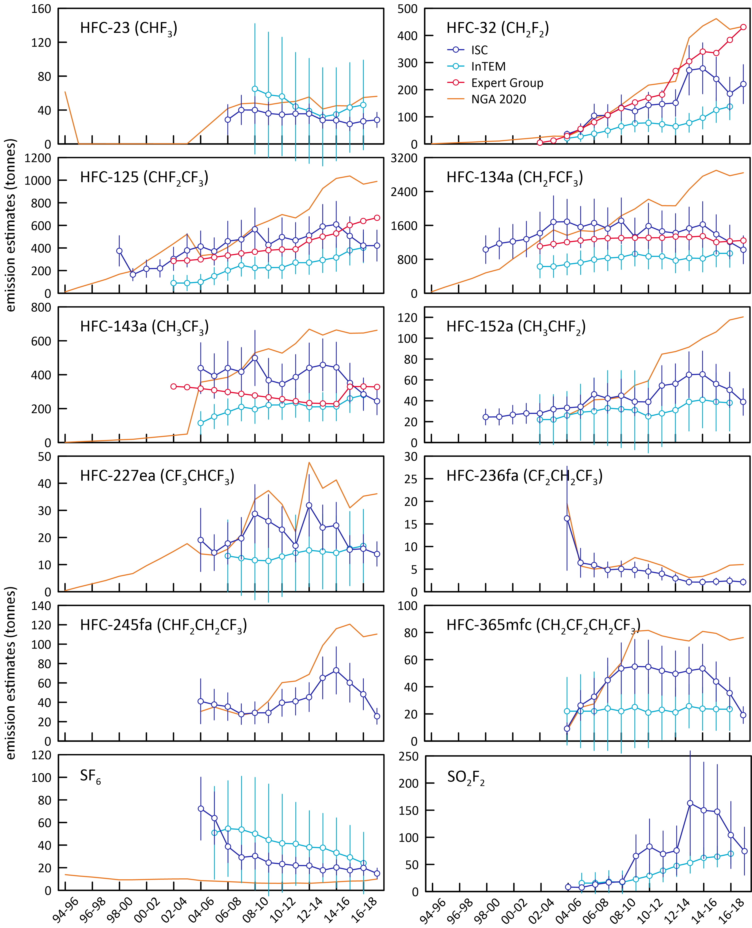

### PFC-14 emissions

SE Australian emissions of PFC-14 (CF4) are evident in the PFC-14 data collected at Cape Grim (Figure 4). The year-to-year variability of the number and intensity of PFC-14 episodes seen at Cape Grim is large, so 3-year averaging is used when deriving PFC emissions from these data (so the latest annual emission calculated from these data is for 2018). Detailed analysis of these PFC-14 pollution episodes shows the Cape Grim PFC-14 pollution originates largely from southern Victoria from the Point Henry and Portland smelters, with some contribution from Bell Bay, Tasmania (Note: The Point Henry smelter closed in July 2014).

The Cape Grim PFC-14 pollution episode data have been used to estimate PFC-14 emissions from these SE Australian smelters. A regional transport model (TAPM – The Air Pollution Model; Hurley, 2008; Hurley *et al.* 2008) is used to calculate emissions in which PFC-14 is released into the model atmosphere from the Point Henry, Portland and Bell Bay locations. For a more detailed description of TAPM see Appendix A.

The NAME transport and InTEM inversion models are used to derive PFC emissions. The current InTEM model domain used to derive emissions is called VextT and incorporates all of Victoria and Tasmania as well as southern and south western New South Wales and eastern South Australia. This domain contains the aluminium smelters at Portland, Point Henry and Bell Bay.

Figure 4. Monthly-mean PFC-14 concentrations observed *in situ* at Cape Grim (dark blue), 2004-2019 PFC-14 pollution episodes (light blue), typically lasting up to 12 hours in duration, are also seen at Cape Grim (Mühle *et al.* 2010).

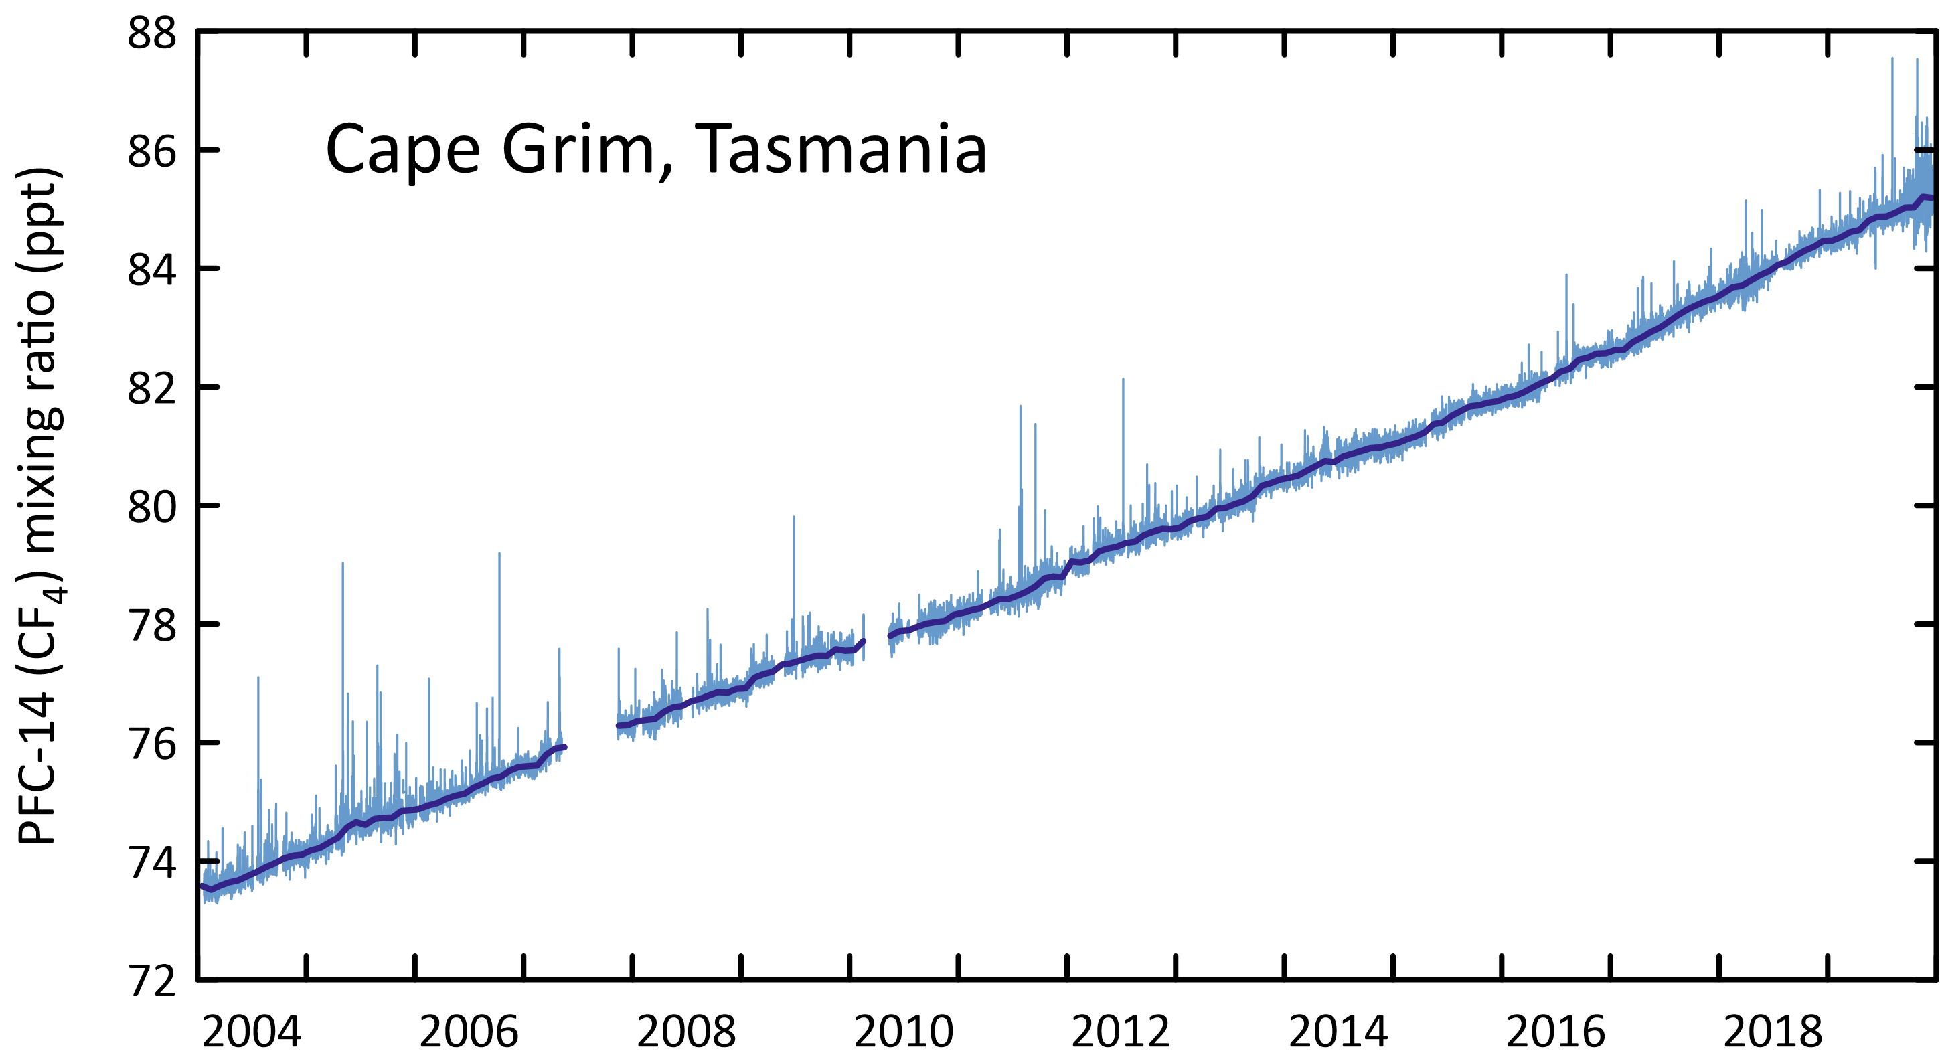

The TAPM and InTEM estimates of regional PFC-14 emissions are scaled to derive Australian emissions on an aluminium production basis. For example, if the PFC-14 emissions derived for the SE Australian smelters, which account for about 35% of Australia’s aluminium production, are assumed to be representative of all Australian aluminium production, then Australian PFC-14 emissions from aluminium production can be derived and compared to emissions in the *National Inventory Report 2018* (DISER 2020) (Figure 5). The emission factors and emissions calculated for the Point Henry, Portland and Bell Bay smelters are shown in Table 5. Australian PFC-14 emission factors as reported in the *National Inventory Report 2018* (DISER 2020) and as derived from atmospheric measurements at Cape Grim using InTEM/TAPM (to 2017) and TAPM (to 2018) modelling are shown in Figure 6.

* PFC-14 emissions estimated using TAPM have averaged around 75 tonnes for the last 6 years. PFC-14 emissions from the Inventory range from 20-30 tonnes per year over the same period.
* Over the period 2009-2018, total PFC-14 emissions in the *Inventory* are about 62% lower than PFC-14 emissions estimated from Cape Grim data (TAPM).
* The fraction of Australian PFC-14 emission seen at Cape Grim has declined significantly since the closure of the Point Henry smelter in 2014.
* The 2016 increase in the PFC-14 TAPM emissions is largely due to increases seen at the Bell Bay smelter. This increase isn’t seen in the InTEM estimates.
* Based on atmospheric data, global emissions of PFC-14 were 14 k tonnes in 2018 (Rigby *et al.* 2014 and Rigby, unpublished data). Australian emissions are therefore estimated to be about 0.6% of global emissions based on TAPM data, and 0.2% based on *Inventory* data. The only significant PFC-14 source in Australia is aluminium production, whereas globally the semiconductor production industry is also a significant source of PFC-14 emissions.
* The Australian emissions derived from atmospheric data prior to 2006, using TAPM or InTEM (VextT) are likely to be underestimated due to the very significant PFC-14 emissions from a single pot-line (#1) at Kurri Kurri, which accounted for nearly half of all Australian PFC emissions from aluminium smelting in 2005. The potline was upgraded in 2006 and this accounts for the dramatic drop in PFC-14 emissions from 2005 to 2006 in the *National Inventory Report*. The large PFC emissions prior to 2006 are not seen in the TAPM estimates of emissions, as they are based on Bell Bay/Pt Henry/Portland data. The NAME inversion, based on the Vic/Tas/NSW domain, uses all pollution episode data, including any Kurri Kurri- or Tomago-affected data that may have impacted on Cape Grim (the Kurri Kurri and Tomago smelters are located in the Hunter Valley, NSW). This is why the Australian PFC-14 estimates in 2005 (182 tonnes) based on the NAME (Vic/Tas/NSW) emissions are significantly greater than the TAPM estimates for 2005 (95 tonnes) (see Figure 5).

Figure 5. Australian emissions of PFC-14 as recorded in the National Inventory Report 2018 (NGA: DISER 2020) and as obtained from TAPM (scaled from Vic/Tas emissions), NAME (scaled from Vic/Tas/NSW emissions) and InTEM (VextT; scaled from a domain that includes Victoria and Tasmania as well as southern and south western New South Wales and eastern South Australia) modelling.

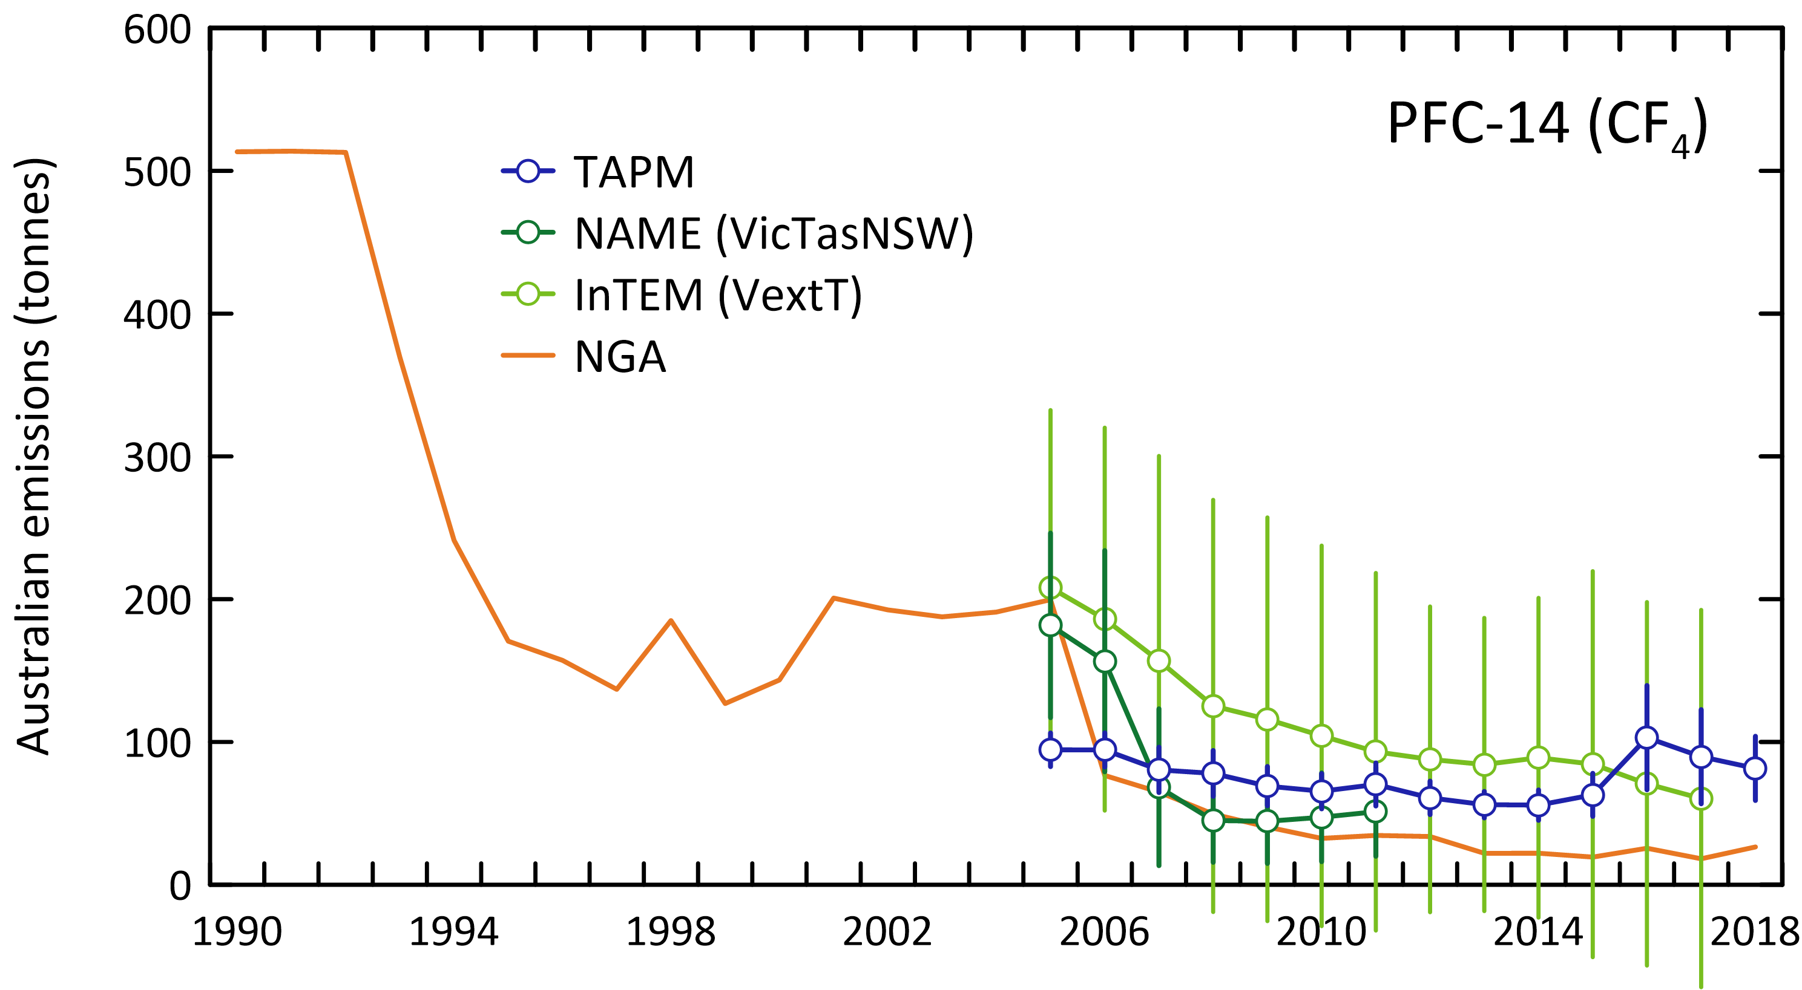

Figure 6. Australian PFC-14 emission factors as reported in the National Inventory Report 2018 (NGA: DISER 2020) and as derived from atmospheric measurements at Cape Grim using TAPM/InTEM (to 2018). The grey band is the average (±1 sd) emission factor derived from TAPM/InTEM. The Kurri Kurri emission factor is based on direct PFC-14 measurements made at the Kurri Kurri smelter in 2009 (Fraser *et al.* 2013).

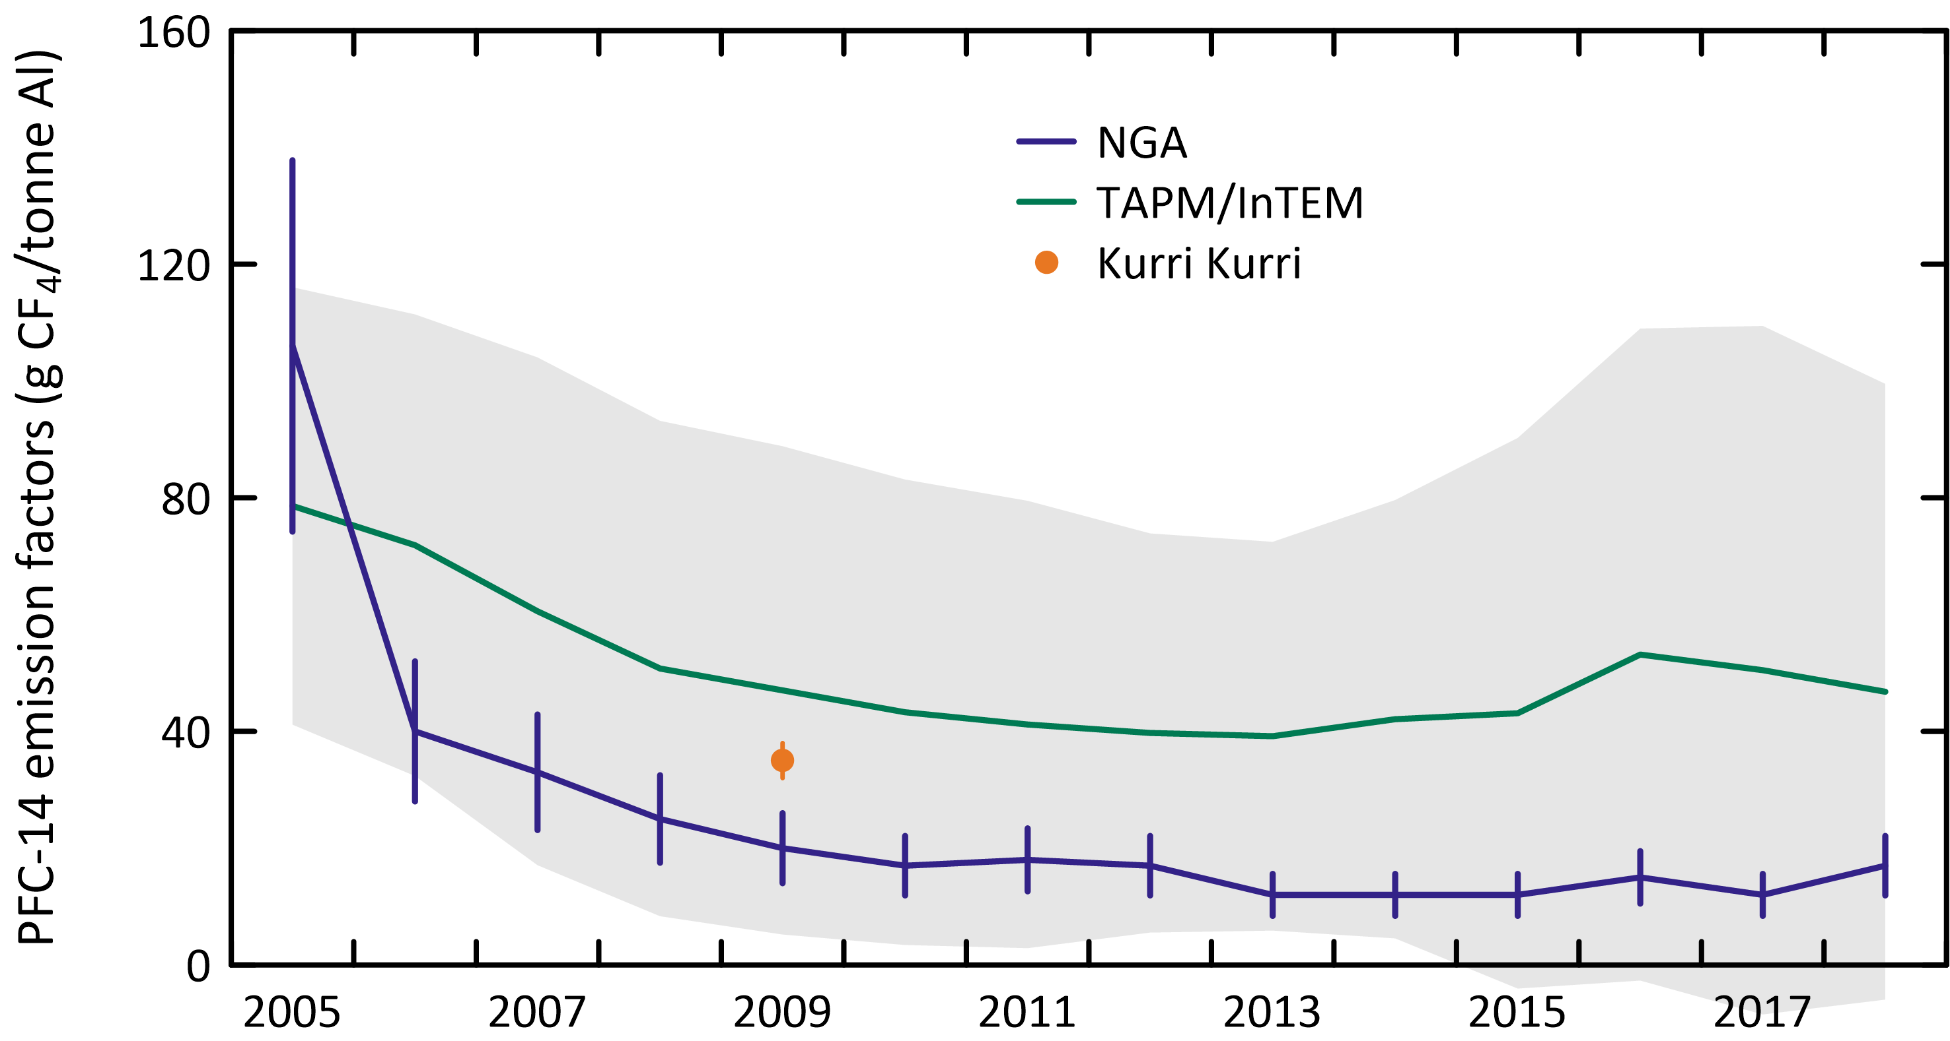

Table 5. Australian PFC-14, PFC-116, PFC-218, PFC-318 emissions (t: tonnes) and PFC-14, PFC-116 emission factors (g/t aluminium, 2005-2018) derived from atmospheric observations – remote (Portland, Pt Henry, Bell Bay) (3-yr averages, e.g. 2010 = average of 2009, 2010, 2011), using the TAPM and InTEM models, directly, at Kurri Kurri.

|  |  |  |  |  |  |  |  |  |  |  |  |  |  |  |
| --- | --- | --- | --- | --- | --- | --- | --- | --- | --- | --- | --- | --- | --- | --- |
| Refrigerant | 2005 | 2006 | 2007 | 2008 | 2009 | 2010 | 2011 | 2012 | 2013 | 2014 | 2015 | 2016 | 2017 | 2018 |
| TAPM emissions (tonnes) |  |  |  |  |  |  |  |  |  |  |  |  |  |  |
| Portland | 18±3 | 18±4 | 14±4 | 15±5 | 12±4 | 12±3 | 12±4 | 10±3 | 10±2 | 12±3 | 15±4 | 18±6 | 11±3 | 12±3 |
| Pt Henry1 | 12±2 | 11±2 | 10±2 | 10±2 | 9±2 | 8±2 | 9±3 | 8±2 | 8±2 | 4±1 |  |  |  |  |
| Bell Bay | 5±1 | 5±1 | 6±3 | 4±2 | 3±2 | 3±2 | 3±2 | 4±2 | 4±2 | 4±2 | 4±2 | 12±9 | 13±8 | 13±6 |
| Australia2 | 95±12 | 94±12 | 80±16 | 78±16 | 69±14 | 65±12 | 70±15 | 61±12 | 56±9 | 56±11 | 63±15 | 103±37 | 90±33 | 82±22 |
| InTEM emissions (tonnes) |  |  |  |  |  |  |  |  |  |  |  |  |  |  |
| PFC-14 | 208±124 | 186±134 | 157±143 | 125±144 | 116±141 | 104±133 | 93±125 | 88±107 | 84±103 | 89±112 | 84±135 | 71±127 | 60±132 | 60±132 |
| PFC-116 | 62±65 | 57±66 | 41±68 | 29±72 | 27±80 | 32±79 | 36±71 | 30±55 | 24±43 | 25±44 | 31±51 | 30±48 | 30±49 | 30±49 |
| PFC-218 | 16±33 | 18±36 | 20±42 | 28±46 | 35±50 | 39±49 | 36±46 | 28±39 | 21±33 | 16±30 | 15±29 | 13±26 | 12±26 | 12±26 |
| ISC emissions (tonnes) |  |  |  |  |  |  |  |  |  |  |  |  |  |  |
| PFC-218 | 7±3 | 6±3 | 9±4 | 6±3 | 7±3 | 12±5 | 13±5 | 11±4 | 7±3 | 7±3 | 8±3 | 7±2 | 6±2 | 6±2 |
| PFC-318 | 17±11c | 17±11c | 17±11c | 17±11c | 17±11 | 13±5 | 16±6 | 14±5 | 11±4 | 8±3 | 8±3 | 8±3 | 10±3 | 9±3 |
| Total PFC emissions ISC | 95±12 | 94±12 | 80±16 | 78±16 | 69±14 | 65±12 | 70±15 | 61±12 | 56±9 | 56±11 | 63±15 | 103±37 | 90±33 | 82±22 |
| CO2-e (k tonnes) | 1044±145 | 1041±145 | 941±165 | 897±165 | 832±155 | 801±115 | 881±135 | 763±105 | 664±85 | 631±90 | 701±120 | 1027±275 | 930±250 | 839±170 |
| CO2-e (M tonnes) | 1.04±0.15 | 1.04±0.15 | 0.94±0.17 | 0.90±0.17 | 0.83±0.16 | 0.80±0.12 | 0.88±0.14 | 0.76±0.11 | 0.66±0.09 | 0.63±0.09 | 0.70±0.12 | 1.03±0.28 | 0.93±0.25 | 0.84±0.17 |
| PFC emission factors |  |  |  |  |  |  |  |  |  |  |  |  |  |  |
| Portland, Victoria | 52±10 | 52±11 | 40±12 | 42±15 | 37±12 | 39±11 | 40±13 | 34±10 | 32±8 | 39±10 | 51±13 | 63±20 | 52±16 | 39±11 |
| Pt Henry, Victoria | 63±12 | 60±11 | 52±11 | 51±9 | 48±10 | 40±11 | 45±13 | 43±11 | 42±8 | 38±8 |  |  |  |  |
| Bell Bay, Tasmania | 31±8 | 30±8 | 32±19 | 22±12 | 19±11 | 19±11 | 19±11 | 19±11 | 19±11 | 19±11 | 19±11 | 63±47 | 69±43 | 71±32 |
| Australia (TAPM)3 | 48±10 | 48±10 | 41±14 | 38±12 | 35±11 | 33±11 | 35±13 | 32±11 | 31±9 | 32±10 | 35±12 | 63±34 | 61±29 | 55±22 |
| Australia (InTEM)4 | 109±65 | 96±69 | 80±73 | 63±73 | 59±72 | 54±69 | 48±64 | 47±58 | 47±58 | 52±65 | 51±82 | 43±78 | 40±88 | 38±84 |
| TAPM/InTEM average | 79±37 | 72±40 | 61±43 | 51±42 | 47±42 | 43±40 | 41±38 | 40±34 | 39±33 | 42±38 | 43±47 | 53±56 | 50±59 | 47±53 |
| Kurri Kurri |  |  |  |  | 35±3d |  |  |  |  |  |  |  |  |  |

1 Pt Henry closure in July 2014

2 Australian emissions scaled from Portland, Pt Henry, Bell Bay emissions by aluminium production

3 TAPM (Portland, Pt Henry, Bell Bay average emissions)/aluminium production

4 InTEM (VextT) emissions/aluminium production

a Australian emissions scaled from Portland, Pt Henry, Bell Bay, Kurri Kurri, Tomago emissions by aluminium production

b C2F6/CF4 = 0.1, Kim *et al.* (2014) c assumed = 2009 emissions d emission factor for 2009 (Fraser *et al.* 2013)

### Other PFC emissions

Figure 7 shows the Australian PFC-116 emissions from the *National Inventory Report 2018*, from PFC-14 emissions (TAPM) assuming a PFC-116/PFC-14 mass emission factor of 0.10±0.01, based on atmospheric observation at Aspendale on the Pt Henry/Portland PFC plumes and on direct measurements on the Kurri Kurri exhaust stack (Fraser *et al.* 2013; Kim *et al.* 2014). The overall agreement between the *Inventory* and the TAPM estimates is reasonably good with average emissions for TAPM 7 tonnes/yr for 2009-2018 and 3.5 tonnes per year for the Inventory for the same period.

Cape Grim observations show that Australian emissions of PFC-218 (ISC) vary from 6-8 tonnes over the last 5 years, with current (2018) emissions for PFC-218 about 6 tonnes. PFC-318 emissions (ISC) vary from 8-10 tonnes over the last 5 years with current emissions of 9 tonnes. There are no significant Australian imports identified for these PFCs. Globally PFC-218 and PFC-318 are used in the electronics industry (etching), in refrigeration, in fire suppression and in medical applications.

Figure 7. Australian PFC-116 emissions from the National Inventory Report 2018 (DISER, 2020) and Australian PFC-116, PFC-218 and PFC-318 from atmospheric measurements at Cape Grim using InTEM, TAPM and ISC modelling; error bars are ± sd. Australian PFC-116 (InTEM) are from the VextT domain data scaled by aluminium production, PFC-116 (TAPM) are from Australian TAPM PFC-14 emissions (Table 5) and the observed PFC-116/PFC-14 ratio (0.10±0.01) in Australian smelter plumes; PFC-218 and PFC-318 are from InTEM and ISC, with Australian emissions obtained from regional emissions by population scaling.

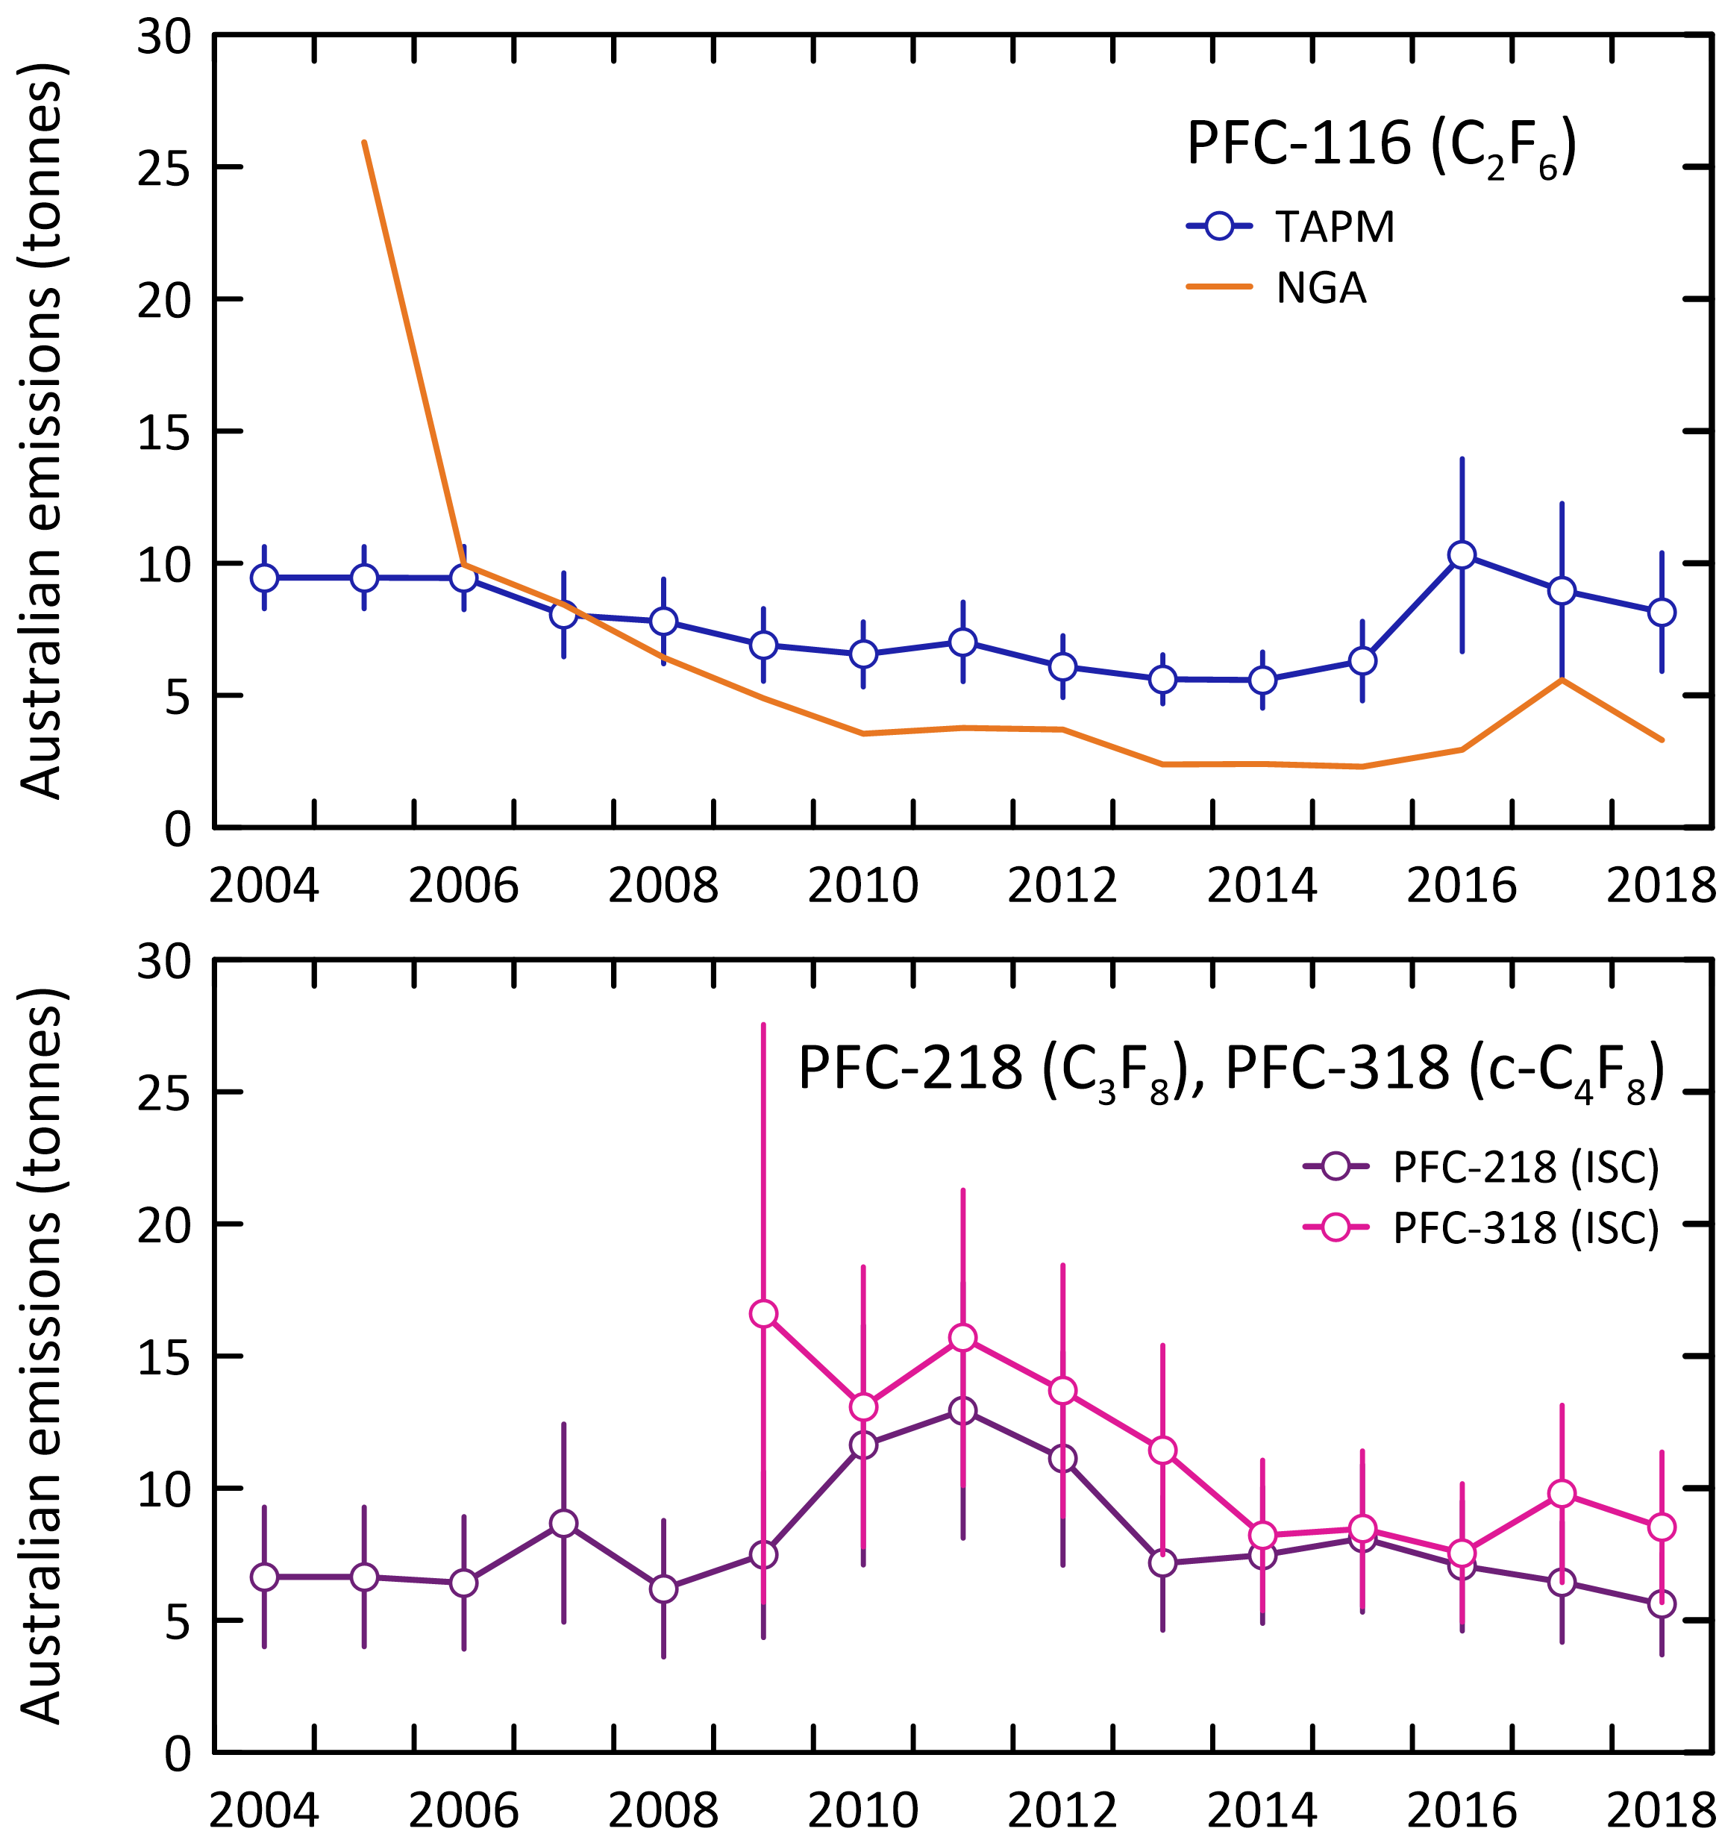

## Comparisons of NGA, ISC and InTEM emission estimates

As mentioned in section 2, the HFC *Inventory* estimates for 2006-2018 have been revised in the *National Inventory Report 2017* (DoEE 2019) and the *National Inventory Report 2018* (DISER 2020). Two significant changes have been implemented for determining HFC emissions in the Inventory. These changes have resulted in reduced differences between the Cape Grim emission estimates and the Inventory estimates, although differences still exist.

* The first change is that the annual leak rates are calibrated to the CSIRO HFC emissions estimates for all equipment types from 2006 onwards.
* The second change to the method is CSIRO species data is used to modify the species percentages each year from 2006 onwards.

The Department of Industry, Science, Energy and Resources, which produces the Inventory, has indicated that it will be reviewing its methodology in future to further reduce differences between the Inventory and Cap Grim emission estimates.

### HFC-134a

The major HFC in the *Inventory* (ageis.climatechange.gov.au; DISER 2020) is HFC-134a, with emissions in 2018 determined to be 2,842 tonnes (Table 3).

* Based on Cape Grim data, Australian emissions of HFC-134a in 2018 were 1,024 tonnes (ISC), 64% lower than reported in the *Inventory* (Table 3, Figure 3).
* For the 10-year period 2009-2018, the average Australian emissions of HFC-134a calculated from Cape Grim data (ISC, 1,427 tonnes/yr) are about 40% lower than the *Inventory* (2389 tonnes/yr; DISER 2020).

Cape Grim data suggest that Australian emissions of HFC-134a peaked in 2009 at 1,709 tonnes and are now in decline, decreasing 40% from 2009 to 2018. The *Inventory* show increasing emissions through to 2018, with emissions growing by 55% from 2009-2018.

* Over the period 2009-2018, Cape Grim data suggest total HFC-134a emissions of 14 k tonnes (ISC) compared to the *Inventory* total of 24 k tonnes which is a factor of 1.7 higher. This is a big improvement from the report (Dunse *et al.* 2018; a factor of 2.3 higher, prior to the revision of the *Inventory* estimates).
* The revised *Inventory* estimates (see section 2) better reflect the year to year variability of the use of individual HFCs and the difference in magnitude between the Cape Grim estimates and the Inventory estimates has been reduced. However, the Inventory estimates are still substantially larger than Cape Grim estimates for HFC-134a.

The InTEM estimates have recently been revised (Redington & Manning 2018 and Redington, unpublished data) which has led to reduced agreement in InTEM and ISC estimates for all HFCs, including HFC-134a. In last year’s report (Dunse *et al.* 2019), ISC and InTEM total HFC-134a emissions for the period 2009-2017 agreed to within 13%. For the revised estimates, InTEM total emissions are 40% lower than ISC total emissions for the same time period. This reduced agreement will be investigated for next year’s report.

Based on atmospheric data, global emissions of HFC-134a were 238 k tonnes in 2018 (Rigby *et al.* 2014 and Rigby, unpublished data). Australian emissions are therefore estimated to be about 0.4% of global emissions based on Cape Grim data, and 1.2% based on *Inventory* data.

* Cape Grim ‘sees’ largely winter emissions of HFC-134a emissions from the Melbourne/Port Phillip region; this could offer a partial explanation of the large difference between Australian emissions of HFC-134a calculated from Cape Grim data and as reported in the *Inventory*.

### HFC-125

The next major HFC emitted into the Australian environment is HFC-125 with current (2018) emissions estimated to be about 989 tonnes in the *Inventory*.

* Based on Cape Grim data, Australian emissions of HFC-125 in 2018 were 421 tonnes (ISC), about 57% lower than the *Inventory* data.
* For the 10-year period 2009-2018, the average Australian emissions of HFC-125 calculated from Cape Grim data (ISC, 500 tonnes/yr) are about 39% lower than the *Inventory* (827 tonnes/yr; DISER 2020).

HFC-125 emissions based on Cape Grim data (421 tonnes in 2018), are similar to 2017 emissions. Emissions appear to have stabilised following a rapid increase in HFC-125 emissions which occurred from 2013-2015 (35%) likely due to the popularity of HFC-125 in newer air-conditioning systems as part of the refrigerant blend R410A.

Over the period 2009-2018, Cape Grim data suggest total HFC-125 emissions of 5.0 k tonnes (ISC) compared to the current *Inventory* total of 8.3 k tonnes, a factor of 1.7 higher, an improvement from previous estimates which were a factor of 2.3 higher (Dunse *et al.* 2018).

As mentioned previously, the InTEM estimates have recently been revised. In last year’s report (Dunse *et al.* 2019), ISC and InTEM total HFC-125 emissions for the period 2009-2017 agreed to within 1.6%. For the revised estimates, InTEM total emissions are 43% lower than ISC total emissions for the same time period. This reduced agreement will be investigated for next year’s report.

Based on atmospheric data, global emissions of HFC-125 were 78 k tonnes in 2018 (Rigby *et al.* 2014 and Rigby unpublished data). Australian emissions are therefore estimated to be 0.5% of global emissions based on ISC data, and 1.3% based on *Inventory* data.

### HFC-143a

According to the *Inventory* (Table 3), the next major HFC emitted into the Australian environment is HFC-143a with current (2018) emissions of 662 tonnes.

* Based on Cape Grim data, Australian emissions of HFC-143a in 2018 were about 244 tonnes (ISC), about 63% lower than the *Inventory* estimates.
* For the 10-year period 2009-2018, the average Australian emissions of HFC-143a calculated from Cape Grim data (ISC, 382 tonnes/yr) are about 37% lower than the *Inventory* (611 tonnes/yr; DISER 2020).

Over the period 2009-2018, Cape Grim data suggest total HFC-143a emissions of 3.8 k tonnes (ISC) compared to the *Inventory* total of 6.1 k tonnes, a factor of 1.6 higher.

In last year’s report (Dunse *et al.* 2019), ISC and InTEM total HFC-143a emissions agreed to within 1.6% for the period 2009-2017. For the latest estimates, InTEM total emissions are 43% lower than ISC total emissions for the same time period.

Based on atmospheric data, global emissions of HFC-143a were 29 k tonnes in 2018 (Rigby *et al.* 2014 and Rigby, unpublished data). Australian emissions are therefore estimated to be about 0.8% of global emissions based on ISC data, and 2.3% based on *Inventory* data.

### HFC-32

HFC-32 emissions based on Cape Grim data (221 tonnes in 2018), increased by 19% compared to 2017 emissions. Emissions appear to have stabilised following a rapid increase in HFC-32 emissions which occurred from 2013-2015 (85%) likely due to the popularity of HFC-32 in newer air-conditioning systems on its own and as part of the refrigerant blend R410A.

* Based on Cape Grim data, Australian emissions of HFC-32 in 2018 were about 221 tonnes (ISC), about 49% lower than the *Inventory* estimate (434 tonnes).
* For the 10-year period 2009-2018, the average Australian emissions of HFC-32 calculated from Cape Grim data (ISC, 189 tonnes/yr) are about 40% lower than the *Inventory* (314 tonnes/yr).

Over the period 2009-2018, Cape Grim data suggest total HFC-32 emissions of 1.9 k tonnes (ISC) compared to the *Inventory* total of 3.1 k tonnes, a factor of 1.6 higher.

Based on atmospheric data, global emissions of HFC-32 were 50 k tonnes in 2018 (Rigby *et al.* 2014 and Rigby, unpublished data). Australian emissions are therefore estimated to be 0.4% of global emissions based on ISC data, and 0.9% based on *Inventory* data.

### HFC-152a

The 2018 HFC-152a emissions have been estimated from Cape Grim data at 39 tonnes (ISC), the lowest HFC-152a emissions have been since 2011. The data suggest that HFC-152a emissions may have peaked in 2015 at 66 tonnes.

* Estimates of HFC-152a emissions were included in the *Inventory* for the first-time last year (DoEE, 2019), with an estimate for 2018 of 120 tonnes (DISER 2020).
* For the 10-year period 2009-2018, the average Australian emissions of HFC-152a calculated from Cape Grim data (ISC, 51 tonnes/yr) are about 50% lower than the *Inventory* (86 tonnes/yr).

The primary uses for HFC-152a are as an aerosol propellant, as an alternative to CFC-11 and CFC-12 in foam expansion and as a component of some refrigerant blends. Imports of HFC-152a into Australia were 21 tonnes in 2018 and 34 tonnes in 2019 (Table 2), on average 40% lower than 2015 imports.

Based on atmospheric data, global emissions of HFC-152a were 54 k tonnes in 2018 (Rigby *et al.* 2014 and Rigby unpublished data). Australian emissions are therefore estimated to be about 0.07% of global emissions based on ISC data, and 0.2% based on *Inventory* data.

### HFC-23

The HFC-23 emission estimate for 2018 in the *Inventory* is 56 tonnes.

* The 2018 emissions have been estimated from Cape Grim data at 28 tonnes (ISC), dropping steadily from 40 tonnes in 2009.
* HFC-23 imports averaged 0.9 tonnes per year from 2011-2016, then imports increased to average 5 tonnes per year from 2017 to 2019.
* For the 10-year period 2009-2018, average Australian emissions of HFC-23 calculated from Cape Grim data (ISC, 32 tonnes/yr) are about 35% lower than the *Inventory* (49 tonnes/yr). Over the same period, Cape Grim data suggest total HFC-23 emissions of 0.32 k tonnes (ISC) compared to the *Inventory* total of 0.49 k tonnes, a factor of 1.5 higher.

Based on atmospheric data, global emissions of HFC-23 were 16 k tonnes in 2018 (Rigby *et al.* 2014 and Rigby, unpublished data). Current Australian emissions are therefore estimated to be about 0.2% of global emissions based on ISC data, and 0.35% based on the *Inventory*.

The origin of Australian HFC-23 emissions is unknown. HFC-23 is a component of the R-508 series of refrigerants, but significant imports of R-508 refrigerants into Australia have not been recorded.

* RRA (M. Bennett, private communication, 2014) is not aware of any significant historical use of R-508 refrigerants in Australia. RRA in their refrigerant reclaim operation have collected only one cylinder of R-508 from a CSIRO instrument testing laboratory in Sydney. Thus, it is unlikely that the unaccounted for HFC-23 is from past or current use of R-508 refrigerants in Australia.

Aspendale atmospheric data on HFC-23 (unpublished) show a significant, but small concentration maximum in the direction NE of Aspendale (as do HFC-134a, HFC-32, HFC-125 etc.). This suggests that HFC-23 is in the general mix of refrigerant/firefighting emissions from Melbourne, but has not been identified, in any significant amounts, in any Australian imports.

One possible explanation is that HFC-23 is present in refrigerant blends as a contaminant – for example with blends containing HFC-32. It is possible that over fluorination during the production of HFC-32 could produce HFC-23 and that the resultant refrigerant blends using HFC-32 could contain small amounts of HFC-23.

Although global emissions of HFC-23 are on the increase (Stanley *et al.* 2020), in Australia we see a steady decline in HFC-23 emissions since 2009 (about 4% per year).

### HFC-227ea

The 2018 emissions from Cape Grim data have been estimated at 14 tonnes (ISC). The HFC-227ea emissions are quite variable, ranging from 14 tonnes in 2006 up to a peak of 32 tonnes in 2013. Imports are also variable with 20 tonnes of HFC-227ea were imported in 2018 and 9 tonnes imported in 2019 (Table 2). HFC-227ea is a gaseous fire suppression agent used as a replacement for Halon 1301.

HFC-227ea emissions are estimated in the *Inventory* to be 36 tonnes in 2018.

* Australian emissions of HFC-227ea from Cape Grim data in 2018 are about 60% lower than the *Inventory* data.
* For the 10-year period 2009-2018, the average Australian emissions of HFC-227ea calculated from Cape Grim data (ISC, 22 tonnes/yr) are about 37% lower than the *Inventory* (35 tonnes/yr).

Over the period 2009-2018, Cape Grim data suggest total HFC-227ea emissions of 0.22 k tonnes (ISC) compared to the *Inventory* total of 0.36 k tonnes, a factor of 1.6 higher.

Based on atmospheric data, global emissions of HFC-227ea were 5.1 k tonnes in 2018 (Rigby *et al.* 2014 and Rigby, unpublished data). Australian emissions are therefore estimated to be about 0.3% of global emissions based on ISC data and 0.7% based on *Inventory* data.

### HFC-236fa, HFC-245fa, HFC-365mfc

HFC-236fa is a clean agent fire suppressant used as a replacement for Halon 1211 in portable fire extinguisher applications. HFC-245fa is used as a blowing agent for plastic foam insulation and is used as a replacement for HCFC-141b. HFC-365mfc is also used as a blowing agent for plastic foam insulation and is a replacement for HCFC-141b.

2018 emissions for HFC-236fa, HFC-245fa and HFC-365mfc have been estimated (ISC) from Cape Grim data at about 2 (steady), 26 (declining) and 19 tonnes (declining) respectively.

* From 2017-2018, both HFC-245fa and HFC-365mfc emissions decreased by 46%.
* In 2018, 0.08, 31 and 34 tonnes of HFC-236fa, HFC-245fa and HFC-365mfc respectively were imported into Australia (Table 2); in 2019 the imports were 0.05, 45 and 46 tonnes respectively.

In 2018, HFC-236fa emissions are estimated in the *Inventory* to be 6 tonnes and from Cape Grim data, 2 tonnes (ISC), dropping steadily from 40 tonnes in 2009.

* For the 10-year period 2009-2018, the average Australian emissions of HFC-236fa calculated from Cape Grim data (ISC, 3 tonnes/yr) compare well with the *Inventory* (5 tonnes/yr).
* HFC-236fa imports have never exceeded 0.2 tonnes per year, but emissions have ranged from 2-6 tonnes per year since 2006 suggesting unrecorded HFC-236fa imports or emissions from banks.

Australian emissions of HFC-245fa from Cape Grim data in 2018 (ISC, 26 tonnes) are about 76% lower than the *Inventory* data (110 tonnes).

* For the 10-year period 2009-2018, the average Australian emissions of HFC-245fa calculated from Cape Grim data (ISC, 46 tonnes/yr) are about 43% lower than the *Inventory* (81 tonnes/yr).
* Imports of HFC-245fa are in decline from peak imports of 290 tonnes in 2009 to 45 tonnes in 2019.

Australian emissions of HFC-365mfc from Cape Grim data in 2018 (ISC, 19 tonnes) are about 75% lower than the *Inventory* data (76 tonnes).

* For the 10-year period 2009-2018, the average Australian emissions of HFC-365mfc calculated from Cape Grim data (ISC, 47 tonnes/yr) are about 38% lower than the *Inventory* (76 tonnes/yr).
* Imports of HFC-365mfc have declined from peak imports of 250 tonnes in 2011 to 46 tonnes in 2019.

Current emissions (ISC) of HFC-236fa and HFC-365mfc are not inconsistent with imports with total emissions 2016-2018 being 232 tonnes and total imports being 283 tonnes.

Based on atmospheric data, global emissions of HFC-236fa, HFC-245fa and HFC-365mfc were 0.34, 13 and 4.9 k tonnes respectively in 2018 (Rigby *et al.* 2014 and Rigby, unpublished data). Australian emissions are therefore estimated to be about 0.6%, 0.2% and 0.4% of global emissions based on Cape Grim data.

### Total HFCs

Total HFC emissions (Table 4), based on Cape Grim observations (ISC) have grown from about 1,900 tonnes in 2005 to a peak of 3,200 tonnes in 2015, dropping to around 2,000 tonnes in 2018.

* Total HFC emissions in 2018 (ISC) are about 62% lower than in the *Inventory*, with the discrepancy shared fairly equally between the major HFCs.
* Over the period 2005-2018, total HFC emissions in the *Inventory* are 45% higher than total emissions based on Cape Grim data (ISC).

Total HFC emissions in the *Inventory* in 2018 are 12 Mt CO2-e, higher (around 150%) than emissions (4.7 Mt CO2-e, ISC) based on Cape Grim data (Table 3, Table 4, Figure 8).

* Over the period 2005-2018, the total HFC emissions in the *Inventory* are 126 Mt CO2-e, compared to 91 Mt CO2-e (38% higher) from Cape Grim data (ISC).

Total global HFC emissions were 489 k tonnes in 2018, rising by 19 k tonnes/yr since 1995; total global HFC emissions in 2018 were 0.4% lower than in 2017 (Rigby *et al.* 2014 and Rigby, unpublished data). Further data will be needed to determine if this is a sustained decline.

* Two of the major HFCs (HFC-134a, HFC-143a) decreased from 2017 to 2018: 1.2% and 3.3% respectively;
* there was no change in HFC-32 emissions and HFC-125 emissions increased by 1.3%.
* Global emissions of HFC-152a peaked in 2011 at 54 k tonnes/yr and were in decline but have now rebounded to 54 k tonnes/yr in 2018.
* HFC-23 global emissions increased by 7% from 2017 to 2018.
* Based on Cape Grim data (ISC), Australian emissions are 0.4% of global HFC emissions or 1.1% based on the *Inventory* data.

Figure 8. Australian emissions of HFCs (-125, -134a, -143a, -23) and other HFCs (-32, -152a, -227ea, -236fa, -245fa, -365mfc) estimated from atmospheric data (ISC) measured at Cape Grim, and in the Inventory (DISER 2020), expressed in units of M tonne CO2-e.

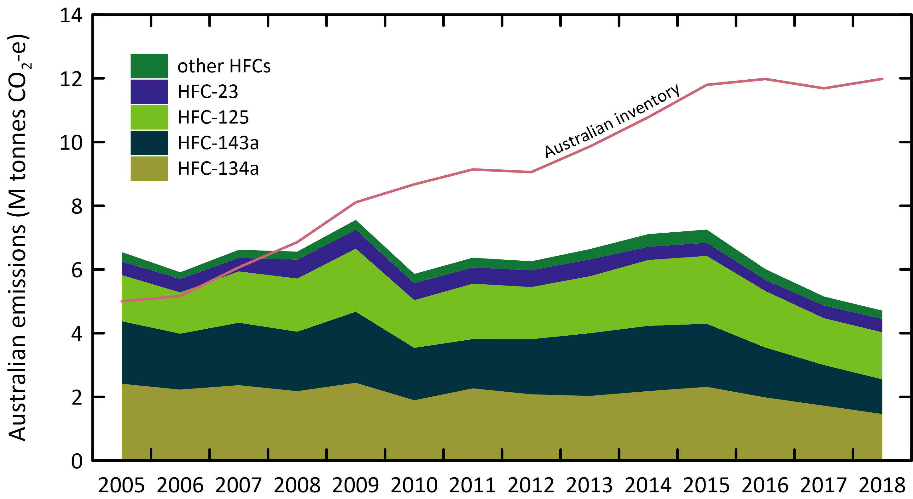

### Sulfur hexafluoride

Australian Sulfur hexafluoride emissions in the *Inventory* are 10 tonnes in 2018, up slightly on 8.3 tonnes in 2017 (Table 3, Figure 3). Estimated emissions using Cape Grim data (ISC: Table 4, Figure 3) are 72 tonnes in 2005, decreasing to a low of 15 tonnes in 2018, an overall decrease of about 11% per year. In CO2-e terms sulfur hexafluoride emissions have fallen by 1.3 Mt CO2-e, from 1.65 Mt CO2-e in 2005 to 0.34 Mt CO2-e in 2018 based on Cape Grim data, whereas in the *Inventory* sulfur hexafluoride emissions have increased from 0.20 to 0.23 Mt CO2-e over the same period.

Over the period 2009 – 2018, the Cape Grim data show that Australian sulfur hexafluoride emissions have declined overall by 50% (30 tonnes to 15 tonnes) however *Inventory* sulfur hexafluoride emissions have increased by 56% over the same period (6.4 tonnes to 10.0 tonnes).

Despite this difference, *Inventory* emissions are significantly lower than emissions estimated from Cape Grim data over the same period. Sulfur hexafluoride emissions in the inventory average 7 tonnes per year, about a factor of 3 lower than estimates from Cape Grim (ISC) over the same period (21 tonnes per year).

From the latest InTEM estimates available, total emissions (2009-2017; 339 tonnes) are 71% higher than ISC total emissions (198 tonnes) over the same time period.

The Australian sulfur hexafluoride emissions from atmospheric data and in the Inventory, and sulfur hexafluoride import data, are shown in Figure 9.

Global sulfur hexafluoride emissions have been increasing steadily from about 3 k tonnes per year in the late-1970s to 9 k tonnes per year in 2018 (an increase of around 0.15 k tonnes/yr) (Rigby *et al.* 2014, Rigby, unpublished data). Australian emissions are estimated to be about 0.2% of global emissions (ISC), but < 0.1% based on the *Inventory* data. It would be unusual for Australian emissions of a widely used industrial chemical to be <0.1% of global emissions.

Figure 9. Australian and global sulfur hexafluoride imports and emissions (tonnes) from Cape Grim data using ISC and InTEM (Ganesan *et al.* 2014; Rigby *et al.* 2014) and from the Inventory (NGA: DISER 2020).

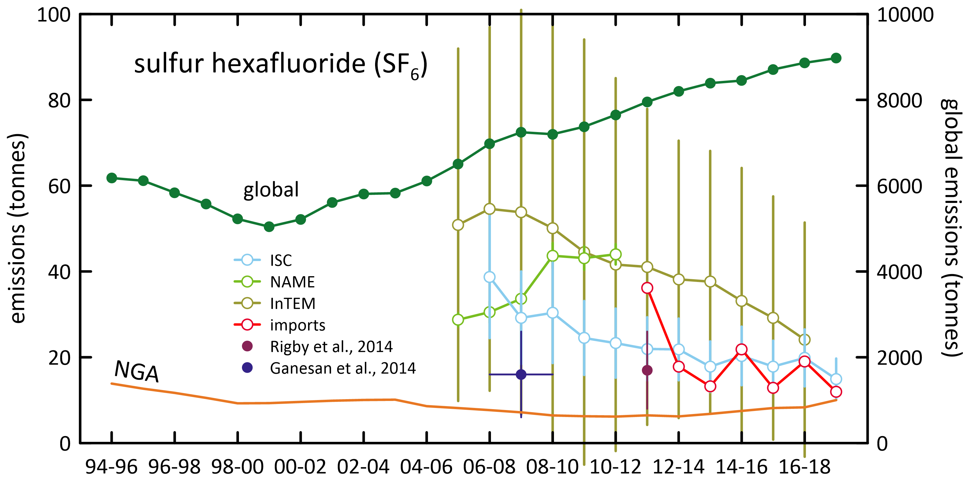

### Sulfuryl fluoride

Based on Cape Grim data (ISC), Australian sulfuryl fluoride emissions averaged 13 tonnes/yr from 2005-2009, but then increased to 163 tonnes in 2013 (Table 4, Figure 10). This may reflect a change in grain fumigation practices away from using methyl bromide and phosphine. By 2018, emissions had declined to 75 tonnes.

Global sulfuryl fluoride emissions were around 1 k tonne per year in the late-1970s, reaching a peak of 3.0 k tonnes per year in 2013 and 2016, then declining to 2.8 k tonnes per year in 2018 (Rigby *et al.* 2014 and Rigby, unpublished data). There is significant year to year variability in emissions, presumably due to the global demand for sulfuryl fluoride being dependant on, in part, variable global grain production. Australia is responsible for 3% of global wheat production, but 10-15% of wheat exports. Sulfuryl fluoride emissions are more closely related to wheat production (grain storage in Australia’s interior) than to wheat export (grain storage at export ports, fumigated with methyl bromide).

In CO2-e terms, sulfuryl fluoride emissions reached 373 k tonnes CO2-e in 2018, compared to 340 k tonnes CO2-e for sulfur hexafluoride, 839 k tonnes CO2-e for PFCs and 4709 k tonnes CO2-e for HFCs. By this metric, Australian sulfuryl fluoride emissions are now more than 44% of the radiative forcing of PFCs.

Figure 10. Australian sulfuryl fluoride emissions (tonnes), scaled from SE Australian emissions based on grain production, derived from Cape Grim *in situ* data, using ISC and InTEM techniques; global emissions (tonnes) are from Rigby *et al.* 2014; Rigby, unpublished data.

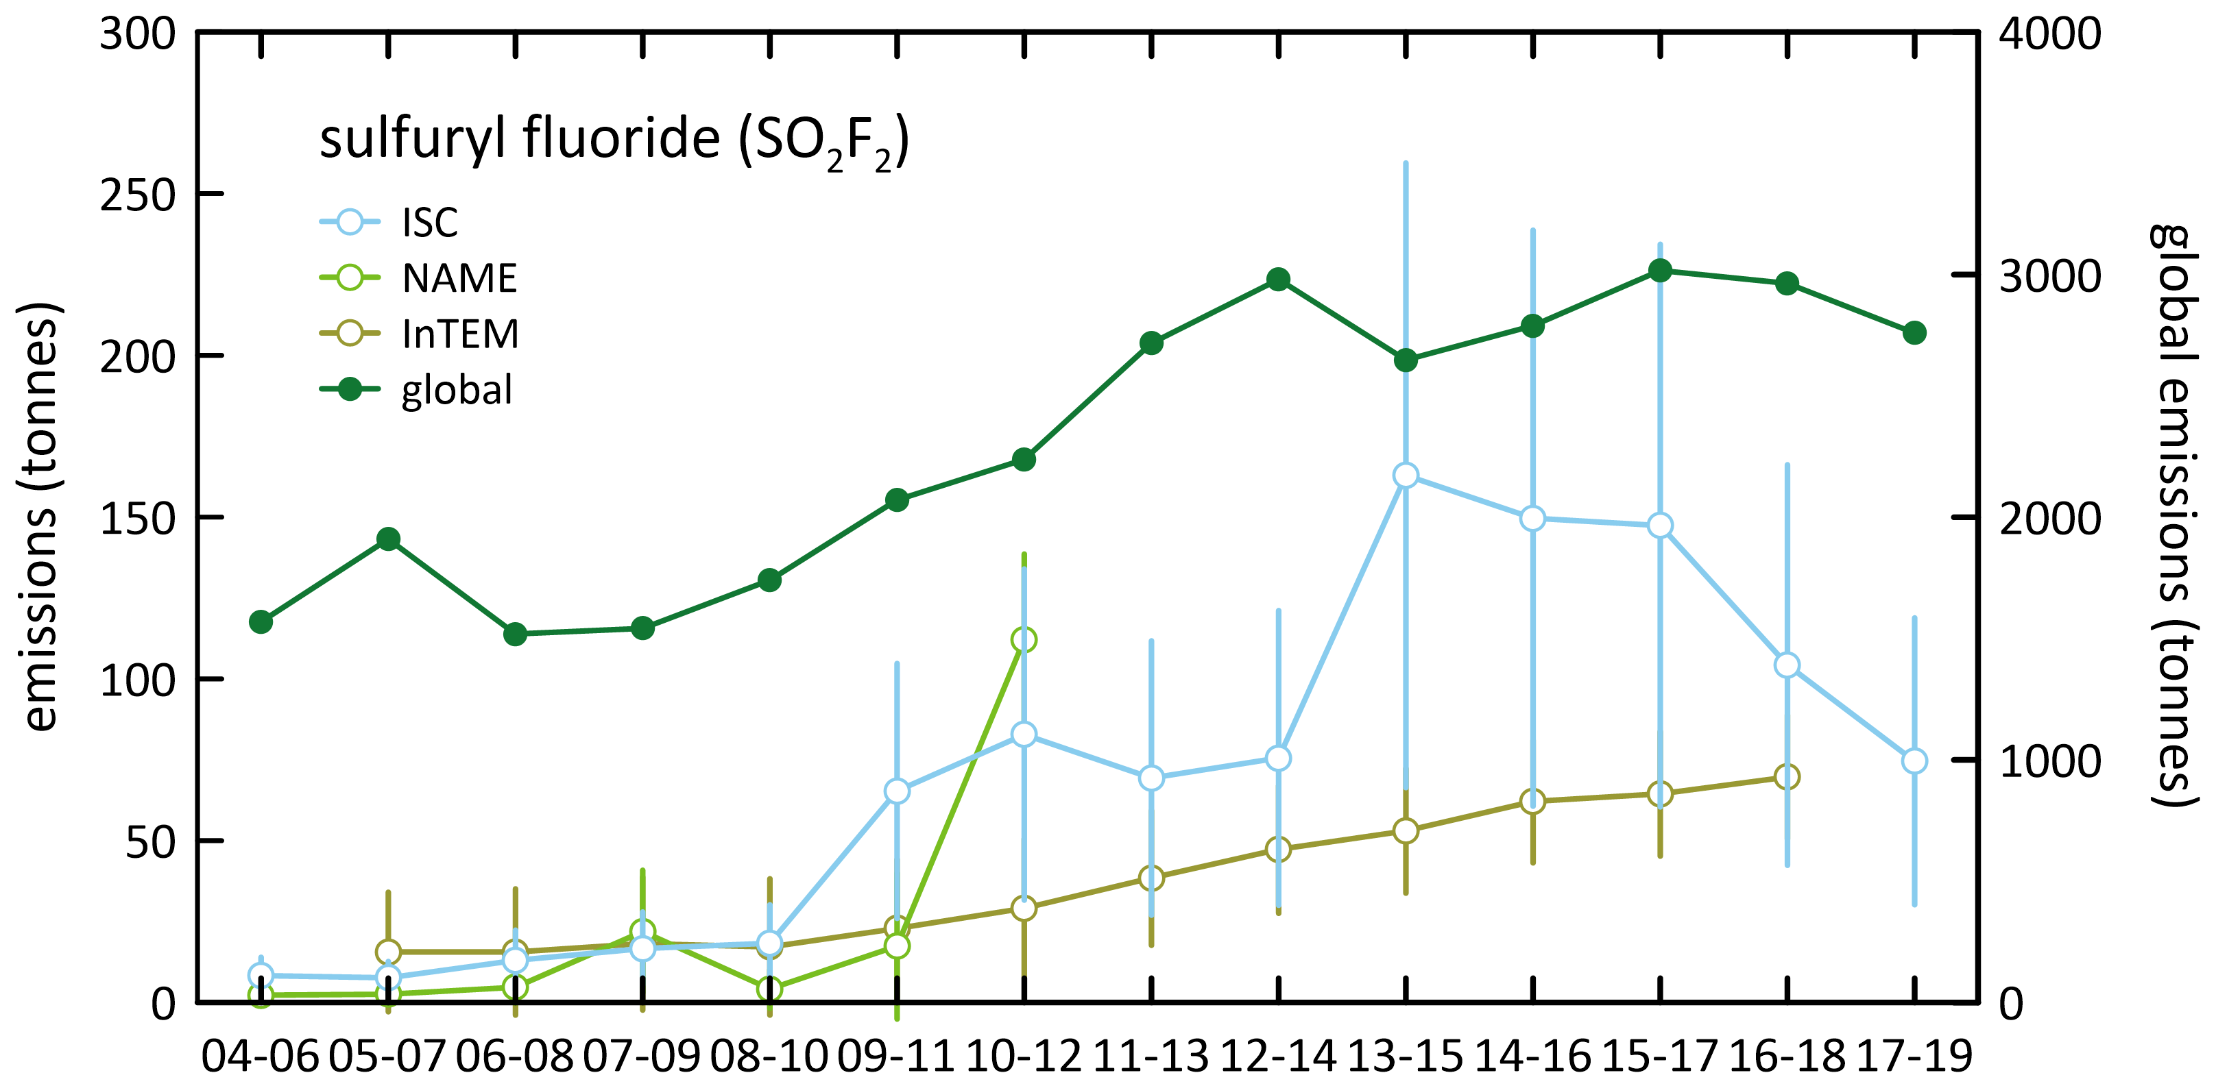

### Total HFC, PFC and sulfur hexafluoride emissions

Total HFC, PFC and sulfur hexafluoride emissions in CO2-e from Cape Grim data are shown in Table 4 and Figure 11.

* For 2018, total Australian HFC, PFC and sulfur hexafluoride emissions in the *Inventory* are 12.5 M tonnes CO2-e, 110% higher than estimates based on Cape Grim data of 5.9 M tonnes CO2-e (ISC).
* Over the period 2009-2018, the average *Inventory* estimates of emissions are 40% higher than estimates of emissions based on Cape Grim data (ISC).
* For PFCs and sulfur hexafluoride, the atmospheric data give higher estimates of emissions than in the *Inventory*. For HFCs, the atmospheric data give lower estimates of emissions than the *Inventory*.

Cape Grim data suggest that the combined Australian emissions of HFCs, PFCs and sulfur hexafluoride have declined 2% per year since 2005. The *Inventory* shows that although emissions stabilised somewhat in the last few years, over all they have grown at 6% per year since 2005.

In 2018, Australian total HFC, PFC and sulfur hexafluoride emissions estimated from Cape Grim data (2,231 tonnes, ISC) are 0.4 % of global emissions (516 k tonnes).

Global emissions of nitrogen trifluoride (controlled by the UNFCCC since 2013) have been estimated from AGAGE global data (including Cape Grim data) by inverse modelling up to 2018. Nitrogen trifluoride emissions were first observed in the mid-1990s, growing at 0.09 k tonnes/yr since 1995 to 2.4 k tonnes in 2018. The 2017-2018 increase was 4.3%.

Total global HFC, PFC, sulfur hexafluoride and nitrogen trifluoride emissions have risen (12 k tonnes/yr, largely HFCs) from about 30 k tonnes per year in the late-1970s to around 519 k tonnes per year in 2018 (Figure 12; Rigby *et al.* 2014 and Rigby, unpublished data). Emissions decreased by 0.4% from 2017-2018, the first decrease since the early 1990’s. Further data will be needed to determine if this is a sustained decline.

Figure 11. Australian HFC, PFC, sulfur hexafluoride emissions calculated from Cape Grim observations (ISC) and the Inventory ([available at the NGA website](https://ageis.climatechange.gov.au)) in M tonne CO2-e.

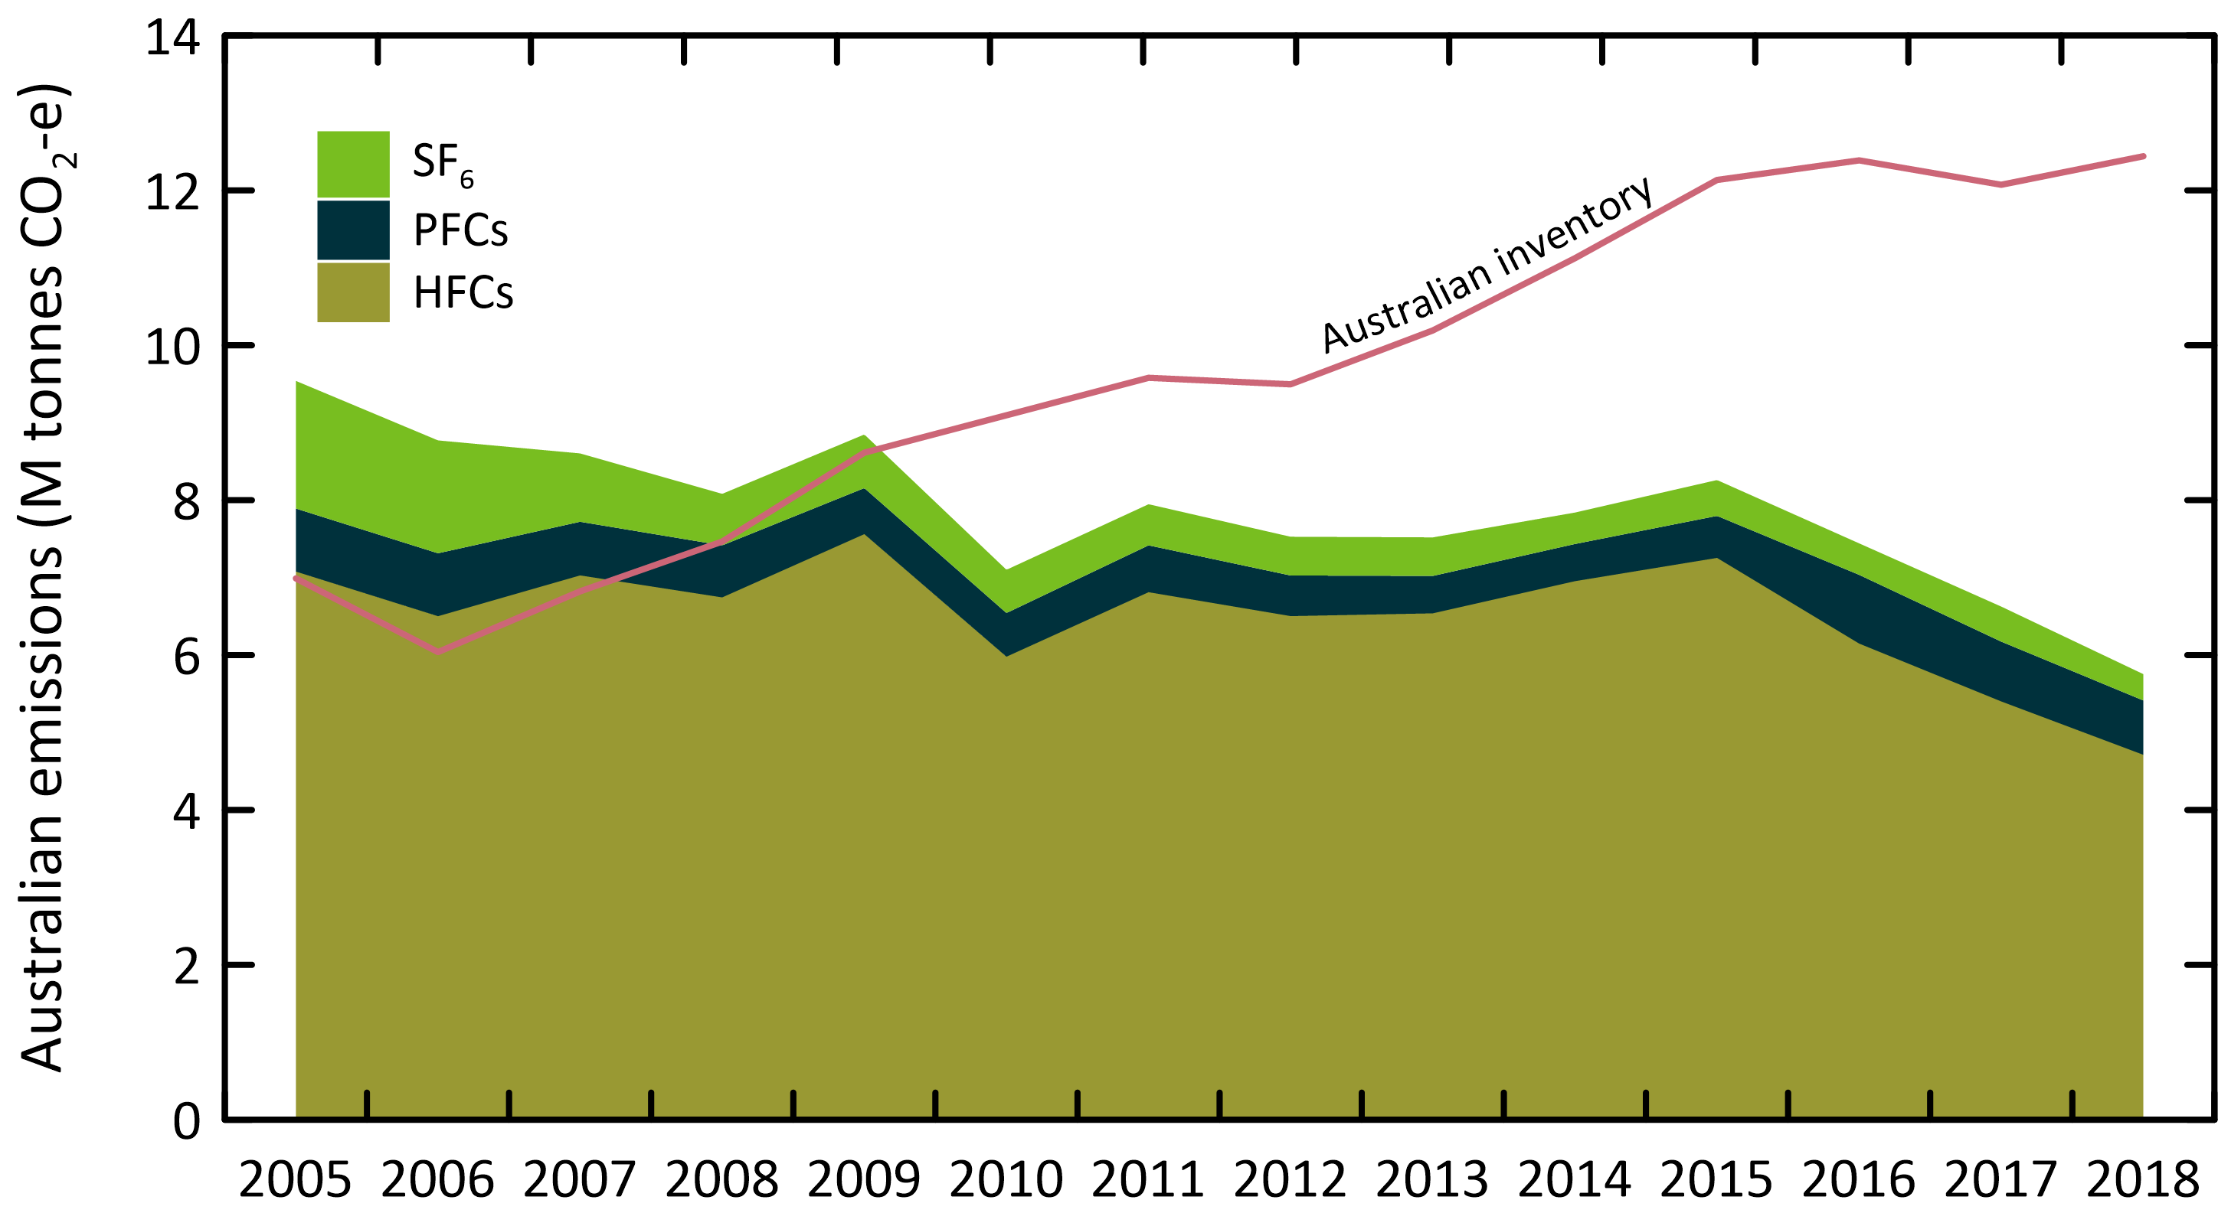

Figure 12. Global HFC, PFC, sulfur hexafluoride and nitrogen trifluoride emissions (left: k tonnes; right: M tonnes CO2-e) from global AGAGE atmospheric measurements (Rigby *et al.* 2014 and unpublished data 2019). CO2-e emission estimates use GWPs from the IPCC 4th Climate Assessment (AR4 GWPs).

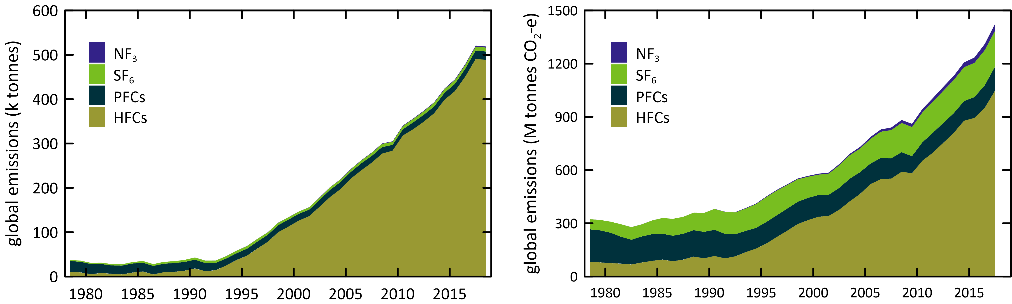

## Appendix A

The NAME (Numerical Atmospheric Dispersion Modelling Environment) particle dispersion model coupled to the InTEM (Inversion Technique for Emission Modelling) inversion model (O’Doherty *et al.* 2009; Manning *et al.* 2003, 2011; Redington & Manning 2018) is used to calculate HFC, PFC, sulfur hexafluoride and sulfuryl fluoride emissions. NAME is a Lagrangian particle dispersion model driven by 3-dimensional wind fields from numerical weather predictions models. NAME has a horizontal resolution (grid boxes 40 km x 40 km) and a minimum boundary layer height of 100 M, NAME operates in a backward mode, so, for example, it identifies, within a 3-hour period at Cape Grim, which grid boxes in the prescribed domain impact on Cape Grim in the previous 12 days. NAME releases 33,000 particles at Cape Grim over the 3-hour period and the resultant 12-day integrated concentrations in each of the domain boxes are calculated. Operating NAME in the backward mode is numerically very efficient and is a very close approximation to the forward running mode, which is what is used to identify emission sources impacting on Cape Grim. In the inverse calculation, InTEM identifies pollution episode data at Cape Grim, and starts with randomly-generated emission maps and searches for the emission map that leads to a modelled pollution time series that most accurately mimics the observations. The inversion method assumes that baseline air enters the inversion domain regardless of direction i.e. it assumes that sources outside the specified domain do not impact significantly on Cape Grim. For the current InTEM inversions (VextT), emissions were scaled from a domain that includes Victoria and Tasmania as well as southern and south western New South Wales and eastern South Australia. Emissions referred to as NAME in the report use a different domain that incorporates all of Victoria, Tasmania and New South Wales.

A regional transport model (TAPM – The Air Pollution Model; Hurley 2008; Hurley *et al.* 2008) is used to calculate emissions in which PFC-14 is released into the model atmosphere from the Point Henry, Portland and Bell Bay locations, with annual emissions that are varied, so that the resultant PFC pollution episodes seen at Cape Grim in the model are a best-fit match to observations. The emissions are constant in any one year, varied year-by-year. Smelter-specific emission factors are calculated from the emissions by dividing by the smelter-specific annual aluminium production (Fraser *et al.* 2007, 2011).

## References

Arnold, T, Harth, CM, Mühle, J, Manning, AJ, Salameh, PK, Kim, J, Ivy, DJ, Steele, LP, Petrenko, VV, Severinghaus, JP, Baggenstos, D & Weiss, RF 2013. ‘[Nitrogen trifluoride global emissions estimated from updated atmospheric measurements](https://doi.org/10.1073/pnas.1212346110)’, *PNAS* 110(6), pp. 2029-2034.

Arnold, T, Ivy, DJ, Harth, CM, Vollmer, MK, Mühle, J, Salameh, PK, Steele, LP, Krummel, PB, Wang, RHJ, Young, D, Lunder, CR, Hermansen, O, Rhee, TS, Kim, J, Reimann, S, O**’**Doherty, S, Fraser, PJ, Simmonds, PG, Prinn, RG & Weiss, RF 2014. ‘[HFC-43-10mee atmospheric abundances and global emission estimates](https://doi.org/10.1002/2013GL059143)’. *Geophys. Res. Lett*. 41(6), pp. 2228-2235.

Brodribb, P & McCann, M 2015. [*Assessment of environmental impacts from the Ozone Protection and Synthetic Greenhouse Gas Management Act 1989*](https://www.environment.gov.au/protection/ozone/legislation), Expert Group, Canberra, ACT, Australia, for the DoE, April 2015.

DoEE 2019, [*National Inventory Report 2017*](https://www.industry.gov.au/data-and-publications/national-inventory-reports), Volume 1,Australian Government Department of the Environment and Energy, Commonwealth of Australia, May 2019, 359 pp

DISER 2020, [*National Inventory Report 2018*](https://www.industry.gov.au/data-and-publications/national-inventory-reports),Volume 1,Australian Government Department of Industry, Science, Energy and Resources, Commonwealth of Australia, May 2020, 386 pp.

Draxler, RR & Hess, GD 1997. ‘[Description of the HYSPLIT_4 Modeling System (pdf 389 kb)](https://www.arl.noaa.gov/documents/reports/arl-224.pdf)’. NOAA Technical Memorandum ERL ARL-224, 31 p., NOAA, Colorado, USA.

Droste, E, Adcock, KE, Ashfold, MJ, Chou, C, Fraser, PJ, Gooch, LJ, Hind, AJ, Langenfelds, RL, Leedham Elvidge, EC, O’Doherty, S, Oram, DE, Ou-Yang, C-F, Reeves, CE, Sturges, WT & Laube, JC 2018. ‘[Long-term trends and emissions of seven perfluorocarbon compounds in the southern and northern hemisphere (pdf 44 kb)](https://meetingorganizer.copernicus.org/EGU2018/EGU2018-8926.pdf)’. EGU General Assembly 2018, 8-13 April 2018, Vienna, Austria, European Geosciences Union, Munich, Germany. *Geophy. Res. Abstracts* 20, EGU2018-8926.

Dunse, BL, LP, Steele, PJ, Fraser & Wilson, SR 2001. ‘An analysis of Melbourne pollution episodes observed at Cape Grim from 1995-1998’. In *Baseline Atmospheric Program (Australia) 1997-98*, Tindale, NW, Derek, N & Francey, RJ (eds.), Bureau of Meteorology and CSIRO Atmospheric Research, Melbourne, Australia, pp. 34-42.

Dunse, BL 2002. ‘[Investigation of urban emissions of trace gases by use of atmospheric measurements and a high-resolution atmospheric transport model](https://ro.uow.edu.au/theses/1159/)’. *PhD thesis*, University of Wollongong, Wollongong, NSW, Australia.

Dunse, BL, Steele, LP, Wilson, SR, Fraser, PJ & Krummel, PB 2005. ‘[Trace gas emissions from Melbourne, Australia, based on AGAGE observations at Cape Grim, Tasmania](https://doi.org/10.1016/j.atmosenv.2005.07.014), 1995-2000’. *Atmos. Environ*. 39(34), pp. 6334-6344.

Dunse, BL, Derek, N, Fraser, PJ, Krummel PB & Steele, LP 2018. ‘Australian and global HFC, PFC, sulfur hexafluoride nitrogen trifluoride and sulfuryl fluoride emissions’. Report prepared for Australian Government Department of the Environment and Energy. CSIRO Oceans and Atmosphere, Aspendale, Australia, iv, 33 p.

Dunse, BL, Derek, N, Fraser, PJ, Krummel PB & Steele, LP 2019 ‘Australian and global HFC, PFC, sulfur hexafluoride nitrogen trifluoride and sulfuryl fluoride emissions’. Report prepared for Australian Government Department of the Environment and Energy. CSIRO Oceans and Atmosphere, Aspendale, Australia, iv, 33 p.

Engel, A & Rigby M (Lead Authors), Burkholder, JB, Fernandez, RP, Froidevaux, L, Hall, BD, Hossaini, R, Saito, T, Vollmer, MK & Yao, B 2018. ‘Update on Ozone-Depleting Substances (ODSs) and Other Gases of Interest to the Montreal Protocol’, Chapter 1 in [*Scientific Assessment of Ozone Depletion: 2018*](https://csl.noaa.gov/assessments/ozone/), Global Ozone Research and Monitoring Project – Report No. 58, pp. 1.1-1.87. World Meteorological Organization, Geneva, Switzerland

Estrada, F, Perron, P & Martínez-López, B 2013. ‘[Statistically derived contributions of diverse human influences to twentieth-century temperature changes](https://doi.org/10.1038/ngeo1999)’. *Nature Geosci.* 6(11), pp. 1050-1055.

Fortems-Cheiney, A, Saunois, M, Pison, I, Chevallier, F, Bousquet, P, Cressot, C, Montzka, S, Fraser, P, Vollmer, M, Simmonds, P, Young, D, O'Doherty, S, Weiss, R, Artuso, F, Barletta, B, Blake, D, Li, S, Lunder, C, Miller, B, Park, S, Prinn, R, Saito, T, Steele, P & Yokouchi, Y 2015. ‘[Increase in HFC-134a emissions in response to the success of the Montreal Protocol](https://doi.org/10.1002/2015JD023741)’. J. *Geophys. Res*. 120, 11728-11742.

Fraser, PJ, Porter, LW, Baly, SB, Krummel, PB, Dunse, BL, Steele, LP, Derek, N, Langenfelds, RL, Levin, I, Oram, DE, Elkins, JW, Vollmer, MK & Weiss, RF 2004. ‘Sulfur hexafluoride at Cape Grim: long term trends and regional emissions’. In *Baseline Atmospheric Program (Australia) 2001-2002*, Cainey, JM. Derek, N & Krummel, PB (eds.), Bureau of Meteorology and CSIRO Atmospheric Research, Melbourne, Australia, 18-23.

Fraser, P, C, Trudinger, B, Dunse, P, Krummel, P, Steele, D, Etheridge, N, Derek, L, Porter & Miller, B 2007. ‘PFC emissions from global and Australian aluminium production’. In *Proceedings of the 9th Australasian Aluminium Smelting Technology Conference and Workshops*, Skyllas-Kazacos, M & Welch, B (eds.), 4-9 November 2007, Terrigal, Australia, School of Chemical Engineering, UNSW, Sydney, ISBN:9780733425561, ©2007.

Fraser, P, Dunse, B, Steele, LP, Krummel, PB & Derek, N 2011. ‘Perfluorocarbon (PFC) emissions from Australian aluminium smelters, 2005-2009’. In *Proceedings of the 10th Australasian Aluminium Smelting Technology Conference*, 9-14 October, 2011, Launceston, Australia, Welch, B, Stephens, G, Metson, J & Skyllos-Kazacos,M (eds.), School of Chemical Engineering, UNSW, Sydney, ISBN:9780733430541, 14 pp., ©2011

Fraser, P, Steele, P & Cooksey, MA 2013. ‘[PFC and CO2 emissions from an aluminium smelter measured using integrated stack sampling, GC-MS and GC-FID](https://link.springer.com/book/10.1007/978-3-319-65136-1).’ *Light Metals 2013*, Sadler, B (ed.), Wiley/TMS 2013, pp. 871-876.

Fraser, PJ, Krummel, PB, Steele, LP, Trudinger, CM, Etheridge, DM, Derek, N, O’Doherty, S, Simmonds, PG, Miller, BR, Mühle, J, Weiss, RF, Oram, DE, Prinn RG & Wang, RHJ 2014a. ‘Equivalent effective stratospheric chlorine from Cape Grim Air Archive, Antarctic firn and AGAGE global measurements of ozone depleting substances’. In *Baseline Atmospheric Program (Australia) 2009-2010*, Derek N, Krummel, PB & Cleland, SJ (eds.) pp. 17-23. Australian Bureau of Meteorology and CSIRO Marine and Atmospheric Research, Melbourne, Australia.

Fraser, PJ, Dunse, BL, Manning, AJ, Wang, RHJ, Krummel, PB, Steele, LP, Porter, LW, Allison, C, O’Doherty, S, Simmonds, PG, Mühle, J & Prinn, RG 2014b. ‘[Australian carbon tetrachloride (CCl4) emissions in a global context](https://doi.org/10.1071/EN13171)’. *Environ. Chem*. 11, pp. 77-88.

Fraser, PJ, LP, Steele, GI, Pearman, S, Coram, N, Derek, RL, Langenfelds & Krummel, PB 2016. ‘Non-carbon dioxide greenhouse gases at Cape Grim: a 40 year odyssey’. In *Baseline Atmospheric Program (Australia) History and Recollections, 40th Anniversary Special Edition,* Derek, N, Krummel, PB & Cleland, SJ (eds.), pp. 45-76. Bureau of Meteorology/CSIRO Oceans and Atmosphere, ISSN:0155-6959.

Ganesan, AL, Rigby, M, Zammit-Mangion, A, Manning, AJ, Prinn, RG, Fraser, PJ, Harth, CM, Kim, K-R, Krummel, PB, Li, S, Mühle, J, O'Doherty, SJ, Park, S, Salameh, PK, Steele, LP & Weiss, RF 2014. ‘[Characterization of uncertainties in trace gas inversions using hierarchical Bayesian methods](https://doi.org/10.5194/acp-14-3855-2014)’. *Atmos. Chem. Phys.* 14(8), pp. 3855-3864.

Greally, BR, Manning, AJ, Reimann, S, McCulloch, A, Huang, J, Dunse, BL, Simmonds, PG, Prinn, RG, Fraser, PJ, Cunnold, DM, O'Doherty, S, Porter, LW, Stemmler, K, Vollmer, MK, Lunder, CR, Schmidbauer, N, Hermansen, O, Arduini, J, Salameh, PK, Krummel, PB, Wang, RHJ, Folini, D, Weiss, RF, Maione, M, Nickless, G, Stordal, F & Derwent, RG 2007. ‘[Observations of 1,1-difluoroethane (HFC-152a) at AGAGE and SOGE monitoring stations in 1994-2004 and derived global and regional emission estimates](https://doi.org/10.1029/2006JD007527)’. *J. Geophys. Res*. 112, D06308.

Harris, NRP & Wuebbles, DJ (Lead Authors), Daniel, JS, Hu, J, Kuijpers, LJM, Law, KS, Prather, MJ & Schofield, R 2014. ‘Scenarios, Information, and Options for Policy Makers’. Chapter 5 in [*Scientific Assessment of Ozone Depletion: 2014*](https://csl.noaa.gov/assessments/ozone/), Global Ozone and Monitoring Project – Report no. 55, pp. 5.1-5.58, WMO, Geneva, Switzerland.

Hurley, PJ 2008. [TAPM. V4 - user manual](https://doi.org/10.4225/08/586d39da69eee). Report No. 5, 36 p. CSIRO Marine and Atmospheric Research, Aspendale, Victoria.

Hurley, PJ, Edwards, MC & Luhar, AK 2008. [TAPM V4. Part 2 - summary of some verification studies](https://doi.org/10.4225/08/585c171cd58c3). Report No. 26, 31 p. CSIRO Marine and Atmospheric Research, Aspendale, Victoria.

Ivy, DJ, ‘[Trends and inferred emissions of atmospheric high molecular weight perfluorcarbons](https://dspace.mit.edu/handle/1721.1/78537)’. *PhD thesis*, MIT, Cambridge, Massachusetts, USA, 2012.

Ivy, DJ, Arnold, T, Harth, CM, Steele, LP, Mühle, J, Rigby, M, Salameh, PK, Leist, M, Krummel, PB, Fraser, PJ, Weiss, RF & Prinn, RG 2012. ‘[Atmospheric histories and growth trends of the high molecular weight perfluorocarbons: C4F10, C5F12, C6F14, C7F16 and C8F18](https://doi.org/10.5194/acp-12-4313-2012)’. *Atmos. Chem. Phys.* 12(9), pp. 4313-4325.

Kim, J, Fraser, PJ, Li, S, Mühle, J, Ganesan, AL, Krummel, PB, Steele, LP, Park, S, Kim, S-K, Park, M-K, Arnold, T, Harth, CM, Salameh, PK, Prinn, RG, Weiss, RF & Kim, K-R 2014. ‘[Quantifying aluminium and semiconductor industry perfluorocarbon emissions from atmospheric measurements](https://doi.org/10.1002/2014GL059783)’. *Geophys. Res. Lett*. 41(13), pp. 4787-4794.

Krummel, PB, Fraser, PJ, Steele, LP, Derek, N, Rickard, C, Ward, J, Somerville, NT, Cleland, SJ, Dunse, BL, Langenfelds, RL, Baly, SB & Leist, M 2014. ‘The AGAGE *in situ* program for non-CO2 greenhouse gases at Cape Grim, 2009-2010’. In *Baseline Atmospheric Program (Australia) 2009-2010*, Derek, N, Krummel, PB & Cleland, SJ (eds.), pp. 55-70. Australian Bureau of Meteorology and CSIRO Marine and Atmospheric Research, Melbourne, Australia

Laube, JC, C, Hogan, MJ, Newland, FS, Mani, PJ, Fraser, CAM, Brenninkmeijer, Martinerie, P, Oram, DE, Röckmann, T, Schwander, J, Witrant, E, Mills, GP, Reeves, CE & Sturges, WT 2012. ‘[Distributions, long term trends and emissions of four perfluorocarbons in remote parts of the atmosphere and firn air](https://doi.org/10.5194/acp-12-4081-2012)’. *Atmos. Chem. Phys.* 12, pp. 4081-4090.

Leedham Elvidge, E, Bönisch, H, Brenninkmeijer, CAM, Engel, A, Fraser, PJ, Gallacher, E, Langenfelds, R, Mühle, J, Oram, DE, Ray, EA, Ridley, AR, Röckmann, T, Sturges, WT, Weiss, RF & Laube, JC 2018. ‘[Evaluation of stratospheric age-of-air from CF4, C2F6, C3F8, CHF3, HFC-125, HFC-227ea and SF6; implications for the calculations of halocarbon lifetimes, fractional release factors and ozone depletion potentials](https://doi.org/10.5194/acp-18-3369-2018)’. *Atmos. Chem. Phys*. 18, pp. 3369-3385.

Levin, I, Naegler, T, Heinz, R, Osusko, D, Cuevas, E, Engel, A, Ilmberger, J, Langenfelds, RL, Neininger, B, v Rohden, C, Steele, LP, Weller, R, Worthy, DE & Zimov, SA 2010. ‘[The global SF6 source inferred from long-term high precision atmospheric measurements and its comparison with emission inventories](https://doi.org/10.5194/acp-10-2655-2010)’. *Atmos. Chem. Phys.* 10, pp. 2655-2662.

Li, P, Mühle, J, Montzka, SA, Oram, DE, Miller, BR, Weiss, RF, Fraser, PJ & Tanhua, T 2019. ‘[Atmospheric histories, growth rates and solubilities in seawater and other natural waters of the potential transient tracers HCFC-22, HCFC-141b, HCFC-142b, HFC-134a, HFC-125, HFC-23, PFC-14 and PFC-116](https://doi.org/10.5194/os-15-33-2019)’. *Ocean Sci.* 15, pp. 33-60.

Liang, Q, Chipperfield, MP, Flemimg, EL, Abraham, NL, Braesicke, P, Burkholder, JB, Daniel, JS, Dhmosa, S, Fraser, PJ, Hardiman, SC, Jackman, CH, Kinnison, DE, Krummel, PB, Montzka, SA, Morgenstern, O, McCulloch, A, Mühle, J, Newman, PA, Orkin, VL, Pitari, G, Prinn, RG, Rigby, M, Razanov, E, Stenke, A, Tummon, F, Velders, GJM, Visioni, D & Weiss, RF 2017. ‘[Deriving global OH abundance and atmospheric lifetimes for long-lived gases: a search for CH3CCl3 alternatives](https://doi.org/10.1002/2017JD026926)’. *J. Geophys. Res.* 122, pp. 11914-11933.

Lunt, MF, Rigby, M, Ganesan, AL, Manning, AJ, Prinn, RG, O'Doherty, S, Mühle, J, Harth, CM, Salameh, PK, Arnold, T, Weiss, RF, Saito, T, Yokouchi, Y, Krummel, PB, Steele, LP, Fraser, PJ, Li, S, Park, S, Reimann, S, Vollmer, MK, Lunder, C, Hermansen, O, Schmidbauer, N, Maione, M, Arduini,J, Young, D & Simmonds, PG, 2015. ‘[Reconciling reported and unreported HFC emissions with atmospheric observations](https://doi.org/10.1073/pnas.1420247112)’. *Proc. Natl. Acad. Sci*. 112(19), pp. 5927-5931.

Maiss, M, Steele, LP, Francey, RJ, Fraser, PJ, Langenfelds, RL, Trivett, NBA & Levin, I 1996. ‘[Sulfur hexafluoride – a powerful new atmospheric tracer](https://doi.org/10.1016/1352-2310(95)00425-4)’. *Atmos. Environ.* 30 (10/11), pp. 1621-1629.

Manning, AJ, Ryall, DB Derwent, , RG, Simmonds, PG & O'Doherty, S 2003. ‘[Estimating European od ozone depleting and greenhouse gases using observations and a modelling back-attribution technique](https://doi.org/10.1029/2002JD002312)’. *J.* *Geophys. Res*. 108(D14), 4405, 2003

Manning, AJ, O'Doherty, S, Jones, AR, Simmonds, PG & Derwent, RG 2011. ‘[Estimating UK methane and nitrous oxide emissions from 1990 to 2007 using an inversion modeling approach](https://doi.org/10.1029/2010JD014763)’. *J.* *Geophys. Res*. 116, D02305, 2011.

Meinshausen, M, Vogel, E, Nauels, A, Lorbacher, K, Meinshausen, N, Etheridge, D, Fraser, P, Montzka, S, Rayner, P, Trudinger, C, Krummel, P, Beyerle, U, Canadell, P, Daniel, J, Enting, I, Law, R, Lunder, C, O'Doherty, S, Prinn, R, Reimann, S, Rubino, M, Velders, G, Vollmer, M, Wang, R & Weiss, R 2017. ‘[Historical greenhouse gas concentrations for climate modelling (CMIP6)](https://doi.org/10.5194/gmd-10-2057-2017)’, *Geosci. Model Dev.*, 10(5), 2015-2116.

Miller, BR, Rigby, M, Kuijpers, LJM, Krummel, PB, Steele, LP, Leist, M, Fraser, PJ, McCulloch, A, Harth, C, Salameh, P, Mühle, J, Weiss, RF, Prinn, RG, Wang, RHJ, O'Doherty, S, Greally, BR & Simmonds, PG 2010. ‘[HFC-23 (CHF3) emission trend response to HCFC-22 (CHClF2) production and recent HFC-23 emissions abatement measures](https://doi.org/10.5194/acp-10-7875-2010)’. *Atmos. Chem. Phys.*, 10(16), pp. 7875-7890.

Montzka, SA & Velders, GJM (Lead authors), Krummel, PB, Mühle, J, Orkin, VL, Park, S, Walter-Terronini, H & Shah, N 2018. ‘Hydrofluorocarbons (HFCs)’, Chapter 2 in [*Scientific Assessment of Ozone Depletion: 2018*](https://csl.noaa.gov/assessments/ozone/), World Meteorological Organization, Global Ozone Research and Monitoring Project – Report No. 58, 67 pp., Geneva, Switzerland

Mühle, J, Huang, J, Weiss, RF, Prinn, RG, Miller, BR, Salameh, PK, Harth, CM, Fraser, PJ, Porter, LW, Greally, BR, O'Doherty, S, Simmonds, PG, Krummel, PB & Steele, LP 2009. ‘[Sulfuryl fluoride in the global atmosphere](https://doi.org/10.1029/2008JD011162)’. *J.* *Geophys. Res*., 114, D05306.

Mühle, J, Ganesan, AL, Miller, BR, Salameh, PK, Harth, CM, Greally, BR, Rigby, M, Porter, LW, Steele, LP, Trudinger, CM, Krummel, PB, O'Doherty, S, Fraser, PJ, Simmonds, PG, Prinn, RG & Weiss, RF 2010. ‘[Perfluorocarbons in the global atmosphere: tetrafluoromethane, hexafluoroethane and octofluoropropane](https://doi.org/10.5194/acp-10-5145-2010)’. *Atmos. Chem. Phys*.10(11), pp. 5145-5164.

Myhre, G & Shindell, D (Lead autors) Breon, F-M, Collins, W, Fuglestvedt, J, Huang, J, Koch, D, Lamarque, J-F, Lee, D, Mendoza, B, Nakajima, T, Robock, A, Stephens, G, Takemura, T & Zhang, H 2014. ‘Anthropogenic and Natural Radiative Forcing’, Chapter 8 in [*Climate Change 2013 – The Physical Science Basis*](https://www.ipcc.ch/report/ar5/wg1/), Working Group I Contribution to the Fifth Assessment Report of the Intergovernmental Panel on Climate Change, Stocker, TF, Qin, D, Plattner, G-K, Tignor, M, Allen, SK, Boschung, J, Nauels, A, Xia, Y, Bex, V & Midgley, P (eds.), Cambridge University Press, Cambridge, UK and New York, NY, USA, pp. 659-740.

O'Doherty, S, Cunnold, DM, Manning, A, Miller, BR, Wang, RHJ, Krummel, PB, Fraser, PJ, Simmonds, PG, McCulloch, A, Weiss, RF, Salameh, P, Porter, LW, Prinn, RG, Huang, J, Sturrock, G, Ryall, D, Derwent, RG & Montzka, SA 2004. ‘[Rapid growth of hydrofluorocarbon 134a and hydrochlorofluorocarbons 141b, 142b, and 22 from Advanced Global Atmospheric Gases Experiment (AGAGE) observations at Cape Grim, Tasmania, and Mace Head, Ireland](https://doi.org/10.1029/2003JD004277)’. *J.* *Geophys. Res*., 109, D06310.

O'Doherty, S, Cunnold, DM, Miller, BR, Mühle, J, McCulloch, A, Simmonds, PG, Manning, AJ, Reimann, S, Vollmer, MK, Greally, BR, Prinn, RG, Fraser, PJ, Steele, LP, Krummel, PB, Dunse, BL, Porter, LW, Lunder, CR, Schmidbauer, N, Hermansen, O, Salameh, PK, Harth, CM, Wang, RHJ & Weiss, RF 2009. ‘[Global and regional emissions of HFC-125 (CHF2CF3) from *in situ* and air archive observations at AGAGE and SOGE observatories](https://doi.org/10.1029/2009JD012184.)’. *J.* *Geophys. Res*. 114, D23304.

O'Doherty, S, Rigby, M, Mühle, J, Ivy, DJ, Miller, BR, Young, D, Simmonds, PG, Reimann, S, Vollmer, MK, Krummel, PB, Fraser, PJ, Steele, LP, Dunse, B, Salameh, PK, Harth, CM, Arnold, T, Weiss, RF, Kim, J, Park, S, Li, S, Lunder, C, Hermansen, O, Schmidbauer, N, Zhou, LX, Yao, B, Wang, RHJ, Manning, AJ & Prinn, RG 2014. ‘[Global emissions of HFC-143a (CH3CF3) and HFC-32 (CH2F2) from *in situ* and air archive atmospheric observations](https://doi.org/10.5194/acp-14-9249-2014)’. *Atmos. Chem. Phys.*, 14(17), pp. 9249-9258.

Oram, DE, Reeves, CE, Sturges, WT, Penkett, SA, Fraser, PJ & Langenfelds, RL 1996. ‘[Recent tropospheric growth rate and distribution of HFC-134a (CF3CH2F)](https://doi.org/10.1029/96GL01862)’. *Geophys. Res. Lett.,* 23(15), 1949-1952.

Oram, DE, Sturges, WT, Penkett, SA, McCulloch, A & Fraser, PJ 1998. ‘[Growth of fluoroform (CHF3, HFC-23) in the background atmosphere](https://doi.org/10.1029/97GL03483)’, *Geophys. Res. Lett.,* 25(1), pp. 35-38.

Oram, DE, 1999. ‘Trends in long-lived anthropogenic halocarbons in the Southern Hemisphere and model calculations of global emissions’. *PhD thesis*, University of East Anglia, Norwich, UK.

Oram, DE, Mani, FS, Laube, JC, Newland, MJ, Reeves, CE, Sturges, WT, Penkett, SA, Brenninkmeijer, CAM, Röckmann, T & Fraser, PJ 2012. ‘[Long-term tropospheric trend of octafluorocyclobutane (c-C4F8 or PFC-318)](https://doi.org/10.5194/acp-12-261-2012)’. *Atmos. Chem. Phys*. 12(1), pp. 261-269.

Prinn, RG, Weiss, RF, Fraser, PJ, Simmonds, PG, Cunnold, DM, Alyea, FN, O'Doherty, S, Salameh, P, Miller, BR, Huang, J, Wang, RHJ, Hartley, DE, Harth, C, Steele, LP, Sturrock, G, Midgley, PM & McCulloch, A 2000. ‘[A history of chemically and radiatively important gases in air deduced from ALE/GAGE/AGAGE](https://doi.org/10.1029/2000JD900141)’. *J. Geophys. Res*. 105(D14), pp. 17751-17792.

Prinn, RG, Weiss, RF, Arduini, J, Arnold, T, DeWitt, HL, Fraser, PJ, Ganesan, AL, Gasore, J, Harth, CM, Hermansen, O, Kim, J, Krummel, PB, Li, S, Loh, ZM, Lunder, CR, Maione, M, Manning, AJ, Miller, BR, Mitrevski, B, Mühle, J, O’Doherty, S, Park, S, Reimann, S, Rigby, M, Saito, T, Salameh, PK, Schmidt, R, Simmonds, PG, Steele, LP, Vollmer, MK, Wang, RH, Yao, B, Yokouchi, Y, Young, D & Zhou, L 2018. ‘[History of chemically and radiatively important atmospheric gases from the Advanced Global Atmospheric Gases Experiment (AGAGE)](https://doi.org/10.5194/essd-10-985-2018)’. *Earth Sys. Sci. Data* 10, pp.985-1018.

Redington, A & Manning, A 2018. ‘InTEM inversion modelling: Australia’, UK Met Office, October 2018, 18 pp.

Rigby, M, Mühle, J, Miller, BR, Prinn, RG, Krummel, PB, Steele, LP, Fraser, PJ, Salameh, PK, Harth, CM, Weiss, RF, Greally, BR, O'Doherty, S, Simmonds, PG, Vollmer, MK, Reimann, S, Kim, J, Kim, K- Wang, RHJ, Olivier, JGJ, Dlugokencky, EJ, Dutton, GS, Hall, BD & Elkins, JW 2010. ‘[History of atmospheric SF6 from 1973 to 2008](https://doi.org/10.5194/acp-10-10305-2010)’. *Atmos. Chem. Phys*. 10(21), pp. 10305-10320.

Rigby, M, Prinn, RG, O'Doherty, S, Miller, BR, Ivy, D, Mühle, J, Harth, CM, Salameh, PK, Arnold, T, Weiss, RF, Krummel, PB, Steele, LP, Fraser, PJ, Young, D & Simmonds, PG, 2014. ‘[Recent and future trends in synthetic greenhouse gas radiative forcing](https://doi.org/10.1002/2013GL059099)’. *Geophys. Res. Lett*. 41(7), pp. 2623-2630.

Simmonds, PG, Derwent, RG, Manning, AJ, McCulloch, A & O’Doherty, S 2015. ‘[USA emissions estimates of HFC-152a, HFC-134a, HFC-143a and HFC-32 based on *in situ* observations at Mace Head](https://doi.org/10.1016/j.atmosenv.2015.01.010)’. *Atmos. Environ*. 104, pp. 27-38.

Simmonds, PG, Rigby, M, Manning, AJ, Lunt, MF, O’Doherty, S, McCulloch, A, Fraser, PJ, Henne, S, Vollmer, MK, Mühle, J, Weiss, RF, Salameh, PK, Young, D, Reimann, S, Wenger, A, Arnold, T, Harth, CM, Krummel, PB, Steele, LP, Dunse, BL, Miller, BR, Lunde, CR, Hermansen, O, Schmidbauer, N, Saito, T, Yokouchi, Y, Park, S, Li, S, Yao, B, Zhou, LX, Arduini, J, Maione, M, Wang, RHJ, Ivy, D & Prinn, RG 2016. ‘[Global and regional emissions estimates of 1,1-difluoroethane (HFC-152a, CH3CHF2) from *in situ* and air archive observations](https://doi.org/10.5194/acp-16-365-2016)’. *Atmos. Chem. Phys*. 16, pp. 365-382.

Simmonds, PG, Rigby, M, McCulloch, A, Young, D, Mühle, J, Weiss, RF, Salameh, PK, Harth, CM, Krummel, PB, Fraser, PJ, Steele, LP, Manning, AJ, Wang, RHJ, Prinn, RG & O’Doherty, S 2017. ‘[Changing trends and emissions of hydrochlorofluorocarbons (HCFCs) and their hydrofluorocarbon (HFCs) replacements](https://doi.org/10.5194/acp-17-4641-2017)’. *Atmos. Chem. Phys*. 17, pp. 4641-4655.

Simmonds, PG, Rigby, M, McCulloch, A, Vollmer, MK, Henne, S, Mühle, J, Miller, BR, O’Doherty, S, Manning, AJ, Krummel, PB, Fraser, PJ, Young, D, Weiss, RF, Salameh, PK, Harth, CM, Reimann, S, Trudinger, CM, Steele, LP, Wang, RHJ, Ivy, D, Prinn, RG, Mitrevski, B & Etheridge, DM 2018. ‘[Recent increases in the growth rate and emissions of HFC-23 (CHF3) and the link to HCFC-22 (CHClF2) production](https://doi.org/10.5194/acp-18-4153-2018)’. *Atmos. Chem. Phys*. 18, pp. 4153-4169.

Stanley, KM, Say, D, Mühle, J, Harth, CM, Krummel, PB, Young, D, O’Doherty, SJ, Salameh, PK, Simmonds, PG, Weiss, RF, Prinn, RG, Fraser, PJ & Rigby, M 2020. ‘[Increase in global emissions of HFC-23 despite near-total expected reductions](https://doi.org/10.1038/s41467-019-13899-4)’. *Nat. Comm*. 11(397)

Stohl, A, Seibert, P, Arduini, J, Eckhardt, S, Fraser, P, Greally, B, Lunder, C, Maione, M, Mühle, J, O’Doherty, S, Prinn R, Reimann, S, Saito, T, Schmidbauer, N, Simmonds, P, Vollmer, M, Weiss, R & Yokouchi, Y 2009. ‘[An analytical inversion method for determining regional and global emissions of greenhouse gases: sensitivity studies and application to halocarbons](https://doi.org/10.5194/acp-9-1597-200)’. *Atmos. Chem. Phys.* 9(5), pp. 1597-1620.

Sturges, WT, Oram, DE, Laube, JC, Reeves, CE, Newland, MJ, Hogan, C, Martinerie, P, Witrant, E, Brenninkmeijer, CAM, Schuck, TJ & Fraser, PJ 2012. ‘[Emissions halted of the potent greenhouse gas CF3SF5](https://doi.org/10.5194/acp-12-3653-2012)’. *Atmos. Chem. Phys*. 12(8), pp. 3653-3658.

Trudinger, CM, Fraser, PJ, Etheridge, DM, Sturges, WT, Vollmer, MK, Rigby, M, Martinerie, P, Mühle, J, Whorton, DR, Krummel, PB, Steele, LP, Miller, BR, Laube, J, Mani, FS, Rayner, PJ, Harth, CM, Witrant, E, Blunier, T, Schwander, J, O’Doherty, S & Battle, M 2016. ‘[Atmospheric abundance and global emissions of perfluorocarbons CF4, C2F6 and C3F8 since 1800 inferred from ice core, firn, air archive and *in situ* measurements](https://doi.org/10.5194/acp-16-11733-2016)’. *Atmos. Chem. Phys.* 16, pp. 11733-11754.

Velders, GJM, Anderson, SO, Daniel, JS, Fahey, DW & McFarland, M 2007. ‘[The importance of the Montreal Protocol in protecting climate](https://doi.org/10.1073/pnas.0610328104.)’. *Proc. Natl. Acad. Sci*. 104(12), pp. 4814-4819.

Velders, GJM, Fahey, DW, Daniel, JS, McFarland, M & Anderson, SO. 2009. ‘[The large contribution of projected HFC emissions to future climate forcing](https://doi.org/10.1073/pnas.0902817106)’. *Proc. Natl. Acad. Sci*. 106, pp. 10949-10954.

Velders, GJM, Ravishankara, AR, Miller, MK, Molina, MJ, Alcamo, J, Daniel, JS, Fahey, DW, Montzka, SA & Reimann, S 2012. ‘[Preserving Montreal Protocol climate benefits by limiting HFCs](https://doi.org/10.1126/science.1216414)’. *Science*, 335(6071), pp. 922–923.

Velders, GJM, Solomon, S & Daniel, JS 2014. ‘[Growth of climate change commitments from HFC banks and emissions](https://doi.org/10.5194/acp-14-4563-2014)’. *Atmos. Chem. Phys*. 14(9), pp. 4563-4572.

Velders, GJM, Fahey, DW, Daniel, JS, Anderson, SO & McFarland, M 2015. ‘[Future atmospheric abundances and climate forcings from scenarios of global and regional hydrofluorocarbon (HFC) emissions](https://doi.org/10.1016/j.atmosenv.2015.10.071)’, *Atmos. Environ*. 123, pp. 200-209.

Vollmer, MK, Miller, BR, Rigby, M, Reimann, S, Mühle, J, Krummel, PB, O’Doherty, S, Kim, J, Rhee, T-S, Weiss, RF, Fraser, PJ, Simmonds, PG, Salameh, PK, Harth, CM, Wang, RHJ, Steele, LP, Young, D, Lunder, CR, Hermansen, O, Ivy, D, Arnold, T, Schmidbauer, N, Kim, K-R, Greally, BR, Hill, M, Leist, M, Wenger, A & Prinn, RG 2011. ‘[Atmospheric histories and global emissions of the anthropogenic hydrofluorocarbons (HFCs) HFC-365mfc, HFC-245fa, HFC-227ea and HFC-236fa](https://doi.org/10.1029/2010JD015309.)*, J. Geophys. Res*. 116, D08304.

Vollmer, M, Reimann, S, Hill, M & Brunner, D, 2015. ‘[First observations of the fourth generation synthetic halocarbons HFC-1234yf, HFC-1234ze(E) and HCFC-1233zd(E) in the atmosphere](https://doi.org/10.1021/es505123x)’. *Environ. Sci. Technol*. 49(5), pp. 2703-2708.

Weiss, RF, Mühle, J, Salameh, PK & Harth, CM 2008. ‘[Nitrogen trifluoride in the global atmosphere](https://doi.org/10.1029/2008GL035913)’. *Geophys. Res. Lett*. 35, L20821.

Wong, D, Fraser, P, Lavoie, P & Kim, J 2015. ‘[PFC emissions from detected versus nondetected anode effects in the aluminum industry](https://doi.org/10.1007/s11837-014-1265-8)’. *JOM* 67(2), 342-353, 2015.

Yao, B, Fang, XK, Vollmer, MK, Reimann, S, Chen, LQ, Fang, SX & Prinn, RG 2019. ‘[China's hydrofluorocarbon emissions for 2011-2017 inferred from atmospheric measurements](https://doi.org/10.1021/acs.estlett.9b00319)’. *Environ. Sci. Technol. Lett.* 6(8), pp. 479-86.

|  |
| --- |
| **As Australia’s national science agency and innovation catalyst, CSIRO is solving the greatest challenges through innovative science and technology.**  **CSIRO. Unlocking a better future for everyone.**  **Contact** **us**  1300 363 400 +61 3 9545 2176 [csiroenquiries@csiro.au](mailto:csiroenquiries@csiro.au) www.csiro.au  **For further information  Oceans & Atmosphere – Climate Science Centre**  Paul Fraser +61 3 9239 4526 paul.fraser@csiro.au  <https://www.csiro.au/en/Research/OandA> |
| **Oceans & Atmosphere – Climate Science Centre**  Bronwyn Dunse +61 3 9239 4617 bronwyn.dunse@csiro.au  <https://www.csiro.au/en/Research/OandA>  **Oceans & Atmosphere – Climate Science Centre**  Paul Krummel +61 3 9239 4568 paul.krummel@csiro.au  <https://www.csiro.au/en/Research/OandA> |