

Regulator Performance   
Self-assessment Report 2017–18



**© Commonwealth of Australia, 2019.**

*Regulator Performance Self-assessment Report 2017–18* is licensed by the Commonwealth of Australia for use under a Creative Commons Attribution 4.0 International licence with the exception of the Coat of Arms of the Commonwealth of Australia, the logo of the agency responsible for publishing the report, content supplied by third parties, and any images depicting people. For licence conditions see: http://creativecommons.org/licenses/by/4.0/au/

This report should be attributed as ‘Regulator Performance Self-assessment Report 2017–18, Commonwealth of Australia 2019’.

The Commonwealth of Australia has made all reasonable efforts to identify content supplied by third parties using the following format ‘© Copyright, [name of third party] ’.

**Disclaimer**

The views and opinions expressed in this publication are those of the authors and do not necessarily reflect those of the Australian Government or the Portfolio Ministers for the Department of the Environment and Energy.

Cover image: Razorback Ridge, Flinders Ranges, South Australia. © Scott Leggo

This report is available at <https://www.environment.gov.au/about-us/publications/regulator-performance-framework-annual-assessment-report-2017-18>

Secretary’s message

I am pleased to present the Department of the Environment and Energy Regulator performance self-assessment report 2017–18. This report outlines the Department’s achievements in implementing the Australian Government’s Regulator Performance Framework and the progress the Department has made to support the Government in protecting the environment and providing secure, affordable and sustainable energy.

The Department’s Regulatory Framework, released in 2017, sets clear goals for the Department in its approach to administering environment and energy legislation.

The Department’s Regulator Evaluation Framework, developed in 2018, provides additional and complementary key performance indicators to those set out in the Australian Government Regulator Performance Framework to support a more comprehensive assessment of the Department’s regulatory performance, including internal systems, processes, and skills and capabilities.

I am proud of the progressive approach that my Department has taken in preparing this report—for the first time commissioning an independent assessment of regulatory performance through the experiences and perceptions of a broad cross-section of stakeholders and staff. This approach has provided the Department with a clear picture of areas of strength and areas for ongoing focus. Regulatory maturity extends beyond good regulatory practices, having the potential to strengthen the Department’s broader operating approach. It is a mindset, requiring commitment to continual improvement.

The Department reports on its performance against it purposes in its annual report, which is tabled in Parliament each year. In the spirit of transparency, the Department is looking to align regulatory reporting with its annual reporting in future years.

I would like to thank everyone in the Department who has contributed to the Department’s regulatory maturity journey and to ensuring that our efforts are evidence led, evaluation focused and transparent. I would also like to thank those members of our regulated community and staff who gave their time to participate in the pilot survey and interviews—your feedback is invaluable.

Finn Pratt AO PSM  
Secretary,   
Department of the Environment and Energy

Executive summary

The Department of the Environment and Energy administers 65 pieces of legislation dealing with environment and heritage protection, biodiversity conservation, Antarctica, climate change and energy. Rather than providing an assessment against individual pieces of legislation, this report provides an overall assessment of the Department’s regulatory performance.

The Department has worked with the Australia and New Zealand School of Government to develop a Regulator Evaluation Framework, which includes outcomes and indicators tailored specifically to the Department’s regulatory operating environment. The Regulator Evaluation Framework created the foundation for the Department’s first independent study of its regulatory performance.

This report contains the results of the independent study which comprised a pilot survey of both staff and stakeholders. To further validate stakeholder findings, a series of one-on-one interviews were also conducted. This approach has provided the Department with an opportunity to engage directly with the regulated community and establish a baseline measure of performance.

The analysis of the study findings highlights that overall the Department is performing well as a regulator, although there remains a number of areas for ongoing focus. These include improvements to internal business processes and better engagement with stakeholders to further develop their understanding of regulatory requirements. Strategies to address areas for ongoing improvement are set out in this report.

Well-balanced regulatory reform measures, partnered with systems and processes that support industry in meeting their regulatory responsibilities, remains central to effective administration of legislation and the delivery of good environment and energy outcomes for the Australian community. This report presents a considered approach to progress the Government’s Deregulation Agenda and positions the Department to meet contemporary challenges in regulating for a sustainable future.

Regulatory roles within the Department

The Department of the Environment and Energy administers 65 pieces of legislation dealing with environment and heritage protection, biodiversity conservation, Antarctica, climate change and energy. Approximately one-third of this legislation is regulatory in nature and may be administered by a single division, across two or more divisions, and in some instances across several agencies or portfolios depending on complexity and scope.

In late 2015, the Department commissioned Mr Joe Woodward, a renowned regulatory expert, to conduct an independent review of the Department’s regulatory practices. In 2017 the Department established the Office of Compliance—one of several recommendations from the review to improve its regulatory practices. The Office of Compliance works closely with divisions administering regulation by providing enterprise-level expertise and assurance. The office undertakes specialist, intelligence-led, risk-based regulatory activities to deter, detect and resolve non-compliance with national environmental law and promotes voluntary compliance through proactive engagement in areas of emerging risk. The Energy Efficiency Compliance Program is delivered through the Department’s Energy Security and Efficiency Division. The Department’s business areas continue to be accountable for policy development, implementation and administration of regulation and program delivery.

Self-assessments of the regulatory performance of the Clean Energy Regulator, Great Barrier Reef Marine Park Authority, Parks Australia and the Sydney Harbour Federation Trust are reported separately and are published by respective agencies on their websites.

Australian Antarctic Division

The Australian Antarctic Division leads Australia’s scientific program in Antarctica and has a regulatory role in administering the following legislation.

*Antarctic Marine Living Resources Conservation Act 1981*

Under the Antarctic Marine Living Resources Conservation Act 1981, a permit is required to harvest or carry out research with respect to Antarctic living marine organisms in an area where the Convention on the Conservation of Antarctic Marine Living Resources applies, unless an activity is authorised under another Commonwealth Act (such as the Fisheries Management Act 1991).

*Antarctic Treaty (Environment Protection) Act* *1980*

The Antarctic Treaty (Environment Protection) Act 1980 includes processes to determine the environmental impact of an activity and in what circumstances an activity may be authorised. The Act stipulates activities that are offences and in what circumstances, if any, an activity can be permitted.

*Heard Island and McDonald Islands Act 1953*

Under the Heard Island and McDonald Islands Act 1953, activities proposed to be undertaken in the Territory of Heard Island and the McDonald Islands must be assessed and approved under strict environmental conditions.

Biodiversity Conservation Division

The Biodiversity Conservation Division contributes to conserving, protecting and sustainably managing Australia’s biodiversity through targeted investments, collaborative partnerships, and regulation. The division has a regulatory role administering relevant aspects of the Environment Protection and Biodiversity Conservation Act 1999 (EPBC Act) to their work.

*Environment Protection and Biodiversity Conservation Act 1999*

The EPBC Act contains an extensive regime for the conservation of biodiversity. The regulatory role of the Biodiversity Conservation Division under this Act includes:

* managing the assessment and listing of threatened species and ecological communities, marine species and migratory species under Parts 9, 13 and 19, including development of conservation advices, recovery plans and wildlife conservation plans for these species
* the assessment and listing of key threatening processes and development and review of threat abatement plans for listed key threatening processes
* regulation of international movement of wildlife specimens under Part 13A, including:
* permitting, compliance monitoring and engagement, assessment and policy development functions
* meeting international obligations under the Convention on International Trade in Endangered Species of Wild Fauna and Flora (CITES)
* oversight and approval of management arrangements for wild harvesting of native species for export
* regulating live imports and administration of the live import list.

Climate Change Division

The Climate Change Division develops and implements our national response to climate change and improving air quality. The division has a role in administering the following legislation, with the Clean Energy Regulator issuing penalties for contravening provisions prescribed by the following Acts.

*Carbon Credits (Carbon Farming Initiative) Act 2011*

The Carbon Credits (Carbon Farming Initiative) Act 2011 aims to:

* remove greenhouse gases from the atmosphere, and avoid emissions of greenhouse gases, in order to meet Australia’s obligations under various international agreements
* create incentives for people to undertake certain offsets projects
* increase carbon abatement in a manner consistent with the protection of Australia’s natural environment and improve resilience to the effects of climate change
* authorise the purchase of units by the Commonwealth that represent carbon abatement.

*Product Emissions Standards Act 2017*

The Product Emissions Standards Act 2017 creates a framework for regulating emissions from products and provides for an emissions controlled product to be certified subject to meeting an emissions standard. It is an offence for a person to import or supply an emissions controlled product that is not certified. There are also offences related to false or incorrect marking of products as certified. Civil penalties are included as alternatives to offences.

Energy Division

The Energy Division supports reliable, affordable, sustainable and secure operations of energy markets by streamlining energy market governance arrangements; increasing collaboration between the Energy Council, energy market bodies and the energy sector; and delivering priority energy reforms by co-designing policy, rules and regulation with states and territories through the work of the COAG Energy Council.

The Commonwealth and states and territories work together, through COAG Energy Council, to manage the laws that govern the National Electricity Market, including the National Electricity Law, National Gas Law and National Energy Retail Law. These laws are passed in the South Australian parliament and adopted in participating jurisdictions.

The Energy Division also has a role providing policy advice in respect of the Renewable Energy (Electricity) Act 2000 as administered by the Clean Energy Regulator.

*Renewable Energy (Electricity) Act 2000*

The Renewable Energy (Electricity) Act 2000 aims to:

* encourage the additional generation of electricity from renewable sources
* reduce emissions of greenhouse gases in the electricity sector
* ensure that renewable energy sources are ecologically sustainable.

This is done by issuing certificates for the generation of electricity using eligible renewable energy sources and requiring certain purchasers (called ‘liable entities’) to surrender a specified number of certificates for the electricity that they acquire during a year. Where a liable entity does not have enough certificates to surrender, the liable entity must pay a renewable energy shortfall charge.

Energy Security and Efficiency Division

The Energy Security and Efficiency Division supports the reliable, affordable, sustainable and secure operations of energy markets by improving Australia’s energy efficiency, performance and productivity for the community. The division has a regulatory role in administering the following legislation.

*Building Energy Efficiency Disclosure Act* *2010*

The Building Energy Efficiency Disclosure Act 2010 aims to reduce emissions and operating costs by encouraging more energy efficient buildings. This is achieved by requiring sellers and lessors of large commercial office spaces (over 1000 m²) to provide energy efficiency information to prospective buyers and tenants. Penalties may be applied for non-disclosure of information or failure to provide access to a premises as prescribed by the Act.

*Fuel Quality Standards Act 2000*

The Fuel Quality Standards Act 2000 provides a framework for setting and enforcing national fuel quality and fuel quality information standards. The objects of the Act reflect the important role that fuel quality plays in managing vehicle emissions and supporting the adoption of better engine technology.

Fuel quality standards have been set for petrol, diesel, autogas, E85 and biodiesel; and information standards (labelling requirements) have been set for ethanol E10 and ethanol E85. These standards are revised in consultation with the Fuel Standards Consultative Committee. The Act allows the Minister for the Environment to grant approvals to supply fuel that varies from a standard under special circumstances. The Act contains various offence provisions attracting substantial penalties for non-compliance.

*Greenhouse and Energy Minimum Standards Act 2012*

The Greenhouse and Energy Minimum Standards Act 2012 (GEMS) aims to promote the development and adoption of more energy efficient appliances and equipment. GEMS determinations specify requirements for energy consumption relative to performance, labelling and other related matters. Generally a product covered by a GEMS determination can only be supplied or offered for supply, or used for a commercial purpose, if:

* the model of the product is registered under this Act against a determination
* the product complies with the requirements of the determination
* the supply, offer or use complies with the determination.

The Act contains various offence provisions attracting substantial penalties for non-compliance.

*Liquid Fuel Emergency Act 1984*

The Liquid Fuel Emergency Act 1984 provides for emergency arrangements in the event of an actual or likely fuel shortage, allowing the Minister for Energy to control industry-held stocks of crude oil and liquid fuels, production by Australian refineries and fuel sales across Australia. Powers under this Act may compel someone to produce information, perform a function and assist with inspections as determined by the Act.

*Petroleum and Other Fuels Reporting Act* *2018*

The Petroleum and Other Fuels Reporting Act 2018 requires the reporting of certain information relating to fuels and fuel-related products in order to manage fuel supply, including the prevention of and preparation for potential disruptions to supply.

An authorised person may enter premises under a warrant or with consent of the occupier and exercise monitoring powers for the purposes of determining whether information given is correct. Infringements may be issued for failure to provide reports.

Environment Standards Division

The Environment Standards Division has extensive regulatory functions to ensure sustainable development outcomes. Some of the measures to achieve this include:

* delivering assessments and approvals for environmental activities which may have a significant impact on matters of national environmental significance
* regulating for environmental health by setting guidelines, goals and quality standards
* working to ensure Regulatory Impact Statements consider the cost of compliance and regulatory actions are proportionate to environmental risk
* administering international obligations under a number of conventions; minimising pollution threats and administering waste permits; and setting fuel quality and emission standards.

*Environment Protection and Biodiversity Conservation Act 1999*

The EPBC Act provides a legal framework to protect and manage matters of national environmental significance. Actions that have, or are likely to have, a significant impact on a matter of national environmental significance require approval from the Minister for the Environment.

The Environment Standards Division’s regulatory role in relation to this Act includes:

* assessment, approval (where appropriate) and post-approval monitoring and compliance of proposals referred to the Department under Parts 7, 8, 9 and section 160 of the EPBC Act
* strategic assessments and approvals under Part 10 of the EPBC Act.

*Environment Protection (Sea Dumping) Act* *1981*

The Environment Protection (Sea Dumping) Act 1981 (Sea Dumping Act) fulfils Australia’s international obligations under the London Protocol to prevent marine pollution from dumping of wastes and other matter. Under the Act, a permit is required for the disposal of waste and pollutants at sea. Permits are most commonly issued for dredging operations and the creation of artificial reefs. Permits are also issued for dumping vessels, platforms and other man-made structures; and burials at sea.

*Fuel Quality Standards Act 2000*

The Fuel Quality Standards Act 2000 regulates the quality of fuels used in Australia and requires the fuel industry, including fuel suppliers, to supply certain fuels which meet strict environmental requirements in accordance with fuel quality standards.

*Hazardous Waste (Regulation of Exports and Imports) Act 1989*

The Hazardous Waste (Regulation of Exports and Imports) Act 1989 regulates the export, import and transport of hazardous waste to ensure that it is managed in an environmentally sound way to protect human beings and the environment, within and outside Australia, from its harmful effects.

*Product Stewardship Act 2011*

The Product Stewardship Act 2011 implements key elements of the National Waste Policy, which is Australia’s strategic framework for waste management and resource recovery. It provides for three levels of product stewardship:

* Voluntary—organisations seek Government accreditation for product stewardship arrangements and obtain permission to use product stewardship logos.
* Co-regulatory—for example, industry-funded annual recycling targets for end-of-life products. Importers and manufacturers of these products fund collection and recycling through membership fees paid to industry-run co-regulatory arrangements. The Minister for the Environment approves these co-regulatory arrangements.
* Regulatory (mandatory)—both requirements and outcomes are prescribed in the Act. No mandatory schemes are currently in operation.

*Product Stewardship (Oil) Act 2000*

The Product Stewardship (Oil) Act 2011 establishes the general framework for the Product Stewardship for Oil Scheme, which provides incentives to increase used oil recycling and encourages environmentally sustainable management and re-refining of used oil.

Note: The Administrative Arrangements Order (19/4/2019) lists this Act as legislation that the Minister for the Environment administers. The Australian Taxation Office administers the day-to-day operation of the legislation and the Department of the Environment and Energy is responsible for the policy underpinning the Act and its operation.

International Climate Change and Energy Innovation Division

The International Climate Change and Energy Innovation Division is responsible for a range of policies and programs which support the reduction of Australia’s greenhouse gas emissions, technological innovation in clean and renewable energy and developing and implementing a national response to climate change. The division has a role in administering the following legislation, with the Clean Energy Regulator issuing penalties for contravening provisions prescribed by the Act.

*Australian National Registry of Emissions Units Act 2011*

The Australian National Registry of Emissions Units Act 2011 establishes a registry for Australian carbon credit units and sets rules for dealing with Kyoto units.

*National Greenhouse and Energy Reporting* *Act 2007*

The National Greenhouse and Energy Reporting Act 2007 aims to introduce a single national reporting framework for the reporting and dissemination of information related to greenhouse gas emissions, greenhouse gas projects, energy consumption and energy production of corporations to:

* inform government policy formulation and the Australian public
* meet Australia’s international reporting obligations
* assist Commonwealth, state and territory government programs and activities
* avoid the duplication of similar reporting requirements in the states and territories
* ensure greenhouse gas emissions do not exceed the baseline applicable to the facility.

*Ozone Protection and Synthetic Greenhouse Gas Management Act 1989*, *Ozone* *Protection and Synthetic Greenhouse Gas (Import Levy) Act 1995* and the *Ozone Protection and Synthetic Greenhouse Gas (Manufacture Levy) Act 1995*

This suite of legislation regulates the use of ozone-depleting substances and synthetic greenhouse gases in Australia and gives effect to Australia’s international obligations concerning these substances.

The Ozone Protection and Synthetic Greenhouse Gas Management Act 1989 provides for a licensing system for the import, export and manufacture of ozone-depleting substances and synthetic greenhouse gases, including equipment that contains these substances. It prohibits the import or manufacture of certain products that contain or use scheduled substances unless the Minister for the Environment grants an exemption.

Australia is obliged under the Montreal Protocol to phase out ozone-depleting substances. This is implemented under the Ozone Protection and Synthetic Greenhouse Gas Management Act 1989 through a quota on these substances, in addition to licensing requirements. Levies are payable by people who import or manufacture certain scheduled substances and equipment under a licence.

Heritage, Reef and Marine Division

The Heritage, Reef and Marine Division acts to conserve, protect and sustainably manage Australia’s biodiversity and heritage. The division has a regulatory role in administering the following legislation.

*Aboriginal and Torres Strait Islander Heritage Protection Act 1984*

The Aboriginal and Torres Strait Islander Heritage Protection Act 1984 aims to preserve and protect areas and objects in Australia and Australian waters that are of particular significance to Indigenous people in accordance with Aboriginal and Torres Strait Islander tradition. Under the Act, the Minister for the Environment may make declarations on application from Indigenous people or groups for protection of Indigenous heritage objects or areas under threat.

*Environment Protection and Biodiversity Conservation Act 1999*

The EPBC Act contains an extensive regime for the conservation of heritage and the marine environment. Under this Act the division is responsible for heritage management under Parts 9, 14 and 15, including:

* supporting the Australian Heritage Council in its assessment of places for inclusion in the National and Commonwealth heritage lists
* promoting best-practice management plans for heritage values of national and international interest
* acting as secretariat to the Australian Heritage Council.

*Historic Shipwrecks Act 1976*

The Historic Shipwrecks Act 1976 provides for the protection of all historic shipwrecks and their associated relics situated in Australian waters that are at least 75 years old. It achieves this through:

* the declaration of shipwrecks and relics and historic wreck protection zones
* prohibiting conduct which destroys, damages, interferes with, disposes of or removes a historic shipwreck or relic
* issuing permits to allow certain conduct, including for the recovery of shipwrecks and relics
* notification and registration of the discovery of historic shipwrecks and relics
* the prohibition of some activities in historic shipwreck protected zones (such as the use of some diving equipment and explosives, trawling and mooring within a protected zone).

*Underwater Cultural Heritage Act 2018*

The Underwater Cultural Heritage Bill 2018 was introduced into Parliament in March 2018. On 27 June 2018, the Underwater Cultural Heritage Bill 2018 passed the House of Representatives. The Underwater Cultural Heritage Bill 2018 will, when enacted and proclaimed, replace the Historic Shipwrecks Act 1976.

Approach to self-assessment

Our commitment to improving regulatory performance

The Department is committed to the Australian Government’s Deregulation Agenda and, over the past few years, has taken significant steps to evaluate and build its capacity and maturity as a regulator.

The Department administers a diverse range of legislation to achieve environment and energy outcomes and has taken a phased approach to building and embedding regulatory capacity across the organisation. To help ensure regulatory efforts are focused on the areas of greatest potential risk, this foundational work has included a strong focus on both internal and external regulatory responsibilities and practices. This approach has helped the Department work towards achieving regulatory reform measures that take into consideration the protection of the environment and the provision of secure, affordable and sustainable energy; and provide a regulatory system that does not place undue burden on our regulated community.

Recognising good regulation takes more than just first-class systems and processes; an emphasis has also been placed on the cultural and behavioural changes required to embed a consistent and streamlined approach to regulation.

Assessing the Department’s regulatory capacity

In late 2015, the Department commissioned Mr Joe Woodward, a renowned regulatory expert, to conduct an independent review of the Department’s regulatory practices. During 2016–17 the Department focused on implementing the Woodard report recommendations, which included the establishment of a dedicated Office of Compliance to provide centralised compliance and strategic intelligence capabilities; improvements to information technology, including the digitisation of permits; targeted staff training; and development of the Department’s Regulatory Framework. This report can be found on the Department’s website. [www.environment.gov.au/epbc/publications/regulatory-maturity-project-final-report](http://www.environment.gov.au/epbc/publications/regulatory-maturity-project-final-report)

The Office of Compliance was established on 1 July 2017 to focus on key areas of contemporary compliance practices in areas such as serious crime, emerging risks and regulatory integrity assurance. The Office works closely with the Department’s other business areas which lead policy and the implementation and administration of regulations and programs. The Energy Efficiency Compliance Program is delivered through the Department’s Energy Security and Efficiency Division. The Department’s business areas continue to be accountable for policy development, implementation and administration of regulation and program delivery.

The Department’s Regulatory Framework was co-designed by staff and representatives from the National Farmers’ Federation, the Clean Air Society of Australia and New Zealand, BHP, the NSW Environmental Protection Authority, the Australian Conservation Foundation and Griffith University. It sets out the Department’s regulatory maturity principles, roles and approach to regulation. Importantly, it also sets out how the required changes will be integrated into the Department’s operating environment through a range of complementary strategies such as the Department’s Compliance and Enforcement Strategy, Regulatory Communication Strategy, Workforce Strategy, Information Strategy, Risk Management Framework and the Regulator Evaluation Framework.

To help realise the intention of the Department’s Regulatory Framework, in early 2018 the Department’s Secretary issued a Statement of Expectations asking divisions to identify ways to support staff to embed regulatory maturity in their daily work and build evaluation, data capture and information sharing into their business. The Secretary also requested that divisions coordinate efforts to seek feedback from regulated stakeholders. All divisions responded to the Secretary through a Statement of Intent articulating their commitments—both business improvements and behavioural commitments. Divisions will report biannually on their progress to demonstrate how their work is giving effect to improved regulatory performance.

Clear expectations from the Secretary, deputy secretaries and division heads has been an important step in building a shared understanding of regulatory responsibilities and has provided a solid foundation for enabling positive, ongoing and enduring cultural change.

A focus on continued improvement

A clear set of departmental regulatory outcomes, underpinned by measurable indicators, is crucial to building a continuous improvement strategy and a strong internal regulatory culture.

In keeping with the Woodward report recommendations, the Department worked with the Australia and New Zealand School of Government to develop a Regulator Evaluation Framework, which includes outcomes and indicators tailored specifically to the Department’s regulatory operating environment. This framework provides additional and complementary key performance indicators to those set out in the Australian Government Regulator Performance Framework. Internally, the outcomes and indicators will be included in all levels of business reporting, providing an enterprise view of areas of good practice and areas for ongoing focus. Externally, they will be used to measure performance for the Department’s annual Regulator Performance Self-assessment Report. Outcomes and indicators are detailed in the foldout on page 16.

Approach to this report

The Department is committed to better practice communication and engagement with our external stakeholders, which include regulated businesses, partners, co-regulators and the wider community. For this reason, the Department has taken the opportunity to use the Regulator Evaluation Framework as a basis for engaging directly with our regulated community through a pilot Regulatory Performance Stakeholder Survey. The Department commissioned an independent research company to undertake this work to ensure that our reporting is rigorous and based on up-to-date research methodology and analysis; and that the results are independently verified to minimise bias.

The survey provides a medium through which the Department can engage as a single regulator. This survey is intended to be repeated on an annual basis as a way of capturing and responding to issues of greatest importance to our regulated community and tracking improvements over time.

The Regulator Evaluation Framework has also been used as the basis for an all-staff survey designed to capture and evaluate current regulatory practices, performance and culture. This survey will also be repeated on an annual basis.

This Regulator Performance Self-assessment Report 2017–18 presents the results of the two pilot surveys together with quantitative data captured through in-depth stakeholder interviews conducted to explore survey findings. The insights gained from both the surveys and in-depth interviews informed the identification of areas for improvement for 2018–19.

Regulatory performance is inextricably linked to the Department’s overall performance against its purposes. From 2020 it is anticipated that the Department’s regulatory performance will be reported alongside the annual report, further integrating existing performance reporting architecture. This initiative strengthens accountability and transparency required under the Public Governance, Performance and Accountability Act 2013 reporting requirements.

Progress on a page

* Establishment of the Department’s Regulatory Maturity Leadership Board to drive and embed best practice regulation across all levels of the organisation.
* Release of the Secretary’s Statement of Expectations requiring all divisions to identify their regulatory priorities and articulate how their efforts were giving effect to broader Government and Department objectives.
* Implementation of the Department’s *Regulator Evaluation Framework* (developed to support reporting against a consistent set of outcomes).
* Establishment of a benchmark for ongoing evaluation and reporting against the evaluation framework (outcomes and indicators) through an independent study of Department’s staff and stakeholders from our regulator community.

**IMPLEMENTATION**

**MOBILISING**

**PLANNING**

**INITIATION**

**REVIEWING**

**INTEGRATION**



**An independent review of the Department’s regulatory functions commissioned by the Department**

**Implementation of the Department’s *Regulator Evaluation Framework* and establishing a baseline measure**

**Australian Government Cutting Red Tape Deregulation Agenda**

**An enterprise view of regulatory performance**

**The Department published its *Regulatory Framework***

**Full integration**

**2014/2015**

**2015/2016**

**2016/2017**

**2017/2018**

**2018/2019**

**2019/2020 beyond**

**KEY MILESTONES (PHASE 6)**

* Alignment and integration of the Department’s Annual Report and Regulatory Performance Self-assessment Report.
* Second independent study of staff and stakeholders to measure performance against the 2017–18 study findings and identified areas for focus.

**KEY MILESTONES (PHASE 5)**

* In-depth stakeholder interviews to explore survey findings.
* Embedding regulatory reporting through divisional reporting to the Department’s Executive Board against the Department’s *Regulator Evaluation Framework*—providing an enterprise view of performance and identification of areas for focus.
* Inclusion of regulatory outcomes and indicators in all levels of business reporting including Divisional and Branch Planning.
* Transition of the Regulatory Maturity Leadership Board and Regulatory Maturity Taskforce responsibilities to existing organisational performance and reporting governance structures.

**KEY MILESTONES (PHASE 4)**

**KEY MILESTONES (PHASE 3)**

* Publication of the Department’s

*Regulatory Framework* which sets out how the Department develops and administers environment and energy regulations.

* Establishing the Office of Compliance—a dedicated function providing centralised support for compliance and enforcement of policy and processes.
* Work undertaken with ANZSOG on the development of additional and complementary key performance indicators to those set out in the Australian Government *Regulator Performance Framework* to provide a more comprehensive assessment of the Department’s regulatory performance including internal systems, processes, and skills and capabilities.

**KEY MILESTONES (PHASE 2)**

* Initiation of an independent review and report on the Department’s regulatory maturity capability and capacity by Joe Woodward.
* Implementation of the recommendations from the Woodward Report including the establishment of an internal community of best practice to help and support the Department’s regulatory practitioners.
* The Department of the Environment and Energy published its first *Regulatory Performance Self-assessment Report 2015–2016* against whole-of-government key performance indicators.

**KEY MILESTONES (PHASE 1)**

* The Australian Government’s *Regulator Performance Framework* released by the Department of the Prime Minister and Cabinet—Government’s Commitment to reduce unnecessary or inefficient regulation and measure the performance of all government regulators.

Regulator Evaluation Framework (Outcomes and Indicators)

|  |
| --- |
| Outcome 1. Regulated entities have the support they need to understand and comply with their regulatory obligations |
| * Information and guidance materials produced by the Department about regulatory obligations are clearly written, accurate, readily available and timely to assist regulated entities to meet their regulatory obligations. * Decisions are clearly communicated to regulated entities. * We work with industry bodies, NGOs, consultants, professional bodies and policy bodies to support regulated entities to understand and comply with their regulatory obligations. |
| Outcome 2. Stakeholders view us as a trusted and respected regulator |
| * Stakeholders have a clear understanding of our approach to regulation. * Stakeholders are satisfied that we act consistently. * Regulated entities feel they are treated fairly and are respected. * Stakeholders value the opportunities for consultation. |
| Outcome 3. Our regulatory activity is consistent, risk and evidence based, and makes effective use of a range of regulatory tools |
| * Development of new regulatory approaches considers efforts to coordinate and integrate regulatory approaches. * Existing mechanisms or processes are used where possible to coordinate and integrate regulatory approaches. * References to evidence base in decision-making. * Methods and practices ensure consistent application of regulation. * Compliance effort and resources are focused on high-risk behaviours and attitudes. * Information is shared with similar domestic and international regulators, where appropriate. |

|  |
| --- |
| Outcome 4. Regulated entities are not unnecessarily impeded in their operations |
| * Availability and use of a range of mechanisms to provide regulated entities with flexibility in how they meet regulatory obligations. * Consideration of the burden and compliance cost for regulated entities. * The objectives of energy and environment legislation are met. |
| Outcome 5. We understand the regulatory environment in which we operate and continuously seek to improve our approach to regulation |
| * Reporting and evaluation processes in our regulatory approaches drive continuous improvement. * The Department consults with, and listens to, a wide range of interests and views across stakeholders to improve regulatory approaches and outcomes. * The Department has a culture of exploring alternative ways to improve its regulatory approach. * Regulatory approaches are developed with consideration of the costs and benefits to stakeholders. * Development of and changes to regulatory activity based on risk assessments. * Risk-based frameworks and policy are publicly available. |
| Outcome 6. Our staff have the skills and capabilities required for effective regulation |
| * Key internal Department documents have clear statements of outcomes. * Staff understand their role and function. * Staff are supported by high-quality training, guidance material and tools. * Use of quality assurance processes in supervising the work of staff. * The Department’s ICT system is fit for purpose and future proofed and facilitates the capture of data that provides insight into regulatory risk, trends and patterns, noncompliance by regulated entities and potential negative regulatory outcomes. |

Regulatory performance stakeholder survey

Research methodology

A requirement for the Department in meeting its commitment to the Australian Government’s Deregulation Agenda is to produce a regulator performance self-assessment report each year. This report, together with the Department’s annual report, helps to provide public transparency and accountability for the Department’s administration of regulatory legislation.

This year, to further strengthen self-assessment reporting, the Department commissioned an independent research company to conduct an analysis of the Department’s current regulatory practices and performance. The Social Research Centre employed methodology that worked to minimise bias and capture the views of both staff and a cross-section from the Department’s regulated community. The findings of two independent pilot surveys together with a series of one-on-one interviews with stakeholders have come together to provide a holistic view of performance and a baseline measure which highlights areas of success and areas where greater focus is required.

Staff survey

In December 2018, all Department staff were invited to participate in an online pilot survey designed to provide an enterprise view of staff regulatory understanding and performance. The survey link was sent to staff from the Department Secretary and was hosted on the Social Research Centre database, with all responses remaining anonymous.

In the development of the questionnaire, cognitive testing of survey questions was undertaken to help to ensure their suitability and repeatability for future studies. A total of 591 staff completed the survey, representing a 31 per cent response rate.

Survey questions, together with summary responses, can be found at Appendix 1.

Stakeholder survey

The stakeholder online survey, conducted between December 2018 and January 2019, was also hosted on the Social Research Centre database. Potential survey participants were suggested by the Department to help to ensure a cross-representation of industry sectors, subject-matter areas, regulated businesses, individuals and grant recipients. All responses were de-identified before being provided to the Department.

Cognitive testing of survey questions was again undertaken to help to ensure the suitability of questions and repeatability for use in future studies.

Of the total 276 stakeholders invited to participate in the survey, 73 stakeholders participated, representing a 26 per cent response rate.

The stakeholder survey process was further used to recruit participants for subsequent qualitative research comprising one-on-one stakeholder interviews.

Survey questions together with summary responses can be found at Appendix 1.

Qualitative interviews

Some 35 stakeholders agreed to take part in the subsequent qualitative interviews. Of these, 20 completed a 45-minute telephone interview, moderated by qualitative researchers from the Social Research Centre.

The interviews were designed to explore in greater depth the areas covered in the stakeholder survey. In this way, qualitative findings have been used in this report to expand upon the survey results, providing further context and nuance to better understand the survey results.

Notes for reading this report

This report is intended to provide a detailed overview of findings from the research, incorporating results of the two pilot surveys and findings from qualitative interviews. Headings throughout the report indicate the source of content.

To assist reading, data tables and charts have been placed in a separate appendix (see Appendix 1). Throughout the report, reference is made to the relevant table or figure containing the data being described.

Performance ratings for questions relating to each of the six Outcomes were measured using a five-point scale, with the response options ‘Strongly disagree’, ‘Disagree’, ‘Neither agree or disagree’, ‘Agree’ and ‘Strongly agree’. Respondents of both surveys could select a response of ‘Don’t know’ or ‘Prefer not to say’ for each question. Stakeholders also had a response option ‘Not applicable’.

A ‘net’ performance rating is reported for questions (usually in brackets) calculated as follows.

|  |  |  |
| --- | --- | --- |
| % Positive (Agree, Strongly agree) | – | % Negative (Disagree, Strongly disagree) |

A single ‘Outcome score’ is reported for each Outcome. The Outcome score is an indexed average of the performance rating of each question within an Outcome area. It has been calculated using the above formula and indexed to derive a value between 0 and 100.

Overall performance

Survey results

Both staff and stakeholders were asked to rate the Department’s ‘overall performance in managing environment and/or energy matters’. Staff and stakeholders rated the Department’s overall performance similarly, with a majority of each cohort giving a positive rating. Figures 1 and 2 contain the full breakdown of responses to this question for each cohort.

Stakeholders were generally positive about the Department’s overall performance.A higher proportion of stakeholders gave a positive rating (36 per cent rated it ‘Good’ or ‘Excellent’) than gave a negative rating (19 per cent rated it ‘Poor’ or ‘Very Poor’). However, those who were positive were more inclined to rate the Department’s overall performance as ‘Good’ rather than ‘Excellent’. A priority for the Department will be to shift stakeholder ratings from ‘Good’ to ‘Excellent’.

Figure 1 Overall performance rating (stakeholders)

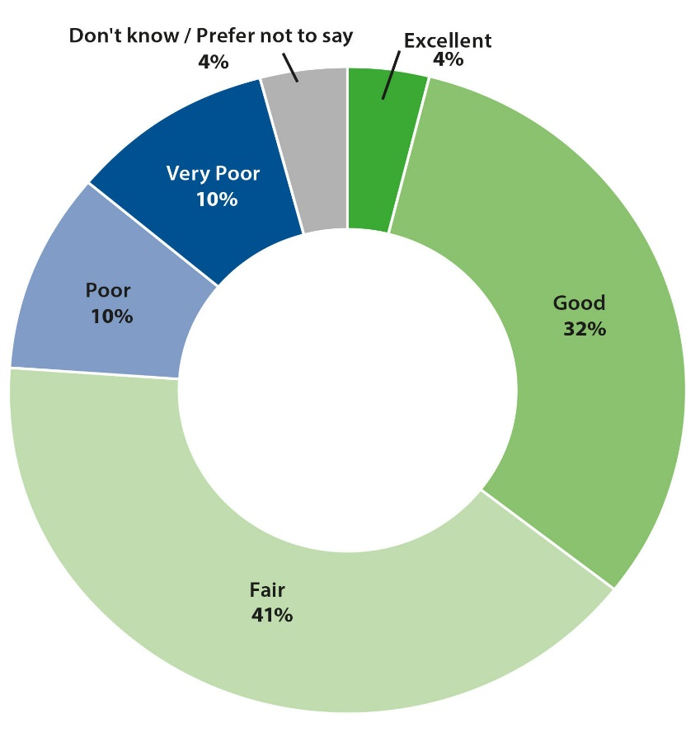

Source: QC1. How would you rate the Department’s overall performance in managing environment and/or energy matters?

Base: All stakeholders (73).

On balance, staff were positive about the Department’s performance; however, there is an opportunity to strengthen the depth of this positive sentiment.

Figure 2 Overall performance rating (staff)

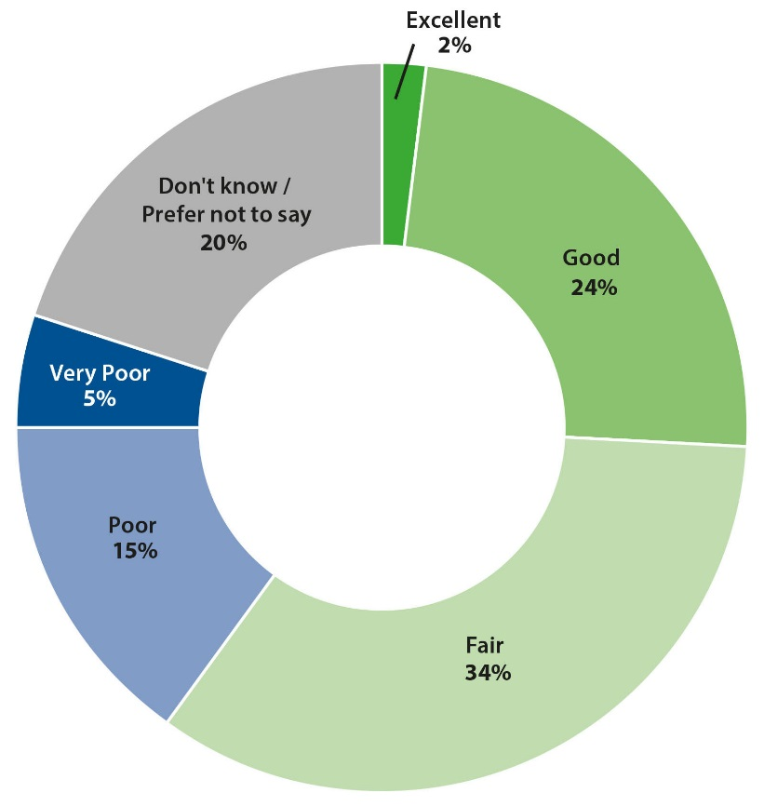

Source: QC1. Based on your experience in your current role, how would you rate the Department’s overall regulatory performance?

Base: Staff aware of the Department’s regulatory responsibilities (557).

Drivers of overall performance perceptions

Regression analysis using data from the stakeholder survey was undertaken to estimate the importance of each Outcome (Outcomes 1–4) in predicting stakeholders’ rating of the Department’s overall performance.

Figure 7 (in Appendix 1) depicts the relative importance of each Outcome, corresponded with its mean performance rating. It shows that the Department’s performance (as perceived by stakeholders) is strongest in the area that is most important to stakeholders—namely, stakeholder engagement. Further analysis of this result can be found at Outcome 2.

The analysis shows that the Department’s decision-making processes (Outcome 3) are also highly important in terms of the impact on overall performance perceptions. However, the mean performance rating for Outcome 3 is relatively low (compared with other Outcomes). This suggests that performance improvement efforts should focus on Outcome 3. Insight into the specific questions which can be prioritised to drive performance perceptions are expanded in Outcome 3.

A secondary area for performance improvement is the impact of regulation (Outcome 4). This Outcome has the lowest performance rating but is relatively important in terms of its contribution to the Department’s overall performance rating. Further analysis is provided in Outcome 4.

Qualitative findings

The qualitative findings mostly confirm the findings from the stakeholder survey. When asked to discuss overall perceptions of the Department’s performance, stakeholders mostly expressed a level of satisfaction. Only a few expressed dissatisfaction with the Department’s performance.

Discussions suggest that stakeholders have low to moderate expectations of government departments in general, and their overall experiences with the Department are consistent with those expectations. Those who rated the Department’s performance poorly tended to have specific experiences that had negatively shaped their views.

When asked what it would take to rate the Department’s performance more highly, stakeholders raised a number of issues. Many stakeholders explained that they would like greater explanation from the Department as to why their applications had been rejected, shorter turnaround times on decision-making, and greater consistency in decision-making over time. This reflects the high value stakeholders place on decision-making and their focus on the regulatory burden on their organisations. This is explored in more detail under the following outcomes.

|  |
| --- |
| Wildlife trade website refresh  In 2018, the Wildlife Trade and Biosecurity Branch undertook a major refresh of its online guidance materials available on the Department of the Environment and Energy’s website.  The information on the website had been identified as a barrier to providing the regulated community with the support they needed to understand and comply with regulatory obligations. This project centred on putting regulatory compliance advice front and centre in the website design. It included significantly reducing the number of pages, rethinking the structure to reflect the identity of the regulated entities and providing information tailored to each of the entities to enable compliance with wildlife regulation.  All applications, relevant forms and guidelines are now available in one central location which is accessible from the main page. An FAQ page has been added that includes updated guidance for frequently queried items such as ivory, rosewood, orchids, hybrids and bird and fish compliance. The centrepiece of this refresh is an interactive pathway which allows users to self-assess and then determine for themselves if they need permits by responding to a series of short questions. All these features increase the usability of the site for the public and also provide staff with resources for providing consistent advice.  The refresh was supplemented by updates to information on Convention on International Trade in Endangered Species of Wild Fauna and Flora (CITES) on the Department of Agriculture and Water Resources ‘BICON’ (Biosecurity Import Conditions) online import program. These updates bring information in line with the information available on the Department’s website and increase the opportunity for regulated entities to become aware of their obligations under Australian environment law. |

Survey findings by regulatory outcome

*Outcome 1: Regulated entities have the support they need to understand and comply with their regulatory obligations*

Analysis of survey results

|  |
| --- |
| Outcome score = 68 (100 point index)  Key findings   * Most stakeholders rated the Department’s overall performance for this Outcome positively. * Stakeholders were most positive about the accuracy and availability of information and guidance materials provided by the Department (with particular reference to online materials). * The timeliness of materials was rated relatively less positively, including ensuring materials are up to date. * The question ‘the Department provides the support needed (for stakeholders) to understand and comply with regulatory/grant obligations’ was found to be most important to overall perceptions of performance for this Outcome, yet it received the lowest performance rating.   Priority areas   * The primary focus area for this Outcome is providing the ‘support needed (for stakeholders) to understand and comply with regulatory/grant obligations’—in particular, explaining the reason for regulatory decisions. * A secondary area to focus on is timeliness of information and guidance materials. |

|  |
| --- |
| Indicative survey questions  Information and guidance materials produced by the Department are clearly written.  Information and guidance materials produced by the Department are accurate.  Information and guidance materials produced by the Department are readily available.  Information and guidance materials produced by the Department are timely.  Regulatory/grant decisions made by the Department are clearly communicated.  The Department provides the support needed to understand and comply with regulatory/grant obligations. |

Overall performance rating (stakeholders)

Most stakeholders rated the Department’s overall performance positively, the positive sentiment was not particularly pronounced, with only 8 per cent of respondents rating performance as ‘Excellent’. Most rated it either ‘Fair’ (41 per cent) or ‘Good’ (27 per cent). Figure 3 shows the full breakdown of responses to this question.

Figure 3 Outcome 1—overall performance rating (stakeholders)

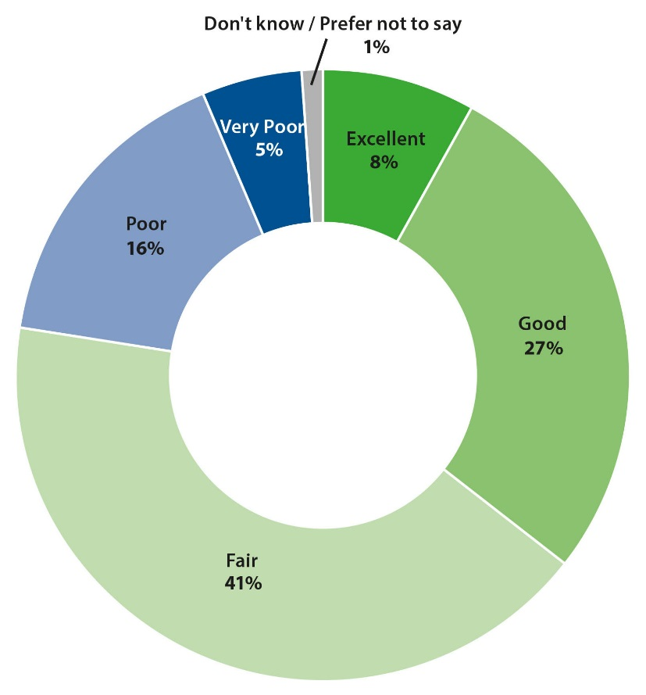

Source: QB1c. Overall, how would you rate the Department for ensuring stakeholders have the support they need to understand and comply with their obligations?

Base: All stakeholders (73).

Questions (stakeholders)

Six questions relating to the support stakeholders receive from the Department were measured in the stakeholder survey, as shown in Figure 8 (in Appendix 1). Collectively, these were labelled in the survey as ‘stakeholder support’ questions.

The first four questions related specifically to the information and guidance materials produced by the Department. Stakeholders were, on balance, positive about all aspects of these materials and were most positive about their accuracy (64 per cent positive; 49 per cent net) and availability (64 per cent positive; 45 per cent net). Stakeholders were relatively less positive about the timeliness (51 per cent positive; 25 per cent net) of information and guidance materials.

The other two questions in this Outcome were also rated positively, on balance. However, there was some indication that more could be done to help stakeholders ‘understand and comply with regulatory/grant obligations’, with 29 per cent of respondents rating this attribute negatively (49 per cent rated it positively; a net rating of 21 per cent).

Figure 9 (in Appendix 1) shows the relative importance of each question, corresponded with its performance rating (the proportion of positive ratings).

The most striking feature of this analysis is that the question which received the lowest performance rating—‘the Department provides the support needed (for stakeholders) to understand and comply with regulatory/grant obligations’—is the most important in terms of driving overall performance perceptions for Outcome 1, making this a priority area for the Department in its ongoing efforts to improve regulatory performance.

The analysis also shows that, of the two questions which received the highest performance rating, accuracy of materials had relatively higher importance. Conversely, the attribute with the lowest performance rating (timeliness of materials) was found to have relatively lower importance and, as such, will be monitored as a secondary focus area for improvement.

Questions (staff)

The staff survey included two questions related to the support and assistance provided by the Department to stakeholders. Figure 10 (in Appendix 1) shows the results for these questions.

Staff were, on balance, distinctly positive about the Department’s performance in providing support and assistance to stakeholders. That said, only a small proportion of staff rated the Department as ‘Excellent’ on these questions—recognition that there is room for improvement in this area.

Qualitative findings

As per the survey findings, stakeholder discussions were mostly positive about the information and guidance materials provided by the Department. Stakeholders felt that the online material was easy to locate and navigate, with the majority feeling that the material was clearly written and accurate.

Several stakeholders felt that the timeliness of information and guidance materials could be improved. A couple of stakeholders noted that some materials appeared to be out of date, and they were unsure therefore if the advice was still accurate.

A key finding from the qualitative discussions is that many stakeholders felt that the Department needed to provide greater support to stakeholders to help them to meet their regulatory obligations. Specifically, stakeholders were frustrated with the way the Department communicated decisions on applications and permits. While they felt that the decision itself was clear, stakeholders wanted greater explanation of the reasons for decisions, particularly where their application had been rejected:

The decision is clear because it comes down with a piece of paper signed by the delegated minister, so the clarity is there but the information behind the decision [is not]. (Respondent Interview 4)

Stakeholders explained that, without greater explanation from the Department, they had limited capacity to learn from the process for subsequent approvals. The perceived lack of communication about the basis for decisions added to stakeholders’ perceptions of inconsistency in decision-making (described in Outcome 3).

Engaging to regulate impacts from changing land use

Regulating land use that affects Australia’s native vegetation is primarily managed by state and local governments. However, there are plants, animals and ecosystems that are protected under national environmental law.

In 2017, native vegetation management laws in New South Wales were changed, and this increased the risk of New South Wales landowners inadvertently contravening national environmental law, even if they were complying with state laws. To help avoid this, the Department implemented an approach to supporting landowner compliance with national environmental law focusing on helping landowners to understand their obligations.

This work involved partnering with NSW Local Land Services and industry peak bodies, including National Farmers’ Federation, to help landowners consider both national and state environmental law in parallel when planning new agricultural development.

Skilled and experienced assessment officers worked with landowners to determine whether, and/or how, national environmental law might apply to them and, where required, assisted landowners to redesign agricultural developments to avoid significant impacts to plants, animals or ecosystems.

The Department is working to develop more regionally specific guidance to support landowners to determine if and when national environmental law may apply to their agricultural development. This guidance will be published on the Department’s website.

Measure for best practice environmental regulation in Antarctica

The Australian Antarctic Division is the Australian Government’s primary authority on Antarctic and sub-Antarctic matters and therefore well placed to implement Australia’s environmental laws in the region. The Australian Antarctic Division regulates activities undertaken by the Australian Antarctic Program (AAP), as well as non-government activities, carried out in Antarctica and the sub-Antarctic.

Self-regulatory arrangements can give rise to conflicts of interest, actual and perceived. To help mitigate this risk, in 2017–2018 the Australian Antarctic Division developed and implemented the policy Measures for Best Practice Environmental Regulation. This policy contains measures designed to help maintain the integrity of AAP activities and projects.

The policy has been applied to projects carried out by the AAP—for example, the project for preparatory fieldwork activity for the Year-Round Aviation Access Project, which includes a proposed runway at Davis Research Station in Antarctica. Here, the policy ensured that the decision-maker and assessment team were quarantined from the development of the initial environmental evaluation by the project team, therefore avoiding perceived or actual conflict of interest.

Outcome 2: Stakeholders view us as a trusted and respected regulator

Analysis of survey results

|  |
| --- |
| Outcome score = 81 (100 Point index)  Key findings   * Stakeholders rated the Department’s performance very positively for Outcome 2, both overall and for each of the questions. * Performance ratings for the questions that are most important (in driving overall performance perceptions) for this Outcome were relatively low. In other words, the Department performs extremely well on questions that are less important to stakeholders, but less well on the things that matter most.   Priority areas   * The priority areas to focus on for performance improvement are providing consistent information and advice, treating stakeholders fairly, and valuing stakeholder consultation. |

|  |
| --- |
| Indicative survey questions  I have a clear understanding of why environmental and energy matters are closely regulated.  The information and advice that your business/organisation receives/you receive from the Department is consistent.  Your business/organisation is/You are treated fairly by the Department.  Your business/organisation respects/You respect the Department in its role as the Australian Government’s regulator of environment and energy.  Your business/organisation has/You have opportunities to engage with the Department on relevant issues.  The Department values stakeholder consultation and engagement. |

Overall performance rating (stakeholders)

Most stakeholders rated the Department’s overall performance positively—12 per cent rated it ‘Excellent’, 34 per cent rated it ‘Good’ and 32 per cent rated it ‘Fair’. The proportion of stakeholders rating it ‘Excellent’ was the highest of all Outcomes rated by stakeholders. Figure 4 shows the full breakdown of responses to this question.

Figure 4 Outcome 2—overall performance rating (stakeholders)

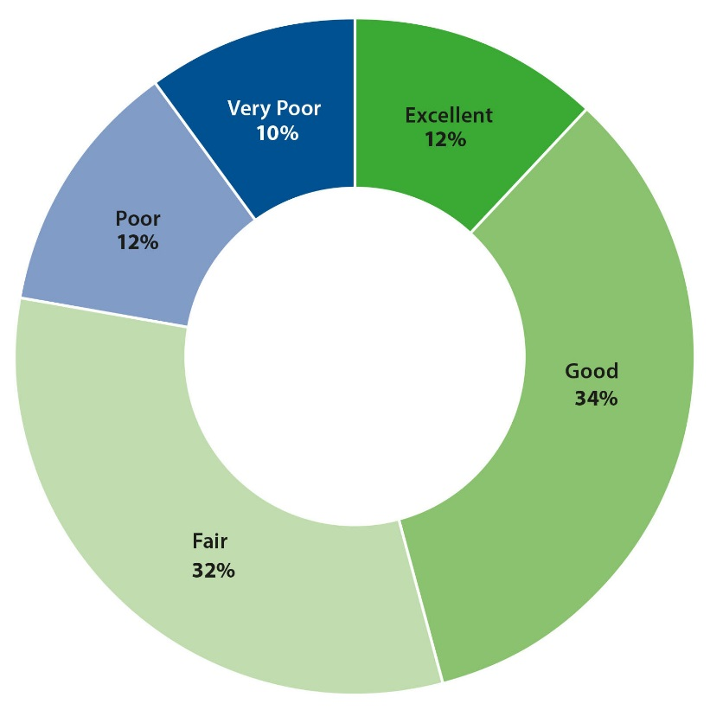

Source: QB2b. Overall, how would you rate the Department for performing in a manner that is consistent with a trusted and respected regulator of environment and energy matters?

Base: All stakeholders (73).

Questions (stakeholders)

Six questions relating to stakeholders’ engagement with the Department were measured in the stakeholder survey, as shown in Figure 11 (in Appendix 1). Collectively, these were labelled in the survey as ‘stakeholder engagement’ questions.

Ratings for these questions were all positive on balance, by a sizeable margin, especially stakeholders having ‘a clear understanding of why environmental and energy matters are closely regulated by the Department’ (82 per cent net, with 85 per cent rating positively and only 3 per cent rating negatively), having ‘opportunities to engage with the Department’ (82 per cent positive; 73 per cent net) and the Department being ‘respected by stakeholders’ (82 per cent positive; 77 per cent net).

The remaining three questions also had positive ratings on balance, though not quite as pronounced. Most notably, nearly a quarter (22 per cent) of respondents disagreed that ‘information and advice from the Department is consistent’ (a sentiment also highlighted in the staff survey). This question received the lowest performance rating (63 per cent positive; 41 per cent net) within this Outcome.

Figure 12 (in Appendix 1) shows the relative importance of each question, corresponded with its performance rating (the proportion of positive ratings).

This analysis shows that the questions which received the most positive performance ratings (‘I have a clear understanding of why environmental and energy matters are closely regulated’ and ‘[Your business/organisation has] [You have] opportunities to engage with the Department on relevant issues’) are least important in terms of their influence on the overall performance rating for this Outcome.

Conversely, the questions which are most important within this Outcome (‘The information and advice that [your business/organisation receives] [you receive] from the Department is consistent’, ‘[Your business/organisation is] [You are] treated fairly by the Department’ and ‘The Department values stakeholder consultation and engagement’) received the lowest performance ratings (41 per cent, 53 per cent and 48 per cent respectively). Improvement on these areas will have the greatest positive impact on overall performance ratings for Outcome 2—in turn, helping to strengthen the Department’s overall performance perceptions (among stakeholders).

Qualitative findings

The qualitative discussions broadly reflect the stakeholder survey findings. All stakeholders interviewed understood the importance of having regulations in place to support positive environmental and energy outcomes for Australia. Stakeholders found it difficult to assess the extent to which the Department’s engagement activities had helped them to understand the importance of regulations as distinct from their general knowledge from working in the sector.

Most stakeholders felt that the Department had been fair and respectful in their interactions with them:

I do respect them enormously … they’re head and shoulders above other Departments I have to deal with … they understand the [regulatory] process and guide you through it … (Interview 11)

Stakeholder opinions on the Department’s approach to consultation varied greatly depending on the type of organisation and the job role of the interviewee:

[I would say] there’s a consultation process, a fair chance for feedback. They genuinely listen to feedback … (Interview 13)

In most cases stakeholders wanted more opportunities for consultation, particularly to share their subject-matter expertise. These stakeholders tended to value mixed approaches to consultation: formal committee consultations as well as informal bilateral consultations. They sought trusted relationships with key Department staff who were genuinely engaged in listening and learning from stakeholders.

|  |
| --- |
| Common assessment method for assessment and listing of threatened species  Australian, state and territory governments are collaborating on a consistent, harmonised and efficient approach to threatened species listings across Australia, providing clarity and certainty to the regulated community and supporting better regulatory outcomes for threatened species.  The Common Assessment Method for assessment and listing of threatened species is based on the best-practice standard developed by the International Union for Conservation of Nature (IUCN), as used for the global IUCN Red List of Threatened Species. Each species is assessed by only one jurisdiction based on the best available evidence, in consultation with the Australian Government and all states and territories where it occurs. It is then listed in the same national threat category in all jurisdictions.  An intergovernmental Memorandum of Understanding to give effect to the Common Assessment Method commenced in 2015. Since then, eight of the nine Australian jurisdictions have signed the memorandum and all are actively involved in implementation. Each jurisdiction is making the administrative and legislative changes necessary to implement the method, including adopting the IUCN Red List categories and criteria. An interjurisdictional working group is developing policies and procedures to ensure consistent application of the method. Progressively, all currently listed threatened species are being reviewed and all new assessments are being undertaken in accordance with the Common Assessment Method. This is leading to the alignment of lists across Australia.  In 2017–2018 the Department made significant progress in applying the Common Assessment Method. The Victorian Government signed the memorandum and Western Australia, New South Wales and the Northern Territory provided the Australian Government with assessments of 68 species undertaken using the Common Assessment Method. These assessments enabled the Australian Government to ensure that the status of these species under the Commonwealth EPBC Act aligned with the state and territory threatened species lists. These were the first Commonwealth listing decisions based on assessments using the method, which resulted in 57 new listings, six transfers between categories within the list and five delistings. |

*Outcome 3: Our regulatory activity is consistent, risk and evidence based, and makes effective use of a range of regulatory tools*

Analysis of survey results

|  |
| --- |
| Outcome score = 58 (100 point index)  Key findings   * Evidence-based decision-making is a strength of the Department, recognised by both staff and stakeholders. * Most stakeholders rated the Department’s overall performance for this Outcome positively; however, the average attribute rating was lower than for other Outcomes. * Question ratings were positive, on balance, except for ‘compliance and enforcement actions being proportional to the level of potential risk’, which had the same proportion of positive and negative ratings. This attribute also has relatively high importance.   Priority areas   * The primary focus for Outcome 3 is to improve stakeholder understanding of ‘compliance and enforcement actions being proportional to the level of potential risk’. |

|  |
| --- |
| Indicative survey questions   * The Department makes evidence-based decisions. * The Department ensures that regulation is applied consistently. * The Department’s compliance efforts and resources are focused on high-risk areas. * The Department’s compliance and enforcement actions are proportional to the level of potential risk. |

Overall performance rating (stakeholders)

The majority of stakeholders rated the Department’s overall performance positively—5 per cent rated it ‘Excellent’, 33 per cent rated it ‘Good’ and 33 per cent rated it ‘Fair’. Around a quarter gave a negative rating (22 per cent ‘Poor’ and 4 per cent ‘Very poor’). Figure 5 shows the full breakdown of responses to this question.

Figure 5 Outcome 3—overall performance rating (stakeholders)

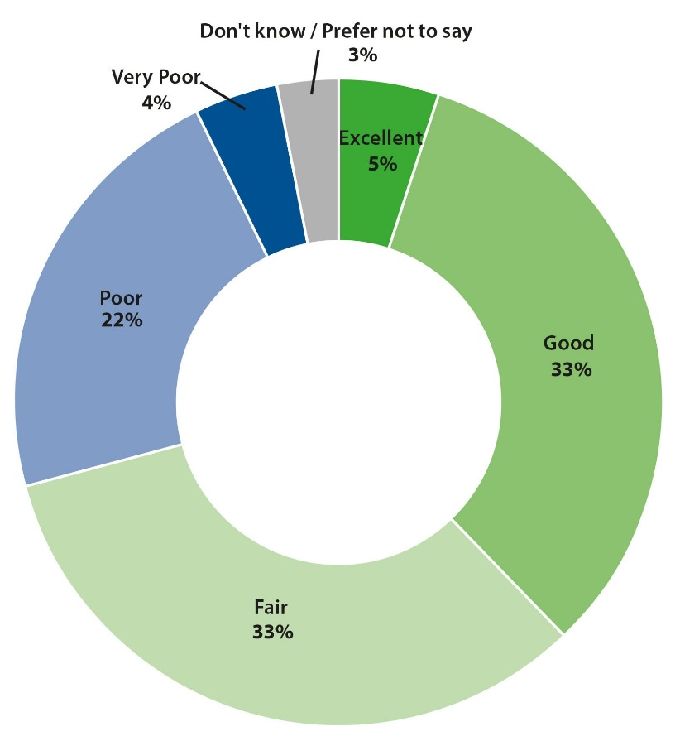

Source: QB3b. Overall, how would you rate the Department’s decision-making processes?

Base: All stakeholders (73).

Questions (stakeholders)

Four questions relating to the Department’s regulatory activity were measured in the stakeholder survey, as shown in Figure 13 (in Appendix 1). Collectively, these were labelled in the survey as ‘decision-making processes’ questions.

There are two interesting aspects of the performance ratings for this Outcome. Firstly, the average performance rating per attribute in this Outcome was lower than all other Outcomes. That said, ratings were positive on balance, with stakeholders most positive that decisions made by the Department are ‘evidence based’ (53 per cent positive; 29 per cent net), and, on balance, they gave positive ratings for the Department ‘applying regulation/rules consistently’ (47 per cent positive; 18 per cent net) and ‘focussing compliance efforts on high risk areas’ (40 per cent positive; 14 per cent net).

However, a net ‘neutral’ (0 per cent) rating was reported for the Department’s ‘compliance and enforcement actions being proportional to the level of potential risk’—38 per cent of respondents agreed with this statement and 38 per cent disagreed.

The second key point to note is that, unlike the other Outcomes, a notable proportion of stakeholders responded ‘don’t know’ to these questions, suggesting there may be an element of ambiguity among stakeholders around these issues. This could reflect a lack of firsthand exposure to regulatory activity or it could indicate a need for the Department to communicate more to stakeholders about its decision-making and other regulatory processes.

Figure 14 (in Appendix 1) shows the relative importance of each question, corresponded with its performance rating (the proportion of positive ratings).

The most important question (‘The Department makes evidence-based decisions’) received the most positive performance rating. However, as noted above, compared to other Outcomes, this performance rating is lower, so there is scope for improvement.

The next most important attribute (‘The Department’s compliance and enforcement actions are proportional to the level of potential risk’) received the lowest performance rating within this Outcome.

Questions (staff)

The staff survey included three questions related to the regulatory decisions made by the Department. These were labelled ‘external engagement’ questions in the staff survey. Figure 15 (in Appendix 1) shows the staff ratings for these questions.

Like stakeholders, staff were most positive about the Department making ‘evidence-based’ decisions. This is clearly a strength of the Department (within this Outcome).

Qualitative findings

The qualitative discussions support the survey findings and provide further insight into stakeholder experiences and perceptions. Stakeholders mostly felt that the Department’s regulatory processes ensured that evidence was provided and considered in decisions. Stakeholders described providing detailed evidence alongside their applications, with Department staff sometimes requesting additional information and seeking peer review from subject-matter experts.

However, some stakeholders felt that the reasons behind decisions were not well communicated such that some did not understand why applications had been rejected while others had been approved. This was a common frustration expressed during qualitative interviews:

We don’t understand—so we don’t agree with the decisions and we don’t understand why they’ve made those decisions … (Interview 1)

With regard to compliance and enforcement, the qualitative discussions support the survey results. Many of the stakeholders interviewed were unaware of compliance and enforcement activities in their sector. Many stakeholders also felt that the Department needed to pay greater attention to compliance and enforcement, making sure that compliance was proportional to the level of potential risk:

[Compliance and enforcement] is critically important, and it needs to be strengthened … The agency needs much more strength and capacity to do that … (Interview 5)

|  |
| --- |
| Supplementary analysis of the cost–benefit analysis for the proposed national phase-out of PFOS  A consultation Regulatory Impact Statement for the national phase-out of PFOS (perfluorooctane sulfonic acid-related chemicals) was published by the Department of the Environment and Energy on behalf of the Australian Government in October 2017. The valuation of the impacts of the national phase-out using a cost–benefit analysis (CBA) was made more challenging by the unquantifiable but significant nature of the benefits of taking action, as is often the case with chemicals that may exert effects on the environment over the long term.  The Economic and Analysis Branch of the Department assisted the policy area in undertaking a supplementary analysis of the commissioned CBA, including the development of a new base case, updating some assumptions in the costings model to more closely align with the evolving policy and Office of Best Practice Regulation requirements, and preparing updated regulatory burden measurements framework costings. The branch was also able to provide an explanation of the limitations of the economic model and supported the policy area in developing a robust approach to including the non-quantifiable impacts into the overall analysis. This work highlighted the importance of considering all impacts, including those for which economic costs cannot be assigned, when determining net benefits. The expertise provided by the branch resulted in a more in-depth consideration of the regulatory impacts associated with the proposed management interventions, including legislation, for the national phase-out of PFOS.  www.environment.gov.au/protection/chemical-management/pfas/ris-phase-out-pfos-consultation |

*Outcome 4: Regulated entities are not unnecessarily hindered in their* *operations*

Analysis of survey results

|  |
| --- |
| Outcome score = 63 (100 point index)  Key findings   * The proportion of positive ratings by stakeholders for this Outcome was relatively low in comparison with other Outcomes, overall and for the each of the questions. * Stakeholders were most positive about the Department’s performance on questions which relate to the broader regulatory agenda of the Department—namely, the ‘purpose of regulation’ and ‘achieving positive environment and energy outcomes’.   Priority areas   * A priority area to focus on for performance improvement is ‘consideration of the burden and cost (to stakeholders) of compliance’. |

|  |
| --- |
| Indicative survey questions   * The Department provides flexibility in how stakeholders meet their regulatory/grant obligations. * The Department takes into consideration the burden and cost of compliance required for stakeholders to meet their regulatory/grant obligations. * The Department’s approach to regulation is focused on ensuring good environmental and/or energy outcomes for Australia. * The Department makes clear the purpose of the legislation relevant to your business/organisation/you/your grant. |

Overall performance rating (stakeholders)

The overall performance rating for this Outcome was the least positive of all Outcomes rated by stakeholders. Only 3 per cent of stakeholders rated it ‘Excellent’, 33 per cent rated it ‘Good’ and 27 per cent rated it ‘Fair’. Almost a third gave a negative rating (21 per cent ‘Poor’ and 10 per cent ‘Very poor’). Figure 6 shows the full breakdown of responses to this question.

Figure 6 Outcome 4—overall performance rating (stakeholders)

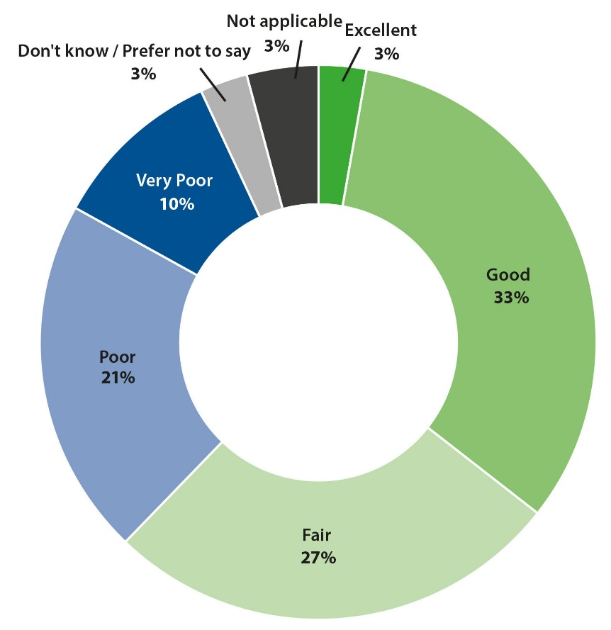

Source: QB4b. Overall, how would you rate the Department in terms of its effort to ensure that regulations/rules do not unnecessarily impact [your business/organisation] [you]?

Base: All stakeholders (73).

Questions (stakeholders)

Four questions measuring the impact of regulation/rules on stakeholders were measured in the stakeholder survey, as shown in Figure 16 (in Appendix 1). Collectively, these were labelled in the survey as ‘impact of regulation/rules’ questions.

Despite the lower overall performance rating for this Outcome (relative to other Outcomes) the average rating per attribute was more positive. The most positive rating was for ‘making clear the purpose of legislation’—64 per cent of stakeholders agreed with this attribute (i.e. rated it positively), indicating they consider this something the Department does well (16 per cent rated this attribute negatively, giving a net rating of 48 per cent).

Stakeholders were also positive, on balance, with the Department’s ‘flexibility in compliance’ (52 per cent positive; 25 per cent net) and that the Department’s ‘approach to regulation ensures good outcomes’ (56 per cent positive; 29 per cent net).

Based on stakeholder feedback, another area for improvement is ‘consideration of the burden and cost to stakeholders of compliance’. This attribute received a net ‘neutral’ (0 per cent) rating, with 34 per cent rating it positively and 34 per cent rating it negatively.

Figure 17 (in Appendix 1) shows the relative importance of each question, corresponded with its performance rating (the proportion of positive ratings).

The two questions found to be most important for Outcome 4 were also the two which received the highest positive performance rating (‘The Department’s approach to regulation ensures good outcomes’ and ‘The Department makes clear the purpose of legislation’). Interestingly, these two questions represent the broader regulatory agenda of the Department rather than specific issues or processes which impact individual stakeholders directly. Stakeholders acknowledge, and view positively, the important role played by the Department in environment and energy regulation.

As noted, the attribute ‘consideration of the burden and cost to stakeholders of compliance’ received a relatively low performance rating (0 per cent net) from stakeholders. While the analysis suggests that this attribute is less important than other questions in this Outcome, the performance rating warrants prioritising this area for performance improvement. The qualitative findings, detailed in Outcome 4, provide further insight into the specific issues related to this attribute.

Qualitative findings

As per the survey findings, the qualitative discussions found that stakeholders overall felt positive about how the Department communicated the purpose of legislation.

Stakeholders expressed particular interest in the Department’s flexibility in compliance and minimising the impacts of regulatory obligations on their organisations/businesses. Several stakeholders felt that the specific circumstances of their approval needs (for example, repeat approvals for similar/same issues, or high-cost permits where the business return was low) warranted further flexibility from the Department in their regulatory processes. While these stakeholders did not expect ‘special treatment’ per se, they felt that the processes were at times overly onerous given the context.

Some stakeholders perceived there to be undue financial costs in meeting their regulatory obligations, often related to project delays while the Department processed approvals. One stakeholder explained that the inconsistencies they had experienced in decision-making, coupled with the financial costs of seeking approvals, meant that certain business activities were no longer viable.

|  |
| --- |
| Strengthened co-regulation of national permit schemes to abate industry emissions of ozone-depleting substances and greenhouse gases  In 2018 the Department undertook an innovative approach to the open tender for services to administer the two ‘end use’ permit schemes for refrigeration and air conditioning, and fire protection under the Ozone Protection and Synthetic Greenhouse Gas Management Regulations 1995. Currently these schemes administer nationwide over 88,000 licences and business authorisations.  Since commencement in 2005, the training qualifications and obligations required by the end use permit schemes have controlled the use of powerful ozone-depleting substances and synthetic greenhouse gases that are the mainstay of the fire protection industry and the refrigeration and air conditioning industry. The schemes are implemented through a unique co-regulatory approach whereby non-government industry corporations are contracted by the Department to administer the permit schemes using regulatory powers and functions delegated by the Minister for the Environment.  The review of the Ozone Protection and Synthetic Greenhouse Gas Program (2014–2016) recommended that the co-regulatory approach continue, as it provides the most efficient and effective option for nationally consistent emission abatement controls within the Australian market. The purpose, benefits and highly technical nature of the systems in which the controls are directed are championed by the range of industry associations that form the boards that administer the permit schemes. Key achievements of the co-regulatory approach include the abatement of more than 55 per cent of emissions that would have otherwise entered the atmosphere—equivalent to 24.7 megatonnes of carbon dioxide (CO2e); and consistently strong support of the boards by industry stakeholders.  Foremost in the future challenges to the success of the schemes is the phase-down of hydrofluorocarbon (HFC) imports. Australia is committed to the HFC phase-down to reduce global warming as part of its international obligations under the Montreal Protocol on Substances that Deplete the Ozone Layer. The HFC phase-down started on 1 January 2018 in Australia to provide a reduction of 23 million tonnes CO2e to 2030. Australia’s ability to meet its HFC targets will depend on how well its regulated entities can costeffectively transition to new gas types and systems. Further, with most equipment lasting from three to more than 20 years, there will be a heightened need to manage the supply needs of existing installed equipment and to recover substances replaced by the transition from end-of-life equipment.  To better meet these challenges, and streamline the delivery of services, the Department undertook significant changes to its procurement of services from the industry boards. These changes are now reflected in new five-year contracts that came into force in October 2018. Most notably the industry boards must now establish ‘industry advisory bodies’ to provide advice to the Department and the boards on the risks and opportunities facing the schemes.  Establishment of industry advisory bodies provides a flexible mechanism for identifying and engaging with relevant stakeholder experts. This includes stakeholders who may not have had a direct or traditional role in informing decisions made by the appointed industry bodies. Gaining stakeholder views that cover the nature of both current and future technological developments will alert the Department of potential impacts to the permit schemes, its regulated entities and the ability of Australia to costeffectively transition to substances that have lower global warming potentials. |

*Outcome 5: We understand the regulatory environment in which we* *operate and continuously seek to improve our approach to* *regulation*

Analysis of survey results

|  |
| --- |
| Outcome score = 60 (100 point index)  Key findings   * Staff perceive the Department to perform strongly on consulting with stakeholders, and a clear majority of stakeholders feel that Department staff demonstrate a good understanding of regulatory issues. * The most important question under this Outcome—‘The Department has a culture of exploring alternative ways to improve its regulatory approach’—received the lowest performance rating. * There is strong support from staff for the Department to seek improvements in its regulatory approach.   Priority areas   * The primary focus for this Outcome is to continue to build a ‘culture of continuous improvement’. |

|  |
| --- |
| Indicative survey questions   * Our regulatory processes help drive improvement—achieving compliance with environment and/or energy legislation. * The Department consults with a wide range of stakeholders to improve regulatory approaches and outcomes. * The Department has a culture of exploring alternative ways to improve its regulatory approach. * The Department’s approach to regulation takes into consideration the costs and benefits to stakeholders. * Changes to our regulatory activity are based on risk assessments. * The Department’s risk-based frameworks are publicly available. |

Questions (staff)

Six questions relating to the regulatory environment and departmental operations were measured in the staff survey, as shown in Figure 18 (in Appendix 1). Collectively, these were labelled in the survey as ‘regulatory environment’ questions.

The questions rated most positively within this Outcome were the Department ‘consulting with a wide range of stakeholders’ (46 per cent positive; 30 per cent net) and ‘taking into consideration the costs and benefits to stakeholders’ (44 per cent positive; 29 per cent net).

Figure 19 (in Appendix 1) shows the relative importance of each question, corresponded with its performance rating (the proportion of positive ratings).

The analysis identified three questions as having relatively high importance—‘The Department has a culture of exploring alternative ways to improve its regulatory approach’, ‘Our regulatory processes help drive improvement—achieving compliance with environment and/or energy legislation’ and ‘Changes to our regulatory activity are based on risk assessments’. The latter two of these questions received positive, on balance, performance ratings (38 per cent positive, 17 per cent net; and 37 per cent positive, 23 per cent net respectively).

Performance on the question relating to the Department’s ‘culture of improvement’ was also positive on balance, but only just (30 per cent positive; 24 per cent negative; 6 per cent net), making this an area to consider improving.

Other survey results suggest that staff would be supportive of initiatives aimed at improving regulatory activities—some 96 per cent of staff felt it was either ‘Important’, ‘Very important’ or ‘Absolutely essential’ that ‘the Department should continually seek to improve its approach to regulation’. Table 3 (in Appendix 1) shows the full breakdown of responses to this question.

Staff awareness of regulatory responsibilities

Nearly all staff reported feeling that it was important they were aware of the Department’s regulatory responsibilities relevant to their current role (95 per cent rated it as either ‘Important’, ‘Very important’ or ‘Absolutely essential’) (see Table 2 in Appendix 1). However, only two-thirds (67 per cent) rated their understanding of the Department’s regulatory responsibilities as ‘Good’ or ‘Excellent’ (see Table 1 in Appendix 1). A further 23 per cent rated their understanding as ‘Fair’, meaning most Department staff reported at least some level of understanding of the Department’s regulatory responsibilities.

Executive Level staff and those who interact frequently with stakeholders reported the highest awareness of the Department’s regulatory responsibilities. The latter were also more likely to rate it as ‘Absolutely essential’ to their role (as might be expected). Conversely, those new to the Department (<1 year) and those who have little or no stakeholder interaction reported lower awareness of the Department’s regulatory responsibilities and (with the exception of new staff) perceived it as less important to their current role.

Questions (stakeholders)

The stakeholder survey included a measure of perceptions of the Department’s staff ‘understanding the regulatory environment relevant to their business’, as shown in Figure 20 (in Appendix 1). Most stakeholders rated the Department positively in this regard and the degree of positive sentiment was quite strong, with 23 per cent rating it ‘Excellent’, 29 per cent rating it ‘Good’ and 33 per cent rating it ‘Fair’.

Qualitative findings

The qualitative discussions provide deeper insight into the stakeholder survey findings. The qualitative discussions revealed that stakeholders feel that staff understand regulatory issues from an administrative perspective but often lack an ‘on-the-ground’ understanding of how regulatory obligations impact and intersect with industry operations.

Stakeholders suggested that the Department could take a greater role in supporting industry—for example, greater support for organisations whose core goal is to improve environmental or energy outcomes (e.g. the Department could play a greater role in promoting offsetting initiatives, supporting relationship building with stakeholders, reducing application fees where financial returns for proposed environmental projects is low); keeping abreast of changes in the industry (e.g. where technology advances in the energy sector may render regulatory processes out of date); and providing better communication of non-compliance penalties as an added incentive for industries to meet their regulatory obligations.

|  |
| --- |
| Administrative law training  In August 2018, the General Counsel Branch delivered training on administrative law as part of the Environment Assessments and Approvals training program. The training was aimed at ensuring that staff carrying out regulatory duties under the EPBC Act have the skills and capabilities required for effective regulation.  The General Counsel Branch carefully designed the training for Environment Standards Division (ESD) staff responsible for the administration of the EPBC Act. As well as outlining key administrative law principles, the training featured real-life case studies of EPBC Act decisions, as well as scenario-based problems for group discussion. The training also provided an opportunity for ESD staff to ask questions about issues they had identified in their regulatory practice, providing an opportunity for staff to share experiences and learn from their colleagues.  The training provided a useful opportunity for the General Counsel Branch to develop guidance material which draws on the General Counsel Branch’s experience in providing legal advice on EPBC Act decisions. As well as providing an overview of the fundamentals of statutory decision-making, the guidance materials included an easy-to-use checklist to assist ESD officers to self-assess whether they are in a position to make a sound decision.  The training received positive feedback from ESD, particularly in relation to its relevance to the daytoday work of ESD staff, the usefulness of the case studies and the comprehensiveness of the written guidance material that was delivered after the face-to-face training.  The General Counsel Branch will deliver this training again in August 2019 to ensure that new staff have the opportunity to build their knowledge of administrative law and statutory decision-making; and to provide existing staff with an opportunity to refresh their knowledge and ensure their skills remain up to date. |

*Outcome 6: Our staff have the skills and capabilities required for effective* *regulation*

Analysis of survey results

|  |
| --- |
| Outcome score = 59 (100 point index)  Key findings   * Quality assurance processes were found to be more important than ICT systems; and staff rated performance on quality assurance processes very positively. * The three questions relating to the Department’s ICT systems each received a net negative performance rating—the only questions across both surveys to achieve this result. * Most staff feel they have a ‘clear understanding of their role and the skills required for effective regulation’. However, ratings of the ‘availability and quality of training’ were relatively weaker. * Moreover, staff indicated interest in training on a range of topics related to regulatory administration. * Stakeholders gave very positive ratings for the skills and capabilities of Department staff.   Priority areas   * The primary focus for this Outcome is to improve the Department’s regulatory ICT systems. * Another area for focus is the improvement of training, guidance materials and tools (for staff). |

|  |
| --- |
| Indicative survey questions   * The Department has quality assurance processes in place to help ensure a high standard and consistency of regulatory advice and practices. * The Department’s ICT systems capture stakeholder details using consistent metadata. * The Department’s ICT systems facilitate the capture of data that provides insight into regulatory risk, trends and patterns. * The Department’s ICT systems facilitate the capture of noncompliance activities. * I clearly understand my role and function with regard to regulation. * I feel that I am supported by high-quality training relevant to administering regulation. * I feel that I am supported by high-quality regulatory guidance materials and tools. * I have the skills required to be effective in my regulatory role.   I have access to on-the-job training to ensure I am effective in my regulatory role. |

Systems and processes questions (staff)

Four indicators relating to the Department’s systems and processes were measured, as shown in Figure 21 (in Appendix 1).

Three questions relating to the Department’s ICT systems received a very high proportion of ‘don’t know’ responses, possibly indicative of the need (or absence of need) for staff to use these systems in their day-to-day job at the Department. On balance staff reported negative (net) ratings of the Department’s ICT systems; that is, a higher proportion disagreed than agreed with these questions.

The fourth question related to the Department’s quality assurance processes; on balance, staff were positive about this attribute (38 per cent positive; 18 per cent net).

Further, staff rated quality assurance processes more important than ICT systems. This was confirmed by analysis, showing that the quality assurance processes were by far the most important aspect of the systems and processes area of Outcome 6, in terms of predicting overall Department performance perceptions. Figure 22 (in Appendix 1) shows the relative importance of each of the ‘systems and processes’ questions, corresponded with its performance rating.

Skills and training questions (staff)

Five questions relating to the Department’s skills and training were measured in the staff survey. Unlike other areas covered in the staff survey, most staff were able to provide a rating for the five ‘skills and training’ questions, as shown in Figure 23 (in Appendix 1).

A high proportion of staff agreed with the statements ‘I understand my role and function with regard to regulation’ (87 per cent) and ‘I have the skills required to be effective in my regulatory role’ (76 per cent) and very few disagreed (4 per cent and 3 per cent respectively). Consequently, these two questions achieved very high net performance ratings (83 per cent and 73 per cent respectively). Staff who reported having high frequency of stakeholder interaction were most likely to agree with these two statements.

Somewhat lower ratings were reported for questions related to training and support. While more than half (of staff who indicated that their role contributes to the Department’s regulatory responsibilities) agreed that they had ‘access to on-the-job training’ (57 per cent positive; 43 per cent net), a relatively high proportion (30 per cent) disagreed that they ‘felt supported by training and guidance materials and tools’ (with 35 per cent giving a positive rating, this question had a net rating of 4 per cent). A further 30 per cent of respondents ‘neither agreed or disagreed’ with these two statements, suggesting the training and guidance materials available to staff may not be perceived as relevant or useful.

A clear majority of staff believe it is important to have the ‘skills required to help the Department in fulfilling its regulatory role’ (95 per cent rated this as either ‘Important’, ‘Very important’ or ‘Absolutely essential’). Perhaps unsurprisingly, those who reported high-frequency interaction with stakeholders were more likely to say this was ‘Absolutely essential’ (53 per cent), while those who never interact with external stakeholders (31 per cent) were significantly less likely to rate this as ‘Absolutely essential’.

Analysis found that the ‘skills and training’ questions had very little influence on staff’s overall performance rating for the Department.

Skills and training needs (staff)

Staff were asked to indicate which regulatory skills or areas of knowledge they felt they needed to develop. As shown in Figure 24 (in Appendix 1), the most common response overall was ‘Legislative interpretation’ (42 per cent), followed by ‘Data management and analysis’ (38 per cent), ‘Compliance’ (33 per cent) and ‘Understanding and applying administrative law’ (32 per cent).

Questions (stakeholders)

Three questions relating to the Department’s staff were measured in the stakeholder survey, as shown in Figure 25 (in Appendix 1). Stakeholders rated the Department’s staff very positively, with all three questions receiving a net positive result and at least one in five responses rating staff as ‘Excellent’ for each attribute.

Qualitative findings

Overall, stakeholders were satisfied with the skills and capabilities of departmental staff. They felt that staff were professional in their interactions and genuine in trying their best to support stakeholders in meeting their regulatory obligations:

The feeling that I’ve got is a positive feeling … they [Department staff] do genuinely listen … they are very, very helpful … (Interview 13)

Despite this overall positivity, stakeholders raised frustrations in their interactions with Department staff. A common perception held by stakeholders was that staff, despite their best efforts, sometimes lacked subject expertise and had limited field experience to inform their approach to advice:

Circumstances are very different across projects. They don’t get a good feel for that, not on the ground … they suffer a little bit from being remote. Years ago, they used to be able to do field visits. We’d make a lot of progress with that [but this is no longer in practice]. (Interview 11)

Several stakeholders felt that staffing issues accounted for some of the inconsistency in the advice they had received from the Department. This was attributed to staff turnover within the Department and having to deal with less-experienced staff:

There’s not a lot of [staff] experience … there is an element of people coming and going … I’ve probably dealt with seven or eight directors in eleven or twelve years … (Interview 2)

Targeting Improvements (Strategies on a Page)

|  |  |  |  |  |  |
| --- | --- | --- | --- | --- | --- |
| **Outcome 1**  Regulated entities have the support they need to understand and comply with their regulatory obligations. | **Outcome 2**  Stakeholders view us as a trusted and respected regulator. | **Outcome 3**  Our regulatory activity is consistent, risk and evidence based, and makes effective use of a range of regulatory tools. | **Outcome 4**  Regulated entities are not unnecessarily impeded in their operations. | **Outcome 5**  We understand the regulatory environment in which we operate and continuously seek to improve our approach to regulation. | **Outcome 6**  Our staff have the skills and capabilities required for effective regulation. |
| **Areas for Improvement**  Assisting stakeholders to understand and comply with regulatory/grant obligations. Also, timeliness of information and guidance materials. | **Areas for Improvement**  Consistent information and advice, treating stakeholders fairly, and valuing stakeholder consultation. | **Areas for Improvement**  Stakeholder understanding of compliance and enforcement actions being proportional to the level of potential risk. | **Areas for Improvement**  Considering the burden and cost of compliance to stakeholders. | **Areas for Improvement**  Building a culture of continuous improvement within the Department. | **Areas for Improvement**  The Department ICT systems. Also, staff training, guidance materials and tools. |
| **Office of Compliance**  Established to provide an enterprise level approach to improving regulation.  **Compliance Policy**  Assisting regulators to better understand how the Department works to support compliance and responds to potential contraventions of national laws.  **Annual Compliance Plan**  Keeps stakeholders informed of our current compliance priorities.  **Stakeholder mapping**  Capturing information on industry sectors the Department engages with, offering the potential for streamlining of communications, and a deeper understanding of the regulatory landscape and the issues affecting industry sectors.  **Seeking ongoing feedback**  Through annual satisfaction surveys, e.g. GEMS stakeholders. | **Co-design process**  Exploring and generating new and better ways to collaborate across government, business and civil sectors to achieve improved environment and energy outcomes.  **Regulatory Framework**  Sets clear goals in approach to administering environment and energy legislation.  **Regulatory Communications and Engagement Strategy**  Driving the uptake of a range of regulatory communication channels and approaches; providing consistent high level messages for staff to use when interacting with regulated stakeholders and the community; and strengthening regulated stakeholders’ understanding of their obligations.  **Internet Refresh**  Regulatory web content reviewed to improve the accessibility, consistency and accuracy of advice. | **Office of Compliance**  Implementing an ‘outcomes-based’ approach to compliance, recognising that an integral part of achieving desired outcomes is to work with stakeholders to assist them in better understanding environment and energy laws.  **Compliance Policy**  Building stakeholder understanding of the Department’s approach to compliance and how the Department identifies potential risks and encourages voluntary compliance. This is achieved through provision of the right tools and information to support compliance; promotion of the goals and reasons for laws; and publication of significant responses to non-compliance.  **Risk Management Framework**  Articulating organisational strategies for managing risks—embedding a positive culture of risk management at every level by proactively identifying, assessing, monitoring and controlling risks.  **Regulatory Risk Map**  Capturing potential risks to the Department’s regulatory performance and identifying enterprise-level controls which work towards mitigating risks to regulatory performance. | **Access to advice**  Providing expert guidance to staff on how and when to consider economic, environmental and social impacts, ensuring that impacts and associated regulatory costs are accounted for at appropriate stages of policy development. This includes providing support for the preparation of Regulatory Impact Statements (RIS) and the application of the Regulatory Burden Measurement (RBM) framework.  **Reviews of legislation (formal and informal)**  Assessing the achievement of objectives, providing an important avenue for examining ways to reduce and simplify the regulatory burden on individuals, businesses and organisations, while maintaining the most appropriate, efficient and effective processes and standards for meeting legislative objectives.  **Upcoming review of the EPBC Act**  Australia’s central piece of environment law is reviewed every ten years to ensure it meets the objectives of the Act. | **Regulatory Maturity Advisory Panel**  A community of practice comprising regulatory practitioners from across the Department to support a culture of continuous improvement. It is working to enhance regulatory problem-solving capability and improve the quality and consistency of regulatory decisions and stakeholder engagement across the Department.  **Strategic Workforce Plan**  Ensuring workforce remains ready to deliver against priorities now and into the future, setting out the Department’s strategic operating environment, workforce profile, key external influences, workforce risks, and areas for future focus.  **Secretary’s Statement of Expectations**  Embedding regulatory outcomes in every level of business reporting driving business improvements and behavioural change that are giving effect to the Department’s Regulatory Framework. | **Technology and Investment Strategy**  Underpinning investment in information and communication technology, setting out the technology needs of the Department, providing a roadmap for the future information and communication technology.  **Information Strategy**  Guiding how the Department values data and information to support business outcomes, and improve information governance systems and culture.  **Investing in skills and capability gaps**  Extensive training programs on environment assessments and approvals, helping to build staff capability and understanding of the Department’s regulatory processes and responsibilities. |



**Future Focus 2019 and beyond**

**Innovative technology solutions to support industry and community in meeting their regulatory obligations and achieve sustainable environmental and energy outcomes.**

**Embedding regulatory reporting in the Department’s annual report and key corporate documents.**

**Ensuring evidence and risk-based decision-making is transparent.**

**Formalising opportunities for ongoing engagement with industry and the community.**

**A Strategic Workforce Plan to ensure the Department maintains the skills and capabilities required to remain a responsive, trusted and influential source of environment and energy information.**

Targeting our improvements

The Department recognises that being a best practice regulator is about being on a continuous improvement journey. The independent research commissioned by the Department and outlined in this report provides a baseline measure of regulatory performance, and identifies areas where improvements can be made to achieve better outcomes for the Department’s stakeholders and staff. The strategies outlined below align with the priority areas of focus identified by the independent analysis of the Department’s performance.

These priority areas for focus have been set out under each of the six outcomes included in the Department’s Regulator Evaluation Framework, and are where the Department is targeting its efforts as it continues to build its capacity and maturity as a regulator.

|  |
| --- |
| Outcome 1: Regulated entities have the support they need to understand and comply with their regulatory obligations.  The primary focus for outcome 1 is providing the support stakeholders need to understand and comply with regulatory/grant obligations; in particular, explaining the reason for regulatory decisions. A secondary focus is timeliness of information and guidance materials. |

To help ensure the Department is able to support regulated entities in understanding and complying with their regulatory responsibilities and obligations, the Department has established the Office of Compliance—a key recommendation of the Woodward review—to provide an enterprise level approach to improving regulation. The Department’s Compliance Policy and companion document, the Annual Compliance Plan 2018–19, have been designed to help regulated entities better understand how the Department works to support compliance; responds to potential contraventions of national laws; and keep stakeholders informed of our current compliance priorities.

In 2018, the Department completed an important body of work which involved mapping and capturing information on industry sectors that the Department engages with. Coordinated data capture allows the Department to better understand and engage with stakeholders, and offers the potential for streamlining of communications, and a deeper understanding of the regulatory landscape and the issues affecting industry sectors.

Additional to annual regulatory performance self-assessment reporting, and the independent study conducted for this report, regulatory areas of the Department actively engage and seek ongoing feedback from their stakeholders. An example of this work includes the annual satisfaction survey of stakeholders regulated by the GEMS Act. This initiative, which began in 2016, has resulted in a number of regulatory changes including the streamlining of application forms, providing online contextual help, developing Chinese language translations and YouTube registration process videos. Importantly, these initiatives have also helped improve the timeliness and accessibility of information and guidance material resulting in significantly reduced registration timeframes (from 3.6 to 1.4 days) and a 20 per cent reduction in enquiries from the 2015–16 to 2016–17 period.

Results from the 2018 GEMS survey showed that 76 per cent of survey participants agreed that the product registration process was improving—up from 60 per cent in the 2016 survey.

The Department continues to build on these initiatives to ensure regulated entities have the support and information needed to understand and meet regulatory obligations.

|  |
| --- |
| Outcome 2: Stakeholders view us as a trusted and respected regulator.  The primary focus for outcome 2 is providing consistent information and advice, treating stakeholders fairly, and valuing stakeholder consultation. |

The Department faces a number of increasingly complex environmental issues that span across jurisdictions, sectors, ecosystems and communities. These complex problems are not able to be solved by government alone, and require collaboration and collective effort. A multidisciplinary, coordinated approach that brings together Government, the community and business to develop effective solutions to environmental and energy challenges is fundamental for achieving good regulatory and policy outcomes.

The Department is committed to working with our stakeholders to improve regulatory capability and to help ensure policies and regulations are well designed and consistent. This includes early engagement and intervention and making sure that staff and stakeholders understand their responsibilities. The Department is actively looking beyond government to collaborate more and leverage the activities of others. From late 2017 through to March 2018, the Department embarked on a successful co-design process to explore and generate new and better ways to collaborate across government, business and civil sectors to achieve improved environment and energy outcomes. The Department is building on the results of this co-design process to develop a model that considers how to better connect with stakeholders and build capacity for more cross-sector partnerships.

The Department’s Regulatory Framework, released in 2017, sets clear goals for the Department in its approach to administering environment and energy legislation. This Framework is supported by a comprehensive Regulatory Communications and Engagement Strategy designed to help drive the uptake of a range of regulatory communication channels and approaches; provide consistent high level messages for staff to use when interacting with regulated stakeholders and the community; and strengthen regulated stakeholders’ understanding of their obligations. The Communications Strategy is also helping to ensure that decisions and behaviours align with the Regulatory Framework.

During 2018, the Department also began a refresh of its regulatory web content in an effort to improve the accessibility, consistency and accuracy of advice and is continuing to look at ways to improve its online communications.

|  |
| --- |
| Outcome 3: Our regulatory activity is consistent, risk and evidence based, and makes effective use of a range of regulatory tools.  The primary focus for outcome 3 is to improve stakeholder understanding of compliance and enforcement actions being proportional to the level of potential risk. |

Through the formation of the Office of Compliance, the Department is progressively implementing an ‘outcomes-based’ approach to compliance, meaning that compliance work is focused on activities that help to achieve identified environmental and energy outcomes. The Department recognises that an integral part of achieving desired outcomes is to work with stakeholders to assist them in better understanding environment and energy laws.

The Department’s Compliance Policy has been developed to help build stakeholder understanding of the Department’s approach to compliance. It describes how the Department identifies potential risks and encourages voluntary compliance. This is achieved through provision of the right tools and information to support compliance; promotion of the goals and reasons for laws; and publication of significant responses to non-compliance. The Department will continue to identify compliance outcome priorities by collecting and analysing data from a range of information sources including feedback from the community, co-regulators and industry partners, results from monitoring activity, trends in non-compliance and open source information.

The Department employs a risk-based approach to its regulatory practices. The Department’s Risk Management Framework articulates organisational strategies for managing risks. This includes embedding a positive culture of risk management at every level by proactively identifying, assessing, monitoring and controlling risks. In late 2018 a Regulatory Risk Map was developed to help capture potential risks to the Department’s regulatory performance. This map identifies enterprise-level controls which work towards mitigating identified risks to regulatory performance in concert with the Department’s broader strategic risks. Embedding these controls across all aspects of the Department’s operations will further bolster the Department’s ability to administer regulation and help to inform decision-making.

|  |
| --- |
| Outcome 4: Regulated entities are not unnecessarily impeded in their operations.  The primary focus for outcome 4 is consideration of the burden and cost of compliance to stakeholders. |

The Australian Government Guide to Regulation highlights the importance of achieving the intended outcomes of regulation without unnecessarily restricting or imposing burden on regulated entities. When designing policies and regulations it is critical for the Department to consider how to avoid imposing unnecessary costs (monetary, administrative or other) while fulfilling statutory outcomes.

To ensure that the Department’s staff have access to high quality economics and statistics advice, in early 2018 the Department established the Economics and Analysis Branch, which is headed by the Department’s Chief Economist. The role of this Branch is to provide expert guidance to staff on how and when to consider economic, environmental and social impacts, ensuring that these impacts and associated regulatory costs are accounted for at appropriate stages of policy development.

The Economics and Analysis Branch also provides support for the preparation of Regulatory Impact Statements (RIS) and the application of the Regulatory Burden Measurement (RBM) framework. The Department regularly procures independent economic research services, such as cost-benefit analyses on policy proposals. Departmental staff are encouraged to engage early with the Economics and Analysis Branch when procuring independent research, as the provision of expert advice throughout the life of projects greatly strengthens the quality of research services procured by the Department (see Administrative law training case study on page 44).

The Department also regularly undertakes reviews of legislation (both formal and informal), to assess the achievement of objectives. While the commencement date is a matter for the Minister, the Department is planning for a review in late 2019 of the EPBC Act—Australia’s central piece of national environment law. This review will provide an important avenue for examining ways to reduce and simplify the regulatory burden on individuals, businesses and organisations, while maintaining the most appropriate, efficient and effective processes and standards for meeting the objectives of the Act.

|  |
| --- |
| Outcome 5: We understand the regulatory environment in which we operate and continuously seek to improve our approach to regulation.  The primary focus for outcome 5 is to build a culture of continuous improvement. |

The Regulatory Maturity Advisory Panel (RMAP) is a community of practice comprising regulatory practitioners from across the Department to support a culture of continuous improvement. Established in December 2017 and led by the Office of Compliance, this forum provides regulatory practitioners with the opportunity to seek and share advice on the development of policies, strategies, tools and guidelines. The community of practice is working to enhance regulatory problem-solving capability and improve the quality and consistency of regulatory decisions and stakeholder engagement across the Department. The work of RMAP extends to running technical and expert seminars on key regulatory themes designed to help Department staff keep abreast of the current and emerging regulatory environment.

The Department appreciates that a diverse, high performing and supported workforce is required to meet broader changes in society and across the Australian Public Service. The Department continues to focus on identifying, attracting and building skills and capabilities of staff required today and into the future. The Department’s Strategic Workforce Plan will help ensure the Department’s workforce remains ready to deliver against priorities now and into the future. Currently under development, the plan sets out the Department’s strategic operating environment, workforce profile, key external influences, workforce risks, and areas for future focus.

At an enterprise level, the Secretary’s Statement of Expectations describes the approach needed to embed regulatory outcomes in every level of business reporting. The statement requires all divisions to respond with clearly articulated regulatory maturity priorities for their respective divisions and to report biannually to the Department Executive Board demonstrating the business improvements and behavioural change that are giving effect to the Department’s Regulatory Framework.

|  |
| --- |
| Outcome 6: Our staff have the skills and capabilities required for effective regulation.  The primary focus for outcome 6 is to improve the Department’s ICT systems. A secondary focus is the improvement of staff training, guidance materials and tools. |

The ability to effectively capture, store and re-use data is integral to delivering effective regulation. The Department is continuing to advance its ICT systems, and has made substantial investment to reform and upgrade its information and communication technology platforms.

The Technology and Investment Strategy has been developed to underpin the Department’s investment in information and communication technology over the next four years. The strategy sets out the technology needs of the Department with a diverse range of regulatory roles and responsibilities, and provides a roadmap for the future of the Department’s information and communication technology. It recognises requirements for fit-for-purpose investment in new technology solutions that will be reliable and help the Department meet its strategic priorities, such as providing an enterprise view of stakeholder interactions through further developing its Customer Relationship Management system (CRM). A better integrated CRM will help with the capture and sharing of stakeholder information providing the Department with a single customer view and reducing potential duplication of processes.

An Information Strategy is also currently under development to guide how the Department values data and information to support business outcomes, and improve information governance systems and culture. Through the implementation of this strategy, the Department will:

* improve data maturity
* recognise and account for the value of data and information as a fundamental asset
* improve data literacy across the Department
* make non-sensitive data open by default
* extract greater value and insights from data through analysis and integration
* support Department staff to seamlessly manage information to meet their obligations.

Investing in skills and capability gaps continues to be a priority for the Department. Throughout 2018, the Department implemented extensive departmental training programs on environment assessments and approvals focused on the EPBC Act and the Sea Dumping Act. Training programs will continue throughout 2019, helping to build staff capability and understanding of legislation they administer with the aim of achieving more effective administration of regulation across the Department.

External reviews

The Department is subject to various external and independent reviews which provide further opportunities to improve our regulatory functions. The following nine external reviews and audits were either commenced or delivered since the Department’s Regulator Performance Framework Self-assessment Report 2015–16.

ANAO Report No. 36 2016–17 Performance Audit: Monitoring Compliance with EPBC Act 1999 Conditions of Approval: Follow-on audit

In February 2017, the Australian National Audit Office (ANAO) published its follow-on audit on monitoring compliance with the conditions of approval under the EPBC Act (No. 43 2013–14).

The objective of the audit was to assess the extent to which the Department has implemented the recommendations from ANAO Report No. 43 2013–14 and strengthened its framework for the delivery of its regulatory activities.

The follow-on audit found the Department has made progress in addressing the five recommendations made to:

1. develop an effective compliance intelligence capability and relevant risk factors for approved controlled actions
2. transfer approved controlled actions to the compliance monitoring area
3. establish risk-based arrangements to manage compliance
4. implement processes for responding to instances of non-compliance
5. establish functional support systems and appropriate performance monitoring and reporting arrangements.

Further information is available on the ANAO’s website.

[www.anao.gov.au/work/performance-audit/monitoring-compliance-epbc-act-follow](http://www.anao.gov.au/work/performance-audit/monitoring-compliance-epbc-act-follow)

ANAO Report No. 1 2017–18 Performance Audit: Accounting and Reporting of Australia’s Greenhouse Gas Emissions Estimates and Projections

In July 2017, the ANAO published its review of Greenhouse Gas Emissions Estimates reporting. The objective of the audit was to assess the effectiveness of the Department’s arrangements for the preparation and reporting of Australia’s greenhouse gas emissions estimates and projections.

The review recommended the Department:

1. introduce consistent quality control and assurance procedures to improve the accuracy of inventory data and referencing to source data
2. publish projected abatement from Australian Government greenhouse gas emission reduction measures in future projections documents; and expand its release of emissions projections information to include key data inputs, assumptions, formulas and methods to enable users to recalculate emissions projections within a reasonable degree of precision
3. undertake fit-for-purpose risk assessments for the preparation and reporting of inventory estimates and emissions projections in accordance with the Department’s risk management policy and guidelines, and actively monitor its implementation of risk treatments.

Further information is available on the ANAO’s website.

[www.anao.gov.au/work/performance-audit/accounting-reporting-australias-greenhouse-gas-emissions-estimates](http://www.anao.gov.au/work/performance-audit/accounting-reporting-australias-greenhouse-gas-emissions-estimates)

Independent review of interactions between the EPBC Act and the agriculture sector

A targeted review to find ways to better support farmers under national environment law

In March 2018, the former Minister for the Environment and Energy and the Minister for Agriculture and Water jointly announced that Dr Wendy Craik would undertake a targeted review to find practical ways to help farmers meet the requirements of the EPBC Act.

The review aimed to deliver meaningful solutions and to identify actions that could be practically implemented in the short term to help farmers to meet their requirements. It looked for ways to improve regulatory clarity for farmers, with a focus on:

* helping farmers to understand when their activity does (or does not) require referral, assessment or approval under the EPBC Act
* ensuring environmental regulation is applied to farmers in a practical way, considering on-ground farming practices and minimising any duplication or conflict with state or local laws
* examining how farmers are informed and able to participate in the listing process for species and ecological communities, and the implications for them when a listing occurs.

Dr Craik met with farmers, key industry stakeholders and environmental non-government organisations in cities and regional towns across Australia between May and June 2018. Interested stakeholders were also invited to provide written submissions during the consultation period.

The Department will consult more broadly on a range of issues relating to the EPBC Act during the next statutory review.

Further information is available on the Department’s website.

[www.environment.gov.au/epbc/information-for/farmers/agriculture-review](http://www.anao.gov.au/work/performance-audit/accounting-reporting-australias-greenhouse-gas-emissions-estimates)

Independent Review of the *Greenhouse and Energy Minimum Standards (GEMS) Act*

In January 2018, the Minister for the Environment and Energy announced the first independent review of the operation of the Greenhouse and Energy Minimum Standards Act 2012 (GEMS Act). Ms Anna Collyer, a partner and head of innovation at law firm Allens, was appointed to undertake the review.

The review advised on:

* the extent to which the framework (including systems and procedures) established by the GEMS Act is achieving its purpose
* improvements that could be made to the operation of the GEMS Act with particular attention to improvements that will lead to an increased reduction in greenhouse gas emissions
* implementation and transition actions to facilitate identified improvements to the GEMS Act
* other matters, including environmental, cost, technical and regulatory issues relevant to the operation of the GEMS Act.

A discussion paper on the GEMS Act was published early in 2018 seeking submissions. This was followed by public consultation sessions on the draft report.

Further information is available on the Department’s website.

[www.environment.gov.au/minister/frydenberg/media-releases/mr20180119.html](http://www.environment.gov.au/minister/frydenberg/media-releases/mr20180119.html)

Productivity Commission review: Inquiry into the Regulation of Agriculture

In March 2017, the Productivity Commission released the final report of the Inquiry into the Regulation of Agriculture. The review made three recommendations relevant to the EPBC Act which included:

* changes to native vegetation and biodiversity conservation regulations at all levels of government so that decisions are risk based, landscape-scaled and consistently consider economic, social and environmental factors
* governments continue to develop market-based approaches to native vegetation and biodiversity conservation
* governments provide greater support for, and engagement with, farmers.

Further information is available on the Productivity Commission’s website.

[www.pc.gov.au/inquiries/completed/agriculture/report](http://www.environment.gov.au/minister/frydenberg/media-releases/mr20180119.html)

Productivity Commission review: Inquiry into the Regulation of Marine Fisheries and Aquaculture

In May 2017, the Productivity Commission released the final report of the Inquiry into the Regulation of Marine Fisheries and Aquaculture. The review found that generally government policies to reduce overfishing have been successful, although current policy settings are sometimes overly prescriptive and outdated (for example, limiting fishing methods). The report welcomed the Department’s decision to extend the maximum duration of the EPBC Act approval for low-risk fisheries from five to 10 years, which has reduced regulatory burden and uncertainty and rewarded good stewardship.

Further information is available on the Productivity Commission’s website.

[www.pc.gov.au/inquiries/completed/fisheries-aquaculture/report](http://www.pc.gov.au/inquiries/completed/fisheries-aquaculture/report)

The Senate Select Committee on Red Tape: Effect of red tape on environmental assessment and approvals—Interim report

In October 2016, the Senate established the Select Committee on Red Tape to report on the effect of compliance obligations on the economy and community—in particular:

* the effects on compliance costs (in hours and money), economic output, employment and government revenue
* any specific areas of red tape that are particularly burdensome, complex, redundant or duplicated across jurisdictions
* the impact on health, safety and economic opportunity, particularly for the low-skilled and disadvantaged
* the effectiveness of efforts to reduce red tape
* alternative institutional arrangements to reduce red tape, including providing subsidies or tax concessions to businesses to achieve outcomes currently achieved through regulation
* how different jurisdictions in Australia and internationally have attempted to reduce red tape.

The committee tabled its interim report, Effect of red tape on environmental assessment and approvals, in October 2017, presenting their findings and recommendations about the effect of red tape on environmental assessment and approvals.

Further information is available on the Parliament’s website.

[www.aph.gov.au/Parliamentary_Business/Committees/Senate/Red_Tape/Environment](http://www.aph.gov.au/Parliamentary_Business/Committees/Senate/Red_Tape/Environment)

External validation

In keeping with the feedback provided through the external validation of the Department’s Regulator Performance Framework Annual Self-assessment Report 2015–16, this report includes measureable (quantitative) performance indicators established to help better evaluate and monitor areas of good practice and areas for focus over time.

The report captures the views of the Department’s regulated stakeholders measured through an independent online survey. Stakeholders were also invited to further validate these findings through independent qualitative studies conducted using one-on-one interviews. Qualitative findings are supported by a series of case studies which highlight performance against the Department’s new Regulator Evaluation Framework. This framework sets out the Outcomes and Indicators which will be used to assess continuous improvement.

The Regulator Performance Self-assessment Report 2017–18 was sent to the parties involved in the co-design of the Department’s Regulatory Framework and the members of the Department’s regulated community who so generously gave their time in providing feedback through the stakeholder survey and one-on-one in-depth interviews.

Conclusion

The Department is committed to continuing to build its capacity and maturity as a regulator of environment and energy legislation. This report presents a considered approach to progress the Government’s Deregulation Agenda and sets the Department on a path to meeting contemporary challenges in regulating for a sustainable future.

The implementation of the Department’s Regulator Evaluation Framework, which describes six outcomes and supporting indicators specifically related to the Department’s regulatory profile, created the foundation for undertaking a comprehensive assessment of our regulatory performance.

The findings from two independent pilot surveys, together with a series of one-on-one interviews with stakeholders, has provided valuable insight to the issues that matter most to our stakeholders. This research afforded the Department the opportunity to engage with the regulated community, highlighting areas to prioritise for improvement, and established a baseline of our regulatory performance to continue measuring progress into the future.

Well-balanced regulatory reform measures, partnered with systems and processes that support industry in meeting their regulatory responsibilities, remains central to effective administration of legislation and the delivery of good environment and energy outcomes for the Australian community.

Appendix 1—Survey tables and figures

Figure 7 Importance vs performance analysis: drivers of overall performance (stakeholders)

This figure shows a regression analysis representing stakeholder responses when asked to rate the Departments performance mean relative to importance when asked to consider the following questions.
Stakeholder support average performance 3.17 relative importance (derived) 20.5.
Stakeholder engagement average performance 3.27 relative importance (derived) 27.4.
Decision making average performance 3.14 relative importance (derived) 27.1.
Impact of regulation average performance 2.99 performance relative importance (derived) 24.9.
Median average performance rating 3.15 relative importance (derived) 26.0.

Source: Stakeholder survey.

QC1. Using a scale of ‘very poor’ to ‘excellent’, how would you rate the Department’s overall performance in managing environment and/or energy matters? (Overall performance)

QB1c. Overall, how would you rate the Department for ensuring stakeholders have the support they need to understand and comply with their obligations? (Stakeholder support)

QB2b. Overall, how would you rate the Department for performing in a manner that is consistent with a trusted and respected regulator of environment and energy matters? (Stakeholder engagement)

QB3b. Overall, how would you rate the Department’s decision-making processes? (Decision-making)

QB4b. Overall, how would you rate the Department in terms of its effort to ensure that regulations/rules do not unnecessarily impact [you / your business]? (Impact of regulation)

Base: All stakeholders (73).

Note: Not applicable, Don’t know and Prefer not to say responses removed from the model.

Relative importance derived from regression analysis. Value represents the extent to which each Outcome explains variation in overall performance rating.

Dashed lines indicate median value for each axis.

Model fit (r-squared) equals 78.7%.

Figure 8 Outcome 1 questions (stakeholder support)—performance rating (stakeholders)

This figure shows six stacked bar graphs representing stakeholder responses when asked to rate to what extent they agree or disagree that information and guidance materials produced by the Department are:
Clearly written 3% Strongly disagree, 14% Disagree, 22% Neither agree or disagree, 48% Agree, 8% Strongly agree, 5% Not applicable/Don’t know/Prefer not to say.
Accurate 3% Strongly disagree, 12% Disagree, 16% Neither agree or disagree, 52% Agree, 12% Strongly agree, 5% Not applicable/Don’t know/Prefer not to say.
Readily available 4% Strongly disagree, 15% Disagree, 14% Neither agree or disagree, 52% Agree, 12% Strongly agree, 3% Not applicable/Don’t know/Prefer not to say.
Timely 10% Strongly disagree, 16% Disagree, 16% Neither agree or disagree, 44% Agree, 7% Strongly agree, 7% Not applicable/Don’t know/Prefer not to say.
Clearly communicated 7% Strongly disagree, 15% Disagree, 18% Neither agree or disagree, 45% Agree, 12% Strongly agree, 3% Not applicable/Don’t know/Prefer not to say.
And lastly, that the Department provides the support needed to understand and comply with regulatory/grant obligations. 11% Strongly disagree, 18% Disagree, 19% Neither agree or disagree, 40% Agree, 10% Strongly agree, 2% Not applicable/Don’t know/Prefer not to say.

Source: QB1a. To what extent do you agree or disagree, that the information and guidance materials produced by the Department are …?

QB1b. Based on your experience, to what extent do you agree or disagree that …?

Base: All stakeholders (73).

Figure 9 Importance vs performance analysis: Outcome 1 (stakeholder support) (stakeholders)

This figure shows a regression analysis representing stakeholder responses when asked to rate the Departments performance as a percentage of those who Agree/Strongly agree, relative to importance as a percentage contribution when asked to consider the following questions. The Departments Information and guidance materials are:
Timely. Performance rating 51% Agree/Strongly agree relative to importance 09.1.
Clearly written. Performance rating 56% Agree/Strongly agree relative to importance 15.7. Accurate. Performance rating 64% Agree/Strongly agree relative to importance 20.1. Readily available. Performance rating 64% Agree/Strongly agree relative to importance 8.2. The regulatory/grant decisions made by the Department are Clearly communicated. Performance rating 58% Agree/Strongly agree relative to importance 18.2. The Department provides the support needed to understand and comply with regulatory/grant obligations. Performance rating 49% Agree/Strongly agree relative to importance 28.8.

Source: Stakeholder survey.

QB1c. Overall, how would you rate the Department for ensuring stakeholders have the support they need to understand and comply with their obligations?

QB1a. To what extent do you agree or disagree, that the information and guidance materials produced by the Department are …?

QB1b. Based on your experience, to what extent do you agree or disagree that …?

Base: All stakeholders (73).

Note: Not applicable, Don’t know and Prefer not to say responses removed from the model.

Relative importance derived from regression analysis. Value represents the extent to which each Outcome explains variation in overall performance rating.

Dashed lines indicate median value for each axis.

Model fit (r-squared) equals 65.5%.

Figure 10 Outcome 1 questions (external engagement)—performance rating (staff)

This figure shows two stacked bar graphs representing staff responses when asked to rate the Departments performance for the following questions.
Ensuring regulated entities have the support they need to understand and comply with environment and/or energy legislation 4% Very poor, 11% Poor, 24% Fair, 31% Good, 6% Excellent, 24% Don’t know/Prefer not to say.
Assists regulated entities to comply with legislative requirements 2% Very poor, 9% Poor, 22% Fair, 34% Good, 8% Excellent, 24% Don’t know/Prefer not to say.

Source: QB3a. How would you rate the performance of the Department for each of the following statements?

Base: All staff aware of the Department’s regulatory responsibilities (557).

Figure 11 Outcome 2 questions (stakeholder engagement)—performance rating (stakeholders)

This figure shows six stacked bar graphs representing stakeholder responses when asked to rate the Departments performance for the following six questions.
I have a clear understanding of why environmental and energy matters are closely regulated. 3% Strongly disagree, 0% Disagree, 10% Neither agree nor disagree, 40% Agree, 45% Strongly agree, 2% Not applicable/Don’t know. 
The information and advice that your business/organisation receives/you receive from the Department is consistent. 8% Strongly disagree, 14% Disagree, 12% Neither agree nor disagree, 52% Agree, 11% Strongly agree, 3% Not applicable/Don’t know. 
Your business/organisation is/You are treated fairly by the Department. 5% Strongly disagree, 11% Disagree, 11% Neither agree nor disagree, 51% Agree, 19% Strongly agree, 3% Not applicable/Don’t know. 
Your business/organisation respects/You respect the Department in its role as the Australian Government’s regulator of environmental and energy. 1% Strongly disagree, 4% Disagree, 11% Neither agree nor disagree, 48% Agree, 34% Strongly agree, 2% Not applicable/Don’t know.
Your business/organisation has/ You have opportunities to engage with the Department on relevant issues. 4% Strongly disagree, 5% Disagree, 7% Neither agree nor disagree, 56% Agree, 26% Strongly agree, 2% Not applicable/Don’t know. 
The Department values stakeholder consultation and engagement. 5% Strongly disagree, 12% Disagree, 14% Neither agree nor disagree, 45% Agree, 21% Strongly agree, 3% Not applicable/Don’t know.

Source: QB2a. Based on your experience, to what extent do you agree or disagree with each of the following statements?

Base: All stakeholders (73).

Figure 12 Importance vs performance analysis: Outcome 2 (stakeholder engagement) (stakeholders)

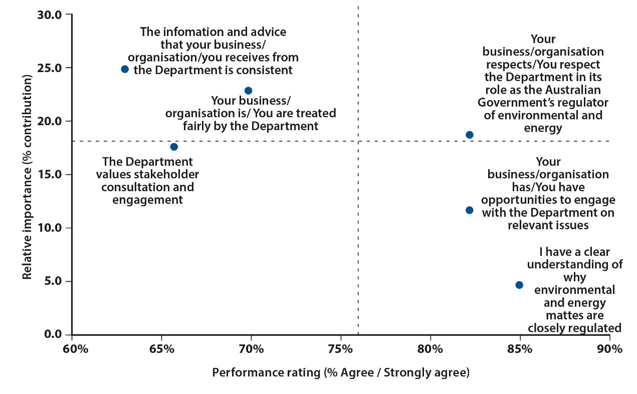

Source: Stakeholder survey.

QB2b. Overall how would you rate the Department for performing in a manner that is consistent with a trusted and respected regulator of environment and energy matters?

QB2a. Based on your experience, to what extent do you agree or disagree with each of the following statements …?

Base: All stakeholders (73).

Note: Not applicable, Don’t know and Prefer not to say responses removed from the model.

Relative importance derived from regression analysis. Value represents the extent to which each Outcome explains variation in overall performance rating.

Dashed lines indicate median value for each axis.

Model fit (r-squared) equals 63.6%.

Figure 13 Outcome 3 questions (decision-making processes)—performance rating (stakeholders)

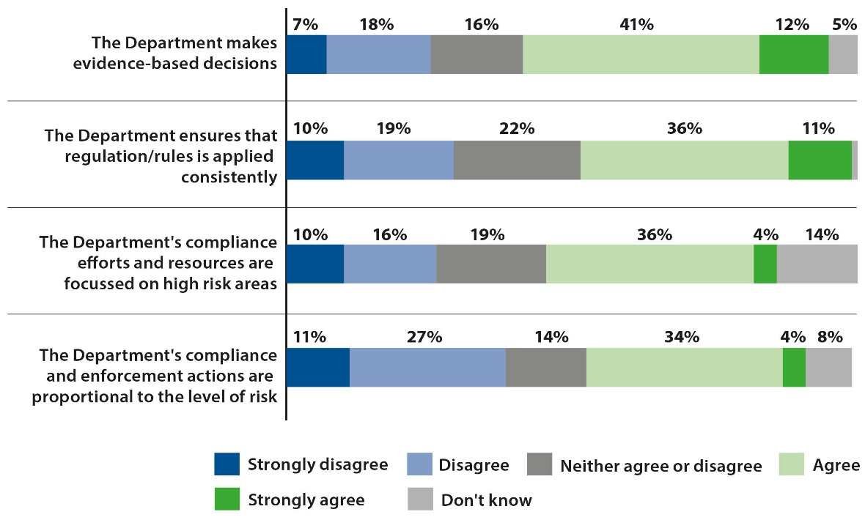

Source: QB3a. Based on your experience, to what extent do you agree or disagree with each of the following statements?

Base: All stakeholders (73).

Figure 14 Importance vs performance analysis: Outcome 3 (decision-making processes) (stakeholders)

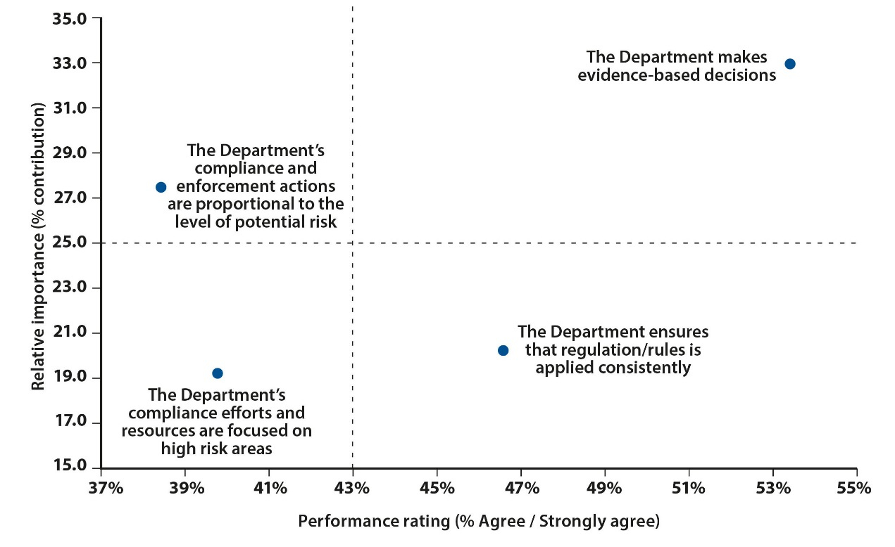

Source: Stakeholder survey.

QB3b. Overall how would you rate the Department’s decision-making processes?

QB3a. Based on your experience, to what extent do you agree or disagree with each of the following statements …?

Base: All stakeholders (73).

Note: Not applicable, Don’t know and Prefer not to say responses removed from the model.

Relative importance derived from regression analysis. Value represents the extent to which each Outcome explains variation in overall performance rating.

Dashed lines indicate median value for each axis.

Model fit (r-squared) equals 66.1%.

Figure 15 Outcome 3 questions (external engagement)—performance rating (staff)

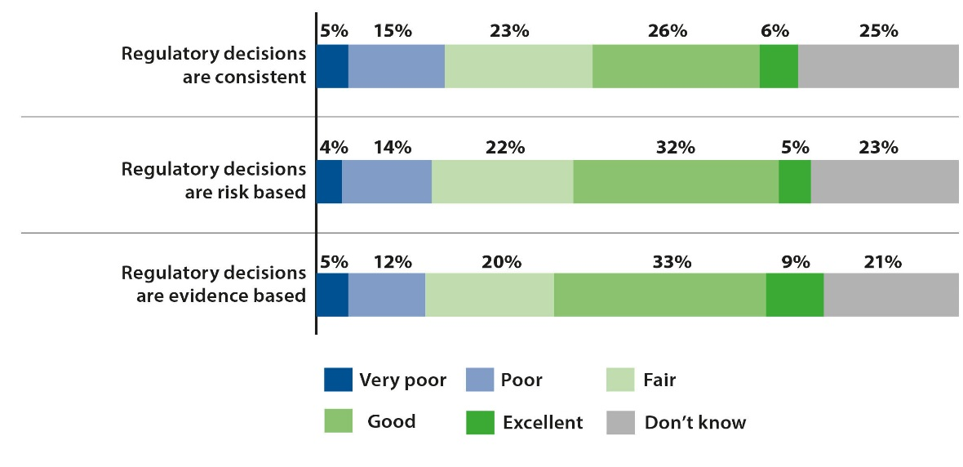

Source: QB3a. How would you rate the performance of the Department for each of the following statements?

Base: All staff aware of the Department’s regulatory responsibilities (557).

Figure 16 Outcome 4 questions (impact of regulation/rules)—performance rating (stakeholders)

This figure shows four stacked bar graphs representing stakeholder responses when asked to rate the Department’s performance for the following.
The Department provides flexibility in how stakeholders meet their regulatory/grant obligations. 5% Strongly disagree, 22% Disagree, 16% Neither agree nor disagree, 42% Agree, 10% Strongly agree, 4% Don’t know/Prefer not to say.
The Department takes into consideration the burden and cost of compliance required for stakeholders to meet their regulatory/grant obligations. 10% Strongly disagree, 25% Disagree, 26% Neither agree nor disagree, 26% Agree, 8% Strongly agree, 5% Don’t know/Prefer not to say.
The Departments approach to regulation is focused on ensuring good environmental and/or energy outcomes for Australia. 10% Strongly disagree, 18% Disagree, 12% Neither agree nor disagree, 41% Agree, 15% Strongly agree, 4% Not applicable/Don’t know/Prefer not to say.
The Department makes clear the purpose of the legislation relevant to your business/organisation/ you/your grant. 5% Strongly disagree, 11% Disagree, 18% Neither agree nor disagree, 51% Agree, 14% Strongly agree, 1% Not applicable.

Source: QB4a. Based on your experience, to what extent do you agree or disagree with each of the following statements?

Base: All stakeholders (73).

Figure 17 Importance vs performance analysis: Outcome 4 (impact of regulation/rules) (stakeholders)

This figure shows a regression analysis representing stakeholder responses when asked to rate the Department’s performance as a percentage of those who Agree/Strongly agree, relative to importance as a percentage contribution when asked to consider the following.
The Department takes into consideration the burden and cost of compliance required for stakeholders to meet their regulatory/grant obligations. Performance rated 34% Agree/Strongly agree relative to importance 15.9.
The Department provides flexibility in how stakeholders meet their regulatory/ grant obligations. Performance rated 52% Agree/Strongly agree relative to importance 19.1.
The Department’s approach to regulation is focused on ensuring good environmental and/or energy outcomes for Australia. Performance rated 56% Agree/Strongly agree relative to importance 40.9.
The Department makes clear the purpose of the legislation relevant to your business/organisation/ you/your grant. Performance rated 64% Agree/Strongly agree relative to importance 24.1.

Source: Stakeholder survey.

QB4b. QB4b Overall, how would you rate the Department in terms of its effort to ensure that regulations/rules do not unnecessarily impact [you/your business]?

QB4a. Based on your experience, to what extent do you agree or disagree with each of the following statements …?

Base: All stakeholders (73).

Note: Not applicable, Don’t know and Prefer not to say responses removed from the model.

Relative importance derived from regression analysis. Value represents the extent to which each Outcome explains variation in overall performance rating.

Dashed lines indicate median value for each axis.

Model fit (r-squared) equals 66.9%.

Figure 18 Outcome 5 questions (regulatory environment)—performance rating (staff)

This figure shows six stacked bar graphs representing stakeholder responses when asked to rate the Department’s performance for the following.
Our regulatory processes help drive improvement – achieving compliance with environment and/or energy legislation. 6% Strongly disagree, 16% Disagree, 20% Neither agree nor disagree, 32% Agree, 6% Strongly agree, 20% Don’t know.
The Department consults with a wide range of stakeholders to improve regulatory approaches and outcomes. 3% Strongly disagree, 13% Disagree, 16% Neither agree nor disagree, 39% Agree, 7% Strongly agree, 22% Don’t know/Prefer not to say.
The Department has a culture of exploring alternative ways to improve its regulatory approach. 6% Strongly disagree, 18% Disagree, 22% Neither agree nor disagree, 26% Agree, 4% Strongly agree, 24% Don’t know/Prefer not to say.
The Departments approach to regulation takes into consideration the costs and benefits to stakeholders. 3% Strongly disagree, 12% Disagree, 18% Neither agree nor disagree, 36% Agree, 8% Strongly agree, 22% Don’t know/Prefer not to say.
Changes to our regulatory activity are based on risk assessments. 3% Strongly disagree, 12% Disagree, 20% Neither agree nor disagree, 34% Agree, 4% Strongly agree, 28% Don’t know/Prefer not to say.
The Departments risk-based frameworks are publicly available. 2% Strongly disagree, 11% Disagree, 17% Neither agree nor disagree, 21% Agree, 3% Strongly agree, 46% Don’t know/Prefer not to say.

Source: QB1a. Thinking about your current role, to what extent do you agree or disagree with each of the following statements?

Base: All staff aware of the Department’s regulatory responsibilities (557).

Figure 19 Importance vs performance analysis: Outcome 5 (regulatory environment) (staff)

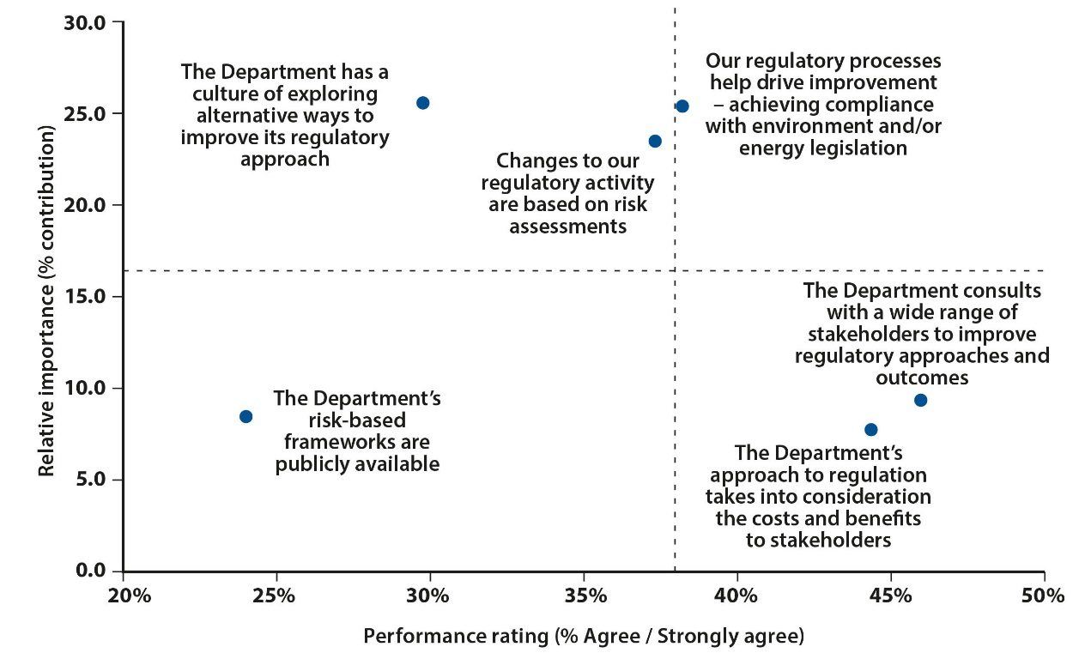

Source: Staff survey.

QC1. How would you rate the Department’s overall regulatory performance?

QB1a. Thinking about your current role, to what extent do you agree or disagree with each of the following statements?

Base: All staff aware of the Department’s regulatory responsibilities (557).

Note: Not applicable, Don’t know and Prefer not to say responses removed from the model.

Relative importance derived from regression analysis. Value represents the extent to which each Outcome explains variation in overall performance rating.

Dashed lines indicate median value for each axis.

Model fit (r-squared) equals 48.4%.

Table 1 Understanding of the Department’s regulatory responsibilities (staff)

|  |  |
| --- | --- |
| Response | % |
| Excellent | 19 |
| Good | 48 |
| Fair | 23 |
| Poor | 7 |
| Very poor | 1 |
| NA / Don’t know / Prefer not to say | 3 |

Source: QB1b. How would you rate your understanding of the Department’s regulatory responsibilities that are relevant to your current role?

Base: Staff who feel their role contributes to the Department’s regulatory responsibilities (447).

Table 2 Perceived importance of awareness of the Department’s regulatory responsibilities (staff)

|  |  |
| --- | --- |
| Response | % |
| Absolutely essential | 37 |
| Very important | 39 |
| Important | 19 |
| Slightly important | 4 |
| Not at all important | 0 |
| NA / Don’t know / Prefer not to say | 2 |

Source: QB1c. How important is it that you have a good awareness of the Department’s regulatory responsibilities that are relevant to your current role?

Base: Staff who feel their role contributes to the Department’s regulatory responsibilities (447).

Figure 20 Outcome 5 questions (Department staff)—performance rating (stakeholders)

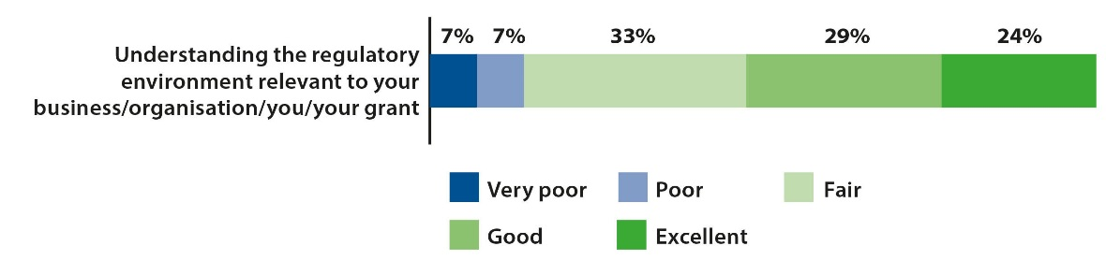

Source: QB5b. Using a scale of ‘very poor’ to ‘excellent’, based on your experience, how would you rate the Department’s staff on …?

Base: All stakeholders (73).

Table 3 Perceived importance of improving regulatory approach (staff)

|  |  |
| --- | --- |
| Response | % |
| Not at all important | 0 |
| Slightly important | 2 |
| Important | 15 |
| Very important | 44 |
| Absolutely essential | 38 |
| NA / Don’t know / Prefer not to say | 2 |

Source: QB1e. How important do you feel it is for the Department to continually seek to improve its approach to regulation?

Base: All staff aware of the Department’s regulatory responsibilities (557).

Figure 21 Outcome 6 questions (systems and processes)—performance rating (staff)

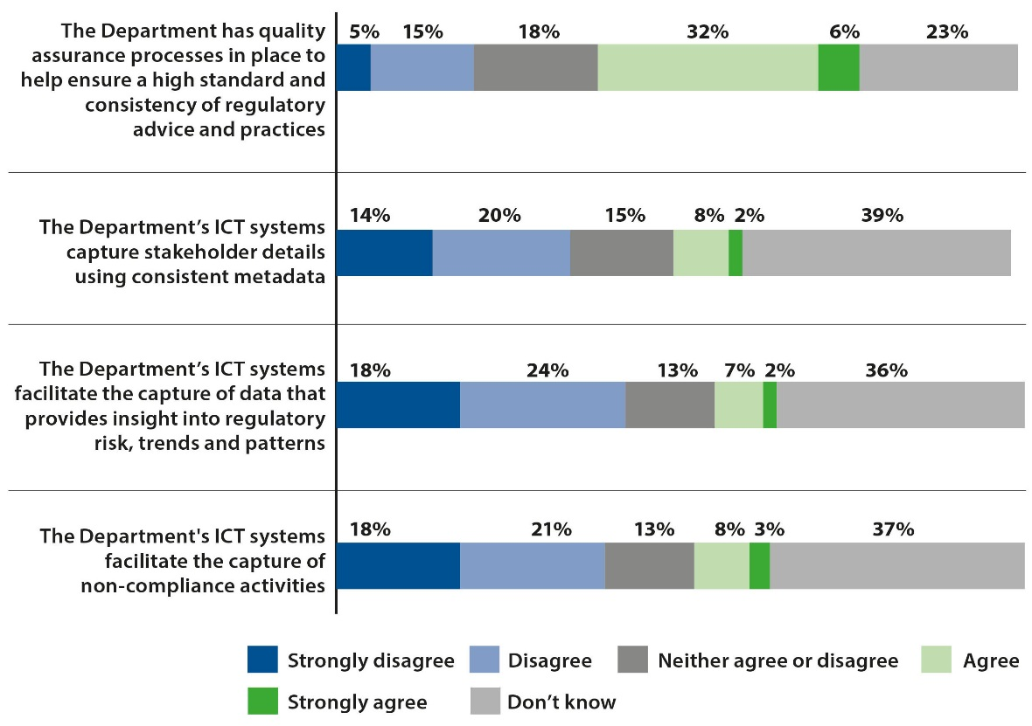

Source: QB2a1. Based on your experience in your current role, to what extent do you agree or disagree with each of the following statements?

Base: All staff aware of the Department’s regulatory responsibilities (557).

Figure 22 Importance vs performance analysis: Outcome 6 (systems and processes) (staff)

This figure shows a regression analysis representing stakeholder responses when asked to rate the Department’s performance as a percentage of those who Agree/Strongly agree, relative to importance as a percentage contribution when asked to consider the following. The Department has quality assurance processes in place to help ensure a high standard and consistency of regulatory advice and practices. Performance rated 37.9% Agree/Strongly agree relative to importance 46.2.
The Department’s ICT systems capture stakeholder details using consistent metadata. Performance rated 10.4% Agree/Strongly agree relative to importance 11.1.
The Department’s ICT systems facilitate the capture of data that provides insight into regulatory risk, trends and patterns. Performance rated 8.8% Agree/Strongly agree relative to importance 17.5.
The Department's ICT systems facilitate the capture of non-compliance activities. Performance rated 10.8% Agree/Strongly agree relative to importance 16.6.
I clearly understand my role and function with regards to regulation. Performance rated 87.0% Agree/Strongly agree relative to importance 5.7.

Source: Staff survey.

QC1. How would you rate the Department’s overall regulatory performance?

QB2a1. Based on your experience in your current role, to what extent do you agree or disagree with each of the following statements?

Base: All staff aware of the Department’s regulatory responsibilities (557).

Note: Not applicable, Don’t know and Prefer not to say responses removed from the model.

Relative importance derived from regression analysis. Value represents the extent to which each Outcome explains variation in overall performance rating.

Dashed lines indicate median value for each axis.

Model fit (r-squared) equals 37.5%.

Figure 23 Outcome 6 questions (skills and training)—performance rating (staff)

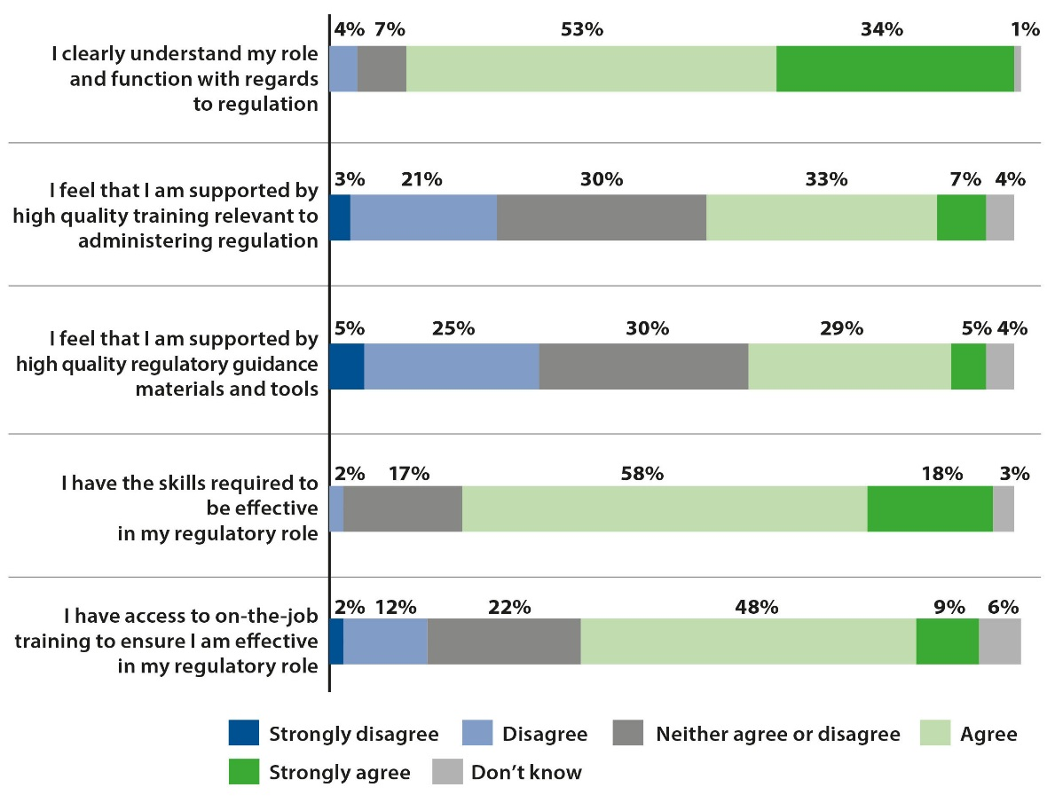

Source: QB2a2. Based on your experience in your current role, to what extent do you agree or disagree with each of the following statements?

Base: Staff who feel their role contributes to the Department’s regulatory responsibilities (447).

Figure 24 Areas of training and development needed (staff)

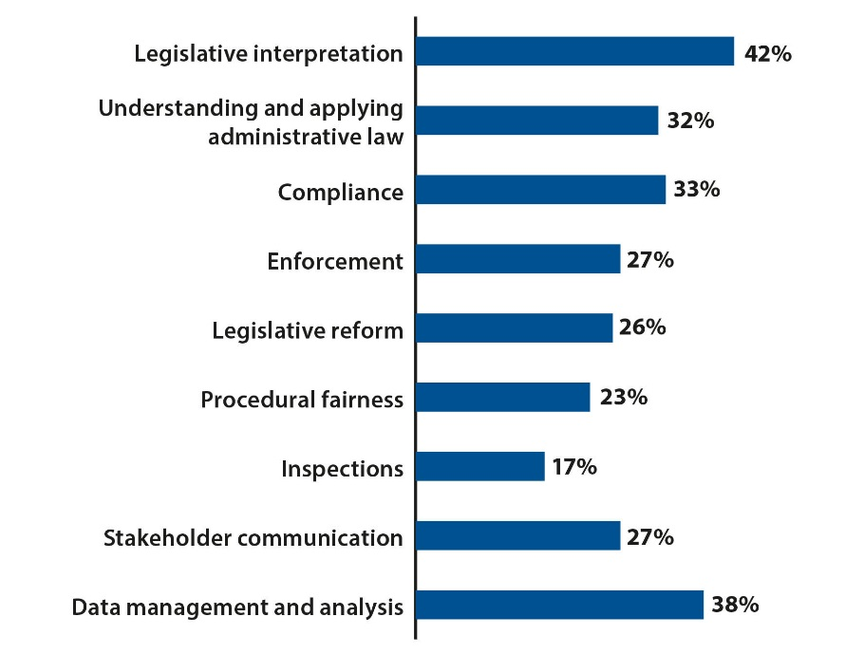

Source: QB2c. Which of the following regulatory skills / areas of knowledge do you feel you need to develop?

Base: Staff who feel their role contributes to the Department’s regulatory responsibilities (447).

Figure 25 Outcome 6 questions (Department staff)—performance rating (stakeholders)

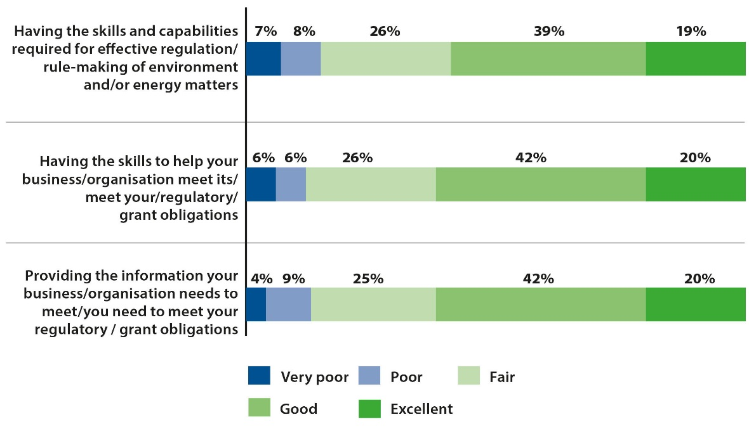

Source: QB5b. Using a scale of ‘very poor’ to ‘excellent’, based on your experience, how would you rate the Department’s staff on …?

Base: All respondents (73).