

**EPBC Act referral guidelines for three threatened black cockatoo species:**

**Carnaby’s cockatoo (endangered)**

*Calyptorhynchus latirostris*

**Baudin’s cockatoo (vulnerable)**

*Calyptorhynchus baudinii*

**Forest red-tailed black cockatoo (vulnerable)**

*Calyptorhynchus banksii naso*

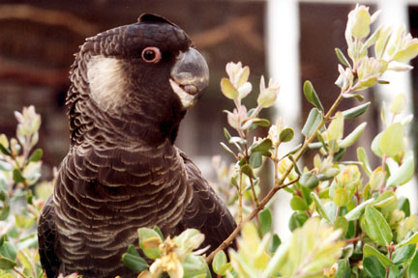

**© Commonwealth of Australia 2012**

This work is copyright. You may download, display, print and reproduce this material in unaltered form only (retaining this notice) for your personal, non-commercial use or use within your organisation. Apart from any use as permitted under the *Copyright Act 1968*, all other rights are reserved. Requests and enquiries concerning reproduction and rights should be addressed to Department of Sustainability, Environment, Water, Populations and Communities, Public Affairs, GPO Box 787 Canberra ACT 2601 or email [public.affairs@environment.gov.au](mailto:public.affairs@environment.gov.au)

**Disclaimer**

The contents of this document have been compiled using a range of source materials and is valid as at January 2012. The Australian Government is not liable for any loss or damage that may be occasioned directly or indirectly through the use of reliance on the contents of the document.

Front page photograph: male Carnaby's cockatoo (Leonie McMahon).

**Important notice**

Please note that these guidelines are general in nature and do not remove your obligation to consider whether you need to make a referral to the federal environment minister under the *Environment Protection and Biodiversity Conservation Act 1999* (EPBC Act). While these guidelines provide information to help you decide whether to refer your action, the possible impacts of your proposal will depend on the particular circumstances of the action. These circumstances may include issues such as the proximity of the action to habitat, indirect impacts and impact-mitigation measures.

These guidelines were made on the basis of the best information available at the time of writing. However, the impacts of proposals will be assessed by the department on the basis of the best information available at that point in time, which may differ from the information on which these guidelines are based.

These guidelines do not provide guidance on requirements under state and local government laws. Information on Western Australian and local government council laws can be obtained from the Western Australian Department of Environment and Conservation ([www.dec.wa.gov.au/](http://www.dec.wa.gov.au/)) and the local councils in or near the proposed project area.

**How to use these guidelines**

These guidelines are intended to assist you in determining whether your action needs to be referred to the Australian Government Department of Sustainability, Environment, Water, Population and Communities (the department). These guidelines should be read in conjunction with *EPBC Act Policy Statement 1.1 Significant Impact Guidelines – Matters of National Environmental Significance* ([www.environment.gov.au/epbc/publications/nes-guidelines.html](http://www.environment.gov.au/epbc/publications/nes-guidelines.html)).

These guidelines apply to Carnaby’s cockatoo (*Calyptorhynchus latirostris*), Baudin’s cockatoo (*Calyptorhynchus baudinii*) and the forest red-tailed black cockatoo (*Calyptorhynchus banksii naso*), collectively referred to here as black cockatoos, anywhere they may occur in Western Australia. These species are listed as threatened under the EPBC Act as follows:

* Carnaby’s cockatoo: endangered.
* Baudin’s cockatoo: vulnerable.
* Forest red-tailed black cockatoo: vulnerable.

Listed threatened species and ecological communities are matters of national environmental significance under the EPBC Act.

If you plan to undertake an action that has, will have or is likely to have a significant impact on any of these species of black cockatoos, you must refer the proposal to the minister before starting. The minister will then decide within 20 business days whether assessment is required under the EPBC Act. The potential significance of each action is judged on a case-by-case basis. Substantial penalties apply for undertaking an action, to which the EPBC Act applies, without approval (civil penalties up to $5.5 million or criminal penalties of up to seven years imprisonment). More information on referral, assessment and compliance is available at [www.environment.gov.au/epbc/](http://www.environment.gov.au/epbc/).

The criteria used to judge significant impact for vulnerable and endangered species are listed in the [*Significant impact guidelines 1.1*](http://www.environment.gov.au/epbc/publications/nes-guidelines.html). The criteria in the significant impact guidelines refer to ‘populations’ and ‘important populations’. These terms have not been defined for black cockatoos, due to the mobile and widely-distributed nature of these species, and the variation in flock compositions (for example, between breeding and non-breeding seasons). For black cockatoos, it is more appropriate to consider significance in terms of impacts on habitat rather than a resident population. Section 6 provides guidance for when one or more of these criteria may trigger the need to refer your action.

A [national recovery plan](http://www.environment.gov.au/biodiversity/threatened/publications/recovery/wa-forest-black-cockatoos.html) is in place for Baudin’s and forest red-tailed black cockatoos. A national recovery plan for Carnaby’s cockatoo is in development at the time of writing. The federal environment minister must not make a decision that is inconsistent with a national recovery plan.

The decision tree in Figure 1 and the rest of these guidelines are designed to assist you in determining whether your proposed action needs to be referred. You may also refer your proposed action if you are uncertain about the need to refer, or contact the department by emailing [epbc.referrals@environment.gov.au](mailto:epbc.referrals@environment.gov.au).

**Possible exceptions to the need to refer**

Certain actions are exempt from the requirement of assessment and approval under the EPBC Act. These include lawful continuations of land use that started before 16 July 2000, or actions that were legally authorised before 16 July 2000. There are a number of criteria that must be satisfied to rely on any such exemptions. More information on exemptions under the EPBC Act is available at [www.environment.gov.au/epbc/publications/exemptions.html](http://www.environment.gov.au/epbc/publications/exemptions.html).

Under certain circumstances a Regional Forest Agreement (RFA) forestry operation that is undertaken in accordance with an RFA may also be exempt from having to be referred under the EPBC Act. For more information on RFAs see [www.daff.gov.au/rfa](http://www.daff.gov.au/rfa).

**Where to get more information**

The SPRAT profiles for these species provides the biological and ecological context for survey guidelines, significant impact guidance and mitigation measures. They can be accessed at [www.environment.gov.au/cgi-bin/sprat/public/sprat.pl](http://www.environment.gov.au/cgi-bin/sprat/public/sprat.pl).

Other EPBC Act policy statements are available to help you understand the EPBC Act and your obligations. They are available from the department’s website at [www.environment.gov.au/epbc/guidelines-policies.html](http://www.environment.gov.au/epbc/guidelines-policies.html) or by contacting the community information unit by email: [ciu@environment.gov.au](mailto:ciu@environment.gov.au) or by phone: 1800 803 772. The department can provide assistance in ensuring your action complies with the EPBC Act, especially when contacted early in the planning process.

The [Protected Matters Search Tool](http://www.environment.gov.au/erin/ert/epbc/index.html) can provide a good starting point for determining the likelihood of having matters of national environmental significance in your area. State and territory government agencies may also hold relevant information including habitat and species distribution information.

Further information on these species can be obtained from the Western Australian Department of Environment and Conservation and relevant non-government agencies.

**Figure 1: Decision making**

YES

NO

YES or UNSURE

YES

NO

Have you **surveyed** for black cockatoo habitat using the recommended methods (see Section 4)?

NO

**REFERRAL RECOMMENDED**

High risk of resulting in significant impact**

Assume black cockatoo habitat is present.

NO

Is black cockatoo habitat present (see section 5)?

Have you reviewed the impact mitigation options (Section 5) and applied to your project as appropriate? Prioritise impact avoidance over impact minimisation.

Could the impacts of your action affect any black cockatoo **habitat** (see Section 3) or individuals?

**REFERRAL MAY NOT BE REQUIRED**\*

**Low risk** that your action will result in a significant impact on black cockatoos (see Section 6)**

**Uncertainty** as to whether your action will result in a significant impact on black cockatoos (see Section 6)*

**High risk** that your action will result in a significant impact on black cockatoos (see Section 6)**

**REFERRAL RECOMMENDED**

**OR CONTACT THE DEPARTMENT**

**REFERRAL RECOMMENDED**

Could the **impacts** of your action occur within the **modelled distribution** of the black cockatoos (see section 2)?

YES or UNSURE

**REFERRAL MAY NOT BE REQUIRED\***

Low risk of resulting in significant impact**

YES or UNSURE

NO

**REFERRAL MAY NOT BE REQUIRED\***

Low risk of resulting in significant impact**

Could your actionrequire a **referral to the federal environment minister** for significant impacts on black cockatoos (see Section 6)?

**REFERRAL MAY NOT BE REQUIRED\***

Low risk of resulting in significant impact**

* Although it may appear that there is a low risk of a significant impact, and that a referral may not be required, you may still choose to refer your proposed action. If you are uncertain about the need to refer then you can contact the department to discuss your action by emailing [epbc.referrals@environment.gov.au](mailto:epbc.referrals@environment.gov.au).

** Risk is the chance of something happening that will have a [significant] impact on objectives [for example, protecting matters of national environmental significance] (adapted from Australian / New Zealand Risk Management Standard ISO 31000:2009).**1.** **What is known about black cockatoos?**

Black cockatoos are long-lived, slow-breeding birds that display strong pair bonds and probably mate for life. These characteristics exacerbate the effects of population decline and habitat loss, and make population recovery very slow.

Baudin’s cockatoo breeds from August/September to February/March, while Carnaby’s cockatoo breeds from July/August to January/February. The forest red-tailed black cockatoo is thought to breed in October/November, but in years with good autumn rainfall they may breed in March/April. All three black cockatoos addressed in these guidelines breed in hollows in very long-lived trees. Hollows large enough for nesting black cockatoos are usually only found in trees that are more than 200 years old.

Currently, the overall population trend for all three black cockatoo species is declining. Large-scale clearing has seen a significant proportion of original black cockatoo habitat removed. Habitat loss and alteration continue to contribute to the major decline in population density and occupancy of habitat across the range.

Relevant background information on the biology and ecology of the black cockatoos is provided in the department’s Species Profile and Threats ([SPRAT](http://www.environment.gov.au/cgi-bin/sprat/public/sprat.pl)) database.

**2. Could the impacts of your action[1] occur within the modelled distribution of black cockatoos?**

Baudin’s cockatoo breeds in the eucalypt forests of the south western humid and sub‑humid zones. From March, flocks migrate north to the central and northern parts of the Darling Scarp for the non-breeding season. Some flocks also move on to the southern Swan Coastal Plain and south coast during the non-breeding season (Map 1). They move back to breeding areas from August.

Carnaby’s cockatoo breeds in the semi-arid and sub-humid interior (“wheatbelt”) and some locations along the south and west coasts (Map 2). From late January/early February most interior-breeding birds leave their breeding areas, moving west, south and east towards the coast. The movement back to breeding sites in the interior occurs in July/August, and September/October to breeding areas on the Swan Coastal Plain.

The forest red-tailed black cockatoo is endemic to the south-west humid and sub‑humid zones of Western Australia (Map 3). Their distribution extends north to Perth and east to Wundowie, Christmas Tree Well, North Bannister, Mount Saddleback, Rocky Gully and the upper King River. They are also found on parts of the Swan Coastal Plain.

The maps presented in this document are based on the best available information at the time of publication and remain a static product. For the most up-to-date report of whether black cockatoos may occur in your project area, always use the [Protected Matters Search Tool](http://www.environment.gov.au/erin/ert/epbc/index.html).

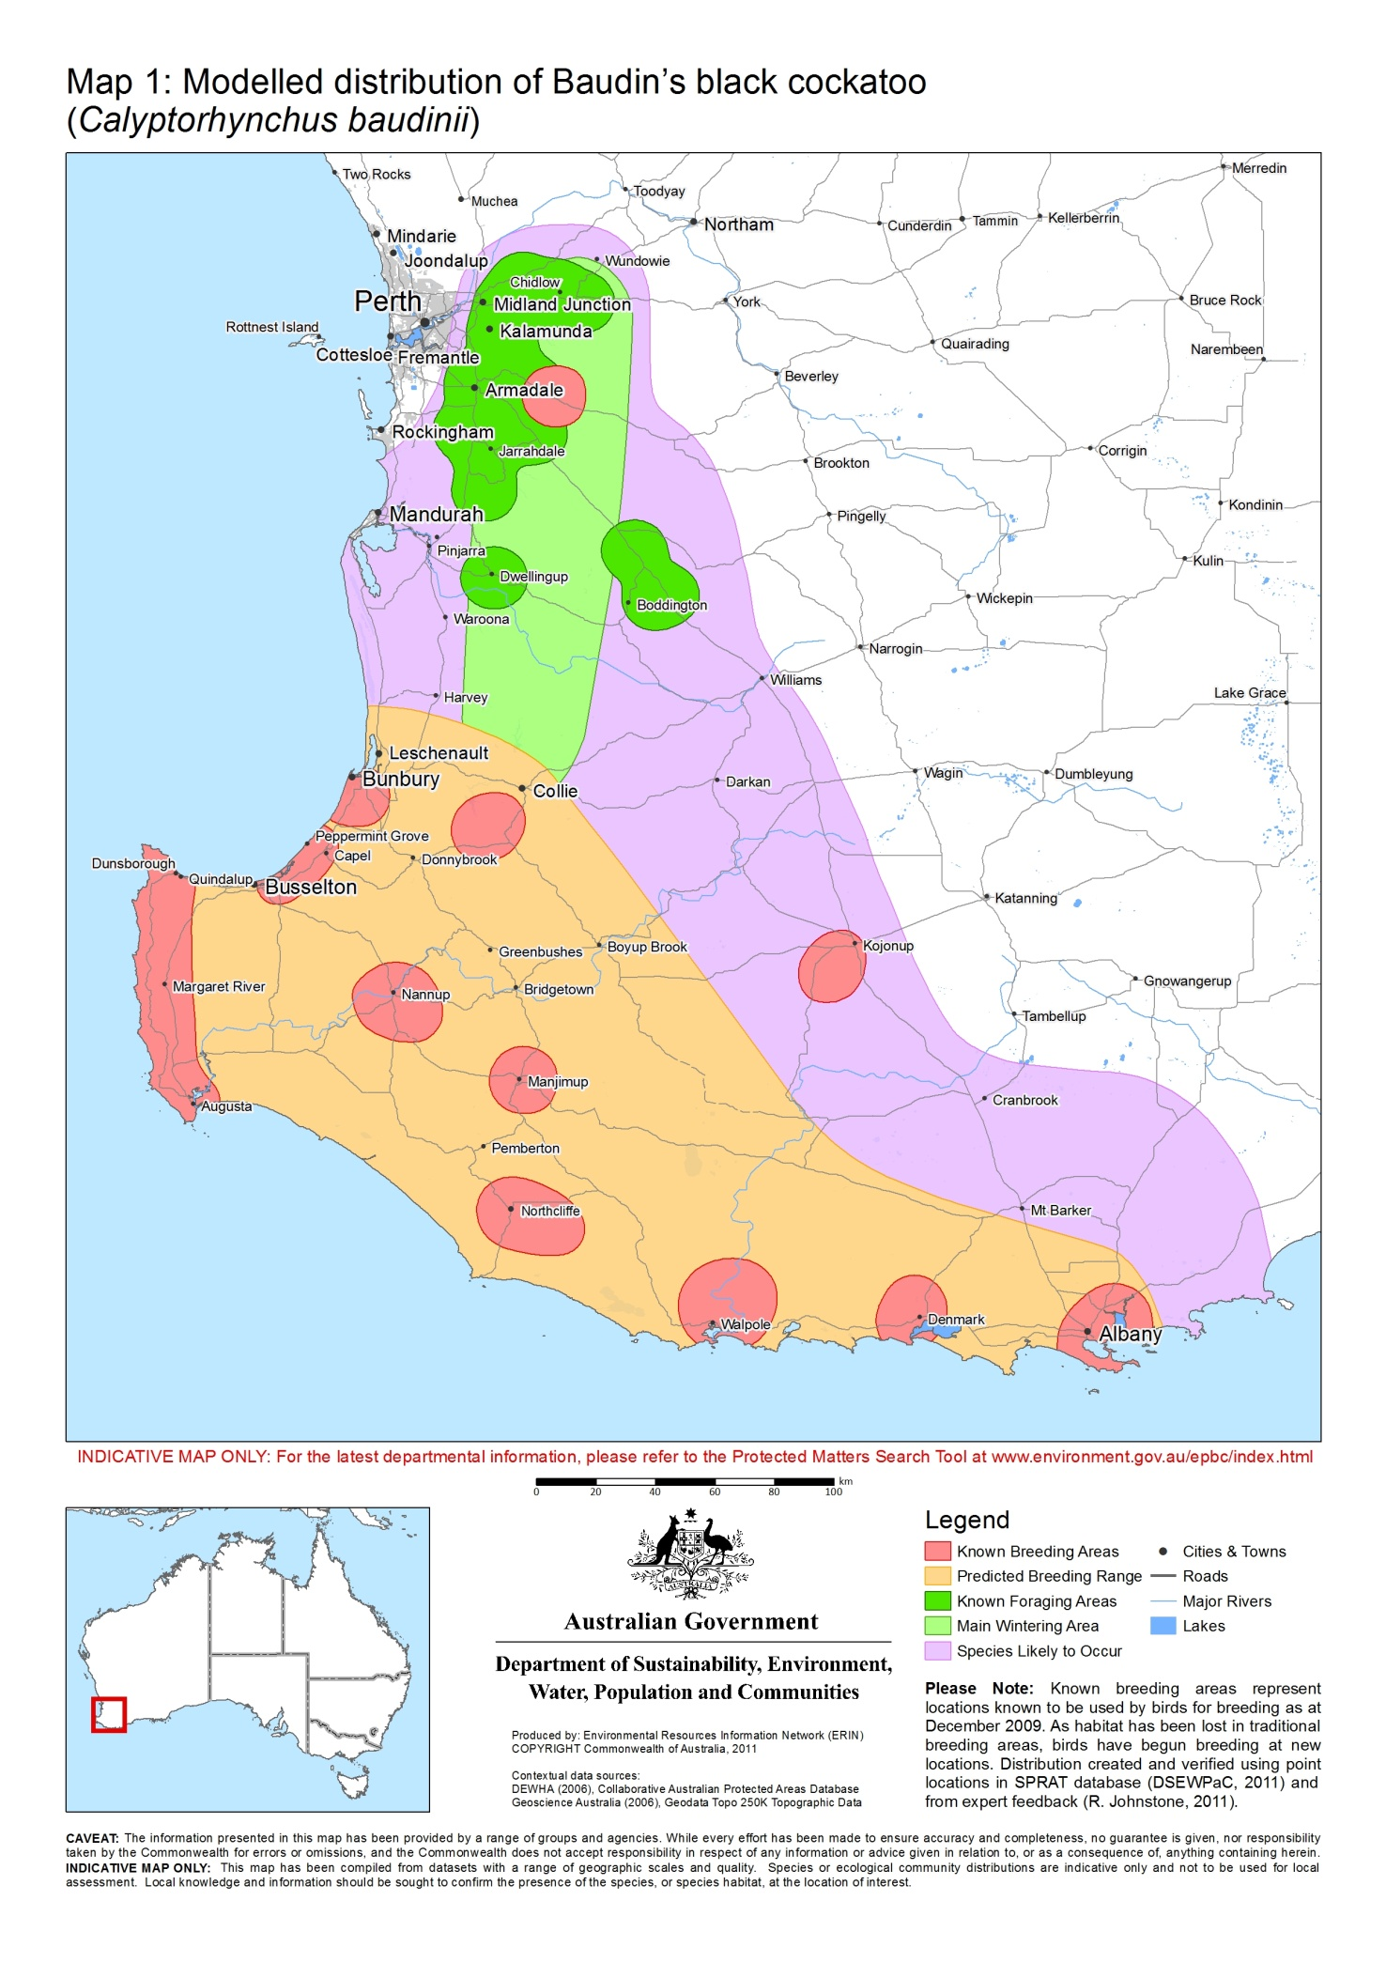

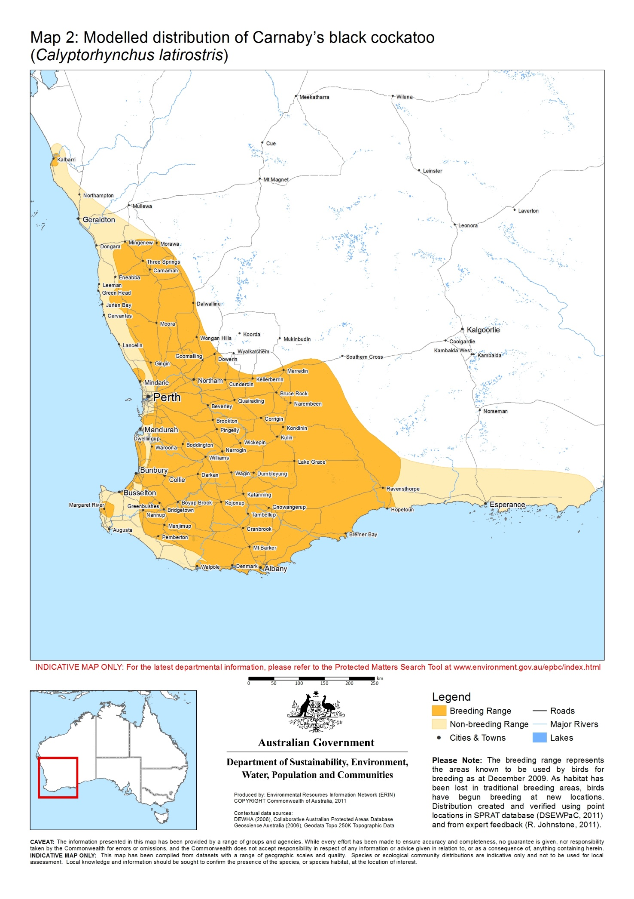

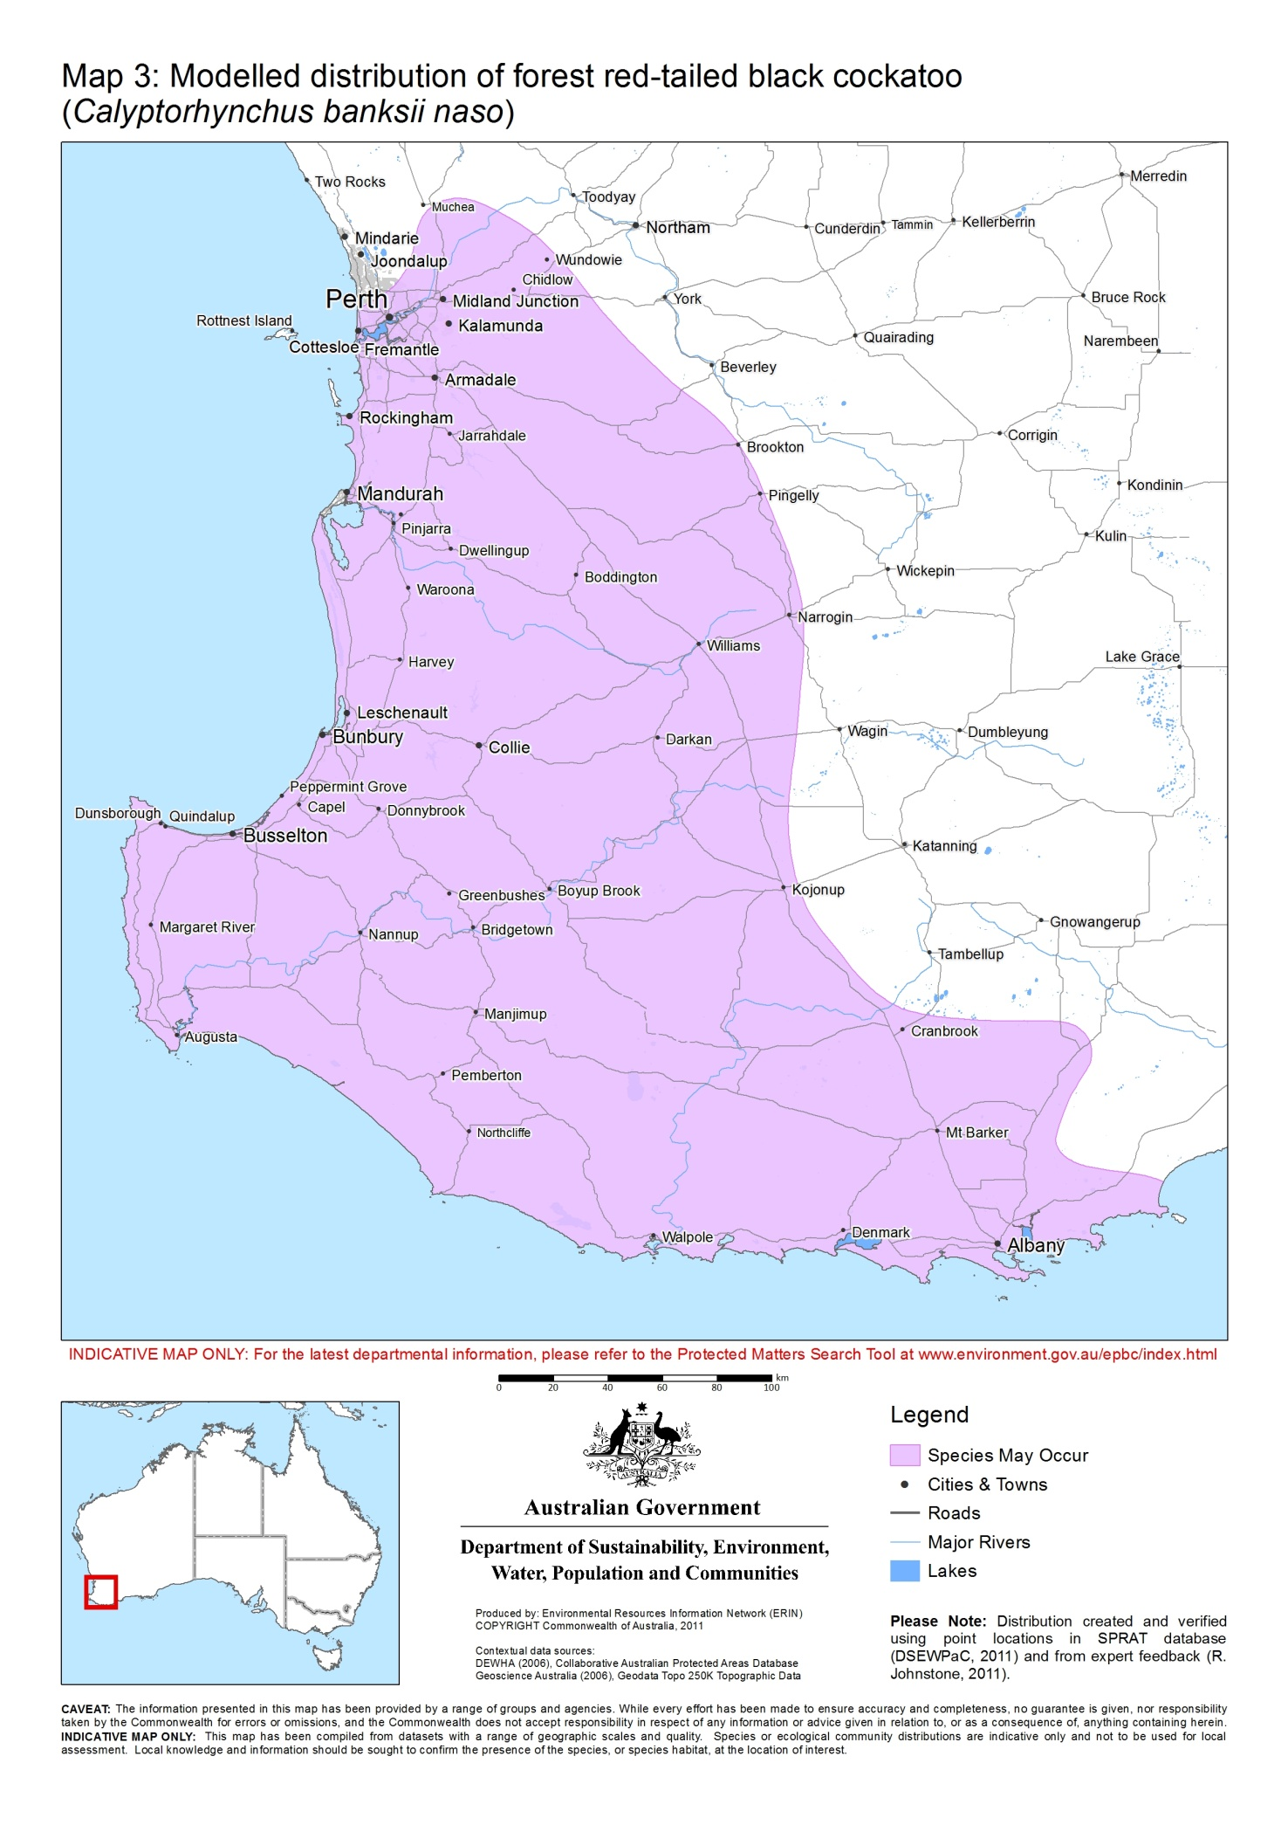

**3. Could the impacts of your action affect habitat for black cockatoos?**

The seasonal movements of black cockatoos means they require large areas of habitat for breeding, night roosting and foraging, as well as connectivity between these habitats to assist their movement through the landscape.

**Breeding habitat**

Black cockatoos breed in large hollow-bearing trees, generally within woodlands or forests. The size of the tree (measured as the diameter at breast height) can be a useful indication of the hollow-bearing potential of the tree. In a woodland stand with trees of suitable diameter at breast height, all trees of all ages and size are potentially important for maintaining breeding in the long term through maintaining the integrity of the habitat and allowing for recruitment of trees to provide future nest hollows. Maintaining the long-term supply of trees of trees of a size to provide suitable nest hollows is particularly important in woodland stands that are known to support cockatoo breeding.

‘Breeding habitat’ is defined in these referral guidelines as trees of species known to support breeding (see Table 1) within the range of the species which either have a suitable nest hollow OR are of a suitable diameter at breast height (DBH) to develop a nest hollow. For most tree species, suitable DBH is 500 mm. For salmon gum and wandoo, suitable DBH is 300 mm.

**Foraging habitat**

While breeding, black cockatoos will generally forage within a 6–12 km radius of their nesting site. Following breeding, birds assemble into flocks and move through the landscape searching for food, usually foraging within 6 km of a night roost. Because of this mobility, potential for reduced seed set and flowering due to drought, and the irregular or infrequent flowering and fruiting patterns of many of their food sources, large areas of foraging habitat are required to support black cockatoo populations.

**Night roosting habitat**

All three black cockatoos use communal night roosting sites. Flocks may use several different night roosts across the year, with major night roosts typically used for a period of weeks or until the local foraging resources are exhausted. Flocks of black cockatoos show some fidelity to roost sites, with ‘traditional’ night roost sites being used in most years to access high-quality feeding sites. Due to changing patterns of food and water availability across the landscape, not all night roosts will be used every year. Different roost sites are used under different weather conditions, so a flock requires a range of options within each area frequented.

Carnaby’s and Baudin’s cockatoos mainly use night roost sites in the non-breeding areas. However, both breeding and non-breeding forest red-tailed black cockatoos use night roosting sites. Groups of birds will roost in a suitable tree or group of tall trees, usually close to an important water source, and within an area of quality foraging habitat. The cockatoos fly to feeding areas each day before returning to the night roost. However, use of a particular night roost site may vary from daily to weekly. Night roosts are generally located in the tallest trees in an area.

Details on the habitat types used by each species for breeding, foraging and night roosting are listed in Table 1.

**Table 1: habitats used by black cockatoos.**

|  |  |  |  |
| --- | --- | --- | --- |
| **Habitat** | **Baudin’s** | **Carnaby’s** | **Forest red-tailed** |
| Breeding[2] | Generally in woodland or forest[3], but may also breed in former woodland or forest now present as isolated trees. Nest in hollows in  live or dead trees of karri (*Eucalyptus diversicolor)*, marri (*Corymbia calophylla)*, wandoo (*E.wandoo*) and tuart (*E. gomphocephala*). | Generally in woodland or forest³, but also breeds in former woodland or forest now present as isolated trees. Nest in hollows in  live or dead trees of salmon gum (*E. salmonophloia*), wandoo, tuart, jarrah (*E. marginata*), flooded gum (*E. rudis*), york gum (*E. loxophleba subsp. loxophleba*), powderbark (*E. accedens*), karri and marri. | Generally in woodland or forest³, but may also breed in former woodland or forest now present as isolated trees. Nest in hollows in  live or dead trees of marri, karri, wandoo, bullich (*E. megacarpa*), blackbutt (*E. patens*), tuart and jarrah. |
| Night roosting[4] | Generally in or near riparian environments or other permanent water sources. Jarrah, marri, flooded gum, blackbutt (*E. patens*), tuart, and introduced eucalypts including blue gum (*E. globulus*), and lemon scented gum (*Corymbia citriodora*). | Generally in or near riparian environments or natural and artificial permanent water sources. Flat-topped yate (*E. occidentalis*), salmon gum, wandoo, marri, karri, blackbutt, tuart, introduced eucalypts (for example blue gum) and introduced pines. | Tall jarrah, marri, blackbutt, tuart and introduced eucalypt trees within or on the edges of forests. |
| Foraging | Eucalypt woodlands and forest, and proteaceous woodland and heath. During the breeding season feed primarily on native vegetation, particularly marri. Outside the breeding season, may feed in fruit orchards (mostly apple and pear, but also persimmon) and tips of *Pinus* spp. | Native shrubland, kwongan heathland and woodland dominated by proteaceous plant species such as *Banksia* spp. (including *Dryandra* spp.), *Hakea* spp. and *Grevillea* spp. Forages in pine plantations (*Pinus* spp.), eucalypt woodland and forest that contains foraging species. Also individual trees and small stands of these species. | Jarrah and marri woodlands and forest, and edges of karri forests including wandoo and blackbutt, within the range of the subspecies. |
| Foraging: common food items | Mostly marri (seeds, flowers, nectar and grubs) and proteaceous trees and shrubs. Also other native seeds and introduced fruits; insects and insect larvae; pith of kangaroo paw (*Anigozanthos flavidus*); juice of ripe persimmons; tips of *Pinus* spp. and seeds of apples and pears. | Seeds, flowers and nectar of native proteaceous plant species (for example, *Banksia* spp.*, Hakea* spp.*, Dryandra* spp*,* and *Grevillea* spp), eucalypts and *Callistemon*. Also seeds of introduced species including *Pinus* spp., *Erodium* spp., wild radish, canola, almonds and pecan nuts; insects and insect larvae; occasionally flesh and juice of apples and persimmons. | Mostly seeds of marri and jarrah, also *Eucalyptus caesia*, illyarrie(*E. erythrocorys*) and some introduced eucalypts such as river red gum (*E. camaldulensis*) and flooded gum (*E. grandis*), *Allocasuarina* cones, fruits of snottygobble (*Persoonia longifolia*) and mountain marri (*Corymbia haematoxylon*). On the Swan Coastal Plain, often feed on introduced cape lilac (*Melia azedarach*). |

**4.** **Have you surveyed for black cockatoo habitat using the recommended methods?**

A guide to conducting surveys for Carnaby’s, Baudin’s and forest red-tailed black cockatoo habitat is outlined below. Surveys should:

* be done by a suitably qualified person with experience in vegetation or cockatoo surveys, depending on the type of survey being undertaken
* maximise the chance of detecting the species’ habitat and/or signs of use
* determine the context of the site within the broader landscape—for example, the amount and quality of habitat nearby and in the local region (for example, within 10 km)
* account for uncertainty and error (false presence and absences)
* include collation of existing data on known locations of breeding and feeding birds and night roost locations.

**Habitat assessment**

Habitat assessment is the primary technique used to inform decisions on significant impact for black cockatoos. Assess the extent, type and quality of the vegetation present, including the presence and extent of plants known to be used by the black cockatoos (see Table 1). In potential breeding habitat, measurements of the diameter at breast height of trees in the patch of woodland/forest must be made to determine whether the habitat meets the definition of ‘breeding habitat’. Surveys for black cockatoo foraging habitat should be done in any remaining vegetation containing proteaceous heath/woodland, eucalypt woodlands or forest (particularly marri and jarrah forest) and in areas dominated by *Pinus* spp. Any area within the range of the black cockatoos that contains known food or nesting plant species is considered to be potential habitat for the species.

Additional information on black cockatoo use of an area can be determined by searching for signs of use by black cockatoos, if this information is desired. Signs of use include suitable nest hollows, feeding signs or feeding debris, and sighting records. The presence of cockatoo droppings and feathers, or ‘chewed’ banksia or pine cones or marri nuts, can indicate feeding by black cockatoos (including, if possible, the identification of bite patterns to indicate which black cockatoo species fed there). This can be assessed at any time of year, as cones can remain on the ground for up to two years. Signs of use should be identified by a person with at least three years’ experience surveying for black cockatoos.

## Targeted surveys for birds

Targeted presence/absence surveys for birds are considered **optional** for the purposes of environmental impact assessment, and, if done, lack of detection should not be taken to mean that black cockatoos do not use the site. Short-term surveys for bird presence are unlikely to give a true representation of habitat use by black cockatoos, due to the mobile nature of these birds and their reliance on different areas of habitat at different times of the year and between years. A guide to conducting targeted surveys can be found in the relevant SPRAT profiles for the three species.

**5. Is your impact mitigation best practice so that it may reduce the significance of your impacts?**

When designing your proposed action, avoiding impacts on black cockatoos should be your principal aim. Effective avoidance will result in no net loss of habitat for the species. For example, locate developments on previously cleared land that that does not contain black cockatoo habitat. If you believe your options to retain habitat and preserve populations are not possible, then you should mitigate any impacts.

Table 2 outlines the main threats to black cockatoos, the associated impacts and mitigation measures to reduce the level of impacts. It is not intended to be exhaustive or prescriptive.

Impact mitigation should be monitored to ensure that it is effective and to allow for adaptive management responses.

**Table 2: Primary threats, impacts and mitigation**

|  |  |
| --- | --- |
| **Threat and impact** | **Avoidance and mitigation** |
| **Habitat loss and degradation[5]**   * Loss and isolation of mature, hollow-bearing trees necessary for breeding. * Lack of or loss of younger age class trees required to replace old trees that die or are destroyed, leading to a shortage of hollows in the future. * Loss, degradation and fragmentation of foraging habitat. This is particularly important in breeding areas: removal of vegetation around breeding sites, and the removal of native vegetation corridors that connect breeding and foraging sites, reduces the amount of food available to breeding birds and can affect chick survival rates. Breaks of more than 4 km have been shown to prevent breeding birds reaching resources. * Removal of native vegetation corridors, restricting the birds’ ability to migrate across the landscape. * Loss, degradation and isolation of night roost sites and surrounding feeding or watering habitat. * Loss and degradation of habitat by secondary impacts such as introduction of dieback caused by *Phytophtora cinnamomi* (and other plant diseases), weed invasion which can affect seed set, and hydrological changes (such as flooding, drainage or salinity). | * Mitigation and management actions should prioritise impact avoidance over impact reduction measures. * Design the action to avoid or minimise clearing of cockatoo habitat. * Manage forested and eucalypt woodland areas to protect present and future hollow-bearing trees in areas where birds breed. * Retain habitat along riparian and other corridors to preserve roosting habitat, movement corridors and watering points. * Improve and manage habitat on or next to the site of the impact. * Preserve foraging habitat near to breeding resources to allow for the successful fledging of chicks. * Re-create movement corridors between patches of remnant habitat, particularly where these link breeding or roosting sites to patches of foraging habitat. * Maintain a mosaic of vegetation age classes and species to increase the ecological value and longer‑term viability of the vegetation. * Plant a mix of foraging habitat species, using local plant species. Plant in blocks or corridors of several hectares to produce enough food to sustain a local population for some weeks. Plantings should be local species of suitable quantity and quality to ensure that they contribute to the local functioning of the landscape and become self-sustaining to support black cockatoos over the long term. Note that it will take many years before new plantings are mature enough to support flocks. * Avoid or control plant diseases. * Notify landowners of the importance of artificial watering points, such as stock watering points, close to night roost sites. |
| **Interactions with humans**   * Death or injury when hit by cars or trucks, particularly road constructions that concentrate birds at roadsides to feed on roadside vegetation and spilt grain, or drink from rainwater retained as puddles on roadsides. * Death or injury from crop protection measures which may trap or injure birds, or prohibit them from accessing nearby native vegetation. * Disturbance to birds from noise, light, vibrations and fumes. * Shooting of birds (for example where they are coming into conflict with humans over fruit or nut crops). * Poaching of birds and eggs. | * Manage habitat for conservation (for example, preventing access from people, livestock, pets, machinery etc.). * Appropriate road and construction design and management to limit concentration of birds on roadsides. For example, avoid planting tree species that will attract cockatoos along road verges. * Signage to alert motorists to watch for birds along roadsides. * Practice good crop transport and farm hygiene. Cover loads (eg canola) when transporting and take care to avoid and clean up crop spills on roadsides. * In apple, pear or other tree crops that may suffer damage by black cockatoos, remove all the fruit when harvesting to avoid attracting cockatoos with surplus fruit left on trees or on the ground. * Employ effective, safe crop protection such as netting that excludes birds during production periods for fruit and nut crops. Contact the Western Australian departments of Environment and Conservation, or Agriculture and Food. * Shooting and poaching are illegal under Western Australian wildlife laws. Substantial penalties may apply to any person found guilty of interfering with native wildlife. |
| **Invasive species**   * Competition for nest hollows with European honeybees and invading bird species * Injury and death from European honeybees. | * Where necessary, control hollow-competing fauna (for example, feral bees, corellas, galahs, wood and mountain ducks) under licence. |

**6. Could your action require a referral to the federal environment minister for significant impacts on black cockatoos?**

As the person proposing the action it is your responsibility to decide whether or not to refer your action. If you believe your action is at high risk of having a significant impact on black cockatoos, you should refer the action to the federal environment minister. If you are uncertain whether your action will have a significant impact on black cockatoos you may also refer your action or contact the department.

Table 3 provides guidance on what may be at high to low risk of requiring a referral to the department, and where uncertainty may exist. **Table 3 provides guidance on your need to refer regardless of any mitigation measures adopted.** If your action meets or exceeds the referral triggers in Table 3 you should consider the referral recommendation even if you have included mitigation in your proposed action. This guidance is not intended to be comprehensive. Other types of actions or impacts may constitute varying degrees of risk.

In determining the potential significance of your action, the department will consider the particular circumstances of your case. This may include factors such as the suitability of the habitat, its connectivity, and the amount of habitat remaining in the region.

**Table 3: Referral guidelines**

|  |
| --- |
| **High risk of significant impacts: referral recommended** |
| * Clearing of any known nesting tree (see glossary). * Clearing or degradation of any part of a vegetation community known to contain breeding habitat (see Section 3). * Clearing of more than 1 ha of quality[6] foraging habitat[7] (see Table 1). * Clearing or degradation (including pruning the top canopy) of a known night roosting site (see glossary). * Creating a gap of greater than 4 km between patches of black cockatoo habitat (breeding, foraging or roosting). |
| **Uncertainty: referral recommended or contact the department** |
| * Degradation (such as through altered hydrology or [fire regimes](http://www.environment.gov.au/epbc/publications/pubs/bushfire-factsheet.pdf)) of more than 1 ha of foraging habitat7. Significance will depend on the level and extent of degradation and the quality of the habitat. * Clearing or disturbance in areas surrounding black cockatoo breeding, foraging or night roosting habitat that has the potential to degrade habitat through introduction of invasive species, edge effects, hydrological changes, increased human visitation or fire. * Actions that do not directly affect the listed species but that have the potential for indirect impacts such as increasing competitors for nest hollows. * Actions with the potential to introduce known plant diseases such as *Phytophthora* spp. to an area where the pathogen was not previously known. |
| **Low risk of significant impacts: referral may not be required** |
| * Actions that do not affect black cockatoo habitat or individuals. * Actions whose impacts occur outside the modelled distribution of the three black cockatoos. |

**7. Glossary**

**Affected area:** The area likely to be affected by the action. This includes the project site and any additional areas likely to be affected, either directly or indirectly. That is, anywhere on or off site where the effects, good and bad, of the proposed action would be felt. Habitat and/or populations may, and often will, extend beyond the development site boundaries. Therefore, the affected area should extend as far as necessary to take all potential impacts, including off site impacts, into account. This is the area that the person proposing an action must survey.

**Breeding habitat:** Habitat which meets the definition set out in Table 1 for the respective species. This habitat is considered to have the potential to support breeding by the species. Breeding habitat predominantly applies to those areas with the breeding range of the respective species as identified in the maps provided. However, given: incomplete knowledge of breeding activity; the potential for these areas to change; and known breeding sites outside the traditional breeding ranges, habitat that meets the definition set out here, but is outside of the predicted breeding range, is considered breeding habitat unless proven otherwise.

**Known nesting trees:** Any existing tree in which breeding has been recorded or suspected. Information on known nesting trees within or near the area of an action is available from the Western Australian Department of Environment and Conservation and the Western Australian Museum.

**Known night roosting site:** A tree or group of trees where there are records or recent evidence of night roosting.

**Suitable nest hollow:** Any hollow that appears to be deep enough and with an opening large enough to be used by black cockatoos. Usually this will be a natural hollow, but artificial hollows may also be suitable in some circumstances (for example, where the artificial hollow has been specifically designed for use by threatened black cockatoos).

1. When considering whether your action will have a significant impact on black cockatoos, you should consider all adverse impacts from the action, including direct, indirect and offsite impacts such as downstream, upstream and facilitated impacts (impacts that result from further actions, which are made possible or facilitated by the action).
2. See glossary.
3. For definitions see for example the CSIRO *Australian soil and land survey field handbook*.
4. Black cockatoos may roost overnight in any native or introduced tree in the Perth metropolitan area which has suitable features (including height and proximity to water and foraging habitat).
5. Degradation may occur through a variety of sources, including changes to the hydrology or fire regimes, and chemical application (causing death or dieback) to known roosting or nesting trees.
6. Quality should be assessed as it pertains specifically to black cockatoo use of the habitat. For example, the condition of the understorey is a standard component of most ecological habitat quality surveys but is of limited relevance to considerations for some black cockatoos, particularly in relation to breeding habitat which may consist of mature woodland canopy with little or no understorey.
7. Maintaining the availability of foraging habitat is especially important in the breeding range, as sufficient foraging habitat within a 6–12 km radius of breeding sites is necessary to successfully raise chicks. Maintaining foraging habitat is also particularly important in the Perth metropolitan area, due to the role of these feeding areas in the survival of young birds and the maintenance of the population between breeding seasons, coupled with the lack of habitat remaining in this region and its connectivity values.