
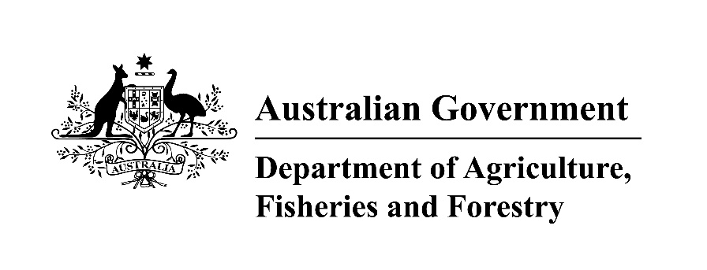

This Quick Reference Guide supports the State Specific Guideline for New South Wales. These documents may be used by processors of raw logs from NSW to facilitate their due diligence process in accordance with the Illegal Logging Prohibition Act 2012 and Illegal Logging Prohibition Regulation 2012.

Documents to demonstrate legality of timber from NSW

Plantations
Public Land
Copy of Forestry Corporation of NSW operational plan
Native Forests
Private Land
Documentation to show information on the compliant plantation, other accreditation, or a harvesting approval
The Private Native Forest Plan number
Documentation to show information on the harvesting approval, area where the log is sourced, or harvesting activity.
Forestry Corporation of NSW delivery docket with the following information:
Harvesting contractor name
Region, location and compartment the log was sourced from
Species and dimensions of timber
Total volume

The NSW Government’s due diligence summary template, attached to the State Specific Guideline for New South Wales, can be used to help gather and record this information.

Timber harvesting regulation in NSW

The NSW Environment Protection Authority (EPA) and the Department of Regional NSW (DRNSW), including the Department of Primary Industries (DPI), Local Land Services (LLS) and the Forestry Corporation of NSW (FCNSW) have key roles and responsibilities in the regulation of the NSW timber industry.
DPI has the role of authorising and regulating plantations on private and public land through the Plantations and Reafforestation Act 1999 and Plantations and Reafforestation (Code) Regulation 2001.
LLS has the role of providing advice and approvals for native forestry on private land through a Private Native Forestry Plan (PNF Plan) approved under the Local Land Services Act 2013.
FCNSW is authorised by the Forestry Act 2012 to remove timber from state forests and other Crown-timber lands in accordance with Integrated Forestry Operations Approvals (IFOAs).
The EPA is the primary environmental regulator, responsible for ensuring native forestry operations comply with the relevant IFOA on public land and Private Native Forestry Code (PNF Code) on private land.

Public native forests

Under the Forestry Act 2012, FCNSW is authorised to conduct native forest harvesting operations in state forests and other crown timber land under IFOAs, which set environmental rules for how forestry operations can be carried out. There are 4 IFOAs in NSW: Brigalow Nandewar, South-Western Cypress, Riverina Red Gum and the Coastal IFOA.
FCNSW must prepare a separate operational plan for each native forest harvesting operation. Copies of FCNSW’s operational plans are available via their website at www.forestrycorporation.com.au.

Private native forests

Under the Local Land Services Act 2013, native forestry operations on private land must be conducted in accordance with: the PNF Plan for the land approved by LLS; the approved Forest Management Plan (except for small scale harvesting); and the requirements of the relevant Private Native Forestry Code.
Forest Management Plans outline how individual forestry operations will be undertaken within a PNF Plan area and are consistent with the requirements of the PNF Code.
LLS will maintain a public register of PNF Plans and Forest Management Plans.

Plantations

NSW DPI authorises new and existing plantations on both public and private lands under the Plantation and Reafforestation Act 1999 (PR Act) and the Plantations and Reafforestation (Code) Regulation 2001 (Plantations Code). Plantations must be authorised under the PR Act before any logging in plantations over 30 hectares in size occurs unless an exception applies. See the State Specific Guideline for NSW for more details on these exemptions.
An operational plan is also required if more than 100 trees in any hectare in any year is harvested in authorised plantations. These plans must be prepared to the standards in the Plantations Code and submitted to the Director-General of DPI.
A public register of authorised plantations is maintained on the DPI website.

Who should I contact for further information?

GPO Box 858, Canberra ACT 2601  Phone: (02) 6272 3933  agriculture.gov.au/illegallogging  illegallogging@agriculture.gov.au |   NSW Environment Protection Authority  Locked Bag 5022  Parramatta NSW 2124Phone: (02) 9995 5555  epa.nsw.gov.au  info@environment.nsw.gov.au
  161 Kite St, Orange NSW 2800  Phone: (02) 6391 3100  forests@dpi.nsw.gov.au  dpi.nsw.gov.au/forestry |   Phone: 1300 795 299  pnf.info@lls.nsw.gov.au  lls.nsw.gov.au/land-management/pnforestry

