**Overview of Vapour Heat Treatment for**

**Fresh Fruits in Sri Lanka**

# Thushara Wickramaarachchi Head of NPPO / IPPC Official Contact Point National Plant Quarantine Service (NPQS) Katunayake, Sri Lanka

**Content**

* **Introduction**
* **Fruit fly diversity and host plant in Sri Lanka**
* **Phytosanitary certification procedure for fruits and vegetable against fruit fly species**
* **Fruit fly studies and VHT standards on Mango in Sri Lanka**

**Introduction**

**Mango production and field extent**

0

50,000

100,000

150,000

200,000

2,000

7,000

12,000

17,000

22,000

27,000

32,000

MT

Ha

2011 2012 2013 2014 2015 2016 2017 2018 2019 2020 Extent Prodution

* There is a high demand for the Sri Lankan high quality export potential mango fruits from the high-end markets such as Japan, Korea and China
* However, due to the fruit fly infestation of local fruits, it needs to apply plant quarantine treatment for the mangoes in order to comply with export phytosanitory conditions

## Diversity of fruit flies in Sri Lanka

* 16 fruit fly species were identified with 45 species of host plants (Tsuruta *et al*., 1997)
* 39 fruit fly species have been reported (Leblanc *et al.,* 2018)
* 12 fruit fly species have been reported to damage to fruits of many agricultural crops throughout the country

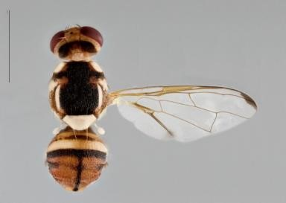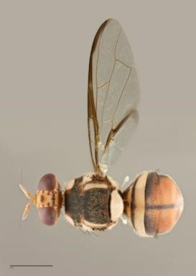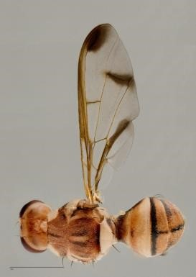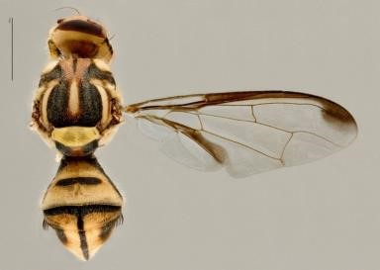

### Fruit fly species damage to fruit and vegetable and their host plants in Sri Lanka

|  |  |
| --- | --- |
| **Fruit fly species** | **Host plants** |
| *Bactrocera dorsalis* | **Mango**, Cashew, Avacado etc. |
| *Bactrocera kandiensis* | **Mango**, Cashew, Guava, Papaya etc |
| *Bactrocera correcta* | Guava, **Mango**, Soursop , etc. |
| *Bactrocera latifrons* | Yellow-fruit nightshade |
| *Bactrocera nigrotibialis* | Indian Almond |
| *Bactrocera versicolor* | Sapodilla |
| *Bactrocera zonata* | Wild guava, Indian almond etc. |
| *Dacus ciliatus* | Cucurbit fruit pest |
| *Zeugodacus caudatus* | Cucurbit flower pest |
| *Zeugodacus cucurbitae* | Cucurbit flower pest |
| *Zeugodacus. diversus* | Cucurbit flower pest |
| *Zeugodacus tau* | Cucurbit flower pest |

**Process Map for Exportation of Sri Lankan Mango with VHT Treatment**

Fruit fly infestation is the major barrier for the exportation of local mango.

Therefore, farmers should adhere to the supply chain introduced by the NPQS

|  |  |  |
| --- | --- | --- |
| **1**  **2**  **3**  **4**  **5**  **6** | |  | | --- | | **Establishment of commercial mango orchards** | |
| |  | | --- | | **Registration of export oriented mango orchards** | |
| |  | | --- | | **Field certification for export** | |
| |  | | --- | | **Pack house inspection procedure fs** | |
| |  | | --- | | **VHT Treatment** | |
| |  | | --- | | **Exit point inspection and exportation** | |

#### Phytosanitory treatment could only be applied for the fruits produced from NPQS certified fields

**Vapour Heat Treatment (VHT) studies carried out in Sri Lanka**

**Vapor Heat Treatment against four species of fruit flies in mango**

**(Var. “Karthakolomban”)**

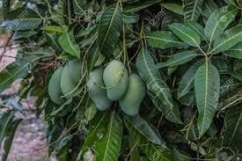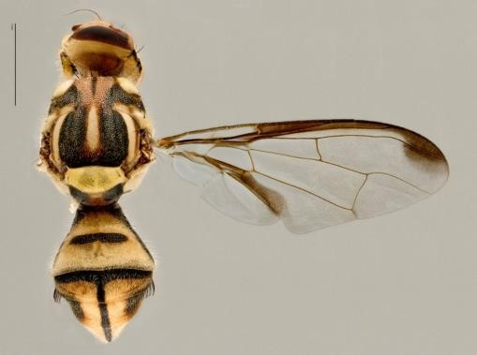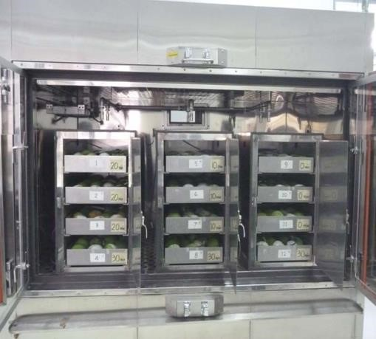

**Target insects**

|  |  |
| --- | --- |
| ***Bactrocera dorsalis*** | ***Bactrocera correcta*** |
|  |  |
| ***Zeugodacus tau*** | ***Zeugodacus cucurbitae*** |
|  |  |

**Target fruit**

**Mango**

**‘**

**Karthakolomban**

**’**

**fruits**

**on the**

**tree**

**Mango**

**‘**

**Karthakolomban**

**’ fruits**

**(**

***Mangifera***

***indica***

**)**

**Mango**

**‘**

**Karthakolomban**

**’**

**orchard**

**Mango**

**‘**

**Karthakolomban**

**’**

**flower**

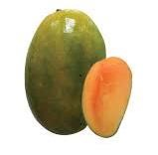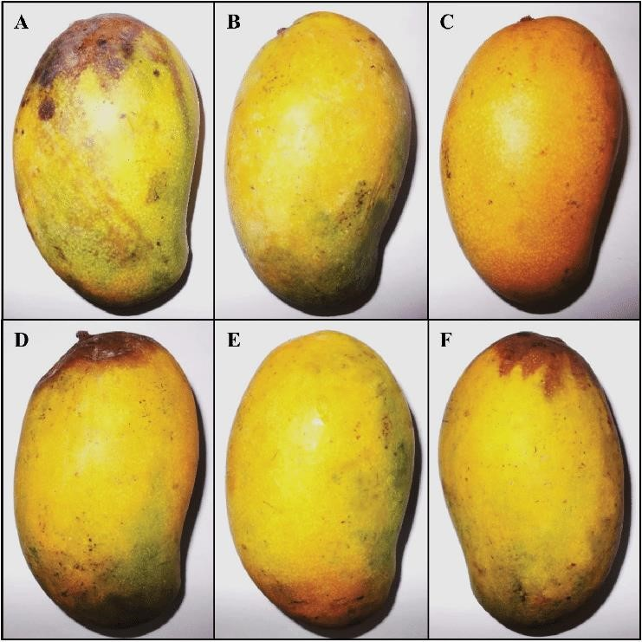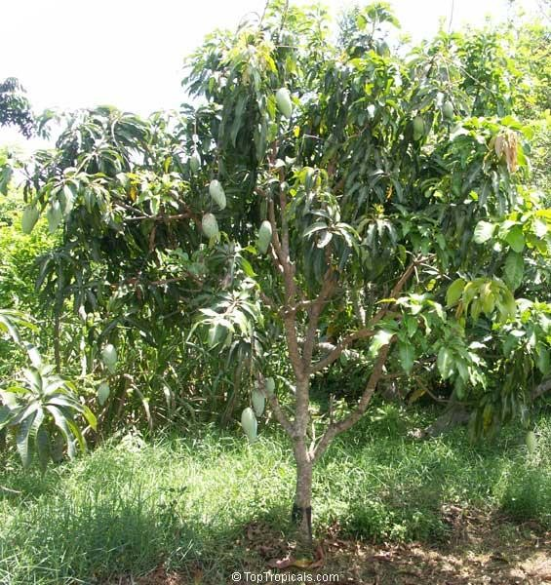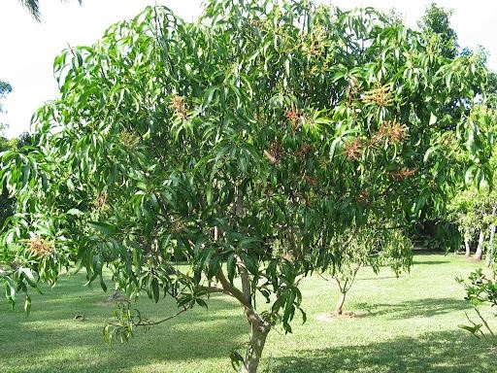

**3**

**. Small**

**-**

**Scale Mortality**

**Test by VHT**

**. Large**

**4**

**-**

**Scale Mortality**

**Test by VHT**

**. Hot Water**

**1**

**ImmersionTest**

**. Susceptibility Mortality**

**2**

**Test by VHT**

**To determine the most heat**

**tolerant species of fruit fly**

**To determine the most heat**

**tolerant species & life stage of**

**fruit fly**

**To Determine VHT standards**

**Fruit core temp.**

**(**

**and Holding time)**

**To confirm VHT standards (**

**100**

**%**

**mortality with more than 30,000**

**effective insects)**

**Mortality Test of Fruit Fly**

**Mass rearing of fruit fly**

* Maintenance 4:1 (Female :male) sex ratio in the test population
* Collect eggs using an egging device
* All adults and subsequent larval stages are reared separately and fed

with

relevant

artificial

diet

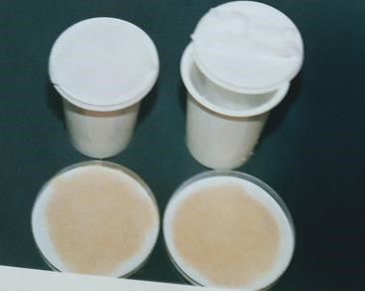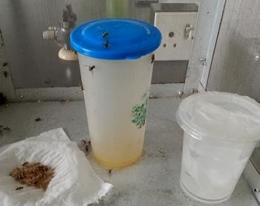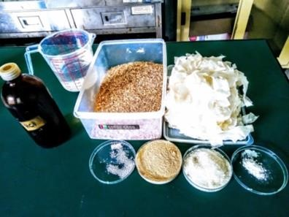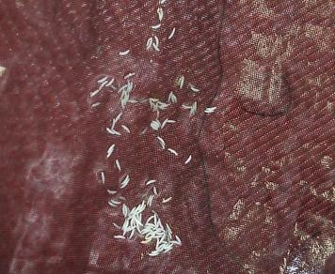

**Artificial Adult**

**diet**

**Egging device**

**Eggs**

**Artificial larval**

**diet**

**Hot water immersion test**

* **Purpose**

To determine the most heat tolerant species of fruit flies for heat generated by ***Hot water immersion***

* **Materials**

Test insect : ***B. dorsalis , B. kandiensis, B. cucurbitae and B. tau***

Target stage : Eggs (mature), larvae (1st, 2nd , 3rd instar)

* **Methods**
* Insects was immersed in hot water
* Temperature : 45.0 oC
* Exposure time : 4, 7, 10, 13, 16, 19, 22, 25, 28 & 31 min

#### Result of hotwater immersion test

**Corrected mortality of each developmental stage of *B. dorsalis, B. kandiensis, B. cucurbitae* and *B. tau* in hotwater immersion test**

|  |  |  |  |  |  |  |  |  |  |  |  |  |  |  |  |  |
| --- | --- | --- | --- | --- | --- | --- | --- | --- | --- | --- | --- | --- | --- | --- | --- | --- |
| **Exposur e time**  **(min)** | **Mortality (%)** | | | | | | | | | | | | | | | |
| **B. *dorsalis*** | | | | **B. *kandiensis*** | | | | **B. *cucubitae*** | | | | **B. *tau*** | | | |
| **Stage** | **ME** | **1st** | **2nd** | **3rd** | **ME** | **1st** | **2nd** | **3rd** | **ME** | **1st** | **2nd** | **3rd** | **ME** | **1st** | **2nd** | **3rd** |
| 4 | 11.51 | 0 | 0 | 11.36 | 24.83 | 8.39 | 33 | 12.5 | 9.3 | 25.17 | 0 | 22.93 | 47.73 | 24.68 | 27.41 | 6.72 |
| 7 | 25 | 35.24 | 10.85 | 22.73 | 51.34 | 12.77 | 24.5 | 31.5 | 28.86 | 39.86 | 30.59 | 57.52 | 45.62 | 32.82 | 70.72 | 61.56 |
| 10 | 20.63 | 31.28 | 40.57 | 39.55 | 51.34 | 16.42 | 83.5 | 78 | 42.02 | 48.6 | 65.75 | 80.45 | 49.85 | 56.74 | 92.21 | 97.31 |
| 13 | 40.87 | 30.4 | 47.64 | 78.18 | 45.68 | 32.48 | 71 | 79.5 | 45.02 | 68.88 | 77.17 | 95.86 | 49.24 | 77.35 | 94.08 | 100 |
| 16 | 50.4 | 47.58 | 76.42 | 81.36 | 57.05 | 45.62 | 89.5 | 89.5 | 50.25 | 82.17 | 88.58 | 96.99 | 58.61 | 96.69 | 98.75 | 99.73 |
| 19 | 55.56 | 36.12 | 81.6 | 83.18 | 58.39 | 63.14 | 94.5 | 97.5 | 51.74 | 88.11 | 87.21 | 98.87 | 62.84 | 99.24 | 99.69 | 100 |
| 22 | 66.27 | 56.39 | 89.15 | 92.73 | 63.31 | 80.66 | 97 | 99.5 | 56.47 | 86.01 | 91.32 | 99.25 | 75.53 | 100 | 100 | 100 |
| 25 | 63.89 | 61.23 | 97.17 | 94.09 | 60.43 | 75.55 | 100 | 99.5 | 67.66 | 95.8 | 98.17 | 100 | 89.73 | 100 | 100 | 100 |
| 28 | 63.49 | 87.67 | 98.58 | 99.55 | 73.74 | 82.48 | 100 | 99 | 81.09 | 96.15 | 99.54 | 100 | 93.96 | 100 | 100 | 100 |
| 31 | 62.7 | 92.51 | 100 | 98.64 | 80.94 | 93.07 | 100 | 99 | 87.81 | 97.2 | 99.54 | 100 | 98.49 | 100 | 100 | 100 |

***B. dorsalis*** has shown the highest heat tolerance at the hot water immersion test

#### Susceptibility mortality test by VHT

* **Purpose:**

To determine the most heat tolerant stage of fruit fly against high temperature

* **Materials**

**Test insect** : ***B. dorsalis , B. kandiensis, B. cucurbitae and B. tau***

##### Target stage : Mature eggs , Larvae (1st, 2nd , 3rd instar) Mango Size : 250-300 g

◼ **Methods**

* Artificially infested mango was treated in vapor heat treatment (VHT)
* Fruit core temperature :41, 43, 44, 45, 46, 47oC and Control

#### Result of susceptibility mortality test

**Corrected mortality of each developmental stages of B. *dorsalis*, B. *kandiensis*, B. *cucurbitae* and B. *tau* in heat susceptibility test by VHT method**

|  |  |  |  |  |  |  |  |  |  |  |  |  |  |  |  |  |
| --- | --- | --- | --- | --- | --- | --- | --- | --- | --- | --- | --- | --- | --- | --- | --- | --- |
| **Temperat ure** | **Mortality (%)** | | | | | | | | | | | | | | | |
| **B. dorsalis** | | | | **B. kandiensis** | | | | **B. cucubitae** | | | | **B. tau** | | | |
| **ME** | **1st** | **2nd** | **3rd** | **ME** | **1st** | **2nd** | **3rd** | **ME** | **1st** | **2nd** | **3rd** | **ME** | **1st** | **2nd** | **3rd** |
| 41 | 4.30 | 37.21 | 6.23 | 20.89 | 37.26 | 43.44 | 0.58 | 17.28 | 79.87 | 19.83 | 4.61 | 4.44 | 47.13 | 0 | 40.46 | 33.16 |
| 43 | 13.58 | 45.64 | 9.76 | 0 | 32.8 | 45.48 | 8.65 | 48.73 | 78.22 | 33.52 | 29.28 | 38.41 | 41.08 | 13.81 | 45.72 | 63.73 |
| 44 | 44.37 | 57.56 | 0 | 41.23 | 51.91 | 47.23 | 10.95 | 71.39 | 87.46 | 42.74 | 38.16 | 90.77 | 47.45 | 54.7 | 80.59 | 99.22 |
| 45 | 21.85 | 65.99 | 43.63 | 65.18 | 64.97 | 81.05 | 36.89 | 80.45 | 100 | 99.44 | 83.55 | 100 | 96.63 | 96.96 | 99.67 | 100 |
| 46 | 54.64 | 93.9 | 73.44 | 89.03 | 76.11 | 88.63 | 92.22 | 100 | 100 | 100 | 100 | 100 | 100 | 100 | 100 | 100 |
| 47 | 99.57 | 97.67 | 96.21 | 100 | 100 | 100 | 100 | 100 | 100 | 100 | 100 | 100 | 100 | 100 | 100 | 100 |

***Eggs, 1st and 2nd instar of B. dorsalis*** has shown the highest heat tolerance at the Vapour Heat Treatment

#### Small scale mortalitytest by VHT

* **Purpose:**

**To Determine VHT standards (fruit core temperature and holding time)**

|  |  |
| --- | --- |
| **Temperature (0C)** | **Time (min)** |
| **46.0** | **2** |
| **46.5** | **0** |
| **46.5** | **10** |
| **46.5** | **20** |
| **47.0** | **0** |
| **47.0** | **10** |

* **Materials**

Test Insect Target : ***B. dorsalis***

stage Mango size : **Mature eggs*, 1st and 2nd instar***

: **250-300 g**

* **Treatment Conditions**

#### Results of small scale mortalitytest by VHT

**Corrected mortality of each developmental stages of B. *dorsalis* in heat susceptibility test by VHT method**

Stages

**Mortality (%)**

Temperature (Time)

Control

46.0 (2

min

)

46.5

(

0)

46.5

(

10)

46.5

(

20)

47.0 (0)

47.0

(

10)

Egg

%

50.44

%

81.44

%

100

100

%

100

%

100

%

47.58

%

1

st

81.39

%

100

%

%

100

%

100

100

%

100

%

85.00

%

2

nd

85.58

%

100

%

100

%

100

%

100

%

100

%

88.27

%

**The Study showed that 46.50- 10 min, 46.50- 20 min, 47.00- 0 min & 47.00- 10 min effective to eradicate eggs, 1st Instar and 2nd Instar of fruit fly**

#### Fruit injury test

09 fruit quality parameters were tested with different temperature and time combinations

|  |  |  |  |  |  |  |  |  |  |  |  |  |  |  |  |  |  |  |  |  |  |  |  |  |  |  |  |  |  |  |  |
| --- | --- | --- | --- | --- | --- | --- | --- | --- | --- | --- | --- | --- | --- | --- | --- | --- | --- | --- | --- | --- | --- | --- | --- | --- | --- | --- | --- | --- | --- | --- | --- |
| |  | | --- | | **Parameter** | | Weight loss | | Ripeness at survey | | pH | | Brix | | Taste & flavor | | Shrinkage | | Cavity and spongy tissue in pulp | | Fruit decay | | Anthracnose | | |  |  | | --- | --- | | **Treatment Conditions** | | | **Temp. and**  **Time**  **Combination** | **Maturity stage** | | 46.5 0C (20) | R, G | | 46.5 0C (30) | R, G | | 47.0 0C (08) | R, G | | 47.0 0C (10) | R, G | | 47.0 0C (20) | R, G | | 47.0 0C (30) | G | | 47.0 0C (60) | R, G | | 48.0 0C (00) | G | |

|  |  |  |  |  |  |  |  |  |  |
| --- | --- | --- | --- | --- | --- | --- | --- | --- | --- |
| **Test No.** | **Trea9tment Condition** | **Weight loss** | **Ripeness at survey** | **Fruit Rot** | **Shrinkage** | **Anthracnose** | **pH** | **Brix** | **Others** |
| **1** | 47.0 – 20 | T:10.8% C:11.2% (**T=C)** | T:4.1% C:4.0% **(T=C)** | T:0.2 C:1.1 (**T<C)** | T:1.4 C:1.2 **(T=C)** | T:0.7 C:1.9 (**T<C)** | T:5.62 C:5.09 (**T=C)** | T:12.1 C:12.1 (**T=C)** |  |
| **2** | 46.5 - 30 | T:11.9% C:11.0% (**T=C)** | T:3.9% C:4.3% (T=<C) | T:0.8 C:2.1 (T<C) | T:2.1 C:2.0% (T=C) | T:1.7 C:2.2 (T=<C) | T:6.0 C:6.23 (T=C) | T:11.0 C:13.2 (T=<C) | Taste & Flavor (T=C) |
| **3** | 47.0 - 20 | T:9.7% C:10.2% **(T=C)** | T:3.7% C:3.4% (T=C) | T:0.4 C:0.5 (T=C) | T:0.5 C:0.7 (T=<C) | T:0.3 C:1.1 (T<C) | T:4.68 C:4.78 (T=C) | T:8.7 C:9.2 (T=C) | Taste & Flavor (T=C) |
| **4** | 47.0 - 60 | T:14.0% C:13.8% (**T=C)** | T:4.1% C:4.2% (T=C) | T:1.1 C:1.3 (T<C) | T:1.1 C:1.3 (T=C) | T:0.4 C:1.4 (T<C) | T:4.53 C:4.91 (T=C) | T:7.6 C:8.4 (T=<C) | Taste & Flavor (T=C) |
| **5** | 48.0 – 00 | T:7.3% C:11.8% (Different conditions) (**T<C)** | T:2.9% C:3.3% (T=<C) | T:0.1 C:1.6 (T>=C) | T:0.1 C:1.6 (Different conditions) | T:0.1 C:0.5 (T<C) | T:4.65 C:4.82 (T>=C) | T:7.7 C:7.6 (T=C) | Taste & Flavor (T=C) |
| **6** | 46.5 - 30 | T:14.8% C:13.3% (T>=C) | T:3.9% C:3.8% (T=C) | T:2.3 C:2.3 (T<C) | T:2.3 C:2.3 (T=C) | T:0.4 C:0.9 (T<C) | T:4.41 C:4.49 (T=C) | T:10.0 C:10.4 (T=C) | Taste & Flavor (T=C) |
| **7** | 47.0 - 60 | G(10d):T=2.5 %  C=3.2%  R(5d):T=2.2%  C=1.3%  **(T=C)** | G(10d):T=2.7 C=2.7  R(5d):T=2.8 C=2.4  (T=C) | G(10d):T=0 .1  C:1.7  R(5d):T=0.6  C=0.4  (T=<C) | G(10d):T=0  C=0  R(5d):T=0.8  C=0.6  (T=C) | G(10d):T=0  C=0.7  R(5d):T=0.1  C=0.3  (T<C) | G(10d):T=4.14  C=4.67  R(5d):T=4.45  C=4.19  (T=<C) | G(10d):T=8.4  C=11.0  R(5d):T=9.0  C=11.0  (T=<C) |  |
| **8** | 47.0 - 10 | G:T =2.6%  C=3.2%  R:T=1.5% C=1.3%  (**T=C)** | G:T =2.4 C=2.7  R:T=2.7 C=2.4  (T=C) | G:T =3 C=1.7  R:T=3 C=0.4  (T<C) | G:T =0 C=0  R:T=1 C=0.6  (T=<C) | G:T =0  R:T=0.2  (T<C) | G:T =3.76  C;4.67  R:T=3.88  C;4.19  (T=C) | G:T =7.7  C:11.0  R:T=8.9  C:11.0  (T=<C) |  |

#### Fruit injury test

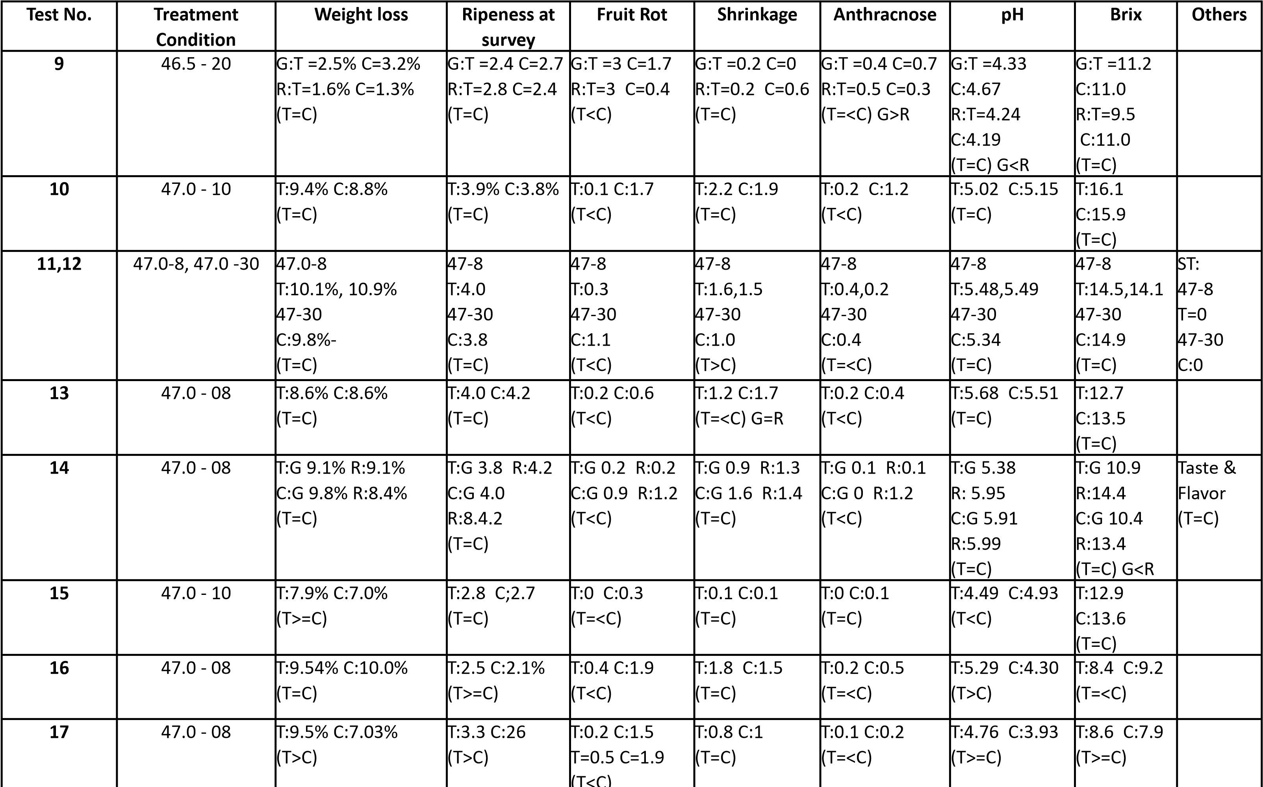

#### Summary of the results of fruit injury test

|  |  |
| --- | --- |
| **Parameter** | **Result** |
| Weight loss | **No difference in weight loss** was observed in most cases |
| Ripeness at survey | **No difference in ripeness** was observed between treated and control mango |
| pH | **No difference in pH** was observed between treated and control mango |
| Brix | **No difference in Brix** was observed between treated and control mango |
| Taste & flavor | **No difference in taste and flavor** was observed between treated and control mango |
| Shrinkage | **Similar shrinkage of outer skin was observed** between treated and control mango |
| Fruit decay | **Fruit decay was reduced in treated mango** than control |
| Anthracnose | **Anthracnose was reduced/low in treated mango** than control |

#### Cavity formation & spongy tissue formation in pulp

•Spongy formation is increased with the exposure time more in green than ripen

✓470C – 08, 10, 20, 30 &

60 min

•Irrespective of the ripeness, cavity formation of the following temperature-time combinations are very slight

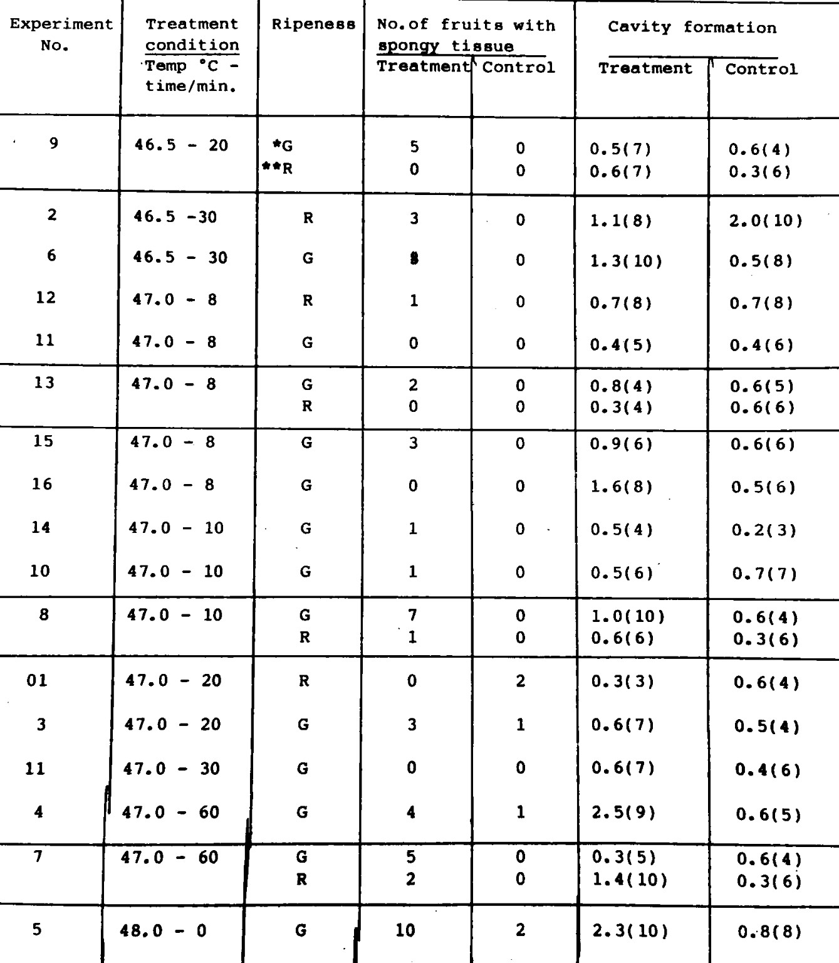

✓46.50C –20 & 30 min

✓470C – 08, 10, 20, 30 &

60 min

***It is concluded that ripen fruit stage is more suitable for the VHT treatment***

46.5

0

C

–

20

min

47.0

0

C

–

08

min

47.0

0

C

–

10

min

47.0

0

C

–

20

min

46.5

0

C

–

10

min

46.5

0

C

–

20

min

47.0

0

C

–

00

min

47.0

0

C

–

min

10

**Optimized Treatment**

**Conditions of Fruit Injury Test**

**100**

**% Mortality Achieved in Small**

**-**

**scale Mortality Test**

**47.0**

**0**

**C**

**–**

**min was selected for**

**08**

**the Large Scale Mortality test**

#### Large scale mortality test by VHT

* **Purpose:**

To confirm a 100 % mortality for more than 30,000 effective insects

* **Materials**

|  |  |
| --- | --- |
| Test insect  Target stage  Mango size  Maturity | : ***B. dorsalis***  : **Mature eggs**  : **250-300 g**  : **Mature green to ½ ripeness** |

* Mango were obtained from Minuwangoda area
* 200 mature eggs were inoculated per fruit

#### Large scale mortalitytest by VHT

▪ **Methods:**

**Treatment conditions:**

Setting of VHT machine : Program mode

Setting Value of Chamber Temp : **47.5 ºC (+1 ºC)**

Target Temperature : **47 ºC + Holding Time 8 Min**.

(Core Fruit)

Relative Humidity : **55% - 95%**

* Both control and treated fruits were kept in air circulation plastic container at 220C until eggs become 3rd install larvae in control fruits
* This test was repeated until total estimated number of test insects based on the number of survivors in control plot become over 30000

#### Results of large scale mortality test

**Number of test fruits, no. of survivor and corrected mortality in the Large**

**Scale Mortality Test, *B. dorsalis* (Mature egg) in VHT**

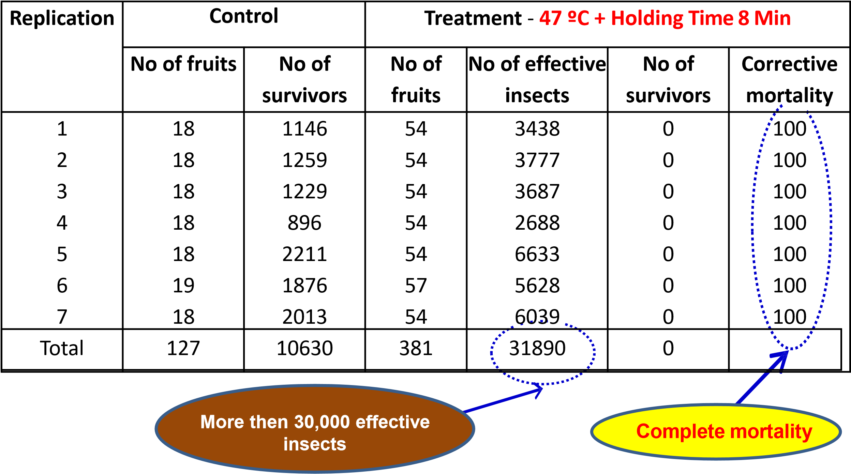

##### Summary

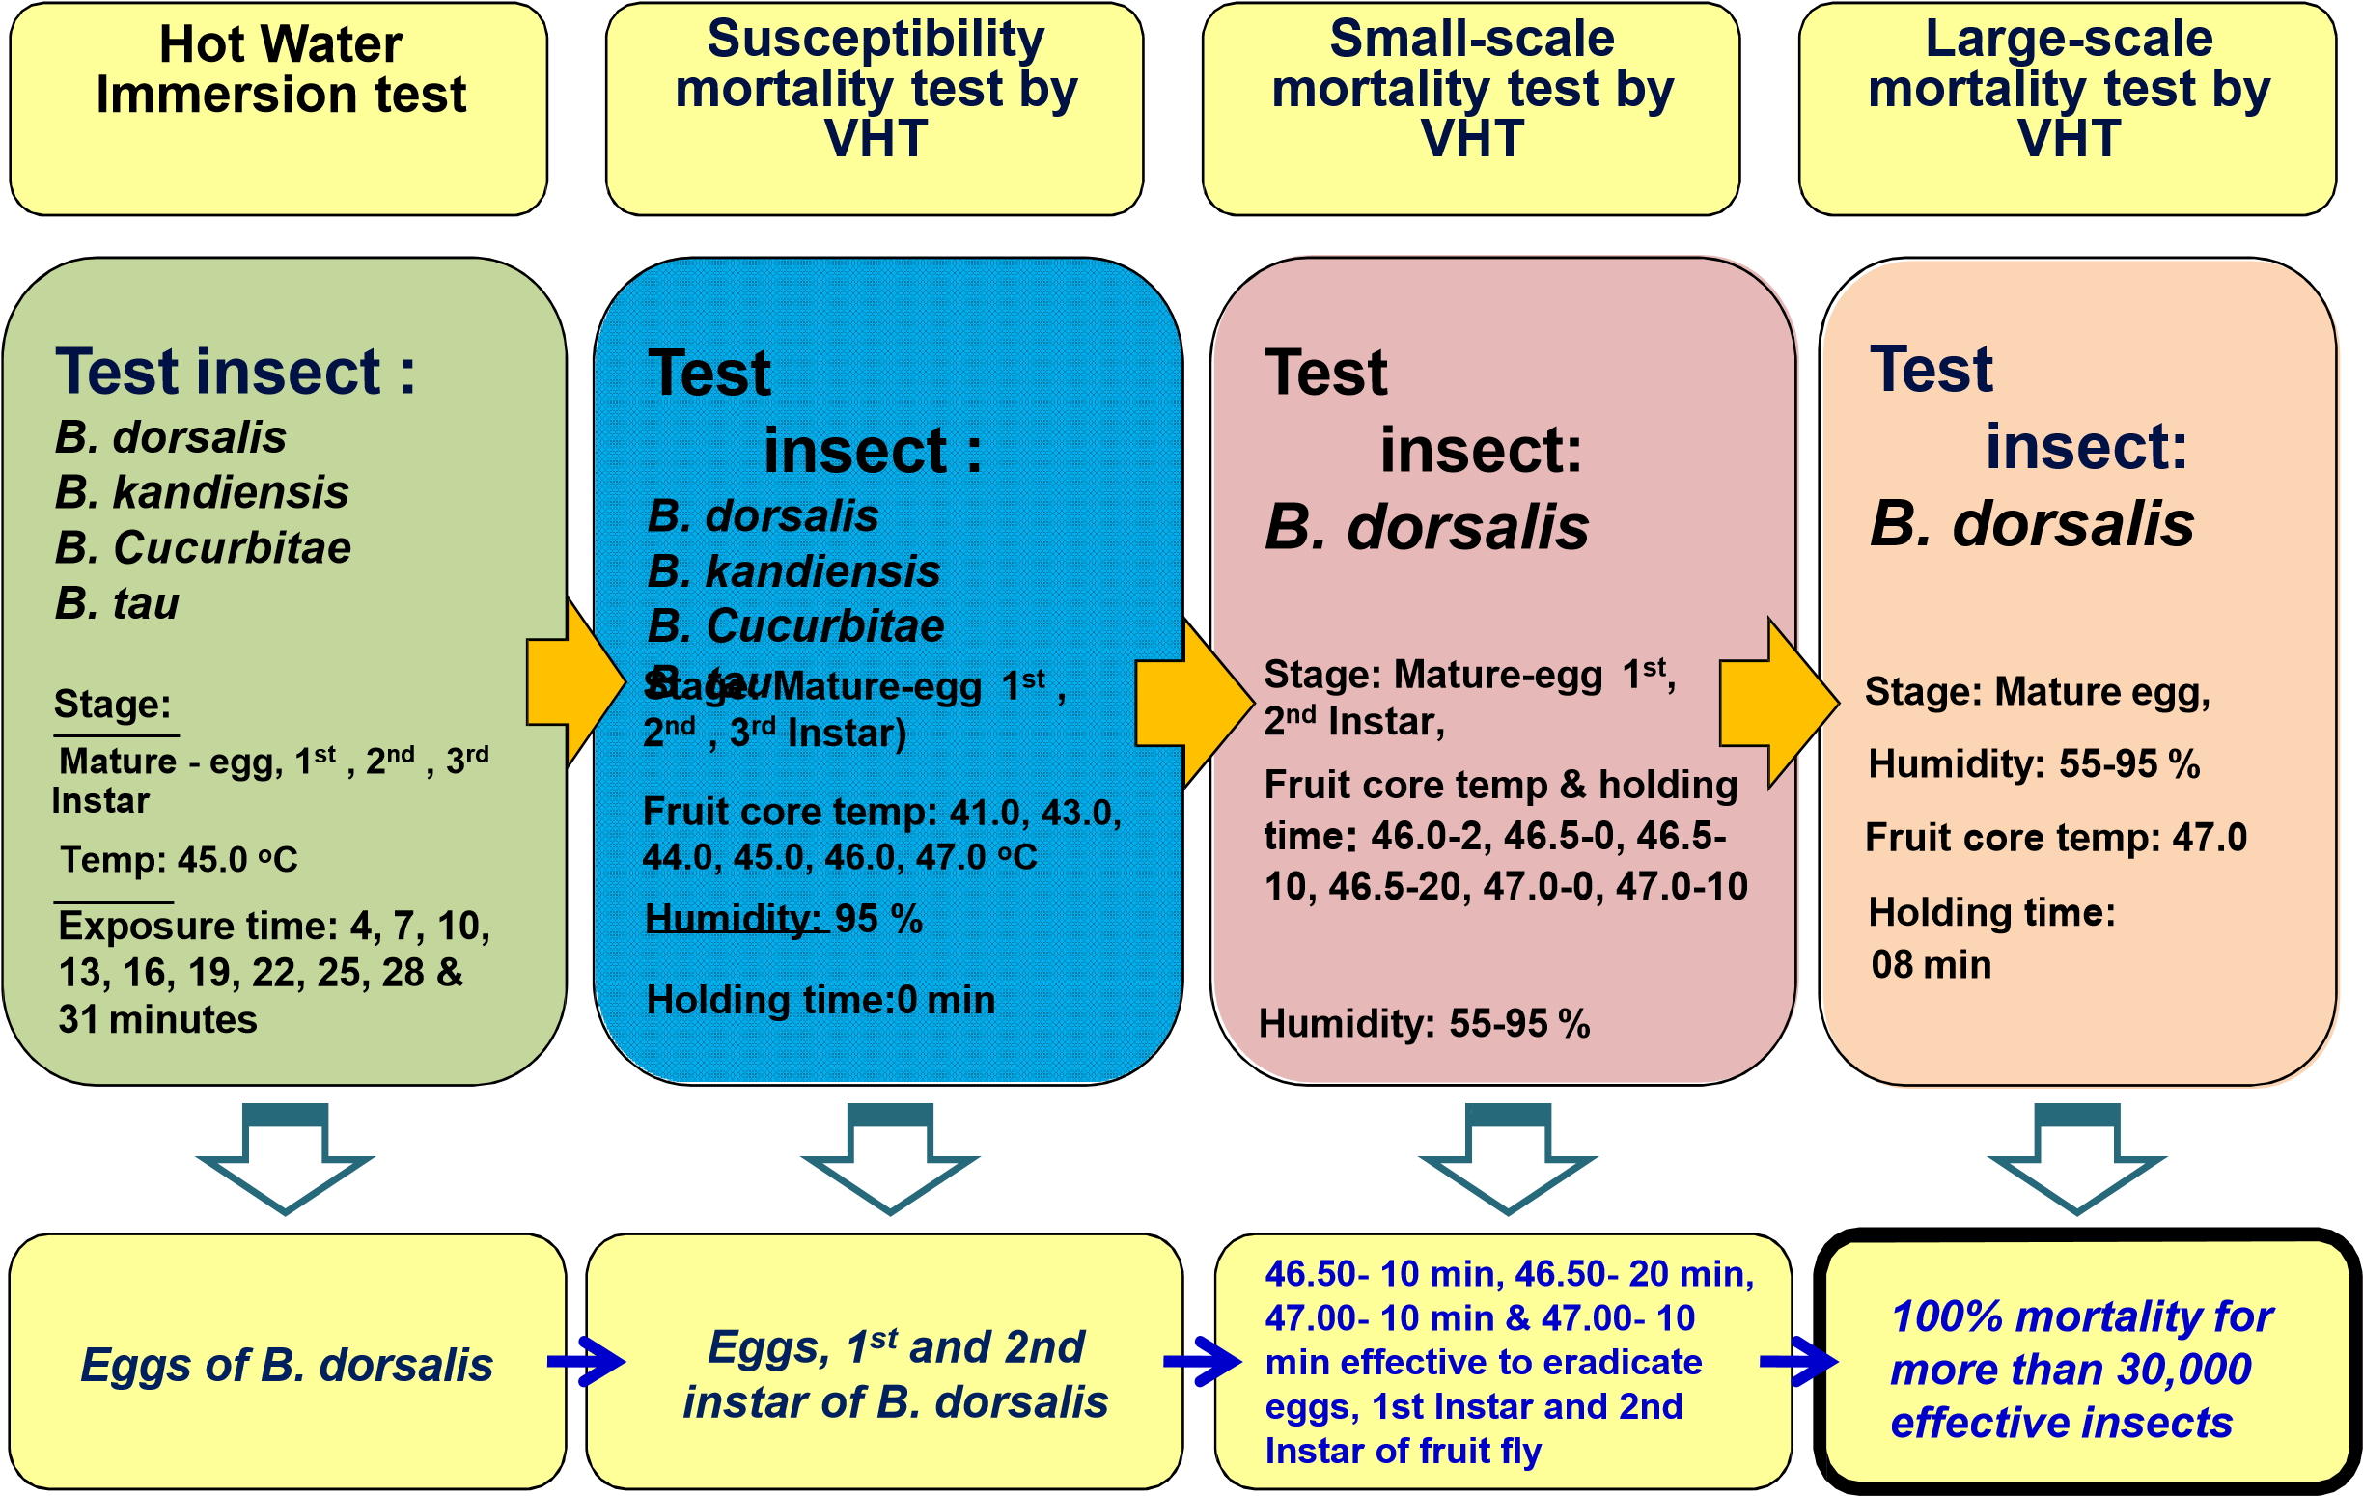

# Recommendation

* **VHT condition with 47.0 oC of fruit core temperature and 08 minutes holding time proved a 100% mortality for more than 30,000 effective insects**

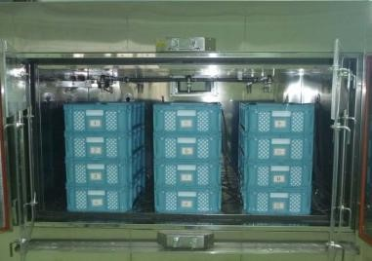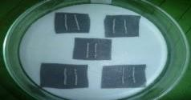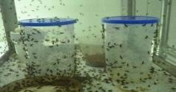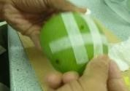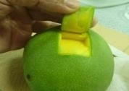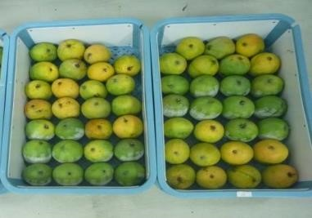

* **Therefore, on commercial scale treatment, these conditions can be used as a standard to ensure complete mortality of all stages of *B. dorsalis , B. kandiensis, B. cucurbitae and B. tau***

**Vapor Heat Treatment against fruit flies in mango (Var. TomEJC)**

**Effect of Vapor Heat Treatment on eradication of fruit fly *Bactrocera dorsalis* (Diptera:**

**Tephritidae) in export TJCmango**

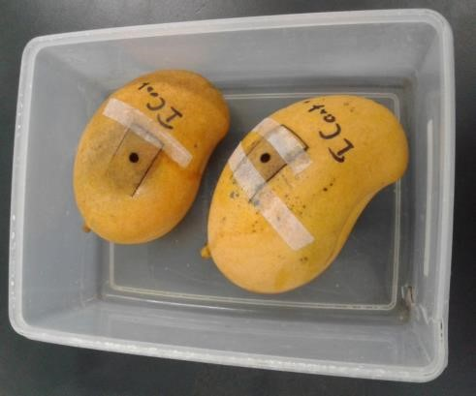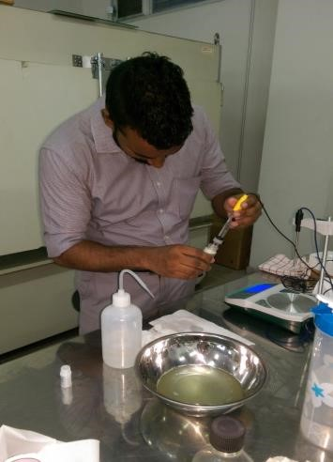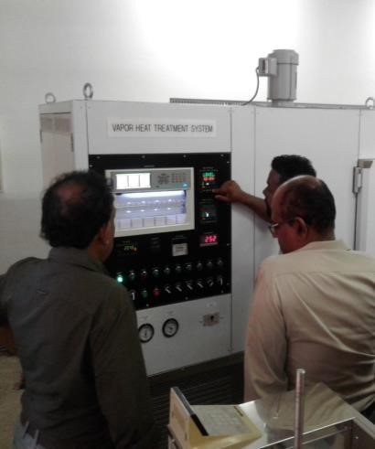

**Test fruits**

**Programming**

**Mortality Test**

**Fruit Injury Test**

**VHT machine**

## Small-scale mortality test by VHT

* A total of 36 TJC mango were used for the experiment and among them 6 mangos were infected with 1st instar (50 instar per mango)
* Six un-infested mangos were kept as control and remaining 24 mangos were used to evaluate the fruit quality
* Treatment was conducted by applying different temperature-time intervals at 95% R.H

|  |
| --- |
| **Temperature (Time)** |
| 46.0 0C (05) |
| 46.5 0C (05) |
| 47.0 0C (05) |
| 47.0 0C (15) |
| 47.0 0C (25) |

## Results of small-scale mortality test

Corrected Mortality %

Inconclusive results

80

85

90

95

100

R1

R2

R3

R4

R1

R2

R3

R4

R1

R2

R3

R4

R1

R2

R3

R4

R1

R2

R3

R4

)

46.0 (05

min

46.5 (05

min

)

)

47.0 (05

min

min

)

47.0 (15

47.0 (25

min)

**Result :**

**47°C for 15 & 25 min were found to be effective for eradication of *B. dorsalis***

## Test on Consumer Preference

**47.00C (15min)**

|  |  |  |
| --- | --- | --- |
|  | **Median** | **S/NS** |
| Color | 2.0 | S |
| Odour | 1.5 | S |
| Texture | 2.0 | S |
| Taste | 1.5 | S |
| Overall Acceptance | 15 | S |

(Wilcoxon Signed Rank Test)

Conclusion is consumer preference is high for the all the attributes with compared to control

## Fruit injury test

**47.00C (15min)**

**Treatment level Avg. pH value Avg. Brix value Avg. Hardness value**

Just after 72 h Just after 72 h Just after 72 h

|  |  |  |  |  |  |  |
| --- | --- | --- | --- | --- | --- | --- |
| 1 | 4.03a | 5.4a | 12.7a | 22.3a | 2.6a | 1.8a |
| 2 | 4.07a | 5.5a | 11.0a | 21.7a | 2.4a | 1.7a |
| 3 | 4.10a | 5.6a | 13.7a | 22.0a | 2.6a | 1.9a |
| 4 | 4.06a | 5.5a | 15.3a | 22.3a | 2.4a | 1.8a |
| Control | 4.00a | 5.6a | 14.7a | 22.3a | 2.5a | 1.8a |
| **P-value** | **0.936** | **0.648** | **0.069** | **0.989** | **0.435** | **0.943** |

*The numbers which was followed by the same letter on the same column is not significantly different based on Tukey-test (α = 5%)

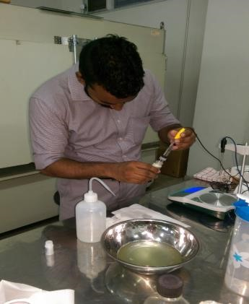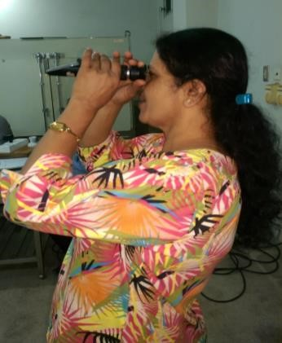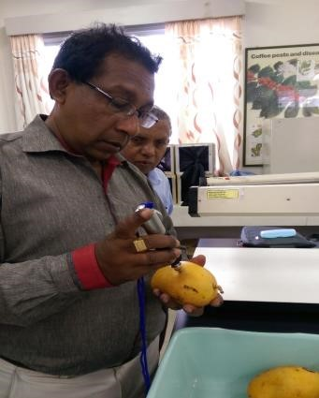

**Hardness test pH test Brix test**

## Conclusion

• **Due to the inconclusive data obtained for 47.00C (05 min), 47.00C (15min) was selected as the effective VHT treatment standard to eradicate fruit fly in TomEJC mango**

## Trade Negotiations for the exportation of Sri Lankan fresh fruits

* On going negotiations with Japan, Republic of China, Republic of Korea and USA to export Sri Lankan fresh mangoes

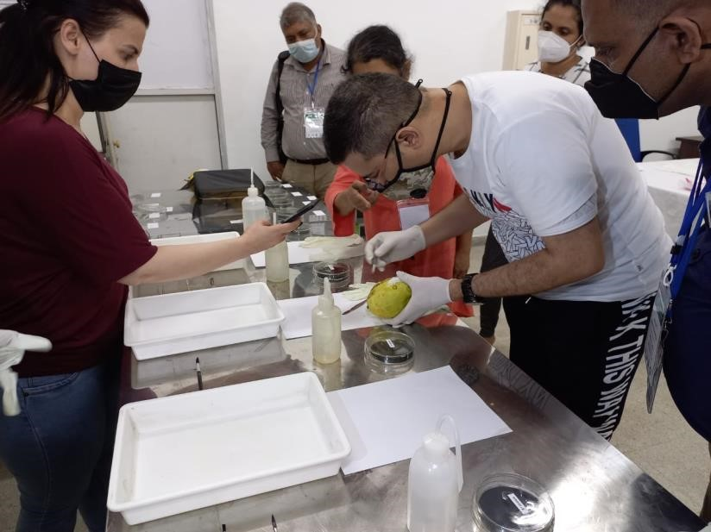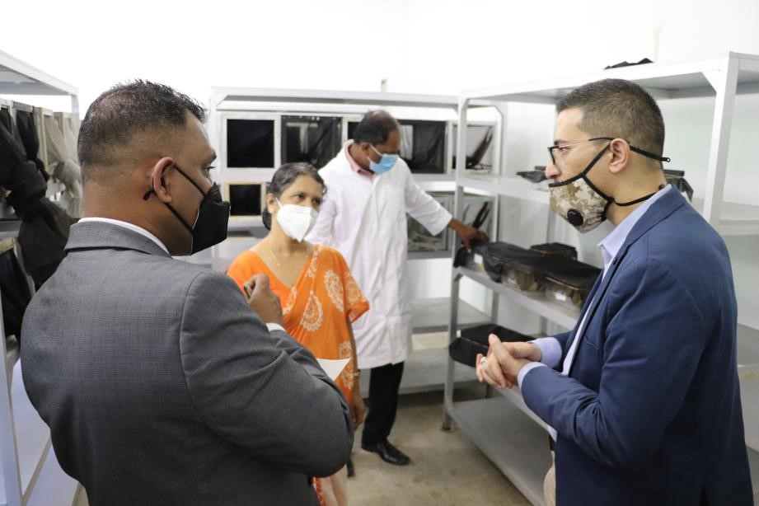

* Exportation of fresh mangoes (Tom EJC) was permitted to Jordan after the certification of VHT facility at NPPO Sri Lanka by Jordanian Technical Team

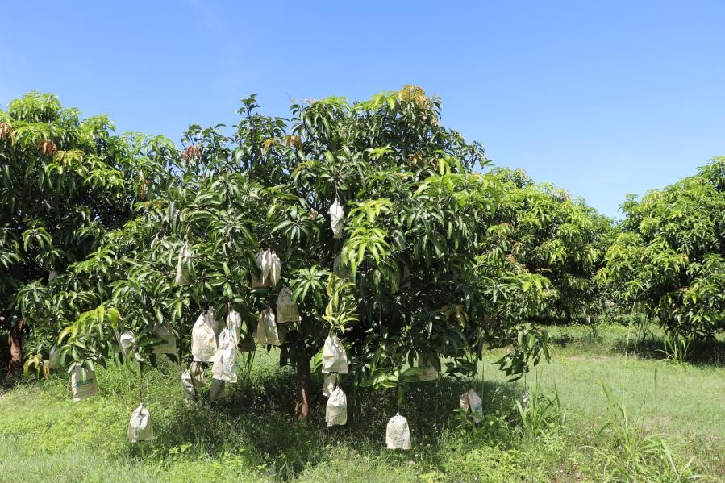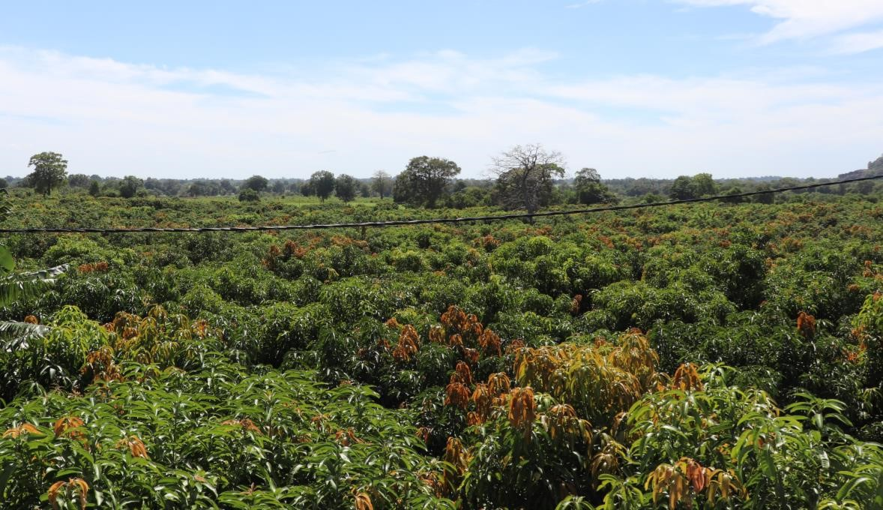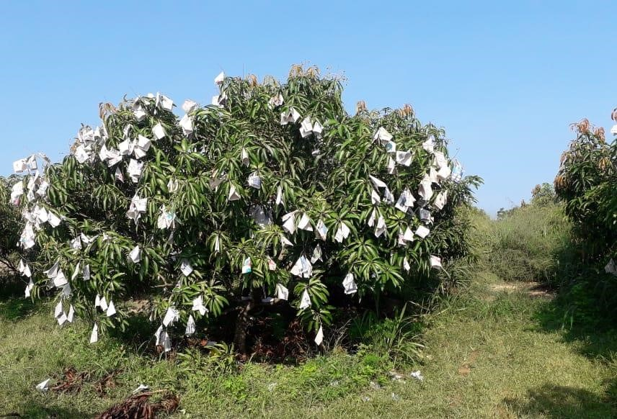

**Large Scale Tom EJC Mango**

**Orchards in Sri Lanka**

Thank You !

**National Plant Quarantine Service**

Department of Agriculture

Canada Friendship Road, Katunayake

Email: npqs@doa.gov.lk | Tel: 0112 252 028 | Fax: 11 225 3709

Web: https://doa.gov.lk/npqs-home-en/