

Chen-Chung Chen

Bureau of Animal and Plant Health Inspection and Quarantine

2022.5.17

**1**

Use and Management of

Quarantine Detector Dogs in Taiwan

|  |
| --- |
| **2** |

Contents



I. Detector Dog Team: History and Development 1/3

|  |
| --- |
| **3** |

 In 1984, the U.S. Animal and Plant Health Inspection Service (APHIS) launched the Beagle Brigade inspection program at the Los Angeles International Airport.

 In 1998, Taiwan customs streamlined inspection procedures and relied on voluntary declaration. Passengers with nothing to declare passed through designated green lanes, while those with items to declare stopped for inspection at the red lanes.

Detector dogs were also planning to help quarantine inspection.

|  |  |
| --- | --- |
| Country | Number of detector dogs |
| United States | 119 (to be increased to 179 in the future) |
| Japan | 140 |
| New Zealand | 33 |
| Taiwan | 56 |

I. Detector Dog Team : History and Development 2/3

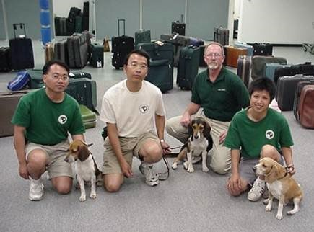 In March 2002, 3 detector dogs and 3 our quarantine officers were trained at the APHIS National Detector Dog Training Center.

|  |
| --- |
| **4** |

 In June, detector dogs returned to Taiwan. The Training Center sent a trainer to Taiwan to supervise training.

 In October 2002, the three detector dogs were deployed at the Taoyuan airport and Kaohsiung airport.

I. Detector Dog Team: History and Development 3/3

 In 2004, a trainer from New Zealand was invited to conduct training in Taiwan. The first batch of locally trained detector dogs completed training in the same year.

|  |
| --- |
| **5** |

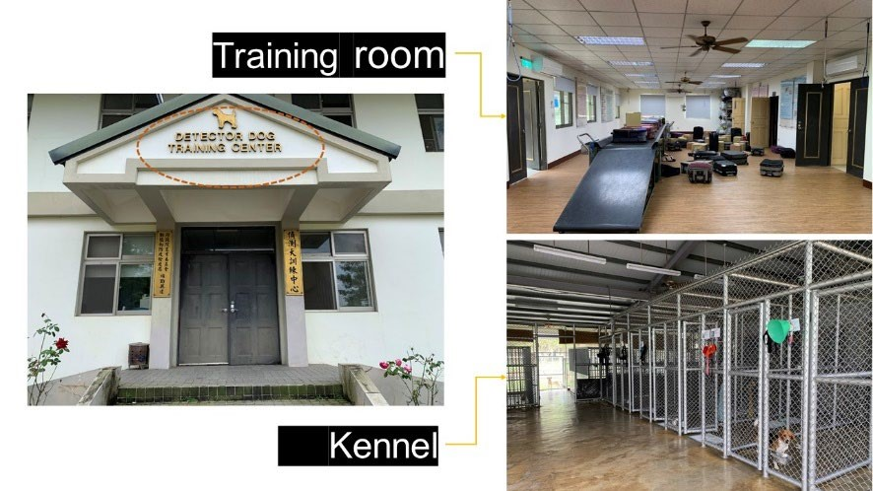 In August 2005, the detector dog training center at National Pingtung University of Science and Technology was inaugurated.

 In 2005, detector dogs were deployed for the inspection of mail and courier parcels.

 Currently, there are 4 trainers, 2 assistant trainers, 43 handers, and 56 detector dogs.

1/3

**6**

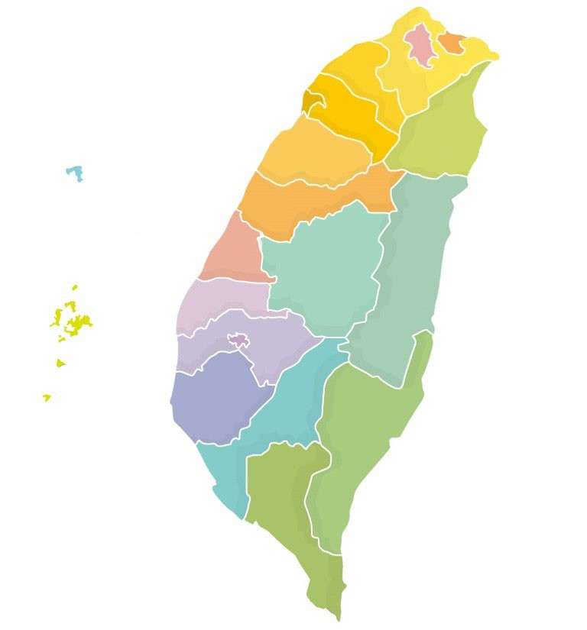

**Keelung branch:**

**teams**

**10**

**Kaohsiung**

**branch: 10 teams**

**Hsinchu branch:**

**teams**

**28**

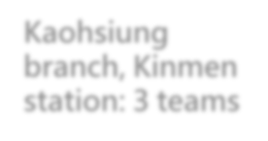

**Kaohsiung**

**branch, Kinmen**

**station: 3 teams**

**Taichung branch:**

**5**

**teams**



**Keelung harbor**

**Taipei harbor**

**Songshan**

**airport**

**Taoyuan International**

**Airport (including cargo**

**terminal)**



**Taichung Airport**

**Taichung Harbor**

**Shuitou**

**Harbor**

**Kaohsiung international airport**



**r**

**Kaohsiung Harbo**

**Tainan International**

**Airport**

**Tainan Chengkong**

**Post Office**



**Kaohsiung mail processing center**

**Taiching**

**Post**

**Office**



**Taipei mail processing center**

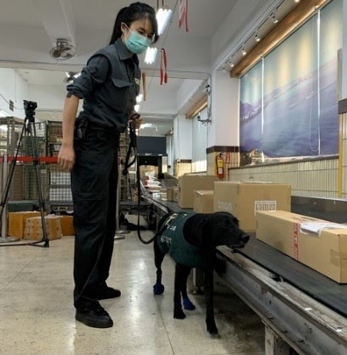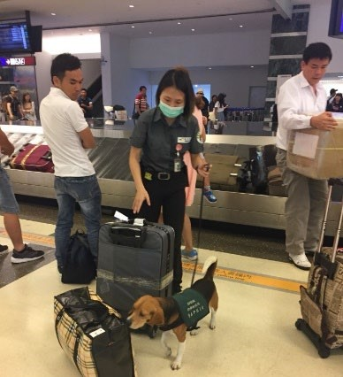

BAPHIQ



BAPHIQ

Branch Office



Quarantine

Inspector



Taiwan Animal and Plant Health

Inspection and Quarantine

Association



Trainer and

assistant

trainer



Handler and detector dog



Coordination committee

and technical committee

**7**

2

/

3

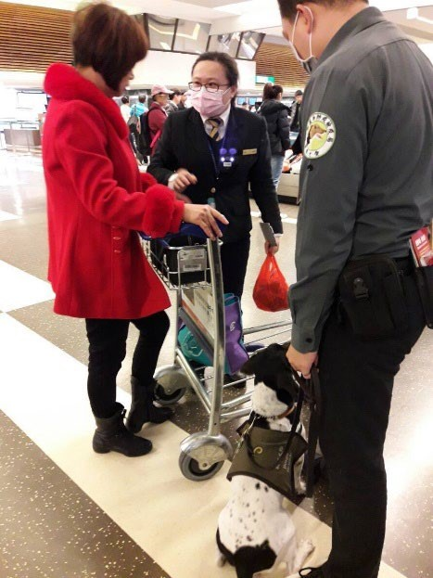

3/3

Working conditions of the personnel

comply with the

*Labor Standards Act*

.

Dog welfare complies with the

stipulations of the

*Management and*

*Care of Canine on Duty at Government*

*Agencies*

.

**8**



**Detector**



**Dog Operations and Management**



**Manual**

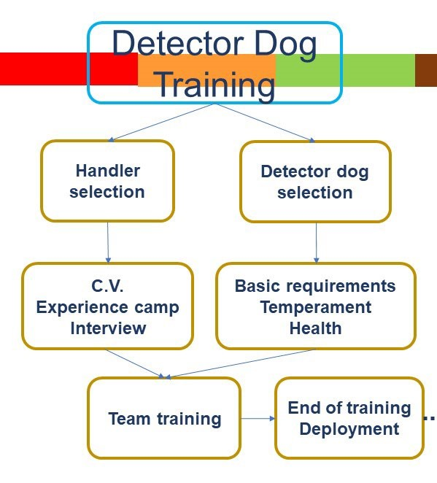

III. Achievements of Detector Dog Operations 1/4



Detection Results

(

Including passengers, mails, and courier

)

**9**

|  |  |  |  |  |  |  |  |  |  |  |  |  |  |  |  |  |  |  |  |  |  |  |  |  |  |  |  |  |  |  |  |
| --- | --- | --- | --- | --- | --- | --- | --- | --- | --- | --- | --- | --- | --- | --- | --- | --- | --- | --- | --- | --- | --- | --- | --- | --- | --- | --- | --- | --- | --- | --- | --- |
| |  |  |  |  |  | | --- | --- | --- | --- | --- | | Year | Detector dog teams | Number of flights  inspected | Successful Detections | Total items seized (Kgs) | | 2017 | 45 | 53,747 | 56,883 | 68,527 | | 2018 | 47 | 66,442 | 61,920 | 70,508 | | 2019 | 50 | 80,739 | 29,598 | 15,713 | | 2020 | 56 | 16,807 | 4,875 | 5,997 | | 2021 | 56 | 10,139 | 3,244 | 7,960 | |  |

1. Results of Detector Dog Operations 2/4



Mail and express parcels detection results in the

last three years

**10**

|  |  |  |  |  |  |  |
| --- | --- | --- | --- | --- | --- | --- |
| Year | Mail | | | Express parcel | | |
| Number of inspection | Number of seized | Total weight seized (kg) | Number of inspection | Number of seized | Total weight seized (kg) |
| 2019 | 267 | 125 | 670 | 375 | 25 | 133 |
| 2020 | 1,150 | 425 | 2,600 | 588 | 115 | 978 |
| 2021 | 1,374 | 645 | 4,593 | 1,292 | 432 | 2,395 |

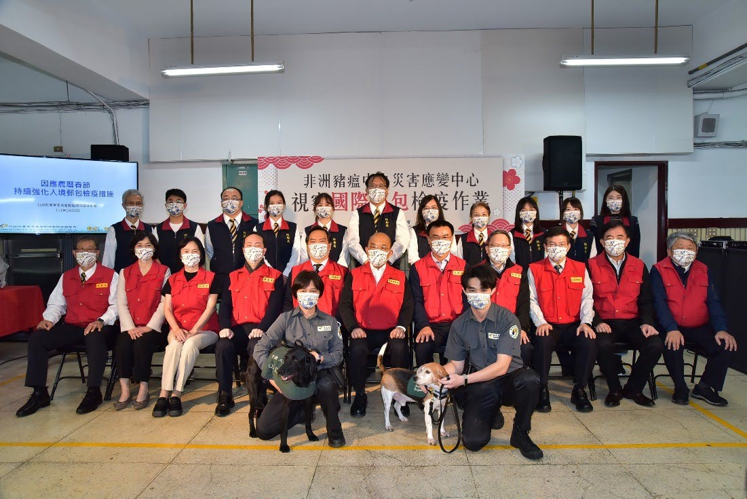 III. Results of Detector Dog Operations 3/4



Public awareness on Animal and Plant Quarantine -1

**11**

New Media interview of Media report on the Premier’s inspection a YouTuber of the quarantine inspection operations during the Chinese New Year 

III. Results of Detector Dog Operations 4/4



Public awareness -

2

**12**



BAPHIQ

Facebook page

Demonstration at a promotion

campaign



1. Conclusion

|  |
| --- |
| **13** |

Maintain an appropriate number of dogs to assist border quarantine detection and public outreach requirements

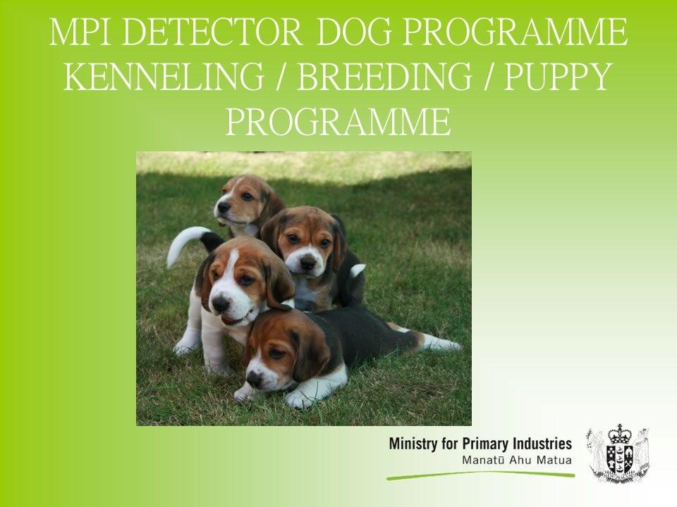

4

,27,2022 Video technical meeting

with New Zealand

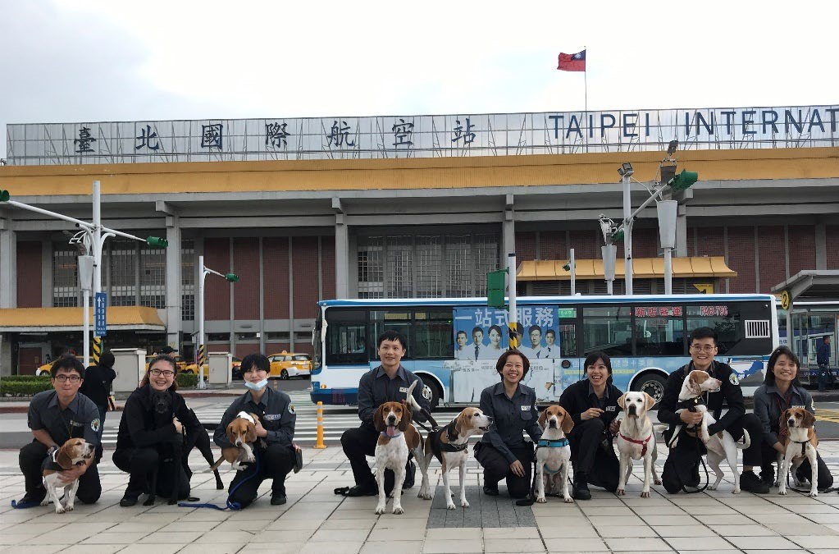

Establish long term technical cooperation with US and New Zealand or other countries to provide training dog or breeding techniques to maintain stable supply of detector dog.



Thank you

