# Let’s keep khapra beetle out!

Khapra is a serious agricultural pest that poses a major threat to our grains industry. This exotic pest comes in second on Australia's most unwanted plant pest list, and we need your help to keep it out.

### What to look for

* Adults beetles (1.6-3mm long) are reddish dark brown, oval-shaped with faint dark lines and do not fly.
* Larvae (1.6-4.5mm long) typically appear very hairy and are golden brown.
* Cast larval skins are the most obvious indicator of infestation.

Adult Khapra beetle

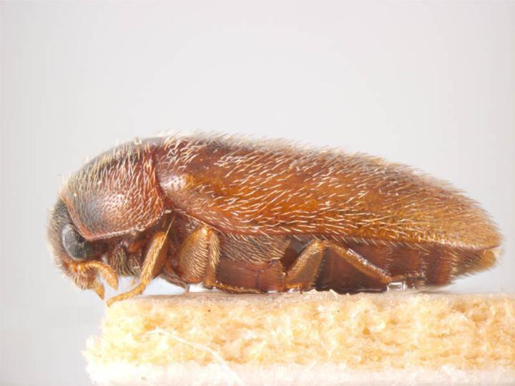

Khapra beetles with larvae

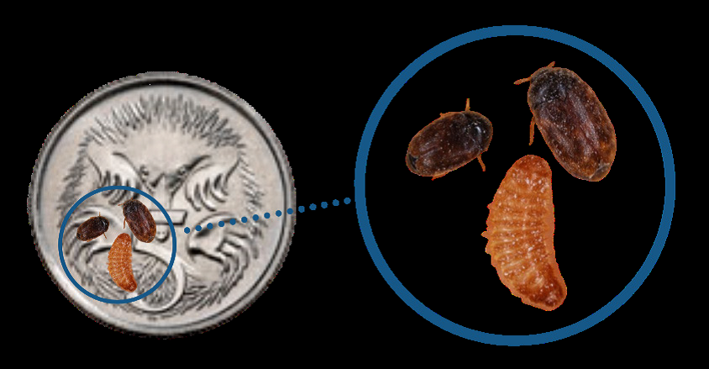

Cast Khapra larval skins

### Khapra larvae cast their skin as they grow. This discarded larval skin is often found in large quantities and is an obvious indicator that the pest is present

### Where to look

Khapra can enter Australia:

* In grains and food stuffs
* As a hitchhiker in a wide range of cargo including machinery, nuts and bolts, timber doors and fridges
* As a hitchhiker on imported shipping containers
* In personal effects

#### Think you've seen khapra beetle?

#### Call the See. Secure. Report Hotline on 1800 798 636.

For more information on how to protect Australia from Khapra beetle, go to the following website: [awe.gov.au/khapra-urgent-actions](https://www.agriculture.gov.au/pests-diseases-weeds/plant/khapra-beetle/urgent-actions)

Facebook: Australian Biosecurity