## Purpose

# Export Meat Operational Guideline

16.2 Product Hygiene Indicators program data entry into the Meat Export Data Collection (MEDC) system

October 2023

Departmental logo
Australian Government Department of Agriculture, Fisheries and Forestry

The purpose of this guideline is to:

* Outline the procedures for the entry of Product Hygiene Indicators (PHI) program data into the MEDC system for departmental on-plant officers and establishment employees.
* Detail the data entry requirements and responsibilities.

During the 2023 transition to Meat hygiene assessment - product monitoring (3rd Edition) known as MHA 3, this guideline will provide instructions for data entry for both MHA 2 and MHA 3.

## Scope

This document applies to all export registered slaughter and boning establishments, and department personnel that enter PHI data into the MEDC system.

The document is applicable to the following species whose PHI data are entered into MEDC:

* Large stock including cattle, buffalo, donkey, and horse
* Small stock including ovine, deer and calves
* Domestic and game pigs
* Deer
* Camels
* Goats
* Kangaroo
* Ratite.

## Legislative basis

Under the *Export Control Act 2020* ('the Act') and its subordinate legislation:

* the requirements of the relevant Australian standard must be met.

In this document

Purpose 1

Scope 1

Legislative basis 1

User access and log-in 3

Entering data into the MEDC system 3

MHA data entry by establishment staff 3

MHA data entry by departmental on-plant officers 5

Carton meat assessment data entry 6

Carton Meat Assessment data entry for MHA 2 6

Carton Meat Assessment data entry for MHA 3 6

Hygiene Assessment data entry 7

Entering microbial data 8

Entering STEC/O157 data 10

Uploading data from an Excel spreadsheet 13

Completion of PHI data entry into MEDC system 15

Data review and analysis 15

Related Material 15

Attachment 1: Roles and responsibilities 17

Attachment 2: Definitions 18

## User access and log-in

Non-department users need to:

* Go to the [self-service portal](https://online.agriculture.gov.au/selfservice/).
* Follow the [account creation guide](https://deptagriculture.sharepoint.com/sites/INT_IT-Systems/Shared%20Documents/MEDC%20self-service%20account%20creation%20guide.docx) to create a username and password.

Department users need to request access to MEDC at the following [link](https://deptagriculture.sharepoint.com/sites/INT_IT-Systems/SitePages/Meat-export-data-collection-system-medc.aspx).

## Entering data into the MEDC system

Log into the MEDC system and click on **Data Entry**.

## MHA data entry by establishment staff

* Click on **Data Entry** > **Establishment MHA Data**
* Select or type your establishment number in the header section.
* Enter relevant information in each field from the dropdown lists.
* 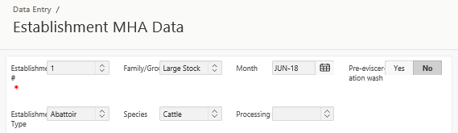In the data entry section click on **Add Row** button

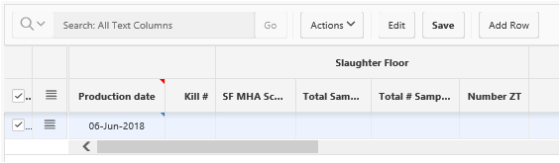

* Enter the data from one entire day on a single row (the data is entered for the day that the MHA examination was conducted).
* Enter total kill for that day.
* Enter daily averaged slaughter floor, offal and boning MHA scores, total number sampled and ZT numbers.
* Only enter “0” when a test has been performed and “0” is the result.
* Leave the cell blank where no test has been performed.
* Enter CCP monitoring data (this is the total number of samples taken to obtain the ZT record i.e. the number of MHA samples plus the number of additional samples examined as per CCP monitoring requirements)
* To add a new row, click on Add Row button and enter data as above. Alternatively, you can copy the previous row and edit the data.
* To copy the previous row, click on the box to the left of the Production date cell and select Duplicate Row. From this menu you can also add a new row or delete a row. To delete a row, tick the box on the left of that row, then click on Delete Row, then Save.
* You must amend copied information where necessary.
* Click Save. A green pop-up box Changes saved will appear. You can edit these data anytime in that month using the Edit button.

**Note**: If there are data entry errors you will receive an error message. You need to fix any data errors before the record can be saved.

**Note**: Where there is more than one shift for the same operation, e.g. slaughter, you need to combine data. For example, to calculate MHA scores where there are two shifts in a day: a) combine the sample sizes to record total number sampled and report the total number sampled over all shifts; b) combine the averaged MHA scores for each shift and divide by the number of shifts being assessed; and c) combine the number of faecal, ingesta or milk contamination events identified (both morning and evening shift) to produce a total number of incidents for the day and record this in the “number ZT” column.

## MHA data entry by departmental on-plant officers

The department’s data can only be entered after the establishment MHA data have been entered on a particular day. To enter departmental MHA data:

* Click on Data Entry > On Plant Vet MHA Data
* Select or type your establishment number in the header section.
* Enter relevant information in each field from the dropdown lists.

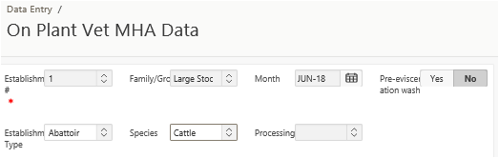

* Do not enter date and kill number as these are captured from the Establishment MHA data entry page and must not be changed. You should however verify for accuracy a sample of the kill numbers supplied.
* Enter the data from one entire day on a single date entry (if there were two shifts on a day, combine the data and enter the totals in the relevant column of the spreadsheet).
* Enter a zero when MHA verification was undertaken but no result was obtained. Data are entered for the day that the MHA examination was conducted.
* Enter a comment in the comment column if there are any issues with sampling on the day.
* Enter the MHA score, total number of carcases examined and number of zero tolerance (faeces, ingesta or milk contamination) defects for each of the slaughter floor, boning room and offal room at the frequency determined by the Meat Establishment Verification System (MEVS).
* When data entry is complete, click Save. A green pop-up box Changes saved will appear. You can edit the data anytime in that month using the Edit button.



Note: If there are data entry errors you will receive an error message. You need to fix those data errors before the record can be saved.

## Carton meat assessment data entry

During the transition to MHA 3, there will be two data entry screens for Carton Meat Assessment (CMA) in MEDC: **Carton Meat Assessment- MHA 2** for the current program and **Carton Meat Assessment-MHA 3** for the revised program.

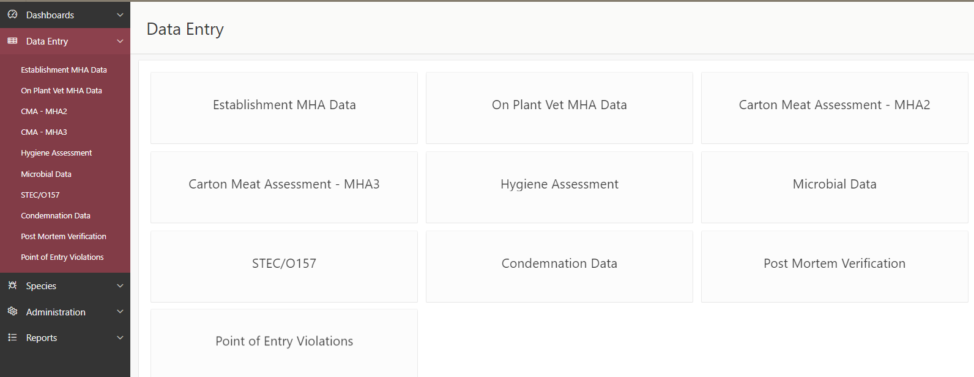

### Carton Meat Assessment data entry for MHA 2

* Click on Data Entry > Carton Meat Assessment - MHA 2.
* Select or type your establishment number in the header section.
* Enter relevant information in each field from the dropdown lists.
* In the data entry section click on the Add Row button.
* Enter total number of cartons sampled per day for all product categories.
* Record contamination, pathology and manufacturing defects as defined in the [Meat Hygiene Assessment Manual -v2](https://www.agriculture.gov.au/biosecurity-trade/export/controlled-goods/meat/elmer-3/meat-hygiene).

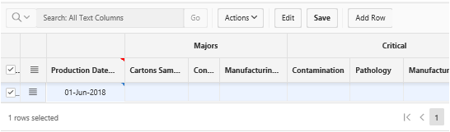

* To add a new row, click the Add Row button and enter data as above, or you can copy the previous row and amend the copied information where necessary.
* Click Save. A green pop-up box Changes saved will appear. You can edit the data anytime in that month using the Edit button.

### Carton Meat Assessment data entry for MHA 3

* Click on Data Entry > Carton Meat Assessment - MHA 3.
* Select or type your establishment number in the header section.
* Enter relevant information in each field from the dropdown lists.
* In the data entry section click on the Add Row button.
* Enter total number of cartons sampled per day for all product categories.
* Record the total count of cartons with ZT (faeces, milk, ingesta) detections for the day (combining high and low risk categories).
* Record the total count of cartons with limits exceeded for any contaminants and pathology as defined in the [*Export Meat operational guideline. Meat hygiene assessment - product monitoring (3rd Ed)*](https://www.agriculture.gov.au/biosecurity-trade/export/controlled-goods/meat/elmer-3/meat-hygiene)***.***

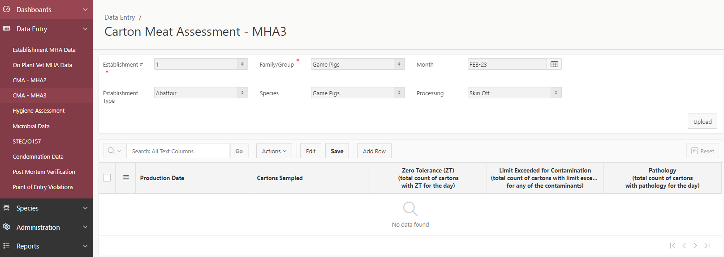

## Hygiene Assessment data entry

Each contact surface sample is assessed by conducting an aerobic plate count of the sample and recording results as colony forming units per square centimetre (CFU/cm2). The data entry page includes two sample categories: contact surfaces and personal hygiene. Each category is divided into a range of results (0, 0-5, >5-10, >10-20, >20-30 and >30). The number entered into these cells is the number of tests on a specific date that returned a result within the range.

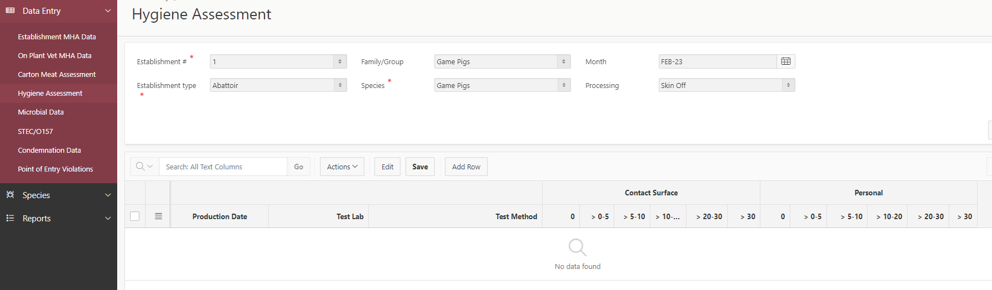

* Click on **Data Entry > Hygiene Assessment**.
* Select or type your establishment number in the header section.
* Enter relevant information in each field from the dropdown lists. If your laboratory/test method is not in the list under Test Lab/Test Method, leave the cell blank or just select ‘N/A’.
* 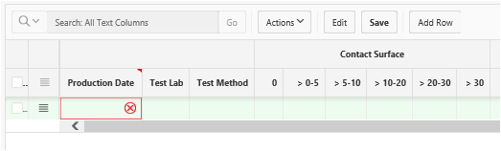In the data entry section click on **Add Row** button.
* Enter the number of tests on the day that returned results within the specified ranges.
* To add a new row, click the **Add Row** button and enter data as above, or you can copy the previous row and amend the copied information where necessary.
* Click **Save**. A green pop-up box **Change saved** will appear. You can edit these data anytime in that month using the **Edit** button.

## Entering microbial data

* Click on **Data entry >Microbial Data**
* Note: There are two tabs (pages) within this data entry page.
* Select or type your establishment number in the header section. In each of the fields, select the relevant information (e.g. Family class, Month, Establishment type, Species and Processing) from the dropdown lists.

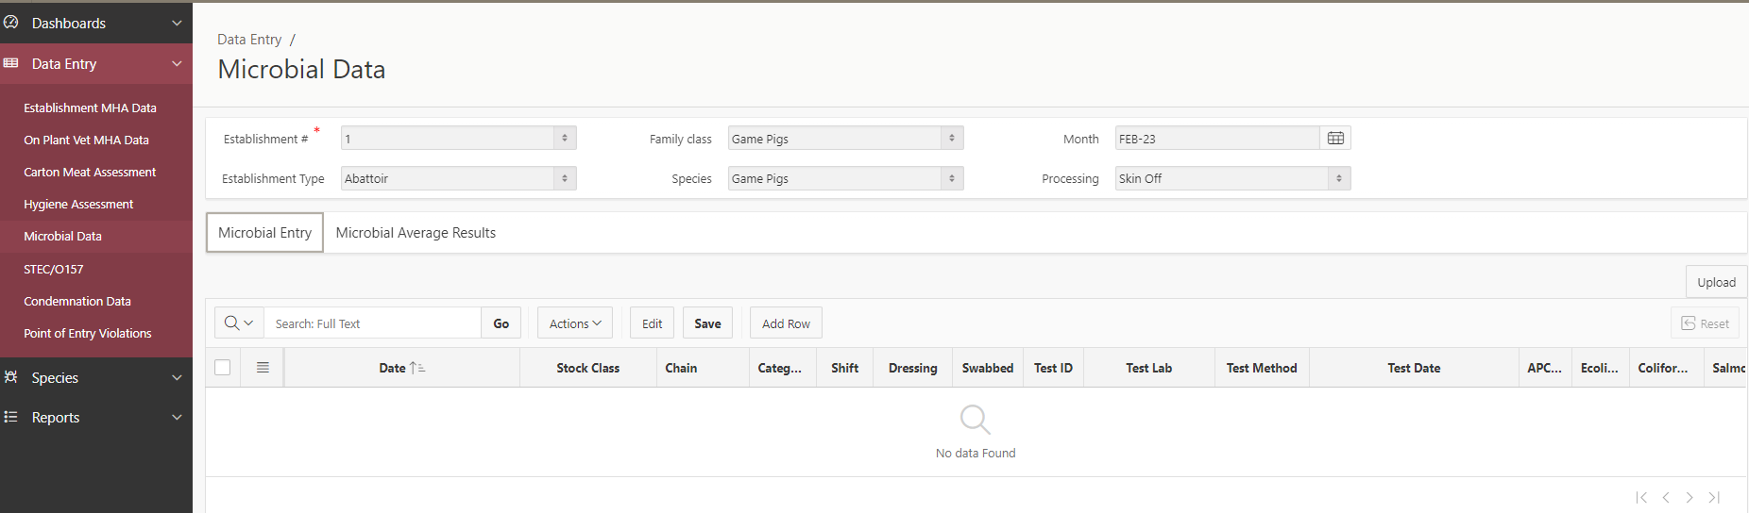

* Click on the **Add Row** button in the data entry section.
* Click on each of the cells in the added row and enter relevant information. Enter the test report number or certificate of analysis number specific to that test in the Test ID cell.
* Enter APC, *E. coli* (mandatory) and coliform (voluntary) counts as number of colonies per cm2 for carcase samples or per gram for carton samples. Results must be numeric values, i.e. if the count is less than the limit of detection enter “0” (zero).
* If the count is greater than the upper limit, enter the upper limit.
* If the count is an estimate enter the estimated number only - do not use symbols.
* Enter a “0” (zero) when a test has been done but no count obtained. Leave the cell blank if no test was undertaken for a particular organism on that day.
* Enter *Salmonella* results from the dropdown menu i.e. Negative or Positive. Enter Pending if the results were not known at the time of data entry. Leave the cell blank if no test was done.
* If needed, enter comments in the Comments column.
* Entering coliform data in the MEDC system is not mandatory. If establishments choose to enter coliform data, these data will be stored but will not contribute to calculation of the monthly PHI Index score.
* To add a new row, click the **Add Row** button and enter data as above. Alternatively, you can copy the previous row and edit the data.
* To copy the previous row, click on the box to the left of the Date cell and select **Duplicate Row** (from this menu you can also add a new row or delete a row. To delete a row, tick the box on the left of that row, click on **Delete Row**, then **Save**).
* You must amend copied information where necessary, especially Stock Class, Category, Swabbed, bacterial counts and Salmonella results.
* Click **Save**. A green pop-up box **Change saved** will appear. You can edit these data anytime in that month using the **Edit** button.

Note: If there are date entry errors you will receive an error message. You need to fix any data errors before the record can be saved.

## Entering STEC/O157 data

* Click **Data Entry > STEC/O157**

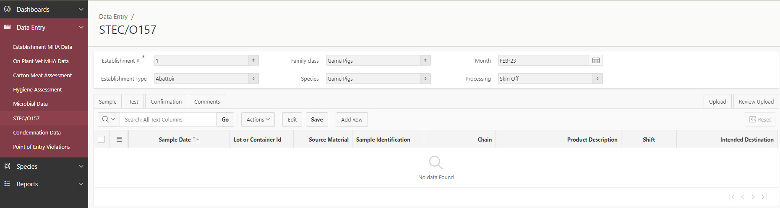

**Note**: There are four tabs (pages) within this data entry page

* Select or type your establishment number in the header section.
* Enter relevant information in each field from the dropdown lists.
* In the data entry section (below) click on the **Add Row** button.
* 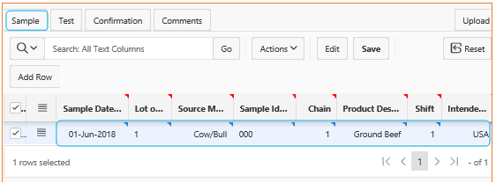Enter date of sampling (this is the actual date of sampling and may not correspond with the date of production) and the lot identification code.
* Enter the source material from which the carton sampled was derived. If the sample represents multiple slaughter classes enter the class that is the dominant slaughter class represented by the lot.
* Enter Sample Identification, Chain, Product Description, Shift and Intended Destinations.
* Click on the **Test** tab.

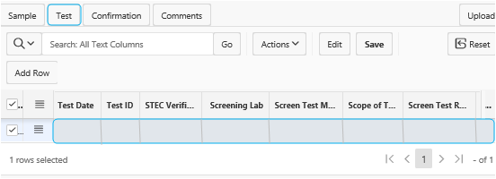

* Enter Test Date (the day the sample was analysed).
* Enter Test ID (e.g. a number generated by the testing lab or the certificate of analysis number).
* If the test is a verification test enter ‘Yes’. If the test is a follow-up verification test enter ‘Yes Follow-up’. Enter ‘No’ if the test is a routine test in the STEC Verific. column.
* Select screening lab, screening method and scope of test from the drop-down menu.
* If the screen result is positive, select ‘Positive’. If the screen result is negative, select ‘Negative’.
* Select ‘Positive, not sent for confirmation’ if the sample was not sent for confirmation. In this case the sample is regarded as deemed positive.
* Select Serotype Detected as ‘STEC’ if the sample is tested for all seven serotypes, select O157 if tested only of E. coli O157:H7. Enter date sent for confirmation.
* Click **Save** to save the data you entered.



Note: If the screen test is positive, you may receive an error message upon saving: “Row 1: The following fields must not be null when test result is positive: Interim Result, Final Result”. In this case you may need to leave the Screen Test Result field blank until you receive the confirmation result. Once you have entered the confirmation result, regardless of whether it is positive or negative, you must also enter ‘positive’ in the Screen Test Result field.

* Use the Disposition & Comments column to enter any text about sampling for that day.
* Click on the **Confirmation** tab.

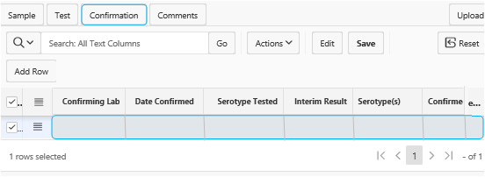

* Enter relevant information provided in the certificate of analysis.
* Select Serotype Tested as “All 7 STEC (including O157)” if the sample confirmed for all 7 STEC, select “O157” if confirmed for E. coli O157:H7 only or select “non-O157 only” if confirmed for top 6 STEC (excluding O157).
* Enter Interim and Confirmed result as per the certificate of analysis. If there is no Interim result, enter the confirmed result in the Interim Result field.
* To enter serotype(s), click on the cell>click on serotype>click forward arrow>enter. If more than one serotype is identified, click serotype>forward arrow>serotype>forward arrow>enter.
* If needed enter comments in the Comment tab. Use the Disposition & Comments column to enter any text about sampling for that day and product disposition.
* To add a new row, click on the **Add Row** button and enter data as above, alternatively, you can copy the previous row and edit the data.
* 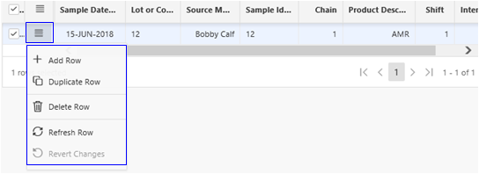To copy the previous row, click on the box to the left of the Date cell and select **Duplicate Row** (from this menu you can also add new row or delete a row. To delete a row, tick the box on the left of that row, click on **Delete Row**, then **Save**).
* You must amend copied information where necessary.
* If needed, enter comments in the **Comments** tab.
* Click **Save**. A green pop-up box **Change** saved will appear. You can edit these data anytime in that month using the **Edit** button.



Note: If there are data entry errors you will receive an error message. You need to fix any data errors before the record can be saved.

## Uploading data from an Excel spreadsheet

Spreadsheets for uploading directly in MEDC require a particular format. If you require additional assistance to upload data from an Excel spreadsheet you can contact the MEDC team for guidelines and requirements.

* Select Data entry then select the page required. For this example, select **Data Entry> CMA-MHA 3.**

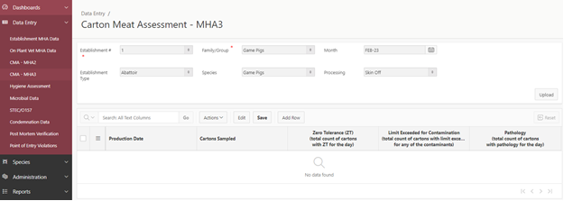

* Select the appropriate Establishment details from the drop-down menus and when complete, click on the upload button on the right-hand side.

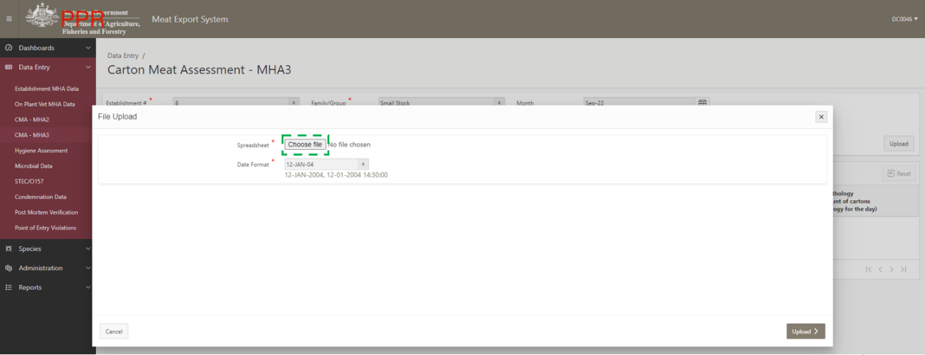

* Select the **Choose file** button to launch the file explorer window and locate your spreadsheet for upload. Select **Open**.
* The selected spreadsheet should appear in the file upload window (as shown by the green arrow). Select the correct date format DD-MM-YYYY HH:MM:SS. When complete, click **Upload**.
* A preview of the spreadsheet will appear, select Save. If the upload is successful, the data will appear.

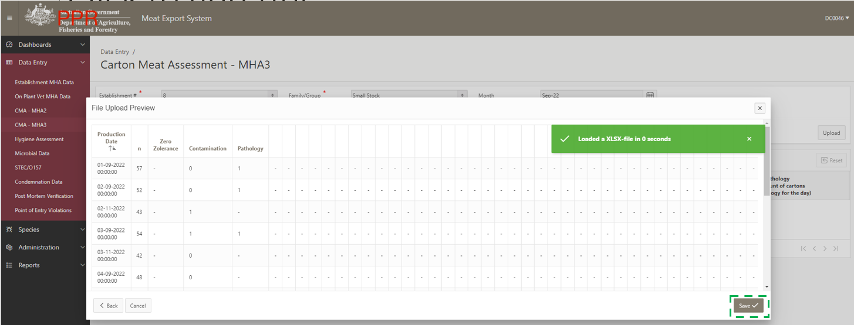

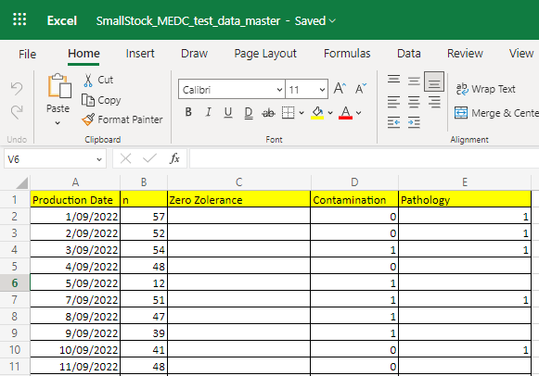**Important**: Spreadsheets will require a specific format to successfully upload in the MEDC system. An example is provided below.

For the Carton Meat Assessment data upload the spreadsheet columns B, C, D and E must be whole numbers (negative or decimal values will result in an error).

Note: this rule will vary if uploading data into the other Data Entry pages. If cells are blank, the upload process will automatically convert them to 0.

Column A - production date must be entered in the correct format of DD/MM/YYYY.

* To select the correct format, right click on column A and select format cells. Go to the number tab, select Date under the category menu on the left-hand side. Select DD/MM/YYYY on the right-hand side as the date type. When selected, click ok.

Detailed instructions can be found [here](https://support.microsoft.com/en-us/office/format-a-date-the-way-you-want-8e10019e-d5d8-47a1-ba95-db95123d273e).

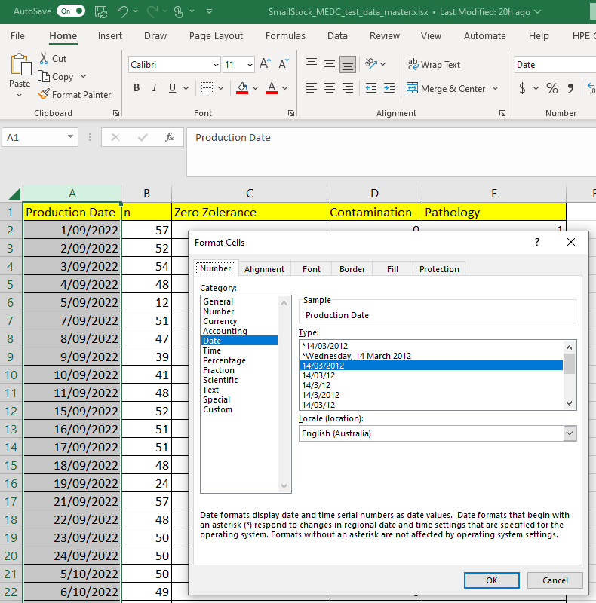

## Completion of PHI data entry into MEDC system

Establishments should enter PHI data within 10 working days of the following month. It is the responsibility of plant management to enter Microbial and STEC data into the MEDC System. It is expected that the only record that might not be completed by the submission deadline is a Salmonella serotyping result. Where a Salmonella result is delayed in its return, the establishment should enter as much data as is available about the test. Any follow up data should be sent via email to the PHI mailbox (ProductHygieneIndex@agriculture.gov.au) and this will be entered into MEDC System by departmental central office staff.

## Data review and analysis

* For data analysis and interpretation, see related material.

## Related Material

The following related material is available on the department's website:

* Webpage: [ELMER 3 – Electronic legislation, manuals and essential references](https://www.agriculture.gov.au/biosecurity-trade/export/controlled-goods/meat/elmer-3)
* Webpage: [Approved arrangement guidelines – Meat](https://www.awe.gov.au/biosecurity-trade/export/controlled-goods/meat/elmer-3/aa-guidelines-meat)
* Webpage: [Approved arrangement guidelines – Wild game meat](https://www.awe.gov.au/biosecurity-trade/export/controlled-goods/meat/elmer-3/aa-wildgame)
* Webpage: [Approved arrangement guidelines – Poultry](https://www.awe.gov.au/biosecurity-trade/export/controlled-goods/meat/elmer-3/aa-guidelines-poultry)
* Webpage: [Eligibility criteria for Tier 2 export establishments to move to an annual audit frequency](https://www.agriculture.gov.au/biosecurity-trade/export/controlled-goods/meat/elmer-3/eligibility-criteria-annual-audit-frequency-policy)
* Webpage: [Meat Hygiene Assessment (MHA) - v2 - DAFF (agriculture.gov.au)](https://www.agriculture.gov.au/biosecurity-trade/export/controlled-goods/meat/elmer-3/meat-hygiene)
* Webpage: [Export Meat operational guideline-Meat hygiene assessment, product monitoring (3](https://www.agriculture.gov.au/biosecurity-trade/export/controlled-goods/meat/elmer-3/meat-hygiene)[rd](https://www.agriculture.gov.au/biosecurity-trade/export/controlled-goods/meat/elmer-3/meat-hygiene) [Ed).](https://www.agriculture.gov.au/biosecurity-trade/export/controlled-goods/meat/elmer-3/meat-hygiene)
* Webpage: [Microbiological Manual for Sampling and Testing of Export Meat and Meat Products - DAFF (agriculture.gov.au)](https://www.agriculture.gov.au/biosecurity-trade/export/controlled-goods/meat/elmer-3/microbiological-manual#daff-page-main)

The following related material is available on the internet:

* Webpage: [*Export Control Act 2020*](https://www.legislation.gov.au/Series/C2020A00012)
* Webpage: [Export Control (Meat and Meat Products) Rules 2021](https://www.legislation.gov.au/Series/F2021L00334)
* Webpage: [Export Control (Wild Game Meat and Wild Game Meat Products) Rules 2021](https://www.legislation.gov.au/Series/F2021L00313)
* Webpage: [Export Control (Rabbit and Ratite Meat and Rabbit and Ratite Meat Products) Rules 2021](https://www.legislation.gov.au/Series/F2021L00308)
* Webpage: [Export Control (Poultry Meat and Poultry Meat Products) Rules 2021](https://www.legislation.gov.au/Series/F2021L00310)
* Webpage: [Self-service portal](https://online.agriculture.gov.au/selfservice/faces/oracle/webcenter/portalapp/pages/private/home.jsf;SSJSESSIONID=Ngf1Db9AbuIsYV7pqaJyJ2HIOlMfA1ABk3MpoBodFIm13sRxohXU!-94235933!-762511794)
* MEDC [Account creation guide](https://deptagriculture.sharepoint.com/:w:/r/sites/INT_IT-Systems/_layouts/15/Doc.aspx?sourcedoc=%7BDF4421BC-F2F1-429A-AF87-5C3A93D54585%7D&file=MEDC%20self-service%20account%20creation%20guide.docx&wdLOR=cCC0B7B5D-D8A9-490D-BD21-8CC3C49A02A2&action=default&mobileredirect=true)
* MEDC system access request for departmental [on-plant officers](https://deptagriculture.sharepoint.com/:w:/r/sites/INT_IT-Systems/_layouts/15/Doc.aspx?sourcedoc=%7B8EF8B704-213E-4139-914B-36F3615E1597%7D&file=MEDC%20access%20form%20-%20establishment%20user.docx&wdLOR=cC82A85F2-4F6B-49B4-B988-B9C5F41BAB1B&action=default&mobileredirect=true)
* MEDC for [non-department users](https://online.agriculture.gov.au/ords-ext/apex/f?p=1101:1:103160168820728:::::).

## Attachment 1: Roles and responsibilities

**The occupier**

* Complying with relevant export legislation, importing country requirements and Australian standards as reflected in the establishment's AA.
* Entry of PHI data within 10 working days of the following month.

**Area Technical Manager (ATM)**

*Establishment ATM*

* Approving the establishment's approved arrangement and/or any amendments made to it.

*EMSAP ATM*

Undertaking the EMSAP audit at the establishment.

**Departmental on-plant officer**

* Entry of PHI data within 10 working days of the following month.
* Verify establishment data and results for accuracy and monitor performance.

## Attachment 2: Definitions

**Aerobic plate count**

A microbiological plating technique to determine the bacterial content of food.

**Area Technical Manager (ATM)**

* A Commonwealth authorised officer with veterinary qualifications who has responsibility for the supervision, technical performance, assessment and verification of technical standards and operations in a defined group of export meat establishments.

*Establishment ATM*

* ATM with day-to-day on-plant responsibilities, on-plant staff technical review responsibilities and an establishment critical incident response audit (CIRA) role.
* Approves the establishment's approved arrangement and/or any amendments made to it.

*EMSAP ATM*

* ATM conducting the EMSAP audit at the establishment. This individual has not been the ATM with day-to-day on-plant responsibilities at the establishment being audited during the previous two years (i.e. held the establishment ATM role).

**Coliforms**

Coliforms are a group of Enterobacteriaceae. Their presence at high levels provides a warning that unhygienic food handling may have occurred, or processing was not effective.

**Departmental on-plant officer**

For the purposes of this document, department authorised on-plant officers refers to the following: on-plant veterinarians, food safety meat assessors and food safety assessors.

***Escherichia coli***

E. coli are gram-negative, facultative anaerobic rod-shaped bacteria that are a common part of the normal intestinal flora of humans and other warm-blooded animals. As such, E. coli is a more specific indicator of faecal contamination than Enterobacteriaceae or coliforms. Its presence in foods indicates recent contamination, either directly or indirectly, by faeces or faecal contaminated material.

**Product Hygiene Indicators (PHI) Program**

The Product Hygiene Indicators (PHI) Program identifies a number of key performance indicators (KPIs) which when combined produce an index, the Product Hygiene Index, which is a measure of hygienic meat production at individual export establishments. The KPIs can be used within an establishment to monitor and assess performance of process control and can be used across establishments to compare performance against other similar slaughter and boning operations.

**Meat Export Data Collection System (MEDC)**

An interactive web portal used to record a range of information gathered about export meat.

This portal combines previous data collection programs such as Establishment Production and Condemnation Statistics (EPACS), data from the Product Hygiene Indicators (PHI) program, Point of Entry detections (POE) and Species Testing (Species).

**Meat Establishment Verification System (MEVS)**

The department’s on-plant verification system utilised at abattoirs, wild game processing plants and Independent Boning Rooms.

**Product Hygiene Index**

A weighted score out of 100 generated from agreed KPIs that is used to compare the performance of a plant against similar establishments and as an input into risk-based government oversight.

**Occupier**

As defined in section 19 of the Export Control Act.

1) The occupier of a registered establishment is the person in whose name the establishment is registered.

(2) An occupier of an establishment (other than a registered establishment) where export operations in relation to goods are, were or will be carried out, is:

(a) the person that operates, operated or will operate the business of carrying out export operations in relation to goods at the establishment; or

(b) a person that manages or controls, managed or controlled or will manage or control export operations carried out in relation to goods at the establishment.

**National Carcass Microbiological Monitoring program (NCMMP)**

All export registered slaughtering and wild game processing establishments are required to participate in the NCMMP program which requires aerobic plate count (APC), E. coli (process control verification) and Salmonella testing (pathogen reduction) to verify slaughtering and chilling operations.

**Shiga toxin-producing E. coli (STEC)**

Strains of E. coli that contain genes that encode the production of Shiga toxin(s) and intimin (eae). STEC denotes E. coli strains of serotype O157, O26, O45, O103, O111, O121 and O145.

***Salmonella***

*Salmonella* spp. are members of the family Enterobacteriaceae.

**Shiga toxin-producing *E. coli* (STEC) including O157:H7 testing program**

This is a test and hold program designed to satisfy the requirements to export raw ground beef and raw ground beef components to the USA, Canada, and other markets where STEC testing is a requirement for export. Product must not be released from the establishment until the result of any testing under this program is known to be negative. All confirmed positive or deemed positive results must be notified to the department and a disposition applied.

**Tier 2 export-registered establishment**

An establishment operating under the Export-Registered Australian standard Meat Establishment (Tier 2) Scheme. Tier 2 establishments have a full-time departmental on-plant presence to ensure maintained compliance.

**Zero tolerance**

Zero tolerance (ZT) contaminants include faeces, ingesta or milk detected during department verification of carcases, offal or carton meat.