# A graphic containing an outboard engine, a leaf blower, a hedge cutter and imports. Description automatically generatedA close up of a logo Description automatically generatedGuide to importing items regulated by the Product Emissions Standards Act 201

© Commonwealth of Australia 2020

Ownership of intellectual property rights

Unless otherwise noted, copyright (and any other intellectual property rights) in this publication is owned by the Commonwealth of Australia (referred to as the Commonwealth).

Creative Commons licence

All material in this publication is licensed under a Creative [Commons Attribution 4.0 International Licence](https://creativecommons.org/licenses/by/4.0/legalcode) except content supplied by third parties, logos and the Commonwealth Coat of Arms.



Inquiries about the licence and any use of this document should be emailed to [copyright@awe.gov.au.](mailto:copyright@awe.gov.au)

Cataloguing data

This publication (and any material sourced from it) should be attributed as: Department of Agriculture, Water and the Environment 2020, Guide to importing items regulated by the Product Emissions Standards Act 2017, Canberra, March. CC BY 4.0.

ISBN 978-1-76003-278-4

This publication is available at environment.gov.au/protection/emissions-standards

Department of Agriculture, Water and the Environment GPO Box 858 Canberra ACT 2601

Telephone 1800 803 772 Web [awe.gov.au](http://agriculture.gov.au/levies)

The Australian Government acting through the Department of Agriculture, Water and the Environment has exercised due care and skill in preparing and compiling the information and data in this publication. Notwithstanding, the Department of Agriculture, Water and the Environment, its employees and advisers disclaim all liability, including liability for negligence and for any loss, damage, injury, expense or cost incurred by any person as a result of accessing, using or relying on any of the information or data in this publication to the maximum extent permitted by law

Contents

1. Introduction 5

2. About the legislative framework 6

3. Process for customs brokers to import products under the emissions standards 7

4. Products covered by the standards 8

5. Certification 10

6. Exemptions 13

7. Community Protection Question 14

8. Tariff codes 15

9. Offences and penalties 16

10. Information relevant to your client 17

11. More information 18

Figures

Figure 1 Process for importing emissions-controlled products for customs brokers 7

Figure 2 Format of Euro Stage II example certification numbers: 11

Figure 3 Format of Euro Stage V certification number 12

Tables

Table 1 Examples of typical products covered by the standards 8

Table 2 Exemption categories 13

Table 3 Tariff codes linked to the Community Protection Question 15

Table 4 Penalties for import, supply and manufacturing contraventions 16

Boxes

Box 1 The Community Protection Question 14

Box 2 Levy threshold examples 17

## Introduction

The Product Emissions Standards regulate the import, supply and manufacture of non-road spark-ignition engines and equipment, through the Product Emissions Standards Act 2017 and the Product Emissions Standards Rules 2017. This guide provides information about importing products captured under the standards, including how to complete the import declaration.

From 1 July 2018, all new outdoor power equipment and marine engines domestically manufactured or imported into Australia have been required to meet the emissions standards specified in the Rules. When importing these products, customs brokers need to be aware that a Community Protection Question is triggered when using certain tariff codes.

From 1 July 2020, imports of European-certified outdoor power equipment transition from Euro Stage II standards to Euro Stage V standards. Also from this date, all new outdoor power equipment and marine engines supplied in Australia must meet the standards.

The department undertakes post-border compliance activities on imports under the Act. If a breach occurs, importers and suppliers of emissions-controlled products are liable for offences relating to import, supply, labelling and record-keeping. Emissions-controlled products imported without a certification or exemption number may be seized and importers may be liable to penalties and prosecution.

### Key points for customs brokers

Importers of emissions-controlled products must ensure their products carry either an Australian certification or a certification from a recognised international authority; or have an exemption from the Australian emissions standards.

Recognised international authorities are the United States Environmental Protection Agency (US EPA), California Air Resources Board, member states of the European Union, and Environment and Climate Change Canada. Importers should check import requirements before importing goods and allow adequate time to apply for Australian certification or an exemption if one is required.

In accordance with the Customs Act 1901, customs brokers must correctly answer the

Community Protection Question (CPQ) in the Integrated Cargo System (ICS) by entering the correct certification (foreign or Australian) or exemption number.

To do this, customs brokers should:

* enter one certificate number per line item on an import declaration
* ensure their import declaration does not group emissions-controlled products with products that are not captured under the standards
* follow the instructions provided in this guide under ‘About foreign certification numbers’ where a certification number exceeds the character limit available in the ICS.

Administration of the emissions standards is fully cost recovered. Import data collected through the ICS is used to calculate the levy. Fees are charged for certification and exemption applications.

## About the legislative framework

The Product Emissions Standards legislation consists of the:

* *Product Emissions Standards Act 2017*—which allows the minister to make Rules that set mandatory emissions standards for products and detail the administrative arrangements for regulating those products. It also establishes offences and civil penalties for the import and supply of non-compliant products and triggers compliance and enforcement provisions under the *Regulatory Powers Act 2014*
* Product Emissions Standards (Customs) Charges Act 2017 and the Product Emissions Standards (Excise) Charges Act 2017—which allows for a levy to be charged on products imported into or domestically manufactured in Australia
* Product Emissions Standards (Consequential Provisions) Act 2017—which allows for an amendment to be made to section 299 of the Customs Act 1901 in relation to the forfeiture of goods at the border
* Trans-Tasman Mutual Recognition Act 1997—which allows for the products captured by the emissions standards, to be exempt from the mutual recognition arrangements.

Subordinate legislation consists of the:

* Product Emissions Standards Rules 2017—which provide details of what products are regulated
* Product Emissions Standards (Customs) Charges Regulations 2018 and Product Emissions Standards (Excise) Charges Regulations 2018—which set the levies for imported and domestically manufactured products.

## Process for customs brokers to import products under the emissions standards

This flow chart has been developed to assist customs brokers to understand what information is needed from clients in order to import a product captured under the emissions standards.

Figure Process for importing emissions-controlled products for customs brokers

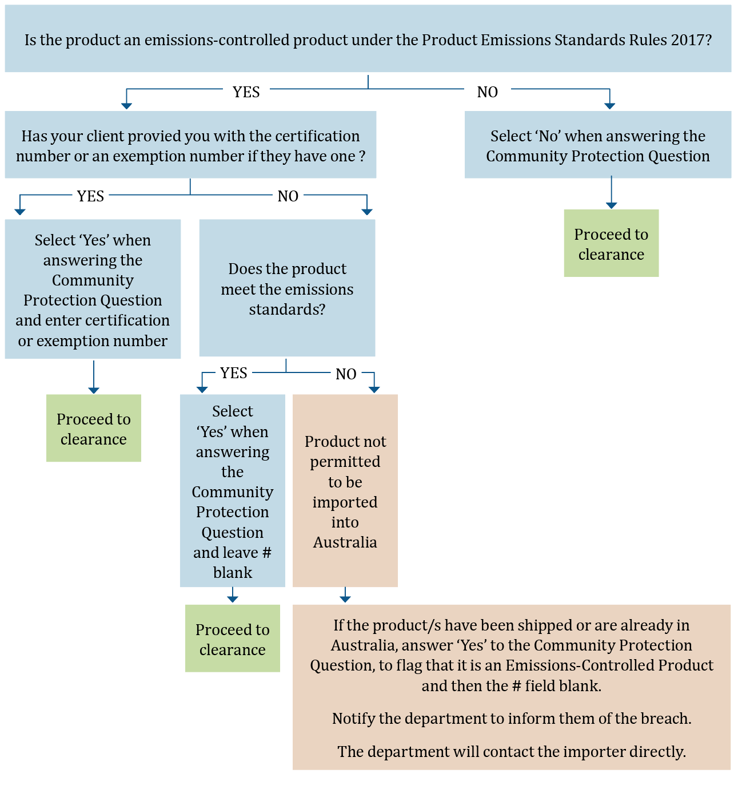

Note that all statements made in the ICS in or in relation to an import declaration—including in answer to a Community Protection Question and in the usual mandatory fields in an import declaration—are deemed to be statements made to a Customs Officer.

## Products covered by the standards

Part 2 of the Rules details products captured by the standards, including:

* new, complete, non-road spark ignition engines with a maximum engine power at or below 19 kilowatts, or 25.5 horsepower
* new, complete, spark-ignition propulsion marine engines.
* These products are predominantly petrol engines but also include a small number of gas-powered engines.

Table Examples of typical products covered by the standards

|  |  |  |
| --- | --- | --- |
| Non-handheld | Handheld | Marine |
| Air compressor | Brick/concrete saw | Auxiliary marine engine |
| Brick elevator | Brushcutter | Inboard engine |
| Cherry picker/scissor lift | Concrete vibrator/rammer | Jet boat engine |
| Concrete grinder | Chainsaw | Outboard engine |
| Concrete mixer | Engine for non-road equipment | Personal watercraft |
| Debris loader | Garden edger | Sterndrive engine |
| Engine for non-road equipment | Hammer drill | Water scooter |
| Firefighting/water pump | Hedge trimmer |  |
| Generator/inverter | Jackhammer |  |
| Go kart | Leaf vacuum/blower |  |
| Lawn aerator/corer | Mist blower |  |
| Leaf/garden vacuum (walk behind) | Pole pruner |  |
| Log splitter | Posthole borer/auger |  |
| Mini loader | Powered broom |  |
| Mulcher/chipper | Trowel machine (concrete) |  |
| Pitch roller | Whipper snipper/line trimmer |  |
| Plate compactor |  |  |
| Pressure cleaner/washer |  |  |
| Push mower |  |  |
| Ride-on mower |  |  |
| Rotary hoe |  |  |
| Slasher (ride-on) |  |  |
| Snow blower |  |  |
| Sod cutter |  |  |
| Stump grinder |  |  |
| Sweeper (non-handheld) |  |  |

Note: This list is not exhaustive and is for guidance only. The engine is subject to the emissions standards, whether imported or supplied as an engine alone or in equipment.

If a product your client is importing is not listed in the above table, but you think it might be an emissions-controlled product, please refer to the technical definition in Part 2 of the Rules. Alternatively, ask your client to contact the manufacturer for further information.

### What products are not captured?

Products that are not captured by the Rules include:

* + second hand engines and equipment
  + outdoor power equipment at or above 19.1 kilowatts
  + all-terrain vehicles
  + hovercrafts
  + amphibious craft
  + compression engines and equipment (diesel).

The Australian product emissions standards align with the US EPA standards. However, the Rules do not set standards for evaporative emissions.

## Certification

Importers must ensure that emissions-controlled products imported into Australia (from 1 July 2018) or supplied (from 1 July 2020) to the Australian market carry either Australian certification or certification from a recognised international authority. Both importers and suppliers are liable for offences under the Act.

### About foreign-certified products

The foreign authorities recognised in the Rules are:

* the United States Environmental Protection Agency (US EPA)
* the California Air Resources Board (CARB)
* European Union member states
* Environment and Climate Change Canada

### About foreign certification numbers

#### United States Environmental Protection Agency certified products

For an engine certified to the US EPA standards (CFR 1054 or CFR 1045), the engine family name should be considered as the certification number and entered in response to the Community Protection Question. It would also be acceptable to enter the Certificate of Conformity certificate number, which is the engine family number with a 3-digit suffix allocated by the EPA.

Engine family names can be accessed from the [US EPA certification database](https://www.epa.gov/compliance-and-fuel-economy-data/annual-certification-data-vehicles-engines-and-equipment).

#### California Air Resources Board certified products

CARB follows the same naming conventions for engine families as the US EPA. The engine family name is considered the certification number and should be entered in response to the Community Protection Question. It is also acceptable to enter the applicable Executive Order number (CARB calls their Certificates of Conformity ‘Executive Orders’).

Both the engine family names and the Executive Order (EO) number can be accessed from the CARB [Off-Road Certification Database](https://www.arb.ca.gov/msprog/offroad/cert/cert.php). In the database, the EO number is hyperlinked to the actual EO for the engine family.

#### European Union authority certified products

For an engine certified to the EU standards for non-road engines (referred to as non-road mobile machinery or NRMM), the ‘type-approval number’ is the certification number and should be entered in response to the Community Protection Question.

##### Transitional provisions for European Union certified products

Under the Rules, non-road European-certified products transition from Euro Stage II emissions standards to Euro Stage V emissions standards. The transition will commence on 1 July 2020. This transition follows the European Union phase-out of Euro Stage II emissions standards, with Stage V regulations adopted in 2016 under Directive 2016/1628.

Under Euro Stage II emissions standards, engines captured under one of the following amending directives to Directive 97/68/EC are accepted for this transitional period only:  
2002/88/EC, 2004/26/EC, 2006/105/EC, 2010/26/EU, 2011/88/EU or 2012/46/EU. These directives amend Directive 97/68/EC.

Euro Stage II certified products can be imported into Australia up until 30 June 2020. After this date, European products must be certified to Euro Stage V standards and labelled correctly before they can be imported into Australia. Euro Stage II certified products can be supplied in Australia up until 30 June 2021. ‘Supply’ includes supply as a giveaway, as part of a deal or as a special offer when supplying another product.

Both Euro Stage II and Euro Stage V certification numbers are located on the type-approval certificate and should be on the corresponding emissions label on the engine. This certificate is generally issued to the manufacturer after their products are certified as meeting the emissions standards.

The field available in the ICS has a limit of 35 characters. If a Euro Stage V certification number exceeds the character limit customs brokers should omit the asterisks and forward slashes in order to insert the complete number. If the product is certified to another recognised foreign standard, customs brokers may use this number rather than the EU certification number.

Euro Stage V certification numbers (Figure 3) are easily distinguishable from Euro Stage II certification numbers (Figure 2) and follow a different format.

Figure Format of Euro Stage II example certification numbers:

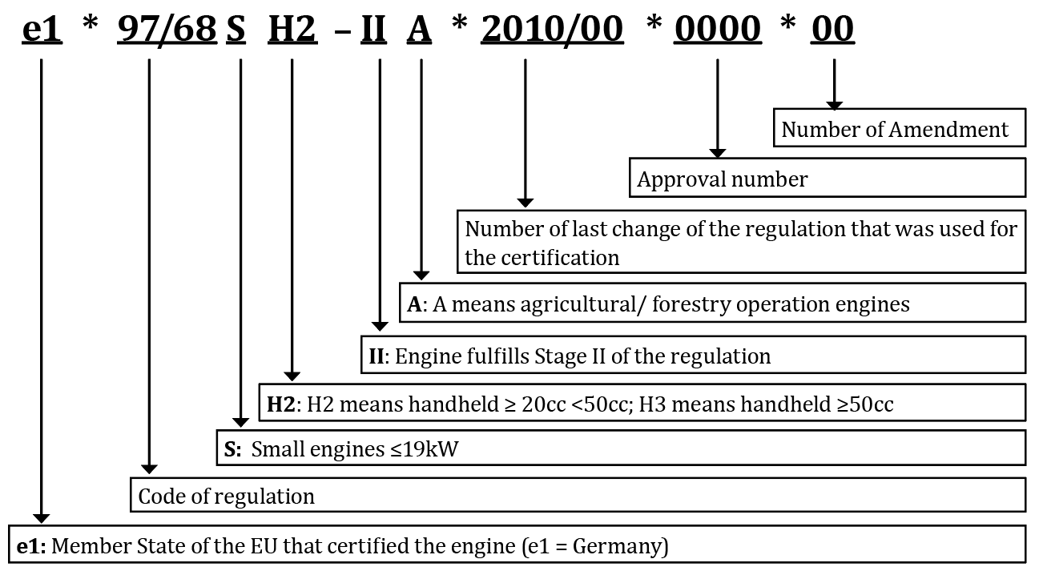

Figure Format of Euro Stage V certification number

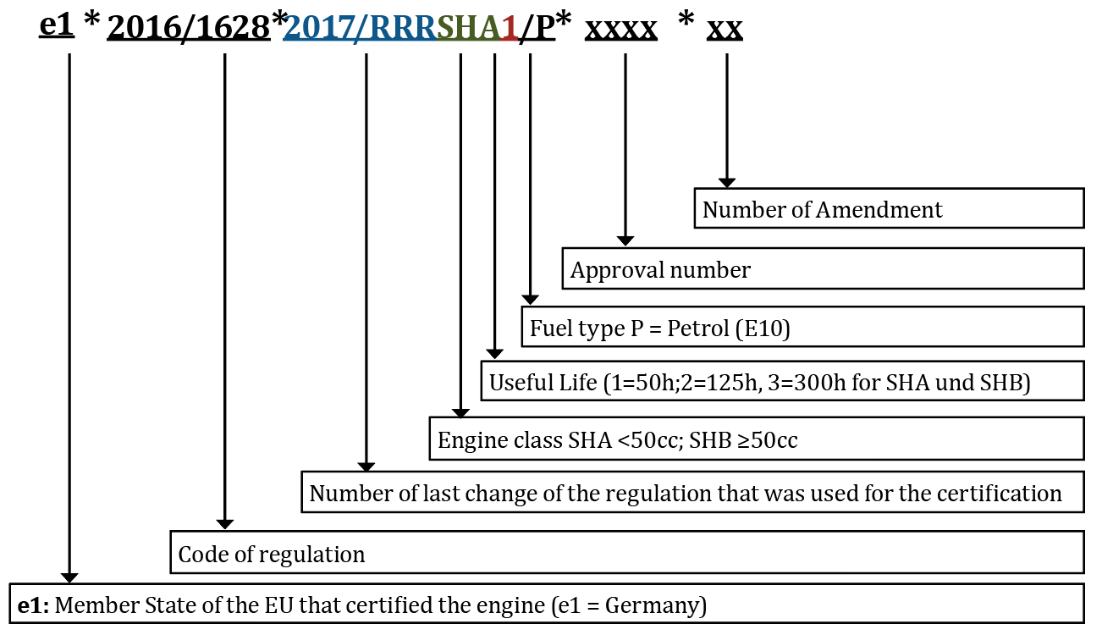

See [Guidance note for importers and brokers](http://www.environment.gov.au/protection/publications/pes-guidance-note-importers-brokers-certification-numbers) regarding certification numbers for a detailed guide about foreign certification numbers.

#### Australian certification

Where a product is not already certified to a recognised international standard, a certification application may be made through the department’s [Online Services Platform](https://onlineservices.environment.gov.au/). An application will typically be made by the manufacturer and will require laboratory emissions testing results to be submitted to the department for assessment. If Australian certification is granted, the applicant will be issued with a certification number. This unique number must be provided when answering the Community Protection Question in the ICS.

See [Guide to Australian certification under the Product Emissions Standards Act 2017](http://www.environment.gov.au/protection/publications/pes-guide-to-australian-certification) for a detailed guide about Australian certification numbers.

## Exemptions

The Department of Agriculture, Water and the Environment may grant an exemption to allow uncertified products to be imported or supplied to the Australian market under limited circumstances. Section 30

of the Rules specifies the 6 exemption categories under which an exemption application can be made (Table 2).

Exemption applications are made through the department’s [Online Services platform](https://onlineservices.environment.gov.au/). If an exemption is granted, the applicant will be issued with an exemption number. This exemption number must be provided when answering the Community Protection Question in the ICS.

Table Exemption categories

|  |  |
| --- | --- |
| **Exemption category (Rules reference)2 Description** | |
| Export (30(1)(a)) | Products will be exported from Australia but not used in Australia. |
| Testing evaluation and display (30(1)(b)) | Products will be tested, evaluated, displayed, advertised, offered for supply or pre-ordered but not used or supplied in Australia before the products are certified. |
| National security (30(1)(c)) | Products will be used by the Australian Defence Force or law enforcement or security agency for national security purposes. |
| Emergency services (30(1)(d)) | Products will be used by an emergency services organisation. |
| Competition (30(1)(e)) | Products will be used in organised competition. |
| Replacement engines (30(1)(f)) | Replacement engines for uncertified, unserviceable engines. |

For national security, emergency services, organised competition and replacement engines exemption categories, the applicant must satisfy the criteria for the nominated category and be able to demonstrate that there are no other products available that meet the emissions standards that could be used instead.

## Community Protection Question

Certain tariff codes are linked to the import of products regulated under the Rules. When a linked tariff code is entered into the Integrated Cargo System (ICS), the Community Protection Question (CPQ) will be triggered.

Box The Community Protection Question

|  |
| --- |
| ‘Are these goods (or do these goods contain) new spark-ignition non-road engines or new spark- ignition propulsion marine engines as defined in the Product Emissions Standards Rules 2017 sections 7, 8 and 9?  If yes, please enter the relevant certification or exemption number for the product.’ |

The Department of Agriculture, Water and the Environment conducts compliance audits on the information provided by the information provided by the CPQ and other monitored tariff codes, and will follow up with the importer.

### Answering the Community Protection Question

The CPQ must be answered and the certification or exemption number entered when prompted. If your client has not provided a certification or exemption number, you should ask your client if the product is certified as meeting the emissions standards.

If your client informs you that the product is certified, but cannot provide you with the certification number, you can answer yes to the CPQ and leave the section for the certification or exemption number blank. However, you should advise your client that the Department of Agriculture, Water and the Environment will receive a notification that the product has been entered into the ICS without a certification or exemption number. The department will contact the importer to determine why this was not provided.

The field available in the ICS has a limit of 35 characters. If a Euro Stage V certification number exceeds the character limit customs brokers should omit the asterisks and forward slashes in order to insert the complete number.

If your client informs you that the product is not certified, you can advise your client that it is illegal to import a product that is not certified as meeting the emissions standards. In this case, you or your client should contact the department immediately. Should your client inform you that the product is certified and it is later identified to be an uncertified product, the importer will be liable for the offences under the Act.

## Tariff codes

The Department of Agriculture, Water and the Environment has identified a range of tariff codes covering emissions-controlled products. Table 3 contains the tariff codes currently linked to the Community Protection Question. This is not an extensive list of the tariff codes monitored under our compliance program and other tariff codes may be added.

Table Tariff codes linked to the Community Protection Question

|  |  |
| --- | --- |
| **Tariff code** | **Statistical code** |
| 84072100 | 49, 50, 51, 52, 53, 54, 55, 56, 57, 58, 59, 61, 62, 63, 64, 65 |
| 84072900 | 25 |
| 84073100 | 26 |
| 84073200 | 11 |
| 84079030 | 30, 31 |
| 84137090 | 62 |
| 84148019 | 50 |
| 84244100 | 01 |
| 84243090 | 51 |
| 84304900 | 19, 44 |
| 84305000 | 45 |
| 84306100 | 23 |
| 84322900 | 47 |
| 84328000 | 14 |
| 84331100 | 48, 55, 56 |
| 84331900 | 62, 63 |
| 84368090 | 42 |
| 84641000 | 10 |
| 84659600 | 37 |
| 84678100 | 10 |
| 84678900 | 28, 60, 68 |
| 84743100 | 24 |
| 84791000 | 14 |
| 84798990 | 90 |
| 85022000 | 38, 39 |
| 89039210 | 15, 16 |
| 89039290 | 17 |
| 89039910 | 18 |

## Offences and penalties

Importers and suppliers are liable for the offences under the Act, which relate to:

* import
* supply
* labelling
* record keeping.

Products imported without a certification or exemption number may be seized and importers may be liable to penalties and prosecution. Each import, supply and manufacturing contravention carries a maximum penalty (Table 4).

Table Penalties for import, supply and manufacturing contraventions

|  |  |  |
| --- | --- | --- |
| **Type of contravention** | **Maximum penalty units per contravention** | **Maximum penalty per contravention** |
| Strict liability offence (individual) | 60  (1 penalty unit equals $210) | $12,600 |
| Strict liability offence (body corporate) | 300  (1 penalty unit equals $210) | $63,000 |
| Civil penalty provision | 120  (1 penalty unit equals $210) | $25,200 |

All products must be labelled in accordance with part 6 of the Rules, including:

* labelling in accordance with the relevant recognised foreign standards
* labelling in accordance with section 39 (2) of the Rules if the product has an Australian certification.

From 1 July 2018, importers have been required to keep records in accordance with Part 7 of the Rules. From 1 July 2020, suppliers are also required to keep records. Records are required to be kept for 5 years after the end of each financial year.

## Information relevant to your client

The information entered into the ICS and the CPQ is used to calculate the levy importers are liable to pay at the end of each financial year.

The levy is charged at 0.45% of the value of products imported and is only payable if more than $32,000 worth of products are imported in a financial year. The levy is also subject to a high value threshold so that no more than $90 is payable for the import of any one item (Box 2).

Box Levy threshold examples

|  |
| --- |
| Low levy threshold example  Threshold: $32,000 worth of products imported in one financial year.   * If an importer imports $40,000 worth of products over one financial year, the importer would be over the low levy threshold—bringing their import levy liability to $180, (0.45% of $40,000). * If an importer imports $29,000 worth of products over one financial year, the importer would not be liable to pay the levy as it is below the low levy threshold of $32,000.   High value item threshold example  Threshold: $20,000 per item.   * If an importer imports one $50,000 boat (including the engine) over one financial year, only $20,000 of its value would go towards calculating the levy. The importer would not need to pay a levy, As because $20,000 is under the low levy threshold of $32,000. * If an importer imports 5 boats (including the engine) each worth $50,000, only $20,000 from the value for each boat would apply towards the calculation of the import levy $450, (0.45% of $100,000). |

Following the end of the financial year, if an importer exceeds the import levy threshold, a notice of liability will be sent to the importer informing them of their liability and allowing 3 months for them to amend their import data if necessary. A final notice with the levy amount and invoice will be sent in October of that year.

## More information

If you have any questions about the product emissions standards, please email the Department of Agriculture, Water and the Environment at [productemissions@awe.gov.au](mailto:productemissions@awe.gov.au) or call **1800 803 772**.

Frequently asked questions are available on the department’s website [environment.gov.au/protection/emissions-standards/faqs](http://www.environment.gov.au/protection/emissions-standards/faqs)