What’s New, What’s Different: Quick Reference Guide

PEMS Release – 17 August 2024
Following the outage on Saturday 17 August 2024, the Plant Export Management System (PEMS) will be updated with the following changes.
PEMS Enhancement
Current
Linking to RFP Version from the Product Inspection record
The ‘Open’ option on the Grain and Plant Product Inspection form has been updated.
Prior to the update, if there were multiple versions of the RFP, the ‘Open’ option would open the RFP associated with the inspection record when it was created. Users were not directed to the latest version of the RFP.
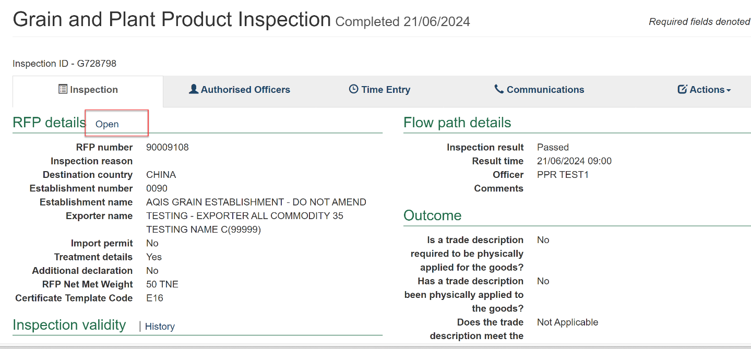

Post enhancement
Linking to RFP Version
- Following the updates, PEMS users will now have two options for navigating to the associated RFP.
Selecting the Open option
- Selecting the ‘Open’ option takes the user to the version of the RFP originally associated with the Inspection record.
Selecting the Open Latest option
- Selecting the ‘Open latest’ if the RFP has been updated since that point, this option takes the user to the latest version of the RFP associated with the Inspection record.
