

REFERENCE

# Plant Exports Management System (PEMS) External Executive User Guide

**In this document**

This document contains the following topics.

Plant Exports Management System (PEMS) External Executive User Guide 1

This document contains the following topics. 1

Purpose of this document 3

External Executive roles 4

Establishment Executive 4

Exporters or EDI users 5

Acronyms and abbreviations 5

Plant Exports Management System Overview 5

What is PEMS and what does it do? 5

Interactions with EXDOC and ER 7

Conventions used in this user guide 7

Conventions used in PEMS 8

Abiding by instructional material 8

1 Getting Started 9

1.1 Accessing and registering for PEMS 9

1.2 Logging into PEMS 9

1.3 PEMS menu bar 10

1.4 Search functions 11

1.5 Managing your PEMS profile 11

2 Pre-inspection documentation 14

3 Viewing RFPs 16

3.1 RFP Search 16

Opening the RFP search page 16

Selecting RFP records from search results 17

3.2 Opening an RFP record 18

3.3 RFP Details 20

3.4 Refresh from EXDOC 20

3.5 RFP lines (view all containers) 21

Viewing container approvals 21

3.6 Inspections 22

3.7 Related calibration records 23

3.8 Time Entry 25

3.9 Downloading the RFP activity report (Establishment executive only) 27

Summary report 27

Detailed report (Establishment executive only) 28

3.10 View import permits 31

3.11 Communications 32

Attachments 32

Correspondence 32

Attaching documents 33

3.12 Service Request 37

Request to Authorise RFP 37

Service Request – Re-submission process for all request types 39

Issuance of EX188 Certificates 41

Issuance of ITCT Calibration Certificate 42

Withdraw RFP Authorisation Request 44

3.13 Actions – Container Report (Establishment executive only) 47

3.14 View comments on an RFP record 48

4 Search Functions 49

4.1 Inspection Search - Establishment Executive only 49

Opening the inspection search page 49

Conducting a simple inspection search 50

Selecting inspection records from search results 51

4.2 Calibration Search – Establishment Executive only 52

Opening the Calibration search page 52

Selecting calibration records from search results 53

5 Viewing Inspection Records 54

5.1 Opening an inspection record 54

Download inspection report 56

5.2 Opening an inspection record from the RFP tab 58

5.3 Opening a calibration record 59

Add/Remove RFP to Onshore Cold Treatment (OSCT) record (Establishment Executive only) 61

Download calibration certificate 62

China Calibration Certificates 64

Document information 65

Version history 65

## Purpose of this document

This guide includes the following step-by-step instructions for external executive user roles when using PEMS, and:

* provides a brief overview of PEMS
* outlines how to get started in PEMS
* explains how to make changes to your profile
* explains how to search for inspections and calibration records in PEMS
* explains how to attach pre-inspection documentation
* explains how to view RFPs and associated tabs
* explains how to request authorisation
* explains how to download inspection reports
* explains how to view attached communication to the record.

**NOTE: Records created in PEMS are viewable by all users who have been associated to that record including exporters, establishments, EDI users and any AO that is part of or has joined the inspection.**

**Any documents attached in PEMS by an Authorised Officer or by an external executive are viewable by all parties, and by the department, for the purpose of completing and assessing the record for approval, export and audit.**

**All users are bound by the PEMS terms and conditions and must not use or disclose information, which is considered confidential, for any purpose other than for the purpose for which it was provided.**

## External Executive roles

### Establishment Executive

If your business is a registered establishment then you should apply for the *Establishment executive* role in PEMS.

As an Establishment Executive, you can use PEMS to:

* search for and view any RFPs or inspections, and any related calibrations, completed at your establishment, that have been recorded in PEMS
* download container reports and activity reports for any inspections completed at your establishment, that have been recorded in PEMS
* access the calibration certificate; and download the approved electronic certificate with signature and stamp.

To apply for this role, you must be listed in department’s Establishment Register (ER) database as a person who manages and controls the export registered establishment.

If you are involved with a number of registered establishments, you can apply for PEMS access for one of these establishments and then email [pems@awe.gov.au](mailto:pems@awe.gov.au) to request the PEMS admin to add any additional establishments to your profile.

This request will be approved provided appropriate evidence of the relationship between the individual and establishments is given. This email must contain documentation with the company’s letterhead stating the user is listed in management or in control of the company and therefore the company authorises this access to be given. The letter must also contain all the establishment names and numbers that need to be linked to the profile.

**!** If you are eligible for an external executive role, but already have an Authorised officer (AO) profile in PEMS then you will have to provide a different email address as the two roles cannot overlap in PEMS.

### Exporters or EDI users

Exporters or EDI users who send RFP authorisation requests to the department will need to select this as their role in PEMS.

The Exporter role should only be requested when you are associated to one entity only.

Where you operate across more than one entity you should request the EDI user role and provide your EDI number (provided when you signed up to use EXDOC).

As an Exporter or EDI user, you can use PEMS to:

* create an RFP extract to attach pre-and post-inspection documentation
* attach pre or post inspection documentation to an RFP
* view all inspections created including submitted, cancelled, and withdrawn to have an oversight of AO performance
* access the calibration certificate; and download the approved electronic calibration certificate with signature and stamp.

**Note:** You can request more than one executive role. So, you can hold both an establishment executive and EDI user/Exporter roles in PEMS. Where we cannot readily establish the legitimacy of the role requested, we may request further evidence.

## Acronyms and abbreviations

|  |  |
| --- | --- |
| AO | Authorised Officer |
| BVI | Bulk Vessel Inspection |
| ER | Establishment Register |
| EXDOC | Department of Agriculture, Fisheries and Forestry Electronic Documentation System |
| IMO | International Maritime Organisation |
| ITCT | In-transit cold treatment |
| Micor | Manual of Importing Country Requirements |
| OSCT | Onshore cold treatment |
| PEMS | Plant Exports Management System |
| QSR | Quality System Recognition |
| RFP | Request for Permit |
| VHT | Vapor Heat Treatment |

## Plant Exports Management System Overview

### What is PEMS and what does it do?

The Plant Exports Management System (PEMS) is a web-based IT system that:

* automatically extracts relevant details from the RFP in EXDOC and establishment details in the Establishment Register (ER)
* allows inspection AOs to enter and submit inspection results, calibration records, and any supporting documentation to the department for the issuance of phytosanitary certification and other government documentation to exporters
* allows exporters and EDI users to view their RFPs in PEMS and upload supporting documentation directly into the system post inspection, for inspections recorded in PEMS
* allows export registered establishments to view and download inspection reports from all inspections that were conducted at their establishment and recorded in PEMS
* centralises and stores all plant export inspection records and supporting documentation, making record keeping easier and accessing these records faster
* automatically validates AO competencies and inspection data to improve the accuracy and quality of inspection and calibration records
* automatically calculates inspection expiration dates
* works on a range of devices including desktop computers, laptops, and mobile devices, such as mobile phones, a tablet or iPad
* includes an offline mode so AOs can record inspection data even when there is no internet / network connection at the inspection location
* is available 24 hours a day, seven days a week.

### Interactions with EXDOC and ER

PEMS has been designed to improve efficiency and accuracy in completing inspection or calibration records by reducing manual transcription and eliminating data duplication. PEMS achieves this by automatically extracting relevant details from the RFP in EXDOC and establishment details in the Establishment Register (ER).

### Conventions used in this user guide

This guide uses several conventions to explain how to use PEMS.

The guide uses a series of descriptions and screenshots to describe how to perform certain functions in PEMS. A description is positioned directly above the image/screenshot being described.

When discussing a specific field or button in PEMS, this user guide will write the field or button name in bold along with a number in superscript, for example:

**Field Name1**

The number in superscript refers to a numbered arrow pointing to the button or field on the screenshot being discussed. The arrow will look like the following:

**#**

If a range of fields or columns are being discussed or referred to in the text, they will be identified on the screenshot by a box with a numbered arrow pointing at it, for example:

**#**

Key points will be presented in information boxes, for example:

* Key information is presented here.

PEMS functions described in this user guide are only relevant to individuals requesting for Establishment Executive Role in PEMS.

### Conventions used in PEMS

If you decide you would like to exit a window at any time, you can click **Close1** or click **Exit (X)2.**

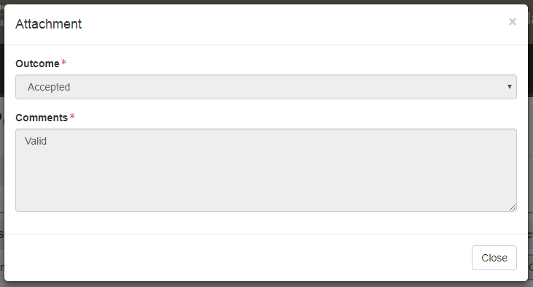

**2**

**1**

### Abiding by instructional material

This user guide provides instructions for using the PEMS system. Establishment executives or Exporters or EDI users must perform their tasks consistent with all approved instructional material provided by the department.

All users are bound by the PEMS terms and conditions and must not use or disclose information, which is considered confidential information, for any purpose other than for the purpose for which it was provided.

## 1 Getting Started

To help you get started in using PEMS, this section provides information on:

* how to login
* the PEMS menu and homepage
* how to manage your PEMS user profile.

### 1.1 Accessing and registering for PEMS

Persons responsible for the management and control of export registered establishments, as listed in ER, can access PEMS to view RFPs associated with their establishment. PEMS can also be accessed by all exporters or EDI users who send RFP authorisation requests to the department.

Once you have successfully registered as a PEMS user (see the [How to register for PEMS](http://www.agriculture.gov.au/export/controlled-goods/plants-plant-products/plant-exports-management-system-information#what-instructional-material-is--available) factsheet)*,* and the administrator has enabled your account, PEMS will automatically identify you and provide you with the appropriate level of access.

### 1.2 Logging into PEMS

To access PEMS, go to: <https://online.agriculture.gov.au/selfservice>

When the PEMS login screen displays, enter your User **Login1** and **Password2.**

If you agree to the ‘terms of use’select the I accept the **terms of use3**checkbox. Click **Log in4.**

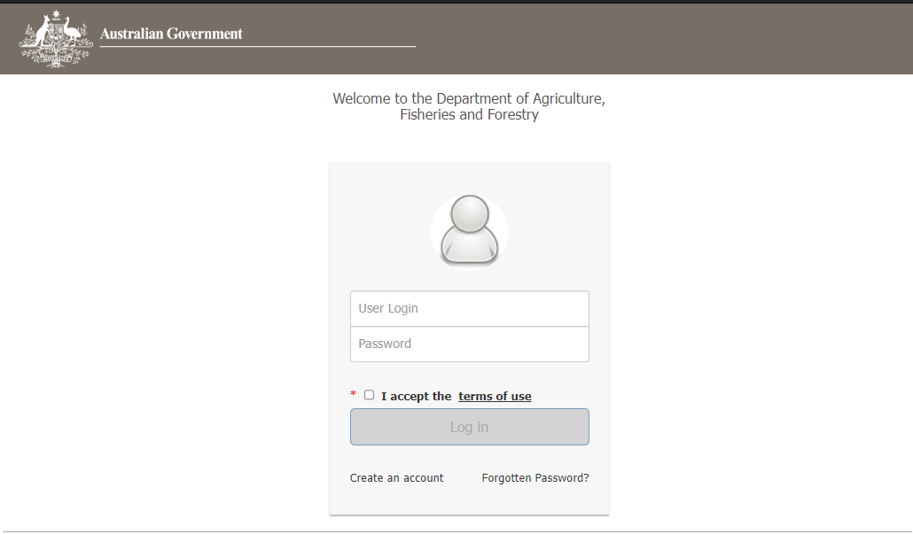

**5**

**4**

**2**

**3**

**1**

* If you forget your password, click **Forgotten Password?5** link and follow the prompts.

* Remember you are responsible for maintaining the confidentiality of your PEMS user login and password.

The PEMS self-service page will display.

Click the **PEMS1** button to enter the PEMS homepage.

**1**

Once you have signed in, the PEMS homepage will display. On the homepage, you will see the PEMS menu bar.

### 1.3 PEMS menu bar

PEMS menu bar will display:

* **Home1** – search inspections and RFPs
* **Search inspections2** – search for an inspection record (this tile and function is not available for Exporter and EDI profile users)
* **Search RFPs3** – search for an RFP
* **Search Calibrations4** – search for calibrations (this tile and function is not available for Exporter and EDI profile users)
* **User Profile5** – view or change your personal details
* **Log Out6** – log out of PEMS.

*The below image is for Establishment user.*

**1**

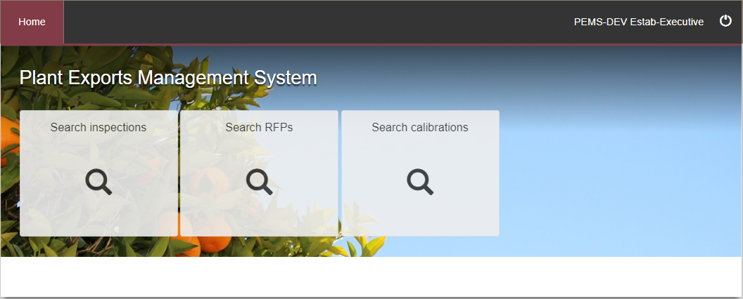

**3**

**4**

**5**

**6**

**2**

### 1.4 Search functions

The PEMS homepage will display a **button1** for each search function you are accredited to perform.

*The below image is for Exporter/EDI user.*

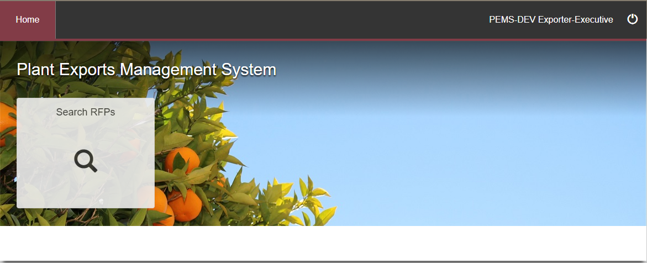

**1**

### 1.5 Managing your PEMS profile

To view or edit your PEMS profile, click **User Profile1** on the PEMS menu bar.

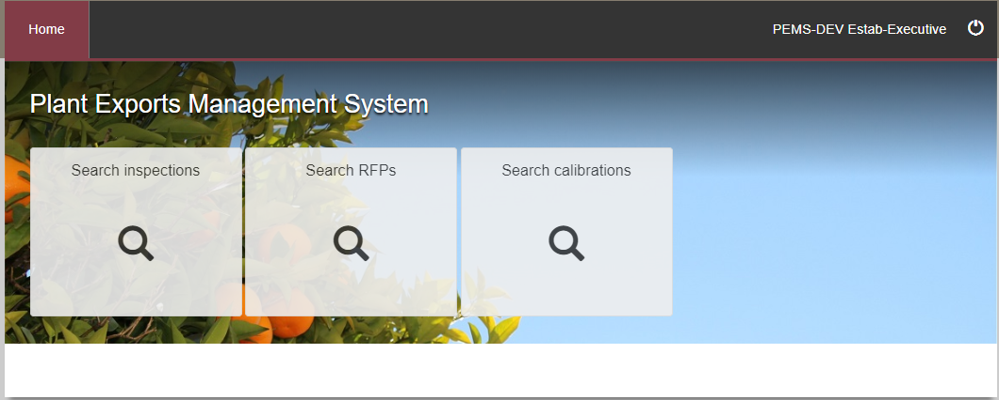

**1**

The *My Profile* page will display.

Your **Personal details1**, **Authorised officer details2** and **PEMS roles3** will be displayed.

You can change your personal details by clicking **Change4** under the personal details section. You cannot change information in the AO details and PEMS roles sections.

The **Establishments5** show what establishment name and numbers are linked to your profile.

Click **Home6** on the top menu bar to return to the PEMS homepage.

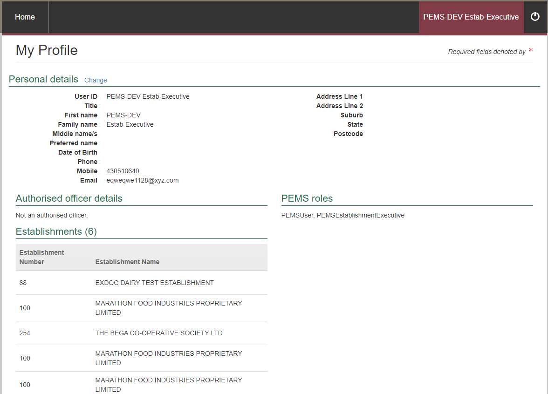

**1**

**2**

**5**

**6**

**3**

**4**

If you choose to change your personal details, the *Personal Details* window will display.

You can edit all fields in this window, except the **Name1**, **Date of Birth2** and **Email3** fields. To make changes to your personal details, select the applicable information from the drop-down lists or enter information into the appropriate free text fields.

Click **Save4** to save any changes to your personal details.

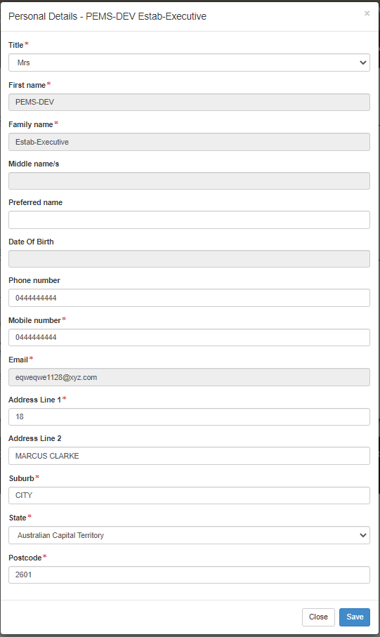

**4**

**1**

**3**

**2**

PEMS will display an acknowledgement message stating that **your personal details have been updated1**.

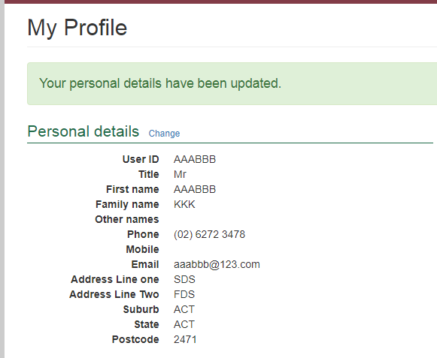

**1**

## 2 Pre-inspection documentation

There is the ability to attach pre-inspection documents on the RFP attachments section. This allows for the AO to view this information when they create the inspection record in PEMS.

This process will also allow you to create an RFP extract in order to attach any manual inspection or calibration records, used only when an exception applies, so that you can request authorisation through the Communications Workflow (see 3.12 Service Request)

Click **Search RFPs1**.

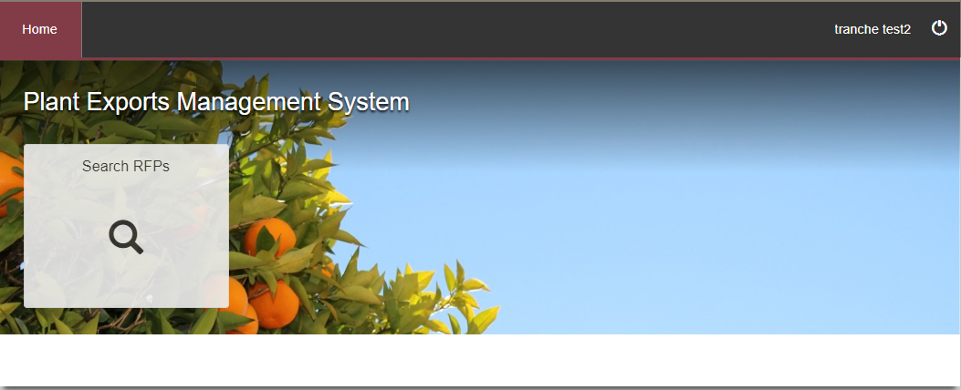

**1**

Enter the **RFP number1** and click **Search2**.

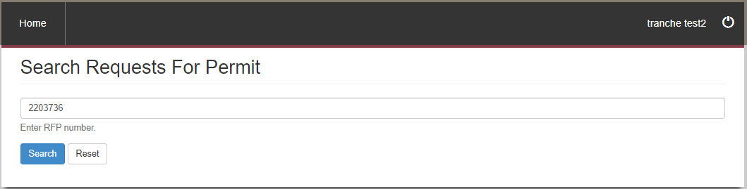

**2**

**1**

PEMS will verify that the RFP is associated to your profile and automatically create an RFP extract from the information in EXDOC. As there is only one search result the record will automatically open.

Click on **Add1** to open the Attachment section.

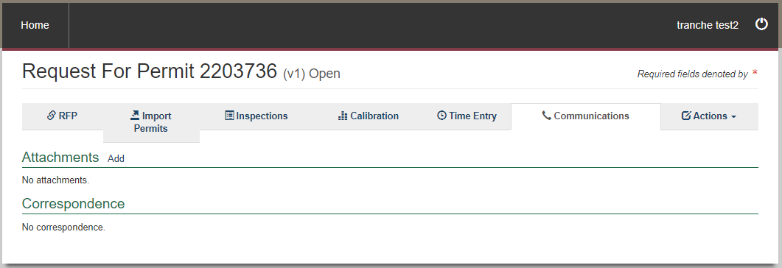

**1**

## 3 Viewing RFPs

This section guides you through the process for viewing RFPs in PEMS and provides step by step instructions for:

* Search RFP
* RFP tabs
* RFP details
* RFP lines (view all containers)
* import permit details
* inspection history
* viewing and recording attachments and correspondences under communications
* actions (view container report).

### 3.1 RFP Search

PEMS RFP search allows you to search for any RFP records associated with your establishment, where the inspection was recorded in PEMS. This section assumes that the inspection has been commenced or completed by the AO. All information is provided to External Executives in **Read Only** format.

#### Opening the RFP search page

To start an RFP record search, click on the **Search RFPs1** button on the PEMS homepage.

*The below image is for Establishment user. Exporter/EDI user profiles will only have the Search RFP tile.*



**1**

The *Search Requests For Permit* page will display.

You can perform a search for the RFP record by entering **RFP number1** and clicking **Search2.**

Click **Reset3** to clear or reset the search criteria.

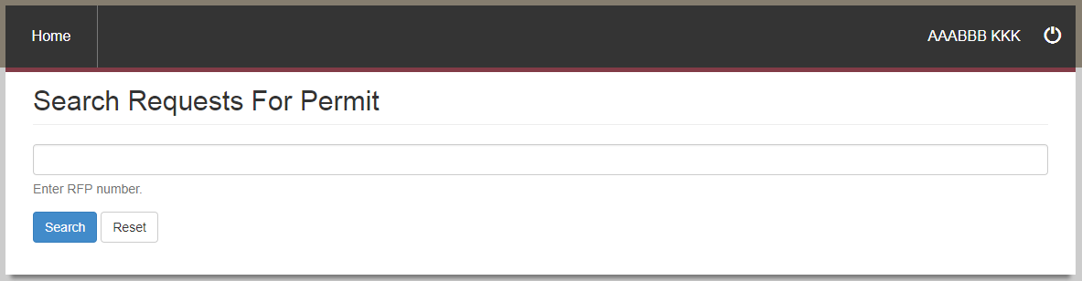

**2**

**3**

**1**

* If PEMS does not find records matching search criteria, it will display a message   
  ‘No search results’.

#### Selecting RFP records from search results

After a search has been entered, PEMS will display the **RFP record1** that matches the supplied search criteria.

If the search result displays one record, that record will be opened automatically. Click **Open2** beside the appropriate RFP record to view the record.

Click **Reset3** to clear or reset the search criteria.

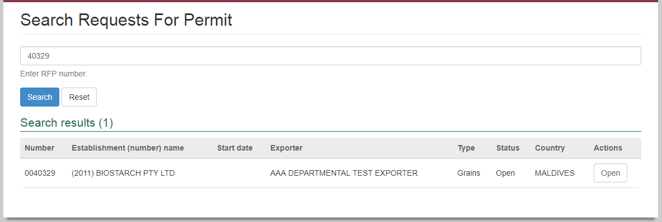

**1**

**2**

**3**

### 3.2 **Opening an RFP record**

To open an RFP record, first follow the instructions provided in Section 3.1 RFP search. From the search results, click **Open1** beside the record you want to view.

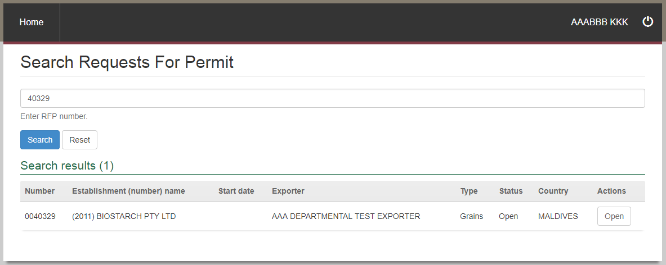

**1**

Once an RFP record has been opened, it will display:

* summary details of the **RFP1** extracted from EXDOC
* **Inspections2** associated with the RFP
* **Calibration3**associated with the RFP
* **Time Entry4** time summary (carried from inspection record)
* attachments and correspondence for the RFP under **Communications5**
* Service Request, to request authorisation for Requests For Permit (RFPs), and the issuance of in-transit cold treatment (ITCT) calibration certificates and declaration and certificate as to condition (EX188)
* **Actions7** to download the container report.

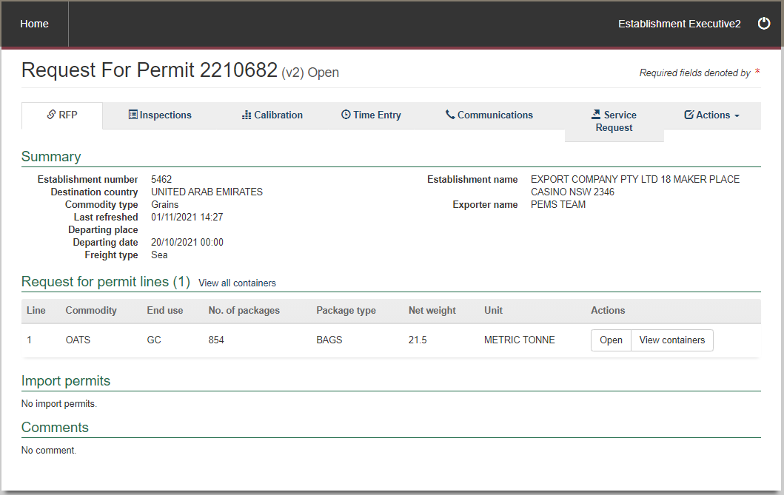

**7**

**6**

**5**

**4**

**3**

**2**

**1**

### 3.3 RFP Details

The RFP tab displays a **Summary1** of the RFP information extracted from the RFP in EXDOC; subject to the following conditions:

1. the RFP must be in INIT or FINL status in EXDOC
2. the RFP must belong to a Grain or Horticulture consignment.

**1**

### 3.4 Refresh from EXDOC

Once extracted into PEMS, the record can be updated by clicking on the **Refresh from EXDOC1**button.

The refresh will update containers, treatment information and import permits that may have been added/changed in EXDOC since the RFP was extracted into PEMS. Containers and import permits can be updated in PEMS anytime until the RFP is closed in PEMS.

**1**

### 3.5 RFP lines (view all containers)

#### Viewing container approvals

PEMS allows you to access empty container approvals associated with an RFP.

Once an RFP for Grain and Plant Product inspection is available in PEMS, you can view the approval status of the containers by clicking on **View all containers1**under the RFP tab or **View containers2** for the RFP line. PEMS will display the containers and their results in a new window.

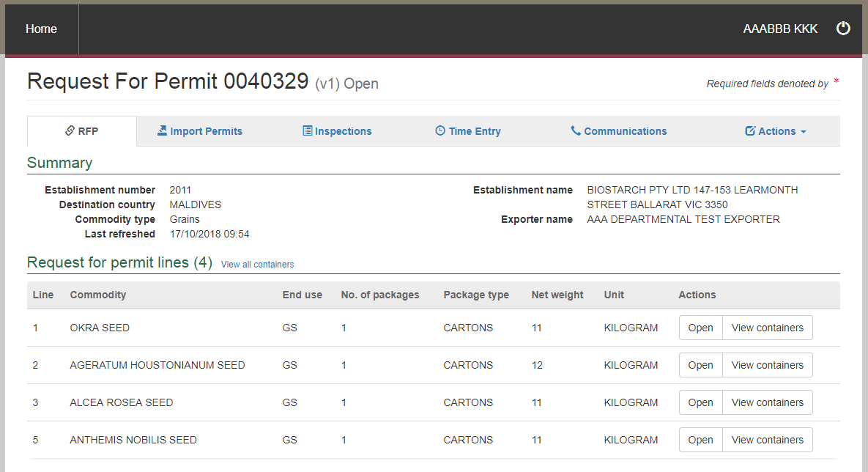

**2**

**1**

The *Containers* pop-up window (below) will list all the containers from the Grain and Plant Product inspection record and the RFP, irrespective of their approval being recorded in PEMS. It will display the inspection Level (Consumable or Non-consumable), Result (Pass or Fail), Expiry date and whether the container has been Used for exporting the goods. You can click **Show1** to view the details of any errors for containers highlighted in Red.

Click **Close2.**

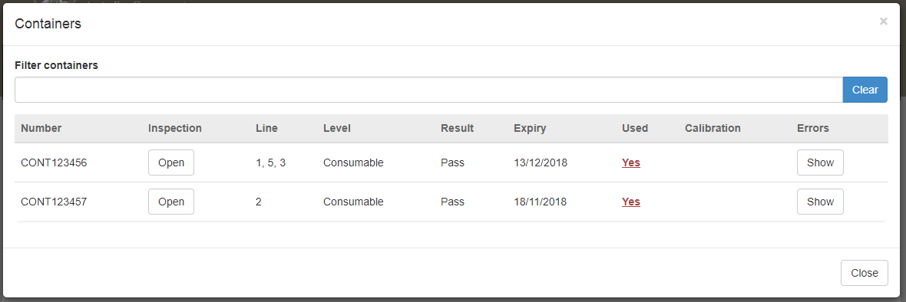

**1**

**2**

* PEMS will fetch the latest inspection result for each container. If a container inspection has not been recorded in PEMS, the container will be displayed in red with the message ’The container has no inspection’.
* The expiry date will only be populated for those containers where the result is ‘Pass’ and the inspection status is ‘Completed’.
* If any of the values in the pop-up window do not satisfy the container approval requirements, those values will be highlighted in RED and appropriate messages can be seen by clicking the ‘Show’ button.

### 3.6 Inspections

Each RFP extracted from EXDOC can have one or more **Related inspections1** listed under the Inspections tab. However, there can only be one active inspection record listed under an open RFP at any time. Each time the RFP is reloaded from EXDOC, the new inspection record will correspond with a new RFP version number.

You can **Open2** any inspection record related to the RFP from this page.

**1**

**2**

### 3.7 Related calibration records

Each RFP extracted from EXDOC can have one or more **Related calibration records1** listed under the Calibration tab.

You can **Open2** any calibration record related to the RFP from this page. However, there can only be one active calibration record against the container number at any time.

**1**

**2**

The *Generic Calibration* page displays and show the following sections:

* **RFP details1 –** populated based on the RFP information extracted from EXDOC.
* **Calibration details2 –** allows you to view the container clock has been set to GMT, the recorder serial number, calibration date, container details and AO who calibrated the container.
* **Loading details3 –** allows you to view the pulp temperatures and seal details.
* **Readings4** **–** allows you to view the sensor readings and sealed date and time.
* **Pre-cooling temperatures5 –** allows you to view the pre-cooling temperatures that were recorded.
* **Comments6** **–** if applicable, allows you to view comments regarding the calibration.

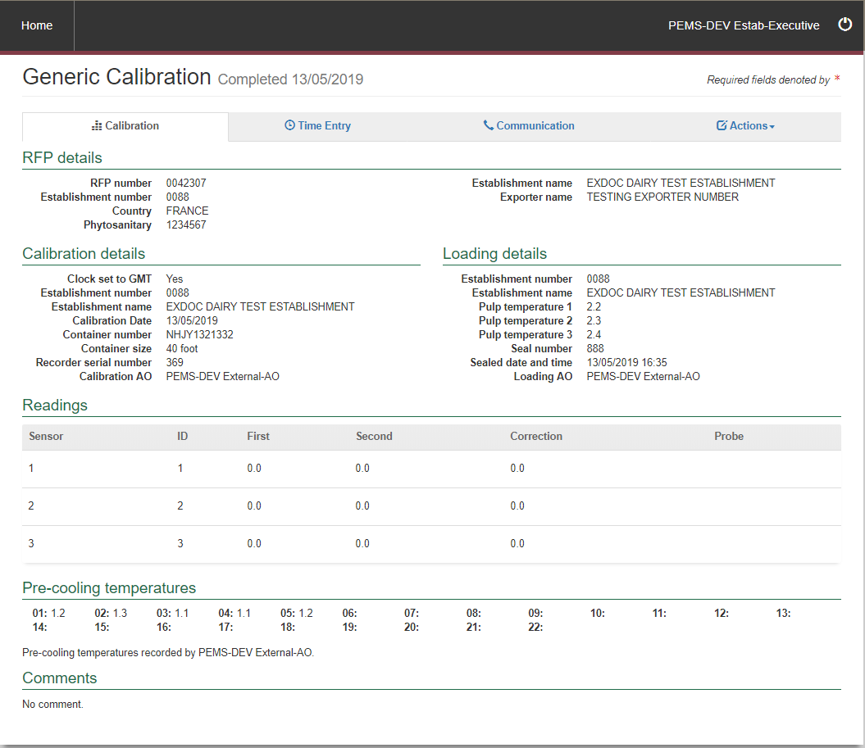

**4**

**1**

**6**

**5**

**2**

**3**

### 3.8 Time Entry

The RFP **Time Entry1** page will display a combined list of each **Time entry2** from all inspection records relating to the RFP. Click **Open3** on the time entry you want to view.

**2**

**3**

**1**

The *Time Entry* window will display.

You can view the applicable **User1, Activity2, Activity date3, Activity time4** and **Comments5.**

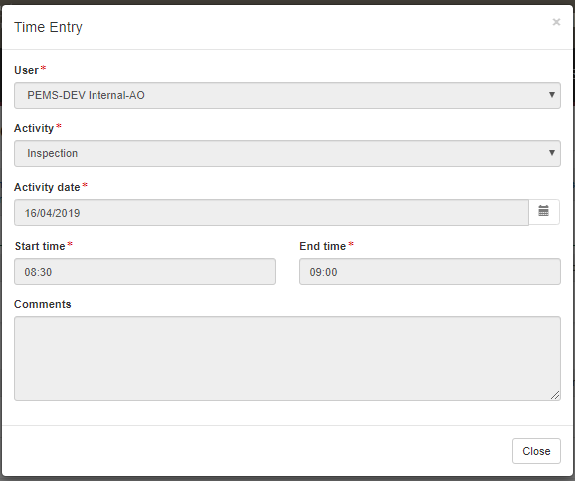

5

**1**

3

2

4

PEMS will update the RFP **Time summary1** as more time entries are included on the RFP record. It will aggregate time entries from inspections and RFPs, and automatically calculate overtime to support invoicing activities for departmental AOs.

**1**

### 3.9 Downloading the RFP activity report (Establishment executive only)

Once time entries have been added to the RFP record, or related inspection records, you can download an RFP activity report (PDF or RTF format) that captures the time recorded for all activities undertaken in relation to the RFP. PEMS allows you to download two types of activity reports—a summary report or a detailed report.

#### Summary report

The summary report is an extract of the RFP record’s time summary section and will display the time recorded against each activity for all AOs assigned to the RFP record. To download a summary report, click the RFP **Time Entry1** tab and then click **Summary report2** under the RFP Time summary section.

**2**

**1**

A *Summary Report* window will display.

Select either PDF or RTF for the **Report format1** and click **Download2**.

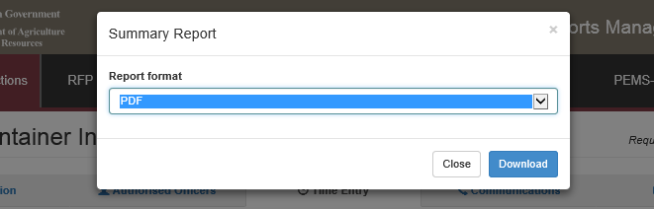

**2**

**1**

The *Activity Report* window will download onto your device. You can save or print the report for your records.

#### Detailed report (Establishment executive only)

The detailed report function allows you to select report parameters to be displayed on the report for specific activities performed in relation to the RFP. To download a detailed report, click the RFP Time **Entry1** tab and then click Detailed **report2** under the RFP Time summary section.

**2**

**1**

The *Activity Report* window will display.

You can choose to enter specific report parameters as necessary by:

* selecting a **Start date and End date1**
* selecting an **Activity2** type
* selecting a **User3**
* entering an **Invoice number4**
* selecting one or more Show these columns on the **report5** checkboxes.

Alternatively, you can leave the report parameters blank. Select a **Report format6** (either PDF or RTF).   
Once all relevant parameters are entered, click **Download7.**

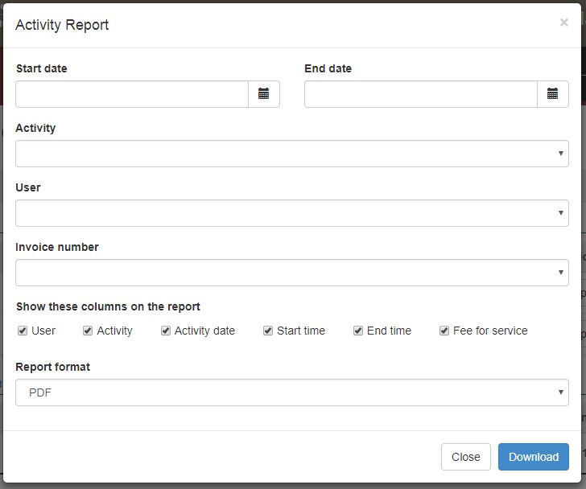

**7**

**6**

**5**

**4**

**3**

**2**

**1**

An Activity Report will be downloaded onto your device.

You can save or print the detailed activity report for your records.

### 3.10 View import permits

Where an importing country requires an exporter to have an import permit, this will be reflected in EXDOC. Import permit numbers, which are provided by the exporter in EXDOC, will be transferred automatically into PEMS.

Import permit numbers will be listed under the Import Permits tab, where you can view the details of the import permit. The import permit number can also be viewed on the Inspections page of PEMS.

Select the **Import Permits1** tab and click **Open2** to view detailed comments beside the relevant import permit listed.

**2**

**1**

### 3.11 Communications

The RFP Communications page will display a combined list of all attached files relating to the RFP. This includes all files attached under the related inspection and calibration records.

* Where a new version of an RFP is created, all files attached against the previous version of the RFP will be retained in the new version of the RFP.

#### Attachments

To view the outcome and comments relating to an attachment select **Communications1** and click **Open2.**

Click **Download3** to view the attached document.

**3**

**2**

**1**

#### Correspondence

To view the comments relating to the correspondence select **Communications1** and click **Open2** under the correspondence section.

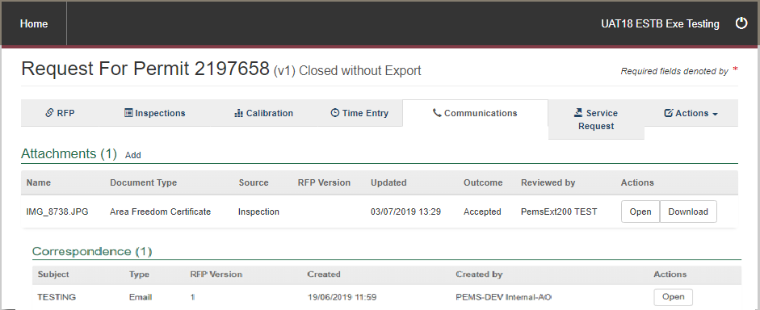

**2**

**1**

#### Attaching documents

The RFP **Communications1** tab will display a list of all attached files relating to the RFP. This includes all files attached under the related inspection records.

You can attach files to the RFP by clicking **Add2** under the attachments section.

**2**

**1**

The *Attachment* window will display.

Click **Choose File1** and a file browser will display to allow you to search and select the relevant file from your device. You can attach Microsoft Word, PDF and image files to the RFP. Emails will need to be saved as a PDF before attaching to the RFP. The maximum file size permitted for each file is 9MB.

Once selected, the file will appear in the **File input2** field.

Select the **Document type3** based on the check boxes provided. Where you have scanned more than one document into a single PDF, you are able to tick as many check boxes as applicable.

* Exporters and EDI users can select the document type as “Sensitive”. When marked as Sensitive the document is only viewable to Exporters and EDI and the National Documentation Hub (NDH).

From the dropdown box, select the **Outcome4** noting that the default is set as ‘Accepted’.

If Other is selected as a Document type, then the **Other document5** line will appear. You will need to enter a description identifying the document.

You can provide additional **Comments6**regarding the attachments if required. Comments are mandatory if the ‘Other’ tick box is selected.

Click **Save7.**

**7**

**6**

**5**

**4**

**3**

**2**

**1**

The *RFP Communications* page will display the newly **attached file1.**

You then have the option to click

* **Open2** to change the outcome, document type or add/amend comments
* **Download3** to download and view the attached file, or
* **Remove4** to delete the document from the RFP record.

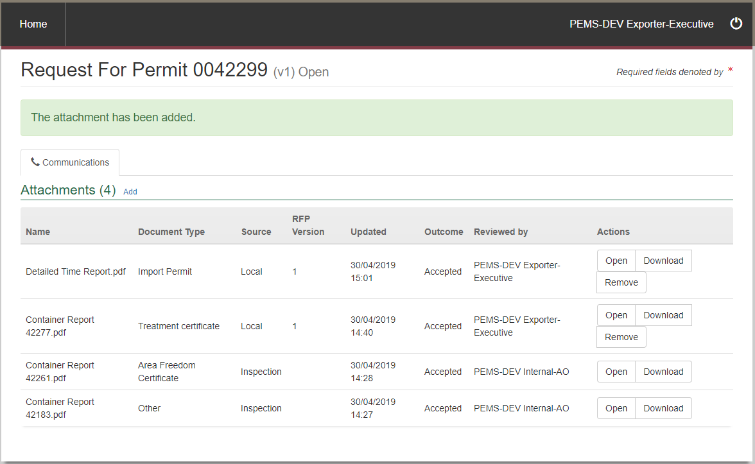

**4**

**3**

**2**

**1**

* Documents attached by other users cannot be removed.

You will also not be able to open the record and change the outcome.

If required, you will be able to download the document.

**Attaching manual documents in PEMS**

When an exception applies an AO may need to create a manual record for an inspection or calibration. PEMS will allow you, or the AO, to upload these documents once the RFP extract is created. Listed below are the exceptions that apply.

You may attach a **Manual Inspection Record1**, a **Manual Vapour Heat Treatment Record2**, **Manual EX188 Form3**, or **Manual ITCT Calibration Record4**.

By attaching all the required information in PEMS you will be able to submit a Service Request through PEMS for authorisation (see 3.12 Service Request).

The use of PEMS is mandatory unless an exception applies. The exceptions are limited to situations where:

* exceptional circumstances arise that affect a PEMS user’s ability to complete and submit a record through PEMS
* a system outage, either planned or unplanned, renders PEMS unusable for a period of time
* the type of record the AO must complete is not available in PEMS
* we have approved, in writing, an individual exception with the client and/or AO that allows records to be made in an approved way other than PEMS, and evidence of this is held by us.
* If you add a manual record and an exception does not apply, then your authorisation request will be refused.

### 3.12 Service Request

The Service Request tab provides an alternative Communications Workflow for clients to communicate with the department in relation to plant exports. It can be used to request authorisation for Requests For Permit (RFPs), and the issuance of in-transit cold treatment (ITCT) calibration certificates and declaration and certificate as to condition (EX188).

You can use the Service Request for inspections and calibrations recorded in PEMS, or if there is a Manual inspection or calibration record attached to the relevant RFP.

#### Request to Authorise RFP

* PEMS will validate that there is at least one Completed inspection for the RFP or a Manual Inspection Record in the Communications tab for the **Request to authorise RFP1** to appear.
* If any information is missing a warning will appear above the tabs, stating what is required.

**1**

The *RFP Authorisation* window displays.

Read and confirm both **declarations1** by ticking the boxes.

If required, a copy of the request can be sent via email by entering an email address in the **CC field2**. You can add multiple email addresses in this field, each separated by a comma.

Enter in any **Comments3** that are to be included in the email.

Click **Save4**.

* If your Service Request will contain any attachments that are Manual records, then please indicate this in the Comments section and confirm that an exception applies, if you fail to do this then your authorisation may be delayed.
* Exporters and EDI users will only see one declaration.
* When you click save an email will automatically be sent to Plant Exports National Documentation Hub.

**4**

**3**

**2**

**1**

The RFP Authorisation status will now change to **Requested1**.

Depending on the inspection type, you will be able to request an issuance of certificates by selecting **Issuance of EX188 Certificate2** and/or **Issuance of ITCT Calibration Certificate3**.

**3**

**2**

**1**

* The ability to request these certificates will not be available prior to the Request to authorise RFP has been submitted.

#### Service Request – Re-submission process for all request types

If it is determined that you Service Request cannot be authorised than you will receive notification via PEMS, and by DoNotReply email that more information is required.

The Service Request status will change to **Awaiting info1**. Click **Open2** to view the details of the email.

**2**

**1**

The below window will appear with the details of what needs to be resubmitted under **Email Comment1**.

**1**

Provide all additional information and/or attachments and then click **Re-submit1**. Add any additional information to the Comments box.

**1**

The original request status changes to **Cancelled1**, and a new **request2** will appear at the top of the list.

**2**

**1**

This process will repeat for each resubmission until authorisation is granted.

#### Issuance of EX188 Certificates

PEMS will validate that a Manual EX188 Certificate template is attached in the Communications tab to procced.

Select **Issuance of EX188 Certificate1**.

**1**

The issuance of Ex188 Certificate screen displays.

If required, a copy of the request can be sent via email by entering an email address in the **CC field1**. You can add multiple email addresses in this field, each separated by a comma.

Enter in any **Comments2** that are to be included in the email.

Click **Save3**.

* Once you click save an email will automatically be sent to Plant Exports National Documentation Hub.

**2**

**1**

**3**

The Issuance of EX188 Certificate status will now change to **Requested1**.

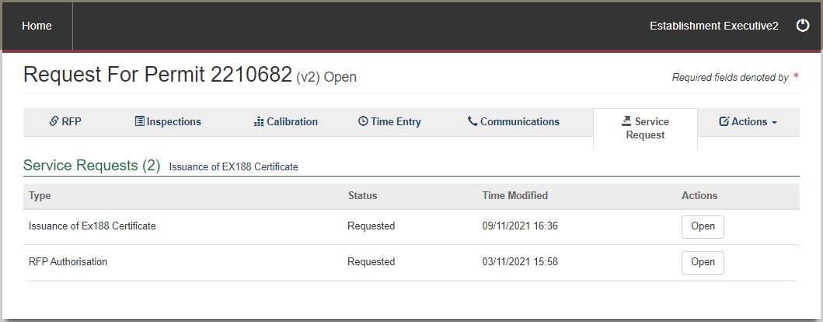

**1**

#### Issuance of ITCT Calibration Certificate

Select **Issuance of ITCT Calibration Certificate1**.

**1**

The *Issuance of ITCT Calibration Certificate* screen will display.

Some calibrations may relate to several containers, tick the required **containers1**, there is no limit to the number of containers that can appear in the certificate.

Add the **Phytosanitary No2** and select **Add3**. You can add up to six phytosanitary numbers for each certificate by pressing the Add button after each entry.

If required, an email copy can be sent to anyone you wish to advise that the request has been sent by entering an email address in the **CC field4**, this can be multiple email addresses each separated by a comma.

Enter in any **Comments5** that are to be included in the email.

Click **Save6**.

* At least one container with at least one valid phytosanitary number must be provided.
* Once you click save an email will automatically be sent to Plant Exports National Documentation Hub. Do NOT add this address in the CC field.

**2**

**4**

**1**

**3**

**5**

**6**

The Issuance of ITCT Calibration Certificate status will now change to **Requested1**.

**1**

#### Withdraw RFP Authorisation Request

If a service request has been submitted and it is no longer required, the authorisation can be withdrawn. To withdraw a service request, click on **Withdraw1**.

**1**

The Withdrawal information window displays.

If required, a copy of the request can be sent via email by entering an email address in the **CC field1**. You can add multiple email addresses in this field, each separated by a comma.

Enter the reason/s for withdrawal in the **Withdraw Reason2**; this is a mandatory field.

Read and confirm the **declaration3** by ticking the box.

Click **Save4**.

**4**

**3**

**2**

**1**

* If you have completed a service request for the Issuance of an EX188 certificate and/or Issuance of an ITCT Calibration certificate and request to withdraw the RPF authorisation
* When you click save an email will automatically be sent to Plant Exports NDH.

The service request will now display a withdrawn status.

### 3.13 Actions – Container Report (Establishment executive only)

You can generate a container report based on:

* container numbers
* RFP line
* inspection level
* empty container inspection result
* expiry date for empty container inspection
* grain and plant product inspection result
* expiry date for grain and plant product inspection
* used flag.

The report can be selected from the RFP or all inspections associated with the RFP or both.

To select the container report, go to actions and click **Container Report1**.

**1**

The *Container Report* page will display. You can select either one or both **checkboxes1** and click **Download2.**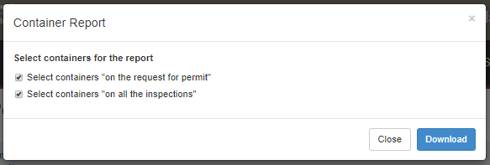

**2**

**1**

The Container Report will be downloaded in PDF format onto your device. You can save or print the report for your records.

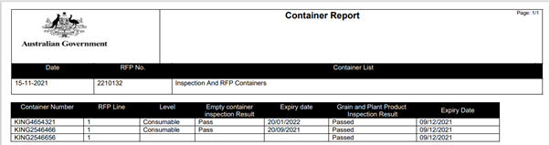

### 3.14 View comments on an RFP record

PEMS allows you to view general comments on all RFP records. The process for viewing general comments is the same for all commodity types. The following screen shots are taken from a Grain and Plant Product inspection record for demonstration purposes.

To view comments on the RFP record, select the **RFP1** tab and view **Comments2**.

2

**1**

## 4 Search Functions

As PEMS captures and records information relating to inspections and calibrations, it is important to be able to search for the record you are looking for.

This section guides you through the process for searching for the following information associated with your establishment:

* Inspection records
* Calibration records
* You will only be able to search for and view information that your permissions allow.

### 4.1 Inspection Search - Establishment Executive only

* This function is only for Establishment Executive user profiles

PEMS inspection search allows you to search for inspection records associated with your establishment.

#### Opening the inspection search page

Click on the **Search** **inspections1** button on the PEMS homepage.



**1**

The *Search Inspections* page will display.

#### Conducting a simple inspection search

Under the simple search mode, you can perform a search for the inspection record by entering the RFP number, container number or International Maritime Organisation (IMO) number, an establishment name or number, or AO name or number into the **search criteria field1** and **click Search2.**

Click **Reset3** to clear or reset the search criteria.

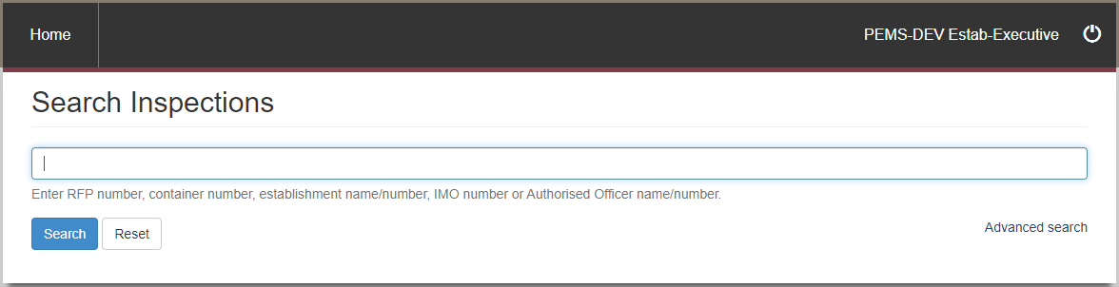

**3**

**2**

**1**

* If PEMS does not find records matching search criteria, it will display a message   
  ’No search results’.

Under the **Advanced search1** mode you can enter all search criteria in any combination to quickly locate a specific inspection record.

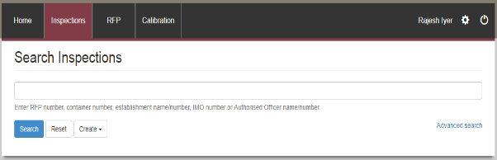

**1**

Enter data into the **search criteria fields1**, and then click **Search2**.

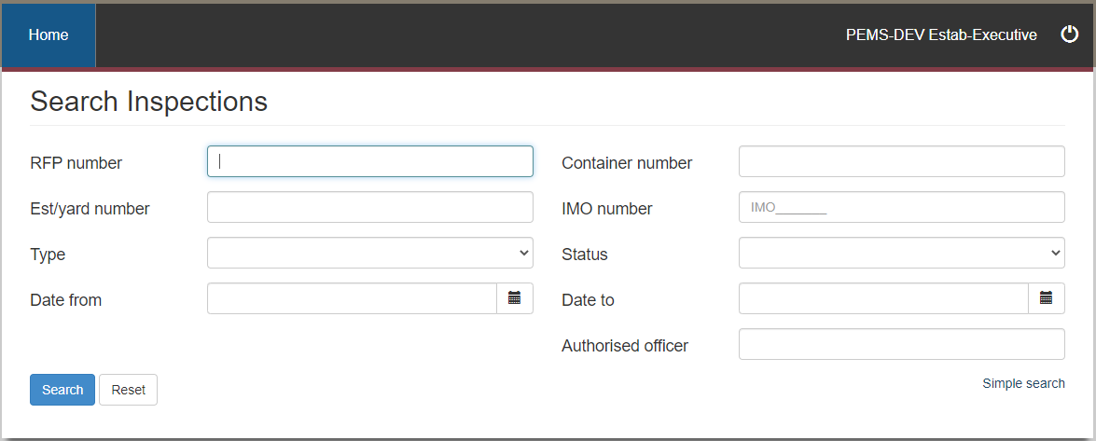

**1**

**1**

**2**

#### Selecting inspection records from search results

After a search has been entered, PEMS will display all **inspection records1** that match the supplied search criteria, in order of newest to oldest.

Click **Open2** beside the appropriate inspection record to view the record. If the search result displays one record, that record will be opened automatically.

Click **Reset3** to clear or reset the search criteria and the results.

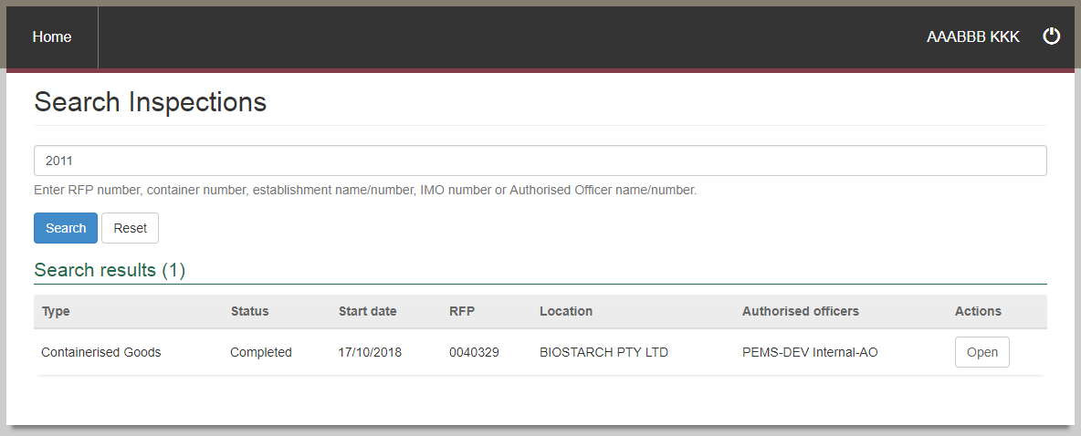

**2**

**1**

**3**

### 4.2 Calibration Search – Establishment Executive only

* This function is only for Establishment Executive user profiles.

PEMS Calibration search allows you to search for any calibration records associated with your establishment, where the inspection was recorded in PEMS.

#### Opening the Calibration search page

To initiate a calibration record search, click on the **Search Calibrations1** button on the PEMS homepage.



**1**

The *Search Calibrations* page will display.

You can perform a search for the calibration by entering the RFP number, an establishment number, or container number into the **search criteria field1**before clicking **Search2.**

Click **Reset3** to clear or reset the search criteria.

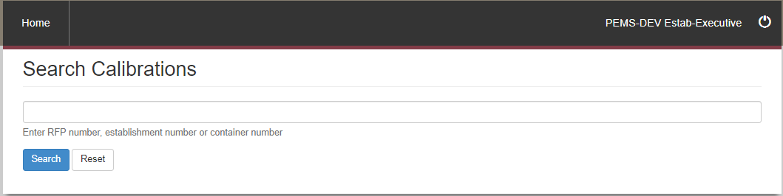

**3**

**2**

**1**

* If PEMS does not find records matching search criteria, it will display a message   
  ‘No search results’.

#### Selecting calibration records from search results

After a search has been performed, PEMS will display the **Calibration record1** that matches the supplied search criteria.

If the search result displays one record, that record will be opened automatically. Click **Open2** beside the appropriate RFP record to view the record.

Click **Reset3** to clear or reset the search criteria.

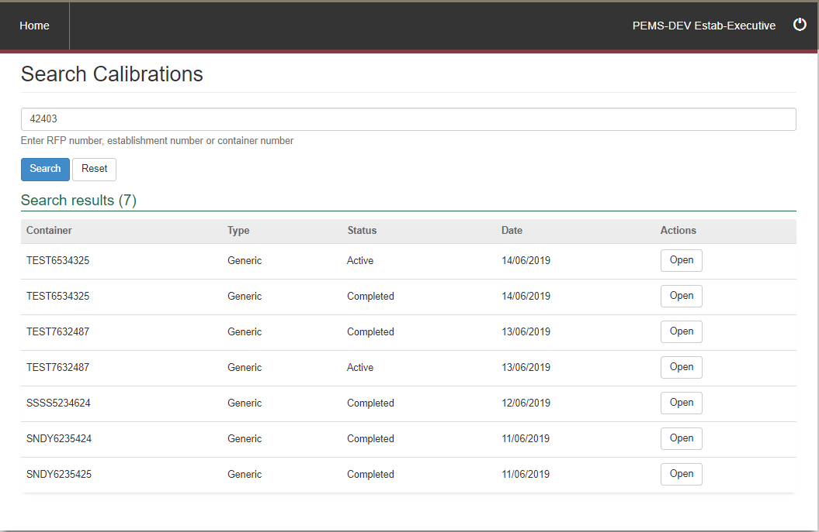

**1**

**3**

**2**

## 5 Viewing Inspection Records

This section guides you through the process for opening PEMS inspection records, associated with your establishment, in ‘Read only’ mode.

This section provides step-by-step instructions for:

* opening an inspection record
* opening an inspection record from the RFP tab
* opening a calibration record.

### 5.1 Opening an inspection record

To open an inspection record, first follow the instructions provided in Section 4.1 Inspection search to locate the record. From the search results, select the record you want to view, and click **Open1.**

**1**

Once the inspection has been opened it will display in ‘*Read only*’ mode:

* the **Inspection1** page for the record
* **Authorised Officers2** assigned to the inspection
* **Time Entry3** time summary
* attachments and correspondence for the RFP under **Communications4**
* **Actions5** to download a copy of the inspection record in PDF format.

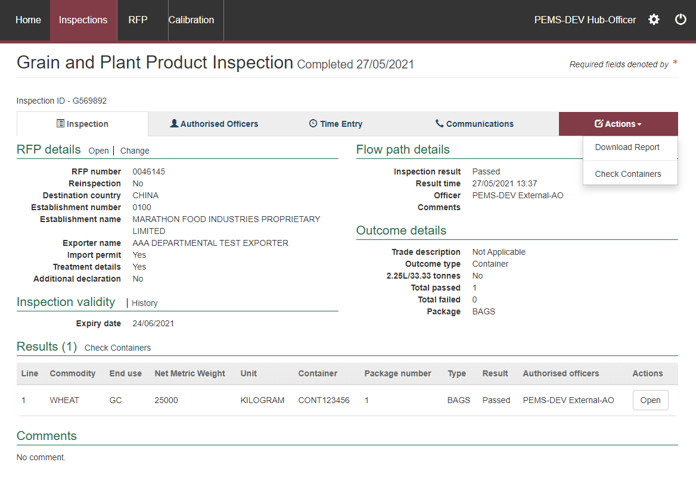

**5**

**4**

**3**

**2**

**1**

#### Download inspection report

You can download the inspection report before or after an inspection record is submitted in PEMS. The process for downloading an inspection report is the same for all inspection types.

To download the inspection report, click the **Actions1** tab and then select **Download report2.**

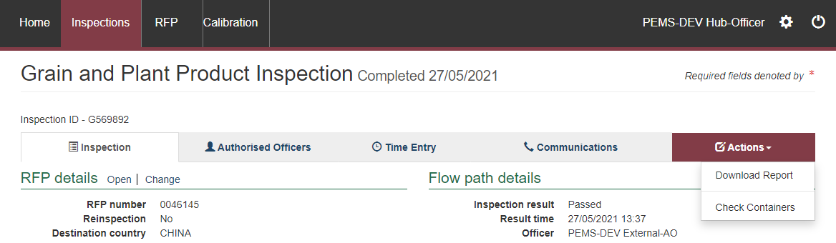

**2**

**1**

A PDF document will be downloaded onto your device (next two screen shots).

Once the document is opened, it will display the relevant inspection record.

For inspection reports downloaded after submission in PEMS, all inspection details will be included on the record. Where multiple AOs are assigned to an inspection, only the details of the **AO who submitted the** **record1** will display.

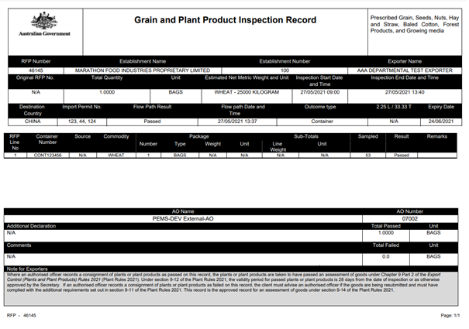

**1**

If the inspection report is downloaded before the record has been submitted in PEMS, the inspection report will be a summary of inspection information provided to date and will not display:

* an end time or date for the inspection
* any AO details
* any inspection approval information
* the note for exporters regarding the Export Control (Plant and Plant Products) Rules 2021.

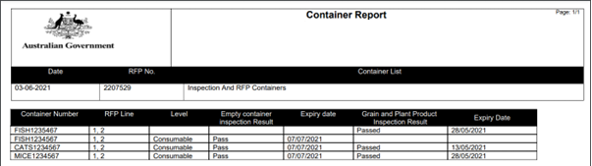

* Once the inspection reports are downloaded, they can be saved, emailed, or printed.

### 5.2 Opening an inspection record from the RFP tab

To open an RFP record, first follow the instructions provided in Section 3.1 RFP search to locate the record.

Once the RFP has been opened, select the **Inspections1** tab—this will list all the **related inspections2** for the RFP.

Select an inspection record, then click **Open4** to view details of the inspection.

* The latest inspection record must have an inspection status of **Completed3**,and the consignment must be export compliant before the RFP can be authorised in EXDOC and automatically closed with export in PEMS.

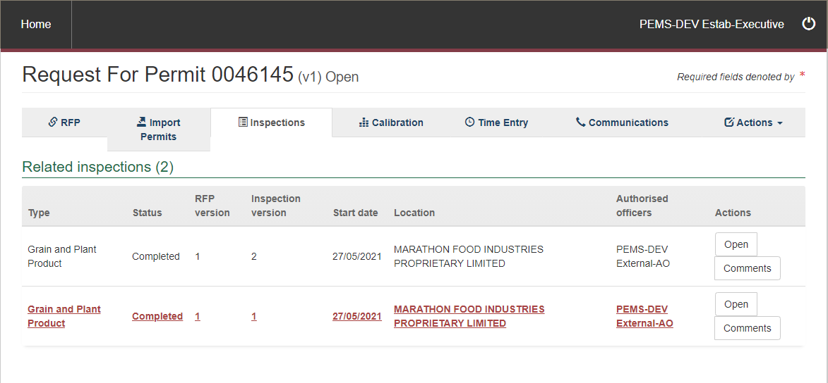

**4**

**2**

**3**

**1**

### 5.3 Opening a calibration record

To open a calibration record, first follow the instructions provided in Section 4.2 Calibration search to locate the record. From the search results, select the record you want to view, and click **Open1.**

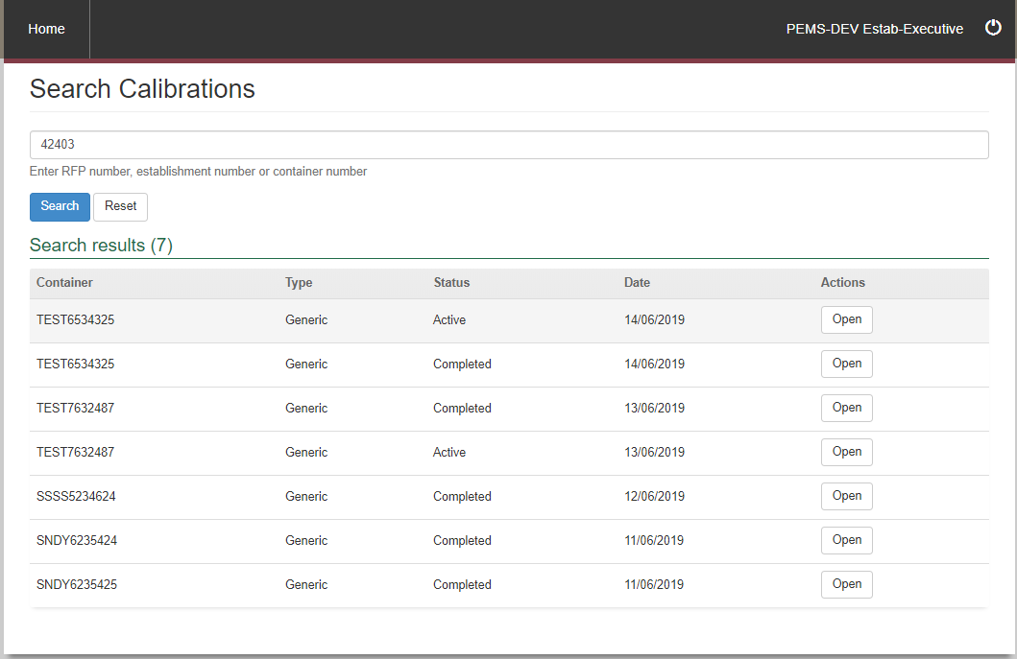

**1**

Once the calibration has been opened it will display in ‘*Read only*’ mode:

**Note:**

* the **Calibration1** page for the record
* **Time Entry2** time summary
* attachments and correspondence for the RFP under **Communications3**
* **Actions4** to download a copy of the certificate in PDF format.

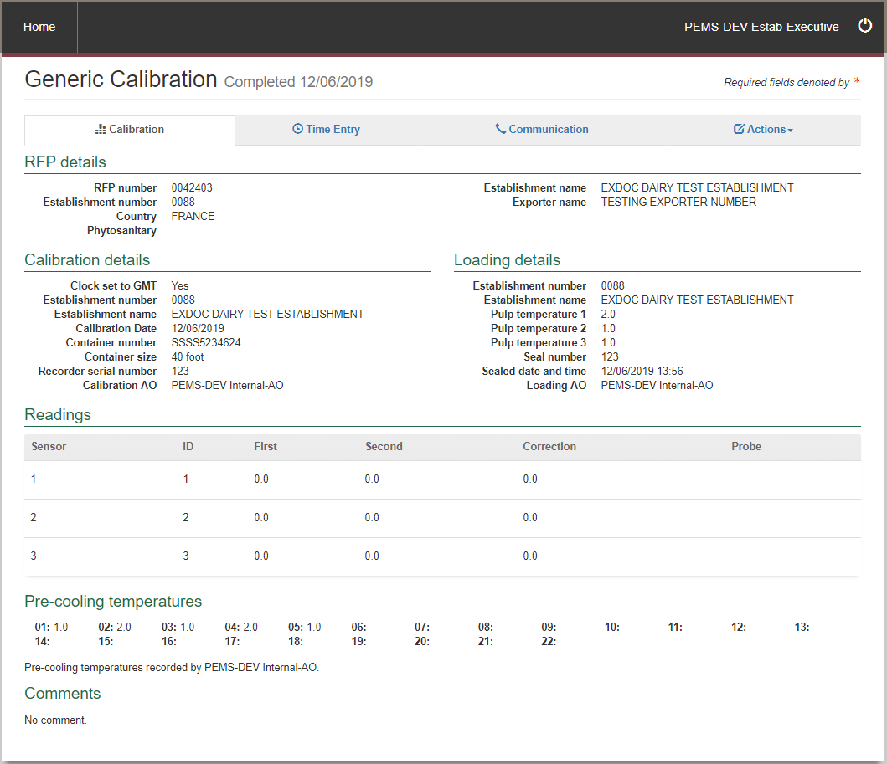

**1**

**4**

**3**

**2**

#### Add/Remove RFP to Onshore Cold Treatment (OSCT) record (Establishment Executive only)

Establishment Executives have the option to add or remove an RFP from a OSCT record by selecting **Add1**.

**1**

The Add RFP details window will appear.

Enter the **RFP number1** in and select **Add2**. To remove an RFP, select **Remove3**.

To keep the changes made click **Save4**.

**4**

**3**

**2**

**1**

The RFP details will be updated.

#### Download calibration certificate

Before or after a calibration is submitted, you can download the certificate.

To download the Calibration Certificate, click the **Actions1** tab and then select **Download certificate2.**

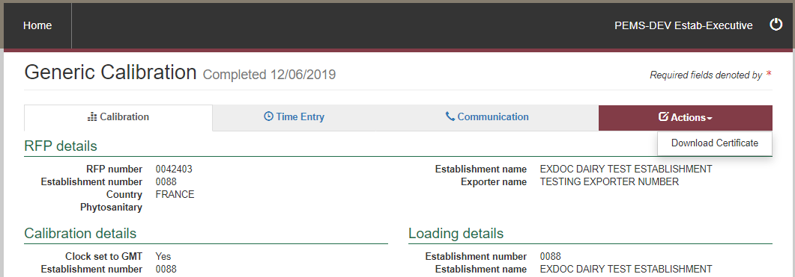

**2**

**1**

If the calibration certificate is downloaded before it is issued it will be a summary of inspection information provided to date and will not display:

* the department’s logo and name
* any AO details
* any inspection approval information.

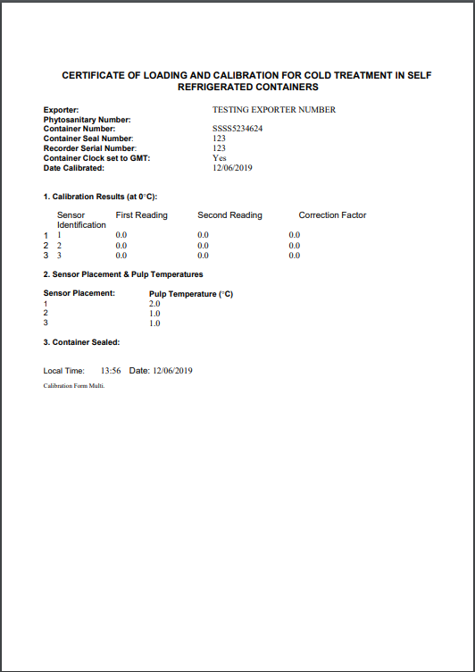

Once the calibration certificate has been approved by the Assessment and Client Contact Group and an email has been sent to the person who requested it to be issued, the certificate will be downloadable with all the required information including an electronic signature and stamp. These certificates will no longer include an ‘original’ or ‘copy’ stamp, excluding for China.

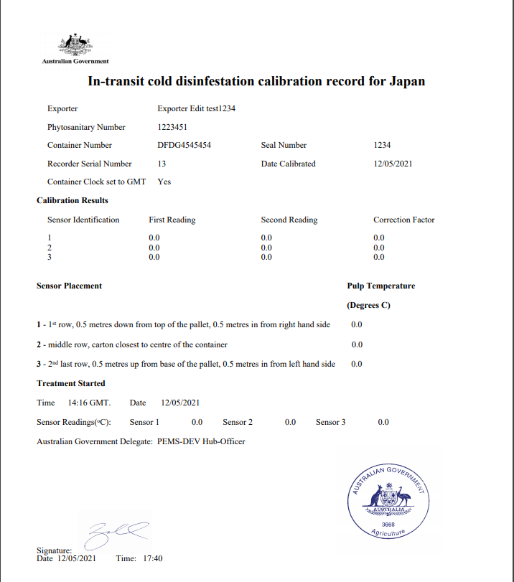

#### China Calibration Certificates

Calibration certificates issued by PEMS for China will continue to include ‘original’ or ‘copy’ stamp. The completed certificate will not be downloadable, however it will be saved and accessed via the communications tab. For more information on how to view this certificate see section 3.11 Communications.

**When more than one Calibration Certificate is required per RFP or where multiple Calibration Certificates are required for a single container**

On occasion, there may be a need to request more than one calibration certificate for a single RFP/container, as more than one phytosanitary number may exist for that request. In this situation the completed certificate will not be downloadable, however it will be saved and accessed via the communications tab. For more information on how to view this certificate see section 3.11 Communications.

## Document information

The following table contains administrative metadata.

| Instructional Material Library document ID | Instructional material owner |
| --- | --- |
| IMLS-9-7863 | Director, Change Management, Digital Clearance Service, Digital Trade Initiative |

## Version history

The following table details the published date and amendment details for this document.

| Version | Date | Amendment details |
| --- | --- | --- |
| 1.0 | 26/10/2018 | First publication of this document. |
| 2.0 | 22/05/2019 | Updated to include v3.1 and v3.2 enhancements. |
| 3.0 | 13/07/2019 | Update to include v3.3 enhancements. |
| 4.0 | 25/11/2020 | Merge Executive user guide with Exporter/EDI user guide as per enhancements from PEMS v3.8. |
| 5.0 | 28/05/2021 | Updated with changes to PEMS in May 2021 release. |
| 6.0 | 7/06/2021 | Further updates to PEMS in May 2021 release. |
| 7.0 | 22/11/2021 | Comms Workflow – Service Request functionality added. |
| 8.0 | 2/03/2022 | Updated to align with PEMS February 2022 release. |
| 9.0 | 7/04/2022 | Updated to align with PEMS April 2022 release. |
| 9.0 | 9/08/2022 | Updated department branding. |