

REFERENCE

# Plant Exports Management System (PEMS) Authorised officer user guide – Vapour Heat Treatment (VHT)

**In this document**

This document contains the following topics.

Purpose of this document 2

Setting up establishment sensors 2

VHT Sensor Calibration 6

Download VHT sensor calibration report 16

Supervision of VHT 18

Adding Country 20

Adding Sensors 21

Adding Accredited information 23

Recording the Loading details 25

Outcome details 27

Submitting the calibration 30

Download Supervision of VHT report 32

Horticulture Inspection Record and VHT in PEMS 34

Related material 39

Document information 40

Version history 40

## Purpose of this document

This reference outlines how to use PEMS to record vapour heat treatment (VHT) records.

**Note:** An overview of PEMS and general functions can be found in the Reference: *Plant Exports Management System (PEMS) Authorised Officer User Guide – Overview and general functions*.

## Setting up establishment sensors

Prior to completing a VHT sensor calibration in PEMS, the sensors that are being used by the establishment will need to be set up, if they have not already been entered into the system. This will only need to be done the first time, or if a sensor is changed in the future.

If the sensors have already been set up, you can progress straight to commencing the VHT Sensor Calibration.

To set up the establishment sensors, click the **Home1** PEMS menu tab and then click the **Settings2** icon.

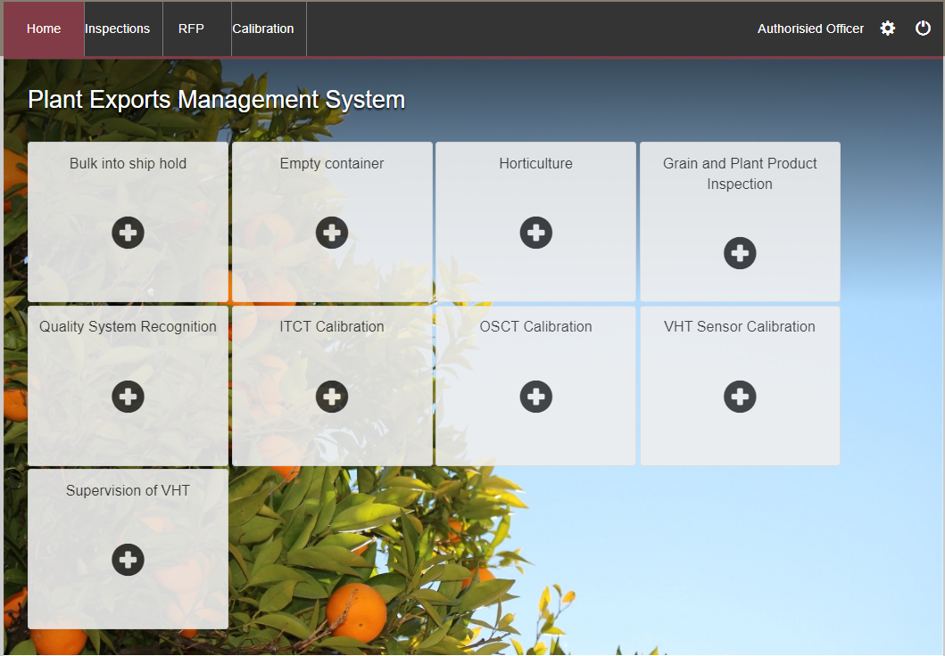

**2**

**1**

The *Administration* window will display.

Select **Establishment Sensors1**.

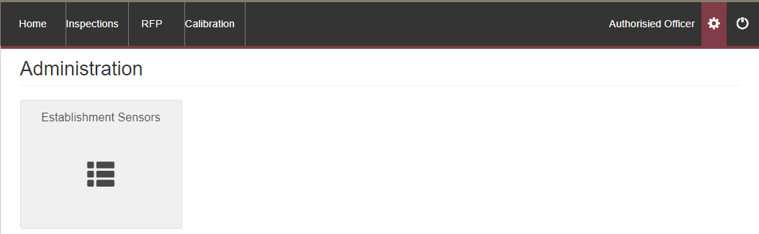

**1**

The *Search Establishments* window will display.

Enter the **Establishment number1**and click **Search2**.

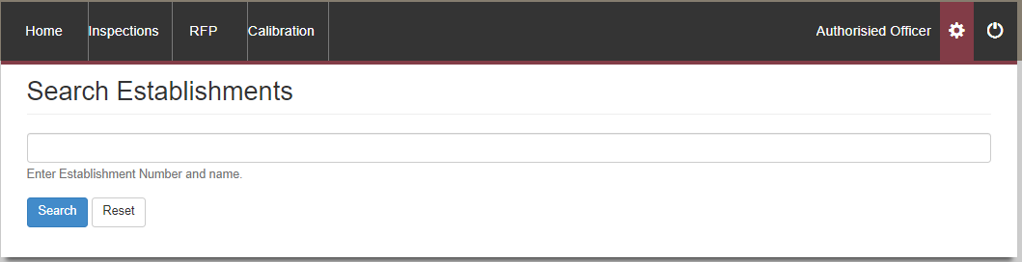

**2**

**1**

The *Vapour Heat Treatment Establishment* window will display.

To add a sensor, click **Add1**.

**!** If no sensors have previously been added for the establishment, the Establishment Sensors field will appear blank.

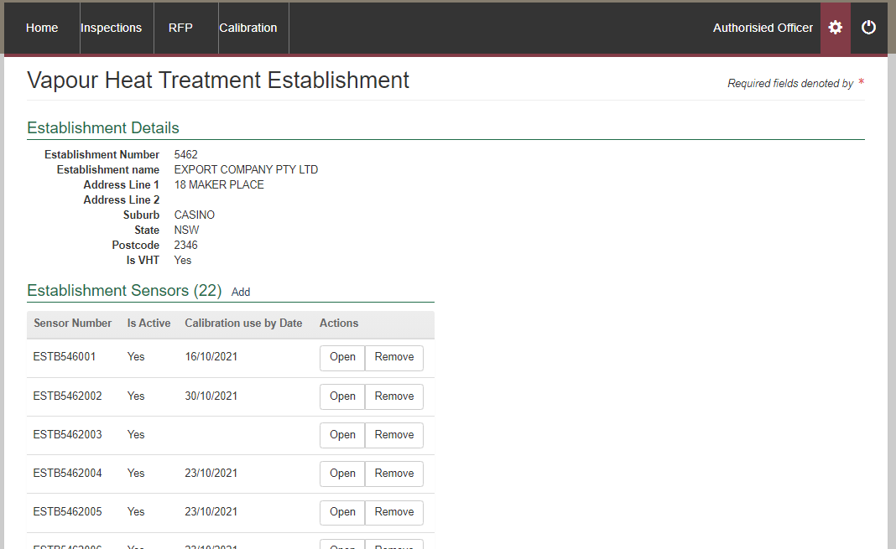

**1**

The *Sensor Details* window will display.

Enter the **Sensor Number1**, select **Yes2** for ‘Is Active’ and the select **Save3**.

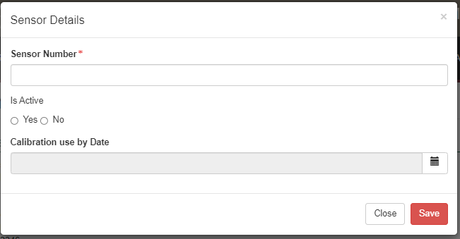

**!** No would only be selected when the sensor is no longer working.

**2**

**1**

**3**

The sensor will now appear in the Establishment Sensors list. Repeat this process to add each sensor.

Once all the sensors have been added you can proceed to the VHT Sensor Calibration step.

**!** The sensors that are added will not show a “Calibration used by date” until they have been calibrated and ready to use.

## VHT Sensor Calibration

To calibrate the VHT sensors, click the **Home1** PEMS menu tab and then click the **VHT Sensor Calibration2** tile.

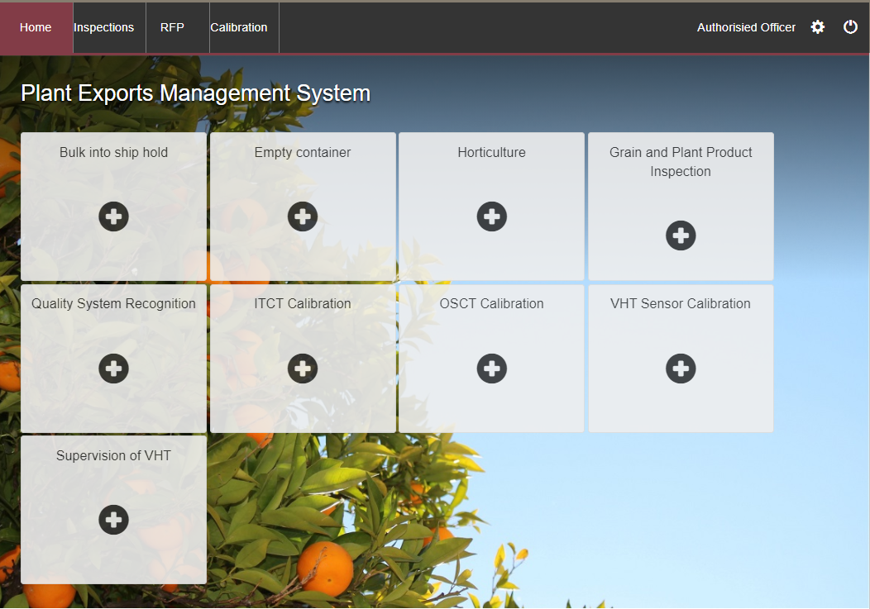

**2**

**1**

The *Vapour Heat Treatment Sensor Calibration* window will appear.

Tick the checkbox if the **Reference Thermometer is NATA Accredited certified within the last 3 years1**. Enter the **Accredited date2**.

Enter the **Establishment Number3** and click **Search4**. The **Establishment Name5** will appear.

Click **Create6**.

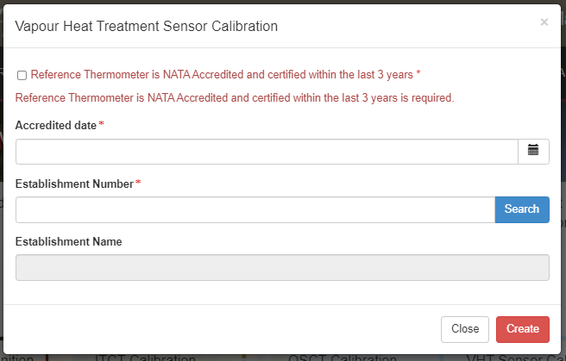

**!** If the Accredited date is not within the last 3 years, you will not be able to procced.

**1**

**6**

**5**

**3**

**4**

**2**

The *VHT Sensor Calibration* window will display.

Beside the Calibration Details, select **Change1**.

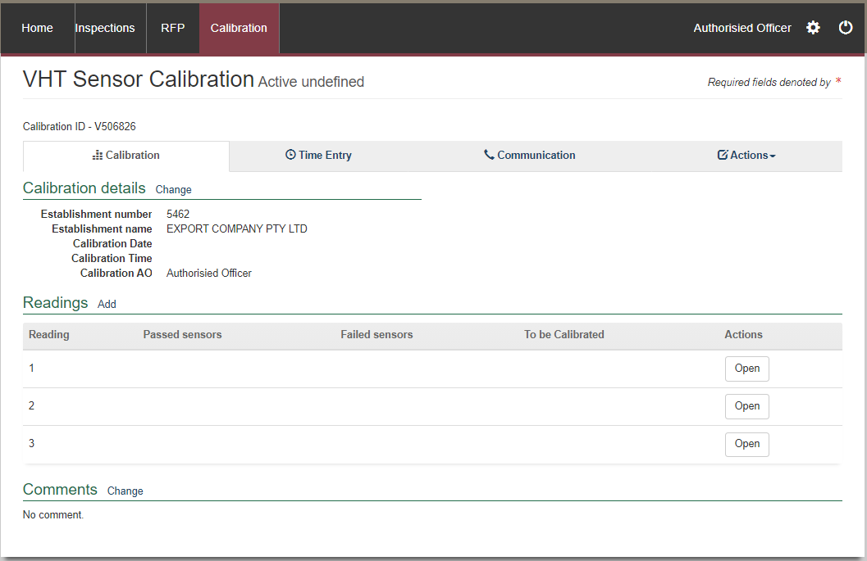

**1**

The *Calibration Details* window will display.

The **Calibration date1** will automatically populate with today’s date, if required change the calibration date, and enter the **Calibration Time2**, which is the time you commence the calibration process,then select **Save3**.

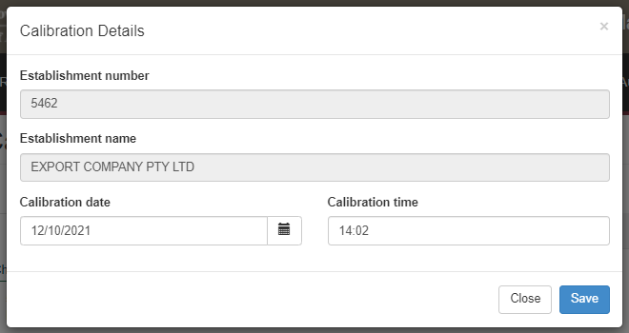

**3**

**2**

**1**

To add the sensors that are being calibrated, select **Add1**. 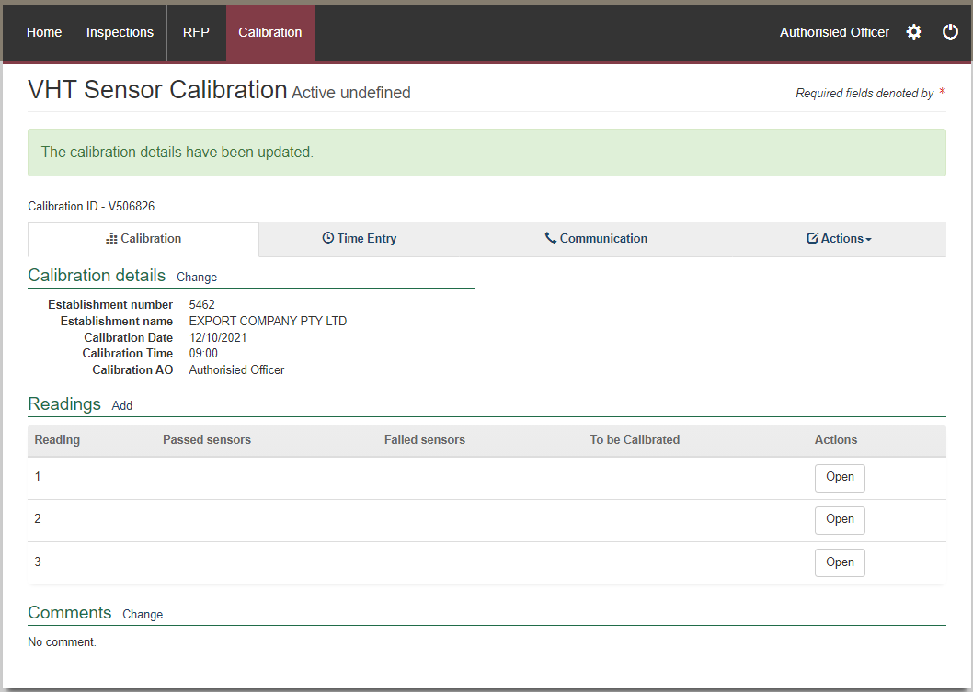

**1**

The *Add Sensor* window will display.

Start entering the **Sensor Number1** and the predictive text of listed sensor numbers will appear, click on the sensor and select **Add2**.

This step can be done mulitple times to add all sensors.

Once all sensors are added click **Save3**.

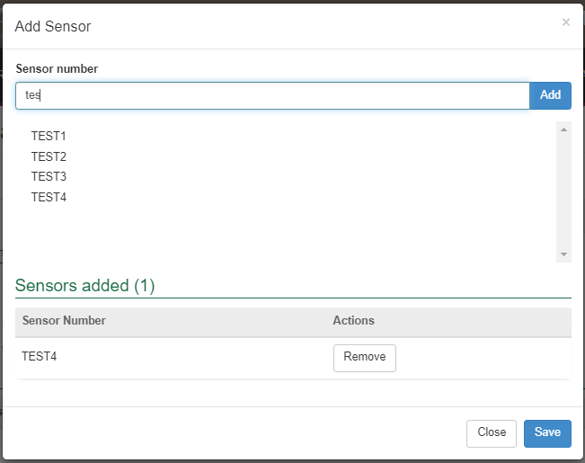

**3**

**2**

**1**

All sensors will appear in the **To be calibrated1** section.

To record a reading select **Open2**.

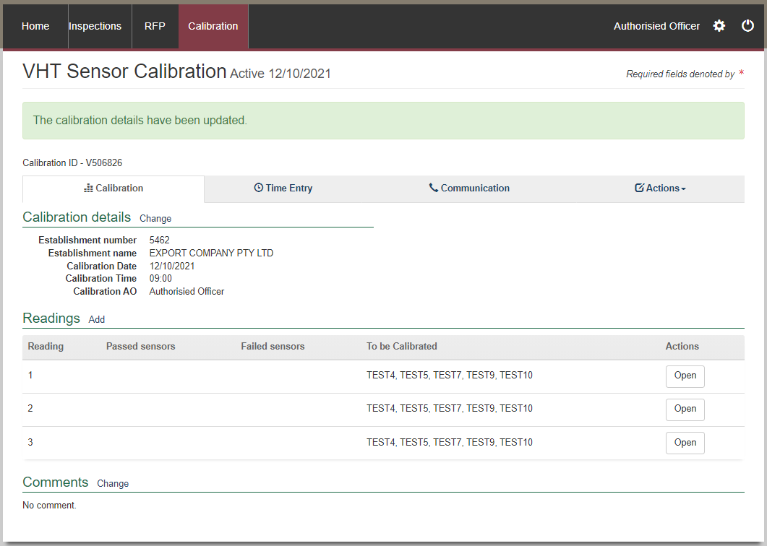

**2**

**1**

The *Reading 1* window will display. All added sensors will be displayed.

There is the option to **Pass all1** or **Fail all2** sensors. Or you can individually select the result for each sensor. Then click **Save3**.

Repeat this step for Reading 2 and 3 windows.

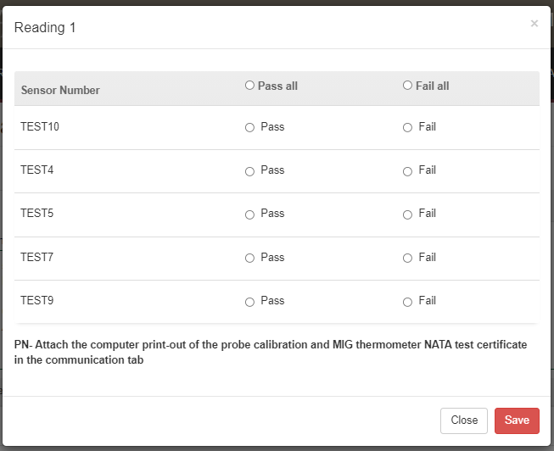

**1**

**3**

**2**

**!** The computer printout of the probe calibration and MIG thermometer NATA test certificate needs to be attached in the communication tab. Details on the Communications tabs can be found in **Section 3: General PEMS functions**, Reference: *PEMS AO user guide – Overview and General Functions*.

The calibration readings will be updated to be listed as **Passed sensors1** or **Failed sensors2.**

If any sensors are listed in the **Failed Sensors column2** they cannot be used.

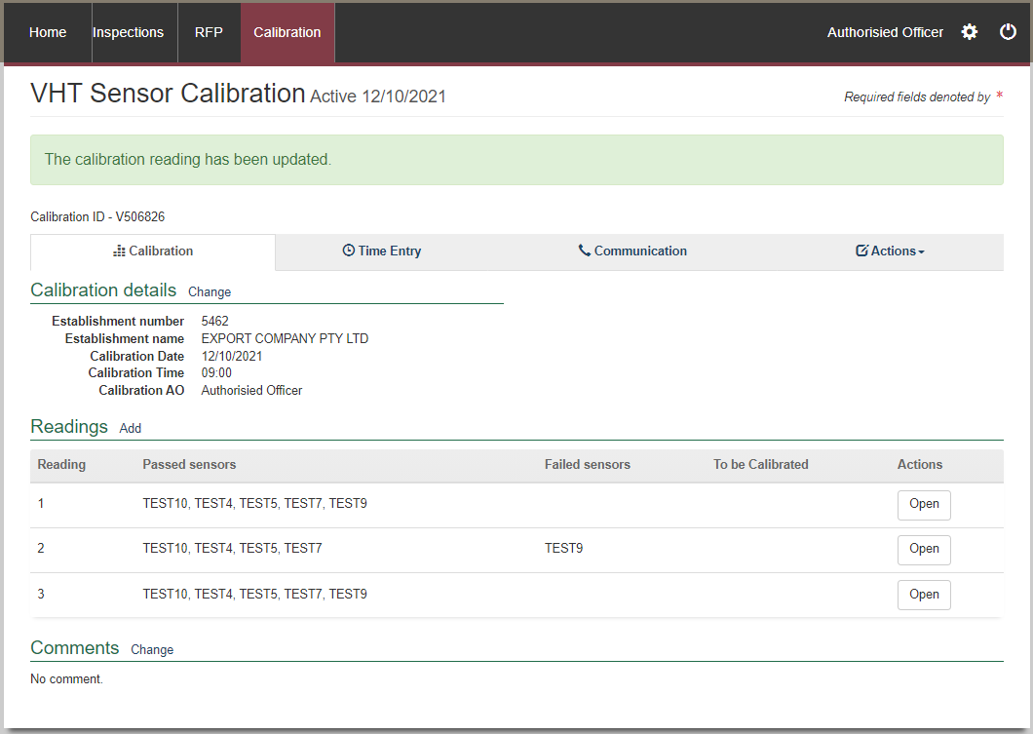

**2**

**1**

The calibration can only be submitted in PEMS after:

* all results and data are recorded appropriately
* a **Time Entry1** is provided for all AOs who recorded the sensor calibration results
* if applicable, attachments and correspondence relating to the sensor calibration are recorded under the **Communications2** tab.

Details on the Time Entry and Communications tabs can be found in **Section 3: General PEMS functions**, Reference: *PEMS AO user guide – Overview and General Functions*.

When you are ready to submit, click the **Actions3**tab and then click **Submit4**.

For more information on **Cancelling** or **Withdrawing5**, see **Section 3.6: Actions tab**, Reference: *PEMS AO user guide – Overview and General Functions*..

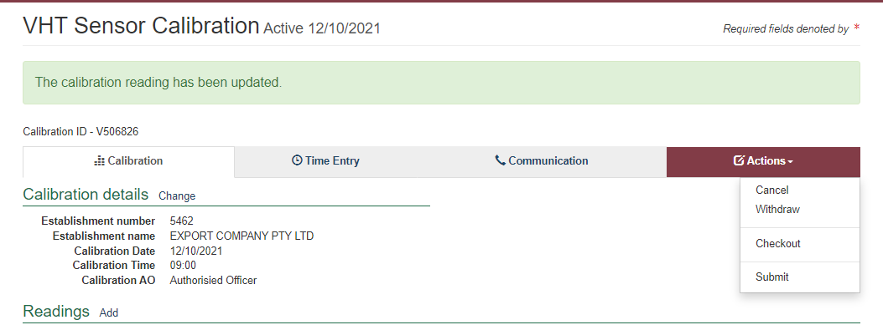

**5**

**4**

**3**

**2**

**1**

A pop-up window will ask if you want to **email the exporter/EDI user on the submission of the inspection1**. When selecting this option, the email address box will expand.

Enter the **email address2**, this can be multiple email addresses each separated by a comma.

Enter in any **Comments3** that are to be included in the email.

Click **Approve4**.

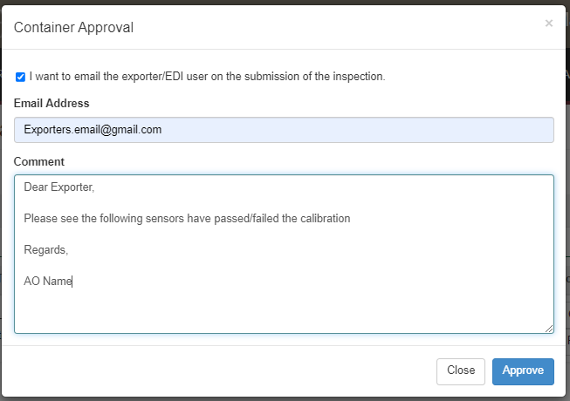

**4**

**3**

**2**

**1**

A pop-up window will ask you to confirm that you want to **submit this calibration1**.

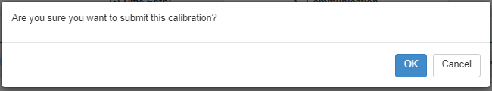

**1**

The VHT Sensor Calibration record status will display as **Completed1**.

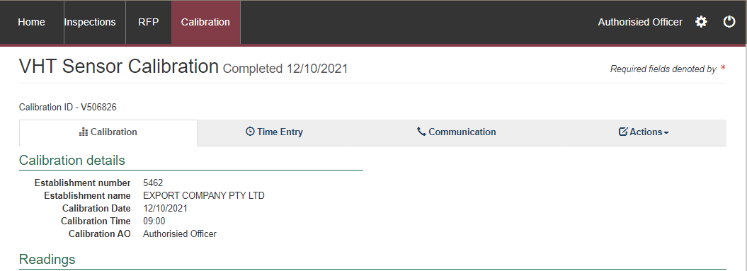

**1**

You can then commence the VHT treatment and supervision.

#### Download VHT sensor calibration report

You can download the VHT sensor calibration record report after the calibration record is submitted in PEMS.

To download the calibration report, click the **Actions1** tab and then select **Download Report2**.

**2**

**1**

A PDF document will be downloaded onto your device.

Once the document is opened, it will display the relevant VHT sensor calibration record.

## Supervision of VHT

Click the **Home1** PEMS menu tab and then click the **Supervision of VHT2** tile.



**2**

**1**

The *Vapour Heat Treatment Calibration* window appears.

Enter the **Batch number1**, select the appropriate **Treatment Schedule2** from the list in the dropdown.

**!** When the Treatment Schedule of 46 degrees Celsius is selected it will automatically populate with China as the Country. Currently China is the only country that uses this schedule.

If applicable, enter the **Country3**. Enter the **Establishment Number4** and click **Search5**.

Start entering the **Sensor Number6** and the predictive text of listed sensor numbers will appear, click on the sensor and select **Add7**. This step can be done mulitple times to add all sensors.

Once all information and sensors are entered select **Create8**.

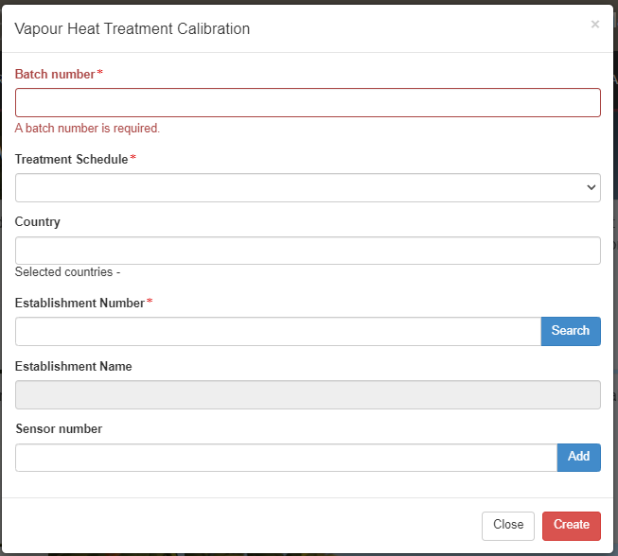

**1**

**3**

**8**

**7**

**6**

**5**

**4**

**2**

The *Supervision of VHT* window will display.

Add additional countries to the supervision by selecting **Add1**.

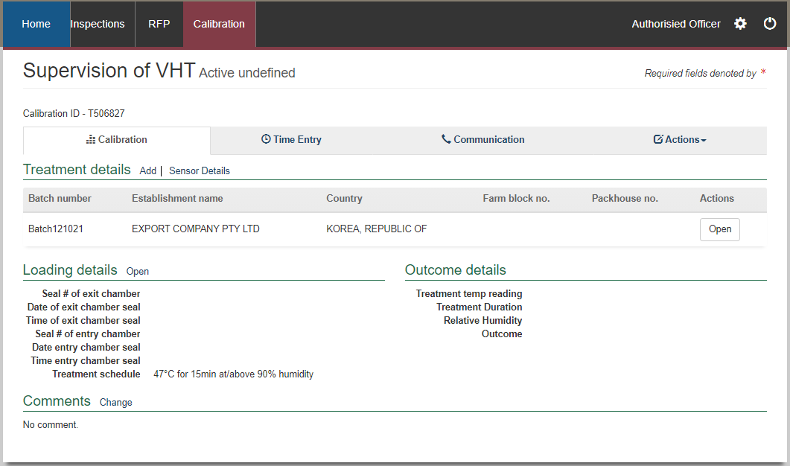

**1**

#### Adding Country

The *Add Treatment* window will display.

From the **Country1** dropdown select the relevant country and select **Save2**.

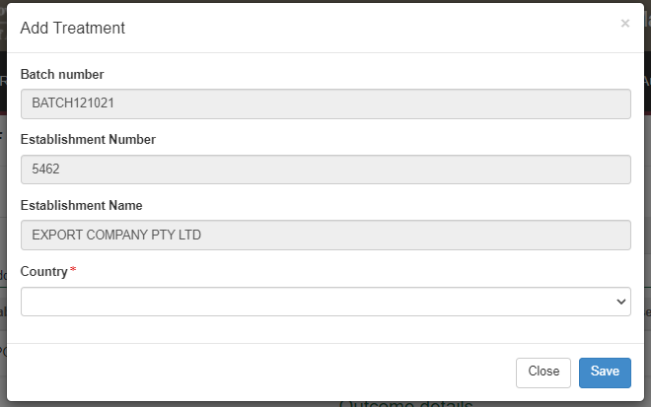

**2**

**1**

#### Adding Sensors

To add or remove sensors select **Sensor Details1**.

**1**

The *Add Sensor* window will display. To add sensors, enter the **Sensor Number1** and click **Add2**.

To remove the sensors, click **Remove3**.

Once completed, select **Save4**.

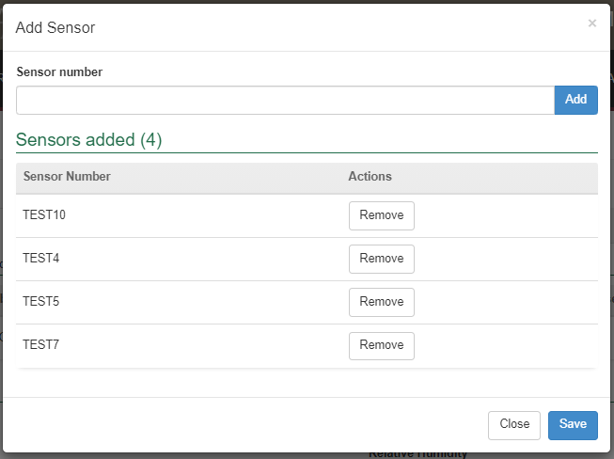

**4**

**3**

**2**

**1**

#### Adding Accredited information

In the Treatment Details, to add accredited property information, select **Open1**.



**1**

The *Add Treatment* window will display.

Enter the **Accredited Farm Block Number1** and click **Add2**. This will validate the Farm Block Number. For each new number, multiple block numbers can be added by clicking the **Add** button.

Enter the **Accredited Packhouse Number3** and click **Add4**. This will validate the packhouse number. For each new number, multiple packhouses can be added by clicking the **Add** button.

Click **Save5**.

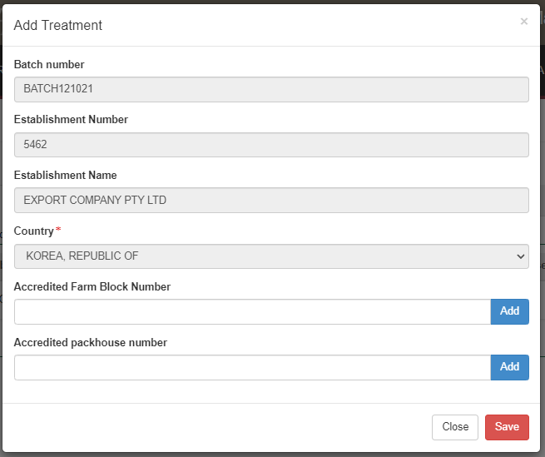

**!** PEMS will show an error if the nominated accredited property is not valid, and you will not be able to procced.

**5**

**4**

**3**

**2**

**1**

#### Recording the Loading details

To record the Loading details, click **Open1**.

**1**

The *Loading Details* window will display.

Enter the **Seal No. for the exit of the chamber1**, add the **Date on the exit chamber seal2** by selecting the date from the pop-up **calendar3** and then enter the **Time on the exit chamber seal4**.

Enter the **Seal No. for the entrance of the chamber5**, the **Date on the entrance chamber seal6** by selecting the date from the pop-up **calendar7** and then enter the **Time on the entrance chamber seal8**.

Tick the checkbox if **The sensors are placed as per the treatment facility document sensor placement plan9**.

Enter the **Number of bins in the chamber10**.

Enter the **Treatment Start date11** by selecting the date from the pop up **calendar12** and then enter the **Treatment Start Time13**.

Select **Save14**.

**14**

**13**

**12**

**11**

**10**

**4**

**2**

**5**

**3**

**9**

**8**

**7**

**6**

**1**

#### Outcome details

To record the Outcome details, click **Open1**.

**1**

The *Outcome Details* window will display (*image below*).

There are several checkboxes that need to be confirmed by ticking each of the **checkboxes1**.

Enter the **Treatment Temperature Reading2**, the **Treatment Duration3**, the **Relative Humidity4**.

Select the **Outcome5** from the dropdown box, either Passed or Failed.

Enter the **Treatment End Date6** by selecting the date from the pop up **calendar7** then enter the **Treatment End Time8**.

Then click **Save9**.

**!** The format for the Temperature and Humidity must be recorded to one decimal place, for example 91.0.

**9**

**6**

**8**

**5**

**4**

**3**

**2**

**7**

**1**

#### Submitting the calibration

The calibration can only be submitted in PEMS after:

* all results and data are recorded appropriately
* a **Time Entry1** is provided for all AOs who recorded calibration results
* The VHT Readings data log must be attached and any other correspondence relating to the calibration are recorded under the **Communications2** tab.

Details on the Time Entry and Communications tabs can be found in **Section 3: General PEMS functions**, *Reference: PEMS AO user guide – Overview and General Functions*.

When you are ready to submit, click the **Actions3**tab and then click **Submit4**.

For more information on **Cancelling** or **Withdrawing5**, see **Section 3.6 Actions tab**, *Reference: PEMS AO user guide – Overview and General Functions*

**!** The Time Entry recorded is from the start of the calibration activity until the end, it is not just the final 15 minutes.

**!** PEMS will validate the batch number and transfer those details to the subsequent horticulture inspection when it is completed.

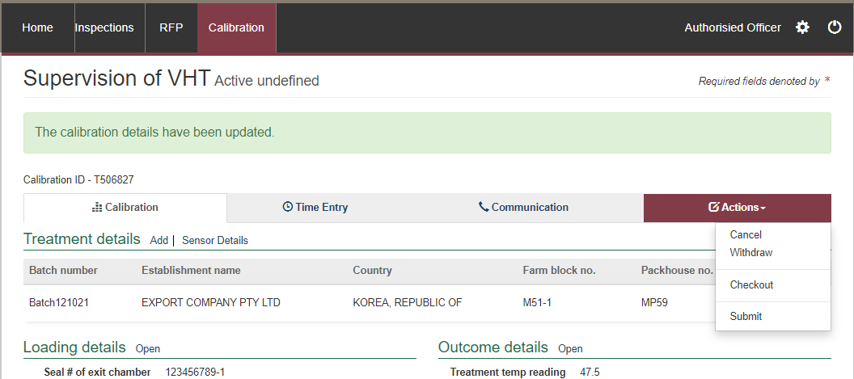

**5**

**4**

**3**

**2**

**1**

A pop-up window will ask if you want to **email the exporter/EDI user on the submission of the inspection1**. When selecting this option, the email address box will expand.

Enter the **email address2**, this can be multiple email addresses each separated by a comma.

Enter in any **Comments3** that are to be included in the email.

Click **Approve4**.



**4**

**3**

**2**

**1**

A pop-up window will ask you to confirm that you want to **submit this calibration1**. Click **OK1**.



**1**

The *Supervision of VHT* record status will display as **Completed1**.

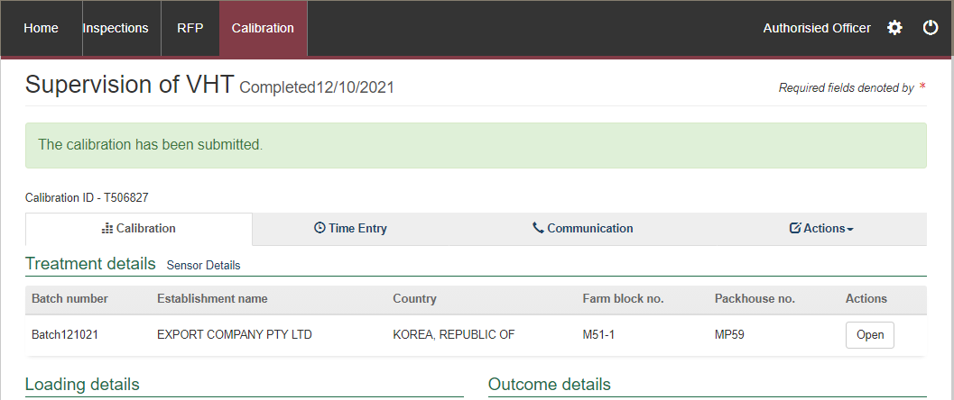

**1**

#### Download supervision of VHT report

You can download the supervision of VHT report after the calibration record is submitted in PEMS.

To download the report, click the **Actions1** tab and then select **Download Report2**.

**2**

**1**

A PDF document will be downloaded onto your device (next two screen shots).

Once the document is opened, it will display the relevant supervision of VHT record.

## Horticulture Inspection Record and VHT in PEMS

This section refers to the VHT requirements connected to the initiating and completing a Horticulture inspection in PEMS.

General details on how to complete a Horticulture inspection can be found in the Reference: *PEMS AO user guide – Horticulture Inspections*.

Once you have initiated the inspection via the normal process you will need to enter some additional information as the process for recording inspection results slightly changes when the commodity has undergone the VHT process.

Click the **Inspection1** tab. From the Results line, select **Open2**.

**1**

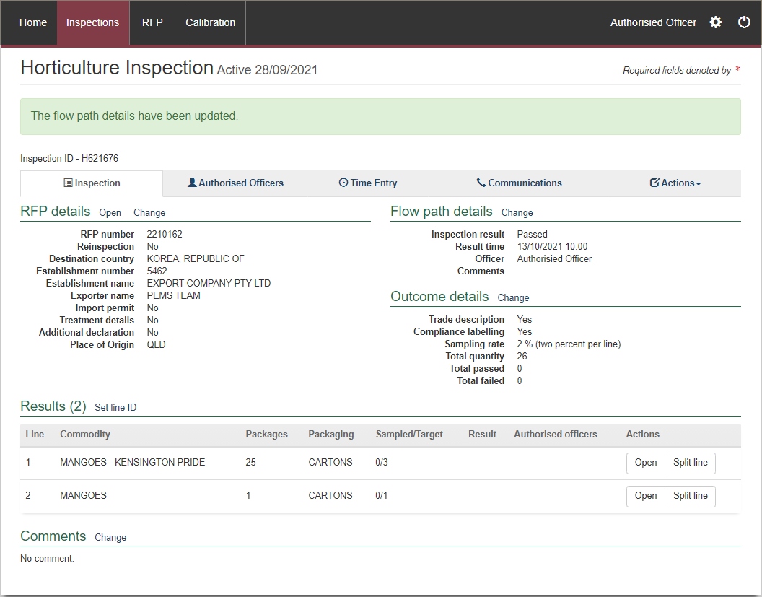

**2**

The *Inspection Result Line* window will display (image below).

For each line inspected, the system will display the mandatory fields for the inspection:

* Enter the **Accredited Farm Block Number1** and click **Add2**. This will validate the Farm Block Number. For each new number, multiple block numbers can be added by clicking the Add button.
* Enter the **Accredited Packhouse Number3** and click **Add4**. This will validate the packhouse number. For each new number, multiple packhouses can be added by clicking the **Add** button.
* If applicable, select **Has the VHT been done using a manual record5**. If this option is selected it becomes mandatory to attach the manual record to the communications tab before submitting the inspection. A manual VHT record should only be used if the appropriate Exception has been granted.
* Enter the **Batch Number6** and click **Add7**. This will validate the batch number. For each new number, multiple batch numbers can be added by clicking the **Add** button.
* If applicable, enter the source of the product into the **Line ID8,**such as grower line and/or lot number.
* Enter the **Number of packages9** presented for inspection if the information is not prepopulated (where split line is used, you will need to amend the number of packages specified in the parent RFP line).
* Enter the **Sampled number10** of units during the inspection (sampled number must be entered before a result can be selected).
* Select a **Result11** of either ‘Pass’ or ‘Fail’ for the line.
* If applicable, select one or more **Remarks12** checkboxes (mandatory if the line fails the inspection).
* Select the checkbox(es) of all **Authorised officers13** who inspected the line. See **Section 3.1 Assigning authorised offiecrs (inspection records only)** Reference: *PEMS AO user guide – Overview and General Functions* for more information.
* Click **Save14** to save the inspection record and exit the Inspection Result Linewindow.

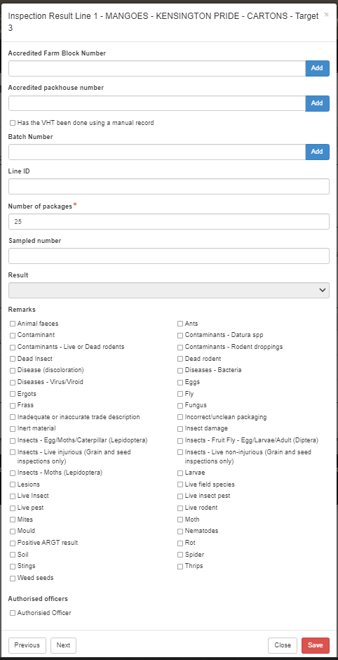

**14**

**13**

**12**

**11**

**10**

**9**

**8**

**7**

**6**

**5**

**2**

**4**

**3**

**1**

Continue the remainder of the horticulture inspection as per the Reference: *Plant Exports Management System (PEMS) Authorised officer user guide – Horticulture Inspections.*

## Related material

The following related material is available on the department’s website:

* Manual of Importing Country Requirements ([Micor](http://micor.agriculture.gov.au/Plants/Pages/Documents.aspx)).
* [Micor Plants](https://micor.agriculture.gov.au/Plants/Pages/default.aspx) (importing country requirements, protocols, and work plans)
* [Protocols, work plans](http://micor.agriculture.gov.au/Plants/Pages/Documents.aspx)
* [Plant Export Operations Manual](http://www.agriculture.gov.au/export/controlled-goods/plants-plant-products/plantexportsmanual)
* Reference: *PEMS AO user guide – Overview and General functions*
  + *Horticulture inspections*

The following related material is available on the department’s [Learnhub](https://learnhub.ssc.gov.au/login/):

* Plant Export Management System (PEMS) video tutorials

**Contact information**

* Authorised Officer Hotline: 1800 851 305
* Authorised Officer Program: PlantExportTraining@awe.gov.au
* PEMS Administration: [PEMS@awe.gov.au](mailto:PEMS@awe.gov.au).

## Document information

The following table contains administrative metadata.

| Instructional Material Library document ID | Instructional material owner |
| --- | --- |
| IMLS-9-8194 | Director, Business Systems Program |

## Version history

The following table details the published date and amendment details for this document.

| Version | Date | Amendment details |
| --- | --- | --- |
| 1 | 11/11/2021 | First publication of this user instruction. |
| 2 | 21/02/2022 | Updated in line with PEMS Feb release. |
| 3 | 4/04/2022 | Update with April 2022 PEMS release |