December 2024

Meeting the Minimum documentary and import declaration requirements policy

# Packing declarations

A packing declaration is a document issued by the packer of a sea container attesting to the type of packing materials used in the container. Packing declarations for FCL/X containers may also include a container cleanliness declaration.

Packing declarations aim to provide assurance that biosecurity risks will not be introduced to Australia through the packing material used in containers or through contamination of the container itself.

Reliable packing declarations reduce the need for containers to be inspected on arrival in Australia.

Watch our [Sea Container Cleanliness video](https://youtu.be/buyBOx53_JI?si=ruXkKuEU3Bsh6k3e) for tips on how to prepare containers for export to Australia.

## Completing a packing declaration

[Packing declaration templates](https://www.agriculture.gov.au/biosecurity-trade/import/arrival/clearance-inspection/documentary-requirements/templates) are available on our website. Using the templates is not mandatory but it is recommended by the department to ensure requirements are met.

## Letterhead

Packing declarations for FCL/X consignments must be issued by the entity who packs the goods into the container or observes (watches) the container being packed for export.

Packing declarations for LCL consignments must be issued by the entity who packs the consignment or observes (watches) the consignment being packed.

In some instances, the packer may also be the supplier or exporter of the goods.

Letterheads should be easily identifiable and can appear at the top, bottom or side margin of the document. Letterheads must include the company’s name and physical address.

** Include the letterhead of the entity who packed the goods on the packing declaration. Ensure the letterhead includes the physical address of the company. If a letterhead is not used, a company stamp that includes the physical address of the company may be used instead.**

## Consignment details

Documents that are relied on to assess the level of biosecurity risk of goods imported to Australia must have a unique consignment-specific link. This provides assurance that the statements included in the document relate directly to the goods being imported to Australia.

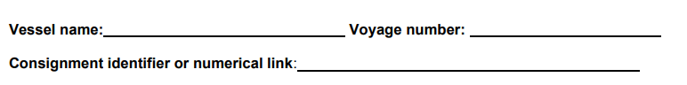

** For consignment specific packing declarations, include a link such as:**

* **container numbers**
* **bill numbers**
* **commercial invoice numbers**
* **lot codes**
* **preferential tariff certificate numbers**
* **packing list numbers**
* **letter of credit numbers**

Note: Annual packing declarations are exempt from having a consignment specific link because they are intended to cover a number of consignments over the year.

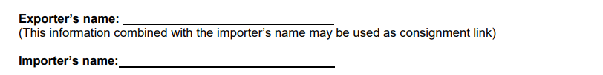

** For annual packing declarations, include the importer and exporter name.**

## Unacceptable packaging material statement

Unacceptable packaging material includes bark, chaff, hay, rice hulls, sandbags, soil bags, used empty bags, used egg cartons, used meat cartons, used tyres, compressed non-timber type material/strawboard including agricultural waste.

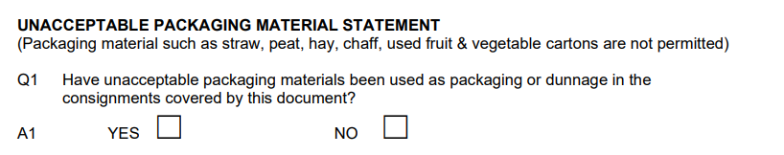

** Use the packing declaration to declare any unacceptable packaging material.**

## Timber/bamboo packaging/dunnage statement

Timber and bamboo packaging includes cases, crates, pallets, bearers, beams, skids, load boards, drums and blocks made from solid timber or bamboo.

Packaging made entirely from reconstituted wood, bamboo laminate or plywood/veneer is not required to be declared as timber packaging or dunnage as they are not considered to pose a biosecurity risk.

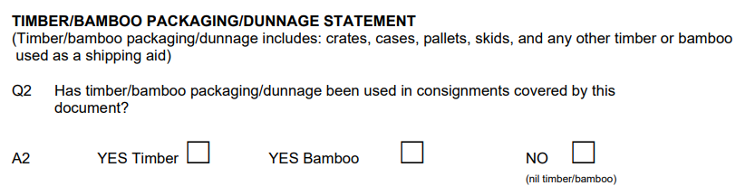

** Use the packing declaration to declare any timber or bamboo packaging or dunnage.**

## Timber/bamboo packaging/dunnage treatment statement

Packaging containing solid timber or bamboo requires mandatory treatment. You can use ISPM 15 compliant packaging, treat the packaging prior to export by an approved method or have the packaging treated on arrival in Australia.

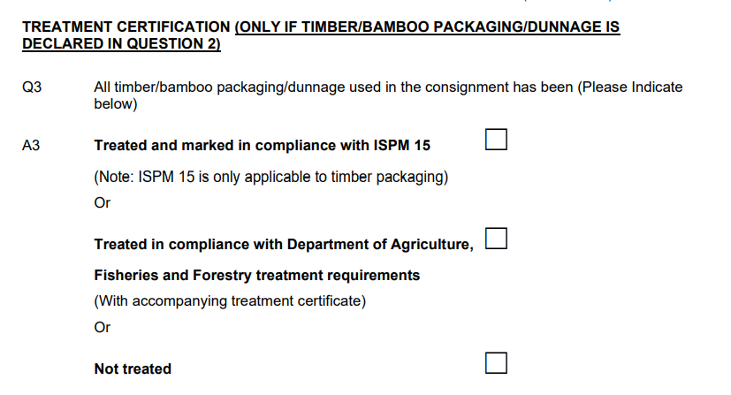

** Use the packing declaration to declare if the timber has been treated, has not been treated or is ISPM 15 compliant. Do not complete this question if timber and/or bamboo packaging and/or dunnage has not been declared.**

## Cleanliness statement

Sea containers must be clean and free from material of animal and/or plant origin and soil.

A cleanliness statement is required for FCL/X containers. LCL consignments do not require a cleanliness statement because they are deconsolidated in controlled, metropolitan premises.

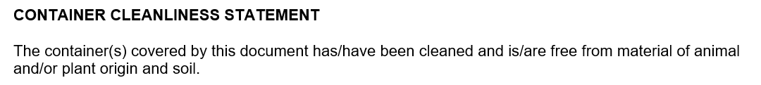

** Use a consignment specific packing declaration to declare that the container has been cleaned and is free from material of animal and/or plant origin and soil. Do not include a container cleanliness statement on LCL packing declarations.**

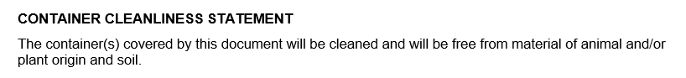

** Use an annual packing declaration to declare that the containers covered by the declaration will be cleaned and will be free from material of animal and/or plant origin and soil. Do not include a container cleanliness statement on LCL packing declarations.**

## Endorsement

Packing declarations must be endorsed by an employee of the company that issues the packing declaration. The endorsement must:

* + include an acceptable signature or individual stamp
  + include the employee’s printed name
  + appear after the information being endorsed

A signature can be handwritten or electronic. Electronic signatures include:

* + licensed signatures (for example, Adobe Acrobat or DocuSign)
  + electronic text as generated by a software programme
  + electronic stamps
  + typed names
  + signature blocks, as used in email programmes

An individual stamp must identify the individual who is applying the stamp/seal and can include any or all of the following:

* + signed name
  + printed name
  + mark or character that is significant to an individual
  + unique identification number.

Individual stamps and printed names do not need to be in English. A company stamp that does not identify an individual person is not sufficient to meet endorsement requirements.

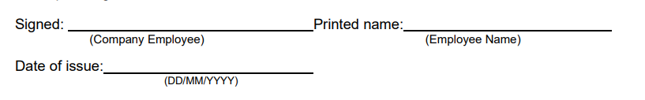

** Endorse the packing declaration using an acceptable signature or individual stamp. Include the endorsing employee’s printed name. Ensure the endorsement appears after the information being endorsed.**

## Date of issue

Consignment specific packing declarations should be issued after the goods are packed and must be dated when they are issued. The date of issue can be before or after the goods are exported to Australia.

Alternatively, include the vessel and voyage number for consignment specific packing declarations.

Annual packing declarations are valid for 12 months from the date of issue and must be valid at the time the shipping container is exported to Australian territory.

** Date the packing declaration when it is issued. Ensure the day, month and year can be clearly identified.**

## More information

Learn more about [Documentary requirements for imported goods](https://www.agriculture.gov.au/biosecurity-trade/import/arrival/clearance-inspection/documentary-requirements/templates).

Web: [agriculture.gov.au/biosecurity-trade/import/arrival/clearance-inspection/documentary-requirements](https://www.agriculture.gov.au/biosecurity-trade/import/arrival/clearance-inspection/documentary-requirements/templates)

Web: [agriculture.gov.au/biosecurity-trade/import/arrival/clearance-inspection/documentary-requirements/templates](https://www.agriculture.gov.au/biosecurity-trade/import/arrival/clearance-inspection/documentary-requirements/templates)

**Acknowledgement of Country**

We acknowledge the Traditional Custodians of Australia and their continuing connection to land and sea, waters, environment and community. We pay our respects to the Traditional Custodians of the lands we live and work on, their culture, and their Elders past and present.

© Commonwealth of Australia 2024

Unless otherwise noted, copyright (and any other intellectual property rights) in this publication is owned by the Commonwealth of Australia (referred to as the Commonwealth).

All material in this publication is licensed under a [Creative Commons Attribution 4.0 International Licence](https://creativecommons.org/licenses/by/4.0/legalcode) except content supplied by third parties, logos and the Commonwealth Coat of Arms.

The Australian Government acting through the Department of Agriculture, Fisheries and Forestry has exercised due care and skill in preparing and compiling the information and data in this publication. Notwithstanding, the Department of Agriculture, Fisheries and Forestry, its employees and advisers disclaim all liability, including liability for negligence and for any loss, damage, injury, expense or cost incurred by any person as a result of accessing, using or relying on any of the information or data in this publication to the maximum extent permitted by law.