# Nodavirus and biosecurity: be alert to avoid alarm (poster 1)

## What is biosecurity?

Programs, procedures and actions you take to prevent the outbreak, or limit the spread of nodavirus and other infectious diseases in your hatchery.

## Why worry about disease?

Disease – viral, bacterial, fungal or parasitic - is a real and present threat to the success of your farming operations. Disease is a major limiting factor to your farm making money (and you getting paid)!

Be alert to the risks! Be alert to the warning signs!

## What are the risks?

Neglecting biosecurity will allow disease to:

* Get onto your farm; or
* Build up on your farm!
* Cause serious losses!
* Spread to other farms in the region.

A group of deceased fish in water.



## What are the warning signs?

* • Fish going off feed
* • Fish behaving abnormally:
* Lethargic
* Not schooling as usual
* Spiralling or swirling
* Not reacting to external stimuli like bright lights, noise, hand movements.
* Fish going darker or lighter than normal
* Fish dying for no apparent reason (i.e., you’ve checked water quality and it is NOT this)
* Scale loss
* Ulcers
* Bleeding from the fins, gills, eyes
* Lumps on fish
* Swelling of eyes and/or abdomen
* Pale or ragged gills.

Comparison of healthy (bottom fish) vs nodavirus affected barramundi (top fish).
Deceased juvenile barramundi.

## So what can you do?

### Establish biosecure areas for your fish

* Clear signposting of areas
* Physical separation of areas with restricted access

### Maintain biosecurity – prevent the introduction of disease

* Quarantine new fish
* Restrict visitor access
* Don’t mix fish species
* Don’t mix batches
* Start with a clean slate for each area and each batch
* Clean, disinfect and dry out between batches
* Rinse and disinfect eggs
* Be responsible for your own area - don’t go where you aren’t needed
* If you MUST move between areas, DECONTAMINATE – footbaths and handwash
* Have dedicated equipment for each area
* If you must move equipment, thoroughly CLEAN and DISINFECT it
* Remove sick fish as much as it is possible and practical
* Maintain good consistent water quality
* Minimise stress on fish AND staff
* Keep good records.

### Investigate problems quickly!

* When warning signs appear - tell your manager immediately
* If you are the manager, tell your staff of the problem
* Make sure you know why the fish died – Get a diagnosis!
* Take a sample of the fish and send to your veterinary diagnostic laboratory
* Have your veterinarian investigate and take samples for laboratory analysis
* Implement Disease Control by:
* Having a Standard Operational Protocol in place – act quickly and decisively.
* The SOP must:
* Be easily accessible
* Be understood by staff BEFORE a disease event
* Include procedures to reduce stress on healthy remaining fish
* Describe decontamination and disinfection protocols
* Include up to date contact details of your vet and diagnostic laboratory
* Be read and understood by staff BEFORE a disease event
* Seeking advice from your veterinarian on treatment and control
* Maintain a sound active working relationship with your vet and diagnostic laboratory
* Getting in touch with your State/Territory health authority (which MUST be done if nodavirus confirmed)
* CONTACT DETAILS

Diagram of staff movements through a farm from the cleanest area to the dirtiest area. Noting that staff should not move backward from dirty to clean areas. Each area has its own biosecurity.

# Nodavirus and biosecurity: be alert to avoid alarm (poster 2)

## What is biosecurity?

Programs, procedures and actions you take to prevent the outbreak, or limit the spread of nodavirus and other infectious diseases in your hatchery.

## What is nodavirus?

A virus that is found in many marine environments around Australia.

## Why worry about nodavirus?

Nodavirus kills hatchery barramundi in their thousands by destroying their brains and eyes (retinas).

Be alert to the risks! Be alert to the warning signs!

## What are the risks?

Neglecting biosecurity may allow nodavirus and other diseases to:

* Get in to your hatchery
* Build up and persist in your hatchery
* Spread to other hatcheries / regions
* Cause serious losses

## What are the warning signs?

* Fish going off feed
* Fish behaving abnormally:
* Lethargic
* Not schooling as usual
* Spinning, spiralling or swirling
* Not reacting to external stimuli like bright lights, noise, hand movements
* Fish going darker or lighter than normal
* Fish dying for no apparent reason (i.e., you’ve checked water quality and it is NOT this) in large numbers over a short time

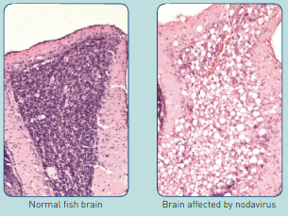 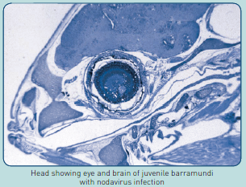

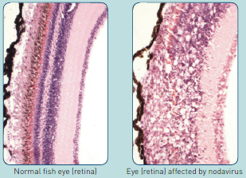

## So what can you do?

### Establish biosecure areas for your fish

* Clear signposting of areas
* Physical separation of areas with restricted access

### Maintain biosecurity –prevent the introduction of disease

* Quarantine new fish
* Restrict visitor access
* Don’t mix fish species
* Don’t mix batches
* Start with a clean slate for each area and each batch
* Clean, disinfect and dry out between batches
* Rinse and disinfect eggs
* Only use live feeds (rotifers, copepods) of known quality

Grown in the hatchery for an extended period of time

* Be responsible for your own area - don’t go where you aren’t needed
* If you MUST move between areas, DECONTAMINATE – footbaths and handwash
* Have dedicated equipment for each area
* If you must move equipment, thoroughly CLEAN and DISINFECT it
* Remove sick fish as much as it is possible and practical
* Maintain good consistent water quality
* Minimise stress on fish AND staff
* Keep good records.

### Investigate problems quickly!

* When warning signs appear - tell your manager immediately
* If you are the manager, tell your staff of the problem
* Make sure you know why the fish died – Get a diagnosis!
* Take a sample of the fish and send to your veterinary diagnostic laboratory
* Have your veterinarian investigate and take samples for laboratory analysis
* Implement Disease Control by:
* Having a Standard Operational Protocol in place – act quickly and decisively.
* The SOP must:
* Be easily accessible
* Be understood by staff BEFORE a disease event
* Include procedures to reduce stress on healthy remaining fish
* Describe decontamination and disinfection protocols
* Include up to date contact details of your vet and diagnostic laboratory
* Be read and understood by staff BEFORE a disease event
* Seeking advice from your veterinarian on treatment and control
* Maintain a sound active working relationship with your vet and diagnostic laboratory
* Getting in touch with your State/Territory health authority (which MUST be done if nodavirus confirmed)
* CONTACT DETAIL.

Diagram of staff movements through a hatchery from the cleanest area to the dirtiest area. Noting that staff should not move backward from dirty to clean areas. Each area has its own biosecurity. 
