USER GUIDE

NEXDOC:
Managing additional users in your NEXDOC Exporter Portal account.

__________________________________________________________________________________
In this document
This document contains the following topics.
Purpose of this document 2
Adding a new User to your Exporter account 2
Changing the status of a User to Inactive or Active 6
Contact the NEXDOC help desk 8

Purpose of this document
This document will give you a step by step to:
- Add a new user to your exporter account.
- Change the status of a user to Inactive or Active
Exporters using the NEXDOC Portal can now have multiple users assigned to their exporter account. More than one person can have access to your account at the same time and each person will have their own log on and user ID.
Note: Adding a new user to an exporter account is only possible after the new user has registered an online service account. Once this is done, the registered email address or AG ID of the new user can be added to your exporter account. To register an online service account refer to the Create a NexDoc Exporter account user guide.

Adding a new User to your Exporter account
Step 1  Log in to the Online Services Portal | 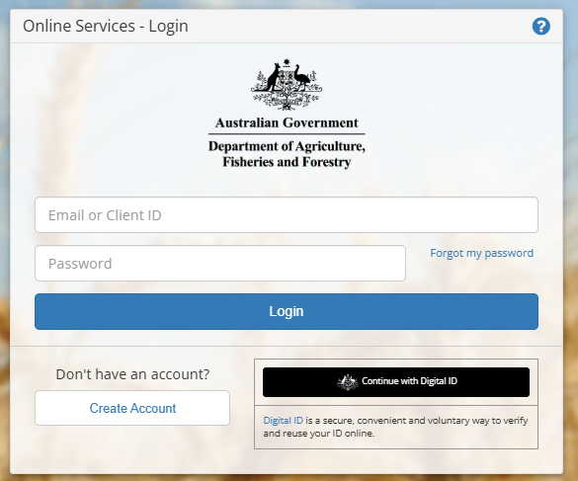
Step 2  Select Go to NEXDOC Homepage. | 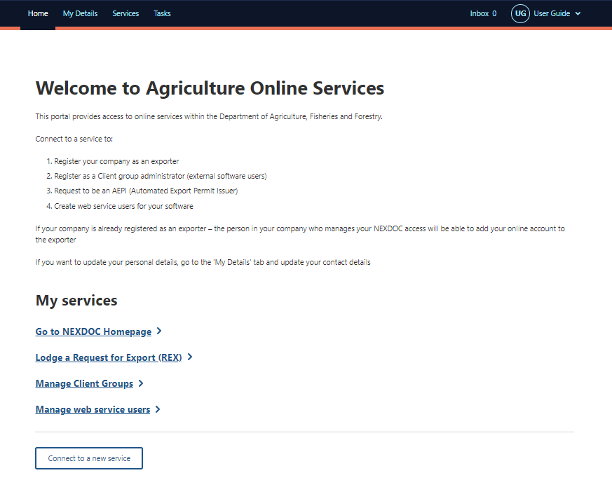
Step 3  Select Account. | 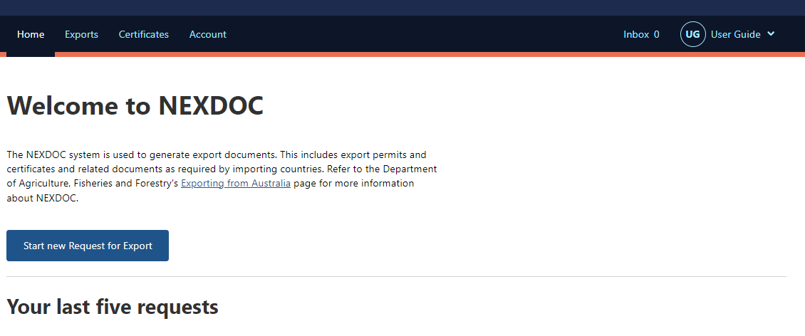
Step 4  Select Manage company users | 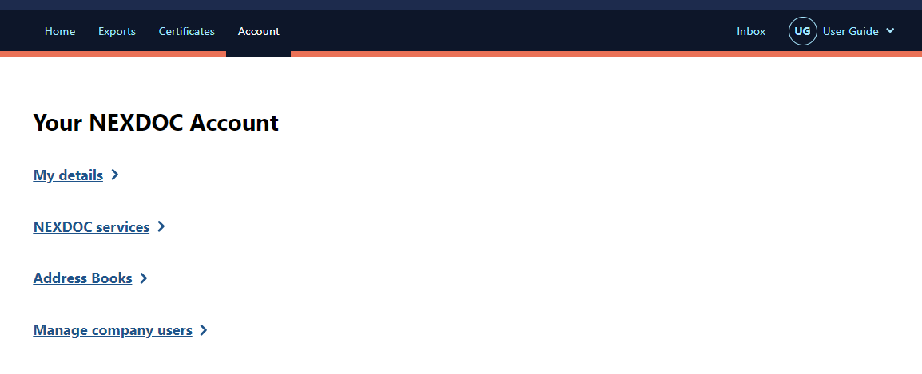
Step 5  Select Add new user | 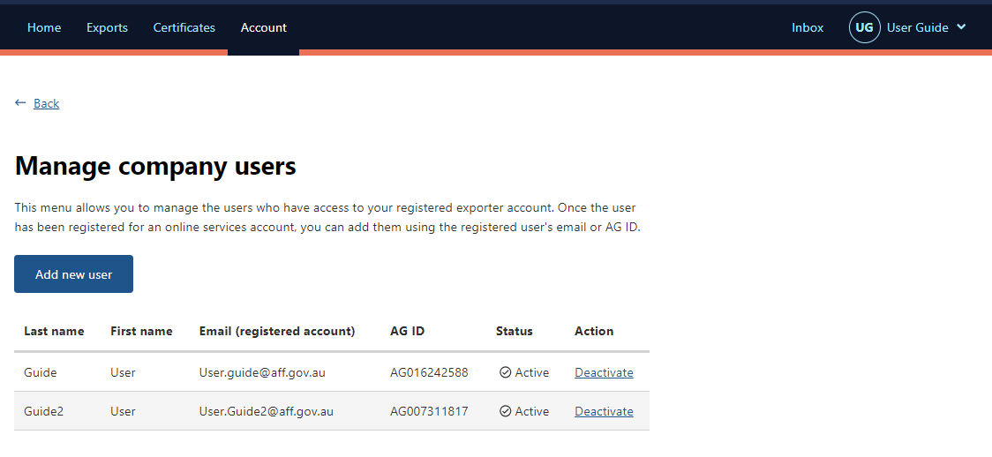
Step 6  Type the new user’s email address or AG ID.  Select Search | 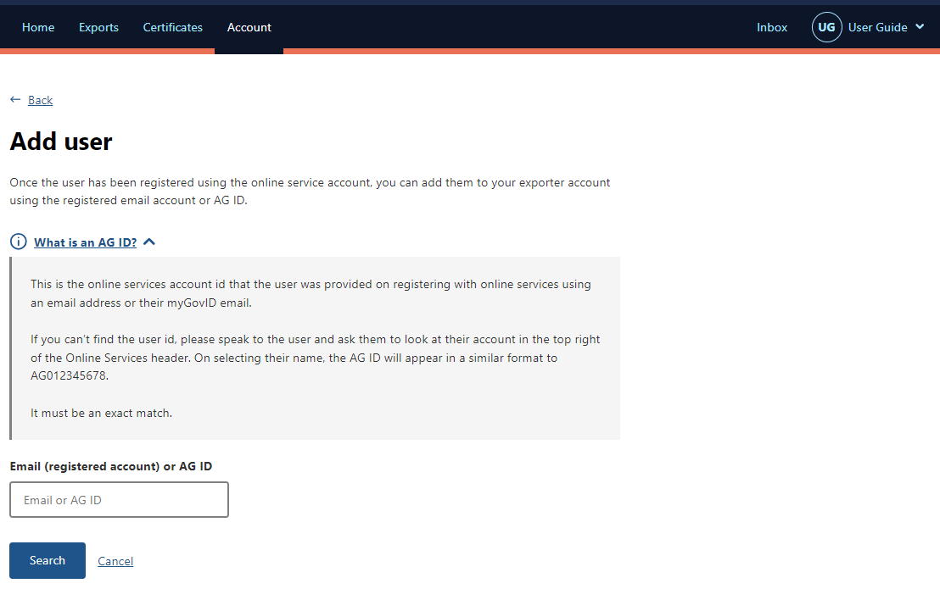
Step 7  The User’s details will appear.  If they match the user you want to add to your exporter account, select Save. | 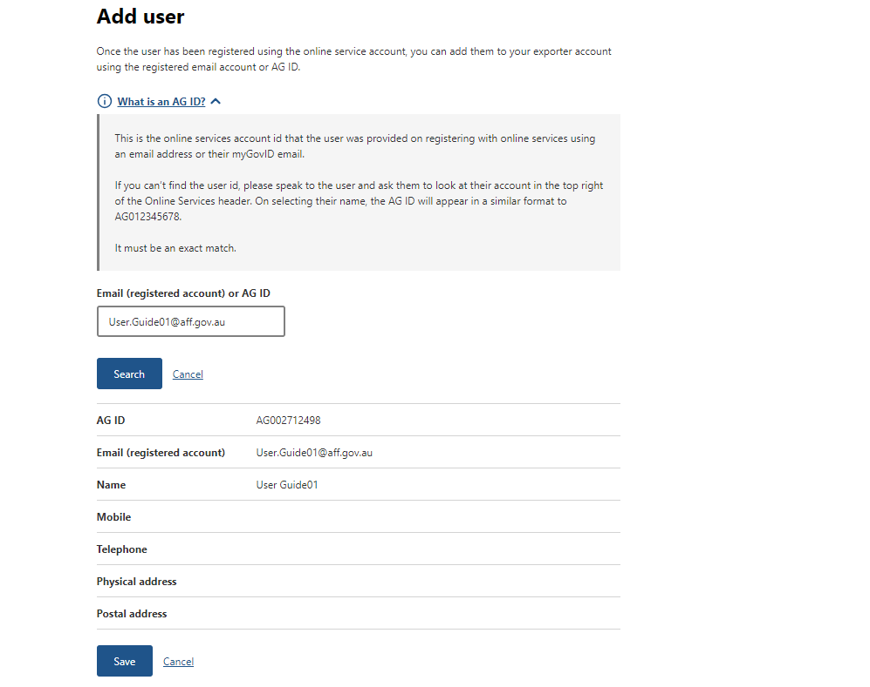
You will receive a prompt that the user has been added successfully. | 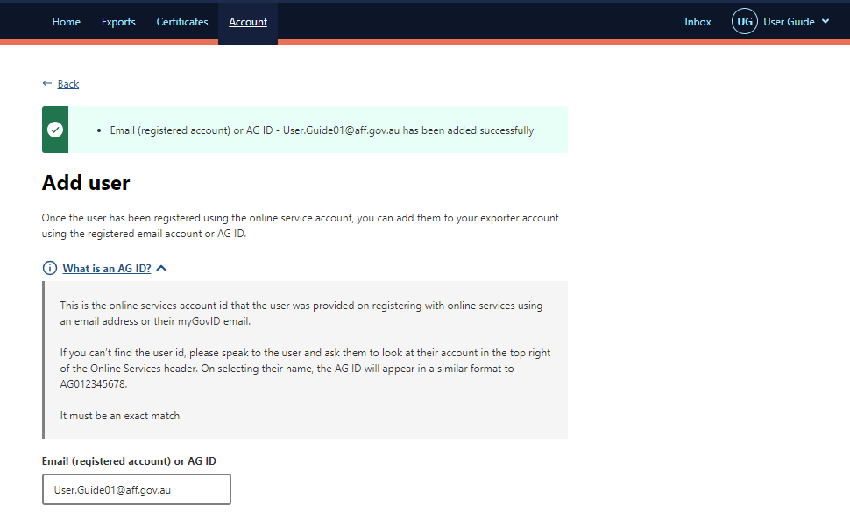
Step 8
To confirm the user has been added select Back
Step 9  The new user’s details will appear. | 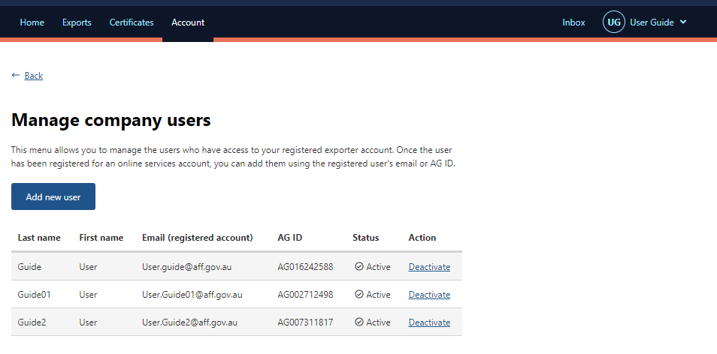

Changing the status of a User to Inactive or Active
As exporter accounts can now have multiple users, you are able to make these users active or inactive. An exporter account must have at least one active user.
The instructions below step you through how to change the status of a user in your export account.
Step 1  Log in to the Online Services Portal | 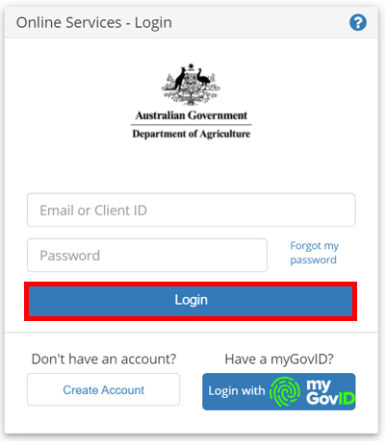
Step 2
Select Go to NEXDOC Homepage.
Step 3
Select Account.
Step 4
Select Manage company users
Step 5
The Manage company users screen will list all users linked to your exporter account.

Note: The Status column shows the current status of the user.
Step 9  Select Active or Deactivate in the status column to change the user’s status.  You will receive a prompt that the user has been made active or inactive successfully. | 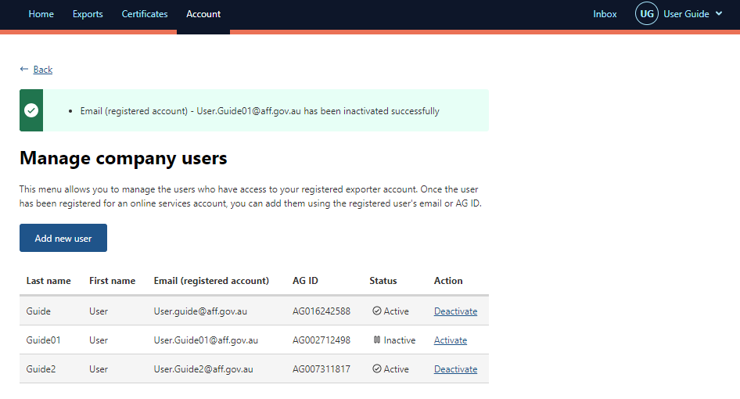

Contact the NEXDOC help desk
For more information or assistance, please contact NEXDOC@aff.gov.au

