Lodge a Request for Export (REX) to obtain the NX418
The below information will guide you through the NEXDOC system and demonstrate how to lodge a Request for Export (REX) to obtain the NX418 (formerly M418) certificate for imported goods (re-exports)
Log in to the Online Services Portal
Step 1  Log in to the online services portal | 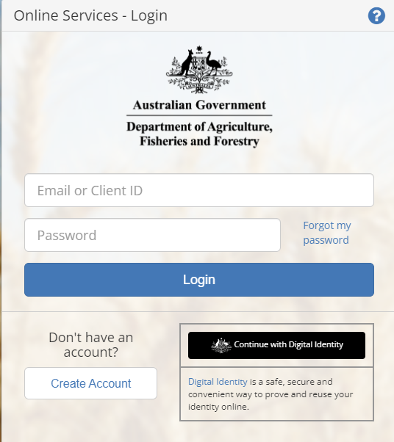

NEXDOC Portal Homepage
Step 1  Select Lodge a Request for Export (REX) | 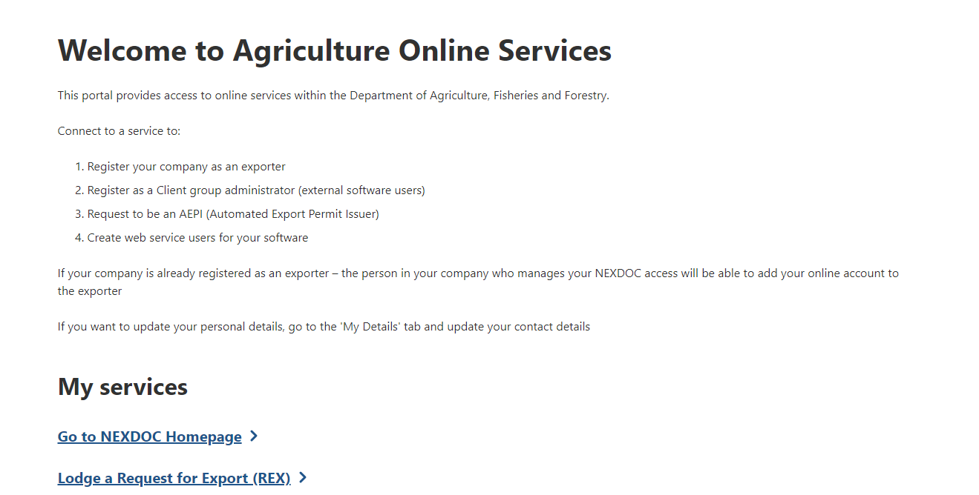

Start a new request for export (REX)
Step 1  Select the Commodity type of your export drop down menu. You will need to select Other Goods.  This is a mandatory field. | 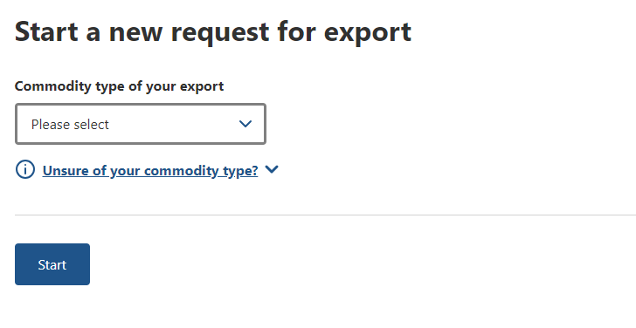
Step 2  Guidance relating to Other Goods products will display below the commodity selection  You will also need to  select the tick box to:  a) Confirm the  goods have  been legally  imported into  Australia, and;’  b) Declare that no  production  steps have  occurred in  Australia.  Select Start | 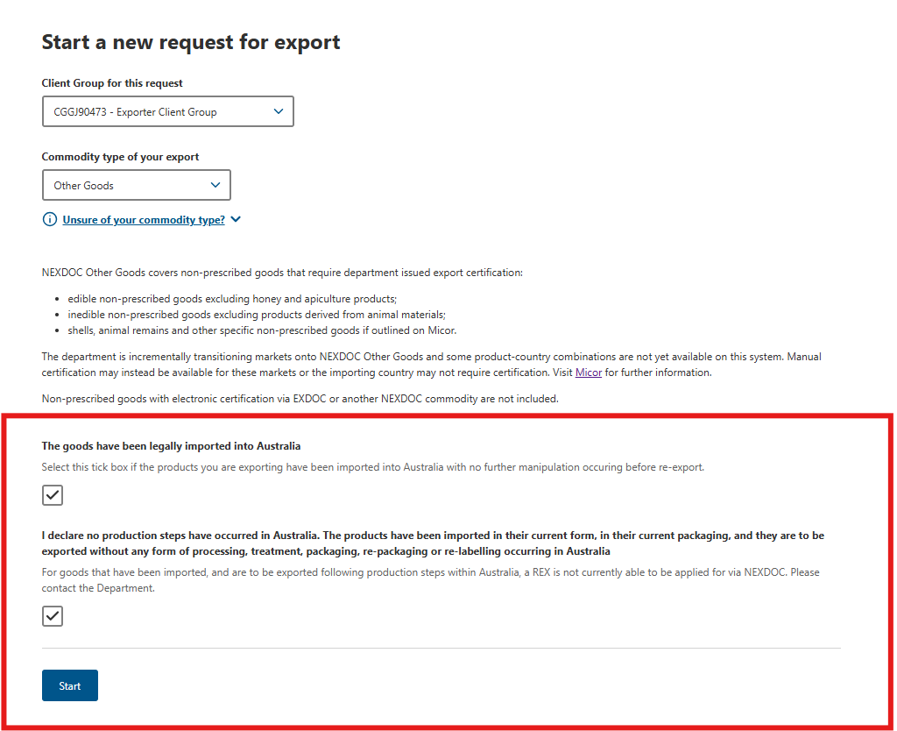

REX Section 1: Country details
Step 1  Select the Country you wish to export to drop down menu. You will need to select your destination country, then select Next.  This is a mandatory field. | 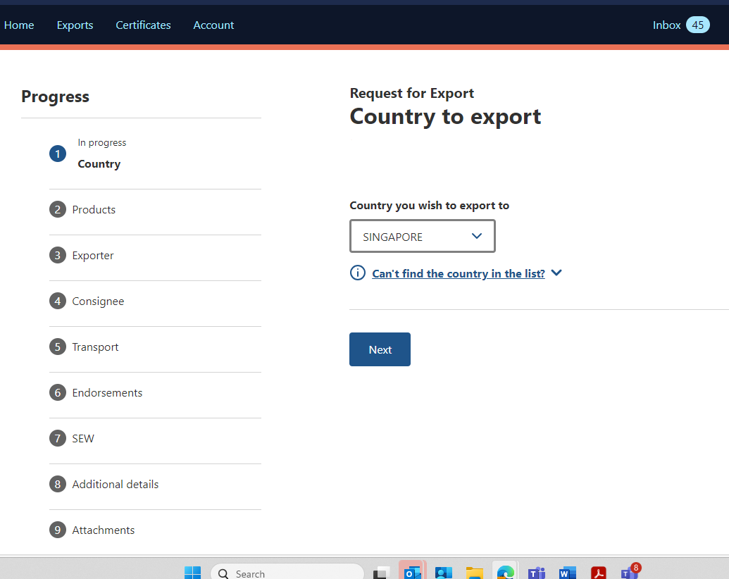

REX Section 2: Product Details
Step 1  Select Add product to export | 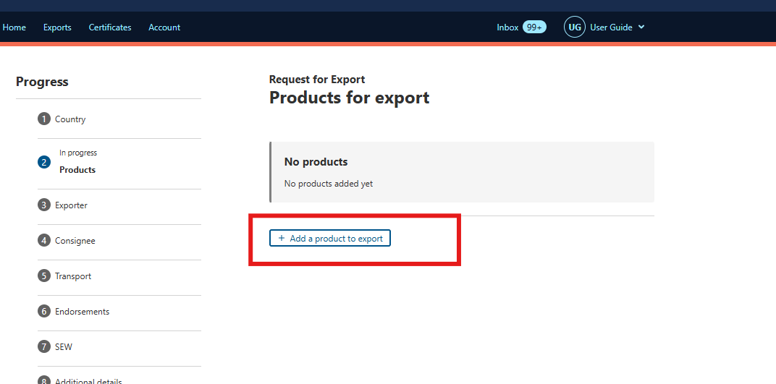
Step 2  Select the Product you wish to export drop down.  NEXDOC will present Imported Goods as the only option.  This is a mandatory field. | 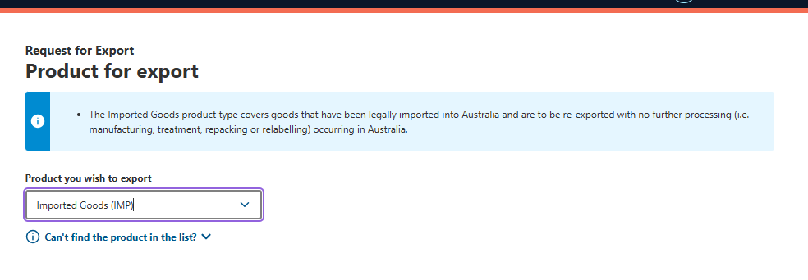
Step 3  Select a suitable option from the What is the product category? drop down menu.  This is a mandatory field. | 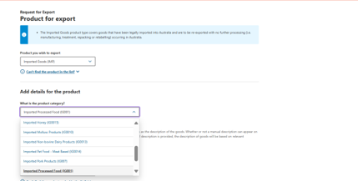
Step 4  Provide a more specific description of your product.  The Manual Description field is a mandatory field. This description will appear on your export certificate. | 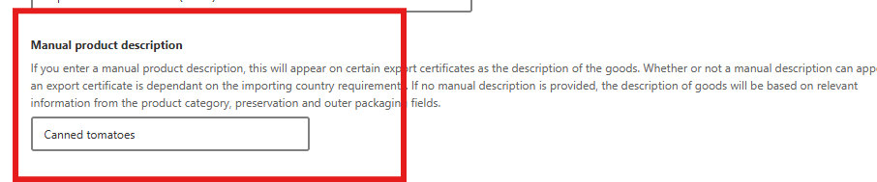
Step 5  Select a suitable option from the What is the product packed in? drop down field.  This is a mandatory field. | 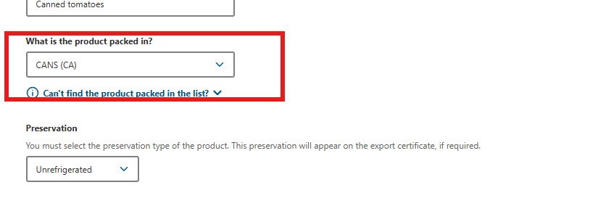
Step 6  Select the Preservation type for the product.  This is a mandatory field. | 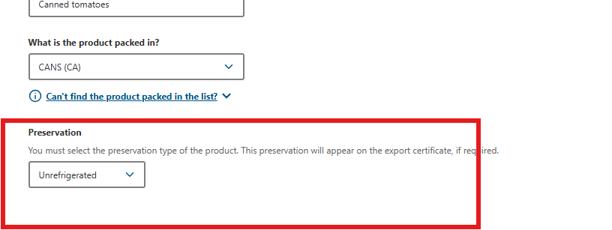
Step 7  Select the relevant AHECC code for the product.  This is an optional field but becomes mandatory field if you are using the Single Electronic Window (SEW) connection to obtain an Export Declaration Number (EDN) via NEXDOC. | 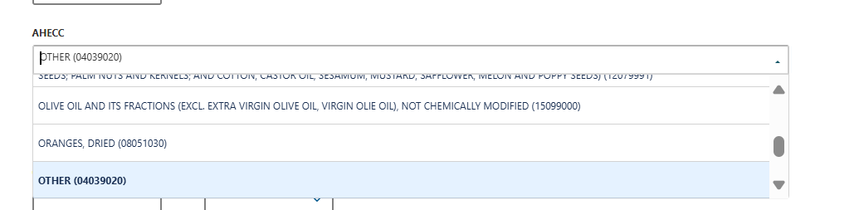
Step 8  Provide the Net metric weight amount and the net metric weight amount.  These fields are mandatory.  The Gross metric weight amount and Gross metric weight unit are optional fields but become mandatory if you wish to use SEW to obtain your EDN.  All weight fields must equal more than zero. | 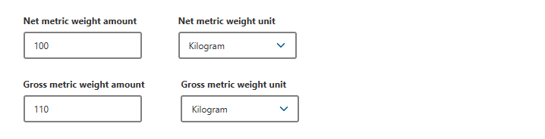
Step 9  Step 9 Provide the Country of origin in the dropdown.  This field is mandatory and will appear on your export certificate.  Provide the Originating country health certificate number. This field is optional and will appear on your certificate, if provided | 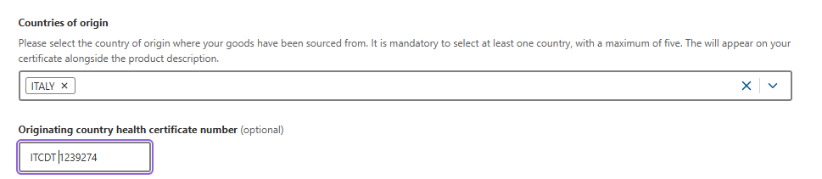
Step 10  Provide the Batch Code. This field is optional and will appear on your certificate, if provided. This field has a limit of 30 characters. | 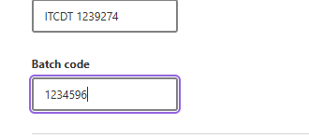
Step 11  Provide the Outer Packaging details.  The Package Type, Quantity, Individual Package Weight, and Weight Unit are mandatory fields. | 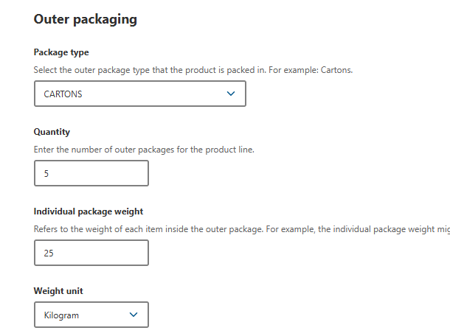
Step 12  Provide the Shipping marks. This field is optional and has limit of 30 characters. | 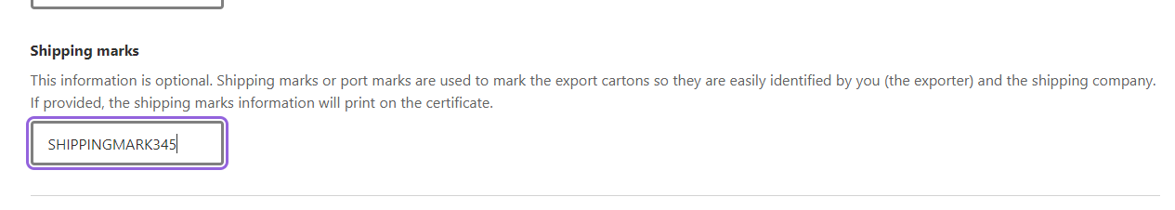
The below information relates to the Additional details of the product.

Step 13  Details relating to Containers are optional.  Details relating to SEW are optional. In this tab, the Net weight amount, Net weight unit and FOB amount fields become mandatory if you wish to use SEW and obtain your EDN.  Additional Details are optional. In this tab, the Product Source State field becomes mandatory if you wish to use SEW and obtain your EDN. | 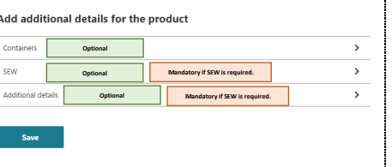
Step 14  If you wish to add container details, select the Containers tab. Container details are optional.  Select the relevant type of freight container then select Add container.  If you decide to provide container details for one product line, you must provide them against all product lines. | 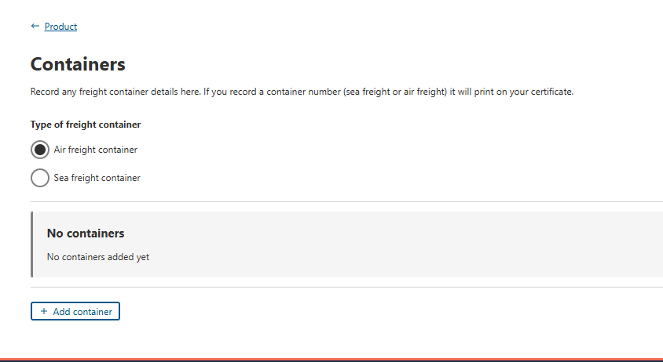
Step 15  If Air Freight  Provide the Container number for the Air Freight container.  If seal numbers are available, select Add seal number and provide the Start and End seal number.  Select Add  Note: It is optional to provide these details. | 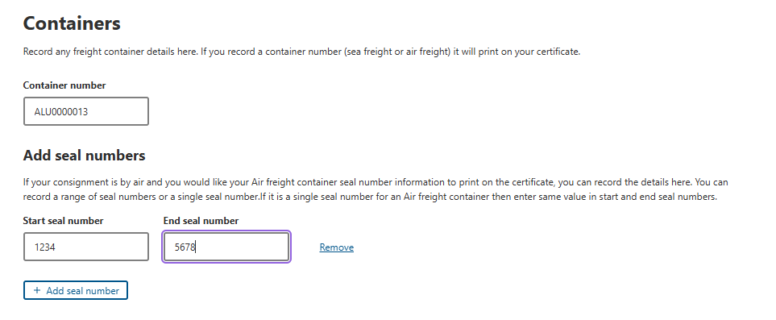
Step 16  If Sea Freight  Provide the Container number for the Sea Freight container.  Select Add seal number and provide the details.  Note: It is optional to provide these details. | 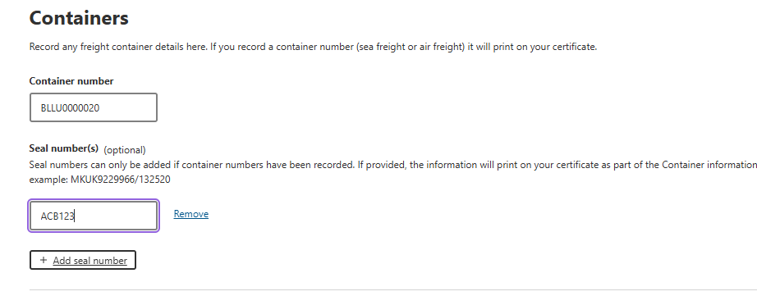
Step 17  If you wish to obtain your EDN through NEXDOC, select SEW  SEW information is optional. | 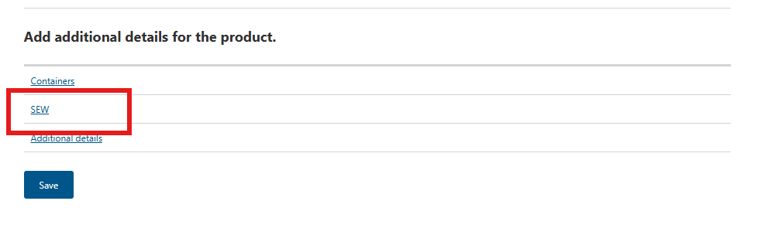
Step 18  If you wish to obtain your EDN through NEXDOC, you must provide the Net weight amount, Net weight unit and FOB amount.  Select Save. | 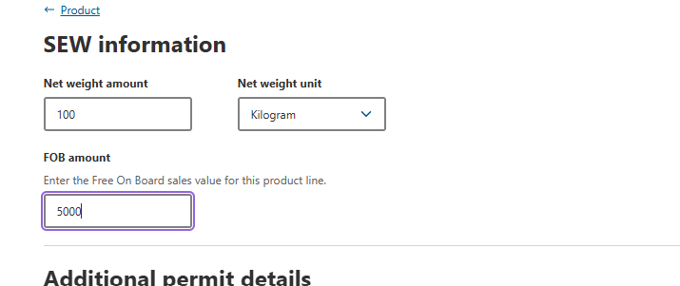
Step 19  Once all necessary is provided, select Save | 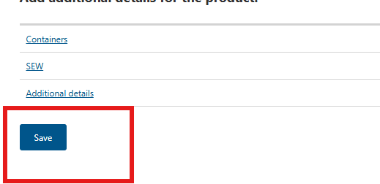
Step 23  You will be taken back to the Products for Export page.  You can either Add another product to export or Copy a product line.  If you copy an existing product line, NEXDOC will copy all base information and allow you to amend any unique information, such as the batch number.  Once you have all product line information saved, select Next | 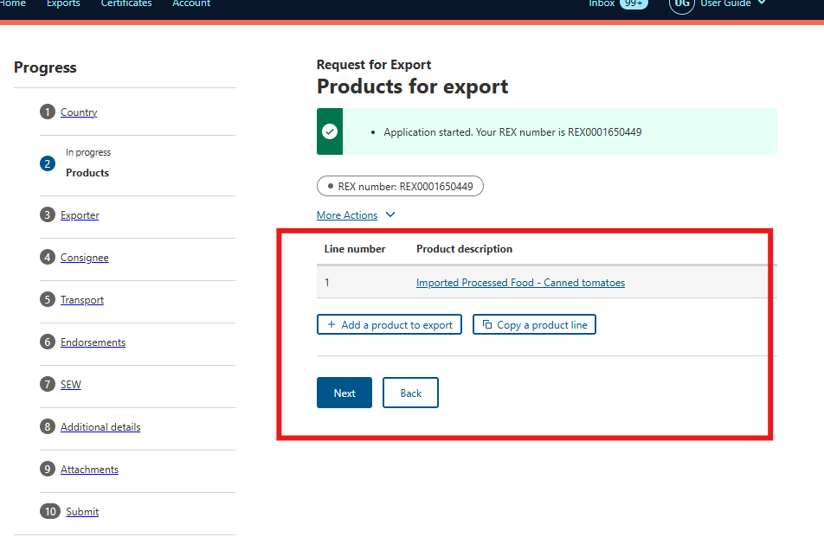

REX Section 3: Exporter Details
Step 1  Exporter details are prepopulated from your exporter registration for NEXDOC.  If you need to update these details, select Edit exporter details.  If you wish to use your other exporter details for the consignment, please select Change exporter.  Provide your Exporter Reference.  This is a mandatory field and limited to 35 characters. This will assist you identifying your REX in your account. This will also appear on your invoice.  Select Save and next. | 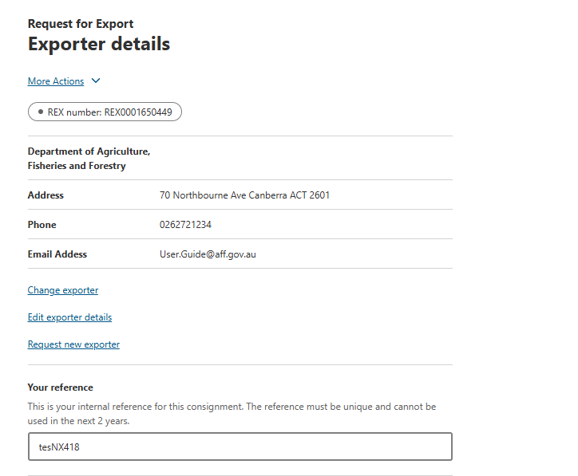

REX Section 4: Consignee Details
Step 1  Provide the consignee Name. This is a mandatory field.  The consignee Phone number, if known. This is an optional field.  Provide the consignee Address. This is a mandatory field.  Select Save and next. | 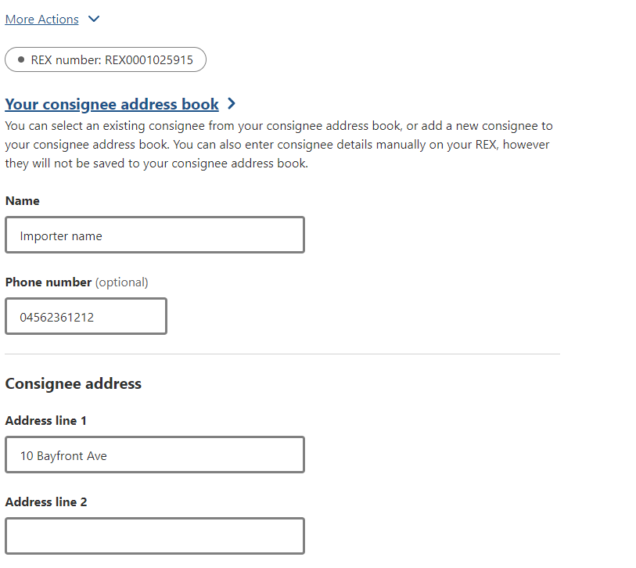

REX Section 5: Transport Details
Step 1  Enter the Departure Date. This is a mandatory field.  Select the Load Port. This is a mandatory field.  Select the Discharge Port. This is an mandatory field.  The Border Inspection Port is an optional field  Provide the Destination City. This is a mandatory field. | 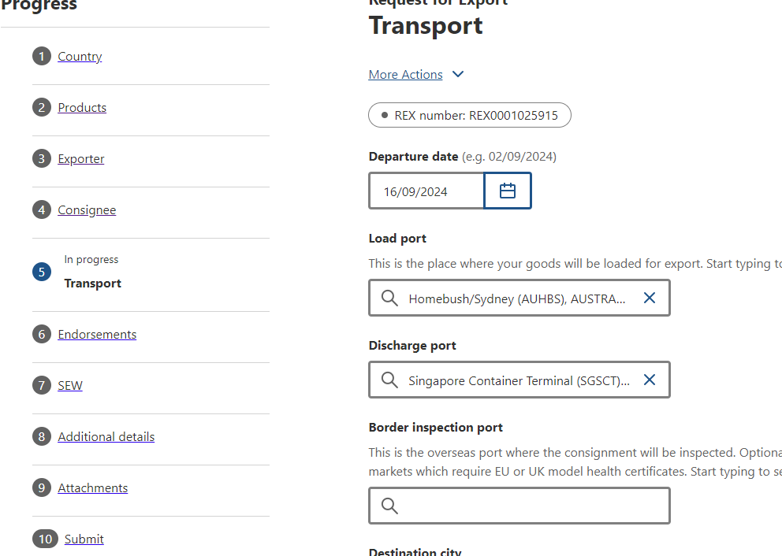
Step 2  Select the Transport Mode. It is mandatory to select either Sea or Air  If you select Sea, you must provide the Vessel Name and Voyage Number. These are mandatory fields. | 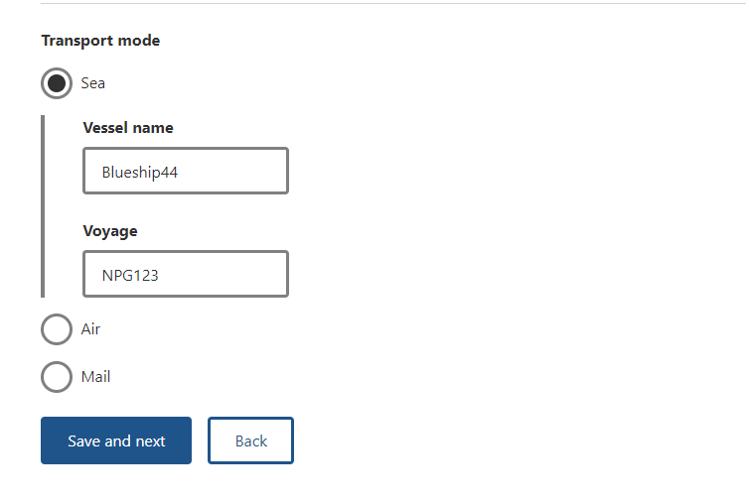
Step 3  If you select Air, you must provide the Flight Number. This is a mandatory field. | 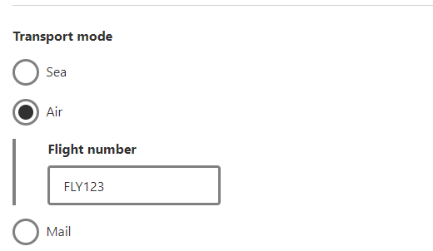
Step 4  Select Save and next. | 

REX Section 6: Templates and Endorsements
NEXDOC will automatically allocate you an appropriate template and endorsement if applicable  As you indicated you are exporting imported goods, you will be assigned the M418 template | 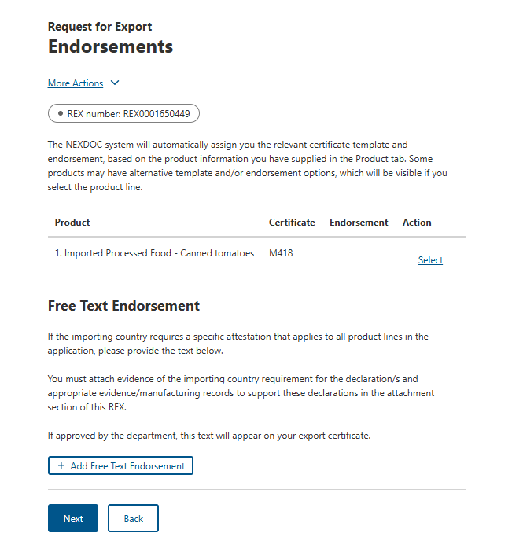
The system will allocate negotiated and/or known endorsements, however if you have evidence of the importing country requiring an endorsement not available in the system, you can provide this text via the + Add Free Text Endorsement function. This request will be reviewed by the department prior to appearing on your export certificate.  Note: This REX level Free Text Endorsement must be applicable to all products in your REX application. One certificate will generate with all products listed against this endorsement.  Note: You will be asked to attach the evidence that the free text endorsement is required in the Attachments tab.  Once you have confirmed the template and/or endorsement combination, select Next. | 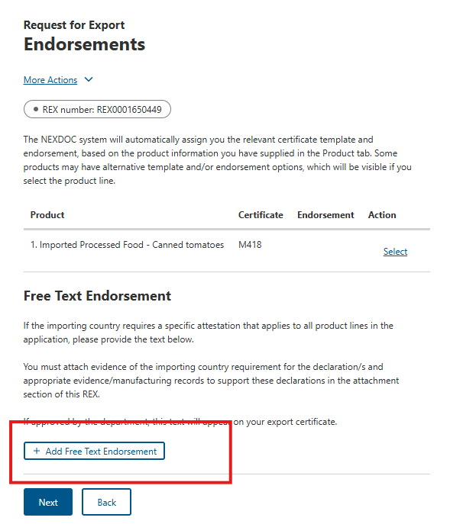

REX Section 7: Single Electronic Window (SEW)
Step 1  Should you wish to use Single Electronic Window (SEW) integration to obtain your EDN (Export Declaration Number) you will need to complete the details on this screen.  Note:  - You must have requested access to SEW in your exporter registration for this to be available. Alternatively, you can update your account and request this permission.  - If you wish to use the SEW connection, you must have provided the relevant details in each of your product lines.  - The FOB total will be calculated based on the information saved in the SEW tab of each product line.  These are optional fields. | 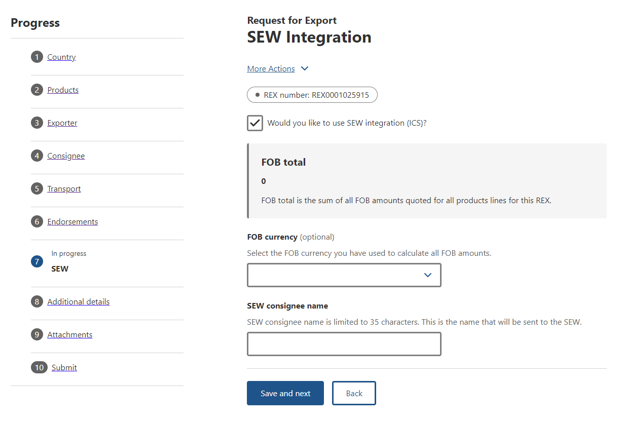

REX Section 8: Additional Details
Step 1  Select your Certificate Print Indicator  You must select Automatic or Hold.  This selection is mandatory.  Please view the NEXDOC Printing FAQ on the NEXDOC Help Page for further information regarding these options. | 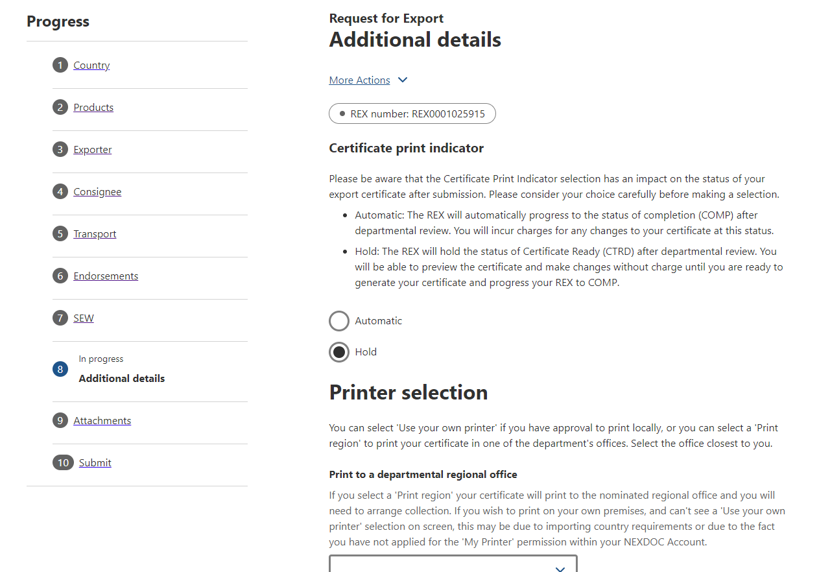
Step 2  Selecting the Use your own printer tick box will allow you to print your certificate remotely, rather than needing to collect it from a regional department office.  If you do not have this option on screen, please request this permission via your registered NEXDOC exporter account. | 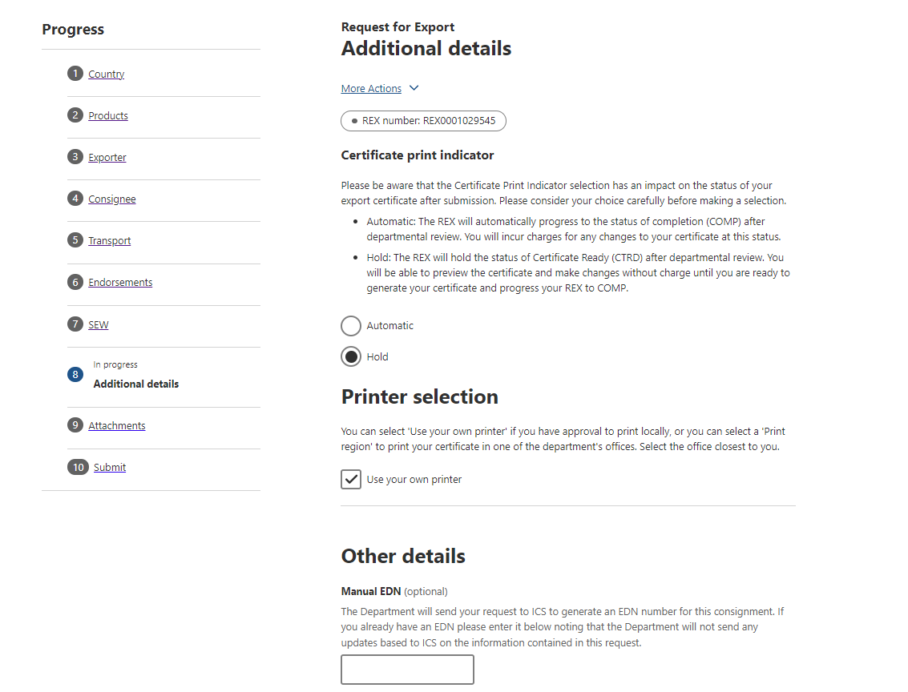
Step 3  If you do not wish to print remotely, you must select an available regional office from the Print region to print your extract.  You will need to contact the department’s Assessment Services (Exports) team to collect the certificate/s. | 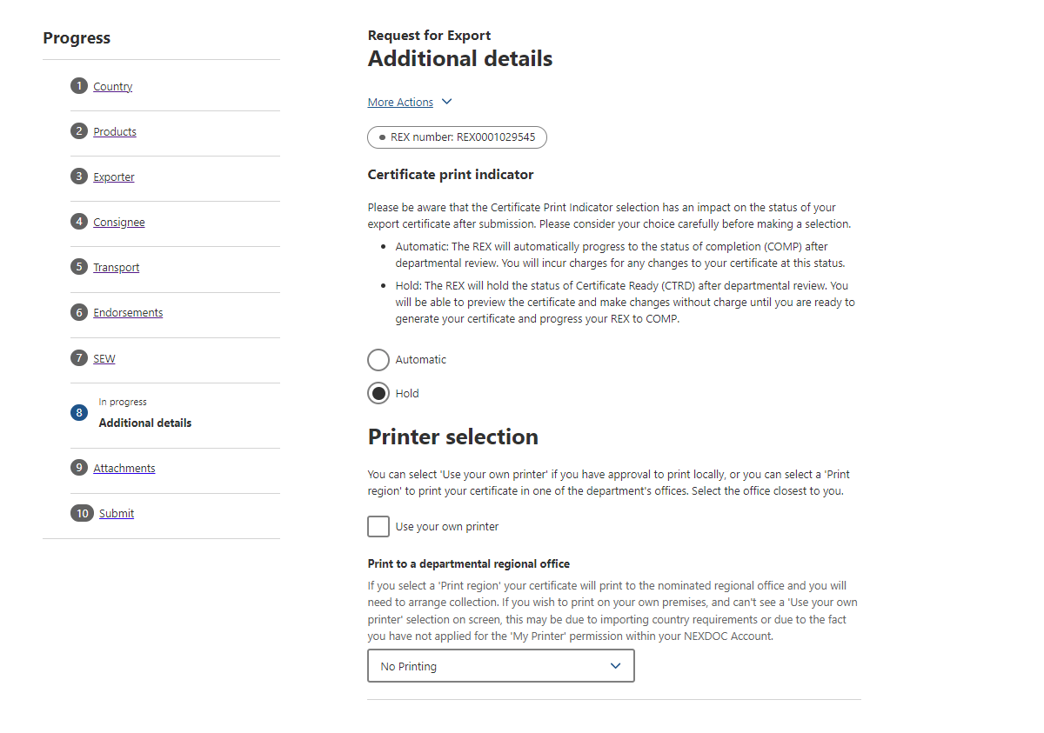
Step 4  Should you wish to save your import permit number and import permit date within your REX, select Add import permit.  This is an optional feature and will appear on your certificate, if provided. | 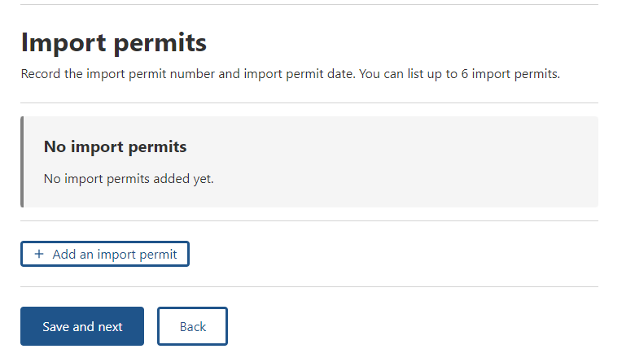
Step 5  Provide your Import permit number and Import permit date.  These are optional fields.  If provided, these details will appear on the export certificate. The import permit date must be in the past.  Select Save. | 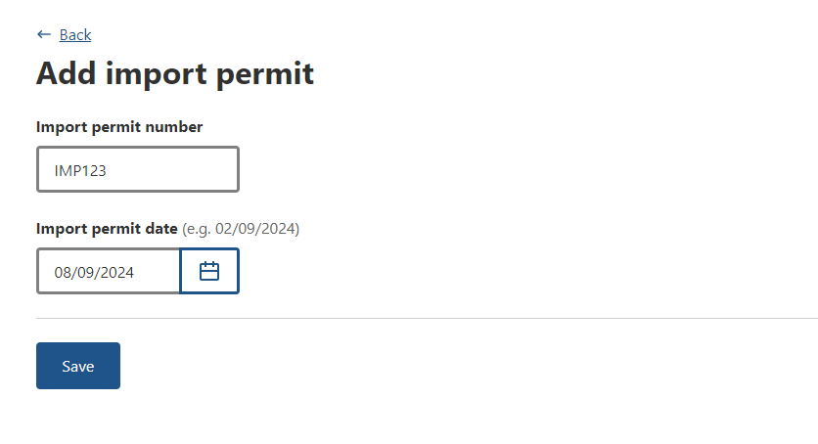
Step 6  Select Save and next. | 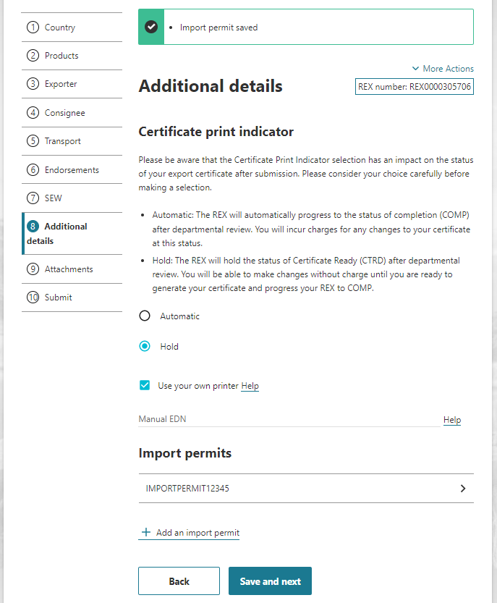

REX Section 9: Attachments
Step 1  Each REX is assessed against importing country requirements. Provide all relevant documentation to support your request for certification. This may include, but is not limited to, an import permit, manufacturers declarations and evidence of free text endorsements  Select Add attachment. | 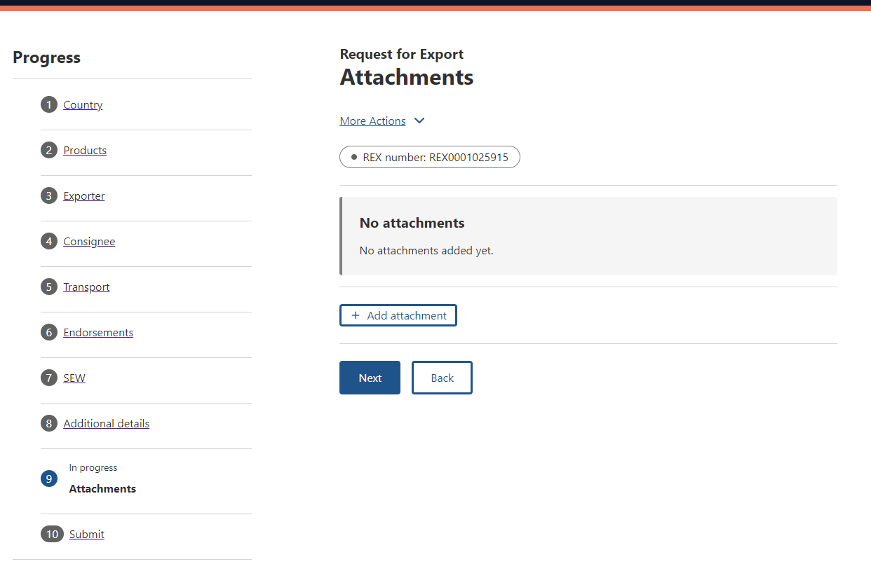
Step 2  Select the drop-down menu and indicate the type of attachment.  This is a mandatory field if you are attaching a document.  Provide a comment in relation to your attachment, if applicable.  This is an optional field.  Select or drag and drop the file to attach.  Select Save. | 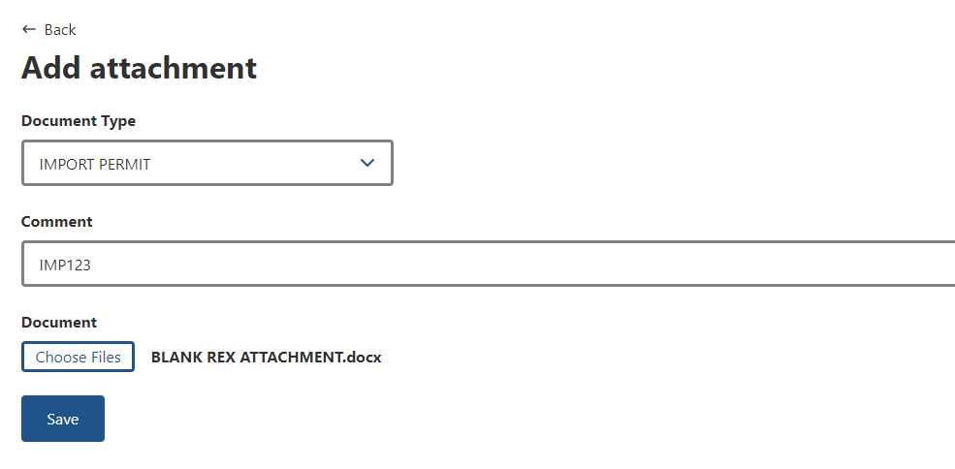
Step 3  Attach all necessary documentation to support your application. A departmental officer will review these documents when assessing your REX.  Select Next. | 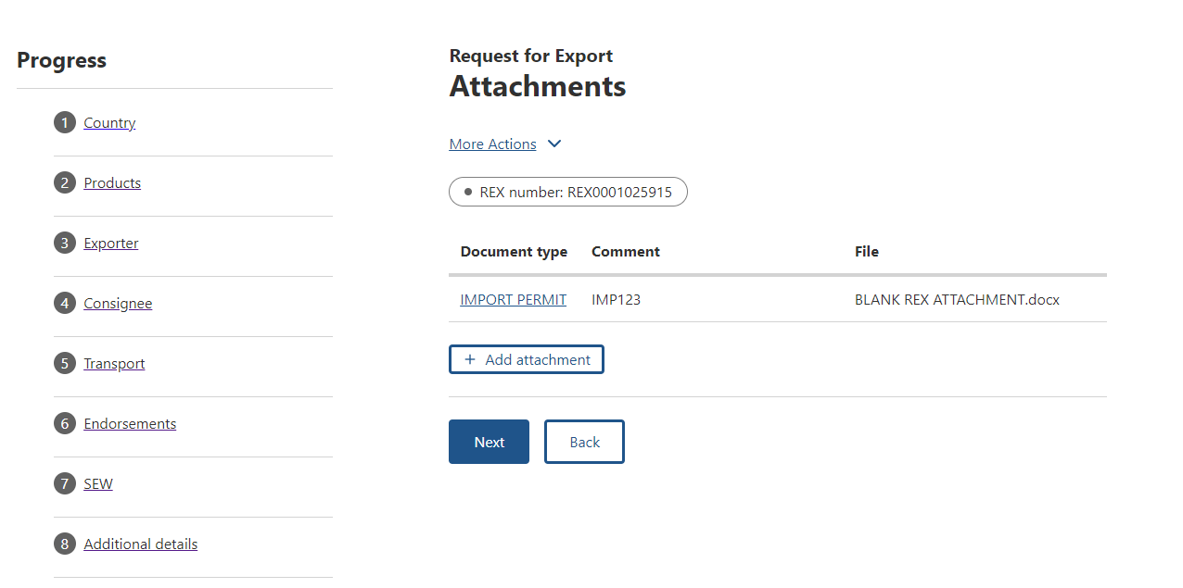

REX Section 10: Submit
Step 1  The Declaration will display. Please read this carefully.  If you wish to proceed with your lodgement, select I agree. | 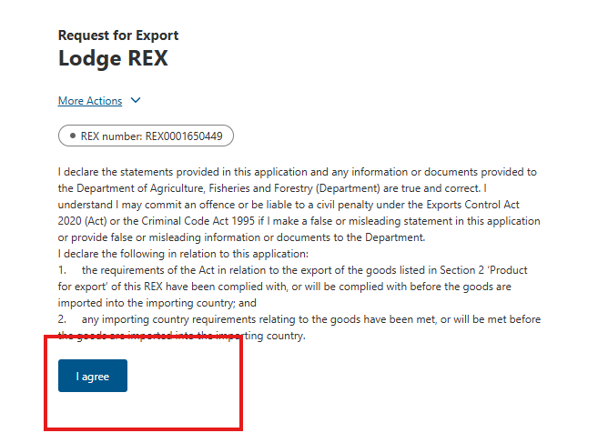
Step 2  The destination country and products will display. If there are no changes required, select Lodge REX. | 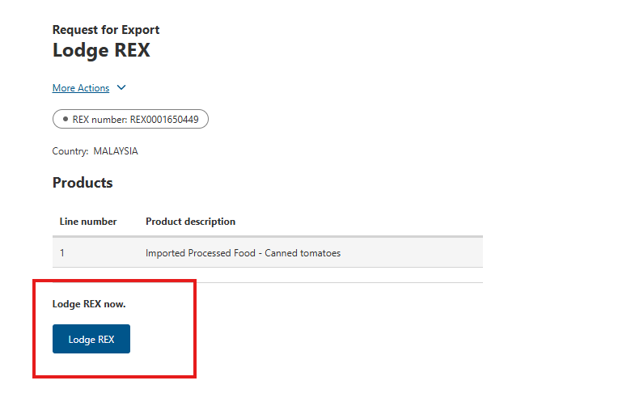
Step 3  A confirmation message will appear, alongside the Service ID associated with your application. Your REX is now awaiting assessment from a departmental officer. | 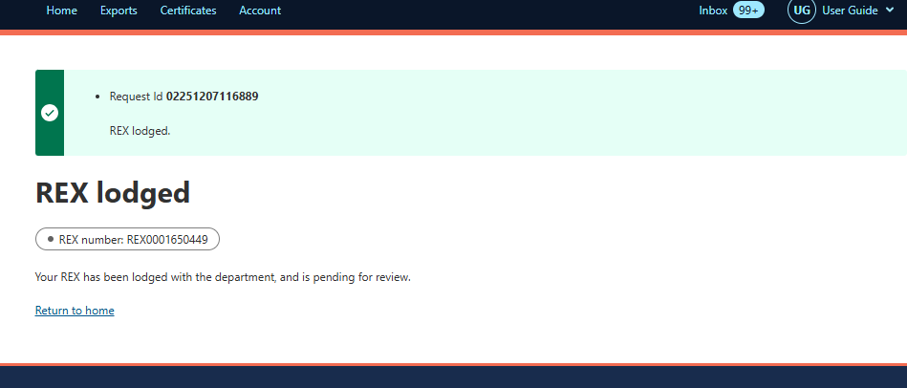
End

