USER GUIDE

NEXDOC:
How to identify if you have lodged a task

__________________________________________________________________________________
In this document
This document contains the following topics.
Purpose of this document 2
View your service request history with the department 2
Contact the NEXDOC help desk. 6

Purpose of this document
This document will give exporters advice on how to identify if you have lodged a task in NEXDOC.
Note: After you have completed your Request to Export (REX) documentation, where applicable, you will receive an export certificate. If you need to amend or replace your certificate, you will need to complete this request through your REX using the More Actions drop down menu. More information on this can be viewed in the ‘Should I amend or replace a Request to Export’ video on the website.

View your service request history with the department

Step 1  Log in to NEXDOC. | 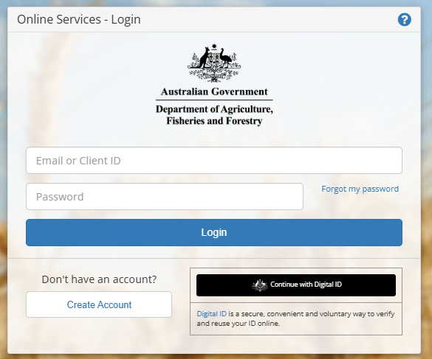
Step 2  Select Connect to a new service. | 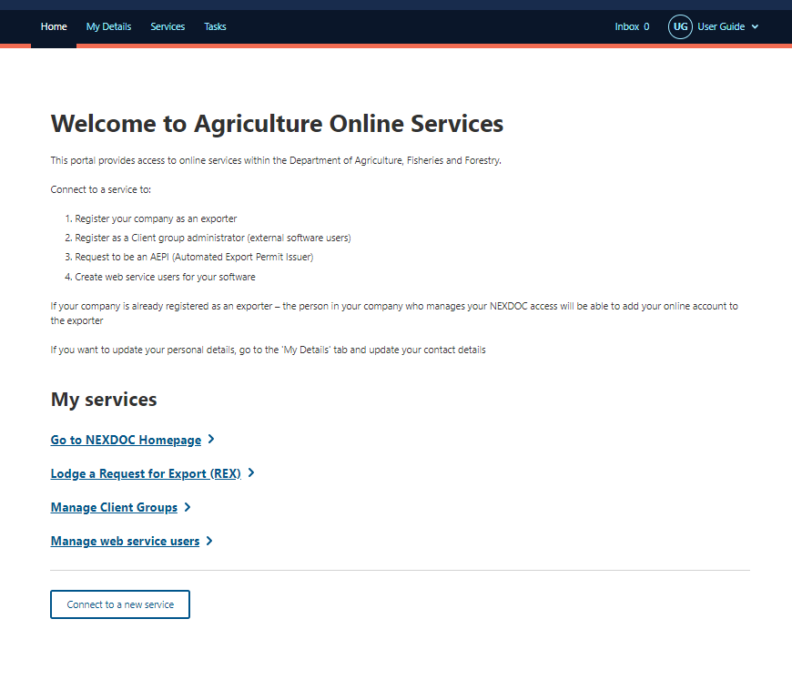
Step 3  Select Service Request History | 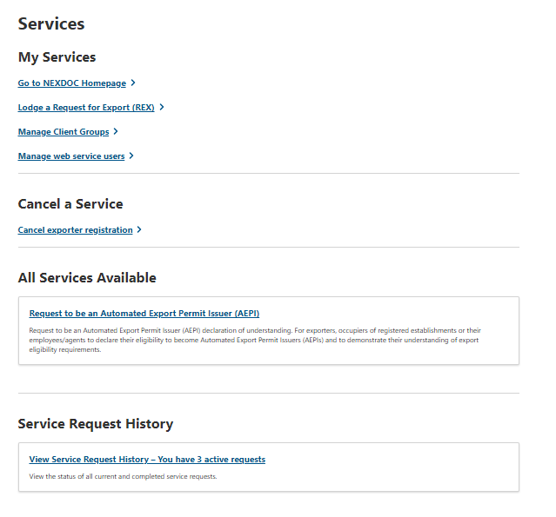
Step 4  A list of all your active service requests will display. These requests are sitting as a task for a departmental officer to action.  Select the task you wish to review. | 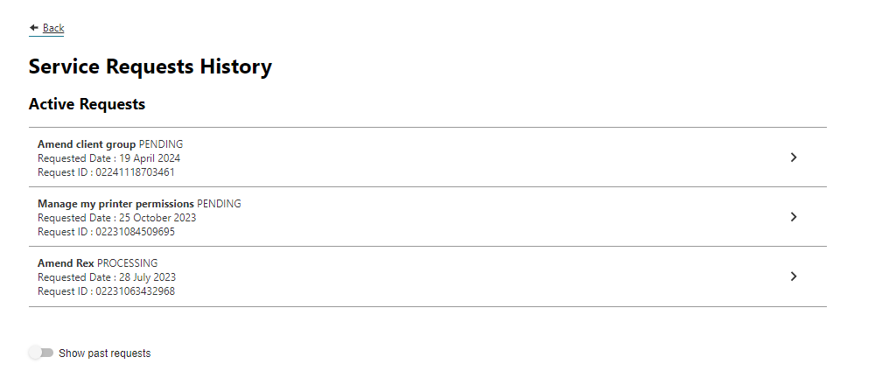
Step 5  The task information will display. | 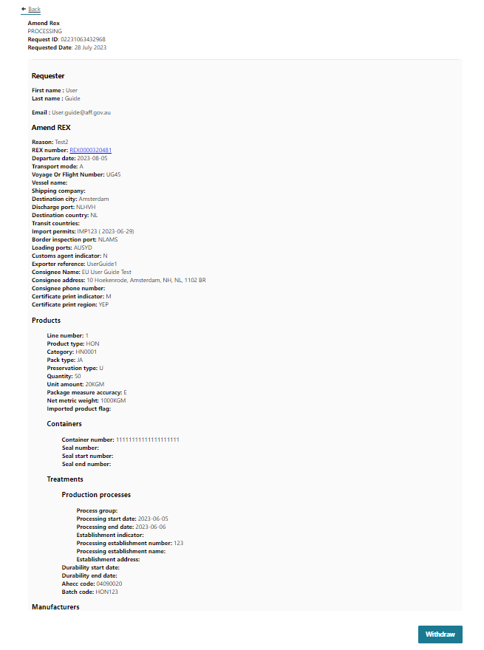
Step 6  Once your application has been processed by the department you will receive a notification in your NEXDOC inbox. | 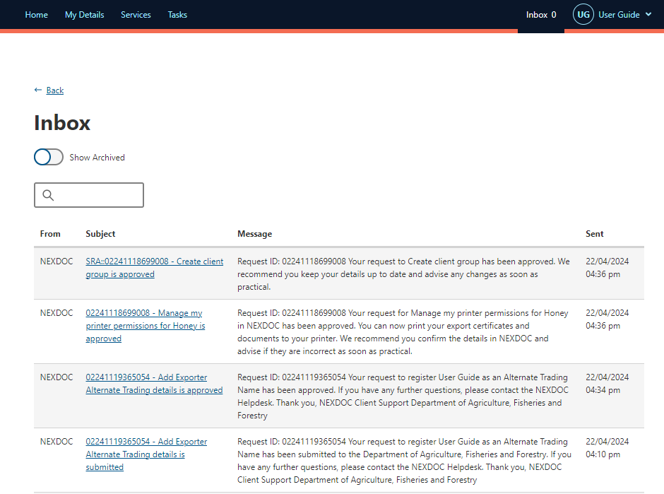

Contact the NEXDOC help desk.
For more information or assistance, please contact NEXDOC@aff.gov.au

