

OFFICIAL

**USER GUIDE**

**How to apply for Automated Export Permit Issuer**

**in NEXDOC**

**In this document**

This document contains the following topics.

Purpose of this document 2

What is AEPI or Automated Export Permit Issuer? 2

1. Access the Online Services portal 2

2. Connect to NEXDOC 5

3. Register as an Exporter or Create a Client Group 5

3. Request to be an Automated Export Permit Issuer (AEPI) 7

4. Applicant Details 7

5. Applicant Status 8

6. Applicant Eligibility 8

7. Eligibility Checklist 9

8. Applicant Declaration 9

Contact the NEXDOC help desk 10

# Purpose of this document

This document provides information on how to apply for the Automated Export Permit Issuer ability in NEXDOC, which enables you to approve export requests (REX) under the *Export Control Act*. It gives guidance on applying for this permission for commodities transitioning to NEXDOC.

## What is AEPI or Automated Export Permit Issuer?

This is a permission in NEXDOC and is equivalent to the AQA User ID in EXDOC. A NEXDOC AEPI user can authorise a Request for Export (REX) for an exporter or establishment where AEPI authorisation is allowed.

In general, a Request for Export (REX) is authorised by the department. This permission enables you to authorise certain REX applications. There are restrictions around AEPI authorisation, such as if the importing country requires departmental authorisation.

In NEXDOC, in accordance with the *Act*, this permission is linked to an individual, rather than to a registered establishment.

For further information, see the FAQ: Automated Export Permit Issuer status in NEXDOC. (link to be added)

# Access the Online Services portal

|  |  |
| --- | --- |
| Step 1  Log in to the [Online Services portal](https://online.agriculture.gov.au/portal/).  If you do not have an account in the Online Portal:  Select Create Account  or  Continue with Digital Identity to create an account.  In this guide we will Create Account |  |
| Step 2  Enter your email address |  |
| Step 3  Read the terms and conditions and if agreed, select the tick box.  Select **Verify Email** |  |
| Step 4  A confirmation code has been sent to your email.  Type the confirmation code into the into the box. |  |
| Step 5  Select **Validate Code** |  |

|  |  |
| --- | --- |
| Step 6  Type in your password.  Retype the same Password. |  |
| Step 7  Retype the same Password in Step 6. |  |
| Step 8  Type your first name and then Last name.  Click Complete Registration. |  |

Once you’ve logged into [Online services,](https://online.agriculture.gov.au/portal/%23/) you will need to connect to NEXDOC.

# Connect to NEXDOC

Step 1

Select

**Connect to a service**

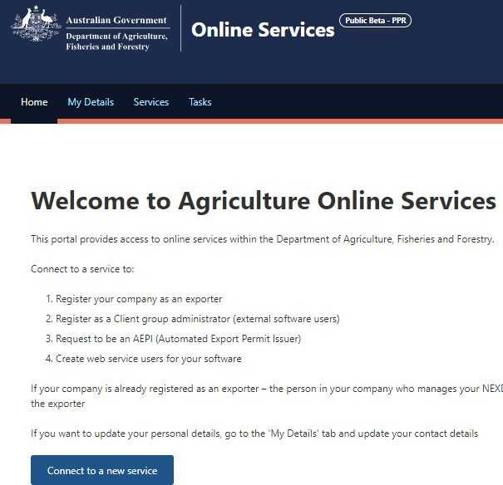

# Register as an Exporter or Create a Client Group

You must complete the process to register either as an Exporter or create a Client Group ***before*** you can Request to be an Automated Export Permit Issuer.

**If you are an Exporter:**

1. Select **Register as an Exporter** and complete the steps in the registration process.
2. Then you can either:
3. Email [NEXDOC@aff.gov.au](mailto:NEXDOC@aff.gov.au) to request to be allocated AEPI permission for the transferring commodity in NEXDOC, or
4. Return to the Services page (using the Back button), and
5. Select the **Request to be an Automated Export Permit Issue**r (AEPI) option from the NEXDOC Services section and complete the steps in the process.

**If you are a Freight Forwarder:**

1. Select **Client Group Administrator for External Software Users** and complete the steps in the registration process.

* If you are not legally responsible for the export of goods but are involved in the process of exporting goods, you are a client of an exporter, as an agent or freight forwarder.

|  |  |
| --- | --- |
| Step1  Select the appropriate option for registration in NEXDOC.  **If you are an Exporter, select Register as an Exporter. Complete this process first.**  **Or**  **Create a Client Group if you are an agent or freight forwarder.** |  |

**Once completed Return to Services**.

# Request to be an Automated Export Permit Issuer (AEPI)

|  |  |  |
| --- | --- | --- |
| Step 1  Select Request to be an Automated Export Permit Issuer (AEPI). |  |  |

# Applicant Details

|  |  |  |
| --- | --- | --- |
| Step 1  Enter the **company name.**  Select the commodity you are applying to issue permits for.  Select **Next**. |  |  |

# Applicant Status

|  |  |
| --- | --- |
| Step 1  Select the option that matches your status.  Select  **Next**. |  |

# Applicant Eligibility

|  |  |  |
| --- | --- | --- |
| Step 1  Select one or all of the eligibility requirements.  Select N**ext**. |  |  |

# Eligibility Checklist

|  |  |  |
| --- | --- | --- |
| Step 1  Upload attachments to confirm products meet minimum export requirements.  If your company does not have a checklist, click on the link to a sample checklist to complete and submit.  For information on eligibility see the [Approving export permits in NEXDOC](https://www.agriculture.gov.au/biosecurity-trade/export/certification/nexdoc/approving-export-permits-nexdoc#aepi-application-guide) advice.  Select **Next.** |  |  |

# Applicant Declaration

|  |  |  |
| --- | --- | --- |
| Step 1  Read the privacy notice and declaration.  If you agree, Select the ***I agree*** button.  **When you click the I agree** button, the application will be lodged. |  |  |

|  |  |
| --- | --- |
| The Request for AEPI has been lodged.  Select Return to Services for more options. |  |
| The department will review your application, and you will be notified of the decision through the NEXDOC inbox within the NEXDOC portal. | |

## Contact the NEXDOC help desk

For more information or assistance, please contact [NEXDOC@aff.gov.au](mailto:NEXDOC@aff.gov.au)