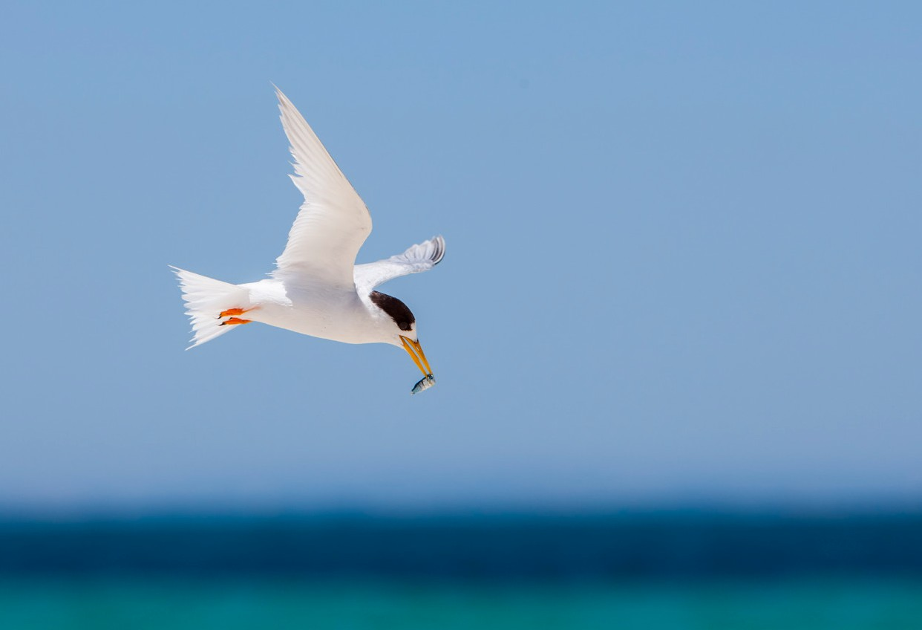

National Recovery Plan for the Australian Fairy Tern

*Sternula nereis nereis*



© Commonwealth of Australia 2020

**Ownership of intellectual property rights**

Unless otherwise noted, copyright (and any other intellectual property rights) in this publication is owned by the Commonwealth of Australia (referred to as the Commonwealth).

**Creative Commons licence**

All material in this publication is licensed under a Creative Commons Attribution 4.0 International Licence except content supplied by third parties, logos and the Commonwealth Coat of Arms.

Inquiries about the licence and any use of this document should be emailed to [copyright@awe.gov.au.](mailto:copyright@awe.gov.au)



The National Recovery Plan for the Australian Fairy Tern (*Sternula nereis nereis*) is licensed by the Commonwealth of Australia for use under a Creative Commons Attribution 4.0 International licence with the

exception of the Coat of Arms of the Commonwealth of Australia, the logo of the agency responsible for publishing the report, content supplied by third parties, and any images depicting people. For licence conditions see: <https://creativecommons.org/licenses/by/4.0>.

ISBN 978-1-76003-332-3

This report should be attributed as ‘National Recovery Plan for the Australian Fairy Tern (*Sternula nereis nereis*), Commonwealth of Australia 2020’.

The Commonwealth of Australia has made all reasonable efforts to identify content supplied by third parties using the following format ‘© Copyright, *[name of third party]* ’.

This publication is available at [awe.gov.au/publications](http://www.awe.gov.au/publications).

Department of Agriculture, Water and the Environment GPO Box 858 Canberra ACT 2601

Telephone 1800 900 090 Web awe.gov.au

The Australian Government acting through the Department of Agriculture, Water and the Environment has exercised due care and skill in preparing and compiling the information and data in this publication. Notwithstanding, the Department of Agriculture, Water and the Environment, its employees and advisers disclaim all liability, including liability for negligence and for any loss, damage, injury, expense or cost

incurred by any person as a result of accessing, using or relying on any of the information or data in this publication to the maximum extent permitted

by law.

**Images credit**

Cover page: Adult Australian Fairy Tern (*Sternula nereis nereis*) over Rottnest Island, Western Australia © Georgina Steytler

All other images: © Claire Greenwell

Contents

Summary 1

1. Introduction 3
   1. Conservation status 3
   2. Taxonomy 4
   3. Species description 4
   4. Species distribution in Australia 5
   5. Population trends 7
   6. Ecology 8
   7. Habitat critical to the survival of the Australian Fairy Tern 10
2. Threats 12
   1. Historical causes of decline 12
   2. Current threatening processes 12
      1. Habitat degradation and loss of breeding habitat 13
      2. Disturbance 14
      3. Invasive species 14
      4. Native wildlife 15
      5. Climate variability and change 15
      6. Water management and increased salinity 15
      7. Pollution 16
      8. Hybridisation 16
   3. Threat prioritisation 17
3. Populations under particular pressure 19
   1. Local conservation strategies 19
4. Recovery plan vision, objectives, and strategies 21
5. Actions to achieve the specific objectives 22
6. Duration and cost of the recovery process 31
7. Effects on other native species and biodiversity benefits 32
8. Social and economic considerations 33
9. Affected interests 34
10. Consultation 37
11. Organisations/persons involved in evaluating the

performance of the plan 38

1. References 40

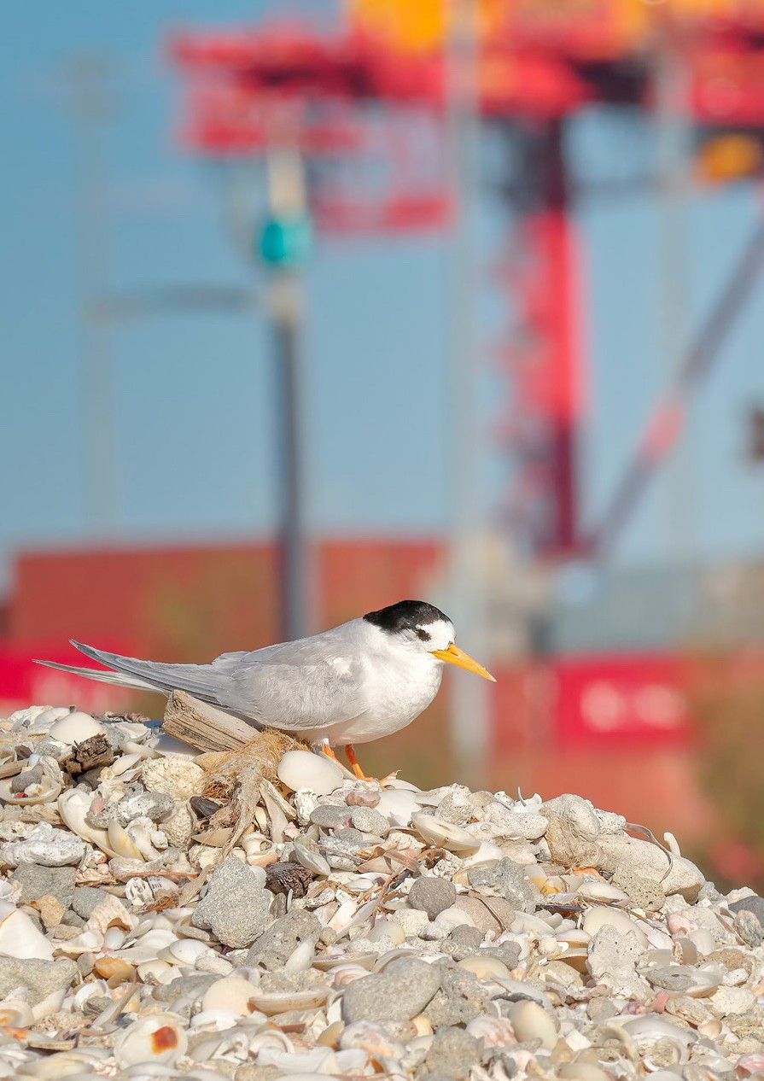Contents

**iv** National Recovery Plan for the Australian Fairy Tern (*Sternula nereis nereis*)

# Summary

**Australian Fairy Tern (*Sternula nereis nereis*)**

**Family:** Laridae

#### Current status of taxon:

* *Environment Protection and Biodiversity Conservation Act 1999* (Cwlth): Vulnerable
* *Threatened Species Protection Act 1995* (Tas): Vulnerable
* *Flora and Fauna Guarantee Act 1988 (*Vic): Critically Endangered
* *National Parks and Wildlife Act 1972* (SA): Endangered
* *Biodiversity Conservation Act 2016* (WA): Vulnerable

#### Distribution and habitat:

Australian Fairy Terns occur along the southern Australian coast from south of the Dampier archipelago Western Australia east to Botany Bay, New South Wales including Tasmania. The Great Australian Bight forms a gap in distribution between western and eastern subpopulations (Higgins and Davies 1996), and there are now substantial gaps amongst breeding colonies in eastern Australia, especially around the Victorian

coastline (Garnett et al. 2011). Australian Fairy Terns use a variety of habitats including offshore, estuarine, lacustrine (lake) islands, wetlands, beaches and sand spits

(TSSC 2011).

#### Recovery plan vision, objective, and strategies:

##### Long-term vision

The Australian Fairy Tern population has increased in size to such an extent that the species no longer qualifies for listing as threatened under any of the *Environment Protection and Biodiversity Conservation Act 1999* listing criteria.

##### Recovery plan objective:

By 2030, sustain a positive population trend (compared to 2020 baseline counts) in the number of mature individuals of the Australian Fairy Tern in both the eastern and western populations. This will be achieved by implementing the actions set out in this

Recovery Plan that minimise threats while protecting the species’ habitat throughout its range, adequately monitoring the species, generating new knowledge to guide recovery and increasing public awareness.

Summary

##### Strategies to achieve objectives

1. Manage and protect known Australian Fairy Tern breeding populations at the landscape scale
2. Develop and apply techniques to measure changes in population trend(s) in order to measure the efficacy of recovery actions
3. Reduce, or eliminate threats at breeding, non-breeding and foraging sites
4. Undertake research and monitoring to improve understanding of breeding,

non-breeding and foraging ecology in order to better target management actions and habitat restoration

1. Engage community stakeholders in Australian Fairy Tern conservation
2. Coordinate, review and report on recovery progress

#### Criteria for success:

This recovery plan will be deemed successful if, by 2030, all of the following have been achieved:

* The Australian Fairy Tern population has increased from 2020 baseline counts, as a result of recovery actions.
* Understanding of the species’ ecology has increased, in particular knowledge of population size, breeding biology, movement patterns, food availability and foraging efficiency relative to colony success, habitat use including the interaction between marine and terrestrial habitat features, post-breeding dispersal and survival rates.
* There is increased participation by key Australian stakeholders and the public in recovery efforts and monitoring.

#### Recovery team:

Recovery teams provide advice and assist in coordinating actions described in recovery plans. They include representatives from organisations with a direct interest in the recovery of the species, including those involved in funding and those participating in actions that support the recovery of the species. The national Australian Fairy Tern Recovery Team has the responsibility of providing advice, coordinating and directing the implementation of the recovery actions outlined in this recovery plan. The membership of the national Recovery Team includes individuals from relevant government agencies, non-government organisations and expertise from independent researchers and community groups.

Chapter 1

# Introduction

This document constitutes the *National Recovery Plan for the Australian Fairy Tern*.

The plan considers the conservation requirements of the species across its range and identifies the actions to be taken to ensure the long-term viability of the species, and the parties that will undertake those actions. The Recovery Plan is the first national plan to be developed for the Australian Fairy Tern.

The Australian Fairy Tern was listed as Vulnerable under the *Environment Protection and Biodiversity Conservation Act 1999* (Cwlth) (EPBC Act) on 3 March 2011. At the time of listing there were fewer than 9,000 mature individuals remaining and the total

population had undergone a substantial decrease of approximately 24 per cent over the past three generations, or 33 years (TSSC 2011). This decrease was expected to continue at a substantial rate over the next three generations, as there was no evidence that the threats affecting this species were abating (TSSC 2011). In 2020, the population was estimated to be 7,450 (range 6,800 – 8,100) mature individuals and was undergoing a continuing decrease, particularly in eastern Australia (Greenwell et al. 2021). There has been no change in the population trajectory since 2011 and the species continues to meet the Vulnerable category (Greenwell et al. 2021).

The accompanying Species Profile and Threats Database (SPRAT) pages provide background information on the biology, population status and threats to the Australian Fairy Tern. The SPRAT pages are available from: [http://www.environment.gov.au/](http://www.environment.gov.au/cgibin/sprat/public/sprat.pl) [cgibin/sprat/public/sprat.pl](http://www.environment.gov.au/cgibin/sprat/public/sprat.pl).

## Conservation status

The Australian Fairy Tern is listed as threatened under the Commonwealth *Environment Protection and Biodiversity Conservation Act 1999* (EPBC Act), and under State legislation (Table 1) in all parts of its range, except New South Wales. This species was included in the Vulnerable category under the EPBC Act in 2011 due to decreases in the number of mature individuals over much of its breeding range. Predation by introduced species, disturbance and inappropriate water level management are thought to have contributed most to this decrease.

**TABLE 1** National and state conservation status of the Australian Fairy Tern

|  |  |
| --- | --- |
| **Legislation** | **Conservation Status** |
| *Environment Protection and Biodiversity Conservation Act 1999* (EPBC Act) | Vulnerable |
| *Threatened Species Protection Act 1995* (Tasmania) | Vulnerable |
| *Flora and Fauna Guarantee Act 1988* (Victoria) | Critically Endangered |
| *National Parks and Wildlife Act 1972 (*South Australia) | Endangered |
| *Biodiversity Conservation Act 2016* (Western Australia) | Vulnerable |
| *Biodiversity Conservation Act 2016* (New South Wales) | Not listed |

## Taxonomy

The Australian Fairy Tern is conventionally accepted as *Sternula nereis nereis* (AFD 2019). It has been suggested that there are two subspecies on mainland Australia,

*S. n. nereis* in the south-east and *S. n. hornii* in the south-west, although key authorities only recognise *S. n. nereis* in Australia (Baling and Brunton 2005; Christidis and Boles 2008; Garnett et al. 2011; AFD 2019). Genetic differences were detected between Australian Fairy Terns in Western Australia and south-eastern Australia, however, these were not sufficient to merit treatment as separate subspecies (Dunlop 2018). The highest genetic diversity was found in the largest population in Western Australia (Baling and Brunton 2005), suggesting that this region was the source for the smaller breeding groups found in south-eastern Australia.

The distribution of the Fairy Tern (*Sternula nereis*) is limited to Australasia, comprising Australia, New Zealand and New Caledonia (Hansen 2006; Dunlop 2018).

Three subspecies have been identified based on phenotypic, genotypic and geographic differences. The New Zealand Fairy Tern (*S. n. davise*) is listed as Nationally Critical under the New Zealand Threat Classification System (Hitchmough et al. 2005; Hansen 2006).

The New Caledonian Fairy Tern (*S. n. exsul*) has approximately 200–400 breeding pairs (Barre et al. 2011), and has recently been recorded in the Swain Reefs, southern Great Barrier Reef, and islands in the Coral Sea Territory, suggesting regular movements of over 1,200 km (Carter and Mustoe 2007; Garnett et al. 2011). The low genetic diversity in the satellite populations in New Zealand and New Caledonia probably reflect the small number of founders (Dunlop 2018).

## Species description

A small piscivorous (fish-eating) bird, the Australian Fairy Tern is approximately 22–27 cm in length, 70 g in mass and has a wingspan of 44–53 cm (Higgins and Davies 1996). The Australian Fairy Tern is bulky and round bodied (Simpson and Day 2004).

The species is very similar to Little Tern (*S. albifrons*) which in breeding plumage can be distinguished from the Australian Fairy Tern by the yellow, black tipped bill and black line through the eye reaching the bill. Little Terns are overall slimmer than

Australian Fairy Terns with darker upperparts and outer primaries (Slater et al. 2009; Menkhorst et al. 2017).

The breeding plumage of both sexes is pale grey-white, with a black crown, nape, ear coverts and patch in front of the eyes (square to round in shape). The forehead is white and the bill is orange-yellow (Higgins and Davies 1996). Legs are dull yellow and the iris is dark brown (Lindsey 1986).

There is also little sexual dimorphism in non-breeding plumage, with a black bill and a more mottled appearance to the crown (Higgins and Davies 1996). The outer primary feathers are also less contrasting with no dark shoulder bar (Simpson and Day 2004).

Immature birds have blackish legs and bills (Lindsey 1986). The crown is streaked dusky and buff with a dark ear patch. The outer wing is dark greyish and the inner wing is pale grey and white (Simpson and Day 2004).

## Species distribution in Australia

The Australian Fairy Tern occurs in coastal southern Australia from the Montebello Islands of the Pilbara, Western Australia east to Botany Bay, New South Wales including Tasmania (Figure 1). The Great Australian Bight forms a gap in distribution between western and eastern populations (Higgins and Davies 1996). There are now a reduced number of nesting colonies in eastern Australia, especially around the Victorian coastline. The species has been recorded in Queensland but is considered to be a vagrant, an occasional visitor or more likely, New Caledonian Fairy Tern individuals.

In Tasmania, Australian Fairy Terns have suffered dramatic population declines.

Both Little and Australian Fairy Tern often nest together and some colonies are well documented. Eight colonies are known to be present in the Glamorgan-Spring Bay and Sorell Municipalities in south-east Tasmania (Blakney 2018). There are four known Key Biodiversity Areas in Tasmania based in part on their value to Australian Fairy Terns, primarily through supporting their breeding locations: Orford, Marion Bay, St Helens and Eastern Flinders Island (Bass Strait). In 2020, the Orford Bird Sanctuary had one of the best breeding seasons in many years with at least 40 adults and 27 chicks recorded between January and February (E. McDonald and P. Geard pers. comm). Maintaining, and if possible, increasing the number and size of these colonies in Tasmania will be crucial to recovering this species in south-east Australia.

Within Western Australia, there appear to be two subpopulations (Dunlop 2018). One is sedentary and based along the Pilbara and upper Gascoyne coasts from Exmouth Gulf to the Dampier Archipelago, including Barrow Island and the Montebello and Lowendal Archipelagos. These Australian Fairy Terns nest from late July to late September (Johnstone and Storr 1998, Dunlop 2018). A second, migratory subpopulation disperses south along the coastline from Shark Bay (Burbidge and Fuller 2000) to breed between the Houtman Abrolhos Islands to the Recherche Archipelago between September

and May, with active breeding flocks appearing at various locations between October and February (Johnstone and Storr 1998). At present it is not clear what controls the recruitment of individuals to these over-lapping subpopulations (Dunlop 2018). It is also currently not known at what scale local breeding groups (which probably establish colonies at a number of sites) represent conservation management units within the migratory subpopulation (Dunlop 2018).

Biologically Important Areas for this species occur in Australian Marine Parks, particularly in the South-west and North-west Marine Parks Networks. Under statutory management plans, Australian Marine Parks are managed for the protection and conservation of biodiversity and other natural, cultural and heritage values of marine parks, including protected species. More information about Australian Marine Parks can be found [here](https://parksaustralia.gov.au/marine/).

**FIGURE 1** Modelled distribution of the Australian Fairy Tern

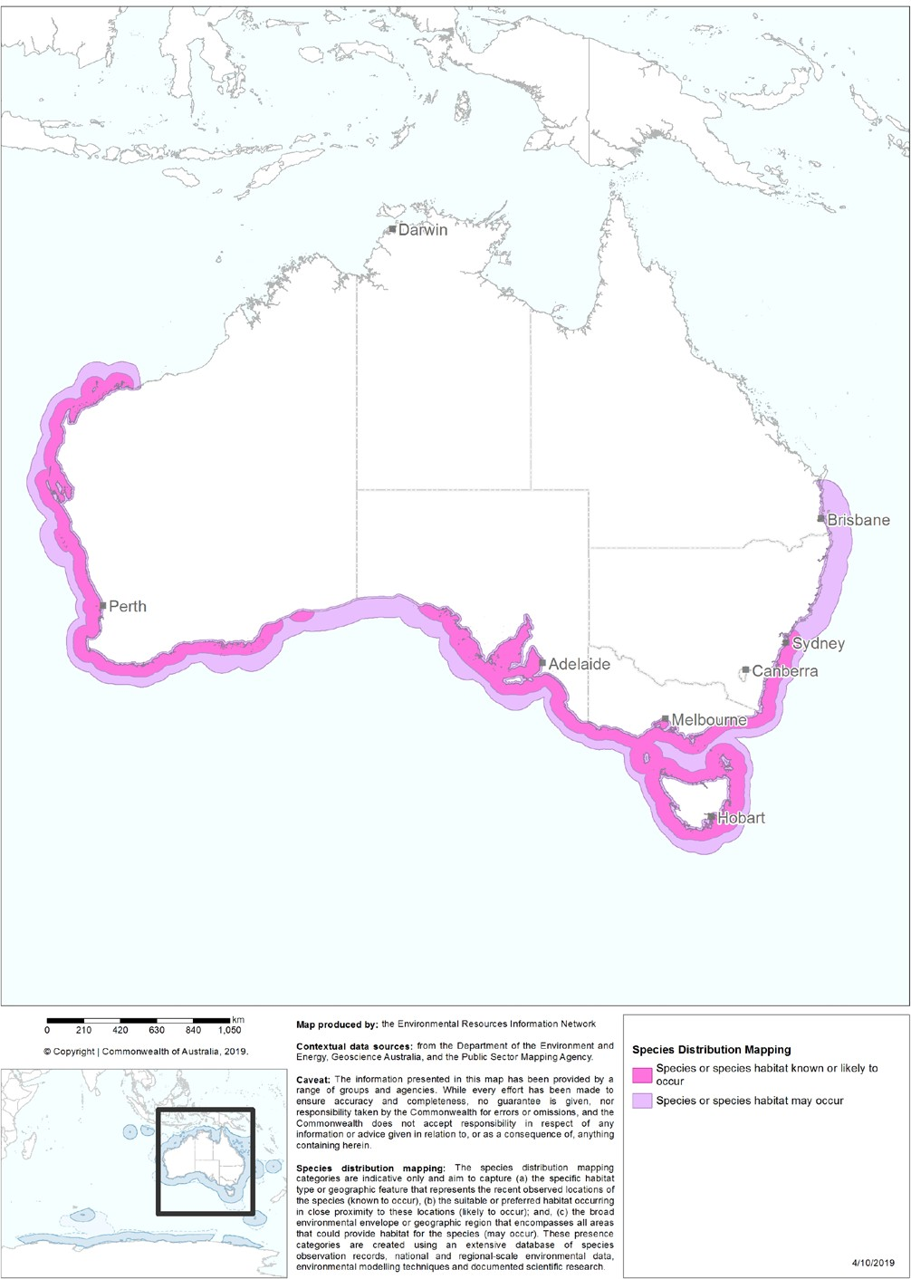

## Population trends

The population of Australian Fairy Terns is about 7,450 (range 6,800–8,100) mature individuals (Greenwell et al. 2021). The largest population of 5,000–6,000 in Western Australia is believed to be stable but there is no reliable historical data. In eastern Australia there have been rapid decreases. State based estimates include 900–1,150 in South Australia (DENR 2012; Cooper 2015; Stephens and Lamanna 2019; D. Paton unpublished), 100–120 pairs in Tasmania (2019/20, E.J. Woehler pers. comm. 2020), 100–150 in Victoria (Adams et al. 2019) and fewer than 50 in New South Wales (South Coast Shorebird Recovery Program 2017; Greenwell et al. 2021).

In South Australia, a survey of 1500 km of coastline in 2011/12 found a minimum of 944 birds at 19 sites (DENR 2012). Numbers in the South Lagoon of the Coorong, Lakes Alexandrina and Albert Wetland Ramsar site (the Coorong) have decreased from 1,330 individuals in 1985 to 150–300 in 2000–2007, an 82 per cent decline (Paton and

Rogers 2009). Only 357 individuals were counted during the annual census of waterbirds in the Coorong in January 2018. This result is less than in January 2015 and 2016 and

is only a little over half of the birds that were using the Coorong in the early 2000s (Paton and Paton 2018). Australian Fairy Tern numbers have continued to decrease in the Coorong over the last five years from 300–350 adult birds to 315 individuals in

January 2019 (Paton et al. 2019). Elsewhere in South Australia, the species disappeared from the Fleurieu Peninsula in the late 1970s and around Kangaroo Island in the early 1990s, however, small numbers are now breeding again around Kangaroo Island

(D. Paton, pers. comm. 2020). Breeding populations in Gulf St Vincent, Spencer Gulf and near Beachport are very small with low breeding success (Garnett et al. 2011).

One island in particular in Gulf St Vincent just 20 km north of Adelaide, Bird Island, has been monitored since 2001, and more intensively since 2015 with weekly visits over the 2018–19 and 2019–20 seasons (Stephens and Lamanna 2019). Bird Island had between 10 and 35 breeding pairs in early 2000s, approximately 60–80 pairs between 2015–2018 and over the 2018–19 season 50–60 pairs (Stephens and Lamanna 2019).

In Victoria, the number of breeding pairs at French Island in Western Port Ramsar site decreased from a peak of 108 in 1993 to an average of 21 for the decade 1996–2005 (Garnett et al. 2001). Historically, colonies of over 50 breeding pairs were observed within Western Port and Port Phillip Bay Ramsar sites but numbers began to decrease in the late 1980s (Adams et al. 2019). There are currently few records documenting successful breeding attempts over the last decade within the two bays and it is thought that breeding success is poor (Adams et al. 2019). Approximately 54 adults comprising three colonies were observed within Western Port and Port Phillip Bay Ramsar sites during the 2016–17 breeding season. Only one breeding colony of 30–40 adults was observed during the 2017–18 breeding season while no breeding colonies were detected during the 2018–19 breeding season (Adams et al. 2019). In Victoria, no successful breeding has occurred in Western Port and Port Phillip Bay Ramsar sites in either the 2017–18 or 2018–19 breeding season (Adams et al. 2019). Gippsland Lakes Ramsar site continues to host breeding Australian Fairy Terns. From 2015–2018,

114 Australian Fairy Terns chicks fledged across the Gippsland Lakes Ramsar site. This was a noteworthy increase in recruitment post sand island rehabilitation. Prior to this, numbers of fledglings of both Australian Fairy and Little Tern species for many years had been recorded in single figures only (DELWP, unpublished). In 2018–19,

an estimated 25 Australian Fairy Terns chicks fledged from only one breeding site. The 2019/20 season did not produce any fledglings despite multiple nesting attempts (Sullivan et al, unpublished report).

In New Zealand, subspecies *davisae* declined to three pairs in 1983 but due to intensive conservation efforts increased to 25–30 birds and 8–10 pairs over four sites in 1998 (Hansen 2006). In 2006 the population had increased to 30–40 individuals and

10 pairs (Parrish and Honnor 1997, Taylor 2000). By 2011, this had increased again to 40–45 individuals and 10 pairs (P-J. Pridham in litt. 2011). As of 2019, the current breeding population is six pairs.

In New Caledonia, subspecies *exsul* numbers 200–400 pairs, but was formerly much more abundant (Barre et al. 2012; BirdLife International 2019). One small population in the Southern Lagoon of New Caledonia may be increasing (Baling et al. 2009).

## Ecology

#### Social behaviour

As with all other terns (Cabot and Nisbet 2013), Australian Fairy Terns are gregarious, gathering together at roost sites both during and outside the breeding season (Dunlop 2018). In Western Australia, night roosts are generally located on open shoreline features such as sandspits, away from vegetation cover and predators (Dunlop 2018). Some are only occupied during the arrival period whilst others are occupied for most of the breeding season. These roosts may contain birds at a range

of ages with the composition changing as the season progresses (Dunlop 2018). Night roosts may include pre- and post-breeding experienced adults, individuals entering their first breeding season, non-breeding individuals in their first summer, and fledglings (Dunlop 2018; J.N. Dunlop pers. obs.).

The social behaviour associated with colony site selection and establishment has not been investigated in Australian Fairy Terns, probably because it is hard to predict when and where it will occur (Dunlop 2018). In other terns that do not have inter-annual

nest-site fidelity, courting flocks of reproductively advanced, nuptial plumaged birds commonly occur adjacent to potential colony sites (e.g. Crested Tern - Dunlop 1987, Little Terns - Cramp et al. 1985, Sooty Tern - Ashmole 1963, and J.N. Dunlop pers. obs.). In Western Australia, ‘clubs’ are social roosts that are occupied by birds in breeding condition, have nuptial plumage, are courting and are ready to breed. Here pair bonds form or reform and these clubs are usually in close proximity to the breeding site.

These areas are critical to the social ecology of the species. Terns in these pre-breeding flocks are typically engaged in bouts of aerial courtship ‘social flights’ and ground displays or parades at diurnal club sites (Cabot and Nisbet 2013). Pairs form or re-form in these flocks and paired courtship displays frequently follow bouts of group behaviour.

In Western Australia, the timing of colony formation and egg-laying is likely dictated by food availability, with colonies forming close to areas of high food abundance (Dunlop 1987). Colonies may occur at the same general location for a series of seasons and then shift (Dunlop 2018). Some observations indicate that a ‘neighbourhood’ of

breeding terns return to the breeding site used in the previous year during the ‘clubbing’ phase but may then move in a coordinated way to a fresh location (Dunlop 1987, Sooty Tern - J.N. Dunlop pers. obs.). This behavioural pattern may assist in maintaining pair bonds together with providing the opportunity to synchronise timely breeding with neighbours of similar age/experience or quality. Younger, less experienced terns tend

to lag in their reproductive cycle, lay later outside the peak foraging window and, as a consequence, have reduced breeding success compared to more experienced pairs (Dunlop 2018).

Male Australian Fairy Terns feed whole fish to their mates in a coition display that precedes copulation (Serventy et al. 1971). Other inshore feeding terns also carry fish crosswise in their bills to clubs as ornaments in group and paired displays, however in these species courtship feeding is not an obligate prelude to mating (Dunlop 2018).

Males also feed their mates whilst they are incubating. It is likely that the ability of male terns to provision females is an important indicator of mate quality and increases breeding performance, as it does in the Common Tern (Nisbet 1973).

#### Breeding

In Australia, the subspecies breeds between June and March in colonies of various sizes (generally between 2–400 pairs but up to 700 pairs in Western Australia (Dunlop et

al. 2015; Dunlop 2018). Colonies can be located on coral shingle on coastal islands, or coral cays, on sandy islands and beaches inside estuaries, and open sandy beaches, laying 1–2 eggs (rarely 3) in a nest scrape (Higgins and Davies 1996). They nest in clear view of the water and on sites where the substrate is either sandy or on shell-grit and the vegetation sparse. In Western Port Ramsar site, Victoria, birds use seagrass covered beaches to nest on Rams Island.

Incubation duties are shared but females probably spend more time at the nest whilst males actively provision females before and after laying, as is the case with Little Terns (Cramp 1985; Cabot and Nisbet 2013). Incubation lasts for approximately 18–22 days (Lindsey 1986; Higgins and Davies 1996). Chicks may be guarded by one parent for the first day or two. However, it is not unusual for chicks to be left alone whilst the adults undertake foraging bouts (C. N. Greenwell. pers. comm. 2020). Chicks fledge at about 20 days. Nesting birds are sensitive to disturbance and can become extremely agitated when disturbed by humans or other animals. Females often crouch on the ground; however both sexes have been known to attack intruders (Higgins and Davies 1996; Lindsey 1986).

There is a high natural rate of breeding failure as breeding sites can become inundated during extreme weather events, such as high tides and storm surges or be smothered by wind-blown sand. Colonies tend to occupy areas rather than fixed sites, and nest sites can be abandoned after one or more years, even if they have been successful (Saunders and de Rebeira 1985).

Interbreeding has been recorded between Fairy Terns and the Little Tern in South Australia (Cox and Close 1977), Victoria (Norman et al. 1996), NSW (Ross et al. 1999) and Tasmania (E.J. Woehler pers. obs).

#### Feeding

Australian Fairy Terns hover and then dive into shallow waters in order to catch small baitfish; however they may scavenge from shoals of feeding predatory fish (Higgins and Davies 1996; Dunlop 2018). Australian Fairy Terns feed almost entirely on fish in near-shore waters adjacent to nesting colonies and around island archipelagos (Higgins and Davis 1996). Fish species consumed include Australian

Anchovies (*Engraulis australis*), Pilchards (*Sardinops neopilchardus*), Striped Trumpeter (*Latris lineata*) and Blue Sprats (*Spratelloides robustus*) (Taylor and Roe 2007; E. Stephens pers. comm 2020). Fairy Terns have been observed opportunistically feeding on small squids during twilight hours (C. N. Greenwell pers. obs).

In south-west Western Australian coastal locations, Australian Fairy Terns have been observed carrying Hardyheads (*Pranesus ogilbyi*), Whitebait (*Hyperlophus vittatus*), and Bluesprat up to about 60 mm in length (Dunlop 2018) and Southern Sea Garfish (*Hyporhamphus melanochir*), Two-by-three Garfish (*Hemiramphus robustus*), Snub-nosed Garfish (*Arrhamphus sclerolepis)* and flying fish (Exocoetidae spp.) up to

~150 mm in length (C. N. Greenwell pers. obs.). At the Abrolhos Islands, Australian Fairy Terns handled during banding operations regurgitated Hardyheads between 20 and

50 mm and, surface-schooling, post-larvae of the Black-spot Goatfish (*Parupeneus signatus*), approximately 20–40 mm (Dunlop 2018; J.N. Dunlop pers. obs). In estuarine environments, Gobiidae spp. and Western Hardyheads (*Leptatherina wallacei*) are important dietary constituents (C. N. Greenwell pers. obs). Contemporary dietary studies in eastern Australia are lacking and require further investigation.

## Habitat critical to the survival of the Australian Fairy Tern

As noted above, the habitat, or biophysical environment, of the Australian Fairy Tern varies across its range, so it is not possible to generate one detailed description or definition of habitat critical to survival. The habitat critical to the survival of the Australian Fairy Tern may be more usefully defined at a bioregional scale that takes into account the local combination of plants, animals, geology, landforms, and climate that are relevant to a geographical unit. However, any categorisation of habitat critical to survival must acknowledge that it exists as a mosaic of coastal habitats and the adverse effects of extant threats.

In general, Australian Fairy Terns utilise a variety of habitats including offshore, estuarine or lacustrine (lake) islands, coastal wetlands, beaches and sand spits.

The species migrates within southern and mid-west Western Australia and possibly Tasmania, where they are seen less frequently during the winter months. The Tasmanian and Victorian populations may form a single subpopulation. The species is more sedentary in the north of Western Australia (Hill et al. 1988; Dunlop 2018). Australian Fairy Terns nest above the high water mark often in clear view of the water and on sites where the substrate is sandy and the vegetation low and sparse. Nests typically consist of a shallow scrape in the sand which is often lined with small shells and vegetation.

Birds will utilise seagrass covered beaches for nesting in Victoria.

As a guide, habitat critical to the survival of the Australian Fairy Tern can be considered to comprise:

* suitable habitat where the species is known or likely to breed or forage as shown in the indicative distribution map (Figure 1)
* any suitable habitat outside the above area that may be periodically occupied by non-breeding Australian Fairy Terns.

Habitat critical to the survival of the Australian Fairy Tern is centred on beaches and offshore islands (for nesting) and near-shore waters (for foraging) and occurs across a wide range of land tenures, including on Indigenous Protected Areas, freehold land, state reserves, and national parks. It is essential that the locations where the species regularly occurs are given the highest protection, as they are likely to be productive habitats

with high resource availability. Conservation measures should target these productive habitats. Sympathetic management of buffer areas adjoining nesting and foraging habitats is also important.

When considering developments in any part of the species range, including in areas where the species ‘may occur’, surveys for occupancy at the appropriate times

(See 2.6 *Ecology*) of the year are an important tool in establishing the areas of importance for the Australian Fairy Tern. In addition, it is also important to note that the Australian Fairy Tern opportunistically use areas depending on the occurrence of prey species. As such, it is critical to understand the interactions between marine

and terrestrial factors and their influence on the areas used by Australian Fairy Terns. Areas that may be important habitat over time might not have birds in any given year. This pattern of ephemeral habitat use means that recent survey data and historical records need to be considered when assessing the relative importance of an area for the Australian Fairy Tern. Regular monitoring of known breeding sites will assist in determining local extent of inter-annual variation in colony size and use.

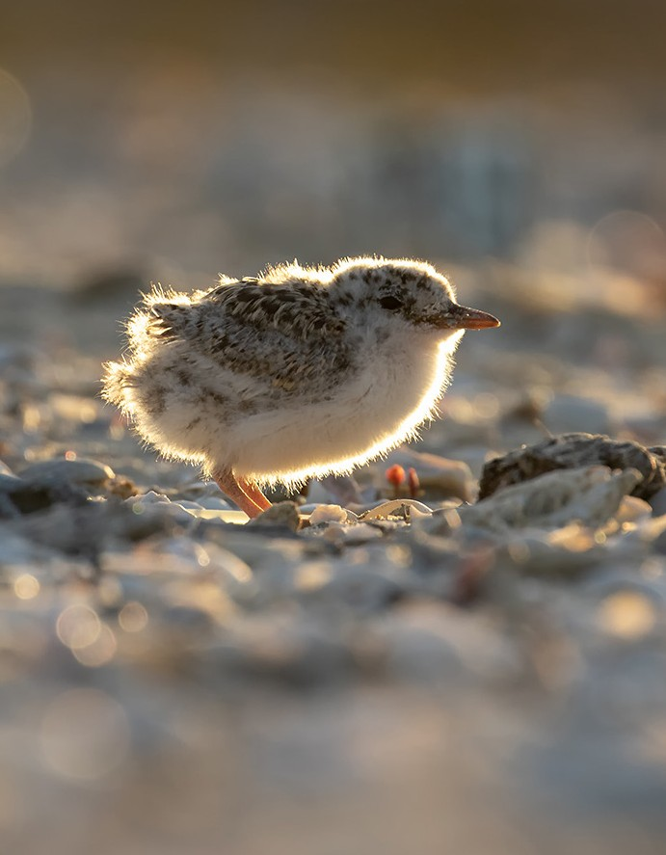

Chapter 2

# Threats

## Historical causes of decline

The Australian Fairy Tern population has been in decreasing for at least the last 30 years (Garnett et al. 2011). The decrease is most prominent in the eastern population and is associated with the loss of key nesting habitats and disturbance from an increasing human population.

## Current threatening processes

The main threat to the Australian Fairy Tern is the disturbance of breeding sites by human activities (including bikes, dogs, horses, drones and vehicles) and predation by introduced species and native birds (TSSC 2011; Garnett et al. 2011; Dunlop 2018). Disturbance of breeding birds may cause direct loss of eggs and chicks or the abandonment of nesting sites resulting in egg-predation or chilling, or overheating of eggs, leading to egg death (Higgins and Davies 1996). Predators of the Australian Fairy Tern include Foxes (*Vulpes vulpes*), Dogs (*Canis familiaris*), Cats (*Felis catus*),

Black Rats (*Rattus rattus*), Silver Gulls (*Chroicocephalus novaehollandiae*), Pacific Gulls (*Larus pacificus*), raptors and ravens (*Corvus* spp.) (Saunders and de Rebeira 1985; Hill et al. 1988; TSSC 2011; Greenwell et al. 2019). Proximity to roads is also another threat for chicks that are fledging or practising flights. The species is also adversely impacted by extreme weather events such as heavy rainstorms and storm surges that reduce breeding success. It is the species’ nesting habitat preferences that make the Australian Fairy Tern so susceptible to disturbance, predation and extreme weather events.

Any threats in or around the breeding sites can be detrimental to the colony. Threats include overgrown vegetation, weed encroachment, land development, extreme weather events, extreme salinities, unsuitable sand management and water management in waters surrounding breeding sites (Higgins and Davies 1996; TSSC 2011; E. Stephens pers comm. 2020).

Furthermore, increased salinity in waters adjacent to breeding colonies (the Coorong, Lakes Alexandrina and Albert Wetland Ramsar site, South Australia) can cause changes to local populations of prey fish abundance and distribution. Nest flooding or an increased exposure to predators can occur due to a rise or decrease in water levels, respectively (TSSC 2011).

In the event of an oil spill or ship-related oil spills, the Australian Fairy Tern could be potentially threatened due to the proximity of the species’ coastal breeding and inshore feeding habitats to known and potential offshore oil facilities, shipping facilities and sea routes (TSSC 2011).

### Habitat degradation and loss of breeding habitat

Australian Fairy Terns do not necessarily retain the same nest site from one breeding attempt to the next (Dunlop 2018). However, colonies may establish in the same general locations in consecutive years or re-use certain places intermittently (Dunlop 2018).

Shoreline sites may be subject to rapid change due to sand erosion or accretion, tidal cycles and sea-levels, beach-wrack movement and deliberate modification. Locations that have been used in the past may be lost, become less attractive to the terns or become subject to increased disturbance or predation (Dunlop 2018). The shifting of nesting sites may be a strategy to reduce predation risks (J.N. Dunlop pers. comm. 2020).

Colony sites that are attractive to breeding pairs may develop naturally or result from coastal development activity including the clearing or loss of dune vegetation, the dumping of dredge spoil or beach-engineering (Dunlop 2018). Clearing of near

coastal areas for development (industrial or residential) can render the area attractive to breeding terns, leading to their rapid colonisation of the site earmarked for development/works. This can lead to conflict between the primary intended use of the land and its occupation by a threatened species. In Western Australia for example, this occurred on a reclaimed seabed area of the Fremantle Harbour, leading to the creation of the Rous Head Fairy Tern Sanctuary by Fremantle Ports and this is now one of the most successful breeding locations for the species. Some sites, which are well above the coastal strand, may become vegetated with native dune vegetation or covered by introduced weeds, making them unusable.

Intervention may be necessary to increase the probability that one or more secure sites will be used, or alternatively, to prevent breeding Australian Fairy Terns being attracted to inappropriate locations (Dunlop 2018). Potential breeding sites that result from development footprints or coastal engineering may put nesting terns at risk of breeding failure and increased adult mortality (Dunlop 2018).

In the absence of sufficient protected breeding sites in the local coastal system, steps may have to be taken to enhance the attractiveness of either naturally developing or artificial habitats (Dunlop 2018). This could involve reducing the vegetation cover, contouring the surface to produce low berms or adding shell or limestone pebble material to otherwise visually uniform substrates (Dunlop 2018). Local shell material to enhance preferred nesting sites has been sourced from Pacific Gull feeding stations, and in one case, from the coarse screenings from a marine lime-sand operation. In the absence of cover for the chicks at the margins of a planned nesting area, simple shading ‘chick-shelters’ can be placed to increase fledging success (Dunlop 2018). These can often be constructed from local rocks or driftwood or purpose built.

In coastal systems where human use pressures now prevent Australian Fairy Terns from breeding successfully, there is growing interest in establishing secure artificial sites (Dunlop 2018). These may be dredge-spoil islands in strategic locations or even floating islands and nesting platforms landscaped to provide breeding habitat. In the absence of legal protections however, even these sites may not be secure from human disturbance.

### Disturbance

The presence of people, and/or their dogs, within 80–100 metres of an Australian Fairy Tern breeding colony will elicit an anti-predator response (BirdLife Australia 2018).

The nest-tending adults will take to the air to avoid disclosing the location of their eggs and/or young, and will then engage in noisy corporate dives on intruders. Direct physical contact is avoided but the terns will accurately defecate on interlopers or foreign objects within the nesting area.

Ongoing disturbance events during the colony establishment or early-laying period will often lead to the abandonment of the site (a predator avoidance response).

Although, relaying a clutch of eggs may occur elsewhere in the coastal system if eggs are lost early in the season, protracted disturbance later in the nesting cycle may cause unattended eggs or chicks to chill or overheat or starve, leading to egg loss and chick death, or clutches may be buried in moving sand or attract predators.

Commensal predators such as gulls, ravens or dogs may follow people (or their rubbish) to colonies and then prey on Australian Fairy Tern eggs or chicks. Gulls and ravens in particular have been known to opportunistically plunder exposed nests during periods of human disturbance.

A number of successful strategies have been employed to try and protect beach nesting birds (including Hooded Plover, Little and Australian Fairy Terns) from human disturbance. These are chick shelters, community education, signage (combined with boundary delineation) and volunteer wardens. However, education does not work on its own without an holistic strategic approach combining education, on-ground cues (e.g. signs/fences), compliance patrols and reviews of effectiveness/staged responses.

### Invasive species

Most Australian seabirds breed on islands to avoid mammalian predators.

However, Australian Fairy Terns also breed at sites along the coastline presumably because they are accessible to near-shore concentrations of small fishes (Dunlop 2018). The breeding strategy adopted by the species (including the regular shifts in nesting areas) is probably, in part, an adaptation to avoid targeting by land-based predators (Dunlop 2018).

At mainland sites, the major mammalian predators of Australian Fairy Tern nests are foxes, cats, rats and dogs (Dunlop 2018; Greenwell et al. 2019; Stephens and Lamanna 2019). Baiting programs for foxes, cats and rats can be carried out on the island nature reserves and at remote coastal locations but are generally not an option in public spaces, such as coastal recreation areas, due to the risks to non-target species including pet animals. Soft-jaw traps baited with scent lures (urine or faeces) can be an effective,

low risk method, for the targeted removal of foxes and cats in peri-urban and rural areas. These traps are designed for live capture and are not in themselves likely to harm the predator or other non-target animals (e.g. domestic dogs). The use of scent lures rather than food baits reduces their attractiveness to other species. Another method for problem foxes or cats around colonies is engaging a trained shooter. Baiting programs, trapping, engaging a trained shooter and other controls methods are subject to relevant approvals from the relevant state or territory agencies.

Some colonies in Tasmania are threatened with the establishment and expansion of Sea Spurge (*Euphorbia paralias*), a coastal plant from the Mediterranean. The plant is tolerant of salt water and establishes coastal meadows that alienate and fragment coastal breeding sites for Australian Fairy Terns (E.J. Woehler unpubl. data).

### Native wildlife

Raptors, such as Whistling Kites (*Milvus sphenurus*), Silver Gulls and Australian Ravens are the principal avian predators of eggs and chicks on mainland Australia (Dunlop 2018; Stephens and Lamanna 2019). During the surveillance of potential breeding sites it is useful to detect evidence of predator activity either from direct observation or from tracks (including prepared sand-pads) or using motion-detector cameras (Dunlop 2018). Any anti-predator interventions need to be timely if they are going to be effective.

Land managers need to be aware that the presence of people around colonies, including staff and conservation volunteers/wardens, may attract predators (that are also scavengers) to a colony area or provide opportunities for them to locate and plunder the nests (Dunlop 2018). Signs, fence-posts and other structures erected to protect colonies may become observation posts for gulls, ravens or birds of prey, increasing the risk of predation (spikes in the top of fence posts can prevent this). Rubbish bins or fish-cleaning stations near beaches with Australian Fairy Tern colonies can attract gulls, ravens and rats, and should be relocated.

### Climate variability and change

Rising sea-levels caused by global warming (thermal expansion and ice-melt) are already forcing changes in shorelines. Coastal engineering works such as sea-walls, groynes, boat harbours, canal developments and reclamation projects also change the pattern of sedimentation and erosion, potentially removing breeding and foraging habitat/resources (i.e. fish species) for Australian Fairy Terns (Dunlop 2018). One result of these changes is that some breeding sites on beaches or sand banks become

exposed to tidal flooding (e.g. Peel-Yalgorup System Ramsar wetland) or storm surges (Dunlop 2018). Other sites on accreting shorelines may become vegetated making them unsuitable nesting habitats. Pre-breeding aggregation sites have been abandoned due to the erosion of sand bars (e.g. Penguin Island, Rockingham, WA) and previously secure islands have been connected to the mainland by new sand banks allowing access to domestic dogs and invasive predators such as foxes and Black Rats (e.g. Tern Island in Safety Bay, WA) (Dunlop 2018).

### Water management and increased salinity

High water levels in the south-west Western Australian estuaries in recent years have generally reduced the availability of roosting and breeding sites (Dunlop 2018).

The consequence of this is the overfilling of the estuaries including the inundation of roosting and nesting sites on banks and sand-spits, and the loss of connection with the marine food-chain which provides the preferred prey species. This removes roosting, breeding and foraging habitat for Australian Fairy Terns leading to their disappearance from some systems (e.g. Wilson Inlet, WA) (Dunlop 2018). In other locations, the drying climate has reduced run-off into some estuaries, leaving entrance blocking sandbars closed throughout the year.

In the Coorong, South Australia, water management (establishment of excessively high salinities) led to a collapse in the numbers of prey fish for 3–4 years at the end of the Millennium Drought in the southern Coorong, and a subsequent abandonment of traditional breeding sites (small islands in the southern Coorong) by Australian Fairy

Terns (Garnett et al. 2011; D Paton pers. comm. 2020). Compounding the loss of foraging habitats, was the lack of secure islands free from predators but close to areas that still support reasonable abundances of small fish (Paton and Rogers 2009). When typical salinities returned at the end of the drought and had allowed the fish to return, the birds also returned to breed on islands in the southern Coorong.

In Victoria, the decommissioning of a saltworks led to the collapse of active water management resulting in salt pans drying out. Once the site of a large breeding colony, Australian Fairy Terns abandoned the site as the previously isolated islands became accessible to mammalian predators and overgrown with vegetation.

### Pollution

Australian Fairy Terns locate colonies close to prey resources (generally small schooling fishes) and can often be seen foraging within visual distance of nesting areas (Dunlop 2018). The ‘baitfish’ often concentrate around estuary mouths where there is enhanced marine productivity from the nutrient plume, or at temperature, salinity or tidal fronts that concentrate plankton (Dunlop 2018). Such areas are also potentially areas of compromised water quality from urban and rural drainage, acid sulphate soils,

canal estates, boat harbours, coastal heavy industries and ports (Dunlop 2018). As such, these areas may be foci for the bio-accumulation of heavy metals and pesticides and the concentration of floating debris.

At present there are no data on the contaminant burden in Australian Fairy Terns from different parts of their breeding range (Dunlop 2018). Little Penguins have a similar diet and foraging habitats to Fairy Terns and these show elevated levels of various contaminants around southwestern Australia, including Mercury in Cockburn Sound and Selenium in the Albany waterways (Dunlop et al. 2013). At the remote Abrolhos Islands, the binders in fabricated plastics (phthalates) were present in the preen gland secretions of 49 per cent of the Australian Fairy Terns sampled (Dunlop 2018). Phthalates are potent pseudo-oestrogens capable of interfering with sexual development and reproduction.

### Hybridisation

Hybridisation has been recorded between Australian Fairy Terns and Little Terns in South Australia (Cox and Close 1977), Victoria (Norman et al. 1996), New South Wales (Ross et al. 1999) and Tasmania (E.J. Woehler unpubl. obs.). Further interbreeding may diminish the genetic distinctiveness of both species (Ross et al. 1999).

Interbreeding between Little and Australian Fairy Terns is particularly problematic in New South Wales where Little Terns are listed as Endangered under state legislation. Appropriate management interventions are required to discourage hybridisation, predominantly in New South Wales.

## Threat prioritisation

Each of the threats outlined above has been assessed at expert workshops to determine the risk posed to the Australian Fairy Tern population using a risk matrix. This, in

turn, determines the priority for actions outlined below. The risk matrix considers the likelihood of an incident occurring and the consequences of that incident. Threats may act differently in different parts of the species range and at different times of year,

but the precautionary principle dictates that the threat category is determined by the subpopulation at highest risk. Population-wide threats are generally considered to present a higher risk.

The risk matrix uses a qualitative assessment drawing on peer reviewed literature and expert opinion. In some cases the consequences of activities are unknown. In these cases, the precautionary principle has been applied. Levels of risk and the associated priority for action are defined as follows:

* **Very High** – immediate mitigation action required
* **High** – mitigation action and an adaptive management plan required, the precautionary principle should be applied
* **Moderate** – obtain additional information and develop mitigation action if required
* **Low** – monitor the threat occurrence and reassess threat level if likelihood or consequences change

**TABLE 2** Risk prioritisation

|  |  |  |  |  |  |
| --- | --- | --- | --- | --- | --- |
| Likelihood of Consequences | | | | | |
| occurrence | Not significant | Minor | Moderate | Major | Catastrophic |
| Almost certain | Low | Moderate | Very High | Very High | Very High |
| Likely | Low | Moderate | High | Very High | Very High |
| Possible | Low | Moderate | High | Very High | Very High |
| Unlikely | Low | Low | Moderate | High | Very High |
| Rare or Unknown | Low | Low | Moderate | High | Very High |

#### Categories for likelihood are defined as follows:

* **Almost certain** – expected to occur every year
* **Likely** – expected to occur at least once every five years
* **Possible** – might occur at some time
* **Unlikely** – such events are known to have occurred on a worldwide basis but only a few times
* **Rare or Unknown** – may occur only in exceptional circumstances; OR it is currently unknown how often the incident will occur

#### Categories for consequences are defined as follows:

* **Not significant** – no long***-***term effect on individuals or populations
* **Minor** – individuals are adversely affected but no effect at population level
* **Moderate** – population recovery stalls or reduces
* **Major** – population decreases
* **Catastrophic** – population extinction

Likelihood of

Consequences

**TABLE 3** Australian Fairy Tern residual risk matrix

|  |  |  |  |  |  |
| --- | --- | --- | --- | --- | --- |
| occurrence | Not significant | Minor | Moderate | Major | Catastrophic |
| Almost certain |  | Hybridisation | Native wildlife  Habitat degradation and loss of breeding habitat | Disturbance Invasive species  Climate variability and change |  |
| Likely |  |  | Water management and increased salinity |  |  |
| Possible |  | Pollution |  |  |  |
| Unlikely |  |  |  |  |  |
| Rare or Unknown |  |  |  |  |  |

Chapter 3

# Populations under particular pressure

The eastern population that occurs in South Australia, Victoria, New South Wales and Tasmania has recorded significant decreases over the last 20 years (Garnett et al. 2011; Greenwell et al. 2021). The eastern population may be as low as 1,300–1,600 mature individuals. Conservation efforts should focus on the eastern population to facilitate an increasing population trend over the life of this Recovery Plan.

## 3.1 Local conservation strategies

Dunlop (2018) outlines a number of practical solutions for protecting colonies from human encroachment, predators and innovative ways to boost breeding success.

One approach to improving Australian Fairy Tern breeding performance within local coastal populations is to encourage the terns to select secure or manageable nesting sites. This can be done using social facilitation techniques that involve the deployment of decoys (models of incubating terns) in configurations that mimic the early stages of colony formation and playbacks of colony noises (Dunlop 2018). The effectiveness of the decoy colonies can also be augmented with continuous playback of contact (flock) or advertising calls, although this may not be necessary in all situations.

Decoy colonies have been used successfully on tern species that nest close together and do not retain nest sites between breeding attempts (e.g. Dunlop 1987). Social facilitation methods have been used effectively on Crested, Caspian, Sooty and Least Terns, and will probably be effective for Australian Fairy Terns (Dunlop 2018). The basic preconditions for attracting terns to a preferred location are an appropriate nesting habitat type, overflying terns in breeding condition and sufficient prey resources within the economic foraging range (Dunlop 2018).

Preferred nesting sites for Australian Fairy Terns, whether natural or artificial, need to be identified by experienced personnel in their respective regions. There will need to be a number of alternatives reflecting the variability in productive foraging locations. Local surveillance will be needed to detect which sites may have Australian Fairy Terns in nuptial plumage passing through or using the selected location. These terns will need to be actively foraging within about 2 km of the potential nesting area. If these pre-conditions are met, a decoy colony could be effectively deployed in the preferred nesting area (Dunlop 2018).

Experience suggests that the decoys mimicking incubating birds should be deployed at about double natural colony-spacing (Dunlop 1987). This equates to about 4 m intervals for Australian Fairy Terns (Dunlop 2018). This will encourage the first tern pairs to settle between the decoys in the core of the selected nesting area, reducing the number of nests occupied near the extremities. Signage or other protective measures can then be located with reasonable confidence about the ultimate nest locations (Dunlop 2018).

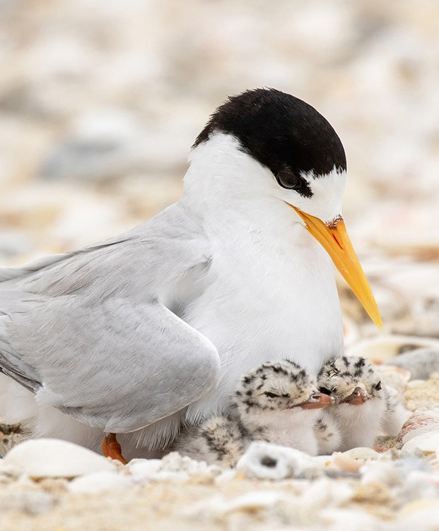

Chapter 4

# Recovery plan vision, objectives, and strategies

## Long-term vision

The Australian Fairy Tern population has increased in size to such an extent that the species no longer qualifies for listing as threatened under any of the *Environment Protection and Biodiversity Conservation Act 1999* listing criteria.

## Recovery plan objective

By 2030, sustain a positive population trend (compared to 2020 baseline counts) in the number of mature individuals of the Australian Fairy Tern in both the eastern and western populations. This will be achieved by implementing the actions set out in this

Recovery Plan that minimise threats while protecting the species’ habitat throughout its range, adequately monitoring the species, generating new knowledge to guide recovery and increasing public awareness.

## Strategies to achieve objectives

1. Manage and protect known Australian Fairy Tern breeding populations at the landscape scale.
2. Develop and apply techniques to measure changes in population trend(s) in order to measure the efficacy of recovery actions.
3. Reduce, or eliminate threats at breeding, non-breeding and foraging sites.
4. Undertake research and monitoring to improve understanding of breeding, non-breeding and foraging attributes in order to better target management actions and habitat restoration.
5. Engage community stakeholders in Australian Fairy Tern conservation.
6. Coordinate, review and report on recovery progress.

Chapter 5

# Actions to achieve the specific objectives

Actions identified for the recovery of the Australian Fairy Tern are described below.

It should be noted that some of the objectives are long-term and may not be achieved before the scheduled five-year review of this recovery plan. Priorities assigned to actions should be interpreted as follows:

**Priority 1:** Taking prompt action is necessary in order to mitigate the key threats to the Australian Fairy Tern and also provide valuable information to help identify long-term population trends.

**Priority 2:** Action would provide a more informed basis for the long-term management and recovery of the Australian Fairy Tern.

**Priority 3:** Action is desirable, but not critical to the recovery of Australian Fairy Tern or assessment of trends in that recovery.

**STRATEGY 1** Manage and protect known Australian Fairy Tern breeding populations at the landscape scale

|  |  |  |  |  |  |
| --- | --- | --- | --- | --- | --- |
| Action | Description | Priority | Performance criteria | Responsible agencies and potential partners **1** | Indicative cost |
| **1a** | Identify management units of high conservation priority | 1 | * Existing and new information has been reviewed and used to identify   important management units that require management intervention | Recovery team | $25,000 |
| **1b** | Actively use colony protection measures to safeguard nests | 1 | * Intervention strategies to protect vulnerable colonies from extreme weather, tides and predation have been developed * Trials to determine best practice techniques have been undertaken * Best practice guidelines have been developed and distributed to relevant stakeholders | State governments  Regional NRM authorities  Traditional Owners BirdLife Australia NGOs | $150,000 pa |
| **1c** | Protect and manage areas of ‘habitat critical for survival’ not currently managed for nature conservation | 1 | * Unprotected Commonwealth, state and privately owned lands in areas of ‘habitat critical to the survival’ for Australian Fairy Terns are identified * Management plans have been developed and implemented to maximise conservation values of the identified sites * Consideration has been given to formal protection for sites where appropriate (i.e. through new conservation reserves, national parks, marine protected areas) | Australian Government  State governments  Regional NRM authorities  Traditional Owners  NGOs | Core government business |
| **1d** | Undertake research on breeding success, survival and causes of mortality across the range of the species | 1 | * Knowledge of breeding success, survival at different stages of the life cycle and causes of mortality has improved from 2020 baselines * New information has been generated for priority management units * New information has been generated to understand the relative impacts of threats and the most successful interventions for mitigating those threats | State governments  Regional NRM authorities  BirdLife Australia NGOs  Academic institutions | $75,000 pa |
| **1e** | Undertake research to identify movement between breeding and non-breeding habitats,  post-breeding dispersal and habitat use | 1 | * Knowledge of movements throughout the different stages of the breeding and non- breeding periods and habitat use has improved from 2020 baselines * New information has been generated for priority management units | State governments  Regional NRM authorities  BirdLife Australia NGOs  Academic institutions | $75,000 pa |

continued ...

**STRATEGY 1** Manage and protect known Australian Fairy Tern breeding populations at the

landscape scale

continued

|  |  |  |  |  |  |
| --- | --- | --- | --- | --- | --- |
| Action | Description | Priority | Performance criteria | Responsible agencies and potential partners **1** | Indicative cost |
| **1f** | Undertake diet analysis over multiple spatial and temporal scales | 3 | * Knowledge of key fish species in the diet of Australian Fairy Terns from across their range has improved from 2020 baselines * New information has been generated for priority management units | State governments  Regional NRM authorities  BirdLife Australia NGOs  Academic institutions | $75,000 pa |
| **1g** | Incorporate Australian Fairy Tern conservation priorities into state  and local government coastal policies, plans and regulations | 1 | * New information on conservation measures for the Australian Fairy Tern have been incorporated into existing policies, management plans, regulations, code of practice and planning   tools to better manage the population across its range | Australian Government  State governments Local government  Regional NRM authorities  BirdLife Australia NGOs | Core government business |

**1** Lead organisations are identified in bold type.

**STRATEGY 2** Develop and apply techniques to measure changes in population trend(s) in order to measure the efficacy of recovery actions

|  |  |  |  |  |  |
| --- | --- | --- | --- | --- | --- |
| Action | Description | Priority | Performance criteria | Responsible agencies and potential partners **1** | Indicative cost |
| **2a** | Design an ongoing monitoring program for the Australian Fairy Tern | 1 | * Consultation with active monitoring projects has occurred * A scientifically robust survey and reporting methodology has been developed, and endorsed by the Recovery team | Recovery team  State governments  Academic institutions | $25,000 |
| **2b** | Conduct regular, ongoing monitoring to assess national, subpopulation and management unit trends | 1 | * Australian Fairy Tern colonies at known sites have been monitored at regular intervals to determine breeding success outcomes and identify site threat profiles * Surveys at non-breeding sites have been undertaken at regular intervals * Population trends have been assessed for each site and reported annually to the Recovery team, Commonwealth and relevant state government agencies * Decreases in the number of mature individuals and/or fledging production at any nesting   site have been reported to the Recovery team, Commonwealth and relevant state government agencies   * A central repository for reporting observations, such as the BirdLife Australia’s Birdata, has been identified and made readily accessible | Recovery team  Australian Government  State governments  Regional NRM authorities  BirdLife Australia  NGOs  Academic institutions | $135,000 pa |
| **2c** | Analyse new and existing data to increase  understanding of population dynamics (e.g. population size, age cohort, dispersal rates) | 1 | * Knowledge on the population trends has increased from 2020 baselines * Baseline measures of current population size, and age structure are identified and dispersal rates have been assessed | Academic institutions  State governments BirdLife Australia NGOs | $10,000 pa |
| **2d** | Undertake a Population Viability Analysis | 2 | * Where data exists, a Population Viability Analysis has been undertaken and results have been used to inform local management actions and priorities | Academic institutions  Recovery team  State governments | $75,000 |

**1** Lead organisations are identified in bold type.

|  |  |  |  |  |  |
| --- | --- | --- | --- | --- | --- |
| **STRATE** | **GY 3** Reduce, or | elimina | te threats at breeding, non-breeding and fo | raging sites |  |
| Action | Description | Priority | Performance criteria | Responsible agencies and potential partners **1** | Indicative cost |
| **3a** | Manage, or improve existing breeding, non-breeding and foraging habitat | 1 | * All relevant Australian Fairy Tern habitat types have been identified * All major breeding and non-breeding areas have developed local management plans * Local management plans have been adequately funded and implemented | State governments Local government  Regional NRM authorities  BirdLife Australia NGOs | $80,000 pa |
| **3b** | Reduce disturbance from human recreation during the breeding season | 1 | * Community education programs during each breeding season have occurred to increase awareness of disturbance * Off-road vehicles have been restricted from the vicinity of active nesting sites * Dogs have been prohibited from the vicinity of active colonies, especially unleashed dogs,   and regular compliance patrols occur to ensure regulations are followed   * Where feasible, signage, fencing and wardens have been deployed at all major breeding areas, including off-shore islands | State governments Local government  Regional NRM authorities  Traditional Owners BirdLife Australia NGOs | $175,000 pa |
| **3c** | Develop and implement a management plan for the control or eradication of cats, foxes, dogs and rats where the species is present | 1 | * Prioritise and implement an eradication or control program of invasive species at all major breeding areas * For island habitats, ensure best practice quarantine measures are followed to stop (re)invasions | State governments Local government  Regional NRM authorities  Traditional Owners BirdLife Australia NGOs | $250,000 pa |
| **3d** | Develop protocols to discourage avian predators where required | 1 | * Control measures around priority breeding areas are in place * The provision of chick shelters around priority breeding areas has occurred with adequate monitoring of use * The investigation of new techniques for deterring native avian predators from breeding sites has occurred and trials have been conducted | State governments Local government  Regional NRM authorities  BirdLife Australia NGOs | $25,000 pa |
| **3e** | Use climate modelling techniques to investigate the potential influence  of climate change on breeding and foraging habitats | 2 | * An improved understanding of the effects of climate change on Australian Fairy Tern population can be demonstrated | State governments  Academic institutions  BirdLife Australia NGOs | $60,000 |

continued ...

|  |  |  |  |  |  |
| --- | --- | --- | --- | --- | --- |
| **STRATE** | **GY 3** Reduce, or | elimina | te threats at breeding, non-breeding and fo | raging sites continued |  |
| Action | Description | Priority | Performance criteria | Responsible agencies and potential partners **1** | Indicative cost |
| **3f** | Monitor, and adaptively manage changes to hydrology at breeding and foraging sites | 1 | * Nesting in flood-prone areas has been discouraged * Changes to hydrology that may result in changes to tide levels, salinity levels or pollution concentrations have been reduced * Disruptions to water flows in wetlands and estuaries have been reduced | State governments Local government  Regional NRM authorities  BirdLife Australia NGOs | $80,000 pa |
| **3g** | Monitor contaminant levels in Australian Fairy Terns | 3 | * Knowledge of heavy metal and organochlorine levels has improved * New information has been generated for both populations | Academic institutions  NGOs | $50,000 |
| **3h** | Assess the level of hybridisation between Little  Tern and Australian Fairy Tern | 3 | * A genetic and behavioural analysis has occurred to assess the levels of interbreeding, particularly in NSW * Protocols have been developed to actively discourage the interbreeding of Little and Australian Fairy Tern | Academic institutions  NGOs | $25,000 |

**1** Lead organisations are identified in bold type.

**STRATEGY 4** Undertake research and monitoring to improve understanding of breeding, non-breeding and foraging attributes in order to better target management actions and habitat restoration

|  |  |  |  |  |  |
| --- | --- | --- | --- | --- | --- |
| Action | Description | Priority | Performance criteria | Responsible agencies and potential partners **1** | Indicative cost |
| **4a** | Identify and map available habitat and assess habitat health | 1 | * Habitat currently used by the Australian Fairy Tern is mapped and preferred local habitat characteristics (marine and terrestrial) have been identified * Habitat health is assessed at all locations where Australian Fairy Tern are observed breeding * Sites with poor habitat health are identified and outcomes have been reported to the Recovery Team * Sites with poor habitat health have been targeted for on-ground action and restoration | State governments Local government  Regional NRM authorities  Traditional Owners BirdLife Australia NGOs  Academic institutions | $125,000 |
| **4b** | Restore historical breeding habitat where feasible | 2 | * Historical breeding areas have been identified * Reasons for site abandonment have been explained * Sites for potential restoration have been prioritised * Restored sites have been monitored for colony formation and reestablishment | State governments Local government  Regional NRM authorities  Academic institutions  Traditional Owners BirdLife Australia NGOs | $125,000 pa |
| **4c** | Investigate the potential for the creation of new nesting sites | 2 | * Opportunities for the creation or enhancement of island or mainland nesting habitat have been evaluated * Social facilitation techniques to improve breeding success have been trialled | State governments Local governments  Regional NRM authorities  Academic institutions  Industry NGOs | $125,000 pa |

**1** Lead organisations are identified in bold type.

|  |  |  |  |  |  |
| --- | --- | --- | --- | --- | --- |
| **STRATE** | **GY 5** Engage com | munit | y stakeholders in Australian Fairy Tern cons | ervation |  |
| Action | Description | Priority | Performance criteria | Responsible agencies and potential partners **1** | Indicative cost |
| **5a** | Develop and implement a broad strategy to raise awareness and educate the  general public about Australian Fairy Tern conservation | 2 | * Articles about Australian Fairy Tern conservation, including threats and recovery actions, have been published in community newsletters,   local bulletins and newspapers   * Informative displays have been developed to educate the broader community about Australian Fairy Tern conservation at key breeding sites, non-breeding areas and foraging areas * Educational resources have been developed that target key user groups and key communities where the Australian Fairy Tern breed * Regular workshops have been undertaken to educate the public and raise awareness/support for the Australian Fairy Tern | Recovery team State governments Local governments  Regional NRM authorities  BirdLife Australia  NGOs | $25,000 pa |
| **5b** | Develop and implement a targeted strategy to promote the use of citizen science in relation to Australian Fairy Tern conservation | 2 | * Articles have been published in relevant community newsletters and magazines to recruit citizen scientists for training and involvement in Australian Fairy Tern conservation | Recovery team  Regional NRM authorities  BirdLife Australia  NGOs | $25,000 pa |
| **5c** | Support and train volunteers to monitor Australian Fairy Tern colonies | 1 | * An Australian Fairy Tern Field Manual has been developed * The field manual has been disseminated and used by state agencies, site wardens and community volunteers * Annual training sessions with site wardens and community volunteers have been undertaken in order to achieve ‘best practice’ in terms of breeding colony monitoring and management | Recovery team  Regional NRM authorities  BirdLife Australia  NGOs | $75,000 pa |

**1** Lead organisations are identified in bold type.

|  |  |  |  |  |  |
| --- | --- | --- | --- | --- | --- |
| **STRATE** | **GY 6** Coordinate | , review | and report on recovery progress |  |  |
| Action | Description | Priority | Performance criteria | Responsible agencies and potential partners **1** | Indicative cost |
| **6a** | Establish and maintain a National Recovery Team for the Australian Fairy Tern | 1 | * A National Recovery team is established within the first six months of the making of the Recovery Plan * The Recovery team has coordinated, reviewed and reported on the recovery outcomes over the life of this plan | All | Core government business |
| **6b** | Approve Recovery Team governance arrangements | 1 | * Terms of Reference for the Recovery team   have been approved in accordance with national best practice guidelines   * The Recovery team has been nationally registered | Recovery team | Core government business |
| **6c** | Submit annual reports on progress against recovery actions | 1 | * The Recovery team has submitted annual reports each year in accordance with the national reporting framework | Recovery team | Core government business |
| **6d** | Review the Recovery Plan five years after making | 1 | * In consultation with relevant stakeholders, a five year review of the Recovery Plan has been endorsed by the Recovery team | Recovery team | $10,000 |
| **6e** | Facilitate knowledge exchange and awareness amongst Australian, New Zealand and New Caledonian Fairy Tern land managers, researchers and decision makers | 1 | * A communication network between interested stakeholders has been established * Meetings between site managers have occurred at least biennially to share knowledge and experience * A researcher network has been established and exchange visits have occurred between Fairy Tern populations | Recovery team | $30,000 |

**1** Lead organisations are identified in bold type.

Chapter 6

# Duration and cost of the recovery process

It is anticipated that the recovery process will not be achieved before the scheduled five year review of the Recovery Plan. The cost of implementation of this Plan should be incorporated into the core business expenditure of the affected organisations, and through additional funds obtained for the explicit purpose of implementing this Recovery Plan. It is expected that Commonwealth and state agencies will use this plan to prioritise actions to protect the species’ and enhance its recovery, and that projects will be undertaken according to agency priorities and available resources. In order to maximise the conservation outcomes and cost effectiveness of this plan, it is intended that the recovery actions proposed complement, where possible, those of

other protected matters. The indicative cost of recovery plans actions was derived from expert elicitation and public comments received in 2020.

**TABLE 4** Summary of recovery actions and estimated costs for the first five years of implementation (these estimated costs do not take into account inflation over time)

|  |  |  |  |  |  |  |
| --- | --- | --- | --- | --- | --- | --- |
| Action | Cost (as of 2020) | | | | | |
| Year 1 | Year 2 | Year 3 | Year 4 | Year 5 | Total |
| Strategy 1 | 400,000 | 375,000 | 375,000 | 375,000 | 375,000 | $1,900,000 |
| Strategy 2 | 170,000 | 145,000 | 145,000 | 145,000 | 145,000 | $825,000 |
| Strategy 3 | 610,000 | 635,000 | 670,000 | 610,000 | 660,000 | $3,185,000 |
| Strategy 4 | 375,000 | 250,000 | 250,000 | 250,000 | 250,000 | $1,375,000 |
| Strategy 5 | 125,000 | 125,000 | 125,000 | 125,000 | 125,000 | $625,000 |
| Strategy 6 | 10,000 | 0 | 10,000 | 0 | 20,000 | $40,000 |
| TOTAL | $1,690,000 | $1,530,000 | $1,575,000 | $1,505,000 | $1,650,000 | $7,950,000 |

Chapter 7

# Effects on other native species and biodiversity benefits

Reducing anthropogenic impacts to coastal and marine habitats, supporting work to reduce disturbance and the adverse impacts of invasive species, will likely benefit

other listed threatened and migratory species, such as Hooded Plover, Little Tern and migratory shorebirds such as the Critically Endangered Eastern Curlew and Curlew Sandpiper. Implementation of the Recovery Plan will also have positive outcomes for other marine and coastal species and listed ecological communities through improving habitat quality.

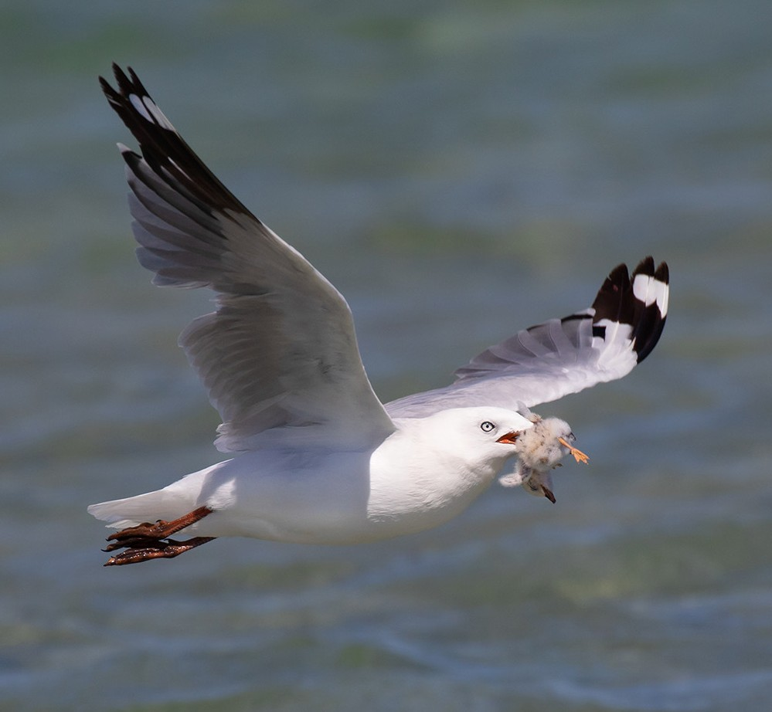

Chapter 8

# Social and economic considerations

The major economic impact of this Recovery Plan will be on those who require approval to remove or modify Australian Fairy Tern habitat and are prevented from doing so, or are required to modify their proposal by a consent authority. As habitats important habitats are identified, there is potential for developments to be restricted under the EPBC Act development assessment and approval process. This may include increased costs due to the assessment processes, requirement to provide offsets to secure or rehabilitate habitat, or for other threat mitigation work. Further information on the EPBC Act environmental assessment arrangements can be accessed here: <http://www.environment.gov.au/protection/environment-assessments>.

Localised, short-term, impacts may occur in areas where nest protection measures are implemented around breeding birds. Temporary fencing to delineate a safe distance from a nesting colony may be required to protect vulnerable eggs and chicks from human disturbance and off-leash dogs. Such structures may restrict access to small areas of beach and cause a minor inconvenience to beach visitors during the Australian Fairy Tern breeding season.

A large network of community volunteers across Australia actively participate in BirdLife Australia coordinated annual surveys for migratory shorebirds and beach nesting birds. Involvement can provide social benefits with community members and engaged groups having a sense of achievement, inclusion, community spirit and pride whilst gaining enjoyment and appreciation of their surrounding natural environment. The community education components of the program also promote community ownership, provide community support and encourage active involvement in protecting local natural resources. In Western Australia, a network of over 300 land managers and citizen scientists regularly contribute information on the movement of banded birds and breeding activities.

In addition, there is the potential for economic gains through ecotourism ventures, nature tours and holiday accommodation operators in areas where the Australian Fairy Tern can reliably be seen. Additional social benefits include encouraging passive recreation, appreciation of natural aesthetic values and increased awareness and appreciation of Indigenous cultural values.

Chapter 9

# Affected interests

Organisations likely to be affected by the actions proposed in this Plan include: government agencies (Commonwealth, state and territory, local), particularly those involved with coastal environments and conservation programs; Indigenous land and sea management groups (including ranger programmes); researchers; bird watching groups; conservation groups; wildlife interest groups; 4WD and fishing groups; environmental consulting companies; tourism operators; industry and commercial bodies; and, proponents of coastal development in the vicinity of important habitat.

However, this list should not be considered exhaustive, as there may be other interest groups that may like to be included in the future or need to be considered when specialised tasks are required.

The following table lists some of the interest groups, how they could contribute to the success of the plan and the potential benefits/impacts that may emerge from the Plan’s implementation:

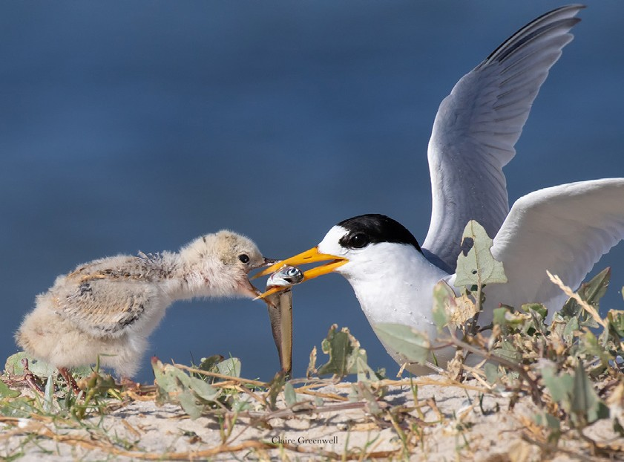

Affected interests

**TABLE 5** Affected interests and their contribution to the Recovery Plan

|  |  |  |
| --- | --- | --- |
| Interest group | Contribution | Impacts/benefits |
| Australian Government | * Responsible for development, coordination and evaluation of the plan. * Responsible for implementation of the plan in Commonwealth areas. * Subject to available resources, providing financial support for implementation of the plan. | * Informed decision making regarding the EPBC Act referral and assessment process. * Streamlined environmental assessment and authorisation arrangements for offshore petroleum and greenhouse gas activities in Commonwealth waters under the Environment Regulations. * Greater ability to deliver on domestic and international obligations with regard to biodiversity conservation. * Increased knowledge of the Australian Fairy Tern and their habitats – increased exchange of information between decision makers and the community. |
| State and territory government agencies | * Contributing to the development of the plan. * Potential implementation of the plan within jurisdictional boundaries. | * Greater ability to deliver on state obligations with regard to biodiversity conservation. * Opportunity to seek funding for conservation projects under biodiversity conservation programs. * Increased knowledge of the Australian Fairy Tern and their habitats – increased exchange of information. |
| Local Government | * Contributing to the development of the plan and taking the plan into consideration when reviewing planning schemes. * Potential implementation of on ground activities within jurisdictions. | * Increased knowledge of the Australian Fairy Tern and their habitats – increased exchange of information. * Opportunity to seek funding for conservation projects under biodiversity conservation programs. * Enhanced ability to deliver obligations with regard to biodiversity conservation. * Supports local tourism industry. |
| Natural Resource Management (NRM) regional bodies | * Integrating the plan into NRM regional plans. * Opportunity to deliver on-ground activities. | * Increased awareness of regional importance of important habitat sites. Informing managers of biodiversity values. * Opportunity to seek funding for conservation projects under biodiversity conservation programs. |
| Land councils and Traditional Owners including those that have co-management or sole  management responsibilities for important habitats. | * Contributing to the development of the plan and development and   implementation of site management plans – research and monitoring activities – contributing traditional knowledge. | * Increased knowledge of the Australian Fairy Tern and their habitats – increased exchange of information. * Opportunity to seek funding for conservation projects and achieve ownership of projects. * Develop research partnerships with scientists and the community. |
| Conservation Groups | * Contributing to the implementation and evaluation of the plan, particularly in conducting research and monitoring programs – implementing on-ground activities. | * Opportunity to seek funding for conservation and awareness projects under biodiversity conservation programs. * Greater coordination of targeted conservation projects. * Delivering on charitable/not-for-profit goals benefiting the public. |

continued ...

Affected interests

**TABLE 5** Affected interests and their contribution to the Recovery Plan

|  |  |  |
| --- | --- | --- |
| Interest group | Contribution | Impacts/benefits |
| Conservation Council of Western Australia (WA Fairy Tern Conservation Network) | * Provision of expert advice on Australian Fairy Tern and their biology, ecology and conservation. * Contributing to the implementation and evaluation of the plan, particularly in conducting research and monitoring programs – implementing on-ground activities. | * Monitoring of Australian Fairy Tern populations and success of conservation actions. * Opportunity to seek funding for conservation and awareness projects under biodiversity conservation programs. * Greater coordination of targeted conservation projects. |
| Australasian Seabird Group/BirdLife Australia | * Provision of expert advice on Australian seabirds and their biology, ecology and conservation. * Contributing to the implementation and evaluation of the plan, particularly in conducting research and monitoring programs – implementing on-ground activities. | * Monitoring of seabird populations and success of conservation actions. * Opportunity to seek funding for conservation and awareness projects under biodiversity conservation programs. * Greater coordination of targeted conservation projects. |
| Community and Special Interest groups | * Contributing to the plan and volunteering for conservation activities   – implementing on-ground activities. | * More Australian Fairy Terns to enjoy. * Opportunity to participate in conservation projects. |
| Researchers | * Contributing to the implementation and evaluation of the plan. | * Increased exchange of information – opportunity to seek funding for research. * Opportunity to establish collaborations within Australia and internationally. |
| Recreational users of sites – beach users, 4WD  groups, personal watercraft (jet skis etc.) users, dog walkers, recreational fishers, horse groups, field and game groups. | * Contributing to the development of the plan. | * Some leisure activities that affect important habitat sites may need to be managed. * These groups will be one of the main recipients for education and awareness activities that focus on how they may continue their activities and contribute to the conservation of seabirds at the same time. |
| Landholders | * Contributing to the development and implementation of the plan. | * Potential land use impacts. These groups will be the target of education and awareness activities. Particularly on how site management plans may be implemented by landholders. * Opportunity to build incentives into the plan for landholders to comply with recommendations. * Enhance certainty with regard to EPBC referrals. |
| Commercial users of sites or surrounding area – aquaculture, salt mining, commercial fisheries, farmers (surrounding land use), airports, maritime ports, renewable energy, tourism operators | * Contributing to the plan and implementing measures that minimise the impact of their operations on seabirds. | * These groups will also be one of the main recipients for education and awareness activities, although theirs will focus on minimising the impacts of their operations on the Australian Fairy Tern and the habitats on which they depend. * Enhance certainty with regard to EPBC referrals. |

continued

Chapter 10

# Consultation

The *Recovery Plan for the Australian Fairy Tern* has been developed through extensive consultation with a broad range of stakeholders. The consultation process brought together key species experts and conservation managers, from a range of different organisations, to categorize ongoing threats to the Australian Fairy Tern, and identify knowledge gaps and potential management options. Consultation included

representatives from government agencies, non-government organisations, researchers and local community groups. During the drafting process the Department of Agriculture, Water the Environment (Cwlth) continued to work closely with key stakeholders.

Notice of the draft plan was made available for public comment for four months between 20 December 2019 and 17 April 2020. Any comments received that were relevant to the survival of the species were considered by the Threatened Species Scientific Committee as part of its assessment process.

Chapter 11

# Organisations/persons involved in evaluating the performance of the plan

This Plan should be reviewed no later than five years from when it was endorsed and made publicly available. The review will determine the performance of the plan and will be coordinated by the Department of Agriculture, Water and the Environment, in association with the Recovery Team, relevant Australian and state government agencies and key stakeholder groups such as non-governmental organisations, local community groups and scientific research organisations.

Key stakeholders who may be involved in the review of the performance of the *National Recovery Plan for the Australian Fairy Tern*, include organisations likely to be affected by the actions proposed in this plan and are expected to include:

#### Australian Government

* Department of Agriculture, Water and the Environment

#### State/territory governments

* Department of Planning and Environment (NSW)
* Department of Environment, Land, Water and Planning (Vic)
* Department of Environment and Water (SA)
* Department of Primary Industries, Parks, Water and Environment (Tas)
* Department of Biodiversity, Conservation and Attractions (WA)
* Natural resource management bodies in coastal regions
* Local government in coastal regions

#### Non-government organisations

* + BirdLife Australia
  + Conservation Council of Western Australia (WA Fairy Tern Conservation Network)
  + Australasian Seabird Group
  + Local conservation groups
  + Local communities
  + Indigenous communities
  + Universities and other research organisations
  + Industry
  + Recreational sports and associations
  + Recreational fishers and associations
  + Recreational boaters

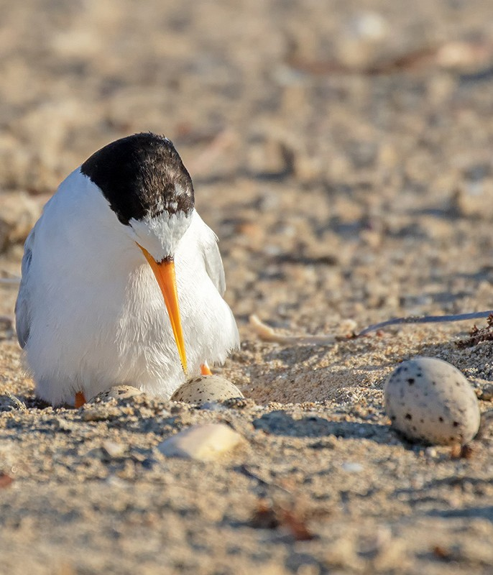

Chapter 12

# References

Adams, A.L., Monks, S., Silcocks, A., and Maguire, G.S. (2019) Monitoring and rehabilitation of Fairy Tern nesting sites in Western Port and Port Phillip Bay. Unpublished report for the Department of Environment, Land, Water and Planning by BirdLife Australia.

Ashmole, N.P. (1963) The biology of the wideawake or sooty tern *Sterna fuscata* on Ascension Island. Ibis 103b: 297-364.

Australian Faunal Directory (AFD) (2019) Australian Faunal Directory. Available from: <https://biodiversity.org.au/afd/home>.

Baling, M. (2008) Conservation of the fairy tern (*Sternula nereis* spp.) via subspecies level management. Auckland, New Zealand: Pacific Invasive Initiative (IUCN Invasive Species Specialist Group), The University of Auckland. Available from: [www.fairytern.org.nz/html/documents/baling2008.pdf](http://www.fairytern.org.nz/html/documents/baling2008.pdf).

Baling M., Jefferies, D., Barre, N, and Brunton, D.H. (2009) A survey of Fairy Tern (*Sterna nereis*) breeding colonies in the Southern Lagoon, New Caledonia. Emu 109: 57-61.

Baling, M. and Brunton, D. (2005) Conservation genetics of the New Zealand Fairy Tern. Unpublished report to the New Zealand Department of Conservation. 32pp

Barré, N., Baling , M., Baillion, N., Le Bouteiller, A.U.B.E.R.T., Bachy, P., Chartendrault,

V. and Spaggiari, J. (2012) Survey of fairy tern *Sterna nereis exsul* in New Caledonia. Marine Ornithology 40: 31-38.

BirdLife Australia (2018) Monitoring Guidelines for Fairy Terns – Bird Island, South Australia. BirdLife Australia, Melbourne.

BirdLife International (2019) IUCN Red List for birds. Downloaded from [www.birdlife.org on 19/03/2019.](http://www.birdlife.orgon19/03/2019)

Blakney, A. (2018) Beach-nesting Birds Management Strategy. BirdLife Tasmania. Available from: [https://www.nrmsouth.org.au/wp-content/uploads/2018/08/](https://www.nrmsouth.org.au/wp-content/uploads/2018/08/Beachnesting-Birds-Management-Strategy-FINAL-compressed-images-1.pdf) [Beachnesting-Birds-Management-Strategy-FINAL-compressed-images-1.pdf](https://www.nrmsouth.org.au/wp-content/uploads/2018/08/Beachnesting-Birds-Management-Strategy-FINAL-compressed-images-1.pdf).

Burbidge, A.A. and Fuller, P.J. (2000) The breeding seabirds of Shark Bay, Western Australia. CALMScience 3: 109-124.

Cabot, D. and Nisbet, I. (2013) Terns. The New Naturalist Library. Collins: London.

Carter, M. and Mustoe, S. (2007) Another Form of Fairy Tern *Sterna nereis* breeding in Australian Territory. Australian Journal of Field Ornithology 24: 167-179.

Christidis, L. and Boles, W.E. (2008) Systematics and Taxonomy of Australian Birds. Collingwood, Victoria: CSIRO Publishing.

Cramp, S. (ed.) (1985) The Birds of the Western Palearctic. Volume IV: Terns to Woodpeckers. New York: Oxford University Press.

Cooper, J. (2015) Surveying and monitoring shorebirds on the west coast of Eyre Peninsula June 2014-February 2015. Report to BirdLife Australia

Cox, J.B. and Close, D.G. (1977) Interbreeding of Little and Fairy Terns. Emu 77: 28-32.

Department of Environment and Natural Resources (DENR) (2012) Status of fairy terns in South Australia. Final Report to Nature Foundation SA.

Dunlop, J.N. (1987) Observations on the social behaviour and colony formation in a population of Crested Terns *Sterna bergii*. Australian Wildlife Research 14: 529-540.

Dunlop, J.N. (2018) Fairy Tern (*Sternula nereis*) conservation in south-western Australia. Second Edition. Conservation Council (WA): Perth.

Dunlop, J.N., McNeill, S. and Cannell, B. (2013) Seabird feathers as indicators of mercury and selenium contamination in the coastal waters of southern-western Australia.

Conservation Council (WA).

Dunlop, J.N., Rippey, E., Bradshaw, L.E. and Burbidge, A.A. (2015) Recovery of seabird colonies on Rat Island (Houtman Abrolhos) following the eradication of introduced predators. Journal Royal Society of Western Australia 98: 29-36.

Johnstone, R.E. and Storr, G.M. (1998) Handbook of Western Australian Birds. Volume 1-Non Passerines, Emu to Dollarbird. Western Australian Museum: Perth.

Garnett ST, Szabo JK and Dutson G (2011). The action plan for Australian birds 2010. CSIRO Publishing, Collingwood, Australia.

Greenwell, C.N., Calver, M.C. and Loneragan, N.R. (2019) Cat gets its tern: A case study of predation on a threatened coastal seabird. Animals, 9: 445.

Greenwell CN, Woehler EJ, Paton DC, Paton F, Dunlop N, Menkhorst P, Carey M, Garnett ST (2021) Australian Fairy Tern *Sternula nereis nereis*. In *Action Plan for Australian Birds 2020*. (Es. ST Garnett and GB Baker) CSIRO Publishing, Melbourne.

Hansen, K. (2006) New Zealand Fairy Tern (*Sterna nereis davisae*) Recovery Plan, 2005–15. Science and Technical Publishing, Department of Conservation, New Zealand.

Higgins PJ and Davies SJJF (eds) (1996) Handbook of Australian, New Zealand and Antarctic Birds. Volume 3: Snipe to Pigeons. Oxford University Press, Melbourne.

Hill, R., Bamford, M., Rounsevell, D. and Vincent J. (1988) Little Terns and Fairy Terns in Australia - an RAOU Conservation Statement. RAOU Report Series. 53:1-12.

Lindsey, T.R. (1986) The Seabirds of Australia. North Ryde, NSW: Angus and Robertson.

Menkhorst, P., Rogers, D., Clarke, R., Davies, J., Marsack, P., Franklin, K. (2017) The Australian Bird Guide. CSIRO Publishing

Nisbet, I.C.T. (1973) Courtship feeding, egg-size and breeding success in Common Terns. Nature 241: 141-142.

Norman, F.I., Dann, P. and Menkhorst, P.W. (1996) The status of seabirds in Victoria. In: Ross, G.J.B., K. Weaver and J.C. Grieg, eds. The Status of Australia's Seabirds: Proceedings of the National Seabird Workshop, Canberra, 1-2 November 1993. Page(s) 185-200. Canberra: Biodiversity Group, Environment Australia.

NSW National Parks and Wildlife Service (2003) Little Tern (*Sterna nereis*) Recovery Plan. NSW, NPWS, Hurstville.

References

Paton, D.C. and Rogers, D.J. (2009) Ecology of breeding Fairy Terns *Sternula nereis* in the Coorong. School of Earth and Environmental Sciences. Adelaide, South Australia: University of Adelaide.

Paton, D.C., Paton, F.L. and Bailey, C.P. (2019) Condition Monitoring of the Coorong, Lower Lakes and Murray Mouth Icon Site: Waterbirds in the Coorong and Lower Lakes 2019. Murray-Darling Basin Authority, Canberra.

Paton, F.L. and Paton, D.C. (2018) Waterbirds breeding in the Coorong and Lower Lakes during summer 2017-18. University of Adelaide and the Department for Environment and Water, South Australia

Parrish G.R. and Honnor, L. (1997) New Zealand Fairy Tern (Tara-iti) *Sterna nereis davisae* Recovery Plan 1997-2002. Threatened Species Recovery Plan No. 23. Wellington: Department of Conservation.

Ross, G.A., Egan, K. and Priddel, D. (1999) Hybridization between Little Tern *Sterna albifrons* and Fairy Tern *Sterna nereis* in Botany Bay, New South Wales. Corella 23: 33-36.

Saunders, D.A. and De Rebeira, P. (1985) The Birdlife of Rottnest Island. The Authors. Perth.

Serventy, D.L., Serventy V.N. and Warham, J. (1971) The Handbook of Australian Seabirds.

A.H. and A.W. Reed: Sydney.

Simpson, K. and Day, P. (2004) Field guide to the birds of Australia. Penguin, Melbourne. Slater, P., Slater, P. and Slater, R. (2009) The Slater Field Guide to Australian Birds.

Second Edition. Reed New Holland, Sydney, Australia.

Stephens, E. and Lamanna, A. (2019) Fairy Tern Monitoring on Bird Island, South Australia, 18/19 Breeding Season Report. Birdlife Australia, Adelaide, South Australia. Monitoring Project and Report preparation funded by the Adelaide and Mount Lofty Natural Resources Management Board.

South Coast Shorebird Recovery Program (2017) The threatened shorebirds we monitor and protect [https://engage.environment.nsw.gov.au/south-coast-shorebird-](https://engage.environment.nsw.gov.au/south-coast-shorebird-recovery-program/news_feed/the-threatened-shorebirds-we-monitor-and-protect) [recovery-program/news_feed/the-threatened-shorebirds-we-monitor-and-protect](https://engage.environment.nsw.gov.au/south-coast-shorebird-recovery-program/news_feed/the-threatened-shorebirds-we-monitor-and-protect). Accessed 24 April 2020.

Taylor, G.A. (2000) The action plan for seabird conservation in New Zealand. Part A: Threatened seabirds. Department of Conservation: Wellington, New Zealand.

Taylor I.R. and Roe, E.L. (2004) Feeding ecology of little terns *Sterna albifrons sinensis* in south-eastern Australia and the effects of pilchard mass mortality on breeding success and population size. Marine and Freshwater Research. 55: 799-808.

Threatened Species Scientific Committee (TSSC) (2011). *Commonwealth Conservation Advice on* Sternula nereis nereis *(Fairy Tern*). [Online]. Department of Sustainability, Environment, Water, Population and Communities. Canberra, ACT: Available on the Internet at: [http://www.environment.gov.au/biodiversity/threatened/species/](http://www.environment.gov.au/biodiversity/threatened/species/pubs/82950-conservation-advice.pdf) [pubs/82950-conservation-advice.pdf](http://www.environment.gov.au/biodiversity/threatened/species/pubs/82950-conservation-advice.pdf).

DA4552_0920