# National Fisheries Plan

## Progress report 2024

### Work undertaken by priority

* 635 total projects/programs underway
* 37% of work is on sustainability
* 13% of work is on adaptation
* 10% of work is on Indigenous opportunity
* 10% of work is on community connection

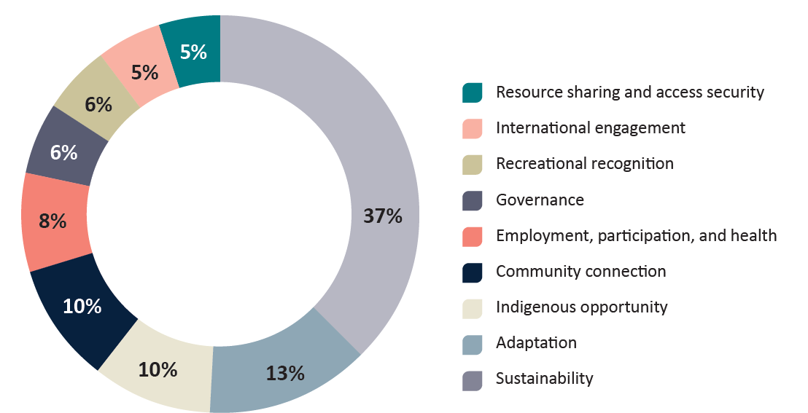

### Count of current work undertaken by priority and type of work

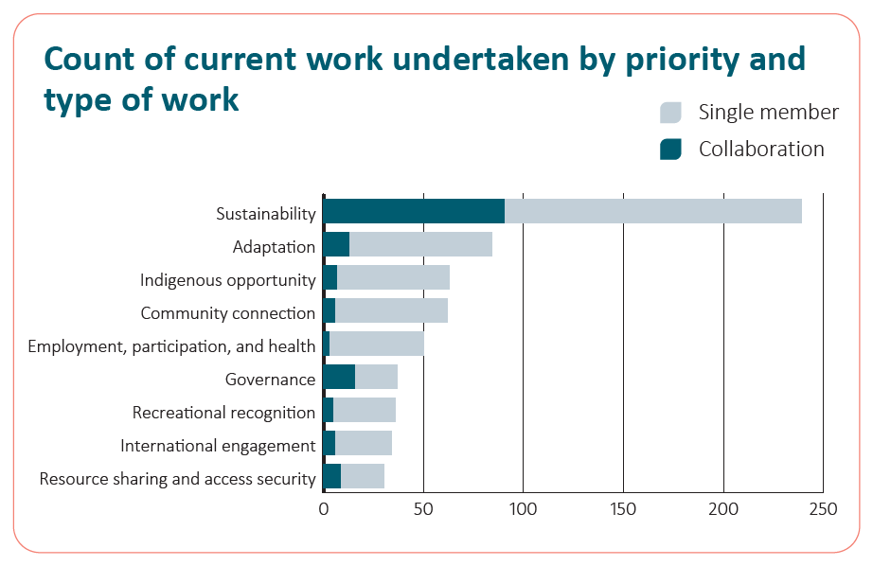

### Case study 1

#### Seafood Careers Australia

This year, Seafood Industry Australia and the Fisheries Research and Development Corporation launched the Seafood Careers Australia website. At seafoodcareers.com.au, individuals can explore the wide variety of opportunities to get involved with industry. There’s an ocean of opportunity. Get connected today!

### Case study 2

#### Abalone Industry Reinvestment Fund

The Tasmanian government’s Abalone Industry Reinvestment Fund is supporting projects to increase the sustainability and productivity of Tasmania’s abalone fishery while addressing the impacts of the longspined sea urchin.