**Catchment Ecology**

**Inland Waters &**

Monitoring salt wedge conditions and black bream (*Acanthopagrus butcheri*) recruitment

in the Coorong during 2017-18

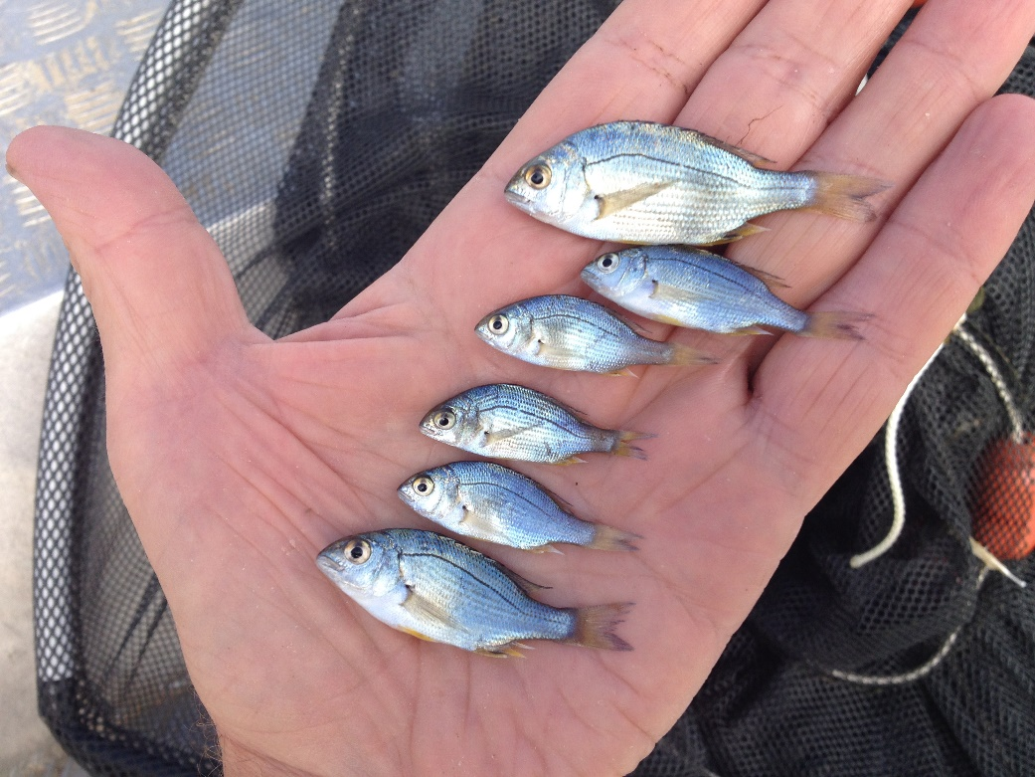

**Qifeng Ye, Luciana Bucater, Zygmunt Lorenz,**

**George Giatas and David Short**

**SARDI Publication No. F2018/000425-1**

**SARDI Research Report Series No. 1012**

**SARDI Aquatics Sciences**

**PO Box 120 Henley Beach SA 5022**

**March 2019**

Monitoring salt wedge conditions and black bream (*Acanthopagrus butcheri*) recruitment

in the Coorong during 2017-18

**Qifeng Ye, Luciana Bucater, Zygmunt Lorenz,**

**George Giatas and David Short**

SARDI Publication No. F2018/000425-1

SARDI Research Report Series No. 1012

March 2019

This publication may be cited as:

Ye, Q., Bucater, L., Lorenz, Z., Giatas, G. and Short, D. (2019). Monitoring salt wedge conditions and black bream (*Acanthopagrus butcheri*) recruitment in the Coorong during 2017-18. South Australian Research and Development Institute (Aquatic Sciences), Adelaide. SARDI Publication No. F2018/000425-1. SARDI Research Report Series No. 1012. 42pp.

**South Australian Research and Development Institute**

SARDI Aquatic Sciences

2 Hamra Avenue

West Beach SA 5024

Telephone: (08) 8207 5400

Facsimile: (08) 8207 5415

[www.pir.sa.gov.au/research](http://www.pir.sa.gov.au/research)

**DISCLAIMER**

The contents of this publication do not purport to represent the position of the Commonwealth of Australia or the MDBA in any way and, as appropriate, are presented for the purpose of informing and stimulating discussion for improved management of the Basin's natural resources. To the extent permitted by law, the copyright holders (including its employees and consultants) exclude all liability to any person for any consequences, including but not limited to all losses, damages, costs, expenses and any other compensation, arising directly or indirectly from using this report (in part or in whole) and any information or material contained in it. The authors warrant that they have taken all reasonable care in producing this report. The report has been through the SARDI internal review process, and has been formally approved for release by the Research Director, Aquatic Sciences. Although all reasonable efforts have been made to ensure quality, SARDI does not warrant that the information in this report is free from errors or omissions. SARDI, the Commonwealth, the MDBA and DEW do not warrant or make any representation regarding the use, or results of the use, of the information contained herein as regards to its correctness, accuracy, reliability and currency or otherwise. SARDI, the Commonwealth, the MDBA and DEW expressly disclaim all liability or responsibility to any person using the information or advice. Use of the information and data contained in this report is at the user’s sole risk. If users rely on the information they are responsible for ensuring by independent verification its accuracy, currency or completeness. The SARDI Report Series is an Administrative Report Series which has not been reviewed outside the department and is not considered peer-reviewed literature. Material presented in these Administrative Reports may later be published in formal peer-reviewed scientific literature.

**© 2019 SARDI DEW MDBA and CEWO**

This work is copyright. Apart from any use as permitted under the *Copyright Act* 1968 (Cth), no part may be reproduced by any process, electronic or otherwise, without the specific written permission of the copyright owner. Neither may information be stored electronically in any form whatsoever without such permission. With the exception of the Commonwealth Coat of Arms, the Murray-Darling Basin Authority, SARDI and DEW logos and photographs, all material presented in this document is provided under a Creative Commons Attribution 4.0 Australia licence (<https://creativecommons.org/licences/by/4.0/>). For the avoidance of any doubt, this licence only applies to the material set out in this document.

The details of the licence are available on the Creative Commons website (accessible using the links provided) as is the full legal code for the CC BY 4.0 AU licence ((<https://creativecommons.org/licences/by/4.0/legalcode> ).

SARDI Publication No. F2018/000425-1

SARDI Research Report Series No. 1012

Author(s): Qifeng Ye, Luciana Bucater, Zygmunt Lorenz, George Giatas and David Short

Reviewer(s): Greg Ferguson (SARDI), Alana Wilkes & Anthony Moore (CEWO), Adrienne Rumbelow & Rebecca Turner (DEW)

Approved by: Xiaoxu Li

Science Leader - Aquaculture

Signed:

Date: 27 March 2019

Distribution: DEW, MDBA, CEWO, SAASC Library, University of Adelaide Library, Parliamentary Library, State Library and National Library

Circulation: Public Domain

# Table of Contents

Table of Contents V

LIST OF FIGURES VI

LIST OF TABLES VIII

Acknowledgements IX

Executive Summary 1

1. Introduction 3

1.1. Background 3

1.2. Need 5

1.3. Objectives 6

2. Methods 7

2.1. Salt wedge monitoring 7

2.2. Sampling YOY 8

2.3. Ageing YOY 8

2.4. Data analysis 10

3. Results 12

3.1. Barrage releases and environmental water use 12

3.2. Characterising salt wedge conditions 15

3.3. Black bream recruitment 26

4. Discussion 31

5. Conclusion 36

References 37

Appendix 40

# LIST OF FIGURES

Figure 1‑1. Map of the Coorong presenting Murray Estuary, North and South lagoons. 5

Figure 2‑1. Map of the Coorong presenting salinity-profiling sites along the Goolwa, Tauwitchere, Coorong and Mundoo, transects. 7

Figure 2‑2. Map of the Coorong presenting sites (solid black circles) for juvenile black bream sampling. 10

Figure 3‑1. Total annual flow discharge to the Coorong (GL.year-1). Discharge from 2003-04 to 2012-13. 13

Figure 3‑2. Daily flow discharge by individual barrages (ML.day-1) for 2017-18….... 14

Figure 3‑3. The longitudinal and depth profile of salinities measured at multiple sites with ~1 km interval along the Goolwa (G1−G8), Tauwitchere (T1−T15) and Coorong (C1−C8) transects in the Murray Estuary and North Lagoon of the Coorong during seven trips between 2 November and 19 December 2017……... 17

Figure 3‑4. The longitudinal and depth profile of water temperature measured at multiple sites with ~1 km interval along the Goolwa (G1−G8), Tauwitchere (T1−T15) and Coorong (C1−C8) transects in the Murray Estuary and North Lagoon of the Coorong during seven trips between 2 November and 19 December 2017……….….. 18

Figure 3‑5. The longitudinal and depth profile of dissolved oxygen measured at multiple sites with ~1 km interval along the Goolwa (G1−G8), Tauwitchere (T1−T15) and Coorong (C1−C8) transects in the Murray Estuary and North Lagoon of the Coorong during seven trips between early November and mid December 2017. 19

Figure 3‑6. Integrating salinity, temperature and dissolved oxygen parameters showing longitudinal sections of suitable areas (in yellow) for black bream larval nursery habitat (using the criteria of salinities 10−30 PSU, salinity gradient ≥10 PSU, temperature >15°C and DO >5 mg L-1) ……. 20

Figure 3‑7. The longitudinal and depth profile of salinities measured at multiple sites with ~1 km interval along the Mundoo transect (M1a−M5) in the Coorong during seven trips between 2 November and 19 December 2017… .….. 21

Figure 3‑8. The longitudinal and depth profile of water temperature measured at multiple sites with ~1 km interval along the Mundoo transect (M1a−M5) in the Coorong during seven trips between 2 November and 19 December 2017….. … 22

Figure 3‑9. The longitudinal and depth profile of dissolved oxygen measured at multiple sites with ~1 km interval along the Mundoo transect (M1a−M5) in the Coorong during seven trips between early November and mid December 2017…. ......… 23

Figure 3‑10. Integrating salinity, temperature and dissolved oxygen parameters showing longitudinal sections of suitable areas (in yellow) for black bream larval nursery habitat (using the criteria of salinities 15−30 PSU, salinity gradient ≥10 PSU, temperature >15°C and DO >5 mg L-1) along the Mundoo transect (M1a−M5) in the Coorong during seven trips between 2 November and 19 December 2017. 24

Figure 3‑11. Scatterplots of suitable areas (longitudinal section) of larval nursery habitat for black bream, using interpolated environmental criteria of salinities (S) 10−30 PSU, depth gradient (G) ≥10 PSU, temperature (T) >15°C and DO (O) >5 mg L-1, against prior 7-day’s mean barrage discharge (including the sampling day) along the Goolwa, Tauwitchere, Coorong and Mundoo transects and the joint results of the first three transects (All) based on data collected in the Coorong during November and December 2017.. 25

Figure 3‑12. Length (left) and daily age (right) frequency distributions of YOY black bream collected in the Murray Estuary and North Lagoon of the Coorong in March and April 2018. 29

Figure 3‑13. Back-calculated spawn dates for young-of-year black bream (grey bars; *n* = 85) collected in the Murray Estuary and North Lagoon of the Coorong in March and April 2018, plotted against total flow discharge (ML day‑1) to the Coorong (blue line) and mean water temperature (°C) (red line). 29

Figure 3‑14. YOY black bream age and length relationship. Solid black line represents trend line; dashed grey lines represent 95% confidence intervals. 30

# LIST OF TABLES

Table 2‑1. Site information on salinity profiling transects. Refer to Figure 2‑1 for a map of locations. 8

Table 3‑1. Estimated monthly barrage discharge and the proportion and volume of Commonwealth environmental water (CEW) releases to the Coorong between October 2017 and March 2018. 13

Table 3‑2. Relative abundance (CPUE) of young-of-year black bream at different sites and the total number collected by single-wing fyke nets and small seine net in January and April 2018 (SE = standard error).... 27

Table 3‑3. Inter-annual comparison of relative abundance (CPUE, fish.net night-1) of young-of year black bream sampled at regular sampling sites in the Murray Estuary between February and June from 2009 to 2018.. 28

# Acknowledgements

This project was co-funded by the Commonwealth Environmental Water Office (CEWO), the South Australian Department for Environment and Water (DEW) and The Living Murray initiative of the Murray-Darling Basin Authority (MDBA). The Living Murray is a joint initiative funded by the New South Wales, Victorian, South Australian, Australian Capital Territory and Commonwealth governments, coordinated by the MDBA. The authors would like to thank the Coorong, Lower Lakes and Murray Mouth Community Advisory Panel and Science Advisory Group for initiating and supporting this project. Thanks to Adrienne Rumbelow, Kirsty Wedge (DEW), Gill Whiting, Andrew Lowes (MDBA), Alana Wilkes, Michelle Campbell, Anthony Moore and Rebecca Harris (CEWO) for support and management of this project, and to Jarrod Eaton, Peter Mettam, Claire Sims (DEW) and Adam Sluggett (MDBA) for providing barrage flow data. Thanks to SARDI staff Neil Wellman, David Fleer, Ian Moody and Arron Strawbridge who provided assistance with fieldwork and laboratory analyses. Chris Bice (SARDI) and Matt Gibbs (DEW) provided constructive feedback during the delivery of this project. Thanks to Greg Ferguson (SARDI), Anthony Moore, Alana Wilkes, (CEWO), Adrienne Rumbelow and Rebecca Turner (DEW) who formally reviewed and provided comments on this report.

# Executive Summary

The Lower Lakes, Coorong and Murray Mouth comprise the terminal system of Australia’s Murray-Darling River and plays a significant role in providing ecosystem services. It is a Ramsar wetland and one of the six ‘icon sites’ identified across the Murray-Darling Basin (MDB) as part of The Living Murray (TLM) Program (MDBC 2006). The Coorong estuary supports a diverse range of fish species. Black bream (*Acanthopagrus butcheri*) is an iconic estuarine fish with environmental targets set in both State and Commonwealth environmental watering plans, including the Basin-wide Environmental Watering Strategy. This species supports an important recreational and commercial fishery, although the population in the Coorong is currently depleted. In recent years, there has been a concerted effort by water managers to improve the barrage flow regimes, by providing environmental water to improve connectivity, estuarine habitat condition and enhance recruitment and population resilience of key fish species, including black bream, in the Coorong.

Freshwater flows into estuaries create salt wedges (haloclines), which provide favourable spawning and larval nursery habitats for black bream. More specifically, the salinity gradient is important as it (1) provides a cue for spawning and for locating spawning ground, (2) provides a cue for larvae and juveniles to locate suitable habitat, and (3) increases food availability for larvae. In the substantially modified estuary of the Coorong, the recruitment of black bream is highly variable. Recent studies suggest strong cohorts are associated with low to moderate river flows. During 2017-18, barrage releases were maintained from October to March using primarily Commonwealth environmental water, along with other environmental water (the TLM Program, Victorian Environmental Water Holder and River Murray Increased Flows) and unregulated flows. Environmental flow releases aimed for a range of ecological outcomes including to promote black bream spawning and recruitment. This project used targeted monitoring to assess the salt wedge conditions and black bream recruitment associated with Murray barrage releases in spring and summer 2017-18, and to evaluate the contribution of environmental water to the ecological outcomes.

In November and December 2017, environmental data were collected to characterise salt wedge conditions in the Murray Estuary and upper part of the North Lagoon, associated with total barrage discharge up to 12,000 ML day-1. The results suggested the presence of suitable larval nursery habitat with favourable salinities (15−30 PSU), stratification/halocline (≥10 PSU), temperature (>15°C) and dissolved oxygen (>5 mg L-1) to support black bream recruitment in this region during spring/summer 2017-18. Successful recruitment of black bream in the Coorong was evident by the detection of young-of-year (YOY) in good numbers throughout the Murray Estuary and North Lagoon in autumn 2018. There was an increase in the relative abundance and distribution of new recruits (YOY) in 2018, compared to the monitoring results over the last nine years.

The spawn dates of these YOY black bream (26 December to 1 February) suggested a delayed or extended spawning season of black bream in the Coorong. The successful spawning period corresponded with barrage releases of 600−5,000 ML day-1 and temperature of 18−25°C, and commenced about 1−2 weeks after a ~10,000−12,000 ML day‑1 flow pulse. Increased temperatures and a flow pulse may have increased food abundance, which, coupled with favourable salt wedge conditions, would have been beneficial to larval growth and survival, and thus recruitment. Additionally, the flow pulse may have attracted larger spawning aggregations of this species, which may be particularly helpful given the low spawning biomass in the Coorong.

Barrage flow management in 2017-18 demonstrated that environmental water can be delivered in a way to generate conditions (particularly salt wedge habitat) that facilitate successful black bream recruitment events, which over time should support recovery of the black bream population in the Coorong. Without environmental water, the favourable conditions that supported the 2017-18 black bream recruitment would not have been present. In addition, conservation management should seek to protect the remnant spawning biomass and improve the survival of new recruits to rebuild population abundance and resilience in the Coorong.

This study was the first main attempt, following a pilot study in 2014-15, to characterise and quantify larval nursery habitat for black bream in the Coorong, and to collect data for developing quantitative relationships between barrage flows and habitat suitability. Future research and monitoring will be required, particularly to improve knowledge of environmental and habitat requirements (including food resources) of black bream that are specific to the Coorong, and how they influence key life history processes and recruitment dynamics. This information will support adaptive management of environmental water and contribute to optimising the barrage flow regimes to improve estuarine habitat and enhance the recruitment of black bream and other estuarine fishes in the Coorong.

**Keywords:** Salt wedge, black bream, recruitment, environmental water, estuaries, Coorong.

# Introduction

## Background

The Lower Lakes, Coorong and Murray Mouth (LLCMM) is the terminus of Australia’s largest river system, the Murray−Darling River, and plays a significant role in providing ecosystem services. It has been recognised as a Wetland of International Importance under the Ramsar Convention since 1985 and represents one of the six ‘icon sites’ identified across the Murray−Darling Basin (MDB) through The Living Murray (TLM) Program (MDBC 2006). There is a diverse fish community inhabiting the LLCMM region, including key commercial/recreational fisheries species (e.g. black bream (*Acanthopagrus butcheri*), mulloway (A*rgyrosomus japonicus*), golden perch (*Macquaria ambigua*)) and those of significant conservation and/or ecological values (e.g. congolli (*Pseudaphritis urvillii*), Murray hardyhead (*Craterocephalus fluviatilis*), Murray cod (*Maccullochella peelii*)). The Coorong and Murray Mouth area (hereafter ‘Coorong’), which includes the ‘Murray Estuary’, ‘North Lagoon’ and ‘South Lagoon’ (see Figure 1‑1), is the only estuary in the MDB, connecting the freshwater and sea. Many estuarine fish species complete their life cycles in the Coorong, whereas others frequently enter the system, using the Coorong as refuge, nursery and feeding grounds, as well as a migration pathway at certain life history stages.

Freshwater flows to the Coorong are pivotal in facilitating a variety of processes, but most importantly for fish, they influence: 1) the estuarine salinity regime; 2) connectivity between freshwater, estuarine and marine environments; and 3) estuarine productivity by transporting nutrients and/or food resources from upstream. Freshwater flows can also affect salt wedge conditions in estuaries, by flowing over the denser marine waters and creating a highly stratified water column at the freshwater and marine interface (‘halocline’). These conditions can influence the location and extent of environmental conditions suitable for spawning and larval development for many estuarine dependent fishes (North and Houde 2003; North *et al*. 2005; Islam *et al*. 2006).

Black bream is a solely estuarine fish species that can complete its entire life-cycle within an estuary (Potter *et al.* 2015). Variability of freshwater inflows has been identified as a key factor influencing recruitment success of this species (Nicholson *et al.* 2008; Jenkins *et al.* 2010; Williams *et al.* 2012), often with greatest recruitment associated with years of intermediate river flows (Jenkins *et al.* 2010). Being a multiple spawner, black bream has a protracted spawning season, generally ranging from September to late December depending on geographical location (Walker and Neira 2001; Sakabe *et al.* 2011; Cheshire *et al.* 2013). Spawning is triggered by a rise in water temperature (>15o C) and often occurs in the upper reaches of estuaries, near the interface between fresh and brackish waters (Walker and Neira 2001; Nicholson *et al.* 2008; Williams 2013), where the level of salinity stratification (difference between bottom and surface salinity) is at least 10 PSU (Williams *et al.* 2012). The optimal salinity range for egg survival to hatching is from 15−35 PSU (Haddy and Pankhurst 2000; Norris *et al.* 2002).

Haloclines have been identified as critical larval nursery habitat that enhance larval growth and survival, and potentially successful recruitment of black bream (William *et al.* 2012; 2013), likely through high prey availability and reduced risk of predation (North and Houde 2003; Islam *et al*. 2006). A recent study in the Gippsland Lakes, Victoria, found high concentrations of eggs and larvae in salinities ranging between 15−30 PSU at sites where the salinity stratification is ≥10 PSU (Williams *et al.* 2013). A pilot study conducted in the Coorong during 2014-15 (Ye *et al.* 2015) showed that halocline conditions could be provided via manipulating water releases through the barrages. Suitable haloclines, based on Williams *et al.* (2012), were present at release rates of 450 ML day-1 and 1.4 ML day-1 below Goolwa and Boundary Creek barrages, respectively, during the species’ peak spawning season of spring to early summer. Nevertheless, lack of detection of young-of-year (YOY) black bream during 2014-15 suggested that the mechanism driving recruitment success of this species warrants further study in the Coorong. Furthermore, the spatial extent of haloclines was not quantified throughout the Coorong system in 2014-15. As ‘salt wedge’ habitat is dynamic, exhibiting a high degree of temporal and spatial variability, the spawning behaviour and reproductive success of species that use estuaries are also likely to be dynamic and highly variable. This may partially explain the variable levels of recruitment success of black bream during recent years in the Coorong (Ye *et al.* 2013).

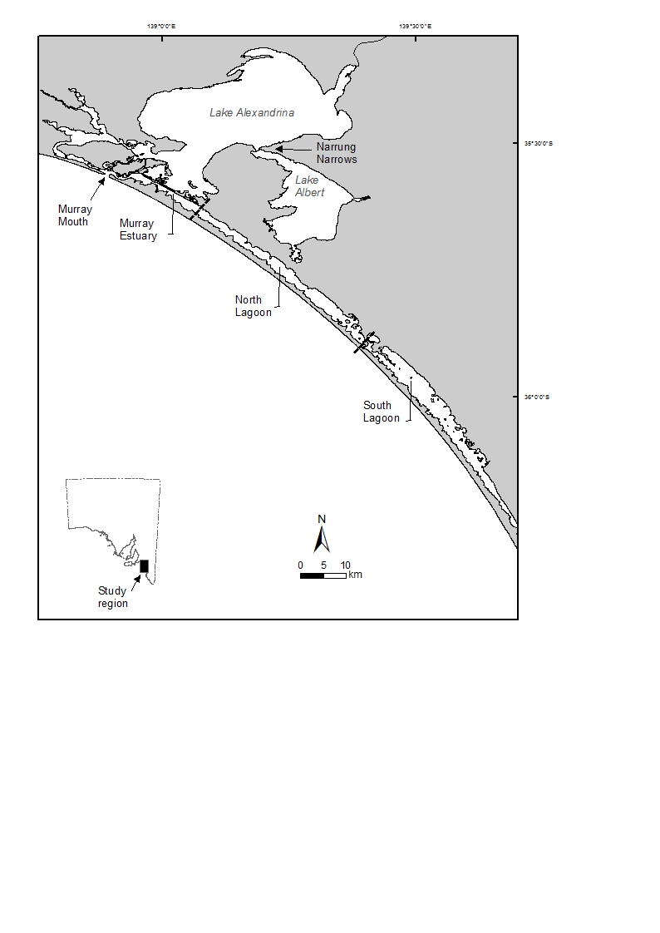

Figure 1‑1. Map of the Coorong presenting Murray Estuary, North and South lagoons.

## Need

Black bream is an iconic species with specific ecological objectives and targets under the Murray−Darling Basin-wide Environmental Watering Strategy (MDBA 2014), TLM LLCMM Condition Monitoring Plan (DEWNR 2017) and South Australian River Murray Long-term Environmental Watering Plan (DEWNR 2015). The species also supports important commercial and recreational fisheries in the LLCMM region. However, currently the population is in a weakened state in this region (Earl *et al.* 2016; Ye *et al.* 2018). The Department for Environment and Water (DEW) has been working on improving barrage operation, with support from the Murray−Darling Basin Authority (MDBA) and the Commonwealth Environmental Water Office (CEWO), to achieve ecological outcomes. This includes environmental flow management to optimise barrage releases and improve connectivity in the Coorong, in order to enhance recruitment and population resilience of estuarine fish species, including black bream.

In 2017-18, flow releases were maintained through Murray barrages, with the support of Commonwealth environmental water, during spring and summer (the peak spawning season of black bream). One of the primary aims was to provide favourable environmental conditions (salt wedge/halocline habitat) to benefit black bream recruitment, following anecdotal evidence from commercial fishers of adult black bream in spawning condition congregating downstream of the barrages. The monitoring project was conducted to evaluate the outcomes and collect empirical data to support adaptive management.

## Objectives

The overall aim of this project was to undertake targeted monitoring to assess the salt wedge conditions and black bream recruitment associated with Murray barrage releases in spring and summer 2017-18. Specific objectives were to:

1. Characterise salt wedge conditions below the barrages (particularly Goolwa and Tauwitchere) associated with environmental water releases during November and December 2017.
2. Quantify the relative abundance of YOY black bream in the Coorong during summer/autumn 2018.
3. Evaluate whether barrage releases and the contribution of environmental water provided suitable estuarine habitat for black bream recruitment, and provide management recommendations.

# Methods

## Salt wedge monitoring

Longitudinal and depth profiles of salinity (practical salinity units, PSU), water temperature (°C) and dissolved oxygen (DO) (mg.L-1) were recorded using a YSI EXO 2 sonde downstream of Goolwa, Tauwitchere and Mundoo barrages, and in the North Lagoon of the Coorong. Monitoring was conducted approximately weekly (5−12 days), with a total of seven field trips, between 2 November and 19 December 2017. Measurements were taken using the continuous sampling mode at multiple sites along four transects with ~1 km intervals (Figure 2-1; Appendix A).

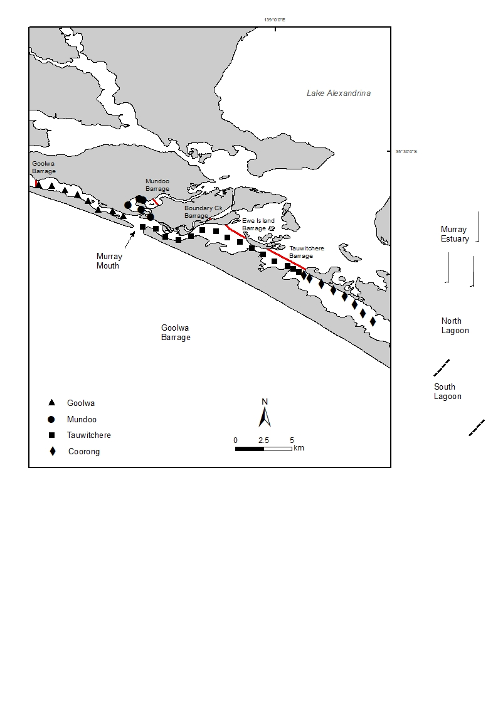

Figure 2‑1. Map of the Coorong presenting salinity-profiling sites along the Goolwa, Tauwitchere, Coorong and Mundoo, transects.

Table 2‑1. Site information on salinity profiling transects. Refer to Figure 2‑1 for a map of locations.

|  |  |  |  |  |
| --- | --- | --- | --- | --- |
| **Transect** | **Distance (kms)** | **Location** | | **No. sites** |
| Start | End |
| Goolwa | 7 | Goolwa Barrage | Murray Mouth | 8 |
| Mundoo | 5 | Mundoo Barrage | 5km DS of Mundoo Barrage | 5 |
| Tauwitchere | 13 | Tauwitcherie Barrage | Murray Mouth | 15 |
| Coorong | 7 | Tauwitcherie Barrage | Mark Point, North Lagoon | 8 |

## Sampling YOY

To quantify the relative abundance of new black bream recruits (YOY, i.e. age 0+ years), two targeted sampling events (i.e. January and April 2018) were conducted, using fyke nets and a small seine net, in the Murray Estuary (8−10 sites) and North Lagoon (2−4 sites) of the Coorong (Figure 2-2). Additional data and samples of black bream collected in March 2018 as part of the TLM Coorong Fish Condition Monitoring (Ye *et al.* 2018) were included in analyses. The March sampling event had five sites in the Murray Estuary and four sites in the North Lagoon (Figure 2-2), and used large and small seine nets.

The fyke nets were single-wing and 8.6 m long (3 m wing plus 5.6 m funnel) with a mesh size of 8 mm and a hoop diameter of 0.6 m. On most sampling occasions, four replicate fyke nets were set overnight at each site. The small seine net was 8 m long with a 2 m drop and a mesh size of 2 mm. It was hauled through water less than 0.5 m deep over a distance of 20 m by two people walking 5 m apart, thus sampling an area of about 100 m2. The large seine net was 61 m long and consisted of two 29 m-long wings (22 mm mesh) and a 3 m-long bunt (8 mm mesh). It was deployed in a semi-circle, sampled to a maximum depth of 2 m and swept an area of about 592 m2 per shot. Seine net sampling was replicated (i.e. three standard shots) at each site. The relative abundance of YOY black bream was based on the estimate of catch per unit effort (CPUE), which was calculated as number of fish per fyke net per night (fish.net night-1) or number of fish per seine net shot (fish.net-1).

On each sampling occasion, the number of juvenile black bream from each net were recorded. A subsample of up to ten individuals from each site (per gear type) were kept for further processing in the laboratory.

## Ageing YOY

Juvenile black bream were measured for total length (TL, mm) and weight (g), and both sagittal otoliths extracted. To estimate the spawning date of YOY black bream, daily increments in otolith microstructure were examined. Otoliths were mounted individually on a glass microscope slide edge using CrystalbondTM. With the distal surface upwards, otoliths were polished down the anterior part so that the primordium was visible, then transferred to the center of the slide (polished side face down). The posterior part was also polished to obtain a transverse cross-section in which increments and the primordium could be clearly seen. Polishing used wetted lapping films (9, 5 and 3 µm), and sections were approximately 50−100 µm in thickness.

Sections were examined using a compound microscope (Olympus BX 51) fitted with a digital camera and Olympus Stream Basic imaging solutions (version 1.9.1). Age estimates were determined by counting the number of daily increments from the primordium to the otolith edge. For each otolith, two readers made two separate counts each. When a discrepancy in count greater than 10% occurred, the two readers performed a reading together (i.e. consensus method). The final readings were used to calculate the mean number of increments. Validation has shown that otolith increments were formed daily, which represent the true age in days of YOY black bream (Sakabe *et al.* 2011). With the hatching time assumed to be two days at ~21o C (Hassell *et al.* 2008), estimated age was calculated as the increment counts plus two days, and thus spawning dates were determined by subtracting the estimated age from the capture date.

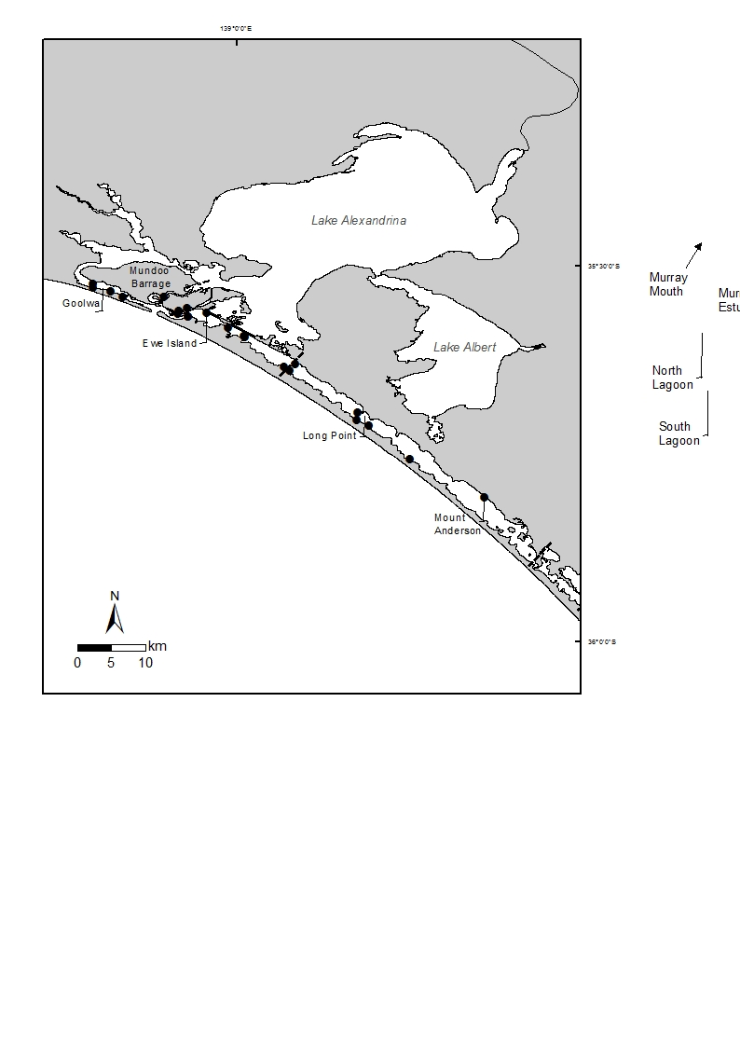

Figure 2‑2. Map of the Coorong presenting sites (solid black circles) for juvenile black bream sampling.

## Data analysis

### Salinity, temperature and DO stratifications

Calculations were performed using R language (R Core Team 2017) and geometry operations with R package rgeos (Bivand and Rundel 2017). The profile data for salinity, temperature and DO concentration were converted into four longitudinal sections of Goolwa, Tauwitchere, Coorong and Mundoo. The first three sections were combined, whereas results from the Mundoo section were presented separately due to separation from the longitudinal gradient. Grids were created by interpolating values at one centimeter vertical distance from sonde profiles using a cubic smoothing spline. In addition, the salinity gradient was calculated along the sections. Based on the results of published research (Hassell *et al.* 2008a; 2008b; Williams *et al.* 2013), environmental criteria were selected for further analysis to identify favourable spawning and larval nursery habitat. These included salinity within a range of 15−30 PSU, combined with salinity stratification (gradient) ≥10 PSU, temperature >15°C and DO >65% saturation level (i.e. >5 mg.L-1 at 25 PSU and 20°C). In the next step, polygons were obtained from the grids for individual areas where salinity, temperature and DO met these criteria. Finally, the areas of suitable larval nursery habitat were computed by intersection of salinity, temperature and DO polygons as well as salinity gradient requirement.

### Linking larval nursery areas with barrage flows

The areas (longitudinal section) of suitable larval nursery habitat for black bream along the Goolwa, Tauwitchere, Coorong and Mundoo transects were plotted against prior 7-day discharge (i.e. mean daily discharge of previous seven days including the sampling day) for each barrage. The patterns of the scatterplots were analysed to explore the potential relationships between nursery area and barrage releases. For the Goolwa, Mundoo and Coorong transects, the discharges from Goolwa, Mundoo and Tauwitchere barrages, respectively, were used, whereas for the Tauwitchere transect (i.e. Pelican Point to Murray Mouth), the total discharges from Tauwitchere and Ewe Island were used.

### Daily age-length relationship

For the daily age-length relationship, a simple linear regression (least squares estimation) was performed. The model (equation) of growth (i.e. total length, TL) expressed as a function of age (days) is described as:

**TL (mm) = a + b * age (days)**

# Results

## Barrage releases and environmental water use

From 2003-04 to 2017-18, freshwater discharge via barrage releases to the Coorong was highly variable (Figure 3‑1). Annual discharge remained <940 GL year-1 between 2003-04 and 2009-10 with no flow from 2007-08 to 2009-10. In 2010-11 and 2011-12 (high flow years), discharge increased substantially to >9,000 GL year-1. Following a gradual decrease in the subsequent four years, the discharge peaked again (~6,500 GL) in 2016-17 (another high flow year), but then decreased to ~850 GL in 2017-18.

Although 2017-18 was a year of low flow, ~404 GL of Commonwealth environmental water was used to maintain barrage releases between October 2017 and March 2018, with Commonwealth environmental water comprising 94% of the total volume of discharge (~427 GL) over the six months (Table 3-1). During this period, the majority of discharge was through Tauwitchere (58%) and Goolwa (23%) barrages, followed by Mundoo (11%) and Ewe Island (8%) barrages, with minor releases (0.8 GL) through Boundary Creek Barrage. The highest discharge occurred in December for all barrages (Figure 3-2), partly due to an unregulated flow event.

At Goolwa Barrage, the discharge varied from 0–957 ML day-1 between October and November 2017, with a mean of 445 ML day-1 (SE ± 29) (Figure 3-2). Discharge increased and was maintained at ~1,500 ML day-1 from 6–11December, followed by a high flow peak of 3,331 ML day-1 on 18 December 2018. Flow then declined rapidly, reaching 630 ML day-1 by 2 January 2018. The mean discharge was ~550 ML day-1 (SE ± 23) between 2 and 16 January; and further reduced to ~240 ML day-1 (SE ± 12) between 17 and 31 January 2018. In February and March, discharge remained <330 ML day-1.

Similarly, at Tauwitchere Barrage, the discharge varied from 0–2,572 ML day-1 from early October to mid-November 2017, with the mean being ~1,000 ML day-1 (SE ± 63) (Figure 3-2). From mid-November to mid-December, the discharge increased steadily, peaking at 6,347 ML day‑1 on 12 December. The flow remained high (5,011‒6,347 ML day-1) between 12 and 17 December, before declining rapidly to 1,455 ML day-1 by 24 December. Following a slight increase to 2,139 ML day-1 on 26 December, the flow declined gradually to ~500 ML day-1 by end of January 2018. From 1 February to mid-March 2018, discharge increased again to ~1,000−1,500 ML day-1 before declining to <500 ML day-1 in late March.



Figure 3‑1. Total annual flow discharge to the Coorong (GL.year-1). Discharge from 2003-04 to 2012-13 were modelled data (Data source: MDBA) and from 2013-14 to 2017-18 were calculated dashboard data (Data source: DEW).

Table 3‑1. Estimated monthly barrage discharge and the proportion and volume of Commonwealth environmental water (CEW) releases to the Coorong between October 2017 and March 2018.

|  |  |  |  |  |  |  |  |
| --- | --- | --- | --- | --- | --- | --- | --- |
|  | **Oct-2017** | **Nov-2017** | **Dec-2017** | **Jan-2018** | **Feb-2018** | **Mar-2018** | **Total** |
| Barrage discharge (ML.month-1) | 59,519 | 61,472 | 205,450 | 48,093 | 29,686 | 23,756 | **427,976** |
| Volume of CEW as barrage discharge (ML month-1) | 59,519 | 61,472 | 184,853 | 44,251 | 29,686 | 23,756 | **403,537** |
| Proportion of CEW as barrage discharge | 100% | 100% | 90% | 92% | 100% | 100% | **94%** |



Figure 3‑2. Daily flow discharge by individual barrages (ML.day-1) for 2017-18. a) Goolwa barrage, b) Mundoo barrage, c) Boundary Creek barrage, d) Ewe Island barrage, e) Tauwitchere barrage and f) Combined discharge (five barrages). Data source: DEW.

## Characterising salt wedge conditions

### Goolwa, Tauwitchere and Coorong transects

Salinities of 15‒30 PSU with high stratification (≥10 PSU) were consistently present below Goolwa Barrage (i.e. along the Goolwa transect) during the sampling period between 2 November and 19 December 2017, whereas such conditions were patchy along the Coorong transect (Figure 3-3). Along the Tauwitchere transect, although salinities of 15‒30 PSU were present at most of the sites, stratifications ≥10 PSU were irregularly present at different sites during the sampling period.

Water temperature remained >15°C throughout the sampling period, with warmer temperature (>18°C) present throughout the water column on 14 and 19 December 2017 (Figure 3-4). DO levels generally remained favourable (>5 mg L-1) across the sampling sites except for trips on 30 November and 14 December 2017 (Figure 3-5), when small areas (e.g. some deeper areas below Goolwa and Tauwitchere barrages and along the Coorong transect) had DO ≤5 mg L‑1.

Overall, there were suitable areas for black bream larval nursery habitat (using the criteria of salinities 15−30 PSU, salinity gradient ≥10 PSU, temperature >15°C and DO >5 mg L-1) during November and December 2017 in the Coorong (Figure 3-6). The presence of such habitat was most consistent below Goolwa Barrage and was irregular along the Tauwitchere and Coorong transects.

### Mundoo transect

Salinities of 15‒30 PSU with high stratification (≥10 PSU) were present in Mundoo Channel throughout the sampling period, although the spatial extent varied (Figure 3-7). However, salinity levels were much lower during 14 and 19 December, when a distinct freshwater layer was present on the surface throughout the channel, pushing the favourable salinity zone of 15‒30 PSU to deeper areas (>1 m deep).

Similar to other sites, water temperature remained >15°C throughout the sampling period (Figure 3-8). DO levels remained favourable (>5 mg L-1) in Mundoo Channel during trips from 2 November to 8 December 2017; however, there was a substantial area of low DO (≤5 mg L‑1) in deeper water (>1 m depth) throughout the channel during 14 and 19 December 2017 (Figure 3-9). Suitable larval nursery habitat was widespread in Mundoo Channel during the first five sampling trips between 2 November and 8 December (Figure 3-10), but minimal during 14 and 19 December, mainly due to low DO.

### Linking flow discharge with suitable larval habitat area

Relationships between daily barrage discharge (prior 7-day mean) and suitable larval nursery habitat for black bream were variable between the Goolwa, Tauwitchere, Coorong and Mundoo transects (Figure 3-11). Because data were limited to seven trips in this one-year study, no simple relationship between discharge and suitable habitat could be discerned for Goolwa, Thauwitchere and Mundoo transects, although there seemed to be a dome shape pattern for the Coorong transect.

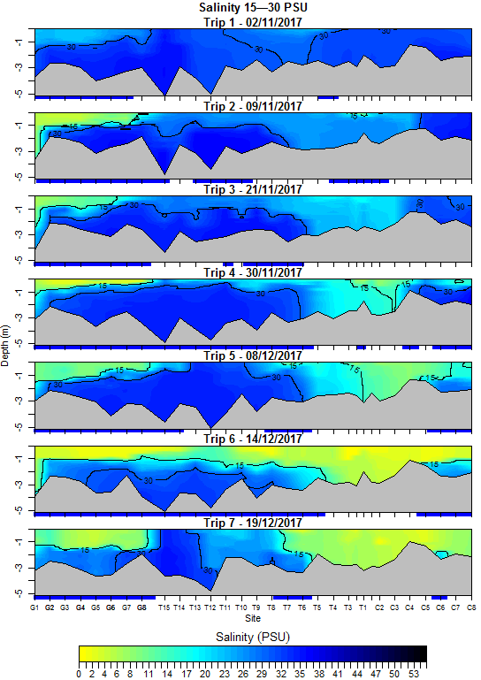

Figure 3‑3. The longitudinal and depth profile of salinities measured at multiple sites with ~1 km interval along the Goolwa (G1−G8), Tauwitchere (T1−T15) and Coorong (C1−C8) transects in the Murray Estuary and North Lagoon of the Coorong during seven trips between 2 November and 19 December 2017. Blue highlighting on the x-axis indicates areas with salinity stratification ≥10 PSU. G1: below Goolwa Barrage; T1: Pelican Point end of the Tauwitchere Barrage; C8: Mark Point; and Murray Mouth: between G8 and T15. Salinity contours of 15 PSU and 30 PSU are shown.

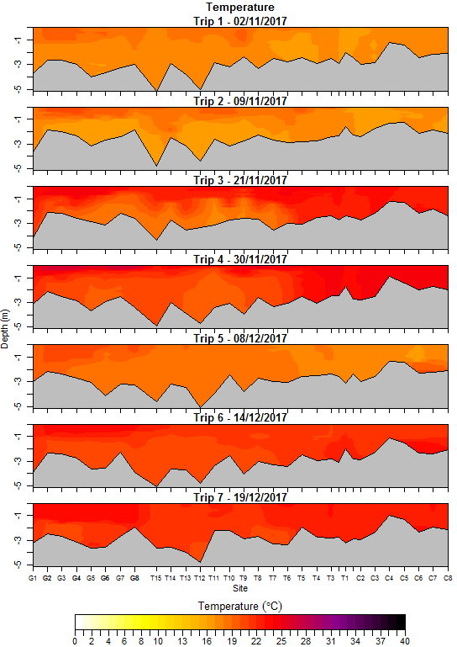

Figure 3‑4. The longitudinal and depth profile of water temperature measured at multiple sites with ~1 km interval along the Goolwa (G1−G8), Tauwitchere (T1−T15) and Coorong (C1−C8) transects in the Murray Estuary and North Lagoon of the Coorong during seven trips between 2 November and 19 December 2017. G1: below Goolwa Barrage; T1: Pelican Point end of the Tauwitchere Barrage; C8: Mark Point; and Murray Mouth: between G8 and T15.

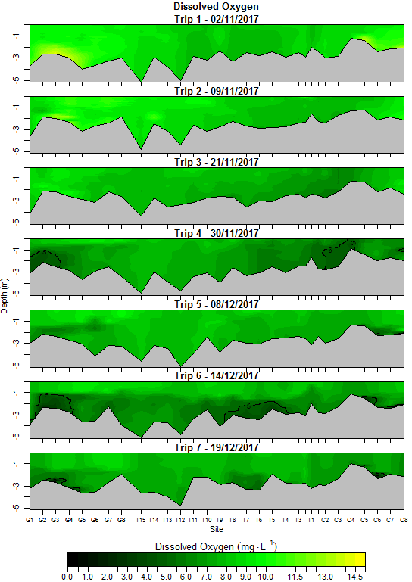

Figure 3‑5. The longitudinal and depth profile of dissolved oxygen measured at multiple sites with ~1 km interval along the Goolwa (G1−G8), Tauwitchere (T1−T15) and Coorong (C1−C8) transects in the Murray Estuary and North Lagoon of the Coorong during seven trips between early November and mid December 2017. G1: below Goolwa Barrage; T1: Pelican Point end of the Tauwitchere Barrage; C8: Mark Point; and Murray Mouth: between G8 and T15. DO contour of 5 mg L-1 is shown.



Figure 3‑6. Integrated values for salinity, temperature and dissolved oxygen showing longitudinal sections of suitable areas (in yellow) for black bream larval nursery habitat (using environmental criteria of salinities 15−30 PSU, salinity gradient ≥10 PSU, temperature >15°C and DO >5 mg L-1) along the Goolwa (G1−G8), Tauwitchere (T1−T15) and Coorong (C1−C8) transects in the Coorong during seven trips between 2 November and 19 December 2017. G1: below Goolwa Barrage; T1: Pelican Point end of the Tauwitchere Barrage; C8: Mark Point; and Murray Mouth: between G8 and T15.

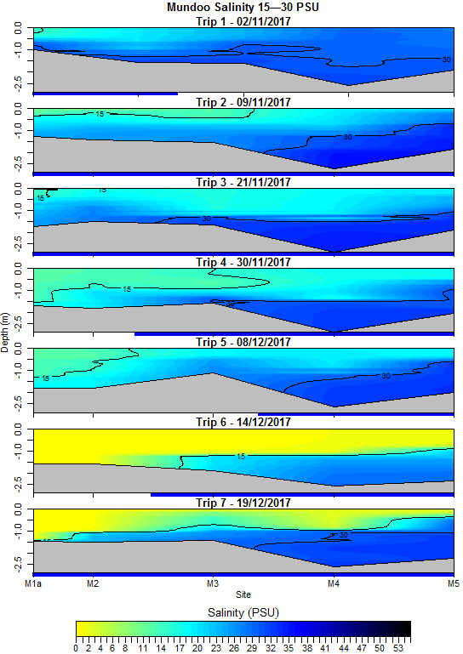

Figure 3‑7. The longitudinal and depth profile of salinities measured at multiple sites with ~1 km interval along the Mundoo transect (M1a−M5) in the Coorong during seven trips between 2 November and 19 December 2017. Blue bars indicate areas with salinity stratification ≥10 PSU. Salinity contours of 15 PSU and 30 PSU are shown.

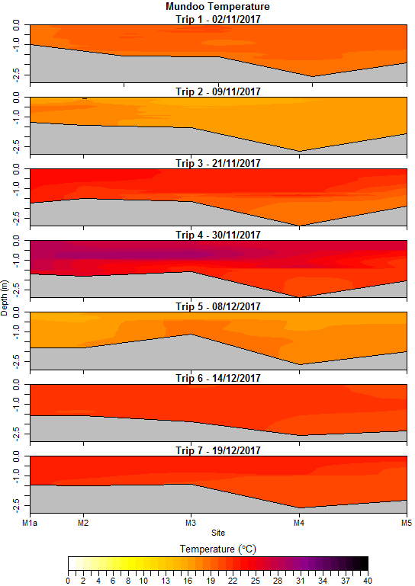

Figure 3‑8. The longitudinal and depth profile of water temperature measured at multiple sites with ~1 km interval along the Mundoo transect (M1a−M5) in the Coorong during seven trips between 2 November and 19 December 2017. Temperature remained >15°C during the sampling period.

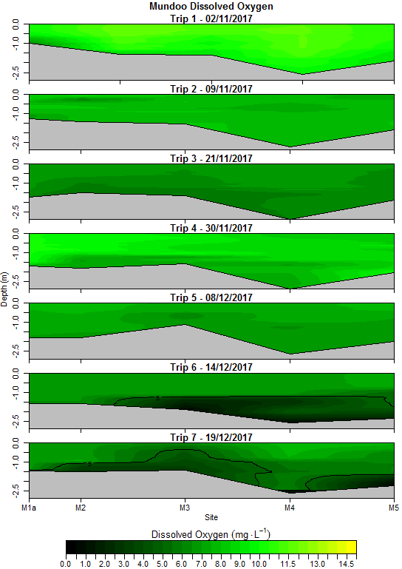

Figure 3‑9. The longitudinal and depth profile of dissolved oxygen measured at multiple sites with ~1 km interval along the Mundoo transect (M1a−M5) in the Coorong during seven trips between early November and mid December 2017. DO contour of 5 mg L-1 is shown.



Figure 3‑10. Integrating salinity, temperature and dissolved oxygen parameters showing longitudinal sections of suitable areas (in yellow) for black bream larval nursery habitat (using environmental criteria of salinities 15−30 PSU, salinity gradient ≥10 PSU, temperature >15°C and DO >5 mg L-1) along the Mundoo transect (M1a−M5) in the Coorong during seven trips between 2 November and 19 December 2017.



Figure 3‑11. Scatterplots of suitable areas (longitudinal section) of larval nursery habitat for black bream, using interpolated environmental criteria of salinities (S) 15−30 PSU, depth gradient (G) ≥10 PSU, temperature (T) >15°C and DO (O) >5 mg L-1, against prior 7-day’s mean barrage discharge (including the sampling day) along the Goolwa, Tauwitchere, Coorong and Mundoo transects and the joint results of the first three transects (All) based on data collected in the Coorong during November and December 2017. Note: The total discharge through Tauwitchere and Ewe Island barrages was used in the plots for the Tauwitchere transect (Pelican Point to Murray Mouth), whereas the discharge through Goolwa, Mundoo and Tauwitchere barrages were used in the plots of Goolwa, Mundoo and Coorong transects, respectively.

## Black bream recruitment

### Catch and CPUE of YOY

A total of 102 juvenile black bream were sampled during March and April 2018, whereas none were caught in January 2018 (Table 3-2). Out of the 102, 74 were collected during the targeted sampling event in April 2018 with all samples coming from fyke net and nil from the small seine net. An additional 28 juveniles were collected by large and small seine nets during the general fish condition monitoring survey in March 2018.

In 2018, mean CPUE was highest in April for fyke netting, when YOY black bream were detected at almost all sites in the Murray Estuary and North Lagoon, showing a wide spatial distribution (Table 3-2). The relative abundance (or CPUE) was similar across sites in both subregions. The catch in March and April 2018 suggested that all three gear types successfully collected YOY black bream; however, fyke net was the most efficient sampling method.

Comparing the relative abundance of YOY black bream over the last ten years (2009‒2018), using catches at four regular sampling sites in the Murray Estuary, the mean CPUE in 2018 was the highest since 2010 (Table 3-3). Although the CPUE in 2009 was at a similarly high level to 2018, the distribution of YOY was restricted to the Murray Estuary subregion in 2009 (Ye *et al.* 2018). Among the four sites, two Goolwa Barrage sites had the highest catch of YOY in most years, whereas Boundary Creek showed the lowest catch in all years. In contrast, in 2018, Mundoo Barrage had the highest catch of YOY, followed by Goolwa Barrage sites and nil catch from Boundary Creek.

Table 3‑2. Relative abundance (CPUE) of young-of-year black bream at different sites and the total number collected by single-wing fyke nets and small seine net in January and April 2018 (SE = standard error). Fyke CPUE = number of fish.net night-1 and seine net CPUE = fish.net-1. HI = Hindmarsh Island and SRP = Sir Richard Peninsula. Note: Additional March sampling using large and small seine nets marked in grey.

|  |  |  |  |  |  |  |  |  |  |  |  |  |
| --- | --- | --- | --- | --- | --- | --- | --- | --- | --- | --- | --- | --- |
|  | Jan-18 | | | | Apr-18 | | | | Mar-18 | | | |
| CPUE | Fyke | | Small Seine | | Fyke | | Small Seine | | Large Seine | | Small Seine | |
| Sites | Mean | SE | Mean | SE | Mean | SE | Mean | SE | Mean | SE | Mean | SE |
| Goolwa Barrage saltwater side HI | 0.0 | 0.0 | 0.0 | 0.0 | 2.3 | 2.3 | - | - | - | - | - | - |
| Goolwa Barrage saltwater side SRP | 0.0 | 0.0 | - | - | 1.8 | 1.1 | - | - | - | - | - | - |
| Beacon 19 | 0.0 | 0.0 | - | - | - | - | 0.0 | 0.0 | 0.0 | 0.0 | - | - |
| Midway bw Goolwa Barrage and Mouth | 0.0 | 0.0 | 0.0 | 0.0 | - | - | - | - | - | - | - | - |
| Mundoo Barrage | 0.0 | 0.0 | - | - | 4.3 | 1.3 | - | - | - | - | - | - |
| Boundary Creek | 0.0 | 0.0 | - | - | 0.0 | 0.0 | - | - | - | - | - | - |
| Boundary Creek Mouth | - | - | - | - | - | - | - | - | 0.0 | 0.0 | - | - |
| Boundary Creek Structure | - | - | - | - | - | - | - | - | 0.0 | 0.0 | - | - |
| Godfrey's landing | 0.0 | 0.0 | 0.0 | 0.0 | - | - | 0.0 | 0.0 | 3.3 | 1.2 | - | - |
| Ewe Island | 0.0 | 0.0 | 0.0 | 0.0 | 1.3 | 0.8 | - | - | - | - | - | - |
| Opposite Tauwitchere barrage | 0.0 | 0.0 | - | - | - | - | - | - | - | - | - | - |
| Pelican Point | 0.0 | 0.0 | 0.0 | 0.0 | - | - | - | - | 0.0 | 0.0 | - | - |
| **Mean (Murray Estuary)** | **0.0** | **0.0** | **0.0** | **0.0** | **1.9** | **0.7** | **0.0** | **0.0** | **0.7** | **0.7** | - | - |
| Cattle Point | 0.0 | 0.0 | - | - | 1.3 | 1.3 | - | - | - | - |  | - |
| Mark Point | 0.0 | 0.0 | 0.0 | 0.0 | 0.5 | 0.5 | - | - | 0.3 | 0.3 | 3.7 | 0.9 |
| Long Point | - | - | - | - | 4.0 | 1.4 | - | - | 2.0 | 1.5 | 0.0 | 0.0 |
| Long Point Sand Dune | - | - | - | - | 2.0 | 1.7 | - | - | - | - |  | - |
| Noonameena | - | - | - | - | - | - | - | - | 0.0 | 0.0 | 0.0 | 0.0 |
| Mt Anderson | - | - | - | - | - | - | - | - | 0.0 | 0.0 | 0.0 | 0.0 |
| **Mean (North Lagoon)** | **0.0** | **0.0** | **0.0** | **0.0** | **1.9** | **0.8** | - | - | **0.6** | **0.5** | **0.9** | **0.9** |
| **Overall** | **0.0** | **0.0** | **0.0** | **0.0** | **1.9** | **0.5** | **0.0** | **0.0** | **0.6** | **0.4** | **0.9** | **0.9** |

Table 3‑3. Inter-annual comparison of relative abundance (CPUE, fish.net night-1) of young-of year black bream sampled at regular sampling sites in the Murray Estuary between February and June from 2009 to 2018. HI = Hindmarsh Island and SRP = Sir Richard Peninsula.

|  |  |  |  |  |  |  |  |  |  |  |
| --- | --- | --- | --- | --- | --- | --- | --- | --- | --- | --- |
| **Regular sites** | **Goolwa Barrage HI** | | **Goolwa Barrage SRP** | | **Mundoo Barrage** | | **Boundary Creek** | | **Annual** | |
| **CPUE** | **Mean** | **SE** | **Mean** | **SE** | **Mean** | **SE** | **Mean** | **SE** | **Mean** | **SE** |
| **2009** | 3.5 | 1.3 | 4.3 | 1.3 | 0.3 | 0.3 | 0.1 | 0.1 | **2.1** | **1.1** |
| **2010** | 0.4 | 0.2 | 1.6 | 0.5 | - | - | 0.0 | 0.0 | **0.7** | **0.4** |
| **2011** | 0.0 | 0.0 | 0.0 | 0.0 | 0.0 | 0.0 | 0.0 | 0.0 | **0.0** | **0.0** |
| **2012** | 0.1 | 0.1 | 0.1 | 0.1 | 0.1 | 0.1 | 0.0 | 0.0 | **0.1** | **0.0** |
| **2013** | 0.8 | 0.3 | 1.3 | 0.5 | 0.1 | 0.1 | 0.0 | 0.0 | **0.6** | **0.3** |
| **2014** | 0.0 | 0.0 | 0.0 | 0.0 | 0.0 | 0.0 | 0.0 | 0.0 | **0.0** | **0.0** |
| **2015** | 0.0 | 0.0 | 0.0 | 0.0 | - | - | 0.0 | 0.0 | **0.0** | **0.0** |
| **2016** | 0.4 | 0.3 | 0.0 | 0.0 | 0.0 | 0.0 | 0.0 | 0.0 | **0.1** | **0.1** |
| **2017** | 0.0 | 0.0 | 0.0 | 0.0 | 0.0 | 0.0 | 0.0 | 0.0 | **0.0** | **0.0** |
| **2018** | 2.3 | 2.3 | 1.8 | 1.1 | 4.3 | 1.3 | 0.0 | 0.0 | **2.1** | **0.9** |

### YOY size and age compositions, and spawn dates

YOY collected in March 2018 ranged from 32−61 mm TL, with ages varying between 58 and 98 days (Figure 3-12). YOY collected in April 2018 ranged from 35−73 mm TL, with ages varying between 62 and 100 days (Figure 3-12). The age-frequency distributions were generally unimodal and showed a modal progression from 75 to 90 days from March to April. The majority (83%) of fish collected were between 75 and 90 days old.

Back-calculated spawn dates of the YOY ranged from 26 December 2017 to 1 February 2018, with 45% spawned between 1 and 10 January 2018 (Figure 3-13). The spawning period occurred during the recession of a barrage flow pulse that peaked at ~12,000 ML day-1 in mid-December. The broader spawning period corresponded to barrage discharge ~600−5,000 ML day-1 and temperature 18−25oC, whereas the peak spawning period was during discharge of 1,475−3,749 ML day-1 and temperature 21−24oC.



Figure 3‑12. Length (left) and daily age (right) frequency distributions of YOY black bream collected in the Murray Estuary and North Lagoon of the Coorong in March and April 2018.



Figure 3‑13. Back-calculated spawn dates for young-of-year black bream (grey bars; *n* = 85) collected in the Murray Estuary and North Lagoon of the Coorong in March and April 2018, plotted against total flow discharge (ML day‑1) to the Coorong (blue line) and mean water temperature (°C) (red line).

### Daily age and length relationship

The equation of daily growth of YOY black bream was determined as: TL (mm) = 8.87 + 0.49 * age (days). YOY collected in March and April 2018 in the Coorong showed considerable variation in length-at-age (Figure 3‑14). For example, 75-day-old fish ranged from 36–54 mm TL and 80-day-old fish from 43–56 mm TL.



Figure 3‑14. YOY black bream age and length relationship. Solid black line represents trend line; dashed grey lines represent 95% confidence intervals.

# Discussion

### Barrage releases and salt wedge conditions

Freshwater flow is critical in maintaining estuarine habitats to support fish recruitment, including providing salt wedge conditions with high salinity stratification (halocline) in estuaries (Jenkins *et al.* 2010). During 2017-18, a climatically and hydrologically dry year, a substantial volume of Commonwealth environmental water (404 GL) supported barrage releases, aiming to maintain estuarine habitats and end-of-system connectivity for the MDB. Between October 2017 and March 2018, Commonwealth environmental water contributed 94% of flows over the barrages, with the remaining discharge consisting of other environmental water (the TLM Program, Victorian Environmental Water Holder and River Murray Increased Flows) and unregulated flows.

Aligning with the reported reproductive season of black bream in the Coorong (Cheshire *et al.* 2013), salt wedge condition monitoring was conducted between 2 November and 19 December 2019, when total barrage releases ranged from 1,000‒12,000 ML day-1. Results from the monitoring program indicated the presence of areas with suitable salinities (15−30 PSU) and stratifications (≥10 PSU) to support black bream spawning and larval development (William *et al.* 2013) in the Murray Estuary, and to a lesser extent in the North Lagoon (Pelican Point to Mark Point). As the water temperature was >15°C, which is known as a spawning cue in other areas (e.g. Williams 2013), and DO was generally >5 mg L-1 (suitable for egg and larval development, Hassell *et al.* 2008a; 2008b) except for the last two trips (14 and 19 December 2017) in Mundoo Channel, suitable spawning and larval nursery habitats were deemed to be available for black bream during this time, although their spatial extent varied among barrages.

From November to mid-December, suitable larval nursery habitat was consistently present below Goolwa Barrage (i.e. Goolwa Channel or transect, ~7 km), associated with barrage discharge at 260‒3,300 ML day-1. In contrast, larval nursery habitat was limited in the North Lagoon during this period, potentially due to the higher salinities and shallower, wind-affected landscape, despite the greater discharge from Tauwitchere Barrage (700‒6,300 ML day-1). For the Tauwitchere transect, although a large area of larval nursery habitat was present, it demonstrated greater spatial/temporal variability compared to that in Goolwa Channel. This was probably because the Tauwitchere transect (~13 km) was located within a ‘less defined’ channel with a large exposed area, subject to stronger influence by wind and tidal conditions. In addition, flow releases from both Tauwitchere and Ewe Island barrages influenced the dynamic habitat conditions along this transect. The Mundoo transect (~5 km) was located in a ‘well defined’ channel, although shallower and narrower than Goolwa Channel. Monitoring indicated that low flow discharge at ≤6 ML day-1 (via fishway only) could provide suitable larval nursery habitat for black bream in the channel (e.g. from early November to early December 2017). However, higher discharge (>800 ML day-1) led to reduced nursery habitat due to a large area of very low salinity below Mundoo Barrage and extensive hypoxic areas in the deeper zone. The potential exists for hypoxic conditions to develop in deeper zones of well-stratified water, particularly during warm temperatures due to increased microbial activities (Rabalais *et al.* 2002).

Following on from a pilot study in 2014-15 (Ye *et al.* 2015), this study was the first main attempt to quantify the extent of suitable larval nursery areas for black bream in the Coorong, and to explore the relationships with barrage discharge. The patterns seemed complex for Goolwa, Tauwitchere and Mundoo transects, whilst a dome shape relationship could be observed for Coorong transect, suggesting that moderate flow releases from Tauwitchere Barrage (~2,700 ML day-1) may maximise the area of larval nursery habitat for black bream along this transect (between Pelican Point and Mark Point). However, the results need to be treated with caution given the small sample size in this first year’s monitoring (seven sampling trips/occasions), and that four parameters (i.e. salinity range, salinity gradient, water temperature and DO) were included in assessing habitat suitability. Furthermore, the Coorong is a highly dynamic system with salinity profiles strongly influenced by other factors (e.g. tidal and wind conditions) in addition to barrage flows (Appendix B and C). Future monitoring will be required under a range of barrage releases and environmental conditions to increase the sample size so that quantitative relationships could be developed to guide flow management.

### Black bream recruitment

Since monitoring commenced in 2008-09, the highest numbers of black bream YOY occurred in 2017-18, suggesting that the level of recruitment was the highest in the Coorong in that year. This was further supported by the broad distribution of YOY during autumn 2018 (Table 3-2). It should be noted that the capture location of YOY does not necessarily reflect the location of spawning.

All YOY were spawned between 26 December 2017 and 1 February 2018, indicating a delayed or extended spawning season compared to the general reproductive period (i.e. September to late December) reported for this species (Walker and Neira 2001; Sakabe *et al.* 2011; Cheshire *et al.* 2013). During these spawn dates, total barrage releases ranged between ~600‒5,000 ML day-1, corresponding to discharge at Goolwa, Tauwitchere and Mundoo barrages between ~200‒1,400 ML day-1, ~400‒2,100 ML day-1 and ~2‒1,000 ML day-1, respectively. Although there was no direct monitoring of salt wedge conditions during this period, data collected during earlier weeks suggested the presence of favourable salinities (15−30 PSU) and haloclines (≥10 PSU) for black bream larval recruitment in the Coorong under similar barrage releases.

The spawn dates of most YOY black bream (26 December to 29 January) corresponded with water temperatures of 20–25°C (Figure 3-13), whereas one individual was spawned on 1 February at 18°C. Temperature profiles indicated that warmer temperature (>20°C) occurred throughout the water column at most sites in the Coorong on 14 and 19 December (Figures 3-4 and 3-8), and such condition was likely maintained in late December and January. Warmer surface water temperatures (>20°C) also occurred between 19 November–1 December (Figure 3-13), but thermoclines (temperature stratification) retained cooler water in deeper areas (Figures 3-4 and 3-8). No successful recruitment occurred during this period. The temperature threshold (generally >20°C) associated with the spawn dates of YOY in this study was higher than the trigger (>15°C) commonly reported for black bream spawning (Sarre and Potter 2000; Walker and Neira 2001; Nicholson *et al.* 2008; Williams 2013). Nevertheless, it was possible that spawning might have occurred earlier (e.g. October−mid December 2017) in the Coorong, but there was negligible recruitment to YOY, potentially due to insignificant spawning events or larval mortality.

Results from other studies suggest that food supply is critical to black bream spawning success and contributes to variability in year-to-year recruitment (Newton 1996). Copepods, in particular nauplii and copepodites, are the preferred prey for black bream larvae (Newton 1996; Willis *et al.* 1999; Williams 2013) with their abundance strongly linked to salinity stratification (halocline) and density maximised around 20°C (Williams 2013). The sustained warm temperature (generally >20°C) from mid-December to early February, coupled with favourable salinities/halocline conditions, may have resulted in high prey availability, which would increase larval growth and survival and subsequent successful recruitment of black bream.

In addition, the flow pulse ~10,000−12,000 ML day-1 around mid-December, coinciding with increasing temperature (>20°C), may have contributed to the improved recruitment of black bream during 2017-18. There are two possible explanations. Firstly, the flow pulse likely attracted larger spawning aggregations of black bream into favourable spawning grounds below barrages, which may be needed considering the current low level of spawning biomass in the Coorong (Earl *et al.* 2016). It is notable that there was no targeted commercial fishing effort reported for black bream in the Murray Estuary during the successful spawning period (i.e. 26 December to 1February) (SARDI unpublished data). Secondly, increased flow may have resulted in increased food resources in the Coorong directly by transport from upstream (e.g. zooplankton) (Shiel and Tan 2013) or indirectly via nutrient input (Giatas and Ye 2016). Research work (e.g. Bice *et al.* 2016) indicates that even small increases in riverine discharge (e.g. a pulse of 11,000 ML day-1 for ~3 weeks) can enhance productivity and food abundance (zooplankton) and thus benefit the Coorong food web. Furthermore, anecdotal information suggest that Goolwa Barrage maintenance work between mid October and early December 2017, which involved the removal of Australian tubeworm (*Ficopomatus enigmaticus)* and opening of a full bay for cleaning, may have contributed to extra nutrient and food resources and therefore attracted black bream to this area (personal comment, Gary Fyke, SA Water). Finally, it should be noted that during the flow pulse in mid-December, favourable salt wedge conditions were generally maintained in the Coorong estuary, particularly along Goolwa and Tauwitchere transects.

The population of black bream in the Coorong is currently depleted, with a substantially reduced abundance and spawning biomass (Earl *et al.* 2016; Ye *et al.* 2018). Promoting more frequent recruitment will help increase abundance over time and rebuild population resilience. In this regard, environmental water and barrage management is critical, particularly in the highly modified and reduced Coorong estuary, to provide suitable flow and habitat conditions and increase food resources to improve recruitment. Concurrently, conservation management should seek to protect the remnant spawning biomass (e.g. by implementing a fishing closed season during the spawning period and extending closed areas below the barrages). In addition, it’s important to enhance the survival of new recruits (e.g. by minimising fishing mortality of undersized black bream) following initial recruitment success, so that they will contribute to adult population and spawning biomass in future years. The survival and growth of new recruits could also be enhanced by barrage flows to improve estuarine habitat and food resources in the Coorong.

### Future research and monitoring needs

Salt wedge condition monitoring conducted during 2017-18 provides initial quantitative data, to link barrage discharge to larval nursery habitat availability for black bream in the Coorong. Such information will guide the barrage operation for optimal releases to maximise quality estuarine habitat that facilitates the recruitment of black bream and other fish species. As black bream spawning occurred in late summer in 2017-18, future salt wedge monitoring needs to cover a broader spawning period (i.e. October to February). Due to the dynamic nature of the Coorong estuary, further monitoring will be required to provide a larger dataset under a range of flow and environmental conditions in order to develop quantitative relationships and to inform adaptive management of barrage releases.

Results from this monitoring program suggest the presence of suitable estuarine habitat for black bream spawning and larval nursery from November to mid-December 2017. However, no YOY were spawned during this period, possibly due to a lack of significant spawning event or high larval mortality. In order to better understand flow and other environmental effects on the key life history processes that underpin the recruitment success of black bream, egg and larval fish sampling could be conducted in the future, in association with salt wedge condition monitoring. In addition, food resource (zooplankton) is a critical driver for recruitment success of black bream and many other estuarine fish (North and Houde 2003; Williams 2013). To further understand trophic impacts on recruitment of black bream and other estuarine species, it would be beneficial to monitor the abundance of zooplankton (e.g. copepods), in conjunction with salt wedge dynamics. In this study, the criteria of habitat suitability (i.e. salinity, stratification level, temperature and DO) for black bream reproduction and larval nursery were based on research findings from other geographical regions; therefore, Coorong specific knowledge may be needed to improve the evaluation of habitat quality and availability for this region.

# Conclusion

The 2017-18 monitoring demonstrated that barrage flow management, supported by environmental water, can generate favourable conditions (particularly salt wedge habitat) that facilitate successful recruitment events of black bream, which over time should support the population recovery in the Coorong. In a dry year such as 2017-18, without environmental water, barrage flows would not have been maintained throughout spring−summer, which is the primary reproductive season of black bream and many other estuarine species.

Recruitment of black bream is highly variable in the substantially modified estuary of the Coorong. Recent studies suggest that strong cohorts are associated with low to moderate river flows. Under such climatic and hydrological conditions, environmental water plays a critical role in maintaining barrage releases, which can be managed to provide optimal flow regimes to increase favourable salt wedge habitat and potentially enhance productivity to promote black bream recruitment. For example, the successful recruits (YOY) in 2017-18 were from the spawning period from late December to early February, which corresponded with barrage releases of 600−5,000 ML day-1 and temperature of 18−25°C, and commenced about 1−2 weeks after a ~10,000−12,000 ML day‑1 flow pulse. Similar flow regimes could be applied, with outcomes monitored to improve our learnings to inform management. Furthermore, given the depleted population of black bream in the Coorong, conservation management should seek to protect the remnant spawning biomass and improve the survival of new recruits to rebuild population abundance and resilience in this region.

This study was the first main attempt, following a pilot study in 2014-15, to characterise and quantify larval nursery habitat for black bream in the Coorong, and collect data for developing quantitative relationships between barrage flows and habitat suitability. Future research and monitoring will be required, particularly to obtain information on environmental and habitat requirements (including food resources), and how they influence key life history processes and recruitment dynamics for the population of black bream in the Coorong. Such information will support adaptive management of environmental water and inform optimal barrage flow regimes to improve estuarine habitat and enhance the recruitment of black bream and many other estuarine fish in the Coorong.

# References

Bice, C. M., Furst, D., Lamontagne, S., Oliver, R. and Zampatti, B. P. (2016). The influence of freshwater discharge on productivity, microbiota community structure and trophic dynamics in the Coorong: evidence of freshwater derived trophic subsidy in the sandy sprat. Goyder Institute for Water Research Technical Report Series No. 15/40, Adelaide.

Bivand, R. and Rundel, C. (2017). rgeos: Interface to Geometry Engine - Open Source ('GEOS'). R package version 0.3-26. https://CRAN.R-project.org/package=rgeos

Cheshire, K. J. M., Ye Q., Fredberg, J., Short, D. and Earl, J. (2013). Aspects of reproductive biology of five key fish species in the Murray Mouth and Coorong. South Australian Research and Development institute (Aquatic Sciences), Adelaide. SARDI Publication No. F2009/000014-3. SARDI Research report Series No. 699.

DEWNR (2015). Long-term environmental watering plan for the South Australian River Murray water resource plan area. November 2015.

DEWNR (2017). Condition Monitoring Plan (Revised) 2017. The Living Murray – Lower Lakes, Coorong and Murray Mouth Icon Site. DEWNR technical report 2016–17. Government of South Australia, through Department of Environment, Water and Natural Resources, Adelaide.

Earl, J., Ward, T. M. and Ye, Q. (2016). Black Bream (*Acanthopagrus butcheri*) Stock Assessment Report 2014/15. Report to PIRSA Fisheries and Aquaculture. South Australian Research and Development Institute (Aquatic Sciences), Adelaide. SARDI Publication No. F2008/000810-2. SARDI Research Report Series No. 885.

Giatas, G. C. and Ye, Q. (2016). Conceptual food-web models for the Coorong: A focus on fishes and the influence of freshwater flows. South Australian Research and Development Institute (Aquatic Sciences), Adelaide. SARDI Publication No. F2016/000124-1. SARDI Research Report Series No. 892.

Haddy, J. A. and Pankhurst, N. W. (2000). The effects of salinity on reproductive development, plasma steroid levels, fertilisation and egg survival in black bream, *Acanthopagrus butcheri*. *Aquaculture* **188**, 115–131.

Hassell, K.L., Coutin, P.C. and Nugegoda, D. (2008).Hypoxia, low salinity and lowered temperature reduce embryo survival and hatch rates in black bream *Acanthopagrus butcheri* (Munro, 1949). Journal of Fish Biology 72:1623-1636.

Hassell, K.L., Coutin, P.C. and Nugegoda, D. (2008).Hypoxia impairs embryo development and survival in black bream (Acanthopagrus butcheri). Marine Pollution Bulletin 57:302-306.

Islam, M. S., Hibino, M. and Tanaka, M. (2006). Distribution and diets of larval and juvenile fishes: influence of salinity gradient and turbidity maximum in a temperate estuary in upper Ariake Bay, Japan. *Estuarine, Coastal and Shelf Science* **68**, 62–74.

Jenkins, G. P., Conron, S. and Morison, A. K. (2010). Highly variable recruitment in an estuarine fish is determined by salinity stratification and freshwater flows: implications of a changing climate. *Marine Ecology Progress Series* **417**, 249–261.

MDBA (2014). Basin-wide Environmental Watering Strategy. Murray‒Daring Basin Authority. MDBA Publication No 20/14. ISBN 978-1-922177-96-4.

MDBC (2006). The lower Lakes, Coorong and Murray Mouth Icon Site Management Plan 2006–2007.

Newton, G. M. (1996). Estuarine icthyoplankton ecology in relation to hydrology and zooplankton dynamics in a salt-wedge estuary. *Marine and Freshwater Research* **47**, 99–111.

Nicholson, G., Jenkins, G. P., Sherwood, J. and Longmore, A. (2008). Physical environmental conditions, spawning and early-life stages of an estuarine fish: climate change implications for recruitment in intermittently open estuaries. *Marine and Freshwater Research* **59**, 735–749.

Norriss, J. V. Tregonning, J. E., Lenanton, R. C. J. and Sarre, G. A. (2002). Biological synopsis of the black bream, *Acanthopagrus butcheri* (Munroe) (Teleostei: Sparidae) in Western Australia with reference to information from other southern states: Fisheries Research report. Department of Fisheries, Western Australia, Perth.

North, E. W. and Houde, E. D. (2003). Linking ETM physics, zooplankton prey, and fish early life histories to striped bass *Morone saxatilis* and white perch *M. americana* recruitment. *Marine Ecology Progress Series* **260**, 219–236.

North, E. W., Hood, R. R., Chao, S-Y. and Sanford, L. P. (2005). The influence of episodic events on transport of striped bass eggs to the estuarine turbidity maximum nursery area. *Estuaries* **28**, 108–123.

Potter, I. C., Tweedley, J. R., Elliott, M. and Whitfield, A. K. (2015). The ways in which fish use estuaries: a refinement and expansion of the guild approach. *Fish and Fisheries* **16**, 230–239.

Rabalais*,* N. N., Turner, R. E., and Wiseman, W. J.(2002). Gulf of Mexico hypoxia, aka “the dead zone”. *Annual Review of Ecology and Systematics*, **33**, 235– 263.

R Core Team (2017). R: A language and environment for statistical computing. R Foundation for Statistical Computing, Vienna, Austria. URL https://www.R-project.org/

Sakabe, R., Lyle, J. M. and Crawford, C. M. (2011). The influence of freshwater inflows on spawning success and early growth of an estuarine resident fish species, *Acanthopagrus butcheri*. *Journal of Fish Biology* **78**, 1529–1544.

Sarre, G. A. and Potter, I. C. (2000). Variations in age compositions and growth rates of *Acanthopagrus butcheri* (Sparidae) amongst estuaries: some possible contributing factors. *Fishery Bulletin* **98**, 785–799.

Shiel, R. J. and Tan, L-W. (2013). Zooplankton response monitoring: Lower Lakes, Coorong and Murray Mouth September 2012 – March 2013. Final report to Department of Environment, Water and Natural Resources, Adelaide.

Walker, S. and Neira, F. J. (2001). Aspects of the reproduction biology and early life history of black bream, *Acanthopagrus butcheri* (Sparidae), in a brackish lagoon system in southeastern Australia. *Journal of Ichthyology and Aquatic Biology* **4**, 135–142.

Williams, J. (2013). The importance of environmental flows to the spawning and larval ecology of black bream (Sparidae: *Acanthopagrus butcheri*). PhD thesis, Department of Zoology, The University of Melbourne.

Williams, J., Hindell, J. S., Swearer, S. E. and Jenkins, G. P. (2012). Influence of freshwater flows on the distribution of eggs and larvae of black bream *Acanthopagrus butcheri* within a drought-affected estuary. *Journal of Fish Biology* **80**, 2281–2301.

Williams, J., Jenkins, G.P., Hindell, J.S. and Swearer, S.E. (2013). Linking environmental flows with the distribution of black bream *Acanthopagrus butcheri* eggs, larvae and prey in a drought affected estuary. *Marine Ecological Progress Series* **483**, 273–287.

Willis, S.E., Laurenson, L.J., Mitchell, B.D. and Harrington, D.J. (1999). Diet of larval and juvenile black bream, *Acanthopagrus butcheri*, in the Hopkins River Estuary, Victoria, Australia. *Proceedings of the Royal Society of Victoria* **111**, 283–295.

Ye, Q., Bucater, L. and Short, D. (2013). Coorong fish condition monitoring 2008‒2013: Black bream (*Acanthopagrus butcheri*), greenback flounder (*Rhombosolea tapirina*) and smallmouthed hardyhead (*Atherinosoma microstoma*) populations. South Australian Research and Development Institute (Aquatic Sciences), Adelaide. SARDI Publication No. F2011/000471-3. SARDI Research Report Series No. 748.

Ye, Q., Bucater, L. and Short, D. (2015). Coorong fish condition monitoring 2008‒2014: Black bream (*Acanthopagrus butcheri*), greenback flounder (*Rhombosolea tapirina*) and smallmouthed hardyhead (*Atherinosoma microstoma*) populations. South Australian Research and Development Institute (Aquatic Sciences), Adelaide. SARDI Publication No. F2011/000471-4. SARDI Research Report Series No. 836.

Ye, Q., Giatas, G., Bucater, L. and Short, D. (2018). Coorong fish condition monitoring 2016/17: Black bream (*Acanthopagrus butcheri*), greenback flounder (*Rhombosolea tapirina*) and smallmouth hardyhead (*Atherinosoma microstoma*) populations. South Australian Research and Development Institute (Aquatic Sciences), Adelaide. SARDI Publication No. F2011/000471-6. SARDI Research Report Series No. 979.

# Appendix

Appendix A. Sampling sites of salt wedge monitoring in November and December 2017 along four transects below Goolwa, Mundoo and Tauwitchere barrages in the Coorong.

|  |  |  |  |  |
| --- | --- | --- | --- | --- |
| **Transect** | **Site Code** | **Distance from barrage release point (~km)** | **Latitude** | **Longitute** |
| Goolwa | G1 | 0.2 | -35.5264 | 138.8103 |
| Goolwa | G2 | 1.2 | -35.5279 | 138.8210 |
| Goolwa | G3 | 2.2 | -35.5311 | 138.8313 |
| Goolwa | G4 | 3.2 | -35.5346 | 138.8414 |
| Goolwa | G5 | 4.2 | -35.5398 | 138.8504 |
| Goolwa | G6 | 5.2 | -35.5466 | 138.8583 |
| Goolwa | G7 | 6.2 | -35.5477 | 138.8695 |
| Goolwa | G8 | 7.2 | -35.5516 | 138.8782 |
| Tauwitchere | T1 | 0.4 | -35.5959 | 139.0185 |
| Tauwitchere | T2 | 0.7 | -35.5933 | 139.0140 |
| Tauwitchere | T3 | 1.2 | -35.5910 | 139.0093 |
| Tauwitchere | T4 | 2.2 | -35.5872 | 138.9992 |
| Tauwitchere | T5 | 3.2 | -35.5817 | 138.9901 |
| Tauwitchere | T6 | 4.2 | -35.5765 | 138.9810 |
| Tauwitchere | T7 | 5.2 | -35.5720 | 138.9713 |
| Tauwitchere | T8 | 6.2 | -35.5683 | 138.9612 |
| Tauwitchere | T9 | 7.3 | -35.5632 | 138.9522 |
| Tauwitchere | T10 | 8.2 | -35.5623 | 138.9415 |
| Tauwitchere | T11 | 9.2 | -35.5670 | 138.9322 |
| Tauwitchere | T12 | 10.2 | -35.5702 | 138.9222 |
| Tauwitchere | T13 | 11.2 | -35.5677 | 138.9117 |
| Tauwitchere | T14 | 12.2 | -35.5612 | 138.9042 |
| Tauwitchere | T15 | 13.2 | -35.5598 | 138.8935 |
| Coorong | C1 | 0.5 | -35.5981 | 139.0230 |
| Coorong | C2 | 1.0 | -35.6007 | 139.0275 |
| Coorong | C3 | 2.0 | -35.6056 | 139.0369 |
| Coorong | C4 | 3.0 | -35.6103 | 139.0463 |
| Coorong | C5 | 4.0 | -35.6156 | 139.0554 |
| Coorong | C6 | 5.0 | -35.6218 | 139.0635 |
| Coorong | C7 | 6.0 | -35.6290 | 139.0704 |
| Coorong | C8 | 7.0 | -35.6355 | 139.0782 |
| Mundoo | M1a | 1.1 | -35.5386 | 138.8941 |
| Mundoo | M2 | 1.4 | -35.5376 | 138.8913 |
| Mundoo | M3 | 2.4 | -35.5429 | 138.8823 |
| Mundoo | M4 | 3.5 | -35.5460 | 138.8927 |
| Mundoo | M5 | 4.8 | -35.5524 | 138.9001 |

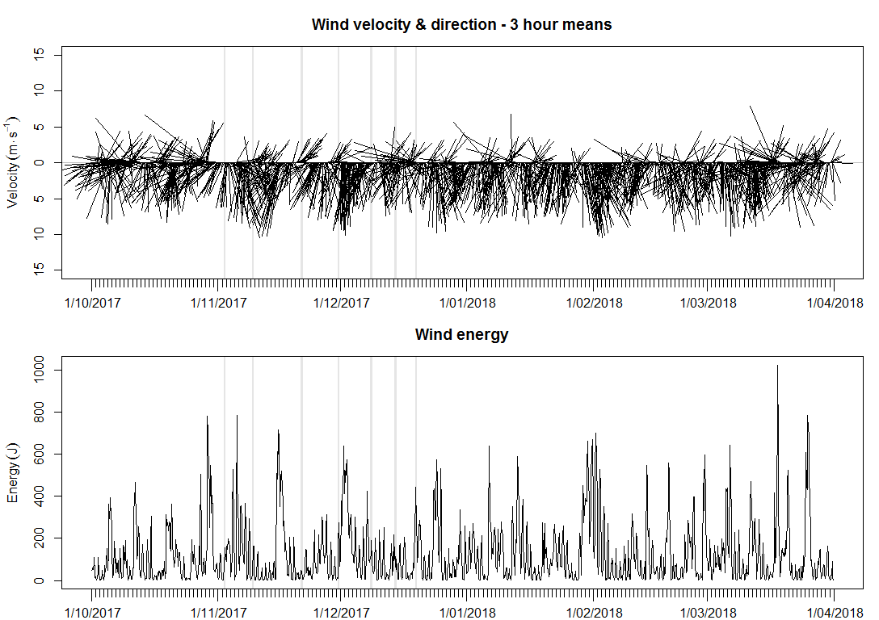Appendix B. Wind velocity, direction (top), and energy (bottom) calculated as 3 hourly averages between October 2017 and April 2018. Top graph: The length of the lines represent the wind velocity and the angle of the lines the wind direction. Data source for wind: DEW; data source for air temperature, atmospheric pressure and humidity: Bureau of Meteorology Hindmarsh Island station (023894).

Appendix C. Water level (m AHD) in the Murray Estuary and North Lagoon of the Coorong between October 2017 and April 2018. The black circles represent sampling time (~weekly) and location of measurements for temperature, salinity and DO profiles during salt wedge condition monitoring from 2 November to 19 December 2017. Gauges data provided by DEW.

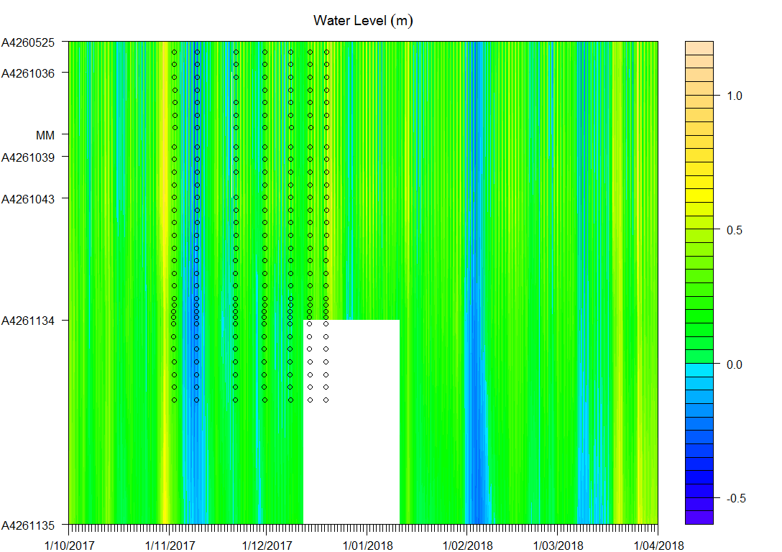

**Gauges:**

**A4260525 - Goolwa Channel at Goolwa Barrage (Recorder)**

**A4261036 - Goolwa Channel at Beacon 12 (Adjacent Reedy Island)**

**A4261039 - Coorong Channel adjacent Barker Knoll**

**A4261043 - Coorong Channel near Beacon 1 (Ewe Island Shacks)**

**A4261134 - The Coorong at Pelican Point**

**A4261135 - The Coorong at Long Point**

**MM - Murray Mouth**