# Methyl bromide fumigation methodology

# Version 3.0



© Commonwealth of Australia 2023

**Ownership of intellectual property rights**

Unless otherwise noted, copyright (and any other intellectual property rights) in this publication is owned by the Commonwealth of Australia (referred to as the Commonwealth).

**Creative Commons licence**

All material in this publication is licensed under a [Creative Commons Attribution 4.0 International Licence](https://creativecommons.org/licenses/by/4.0/legalcode) except content supplied by third parties, logos and the Commonwealth Coat of Arms.

**Cataloguing data**

This publication (and any material sourced from it) should be attributed as: DAFF 2023, *Methyl bromide fumigation methodology*, Department of Agriculture, Fisheries and Forestry, Canberra. CC BY 4.0.

This publication is available at [agriculture.gov.au/biosecurity-trade/import/arrival/treatments/treatments-fumigants](https://www.agriculture.gov.au/biosecurity-trade/import/arrival/treatments/treatments-fumigants#methyl-bromide-fumigation).

Department of Agriculture, Fisheries and Forestry

GPO Box 858 Canberra ACT 2601

Telephone 1800 900 090

Web [agriculture.gov.au](https://www.agriculture.gov.au/)

**Disclaimer**

The Australian Government acting through the Department of Agriculture, Fisheries and Forestry has exercised due care and skill in preparing and compiling the information and data in this publication. Notwithstanding, the Department of Agriculture, Fisheries and Forestry, its employees and advisers disclaim all liability, including liability for negligence and for any loss, damage, injury, expense or cost incurred by any person as a result of accessing, using or relying on any of the information or data in this publication to the maximum extent permitted by law.

**Acknowledgement of Country**

We acknowledge the Traditional Custodians of Australia and their continuing connection to land and sea, waters, environment and community. We pay our respects to the Traditional Custodians of the lands we live and work on, their culture, and their Elders past and present.

## Purpose

This methodology sets out the minimum requirements for treatment providers performing methyl bromide fumigations on import and export consignments for Quarantine and Pre‑Shipment (QPS) purposes. Compliance auditing of treatment providers is performed against the requirements in this methodology to gain assurance QPS treatments are performed effectively.

Treatment providers required to perform fumigations in accordance with this methodology must have the:

* equipment
* facilities
* personnel and
* administrative procedures necessary to comply with these requirements.

Importing jurisdictions may impose more stringent treatment requirements to address specific biosecurity risks. In such cases, those additional requirements, referred to in this document as import conditions, take precedence over the requirements of this methodology and must be complied with to the satisfaction of the relevant authority of the importing jurisdiction.

## General

All requirements in this methodology must be performed to ensure:

* target pests are killed
* the people performing the treatment remain safe and are not harmed
* all people in the area around the treatment area remain safe and are not harmed
* the goods or commodities being treated are not damaged or adversely affected.

Methyl bromide is listed as a category 1 ozone depleting substance under the Montreal Protocol 1992. Performing methyl bromide fumigations in accordance with these requirements will reduce the use of methyl bromide by minimising the need for re-treatment of consignments due to ineffective fumigations caused by poor fumigation practices.

Use and handling of methyl bromide must not contravene any instructions on the product label, safety data sheet, local regulations or relevant licence requirements.

## How to use this document

This document outlines the minimum set of requirements for performing methyl bromide fumigation treatments.

The [Guide to performing QPS fumigations with methyl bromide](https://www.agriculture.gov.au/biosecurity-trade/import/arrival/treatments/treatments-fumigants#methyl-bromide-fumigation) and [Guide to packaging suitability for performing QPS treatments](https://www.agriculture.gov.au/biosecurity-trade/import/arrival/treatments/treatments-fumigants#methyl-bromide-fumigation) provide information that may assist in meeting these requirements in commonly encountered situations.

It is important treatment providers and compliance auditors understand the purpose of the requirements of this methodology, the outcomes they are intended to achieve and the circumstances in which they apply.

The technical terms used in this methodology are defined in the glossary. For all terms not defined in the glossary, refer to the definition used by the [Macquarie Dictionary](https://www.macquariedictionary.com.au/).

Contents

Purpose 3

General 3

How to use this document 3

1 Fumigator readiness 8

1.1 Fumigation personnel 8

1.2 Fumigation equipment 8

1.3 Site suitability 8

2 Safety 8

2.1 Safety considerations 9

2.2 Risk assessment 9

2.3 Personal protective equipment (PPE) 9

3 Consignment suitability 10

3.1 Target of fumigation 10

3.2 Impermeable packaging, wrappings and surface coatings 10

3.3 Requirements for perishable commodity packaging 11

3.4 Load factor requirements for perishable commodity fumigations 11

3.5 Requirements for timber 11

4 Fumigation enclosures 12

4.1 All enclosures 12

4.2 Sheeted enclosures 12

4.3 Fumigation chambers 12

4.4 Pressure testing a fumigation chamber 13

4.5 Vacuum chamber 13

5 Preparing to fumigate 14

5.1 Establish an exclusion zone 14

5.2 Gas concentration monitoring equipment 14

5.3 Gas concentration monitoring locations 15

5.4 Gas concentration monitoring locations – perishable commodities 16

5.5 Temperature monitoring instrument locations 17

5.6 Methyl bromide supply pipes 18

5.7 Heaters and fans 18

6 Temperature used to calculate the dose 18

6.1 Ambient temperature fumigations 18

6.2 Controlled temperature fumigations 19

6.3 Perishable commodity fumigations 19

7 Temperature during the exposure period 20

7.1 Ambient temperature fumigations 20

7.2 Controlled temperature fumigations 20

7.3 Perishable commodity fumigations 21

8 Performing the fumigation 21

8.1 Dose rate compensation for temperature variation 21

8.2 Calculating the dose 21

8.3 Injecting methyl bromide into the fumigation enclosure 22

8.4 Checking for leaks 22

8.5 Even methyl bromide distribution 22

8.6 Exposure period 23

9 Monitoring the fumigation 24

9.1 Gas concentration monitoring 24

9.2 Gas concentration monitoring – multiple sea containers in a sheeted stack 24

10 Topping-up methyl bromide levels 25

10.1 Topping-up during the exposure period 25

10.2 Topping-up at the end of the exposure period 25

10.3 Performing the top-up 25

11 Ventilating the fumigation enclosure 26

11.1 Threshold limit value (TLV) 26

11.2 Releasing methyl bromide from the enclosure 26

11.3 Releasing the consignment from the control of the fumigator-in-charge 27

12 Documentation 27

12.1 Retainment of fumigation documents 27

12.2 Record of fumigation 27

12.3 Fumigation treatment certificate 29

Appendix 1: Example record of fumigation 31

Appendix 2: Example record of fumigation perishable commodity 32

Appendix 3: Example fumigation treatment certificate 33

Appendix 4: Methyl bromide monitoring tables 34

Glossary 38

**Figures**

Figure 1 Monitoring locations for a sheeted enclosure with one sea container 15

Figure 2 Monitoring locations for a sheeted enclosure with more than one sea container 16

Figure 3 Monitoring tube in a perishable fruit package 17

Figure 4 Monitoring tube in a package of cut flowers 17

## Fumigator readiness

**Note**: Prior to fumigation the fumigator must ensure they have trained personnel, suitable equipment, and suitable site to conduct fumigations.

### Fumigation personnel

The fumigator-in-charge must ensure the requirements of this methodology are complied with.

The fumigator-in-charge must comply with the treatment schedule, as set by the relevant authority, for the goods being treated.

### Fumigation equipment

The equipment used for performing a fumigation must be fit for purpose and in good working order.

Electronic instruments used to measure temperature or methyl bromide concentration or to detect the presence of methyl bromide, must be calibrated and serviced in accordance with the manufacturer’s instructions. If the manufacturer’s instructions do not specify calibration frequency, equipment must be calibrated every 12 months.

Gas concentration measuring instruments must be fitted with any filters as specified by the manufacturer to suit the circumstances of the fumigation.

Equipment must be used in accordance with the manufacturer's instruction manual.

Temperature monitoring instruments must be accurate to within +/-1°C.

### Site suitability

The fumigation site must:

1. have adequate space to establish an exclusion zone around the enclosure in accordance with section 5.1 Establish an exclusion zone; and
2. allow for safe ventilation; and
3. be on a flat and even surface; and
4. be well ventilated; and
5. have power available, either via mains or a generator.

## Safety

**Note:** Local jurisdictions may have safety legislation and regulations that govern the safe performance of a fumigation. The requirements contained in Section 2 may differ from the local laws, the fumigator-in-charge must comply with the laws relevant to where the fumigation is being performed.

### Safety considerations

* + 1. If a fumigation is performed in a jurisdiction that does not have legislation or local regulations for the safe performance of a fumigation section 2 Safety applies.

Methyl bromide must be handled in a manner consistent with instructions on the product label, safety data sheet or relevant licence requirements.

### Risk assessment

Before commencing fumigation, a risk assessment must be carried out to identify the risk of methyl bromide exposure to:

1. fumigation personnel; and
2. people in the vicinity; and
3. occupants of surrounding buildings.

Before commencing fumigation, safety measures must be put in place to minimise all the risks identified in the risk assessment. These safety measures must minimise the risk of methyl bromide exposure to:

1. fumigation personnel; and
2. people in the vicinity; and
3. occupants of surrounding buildings.

### Personal protective equipment (PPE)

Respiratory protection equipment must be worn, at all times, by any person inside the exclusion zone, including during ventilation, from the time of injecting methyl bromide into the fumigation enclosure until the threshold limit value (TLV) is achieved.

Full-face respirators must be:

1. operated in accordance with the manufacturer’s instructions; and
2. fitted with a gas filter canister suitable for use with methyl bromide and replaced in accordance with the manufacturer's instructions; and
3. maintained in accordance with the manufacturer's instructions, with all valves clean and intact; and
4. able to form an airtight seal against the face of the fumigator.

Self-contained breathing apparatus must be:

1. operated in accordance with the manufacturer's instructions; and
2. used only by properly trained personnel; and
3. maintained in good working order and in accordance with the manufacturer's instructions.

## Consignment suitability

### Target of fumigation

**Note:** The fumigator-in-charge must determine if the consignment and target of fumigation is suitable for fumigation with methyl bromide. To be considered suitable, consignments must meet the requirements of section 3 Consignment suitability.

The fumigator must record the target of fumigation on the record of fumigation (see section 12 Documentation).

If the consignment is not suitable for fumigation, remedial action must be taken to make the consignment suitable prior to fumigation. If the consignment cannot be made suitable, the consignment must not be fumigated with methyl bromide.

If the target of fumigation includes the exterior of a sea container, the fumigation must be performed as a sheeted enclosure in accordance with section 4.2 Sheeted enclosures or otherwise made suitable for fumigation.

If the target of fumigation is inside a sea container, and the sea container is not sufficiently gas tight (in accordance with Section 4.1 All Enclosures), the fumigation must be performed as a sheeted enclosure in accordance with section 4.2 Sheeted enclosures or otherwise made suitable for fumigation.

### Impermeable packaging, wrappings and surface coatings

The target of fumigation must not be covered by impermeable packaging, wrapping or surface coatings that impede methyl bromide distribution.

Impermeable packaging and wrappings that impede methyl bromide distribution or impede methyl bromide penetration into the target of fumigation must be removed, opened, slashed or made pervious prior to fumigation in accordance with the specifications set out at 3.2.3 and 3.2.4.

To be considered pervious, wrappings must have at least:

1. 4 holes of 6 mm diameter per 100 mm x 100 mm surface area, or
2. 5 holes of 5 mm diameter per 100 mm x 100 mm surface area, or
3. 6 pinholes per 10 mm x 10 mm surface area.

Pervious wrappings must be in a single layer, so the perforations are not blocked by the wrapping overlapping itself.

If penetration into the target of fumigation is required, the target of fumigation must not be coated in materials that may impede penetration of methyl bromide into the target of fumigation (for example: lacquers, paints, waxes, natural oils, veneers or plastic wraps).

### Requirements for perishable commodity packaging

Section 3.3 requirements apply to perishable commodities.

**Note:** If the target of fumigation is in impermeable packaging, the impermeable packaging must be removed, opened or made pervious in accordance with section 3.2 Impermeable packaging, wrappings and surface coatings prior to fumigation.

Cartons must allow for methyl bromide to be distributed within the cartons and reach the target of fumigation.

To achieve the requirement under 3.3.2, prior to fumigation, all cartons must:

1. be opened or have lids removed, or
2. have holes created in the cartons that allow distribution of methyl bromide into the cartons and reach the target of fumigation (holes may be covered with insect-proof mesh).

Cartons must be arranged in a way that does not block holes or impede methyl bromide distribution.

All packaging material associated with consignments must be fumigated in accordance with the treatment schedule specific to the consignment.

### Load factor requirements for perishable commodity fumigations

Section 3.4 requirements apply to perishable commodities.

If the target of the fumigation is a perishable commodity, and the treatment schedule does not specify load factor requirements, the following load factor requirements apply:

1. A maximum load factor of 80%.
2. Packages must be placed on pallets or raised off the ground by at least 100 mm by other means.

### Requirements for timber

Section 3.5 requirements apply to timber and timber products.

**Note:** If the target of fumigation is timber, the methyl bromide must be able to penetrate every part of the timber. The accepted depth that methyl bromide can penetrate into timber is 100 mm from the surface of the timber.

If the target of the fumigation is uncoated timber, all internal points within the timber must be no greater than 100 mm from a surface of the timber.

If the target of fumigation is timber coated with an impermeable material the timber must:

1. have one uncoated surface no more than 100 mm from the coated surface, or
2. be fumigated before any impermeable surface coatings are applied.

Individual timber products must be separated by a minimum of 5 mm every 200 mm to create space for fumigant penetration along the entire length of the timber. This separation can be horizontal or vertical.

## Fumigation enclosures

### All enclosures

All fumigation enclosures must be:

1. sufficiently gas-tight to retain the methyl bromide for the duration of the exposure period; and
2. prepared to safely inject and ventilate methyl bromide; and
3. sealed to minimise methyl bromide escape; and
4. prepared to ensure even methyl bromide distribution throughout the enclosure and the target of fumigation; and
5. monitored for temperature if applicable.

Each individual enclosure is a separate fumigation and must be recorded on its own record of fumigation.

### Sheeted enclosures

Section 4.2 requirements apply to sheeted enclosures.

Surfaces on which sheeted enclosures are constructed must be impermeable to methyl bromide or covered with a gas-proof sheet to make it impermeable.

Fumigation sheets must be weighed down to seal it against the surface and hold it securely in place. The seal must be:

1. created using materials that can follow the contour of the surface; and
2. arranged so there are no gaps or breaks in the seal around the entire enclosure.

All sea containers fumigated in a sheeted enclosure must have at least one door fully open during the fumigation.

If multiple sea containers are fumigated in a sheeted enclosure the fumigation must be monitored in accordance with section 5.3 Gas concentration monitoring locations.

### Fumigation chambers

Section 4.3 requirements apply to fumigation chambers.

A fumigation chamber must:

1. be permanently sealed along all joins between the walls, ceiling and floor; and
2. be gas-tight once the door is closed without the need to use tape, sealant, sand snakes or any other means; and
3. not have anything, such as concentration sampling tubes, supply pipes or electrical leads, enter the chamber that will interfere with the seal; and
4. have an inbuilt extraction system that actively removes methyl bromide from the enclosure; and
5. pass a pressure test at least every six months in accordance with section 4.4 Pressure testing a fumigation chamber.

### Pressure testing a fumigation chamber

Pressure testing must be performed with all concentration sampling tubes, supply pipes and electrical leads in place as they would be for fumigation.

To perform a pressure test, the pressure within the enclosure must be raised by 250 pascals (Pa) relative to atmospheric pressure. To pass the pressure test, it must take 10 seconds or more for the pressure in the enclosure to fall from 200 Pa to 100 Pa relative to atmospheric pressure.

If the pressure falls from 200 Pa to 100 Pa in less than 10 seconds, the enclosure has not passed the pressure test and an exclusion zone must be maintained throughout the exposure period in accordance with section 5.1 Establish an exclusion zone.

A record of the pressure test must be completed for every pressure test and kept for a minimum of two years.

All following information must be recorded on a record of pressure test:

1. Location – the site address where the pressure test is performed.
2. Chamber identification details.
3. Time and date the pressure test is performed.
4. The name and signature of the person who performed the pressure test.
5. The time taken for the pressure in the enclosure to fall from 200 Pa to 100 Pa.

A record of pressure test must be completed accurately.

### Vacuum chamber

Section 4.5 requirements apply to vacuum chambers.

A vacuum chamber must be capable of attaining an initial vacuum of at least 660 mmHg, equivalent to 88 kPa.

Once methyl bromide has been injected, the resulting vacuum pressure must be maintained without further extraction of gas from the chamber for the duration of the exposure period.

The exposure period for fumigations performed in a vacuum chamber starts at the completion of methyl bromide injection into the chamber.

Temperature and pressure must be monitored within the chamber for the duration of the treatment.

## Preparing to fumigate

### Establish an exclusion zone

**Note:** Local jurisdictions may have safety legislation and regulations that govern the safe performance of a fumigation. The requirements contained in Section 5.1 may differ from the local laws, the fumigator-in-charge must comply with the laws relevant to where the fumigation is being performed.

An exclusion zone must be established around the fumigation enclosure and equipment used for methyl bromide injection.

The exclusion zone must have a physical barrier at all points where the enclosure is accessible.

The exclusion zone barrier must be in place when the exclusion zone is in force.

The exclusion zone barrier must have warning signs that:

1. are visible from all angles of approach; and
2. display symbols indicating danger and/or toxic gas is in use; and
3. are in a language spoken by staff at the fumigation site.

The size of the exclusion zone must not be less than:

1. 3 metres from the enclosure, if the enclosure is located outdoors, or
2. 6 metres from the enclosure, if the enclosure is located inside a building or structure.

The exclusion zone must be in force from immediately prior to methyl bromide injection and until the enclosure has been ventilated and the methyl bromide concentration is verified at or below the TLV in accordance with section 11 Ventilating the fumigation enclosure.

If the enclosure is a fumigation chamber, compliant with section 4.3 Fumigation chambers, or a vacuum chamber, compliant with section 4.5 Vacuum chamber, the exclusion zone may be removed once the methyl bromide has been injected and the doors are locked.

If the exclusion zone is removed in accordance with requirement 5.1.7, the exclusion zone must be re-established prior to ventilation and remain in-place until the methyl bromide concentration is verified at or below the TLV in accordance with section 11 Ventilating the fumigation enclosure.

### Gas concentration monitoring equipment

Gas concentration monitoring equipment must be able to detect methyl bromide concentrations within the treatment dose range for all treatment schedules applied and be in good working order.

Gas concentration monitoring instrument must be operated, calibrated and serviced according to the manufacturer’s instructions.

If using concentration sampling tubes that extend outside the enclosure, each concentration sampling tube must:

1. be clearly identified according to their location within the enclosure; and
2. be free from kinks and blockages; and
3. be of a diameter suitable to fit the inlet of the concentration measuring instrument.

If gas concentration monitoring instruments are placed within the enclosure each instrument must:

1. allow for readings to be read outside of the exclusion zone; and
2. be clearly identified according to their location within the enclosure.

### Gas concentration monitoring locations

**Note:** Section 5.3 does not apply to perishable commodities. See section 5.4 for gas concentration location requirements for perishable commodities.

Enclosures less than 30 m³ in volume must have at least one gas concentration monitoring location. The monitoring location must be on the top-centre of the goods.

Enclosures equal to or greater than 30 m³ in volume must have at least three gas concentration monitoring locations. The monitoring locations must be:

1. on top of the goods within 2 metres of the end of the enclosure; and
2. no more than 250 mm above the floor of the enclosure and within 2 metres of the opposite end from the top gas concentration monitoring location; and
3. in the middle centre of the enclosure among the goods and at least 2 metres from the other gas concentration monitoring locations.

Figure 1 Monitoring locations for a sheeted enclosure with one sea container

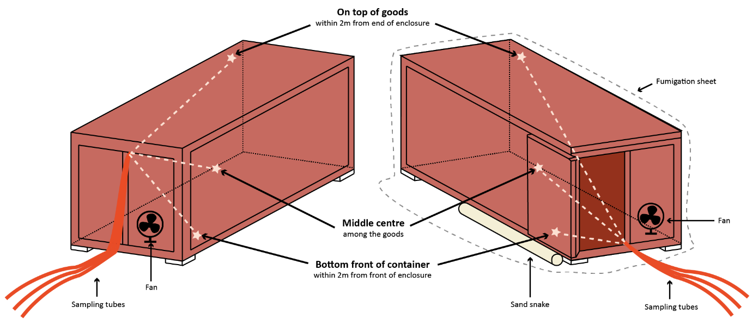

If a sheeted enclosure contains multiple sea containers, each sea container must have at least three gas concentration monitoring locations in accordance with requirement 5.3.2.

Figure 2 Monitoring locations for a sheeted enclosure with more than one sea container

Additional gas concentration monitoring locations must be used if mandated by import conditions.

### Gas concentration monitoring locations – perishable commodities

Section 5.4 requirements apply to perishable commodity fumigations.

If there is one type of commodity and packaging, and the total enclosure volume is less than 5 m3 the gas concentration must be monitored in at least one location. The gas concentration monitoring location must be inside a carton:

1. in the centre of the stack, or
2. in the middle of the enclosure, if the cartons are not stacked.

If the enclosure is equal to or greater than 5 m3 in volume the gas concentration must be monitored in at least three locations. The gas concentration monitoring locations must be inside a carton:

1. at the top of a stack within 2 meters of the end of the enclosure; and
2. no more than 250 mm above the floor of the enclosure and within 2 metres of the opposite end from the top gas concentration monitoring location, and
3. in the middle centre of the enclosure halfway up a stack.

If the target of fumigation is packaged inside one or more layers of packaging, the gas concentration monitoring locations must be located inside the packaging next to the target of fumigation.

Figure 3 Monitoring locations in a perishable fruit package

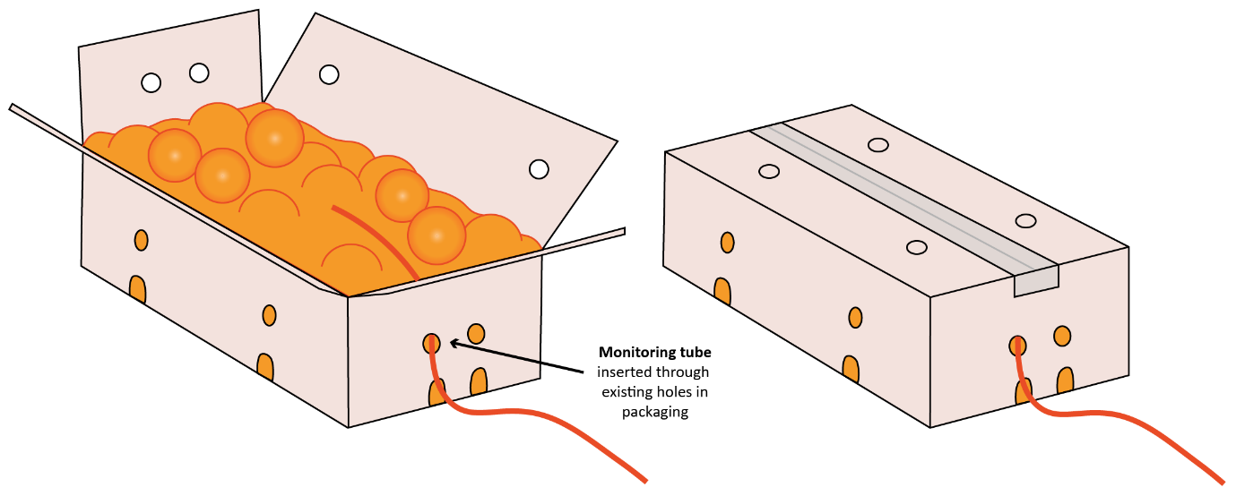

If the target of fumigation is cut flowers, leaf, stem material or bulbs imported as nursery stock, the gas concentration monitoring location must be located within the bunch in the middle of a carton.

Figure 4 Monitoring locations in a package of cut flowers

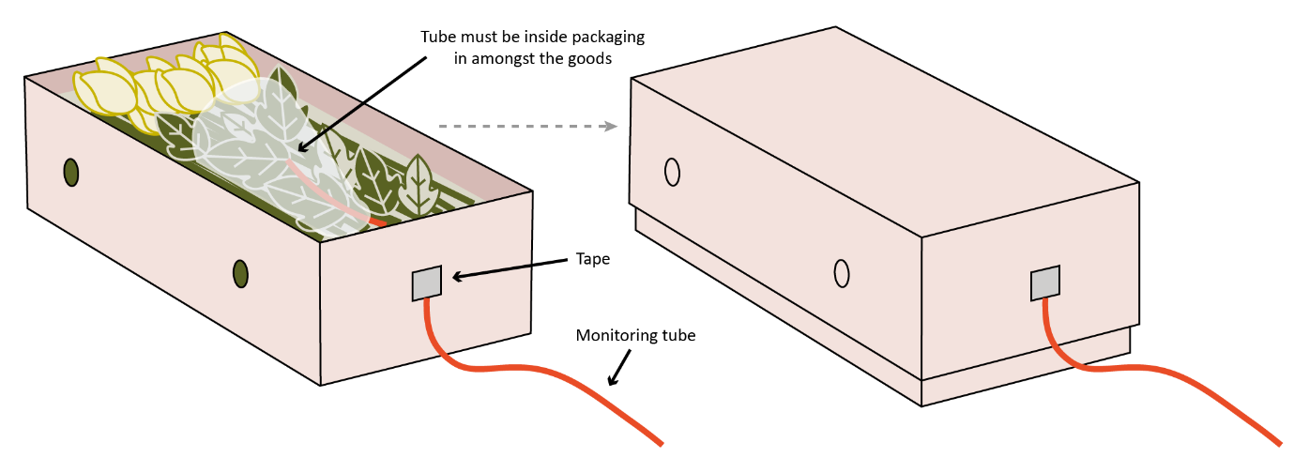

The placement and installation of gas concentration monitoring equipment within cartons or packaging must not change the gas penetration properties of the carton or package.

If there are different types of packaging in the consignment, there must be one gas concentration monitoring location inside each of the different packaging types. The minimum number of monitoring locations and position of the monitoring locations must be in accordance with section 5.4.3. If there are more than three different types of packaging, the number of gas monitoring locations must be the same as the number of different packaging types.

Additional concentration monitoring locations must be used if mandated by import conditions.

### Temperature monitoring instrument locations

Section 5.5 requirements apply to perishable commodity fumigations and controlled temperature fumigations.

The temperature of the enclosure must be monitored with a digital thermometer in at least one location within the enclosure.

If heaters are used, the temperature monitoring instruments must be placed within the enclosure as far away as practical from the heat source.

Temperature monitoring instruments must:

1. allow for readings to be read outside of the exclusion zone; and
2. be identified.

### Methyl bromide supply pipes

If a sheeted enclosure contains multiple sea containers, at least one supply pipe must be placed in each sea container.

For sheeted enclosure fumigations, the supply pipes must be left in position for the duration of the exposure period.

Supply pipes left in place must be sealed once the methyl bromide has been injected.

### Heaters and fans

If fans are used to circulate the gas, enclosures must have at least one fan for each 100 m³ of volume or part thereof.

Multiple sea containers fumigated in a single enclosure must have at least one fan placed in each container.

If heaters are used, they must be positioned in such a way to raise and maintain the air temperature throughout the entire enclosure above the treatment temperature used for the dose calculation.

## Temperature used to calculate the dose

### Ambient temperature fumigations

Section 6.1 requirements apply to ambient temperature fumigations.

A weather forecast for the location closest to the fumigation site must be obtained from a verifiable weather source to determine the forecast temperature during the fumigation exposure period.

The lowest forecast minimum temperature for the exposure period must be used to calculate the dose as specified in section 8.2 Calculating the dose.

The forecast minimum temperature must be sourced no earlier than the previous day of the start of exposure period and a record of the source of the information must be retained with the fumigation documentation.

The forecast minimum temperature must be recorded on the record of fumigation.

**Note**: If the ambient temperature is forecast to be 10˚C or lower the fumigation cannot be performed as an ambient temperature fumigation. The temperature of the enclosure will need to be raised and maintained meaning the controlled temperature fumigation requirements will apply.

### Controlled temperature fumigations

Section 6.2 requirements apply to controlled temperature fumigations.

The minimum temperature within the enclosure during the exposure period must be predicted. This predicted temperature must be used to calculate the dose in accordance with section 8.2 Calculating the dose.

### Perishable commodity fumigations

Section 6.3 requirements apply to perishable commodity fumigations.

Dose calculations must be based on the core temperature specified in the treatment schedule.

Prior to applying the dose:

1. the fumigator must measure the core temperature of the goods; and
2. the core temperature of the goods must be at or above the temperature specified in the treatment schedule.

The minimum number of temperature readings required in 6.3.3 is the same as the number of concentration monitoring locations required in section 5.4 Gas concentration monitoring locations – perishable commodities.

Temperature readings must be obtained:

1. from the same positions as the concentration monitoring locations, or
2. with at least one temperature reading from each different type of perishable commodity within the enclosure.

If the target of fumigation is fruit or vegetables, the pulp temperature must be measured. The temperature measuring instrument must be:

1. inserted into the centre of the fruit or vegetable, or adjacent to the pit; and
2. covering the whole temperature instrument probe (multiple pieces of fruit may be inserted onto the instrument if the fruit is small); and
3. placed into the largest sized commodity in mixed consignments; and
4. placed in the middle of the carton.

If the target of fumigation is cut flowers, leaf, stem material or bulbs imported as nursery stock, temperature readings must be placed within the bunch in the middle of a carton.

Dose compensation for temperature variation does not apply to perishable commodities unless specified by the treatment schedule.

If the treatment schedule allows dose compensation for temperature variation, the temperature used for dose compensation must be the lowest of:

1. the temperature of the goods, or
2. the expected minimum temperature within the enclosure during the exposure period and compliant with section 6.1 Ambient temperature fumigations or 6.2 Controlled temperature fumigations.

## Temperature during the exposure period

### Ambient temperature fumigations

Section 7.1 requirements apply to ambient temperature fumigations.

The minimum ambient temperature must be obtained using:

1. a verifiable weather source, or
2. temperature monitoring equipment compliant with section 1.2 Fumigation equipment.

During the exposure period:

1. the minimum temperature must be equal to or above the temperature used for dosing, or
2. if dose calculations for temperature variation is permitted and the minimum temperature is above 10˚C, all concentration readings must be equal to or above the standard concentration requirements in Appendix 4: Methyl bromide monitoring tables for the minimum temperature obtained.

**Note**: If the temperature obtained during the exposure period is equal to or below 10˚C the fumigation has failed.

### Controlled temperature fumigations

Section 7.2 requirements apply to controlled temperature fumigations.

The temperature within the enclosure must be monitored with a minimum of one temperature instrument.

The temperature within the enclosure must be monitored and recorded at least once every 15 minutes for the entirety of the exposure period. These records must be retained with the fumigation documentation.

The temperatures recorded within the enclosure during the exposure period must be equal to or above the temperature used for dosing.

The minimum temperature recorded within the enclosure during the exposure period must be recorded on the record of fumigation.

### Perishable commodity fumigations

Section 7.3 requirements apply to perishable commodity fumigations.

The temperature of the enclosure must be monitored and recorded at least once every 15 minutes for the entirety of the exposure period. These records must be retained with the fumigation documentation.

The temperatures recorded during the exposure period, including enclosure temperature and all core/pulp temperatures, must be equal to or above the temperature used for dosing.

The minimum temperature of the goods achieved for the exposure period must be recorded on the record of fumigation.

## Performing the fumigation

### Dose rate compensation for temperature variation

If the treatment schedule or import conditions allow dose compensation for temperature variation, and the enclosure temperature is expected to fall below the temperature specified in the treatment schedule, the dose rate may be adjusted to compensate for the lower temperature.

If the treatment schedule allows dose compensation for temperature variation (in accordance with requirement 8.1.1), and the treatment schedule does not specify dose compensation requirements, the following calculation must be used: for each 5°C, or part thereof, the temperature is expected to fall below 21°C add 8 g/m³ to the prescribed dose rate.

### Calculating the dose

The weight of methyl bromide needed to achieve the prescribed concentration must be calculated by multiplying the dose rate (temperature adjusted in accordance with section 8.1 Dose rate compensation for temperature variation) by the volume of the enclosure. The formula is:

**Dose (g) = Enclosure Volume (m3) x Dose Rate (g/m3)**

If the fumigation is performed as a sheeted enclosure, the external dimensions of the enclosure must be measured prior to each fumigation and used to calculate the enclosure volume.

If the fumigation is performed in a fixed-sized enclosure, the internal dimensions of the enclosure must be used to calculate the enclosure volume.

If the methyl bromide is mixed with another gas, compensation must be made to the dose amount, so the full amount of methyl bromide required is injected into the enclosure. For methyl bromide supplied with 2% chloropicrin the formula is:

**Dose (g) = (Enclosure Volume (m³) x Dose Rate (g/m³)) ÷ 0.98**

Once the dose has been calculated, the injected dose must be rounded up to the next increment that can be accurately measured by the equipment used to dispense methyl bromide. If methyl bromide is supplied in cans, the dose must be rounded up to the next full can.

### Injecting methyl bromide into the fumigation enclosure

A vaporiser must be used when methyl bromide is injected into the enclosure. The vaporiser must maintain a water temperature of at least 65°C while the methyl bromide is being injected to the enclosure.

A fan(s), or alternate way of evenly distributing the gas, must be used while injecting methyl bromide into the enclosure.

Supply cylinders and the vaporiser must be inside the exclusion zone while methyl bromide is being injected into the enclosure.

The time methyl bromide injection is completed must be recorded on the record of fumigation.

### Checking for leaks

During the injection of methyl bromide, the supply system must be checked for leaks. If a leak is detected the problem must be rectified before continuing to inject the dose.

The fumigation enclosure must be checked for leaks (unless the fumigation is being performed in a pressure tested enclosure). If leaks are detected, they must be rectified.

### Even methyl bromide distribution

The methyl bromide must be evenly distributed throughout the enclosure. This is verified by equilibrium.

Equilibrium is achieved when the highest concentration reading is within 15% of the lowest concentration reading.

**Note:** Equilibrium result is expressed as a percentage and is equal to the highest concentration reading minus the lowest concentration reading, then divided by the lowest concentration reading, then multiplied by 100. The calculation for equilibrium is pictured:

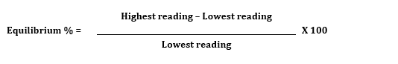

If the result of this calculation is more than 15%, equilibrium has not been achieved and additional time is needed to allow the methyl bromide to further distribute throughout the enclosure.

**Note:** Once equilibrium has been achieved it is not required at any other time.

### Exposure period

The fumigation exposure period must not start until:

1. all concentration readings are equal to or above the retention rate in the treatment schedule or, in the absence of specific retention information, the retention rates in Table 1, and
2. equilibrium has been achieved in accordance with section 8.5 Even methyl bromide distribution*.*

Table 1 Time of concentration readings after methyl bromide injection and required retention rate of initial dose rate

| **Time after methyl bromide injection** | **Retention rate of initial dose rate concentration** |
| --- | --- |
| 15 to 30 minutes | 85% or more |
| 30 minutes to 1 hour | 75% or more |
| More than 1 hour | 70% or more |

**Note:** See Appendix 4: Methyl bromide monitoring tables for the retention rates for a range of initial dose rates at different time increments.

Retention rates and standard concentrations must be determined based on actual dose rate applied.

If additional methyl bromide needs to be added before start point has been reached, the amount must be calculated by subtracting the lowest concentration reading from the initial dose rate and multiplying that by the volume of the enclosure.

**Additional dose (g) = Enclosure volume (m³) x (Initial dose rate – Lowest concentration reading)**

If additional methyl bromide needs to be added before start point has been reached and the formulation contains less than 100% methyl bromide, the amount must be calculated in accordance with section 8.2.4.

If additional methyl bromide is added to the enclosure before the start of the exposure period, the time the injection of additional methyl bromide is completed becomes the new injection time for determining the required start time concentration.

The elapsed time between the start time and the end time of the fumigation must not be less than the exposure period prescribed in the treatment schedule.

After the specified exposure period has elapsed, final concentration readings must be taken from all monitoring locations. The readings and the time they are taken must be recorded on the record of fumigation.

At the end of the exposure period all concentration readings must be equal to or above the concentration in the treatment schedule or, in the absence of specific retention information, the standard concentrations in Appendix 4: Methyl bromide monitoring tables.

## Monitoring the fumigation

### Gas concentration monitoring

Fans used to circulate methyl bromide must be turned off before taking gas concentration readings.

Gas concentration readings must be taken from all gas concentration monitoring locations at the start of the exposure period and at the end of the exposure period.

If the exposure period is longer than 24 hours, concentration readings must be taken from all concentration monitoring locations at least every 24 hours in addition to the start and end point readings.

All gas concentration readings must be recorded on the record of fumigation at the time they are taken. This includes readings taken prior to achieving start time or optional readings during the exposure period. Readings from additional concentration monitoring locations that are mandated by import conditions must also be recorded.

The time each set of concentration readings is taken must be recorded. If there is more than one reading in a set, the time the last reading is completed must be the time recorded.

**Note:** Additional readings can be taken at any time during the exposure period to check concentrations are equal to or above the levels required for an effective treatment.

### Gas concentration monitoring – multiple sea containers in a sheeted stack

Section 9.2 applies if:

1. the fumigation enclosure is a sheeted enclosure with multiple sea containers, and
2. the target of the fumigation is contained wholly inside the sea containers.

The fumigator may fail one single container in the sheeted enclosure, and pass the remainder of the sea containers in that enclosure, if:

1. concentration readings fall below the standard in one single container, and,
2. the enclosure is not, or cannot be, topped up in compliance with the topping up requirements, and
3. all other concentration readings in all other containers are above the standard for all other concentration readings during the exposure period.

## Topping-up methyl bromide levels

### Topping-up during the exposure period

Additional methyl bromide may be added to the enclosure at any time during the exposure period if:

1. all the concentration readings are equal to or above the standard concentration (Appendix 4: Table 3 Methyl bromide monitoring table, fumigation phase) and
2. the lowest concentration reading is below the maximum top-up concentration (Appendix 4: Table 3 Methyl bromide monitoring table, fumigation phase), and
3. the treatment schedule allows top-ups.

If a top-up is performed during the original exposure period, no extension of the exposure period is required.

Multiple top-ups are permitted during the exposure period.

### Topping-up at the end of the exposure period

If the lowest concentration reading at the end of the exposure period is below the standard concentration but not below the minimum concentration to allow top-up (Appendix 4: Methyl bromide monitoring tables), additional methyl bromide may be added to the enclosure.

If a top-up is performed at the end of the exposure period, the fumigation must be extended for the minimum time specified in the treatment schedule. If no time extension is specified, the minimum time extension is four hours.

After the minimum four-hour extension time, readings must be taken from all sampling lines and the concentrations must be equal to or above the standard concentration required for the original exposure period, if not, the fumigation has failed.

Only one top-up at the end of the exposure period is permitted.

Topping-up the concentration at the end of the exposure period is not permitted if:

1. the lowest concentration reading is below the minimum concentration to allow top-up (Appendix 4: Table 3 Methyl bromide monitoring table, fumigation phase); or
2. the treatment schedule prohibits topping-up.

### Performing the top-up

The weight of methyl bromide for top-up must be calculated by subtracting the lowest concentration reading from the maximum to allow top-up concentration contained in Appendix 4: Methyl bromide monitoring tables, and multiplied by the volume of the enclosure.

**Top-up amount (g) = Enclosure volume (m³) x (Maximum to allow top-up – Lowest concentration reading)**

The top-up amount for formulations that contain less than 100% methyl bromide and round up must be performed in accordance with section 8.2 Calculating the dose.

The top-up amount must be injected into the fumigation enclosure in accordance with section 8.3 Injecting methyl bromide into the fumigation enclosure.

When the additional methyl bromide has circulated, a concentration reading must be taken from the monitoring location that had the lowest reading to verify that the methyl bromide is at or above the standard concentration.

Top-up details (amount, time and concentration readings) must be recorded on the record of fumigation.

If top-ups are performed equilibrium is not required.

## Ventilating the fumigation enclosure

### Threshold limit value (TLV)

The TLV is 5 parts per million (ppm) for methyl bromide unless a lower concentration is imposed by the relevant authorities in the jurisdiction where the fumigation takes place or the consignment destination.

The equipment used for measuring TLV must be able to measure the actual concentration, not just the presence of methyl bromide, to at least 1 ppm.

If stain tubes are used to detect methyl bromide, they must be used:

1. in accordance with the manufacturer’s instructions; and
2. in conjunction with the sampling pump specified by the manufacturer; and
3. before the expiry date.

### Releasing methyl bromide from the enclosure

At the end of the exposure period, the methyl bromide must be fully ventilated from the enclosure in a controlled and safe manner.

A risk assessment must be performed to manage the ventilation process and ensure it is safe by considering:

1. prevailing wind direction; and
2. location and proximity of unprotected personnel; and
3. extension of the exclusion zone (see section 5.1 Establish an exclusion zone) around the enclosure if required to prevent unprotected personnel in the vicinity from being exposed to methyl bromide levels above the TLV.

Personnel who are not wearing PPE (in accordance with section 2.3 Personal protective equipment (PPE)) are not permitted to enter the exclusion zone until the fumigator-in-charge verifies the concentration in the area and throughout the enclosure is at or below the TLV.

The enclosure must be ventilated until the concentration of methyl bromide within the enclosure remains at or below the TLV.

If the consignment is fumigated in the sea container(s) that will be used to transport the goods, each container must be checked individually to verify concentration at or below the TLV.

If the consignment is fumigated in an un-sheeted sea container, the sea container must not be moved until the methyl bromide concentration inside the enclosure is at or below the TLV.

If the consignment is a perishable commodity fumigation, packed in cartons and/or bags that have been opened during fumigation, the cartons and/or bags can only be closed once the methyl bromide concentration inside the cartons and/or bags is under the TLV.

The TLV readings and the time they are taken must be recorded on the record of fumigation.

### Releasing the consignment from the control of the fumigator-in-charge

Following a fumigation, the consignment can only be released from the control of the fumigator-in-charge once the following requirements have been met:

1. the fumigation complies with the requirements of this methodology and the methyl bromide concentration has been verified at or below the TLV, or
2. the fumigation has failed, and it is subsequently unsuitable for further fumigation with methyl bromide and the methyl bromide concentration has been verified at or below the TLV.

## Documentation

### Retainment of fumigation documents

The treatment provider must keep a copy of all fumigation documentation for a minimum of two years.

### Record of fumigation

A record of fumigation must be produced to demonstrate the fumigation complied with the requirements of this methodology.

The record of fumigation must be completed on the fumigation site as the tasks are performed.

The record of fumigation must be retained by the treatment provider for a minimum of two years.

False or misleading information must not be recorded on a record of fumigation.

At a minimum the record of fumigation must include:

1. treatment provider identification
2. client name
3. start date and time of the fumigation
4. location – the site address where the fumigation is performed
5. a description of the consignment
6. the target of fumigation
7. consignment identification - container number(s), bill of lading, silo/shed number or other means to clearly identify the consignment
8. a declaration that the consignment complies with the treatment schedule, import conditions, and all requirements of the Methyl Bromide Fumigation Methodology
9. type of enclosure used
10. enclosure volume
11. the specified treatment schedule - dose rate, exposure period, and temperature
12. dose rate used – the dose rate used for the fumigation (if dose compensation for temperature variation is applied the temperature adjusted dose rate is recorded)
13. calculated dose – dose rate used multiplied by the enclosure volume, expressed as weight of methyl bromide
14. amount methyl bromide applied - the actual volume of methyl bromide injected into the enclosure, expressed as weight of methyl bromide
15. the time the methyl bromide injection into the enclosure is complete
16. the concentration readings from each concentration monitoring location and the time they are taken
17. result of the equilibrium calculation
18. serial number of the gas concentration monitoring device(s) used (minimum last 4 digits of the serial number)
19. the TLV readings and the time and date they are taken
20. the name and signature of the fumigator-in-charge
21. initial or signature of the fumigator at each concentration reading stage and TLV reading,

If the fumigation is an ambient temperature fumigation (section 6.1 Ambient temperature fumigations), the forecast minimum temperature must be recorded on the record of fumigation.

If the fumigation is a controlled temperature fumigation (section 6.2 Controlled temperature fumigations), the minimum temperature achieved within the enclosure must be recorded on the record of fumigation.

If the fumigation is a perishable commodity fumigation or if the temperature of the goods must be verified (section 6.3 Perishable commodity fumigation), the temperature of the goods must be recorded on the record of fumigation.

If the fumigation is a perishable commodity fumigation (section 6.3 Perishable commodity fumigation), the load factor and retention rate must be recorded on the record of fumigation.

If additional fumigant is added to the fumigation (in accordance with section 10 Topping up the methyl bromide levels), the top-up amount, time and concentration must be recorded on the record of fumigation.

If additional fumigant is added (in accordance with section 8.6 Exposure period), the additional amount and time injected must be recorded on the record of fumigation.

**Note:** An example record of treatment is provided at Appendix 1: Example record of fumigation and Appendix 2: Example record of fumigation perishable commodity.

### Fumigation treatment certificate

A fumigation treatment certificate is issued once the fumigator-in-charge determines the fumigation has complied with requirements of this methodology.

False or misleading information must not be recorded on a fumigation treatment certificate.

At a minimum the fumigation treatment certificate must include:

1. treatment provider’s letterhead including name and physical address
2. treatment provider’s identification (AEI if an AEI is required by the treatment scheme or import conditions)
3. certificate number
4. name of fumigant
5. target of fumigation
6. description
7. quantity
8. consignment link (such as container number, bill of lading, invoice number)
9. country or origin
10. port of loading
11. country of destination
12. date and time fumigation commenced
13. date and time fumigation completed
14. place of fumigation (site registration number if applicable)
15. type of enclosure used
16. treatment schedule [prescribed dose rate/ specified dose rate (g/m3)]
17. exposure period (hours)
18. forecast minimum temperature (˚C) or minimum temperature achieved in the enclosure or commodity core temperature.
19. applied dose rate (g/m3)
20. final TLV reading (ppm)
21. a declaration that the consignment complies with the treatment schedule, import conditions, and all requirements of the Methyl Bromide Fumigation Methodology
22. the signature of the fumigator-in-charge and date of signing
23. date the certificate is endorsed and issued.

**Note:** An example fumigation treatment certificate is provided at Appendix 3: Example fumigation treatment certificate

The treatment provider must make all fumigation documentation available on request, by the relevant authorities, for audit and registration purposes.

The fumigation treatment certificate must be clearly linked to the consignment.

## Appendix 1: Example record of fumigation

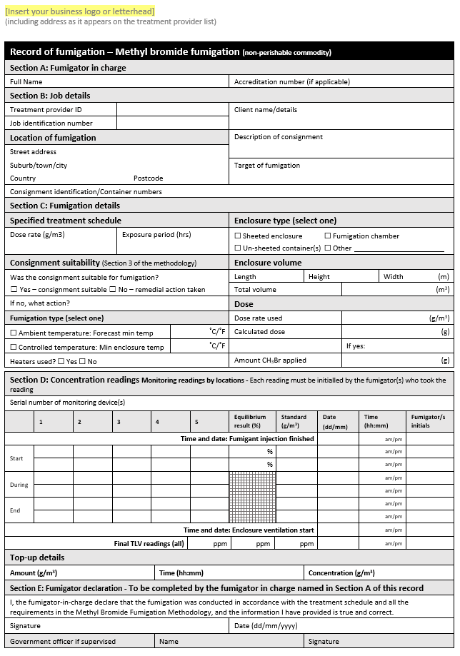

## Appendix 2: Example record of fumigation perishable commodity

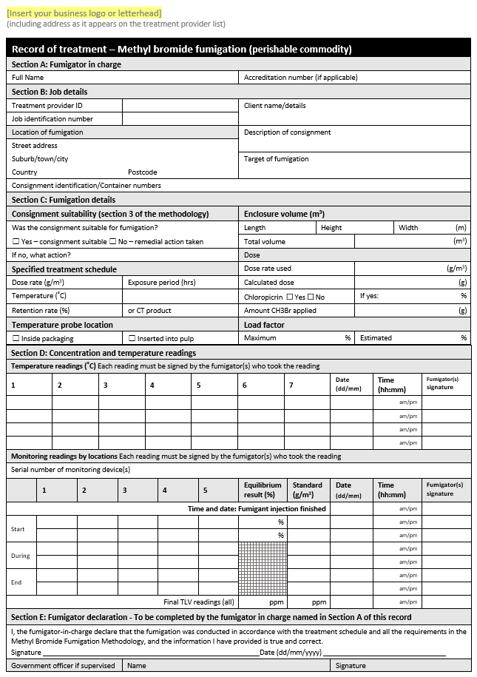

## Appendix 3: Example fumigation treatment certificate

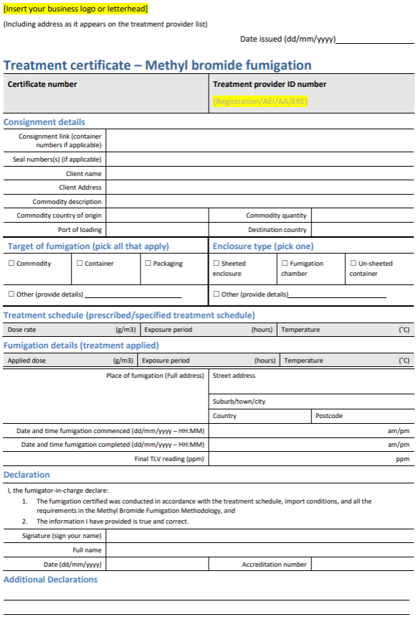

## Appendix 4: Methyl bromide monitoring tables

Table 2 Methyl bromide monitoring table, gas distribution phase

| Category | Timing | Dose a | Standard concentration (g/m3) | | | | | | | | |
| --- | --- | --- | --- | --- | --- | --- | --- | --- | --- | --- | --- |
| Initial dose | 0 hours | 100% | 32 | 40 | 48 | 56 | 64 | 72 | 80 | 88 | 128 |
| Start point | ¼ to ½ hour | 85% or more | 27.2 | 34 | 40.8 | 47.6 | 54.4 | 61.2 | 68 | 74.8 | 108.8 |
| ½ to 1 hour | 75% or more | 24 | 30 | 36 | 42 | 48 | 54 | 60 | 66 | 96 |
| More than 1 hour | 70% or more | 22.4 | 28 | 33.6 | 39.2 | 44.8 | 50.4 | 56 | 61.6 | 89.6 |

**a** % of initial dose

**Notes:** Dosing is complete once the required amount of gas has been applied to the enclosure. Start Point is achieved when all concentration readings are at or above the standard. Maximum top-up concentration is 100% of initial dose.

Table 3 Methyl bromide monitoring table, fumigation phase

| Timing | Dose a | Concentration (category) | Concentration (g/m3) | | | | | | | | |
| --- | --- | --- | --- | --- | --- | --- | --- | --- | --- | --- | --- |
| 0 hours: initial dose | 100% | Standard | 32.0 | 40.0 | 48.0 | 56.0 | 64.0 | 72.0 | 80.0 | 88.0 | 128.0 |
| 2 hours | 60% or more | Standard | 19.2 | 24.0 | 28.8 | 33.6 | 38.4 | 43.2 | 48.0 | 52.8 | 76.8 |
| Minimum to allow top-up | 14.2 | 19.0 | 23.8 | 28.6 | 30.4 | 35.2 | 40.0 | 44.8 | 68.8 |
| Maximum top-up | 24.2 | 29.0 | 33.8 | 38.6 | 46.4 | 51.2 | 56.0 | 60.8 | 84.8 |
| 4 hours | 50% or more | Standard | 16.0 | 20.0 | 24.0 | 28.0 | 32.0 | 36.0 | 40.0 | 44.0 | 64.0 |
| Minimum to allow top-up | 11.0 | 15.0 | 19.0 | 23.0 | 24.0 | 28.0 | 32.0 | 36.0 | 56.0 |
| Maximum top-up | 21.0 | 25.0 | 29.0 | 33.0 | 40.0 | 44.0 | 48.0 | 52.0 | 72.0 |
| 12 hours | 35% or more | Standard | 11.2 | 14.0 | 16.8 | 19.6 | 22.4 | 25.2 | 28.0 | 30.8 | 44.8 |
| Minimum to allow top-up | 6.2 | 9.0 | 11.8 | 14.6 | 14.4 | 17.2 | 20.0 | 22.8 | 36.8 |
| Maximum top-up | 16.2 | 19.0 | 21.8 | 24.6 | 30.4 | 33.2 | 36.0 | 38.8 | 52.8 |
| 24 hours | 30% or more | Standard | 9.6 | 12 | 14.4 | 16.8 | 19.2 | 21.6 | 24 | 26.4 | 38.4 |
| Minimum to allow top-up | 4.6 | 7.0 | 9.4 | 11.8 | 11.2 | 13.6 | 16.0 | 18.4 | 30.4 |
| Maximum top-up | 14.6 | 17 | 19.4 | 21.8 | 27.2 | 29.6 | 32.0 | 34.4 | 46.4 |
| 48 hours | 25% or more | Standard | 8.0 | 10.0 | 12.0 | 14.0 | 16.0 | 18.0 | 20.0 | 22.0 | 32.0 |
| Minimum to allow top-up | 3.0 | 5.0 | 7.0 | 9.0 | 8.0 | 10.0 | 12.0 | 14.0 | 24.0 |
| Maximum top-up | 13.0 | 15.1 | 17.0 | 19.0 | 24.0 | 26.0 | 28.0 | 30.0 | 40.0 |

**a** % of initial dose

**Notes:** Dosing is complete once all the required amount of gas has been applied to the enclosure. Start point is achieved when all concentration readings are at or above the standard. The duration of the fumigation is measured from when the start point is achieved. For example, if a 24-hour fumigation reaches start point 1½ hours after dosing, the fumigation is completed 25½ hours after applying the dose and all concentrations are at or above the standard specified for 24 hours.

Table 4 Methyl bromide minimum standard concentrations

| Timing (hours) | Retention (%) | Minimum standard concentration required (g/m3) a | | | | | | | | | | | | |
| --- | --- | --- | --- | --- | --- | --- | --- | --- | --- | --- | --- | --- | --- | --- |
| 0 b | 100.00 | 32 | 48 | 56 | 64 | 72 | 80 | 88 | 96 | 104 | 128 | 136 | 144 | 152 |
| ½ | 75.00 | 24.00 | 36.00 | 42.00 | 48.00 | 54.00 | 60.00 | 66.00 | 72.00 | 78.00 | 96.00 | 102.00 | 108.00 | 114.00 |
| 1 | 70.00 | 22.40 | 33.60 | 39.20 | 44.80 | 50.40 | 56.00 | 61.60 | 67.20 | 72.80 | 89.60 | 95.20 | 100.80 | 106.40 |
| 2 | 60.00 | 19.20 | 28.80 | 33.60 | 38.40 | 43.20 | 48.00 | 52.80 | 57.60 | 62.40 | 76.80 | 81.60 | 86.40 | 91.20 |
| 3 | 54.80 | 17.54 | 26.30 | 30.69 | 35.07 | 39.46 | 43.84 | 48.22 | 52.61 | 56.99 | 70.14 | 74.53 | 78.91 | 83.30 |
| 4 | 50.00 | 16.00 | 24.00 | 28.00 | 32.00 | 36.00 | 40.00 | 44.00 | 48.00 | 52.00 | 64.00 | 68.00 | 72.00 | 76.00 |
| 5 | 47.80 | 15.30 | 22.94 | 26.77 | 30.59 | 34.42 | 38.24 | 42.06 | 45.89 | 49.71 | 61.18 | 65.01 | 68.83 | 72.66 |
| 6 | 45.70 | 14.62 | 21.94 | 25.59 | 29.25 | 32.90 | 36.56 | 40.22 | 43.87 | 47.53 | 58.50 | 62.15 | 65.81 | 69.46 |
| 7 | 43.70 | 13.98 | 20.98 | 24.47 | 27.97 | 31.46 | 34.96 | 38.46 | 41.95 | 45.45 | 55.94 | 59.43 | 62.93 | 66.42 |
| 8 | 41.80 | 13.38 | 20.06 | 23.41 | 26.75 | 30.10 | 33.44 | 36.78 | 40.13 | 43.47 | 53.50 | 56.85 | 60.19 | 63.54 |
| 9 | 40.00 | 12.80 | 19.20 | 22.40 | 25.60 | 28.80 | 32.00 | 35.20 | 38.40 | 41.60 | 51.20 | 54.40 | 57.60 | 60.80 |
| 10 | 38.30 | 12.26 | 18.38 | 21.45 | 24.51 | 27.58 | 30.64 | 33.70 | 36.77 | 39.83 | 49.02 | 52.09 | 55.15 | 58.22 |
| 11 | 36.60 | 11.71 | 17.57 | 20.50 | 23.42 | 26.35 | 29.28 | 32.21 | 35.14 | 38.06 | 46.85 | 49.78 | 52.70 | 55.63 |
| 12 | 35.00 | 11.20 | 16.80 | 19.60 | 22.40 | 25.20 | 28.00 | 30.80 | 33.60 | 36.40 | 44.80 | 47.60 | 50.40 | 53.20 |
| 16 | 33.35 | 10.67 | 16.01 | 18.68 | 21.34 | 24.01 | 26.68 | 29.35 | 32.02 | 34.68 | 42.69 | 45.36 | 48.02 | 50.69 |
| 20 | 31.65 | 10.13 | 15.19 | 17.72 | 20.26 | 22.79 | 25.32 | 27.85 | 30.38 | 32.92 | 40.51 | 43.04 | 45.58 | 48.11 |
| 24 | 30.00 | 9.60 | 14.40 | 16.80 | 19.20 | 21.60 | 24.00 | 26.40 | 28.80 | 31.20 | 38.40 | 40.80 | 43.20 | 45.60 |
| 28 | 29.15 | 9.33 | 13.99 | 16.32 | 18.66 | 20.99 | 23.32 | 25.65 | 27.98 | 30.32 | 37.31 | 39.64 | 41.98 | 44.31 |
| 32 | 28.31 | 9.06 | 13.59 | 15.85 | 18.12 | 20.38 | 22.65 | 24.91 | 27.18 | 29.44 | 36.24 | 38.50 | 40.77 | 43.03 |
| 36 | 27.47 | 8.79 | 13.19 | 15.38 | 17.58 | 19.78 | 21.98 | 24.17 | 26.37 | 28.57 | 35.16 | 37.36 | 39.56 | 41.75 |
| 40 | 26.64 | 8.52 | 12.79 | 14.92 | 17.05 | 19.18 | 21.31 | 23.44 | 25.57 | 27.71 | 34.10 | 36.23 | 38.36 | 40.49 |
| 44 | 25.82 | 8.26 | 12.39 | 14.46 | 16.52 | 18.59 | 20.66 | 22.72 | 24.79 | 26.85 | 33.05 | 35.12 | 37.18 | 39.25 |
| 48 | 25.00 | 8.00 | 12.00 | 14.00 | 16.00 | 18.00 | 20.00 | 22.00 | 24.00 | 26.00 | 32.00 | 34.00 | 36.00 | 38.00 |

**a** If the concentration measuring instrument used can only read in whole grams then the minimum standard concentration must be rounded up to the nearest whole number. **b** Initial dose.

**Notes:** Minimum concentration to allow top-up is 5 g/m3 below the standard concentration for initial doses of 32 to 56 g/m3. Minimum concentration to allow top-up is 8 g/m3 below the standard concentration for initial doses of 64 to 152 g/m3. Maximum top-up concentration is 5 g/m3 above the standard concentration for initial doses of 32 to 56 g/m3. Maximum top-up concentration is 8 g/m3 above the standard concentration for initial doses of 64 to 152 g/m3. Concentration readings must be equal to or above the required concentrations specified for the hour preceding the reading – for example, a reading taken at 2½ hours must be equal to or above the concentrations specified at 2 hours.

Table 5 Methyl bromide minimum concentrations for fumigations that require 80% retention

| Concentration | Minimum standard concentration required (g/m3) a | | | | | | | | | | | | |
| --- | --- | --- | --- | --- | --- | --- | --- | --- | --- | --- | --- | --- | --- |
| Starting | 32 | 48 | 56 | 64 | 72 | 80 | 88 | 96 | 104 | 128 | 136 | 144 | 152 |
| Minimum | 25.6 | 38.4 | 44.8 | 51.2 | 57.6 | 64.0 | 70.4 | 76.8 | 83.2 | 102.4 | 108.8 | 115.2 | 121.6 |

**a** If the instrument used only reads in whole grams, the standard concentration must be rounded up to the nearest whole number.

Table 6 Methyl bromide monitoring ready reckoner

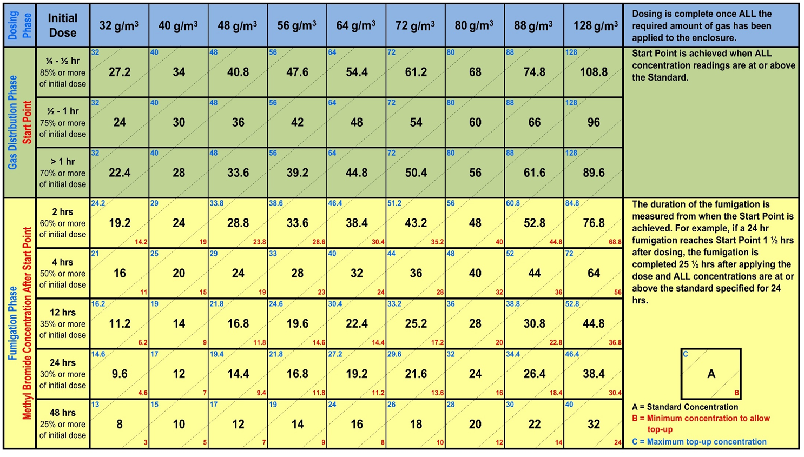

## Glossary

| **Term** | **Definition** |
| --- | --- |
| Ambient temperature | The air temperature of the surrounding area where the fumigation will be performed. |
| Ambient temperature fumigation | When the enclosure being fumigated is subject to environmental ambient temperatures or outdoors. |
| Carton | Box, often cardboard or polystyrene, in which perishable commodities are packed for transport and sale. |
| Chloropicrin | A strong-smelling chemical commonly added to the odourless methyl bromide to indicate the presence of gas. |
| Commodity | The item or goods that are being exported or imported. |
| Concentration | The amount of methyl bromide present at a certain point in the fumigation enclosure, usually expressed as grams per cubic metre (g/m³). |
| Concentration sampling tube | A small diameter tube used to draw a sample of gas/air mixture from within a fumigation enclosure to measure the methyl bromide concentration. |
| Consignment | Refers collectively to the commodity, any packing materials used and the mode of transport such as sea container. |
| Controlled temperature fumigation | When an artificial heat source is used to heat and maintain the temperature of an enclosure during a fumigation. |
| Dose | The amount of methyl bromide injected to a fumigation enclosure. |
| Dose rate | The prescribed concentration of methyl bromide to be used per unit of volume and the exposure period (temperature adjusted if applicable). |
| Enclosure | Any gas-tight space intended to contain sufficient concentrations of methyl bromide for a period of time. Common examples of fumigation enclosures used for QPS fumigations are (but not limited to) un-sheeted sea containers, semi-permanent or permanent structures, sheeted enclosures, vessel holds, silos and bunkers. |
| Equilibrium | An even distribution of methyl bromide throughout the enclosure. |
| Exclusion zone | The area around the enclosure to which access is restricted to personnel wearing personal protective equipment. |
| Exposure period | The amount of time, in one continuous block, that the consignment must be exposed to sufficient concentration levels of methyl bromide to be lethal to the targeted pests. |
| Fit for purpose | Equipment that is suitable and appropriate for its intended use. That is, capable of measuring methyl bromide or temperature specifically and in the concentration or temperature ranges necessary to meet the requirements of this methodology. |
| Fumigant | A chemical, which at a particular temperature and pressure can exist in a gaseous state in sufficient concentration and for sufficient time to be lethal to insects and other pests. |
| Fumigation chamber | A gas-tight fumigation enclosure with an inbuilt extraction system. All requirements for fumigation chambers specified in section 4.3 Fumigation chambers. |
| Fumigation documentation | Documents and records associated with particular fumigations that is not a record of fumigation. May be hardcopy or softcopy. |
| Fumigation sheets | A sheet (or tarpaulin) used to create a sheeted enclosure that is made of material impermeable to methyl bromide. |
| Fumigator | An individual responsible for conducting fumigation activities under the supervision of the fumigator-in-charge. |
| Fumigator-in-charge | The licenced and/or accredited individual that is responsible for the conduct of the fumigation at the time specific fumigation activities are undertaken. |
| Gas concentration monitoring location | The specified location where gas must be drawn from for the purpose of determining the gas concentration at that location. This is location where concentration sampling tubes or gas concentration sampling equipment is placed. |
| Goods | Goods includes an animal, a plant, a sample or specimen, a pest, mail or any other article, substance or thing (including, but not limited to, any kind of moveable property). |
| Good working order | State of an item, system or equipment is deemed to be functioning properly, without significant defects or impairments that hinder its intended operations or performance. |
| Impermeable package and wrappings | Intact and solid plastic films and wrappings that prevent or impede gas exchange. |
| Load factor | Specifies the maximum volume of space that the commodity can occupy in the enclosure to achieve rapid fumigation circulation. Normally expressed as a percentage (for example, maximum load factor of 50%) |
| Manufacturer’s instructions | Specific details on equipment produced by the equipment manufacturer. May include instruction manuals, operating instructions, conditions of use or calibration information. |
| Maximum top-up concentration | The concentration used to calculate the amount of methyl bromide to be added to the enclosure when topping-up. |
| Minimum top-up concentration | The absolute minimum concentration below which levels methyl bromide concentration must not be below to allow top-up at the end of the exposure period. |
| Pascal (Pa) | The standard international unit for pressure. Standard atmospheric pressure is 101.325 kPa. |
| Perishable commodities | Commodities such as, cut flowers, fresh fruit, fresh vegetables, fresh leaves, fresh herbs, fresh fungi and nursery stock that will deteriorate rapidly if not stored or transported under suitable conditions. |
| Pest | Any animal, plant or other organism that may pose a threat to the community or the natural environment. |
| Quarantine pest | A pest of potential economic and/or environmental importance to an area where it is not yet present or is present but not widely distributed and is being officially controlled. |
| Quarantine and Pre-shipment (QPS) | 1) ‘Quarantine applications’, with respect to methyl bromide, are treatments to prevent the introduction, establishment and/or spread of quarantine pests (including diseases), or to ensure their official control, where:  a) Official control is that performed by, or authorised by, a national plant, animal or environmental protection or health authority.  b) Quarantine pests are pests of potential importance to the areas endangered thereby and not yet present there, or present but not widely distributed and being officially controlled.  2) ‘Pre-shipment applications’ are those non–quarantine applications applied within 21 days prior to export to meet the official requirements of the importing country or existing official requirements of the exporting country.  This definition is based on the Montreal Protocol on Substances that Deplete the Ozone Layer. Non-QPS uses of methyl bromide is prohibited under the Montreal Protocol unless a specific exemption is approved by Parties to the Montreal Protocol. |
| Record of fumigation | An official document or electronic record that records the information of section 12 to demonstrate the fumigation complied with requirements. |
| Relevant authority | The government department, ministry or agency responsible for animal and plant biosecurity in the importing or exporting jurisdiction. |
| Risk Assessment | An assessment performed and recorded according to any instructions on the product label, safety data sheet or jurisdictional licence requirements. In the absence of this, a visual inspection to meet the requirements of this methodology that the fumigator-in-charge can verbally describe. |
| Sheeted enclosure | An enclosure created under a gas-proof sheet that is covering/enclosing the commodities to be fumigated. |
| Sheeted stack | Any sheeted enclosure over free standing goods. |
| Sea container | Standardised transportation units that can be moved from one mode of transport to another without needing to unload the contents. |
| Standard concentration | The methyl bromide concentration below which the fumigation will not be effective unless additional fumigation is added to the enclosure to compensate. |
| Target of fumigation | The specific object or area that is intended to be treated through the fumigation process. The target of fumigation may be the commodity, packaging material, container, or conveyance or combination of these. |
| Threshold limit value (TLV) | TLV is the maximum concentration of methyl bromide that a person can be repeatedly exposed to in the workplace without harmful effects. This figure is based on an 8-hour day, 40-hour working week. |
| Treatment | Application of a set of specified requirements intended to kill pests and diseases that may be associated with a consignment. |
| Timber | Processed wood harvested from trees, often processed into beams and planks. |
| Timber products | Any product made from timber or wood. |
| Treatment provider | An entity or company that is responsible for the effective conduct of a QPS treatment. |
| Treatment schedule | Specific treatment rates, exposure period and rules as imposed by the relevant authority – usually the importing jurisdiction. |
| Treatment temperature | The temperature at which the applied dose rate is calculated. |
| Vacuum chamber | A rigid enclosure from which air and other gases are removed by a vacuum pump. This results in a low-pressure environment within the chamber. |
| Verifiable weather source | Reliable source of weather data that can be independently confirmed and validated at audit. |