RESOLUTION MEPC.387(81) (adopted on 22 March 2024)

INTERIM GUIDANCE ON THE APPLICATION OF THE BWM CONVENTION TO SHIPS

OPERATING IN CHALLENGING WATER QUALITY CONDITIONS

RESOLUTION MEPC.387(81) (adopted on 22 March 2024)

INTERIM GUIDANCE ON THE APPLICATION OF THE BWM CONVENTION TO SHIPS

OPERATING IN CHALLENGING WATER QUALITY CONDITIONS

MEPC 81/16/Add.1 Annex 5, page 1

**ANNEX 5**

**RESOLUTION MEPC.387(81)
  
(adopted on 22 March 2024)**

**INTERIM GUIDANCE ON THE APPLICATION OF THE BWM CONVENTION TO SHIPS
  
OPERATING IN CHALLENGING WATER QUALITY CONDITIONS**

THE MARINE ENVIRONMENT PROTECTION COMMITTEE,

RECALLING Articles 38(a) and 38(b) of the Convention on the International Maritime Organization concerning the functions of the Marine Environment Protection Committee conferred upon it by international conventions for the prevention and control of marine pollution from ships, and its functions for considering appropriate measures to facilitate the enforcement of such conventions,

RECALLING ALSO that resolution MEPC.290(71) established an experience-building phase (EBP) associated with the *International Convention for the Control and Management of Ships ' Ballast Water and Sediments, 2004* (BWM Convention), in order to identify aspects of this Convention that are working well and to shed light on issues that require further attention,

RECOGNIZING that properly installed, operated and maintained type-approved ballast water management systems (BWMS) may effectively become temporarily inoperable in the various challenging water quality (CWQ) conditions that exist in a number of global ports and locations,

CONCERNED that bypassing installed BWMS in CWQ, while sometimes necessary as a last resort to permit the continued operation of ports and ships, may contaminate ballast tanks and sediments with harmful aquatic organisms and pathogens that present substantial risks for the environment, human health, property and resources where ballast water is later discharged,

EMPHASIZING its expectation that discharged ballast water meets the performance standard in regulation D-2 of the BWM Convention whenever the Convention requires this to be the case, while recognizing the challenges currently faced by ships encountering CWQ in enclosed and semi-enclosed seas,

DETERMINED to thoroughly address the issue of CWQ through the holistic review of the Convention under the experience-building phase (EBP), the scope of which includes the *Code for Approval of Ballast Water Management Systems* (BWMS Code, resolution MEPC.300(72)) and the *Guidelines for port State control under the BWM Convention* (resolution MEPC.252(67)), and avoid unintended consequences for ships already equipped with BWMS,

CONSIDERING that, in the meantime, ships urgently need guidance on managing CWQ and retaining compliance with the D-2 performance standard in subsequent discharge operations, while also considering that Administrations, BWMS manufacturers and port States would also benefit from guidance on implementing their roles with respect to CWQ,

1 ADOPTS the *Interim guidance on the application of the BWM Convention to ships operating in challenging water quality*, as set out in the annex to the present resolution;

2 REAFFIRMS the conditions for temporary non-penalization agreed in operative paragraph 4 of resolution MEPC.290(71) relating to non-compliance of a ship with the performance standard in regulation D-2 following the use of a BWMS during the EBP;

<I:\MEPC\81\MEPC> 81-16-Add.1.docx

RESOLUTION MEPC.387(81) (adopted on 22 March 2024)

INTERIM GUIDANCE ON THE APPLICATION OF THE BWM CONVENTION TO SHIPS

OPERATING IN CHALLENGING WATER QUALITY CONDITIONS

MEPC 81/16/Add.1
  
Annex 5, page 2

3 CALLS UPON all relevant entities to maximize the suitability and regular use of BWMS for the management of CWQ in both the short and long term, and calls particularly upon:

.1 BWMS manufacturers to develop performance improvements regarding commonly encountered water quality challenges;

.2 ships and shipyards to invest in the most suitable, robust BWMS where known and available;

.3 ships to treat as much ballast water as practicable in CWQ and use bypass as a last resort;

4 AGREES to keep this interim guidance under review in connection with the EBP.

<I:\MEPC\81\MEPC> 81-16-Add.1.docx

RESOLUTION MEPC.387(81) (adopted on 22 March 2024)

INTERIM GUIDANCE ON THE APPLICATION OF THE BWM CONVENTION TO SHIPS

OPERATING IN CHALLENGING WATER QUALITY CONDITIONS

MEPC 81/16/Add.1 Annex 5, page 3

ANNEX

**INTERIM GUIDANCE ON THE APPLICATION OF THE BWM CONVENTION TO SHIPS
  
OPERATING IN CHALLENGING WATER QUALITY (CWQ) CONDITIONS**

**TABLE OF CONTENTS
  
Introduction**

Purpose
  
Principles
  
Application
  
Definitions

**Guidance for ships operating in CWQ**

Pre-planning

Assessment

Troubleshooting and mitigation

CWQ triggers

Alternatives to bypass

Bypass procedure

Decontamination

Communication

Record-keeping

**Guidance for Administrations with respect to Ballast Water Management Plans and CWQ**

**Guidance for port State control officers with respect to ships that have encountered CWQ Guidance for BWMS manufacturers with respect to participation in pre-planning Appendices**

1 Example decontamination procedure

2 Sample process diagrams for ships ballasting in areas with CWQ

<I:\MEPC\81\MEPC> 81-16-Add.1.docx

RESOLUTION MEPC.387(81) (adopted on 22 March 2024)

INTERIM GUIDANCE ON THE APPLICATION OF THE BWM CONVENTION TO SHIPS

OPERATING IN CHALLENGING WATER QUALITY CONDITIONS

MEPC 81/16/Add.1
  
Annex 5, page 4

**INTRODUCTION
  
Purpose**

1 The primary purpose of this Guidance is to assist ships in planning for compliance with the BWM Convention and the D-2 discharge standard when a type-approved ballast water management system (BWMS) that has been properly installed, operated and maintained encounters operational limitations or has difficulty meeting operational demand in challenging water quality (CWQ) conditions. The Guidance may also serve as a practical operational guide for ships and voyage planners in this regard.

2 This Guidance also includes sections intended to guide Administrations, port States and BWMS manufacturers in providing appropriate support and oversight to ships before, during and after CWQ operations.

3 This interim Guidance has been developed while the Committee takes steps through the experience-building phase (EBP) associated with the BWM Convention (resolution MEPC.290(71)) to improve the performance and reliability of BWMS.

4 This Guidance includes recommended steps that can be taken to restore or maintain effective operation of a BWMS when operating in CWQ. These include steps to identify when a system is inoperable owing to CWQ; actions to avoid bypass of the system; steps to recover from bypass including steps to return to compliance with the D-2 discharge standard; and planning, record-keeping and communication principles.

5 This Guidance does not address situations in which a BWMS is inoperable for reasons unrelated to CWQ, or in which inadequate performance is due to installation, operation or maintenance issues. Such situations should be addressed on a case-by-case basis in consultation with the Administration of the ship and implicated port States (see also the *Guidance on contingency measures under the BWM Convention* (BWM.2/Circ.62, as may be revised)).

**Principles**

6 Ships, supported by BWMS manufacturers, should plan for circumstances where CWQ may be experienced and include procedures informed by this Guidance in their approved Ballast Water Management Plan (BWMP). This Guidance is not intended to reduce the importance of selecting the most suitable BWMS, as known and available, for the circumstances of the ship where appropriate. Relevant stakeholders may, for example, use the INTERTANKO CWQ database1 until a universal platform becomes available.

7 When operating a BWMS in CWQ, encountering an operational limitation or experiencing a challenge in satisfying operational demand does not indicate a BWMS failure. A BWMS has warnings and alarms to protect the BWMS equipment and/or the ship and the triggering of these set points or flow reductions demonstrates proper BWMS operation as designed.

8 Triggers for implementing CWQ procedures should be included in the BWMP and should be based on the performance and self-monitoring functions of the BWMS. The list of triggers should be developed based on information provided by the BWMS manufacturer in the Operations, Maintenance and Safety Manual (OMSM), based on the BWMS design and operational limitation(s).

1 See document MEPC 81/4/11 and<https://www.intertanko.com/search-article/articleview/pcwq-database>

<I:\MEPC\81\MEPC> 81-16-Add.1.docx

RESOLUTION MEPC.387(81) (adopted on 22 March 2024)

INTERIM GUIDANCE ON THE APPLICATION OF THE BWM CONVENTION TO SHIPS

OPERATING IN CHALLENGING WATER QUALITY CONDITIONS

MEPC 81/16/Add.1 Annex 5, page 5

9 CWQ triggers should be assessed on a voyage-by-voyage basis because water quality challenges may vary: from berth to berth, with conditions on board the ship, and with environmental factors such as organism density, tides and seasons.

10 Following a bypass event in a location with CWQ, decontamination to ensure that subsequent discharges meet the D-2 performance standard may include ballast water exchange through a BWMS (BWE+BWT). However, BWE+BWT alone may not be sufficient to meet the standard. This risk may be mitigated by conducting ballast water flushing as described in appendix 1.

11 Bypass should always be considered as the last resort and the BWMS should be used as far as practicable to treat ballast water with CWQ. However, some BWMS are able to treat ballast water at flow rates that are prohibitively low for practical, safe operations.

12 Ports are requested to take CWQ conditions into account and work with ships to plan arrival, departure and berthing times that will accommodate the consistent use of BWMS at expected ballasting rates. When ballasting rates are impacted by CWQ, ports are requested to exercise flexibility and support the ship in using a BWMS as long as operational demand is met (as defined in this Guidance and the ship's approved BWMP).

13 A ship fully applying this Guidance minimizes the risk of non-compliance with the D-2 standard at subsequent discharges. While this Guidance does not limit the rights of a port State in verifying a ship's compliance with the Convention (including sampling), this Guidance should be taken into account when prioritizing compliance verification activities.

14 Administrations and manufacturers of BWMS should collect information to improve the Convention and support the development of BWMS performance improvements regarding commonly encountered CWQ conditions. This information should be shared with the Committee as appropriate.

**Application**

15 This Guidance is applicable to:

.1 ships that are required to meet the ballast water performance standard in accordance with regulation B-3 of the BWM Convention;

.2 Administrations approving BWMPs in accordance with regulation B-1 and applying articles 13 and 14 of the BWM Convention;

.3 port States applying articles 8 to 10 of the BWM Convention; and

.4 BWMS manufacturers defining troubleshooting procedures in the OMSM in accordance with paragraph 4.8 of the BWMS Code.

**Definitions**

16 *Challenging water quality* (CWQ) refers to ambient uptake water having quality parameters (including but not limited to high total suspended solids,2 or turbidity) that cause a properly installed, maintained and operated type-approved BWMS to be temporarily inoperable due to an operational limitation or an inability to meet operational demand. However, temperature and salinity are not parameters that define CWQ.

2 Total suspended solids are defined as solids in water that can be trapped by a filter.

<I:\MEPC\81\MEPC> 81-16-Add.1.docx

RESOLUTION MEPC.387(81) (adopted on 22 March 2024)

INTERIM GUIDANCE ON THE APPLICATION OF THE BWM CONVENTION TO SHIPS

OPERATING IN CHALLENGING WATER QUALITY CONDITIONS

MEPC 81/16/Add.1
  
Annex 5, page 6

17 *Operational demand* means the minimum BWMS flow rate defined in the BWMP that will permit the ship to continue cargo operations while using the BWMS, which should be no greater than 50% of the BWMS treatment rated capacity (TRC).3

18 *Operational limitation* means an automatic shutdown of the BWMS, a critical alarm for which the BWMS OMSM directs a manual shutdown, or a safety-related circumstance that requires the shutdown of the BWMS for the protection of the BWMS equipment, the ship or its crew.4

19 *Pre-emptive bypass* means a BWMS bypass undertaken, prior to or during a ballasting operation, in anticipation of reaching an operational limitation or encountering an inability to meet operational demand.

20 *Reactive bypass* means a BWMS bypass undertaken during a ballasting operation upon reaching an operational limitation or encountering an inability to meet operational demand.

**GUIDANCE FOR SHIPS OPERATING IN CWQ**

21 This part of the guidance is intended to inform the development of Ballast Water Management Plans (BWMP), which should include ship-specific guidance and procedures identified in the conceptual overview provided in figure 1. This planning is intended to facilitate ship operations and efficiency by optimizing the performance of BWMS in CWQ, reducing the need to bypass this environmentally protective equipment and decontaminate ballast tanks.

22 While the focus of this part is on planning, its specific guidance and example process flow charts may also help ship crews reduce risks to the environment, human health, property and resources when operating in CWQ. However, this guidance should be read in conjunction with the ship-specific BWMP and OMSM.

3 Operational demand pertains to the ship.

4 Operational limitation pertains to the BWMS.

<I:\MEPC\81\MEPC> 81-16-Add.1.docx

RESOLUTION MEPC.387(81) (adopted on 22 March 2024)

INTERIM GUIDANCE ON THE APPLICATION OF THE BWM CONVENTION TO SHIPS

OPERATING IN CHALLENGING WATER QUALITY CONDITIONS

**Figure 1: Conceptual overview of the CWQ process**

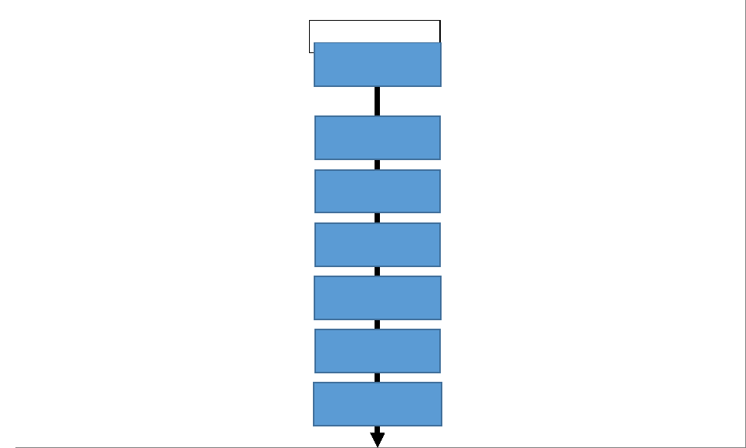

MEPC 81/16/Add.1 Annex 5, page 7

Regularly update the Ballast Water Record Book and inform future ports of any BWMS bypass

Load the minimum amount of unmanaged water and limit the tanks and piping affected

Determination that the BWMS is not performing at its expected treatment rated capacity

Ensure proper operation and maintenance of BWMS and deploy measures to assist it

Decontaminate tanks and piping to lower the risk of not meeting D-2 at next discharge

Assess operational limitations and operational demands to establish CWQ

Take all additional steps possible before

bypassing the BWMS

Decontamination

Record-keeping/ communication

Troubleshooting and mitigation

**CWQ process**

CWQ triggering

Alternatives to bypass

Assessment

Bypass

e.g. indications from the self-monitoring system, mechanical observations

e.g. verify valves, address alarms, clean, add reagents, backflush, increase intensity, slow flow

e.g. consult BWMS self-monitoring system, and monitor BWMS flow rate

e.g. restrict flow to operational demand, optimize BWMS for CWQ, load less ballast

e.g. consider partial BWMS bypass, load minimum safe amount and reposition ballast

e.g. conduct exchange, flushing and treatment, preferably in mid-ocean

e.g. make BWRB entries throughout this process, and submit a pre-arrival reporting form

**Pre-planning**

23 Operations in CWQ will be most efficient when the BWMP includes practical and

realistic measures specific to the ship that take into account this Guidance, the BWMS technology installed on board, and specific instructions and procedures from the OMSM.

24 The approved BWMP should include a ship-specific definition of operational demand

based on paragraph 17 that identifies the sustained flow rate below which cargo operations cannot practicably be continued by the ship. This flow rate should not be higher than 50% of the treatment rated capacity of the BWMS unless the ship's safety or stability would be affected. For example:

"On this ship, the operational demand to practicably permit continued cargo operations without affecting the ship's safety or stability while using the BWMS is defined by a sustained flow rate of ___ m3/h, which is 50% of the treatment rated capacity of the BWMS."

25 Developing ship-specific process flow charts based on the appended samples and

manufacturer's guidance is recommended.

26 A detailed plan for at least the following items should be included in the ship-specific

BWMP and BWMS operating instructions, taking into account ship safety and the maintenance and operation instructions in the OMSM. Further information and guidance on selected topics from this list are included in the sub-sections below.

.1 Maintenance: Maintenance timetables and checklists for maintaining the

system in optimal condition for managing CWQ when it is encountered, including:

<I:\MEPC\81\MEPC> 81-16-Add.1.docx

RESOLUTION MEPC.387(81) (adopted on 22 March 2024)

INTERIM GUIDANCE ON THE APPLICATION OF THE BWM CONVENTION TO SHIPS

OPERATING IN CHALLENGING WATER QUALITY CONDITIONS

MEPC 81/16/Add.1
  
Annex 5, page 8

.1 crucial maintenance actions, such as those related to inspection,

cleaning, calibration, active substance monitoring, etc.; and

.2 ensuring the availability on board of sufficient approved spare parts,

Active Substances and neutralizing agents.

.2 Assessment: Indications from the BWMS self-monitoring system or a

mechanical observation that the BWMS is not performing at its expected treatment rated capacity.

.3 Troubleshooting and mitigation: Procedures to identify and resolve

challenges linked to the operation and maintenance of the BWMS, as well as ship-specific procedures for assisting and optimizing the BWMS in treating CWQ, with a view to completing normal ballast water treatment without bypassing the BWMS, giving consideration to operational demands.

.4 CWQ triggers: In case troubleshooting and mitigation is unsuccessful, a table

of critical alarms specific to the BWMS based on the OMSM indicating that an operational limitation has been reached (see paragraph 18). This should include ship-specific procedures to be taken when an alarm is encountered.

.5 Alternatives to bypass: Pre-planned actions, considerations and procedures,

taking into account the OMSM, that may clear operational limitations or allow the BWMS to meet operational demands.

.6 Bypass procedure: Steps to be taken to bypass the BWMS, including

treatment of a fractional part of the ballast water stream and/or bypassing only the inoperative part of the ballast water treatment process.

.7 Decontamination: Specific procedures for decontaminating ballast tanks

and/or piping to reduce the risk of bypassed water, with a view to meeting the D-2 standard at subsequent discharges. Any use of the ballast water exchange plus treatment (BWE+BWT) approach should be clearly detailed in the approved BWMP.

.8 Communication: Procedure for informing the port State(s) that will receive

any ballast water discharge impacted by reactive bypass of the BWMS, before arrival of the ship in such State(s).

.9 Record-keeping: How to record CWQ situations in the Ballast Water Record

Book (BWRB), in line with the *Guidance on ballast water record-keeping and reporting* (BWM.2/Circ.80, as may be revised). The BWRB should provide a detailed description of the ballast water management method(s) used, as well as location and affected tanks (tank ID).

27 The BWMP should provide that, when a ship encounters CWQ, an evaluation of ship

safety should be conducted prior to the application of any steps to manage CWQ as included in this Guidance. Any safety risks identified should be evaluated to determine mitigating actions.

**Assessment**

28 CWQ may be impacting ballasting operations if the BWMS is not functioning at its

expected treatment rated capacity, and alarms indicating an operational limitation arise or the BWMS is not meeting operational demand. A sample process for performing this assessment is set out in process diagram 1 ("Assessment of BWMS operation") in appendix 2.

<I:\MEPC\81\MEPC> 81-16-Add.1.docx

RESOLUTION MEPC.387(81) (adopted on 22 March 2024)

INTERIM GUIDANCE ON THE APPLICATION OF THE BWM CONVENTION TO SHIPS

OPERATING IN CHALLENGING WATER QUALITY CONDITIONS

MEPC 81/16/Add.1 Annex 5, page 9

29 Pre-emptively bypassing the BWMS based on historical CWQ issues experienced at

a location is discouraged because water quality conditions may vary by precise location, ship and/or nearby port operations, time of day, tide, weather or seasonality. Through the self-monitoring system, the BWMS is the most suitable and technical method to precisely determine the water quality challenge at any moment and relieves the ship crew of this determination.

30 However, if a pre-emptive bypass is warranted in the case of regular visits to a port

or location with known and recurring CWQ, this should be agreed in advance bilaterally between the Administration of the ship and the port State receiving the ballast water (see paragraph 52 below).

**Troubleshooting and mitigation**

31 If CWQ is impacting ballasting operations, as described in paragraph 28, then the

crew should implement ship-specific troubleshooting procedures set out in the BWMP and the OMSM to ensure the system is being operated in accordance with proper procedure and the manufacturer's instructions. For example, this may include steps such as verifying the correct alignment of valves, that the BWMS is in the correct mode, and fully addressing any BWMS warnings and alarms.

32 The crew should also follow ship-specific procedures in the BWMP and the OMSM to

verify that the BWMS has been properly maintained. For example, these procedures may include ensuring that any necessary reagents have been introduced into the BWMS, that any cleaning cycles have been run, and that no mechanical or electrical failures are present.

33 If the steps above indicate that the BWMS has been properly operated and

maintained, the crew should follow procedures in the BWMP and the OMSM to deploy mitigating measures that assist the system in treating the water successfully. For example, these may include manually operating any backflushing controls, applying suitable backpressure at high differential filter pressures, maximizing UV intensity in the presence of turbid water or low UV transmittance, progressively reducing ballast water flow rate to the point of operational demand or operational limitation.

34 In planning troubleshooting and mitigation, refer to the ship's OMSM and the sample

process diagram 2 ("Challenging water quality process") in appendix 2.

**CWQ triggers**

35 The crew should implement CWQ actions when, despite maximizing all mitigating

measures, the BWMS delivers a critical alarm identified in the BWMP signalling that an operational limitation has been reached (see paragraph 18), or the BWMS is not meeting operational demand (see paragraph 17).

36 CWQ triggers relating to operational limitations should be based on the system design

limitations of the BWMS as tested during the type approval process, clearly identified in the ship's approved BWMP, and should be developed with reference to the OMSM. CWQ triggers may consist of relevant alarms concerning matters such as:

.1 the required UV transmittance or UV dose of the BWMS;

.2 the maximum allowable differential pressure across the filter to prevent

permanent damage to the filter element;

<I:\MEPC\81\MEPC> 81-16-Add.1.docx

RESOLUTION MEPC.387(81) (adopted on 22 March 2024)

INTERIM GUIDANCE ON THE APPLICATION OF THE BWM CONVENTION TO SHIPS

OPERATING IN CHALLENGING WATER QUALITY CONDITIONS

MEPC 81/16/Add.1
  
Annex 5, page 10

.3 a reduction in flow rate that is below the minimum operating requirements of

the BWMS, as identified by the OMSM; and

.4 monitoring data of the BWMS when the self-monitoring system indicates the

BWMS is not operating normally owing to issues such as those listed below, and that cannot be remediated through optimization of the BWMS in accordance with the BWMP:

.1 variation of pressure in filters;

.2 UV transmittance or dosage and/or the levels of dissolved organic carbon; and

.3 turbidity and/or total suspended solid that triggers an alarm of the BWMS.

**Table 1: Water quality parameters for challenging water**

|  |  |  |
| --- | --- | --- |
| **Potential CWQ  parameters** | **Impacts** | **Types of BWMS  affected** |
| Turbidity | Decreased light transfer through water due to deflection from particles/organisms (UV scatter), increased filter differential pressure | UV, filtration |
| UV transmissivity | Decreased penetration of UV light through seawater | UV |
| Dissolved organic carbon | Increased consumption of Active Substance, UV absorption | UV, Active Substance |
| Particulate organic carbon | Increased consumption of Active Substance, UV scatter | UV, Active Substance |
| Total suspended solids (sediment and/or organism load) | Increased consumption of Active Substance, UV scatter, increased filter differential pressure | UV, filtration, Active Substance |

37 The relevant CWQ triggers should be reviewed and amended, as applicable, in the event of any change to the BWMS.

38 The crew should respond with the pre-planned steps in the BWMP and the OMSM for managing any critical alarm or operational demand.

**Alternatives to bypass**

39 Alternatives should be tried before the ship bypasses a BWMS, because bypass increases the risks ballast water poses to the environment, human health, property and resources. Bypass also increases the operational workload for ship crew to perform alternative management methods and subsequently return the BWMS and ship to normal operations for D-2 compliance.

<I:\MEPC\81\MEPC> 81-16-Add.1.docx

RESOLUTION MEPC.387(81) (adopted on 22 March 2024)

INTERIM GUIDANCE ON THE APPLICATION OF THE BWM CONVENTION TO SHIPS

OPERATING IN CHALLENGING WATER QUALITY CONDITIONS

MEPC 81/16/Add.1 Annex 5, page 11

40 Before the BWMS is bypassed, the officer designated in accordance with regulation B-1.5 should:

.1 ensure that any BWMS alarm that could be ascribed to CWQ is not due to other factors such as malfunction, maintenance, crew familiarity or experience;

.2 ensure that the BWMP and OMSM have been followed in troubleshooting the operation of the BWMS (see paragraph 31), verifying that the BWMS has been properly maintained (see paragraph 32) and ensuring that applicable mitigating measures have been applied (see paragraph 33) to optimize the performance of the BWMS before any bypass;

.3 restrict the flow rate of the BWMS to the minimum level consistent with operational demand (see paragraph 17); and

.4 consider persisting with using the BWMS in the challenging area to load the minimum safe amount of ballast water and complete remaining ballasting at a nearby less challenging location at a later time, taking into account the ship's stability and cargo condition as well as expected weather conditions.

**Bypass procedure**

41 The sequence of steps for safely bypassing the BWMS in the BWMP and OMSM should be followed. In undertaking an assessment of alternatives to bypassing the BWMS, refer to sample process diagram 3 ("Alternatives to bypass") in appendix 2.

42 The crew should consider that partially managed or unmanaged ballast water loaded through a bypass is likely to contaminate ballast tanks and piping systems with harmful aquatic organisms and pathogens that pose a risk to the environment, human health, property and resources. Therefore:

.1 consideration should be given to limiting the number of ballast tanks that will

be exposed to partially treated or unmanaged ballast water;

.2 consideration should be given to treating the greatest possible fraction of the uptake water, by continuing to apply the BWMS to as much of the uptake water stream as practicable;

.3 in cases where only one part of a BWMS treatment process is inoperable, consideration should be given to applying the remainder of the treatment process to the uptake water, if practicable; and

.4 only the minimum safe volume of ballast water should be taken on board through the bypass following which, if necessary and practicable, the ship should proceed to a nearby area where less challenging uptake water may be obtained in order to complete ballasting using the BWMS as usual.

**Decontamination**

43 When a bypass is undertaken, the ship is still responsible for meeting the D-2 standard at subsequent discharge locations. The density of organisms at the location of uptake may impact the ship's return to D-2 compliance following a bypass. The recovery steps within this Guidance and the BWMP for decontaminating affected ballast tanks and piping should be followed to mitigate risks to the environment, human health, property and resources.

<I:\MEPC\81\MEPC> 81-16-Add.1.docx

RESOLUTION MEPC.387(81) (adopted on 22 March 2024)

INTERIM GUIDANCE ON THE APPLICATION OF THE BWM CONVENTION TO SHIPS

OPERATING IN CHALLENGING WATER QUALITY CONDITIONS

MEPC 81/16/Add.1
  
Annex 5, page 12

44 The approved BWMP should include a procedure for decontaminating ballast tanks, taking into account the example procedure set out in appendix 1 and the sample process diagram 4 in appendix 2.

45 Regulation B-4.3 does not apply to decontamination following a bypass of a BWMS, in order to restore compliance to regulation D-2.

46 In the case of a ship operating in a sea area where ballast water exchange in accordance with regulations B-4.1 and D-1 is not possible (e.g. an enclosed or semi-enclosed sea) and no ballast water exchange area has been designated, the ship should follow any instructions provided by subsequent port States to reduce the risk of discharging unmanaged or partially unmanaged ballast water and/or residuals. Port States should take into account adjacent or other States that may be affected by such instructions, as well as the safety of ships.

**Communication**

47 Whenever a full or partial bypass of a BWMS is undertaken, the next State receiving water from affected ballast tanks should be informed of the bypass, such as through a pre-arrival ballast water reporting form5 when such a form is required. Any deviation from the procedures in this Guidance or the BWMP should be noted in the communication.

**Record-keeping**

48 In instances when the BWMS has not operated as expected owing to CWQ and may not be treating the water successfully, such circumstances carry greater environmental risk and should be recorded in the Ballast Water Record Book, taking into account the *Guidance on ballast water record-keeping and reporting* (BWM.2/Circ.80, as may be revised).

49 The ship's BWRB should include a description of:

.1 the reason why normal ballasting operations were stopped;

.2 any steps taken to optimize the treatment process and resolve BWMS technical malfunctions;

.3 the operational demands that were not met and/or operational limitations encountered (see paragraphs 17 and 18);

.4 the steps that were taken prior to a bypass being initiated (as relevant);

.5 the tanks which have received bypassed ballast water (tank ID);

.6 the date, time and location where the bypass took place; and

.7 the decontamination steps that were taken to recover from BWMS bypass as per the approved BWMP, including: the start and end locations (GPS coordinates) at which any flushing and/or exchange took place, the start date and time; end date and time, the method of exchange and the volume exchanged and/or flushed.

5 See the *Guidance on ballast water record-keeping and reporting* (BWM.2/Circ.80, as may be revised).

<I:\MEPC\81\MEPC> 81-16-Add.1.docx

RESOLUTION MEPC.387(81) (adopted on 22 March 2024)

INTERIM GUIDANCE ON THE APPLICATION OF THE BWM CONVENTION TO SHIPS

OPERATING IN CHALLENGING WATER QUALITY CONDITIONS

MEPC 81/16/Add.1 Annex 5, page 13

**GUIDANCE FOR ADMINISTRATIONS WITH RESPECT TO BALLAST WATER MANAGEMENT PLANS AND CHALLENGING WATER QUALITY**

50 Administrations should ensure that ships are fully prepared to encounter CWQ. Approved BWMPs should be ship-specific, reflect the OMSM of the BWMS, and include at least: equipment maintenance procedures and intervals, predetermined mitigating measures that may preserve and optimize the treatment process in marginal conditions, a table of critical alarms that justify CWQ action, ship-specific alternatives to bypassing the BWMS, safe bypass procedures that minimize the exposure of tanks/piping to unmanaged water, and a decontamination procedure that reflects this Guidance and is safe for the ship and crew. Administrations should also ensure that crew familiarization includes relevant aspects of this Guidance, BWMS operating instructions and the environmental risks of bypassing BWMS and steps to avoid/minimize them.

51 Reactive bypasses (see paragraph 20) may be undertaken by the ship without consulting the Administration or the next port State. Port States receiving water from affected tanks should be notified before arrival (see paragraph 47).

52 Pre-emptive bypass (see paragraph 19) should be discouraged for the reasons set out in paragraph 29. However, in cases where pre-emptive bypass may be appropriate, the Administration should ensure this will not impair or damage the environment, human health, property or resources of other States. In bilaterally agreeing to the pre-emptive bypass, the Administration of the ship and the receiving port State should ensure that the pre-emptive bypass will not impair or damage the environment, human health, property or resources of any State. Pre-emptive bypass arrangements should be specific to voyages between specified ports or locations and should be documented in the ship's approved BWMP and the BWRB.

**GUIDANCE FOR PORT STATE CONTROL OFFICERS WITH RESPECT TO SHIPS THAT HAVE ENCOUNTERED CHALLENGING WATER QUALITY**

53 When determining compliance with the Convention by a ship that has encountered CWQ, a port State control officer should consult the BWMP, BWRB and crew. In determining that the ship has done all it can to meet the D-2 standard, the officer should use professional judgement in considering:

.1 the nature and degree of the challenge;

.2 whether challenges arose despite proper BWMS operation and maintenance;

.3 whether steps were taken to avoid or limit the bypass of a BWMS, such as efforts to mitigate challenges while continuing to use the BWMS;

.4 whether the ship and crew followed the procedures in the BWMP and recorded this in the BWRB; and

.5 whether decontamination was properly undertaken following any bypass.

54 Port States should consider that a ship fully applying this Guidance is minimizing its risk of non-compliance with the D-2 standard at subsequent discharge locations.

<I:\MEPC\81\MEPC> 81-16-Add.1.docx

RESOLUTION MEPC.387(81) (adopted on 22 March 2024)

INTERIM GUIDANCE ON THE APPLICATION OF THE BWM CONVENTION TO SHIPS

OPERATING IN CHALLENGING WATER QUALITY CONDITIONS

MEPC 81/16/Add.1
  
Annex 5, page 14

**GUIDANCE FOR BWMS MANUFACTURERS WITH RESPECT TO PARTICIPATION IN PRE-PLANNING**

55 Manufacturers of BWMS should ensure that the self-monitoring system of the BWMS records and provides clear indications to the crew on the degree of challenge being experienced by the BWMS. Specific CWQ instructions and procedures should be included in the OMSM to assist the ship and Administrations in developing and approving BWMPs, which should include specific, realistic actions the crew can follow to optimize the efficiency and performance of the BWMS. The OMSM should also include a table of unambiguous triggers necessitating actions in CWQ that could compromise the treatment process.

56 Manufacturers of BWMS should support providing appropriate technical information and possible actions to be taken in CWQ scenarios that are appropriate for the installed BWMS for inclusion in the ship-specific BWMP. This may include, but is not limited to:

.1 simple, easy to use operating instructions for the crew to allow prompt identification of BWMS operational issues and an understanding of BWMS alarms and relevant actions to be taken by crew when an alarm arises;

.2 clearly identifying critical alarms in the OMSM and BWMP;

.3 providing clear troubleshooting and mitigation instructions in the OMSM and BWMP for crews to use when CWQ is encountered; and

.4 actions that can be taken pre-emptively to support the BWMS in successfully operating even in CWQ conditions (paragraph 33).

57 Manufacturers of BWMS are encouraged to take efforts to collect relevant information and/or data from ship operators, as available, about BWMS operation in CWQ (including in specific water qualities, and/or at specific ports and locations, if appropriate) for the purposes of informing and guiding relevant stakeholders (e.g. ships, Administrations, port States, IMO) with a view to optimizing the operation of BWMS in CWQ. Ship crews are encouraged to cooperate with BWMS manufacturers to support collection of information and/or data regarding BWMS operations in CWQ.

<I:\MEPC\81\MEPC> 81-16-Add.1.docx

RESOLUTION MEPC.387(81) (adopted on 22 March 2024)

INTERIM GUIDANCE ON THE APPLICATION OF THE BWM CONVENTION TO SHIPS

OPERATING IN CHALLENGING WATER QUALITY CONDITIONS

MEPC 81/16/Add.1 Annex 5, page 15

**APPENDIX 1**

**EXAMPLE DECONTAMINATION PROCEDURE**

1 The following steps are intended to promote a return to compliance with

regulation D-2 after a BWMS has been bypassed.

2 Having loaded the minimum volume of ballast water, proceed to the first suitable

location for the discharge of ballast water from the following list:

.1 a location specified in regulation B-4.1; or

.2 a location specified in regulation B-4.2 by the port State in whose waters the

BWMS is bypassed; or

.3 a location specified in regulation B-4.2 by the port State in whose waters the

ballast water is to be discharged.

3 Replace the ballast water in each contaminated tank through ballast water exchange

(in accordance with the operational and safety provisions of the BWMP), flushing and treatment.

.1 In the case of a ship using the sequential method, which is preferred:

.1 the ballast water should be fully discharged through the

neutralization, if applicable, and/or treatment process for the deballasting operation of the BWMS, if technically feasible;

.2 the stripping pump (eductor) should be used to remove residual

water from the tank;

.3 the concentration of organisms in remaining residual ballast water

and sediments should be reduced by flushing the tank using the following sequential steps, if allowed and/or required by the receiving port State:6

.1 the addition of treated water to the ballast tanks

(decontamination will be most effective with the addition of as much treated mid-ocean water into the tank as is safe for the ship and crew, at minimum an amount that will cover the entire bottom of the ballast tank);

.2 the mixing, through the motion of the ship, of the added

water with the residual ballast water and any sediments that have settled in the tanks; and

.3 the release of the mixed waters; and

6 The concentration of organisms in unmanaged ballast water (e.g. resulting from a bypass) is expected to

exceed the D-2 standard. The purpose of flushing the emptied tanks with treated water is to reduce the concentration of organisms remaining in residual unmanaged ballast water and sediments. This practice has been shown to reduce the risk of subsequent ballast water discharges and can promote a return to D-2 compliance after the tank is refilled with treated water during exchange.

<I:\MEPC\81\MEPC> 81-16-Add.1.docx

RESOLUTION MEPC.387(81) (adopted on 22 March 2024)

INTERIM GUIDANCE ON THE APPLICATION OF THE BWM CONVENTION TO SHIPS

OPERATING IN CHALLENGING WATER QUALITY CONDITIONS

MEPC 81/16/Add.1
  
Annex 5, page 16

.4 the tank should be refilled with treated ballast water.

.2 The use of the flow-through or dilution method is not recommended.

However, in the case of a ship which must use the flow-through or dilution method:

.1 a sufficient volume of treated uptake water should be pumped through to reduce the concentration of organisms in the tank to the standard in regulation D-2, at least 1.66 times the volume specified by regulation D-1.2, if required by the receiving port State;7 and

.2 to reduce the risk that non-neutralized Active Substances could damage the environment, human health, property or resources, a ship with a BWMS that uses Active Substances should only conduct this exchange in a location described in regulation B-4.1 and in compliance with any precautions in the approved BWMP designed to ensure the safety of the ship and crew.

.3 Record the ballast water exchange and flushing operations in the BWRB.

7 The concentration of organisms in unmanaged ballast water (e.g. resulting from a bypass) is expected to

exceed the D-2 standard. Pumping through 1.66 times the normal volume of treated ballast water can promote a return to D-2 compliance by ensuring that a sufficient proportion of the unmanaged water (and the organisms contained within it) has been replaced with the treated water.

<I:\MEPC\81\MEPC> 81-16-Add.1.docx

RESOLUTION MEPC.387(81) (adopted on 22 March 2024)

INTERIM GUIDANCE ON THE APPLICATION OF THE BWM CONVENTION TO SHIPS

OPERATING IN CHALLENGING WATER QUALITY CONDITIONS

MEPC 81/16/Add.1 Annex 5, page 17

**APPENDIX 2**

**SAMPLE PROCESS DIAGRAMS FOR SHIPS BALLASTING IN AREAS WITH
  
CHALLENGING WATER QUALITY**

**Process diagram 1: Assessment of BWMS operations**

* Operational demand means the minimum BWMS flow rate defined in the approved BWMP that will permit the ship to continue

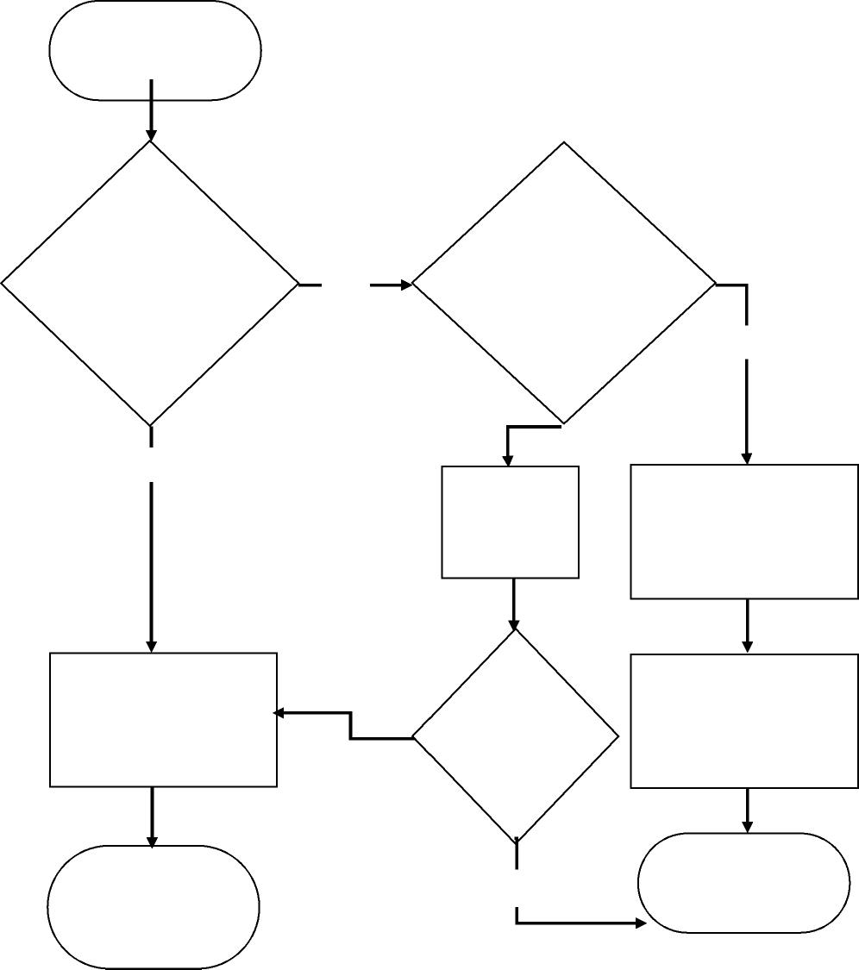

Continue ballasting operations

Start BWMS for ballasting operations

Complete ballasting operations using the BWMS; proceed to discharge port

Treatment Rated
  
Capacity (TRC)
  
during entire

Does the BWMS
  
function at the
  
expected

ballasting

Yes

No

Yes

Consult system's
  
OMSM for
  
troubleshooting
  
and mitigation
  
steps to improve
  
performance

No

Is the
  
BWMS at
  
least
  
meeting
  
operational
  
demand?*

Does BWMS
  
indicate a critical
  
alarm as detailed in
  
the system's
  
Operations,
  
Maintenance and
  
Safety Manual
  
(OMSM)?

No

Log alarms and any shutdowns in Ballast Water Record Book.

Consult system's OMSM and
  
ship's Ballast Water
  
Management Plan (BWMP) for
  
needed actions

Proceed to "Challenging water process"

Yes

cargo operations while using the BWMS, which should be no greater than 50% of the BWMS treatment rated capacity (TRC).

<I:\MEPC\81\MEPC> 81-16-Add.1.docx

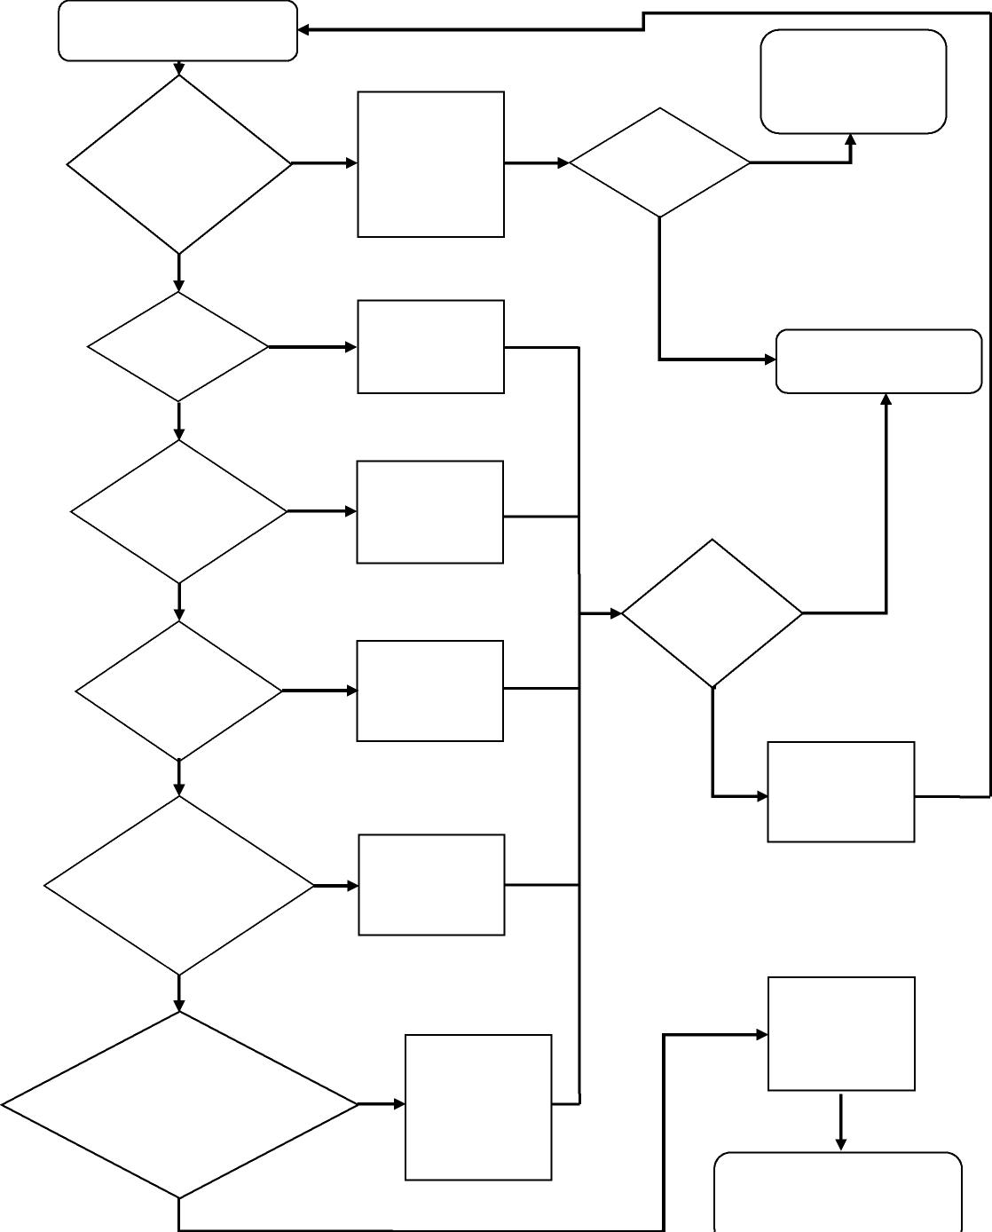



RESOLUTION MEPC.387(81) (adopted on 22 March 2024)

INTERIM GUIDANCE ON THE APPLICATION OF THE BWM CONVENTION TO SHIPS

OPERATING IN CHALLENGING WATER QUALITY CONDITIONS

MEPC 81/16/Add.1
  
Annex 5, page 18

**Sample process diagram 2: Challenging water quality process**

Determine reason for BWMS critical

**D**

alarm / shutdown / not meeting
  
operational demands

Have all mitigation

measures outlined in OMSM and Ballast Water

Management Plan (BWMP) been implemented?

Have all troubleshooting procedures as per OMSM and BWMP been completed?

Yes

Is the BWMS free

of mechanical or electrical equipment failures?

Is BWMS in
  
proper mode and
  
is full power
  
available?

Has all
  
maintenance
  
been completed
  
on BWMS?

Yes

Yes

Yes

Yes

Yes

Are all valves
  
aligned
  
correctly?

No

No

No

No

No

No

Properly align
  
system for function
  
and restart BWMS

Place BWMS in
  
proper mode,
  
increase system to
  
full power

Troubleshoot
  
BWMS as per
  
OMSM and BWMP

Consult with
  
manufacturer
  
and/or BWMS
  
Operations
  
Maintenance and
  
Safety Manual
  
(OSMS) to repair
  
system

Complete all
  
outstanding or
  
deferred
  
maintenance

Implement
  
mitigation
  
measures as per
  
OMSM and BWMP

Yes

Has BWMS
  
been
  
repaired?

Does BWMS return to normal function?

No

Proceed to "Alternatives to bypass" process diagram

No

Consult port State and
  
Administration regarding
  
potential contingency
  
measures (BWM.2/Circ.62)

Water ship is
  
encountering is
  
outside of BWMS
  
operational
  
limitations (CWQ)

Record any shutdowns and alarms in Ballast Water Record

Book

Resume normal ballasting operations

Yes

<I:\MEPC\81\MEPC> 81-16-Add.1.docx

RESOLUTION MEPC.387(81) (adopted on 22 March 2024)

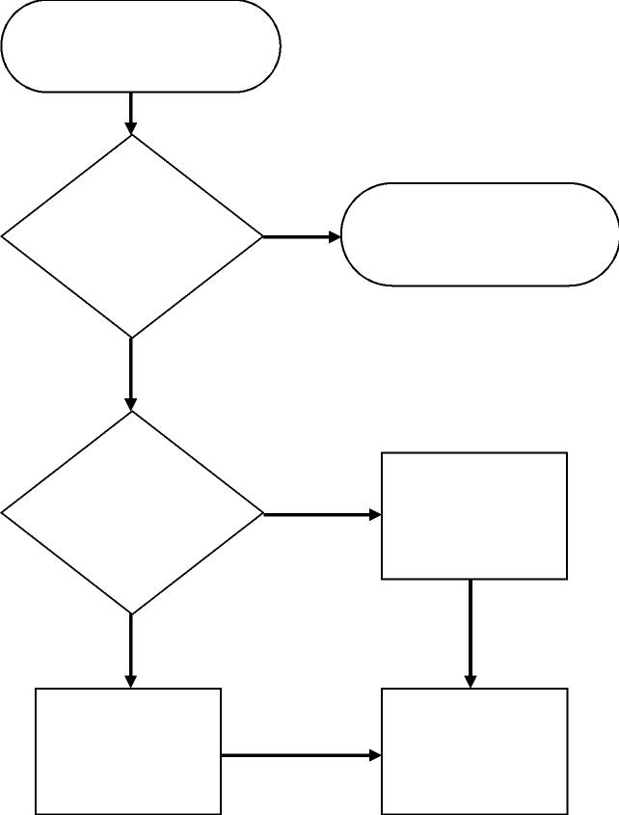

Evaluate alternatives to bypass

Fully treat the greatest
  
possible fraction of the

uptake water or

bypass only the
  
inoperable portions of

the BWMS

Is ballasting critical
  
for safety or due to
  
operational
  
demand of the
  
ship?

Is partial treatment possible?

Yes

Yes

No

No

Avoid ballasting until BWMS is
  
fully operational or CWQ is no
  
longer observed

Record bypass in
  
Ballast Water Record
  
Book

Bypass the BWMS

INTERIM GUIDANCE ON THE APPLICATION OF THE BWM CONVENTION TO SHIPS

OPERATING IN CHALLENGING WATER QUALITY CONDITIONS

MEPC 81/16/Add.1 Annex 5, page 19

**Sample process diagram 3: Alternatives to bypass**



|  |
| --- |
| Take on the minimum  ballast required to  maintain safety and  operational demand of  the ship |



Ballast to the minimum
  
number of tanks to
  
maintain the safety
  
and operational
  
demand of the ship



<I:\MEPC\81\MEPC> 81-16-Add.1.docx



Proceed to "Managing ballast
  
water following a BWMS bypass"
  
process diagram

RESOLUTION MEPC.387(81) (adopted on 22 March 2024)

INTERIM GUIDANCE ON THE APPLICATION OF THE BWM CONVENTION TO SHIPS

OPERATING IN CHALLENGING WATER QUALITY CONDITIONS

MEPC 81/16/Add.1
  
Annex 5, page 20

**Sample process diagram 4: Decontamination: managing ballast water following**

* For decontamination purposes, BWE+BWT is to be done in accordance with the OMSM, approved Ballast Water Management Plan, and best practices. For the sequential method, ballast tanks should be emptied, residual ballast water and sediments should be managed (by flushing the tank with treated water, if allowed and/or required by the receiving port State), and then the tank should be refilled with treated water. For non-sequential methods, a sufficient volume of treated uptake water should be pumped through to reduce the concentration of organisms in the tank to the standard in regulation D-2, at least 1.66 times the volume specified by regulation D-1.2, if required by the receiving port State. The BWMS should be used during emptying of contaminated tanks, as well as subsequent uptakes, flushing and discharges during decontamination, if

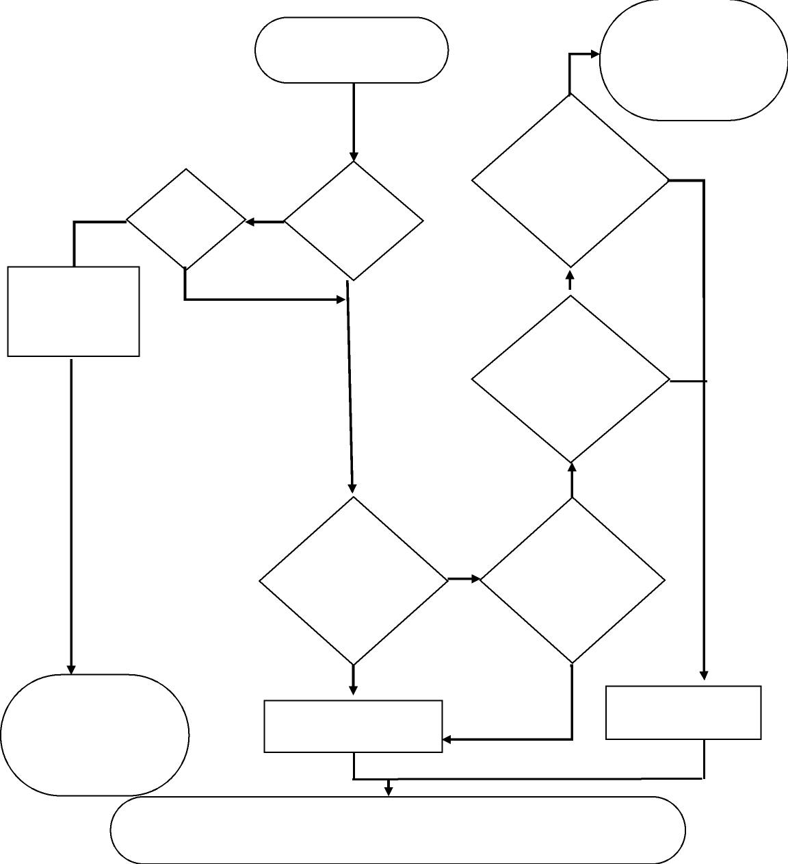

Contact BWMS
  
manufacturer to
  
provide support to
  
repair BWMS at next

port of call

Ballast water is not expected to meet D-2. Consult next port of call

prior to arrival for instructions, taking into account BWM.2/Circ 62

No

Inform the next State receiving water from affected ballast tanks of the bypass, such as through a pre-arrival
  
ballast water reporting form when such a form is required. Any deviation from the procedures in this guidance or
  
the BWMP should be noted in the communication.

Is the
  
system
  
repaired?

Yes

Yes

Conduct BWE+BWT* in
  
accordance with the ship's
  
BWMP before entering next port

Yes

To manage ballast water
  
following a BWMS bypass
  
event

Can the ship safely
  
conduct ballast
  
water exchange
  
(BWE) in
  
accordance with
  
regulation B-4.1.1?

No No

Was system bypassed due to mechanical failure?

**a BWMS bypass**

No

No

Does the discharge port have an area for ballast water

exchange in accordance with regulation B-4.2?

Can the ship safely
  
conduct ballast
  
water exchange
  
(BWE) in
  
accordance with
  
regulation B-4.1.2?

Does the uptake
  
port have an area
  
for ballast water

exchange in
  
accordance with
  
regulation B-4.2?

No

Yes

Conduct BWE+BWT* in
  
accordance with the ship's
  
BWMP in designated area

Ballast water is not expected to meet D-2. Consult next port of call

prior to arrival for instructions, taking into account BWM.2/Circ 62

Yes

Yes

technically feasible. See appendix 1. ***

<I:\MEPC\81\MEPC> 81-16-Add.1.docx

RESOLUTION MEPC.387(81) (adopted on 22 March 2024)

INTERIM GUIDANCE ON THE APPLICATION OF THE BWM CONVENTION TO SHIPS

OPERATING IN CHALLENGING WATER QUALITY CONDITIONS