# Future Drought Fund Monitoring, Evaluation and Learning Framework



© Commonwealth of Australia 2020

**Ownership of intellectual property rights**

Unless otherwise noted, copyright (and any other intellectual property rights) in this publication is owned by the Commonwealth of Australia (referred to as the Commonwealth).

**Creative Commons licence**

All material in this publication is licensed under a [Creative Commons Attribution 4.0 International Licence](https://creativecommons.org/licenses/by/4.0/legalcode) except content supplied by third parties, logos and the Commonwealth Coat of Arms.

Inquiries about the licence and any use of this document should be emailed to [copyright@awe.gov.au](mailto:copyright@awe.gov.au).



**Cataloguing data**

This publication (and any material sourced from it) should be attributed as: DAWE 2020, Future Drought Fund Monitoring, Evaluation and Learning Framework, Department of Agriculture, Water and the Environment, Canberra, December. CC BY 4.0.

ISBN 978-1-76003-360-6

This publication is available at [agriculture.gov.au/ag-farm-food/drought/future-drought-fund](https://www.agriculture.gov.au/ag-farm-food/drought/future-drought-fund).

Department of Agriculture, Water and the Environment

GPO Box 858 Canberra ACT 2601

Telephone 1800 900 090

Web [awe.gov.au](http://agriculture.gov.au/)

**Disclaimer**

The Australian Government acting through the Department of Agriculture, Water and the Environment has exercised due care and skill in preparing and compiling the information and data in this publication. Notwithstanding, the Department of Agriculture, Water and the Environment, its employees and advisers disclaim all liability, including liability for negligence and for any loss, damage, injury, expense or cost incurred by any person as a result of accessing, using or relying on any of the information or data in this publication to the maximum extent permitted by law.

Contents

1 Purpose and use of this framework 5

1.1 Use of the MEL Framework 6

2 Rationale and direction for monitoring, evaluation and learning 8

2.1 Objectives 8

2.2 Audiences 8

3 Scope of monitoring, evaluation and learning 9

4 Program theory for the FDF 11

4.1 Resilience concepts and measures 11

4.2 Theory of change 12

4.3 Theory of action (program logic) 15

4.4 MEL indicators and data sources 21

5 Monitoring, evaluation and learning approaches 26

5.1 Design considerations for MEL approaches 26

5.2 FDF MEL approaches 28

5.3 Program MEL approaches 29

6 Monitoring, evaluation and learning management 31

6.1 MEL roles 31

6.2 MEL risks and management 32

6.3 Resourcing 33

Glossary 34

**Tables**

Table 1 Key MEL questions 10

Table 2 Funding Plan overall Program Logic – Detailed 18

Table 3 Framework mapping high-level indicators of drought resilience 22

Table 4 Fund-level MEL processes 27

Table 5 Risks and mitigations 32

**Figures**

Figure 1 Use of the MEL Framework 6

Figure 2 Scope of enquiry for MEL under the Funding Plan 9

Figure 3 FDF Theory of Change 14

Figure 4 Program logic overview 17

Figure 5 Reporting for the Funding Plan and its programs 25

Figure 6 The focus of each evaluation 28

## Purpose and use of this framework

The Future Drought Fund (FDF) represents the Australian Government’s ongoing commitment to strengthen drought preparedness and resilience. It was established as an endowment fund to be preserved in perpetuity, providing a permanent revenue source to enhance drought resilience for Australian farm businesses and communities. Following an initial credit of $3.9 billion, the FDF is expected to grow to $5 billion by 2028–29, and to distribute up to $100 million each year.

The FDF’s vision is:

An innovative and profitable farming sector, a sustainable natural environment and adaptable rural, regional and remote communities – all with increased resilience to the impacts of drought and climate change.

The Drought Resilience Funding Plan 2020 to 2024 (‘the Funding Plan’) sets out an approach for making arrangements or grants in relation to drought resilience, or entering into agreements in relation to such grants, under the FDF, in accordance with the Future Drought Fund Act 2019 (which gave effect to the 2018 National Drought Agreement).

This Monitoring, Evaluation and Learning (MEL) Framework outlines the rationale, scope and approach for monitoring and evaluating the activities carried out under the Funding Plan, and for the generation and sharing of knowledge gained through funded activities about how to build drought resilience.

The MEL Framework applies to the period of the Funding Plan and should be read in conjunction with it. The MEL Framework is also likely to inform efforts beyond the initial funding period, in line with the Australian Government’s long-term vision and ongoing commitment to invest in strengthening drought preparedness and resilience.

The MEL Framework sets the scope for:

* Monitoring – continuous and systematic observation of how the programs are implemented, situational change in the problems that they are intended to address, and early indicators of outcomes. This is to ensure that programs are on track to achieve their intended outcomes, and to support adaptive management and communicate progress.
* Evaluation – evidence-based assessment of the appropriateness, effectiveness, efficiency and impact of the programs. This includes evaluating delivery of the programs, their economic, environmental and social outcomes (intended and unintended), and the potential contribution they have made to long-term drought resilience.
* Learning – the generation and sharing of insights and information across the FDF to improve program delivery and inform future policy and program design to build drought resilience. This includes developing a shared understanding of drought resilience and identifying the factors that enable or constrain desired outcomes.

The establishment of the MEL Framework alongside the Funding Plan ensures clarityabout what is required, and why, and helps instil an evaluative mindset.

The MEL Framework operates at two timescales, as illustrated in Figure 1. It serves to evaluate progress against and context for the Funding Plan over a horizon of greater than 4 years, and over a shorter timeframe, to guide program activities to demonstrate progress and achievements and to support learning. Flexibility is expected in MEL approaches to enable the Government and the Future Drought Fund team to respond to new findings, priorities and knowledge related to drought and drought resilience.

Figure 1 Use of the MEL Framework

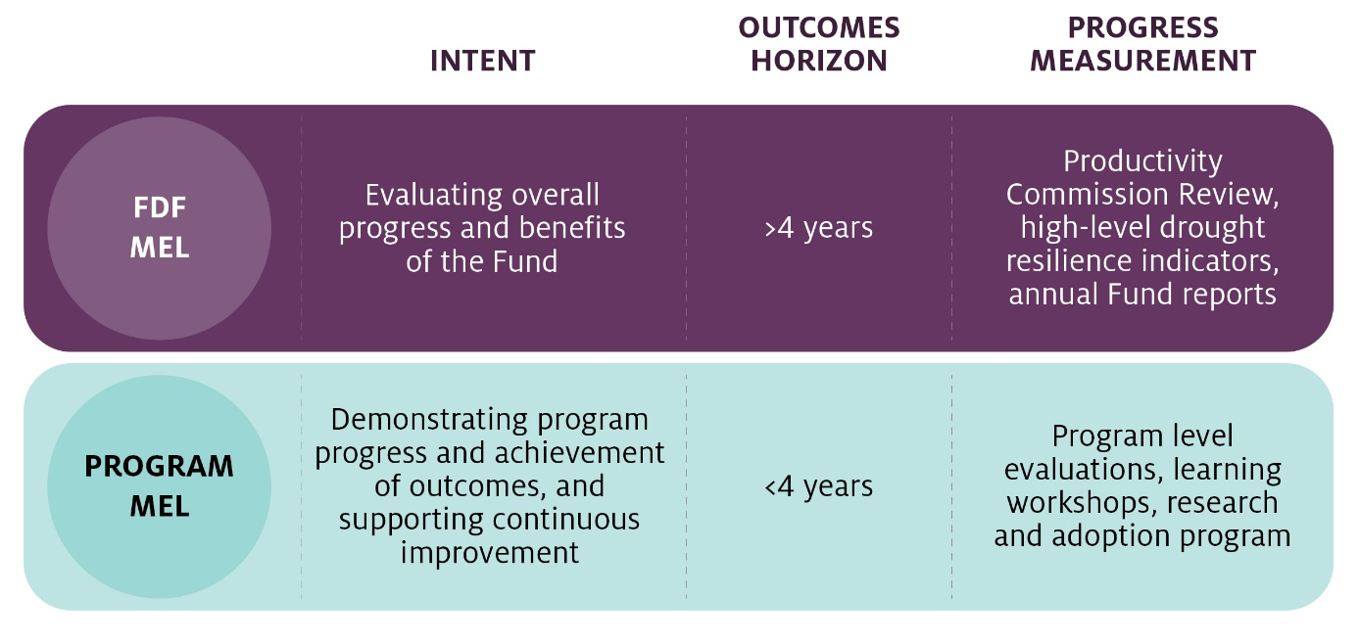

### Use of the MEL Framework

#### Future Drought Fund team

The Future Drought Fund team within the the Department of Agriculture, Water and the Environment (the department) will use the MEL Framework to set the direction, scope and approach to tracking implementation of the Funding Plan, monitoring long-term national trends in drought resilience, and collating data and findings from programs to assess progress against the FDF’s policy objective to build drought resilience.

#### Managers of FDF programs

FDF programs are overseen by a program manager within the Department. Program managers are expected to develop a program-level MEL plan to guide the design and delivery of monitoring, evaluation and learning for their program. Service providers engaged to deliver the FDF programs may be responsible to implement many of the program MEL activities. Approaches should be developed that are fit for purpose and commensurate with the size and complexity of each program. Program managers can use the overarching MEL Framework to:

1. Set the direction and scope for MEL in their program. Alignment in direction and scope across MEL related to the Funding Plan ensures that data and findings from all programs can be used to assess the contribution of programs to the Funding Plan’s objectives of building economic, environmental and social resilience to drought.
2. Clarify how their program is expected to contribute to the Funding Plan’s objectives and outcomes. The MEL Framework sets out a shared understanding – in a ‘program theory’ – of what outcomes the Funding Plan seeks to bring about, and how. Each program will contribute to a selection of these outcomes; program managers can draw on the program theory to clarify and to identify which of the shared indicators they will report on.
3. Identify specific MEL activities for their program. Program managers will identify methodologies to collect and analyse data to understand whether program resources are being used appropriately, effectively, efficiently and how learning will be applied. The MEL Framework provides advice on the types and timing of MEL activities expected to be conducted to ensure appropriate oversight and risk management.

## Rationale and direction for monitoring, evaluation and learning

The Future Drought Fund Act 2019 requires the Future Fund Board to keep responsible ministers informed about the fund, and to provide reports and information to the Minister for Finance. The role of this MEL framework is to support performance measurement and reporting against the FDF Funding Plan. It is consistent with the requirements of the Commonwealth resource management framework and with the department’s program and project management frameworks that prioritise outcomes-based performance measurement. Reporting from MEL activities is expected to give the parliament and the public confidence that investment under the Funding Plan is being used appropriately, transparently and accountably.

### Objectives

The objectives for monitoring, evaluation and learning under the Funding Plan are for the Future Drought Fund team and program managers to:

1. demonstrate progress towards drought resilience
2. be accountable for the appropriate, efficient and effective use of funds
3. support knowledge transfer about how to effectively build drought resilience.

### Audiences

The primary audiences for findings from monitoring, evaluation and learning on the FDF’s progress and outcomes are:

* the Minister for Drought, who will use data and findings to allocate funding and inform future policy directions – including future 4-year Funding Plans
* the Future Drought Fund Consultative Committee, who will use findings to affirm whether or not the Funding Plan is achieving its objectives and provide recommendations on implementation and future directions
* the Productivity Commission, who will use findings to inform its 3-yearly legislated review on the viability, operations and economic, environmental and social outcomes of the Funding Plan
* departmental officials, who will use findings to make policy recommendations and operational decisions
* program managers, who will use findings to track and adjust their programs to improve performance
* members of the public and within other organisations who have an interest in drought resilience, who may use the findings to inform their own activities
* members of the public who want information about the use of public resources for the purpose of improving drought resilience, including for accountability purposes.

## Scope of monitoring, evaluation and learning

Program managers are expected to plan, undertake and/or commission MEL activities to assist them to demonstrate impact, be accountable and support knowledge transfer. The data, findings and recommendations from MEL activities will inform reporting and contribute to the ongoing consideration by the department and the FDF Consultative Committee of the Funding Plan’s priorities and program design.

The overall scope of enquiry for MEL activities under the Funding Plan, to support the MEL objectives, is illustrated in Figure 2. Each segment of the circle represents the MEL activities that will be pursued through the lines of enquiry presented outside of the circle.

Figure 2 Scope of enquiry for MEL under the Funding Plan

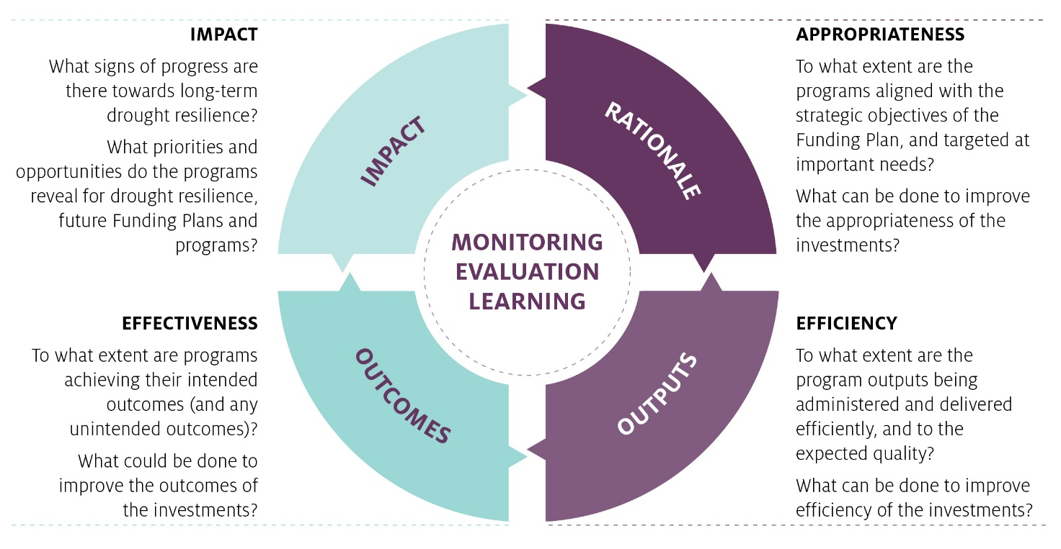

This scope has been broken down into a series of key MEL questions (Table 1). Program managers should use these questions as a basis to select and develop program-specific MEL questions, indicators and data collection tools that are consistent with this overall scope and tailored to be relevant to the specific program.

Table 1 Key MEL questions

| Line of enquiry | Scope | Key MEL questions |
| --- | --- | --- |
| Appropriateness | To what extent are the programs aligned with the strategic objectives of the Funding Plan, and targeted at important needs?  What can be done to improve the appropriateness of the investments? | * What is the nature, magnitude and distribution of the problem or opportunity the program is designed to address? * What is the broader context in which the FDF/program is operating, and how does the Funding Plan/program contribute in that context? * To what extent were the Funding Plan/program’s objectives and design clear, consistent, and aligned to the problem or opportunity the Funding Plan/program was intended to address? * In which ways did the program contribute to the Funding Plan’s strategic objectives? |
| Efficiency | To what extent are the programs being administered and delivered efficiently, and to the expected quality?  What can be done to improve the efficiency of the investments? | * To what extent did the Funding Plan/program meet its targets within the agreed timeframes? * How efficiently was the program administered? (value returned for money invested, value for time taken) * How well did the program manage risk? * To what extent did the program’s governance support its delivery? * How well did the program work with other initiatives designed to achieve similar objectives? * What could be done to improve the efficiency of the program? |
| Effectiveness | To what extent are programs achieving their intended outcomes (and any unintended outcomes)?  What could be done to improve the outcomes of the investments? | * Did the program deliver outputs to the appropriate target audience? Why or why not? * To what extent did the Funding Plan/program achieve the outcomes it was intended to achieve? Why or why not? * What, if any, unintended outcomes resulted from the Funding Plan/program? Why or why not? * What factors affected the achievement of outcomes, how and why? * What actions were taken to maximise opportunities and address barriers that emerged? |
| Impact | What signs of progress are there towards long-term drought resilience?  What priorities and opportunities do the programs reveal for drought resilience policy, future Funding Plans and programs? | * How is economic, environmental and social drought resilience changing (or not) in Australia, in which locations, how and why? * To what extent do the outcomes achieved by the program align with improvements in overall drought resilience? * What future priorities and opportunities are revealed by overall trends in drought resilience and/or by the outcomes of the programs, for the investment under the Funding Plan? * What priorities and lessons can be drawn to improve the appropriateness, efficiency or effectiveness of future programs so that they make the best possible contribution to the Funding Plans strategic priorities? |

## Program theory for the FDF

The design of MEL activities to assess the appropriateness, efficiency, effectiveness and impact of the Funding Plan and its programs must be based in a sound understanding of what the Funding Plan aims to achieve and the ways in which it is expected to help improve drought resilience. This understanding can be set out in a program theory. In [Purposeful Program Theory: Effective Use of Theories of Change and Logic Models](https://www.researchgate.net/publication/259999058_Purposeful_Program_Theory_Effective_Use_of_Theories_of_Change_and_Logic_Models), program theory is defined as ‘an explicit statement or model of how change in a particular situation will occur and how an intervention will produce the causal processes that lead to that change’. Guided by the program theory, the FDF team, program managers and external evaluators can enquire into relevant aspects of the Funding Plan and its programs, and use the data and analysis to ask ‘what is happening compared to what was thought would happen, and why or why not?’

The program theory sets out a current, evidence-based understanding of what change in drought resilience is needed, and what is expected to work, and why, to help drive that change across the 3 strategic priorities of economic, environmental and social resilience. As the Funding Plan is implemented and more is learnt over time about how to build drought resilience, the Future Drought Fund managers can refine the program theory and identify further efforts to enhance drought resilience.

Each program is expected to develop its own subsidiary program theory. The subsidiary program theory will be consistent with the overall understanding expressed in the Funding Plan level program theory, but will explain in more detail the specific outcomes the program seeks to achieve and how it expects to bring about those outcomes. The discipline involved in developing a program theory can support the design, delivery and MEL of programs that are appropriate, efficient and effective.

A program theory has 2 parts:

1. The theory of change describes the positive change sought, why it matters, and what the mechanisms of change are.
2. The theory of action (or program logic) describes what will be done to work towards that change with the resources available and appropriate to the context.

This section describes our understanding of resilience, the theory of change and theory of action .

### Resilience concepts and measures

Resilience is a complex concept, and contested in both public policy and research. It is often described as the ability to cope with adversity and adapt positively to changing circumstances. Aligning with the Funding Plan, the MEL framework’s working definition of drought resilience is:

The ability to adapt, reorganise or transform in response to changing temperature, increasing variability and scarcity of rainfall and changed seasonality of rainfall, for improved economic, environmental and social wellbeing.

There is no simple measure of resilience, as it is multi-layered and influenced by many factors. The effects of drought generally build and subside over time, interacting with other stresses – and so it is a significant challenge to separate resilience to drought from resilience to wider adversity. Acknowledging this, the Funding Plan addresses social and economic resilience as well as the resilience of agricultural and environmental systems. Resilience measures also need to consider this wider context.

Actual resilience behaviour can only be measured by looking at the before-state, the nature of a change or stress, and the actual response. Therefore, frameworks to represent resilience typically assess the determinants or factors likely to influence and confer resilience. A common approach and the one currently adopted in our MEL approach, assesses a range of resources or capitals that can be drawn on collectively and influence adapting and coping responses. This can be applied at individual scale, a community or an economy. The term adaptive capacity is sometimes used interchangeably with resilience to depict these resources.

Using a capitals framework, resilience resources are grouped in categories including:

* financial capital – for example, income or savings at business or household level
* human capital – for example, knowledge, skills, wellbeing, health and confidence
* social capital – for example, networks, linkages and cohesion
* physical capital – for example, infrastructure
* natural capital – for example, the environment, soil, vegetation
* community capital – for example, leadership, equity, services
* institutional capital – for example, government and organisations.

Understanding the relative importance of these various sub-components is a challenge in programs and research addressing resilience. Capitals and adaptive capacity are referred to in section 4.3 on indicators to assist monitoring resilience levels, over time and between areas.

Drought resilience levels will vary with levels of access that farms, individuals and communities have to capitals resources, as well as opportunities and context such as trade settings and the macro-economy. Drought resilience will also be influenced by external factors, including the timing, duration and severity of drought events (exposure) that affect the environment and also influence farmers’ and community attitudes to risk, decision-making and policy interventions.

As well as a framework to understand resilience determinants, it can be useful to consider how it occurs in categories of behaviour: incremental coping (stable system); transitioning (mitigating shocks, adapting the system); transforming (change to systems, re-thinking). This can give a basis to frame what resilience aspects interventions may be influencing. It may also useful to guide evaluating resilience building activities: How effectively did efforts address adapting? Did we address coping? How well did we achieve transformation to whole new systems?

As the programs further develop, understanding of these concepts will be explored further, including through regional groups involved in planning resilience actions.

### Theory of change

The FDF aims to enhance the public good by building drought resilience in Australia's agricultural sector, the agricultural landscape, and communities. Guided by the Funding Plan, it is expected that funding is allocated to programs that contribute to one or more of its 3 inter-connected strategic priorities:

1. Economic resilience for an innovative and profitable agricultural sector
2. Environmental resilience for sustainable and improved functioning of farming landscapes
3. Social resilience for resourceful and adaptable communities.

The Funding Plan requires that benefits generated by FDF funding must be accessible to, and/or shared by, many (public benefits), rather than be captured solely by individual businesses or industries solely for private commercial gain (private benefits). It recognises the diversity of people, businesses and landscapes involved in agricultural production, including the role of indigenous landholders, and operates on the principle that the social, economic and environmental benefits achievable should outweigh the costs.

The theory of change for the FDF in Figure 3, sets out the central hypotheses about the ways in which efforts to build economic, environmental and social resilience can contribute to the overall vision for drought resilience. It thus gives the overall rationale for the types of programs the FDF will invest in.

Figure 3 FDF Theory of Change

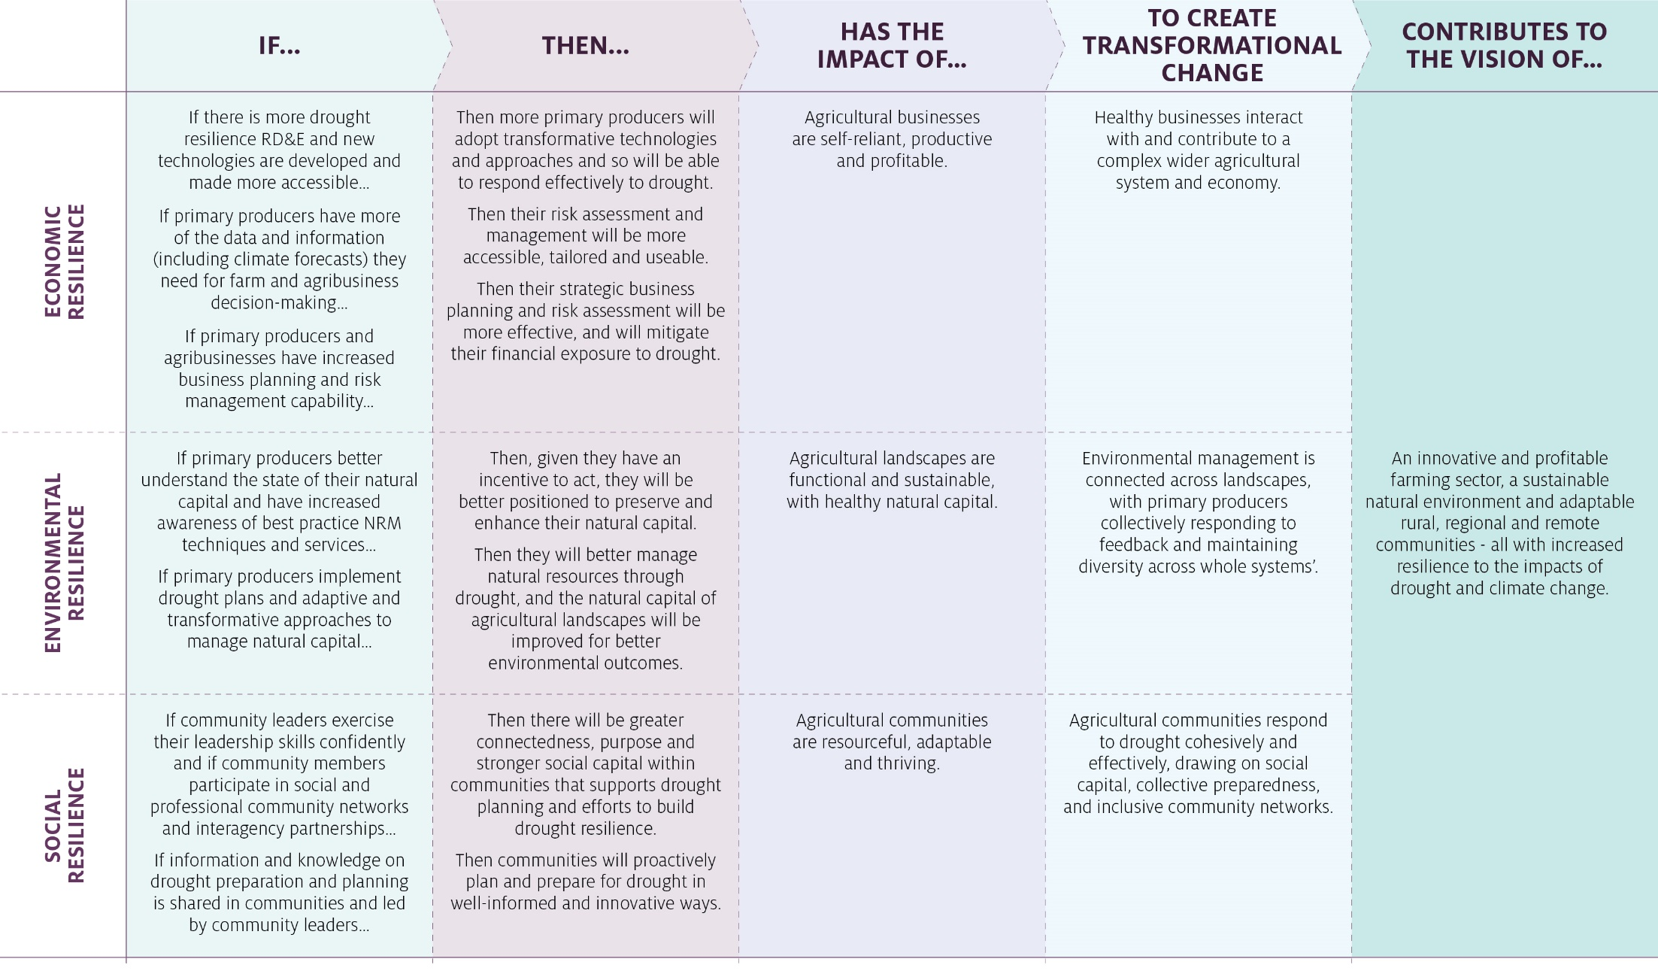

#### Theory of change limitations

There are several limitations to this theory of change that reflect the complexity, ambition and long-term nature of achieving drought resilience. These limitations should be kept in mind in the design of programs and in associated MEL activities.

##### Resilience is not an absolute

In the context of the FDF, the underlying premise is that drought is a shock, to individuals, farm businesses, communities and to agricultural landscapes. Practice change is therefore required to better prepare for drought, cope with the consequences of drought and contribute to recovery from drought. There is no clear end-point of when resilience is attained, given the dynamic nature of drought and the fact that resilience is not absolute. Rather, resilience is measured on a continuum. Every person, farm, community and agricultural landscape has unique circumstances which mean that unique interventions are required to increase their drought resilience.

##### External influences

The Funding Plan has an aspirational vision and ambitious objectives which cannot be achieved by the FDF alone. Drought resilience is influenced by a range of external factors, including international trade and investment decisions, community and personal preferences, and future climatic conditions. Furthermore, a range of drought related initiatives are undertaken by state and territory governments, regional authorities and organisations. MEL activities will need to assess the contribution of programs towards their specific objectives and the Funding Plan’s strategic objectives while acknowledging and understanding the complex factors that shape the achievement of desired outcomes. It is reasonable for MEL activities to initially focus on reporting on program outputs, processes and relationships expected to underpin longer-term outcomes of drought resilience, while also looking for signs of progress towards those outcomes.

##### Timeframes and scales for achieving outcomes

Achieving the FDF’s objectives requires changes to management practices whose benefits may take years or even decades to materialise. For example, modifying cropping practices to assist in soil moisture retention, changing farming systems, enhancing natural resource outcomes, or building enduring changes in rural communities all require investments in equipment, capacity and infrastructure, management approaches and capability and knowledge before physical changes manifest. Further, some influences on drought resilience may require actions to occur at catchment or regional scales to have enduring impact, such as managing total grazing pressure by reducing the impact of feral and native herbivores animals. These outcomes can only be achieved by collective action over time, recognised by the Australian Government’s enduring commitment to building drought resilience.

### Theory of action (program logic)

Where the theory of change sets out the central hypotheses about the ways in which economic, environmental and social resilience can be brought about, the theory of action should set out the short, intermediate and long-term outcomes that programs are expected to contribute to (and which, in turn, are expected to contribute to improved drought resilience), and the mechanisms by which they will make this contribution. Together these form the program logic. Figure 4 provides a high-level overview of each component of the program logic. Its purpose is to illustrate the connections between elements of the program logic. Table 2 presents the detailed program logic.

The Funding Plan program logic at Table 2 expresses the highest order of what the Funding Plan is expected to achieve and provides an ‘umbrella’ logic that program managers can use to develop a theory of action for their program. This overarching program logic provides a general scope of interventions proposed under the Funding Plan, and the outcomes expected over 2 to 4 years and over the long term (over 4 years). The Funding Plan intermediate outcomes represent a broad summary of what the foundational programs are expected to achieve together, as a whole. The program intermediate outcomes are examples drawn from the programs, with detail to be more comprehensively described in their MEL plans. While the intermediate and long-term outcomes have a multi-year outlook, detail program activities may change year to year.

The program logic expresses expected outcomes in direct, active language that makes clear who the subject of the desired outcome is and what they are expected to know or do differently (which in turn is expected to support improved drought resilience). Such language is important in a program logic because it encourages program managers to be disciplined during their program design and MEL, in focusing not just on what is being done, but what is changing in terms of drought resilience.

As the Funding Plan is implemented, the types of activities supported, their outputs and their influence on outcomes will evolve. The further development of programs as well as data and insights gained through MEL activities, can be used to test, confirm and refine the Funding Plan program logic.

Figure 4 Program logic overview

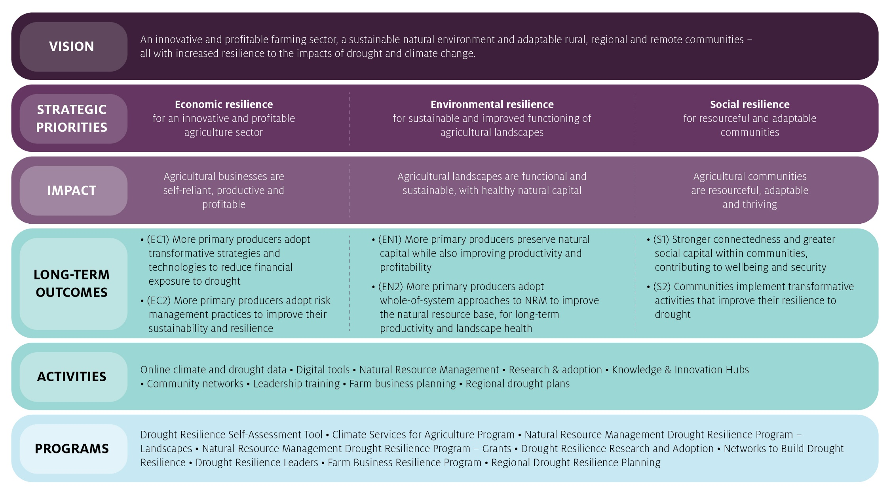

Table 2 Funding Plan overall Program Logic – Detailed

| Initial programs  (numbered Funding Plan long-term outcomes) | Program – Indicative intermediate outcomes (2 to 4 years) | Funding Plan – Intermediate outcomes (2 to 4 years) | Funding Plan – Long-term outcomes (>4 years) | Impact | Drought resilience strategic priority |
| --- | --- | --- | --- | --- | --- |
| * Drought Resilience Self-Assessment Tool   EC1 EC2 EN1 S2   * Climate Services for Agriculture   EC1 EC2 EN1 S2   * Natural Resource Management Drought Resilience   EC2 EV1 EN2   * Drought Resilience Research and Adoption   EC1 EN1 S2   * Networks to Build Drought Resilience   S1 S2   * Drought Resilience Leaders   EC2 EN2 S2   * Farm Business Resilience   EC1 EC2 EN1 S1   * Regional Drought Resilience Planning   EN2 S1 S2 | * New partnerships are formed to fund and undertake drought resilience RD&E * The volume and adoption of relevant drought resilience RD&E increases * Primary producers and businesses have improved access to new and existing knowledge and technology to enable more effective responses to risks such as drought * More primary producers and businesses engage in strategic business planning and risk assessment * More primary producers incorporate NRM philosophies and approaches in business planning and risk assessment to better manage their natural resources through drought * The managers of agricultural businesses have greater financial literacy and business acumen * More primary producers and businesses make greater use of data to better understand their farm business’ level of drought resilience and make business decisions * Climate information are relevant, reliable and useable | * Primary producers and businesses better understand their resilience to drought * Primary producers and businesses have built skills in business planning, financial and risk management * More innovative approaches and technologies for drought resilience are being developed, and adopted * Relevant and reliable climate data are available, and used for decision-making | (EC1) More primary producers adopt transformative strategies and technologies to reduce financial exposure to drought  (EC2) More primary producers adopt risk management practices to improve their sustainability and resilience | Agricultural businesses are self-reliant, productive and profitable | Economic resilience for an innovative and profitable agriculture sector |
| * NRM activities are better designed to more closely address regional climate priorities, and are better aligned across regions and with other government programs * More primary producers are engaged in the co-design of NRM related RDE&A activities * NRM related RDE&A outputs are relevant and tailored * Communities’ and farm businesses’ engagement and collaboration with NRM bodies increases * Partnerships and engagement is built between stakeholders managing natural resources * Primary producers’ awareness of new and existing NRM practices is increased, and lessons from experimentation are shared * More primary producers and agricultural communities experiment with adaptive or transformative NRM practices and systems | * More primary producers are aware of and experimenting with transformative NRM practices to manage drought * More primary producers have the skills, data and support to apply better NRM practices * Improved collaboration between NRM bodies, governments, communities and primary producers * Better use of research and co-design processes to develop NRM activities that directly address regional priorities | (EN1) More primary producers preserve natural capital while also improving productivity and profitability  (EN2) More primary producers adopt whole-of-system approaches to NRM to improve the natural resource base, for long-term productivity and landscape health | Agricultural landscapes are functional and sustainable, with healthy natural capital. | Environmental resilience for sustainable and improved functioning of agricultural landscapes |
| * The number of, and participation in, local networks and programs to enhance drought resilience increases * Improved access to, and greater utilisation of community infrastructure * Communities share knowledge, collaborate and partner with government more often to build drought resilience * Community leaders and networks have stronger capability to undertake strategic drought resilience planning * Communities use best practice data and information to better understand their resilience to drought, and plan for resilience to drought * Communities and businesses identify and adopt innovative and transformative ways to build drought resilience * More communities develop and enact regional drought resilience and management plans * Planning for regional drought resilience is more coordinated across regions and agricultural sectors | * Communities better understand their resilience to drought * Communities learn from and share innovative ways to build drought resilience * Communities build their local leadership, networks and social support * Communities proactively plan/prepare for drought, using collaboration and innovation | (S1) Stronger connectedness and greater social capital within communities, contributing to wellbeing and security  (S2) Communities implement transformative activities that improve their resilience to drought | Agricultural communities are resourceful, adaptable and thriving | Social resilience for resourceful and adaptable communities |

### MEL indicators and data sources

An indicator can be used to measure the extent of progress towards the outcomes expressed in the program logic about the changes in knowledge, motivation or practice expected of an individual, group of people or organisation, or in an overall situation.

Progress towards the desired outcomes as specified in the Funding Plan will be measured using 2 types of indicators:

1. High-level drought resilience indicators, which will enable the Consultative Committee and the Future Drought Fund team to monitor overall patterns in drought resilience over the long-term, as programs are implemented and refine these programs or support development of new interventions.
2. Funding Plan and program-level indicators, which will enable the Consultative Committee, Future Drought Fund team and program managers to track how each program is contributing to the drought resilience outcomes defined in this MEL Framework.

#### High-level indicators of drought resilience

For the first purpose, Table 3 sets out a framework mapping prospective high level indicators to capabilities and characteristics representing resilience. The rationale is that if the characteristics are at higher levels, there will be higher levels of resilience or progress towards achieving that. While some themes and indicators have specific links to drought, others represent resilience to adversity more broadly. This indicator framework will be refined in consultation with experts and custodians of relevant data sources. Indicators will be reviewed and monitored over time as the FDF evolves.

The department will collate baseline data for indicators in this framework, against which changes in drought resilience can be measured over time. Relative levels can be used to measure trends and identify variation in resilience aspects between in different regions. The baseline year may vary depending on industry or agricultural sectors, biophysical factors (for example, geography, drought incidence and risk, and land types) and data access and availability. Rather than combining the indicators together, a range and selection of indicators is appropriate so they can be monitored separately.

It is likely that the programs designed under the current Funding Plan will make a contribution towards the progress of building drought resilience as captured by these indicators. However, it is unlikely that overall changes in these drought resilience factors can be solely attributed to the programs funded under the first Funding Plan. There are many influences on drought resilience and MEL activities will work to understand how the FDF’s programs interact with these. The Future Drought Fund team will work towards assessing the contribution, to the extent that is possible and appropriate after a suitable period, to assess the influence of the FDF programs on these indicators.

Monitoring high-level resilience indicators is expected to assist the ongoing development and potentially targeting, of programs under the Funding Plan – for example, by identifying areas or sectors with relatively lower resilience levels.

Under the Drought Resilience Research and Adoption program, an expected function is a role delivering, shaping and analysing some of these drought resilience indicators, utilising connections to the Drought Resilience Adoption and Innovation Hubs and their researchers and groups. This could include reviewing indicators and their applicability to different regions, and developing case studies to indicate progress towards drought resilience in those regions.

Table 3 Framework mapping high-level indicators of drought resilience

| Strategic priority | Thematic area | High-level indicators | How indicator informs progress towards resilience*/ strategic priority |
| --- | --- | --- | --- |
| Economic resilience for an innovative and profitable agricultural sector | Macroeconomic | Rural Economies  Sector performance | If rural economies are healthy with diverse and well-performing sectors and markets for trade, this will have flow on effects to businesses, individuals and systems in the agriculture sector, including though alternative income and business opportunities. |
| Microeconomic | Farm financial diversification:   * On-farm diversification of activity and income * Off-farm income | This is about strategies, financial practices and decisions to minimise impact of drought. More diversification of farm and household income sources translates to less sensitivity to drought, and resources to draw on and manage through seasonal downturns. Diversifying income may include carbon farming. |
| Microeconomic | Farm business drought risk:   * change in farm profit * change in household income | Tailored analysis of aggregate farm performance comparing drought versus normal years and controlling for non-climate factors, measures the sensitivity and exposure of broadacre farms to drought over time. This is also influenced by farms’ financial and human capital, and shows how impact of drought on farm outcomes varies between sectors, and regions. |
| Management structures | Farm planning and management practice | This indicator covers: planning for farm risks, planning for drought, drawing on planning to make business decisions, and confidence in achieving outcomes. These practices and management capacities are key elements in responding to adversity and taking action. |
| Economic productivity | Total Factor Productivity (climate adjusted)  R&D investment and impact | Analysis of farm productivity, driven by technological progress, helps indicate progress of adoption of transformative approaches and technologies for improved financial resilience. Climate-adjusted estimates will isolate the effects of long-term technological change on productivity.  Farm business expenditure (including through levies), and government investment in research and development supports capacity to innovate and adopt new approaches. Links to the FDF Drought Resilience Research and Adoption Program for investment analysis, regional applicability and impacts. |
| Environmental resilience for sustainable and improved functioning of agricultural landscapes | Ecological management | Ecosystem Services  Environmental stewardship uptake | Functioning ecosystems and the range of goods and services they provide underpins the health and productivity of agricultural landscapes and systems. Greater uptake of practices and value placed on (this aspect of) natural capital will contribute to adaptive capacity through income, and resource protection. |
| Innovation | Carbon farming uptake  Other innovation | Managing land for carbon sequestration is an example of innovation and re-thinking production that can provide income and protect natural capital stocks.  Access to ideas, technology, and willingness to improvise and experiment supports adaptive capacity and transforming through change and taking opportunities. |
| Landscape function | Groundcover (total vegetation cover)  Soil health measures | Groundcover is a recognised biophysical process indicator that can suggest landscape health, function and soil condition. Important for drought resilience by enabling rain infiltration and protecting soil from erosion. Groundcover analysed at landscape level relative to suitable targets is a key natural capital measure to track preparedness and recovery from drought and linked environmental stresses.  Soil health markers including carbon, organic matter and nutrition and soil acidification or salinity levels, associated with management, suggests landscape functioning and long-term productivity. |
| Agricultural production | NRM Practices and farming practices | Extent of specific on-farm NRM practices, for managing productivity and drought resilience. Sub-indicators here include improving soil water retention, more water efficient pastures, changed soil additives, increase fodder held, de-stocking early, or retaining groundcover. Higher levels of these will enable more efficient or productive use of the natural capital base, prior to and through drought. |
| Social resilience for resourceful and adaptable communities | Demographic | Women, Indigenous, young people representation in agriculture  Socio-economic status - Index of Education and Occupation**  Population change, migration  Australian Natural Disaster (hazard) Resilience Index | Active participation of diverse groups of people within agriculture will enhance resilience through greater inclusion within communities, and more diverse ideas, skills, perspectives, and networks.  Combining measures of educational attainment, employment and occupation participation indicates collective human capital in a community contributing to adaptive capacity and likely access to resources to respond to change (drought and other). Also indicates likelihood to share learnings.  Population change can indicate desirability of area to live in, health and diversity of local economy.  The Australian Natural Disaster Resilience Index applies across other thematic areas and could be applied to preparedness and response capacity to drought. |
| Individual and social connectivity | Personal wellbeing  Social capital  Community human capital and partnerships | Levels of personal wellbeing (happiness and life satisfaction), and strength of bonding and bridging links within community such as through volunteer networks and sporting club participation, contribute to ability to respond to adversity individually and provide support to others, building resilience. Identification with shared norms and values increases trust and social capital.  Effective local leadership and groups, community values and mutual trust are a key to solving problems and coordination when communities are faced with challenges. |
| Economic | Financial Capital  Economic Diversity Index | Personal and household income levels and financial wellbeing indicate extent of access to financial resources that the community can draw on to cope in the short-term and adapt to long-term adversity.  An economic diversity index measures variety of employment sectors in a local economy relative to the Australian economy and is one of the most common and influential components of adaptive capacity metrics (human and financial capital). Areas that are more economically diverse are likely to be in a better position to respond to change than are less diverse areas. |
| Structural factors | Community capital  Services and infrastructure | Higher levels of confidence in leadership and governance capacity, safety, and access to local physical and support services contribute to adaptive capacity through the collective ability within a community to plan, connect and make decisions. |

Notes: * With reference to capitals framework for representing resilience and adaptive capacity. ** The Index of Education and Occupation is one of 4 Socio-Economic Indexes for Areas (SEIFA), produced by the Australian Bureau of Statistics. Some indicators will have corresponding sub-indicators.

#### Funding Plan and Program-level indicators

In addition to high-level indicators, each program will develop its own set of indicators to measure short- and medium-term program-level outcomes, as well as the achievement, extent and quality of program outputs. While program managers will select indicators and data sources that are relevant to their program, having some consistency in the indicators tracked by different programs will support the collation of data and comparison of outcomes across the FDF’s investments. Program managers will be given guidance on the development of indicators to ensure both relevance and consistency.

Program-level MEL activities, and selection of indicators will be aligned to the program-level lines of enquiry and key evaluation questions shown in Table 1. These are: appropriateness; efficiency; effectiveness; impact. Alignment of program MEL plans, indicators and reporting templates with the key evaluation questions will ensure there is a collective body of evidence that can feed into Funding Plan-level evaluations and reviews.

The Future Drought Fund team will also develop indicators to monitor performance of overall investments under the Funding Plan in achieving outcomes, as well as against the wider key evaluation questions. Data for these indicators will be drawn from program level reporting, as well as through some additional data collection to understand performance at the Funding Plan level.

## Monitoring, evaluation and learning approaches

To achieve the MEL evaluation objectives, the department requires a continuous view of implementation progress (gained through monitoring), a periodic view of performance and the public benefits gained (gained through evaluation) and opportunities to reflect on, and use, the evidence generated to further support innovation, collaboration and improvement to realise the ambition of the FDF (gained through learning).

There are common considerations for the design of MEL approaches for the Funding Plan and its programs that will deliver the insights required and overall reporting requirements. The specific scope, timing and methodology of MEL for each program will be determined in a program level MEL plan. Reporting on the Funding Plan and its programs, which will draw on MEL findings, is expected to work together as illustrated in Figure 5.

Figure 5 Reporting for the Funding Plan and its programs

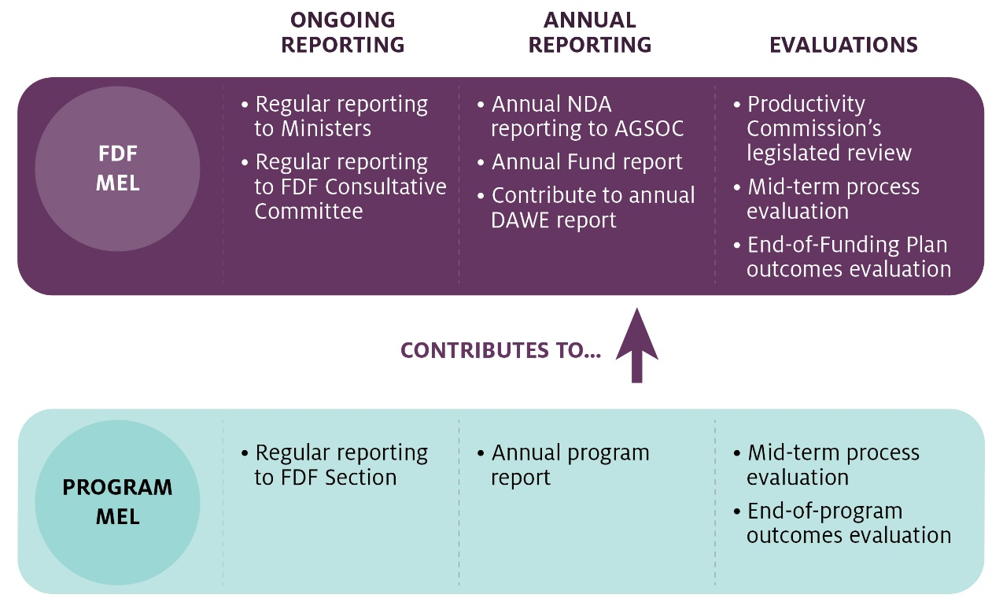

### Design considerations for MEL approaches

#### Monitoring

Monitoring of the Funding Plan and its programs will involve the regular collection and analysis of data to track progress and performance to date and the use of that data to inform program decisions. Monitoring is a descriptive activity, incorporated into regular program work, with the intent of understanding whether or not, and why, the program is being delivered as expected in terms of expenditure, activities and outputs). Monitoring also helps determine whether or not, and why, it is progressing towards desired outputs targets and program outcomes.

Monitoring is best conducted by fund and program staff so that they are informed about progress, challenges and opportunities throughout the delivery of the program. It will generally be directed to the lines of enquiry of appropriateness and efficiency, with some view towards effectiveness. Monitoring can encourage a culture of accountability and allow for agile decision-making to improve a program's design or implementation while it is in progress.

#### Evaluation

Evaluation of the Funding Plan and its programs will involve the periodic collection and analysis of data, building on monitoring data but also collecting new primary and secondary data to gain greater insight. Evaluation is an exploratory activity, seeking not only to understand and document what has happened but to explain why programs have been delivered as they have, what outcomes have or have not been achieved, and what the implications are for ongoing programming and policy.

Evaluations can be conducted internally by departmental staff and commissioned from external suppliers. Evaluation generally considers all lines of enquiry, although certain questions may be given more emphasis in evaluations conducted at different stages of a program’s implementation.

#### Learning

Learning activities are intended to ensure that data and analysis is used not only to report on what is being done and achieved under the Funding Plan, but also to build knowledge, capability and practices that can support programs to become more effective over time. Learning is a reflective activity that requires the deliberate cultivation of opportunities to review, reflect on, discuss and respond to data.

Learning can be driven by leaders in each program to facilitate learning within and across programs. Learning should span the full program cycle, from the formation of program assumptions, to inputs design and implementation. Learning can examine the feasibility and quality of outputs, the factors inside and external to programs that shape outcomes, and what objectives and approaches will be relevant in future.

The principles that should inform the design and delivery of all MEL activities are:

* utilisation-focused – MEL data, findings and recommendations should be developed and presented so that their intended audiences can use them to make the decisions required to support effective management
* cost-effective – to ensure the reasonable use of funds for MEL activity, relative to program cost and value
* fit-for-purpose – to enable reporting commensurate with the scale and complexity of projects and programs
* transparent and accountable – to ensure fairness for grant applicants and to give confidence in the delivery of the Funding Plan to audiences and stakeholders
* realistic in terms of targets and timeframes – so that MEL is conducted without unduly burdening program managers and grantees
* flexible – to respond to new issues that arise but consistent to the desired impact across a program’s lifecycle as well as the Funding Plan time frames and to inform development of future Funding Plans.

### FDF MEL approaches

In its management role, the Future Drought Fund team is responsible for reporting to the Consultative Committee, reporting regularly to ministers as required and preparing annual reports on the Funding Plan for publication, as well as contributing to the Department’s annual report. The Future Drought Fund team will also provide information and support, as required, to the Productivity Commission’s 3-yearly legislated review on the viability, operations and economic, environmental and social outcomes of the Funding Plan.

To inform this reporting, the Future Drought Fund team will manage the MEL processes described in Table 4. These are complemented by and build upon MEL activities at program level, which are detailed in program level MEL plans.

Table 4 FDF MEL processes

| MEL process | Timing | Scope and focus | Using |
| --- | --- | --- | --- |
| Monitor drought resilience context | Periodic | Collect and analyse data against high level indicators of drought resilience, as it becomes available. | Future Drought Fund team, annual Funding Plan reports |
| Monitor delivery of the Funding Plan | Ongoing | Monitor the delivery of programs, including grant applications, grant management, the delivery of activities and completion of milestones.  Monitor stakeholder relationships and feedback, and the extent of coordination, planning and collaboration in support of programs. | Program management system  Future Drought Fund team, Program managers |
| Monitor program outcomes | Ongoing | Monitor programs’ performance and outcomes to identify and understand the collective outcomes achieved by FDF investments. | Ongoing program reporting |
| Evaluate Funding Plan implementation | Mid point of the Funding Plan (2022) | Conduct a process-focused evaluation, assessing the extent to which the Funding Plan’s rationale remains relevant, the progress in delivery of programs, and early signs of progress towards desired outcomes.  It will consider how well management, coordination and allocation has supported program delivery and outcomes, and identify opportunities to improve program management. | Mid-term/Process evaluation of the delivery of the Funding Plan |
| Evaluate Funding Plan outcomes | Towards the end of the Funding Plan (2024) | Conduct an outcomes focused evaluation of the performance of the Funding Plan, seeking to understand the outcomes collectively achieved (or not) by programs. This evaluation will consider outcomes in the light of data collected about long-term drought resilience trends (against the high-level indicators), and any analysis undertaken to understand the influence of programs on those indicators.  It will identify what insights the Funding Plan’s outcomes and the longer-term trends offer for the design of future Funding Plans, policy and programs. It will also document delivery across the full Funding Plan. | End of Funding Plan/Outcomes evaluation at the Funding Plan level |
| Facilitate learning at Funding Plan level | Ongoing | Facilitate the sharing of knowledge and learning among programs, with steps that could include:   * Identify major innovations occurring that will be relevant to other programs and broker the relevant links between programs and with other relevant stakeholders. * Document and disseminate data, case studies and insights from different programs. * Facilitate discussion among program leaders and stakeholders about the factors observed to support or constrain program success and facilitate collaborative problem definition and development of solutions. * Review risk mitigation and share lessons across programs. | Future Drought Fund team, program managers, research and adoption program |

Figure 6 provides an overview of the focus of each type of evaluation. Mid-term process evaluations and end-point outcome evaluations will be completed both at Funding Plan and program levels.

Figure 6 The focus of each evaluation

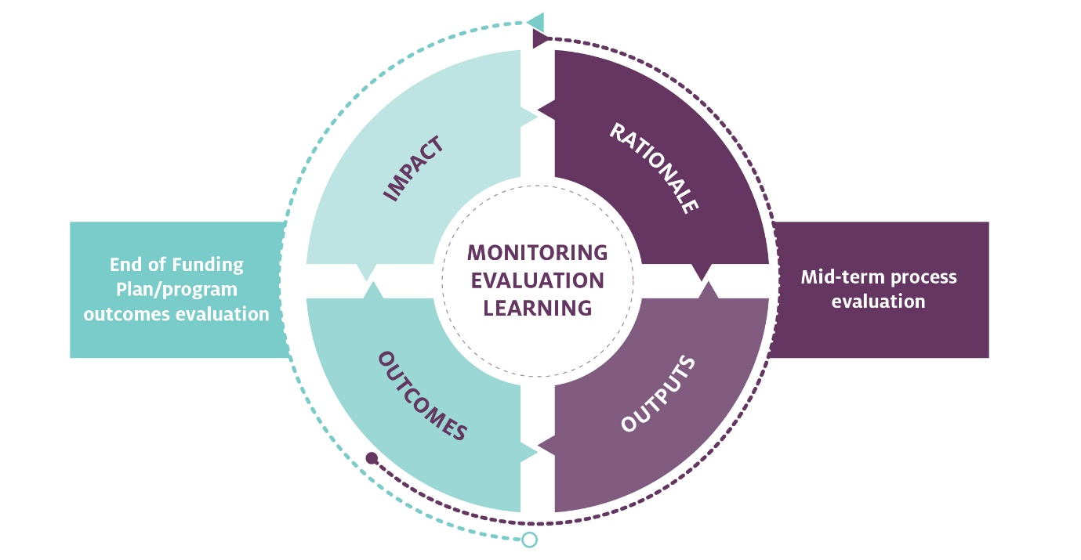

### Program MEL approaches

Each program will develop a program-level MEL plan that sets out the scope and approaches required to monitor, evaluate and learn from the program-funded activities and projects and report on them. The program-specific MEL plan must align to the long-term outcomes and expectations in the MEL Framework, and will include a program logic, a series of key evaluation questions, a list of indicators and corresponding data sources, and a set of data collection and analysis activities.

Broadly, program managers will incorporate monitoring strategies into their operations to track program delivery, respond to opportunities and challenges that arise, and identify early any factors that may constrain the achievement of desired program outcomes. This monitoring requires the collection and analysis of data in the course of the program’s work, for example about milestones, stakeholder engagement and program quality.

Program managers are expected to conduct and/or commission a mid-term evaluation and an outcomes evaluation of their program. These evaluations can be used to answer key evaluation questions at relevant times and make decisions required to ensure the program remain appropriate, effective and efficient and deliver the benefits sought. Evaluations should use a mix of methods, both quantitative and qualitative, to collect and analyse primary and secondary data to answer key evaluation questions developed for each program, based on those shown in Table 1.

#### Mid-term, process evaluation

A mid-term, process evaluation should be led by the program manager, or commissioned and carried out by an external supplier, part-way through the program’s implementation. The mid-term evaluation will be largely process-oriented. It asks, 'Are we doing what we said we’d do?' and 'Are we doing it well?'. It will also ask about early signs of progress towards outcomes, that is, 'What changes are we starting to see?' and 'What can we do more of, less of or differently to support the achievement of outcomes over time?' It is undertaken part-way into the program being evaluated, allowing time to enquire about the appropriateness, efficiency and effectiveness of delivery to date and to address the issues that are most important to solve to support ongoing program delivery and the achievement of expected outcomes in the remaining period of the program.

#### End-of-program, outcomes evaluation

An end-of-program, outcomes evaluation should be commissioned and carried out by an external supplier towards the end of the program’s implementation. Outcomes evaluation is results-oriented. It asks 'Did we do the right thing? Did we have the effect we thought we’d have?' It explores what outcomes the program has achieved, any wider impacts to which these outcomes have contributed, what has changed as a result and why or why not, how the program did this and what other influences were involved. An outcomes evaluation makes recommendations for future programs, including whether to continue, discontinue, replicate or scale up an intervention. These recommendations take account of what has been learnt through the program as well as how the overall need and policy and operational context may have changed and what interventions will be appropriate in future.

Program managers are also expected to establish ways to learn from progress and respond to feedback during program implementation. The incorporation and use of learning will be facilitated by the:

* inclusion of learning aspects within program logics
* explicit identification in reports of lessons learned
* careful monitoring of risks and responses to them
* use of surveys, interviews and workshop tools with program managers to facilitate collective reflection and problem-solving
* dissemination and discussion among program stakeholders of data, case studies and insights
* involvement of program stakeholders in the collection and analysis of data during monitoring and evaluation, to build greater understanding of what works and why, and how to measure change.

## Monitoring, evaluation and learning management

Monitoring, evaluation and learning activities need to be coordinated, overseen and managed explicitly to ensure they achieve their objectives and effectively support the FDF and its Funding Plan.

### MEL roles

#### MEL coordination and management

The owner of the MEL Framework in the department is the Future Drought Fund team (currently under the Drought Preparedness and Policy Branch, Drought and Bushfire Division). In accordance with their overall coordination role, officials will:

* Disseminate the MEL Framework to program managers and build understanding among all program managers about the MEL requirements.
* Provide advice and support to managers of programs as they design their programs and develop and deliver program-level MEL plans.
* Plan, coordinate and conduct all Funding Plan-level monitoring, evaluation, learning and reporting, including via the collation of data and findings from programs, the commissioning of a Funding Plan-level summative evaluation and support required for the Productivity Commission’s review.
* Review and update the MEL Framework on an annual basis to ensure its direction and scope remains relevant to the priorities of the Funding Plan and to ensure it can be used easily by program managers.
* Report to the consultative committee on the scope, progress and quality of MEL work undertaken by the programs.

#### MEL governance: MEL committee

A MEL committee will be established, consisting of representatives with experience and responsibilities for MEL activities across the department.

The committee will provide periodic advice to the Future Drought Fund team to support the overall design, delivery and coordination of MEL and ensure it achieves the overall MEL objectives of the Funding Plan. It will build and maintains organisational capability to support MEL, monitor performance against departmental objectives and priorities and monitors and respond to strategic risks which may materially impact the achievement of the Funding Plan’s objectives. Finally, the MEL committee will oversee alignment with legislative, governance and administrative frameworks.

### MEL risks and management

There are risks related to, or arising from, MEL at the Funding Plan and program levels. MEL risks at a Funding Plan level (distinct from other fund-management and delivery-related risks) will be carefully managed and overseen by the Future Drought Fund team, drawing on performance information and procedures and systems that continuously identify and treat emerging risks.

In their MEL plans, program managers will be required to identify specific risks that may arise in relation to MEL (distinct from wider program management risks) and to propose mitigating actions.

Funding Plan-level MEL risks that have been identified are listed in Table 5, along with potential mitigations.

Table 5 Risks and mitigations

| Risk | Mitigation |
| --- | --- |
| Data to be used in MEL is not available. It either does not exist, is restricted, or is not available within MEL timelines. | High-level indicators have been specifically selected to be measurable using existing, enduring data sources that will allow measurement both regularly and over the long-term. Program-level indicators will be developed using these same principles. |
| Data to be used in MEL is of low quality or is untrustworthy or fraudulent. | High-level indicators have been specifically selected to directly align with the broader objective of the FDF to build drought resilience, be fit-for-purpose with accurate and reliable data, and be enduring to enable long-term measurement. Data for each indicator is collected using standard methods and sufficient sample sizes to ensure confidence in the results. Program-level indicators will be developed using these same principles.  The governance arrangements outlined in MEL roles will ensure appropriate oversight of the Funding Plan and its programs, and regular reporting as part of MEL. The department maintains a Fraud and Corruption Team who are responsible for the receipt, assessment and investigation of fraud and corruption allegations. |
| False or inappropriate assumptions lead to an incorrect or incomplete understanding of the Funding Plan’s impact. | The MEL Framework acknowledges that changes in drought resilience will not be solely attributable to investments made under the Funding Plan. Baseline data will be developed for each indicator to allow benchmarking and identification of changes in drought resilience by controlling for other variables. The key evaluation questions for the Funding Plan and programs are designed to challenge assumptions about the effectiveness of interventions and rely on data. |
| Program managers do not agree on, or successfully implement lessons learned from MEL. | The MEL Framework articulates the relationship between the Funding Plan and programs, and the governance responsibilities relevant to MEL. Program managers will work to ensure clarity over what is being monitored at the program-level and to track learnings. These learnings may lead to changes in programs which will require successful implementation. There is a risk that changes to programs will not be successfully implemented, or that changes will affect data collection or distract from programs’ core purpose. By using agreed program-level MEL plans and indicators selected to be aligned, measurable, fit-for-purpose and enduring, program and fund managers will be best position to agree on and implement MEL learnings. |
| Significant drought events, policy changes and operational challenges affect the kind of information required from MEL and how it may be used. | The FDF reflects the government’s enduring policy commitment, and it is likely that there will be adjustments to policy direction and priorities over time. Major changes that may affect the scope or utility of MEL approaches underway by the Funding Plan orits programs will be discussed, and strategies to adjust MEL approaches to ensure the relevance, timeliness and utility of findings will be identified. |
| Resources for conducting MEL at the Funding Plan and program level are inadequate. | In Resourcing, the MEL Framework outlines the department’s role in resourcing evaluations. Where independent evaluations are needed at the Funding Plan level, the department will follow the Commonwealth Procurement Rules and Guidelines. |

### Resourcing

The department will resource MEL activity for the Funding Plan and programs, whether it is conducted internally, by service providers engaged to deliver FDF programs, or by external evaluators. Proponents who receive funding will be expected to use some of their funding to collate and report on their activities and outcomes, under their monitoring and evaluation obligations, and where appropriate undertake evaluations.

## Glossary

| Term/abbreviation | Definition |
| --- | --- |
| ABARES | Australian Bureau of Agricultural and Resource Economics and Sciences |
| ABS | Australian Bureau of Statistics |
| AGMIN | Agriculture Ministers' Forum |
| AGSOC | Agriculture Senior Officials' Committee |
| DRMP | Drought Resilience Management Plans |
| MEL | monitoring, evaluation and learning |
| NDA | National Drought Agreement |
| RDE&A | research, development, extension and adoption |
| RWS | Regional Wellbeing Survey |
| SEIFA | Socio-Economic Indexes for Areas |