Monitoring, Evaluation and Learning Framework: Program logic overview
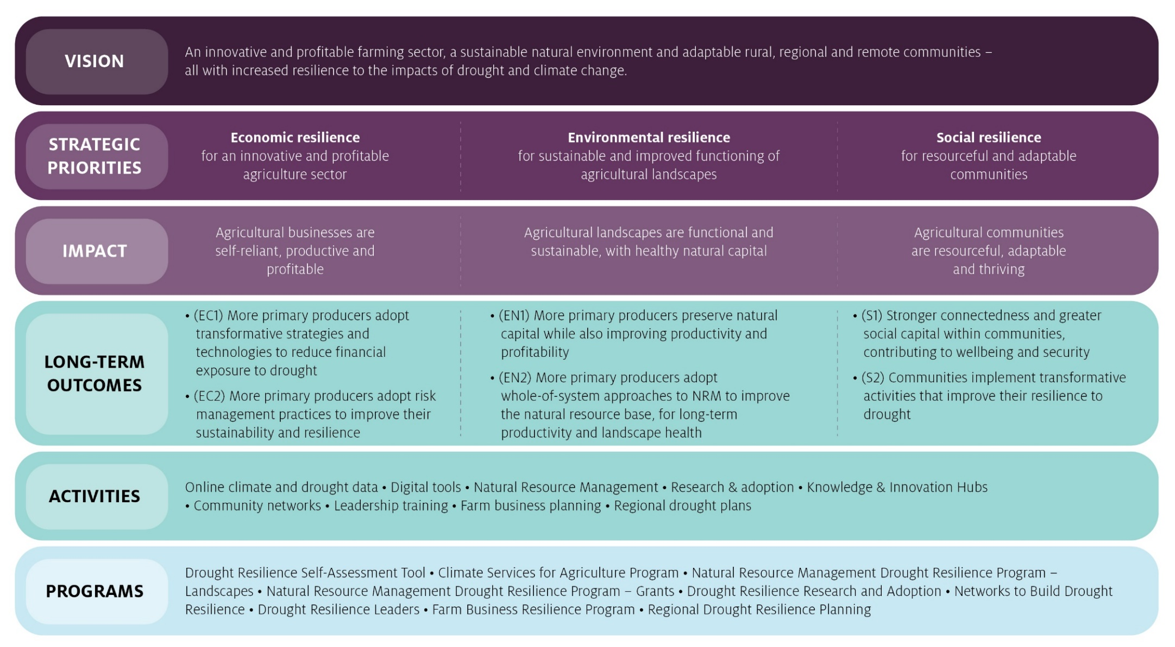
Table 1 Fund overall Program Logic – Detailed
Initial programs  (numbered fund long-term outcomes) | Program – Indicative intermediate outcomes (2 to 4 years) | Fund – Intermediate outcomes (2 to 4 years) | Fund – Long-term outcomes (>4 years) | Impact | Drought resilience strategic priority
- Drought Resilience Self-Assessment Tool  EC1 EC2 EN1 S2  - Climate Services for Agriculture  EC1 EC2 EN1 S2  - Natural Resource Management Drought Resilience  EC2 EV1 EN2  - Drought Resilience Research and Adoption  EC1 EN1 S2  - Networks to Build Drought Resilience  S1 S2  - Drought Resilience Leaders  EC2 EN2 S2  - Farm Business Resilience  EC1 EC2 EN1 S1  - Regional Drought Resilience Planning  EN2 S1 S2 | - New partnerships are formed to fund and undertake drought resilience RD&E  - The volume and adoption of relevant drought resilience RD&E increases  - Primary producers and businesses have improved access to new and existing knowledge and technology to enable more effective responses to risks such as drought  - More primary producers and businesses engage in strategic business planning and risk assessment  - More primary producers incorporate NRM philosophies and approaches in business planning and risk assessment to better manage their natural resources through drought  - The managers of agricultural businesses have greater financial literacy and business acumen  - More primary producers and businesses make greater use of data to better understand their farm business’ level of drought resilience and make business decisions  - Climate information are relevant, reliable and useable | - Primary producers and businesses better understand their resilience to drought  - Primary producers and businesses have built skills in business planning, financial and risk management  - More innovative approaches and technologies for drought resilience are being developed, and adopted  - Relevant and reliable climate data are available, and used for decision-making | (EC1) More primary producers adopt transformative strategies and technologies to reduce financial exposure to drought  (EC2) More primary producers adopt risk management practices to improve their sustainability and resilience | Agricultural businesses are self-reliant, productive and profitable | Economic resilience for an innovative and profitable agriculture sector
 | - NRM activities are better designed to more closely address regional climate priorities, and are better aligned across regions and with other government programs  - More primary producers are engaged in the co-design of NRM related RDE&A activities  - NRM related RDE&A outputs are relevant and tailored  - Communities’ and farm businesses’ engagement and collaboration with NRM bodies increases  - Partnerships and engagement is built between stakeholders managing natural resources  - Primary producers’ awareness of new and existing NRM practices is increased, and lessons from experimentation are shared  - More primary producers and agricultural communities experiment with adaptive or transformative NRM practices and systems | - More primary producers are aware of and experimenting with transformative NRM practices to manage drought  - More primary producers have the skills, data and support to apply better NRM practices  - Improved collaboration between NRM bodies, governments, communities and primary producers  - Better use of research and co-design processes to develop NRM activities that directly address regional priorities | (EN1) More primary producers preserve natural capital while also improving productivity and profitability  (EN2) More primary producers adopt whole-of-system approaches to NRM to improve the natural resource base, for long-term productivity and landscape health | Agricultural landscapes are functional and sustainable, with healthy natural capital. | Environmental resilience for sustainable and improved functioning of agricultural landscapes
 | - The number of, and participation in, local networks and programs to enhance drought resilience increases  - Improved access to, and greater utilisation of community infrastructure  - Communities share knowledge, collaborate and partner with government more often to build drought resilience  - Community leaders and networks have stronger capability to undertake strategic drought resilience planning  - Communities use best practice data and information to better understand their resilience to drought, and plan for resilience to drought  - Communities and businesses identify and adopt innovative and transformative ways to build drought resilience  - More communities develop and enact regional drought resilience and management plans  - Planning for regional drought resilience is more coordinated across regions and agricultural sectors | - Communities better understand their resilience to drought  - Communities learn from and share innovative ways to build drought resilience  - Communities build their local leadership, networks and social support  - Communities proactively plan/prepare for drought, using collaboration and innovation | (S1) Stronger connectedness and greater social capital within communities, contributing to wellbeing and security  (S2) Communities implement transformative activities that improve their resilience to drought | Agricultural communities are resourceful, adaptable and thriving | Social resilience for resourceful and adaptable communities

