# Keep khapra beetle out of Australia!

Adult khapra beetles (1.6-3mm) and a larvae (1.6-4.5mm)

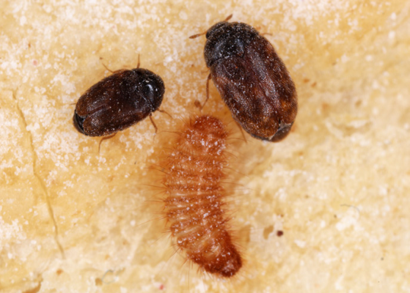

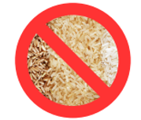

Adult Khapra beetle

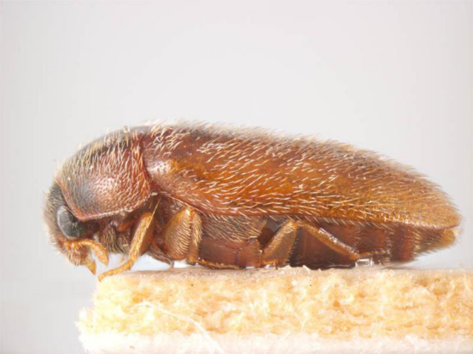

If you are carrying plant products, khapra beetle could be hiding in your bags! You must declare plant products including rice, seeds, nuts, beans, pulses, wheat, dried chilli and powdered seeds and grains.

You must answer truthfully when completing your Incoming Passenger Card.

Incoming Passenger Card

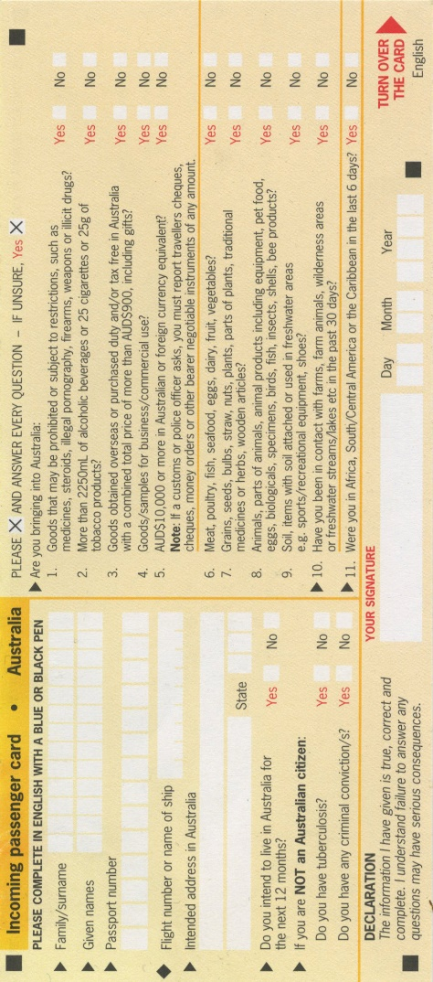

#### Penalties apply for breaching Australia’s biosecurity laws – don’t be sorry, JUST DECLARE IT!



Learn more at: [agriculture.gov.au/khapra-urgent-actions](https://www.agriculture.gov.au/biosecurity-trade/pests-diseases-weeds/plant/khapra-beetle/urgent-actions)