# Phasing out live sheep exports from Australia

Strategies to target minimal impact upon farmers and supply chain participants

Matt Dalgleish, Andrew Whitelaw and Dr Graham Lean

Episode 3 Pty Ltd

© Copyright, Episode 3 Pty Ltd, July 2023

Authors:

Matt Dalgleish

Andrew Whitelaw

Dr Graham Lean

This work is copyright. Apart from any use as permitted under Copyright Act 1963 or under the contractual agreement with the Department of Agriculture, Fisheries & Forestry, no part may be reproduced without written permission of Episode 3 Pty Ltd.

This publication is prepared by Episode 3 Pty Ltd (ABN 95 662 455 021) and Agrivet Business Consulting (ABN 69 412 853 150) Neither Episode 3, Agrivet Business Consulting nor any member or employee of either company takes responsibility in any way whatsoever to any person or organisation (other than that for which this report has been prepared) in respect of the information set out in this report, including any errors or omissions therein. In the course of the preparation of this report, projections have been prepared on the basis of assumptions and methodology which have been described in the report.

It is possible that some of the assumptions underlying the projections may change. Nevertheless, the professional judgment of the members and employees of Episode 3 and Agrivet Business Consulting have been applied in making these assumptions, such that they constitute an understandable basis for estimates and projections. Beyond this, to the extent that the assumptions do not materialise, the estimates and projections of achievable results may vary.

Contents

I. Executive summary viii

II. Introduction 1

A. Project scope 1

B. Methodology and assumptions 1

C. Overview of live sheep exports from Australia 12

D. Overview of sheep cropping and enterprise mix in WA 27

E. Key stakeholders involved in the supply chain and their reliance on the trade 42

III. Assessment of the impact of a phaseout on WA sheep industry supply chain, as identified by the consultative process 45

A. Sheep producers 45

B. Shearing services 50

C. Livestock transport operators 52

D. Feed mills and fodder suppliers 53

E. Lamb feedlot operators 56

F. Sheepmeat processors 57

G. Veterinarians 59

H. Exporters 60

I. Agency services 60

J. Other live export sector participants 61

IV. Strategies to minimise the impact on stakeholders 62

A. Phaseout timeline 62

B. Identify options to support the transition by farmers 70

C. Support across the supply chain 92

D. Identification of the steps required, and timelines required for the development of alternative markets and industries 97

V. Conclusion 150

Appendix A: Sheep sold by LGA 151

Appendix B: Number of vendors by LGA 154

Appendix C: Survey questions 157

**Tables**

Table 1 Consultation list 2

Table 2 Survey respondent list 2

Table 3 ASBV performance of maternal and shedding ewes 10

Table 4 Summary of the northern hemisphere prohibition dates 24

Table 5 WA LGA region top 20 by number of sheep 29

Table 6 WA LGA region top 20 by wheat production 31

Table 7 WA LGA region top 20 by barley production 33

Table 8 WA LGA region top 20 by canola production 34

Table 9 WA LGA region top 20 by oat production 36

Table 10 WA LGA region top 20 by lupin production 37

Table 11 WA LGA region top 20 by hay and silage production 40

Table 12 MLA-AWI sheep producer intentions 49

Table 13 Live export contributions to WA wool sector 51

Table 14 Estimated WA sheep and lamb slaughter capacity 59

Table 15 Backgrounding on faba bean stubble and feedlot phase – lamb finishing budget and sensitivity 86

Table 16 Backgrounding on standing crop, fodder crops or long season pasture and feedlot phase – lamb finishing budget and sensitivity, high rainfall zone 87

Table 17 Transport costs from west to east 91

Table 18 MENA red meat shelf life 111

Table 19 MENA business development budget 135

**Figures**

Figure 1 Timeline for phaseout xiii

Figure 2 Performance of maternal carcass plus index of Cashmore Park nudies versus other shedding sheep (breed all) and all maternal ewes (analysis all) 9

Figure 3 Performance of maternal carcass plus index of Cashmore Park nudies versus Cashmore Park maternal composites 10

Figure 4 WA gross value of livestock production 12

Figure 5 WA Gross value of livestock production (% share) 13

Figure 6 WA sheep export value (boxed and live export) 13

Figure 7 WA sheep export value (mutton and lamb) 14

Figure 8 Sheep live exports by value 15

Figure 9 Live sheep exports by volume 16

Figure 10 WA wool exports by value 17

Figure 11 Wool exports by volume 18

Figure 12 Saleyard lamb prices 20

Figure 13 Saleyard lamb price spreads 21

Figure 14 Live sheep export prices 21

Figure 15 WA wool prices 22

Figure 16 WA sheep turnoff options 23

Figure 17 WA sheep turnoff options (% share) 24

Figure 18 Live sheep mortality 25

Figure 19 WA sheep price spreads to east and eastern transport since prohibition 26

Figure 20 WA sheep price spreads since prohibition 26

Figure 21 WA flock and annual turnoff 27

Figure 22 WA sheep flock composition 28

Figure 23 WA sheep flock composition 2021 28

Figure 24 Sheep farmers heat map by LGA 30

Figure 25 Sheep heat map by LGA 30

Figure 26 Cropping area and sheep flock (Western Australia) 31

Figure 27 Wheat production heat map by LGA 32

Figure 28 Barley production heat map by LGA 34

Figure 29 Canola production heat map by LGA 35

Figure 30 Oat production heat map by LGA 37

Figure 31 Lupin production heat map by LGA 38

Figure 32 Lupin area and sheep flock (Western Australia) 39

Figure 33 Grain and oilseed prices (WA, harvest) 39

Figure 34 Hay and silage production heat map by LGA 41

Figure 35 Reliance on the live sheep export trade by participant category 42

Figure 36 Sheep sold to live export by LGA (2019–2023, animation) 43

Figure 37 Industry assistance as part of phaseout process 45

Figure 38 Producers selling to live export by LGA (2019–2023, animation) 47

Figure 39 WA sheep producer intentions 48

Figure 40 Sheep producer 50

Figure 41 Other live export industry participants – industry assistance programs 50

Figure 42 WA transport operator intentions 53

Figure 43 WA feed grain use by sector (2018 to 2022) 55

Figure 44 Preferred timeline for phaseout 63

Figure 45 Timeline for phaseout 64

Figure 46 Variation in gross margin/ha for the typical flock selling live export wethers 70

Figure 47 Variation in pasture herbage availability over time for the typical flock selling live export wethers 71

Figure 48 Variation in wether body weight over time for the typical flock selling live export wethers 71

Figure 49 Variation in gross margin/ha for the typical flock live export banned 72

Figure 50 Variation in gross margin/ha for the typical flock running wethers to 1.5 year old 73

Figure 51 Variation in gross margin/ha for the typical flock lambing later airfreight lambs 74

Figure 52 Variation in gross margin/ha for dual purpose merino producing store prime lambs 75

Figure 53 Variation in gross margin/ha for superfine merino running 3 age groups of wethers 76

Figure 54 Variation in gross margin/ha for shedding sheep 77

Figure 55 Variation in gross margin/ha for self-replacing cow/calf enterprise 78

Figure 56 Variation in gross margin for trading steer enterprise 79

Figure 57 Variation in gross margin/ha for Wongan Hills export wether enterprise 80

Figure 58 Variation in gross margin/ha for Wongan Hills airfreight lamb enterprise 81

Figure 59 Enterprise gross margin/ha and gross margin/ha variation 83

Figure 60 Enterprise gross margin/DSE from various sheep enterprises 83

Figure 61 WA sheep and lamb turnoff versus processing capacity 90

Figure 62 WA turnoff versus processing capacity 2011–2023 98

Figure 63 WA turnoff versus processing capacity 2017–2023 98

Figure 64 WA turnoff versus processing capacity 100

Figure 65 WA dwelling approvals 106

Figure 66 WA building approvals 107

Figure 67 WA building approvals by population 107

Figure 68 Live sheep and goat import options and forecast 108

Figure 69 MENA sheepmeat import prices 110

Figure 70 Live sheep and sheepmeat import volumes – Kuwait 113

Figure 71 Australian share of live sheep and sheepmeat import volumes – Kuwait 114

Figure 72 Live sheep and sheepmeat import volumes – Oman 116

Figure 73 Australian share of live sheep and sheepmeat import volumes – Oman 117

Figure 74 Live sheep and sheepmeat import volumes – Jordan 118

Figure 75 Australian share of live sheep and sheepmeat import volumes – Jordan 119

Figure 76 Live sheep and sheepmeat import volumes – UAE 121

Figure 77 Australian share of live sheep and sheepmeat import volumes – UAE 122

Figure 78 Live sheep and sheepmeat import volumes – Qatar 123

Figure 79 Australian share of live sheep and sheepmeat import volumes – Qatar 124

Figure 80 Live sheep and sheepmeat import volumes – Israel 126

Figure 81 Australian share of live sheep and sheepmeat import volumes – Israel 127

Figure 82 Live sheep and sheepmeat import volumes – Saudi Arabia 128

Figure 83 Australian share of live sheep and sheepmeat import volumes – Saudi Arabia 129

Figure 84 Live sheep and sheepmeat import volumes – Bahrain 130

Figure 85 Australian share of live sheep and sheepmeat import volumes – Bahrain 131

Figure 86 Shipping container rates 136

Figure 87 Air and sea freight – sheepmeat 136

Figure 88 Air freight – sheepmeat 137

Figure 89 Share of air freight – sheepmeat 138

Figure 90 Air freight average tonnes per day – sheepmeat 138

Figure 91 MENA sheepmeat air freight versus passenger volumes 139

Figure 92 Direct flights exit Perth the MENA and UK 140

Figure 93 MENA sheepmeat air and sea freight 141

Figure 94 Share of MENA sheepmeat air and sea freight 142

Figure 95 Value of sheepmeat air freight 142

Figure 96 Volume of sheepmeat air freight 143

**Maps**

Map A1 Sheep sold by LGA 2019 151

Map A2 Sheep sold by LGA 2020 151

Map A3 Sheep sold by LGA 2021 152

Map A4 Sheep sold by LGA 2022 152

Map A5 Sheep sold by LGA 2021 153

Map B1 Number of vendors by LGA 2019 154

Map B2 Number of vendors by LGA 2020 154

Map B3 Number of vendors by LGA 2021 155

Map B4 Number of vendors by LGA 2022 155

Map B5 Number of vendors by LGA 2023 156

## I. Executive summary

This report has been commissioned by the Australian Government’s Federal Department of Agriculture, Fisheries and Forestry (DAFF), and it aims to outline the potential effects of phasing out live sheep exports by sea on Western Australian farmers, businesses, and other participants in the supply chain.

Episode 3 does not support the policy to phase out live sheep exports by sea from Australia and believes it may have adverse consequences for the Western Australian sheep and wool industry if the process is undertaken too rapidly.

However, they acknowledge that if the phaseout is implemented over a more extended period, approximately 8 to 12 years, and if careful attention is paid to mitigate any potential damage to supply chain participants, as outlined in this report, then Western Australia could ultimately benefit from a stronger, more diverse, and sustainable sheep and wool industry at the conclusion of the phaseout process.

This longer-term approach to a proposed phase out would allow ample time for industry stakeholders to adapt to the changes, explore alternative enterprise mix strategies, and find new opportunities for growth and development within the transformed landscape. By taking a well-considered and gradual approach, Episode 3 envisions the potential for a positive and successful transition towards a thriving sheep and wool industry in Western Australia.

This report has employed direct consultation with industry representatives, an online survey, and desk-top analysis/modelling of various data sources to assess the impacts of the phaseout. Additionally, the report will propose strategies to minimise harm to the WA sheep industry supply chain, provide a short-term and long-term phaseout timeframe, and assess the benefits and disadvantages of each timeline.

The methodology section explains that key representatives from the WA sheep industry supply chain and associated industries were consulted, and an online survey gathered information from participants in the live sheep export supply chain and the WA sheep/wool industry. The data used for modelling and assumptions were derived from actual farm data from various sources and industry data collected from a range of reputable sources.

The modelling assumptions used in this analysis primarily focus on alternative livestock enterprises in the Western Australian farming regions, particularly those areas where sheep and cropping enterprises are prevalent, such as the Great Southern, Central Wheatbelt, and Eastern Wheatbelt. The analysis excludes major shifts in crop percentages, assuming that if the profitability of alternative enterprises is similar to the current sheep enterprise, there would not be a significant change in the percentage of farm area under crops.

The research utilises the CSIRO-developed GrassGro bioeconomic model of livestock production systems to simulate various enterprise alternatives. While focusing on alternative livestock options, the report takes into account some cropping options like faba bean and lupin stubbles, which have the potential to support sheep nutritionally. However, these cropping options are currently limited in Western Australia.

Key assumptions are based on extensive verification from various sources and data sets, providing a robust foundation for modelling. For example, the typical Western Australian sheep enterprise is considered representative of the majority of sheep farms in the Great Southern region, which is most susceptible to a cessation of live sheep exports, as it heavily relies on supplying the live export trade.

The analysis explores different scenarios for sheep enterprises, including various lamb production options, shedding sheep flocks, and cattle enterprises. Notably, shedding sheep enterprises show potential interest due to the scarcity of shearers in the region.

Additionally, the study factors in cost and price assumptions based on historical trends, with adjustments for seasonal variation and future market predictions. Wool, lamb, mutton, beef cattle, and grain prices are considered in the modelling process.

Overall, the analysis aims to explore potential options for Western Australian farmers to adapt to the phaseout of live sheep exports by considering alternative livestock enterprises and cropping options. The use of reliable data and robust assumptions strengthens the credibility of the modelled scenarios, providing valuable insights for stakeholders in the Western Australian sheep and wool industry.

This report provides an overview of live sheep exports in Australia, with a focus on Western Australia (WA) livestock production and the wool industry. The sheep and wool sector are a significant contributor to the WA economy, accounting for a production value of A$1.35 billion in FY2021/22, including A$82 million attributed to the live sheep trade.

The value of sheep meat exports from WA has steadily increased over the last decade, reaching a combined total of A$705 million in 2022, the second highest on record. However, the contribution of the live sheep trade to total sheep industry exports has declined to 11% in 2022 due to the introduction of the northern hemisphere summer prohibition.

Factors contributing to the decrease in live sheep export volumes in recent years include high sheep prices, excellent seasonal conditions leading to flock rebuilding, increased regulatory intervention, and high grain prices. The live sheep export industry in WA plays a key role in creating price competition for sheep farmers and allows for an adaptable business model.

The WA Merino wool industry, which represents 85% of the state’s flock, is a vital contributor to the nation’s export value, but wool production has decreased from the industry high in 1990. The live export market provides a market channel for semi-finished stock that does not meet domestic meat markets’ specifications, supporting the viability of wool growing businesses.

Recent wool and mutton prices have experienced fluctuations, impacted by various factors, including labour issues stemming from COVID-19 outbreaks. The option to transport sheep to the eastern states is not reliable every season, requiring strong demand and price discounts. The introduction of the northern hemisphere prohibition has reduced sheep mortality during the summer, but it has significant economic costs to the live sheep export supply chain and workers in regional areas.

The decline in live sheep export volumes and the implementation of the northern hemisphere summer prohibition have presented challenges to the WA sheep and wool industries. Strategies such as growing processing capacity, developing offshore export markets, and supporting the wool industry’s viability may require consideration in order to address these challenges and provide a diverse range of turnoff options for WA sheep producers.

This report provides an overview of sheep farming and cropping enterprises in Western Australia (WA) during FY2021/22. The sheep population in WA decreased by 2% to 12.4 million, constituting approximately 18% of the national flock. There has been a significant shift in the industry towards sheepmeat and lamb production, leading to an increase in the proportion of ewes in the WA flock to over 60% in 2021. Consequently, surplus wethers are being sold for domestic slaughter as they are no longer productive.

The live export sector serves as a channel to sell semi-finished stock, with aged wethers accounting for approximately two-thirds of live sheep export volumes to the Middle East. However, local processors tend to discount these sheep on their grid pricing due to their characteristics and deviation from desired processor specifications.

The report also highlights the distribution of sheep populations across various Local Government Areas (LGA) in WA and their correlation with cropping areas. Over the past 3 decades, there has been a decline in the sheep flock as more areas are dedicated to cropping, particularly wheat, barley, canola, oats, and lupins. Lupin production, in particular, has declined due to reduced demand resulting from the shrinking sheep flock.

The reduction in the domestic market for lupins could necessitate funding grants to Grains Australia or Australian Export Grains Innovation Centre (AEGIC) in market development to encourage their continued use as a crop option in WA. Additionally, there is a potential increase in feedlot demand that may partially offset the decline in lupin demand, but it might not fully replace the domestic market for lupins used for on-farm purposes.

This report also presents estimates of potential declines in the sheep flock based on producer intention surveys. Depending on the extent of sheep farmers exiting the industry due to the phaseout of live sheep exports, the WA flock could decrease by 450,000 to 2.9 million head.

A commissioned report by Livecorp and Meat & Livestock Australia in 2019 revealed the dependence of the live sheep export supply chain participants on the industry for revenue. The findings showed that fodder pellet manufacturers and stock handlers in Western Australia (WA) were significantly reliant on the live sheep export trade, constituting 75% to 100% and 50 to 70% of their revenue respectively. However, due to difficulties in managing the northern hemisphere summer prohibition period and declining trade volumes, many groups had shifted their revenue reliance away from the live sheep export sector. This was especially evident among WA fodder pellet manufacturers, where their dependency reduced from 75% to 100% in 2019 to 5% to 25% in 2023.

The industry-wide data corroborated these findings, showing a decrease in the number of sheep sold to the live export trade by WA LGA from 2019 to 2023. With the potential phase out of the live sheep export industry, the surveyed participant groups desired increased domestic processing capacity, development of new markets for sheep meat exports, facilitation of easier sheep transportation, and compensation for recent infrastructure investments.

The absence of live sheep export trade had led to strong negative sentiment among sheep producers, evidenced by the AWI-MLA May 2023 Sheep Producers Intention Survey. The phaseout, coupled with low prices for sheepmeat and wool, had led to many WA mixed farmers considering transitioning away from sheep. Consequently, the removal of the live sheep export trade would severely impact the WA sheep farmers, who fear becoming price takers to local processors.

Among other participant groups in the supply chain, the shearing services expressed concern about the potential phaseout of live sheep trade, fearing a reduction in sheep numbers and a shift in sheep variety, which could negatively impact WA’s wool production volumes and revenues.

Livestock road transport operators in Western Australia are heavily dependent on the live export trade, with this business making up 25% to 50% of their revenue. The specialised skills and equipment required for this trade limit diversification opportunities for these operators. A prohibition on live sheep exports during the northern hemisphere’s summer has led to business closures and had a negative impact on related suppliers such as mechanics, engineers, and fuel depots.

Surveying showed that the removal of live sheep exports could negatively affect 30% to 40% of these operators’ bottom line, leading to layoffs. An increase in feedlot operations could increase the demand for transport services, but a potential phasing out of live sheep exports could lead to nearly 40% of operators leaving the industry. Operators fear a drop in the value of their specialised equipment if live sheep export is phased out. However, some operators would attempt to increase their services in other areas of bulk haulage or other livestock transport, where this was an option.

Direct financial compensation, fuel rebates, tax breaks, or interest-free loans to retrofit trucks were suggested as mitigation strategies if the live sheep trade was phased out. Nevertheless, there were concerns over potential targeting by animal activists for long-haul sheep transport.

In terms of feed mills and fodder suppliers, some businesses supplying live sheep exporters noted that over 90% of their revenue comes from this trade. However, with the introduction of live export prohibition periods, some have shifted their focus to the domestic feed or live cattle feed markets. This shift is impacting contract balers, bale stackers, engineers, mechanics, and producers of grain, hay, and straw.

Any changes in demand have a ripple effect, affecting a range of other participants like rural merchandise stores, fuel suppliers, local mechanics, and transport operators. Furthermore, with limited options to sell straw/hay, there is concern over less straw/hay being used by the domestic/export feed pellet sector. Yet, there is some enthusiasm regarding an expansion of the export feed pellet market, lamb feedlot operations, or the export hay market.

Some straw/hay growers indicated that government funding or assistance to explore bio-waste opportunities could be an alternative market for their product. However, this seems to be a long term and somewhat speculative possibility. The overall grain/feed pellet usage has increased slightly over the last 5 years, but a decline in live sheep exports has decreased feed pellet demand. This could potentially be offset by the development of the lamb feedlot industry.

The scale of lamb feedlots in Western Australia varies significantly, and they’ve seen significant changes in the past decade, with processors investing in commercial-scale feedlots. Two feedlots consulted indicated they were planning to expand their operations, one from a capacity of 18,000 to 28,000 head and another from 80,000 to 100,000 to 300,000 to 400,000 head. However, obtaining permits, especially in areas near private housing, poses significant challenges to expansion. The process can take up to 5 to 6 years for new sites and 1.5 to 2 years for existing sites post-EPA approval.

WA sheep meat processors face recurring issues limiting their capacity or expansion. These challenges include a shortage of skilled labour, inadequate cold storage space, power costs, energy, water, and logistical hurdles. The industry is exploring technology solutions to mitigate these issues, despite the associated high costs. Additionally, the industry expects a significant increase in workforce size if there is a phaseout of live sheep. The ongoing pandemic also impacts the industry, with a ripple effect on logistics and supply chains. All operating abattoirs in WA plan to expand in the future, with expansion timelines projected to span between 3 to 5 years.

The current estimated combined full capacity for WA processing for sheep and lamb is 106,000 head per week, equating to approximately 424,000 per month. Under ideal conditions (unlimited labour and optimal logistics), potential WA processing capacity for sheep and lamb could increase to 140,000 head per week, or 560,000 head per month.

Veterinarians in the live sheep export industry serve in varied roles across the supply chain, with Australian Government Accredited Veterinarians (AAVs) deriving between 5% and 25% of their income from this trade. While most vets work on farms reducing their financial dependency on the live export trade, concerns are growing about potential downsizing of the Western Australian sheep flock and the effect it will have on on-site services.

Live export companies are greatly impacted by the proposed phaseout of the trade, with significant investments in infrastructure, livestock carriers and animal welfare initiatives at risk of devaluation. Notably, Kuwait Livestock Transport & Trading (KLTT) and Rural Export and Trading Pty Ltd (RETWA) have invested significantly in facilities, livestock carriers and animal welfare initiatives, while Livestock Shipping Services (LSS) has invested in supply chain improvements and animal welfare.

The livestock, wool and property agency industry, operating on a commission-based model, is also affected as any price reduction and volume decline impacts their business. Agents source sheep for live export, an important aspect of their business and significant revenue stream. The proposed phaseout could see reduced buyer numbers, competition and marketing alternatives, leading to lower livestock prices and reduced returns for agents. About 43% of livestock agents in an online survey indicated that the phaseout would significantly impact their operations, while 30% of wool agencies foresaw a 15% to 25% reduction in wool clip and subsequent staff reductions.

Other participants in the live sheep trade include registered facility staff, sheep buyers, shipping services, dockworkers, livestock handlers, quality control experts, ship owners, and port authorities. The potential phaseout of the trade could result in unemployment for those fully reliant on the live export process, necessitating financial assistance for re-skilling and possible relocation.

The live sheep export industry is expecting a phaseout process that could take more than a decade based on the survey responses from industry stakeholders and the genetic shift required for profitability. The transition process is complex and involves several interrelated elements that utilises strategic planning and execution, including consultation with industry representatives regarding lamb feedlot expansion, processor capacity development, and logistics/growth in air or sea-freight capabilities.

Initially, funding for change consultancy, farm enterprise change trials, lamb feedlot trials, airfreight capacity redevelopment, and the introduction of an intermittent west to east freight equalisation scheme are worthy of consideration. Subsequently, transitional packages for impacted workers, increased abattoir labour and plant capacity, commercial lamb feedlot expansion, and boxed sheepmeat access to the Middle East and North Africa (MENA) market could be addressed.

The report emphasises the need for accommodation facilities before expanding the processor labour force, and the consistency of sheep supply before undertaking processing plant capacity expansion. Introducing new genetics to the flock is a lengthy process and will be important for maintaining profitability as the transition advances. Similarly, developing and expanding offshore markets for boxed sheep meat is also a consideration for the long-term success of the phaseout.

The long-term transition would also be assisted by the expansion of existing sheep meat export market access to destinations like China, USA, South East Asia, and the development of a sheep meat export market into India. Penetrating the Indian market would need a comprehensive business development and marketing plan extending over a decade, starting from market research to building strategic partnerships, product localisation and branding, strategic market entry and expansion, investment in cold chain infrastructure, and community engagement. This could lay the groundwork for long-term, sustainable market growth.

Figure 1 Timeline for phaseout

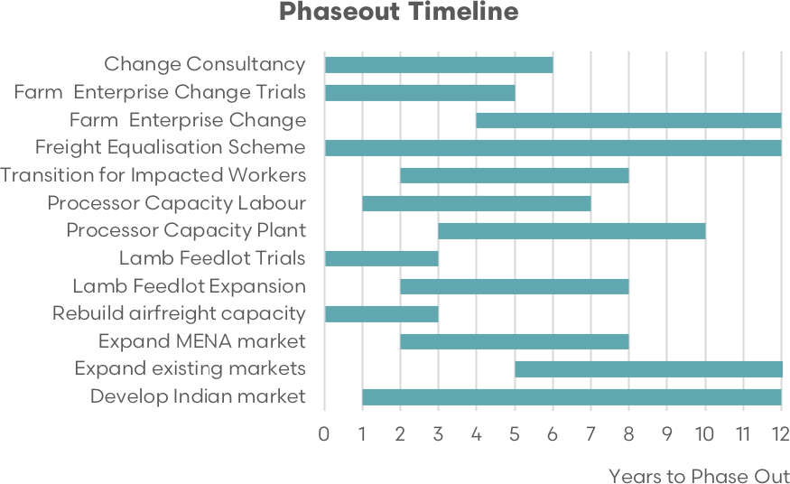

Source: EP3

The analysis on phaseout timeframes for live sheep exports presents 2 options: short term (5 to 8 years) and long term (8 to 12 years). The short-term phaseout offers the potential for rapid adaptation and quick gains, but it comes with high financial costs, socio-economic instability, and insufficient time for thorough development and adjustments within the supply chain.

In contrast, the long-term approach could result in a smoother, more cost-effective transition with better allowance for foundational adjustments in the supply chain, permit acquisitions, capacity building, and infrastructure development. However, the long-term option might extend the adjustment period and risk complacency or unforeseen global market shifts.

While both timeframes offer unique strengths and challenges, the long-term timeframe seems to strike a better balance by managing transition costs, reducing supply chain disruptions, and enabling industry adaptation to global market trends. The success of either plan is heavily dependent on the sequence and timing of transitional elements across the supply chain, indicating a need for a well-structured and well-timed transition plan.

In terms of on-farm modelling for enterprise change, the report highlights various options to support the transition for farmers in Western Australia. The aim is to identify alternative farm enterprise mix options in light of the banning of live exports. The current enterprise simulation results in an average gross margin of $637/ha or $53/DSE, which is based on a typical WA flock using live export as an option for turnoff. The alternative enterprise options examined are as follows:

**Running wethers for longer:** This option involves keeping wethers on the farm for at least another year instead of selling them as lambs for live export. This enterprise has a gross margin of $513/ha or $43/DSE.

**Shifting lambing time and targeting airfreight market:** Shifting lambing to August and targeting the airfreight market leads to higher productivity per hectare due to lower winter nutritional requirements. This option results in a gross margin of $693/ha or $58/DSE.

**Dual-purpose merino genotype for lamb production:** Using a larger Dual-Purpose Merino genotype for lamb production and potentially finishing on stubbles, fodder crops, or feedlots. The gross margin is $583/ha or $49/DSE.

**Superfine wool flock with focus on fleece value:** This option focuses on producing superfine wool with higher fleece value/head. The gross margin is $819/ha or $68/DSE.

**Shedding sheep flock:** Due to the scarcity of shearers, there’s an interest in shedding sheep enterprises. However, the results show a lower gross margin of $260/ha or $22/DSE compared to other options.

**Self-replacing cow/calf enterprise:** Transitioning to a self-replacing cow/calf enterprise with a gross margin of $581/ha or $48/DSE.

**Trading steer enterprise:** This option is highly profitable with a gross margin of $1,244/ha or $104/DSE, but it is subject to volatile returns and has some challenges for implementation.

The study also explores the specific results for certain options at different locations, such as Wongan Hills, representing the Central Wheatbelt.

Overall, the report examines various options to support farmers in the transition away from the typical live export wether enterprise, considering factors like profitability, seasonal variations, and regional suitability.

The report assesses the need for a change in sheep genotype in commercial flocks and the time allowed for this transition. Proprietary software was used to analyse the time and returns involved in changing the genotype. Based on this analysis, it could take as long as 14 years for a commercial flock to transition completely to a new genotype, such as Dual Purpose Merino, Superfine Merino, or a shedding flock.

The profitability of different sheep enterprises was also evaluated. While most enterprises had similar gross margins, they were still lower than the typical flock selling live export wethers. The airfreight enterprise, which requires little on-farm changeover, could be more profitable, but constraints in air transport capacity may limit its adoption, and it is not a long-term total supply chain solution.

Shifting to Superfine Merino genotype could be more profitable, but access to elite genetics and the time allowed for genotype conversion are significant challenges. Shedding sheep and running wethers to 1.5 years old were found to be the least profitable options, when selling as store lambs to supply to the same market as Dual Purpose Merino enterprises.

The analysis also explored cattle enterprises as an alternative to sheep. Self-replacing cow herds and trading steer enterprises were profitable, but infrastructure requirements could be a deterrent for most producers.

Regarding backgrounding and finishing options, producing airfreight ‘bag lamb’ was seen as a profitable and relatively easy transition. However, due to limited air transport capacity, producing store lambs in the Great Southern for other farmers to background and finish was considered a more viable alternative. Backgrounding options with low-cost feed sources, such as Pallaton Raphnobrassica and standing crops, were found to be profitable.

The report findings emphasise that changing sheep genotypes and exploring different enterprises will take time and careful consideration. Some options, such as Superfine Merino, may require at least 7 years to achieve reasonable profitability. Overall, more research and scientific evidence are needed to confirm the viability of different backgrounding and finishing options for sheep and cattle enterprises.

The report explores the potential implementation of a Freight Equalisation Scheme (FES) between Western Australia (WA) and the eastern states, similar to the existing scheme between Tasmania and the mainland. The FES aims to compensate businesses, including farmers, for the geographical disadvantages and higher transport costs they face when shipping goods over long distances.

The FES in Tasmania provides financial subsidies to eligible businesses, neutralising the additional costs associated with sea transport and making them comparable to mainland road transport expenses. It applies to goods transported directly between Tasmania and the mainland or indirectly via other ports.

Extending the FES to WA and the eastern states is supported by several reasons:

**Geographical disadvantage:** WA sheep producers face significant transport distances to reach eastern states’ abattoirs and livestock markets, resulting in higher costs and lower prices for WA sheep and lamb compared to the eastern states.

**Price parity:** A freight equalisation scheme could balance sheep and lamb prices across Australia, ensuring fairer returns for WA producers and promoting price consistency.

**Increased competitiveness:** Lower transport costs through the FES would enhance the competitiveness of WA sheep producers, benefitting the local economy with growth and job opportunities.

**Mitigating live sheep export phaseout:** The potential phaseout of the live sheep export trade could lead to price drops for WA sheep and lamb. The FES would help mitigate this impact and protect the viability of sheep farming in WA.

**Supply chain resilience:** Reducing internal freight costs would incentivise a more robust domestic market, making the WA sheep industry more resilient to external shocks and disruptions like the COVID-19 pandemic.

Implementing an intermittent freight equalisation scheme, where subsidies are available when price spreads in the west compared to eastern prices are heavily discounted due to WA processor capacity constraints, could be a practical approach.

Transport costs for sheep/lamb haulage from west to east have increased over the last 5 years, putting further pressure on WA producers and contributing to price discrepancies. An FES would help alleviate these challenges and create a more balanced marketplace.

The establishment of a freight equalisation scheme between WA and the eastern states would address the geographical disadvantages faced by WA sheep producers and ensure a fair and equitable marketplace for sheep producers across Australia. The scheme could provide financial support and foster a more resilient and competitive domestic sheep industry.

The report highlights the need for research and development (R&D) to validate alternative farming practices in Western Australia (WA) and the importance of training and education to support farmers in adopting new enterprises. The proposed R&D includes comprehensive trials over a 5-year period to test store lamb production, investigate faba bean agronomy on different soil types, and assess the performance of maternal prime lamb genotypes and shedding breeds.

However, strict animal ethics committee requirements may extend the trial period, resulting in a 7‑year timeframe before trial results can be published with confidence. Following the research phase, intensive training and extension activities would be helpful in order to disseminate the findings among producers, with an estimated 2-year training period for farmers to adopt new enterprises and technologies. For changes involving the flock’s genotype, a full transition would take at least 7 years to implement, and potentially beyond a decade before the WA industry could completely move away from selling wethers for live export.

Support across the supply chain is a key element to managing the workforce transition resulting from the live sheep export phaseout. A multi-faceted approach is recommended, including the creation of a Transition Assistance Fund to provide financial support during the transitional period, investment in industry-specific re-skilling and training programs, and offering employment transition services such as job placement assistance and career counselling.

Moreover, partnerships with private sector companies could help align the skill sets of affected workers with available job opportunities, and regional development programs could stimulate job growth in impacted areas. Additionally, providing educational grants and scholarships for younger workers interested in shifting industries is proposed.

In terms of financial assistance, the establishment of an Allied Rural Business Management Deposit (ARBMD) scheme is suggested. This scheme would support eligible rural businesses heavily involved in the live sheep trade during the phaseout period, functioning similarly to the existing Farm Management Deposit (FMD) scheme, enhancing their resilience and reducing reliance on direct government assistance.

Addressing mental health is a critical aspect of support. The decline in confidence among WA sheep producers due to the live sheep export phaseout and alarming mental health statistics in the agricultural community highlight the urgent need for mental health services. Investing in mental health support, providing resources to reduce stigma, and developing resilience and coping strategies will be useful in facilitating the transition away from live sheep exports.

Digital technology could be employed to reach isolated farmers and offer online counselling and support services. Preventive measures, such as training programs and wellness initiatives, would promote self-care and mental health awareness. Ensuring a comprehensive support plan is part of a broader long-term strategy to diversify the workforce and promote sustainable and resilient industries.

Financial support for farmers and businesses impacted by the live sheep export industry phaseout is an important consideration. The government could provide financial counselling services to offer advice on debt management, budgeting, and financial planning. Business consultation services can help affected businesses pivot their models or diversify services. Low-interest loans could aid in adjusting operations, and grants for business innovation could foster new approaches. Temporary tax relief measures may also be implemented. Training and development programs can equip business owners with useful skills. Investment in local infrastructure can stimulate economic activity in affected areas. Long-term strategy development in consultation with businesses ensures sustainability and economic viability.

Relocation assistance is important for impacted workers. One-time relocation grants can cover moving costs, while housing assistance provides subsidies or loans for purchasing new homes. Job search assistance, transitional living expenses, and family support are vital. Community integration programs welcome newcomers and establish social connections. Career counselling and retraining opportunities increase employability in new locations. Transportation assistance, such as vehicle subsidies, can aid in areas with limited public transportation. The goal of these packages is to make the transition process seamless for workers and their families, enabling them to focus on building their future in new communities.

The development of alternative markets and industries to cope with the phaseout of the live sheep export industry would be assisted by careful planning and investment. One option is the expansion of the domestic meat processing industry in Western Australia. Analysis shows that processing capacity needs to be increased to accommodate the additional slaughter volumes diverted from the live trade.

Investment in new infrastructure, technology, and labour-saving devices like robotics and DEXA scanning can improve efficiency. Training programs for local workers and creating a program to encourage indigenous people to work in abattoirs could be a useful strategy to address the labour shortage.

Additionally, a program for skilled offshore abattoir workers can be implemented to handle the extra load. Consultation and addressing industrial relations and skilled migration pathways are critical for success. These steps, if implemented in a well-planned and coordinated manner, can pave the way for a successful transition in the sheep industry and foster growth in alternative markets.

The report discusses several concerns and considerations related to industrial relations, skilled migration, worker accommodation, and regional housing in the context of the phasing out of the live sheep export industry and the expansion of the WA processing sector.

**Industrial relations (IR):** Multi-employer bargaining and the Secure Jobs, Better Pay Act may increase wages and inflate costs along the food supply chain. Business concerns, especially those as important as the meat industry, must be recognised and considered when formulating Government policy. There are increasingly concerns from industry that unions are setting the agenda and pushing for reforms which could ultimately damage business and undermine future economic growth

**Meat industry labour agreement (MILA) and skilled migration:** The MILA allows meat processors to sponsor overseas workers under the Temporary Skill Shortage visa. The Temporary Skilled Migration Income Threshold (TSMIT) and English literacy requirements have implications on the utilisation of overseas workers. The Skilling Australians Fund (SAF) levy could be used to support training and development. Dependents of working visa holders could have access to education and training.

**Pacific Australia Labour Mobility (PALM):** The PALM program’s obligations and costs need to be reasonable and consider employers’ challenges. Providing pathways to permanent residency can retain skilled workers in local communities.

**Worker accommodation:** Rural areas face housing market failures, leading to higher labour costs and reduced living standards. Adequate staff accommodation is a barrier to meeting domestic processing staffing requirements. The challenges in obtaining housing approvals in regional areas, particularly in regions with major abattoirs, present a barrier to achieving full domestic slaughter of Western Australian sheep and lamb.

Potential considerations include expedited approvals, higher density accommodations, affordable housing provisions, and temporary accommodation permissions for abattoir workers. Addressing these housing issues is part of meeting the workforce needs of the meat industry during the live sheep export phaseout.

The report demonstrates the potential for Australia to participate in the growing global sheepmeat consumption, with a focus on the Middle East and North African (MENA) region. MENA’s preference for live sheep is deeply rooted in cultural, religious, and culinary practices, making it a significant market for Australian live sheep exports. However, there are challenges, including a competitive pricing environment, non-tariff barriers, and unpredictable shifts in the market.

Despite these challenges, opportunities exist in MENA for high-end lamb and boxed sheep meat, especially in the Gulf Cooperation Council countries due to rising incomes and influence from Western culture. Australia, New Zealand, and the European Union dominate MENA’s boxed sheep meat market. However, some non-tariff barriers hinder trade and don’t consider Australia’s safe food handling and high-quality products.

Adjusting rules to reflect scientific findings and a risk-based approach could benefit Australian exporters and customers in other countries. Reforming shelf requirements for imported Australian sheepmeat in key MENA markets has shown positive results, unlocking new marketing channels and reducing food waste.

To further develop the chilled and frozen meat export market, Australia could identify suitable markets, products, and opportunities in MENA, and support the MLA MENA in-market team to maintain and expand Australia’s sheep meat market share. By addressing challenges and seizing opportunities, Australia can capitalise on the anticipated growth in global sheepmeat consumption and strengthen its position as a key global sheep meat exporter.

The report provides an overview of key trade destinations for Australian sheep meat and live sheep exports in the Middle East and North African (MENA) region, including Kuwait, Oman, Jordan, United Arab Emirates (UAE), Qatar, Israel, Saudi Arabia, and Bahrain. Each country’s per capita sheep meat consumption, market share of Australian exports, and trends in market share over the years are analysed.

In Kuwait, Australia is the top source nation for live sheep exports but faces challenges in the boxed sheep meat market due to increased competition and high pricing. Oman has shown a growing demand for live sheep imports from various countries, impacting Australia’s market share. Jordan has been relatively stable in its consumption of Australian sheep meat, but competition from other countries is increasing. The UAE is the largest market for Australian boxed sheep meat in the MENA region, but live sheep exports have faced fluctuations and competition.

Qatar, historically a significant importer of Australian sheep meat, experienced changes due to the removal of import subsidies, leading to diversification in its sources. Israel’s sheep meat imports have grown substantially, but Australia’s market share has declined over time. Saudi Arabia remains a significant importer of Australian boxed sheep meat, unaffected by the cessation of live sheep exports. Bahrain has the highest per capita sheep meat consumption in MENA, but Australia’s market share has decreased as other countries aggressively compete.

This sheep meat and live sheep trade analysis of the MENA region highlights the importance of understanding market dynamics, pricing, competition, and policy changes to maintain and strengthen Australia’s market penetration in the MENA region for both boxed sheep meat and live sheep exports.

It also suggests that the cessation of live sheep exports from Australia may have implications for the boxed meat trade in some destinations, while others demonstrate resilience. Overall, targeted business development and relationship building efforts are needed to address challenges and opportunities in each market effectively.

The Australia-India Economic Cooperation and Trade Agreement (AI-ECTA) has opened up significant opportunities for Australian sheep meat exporters to access the fast-growing Indian market. India’s vast population and economic growth present a promising market for high-quality sheep meat products from Australia.

To successfully penetrate the Indian market, a 10 to 12-year strategy is proposed, starting with comprehensive market research to understand consumer preferences, competitors, economic indicators, and the regulatory environment. Building strong relationships with local partners and industry bodies is part of the process needed to navigate this market effectively.

Over the years, efforts could be made to tailor products to match local tastes, develop a strong brand narrative, and leverage local marketing techniques to increase visibility. Initially targeting affluent urban areas and gradually expanding to smaller cities and towns is recommended.

Investment in cold chain infrastructure and logistics will be an important consideration in order to ensure the product reaches consumers in optimal condition across the country. Additionally, engaging in community development and corporate social responsibility initiatives will help build a positive brand image and maintain market access.

The Meat & Livestock Australia (MLA) International Markets team plays an important role in promoting Australian red meat abroad and ensuring access to global markets. The team tailors its efforts to suit local tastes, preferences, and business practices in key regions worldwide.

In the Middle East and North Africa (MENA) region, where live sheep export access is reducing, there are opportunities to increase boxed sheep meat exports from Australia. Additional funding for business development activities in MENA could support this growth and signal Australia’s commitment to be a reliable trade partner.

However, there are challenges related to cold chain infrastructure and airfreight capacity for sheep meat exports. Short-term air freight subsidy programs may be a helpful strategy adopted to support initial supply pressures during the phaseout of live exports, but longer-term solutions could focus on developing expanded chilled and frozen sea freight options.

Overall, the development of the Indian and MENA markets should be considered a long-term plan, requiring patience and adaptability to the unique characteristics of each market. Strategic planning and investment will need to be considered in order to seize the opportunities and maintain Australia’s position as a competitive player in the global sheep meat industry.

This document explores potential opportunities in wool and other sheep-derived products, research and development in wool innovation and technology, and the marketing of wool and sheep-derived products in global markets. It also discusses the concept of dry aging sheep meat and outlines marketing strategies for promoting this potential premium product. Additionally, it introduces the Future Energy Australia project, aimed at establishing renewable fuel biorefineries in Western Australia.

The wool sector in Western Australia (WA) faces challenges due to the phaseout of live sheep and changes in farm enterprises. However, opportunities exist in wool innovation and technology, such as the use of biological shearing injectables that may automate wool harvesting and reduce costs for farmers. Sustainable packaging solutions like ‘Woolpack’, made from sheep’s wool, present environmentally friendly alternatives to traditional packaging materials.

Promoting bulk wool insulation involves identifying target markets, differentiating wool insulation from synthetic alternatives, and educating consumers about its benefits. To promote dry-aged sheep meat, marketing strategies could focus on its unique flavour profile, sustainability, and premium branding.

Lastly, the Future Energy Australia project aims to build renewable fuel biorefineries producing biodiesel from various feedstocks, including vegetable oils, animal fats, waste cooking oil, and potentially lignocellulosic biomass like straw. Ongoing research and development efforts seek to improve the efficiency and commercial viability of using straw and hay for biodiesel production.

These opportunities and initiatives can contribute to the sustainability and growth of the wool and sheep industry in Western Australia.

## II. Introduction

### A. Project scope

The project scope for this report is to identify and provide an analysis of the potential effects upon Western Australian farmers, businesses and other live export supply chain participants by the proposed phase out of live sheep exports by sea.

This report will utilise a combination of direct consultation with industry representatives across the supply chain, online surveying and desk-top analysis/modelling of several data sources in order to identify the impacts of a live sheep export phase out.

The report will provide an on-farm analysis of possible changes to enterprise mix with the goal of minimising the potential negative impacts of the proposed phase out on Western Australian sheep producers.

Additional strategies will be included in this report which aim to minimise the harm to the WA sheep industry supply chain that may occur due to the closure of the live sheep export sector from Australia.

The report will outline a proposed short-term and long-term time frame for the phaseout, which will detail transition packages that could be implemented to support the supply chain through the phaseout and provide an assessment of the benefits/disadvantages of the 2 phaseout timelines.

### B. Methodology and assumptions

#### i. Consultation

As part of the preparation for this report, a consultation process was undertaken with key representatives across the WA sheep industry supply chain and the industries that are associated with the live sheep export trade, both within Western Australia and on a national level.

This consultation included in-person meetings with several stakeholders and representative bodies within WA and nationally and follow-up phone calls to relevant participants who were unavailable for in-person meetings.

Industry representative bodies that were consulted as part of this process included:

* Sheep Producers Australia (SPA)
* WA Farmers (WAFF)
* Pastoralists & Graziers Association of WA (PGA)
* National Farmers Federation (NFF)
* Australian Wool Innovation (AWI)
* WA Shearing Industry Association
* WA Department of Primary Industries, Research & Development (DPRID)
* Australian Live Exporters Council (ALEC)
* Australian Live Export Corporation (LiveCorp)
* Australian Meat Industry Council (AMIC)
* Meat & Livestock Australia (MLA)
* Livestock and Rural Transport Association of WA (LRTA).

In addition to the industry, bodies consulted directly, there were several individual participants across the supply chain that were interviewed either in person or over the phone. A summary of these participant groups is listed in Table 1.

Table 1 Consultation list

|  |  |
| --- | --- |
| Participant groups | Direct consultations |
| Industry bodies & Government Departments | 14 |
| Sheep Producers | 21 |
| Live Sheep Exporters | 2 |
| Transport Operators | 9 |
| Farm Contractors | 7 |
| Farm Consultants | 8 |
| Agency Services | 7 |
| Abattoirs | 6 |
| Feed Mill & Feed Mill Suppliers | 12 |
| Other supply chain participants | 13 |
| Total | 99 |

#### ii. Online survey

Further to the direct consultation process, there was an online survey that was conducted over a 3‑week period (ending on Monday, 19th June 2023) that gathered information from participants across the live sheep export supply chain and from within the WA sheep/wool industry.

In total, there were 379 respondents to the online survey. Some survey respondents were also consulted directly as part of the consultation process so there was a potential for overlap in the data collected. Where relevant duplicate answers were adjusted to represent a single response. Sheep producers comprised 68.3% of survey respondents. Transport operators and agency services participants were also well represented, comprising 7.3% and 6.8% of respondents, respectively. Table 2 highlights a summary of survey respondents by participant group category.

Table 2 Survey respondent list

| Participant groups | Respondents to online survey |
| --- | --- |
| Sheep Producers | 259 |
| Live Sheep Exporters | 2 |
| Transport Operators | 28 |
| Farm Contractors | 8 |
| Farm Consultants | 4 |
| Agency Services | 26 |
| Abattoirs | 7 |
| Feed Mill & Feed Mill Suppliers | 17 |
| Other supply chain participants | 28 |
| Total | 379 |

#### iii. Data

##### a. On farm data

Farm data used for modelling and key assumptions throughout this report has been based on actual farm data from several sources. Some of the key data sources accessed include:

* Farmanco farm benchmarking data set based on 438 farms financial and physical performance in WA
* Pingelly Merino Lifetime Productivity Report October 2022
* Merino Superior Sires database
* Discussions with several Western Australian farm management consultants in regard to their client’s average sheep and crop productivity. Most had significant farm benchmarking databases to draw on to back their statements
* Australian Bureau of Statistics.

##### b. Industry data

Industry data utilised in this report was collected from a range of sources, including:

* Australian Bureau of Statistics (ABS)
* Meat & Livestock Australia (MLA)
* Australian Bureau of Agricultural and Resource Economics and Sciences (ABARES)
* Department of Agriculture, Fisheries and Forestry (DAFF)
* United Nations Comtrade (Comtrade)
* WA Department of Primary Industries and Regional Development (DPIRD)
* Bureau of Infrastructure and Transport Research Economics (BITRE)
* confidential industry sources.

Where appropriate data sets from one source were cross referenced to an alternative source to ensure data integrity and accuracy.

#### iv. Model assumptions

Cropping enterprises are an important contributor of farm profit in most farming regions of Western Australia, particularly in the key sheep regions of Great Southern, Central wheatbelt and Eastern Wheatbelt.

While sheep and cropping enterprises complement each other, it is anticipated that if the profitability of alternative enterprises is similar to the current sheep enterprise, then there would not be a major shift in the percentage of farm under crop by Western Australian farmers.

Thus, this analysis is confined to alternative livestock enterprises, and mostly ignores the interaction of those enterprises with the cropping program, as they are already occurring with the current sheep enterprise. Therefore, we do not anticipate a reduction in whole farm net profit, provided the livestock enterprise run on the farm, is as profitable as the current sheep enterprise.

While sheep can be supported nutritionally on stubbles, this is limited on most cereal stubbles today due to highly efficient harvesting machines. Canola stubbles also provide limited nutrition to sheep.

However, faba bean stubbles, which are increasingly common in Eastern Australia are very high quality and are good enough to fatten young lambs. This will be considered separately, as currently the area sown to faba beans in Western Australia is currently limited.

Likewise, lupin stubble is known to support sheep well, but due to low yields over a number of years, most producers in Western Australia have not sown lupins as part of the crop rotation, but recent varieties are yielding much better and are starting to be sown again. But this is very recent.

The CSIRO developed GrassGro bioeconomic model of livestock production systems was used to simulate all these enterprise alternatives.

For each enterprise alternative examined the specific GrassGro simulation assumptions are appended. GrassGro has been extensively verified across Australian, including Western Australia – (Donnelly, J.R., Simpson, R.J., Salmon, L., Moore, A.D., Freer, M. and Dove, H. (2002) Forage-livestock models for the Australian livestock industry. *Agricultural System models in Field Research and Technology Transfer*. (Chapter 2), (Eds. Ahuja, L.R., Ma, L. and Howell, T.A.) pp. 9 to 32, CRC Press/Lewis Publishing).

Current sheep enterprise assumptions are based on several sources, outlined above and there is general agreement on these assumptions from these different sources, hence we can be very confident the basis of our modelling reliably describes the typical Western Australian sheep enterprise.

While there are variations around this average, this typical sheep enterprise is most susceptible to a cessation of live sheep export as the enterprise is focused on supplying the live export trade.

The central assumptions when modelling alternative enterprises was to have the mid-winter stocking rate, at limiting of the year when pasture growth is least, in mid-June in particular, was constant at 12 DSE/ha at Kojonup. Pasture food-on-offer (FOO) levels were at similar levels between the different enterprises but given the feed demand of the various enterprises tested, there were some slight differences in pasture FOO levels through the latter part of July and August.

There was wide agreement between various on farm data sources of the productivity of a typical WA sheep enterprise. There were some differences in the expression of that genotype across the different environments of WA, but the focus was on the typical sheep farm based in the Great Southern as that is where the majority of sheep are located in WA (see Figure 25 for a heat map of sheep numbers in WA).

Most of the farms selling live sheep for export are situated in the southwest shires of the Great Southern (see Figure 36 for a heat map animation of the volume of sheep sold into the live export sector or Appendix A). Hence, all the scenarios tested were tested at Kojonup, which is in the middle of this region.

Two of the sheep enterprises tested by GrassGro simulation do not have a lot of data to support their performance in the WA environment. In fact, the shedding sheep enterprise does not have a lot of data to support its performance anywhere across Australia. Nevertheless, we believe we have assembled some credible data to support the assumptions used in this GrassGro simulation.

There are few genuine superfine wool enterprises run in Western Australia. However, discussions with individual farmers running these enterprises led to a GrassGro simulation to test their performance in the Western Australian environment.

Further sensitivity of the validity of the best alternative enterprises was tested in the Central Wheatbelt, which is where there are also a number of sheep enterprises run that sell to the live sheep trade for export.

In all scenarios, labour is costed based on local benchmarking results, but standardised across the flocks at achievable labour efficiency benchmarks of 6,000 DSE/person, which costs $2/DSE in additional wages, above contract services.

Key productivity assumptions of the typical flock selling live sheep for export are:

* Clean wool cut – 3.5 kg/head.
* Average flock fibre diameter – 19.0 mpg (micron price guide (mpg), refers to the fleece fibre diameter).
* Standard Reference Weight (SRW) – 55 kg.
* Average marking percentage – 95%.
* Air freight ‘bag market’ wether sold at 41 kg liveweight (19 kg dressed).

Some additional assumptions include:

* A constant mid-June stocking rate of 12 DSE/ha at Kojonup was assumed for all enterprises as this is indicative of the time of the year in the growing season that pasture growth is most limited.
* The simulated pasture coverage over the summer and autumn period that GrassGro simulated was mainly ignored due to extensive use of stubbles possible on the typical Western Australian farm, given that the average farm has about 50% of the farm area in crop.
* In any case, all flocks apart from the superfine wool enterprise easily passed this test.

##### Typical flock, still producing wethers but live export banned

The wether sale price is assumed to be 25% less than the 5-year real average recorded in WA. This is based on various studies:

* ACIL Allen June 2023 report to LiveCorp and MLA suggests 19% to 33% fall in price
* CIE report in 2018 estimated price falls of between 29% to 51%
* Ultimately, price falls will depend on Eastern States mutton pricing and cost of transport at the time
* Other sheep sold are assumed to suffer a 15% price discount due to about 500,000 extra sheep being sold into the domestic WA market. This drop in price is probably a conservative estimate.

##### Typical flock running wethers through rather than to sell as wether lambs

A relatively easy enterprise change is to keep wethers on the farm and run them for at least another year until about 18 months of age. This would result in a decrease in ewe numbers to maintain a similar number of sheep run through each year. In line with this change, ewe hoggets are also sold at 18 months of age.

##### Superfine wool flock running wethers

While there are superfine wool flocks in Western Australia that are running several age groups of wethers, their numbers are few, hence they don’t appear on farm benchmarking data sets. Similar to the methodology used for the Merino Dual-Purpose enterprise producing prime lamb, the source of the productivity of this fine wool flock is based on the best performing sires in the [Merino Superior Sires](https://merinosuperiorsires.com.au/) database and the Pingelly MLP results report July 2023.

Key productivity assumptions of the fine wool flock are:

* clean wool cut – 3.9 kg/head
* average flock fibre diameter – 17.0 mpg
* standard Reference Weight (SRW) – 55 kg
* average marking percentage – 95%
* wethers and ewes sold as culled for age mutton.

Note, currently the wethers may end up on a boat, but mutton prices are assumed for both, as it is assumed that the live export option has ceased.

##### Typical flock – airfreight lamb assumptions

Supplying the airfreight MENA (Middle East North Africa) is a potential short-term relief valve for the live export trade, but not a complete solution. This option is referred to as the ‘bag market’ trade, also known as Middle Eastern Kill (MK) lamb. While traditional target carcass weights for this trade have ranged from 12–18 kg, the preferred target carcass weight, now appears to be closer to 19 kg dressed weight.

Given the lighter carcass and liveweight target of this market, it is assumed that lambing could occur later in the season allowing an increase in the number of ewes run during the winter at an equal stocking rate to the current typical sheep enterprise. Major changes in genotype are not assumed to be needed to meet the requirements of this trade given pure Merino genetics are preferred to provide the lean carcass preference of this market destination.

##### Domestic trade lamb and WA export lamb assumptions

Given the typical length of growing season and the need to grow out lambs to meet both these market specifications of 18–23 kg carcass weight, the natural fit for this enterprise is for typical sheep operations in the main sheep producing area of the Great Southern to produce a store lamb suitable for backgrounding. This is likely to be a 35 kg live lamb ready for backgrounding on pasture on the south coast and south and west of Boyup Brook where the growing season is longer.

Anecdotal reports indicate that this is already occurring on the south coast of Western Australia. Other backgrounding options, including to the finishing stage, include:

* faba bean crop stubbles
* lupin crop stubbles
* standing crop options including lupins, oats or an oat/legume mix
* summer green fodder crops, particularly Pallaton Raphnobrassica.

The finishing phase of about 60 days could be undertaken in a feed lot anywhere in the agricultural regions of Western Australia. However, it is more likely to occur where most of the store or backgrounded lambs are produced and where freight costs are low.

Hence, it is likely that they could be established at or between the south coast, the deep southwest regions of WA and Kwinana/Fremantle where they are already being established due to the efficiency of freight and close access to grain.

While a trade lamb carcass weight is usually achieved by joining a terminal ram over a Merino ewe or joining a terminal ram over a cross bred ewe, there are Merino genotypes that can achieve a similar result. This option would need to be acceptable to processors and end point consumers, but this is already occurring. For many WA producers, this would require a relatively small change to the Merino genetics run on farm.

The Dual-Purpose Merino genetics run for the Trade and Export store lamb enterprise made the following assumptions, mainly based on the performance of these genotypes at the Pingelly Lifetime Merino productivity trial where their Estimated Breeding Values have been calculated. The Merino Superior Sires database was also referenced. Thus, these are:

* clean wool cut – 3.5 kg/head
* average flock fibre diameter – 20.0 mpg
* Standard Reference Weight (SRW) – 60 kg
* average marking percentage – 95%
* store lamb sold at less than 35 kg liveweight (less than 16 kg dressed) due early turnoff. Lambs are likely needed to be in this weight range due to the requirements of potential backgrounders and/or finishers.

##### Heavyweight export lamb assumptions

WA export lamb carcass weight is targeted at 18 kg plus. Therefore, to achieve this carcass weight, the lamb will be very similar to the domestic trade lamb. While the GrassGro output of an export lamb production assumes steady state new genetics to produce a bigger lamb carcass, these new genetics would need to be introduced into the existing sheep flock and thus would take some years before the flock would consist predominantly of these new genetics.

Thus, as an associated exercise, propriety software will be used to track the flock gene flow and impact on flock productivity as a result. It is expected that the flow of sheep geographically would be the same as that to produce trade lambs.

##### Shedding sheep flock assumptions

There is currently a lot of interest in shedding sheep enterprises in Western Australia due to the scarcity of shearers. The key issues to this being a quick fix for the Western Australian sheep industry, as for other flock genotype changes, is the long time period it takes for the flock to be changed over genetically.

There is also a paucity of reliable facts in regard to the performance of key profit driver traits in shedding flocks. Cashmore Park is a sheep stud in Victoria that breeds shedding sheep (Nudies) and a maternal composite.

In 2023, the scanning rates for Cashmore Park’s commercial shedding flock were 45% lower than the average of the Cashmore Park’s commercial maternal composite flock. This result is consistent with anecdotal reports from Eastern and Western Australia of scanning results and subsequent lamb marking percentages.

Figure 2 and Figure 3 were generated by Sheep Genetics Australia. It highlights 2 critical points about running a GrassGro simulation based on data from Cashmore Park:

* The Maternal Carcass Production Plus Index (MCP+) is a dollar value selection index for prime lamb enterprises. The higher the value of the index leads to more dollars generated by the higher indexing genetics and thus more profit.
* The lower performance of traits that drive profit for a maternal prime lamb flock such as growth rates and reproduction rates are displayed by the shedding genetics.
* There are very few shedding flocks in Australia that have their performance data calculated by Sheep Genetics Australia – other flocks either don’t measure or use another service provider, which is unlikely.
* That is, the superior genetic performance claimed by some breeders of shedding sheep cannot be verified, and thus it has not been used in this analysis.
* All the shedding breeders that use the Sheep Genetics Australia database have similar or poorer results to Cashmore Park Nudies.

Table 3 provides more detail as to the difference between shedding breeds and maternal ewe breeds. These are quite significant and explains the lower MCP+ index value of the Cashmore Park Nudies.

Figure 2 Performance of maternal carcass plus index of Cashmore Park nudies versus other shedding sheep (breed all) and all maternal ewes (analysis all)

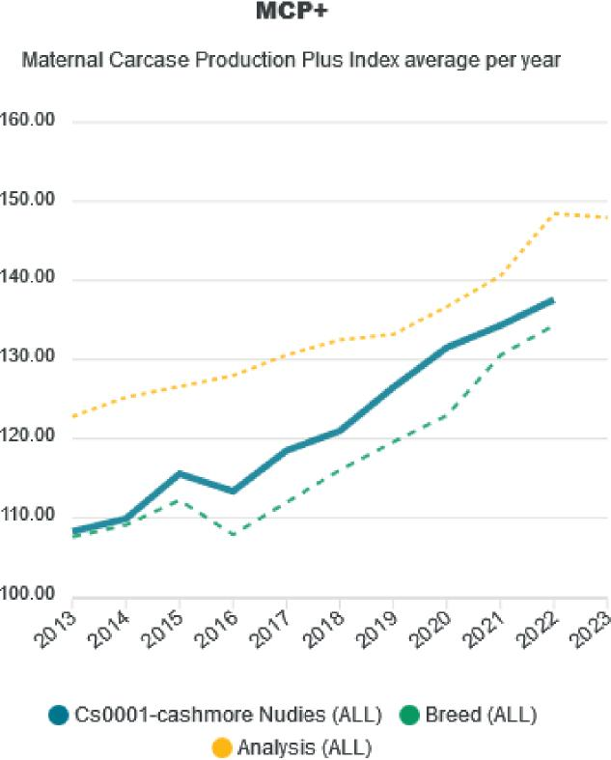

Sources: Sheep Genetics Australia and Cashmore Park

Figure 3 Performance of maternal carcass plus index of Cashmore Park nudies versus Cashmore Park maternal composites

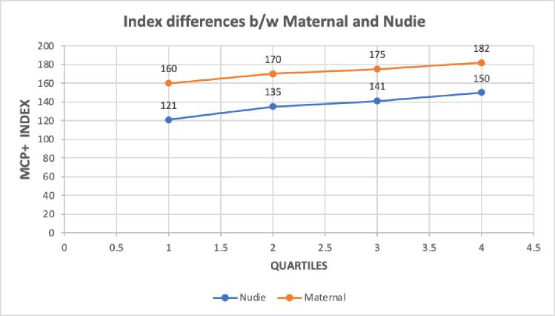

Source: Sheep Genetics Australia

Table 3 ASBV performance of maternal and shedding ewes

| Category | Maternal | Shedding | Difference |
| --- | --- | --- | --- |
| Weaning weight ASBV (kg) | 9 | 7 | 2 |
| Post weaning weight ASBV (kg) | 14 | 10 | 4 |

Source: Sheep Genetics Australia

##### Cattle enterprises

Self-replacing cow/calf enterprise have been run in the Great Southern in the past but have tended to be replaced over sheep since the middle of the 1970s following the 1974 beef crash. This will be examined as another enterprise opportunity.

##### Trading steer enterprise

This will be examined as another enterprise opportunity as it is a common enterprise in the Eastern States and is one of the most profitable enterprises benchmarked in the Eastern States.

##### Dairy beef steer backgrounding enterprise

This enterprise is rapidly expanding its footprint in Eastern Australia and overseas. It is being driven by the ending of bobby calf sales for welfare reasons. Sexed semen is being used by dairy farmers to breed enough female replacements for their herds and beef dairy cross calves to the remaining cows

The calves are then hand reared and then backgrounded typically from about 150 kg and sold to grass finishers. Once the background phase is complete, they are sold to feedlots similarly to the Trading Steer Enterprise at 400 kg plus.

Thus, the 116 registered dairy farms in Western Australia, carrying 50,000 cows could potentially produce 30,000–40,000 calves for backgrounding on broadacre farms, particularly in the Great Southern from Autumn to early summer, depending on replacement rates in the dairy industry.

GrassGro modelling predicts hybrid vigour driving high growth rates and the dairy component driving meat quality (marbling) resulting in a very profitable beef enterprise. Due to the very early development of this enterprise, it is perhaps too early to model its adoption in WA, but it’s potential could mean it is worthwhile to trial in the WA environment to prove it’s worth. However, modelling in the Eastern States suggests higher profitability than the standard Steer Trading enterprise.

##### Cost and price assumptions

Western Australian meat prices were accessed from the MLA database and a 5 year real (corrected for CPI inflation) average was used in all modelled scenarios. The wool, lamb and mutton prices reflect ongoing strong demand and a weak supply response in the Australian sheep industry. Beef cattle prices have been particularly buoyant over the last 5 years, which has moderated over the last 12 months and are likely to remain more subdued over the next few years, albeit at higher levels than current beef prices.

Similarly, grain prices have also been elevated over the last 5 years and given long term trends for global supply and demand, it is likely that these current high prices will moderate to longer term levels, Mr Putin’s enthusiasm for disrupting markets notwithstanding.

All meat prices were adjusted for seasonal variation, which was the actual average for the last 5 years. Wool prices were net in bank, sweep the board, based on a flock average model for a clip measuring 26 N/kTex and 2.5% VM (summer shearing), based on Wool Agency Co client clip analysis and the average of the North and South Micron Price Guides (Source: AWEX), 5-year weekly average in real dollars (corrected for CPI inflation).

Costs were based on Western Australian farm benchmarking databases, with an adjustment for a shearing increase. Calculations used in this modelling are based on variable costs of the livestock enterprise being allowed for including enterprise specific casual labour, machinery depreciation and replacements costs, in addition to repairs. Nevertheless, these are usually very modest costs in livestock enterprises. Note, permanent labour, overhead costs and financing costs are not included as is appropriate for gross margin calculations.

The shedding sheep enterprise costs were reduced to account for lack of shearing costs. But it is noted that the main savings in a shedding enterprise are not accounted for here. It is anticipated that less permanent or family labour would be needed to run a shedding enterprise, thus improving potential whole farm profit. Furthermore, wool shed infrastructure, if it is inadequate or absent, would not be required at a considerable saving in capital expenditure.

The shedding sheep enterprise costs were $27/DSE in comparison to the typical flock’s variable enterprise costs of $37/DSE.

Faba beans yield potential sourced from [GRDC National Variety Trials (NVT) Kojonup trial site](https://app.nvt.grdc.com.au/ssy/table/faba-bean/wa/agzone3,agzone5,agzone2/kojonup/?year=2020-2022). This puts faba bean yield with the best varieties over the 3 years they have been tested, at yield of 2.7 t/ha. Local agronomist with Farmanco at Kojonup, Chris Robinson estimated a 2.5 t/ha assumption for a whole farm average yield estimate.

To date, with limited quantities of faba beans to sell, marketing them has seen volatile pricing, particularly since there is only one main international market, Egypt. Thus, we have assumed that with volume of faba beans for sale in Western Australia that pricing would be similar to Eastern Australia. Faba bean pricing for Eastern Australia has been used as a proxy for what WA pricing might be if faba bean area expands.

### C. Overview of live sheep exports from Australia

#### WA agricultural production

The value of livestock production in Western Australia is heavily skewed toward the sheep and wool industry. In FY2021/22 the combined WA sheep and wool sector contributed a production value of A$1.35 billion to the WA economy, this total included $A655 million in wool production value and A$692 million in sheep meat value, which also includes the A$82 million attributed to the WA live sheep trade.

Figure 4 WA gross value of livestock production

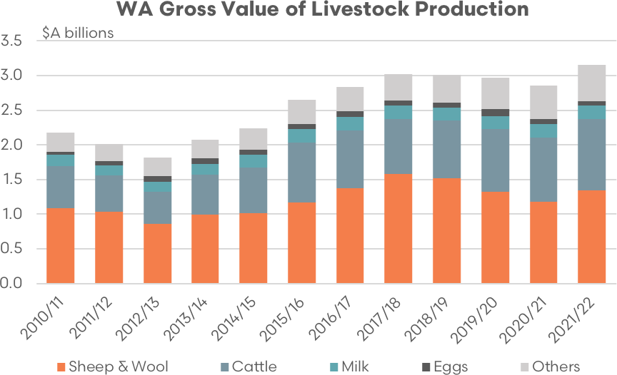

Sources: EP3, DPIRD, ABS

Since FY2010/11 the share of the wool and sheep meat industry in WA as a proportion of the total value of livestock production has averaged 47%, ranging from a low of 41% in FY2020/21 to a high of 52% in FY2017/18.

Figure 5 WA Gross value of livestock production (% share)

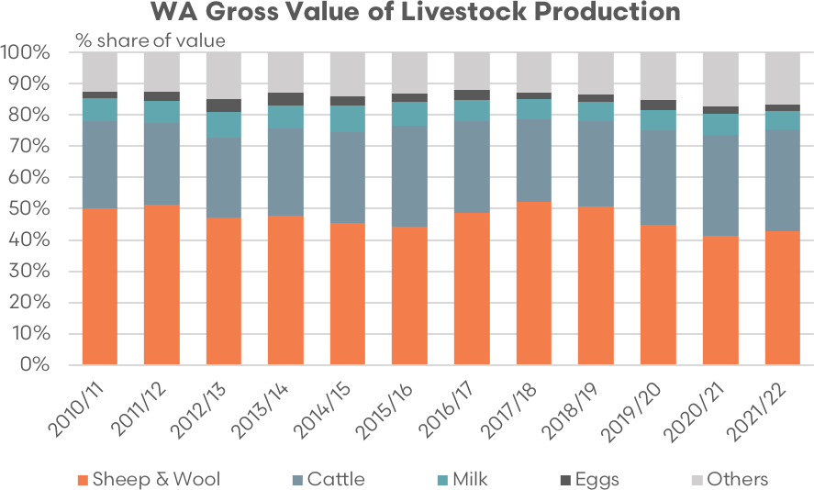

Sources: EP3, DPIRD, ABS

#### WA sheep meat and live sheep exports

The value of both lamb and mutton sheep meat exports from WA has increased steadily over the last decade, Figure 6, reaching a combined total of A$625 million in 2022, the highest on record for sheep meat exports from WA.

Figure 6 WA sheep export value (boxed and live export)

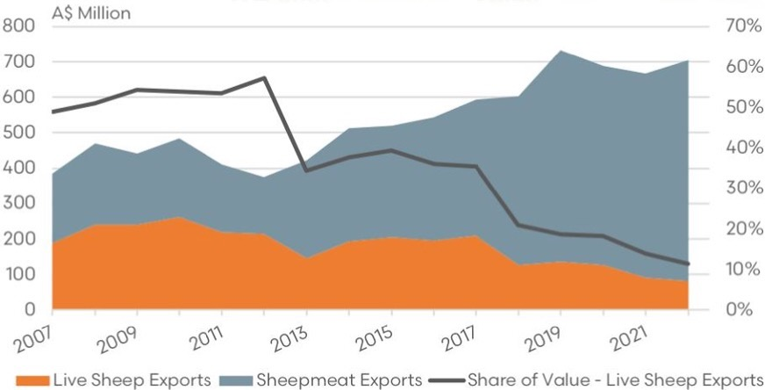

Sources: EP3, DPIRD, ABS

When combined with the value of the WA live sheep trade, the 2022 sheep meat export value reached A$705 million, the second highest on record and just 4% below the record of A$733 million achieved in 2019. Between 2007 and 2012, the contribution of the WA live sheep trade to total sheep industry exports (boxed and live export) averaged 53%. However, strong growth in boxed export markets from 2013 saw the live export contribution drop to an average of 37% over the following 5-year period to 2017.

The introduction of the northern hemisphere summer moratorium in 2018 and the subsequent legislated prohibition to the trade from mid-May to September each year has seen the WA live sheep export industry’s contribution to the total sheep industry value drop to 11% in 2022.

Over the last decade, the value of WA mutton boxed exports has increased 191%, from A$68 million in 2012 to A$199 million in 2022. Meanwhile, the value of WA lamb exports has also followed a positive trajectory, increasing from A$93 million in 2012 to $425 million in 2022, an increase of 358%. In 2022 China was the largest market for WA sheep meat exports accounting for 40% of the volume of sheep meat exported. The USA followed with 11%, and Malaysia was in third place, holding a 7% share of the trade.

Figure 7 WA sheep export value (mutton and lamb)

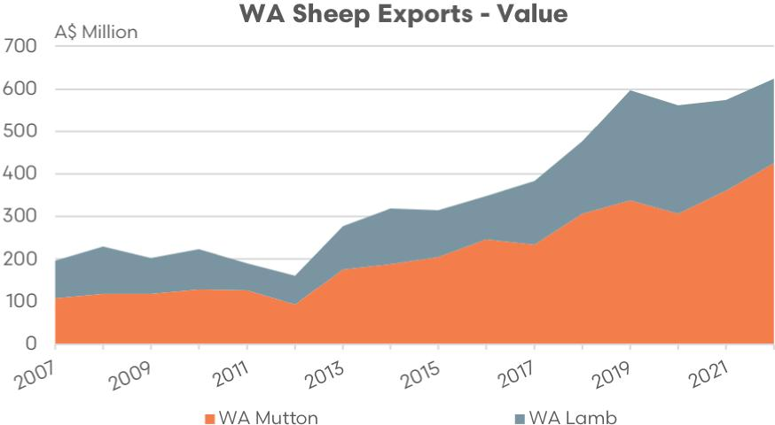

Sources: EP3, DPIRD, ABS

In Western Australia, the presence of live sheep exporters in the market has enabled the development of a more productive and profitable overall production system. This system, which encompasses grain, wool, and sheepmeat collectively, is better suited to the climate and natural environment of WA compared to production systems in the rest of Australia.

Live exporters play a key role in creating price competition for WA sheep farmers, particularly for a class of sheep that domestic meat processors find less desirable. This class of sheep, which is heavier and older, does not meet the demands of Australian consumers. Typically, the sheep destined for live export are raised by sheep producers primarily for wool production, as processing them domestically is not as viable economically.

Live exporters enhance the weight and condition of these sheep prior to shipping. Consequently, the resulting meat tends to be leaner, which is preferred by Middle Eastern consumers. Over the years, Australia’s reputation for supplying a product that satisfies offshore consumer preferences has greatly benefited WA sheep producers. However, despite the obvious benefits of the live sheep export sector to WA farmers export values and trade volumes have been in decline in recent years.

Figure 8 Sheep live exports by value

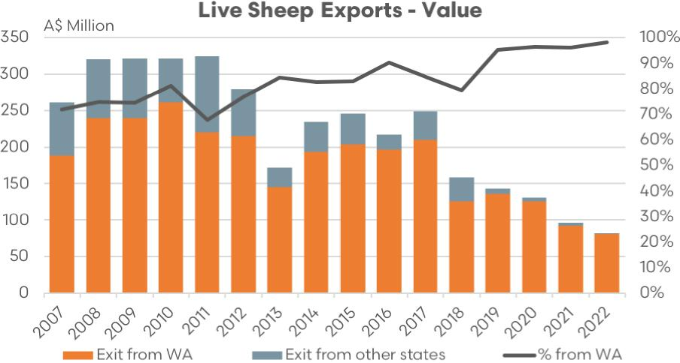

Sources: EP3, DPIRD, ABS

Over the last decade, the value of WA live sheep exports has fallen by 62%, from A$215 million in 2012 to A$81 million in 2022. In terms of export volumes, the decline in the sector is even more pronounced, with a 72% drop in live sheep export volumes noted in WA over the last decade, from 1.77 million head in 2012 to 0.49 million head in 2022.

Presently, the live sheep export trade is almost exclusively a WA-centric industry with 99% of the national flow of sheep leaving from the port of Fremantle. In contrast, WA contributed around 73% of the live trade from 2007 to 2009 and 82% of the trade from 2010 to 2018. In 2022, of the sheep exported by sea from WA, 53% were exported to Kuwait, 19% to the UAE, 18% to Israel and 5% to Oman and Qatar.

Figure 9 Live sheep exports by volume

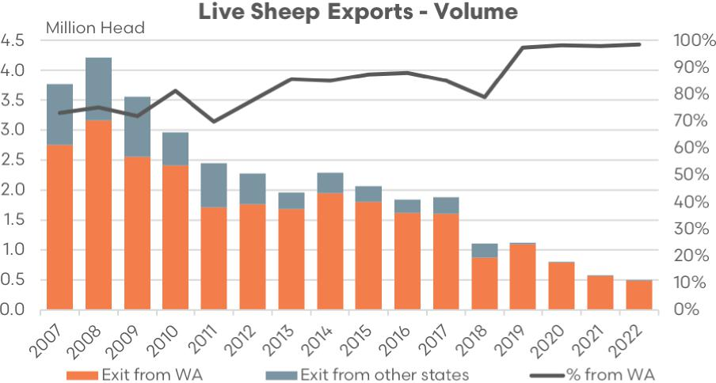

Sources: EP3, DPIRD, ABS

Several factors are likely to have contributed to the current decrease in live sheep export volumes in recent years.

Firstly, high sheep prices across Australia, especially when compared to some major competitors, have played a role. The national sheep indicator prices in Australia have increased significantly over the years, more than five-fold between 2000 and 2022. This includes a 40% increase since 2011 and a 20% increase since 2017. As a result, the demand for Australian live sheep has been inhibited.

Australia’s main competitors in supplying live sheep to the Middle East are countries in the European Union like Romania, Spain, and Portugal, as well as North African countries like Sudan and Somalia. In recent months, Australian sheep have become more competitive compared to their offshore counterparts, although over the last Australian flock rebuild phase domestic sheep and lamb prices have generally been higher than prices in countries with which we compete.

Secondly, excellent seasonal conditions have affected the availability of sheep across Australia. Favourable weather conditions have prompted flock rebuilding, resulting in a lower supply of sheep. There have also been record levels of sheep movements from Western Australia to the eastern states, particularly in 2020 to 2021.

Strong demand for sheep from the east during 2020 to restock after the 2019 drought, particularly from NSW producers, saw annual flows from west to east spike to 1.9 million head, or about 30% of WA turnoff that year. During 2021 nearly 700,000 head were trucked west to east. Since 2010 the average annual volume sent west to east sits at around 400,000 head so the 2020 and 2021 season acted as a significant relief valve for WA producers to turnoff sheep instead of using the live export channel.

Thirdly, increased regulatory intervention in the live sheep trade has also had an impact. This includes the introduction of the Exporter Supply Chain Assurance System (ESCAS) in 2011 which saw the Saudi Arabian market look elsewhere for live sheep beyond 2012, the suspension of exporter licenses in 2018, and the prohibition on exporting sheep by sea between the northern hemisphere summer period (which was initially introduced in 2018 as an industry led moratorium and then became a legislated prohibition from 2019 onwards). Other regulatory changes have included reductions in sheep stocking densities on vessels and the removal of double-tier vessels.

Finally, high grain prices have had an impact. Farmgate wheat prices in Australia have risen by over 50% since 2010/11. These increased grain prices have led producers to shift their production decisions away from sheep and towards grain.

#### WA wool industry

Australia is projected to produce nearly 330,000 tonnes of greasy wool this year and holds the title of the world’s largest producer of raw wool. While it represents only 1.2% of the global apparel market in terms of volume, it accounts for a substantial 8% in terms of value and holds an 83% share in the world’s superfine wool market. With approximately 200,000 workers, including shearers, shed hands, and wool brokers, the Australian wool industry plays a vital role contributing around $3.5 billion to the nation’s export value annually.

Figure 10 WA wool exports by value

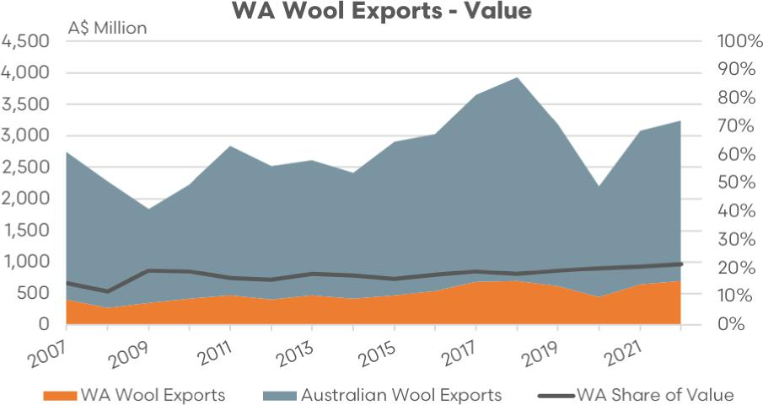

Sources: EP3, DPIRD, AWI

Even as the world’s largest supplier of apparel wool, the Australian wool industry only produces 330,000 tonnes annually, down from the industry high of one million tonnes in 1990. Any significant loss in wool production, as is being foreshadowed by Western Australian producers, may have serious ramifications on national wool production and its substantial $3.5 billion contribution to the national economy in exports alone.

Among Australian states, WA boasts the third-largest sheep flock, with 12.4 million head shorn out of a national total of nearly 73 million head. These WA sheep are expected to produce an estimated 60,600 tonnes of wool in FY2022/23 according to the [Australian Wool Production Forecasting Committee (AWPFC)](https://www.wool.com/globalassets/wool/market-intelligence/wool-production-forecasts/april-2023/australian-wool-production-forecast-report---april-2023.pdf). The volume of WA wool tested for sale in 2022 reached 66,200 tonnes, was worth A$697 million, and comprised approximately 20% of the national volume of wool tested.

From 2017 there was a 3-year decline in wool exports from both Australia and WA (Figure 11). In 2017, WA wool exports totalled 63,950 tonnes but this fell to 47,800 tonnes in 2020, a fall of 25%. National wool exports declined by 28% over this period, from 358,000 tonnes in 2017 to 256,140 tonnes in 2020.

Wool exports experienced a downturn due to dwindling demand and lower production levels, exacerbated by dry weather conditions. The situation was further intensified by the 2020 outbreak of the Coronavirus. The primary consumers of wool products globally are China, the USA, and Europe. About half of China’s wool imports cater to their domestic market, while a substantial portion of the remainder is exported to the EU and the USA. However, global lockdowns and the shift towards working from home led to reduced demand for wool and woollen apparel.

However, a rebound in wool export volumes was seen in WA during 2021, with wool export volumes rising to 63,890 tonnes, and even more impressively, to 67,030 tonnes in 2022 – which was the highest level since 2010. Some of this wool might have been stored on farms over previous years as farmers chose to hold back from selling during periods of low prices. As of 2022, approximately 92% of WA’s wool exports were destined for China, with India receiving about 7%.

Figure 11 Wool exports by volume

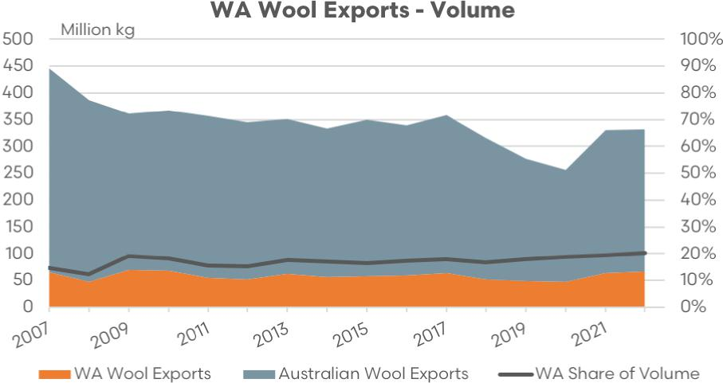

Sources: EP3, DPIRD, AWI

The majority of the WA flock consists of Merino sheep, comprising 85%. In self-replacing Merino flocks, a portion of wethers are kept for wool production, while many culled or older wethers are destined for the live-export trade. This highlights the key role played by the live export trade in the Western Australian wool industry.

WA’s shorter seasons and lack of pastures in more marginal areas inhibit the ability of Merino wether lambs to reach target specifications for slaughter without supplementary feeding. The live export market provides a market channel for semi-finished stock, such as Merino wether hoggets or mature age wethers, that do not meet ideal specifications for slaughter for either domestic meat markets or packaged meat exports. The preferred specification for live export mutton is for animals in good condition that exceed 50 kg liveweight (lwt).

In comparison, local processors prefer mutton below 50 kg lwt and impose price penalties for larger, mature sheep. Having the option of live trade as an accessible market ensures that Western Australian wool growers can retain a viable wool growing business and allows for an adaptable business model that can pivot as required due to seasonal and other variable factors. The removal of this option may make wool production in the West less attractive. (Wool Producers Australia submission to the Live Sheep Export Phaseout Panel)

It should be highlighted that WA producers have already observed a significant projected decrease in the number of wethers/breeding ewes in the next year, which has been attributed to the decision to phase out the live sheep trade. The [May 2023 Meat & Livestock Australia (MLA) – Australian Wool Innovation (AWI) Sheep Producer Intentions Survey](https://www.mla.com.au/globalassets/mla-corporate/prices--markets/documents/trends--analysis/sheepmeat-survey/spis---03-may-2023---final-report.pdf) projected a 33% decline in WA wethers and an 18% drop in the number of breeding ewes over the coming season. A decline of this magnitude would be expected to adversely affect the volume of wool production in WA.

#### WA sheep and wool prices

In the past year and a half, the prices for mutton in WA have been decreasing, mirroring a similar trend in eastern markets. As of April 2023, the average price for mutton in WA was 211 c/kg carcass weight (cwt), the lowest since January 2016.

The decline in prices began after a high point in January 2022, when mutton was priced at 592 c/kg cwt. However, the record high was achieved earlier, in August 2021, when it reached 594 c/kg. This downturn in prices may be related to a decrease in demand resulting from a backlog of animals waiting to be processed. This delay was primarily due to labour issues stemming from Coronavirus outbreaks in WA during 2022.

Although the drop isn’t as drastic as in mutton, the price of trade lamb in WA sale yards has been falling recently as well. By April 2023, the WA Trade Lamb Indicator (WATLI) averaged 522 c/kg carcass weight, a decrease from the record high of 840 c/kg in January 2022. However, the market did witness a brief surge over the summer, with prices reaching 636 c/kg in January 2023.

Figure 12 Saleyard lamb prices

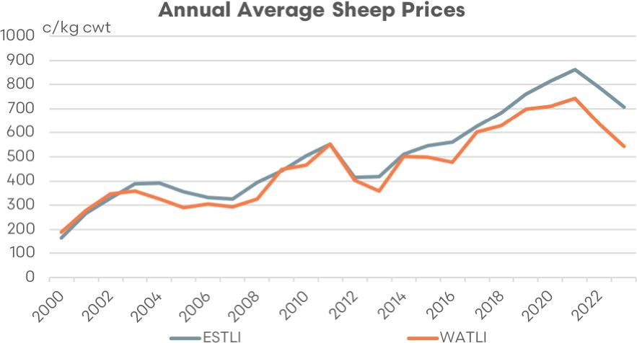

Sources: EP3, MLA

The annual average trade lamb price spreads between WA and the east coast (as demonstrated by the Eastern States Trade Lamb Indicator – ESTLI) shows that it is a pretty rare occurrence to see WA trade lambs at a premium. Over the last 2 decades, the percentage spread has fluctuated between a 15% premium to a 20% discount, with most of the time spent in discount territory.

The recent trend in the spread, since the beginning of the northern hemisphere summer moratorium in 2018 and the halving in live sheep export volumes over this time, highlights that the WA trade lamb spread to the east coast is firmly entrenched in discount territory.

Indeed, between 2000 to 2022 the long-term average discount has been 7% for WA Trade Lamb compared to their east coast counterparts. However, 2023 has seen the WATLI to ESTLI spread reach its lowest point on record at a discount of 23%.

Figure 13 Saleyard lamb price spreads

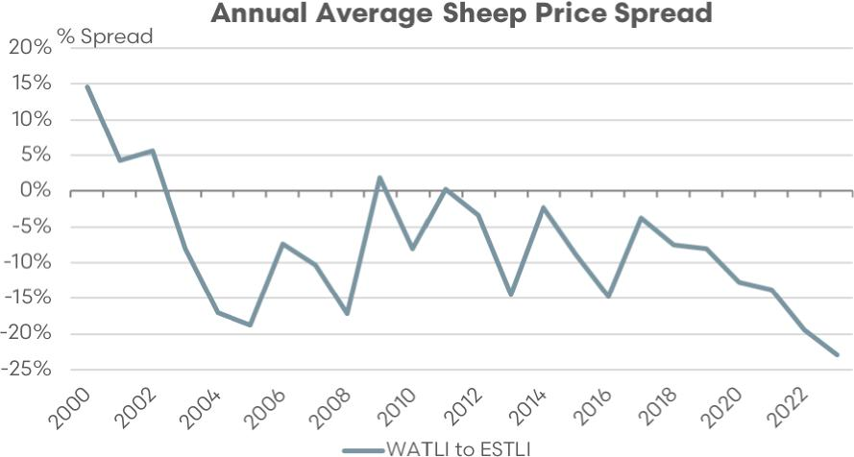

Sources: EP3, MLA

Using live sheep export annual trade value and volume data an average live sheep selling price can be estimated, when combined with the MLA reported saleyard export wether price it can be shown that they display quite similar trends. 2020 to 2022 saw a period of record pricing for live sheep which likely contributed to softer demand in offshore markets. Recently, prices have eased to more competitive levels and this has corresponded into a lift in live sheep export volumes into 2023.

Figure 14 Live sheep export prices

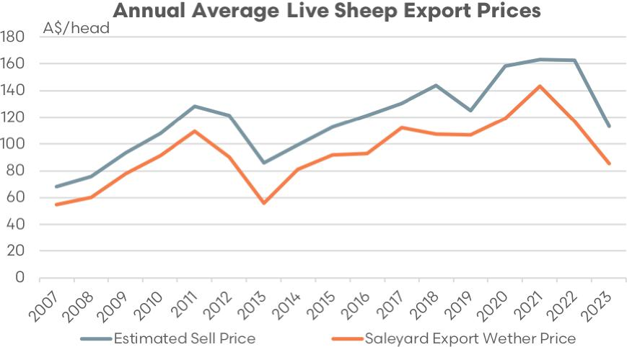

Sources: EP3, DPIRD, MLA

After the significant drop during the COVID-19 period, WA wool prices have been largely stable for the past year, although they haven’t reached the peak levels of late 2018. Back then, the Western Market Indicator (WMI) and Western 19-micron wool (W19) hit record highs of 2,231 c/kg clean and 2,406 c/kg, respectively, in August 2018. By April 2023, the average price of the WMI dipped to 1,482 c/kg from 1,529 cents in the previous month. Similarly, the W19 also saw a slight decline, averaging 1,668 c/kg, down from 1,712 cents.

Figure 15 WA wool prices

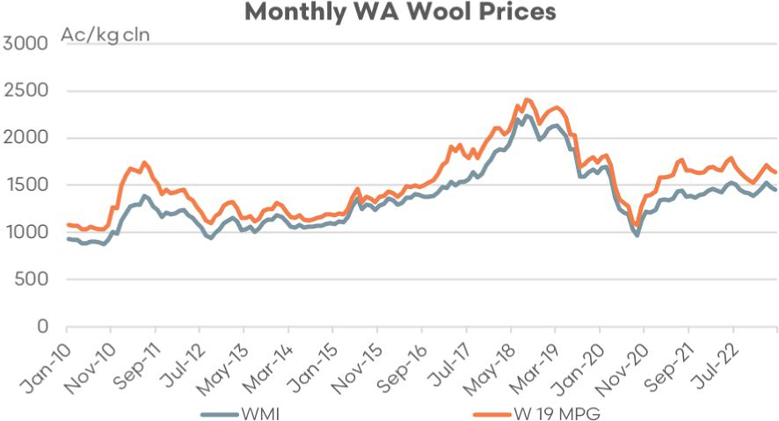

Sources: EP3, DPIRD, AWEX

#### WA sheep turnoff options

Alternatives to live export for the WA sheep producer will be to turnoff into the domestic processing sector in WA, provided they have the capacity and labour force to cope with the additional volumes, or they can look to transport their sheep to the east. However, the eastern states have proven to be a fickle destination.

For the eastern states to be a viable option for turnoff for the WA sheep producer it has to be available more readily, and not just when the price discount is so punishing for the WA producer.

An eastern states producer facing drought conditions aren’t likely to have strong demand for sheep, even if they are a very cheap option. The 2014 and 2015 season, which were very dry years on the east coast, saw minimal flows of sheep from west to east (of 75,000 and 85,000 sheep, respectively). Nowhere near enough to support the WA producer as a reliable option for turnoff.

Strong demand for sheep from the east during 2020 to restock after the 2019 drought, particularly from NSW producers, saw annual flows from west to east spike to 1.9 million head, or about 30% of WA turnoff that year.

But the option to send east isn’t something that can be relied upon every season, it needs a significant price discount from west to east to make the transport costs work out. Historically, prior to 2020, the 10-year average of proportion of sheep sent west to east was about 5% of total WA turnoff per year. Over the last decade, including 2022, the average proportion of turnoff from west to east was about 8%.

In 2022 the proportion of WA sheep turnoff that was processed locally was 81%, the highest it has been on record (until 2023). This underscores the importance of running the processing sector smoothly in WA, especially regarding processing capacity and labour, so that the planned phase out of the live trade doesn’t jeopardise the WA sheep farmer.

Prior to the live export moratorium/prohibition the proportion of WA turnoff into live export ranged between 30% and 40% of total turnoff. In 2018 and 2019 this proportion dropped to around 20%, then in the last few years it has drifted toward 10%.

In 2022 volumes sent from WA to live export was around 496,000 head, which was 11% of total turnoff that year. In terms of options to transport to the eastern states, volumes were even lower, at 368,000 head or 8% of total turnoff.

Figure 16 WA sheep turnoff options

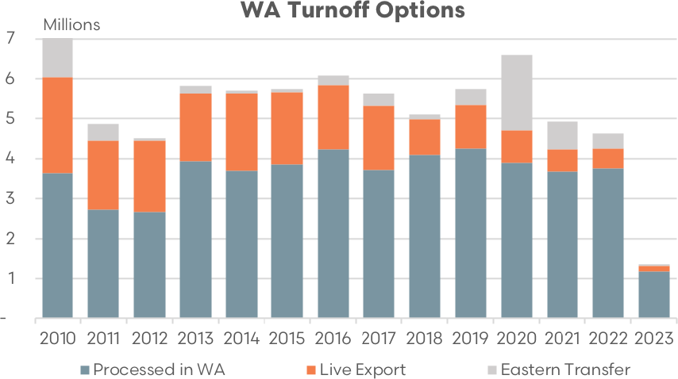

Sources: EP3, DPIRD, MLA, ABS, DAFF

Figure 17 WA sheep turnoff options (% share)

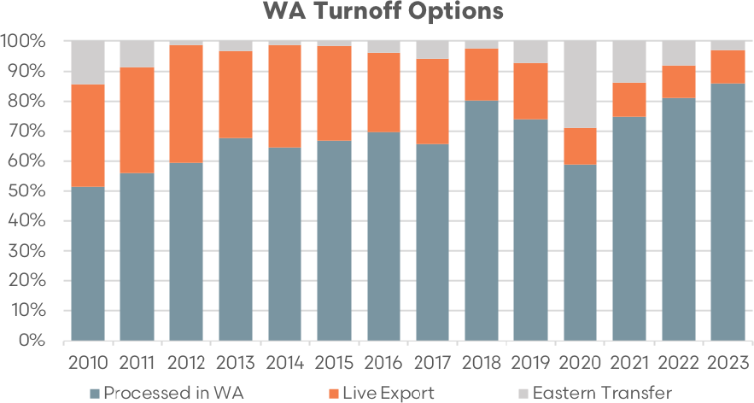

Sources: EP3, DPIRD, MLA, ABS, DAFF

A comparison of WA sheep processed locally versus transport to the east or into the live export sector for quarter one of 2023 shows that 86% of turnoff has gone into the domestic processing sector in WA. There have been around 11% of WA sheep turned off into live export sector so far in 2023, this ratio of live export turnoff has been pretty stable since 2020. In terms of sheep transported east, during January to March this year, there have just been 3% trucked across the Nullarbor which is down from the 8% sent east seen in 2022.

#### Impact of Northern Hemisphere Prohibition

Since 2018 the live sheep export supply chain has faced a ban on the trade during the northern hemisphere summer whereby live sheep export vessels have not departed Australia between mid-May to mid- September, depending upon the year and destination.

Table 4 Summary of the northern hemisphere prohibition dates

|  |  |  |
| --- | --- | --- |
| Destination | Prohibited | Conditional prohibition |
| Kuwait | 1 June – 14 September | – |
| Oman | 8 May – 14 September | – |
| Qatar | 1 June – 22 September | 22 May – 31 May |
| Persian Gulf (other than Kuwait, Oman Qatar) | 1 June – 14 September | 22 May – 31 May |
| Red Sea (to, or through) | 15 June – 14 September | – |

Source: DAFF

Historically, live sheep export mortalities during the northern hemisphere summer have reached their seasonal peaks. In 2018 the industry placed a self-imposed moratorium on the trade during this period while actions were undertaken to investigate how heat stress during the northern hemisphere summer could be mitigated. In 2019 the Australian government legislated that the export of live sheep by sea during the northern hemisphere summer would be prohibited and this annual prohibition has continued to 2023.

Figure 18 Live sheep mortality

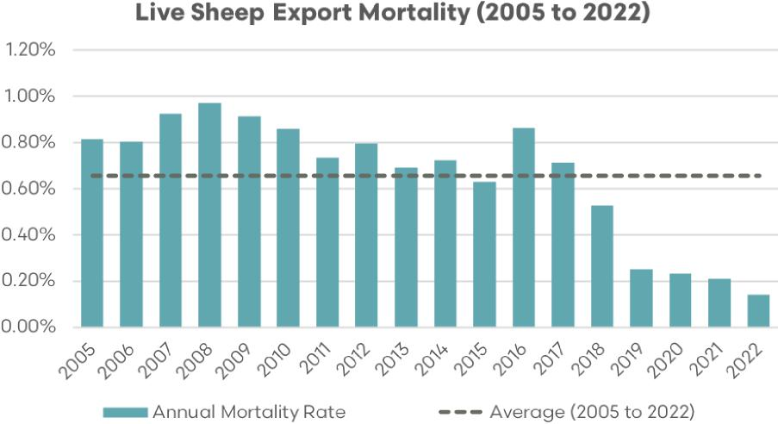

Sources: EP3, DAFF

Prior to the moratorium/prohibition period August was considered the riskiest month with mortality figures rising above 1.2% during this month and displaying a range (as measured by +/– one standard deviation around the average) anywhere between 0.8% to 1.8% over August. The impact of the northern hemisphere summer moratorium/prohibition on lowering annual average sheep mortality has been quite evident. However, the May to September ban on the live sheep trade doesn’t come without significant economic cost to the supply chain and workers within regional areas, particularly in live sheep export dependent Western Australia.

In a 2020 [report on the live sheep trade](https://livecorp.com.au/report/oLS7Gv9fkcu11703tJB5H) commissioned by LiveCorp and Meat & Livestock Australia it was estimated that the moratorium in 2018 had cost the industry $83.6 million and a further $65.8 million during the 2019 season. While the 2020 LiveCorp report identified that farmers and exporters were adjusting their operations to work around the moratorium period there were several participants in the supply chain that were significantly impacted by the length of the moratorium.

Shearing teams in regional towns reducing their workforce from 40 to 10 staff and noting the difficulty in holding onto already scarce shearing contractors during the moratorium lockdown. Not to mention the reduced spend in regional communities on daily supplies for these shearing team as they travelled across the state from contract to contract.

Some livestock transport operators reported up to an 85% reduction in their usual workload during the 2019 moratorium. The reduction in contract work of this magnitude also had economic implications for regional suppliers such as fuel depots, tyre fitters, mechanics and engineering firms providing services to the livestock transport sector.

These type of economic impacts of the moratorium-based lockdown to the live sheep export trade isn’t limited to shearing teams and transport operators. Feed mills, contract balers, feed suppliers, livestock agents, veterinarians and other associated livestock export services reported declines in their business revenues during the moratorium mirroring the magnitude of revenue decline seen across many sectors impacted by Covid-19 lockdowns during 2020.

Figure 19 WA sheep price spreads to east and eastern transport since prohibition

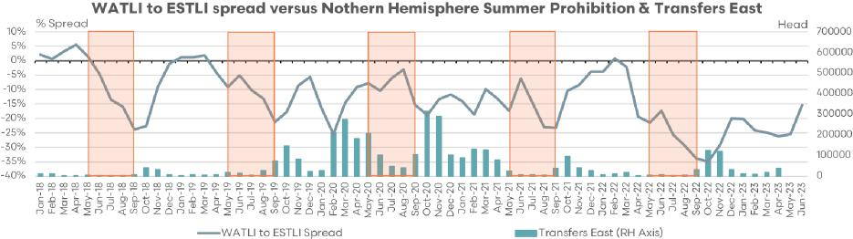

Sources: EP3, DPIRD, MLA

Analysis of the behaviour of lamb price spreads between the west and east since the moratorium/prohibition has been in place demonstrates that the discount of WA lambs often deteriorates during the period when live exports by sea are banned.

Since 2018 WA price spread discounts to the east, on average, have declined by 16% during the May to September period. However, in recent years with the addition of Covid-19 export supply chain issues and WA abattoir labour constraints, the WA spread discount has deteriorated further over the live sheep export prohibition period extending toward a 20% to 25% average discount from May to September.

Figure 20 WA sheep price spreads since prohibition

WA sheep price spread May to September 2018 to 2023



Sources: EP3, MLA

In 2020, when the eastern transportation turnoff option saw nearly 2 million head of WA sheep transported east, the discount pricing for WA was more consistent with the historic long term spread discount seen before 2018. As outlined earlier in this report from 2000 to 2022, the long-term discount spread of the WATLI to the ESTLI sits at 7%; during 2020 the discount was 9%.

This suggests that an eastern transportation option could be part of a solution for WA farmers and some participants of the live export supply chain, such as transport operators. However, further growth of the WA processing capacity and lamb feedlot sector could also play a role in the solution, as well as the ongoing development and expansion of offshore export markets in order to cater more inclusively to live export supply chain participants and provide a diversity of turnoff options for the WA sheep producer.

### D. Overview of sheep cropping and enterprise mix in WA

During FY2021/22 the sheep population in WA decreased by 2% to 12.4 million, making up approximately 18% of the national flock.

Figure 21 WA flock and annual turnoff

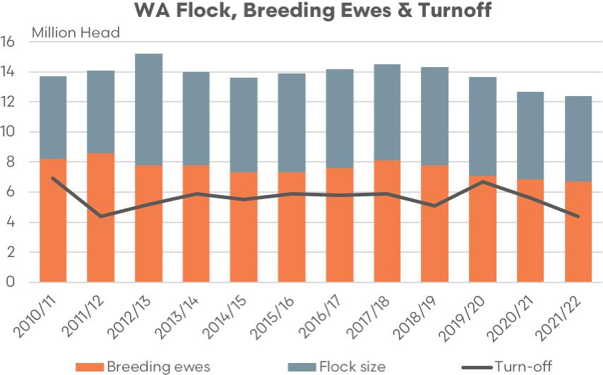

Sources: EP3, MA, ABS DPIRD

Since 1990, there has been an increasing proportion of ewes in the WA flock. In 2021, ewes accounted for over 60% of the flock, compared to 45% in 1990. This restructuring of the industry indicates a shift towards sheepmeat and lamb production, necessitating a higher number of breeding animals and resulting in surplus wethers, particularly in unfavourable seasonal conditions where feed is scarce or expensive.

Figure 22 WA sheep flock composition

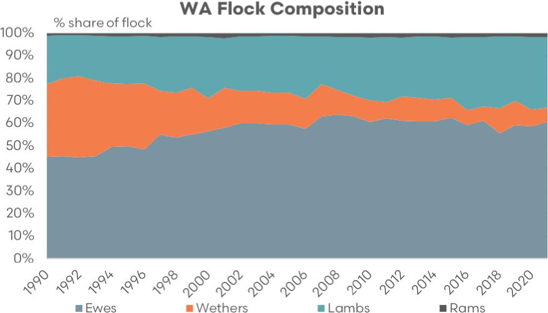

Sources: EP3, MA, ABS DPIRD

Wethers, when no longer productive, are generally sold for domestic slaughter. The number of wethers has significantly decreased, representing a little over 6% in 2021 compared to 32% in 1990. Conversely, lamb numbers have increased by 10% over the past 20 years.

Figure 23 WA sheep flock composition 2021

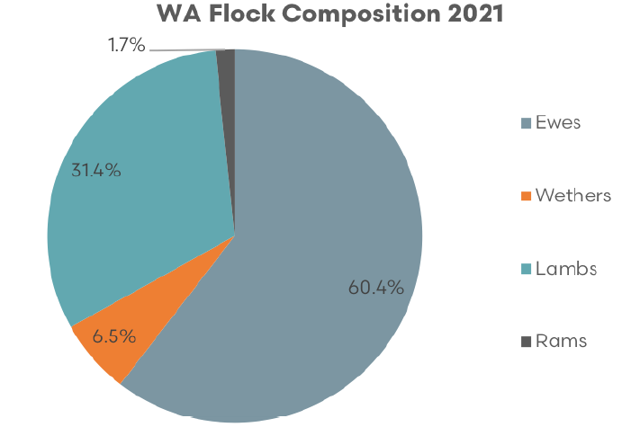

Sources: EP3, MA, ABS DPIRD

Most young Merino lambs/wethers in the Eastern States are typically sold in the light ‘bag’ lamb market, also referred to as Middle Eastern Kill lambs (MK Lambs). However, in WA, due to shorter seasons and limited pastures, Merino lambs and wethers cannot always meet processor slaughter specifications without additional feeding.

As a result, live export sector provides a channel to sell semi-finished stock. Aged wethers constitute approximately two-thirds of live sheep export volumes to the Middle East, with the remaining consisting of lambs and hoggets. Local processors tend to impose penalties for these sheep due to their characteristics and the fact that they are often out of desired processor specifications.

#### WA sheep distribution by local government area (LGA)

Table 5 outlines the top 20 WA local government areas (LGA) in terms of sheep population, based on the 2020/21 ABS agricultural survey. Included in the table is the production estimates for these LGA for the main crop types produced in WA.

Table 5 WA LGA region top 20 by number of sheep

|  |  |  |  |  |  |  |  |  |  |  |
| --- | --- | --- | --- | --- | --- | --- | --- | --- | --- | --- |
| Rank | LGA region | Sheep (head) | Number of sheep farmers | Average number of sheep per farm | Wheat (tonnes) | Barley (tonnes) | Canola (tonnes) | Oats (tonnes) | Lupins (tonnes) | Hay and silage (tonnes) |
| 1 | Broomehill–Tambellup | 622,184 | 128 | 4,842 | 76,392 | 105,080 | 56,180 | 23,201 | 4,380 | 24,459 |
| 2 | Kojonup | 605,071 | 125 | 4,842 | 74,290 | 102,190 | 54,635 | 22,563 | 4,259 | 23,787 |
| 3 | Esperance | 503,496 | 160 | 3,151 | 103,802 | 524,198 | 306,283 | 10,825 | 1,412 | 55,205 |
| 4 | Cranbrook | 502,302 | 104 | 4,842 | 61,672 | 84,833 | 45,355 | 18,731 | 3,536 | 19,746 |
| 5 | Lake Grace | 469,970 | 137 | 3,435 | 246,247 | 363,994 | 27,624 | 38,509 | 22,293 | 44,123 |
| 6 | Boyup Brook | 452,438 | 137 | 3,293 | 4,362 | 26,295 | 9,542 | 14,806 | 2,428 | 38,980 |
| 7 | Plantagenet | 451,413 | 148 | 3,059 | 41,128 | 86,541 | 57,462 | 7,891 | 504 | 65,637 |
| 8 | West Arthur | 438,745 | 88 | 4,977 | 26,921 | 79,968 | 24,514 | 51,822 | 5,566 | 55,497 |
| 9 | Wagin | 398,347 | 80 | 4,976 | 24,442 | 72,605 | 22,257 | 47,050 | 5,053 | 50,387 |
| 10 | Corrigin | 370,946 | 100 | 3,727 | 81,766 | 116,089 | 25,818 | 31,669 | 12,444 | 46,640 |
| 11 | Williams | 360,792 | 73 | 4,976 | 22,138 | 65,760 | 20,158 | 42,615 | 4,577 | 45,636 |
| 12 | Narrogin | 340,778 | 74 | 4,591 | 19,906 | 55,617 | 17,549 | 40,046 | 3,322 | 36,583 |
| 13 | Kent | 267,124 | 79 | 3,380 | 175,854 | 177,541 | 45,614 | 14,356 | 9,906 | 10,820 |
| 14 | Dandaragan | 264,006 | 86 | 3,058 | 70,712 | 19,536 | 23,480 | 3,727 | 15,975 | 15,072 |
| 15 | Kulin | 263,852 | 77 | 3,436 | 138,249 | 204,354 | 15,509 | 21,620 | 12,516 | 24,772 |
| 16 | Albany | 254,739 | 123 | 2,071 | 23,957 | 64,023 | 39,106 | 3,919 | 348 | 73,152 |
| 17 | Jerramungup | 249,790 | 74 | 3,380 | 164,442 | 166,020 | 42,654 | 13,424 | 9,263 | 10,117 |
| 18 | Gnowangerup | 243,047 | 72 | 3,380 | 160,003 | 161,539 | 41,503 | 13,062 | 9,013 | 9,844 |
| 19 | Dalwallinu | 232,256 | 95 | 2,449 | 422,353 | 123,537 | 51,998 | 8,437 | 20,945 | 61,025 |
| 20 | Kondinin | 227,322 | 66 | 3,435 | 119,108 | 176,062 | 13,361 | 18,627 | 10,783 | 21,342 |

Sources: EP3, ABS

Broomehill–Tambellup LGA has the highest number of sheep at 622,184 head and is fifth highest in terms of concentration of sheep farmers, according to the ABS survey. Esperance LGA has the highest concentration of sheep farmers at 160 and sits in the top third spot in terms of the number of sheep at 503,496 head.

Figure 24 Sheep farmers heat map by LGA

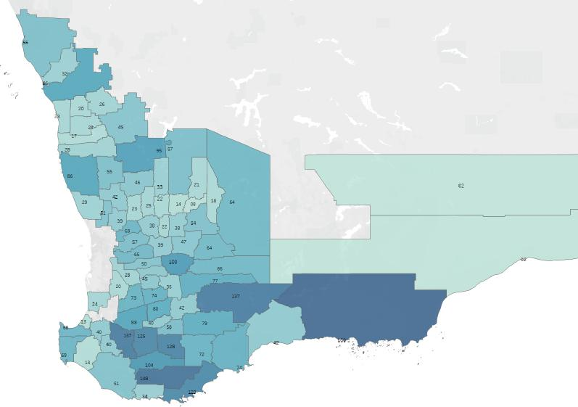

Sources: EP3, ABS

Figure 25 Sheep heat map by LGA

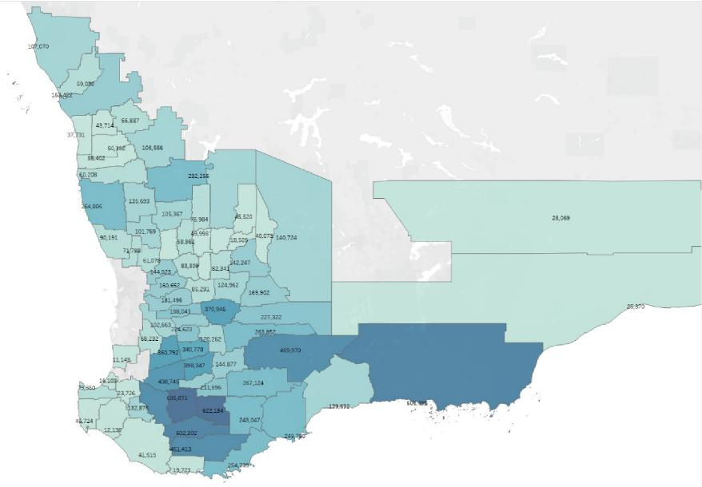

Sources: EP3, ABS

Figure 26 highlights that over the last 3 decades in WA there has been a decline in the sheep flock in favour of putting more area to cropping. WA cropping area has grown from around 5 million hectare in the early 1990s to a little over 9 million hectare in recent years. Over the same timeframe the WA sheep flock has reduced from approximately 37 million head to around 13 million head.

Figure 26 Cropping area and sheep flock (Western Australia)

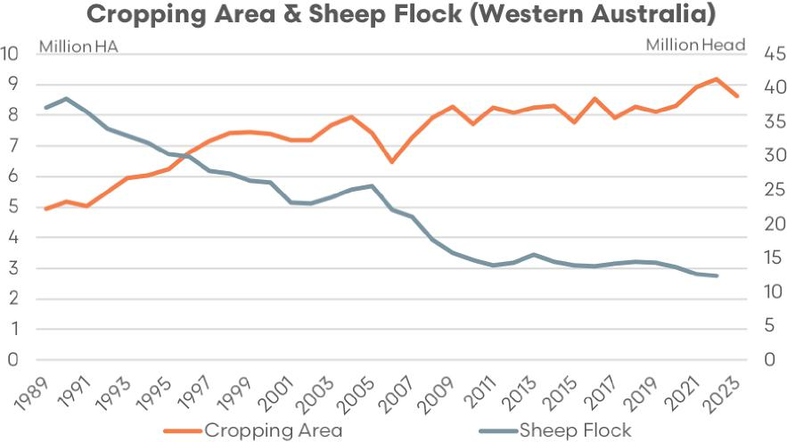

Sources: MA, ABARES, ABS

#### WA Wheat Production by Local Government Area (LGA)

Table 6 highlights the top 20 WA LGA by tonnes of wheat produced. Greater Geraldton topped this list in 2020/21 with an estimate of 501,104 tonnes. Despite being heavily wheat focused Greater Geraldton still holds a reasonable number of sheep, placed top 26th LGA in terms of sheep population.

Table 6 WA LGA region top 20 by wheat production

| Rank | LGA region | Sheep (head) | Number of sheep farmers | Average number of sheep per farm | Wheat (tonnes) | Barley (tonnes) | Canola (tonnes) | Oats (tonnes) | Lupins (tonnes) | Hay and silage (tonnes) |
| --- | --- | --- | --- | --- | --- | --- | --- | --- | --- | --- |
| 1 | Greater Geraldton | 163,422 | 86 | 1,906 | 501,104 | 16,207 | 52,658 | 2,059 | 60,675 | 9,960 |
| 2 | Dalwallinu | 232,256 | 95 | 2,449 | 422,353 | 123,537 | 51,998 | 8,437 | 20,945 | 61,025 |
| 3 | Northampton | 107,070 | 56 | 1,911 | 340,639 | 11,075 | 35,997 | 1,416 | 41,256 | 6,558 |
| 4 | Yilgarn | 140,724 | 64 | 2,184 | 286,589 | 44,097 | 9,623 | 8,433 | 5,945 | 2,905 |
| 5 | Mount Marshall | 124,136 | 57 | 2,185 | 252,806 | 38,899 | 8,488 | 7,439 | 5,244 | 2,562 |
| 6 | Moora | 135,693 | 55 | 2,449 | 246,755 | 72,175 | 30,379 | 4,930 | 12,237 | 35,653 |
| 7 | Wongan–Ballidu | 105,367 | 46 | 2,313 | 246,409 | 66,304 | 37,417 | 2,776 | 16,072 | 11,257 |
| 8 | Lake Grace | 469,970 | 137 | 3,435 | 246,247 | 363,994 | 27,624 | 38,509 | 22,293 | 44,123 |
| 9 | Narembeen | 169,902 | 64 | 2,641 | 213,301 | 73,265 | 17,127 | 11,723 | 8,948 | 9,187 |
| 10 | Victoria Plains | 101,769 | 42 | 2,449 | 185,064 | 54,131 | 22,784 | 3,697 | 9,178 | 26,739 |
| 11 | Merredin | 142,247 | 54 | 2,641 | 178,581 | 61,340 | 14,339 | 9,815 | 7,492 | 7,691 |
| 12 | Koorda | 75,984 | 33 | 2,313 | 177,694 | 47,814 | 26,983 | 2,002 | 11,590 | 8,117 |
| 13 | Kent | 267,124 | 79 | 3,380 | 175,854 | 177,541 | 45,614 | 14,356 | 9,906 | 10,820 |
| 14 | Chapman Valley | 59,030 | 32 | 1,869 | 174,993 | 5,834 | 18,933 | 727 | 21,194 | 3,838 |
| 15 | Jerramungup | 249,790 | 74 | 3,380 | 164,442 | 166,020 | 42,654 | 13,424 | 9,263 | 10,117 |
| 16 | Gnowangerup | 243,047 | 72 | 3,380 | 160,003 | 161,539 | 41,503 | 13,062 | 9,013 | 9,844 |
| 17 | Bruce Rock | 124,962 | 47 | 2,641 | 156,881 | 53,886 | 12,597 | 8,622 | 6,582 | 6,757 |
| 18 | Kulin | 263,852 | 77 | 3,436 | 138,249 | 204,354 | 15,509 | 21,620 | 12,516 | 24,772 |
| 19 | Dowerin | 58,862 | 25 | 2,313 | 137,653 | 37,040 | 20,903 | 1,551 | 8,979 | 6,288 |
| 20 | Goomalling | 52,891 | 23 | 2,314 | 123,689 | 33,282 | 18,782 | 1,393 | 8,068 | 5,650 |

Sources: EP3, ABS

Greater Geraldton, Dalwallinu, Gnowangerup, Jerramungup, Kulin, Kent and Lake Grace feature in the top 20 WA LGA wheat production and also feature in the top 20 LGA for sheep populations. There is an estimated total of 3.28 million head of sheep in the top 20 WA LGA for wheat production.

Figure 27 Wheat production heat map by LGA

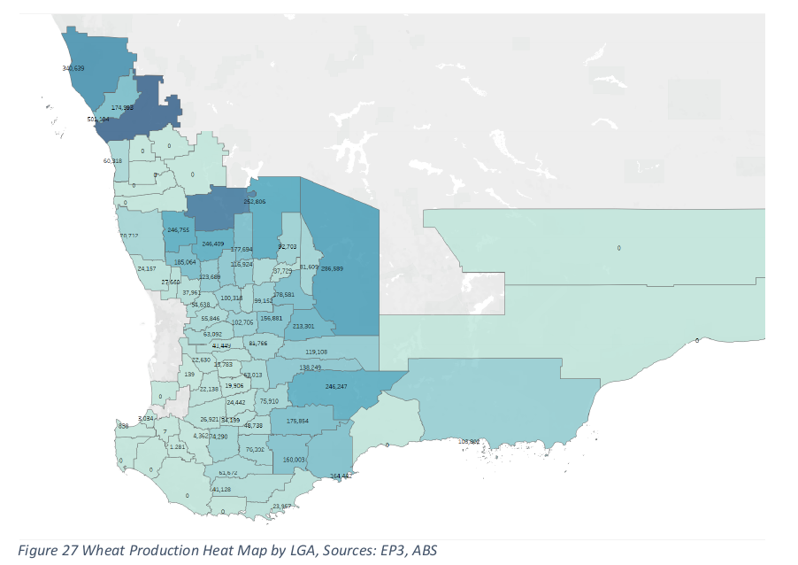

Sources: EP3, ABS

#### WA barley production by local government area (LGA)

Table 7 outlines the top 20 WA LGA based on estimated barley production levels. Esperance is the top LGA for barley production at 524,198 tonnes in 2020/21, according to the ABS survey. Esperance is also the third highest LGA for sheep population at 503,496 head.

Table 7 WA LGA region top 20 by barley production

| Rank | LGA region | Sheep (head) | Number of sheep farmers | Average number of sheep per farm | Wheat (tonnes) | Barley (tonnes) | Canola (tonnes) | Oats (tonnes) | Lupins (tonnes) | Hay and silage (tonnes) |
| --- | --- | --- | --- | --- | --- | --- | --- | --- | --- | --- |
| 1 | Esperance | 503,496 | 160 | 3,151 | 103,802 | 524,198 | 306,283 | 10,825 | 1,412 | 55,205 |
| 2 | Lake Grace | 469,970 | 137 | 3,435 | 246,247 | 363,994 | 27,624 | 38,509 | 22,293 | 44,123 |
| 3 | Kulin | 263,852 | 77 | 3,436 | 138,249 | 204,354 | 15,509 | 21,620 | 12,516 | 24,772 |
| 4 | Kent | 267,124 | 79 | 3,380 | 175,854 | 177,541 | 45,614 | 14,356 | 9,906 | 10,820 |
| 5 | Kondinin | 227,322 | 66 | 3,435 | 119,108 | 176,062 | 13,361 | 18,627 | 10,783 | 21,342 |
| 6 | Jerramungup | 249,790 | 74 | 3,380 | 164,442 | 166,020 | 42,654 | 13,424 | 9,263 | 10,117 |
| 7 | Gnowangerup | 243,047 | 72 | 3,380 | 160,003 | 161,539 | 41,503 | 13,062 | 9,013 | 9,844 |
| 8 | Ravensthorpe | 139,692 | 42 | 3,320 | – | 154,900 | 89,850 | 2,326 | – | 14,440 |
| 9 | Dalwallinu | 232,256 | 95 | 2,449 | 422,353 | 123,537 | 51,998 | 8,437 | 20,945 | 61,025 |
| 10 | Corrigin | 370,946 | 100 | 3,727 | 81,766 | 116,089 | 25,818 | 31,669 | 12,444 | 46,640 |
| 11 | Dumbleyung | 144,877 | 42 | 3,436 | 75,910 | 112,208 | 8,516 | 11,871 | 6,872 | 13,602 |
| 12 | Broomehill–Tambellup | 622,184 | 128 | 4,842 | 76,392 | 105,080 | 56,180 | 23,201 | 4,380 | 24,459 |
| 13 | Kojonup | 605,071 | 125 | 4,842 | 74,290 | 102,190 | 54,635 | 22,563 | 4,259 | 23,787 |
| 14 | Wickepin | 120,262 | 35 | 3,435 | 63,013 | 93,143 | 7,069 | 9,854 | 5,705 | 11,291 |
| 15 | Plantagenet | 451,413 | 148 | 3,059 | 41,128 | 86,541 | 57,462 | 7,891 | 504 | 65,637 |
| 16 | Beverley | 181,496 | 65 | 2,807 | 63,092 | 85,007 | 22,551 | 9,242 | 5,443 | 32,605 |
| 17 | Cranbrook | 502,302 | 104 | 4,842 | 61,672 | 84,833 | 45,355 | 18,731 | 3,536 | 19,746 |
| 18 | West Arthur | 438,745 | 88 | 4,977 | 26,921 | 79,968 | 24,514 | 51,822 | 5,566 | 55,497 |
| 19 | York | 160,652 | 57 | 2,807 | 55,846 | 75,244 | 19,961 | 8,181 | 4,818 | 28,861 |
| 20 | Narembeen | 169,902 | 64 | 2,641 | 213,301 | 73,265 | 17,127 | 11,723 | 8,948 | 9,187 |

Sources: EP3, ABS

Esperance, Kojonup, Broomehill–Tambellup, Cranbrook, Lake Grace, Kulin, Kent, Kondinin, Jerramungup, Gnowangerup, Dalwallinu, Corrigin, Plantagenet and West Arthur feature in the top 20 LGA for barley production and they also feature in the top 20 LGA for sheep populations. There is an estimated total of 6.36 million head of sheep in the top 20 WA LGA for barley crops.

Figure 28 Barley production heat map by LGA

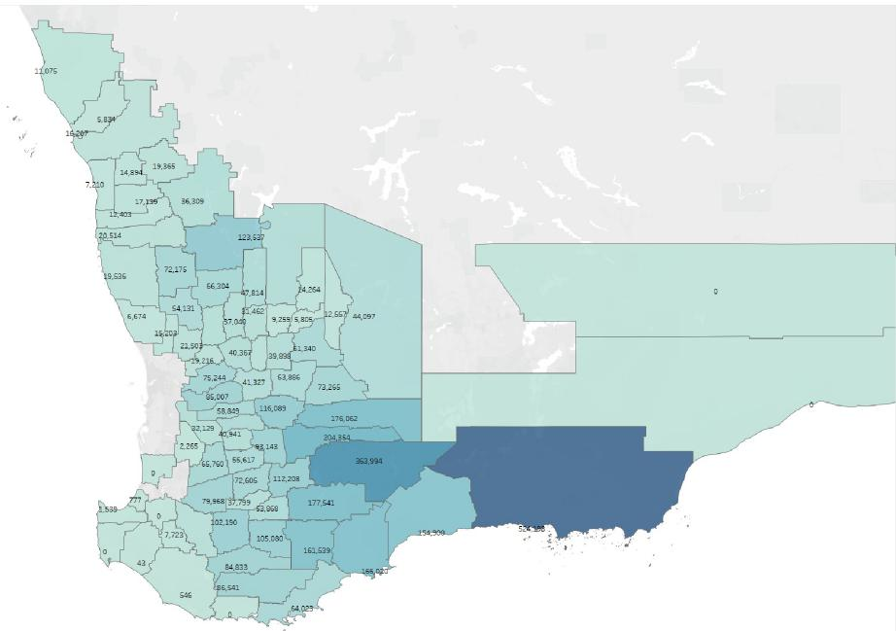

Sources: EP3, ABS

#### WA canola production by local government area (LGA)

Table 8 highlights the top 20 WA LGA based on estimated canola production for 2020/21. Esperance is the top LGA for canola production at 306,283 tonnes in 2020/21, according to the ABS survey. Esperance is also the third highest LGA for sheep population at 503,496 head.

Table 8 WA LGA region top 20 by canola production

| Rank | LGA region | Sheep (head) | Number of sheep farmers | Average number of sheep per farm | Wheat (tonnes) | Barley (tonnes) | Canola (tonnes) | Oats (tonnes) | Lupins (tonnes) | Hay and silage (tonnes) |
| --- | --- | --- | --- | --- | --- | --- | --- | --- | --- | --- |
| 1 | Esperance | 503,496 | 160 | 3,151 | 103,802 | 524,198 | 306,283 | 10,825 | 1,412 | 55,205 |
| 2 | Ravensthorpe | 139,692 | 42 | 3,320 | – | 154,900 | 89,850 | 2,326 | – | 14,440 |
| 3 | Plantagenet | 451,413 | 148 | 3,059 | 41,128 | 86,541 | 57,462 | 7,891 | 504 | 65,637 |
| 4 | Broomehill–Tambellup | 622,184 | 128 | 4,842 | 76,392 | 105,080 | 56,180 | 23,201 | 4,380 | 24,459 |
| 5 | Kojonup | 605,071 | 125 | 4,842 | 74,290 | 102,190 | 54,635 | 22,563 | 4,259 | 23,787 |
| 6 | Greater Geraldton | 163,422 | 86 | 1,906 | 501,104 | 16,207 | 52,658 | 2,059 | 60,675 | 9,960 |
| 7 | Dalwallinu | 232,256 | 95 | 2,449 | 422,353 | 123,537 | 51,998 | 8,437 | 20,945 | 61,025 |
| 8 | Kent | 267,124 | 79 | 3,380 | 175,854 | 177,541 | 45,614 | 14,356 | 9,906 | 10,820 |
| 9 | Cranbrook | 502,302 | 104 | 4,842 | 61,672 | 84,833 | 45,355 | 18,731 | 3,536 | 19,746 |
| 10 | Jerramungup | 249,790 | 74 | 3,380 | 164,442 | 166,020 | 42,654 | 13,424 | 9,263 | 10,117 |
| 11 | Gnowangerup | 243,047 | 72 | 3,380 | 160,003 | 161,539 | 41,503 | 13,062 | 9,013 | 9,844 |
| 12 | Albany | 254,739 | 123 | 2,071 | 23,957 | 64,023 | 39,106 | 3,919 | 348 | 73,152 |
| 13 | Wongan–Ballidu | 105,367 | 46 | 2,313 | 246,409 | 66,304 | 37,417 | 2,776 | 16,072 | 11,257 |
| 14 | Northampton | 107,070 | 56 | 1,911 | 340,639 | 11,075 | 35,997 | 1,416 | 41,256 | 6,558 |
| 15 | Moora | 135,693 | 55 | 2,449 | 246,755 | 72,175 | 30,379 | 4,930 | 12,237 | 35,653 |
| 16 | Perenjori | 106,566 | 49 | 2,190 | – | 36,309 | 29,819 | 1,883 | 24,962 | 8,261 |
| 17 | Lake Grace | 469,970 | 137 | 3,435 | 246,247 | 363,994 | 27,624 | 38,509 | 22,293 | 44,123 |
| 18 | Koorda | 75,984 | 33 | 2,313 | 177,694 | 47,814 | 26,983 | 2,002 | 11,590 | 8,117 |
| 19 | Corrigin | 370,946 | 100 | 3,727 | 81,766 | 116,089 | 25,818 | 31,669 | 12,444 | 46,640 |
| 20 | West Arthur | 438,745 | 88 | 4,977 | 26,921 | 79,968 | 24,514 | 51,822 | 5,566 | 55,497 |

Sources: EP3, ABS

Esperance, Kojonup, Broomehill–Tambellup, Cranbrook, Lake Grace, Kent, Jerramungup, Albany, Gnowangerup, Dalwallinu, Corrigin, Plantagenet and West Arthur feature in the top 20 LGA for canola production and they also feature in the top 20 LGA for sheep populations. There is an estimated total of 6.04 million head of sheep in the top 20 WA LGA for canola production.

Figure 29 Canola production heat map by LGA

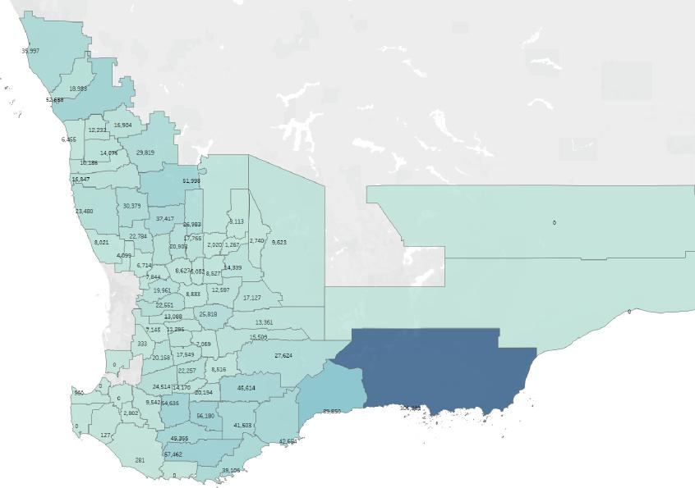

Sources: EP3, ABS

#### WA oat production by local government area (LGA)

Table 9 outlines the top 20 WA local government areas (LGA) in terms of oat production, based on the 2020/21 ABS agricultural survey. West Arthur is the top LGA for oat production in WA at an estimate of 51,822 tonnes and is placed in top 8th position in terms of sheep population at 438,745 head.

Table 9 WA LGA region top 20 by oat production

| Rank | LGA region | Sheep (head) | Number of sheep farmers | Average number of sheep per farm | Wheat (tonnes) | Barley (tonnes) | Canola (tonnes) | Oats (tonnes) | Lupins (tonnes) | Hay and silage (tonnes) |
| --- | --- | --- | --- | --- | --- | --- | --- | --- | --- | --- |
| 1 | West Arthur | 438,745 | 88 | 4,977 | 26,921 | 79,968 | 24,514 | 51,822 | 5,566 | 55,497 |
| 2 | Wagin | 398,347 | 80 | 4,976 | 24,442 | 72,605 | 22,257 | 47,050 | 5,053 | 50,387 |
| 3 | Williams | 360,792 | 73 | 4,976 | 22,138 | 65,760 | 20,158 | 42,615 | 4,577 | 45,636 |
| 4 | Narrogin | 340,778 | 74 | 4,591 | 19,906 | 55,617 | 17,549 | 40,046 | 3,322 | 36,583 |
| 5 | Lake Grace | 469,970 | 137 | 3,435 | 246,247 | 363,994 | 27,624 | 38,509 | 22,293 | 44,123 |
| 6 | Corrigin | 370,946 | 100 | 3,727 | 81,766 | 116,089 | 25,818 | 31,669 | 12,444 | 46,640 |
| 7 | Cuballing | 224,623 | 45 | 4,976 | 13,783 | 40,941 | 12,550 | 26,531 | 2,849 | 28,412 |
| 8 | Broomehill–Tambellup | 622,184 | 128 | 4,842 | 76,392 | 105,080 | 56,180 | 23,201 | 4,380 | 24,459 |
| 9 | Kojonup | 605,071 | 125 | 4,842 | 74,290 | 102,190 | 54,635 | 22,563 | 4,259 | 23,787 |
| 10 | Kulin | 263,852 | 77 | 3,436 | 138,249 | 204,354 | 15,509 | 21,620 | 12,516 | 24,772 |
| 11 | Cranbrook | 502,302 | 104 | 4,842 | 61,672 | 84,833 | 45,355 | 18,731 | 3,536 | 19,746 |
| 12 | Kondinin | 227,322 | 66 | 3,435 | 119,108 | 176,062 | 13,361 | 18,627 | 10,783 | 21,342 |
| 13 | Brookton | 188,043 | 50 | 3,727 | 41,449 | 58,849 | 13,088 | 16,054 | 6,308 | 23,643 |
| 14 | Boyup Brook | 452,438 | 137 | 3,293 | 4,362 | 26,295 | 9,542 | 14,806 | 2,428 | 38,980 |
| 15 | Kent | 267,124 | 79 | 3,380 | 175,854 | 177,541 | 45,614 | 14,356 | 9,906 | 10,820 |
| 16 | Pingelly | 162,278 | 44 | 3,727 | 35,770 | 50,786 | 11,295 | 13,854 | 5,444 | 20,404 |
| 17 | Jerramungup | 249,790 | 74 | 3,380 | 164,442 | 166,020 | 42,654 | 13,424 | 9,263 | 10,117 |
| 18 | Katanning | 211,896 | 58 | 3,682 | 48,738 | 53,868 | 20,194 | 13,376 | 4,935 | 13,876 |
| 19 | Gnowangerup | 243,047 | 72 | 3,380 | 160,003 | 161,539 | 41,503 | 13,062 | 9,013 | 9,844 |
| 20 | Dumbleyung | 144,877 | 42 | 3,436 | 75,910 | 112,208 | 8,516 | 11,871 | 6,872 | 13,602 |

Sources: EP3, ABS

West Arthur, Wagin, Williams, Narrogin, Lake Grace, Corrigin, Broomehill–Tambellup, Kojonup, Kulin, Cranbrook, Kondinin, Boyup Brook, Kent, Jerramungup and Gnowangerup feature in the top 20 WA LGA for oat production and they also feature in the top 20 for sheep population. There is an estimated total of 6.74 million head of sheep in the top 20 WA LGA for oat production.

Figure 30 Oat production heat map by LGA

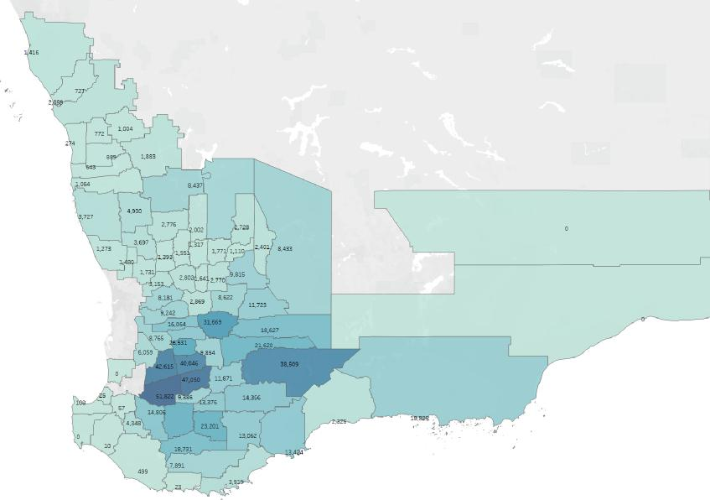

Sources: EP3, ABS

Table 10 shows the top 20 WA LGA by tonnes of lupins produced. Greater Geraldton topped this list in 2020/21 with 60,675 tonnes estimated by the ABS. Greater Geraldton also holds 163,422 head of sheep, which puts it in the top 26th LGA in terms of sheep population.

Table 10 WA LGA region top 20 by lupin production

| Rank | LGA region | Sheep (head) | Number of sheep farmers | Average number of sheep per farm | Wheat (tonnes) | Barley (tonnes) | Canola (tonnes) | Oats (tonnes) | Lupins (tonnes) | Hay and silage (tonnes) |
| --- | --- | --- | --- | --- | --- | --- | --- | --- | --- | --- |
| 1 | Greater Geraldton | 163,422 | 86 | 1,906 | 501,104 | 16,207 | 52,658 | 2,059 | 60,675 | 9,960 |
| 2 | Northampton | 107,070 | 56 | 1,911 | 340,639 | 11,075 | 35,997 | 1,416 | 41,256 | 6,558 |
| 3 | Perenjori | 106,566 | 49 | 2,190 | – | 36,309 | 29,819 | 1,883 | 24,962 | 8,261 |
| 4 | Lake Grace | 469,970 | 137 | 3,435 | 246,247 | 363,994 | 27,624 | 38,509 | 22,293 | 44,123 |
| 5 | Chapman Valley | 59,030 | 32 | 1,869 | 174,993 | 5,834 | 18,933 | 727 | 21,194 | 3,838 |
| 6 | Dalwallinu | 232,256 | 95 | 2,449 | 422,353 | 123,537 | 51,998 | 8,437 | 20,945 | 61,025 |
| 7 | Wongan–Ballidu | 105,367 | 46 | 2,313 | 246,409 | 66,304 | 37,417 | 2,776 | 16,072 | 11,257 |
| 8 | Dandaragan | 264,006 | 86 | 3,058 | 70,712 | 19,536 | 23,480 | 3,727 | 15,975 | 15,072 |
| 9 | Coorow | 60,208 | 28 | 2,189 | – | 20,514 | 16,847 | 1,064 | 14,103 | 4,667 |
| 10 | Morawa | 56,837 | 26 | 2,189 | – | 19,365 | 15,904 | 1,004 | 13,313 | 4,406 |
| 11 | Kulin | 263,852 | 77 | 3,436 | 138,249 | 204,354 | 15,509 | 21,620 | 12,516 | 24,772 |
| 12 | Corrigin | 370,946 | 100 | 3,727 | 81,766 | 116,089 | 25,818 | 31,669 | 12,444 | 46,640 |
| 13 | Moora | 135,693 | 55 | 2,449 | 246,755 | 72,175 | 30,379 | 4,930 | 12,237 | 35,653 |
| 14 | Three Springs | 50,302 | 23 | 2,190 | – | 17,139 | 14,075 | 889 | 11,782 | 3,899 |
| 15 | Koorda | 75,984 | 33 | 2,313 | 177,694 | 47,814 | 26,983 | 2,002 | 11,590 | 8,117 |
| 16 | Irwin | 37,731 | 23 | 1,674 | 60,318 | 7,210 | 6,455 | 274 | 11,221 | 3,693 |
| 17 | Kondinin | 227,322 | 66 | 3,435 | 119,108 | 176,062 | 13,361 | 18,627 | 10,783 | 21,342 |
| 18 | Mingenew | 43,714 | 20 | 2,190 | – | 14,894 | 12,232 | 772 | 10,239 | 3,389 |
| 19 | Kent | 267,124 | 79 | 3,380 | 175,854 | 177,541 | 45,614 | 14,356 | 9,906 | 10,820 |
| 20 | Jerramungup | 249,790 | 74 | 3,380 | 164,442 | 166,020 | 42,654 | 13,424 | 9,263 | 10,117 |

Sources: EP3, ABS

Greater Geraldton, Lake Grace, Dalwallinu, Dandaragan, Kulin, Corrigin, Kondinin, Kent and Jerramungup feature in the top 20 LGA for lupin production and they also feature in the top 20 LGA for sheep population. There is an estimated total of 3.35 million head of sheep in the top 20 WA LGA for lupin production.

Figure 31 Lupin production heat map by LGA

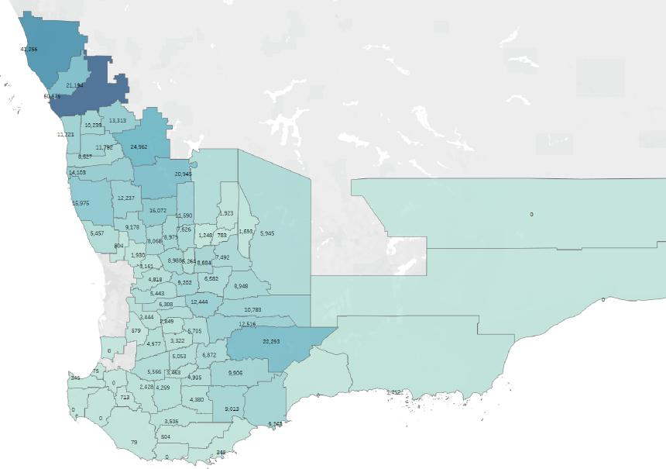

Sources: EP3, ABS

Lupin production is expected to be reduced by the phase out of the live sheep exports, due to the expected reduction in the Western Australian sheep flock. Since the end of the wool price reserve scheme in 1991, the Western Australian flock has declined, with a corresponding increase in cropping area. The correlation between Western Australian cropping area and the Western Australian sheep flock is −0.92. In comparison, the area utilised for lupin production in Western Australia has declined, in line with the fall in the sheep flock. A large market for lupins is the domestic sheep market; as sheep numbers decline, demand drops.

Figure 32 Lupin area and sheep flock (Western Australia)

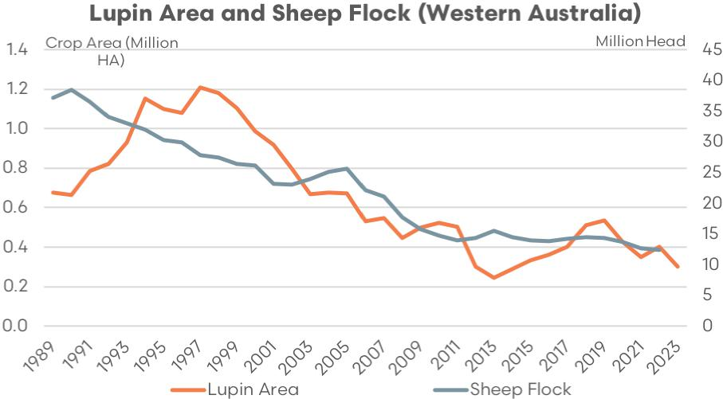

Sources: MLA, ABARES, ABS

The reduced demand for lupins domestically and the difficulty in finding alternate markets has meant that other crops, such as canola, have taken over the area previously planted to lupins. The alternate cropping commodities, especially canola, have experienced significant price growth in recent years resulting in lupins becoming less attractive to plant. A reduced Western Australian sheep flock is likely to cause a decreased demand for lupins domestically and exacerbate the price difference between lupins and alternative crops.

Figure 33 Grain and oilseed prices (WA, harvest)

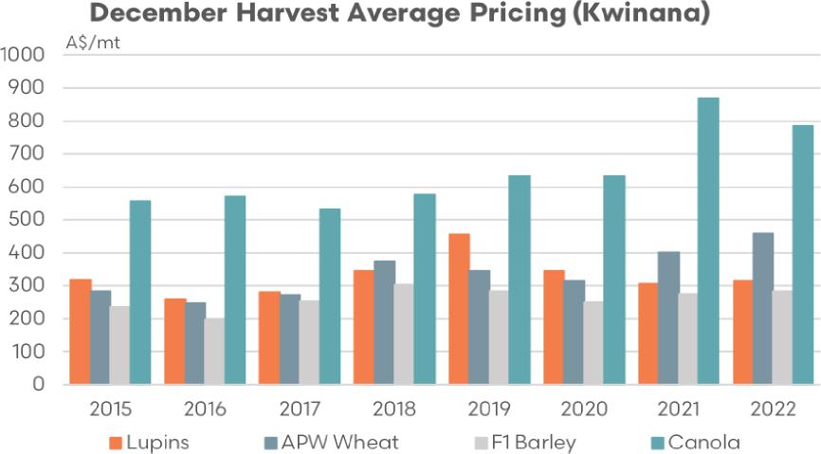

Sources: EP3

The scope of this report does not include an investigation of agronomic issues. However, lupin production is beneficial to the environment due to its nitrogen fixation properties as a legume.

Lupins have a symbiotic relationship with bacteria that can fix nitrogen from the atmosphere. The bacteria reside in the root nodules of the lupin plants, where they convert atmospheric nitrogen into a form that plants can use. Nitrogen fixation reduces the need for nitrogenous fertilizers, reducing farmer input costs and reducing emissions.

The reduction in the domestic market for lupins due to a fall in the sheep flock may require funding in market development of lupins to encourage the continued use of lupins as a crop option in Western Australia. This market development could be performed by the Australian Export Grains Innovation Centre and Grains Australia.

There is the potential for some improvement in demand for lupins domestically if there is an increase in feedlot demand within Western Australia. This may not, however, be of the volume to replace the domestic market for lupins for on-farm usage.

#### WA hay and silage production by local government area (LGA)

Table 11 highlights the top 20 WA LGA based on hay and silage production for 2020/21. Albany is the top LGA for hay and silage production at 73,152 tonnes, according to the ABS survey. Albany is also the 16th highest LGA for sheep population at 254,739 head.

Table 11 WA LGA region top 20 by hay and silage production

| Rank | LGA region | Sheep (head) | Number of sheep farmers | Average number of sheep per farm | Wheat (tonnes) | Barley (tonnes) | Canola (tonnes) | Oats (tonnes) | Lupins (tonnes) | Hay and silage (tonnes) |
| --- | --- | --- | --- | --- | --- | --- | --- | --- | --- | --- |
| 1 | Albany | 254,739 | 123 | 2,071 | 23,957 | 64,023 | 39,106 | 3,919 | 348 | 73,152 |
| 2 | Plantagenet | 451,413 | 148 | 3,059 | 41,128 | 86,541 | 57,462 | 7,891 | 504 | 65,637 |
| 3 | Dalwallinu | 232,256 | 95 | 2,449 | 422,353 | 123,537 | 51,998 | 8,437 | 20,945 | 61,025 |
| 4 | Busselton | 79,350 | 68 | 1,167 | 838 | 1,539 | 960 | 108 | 345 | 55,688 |
| 5 | West Arthur | 438,745 | 88 | 4,977 | 26,921 | 79,968 | 24,514 | 51,822 | 5,566 | 55,497 |
| 6 | Esperance | 503,496 | 160 | 3,151 | 103,802 | 524,198 | 306,283 | 10,825 | 1,412 | 55,205 |
| 7 | Wagin | 398,347 | 80 | 4,976 | 24,442 | 72,605 | 22,257 | 47,050 | 5,053 | 50,387 |
| 8 | Augusta Margaret River | 46,724 | 69 | 679 | – | – | – | – | – | 48,818 |
| 9 | Corrigin | 370,946 | 100 | 3,727 | 81,766 | 116,089 | 25,818 | 31,669 | 12,444 | 46,640 |
| 10 | Harvey | 11,143 | 24 | 457 | – | – | – | – | – | 46,510 |
| 11 | Williams | 360,792 | 73 | 4,976 | 22,138 | 65,760 | 20,158 | 42,615 | 4,577 | 45,636 |
| 12 | Lake Grace | 469,970 | 137 | 3,435 | 246,247 | 363,994 | 27,624 | 38,509 | 22,293 | 44,123 |
| 13 | Boyup Brook | 452,438 | 137 | 3,293 | 4,362 | 26,295 | 9,542 | 14,806 | 2,428 | 38,980 |
| 14 | Narrogin | 340,778 | 74 | 4,591 | 19,906 | 55,617 | 17,549 | 40,046 | 3,322 | 36,583 |
| 15 | Moora | 135,693 | 55 | 2,449 | 246,755 | 72,175 | 30,379 | 4,930 | 12,237 | 35,653 |
| 16 | Manjimup | 41,515 | 51 | 813 | – | 546 | 281 | 499 | 79 | 33,498 |
| 17 | Beverley | 181,496 | 65 | 2,807 | 63,092 | 85,007 | 22,551 | 9,242 | 5,443 | 32,605 |
| 18 | Capel | 16,103 | 13 | 1,214 | 3,034 | 777 | – | 25 | 75 | 29,122 |
| 19 | York | 160,652 | 57 | 2,807 | 55,846 | 75,244 | 19,961 | 8,181 | 4,818 | 28,861 |
| 20 | Northam | 144,023 | 69 | 2,081 | 54,638 | 19,216 | 7,844 | 3,153 | 3,161 | 28,784 |

Sources: EP3, ABS

Albany, Dalwallinu, West Arthur, Esperance, Wagin, Corrigin, Williams, Lake Grace, Boyup Brook, and Narrogin feature in the top 20 WA LGA for hay and silage production and they also feature in the top 20 LGA for sheep population. There is an estimated total of 5.09 million head of sheep in the top 20 WA LGA for hay and silage production.

Figure 34 Hay and silage production heat map by LGA

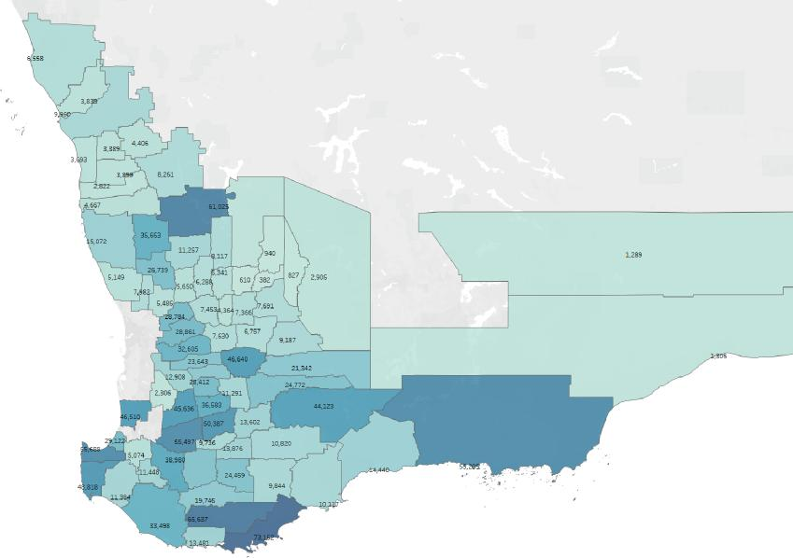

Sources: EP3, ABS

Across the main cropping LGA in WA there is an estimated range of 3.3 million to 6.7 million head of sheep. Sheep producer intention surveys have suggested (on a conservative basis) that around 14% of farmers have said they will get out of sheep entirely if the live sheep export trade is phased out.

Based upon the sheep population range of 3.3 to 6.7 million head in the main WA cropping regions this could equate to a drop in the flock of 450,000 to 0.9 million head. Some producer intention surveys have suggested that the decision to exit sheep entirely is higher than 14% and closer to 44%. An exit of this magnitude, if the surveying result proves accurate, could result in a decline in the WA flock of 1.4 million to 2.9 million head.

### E. Key stakeholders involved in the supply chain and their reliance on the trade

A 2019 [report commissioned by Livecorp and Meat & Livestock Australia](https://www.mla.com.au/globalassets/mla-corporate/research-and-development/final-reports/2020/w.liv.1001-final-report.pdf) outlined the revenue reliance on the live sheep export industry across the supply chain within Western Australia. This report surveyed live export supply chain participant groups in order to determine the proportion of their annual revenue that was earned via the live sheep export channel.

Figure 35 Reliance on the live sheep export trade by participant category

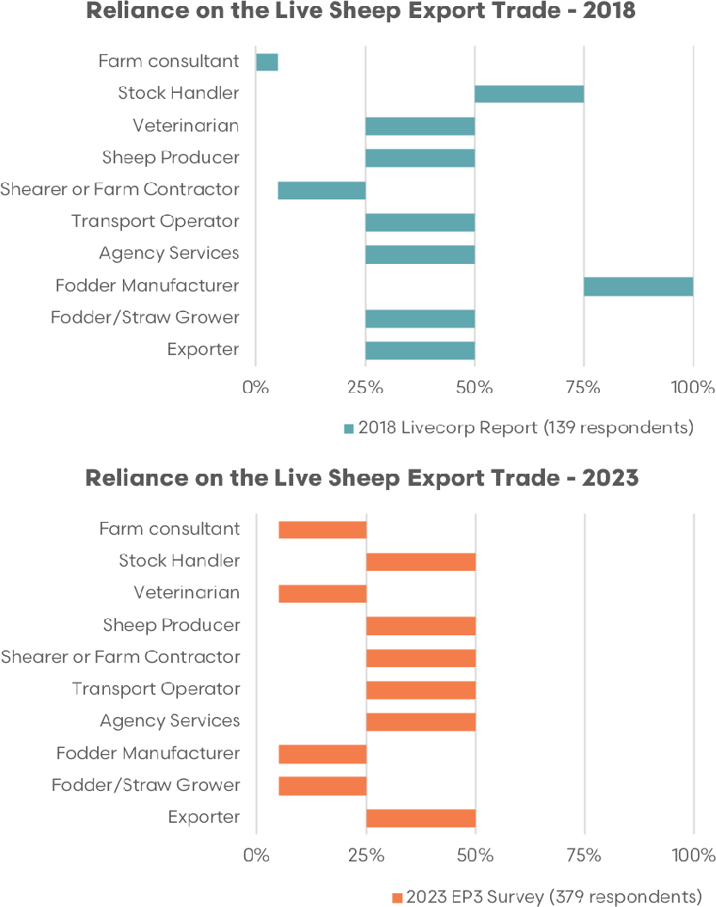

Sources: EP3, Livecorp

The 2019 report demonstrated that in WA fodder pellet manufacturers were the participant group that was the most reliant on the live sheep trade reporting 75% to 100% of their revenue attributable to the live sheep trade. Stock handlers surveyed also reported a significant amount of their annual revenue stream as being reliant on the live sheep export trade, consisting of 50% to 70% of their earnings.

As part of the consultation and surveying undertaken for this report, the revenue reliance for participant groups across the supply chain was assessed. Several participant groups consulted for this report had indicated that they had shifted their revenue reliance away from the live sheep export sector in recent years due to the difficulties in navigating the northern hemisphere summer prohibition period and the declining trade volumes.

Most notable shifts in reliance were WA fodder pellet manufacturers that had seen their reliance on the live sheep trade move from 75%–100% to 5%–25% from 2019 to 2023. One pellet manufacturer consulted indicated that they were still very exposed to the live export trade in terms of revenue reliance and had seen a 54% decline in annual revenues due to the reduced live sheep export volumes. However, most pellet manufacturers surveyed had noted that the decline in the live sheep export volumes had meant that their business model was now more reliant upon revenue streams from the domestic feed market.

Veterinarians and fodder/straw growers were 2 other participant groups that had indicated a downward shift in their revenue reliance on the live sheep export trade during the 2019 to 2023 period, with both groups reported their reliance easing from 25%–50% to 5%–25%.

Figure 36 Sheep sold to live export by LGA (2019–2023, animation)

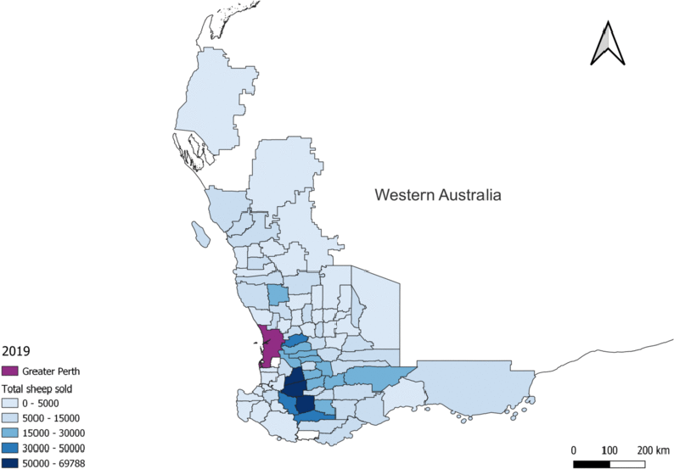

Sources: EP3, industry

It is estimated that the data used to create this animated graphic represents 70% to 80% of the trade. If you are viewing this document as a PDF the animation may not display – you can [view the animation on the EP3 website](https://episode3.net/content/uploads/2023/07/Sheep-Sold.gif). You can also view each slide used in this animation in Appendix A of this report.

Similarly, industry data demonstrating the number of sheep sold to the live export trade by WA LGA has reduced in line with declining overall trade volumes during the 2019 to 2023 period. Figure 36 is an animated graphic that demonstrates the reducing number of WA LGA selling sheep into the live export trade over the last 5 years and the declining intensity of sales, particularly in LGA situated south east of Perth such as Boyup Brook, Kojonup, West Arthur, Williams, Cranbrook, Wagin and Narrogin.

## III. Assessment of the impact of a phaseout on WA sheep industry supply chain, as identified by the consultative process

Participant groups across the live sheep export supply chain in WA were surveyed with regard to their expectations for industry assistance as part of the phase out transition. Participant groups included sheep producers, farm workers, shearers, farm contractors, transport operators, agency services, exporters, abattoirs, lamb feedlots, fodder/straw growers, fodder pellet manufacturers, stock handlers, veterinarians and other industry participants.

The consensus across all participant groups in terms of priority assistance was to increase the domestic processing capacity in WA, to develop new markets for sheep meat exports and expand existing markets for sheep meat exports with approximately three-quarters of participants surveyed expressing these requirements as key considerations of the phaseout process.

Figure 37 Industry assistance as part of phaseout process

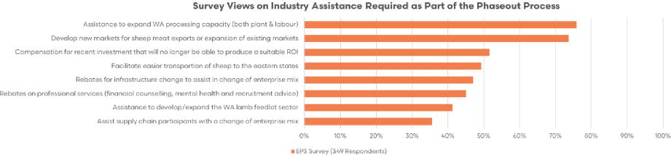

Sources: EP3

Featuring prominently was assistance to facilitate easier road transportation of sheep from west to east and compensation packages for recent infrastructure investments unable to produce a suitable return on investment due to the phase out of the live sheep trade, with around half of all survey respondents indicating that these were also desirable outcomes.

### A. Sheep producers

Sheep producers in Western Australia are currently experiencing strong negative sentiment, as indicated by the [May 2023 Sheep Producers Intention Survey](https://www.mla.com.au/globalassets/mla-corporate/prices--markets/documents/trends--analysis/sheepmeat-survey/spis---03-may-2023---final-report.pdf) conducted by MLA and AWI. The survey reveals a significant decline in producer confidence within the WA sheep industry. The phaseout of live export is a major concern weighing heavily on the minds of sheep producers. Sheep turnoff currently exceeds the processing capacity in Western Australia, leading to challenges in managing the surplus stock.

According to the [Australian Wool Production Forecast Committee (AWPFC)](https://www.wool.com/globalassets/wool/market-intelligence/wool-production-forecasts/april-2023/australian-wool-production-forecast-report---april-2023.pdf), limited processing capacity has resulted in the retention of young sheep that couldn’t be processed, along with older ewes kept on-farm due to declining mutton prices. As a result, an estimated 1.4 million sheep will carry over into the new season in WA.

Live export numbers are slightly up in 2023, and there has been an increase in the mutton slaughter volumes. However, the prevailing negative sentiment in WA may have implications for sheep production in the upcoming season and beyond.

The low prices for sheepmeat and wool are leading to unfavourable gross margins for mixed farming enterprises involved in wool production in WA. The AWPFC anticipates that many WA mixed farmers will transition away from sheep after the spring shearing. The value of mutton will play an important role in determining the pace of this transition, whether it will be a more gradual development or involve a significant and quick sell-off of sheep.

The negative price impact of limited turnoff options for WA sheep producers should come as no surprise according to the WA Farmers Federation given the 2018 Centre for International Economics (CIE) report titled Contribution of live exports to Woolgrower’s incomes reported that WA growers would likely experience price falls of $32 per head for lambs or a fall in the saleyard price of around 29% and a decline of $39 per head for sheep or a fall in the saleyard price of 51% without the competition provided by the live export sector in WA.

Without live exports to set a stable price floor, the Western Australian price paid by processors could default to the eastern states (South Australian) price less the transport cost. This transport cost will be most likely be $30 per head, which until the supply side adjusts further, will be borne by wool and sheep producers. (WA Farmers Federation submission to the Live Sheep Export Phaseout Panel)

Furthermore, ACIL Allen’s 2023 report on the live sheep export sector estimates that without the option of live sheep export trade there will be a 19% to 33% reduction in the per head value of a wether in WA, or in dollar terms a decline of around $22 to $37 per head. An April 2018 report for WA Farmers authored by Episode 3 analysts demonstrated similar magnitude price declines as a result of a ban to the live sheep export trade.

This [WA Farmers report](https://wafarmers.org.au/new-live-export-data-shows-potential-impact-trade-ban/) highlighted that ‘a proposed increase in the domestic sale and processing of WA sheep and lamb as a result of a ban on live exports could see price declines of around 18% to 35% for WA producers.’

In the absence of the live sheep export trade WA sheep farmers consulted as part of this report have expressed their fear of becoming price takers to local processors who will be able to offer discounted pricing up to the point of the transport cost differential to the eastern states.

Presently, WA sheep producers are desperate for an alternative market to the live export trade as a dry start to autumn/winter, bottlenecks in local abattoir labour capacity, the beginning of the northern hemisphere summer prohibition period and a lack of demand from the eastern states has seen a large number surplus lambs retained on farm that are quickly losing their value as they age.

The animation in Figure 38 highlights the reduced number of sheep producers in WA selling sheep and lambs into the live export trade over the last 5 years, based the producer’s on local government area (LGA).

Figure 38 Producers selling to live export by LGA (2019–2023, animation)

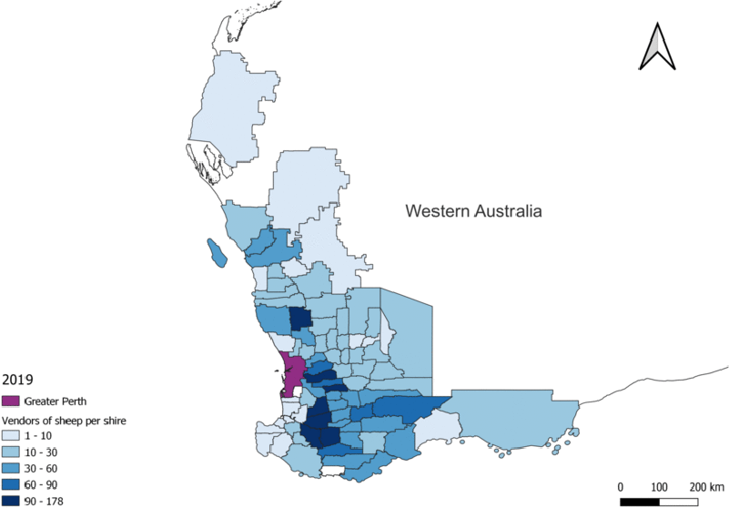

Sources: EP3, industry

It is estimated that the data used to create this animated graphic represents 70% to 80% of the trade. If you are viewing this document as a PDF the animation may not display – you can [view the animation on the EP3 website](https://episode3.net/content/uploads/2023/07/Producers-selling-to-LE.gif). You can also view each slide used in this animation in Appendix B of this report.

Seven LGA reported between 90 and 178 producers within their region selling into the live sheep export trade in 2019 and several other LGA indicated that 60 to 90 producers had utilised the live sheep export avenue for turnoff.

However, declining sheep export volumes over the last 5 years and reduced confidence in the longevity of the sector have seen the volumes of sheep producers, using live export as an avenue for turnoff, decline. As of 2023 just 4 LGA reported between 30 and 60 producers in their area turning off into the live export trade with the remaining LGA reporting between 1 and 30 producers in their region using the live export trade as a method of turnoff.

Several LGA that had reported 30 or more producers in their area using the live export trade as a method of turnoff in 2019 were reporting nil producers had used this option for turnoff in 2023.

Surveying of WA sheep producer intentions, should the live sheep trade phaseout proceed, was undertaken as part of this reporting process, and an alternative survey was also conducted by WA Farmer’s Federation (WAFF) and the Pastoralists and Graziers Association of WA (PGA) enquiring about sheep producer intentions.

Figure 39 WA sheep producer intentions

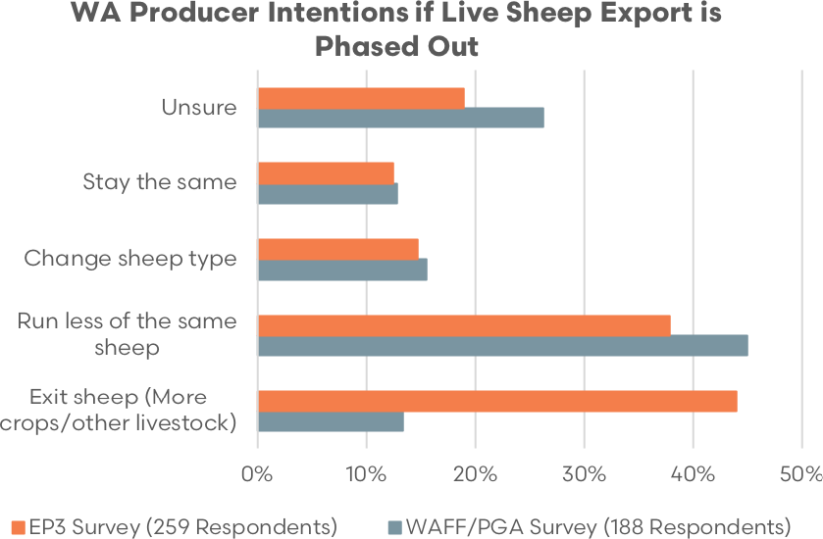

Sources: EP3

Survey results for each outcome do not sum to 100% as the producer had the option of choosing more than one decision, i.e. They could choose to run less of the same sheep and also choose to change sheep type.

A comparison of survey results for the WA producer intentions for the Episode 3 (EP3) survey versus the WAFF/PGA survey demonstrated similar outcomes for most options. There were between 19% to 26% of producers that were still unsure of their decision, nearly 13% were likely to stay the same and around 15% were opting to change sheep type. Between 38% to 45% of producers were intending to run less of the same sheep variety (most likely this would mean less Merino sheep).

Meanwhile, the largest variance in outcomes between the 2 surveys was regarding the option to exit sheep entirely. The EP3 survey discovered that 44% of sheep producers were intending to exit sheep in favour of cropping or another livestock mix. The WAFF/PGA survey suggested the option to exit was favoured by nearly 14% of respondents.

Additional to these 2 surveys, but also highlighting the developing negative sentiment for WA sheepmeat and wool producers was the [May 2023 MLA–AWI producer intentions survey](https://www.mla.com.au/globalassets/mla-corporate/prices--markets/documents/trends--analysis/sheepmeat-survey/spis---03-may-2023---final-report.pdf). Overall the national sentiment indicator for wool sector producers sat at a score of +13. However, in WA this sentiment was the lowest of all states at just +1.

Negative sentiment within the sheep meat sector in WA was even more pronounced with a score of −48. All other states recorded positive sentiment scores for their respective sheep meat producers, and this boosted the national overall to a sentiment score of +27.

In terms of breeding intentions, WA producers scored the lowest forecasted change to breeding ewe and whether flock size. WA producers have signalled an 18% drop in the breeding ewe flock compared to a 0% to 5% fall across all other states. Similarly, the WA wether flock was forecast to drop by 33% compared to a range of +3% to −15% for the remaining states.

Table 12 MLA-AWI sheep producer intentions

| Category | Topic | Overall | NSW | QLD | SA | TAS | VIC | WA |
| --- | --- | --- | --- | --- | --- | --- | --- | --- |
| – | Base | 1,958 | 646 | 68 | 291 | 77 | 470 | 405 |
| Sentiment | Nett sentiment – wool industry | +13 | +18 | +23 | +15 | +9 | +9 | +1 |
| Nett sentiment – sheepmeat industry | +27 | +36 | +50 | +29 | +47 | +40 | −48 |
| Breeding ewe flock profile | Estimate of total breeding ewe flock | 46.14M | 16.39M | 1.23M | 7.44M | 1.56M | 10.60M | 8.91M |
| Dominant breeds on hand: merino | 64% | 65% | 72% | 66% | 44% | 47% | 85% |
| Dominant breeds on hand: first cross | 14% | 16% | <1% | 12% | 5% | 25% | 2% |
| Dominant breeds on hand: prime lamb | 12% | 8% | 4% | 10% | 45% | 21% | 3% |
| Breeding ewe producer intentions | Reported breeding ewe flock size for 2023 | 46.14M | 16.39M | 1.23M | 7.44M | 1.56M | 10.60M | 8.91M |
| Forecast breeding ewe flock size for 2024 | 43.48M | 16.03M | 1.17M | 7.19M | 1.57M | 10.23M | 7.30M |
| Forecasted change in total breeding ewe flock | −6% | −2% | −5% | −3% | 0% | −3% | −18% |
| Producer-level intentions (ignoring size): increase from 2023 to 2024 | 30% | 33% | 55% | 27% | 31% | 27% | 19% |
| Producer-level intentions (ignoring size): no change | 38% | 38% | 22% | 40% | 50% | 41% | 35% |
| Producer-level intentions (ignoring size): decrease from 2023 to 2024 | 32% | 29% | 24% | 34% | 19% | 32% | 46% |
| Wether flock profile | Estimate of total wether flock | 9.20M | 3.50M | 0.46M | 1.04M | 0.32M | 2.11M | 1.76M |
| Dominant breeds on hand: merino | 87% | 83% | 79% | 87% | 96% | 89% | 91% |
| Dominant breeds on hand: first cross | 4% | 5% | <1% | 3% | <1% | 5% | 1% |
| Dominant breeds on hand: prime lamb | 3% | 4% | <1% | 3% | 3% | 4% | 2% |
| Wether producer intentions | Reported wether flock size for 2023 | 9.20M | 3.50M | 0.46M | 1.04M | 0.32M | 2.11M | 1.76M |
| Forecast wether flock size for 2024 | 7.92M | 3.22M | 0.47M | 0.89M | 0.30M | 1.87M | 1.18M |
| Forecasted change in total wether flock | −14% | −8% | +3% | −15% | −8% | −12% | −33% |
| Producer-level intentions (ignoring size): increase from 2023 to 2024 | 19% | 27% | 31% | 11% | 11% | 14% | 19% |
| Producer-level intentions (ignoring size): no change | 53% | 49% | 55% | 58% | 64% | 61% | 36% |
| Producer-level intentions (ignoring size): decrease from 2023 to 2024 | 28% | 25% | 14% | 32% | 24% | 24% | 45% |

Sources: MLA, AWI

There were 46% of WA producers that reported they intended to reduce their breeding ewe flock and 45% of WA producers that intended to reduce their wether flock during the 2023 to 2024 season.

The MLA-AWI survey reported that in WA the breeding ewe flock was expected to reduce by 1.6 million head and the WA wether flock by nearly 600,000 head by 2024. The MLA-AWI report specifically noted that the decision to phase out the live sheep trade was having a detrimental impact upon WA producer sentiment and flock intentions.

Producers in WA are having a clear dampening impact on the national results … The impending decision on the live export trade for sheepmeat is weighing heavily on these producers. ([May 2023 MLA–AWI producer intentions survey](https://www.mla.com.au/globalassets/mla-corporate/prices--markets/documents/trends--analysis/sheepmeat-survey/spis---03-may-2023---final-report.pdf))

In terms of expectations for industry assistance implemented as part of the transition to a phase out of the live sheep trade, WA sheep producers demonstrated a similar view to the outcome noted above for all survey participants combined. (see Figure 37).

Approximately three-quarters of WA sheep producers indicated that assistance to expand domestic processing capacity in WA and the development/expansion of export markets for sheepmeat were the top priorities.

Figure 40 Sheep producer

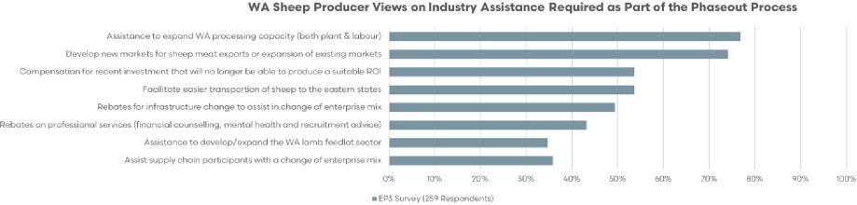

Sources: EP3

Filtering respondent attitudes towards assistance packages and removing sheep producer’s views saw a redistribution of views for some categories. The expansion of abattoir capacity and market access for sheepmeat exports were still top priorities among industry participant groups (excluding sheep producers). However, assistance to develop/expand the WA lamb feedlot sector also featured prominently with around 60% of respondents favouring this assistance option.

Figure 41 Other live export industry participants – industry assistance programs

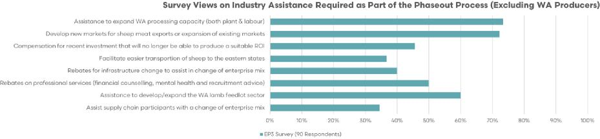

Sources: EP3

### B. Shearing services

Broadly speaking participants across the WA wool sector have expressed concern over the phase out of the live sheep trade and the implications this may have for the WA sheep flock, both in terms of flock size and composition. Many have expressed a concern that proceeding with the phase out will lead to reduced sheep numbers in WA and/or a reduced Merino mix in terms of sheep variety in favour of shedding sheep or composite sheep/wool breeds.

A reduction in Merino sheep numbers could have a negative impact on WA’s wool production volumes. For example, based upon the WA wool bale volumes sold last financial year, a 20% reduction in the WA Merino flock could reduce WA wool production by approximately 75,000 bales. While a reduction of wool bales of this magnitude would have an impact upon the entire WA wool supply chain there would be a significant impact upon shearing services.

Shearing services play a vital role in the live export supply chain, as all sheep need to be shorn before they can be exported. Various roles make up a shearing team, including shearers, wool classers, wool pressers, rouseabouts, and sometimes even a cook.

The retention of staff is already a challenge for shearing managers, and consultation with shearing industry representatives in WA indicate that it will become even more difficult if there is a halt in demand from the live trade.

Shearing services do not heavily rely on the purchase of technical inputs or other services for their operation. However, there is a significant benefit to regional and rural communities resulting from shearing contracting operations with shearing teams often spending on food, fuel and sometimes accommodation when travelling around the state undertaking shearing contracts.

Table 13 Live export contributions to WA wool sector

|  |  |  |
| --- | --- | --- |
| Per annum | 2022 estimate | 2017 estimate |
| Sheep Shorn | 496,000 | 1,610,000 |
| Wool Bales Produced (clean) | 6,889 | 22,361 |
| Shearing Revenues | $3,659,546 | $8,665,251 |

Sources: EP3, Industry

Based upon the declining numbers of live sheep export volumes seen from 2017 to 2022 there has already been a reduced contribution to the WA wool sector and shearing revenues attributable to the live export trade.

In 2017 1.6 million head of sheep were sent offshore as live export and as these sheep were expected to be shorn prior to departure, produced an estimated 2.5 kg of clean fleece per sheep, which would equate to around 22,361 bales (based upon a 180 kg bale). Estimated shearing revenues for this volume of sheep would equate to A$8.7 million (based on an average cost of $5.38 per sheep shorn).

A calculation of the contribution of the live export sector to shearing revenues and wool volumes based on the lower live export volumes seen in 2022 of just 496,000 head equates to 6,889 wool bales and A$3.6 million in shearing receipts (based on an average cost of $7.38 per sheep shorn).

Shearers surveyed as part of the consultation for this report feared that a smaller WA sheep flock and reduced holding of Merino sheep would result in less work. Most shearers indicated that they would exit the industry if work wasn’t available throughout the season.

In terms of government assistance to successfully transition away from the live export trade most shearers indicated that they would benefit from training to re-skill and/or assistance to relocate.

### C. Livestock transport operators

Livestock road transport operators in Western Australia are highly reliant on the live export trade compared to other participants in the value chain. The revenue generated from live exports plays a significant role in road transport businesses, often accounting for a substantial proportion, typically ranging from 25% to 50%. The revenue reliance on the live sheep trade for road transport operators in WA sits at 25% to 50% of total revenues according to the online surveying undertaken for this report and an earlier survey undertaken for the [Livecorp report into the live sheep export trade](https://assets.ctfassets.net/8fjsq0xyf4sy/62P1HVEflIuSpl74O0Ylai/89ae72890e8450d5b87ff38389130c3e/W.LIV.1001_Final_report_Phase_1.pdf).

Transporting livestock on roads necessitates specialised skills, customised vehicles, and specific facilities and loading equipment. Stock trucks are designed exclusively for transporting livestock, which limits the transportation opportunities available to these operators.

Due to the prohibition on live sheep exports during the summer period in the northern hemisphere, some individual truck operators have faced business closures. This prohibition has also caused a ripple effect on their suppliers in regional towns. Mechanics, engineers, welders, tire suppliers, and fuel depots have been affected as the side-lined trucks have had an impact on their businesses.

A recent survey of the Australian Livestock & Rural Transporters Association (ALRTA ) WA members indicated that:

the removal of live sheep exports would have an impact of between 30 and 40% to their bottom line. 64% of the respondents said they will need to terminate at least one driver and 27% would terminate more than two drivers. (ALRTA WA submission to the Live Sheep Export Phaseout Panel)

According to the ALRTA, the sale of sheep from farm to the live export trade requires 3.5 movements, on average. In comparison, sheep sold to a WA meat works would be moved just 1.5 times. The expansion of the feedlot sector for sheep in WA could see road transport utilised more frequently, akin to the multiple transportation points seen when sheep are turned off into the live export sector compared to domestic processing.

Surveying of WA transport operators undertaken by Episode 3 as part of this report demonstrated that nearly 40% of respondents intended to exit the industry if the live sheep export phaseout was to proceed.

Direct consultation with several transport operators indicated a consistent view that the phaseout would likely result in a 20% to 30% reduction in current staffing requirements for livestock transport operations. Operators indicated that the market for bulk haulage and transportation of livestock was competitive so they could not just expect to pick up alternative work in other areas if the live sheep trade was phased out and the phase out resulted in a reduced WA sheep flock.

Despite concerns regarding the difficulty in switching to alternative transport options around a third of operators surveyed suggested they would attempt to increase their bulk haulage transport if the live export trade was phased out. A further 14% intended to switch to other livestock transport options and 7% felt that their operation would be relatively unaffected by the live sheep phaseout.

Transport operators that intended to exit the sector or increase their bulk haulage raised concerns over the potential loss in value of livestock crates. Several transport operators consulted directly indicated that a new livestock crate cost between $700,000 and $800,000 and sold for between $500,000 and $600,000 second hand. There were fears that a glut of crates due to livestock operators exiting the sector or switching to bulk haulage could see prices for second-hand crates dropping below $400,000.

Similarly, most respondents to the ALRTA WA members survey:

said the phase out would result in the sale of equipment both trailers and trucks. Considerable anxiety was expressed about the likelihood of livestock crates losing value. A new set of livestock crates is worth between $500,000 – $600,000. Second hand, five year old crates typically sell for around $300,000 – 350,000. A glut of crates on the market will have a damaging effect on their saleable value. (ALRTA WA submission to the Live Sheep Export Phaseout Panel)

Figure 42 WA transport operator intentions

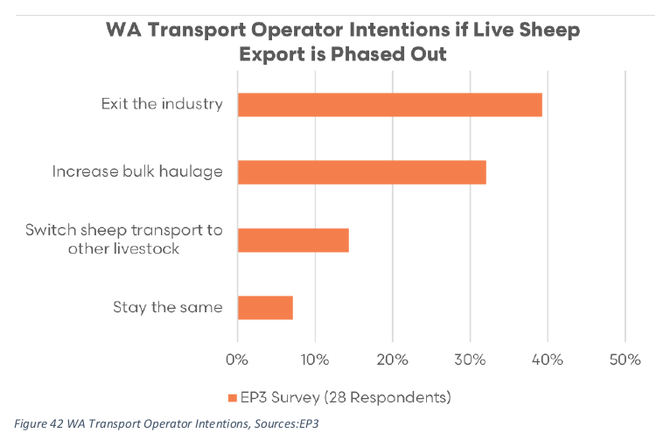

Sources: EP3

An assistance package such as a subsidy or fuel rebate to encourage transport of sheep west to east was well received by most WA transport operators. However, concerns were raised over the potential for animal activists to target long haul transport and the impact this may have for limiting a west to east turnoff option for WA producers.

Many transport operators thought financial compensation for investment in assets no longer providing the expected return on investment due to the live sheep phase out was appropriate, but unlikely to eventuate. Rebates/tax breaks or interest free loans to retrofit trucks for other haulage options was another common suggestion among several WA transport operators consulted.

### D. Feed mills and fodder suppliers

There are several feed manufacturing businesses located in regional Western Australia that supply feed products to live sheep exporters. The proportion of product sold to domestic markets versus live export varies among these businesses. For certain feed pellet manufacturers consulted, who primarily focus on supplying the live export market, over 90% of their revenue comes from this trade.

However, some pellet manufacturers consulted as part of this report noted that since the introduction of the live export prohibition period, they have moved their focus away from the live sheep trade toward the domestic/export feed pellet market or the live cattle feed sector and nowadays have between 5% to 25% of their business revenues exposed to the live sheep export trade.

A specific WA pellet manufacturer consulted, still heavily focused on supplying the live sheep export sector, noted a 54% decline in annual revenues over the last 5 years, since the beginning of the northern hemisphere summer prohibition. A fall in revenue of this magnitude would make sense given the annual live sheep export volumes have fallen by a similar degree, dropping from around 1 million head prior to the prohibition to around 500,000 head in recent years. Half the number of sheep being sent on live export vessels each year means half the feed needed to sustain them on the voyage.

Fodder manufacturers play an important role in providing employment opportunities in Western Australia. It is estimated that they directly employ around 100 staff members and also engage contract balers, bale stackers, engineers, mechanics, and producers of grain, hay, and straw. The 100 staff figure quoted is obtained from the Livecorp submission to the Live Sheep Export Phaseout Panel.

Live sheep shipments create a significant demand for feed and grain products in Western Australia. During the live export voyage, sheep are fed a high fibre pellet composed of approximately 50% hay or straw, 30% barley grain, 10% lupins, and the remaining portion consists of bulk roughage and urea. Chaff is also provided for bedding during the voyages.

Some feed pellet manufacturers consulted directly had already shifted their business model away from supplying the live sheep trade and had begun to focus more on the domestic feed market. However, several pellet manufacturers explained that their feed mills are dedicated to ruminant feed so are unable to switch to monogastric (pigs, meat chickens, layers) easily.

In the WA regions where straw and hay are supplied to fodder manufacturers, a substantial portion of work for contract balers and stackers is derived from the livestock export trade. WA feed and straw suppliers consulted as part of this report indicated that the average volume of straw/hay supplied per annum was around 3,000 tonnes per farmer (with survey results ranging from 1,000 to 6,000 tonnes of straw/hay) and the average volume of grain supplied per annum circa 6,000 tonnes per farmer (with survey results ranging from 200 tonnes to 15,000 tonnes). Several feed and straw suppliers had reported a 60% to 80% fall in demand since the live sheep export prohibition had come into effect with some growers noting that they had not sold anything to the live export feed pellet market during 2023 due to the falling live sheep export volumes.

The demand for straw and hay arises not only from fodder manufacturers producing feed pellets for use on board the ships but also from the registered feedlot facilities that hold sheep prior to departure. Hay and fodder growers rely on the livestock export trade, with their reliance on the trade in terms of revenues earned sitting between 5% to 25%, according to the online survey undertaken as part of this report.

Any changes in demand for contract balers and stackers have a trickle-down effect, reducing the volumes of straw and hay purchased from growers. This, in turn, impacts fodder growers. Additionally, a range of other participants, including rural merchandise stores supplying baling string, fuel suppliers, local mechanics, and transport operators, are also affected by the decreased workload for contract balers and stackers.

WA straw/hay growers indicated that there are limited options to sell their product, other than to supply to the feed pellet manufacturers. Export hay provides an outlet some years, but the demand is very sporadic and volatile. Currently, when there is no outlet for straw/hay the product is burnt rather than baled. Additionally, growers noted that feed pellets used in the live export trade use higher fibre content than the pellets used in the domestic/export feed market. Therefore, a switch to domestic/export feed markets would mean that the ration won’t utilise as much straw/hay inputs as the live trade.

Despite the concern of less straw/hay being utilised by the domestic/export feed pellet sector there was still enthusiasm expressed by feed mills and growers regarding an expansion of the export feed pellet market, an expansion of WA lamb feedlot operations and/or the expansion of an export hay market as alternative options for sale of straw/hay.

Figure 43 WA feed grain use by sector (2018 to 2022)

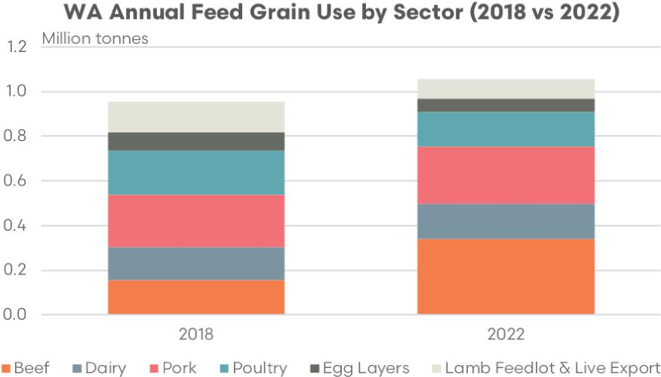

Sources: EP3, ABS, industry

Analysis of estimated WA feed grain use by the intensive livestock sector over the last 5 years has shown that the overall grain/feed pellet usage has increased marginally from 0.95 million tonnes to 1.05 million tonnes. Live sheep export numbers from WA have nearly halved from 2018 to 2022 and this has seen feed pellet demand decline by a similar magnitude. However, some of this reduction in feed pellet demand from the live sheep export sector has been offset by the development of the lamb feedlot industry.

Proportionally, most intensive feed sectors in WA have maintained their share of feed grain use over the last 5 years with the exception of the beef feedlot, lamb feedlot and live export sectors. WA beef feedlot share of feed grain consumption has risen from around 16% in 2018 to 32% in 2022. In contrast, the share of demand from the live export and lamb feedlot sector has declined from 15% in 2018 to around 10% in 2022. An expanded lamb feedlot sector in WA could replace the feed demand that has already been lost from a declining live sheep export sector and could potentially develop into an intensive livestock sector that matches the demand shown by the dairy and poultry sector.

Several straw/haw growers indicated that government funding or assistance provided to explore opportunities to use bio-waste like straw in green energy production or in the creation of biodiesel could be an alternative market for their product. However, the timeline for this option was long-term and still appeared to be a relatively speculative possibility.

### E. Lamb feedlot operators

Lamb feedlots are facilities where lambs are intensively raised and fed a controlled diet for the purpose of finishing and fattening them before they are ready for market. Feedlots provide an alternative to traditional extensive grazing systems, allowing for faster growth and consistent production throughout the year.

WA lamb feedlots vary in size and capacity, ranging from smaller operations to larger-scale facilities. The WA Department of Water and Environmental Regulation (DWER) allows for sheep producers to operate a feedlot on farm without the requirement for construction and operation permits if the feedlot holds less than 5,000 head. However, feedlots of any size still need to obtain planning approvals through their relevant shire.

WA has seen a significant change to the feedlot sector over the last decade. A noticeable shift has been towards WA processors investing in commercial-scale feedlots. V&V Walsh (Bunbury), Fletchers (Narrikup) and AusVision (Narrogin) have all invested in sheep feedlots in the last 5 to 10 years in an attempt to secure continuity of supply.

There were 2 feedlots consulted as part of this report and both were in the process of expansion. The smaller feedlot is currently running between 10,000 and 12,000 head of lamb with a present capacity capped at 18,000 head. If their expansion plans are successful, they would be increasing total capacity to 28,000 head. Consultation with WA lamb feedlots was only undertaken with 2 operators; therefore the information provided is somewhat anecdotal.

The Environmental Protection Authority (EPA) approval process is holding up their current permit to expand and there has been a 6-month delay on this process just for the EPA section alone. There has been no time frame given for when the EPA may reach a decision and the whole planning process to expand has been 3 years since the original approval to expand was sought.

At present, it is unknown how long the process will take to get final approval. If EPA permission was granted tomorrow, the feedlot operator estimates that it would still be a further 1.5 to 2 years to get construction completed, given constraints around building materials and building labour.

The larger feedlot surveyed is currently running 40,000 head. In 2022 they averaged 70,000 head. Present capacity is between 80,000 to 100,000 head, although they have run more than this when the season has allowed (there was a recent peak of 130,000 head, but this volume in the feedlot isn’t ideal given current capacity constraints). If their expansion plans are successful, they would aim to run between 300,000 to 400,000 head.

Both feedlot operators noted that obtaining permits are the biggest obstacle to expansion, particularly for those feedlots near private housing that require public amenity provisions and approvals by local residents. Expansion involving a green field site from start to finish is estimated at 5 to 6 years, assuming there are no unexpected delays. Expansion of existing sites can be faster, but this is not assured, as they can get bogged down in the EPA or amenity approvals process.

### F. Sheepmeat processors

Consultation was undertaken with most WA sheep meat processors as part of this report and several recurring issues were raised by these processors that are limiting their on-going capacity or expansion.

Episode 3 surveying identified that abattoirs processing sheep and lamb in Western Australia currently employ approximately 1,750 full-time equivalent (FTE) workers. On average, each abattoir sustains a workforce of around 300 FTE, although this figure can range anywhere from 110 to 800 FTE per facility.

However, should there be a phaseout of live sheep, the industry estimates that this number would need to significantly increase to about 3,200 FTE in total. This would equate to an average workforce of around 500 FTE for each abattoir, with some requiring as few as 110 FTE and others as many as 1,600 FTE.

However, securing a skilled and reliable workforce poses a major challenge for all abattoirs. This issue not only dictates what can be processed on any given day but also sets a limit on the overall capacity on a weekly or monthly basis. While it would be ideal to hire skilled labour, the current conditions make this difficult. As a result, many processors resort to on-the-job training, which typically takes 3 to 4 weeks for each employee to acquire the skills for a specific role.

The difficulty of finding local talent has led several processors to hire workers from overseas, although this approach has had varying levels of success. The current 3-year visa scheme has been deemed inadequate due to the lengthy training process and the time it takes to fully incorporate a new employee into the business operations.

Moreover, the shortage of suitable accommodation poses another significant hurdle. This challenge has prompted some processors to invest in existing housing facilities or even to build their own in order to provide accommodation for their workers. This situation underscores the complexities involved in managing and expanding the workforce in the abattoir industry.

Most processors are grappling with the issue of inadequate cold-store space, particularly in/around Perth. This problem is further exacerbated as major retailers occupy a portion of the existing space to ensure a steady food supply, particularly in anticipation of possible disruptions to the east–west supply chains.

Technological advancements in automation offer a potential solution to the dependence on labour for certain tasks. However, the associated costs often make implementation a prohibitive venture. Regardless, automation is deemed important for the industry as it presents opportunities to redeploy labour resources and modifies the skills suited to various roles.

Another key concern lies in the substantial costs of power, energy, and water, which can sometimes even hinder expansion plans. While there are opportunities for recycling and power generation, investments in these areas must be judiciously weighed against other priorities.

Several abattoirs have pinpointed the expansion of on-site chiller space as a significant capacity constraint. For instance, one abattoir has faced an 18-month delay in expansion, a predicament attributed to the local power company’s inability to install a larger transformer in the vicinity. This setback, which is needed to accommodate the increased power requirement for chilling, is not expected to be resolved for another 18 months.

In addition to chiller space, other operational areas such as feedlots, lairage, and boning rooms were identified as potential bottlenecks by several abattoirs. To mitigate part of their labour capacity issues in the long term, processors have suggested the provision of tax rebates or grants to install advanced technologies like robotics and DEXA scanning.

In terms of logistics, the recent collapse of Scott’s Transport Company has instigated a ripple effect, influencing some processors adversely. This has been further complicated by the substantial challenge of finding truck drivers, which in turn hampers the speedy mobilisation of containers.

Air freight presents another substantial concern. While the costs have returned to pre-pandemic levels, the availability of freight for exports, particularly to the Middle East, fluctuates based on the type of aircraft being used for passenger transport.

Additionally, the ongoing effects of the COVID-19 pandemic on the global supply chain are still perceptible. The inability of ships to unload products for several weeks or even months has resulted in an excess of stored goods. This situation continues to reverberate through the industry, adding another layer of complexity to the existing challenges.

WA processors are gearing up for the impending implementation of electronic ID systems for sheep. This transition necessitates substantial investment in infrastructure and the development of feedback mechanisms for producers. Moreover, some processors face challenges concerning the availability of veterinarians for meat inspection, primarily due to short-term appointments leading to shifting priorities among the inspectors.

There are also administrative obstacles that hamper progress, such as government red tape and increasingly stringent regulations imposed by certain state government departments, especially those concerning environmental standards. The complexity and complications surrounding the expansion of water treatment plants has been mentioned by some processors with several indicating that this might become a significant issue that will need to be addressed over the medium to long term.

Over the past 18 months, all operating abattoirs have signalled their intention to expand in the foreseeable future, either informally or through official development applications. Expansion timelines are projected to span between 3 to 5 years, and the scale of this expansion is largely contingent on the extent of government financial aid provided. The requested assistance ranges between 15 and 75 million Australian dollars.

However, several processors have pointed out that non-financial support, such as expedited approval processes for expansion, permits from the EPA, and enhancements to power infrastructure from the grid, would also significantly contribute to streamlining their expansion timelines.

#### Processor current capacity and potential capacity

Table 14 outlines the current estimated combined full capacity for WA processing for sheep and lamb is 106,000 head per week, although some smaller processors were not included in this total. This equates to approximately 424,000 per month.

As part of the consultation, WA processors were asked to provide an estimate of their capacity under the assumption that access to labour (including accommodation for additional staff) was not a barrier, offshore demand for their product was adequate and freight/logistics downstream of the plant were not problematic. Under this scenario, potential WA processing capacity for sheep and lamb increased to 140,000 head per week, which would equate to approximately 560,000 head per month.

Table 14 Estimated WA sheep and lamb slaughter capacity

|  |  |  |
| --- | --- | --- |
| Time period | Current limit  head/day | Potential capacity  head/day |
| Weekly slaughter | 106,000 | 140,000 |
| Monthly | 424,000 | 560,000 |

Sources: EP3, industry

### G. Veterinarians

Veterinarians engaged in the live sheep export industry take on specialised roles across various points in the supply chain. This could range from providing health services on farms, serving as Australian Government Accredited Veterinarians (AAVs) who prepare animals pre-voyage, acting as AAVs during the live export journey, or even working in research or government roles.

The degree of AAVs’ reliance on the live sheep export sector fluctuates based on their specific professional practice and their experience with different livestock categories. Surveys conducted for this study revealed that in Western Australia, AAVs derive between 5% and 25% of their income, on average, from the live sheep export trade. Moreover, many AAVs also step into the shoes of stock handlers as needed during the voyages.

The majority of the veterinarians surveyed indicated that they predominantly work on farms, thereby reducing their direct financial dependency on the live export trade. However, there is growing apprehension about the potential downsizing of the Western Australian sheep flock and its implications for the on-site services they provide to sheep producers.

Nonetheless, a handful of surveyed veterinarians who exclusively work on live export vessels expressed concerns about potential unemployment. These individuals would likely benefit from assistance to either relocate or seek alternative employment should the industry change significantly.

### H. Exporters

Live export companies are the supply chain participants most impacted by the proposed phaseout of the trade. The Australian Livestock Exporters Council (ALEC) has outlined significant investments made by several livestock exporters, or their subsidiaries, locally and offshore as part of their involvement in the trade. ALEC maintain that these investments would be subject to significant devaluation should the live sheep export phaseout proceed.

Kuwait Livestock Transport & Trading (KLTT) – recently built a new, modern slaughterhouse, compliant with the Australian Government’s Exporter Supply Chain Assurance System (ESCAS) requirements and purchased a new livestock carrier to enable them to meet requirements under Australian Standards for the Export of Livestock (ASEL) and Australian maritime regulations. These investments were valued around US$100m.

Rural Export and Trading Pty Ltd (RETWA), an Australian-based subsidiary of KLTT, invested heavily in a registered premises to hold sheep prior to departure, an office building and a feed mill. From 2018 to 2022 RETWA also spent around $650,000 (co-funded with MLA) on projects in the Middle East to improve animal welfare and facility operations. Livestock Shipping Services (LSS) – invested in the Australian supply chain and in destination markets based on Australian regulatory animal welfare requirements.

Since the company’s inception in 1998, they have built up a fleet of five livestock transport vessels that are approved by the Australian Maritime Safety Authority and have built an in-market consulting and development team devoted to improving livestock handling, animal welfare, food safety and meat hygiene in the markets of their customers. (Australian Livestock Exporters Council submission to the Live Sheep Export Phaseout Panel)

### I. Agency services

The livestock and property agency industry operates on a commission-based model, where revenue is largely dependent on the price and volume of transactions. Any price reduction experienced by producers directly impacts agency businesses. Reduced sheep prices, coupled with declining sales volumes, will inevitably have negative consequences for agency operations. Additionally, concerns arise regarding the potential changes in the sales environment under the circumstances of a live sheep export phaseout.

Agents play a significant role in sourcing sheep for the live export industry, which constitutes an important aspect of their business. The elimination of this market segment could remove a key revenue stream. If these animals are redirected to domestic markets for processing, there is a high risk that many of them will be sold directly to processors over-the-hooks, bypassing agents and thereby diminishing agency business.

The primary responsibility of agents is to identify the best livestock marketing option for their clientele. For a considerable number of sheep producers, the live export trade represents the most favourable choice. Agents earn commissions based on the prices achieved for the stock they sell on behalf of farmers. However, a prohibition on live sheep exports would lead to a decrease in the number of buyers, reduced competition in saleyards, and fewer marketing alternatives. These factors collectively contribute to lower prices received for livestock and subsequently diminish the returns for agents.

In the online EP3 survey conducted nearly 43% of livestock agents that responded indicated that the phaseout of the live sheep trade and the subsequent reduction in the WA sheep flock that could follow the phaseout would be significantly detrimental to their agency and that they would not have a sustainable operation. Similarly, 30% of wool agency businesses that responded to the survey felt that a phaseout of the trade would reduce the wool clip in WA by between 15% to 25% and this would result in a similar reduction in staff.

Agents have expressed concerns about the challenge of finding alternative buyers for lighter sheep and those sheep that are not within the processor specifications. Even sheep in a condition suitable for local processing are not guaranteed a sale, as many abattoirs face limitations in terms of labour capacity during peak periods.

In terms of wool agencies, Western Australia has a wool selling centre in Fremantle and an Australian Wool Testing Authority (AWTA) laboratory situated in Bibra Lake. These facilities were established to cater for the WA wool industry, which saw nearly 375,000 bales transacted in FY2021/22.

It should be noted that a reduction in wool production in WA would have negative impacts on both the Western Wool Selling Centre and Western Australian AWTA facility, with some industry people suggesting that the live sheep ban and predicted reduction in sheep numbers may see the closure of the selling centre. (Wool Producers Australia submission to the Live Sheep Export Phaseout Panel)

### J. Other live export sector participants

In addition to the categories of supply chain participants mentioned above, there are other businesses involved in the live sheep trade. These businesses work with exporters and importers to ensure the smooth transportation of each shipment. They include staff at registered facilities, sheep buyers, shipping services, dockworkers, livestock handlers, quality control experts, ship owners, and port authorities. These different entities play important roles in making sure the live sheep trade operates effectively, meeting key standards in terms of animal welfare and trade regulations.

Many of these participants, such as sheep buyers, registered facility staff and onboard livestock handlers that work completely within the live export process would be unemployed due to a closure of the trade. They have all indicated via the online survey that they would benefit from financial assistance to re-skill and possibly relocate as part of the phaseout transition.

## IV. Strategies to minimise the impact on stakeholders

The closure of the live sheep export trade channel presents a pressing need for the WA sheep industry to undergo substantial restructuring, given the absence of a viable alternative market capable of accommodating the significant volumes of sheep types currently supplied for live export. In order to mitigate the negative impacts of this closure, implementing effective strategies becomes imperative for the industry’s long-term sustainability and success.

### A. Phaseout timeline

Nearly 95% of survey respondents from across the live sheep export supply chain indicated that the phaseout process should take 5 years or more.

Given that new genetics are usually introduced into a flock via a new ram source, it takes 7 years for nearly 60% of the flock to carry the new genes. Thus, by year 7, in simplistic terms, the gross margin/DSE of the new flock will be halfway between the gross margin/DSE of the old flock and the new genetics. If the case is strong enough to change sheep genetics, then usually, the profitability by year 7 will be at a level that is sufficient.

Thus, if it takes 2 years to set up trials to provide evidence and proof of concept, and to have at least 3 years to run them to take into account seasonal variation (5 years would be preferable), then another 2 years of extension programs of the results and another 7 years to see that improvement in genetics to allow for the WA sheep flock to be profitable, the phase out might have to be 14 years in length.

Consultation with industry representatives regarding lamb feedlot expansion, processor capacity development, and cold-store logistics/growth in airfreight or sea-freight capability could take between 3 and 6 years to complete, with the assumption of no significant delays to the process. Meanwhile, developing and expanding offshore markets for boxed sheep meat could take 5 to 10 years to reach maturity.

Figure 44 Preferred timeline for phaseout

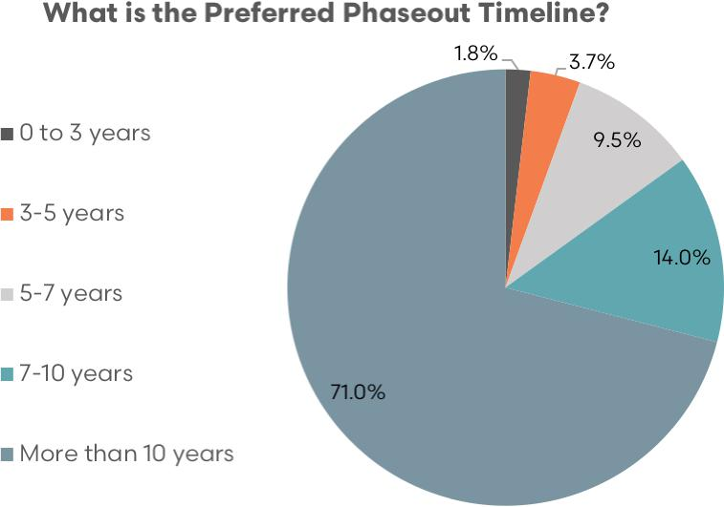

Sources: EP3

#### i. Analysis of the timeline for phaseout

The proposed phaseout of the live sheep trade has several impacts across the supply chain, with the transition requirements of many supply chain participants conditional upon key interrelated elements or supply chain adjustments to have taken place, in advance, in order to ensure a successful transition outcome.

An example of this supply chain reliance would be that consistent supply of sheep and lambs, that meet processor specifications for their destination markets, are available before processing plant capacity expansion such as lairage or cold store space is undertaken. Or, alternatively, to ensure that the supply of accommodation facilities is adequate in regional towns before the processor labour force is expanded.

Figure 45 provides an outline of the long-term phaseout process across several supply chain aspects identified for a successful transition, bearing in mind that year zero is set from when the phaseout process formally begins, not the current year.

It is assumed that the phaseout plan will be finalised by the Australian Government in late 2023 or early 2024 for implementation after the next election, which is most likely to be in 2025. Therefore, year zero in the timeline is estimated to begin in 2025.

Figure 45 Timeline for phaseout

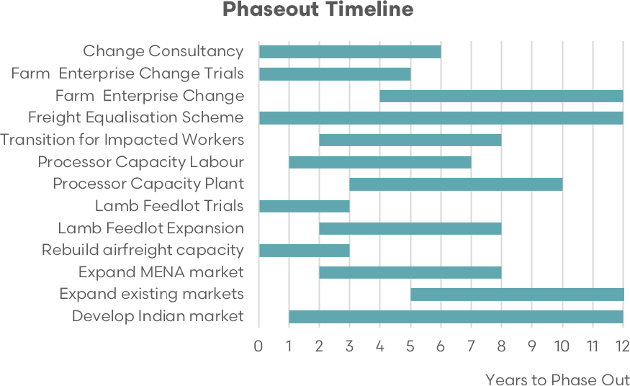

Source: EP3

Preliminary elements that would benefit from immediate action include funding for change consultancy, farm enterprise change trials, lamb feedlot trials and extension, redevelopment of sheep meat airfreight capacity (particularly focused upon the MENA region) and the introduction of an intermittent west to east freight equalisation scheme.

Change consultancy would encompass services relating to on-farm assistance to oversee enterprise change trials, extension staff to assist sheep producers unfamiliar with the lamb feed lotting process to trial the concept on farm at a small scale (under 5,000 head), financial counsellors to assist with cashflow, budget, subsidy/rebate applications and management of debt, recruitment specialists to assist with preliminary assessment of training and development services to assist impacted workers likely to need retraining/redeployment and relocation during the transition phase, and mental health counselling services as needed.

Farm enterprise change trials would likely require formal approvals from animal ethics committee, which can take 2 years to set up, and, ideally, the trials would run for several years to account for any potential seasonal variations.

Lamb feedlot trials and extension work relevant to this process would be focused on sheep producers not experienced with feedlot design, animal welfare requirements within a feedlot environment and feedlot management practices. This program would be directed towards small scale on-farm feedlot operations and act as a proof of concept for WA sheep producers to demonstrate that lamb finishing via an intensive system is a viable option for their enterprise and that it could help them manage risks associated with the shorter growing season specific to the Western Australian context. This program would be separate from the assistance provided to commercial large-scale lamb feedlot operators as part of their initial development or expansion plans.

Redevelopment of sheep meat airfreight capacity refers to a targeted approach to increase air traffic flows, particularly from the MENA region, in order to enhance market access for Middle Eastern lightlamb carcass (mainly for Merino types) via the return flights from WA to the MENA region. This could also encompass a dedicated subsidy program to support cargo only flights such as the International Freight Assistance Mechanism (IFAM) that operated during Covid disruptions to international air passenger movements that limited airfreight access for ‘bag lamb’ to the Middle East. Refer to section IV D ii of this report for additional detail on the airfreight access to MENA.

An intermittent scheme of freight equalisation for transfers of sheep and lamb from WA to the east would be a subsidy-based program available throughout the entire transition phase, but only when price discounts between WA sheep and lamb compared to their eastern equivalents were historically excessive. Refer to section IV B ii of this report for additional detail on the west to east freight equalisation scheme.

Secondary elements to the transition, mainly spanning years 2 to 8, include transition packages for impacted workers, increased abattoir labour capacity (including worker accommodation), increased abattoir plant capacity, commercial lamb feedlot expansion and further development to boxed sheepmeat access into the MENA market.

In the initial phase of the phaseout transition it is not expected that significant numbers of supply chain workers will be impacted by the eventual closure as live sheep export volumes are likely to remain relatively stable, or potentially increase slightly as pricing has returned to more globally competitive levels.

However, as the transition phase builds momentum, capacity for WA processing and feed lotting grows, and alternative boxed product turnoff options increase, the live export volumes will begin to decline, and targeted transition packages will need to be available during the middle of the phaseout for impacted workers. These transition packages would include training/development programs for workers to be re-skilled, assistance to relocate workers (where applicable) and programs to assist with the mental health or any financial difficulties faced by workers undergoing this transition.

Access to labour is a primary obstacle for WA processors wishing to increase sheep and lamb throughput and non-plant processing capacity. Many processors have indicated that the existing labour visa schemes for offshore workers are not entirely fit for purpose, and a secondary barrier to the expansion of offshore workers is the access to accommodation for these workers in regional areas.

Any attempt to increase offshore worker capacity will need to address accommodation requirements prior to any significant lift in offshore abattoir staff. Refer to section IV D i of this report for additional detail on the WA regional accommodation constraints. Alternatively, domestic labour could be utilised to fill the gap in abattoir labour access. However, processors have indicated an unwillingness to work in the meat processing sector is prevalent among many potential candidate groups.

Furthermore, several processors have indicated that shortfalls in current training and development programs for meat workers offered at registered training organisations (RTOs) or within the TAFE sector would need to be suitably addressed in order to develop a domestic workforce. Refer to section IV D i of this report for additional detail on the training and development constraints for domestic abattoir labour, including potential program options for an indigenous abattoir workforce.

WA processors have outlined that labour capacity constraints are a short to medium term barrier to their throughput expansion. In contrast, plant infrastructure upgrades pose a more medium to longer term obstacle to expansion. Part of the delay in the expansion of plant-based capacity is due to regulatory requirements such as EPA permits and access to power.

However, some WA processors are reluctant to expand plant capacity due to concerns over the ongoing continuity of sheep/lamb supply throughout the season and market access for their product. Expansion of the WA commercial lamb feedlot sector and further development of offshore markets for boxed products will be useful to help alleviate processor concerns around the supply of livestock and growth in offshore demand.

Therefore, the long-term timeline for phaseout would benefit from increased feedlot capacity and further export destination market development to run concurrently to the abattoir expansion phase so that the supply/demand considerations of these sectors are matched.

The commercial lamb feedlot expansion phase is targeted to existing WA large-scale lamb feedlots looking to expand and any proposed large-scale greenfield sites. Assistance offered could include financial support such as matched funding grants, rebates or interest-free CPI indexed loan programs to encourage investment in feedlot operations.

Additionally, there could be non-financial assistance provided to fast track the regulatory process within the council permit application phase, the EPA approval phase or during consultation with residents and other stakeholders that may object on amenity grounds to feedlot expansion or new feedlot development in their area.

An increase in airfreight capacity could alleviate some immediate pressure on sheep and lamb turnoff in WA, particularly if there was a focus on ‘bag lamb’ market trade to the MENA region. However, additional development of the MENA boxed market into the middle of the phaseout period could see the volume of higher value, more processed cuts of WA lamb/sheep product expand.

Consultation with the Meat & Livestock Australia MENA in market team suggests that a targeted business development and marketing plan in the region could see an increased proportion of the export trade focused on boxed product, such that the declining market share of the live trade from Australia due to the phase out of the live sheep export industry is somewhat offset. Refer to section IV D ii of this report for additional detail on the expansion of the MENA boxed market.

Final elements to the long-term transition timeline that would take us through to the end of the live sheep export phaseout process would include the completion of WA farm enterprise change, expansion of the existing sheep meat export market access to destinations like China, USA and South East Asia, and the development of a sheep meat export market into India.

Tracking gene flow, as outlined in Merinos, Money and Management by Dr Fred Morley, which is referenced later, takes about 7 years after new genetics are introduced via a new ram source to represent nearly 60% of the flock’s genetic makeup. Sometimes heterosis may help to speed the gains up. In the case of moving from a typical flock that was selling live export wethers to a flock based on Dual Purpose Merinos, a similar level of profitability may be restored by about year 7 when the flock’s gross margin is likely to be similar to that of a typical flock before a live export ban.

As the live sheep phaseout progresses and WA producers begin to make on farm flock adjustments, the composition of sheep/lamb types being turned off for processing may move away from Merino types toward composite/crossbred sheep, prime lamb operations (where suitable) and potentially shedding varieties.

This pathway could mirror the adjustment in flock composition seen in the eastern states over the past few decades and will result in more WA sheep and lamb turn off that will be a better match the export specifications that exist for key existing destinations such as China, USA and South East Asia.

Funding for the ongoing development of these existing markets in terms of consumer preference surveying, targeted business development programs, trade fairs and the expansion of market access will be helpful to ensure that the additional domestically processed products from the increased feedlot and abattoir capacity in WA will find a suitable offshore outlet, at the right price.

Australia now has a free trade agreement with India that includes a preferential tariff regime for Australian sheep meat exports. However, there is presently limited market penetration into India for Australian sheep meat due to low per capita Indian sheep meat consumption levels, relatively low per capita GDP and an Indian sheep flock that satisfies their present consumption requirements.

Indian population, per capita income levels and meat consumption is anticipated to grow in the coming decades. Australia has the opportunity to expand the presence of sheep meat exports into this market, but it will need to be built from the ground up.

To effectively penetrate the Indian market with Australian sheep meat exports, a comprehensive 10 to 12 year business development and marketing plan has been provided. Greater detail on the Indian sheep meat export strategy is outlined in section D ii. The plan commences with a thorough market research and analysis phase during the initial 2 years to understand Indian consumer preferences, competitor landscape, economic indicators, and the regulatory environment.

Subsequently, the next stage involves building relationships and forming strategic partnerships over years 2 to 4. This entails identifying local partners such as importers, distributors, and retailers, establishing connections with local industry bodies and government institutions, and considering joint ventures for seamless market entry and mutual growth.

The following phase, spanning years 4 to 6, centres on product localisation and branding. This involves tailoring products to local preferences, establishing a strong brand narrative emphasising the quality, safety, and sustainability of Australian sheep meat, and leveraging local media for marketing.

From years 6 to 8, the plan focuses on strategic market entry and gradual expansion. Initially targeting the affluent urban population in major cities, the expansion could progress towards smaller cities and towns as brand recognition increases.

Investment in cold chain infrastructure constitutes the strategic focus for years 8 to 10, with an emphasis on ensuring reliable distribution and potential collaborations with local logistics firms.

Finally, the last phase, from years 10 to 12, promotes community engagement and corporate social responsibility initiatives to build an ongoing positive brand image for Australian sheep meat exports. This includes investing in local communities and incorporating shared Indian/Australian values into corporate social responsibility strategies.

#### ii. Analysis of the Differing Time Periods for Phaseout

The proposal to phase out live sheep exports involves considering 2 potential timeframes: short term (5 to 8 years) and long term (8 to 12 years). Each period has distinct advantages and challenges that necessitate thorough evaluation.

The short-term timeframe would benefit from significant financial transition assistance, given the rapidity of the proposed shift. Within 5 to 8 years, there may be insufficient time for the complete development of export markets, expansion of domestic processing capacities, and smooth transition to alternative sheep farming enterprises. The rapid pace may also result in more social disruptions and economic uncertainty, especially in regions heavily reliant on the live export industry.

Conversely, the long-term timeframe of 8 to 12 years could potentially be a more cost-effective and stable approach. A longer transition allows a gradual shift in business models, a more measured development of markets, and smoother supply chain adjustments. It also provides ample time for obtaining permits for feedlot and processor expansion, capacity building, and infrastructure development.

The success of either phaseout plan, however, is significantly tied to the sequence and timing of transitional elements across the entire supply chain. Certain foundational adjustments need to be implemented before subsequent changes can take effect. For instance, before processing plant capacity can be expanded, there needs to be a reliable and consistent supply of sheep and lambs that meet the processor specifications for their destination markets. Similarly, adequate accommodation facilities in regional towns need to be ensured before ramping up the processor labour force.

Moreover, infrastructure and technology changes, such as automation and more efficient processing methods, would benefit from substantial planning, investment, and workforce training before implementation. A longer transition period is more conducive to these interrelated changes and allows for a structured transition plan that minimises disruptions and maximises benefits.

Therefore, the long-term timeframe appears to provide a better pathway to a successful transition outcome, particularly given the complex interdependencies within the supply chain. It facilitates a gradual, well-planned adjustment that respects the sequence of changes, safeguards stability, and ultimately optimises the phaseout’s benefits for all involved stakeholders.

Outlined [below](#_Short-term_timeframe_(5–8) is a SWOT (Strengths, Weaknesses, Opportunities, and Threats) analysis for both the short-term (5 to 8 years) and long-term (8 to 12 years) timeframes for the phaseout of live sheep trade:

##### Short-term timeframe (5 to 8 years)

###### Strengths

Rapid transition: A quicker adaptation to global market trends in some high-value markets favouring processed meat over live exports.

Potential for quick gains: If executed well, short-term discomfort could lead to faster realisation of new market opportunities.

###### Weaknesses

High financial burden: May require substantial financial assistance from the government to facilitate the transition.

Potential instability: The fast pace of change might result in socio-economic disruptions, particularly in regions heavily reliant on the live export industry.

Insufficient development time: May not provide adequate time to fully develop export markets and expand domestic processing capacities. May not allow enough time for trials/proof of concept trials to maintain confidence in the sector that a positive outcome from the phaseout will be possible. May not allow enough time for genetic changeover in flock composition.

###### Opportunities

Innovation: The urgency of the situation may spark innovation in sheep processing methods and marketing strategies.

Social licence: Rapid end to live export could signal animal welfare concerns, expressed by some members of society, are a priority for the Australian sheep industry and could improve the image and social licence of the Australian sheep industry, improving the consumer perception of Australian boxed sheepmeat export products in key high value offshore markets.

###### Threats

Supply chain disruption: Fast changes could strain the supply chain, leading to possible disruptions.

Market loss: A rushed transition could lead to market loss if supply chain adjustments are not completed in time to meet market demands and existing live export markets shun Australian boxed sheepmeat export product due to a perceived lack of reliability.

##### Long-term timeframe (8 to 12 years)

###### Strengths

Gradual transition: Allows for a smoother shift in business models, markets, and supply chain adjustments. A longer time frame allows for specific foundational adjustments in one segment of the supply chain to be completed before subsequent changes that rely upon the earlier adjustment can take effect.

Financial efficiency: Likely to require less financial assistance from the government as changes are spread over a longer period.

Regulatory requirements: Extended timelines might allow for enough lead time to deal with potential delays in obtaining permits for feedlot and processor expansion, and other formal regulatory approvals.

###### Weaknesses

Prolonged adjustment period: It may take longer for the Australian sheep industry to reap the benefits of new market opportunities.

Possible complacency: Longer transition periods may result in slower progress if urgency is not maintained and a structured, well planned approach to the phaseout is not executed.

###### Opportunities

Market development: Provides sufficient time to establish new markets and expand domestic processing and lamb feedlot capacities.

Workforce transition: Allows for a more orderly transition and training of the workforce into new roles and technologies.

###### Threats

Global market changes: During the longer transition period, unexpected shifts in global demand or competition could occur.

Overall, both timeframes have their own unique strengths and challenges. However, the long-term timeframe provides a better balance between managing transition costs and minimising supply chain disruptions while allowing the industry to adapt to global market trends.

### B. Identify options to support the transition by farmers

#### i. Investigation into alternative WA farm enterprise mix

##### Typical flock, currently producing wethers for live export

The current enterprise simulation results in an average gross margin of $637/ha or $53/DSE at an optimised stocking rate of 12.8 DSE/ha annual average and 12 DSE/ha mid-June stocking rate. The boxplot displays the variation in gross margin/ha, which is $74/ha standard deviation given seasonal variation over the simulation period of 1 Jan 1957 to 31 Dec 2019.

Figure 46 Variation in gross margin/ha for the typical flock selling live export wethers

Variation in gross margin per hectare for live export wethers


Source: GrassGro simulation

Figure 47 Variation in pasture herbage availability over time for the typical flock selling live export wethers

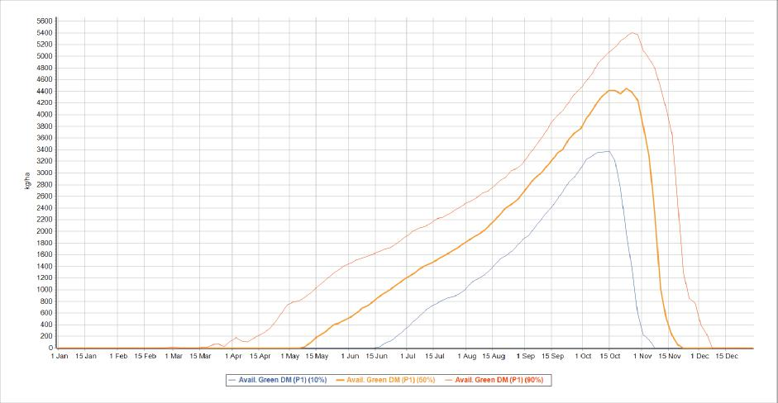

Source: GrassGro simulation

Figure 48 Variation in wether body weight over time for the typical flock selling live export wethers

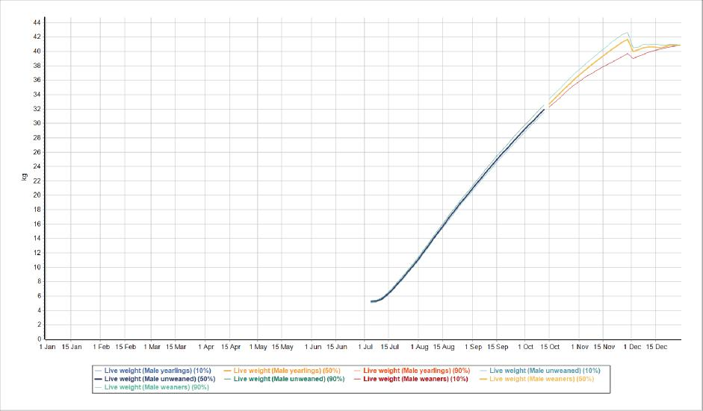

Source: GrassGro simulation

##### Typical flock, still producing wethers but live export banned

The current enterprise simulation results in a gross margin of $531/ha or $44/DSE at 12 DSE/ha mid-winter stocking rate. The boxplot displays the variation in gross margin/ha, which is $82/ha standard deviation given seasonal variation over the simulation period of 1 Jan 1957 to 31 Dec 2019. The variation is similar to selling wethers as shippers but is at a lower level due to the lower price received for wethers once they can’t be shipped on a boat, along with other sale stock.

Figure 49 Variation in gross margin/ha for the typical flock live export banned

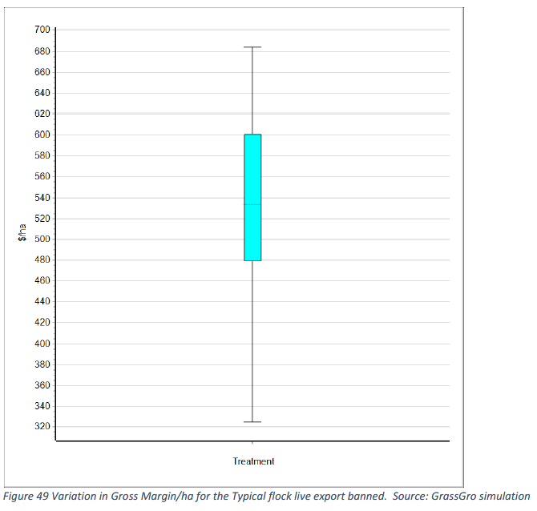

Source: GrassGro simulation

##### Running wethers through to 1.5 year old rather than to sell as wether lambs

A relatively easy enterprise to change to is to keep wethers on the farm and run them for at least another year. This results in a decrease in ewe numbers to maintain a similar number of sheep run through each year, but the mid-winter stocking rate is kept at 12.0 DSE/ha.

This enterprise has a gross margin of $513/ha or $43/DSE at 12 DSE/ha mid-winter stocking rate and an annualised average stocking rate of 12.3 DSE/ha. The boxplot displays the variation in gross margin/ha, which is $74/standard deviation given seasonal variation over the simulation period of 1 Jan 1957 to 31 Dec 2019. This is similar to the seasonal variation in gross margin/ha to the typical live sheep enterprise, but there is more upside variation.

Thus, banning live export with 500,000 wether lambs flooding onto the domestic market results in 17% drop in gross margin, or $9/DSE less.

Figure 50 Variation in gross margin/ha for the typical flock running wethers to 1.5 year old

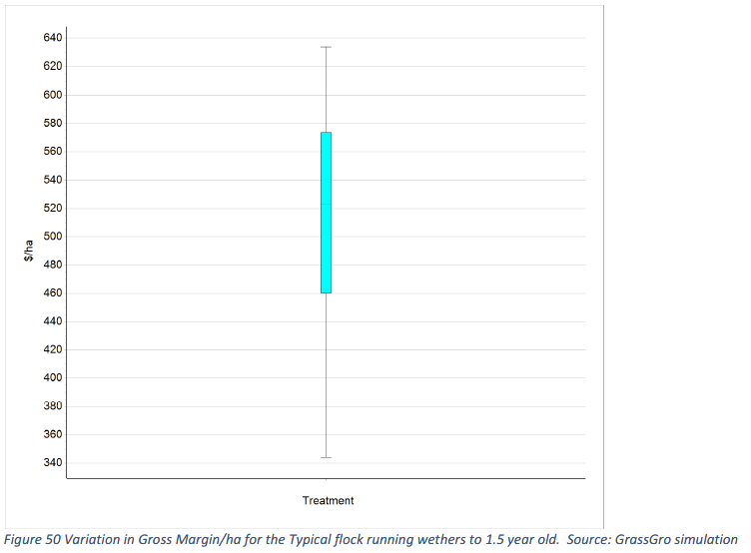

Source: GrassGro simulation

##### Typical flock, lambing later and selling lambs to Airfreight

Ewes lamb in August, and due to lower nutritional requirements in winter, more ewes can be carried through winter, with the number adjusted to have the same winter stocking rate as the typical live export wether flock.

Thus, despite the lower value of lamb/ewe produced, more lambs, more mutton and more wool are produced per hectare of pasture due to more ewes running through the winter with lower energy requirements/ewe due to lambing later.

Targeting the airfreight market results in a gross margin of $693/ha or $58/DSE at 12 DSE/ha mid-winter stocking rate and an annualised average stocking rate of 13.8 DSE/ha.

The boxplot displays the variation in gross margin/ha given seasonal variation of $84/standard deviation over the simulation period of 1 Jan 1957 to 31 Dec 2019. This is considerably higher than the seasonal variation in gross margin/ha to the typical live sheep enterprise, but there is more upside variation, with the lowest gross margin/ha higher than the current typical flock.

Figure 51 Variation in gross margin/ha for the typical flock lambing later airfreight lambs

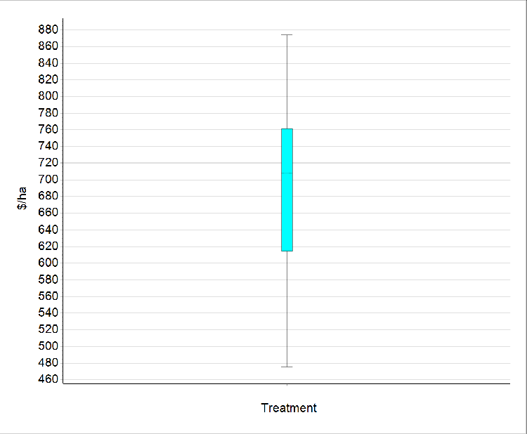

Source: GrassGro simulation

##### Domestic trade lamb and WA export lamb

A larger Dual Purpose Merino genotype enables a store lamb to be produced earlier, so it can be backgrounded and finished at on stubbles, summer fodder crops or a feedlot. Thus, this enterprise is essentially a store lamb enterprise, but these lambs could be backgrounded or finished potentially on the same farm.

However, it is anticipated that in most instances, they would be sold to a backgrounder/finisher. These lambs ultimately will be needed to gain further weight to reach a target carcass weight of 19 to 22 kg for domestic trade lamb and some US export markets. Merino is very acceptable for this market.

The store lamb enterprise results in a gross margin of $583/ha or $49/DSE at 12 DSE/ha mid-winter stocking rate and an annualised average stocking rate of 12.3 DSE/ha. The boxplot displays the variation in gross margin/ha of $74/standard deviation given seasonal variation over the simulation period of 1 Jan 1957 to 31 Dec 2019. This is similar to the seasonal variation in gross margin/ha to the typical live sheep enterprise.

Figure 52 Variation in gross margin/ha for dual purpose merino producing store prime lambs

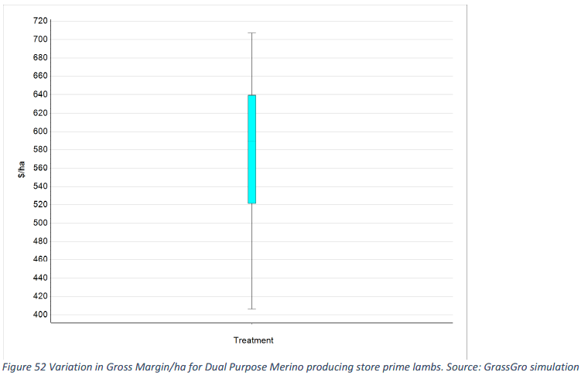

Source: GrassGro simulation

The store lamb enterprise begs the question: where will they be backgrounded and finished?

This has been examined by [Dr Graham Lean for DPIRD previously in 2017](https://www.agric.wa.gov.au/sites/gateway/files/Lamb%20Backgrounding%20for%20WA%20report_0.pdf). The critical findings from this project were:

* Cheap backgrounding of lambs enables lambs to be grown out from store lamb suppliers to be ready for feedlot entry (as one way of finishing them).This could be achieved by standing fodder crops such as oats, lupins or other mixes.
* Using Pallaton Raphnobrassica to finish lambs in the Great Southern and the traditional cattle zone of southwest Western Australia.
* Using faba bean stubbles as is the case in the Eastern States.
* On pastures in the later spring on the south coast and the cattle zone of southwest Western Australia.
* Forward contracts were potentially a way to facilitate the risky finishing of lambs, particularly out of season lamb finishing in a very dry WA summer environment

Backgrounding and finishing options will be discussed later in this section.

##### Superfine wool flock running 3 age groups of wethers

The typical flock producing live export wethers has been focussed on meat production efficiency, hence when wethers are retained, the enterprise underperforms due to the lack of meat sales not being balanced from additional wool sales.

However, more productive superfine wool producers have tended to increase fleece value/head as a priority, with considerable success. Fleece value is a function of clean fleece weight and fibre diameter, which are both highly heritable traits in sheep.

Reproductive rates are lowly heritable, so are slow to make genetic gain quickly. This superfine flock is representative of the best superfine genetics accessed based on the Fibre Production Plus (FP+) index as published by Sheep Genetics Australia. This was the same screening process that was used for the Dual-Purpose Merino.

The Superfine enterprise gross margin was $819/ha or $68/DSE at 12 DSE/ha mid-winter stocking rate and an annualised average stocking rate of 13.4 DSE/ha. The boxplot displays the variation in gross margin/ha given seasonal variation of $89/ha standard deviation over the simulation period of 1 Jan 1957 to 31 Dec 2019. This is similar to the typical live sheep enterprise, but there is more upside, with the lowest gross margin/ha similar to average of the current typical flock.

Figure 53 Variation in gross margin/ha for superfine merino running 3 age groups of wethers

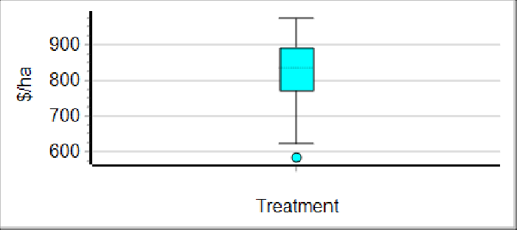

Source: GrassGro simulation

That this enterprise is very profitable is not a surprise given similar results in the Eastern States, based on the last 5 years commodity prices, and anecdotal reports in Western Australia. What is a surprise is the lack of enthusiasm for this type of enterprise in Western Australia. Certainly it is a departure from the meat focus the industry has had for some time.

One of the common objections put forward by WA farmers for running more wethers is that more sheep will be carried over the dry summer. This is a legitimate concern, but with the crop stubble area available, the risk of overgrazing summer pastures is considerably reduced.

In fact, similar numbers of sheep are run in both enterprises. The typical live export enterprise carries about 7 adult ewes/ha. The Superfine Merino enterprise carries about 8 adult ewes and wethers/ha.

Wethers also allow easier management of variable seasonal conditions due to their nutritional requirements not being so demanding and can be run safely at a lower condition score. Moreover, if seasonal conditions are too poor, then they can be easily sold off. This is not an option for lambing ewes.

##### Shedding sheep flock

There is currently a lot of interest in shedding sheep enterprises in Western Australia due to the scarcity of shearers. The key issues to this being a quick fix for the Western Australian sheep industry, as for other flock genotype changes, is the long time period it takes for the flock to be changed over genetically.

Given the assumptions for a shedding sheep enterprise outlined previously, gross margin was $260/ha or $22/DSE at 12 DSE/ha mid-winter stocking rate and an annualised average stocking rate of 12.0 DSE/ha. The boxplot displays the variation in gross margin/ha given seasonal variation of $73/ha standard deviation over the simulation period of 1 Jan 1957 to 31 Dec 2019. The best result over the simulation period was less than the average for the typical flock producing live export wethers.

Figure 54 Variation in gross margin/ha for shedding sheep

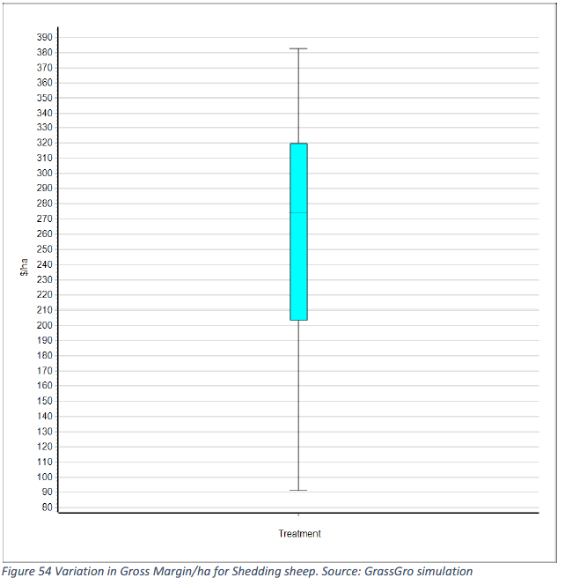

Source: GrassGro simulation

##### Self-replacing cow/calf enterprise

Self-replacing cow/calf enterprise have been run successfully in the Great Southern in the past but have tended to be replaced over sheep since the middle of the 1970s following the beef crash of 1974.

The Self-replacing cow/calf enterprise results in a gross margin of $581/ha or $48/DSE at 12 DSE/ha mid-winter stocking rate and an annualised average stocking rate of 12.9 DSE/ha. The boxplot displays the variation in gross margin/ha given seasonal variation over the simulation period of 1 Jan 1957 to 31 Dec 2019. This is more than the seasonal variation in gross margin/ha to the typical live sheep enterprise.

Beef prices have been strong over the last 5 years, so it is possible they may be lower in the future. Most farmers in the Great Southern do not have effective infrastructure to handle realistic numbers of cattle to run a modern beef enterprise efficiently and safely.

Figure 55 Variation in gross margin/ha for self-replacing cow/calf enterprise

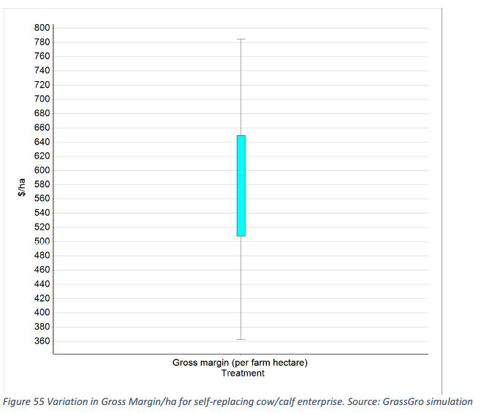

Source: GrassGro simulation

##### Trading steer enterprise

This enterprise is one of the most profitable enterprises in the Eastern States but due to large swings of buy-in and selling prices, has a history of volatile returns. The Trading steer enterprise results in a gross margin of $1,244/ha or $104/DSE at 12 DSE/ha mid-winter stocking rate and an annualised average stocking rate of 7.8 DSE/ha.

This annual average stocking rate is low due to the period of destocking over the summer and autumn. The boxplot displays the variation in gross margin/ha given seasonal variation over the simulation period of 1 Jan 1957 to 31 Dec 2019. While this is a very high gross margin, caution must be exercised about the prospect for beef prices going forward to match the high prices experienced over much of the last 5 years.

Further, there are a number of issues with the prospects for this enterprise in Western Australia. Namely:

* Availability of store steer calves to purchase. At best, given the current local availability of this type of stock from other producers running a cow/calf enterprise this enterprise is only likely to be run by a small number of producers.
* If calves are sourced from northern WA, such as the Gascoyne, there is a reasonable Bos indicus content in these young steers, which limits the attractiveness of the steer at the feeder entry stage. There is also the high cost of transport.
* But these steers have been accessed in the past by southern producers and have been a profitable enterprise.
* The availability of feedlot capacity for large numbers of backgrounded steers in WA.

Figure 56 Variation in gross margin for trading steer enterprise

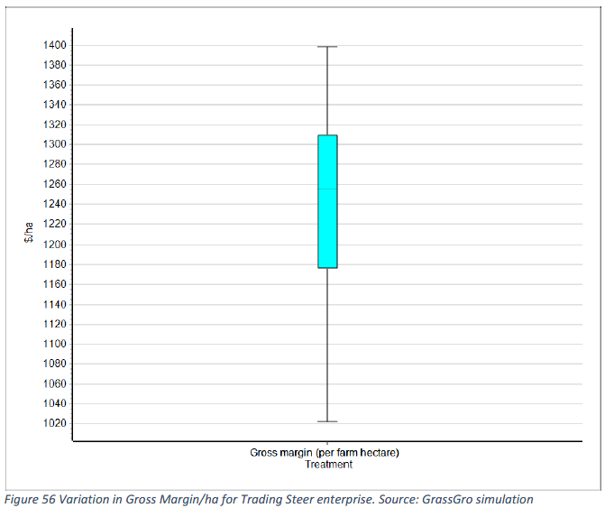

Source: GrassGro simulation

##### Sensitivity study of enterprises in Central Wheatbelt

The current enterprise producing live export wethers when situated at Wongan Hills was tested by a GrassGro simulation lambing in June. This results in an average gross margin of $245/ha or $35/DSE at an optimised stocking rate of 7.1 DSE/ha annual average and 7.0 DSE/ha mid-June stocking rate.

This lower gross margin/DSE at Wongan Hills compared to Kojonup is due to the higher feeding costs at Wongan Hills. In fact, this is unlikely as there should be more stubbles available at Wongan Hills to feed the sheep at no cost.

There is considerably more variation in the gross margin/ha at Wongan Hills, which is expected due to a shorter and variable pasture growing season. The variation in gross margin/ha, which is $89/ha standard deviation given seasonal variation over the simulation period of 1 Jan 1966 to 31 Dec 2019.

Figure 57 Variation in gross margin/ha for Wongan Hills export wether enterprise

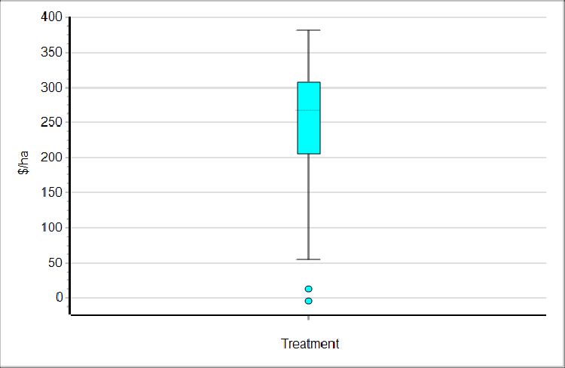

Source: GrassGro simulation

The Airfreight later lambing flock was tested at Wongan Hills with a 1st August lambing. This results in an average gross margin of $281/ha or $40/DSE at an optimised stocking rate of 8.3 DSE/ha annual average and 7.0 DSE/ha mid-June stocking rate.

The later lambing enables a stocking rate of 4.5 ewes/ha to be carried through winter lambing in comparison to 3.0 ewes/ha with a June lambing. There is considerably more variation in the gross margin/ha at Wongan Hills, which is expected due to a shorter and variable pasture growing season. The later lambing also results in more variation, depending on the seasonal conditions. The variation in gross margin/ha, which is $127/ha standard deviation given seasonal variation over the simulation period of 1 Jan 1966 to 31 Dec 2019.

Figure 58 Variation in gross margin/ha for Wongan Hills airfreight lamb enterprise

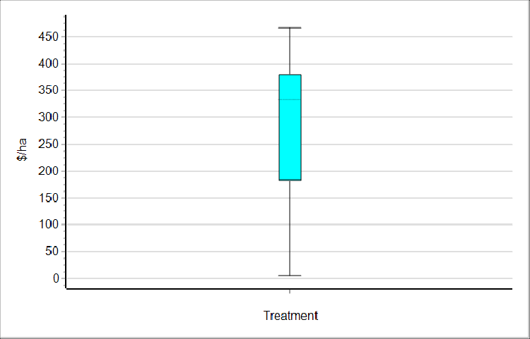

Source: GrassGro simulation

At Wongan Hills, which is representative of the Central Wheatbelt, the profitability of the Airfreight lamb production enterprise is similar to the current live export wether enterprise. However, it is more than likely the availability of stubbles that the amount of grain fed would be less for both enterprises and hence profit should be better of sheep enterprise, in conjunction with crop in that environment.

##### Time to change genotype in commercial flocks

Some of the sheep enterprises will need to consider a change of sheep genotype. This may involve some expense to change genotype but will also take time. To answer this question, propriety software was utilised, which was designed to test the time and returns from changing genotype in a commercial flock

This is based on an outline of the gene flow outlined in Merinos, Money and Management, by Dr Fred Morley, published by the Post Graduate Foundation of Veterinary Science, Sydney University. After 7 years of using the new genotype, the flock would be about 60% along the way to being converted to the new genotype, with the process being complete after 14 years.

This process can be hastened by buying in more new genetic material such as ewes or using elite sires via artificial breeding. However, nothing but an entire changeover will result in a quick genetic makeover. It will take some years for current flocks to become Dual Purpose Merino, Superfine Merino or a shedding flock.

It is possible to see heterosis boost productivity in 1st and 2nd cross animals, particularly for fleece weight, growth rates and reproductive performance, but not fibre diameter. Use of specialist terminal rams in the case of a changeover to a Dual Purpose Merino could make this process quicker.

In summary, it will be difficult to see some of these different genotypes be introduced into WA sheep enterprises under 7 years. In fact, it may take much longer.

##### Sheep enterprise summary

Figures 59 and 60 illustrate that most of the enterprises have similar gross margins but are less than the typical flock selling live export wethers. The Airfreight enterprise, which would take little change on farm to change over to, would benefit from more plane transport space, which is not available currently to take another 500,000 lambs.

However, the current volume of this air freight trade from WA is small and is dependent on the number of passenger jets flying in and out of WA. Thus, without active support, it is unlikely that the extra airfreight lambs would be able to be sold as such if there was a significant swing to this enterprise.

A composite maternal ewe producing prime lambs was not modelled, as this enterprise is better suited for a long growing season, which is exactly what the WA environment is not. Further, it is a large ewe with a large energy requirement over summer and autumn, and produces bigger lambs than current or potential WA lamb markets require.

The Superfine Merino enterprise is also more profitable than a typical flock, but it is likely to take at least 7 years (at a minimum) to change the current sheep genotype to this new genotype. With 60% of the flock genes carrying the new genetics, it is feasible to have similar profitability to the current flock after 7 years. But it also needs to be stressed that the Superfine Merino flock is based on the most elite genetics available in Australia, and these may not necessarily be available to all in Western Australia due to access to suitable rams or semen.

Thus, 7 years could be considered a minimum period to achieve reasonable profitability of the new enterprise.

Shedding sheep and running wethers to 1.5 year old with the existing genetics are the least profitable options. In particular, on the best data we can put together, for an industry solution, shedding sheep offer very little on an industry basis. For some individuals that don’t have wool harvesting infrastructure or access to labour, they are a low input alternative. However, trading steers may be easier to enter and more profitable.

Figure 59 Enterprise gross margin/ha and gross margin/ha variation

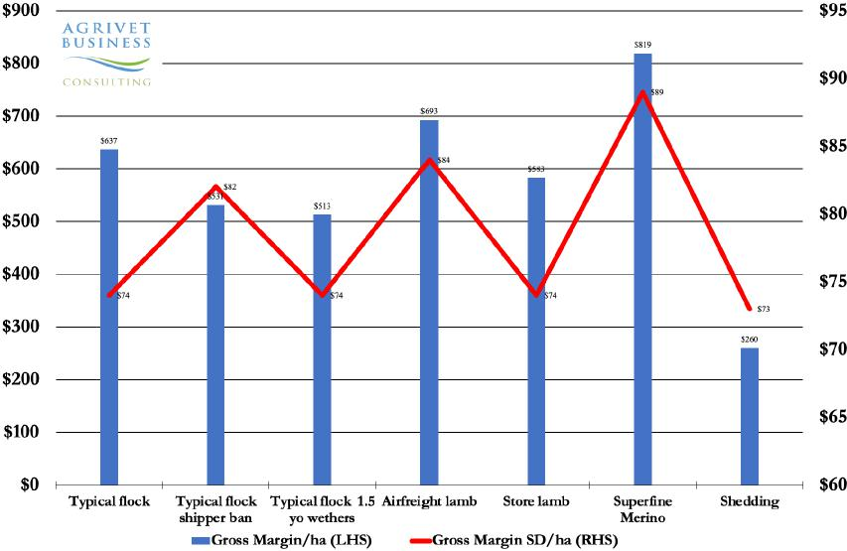

Source: GrassGro simulations

Figure 60 Enterprise gross margin/DSE from various sheep enterprises

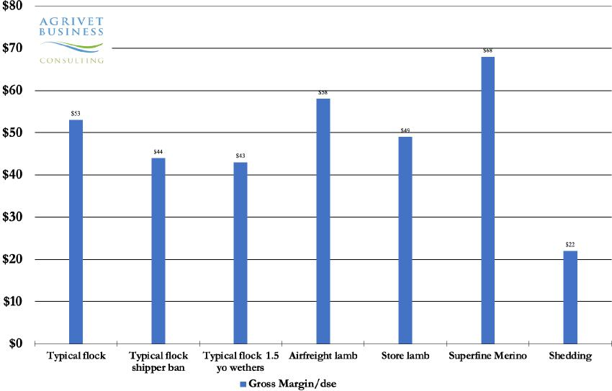

Source: GrassGro simulations

##### Cattle enterprise summary

For completeness, cattle have been included in this comparison, so an alternative to sheep is presented. The relatively strong gross margin performance of a self-replacing cow herd, probably overstates the profit potential of this enterprise for the future as outlined in the assumptions section.

Similarly, the Trading Steer enterprise while being very profitable is not likely to see the same performance going forward. Nevertheless, it is a profitable enterprise at lower beef prices. Even more profitable is a Wagyu Steer Trading enterprise but accessing Wagyu genetics reliably is difficult.

Cattle enterprises may benefit from a significant upgrade of farm infrastructure, which is unlikely to be attractive to most producers. However, the Dairy Beef backgrounding option is an enterprise that could develop in WA and be very profitable. This would make infrastructure investment in cattle handling facilities easily worthwhile potentially.

There is the option to explore this enterprise mix and facilitating its development by including on-farm trials to demonstrate what productivity can be achieved and assessing the value of the quality of the meat produced.

##### Backgrounding and finishing options

While the production of Airfreight lambs is both a profitable and easy enterprise to transition to, it may not be possible for all the current wether lambs that are exported live to transition to this market.

Hence the production of store lambs in the Great Southern to be purchased by other farmers to background and finish is a reasonably attractive alternative financially and also is a good replacement enterprise as it is very similar to the typical Live Export enterprise currently being run.

Backgrounding options have been limited in Western Australia but there are now some real practical and profitable options. Some producers on the South Coast are already backgrounding store prime lambs produced in the Great Southern as this region has a longer growing season, and surplus spring feed can be used to have the lambs grow about 100–150 g/head/day.

In about 2 months they might have transformed from 30 kg to 40 kg lambs that are ready to go into a finishing phase. The key for producers to make money by backgrounding is to have a very low-cost source of feed to put weight on the store lambs. And thus, before they are finished on grain or some other high value feed source, they are ready to enter the finishing phase and have got there with low cost. Otherwise, the seasonal variation in lamb price won’t support the finishing phase.

Both on the South Coast of WA and the region west and south of Boyup Brook, which is traditionally a cattle farming area only, there is potential to use the spring surplus to background lambs. Particularly if perennial pastures are sown, such as Holdfast GT and Landmaster Phalaris as well as winter active Mediterranean sourced Tall Fescues in the far southwest region. In the Great Southern, far southwest and the South Coast there is potential for Pallaton Raphnobrassica to finish lambs.

DLF Seeds, who distribute this brassica crop, are observing in the Great Southern lambs to be carried at 50/ha over the summer and growing at 250 g/head/day for Merino lambs and 350 g/head/day for Crossbred lambs. This is consistent with trial results in the Eastern States, but this needs to go to the proof stage in Western Australia.

Pallaton Raphnobrassica achieves this productivity due to being 40% more water efficient than other brassicas. In areas with more reliable summer rainfall, summer crops such as Pallaton Raphnobrassica has been trialled successfully by the Stirlings to Coast farmer group with support from MLA (see [Alternate forage crops for southern WA](https://www.mla.com.au/extension-training-and-tools/search-pds/pds-data/alternate-forage-crops-for-southern-wa/) on the MLA website).

Faba beans have had limited sown area in Western Australia to date. Although, newer disease resistant varieties about to be released may provide a valuable crop rotation and the stubble can finish lambs. Anecdotally, some producers growing faba beans have finished lambs on the stubble after harvest over the summer period.

Yield potential with current faba bean varieties @2.5 t/ha $450/t = $1,125/ha gross income, with costs likely to be similar to Canola @ $840/ha. gross margin likely to be $285/ha, plus value of sheep feed over summer. This is less than other crops types coming in at about $500–$600/ha depending on crop type, according to Farmanco benchmarking data.

Given typical faba bean stubbles support about 7.5 lambs/ha that gain about 10 kg over 6 weeks, this equates to 79 kg/ha gain at a store value of $335/ha given a 46% dressing percentage and store price of 709 c/kg. Taking the total potential return of faba beans to around $620/ha gross margin, which is in line with other crops. Although, it is important to note that backgrounding or fattening lambs on the bean stubble is critical to achieving these better faba bean returns.

Given the potential for faba beans on better soil types in WA and the prospect of much high yielding varieties in the future it makes more research to confirm whether faba beans have potential across the Great Southern and the wheatbelt to background and finish lambs.

Currently, there is only anecdotal evidence from WA farmers and Eastern States experience on very different soil types. The budget shown in Table 15 indicates the potential returns from backgrounding on a faba bean stubble. Clearly, it is profitable to at least background lambs on faba bean stubble.

Standing crops can be used to background or finish lambs, depending on quality. There is a wide variety of mixes or single variety crops that can be used, but most in WA probably will include or be lupins by themselves. Again, there is an imperative for more research in this area to provide evidence based on strong scientific principles of what might be achieved with various standing crops.

Feed lotting has grown in recent years in WA as demand for finished lambs to export has grown. The second example (Table 16) adds a finishing phase in a feedlot for lambs backgrounded on faba beans. But in higher rainfall regions of WA, as outlined previously, there is potential for stock to be backgrounded on pasture, or more likely on standing crops or brassica fodder crops.

An example of this is presented below, with conservative growth rates in the backgrounding phase. This results in more weight gain in the feedlot finishing phase, but is still profitable. These results needs to be confirmed with firm scientific evidence that perennial pastures sown in southwest WA will background lambs, along with evidence that Pallaton Raphnobrassica and standing crops are a viable option for farmers to adopt.

Table 15 Backgrounding on faba bean stubble and feedlot phase – lamb finishing budget and sensitivity

| Period | Measure | X bred |
| --- | --- | --- |
| Store period (Nov–Feb) | Lamb start weight (Nov) | 28 kg |
| Landed value of store lamb ($/hd) | $93/hd |
| Days on crop | 100 days |
| Amount of feed eaten (kg/day) | 0.0 kg/hd/day |
| Total feed eaten (kg) | 0 kg |
| Total cost of ration ($) | $0.00/hd |
| Final liveweight (kg) | 43 kg |
| LW Gain (g/day) | 150g/day |
| Fodder crop cost/hd | $0.00 |
| Starting fleeceweight (kg) | 1.0 kg |
| End fleeceweight (kg) | 1.9 kg |
| Finishing period (Feb–Mar) | Store land start weight (Feb) | 43 kg |
| Days on feed | 28 days |
| Amount of feed eaten (kg/day) | 1.7 kg/day |
| Growth rate on feed (g/hd/day) | 280 g/hd/day |
| Final liveweight (kg) | 51 kg |
| Final dressed weight (kg) | 23 kg |
| Dressed price (c/kg) | 748 c/kg |
| Final carcass value ($) | $175/hd |
| Total feed eaten (kg) | 52 kg |
| Total cost of ration ($) | $19/hd |
| Starting fleeceweight (kg) | 1.9 kg |
| Final greasy fleeceweight (kg) | 2.2 kg |
| Store lamb buy-in price (from above) | $93/hd |
| Labour cost ($/hd) | $0.77/hd |
| Animal health ($/hd) | $2.00/hd |
| Shearing cost ($/hd) | $0.00/hd |
| Crutching cost ($/hd) | $2.00/hd |
| Freight – out ($/hd) | $2.00/hd |
| Death rate & shy feeders (%) | 6% |
| Total costs ($) | $118.96/hd |
| Value of skin in April–June | $4.00/hd |
| Total income ($) (skin, lamb) | $166.69/hd |
| Profit $/hd | $47.74/hd |
| % return on investment | 40% |

Source: Agrivet, EP3

Client: DAFF Live Export Phase One Panel. Comments: 5-year real prices. Prepared by: Graham R. Lean BVSc MAAAC. Date: 24 July 2023.

Table 16 Backgrounding on standing crop, fodder crops or long season pasture and feedlot phase – lamb finishing budget and sensitivity, high rainfall zone

| Period | Measure | X bred |
| --- | --- | --- |
| Store period (Nov–Feb) | Lamb start weight (Nov) | 258 kg |
| Landed value of store lamb ($/hd) | $93 /hd |
| Days on crop | 50 days |
| Amount of feed eaten (kg/day) | 0.0 kg/hd/day |
| Total feed eaten (kg) | 0.0 kg |
| Total cost of ration ($) | $0.00 per head |
| Final liveweight (kg) | 38 kg |
| LW Gain (g/day) | 100 g/day |
| Fodder crop cost/hd | $3.35 |
| Starting fleeceweight (kg) | 1.0 kg |
| End fleeceweight (kg) | 1.5 kg |
| Finishing period Feb–March | Store lamb start weight (Feb) | 38 kg |
| Days on feed | 43 days |
| Amount of feed eaten (kg/day) | 1.7 kg/day |
| Growth rate on feed (g/hd/day) | 280 g/hd/day |
| Final liveweight (kg) | 50 kg |
| Final dressed weight (kg) | 23 kg |
| Dressed price (c/kg) | 748 c/kg |
| Final carcass vale ($) | $172 per head |
| Total feed eaten (kg) | 77 kg |
| Total Cost of ration ($) | $29 per head |
| Starting fleeceweight (kg) | 1.5 kg |
| Final Greasy fleeceweight (kg) | 1.9 kg |
| Store lamb buy-in price (from above) | $93 per head |
| Labour cost ($/hd) | $0.56 per head |
| Animal Health ($/hd) | $2.00 per head |
| Shearing cost ($/hd) | $0.00 per head |
| Crutching cost ($/hd) | $2.00 per head |
| Freight – Put ($/hd) | $2.00 per head |
| Death rate & shy feeders (5) | 6% |
| Total Costs ($) | $128.24 per head |
| Value of skin in April-June | $4.00 per head |
| Total Income ($) (skin, lamb) | $160.76 per head |
| Profit $/hd | $32.52 per head |
| % return on investment | 25% per head |
| Market value of finishing ration | $370 per tonne |

Source: Agrivet, EP3

Client: DAFF Live Export Phase Out Panel. Comments: 5-year real prices. Prepared by: Graham R. Lean BVSc MAAAC. Date: 24 July 2023.

#### ii. Options for further development of an eastern transportation corridor

A Freight Equalisation Scheme (FES) exists between Tasmania and the Australian mainland. The logic behind this scheme is to compensate Tasmanian businesses, including farmers, for the transport/logistical disadvantages of being geographically separated from the mainland.

The essence of the FES is to offer a financial subsidy to eligible businesses. This helps neutralise additional costs they incur when shipping goods via sea, making the costs more comparable to the expenses associated with road transport within the mainland of Australia. The applicability of this scheme extends to goods transported either directly between Tasmania and the mainland or indirectly via other ports.

The FES is an initiative of the Australian Government that was established in 1976. Its purpose is to counterbalance the higher expenses associated with moving goods by sea across the Bass Strait between Tasmania and mainland Australia. By doing this, the FES helps provide equal opportunities for Tasmanian industries to compete with their mainland counterparts.

Eligibility for the FES depends on several factors, and decisions are made on a case-by-case basis. Factors under consideration include the nature of the goods, the specific details of their transportation, among others. Typically, the scheme covers goods originating from Tasmania and intended for consumption or use in the mainland market. It also applies to goods transported to Tasmania for significant processing or transformation before being sold in the mainland markets.

The FES benefit amount provided to a business is calculated based on the sea freight cost disadvantage. In most instances, this is determined as the difference between the actual sea freight cost and a notional equivalent road freight cost.

For the agricultural sector in Tasmania, the FES is particularly beneficial. It enables Tasmanian farmers and agribusinesses to compete more effectively by compensating for some of the elevated costs associated with transporting agricultural products across the Bass Strait.

The case for implementing a freight equalisation scheme between Western Australia (WA) and the eastern states is compelling, particularly given the potential phaseout of live sheep export trade.

Several reasons underpin this concept.

##### Geographical disadvantage

WA sheep producers are significantly disadvantaged due to the vast road transport distances between WA and the eastern states’ abattoirs and livestock markets. This distance inflates the cost of transporting livestock, which is then often reflected in lower prices for WA sheep and lamb, compared to prices in the eastern states.

##### Price parity

A freight equalisation scheme could help to balance sheep and lamb prices across Australia. Currently, due to the higher transportation costs, WA sheep and lamb often fetch lower prices than similar livestock in the eastern states. An equalisation scheme would help to neutralise this discrepancy, ensuring a fairer return for WA producers.

##### Increased competitiveness

With reduced transport costs due to a freight equalisation scheme, WA sheep producers would be more competitive. This would benefit not just individual producers but also the broader WA economy, stimulating growth and jobs in the region.

##### Mitigate the impact of the live sheep export phaseout

The potential phaseout of the live sheep export trade is a looming concern for WA sheep producers. As this export market currently plays a key role in supporting WA sheep and lamb prices, its phaseout could result in significant price drops. A freight equalisation scheme would help mitigate the impact of this phaseout, protecting the viability of sheep farming in WA.

##### Supply chain resilience

The COVID-19 pandemic has underscored the importance of resilient domestic supply chains. By reducing the cost burden of internal freight, a freight equalisation scheme could incentivise a more robust domestic market, making the Western Australian sheep industry more resilient to external shocks and disruptions.

In conclusion, a freight equalisation scheme between WA and the eastern states would go a long way in ensuring a fair and equitable marketplace for sheep producers across Australia. It would address the geographical disadvantages inherent to WA and provide financial support in the wake of the live export phaseout, thereby promoting a more resilient and competitive domestic sheep industry.

Historic seasonal levels of WA turnoff (processing and live export) plus road transport shipments to the east demonstrate that even with an expanded processing capacity of domestic WA sheep/lamb processing of 560,000 head per month there still could be times when the WA processing sector is overwhelmed, and sheep producers would need to rely on an eastern corridor for turnoff to alleviate the supply pressure in WA.

Figure 61 WA sheep and lamb turnoff versus processing capacity

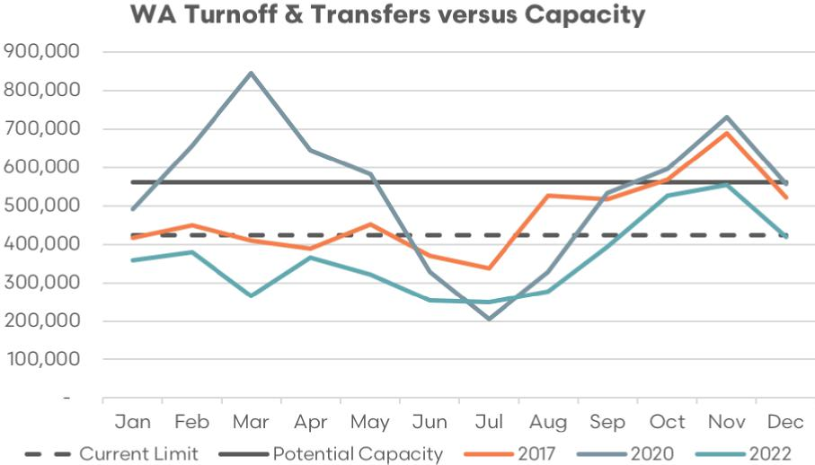

Sources: EP3, MLA, ABS, industry

Figure 61 demonstrates that during the recent calendar years of 2017, 2020 and 2022 there were significant periods of time during the season the total WA sheep and lamb monthly turnoff (domestic slaughter, live export volumes and transfers east combined) exceeded the ability for WA processors to accommodate the volumes, even assuming an increased monthly capacity of 560,000 head per month.

Specifically, the 2017 season was the last year the live sheep trade operated without a northern hemisphere prohibition in place and annual live sheep turnoff from WA was 1.6 million head, which is much higher than the 496,000 head seen in 2022.

Figure 61 highlights the historic monthly turnoff that occurred in WA when local slaughter volumes, live export volumes and transportation volume to the east are combined. If there was no live export turnoff option nor the option to transport to the east during 2017 then WA processors would have been overwhelmed from July onwards based on the current processing capacity estimate of 424,000 head per month and would have been overwhelmed for the final quarter of 2017 assuming a capacity constraint of 560,000 head.

During the 2020 season, there was a huge volume of sheep that were transported to the east from WA. If there was no option for eastern transfer nor live sheep export during 2022 and all WA turnoff had to be processed locally in WA then there would have been 7 months out of the year that the WA abattoir sector would have been overwhelmed, based on the 560,000 head capacity limit, and 9 months out of the year that would have seen WA processors overwhelmed, based on the 424,000 head limit on processor capacity.

This highlights that without the live export avenue for WA sheep and lamb turnoff, and an increased processor capacity of 560,000 head per month in WA, there could still be times when turnoff exceeds local ability to slaughter in WA. Additionally, during these times there would be a need for an intermittent freight equalisation scheme for west to east transfers which would operate only when WA processing is overwhelmed and price spreads in WA for sheep and lamb falls to heavily discounted levels, when compared to the eastern states.

##### Transport costs (west to east)

Table 17 demonstrate that over the last 5 years transportation costs for sheep/lamb haulage from west to east has increased by around $8 per head for lighter stock and $14 per head for heavier stock. This equates to increased transport costs of 30% to 40% for WA producers and has allowed for further discounting of WA sheep and lamb compared to their eastern states’ equivalents in recent years, particularly when the live sheep prohibition is in operation.

Table 17 Transport costs from west to east

| Long haul transport details | 2018 | 2022 | 2023 |
| --- | --- | --- | --- |
| 35kg lwt – 725 head | $5.30–$5.80 per km | $6.00–$6.50 per km | $7.00–$7.50 per km |
| 3,400 km trip cost | $18,020–$19,720 | $20,400–$22,100 | $23,800–$25,500 |
| $/head charge (including feedlot) | $27–$29 | $30–$32 | $35–$37 |
| 55kg lwt – 575 head | $5.30–$5.80 per km | $6.00–$6.50 per km | $7.00–$7.50 per km |
| 3,400 km trip cost | $18,020–$19,720 | $20,400–$22,100 | $23,800–$25,500 |
| $/head charge (including feedlot) | $33–$36 | $37–$40 | $47–$50 |

Sources: EP3, industry

Note: Feedlot charge estimated at $1.75 per head.

Assumptions that underpin the calculations outlined in Table 17 are as follows.

* Transportation rates for sheep in 2023 vary depending on the distance covered. For long haul transport, the cost is between $7.00 to $7.50 per kilometre, marking an increase from $6.00 to $6.50 per kilometre in 2022, and $5.30 to $5.80 per kilometre in 2018. Short haul transport, typically covering 800 kilometres or less, costs between $8.50 to $9.00 per kilometre.
* A B-double truck can accommodate 700 to 750 sheep, if each weighs an average of 35 kg, or 550 to 600 sheep if the average weight is 55 kg.
* The journey from Western Australia involves a stop at Nundroo, South Australia, for an overnight break. This rest, including feeding and watering the livestock, incurs a cost of $1.50 to $2.00 per head. Both the leg from Katanning to Nundroo and the continuation from Nundroo to either Wagga Wagga or Brooklyn, cover roughly 1,700 kilometres each, or around 17 to 18 hours of travel time.

An intermittent freight equalisation scheme could be implemented whereby subsidies are paid to facilitate lower cost transportation of sheep from the west to the east, but the subsidies are only available when sheep/lamb price spreads in the west compared to eastern prices are heavily discounted due to WA processor capacity constraints.

#### iii. Support for Adopting New Farming Practices

##### Research and development requirements

Most of the alternative enterprises explored above, with the exception of the Airfreight lamb enterprise, would benefit from validation for Western Australian conditions. Much of the agricultural zone of Western Australia (WA) has a Mediterranean climate with a very short growing season, which is different from the Eastern States. This suits the production of live export wethers.

Consequently, before the industry in WA could adopt some of these enterprises with confidence that they would in fact equal or improve their current profitability, it is recommended for the following research to be undertaken.

Properly test the performance of store lamb production with replicated trials over 5 years:

* The option to background/finish these lambs is possible.
* In the Great Southern on Pallaton Raphnobrassica.
* On standing summer crops of oats/lupins and other mixes and is profitable.
* Investigate faba bean agronomy on difference soil types and climatic zones.
* And in particular test whether bean stubbles can background/finish lambs.

Anecdotal reports suggest that Beans are yielding around 2.5 t/ha and that the stubble is capable of finishing lambs. Similarly, test the performance of maternal prime lamb genotypes and shedding breeds. It should be noted, given the stringent requirements of animal ethics committees for any trials involving animals it is likely the set up for any trials would be 2 years, adding to the 5-year trial period that takes into account seasonal variation.

This could mean a 7-year time frame is needed before trial results could be published and extended with confidence. At least 5 years would normally be used to capture seasonal variation, with a 3-year time period considered to be an absolute minimum to run the trials.

##### Training and education requirements

Given the outcome of the above trials, training and extension activities would be helpful to ensure producers would be able to:

* Be exposed to the results of these trials to be aware of them.
* Once awareness is achieved, implementation of these new enterprises and technologies may require intensive training that is likely to take another 2 years.
* If changes involve changing their flock’s genotype, a significant change in production would take at least another 7 years to implement.
* This totals 16 years before the WA industry might be able to move totally away from selling wethers for live export – 14 years if trial only run for a bare minimum of 3 years.
* Training may require trainers to be trained and accredited. Given the scale of the industry training program, it’s likely that trainers from the Eastern States could be utilised as well.

### C. Support across the supply chain

#### i. Workforce transition

##### Job attraction, skill development programs and employment services for impacted workers

To assist the workers affected by the phaseout of the live sheep export industry, the Australian government could consider a multi-faceted approach that addresses both immediate job loss and long-term employment.

**Creation of a transition assistance fund:** The government can set up a fund specifically designed to assist affected workers during the phaseout period. This fund could provide immediate financial assistance to help individuals manage their living expenses as they seek new employment opportunities. Alternatively, the Skilling Australia Fund could be used to support transition and re-skilling programs.

**Re-skilling and training programs:** The government could invest in industry-specific re-skilling and training programs. These programs could be designed in consultation with industry bodies to ensure that they provide the skills suited to jobs in high-demand areas. Such programs could be made accessible to affected workers at little or no cost.

**Employment transition services:** Offering services such as job placement assistance, career counselling, and resume workshops could be a practical measure to assist workers in finding new job opportunities. These services could be offered through existing job agencies, with a special focus on the workers affected by the phaseout of the live sheep export industry.

**Partnership with private sector:** The government could facilitate partnerships with private sector companies that have labour requirements aligning with the skill sets of the affected workers. Such collaborations could lead to job placements and an easier transition for workers. This could include partnerships with industry bodies such as the Australian Meat Industry Council (AMIC) who are well placed to manage projects of this nature.

**Regional development programs:** Recognising that the phaseout will disproportionately affect certain regions, the government could invest in regional development programs to stimulate job growth in these areas. This could include infrastructure projects, tourism development, or supporting emerging industries.

**Educational grants and scholarships:** For younger workers or those interested in shifting industries entirely, the government could provide educational grants or scholarships to pursue tertiary education or vocational training in a variety of fields.

**Long-term strategy:** This comprehensive support plan could be part of a broader long-term strategy to diversify the skills of the workforce and promote industries that are sustainable and resilient to change.

These measures, taken together, would not only mitigate the impact of job losses from the phaseout of the live sheep export industry, but could also contribute to a more versatile and adaptable Australian workforce.

#### ii. Financial assistance

##### FMD scheme for allied rural sectors

Currently, primary producers have access to a Farm Management Deposit (FMD) scheme. This scheme allows them to make tax-deductible deposits during prosperous years, which can be withdrawn and subsequently taxed in later years. However, farm enterprises aren’t the only rural business that are susceptible to volatile income streams, rural businesses with revenue streams closely aligned with farming can also suffer the same income variability.

To provide support to business participants heavily involved in live sheep industry during the phaseout period and enhance the resilience of eligible rural businesses, this proposal suggests the implementation of an Allied Rural Business Management Deposit (ARBMD) scheme. This scheme would operate similarly to the existing FMD scheme, offering assistance to eligible businesses and reducing their reliance on direct government assistance.

The Australian Government could consider an investigation into the feasibility of establishing an income smoothing scheme for rural businesses, particularly those closely allied with the live sheep trade. This scheme aims to determine the eligibility criteria, rules, and rollout process.

The following operational criteria and rules are suggested (operational criteria and rules for the proposed ALBMD scheme is adopted from the ALRTA 2022 Senate Inquiry submission):

* The allied rural business that can demonstrate that at least 50% of its income for the year in which the deposit is made.
* The income is derived from clients who fit the definition of primary producers. This could be based on Australian Accounting Standards identification numbers, which is the existing legislation that defines primary producers or even existing definitions of what constitutes primary produce.
* There will be legacy provisions for management of the scheme in the event that a business is sold or ceases trading.
* The account agreement must describe the deposit as an ALBMD with these conditions:
  + The amount of any deposit or repayment must be $1,000 or more.
  + The total of all deposits you hold can’t be more than $800,000.
  + Interest earned on deposits is assessable in the income year in which it is paid.
  + Interest must not be paid into an ALBMD account.
  + Transfers of deposits between ALBMD providers must be made electronically.
  + Rights as a depositor can’t be transferred to another individual.
  + The deposit cannot be used as security for any amount owed to a financial institution or any other person.

##### Mental health services

Alongside the training and development programs designed to assist workers across the live export supply chain impacted by the phaseout, the government could also consider funding mental health support for affected workers, sheep farmers and business owners that may be impacted by the transition. Job loss and industry change can be stressful, and access to support services is critical during such times.

The [MLA and AWI May 2023 Sheep Producers Intentions survey](https://www.mla.com.au/globalassets/mla-corporate/prices--markets/documents/trends--analysis/sheepmeat-survey/spis---03-may-2023---final-report.pdf), has outlined that there is a loss of confidence being experienced by WA sheep producers and that the decision to phase out the live sheep trade is a contributing factor to this decline in confidence.

Furthermore, the [National Farmer Wellbeing Report 2023](https://nff.org.au/media-release/farmers-in-crisis-depression-and-anxiety-rife-among-aussie-farmers/), a collaboration between dairy co-operative Norco and the National Farmers’ Federation (NFF), discovered a distressing state of mental health among Australia’s agricultural community. Over the last few years, a substantial 30% of farmers reported a deterioration in their mental well-being.

Alarmingly, almost half of Australian farmers, around 45%, have battled depression, and an even larger proportion, close to 64%, grapple with anxiety. For a significant minority, around 14%, these experiences are a common occurrence.

The statistics turn even more grim with nearly 45% of these farmers admitting to thoughts of self-harm or suicide, and a disheartening 30% have even attempted to harm themselves or commit suicide.

Highlighting a national health crisis that urgently requires attention, this data contributes to the pre-existing research indicating that every 10 days, a farmer takes their own life. Moreover, the suicide rate among Australian farmers is shockingly double that of the general population.

A significant 27% of farmers cite feelings of isolation or loneliness and insufficient access to mental health services as the primary factors impacting their mental health over the past half-decade. These troubling figures illuminate a dire need for support and resources in these communities.

There could be multiple reasons behind this crisis. Farming is often physically demanding and involves long, irregular hours. Farmers can be isolated, and face challenges related to changing weather patterns, pest infestations, and market fluctuations, all of which can cause significant stress and anxiety. However, from a WA sheep farming perspective, the intention to phase out the live sheep trade has been suggested as a contributing factor to the decline in mental health outcomes for WA sheep producers in recent years.

Limited access to mental health services in rural and remote areas can exacerbate these issues. Furthermore, cultural factors such as stigma surrounding mental health may prevent farmers from seeking help. These factors combined with feelings of loneliness or isolation can be particularly damaging.

Efforts could be directed towards improving mental health support in these communities, reducing stigma, and developing resilience and coping strategies. Digital technology could potentially be used to reach isolated farmers, providing them with online counselling and support services.

Preventive measures are also important. Governments, non-profit organisations, and communities could work together to ensure farmers have access to resources and support networks that can help them manage stress. This may include training programs that help farmers better handle the challenges they face, and wellness initiatives that promote self-care and mental health awareness.

As part of the phaseout process there could be appropriate measures put in place to facilitate more positive mental health and well-being outcomes for WA farmers and supply chain participants that may be negatively impacted by the phaseout.

##### Financial counselling services

Just as it’s helpful to address the employment concerns of workers affected by the phaseout of the live sheep export industry, it’s equally important to support the farmers and businesses that may face financial difficulties due to this change. Suggestions for government assistance packages that could be provided include:

**Financial counselling services:** The government could fund a free or low-cost financial counselling service specifically for those affected by the phaseout. These professionals could provide advice on debt management, budgeting, financial planning, and navigating government assistance programs.

**Business consultation services:** Offer access to business consultants who can help affected businesses pivot their business models, explore new markets or diversify their services to adapt to the changing landscape.

**Low-interest loans:** Provide low-interest loans to help businesses adjust their operations in response to the phaseout. These loans could be used for investing in new equipment, diversifying product offerings, or other operational changes.

**Grants for business innovation:** Offer grants to businesses developing innovative approaches to dealing with the phaseout. This could include new farming techniques, alternative revenue streams, or investment in other agricultural sectors.

**Tax relief measures:** Temporary tax relief measures could be implemented to alleviate some of the financial burden. These could include reductions or deferments in business taxes.

**Training and development programs:** As with workers, providing training and development programs for business owners can help them acquire new skills or knowledge needed to pivot their business.

**Investment in local infrastructure:** In areas heavily affected by the phaseout, investment in local infrastructure could stimulate economic activity and open up new business opportunities.

**Long-term strategy development:** Businesses need to be part of the long-term strategy to adapt to the changing agricultural landscape. Government can work in consultation with businesses to develop these strategies, ensuring they’re both sustainable and economically viable.

These strategies aim to provide immediate financial support to those affected, while also fostering the innovation and adaptation to encourage long-term successful outcomes in the face of industry changes. It’s important that these assistance packages are flexible and responsive to the needs of the farmers and businesses they’re designed to support.

##### Relocation assistance

Relocation assistance can be a key component of the support system for workers impacted by the live sheep export industry phaseout. When jobs in one region or sector become scarce, opportunities elsewhere may be plentiful. Here’s a proposed package to help facilitate such transitions:

**Relocation grants:** Provide a one-time financial assistance grant to cover the costs of moving, including transportation of household goods, security deposits or initial rent, and other incidental expenses.

**Housing assistance:** Offer housing subsidies or low-interest loans for purchasing new homes. This support could be particularly beneficial in regions where housing markets are more expensive.

**Job search assistance:** Fund local job centres or online platforms that provide resources and support for job searches in the new location, including resume reviews, interview coaching, and local job listings.

**Transitional living expenses:** Offer a stipend for a fixed period to help cover the costs of living in a new location while the worker secures stable employment.

**Family support:** Assist with family-related challenges of relocation, such as finding new schools for children or providing support for trailing spouses to find employment.

**Community integration programs:** Facilitate the integration of workers into their new communities, with programs designed to welcome newcomers and help them establish social connections.

**Career counselling and retraining:** Where the move involves a shift in industry, provide access to career counselling and retraining opportunities to increase the employability of these workers in their new location.

**Transportation assistance:** In areas where public transportation is less accessible, assist with the costs of purchasing a vehicle or provide subsidies for public transportation.

The primary goal of these packages is to make the transition process as seamless as possible for affected workers and their families. By alleviating some of the immediate financial burdens and logistical challenges of relocation, these assistance programs can help workers focus on building their future in a new community.

### D. Identification of the steps required, and timelines required for the development of alternative markets and industries

#### i. Expansion of the domestic meat processing Industry

Historic analysis of monthly sheep and lamb turnoff options in WA compared to current and potential monthly processor capacity demonstrates that there were not many instances since 2011 when the current capacity of WA processors was breached on a monthly basis by slaughter volumes, alone. Turnoff options include domestic processing in WA, live export shipment or transfer to eastern states. Current WA processor capacity is estimated at 424,000 head per month and potential capacity estimated at 560,000 head per month.

Figure 62 WA turnoff versus processing capacity 2011–2023

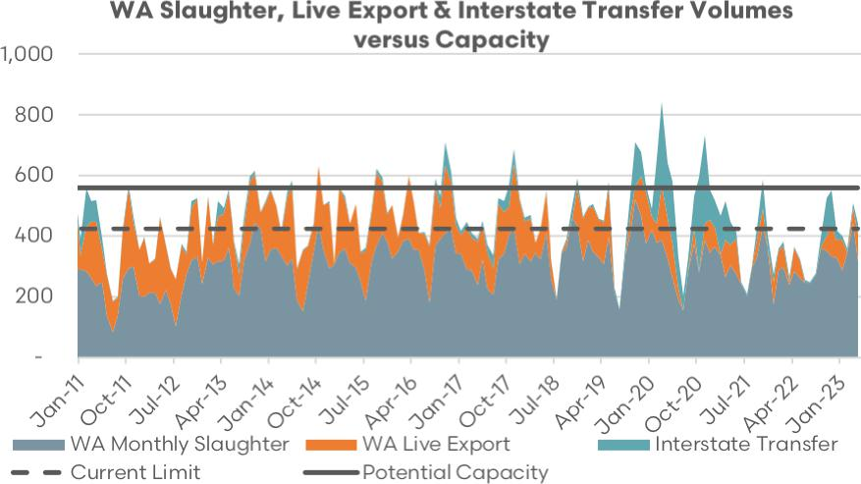

Sources: EP3, MLA, ABS, industry

However, when monthly live export volumes are added to the monthly slaughter volumes there are significant periods of time since 2011 that the current monthly capacity of WA processors would have been breached. This demonstrates that WA processing capacity needs to be expanded in order to cope with the additional slaughter volumes diverted from the live trade as the phaseout progresses.

Figure 63 focuses on the historic monthly WA turnoff options since 2017, which encompasses the moratorium/prohibition period over the northern hemisphere summer and the reduced live export volumes seen in recent years.

Figure 63 WA turnoff versus processing capacity 2017–2023

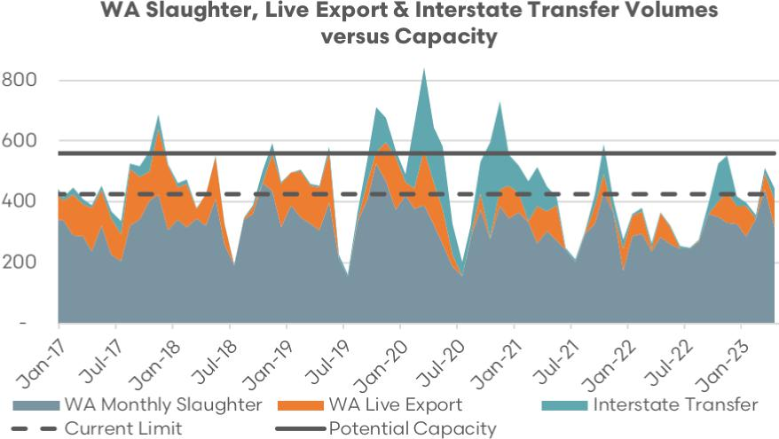

Sources: EP3, MLA, ABS, industry

An inspection of the trend in WA turnoff options since 2017 highlights that from 2020 onwards, with reduced live export flows, there haven’t been many times when the current WA processor capacity has been breached based on combined monthly slaughter and live export volumes.

Furthermore, when the potential WA abattoir capacity limit is taken into account there are only a handful of times since 2017 when the monthly capacity is breached by the combined slaughter and live export volumes.

Indeed, it is only the addition of turnoff volumes to the eastern states that would have seen several significant breaches of the potential capacity limits had the eastern states turnoff option been unavailable and those volumes were required to have been processed within WA. This reinforces the notion that even with increased WA abattoir capacity the eastern transportation option still needs to be available for WA sheep producers during times when local processing capacity is overwhelmed.

Analysis of monthly seasonal turnoff in WA (excluding volumes transported to the east) has been modelled based on historic flows of live sheep export volumes and slaughter volumes. Two turnoff scenarios have been assessed, an average turnoff scenario and a high turnoff scenario, whereby live export turnoff estimates (based upon historic monthly flows) are added to slaughter volumes, assuming the live export trade has been phased out and domestic slaughter in WA is the only option for turnoff of these livestock.

Under an average turnoff scenario, current WA processing capacity of around 424,000 head per month demonstrates the ability to manage turnoff for most months of the season. However, during September through to December there is the chance of WA processing capacity becoming stretched, particularly in October and November.

Modelling of an expanded processing capacity of 560,000 head per month demonstrates that under an average turnoff scenario the WA processing sector would be able to cope adequately throughout the entire year.

Under a strong turnoff scenario, current WA processing capacity (424,000 head per month) would be overwhelmed during most months of the year, with the possible exception of June and July. However, assuming an expanded WA processing capacity (560,000 head per month) the modelling suggests that processing capacity would only be problematic in October and November, assuming a strong turnoff scenario.

Figure 64 WA turnoff versus processing capacity

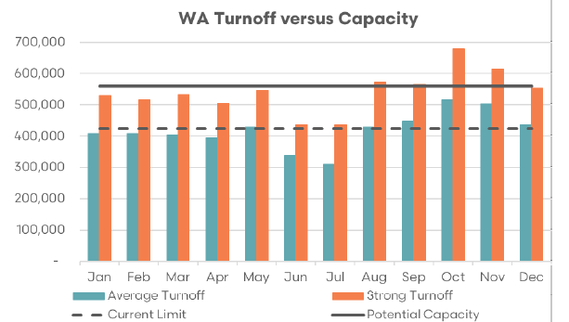

Sources: EP3, MLA, ABS, industry

It is important to note that the estimate for increased WA processor capacity of 560,000 head per month was based upon the assumption that access to labour (including accommodation for additional staff) was not a barrier, offshore demand for their product was adequate and freight/logistics downstream of the plant were not problematic.

Therefore, this estimate does not take into account potential plant upgrades to infrastructure like larger boning rooms, extra chiller space, bigger lairage yards, nor additional investment in labour saving technology such as robotics and DEXA scanning. It is likely that over the longer term, plant capacity upgrades and a move toward multiple shifts as sheep/lamb supply volumes and market demand increases could see WA plant capacity extend beyond this 560,000 per head limit.

##### Investment in new infrastructure and technology (DEXA, robotics and other labour-saving devices)

The Australian Government could facilitate the adoption of robotic technology, Dual Energy X-Ray Absorptiometry (DEXA) scanning, and other labour-saving strategies in several ways. An outline of possible measures is as follows:

**Funding and financial incentives:** The government could provide direct funding to abattoirs to support the purchase and implementation of new technologies. This could be in the form of grants, low-interest loans, or tax rebates.

**R&D tax incentives:** To encourage research and development in automation technologies suitable for abattoirs, the government could introduce or enhance tax incentives for companies investing in R&D. This could help drive innovation and the development of tailored solutions for the sector.

**Support for skills training:** In addition to funding for technology, there will be a need for skilled workers to operate, maintain, and troubleshoot these new systems. Government-funded training programs, possibly developed in partnership with technology providers and educational institutions, could help build these skills within the workforce.

**Regulatory support:** Government can also play a role in ensuring that the regulatory environment is supportive of the adoption of these technologies. This could involve streamlining approval processes for new technology implementation or updating regulations to account for new ways of working.

**Public–private partnerships:** The government could foster partnerships between technology companies, abattoirs, and educational institutions. These partnerships could help to ensure the technology meets industry needs, and that training programs are available to develop skills.

**Demonstration projects:** Funding could be provided for a number of pilot or demonstration projects, where the technology could be implemented, and results studied. This would provide valuable case studies and learnings for other abattoirs considering adopting similar technologies.

**Consultancy support:** The government could provide support to abattoirs to engage consultants to assess their specific needs, and to identify the most effective technologies and implementation strategies.

**Infrastructure assistance:** Government could assist with infrastructure for the technology’s implementation like stable power supply or high-speed internet access.

It is important to note that the implementation of DEXA technology would be of benefit beyond the WA live sheep phaseout context, bringing helpful carcass feedback to producers and creating a more efficient processing sector nationally.

These measures can be used individually or in combination to facilitate the adoption of robotic technology, DEXA scanning, and other labour-saving strategies in WA’s abattoirs. A proposed timeline for the implementation of labour-saving robotic/scanning technology in Western Australian meat processing facilities could include the following steps.

###### Year 1–2: planning and assessment

The initial years could focus on a comprehensive assessment of the needs and capabilities of individual processing facilities. This includes a cost-benefit analysis and technical feasibility studies to understand the types of technology that would deliver the most benefit. Engage technology consultants to help with this analysis and plan for the specific requirements of each facility. Simultaneously, start exploring funding options, including government grants, tax incentives, or low-interest loans.

###### Year 3: pilot implementation

Identify a small number of facilities for a pilot implementation of selected technologies. This allows for a controlled environment to observe the actual benefits, identify potential issues, and make suitable adjustments. Invest in training for staff who will operate and maintain the new technologies. Evaluate the success of these pilot projects and make any adjustments to the broader implementation plan.

###### Year 4: broad implementation

Begin broad implementation of technologies across other facilities, using the learnings from the pilot projects to ensure smoother rollouts. Continue investing in staff training and ensure that facilities have suitable infrastructure to support these technologies. Regularly review the implementation process to identify and rectify any problems promptly.

###### Year 5–6: review and optimisation

Review the impact of implemented technologies across all facilities. Are they delivering the expected benefits? Are there issues with maintenance or operation that need to be addressed? Use this time to optimise the use of these technologies and provide additional training as needed. Consider implementing additional technologies if they would deliver further benefits.

###### Year 7: future planning

By this point, the initial wave of technology implementation should be complete. Review the overall impact of this transformation on the sector. Consider what further technologies or strategies could be implemented to continue improving efficiency and reducing reliance on labour. Start planning for the next phase of technological evolution in the industry.

Throughout this process, it’s important to have clear communication with all stakeholders. This includes staff, who may have concerns about the impact of automation on their jobs, as well as government bodies, partners, and investors. It’s also important to stay abreast of technological advancements and industry trends, to ensure that the chosen technologies remain relevant and effective.

##### Training programs for local workers in the meat processing sector

The meat processing sector needs long term investment by Government in training and development for improved employment outcomes within industry to ensure they have the skills for the future.

In addition to internal training programs, the meat industry utilises private Registered Training Organisations (RTO) due to their flexibility and intimate knowledge of industry operations. As such it is imperative that like for like funding be provided to support skills development is available directly to employers and private RTOs, in addition to TAFE’s. However, in the current environment, immediate workforce shortages need to be addressed via an overseas visa program.

Programs focusing on building inclusion into the meat industry workforce could include practical steps to help build diversity in the sector by targeting increased participation by females, other minority groups and the indigenous.

##### Programs to promote inclusion and diversity

Funding for inclusion training for all managers and team leaders in the meat processing sector to help them understand their role in creating an inclusive culture. Create and share practical resources which help overrepresented groups of employees know the small, everyday actions they can take to be more supportive of underrepresented groups and to challenge day-to-day exclusion.

Create or foster an industry-wide forum to develop and share best practice, to progress policy issues and align career promotion through schools and colleges. Initiatives such as [Meat Business Women](https://meatbusinesswomen.org/she-looks-like-me/) (MBW) and the Australian Intercollegiate Meat Judging Association (ICMJ) present worthwhile partnerships. Furthermore, the Australian Meat Processor Corporation (AMPC) [More to Meat](https://www.ampc.com.au/news-events/news/more-to-meat-campaign-continues-in-2023#:~:text=Last%20year%20AMPC%20launched%20our,contribution%20to%20the%20national%20economy) campaign is a useful example of initiatives that help raise the profile of job opportunities in the meat processing sector and can encourage increased workforce diversity/inclusion.

##### Indigenous program

Creating a training program to encourage local indigenous people to work in Western Australia’s abattoirs could be a strategic move to alleviate the current labour shortage in the sector. The structure of such a program could include:

**Awareness and engagement:** The initial phase of the program could be aimed at raising awareness about the opportunities within the sheep and lamb processing sector. This could be done through community outreach initiatives, workshops, and collaborations with indigenous community leaders. The goal is to engage with the indigenous communities and understand their needs, concerns, and interests, to ensure that the program is culturally appropriate and beneficial to all parties involved.

**Training program:** Develop a comprehensive training program tailored to the needs of the industry and the skills of the potential workers. This could involve modules on animal welfare, meat processing techniques, hygiene and safety protocols, and other relevant skills. On-the-job training at the abattoirs could be a key part of this, allowing trainees to gain hands-on experience.

**Mentorship and support:** Assign experienced workers or managers as mentors to the trainees, to provide guidance and support throughout the training process. This can help new workers acclimate to the workplace culture and expectations.

**Partnerships with education institutions:** Collaborate with local educational institutions, such as vocational schools or community colleges, to offer accredited training courses. This can increase the attractiveness of the program and provide participants with recognised qualifications.

**Pathways to employment:** Ensure a clear path from training to employment, with job placements in the abattoirs for successful graduates of the program.

**Support services:** As part of the program, provide services to address potential barriers to employment. This could include transportation services, childcare support, or assistance with finding housing.

**Program evaluation:** Regularly evaluate the effectiveness of the program, with input from participants, trainers, and employers. Use these evaluations to refine and improve the program over time.

The success of such a program would rely heavily on mutual respect and understanding. Working closely with the indigenous communities, respecting their cultural practices, and integrating their unique skills and knowledge can result in a beneficial initiative that can bring about long-term positive change.

##### Implementation of a program for skilled offshore abattoir workers

Western Australia has enough facilities to handle a much larger number of animals for meat production each week. However, there aren’t enough workers to manage the extra load, even if more shifts are added. This means that many potential value add processes are not being undertaken.

Presently, there aren’t enough workers to ensure the value from each animal is fully utilised. The WA meat industry is trying to train more local workers for the long term. But right now, they really need workers from other countries to help out, both skilled ones and unskilled ones. They are part of the strategy to accommodate any additional processing load due to the closure of the live sheep export trade.

If abattoirs are unable to solve these workforce shortages, the meat industry won’t reach its full potential. This means the extra value from using all parts of the animal properly won’t be spread out along the supply chain, from the producers to the consumers.

Consultation with several WA meat industry participants have identified that problems exist within the industrial relations and skilled migration pathways.

##### Meat Industry Labour Agreement (MILA)

Australia’s Meat Industry Labour Agreement (MILA) provides a channel for Australian meat processing firms to sponsor foreign workers through the Temporary Skill Shortage (TSS) visa (subclass 482) when there’s a shortage of suitable local workforce.

The agreement also extends to semi-skilled foreign workers, provided they meet upskilling requirements. Hence, under MILA, meat processing employers are encouraged to invest in enhancing the skill set of their overseas employees, fostering a more competent and sustainable domestic workforce in the long run.

The Temporary Skilled Migration Income Threshold (TSMIT) has often contradicted domestic wage norms within the meat industry. It’s paramount that foreign workers receive fair treatment and compensation per Australia’s national workplace relations standards (like the Meat Industry Award or Enterprise Agreements). In the long term, the appropriateness of the TSMIT warrants a complete assessment.

The recent TSMIT increment to $70,000 may diminish the attractiveness of the MILA, as it positions the incomes of MILA workers above most local wages. If equal pay for equal work is enforced, employing MILA workers could instigate a rise in domestic wages. One approach to mitigate this impact could be to extend TSMIT concessions in rural areas to metropolitan regions as well. Alternatively, meat industry workers could be exempted from the TSMIT requirement, akin to offshore workers in the aged care sector.

Moreover, the prevailing English literacy prerequisites seem too demanding for individuals often having basic literacy skills in their native language. It would be helpful to consider appropriate English language proficiency levels to better suit workplace and social requirements.

##### Pacific Australia Labour Mobility (PALM)

The binding agreement and duties employers must fulfil to hire workers under the PALM program can impose considerable costs and additional responsibilities (like providing housing). While the industry understands the necessity of providing a year’s accommodation, these requirements should be reasonable and consider the challenges employers confront.

The PALM scheme could introduce avenues for permanent residency, thereby allowing skills nurtured in Australia to continue benefitting local industries and communities.

The expenses and duties associated with securing visa workers through the PALM and MILA programs are often too high for many businesses, with the SAF levy being one such example.

The Skilling Australians Fund (SAF) levy should not impose additional burden on employers, especially when there’s no alternative to hiring domestically. When the SAF levy is enforced, the meat industry could have the provision to leverage it for training, development, and improved job prospects.

Recent incidents in other sectors have raised concerns that businesses looking to modify their labour agreements might need a Memorandum of Understanding (MoU) with the union, potentially leading to the imposition of stringent conditions.

Dependents of work visa holders are currently unable to access education and training in Australia. Given the severe labour shortages, these dependents living in the country could potentially be trained and employed as additional labour.

##### Worker accommodation

Australian rural areas have seen a growth in population since 2010, with an average rural population growth of 76,500 per year in the decade to 2020 (see Regional Australia Institute, [Building the good life foundations of regional housing](https://regionalaustralia.org.au/Web/Shared_Content/Smart-Suite/Smart-Library/Public/Smart-Library-Viewer.aspx?ResourceID=96)). This growth was exacerbated during the COVID-19 pandemic as urban-based workers relocated into the regions.

Analysis by the Regional Australia Institute identified a regional housing market failure with many dimensions, including:

* The total absence in many places of available housing for incoming workers to a country town or other regional settings.
* Sustained unaffordable housing, resulting in poor living conditions.
* Long commuting times for workers in some regional centres, forced by price to live some distance from their place of work.
* Under-investment in the housing stock, resulting in under-maintained dwellings and housing that is a risk to human health.

The research concluded that there were social and economic consequences to the regional housing market failure, including:

* Higher labour costs as firms need to pay more to attract staff into localities with limited housing options.
* Elevated staff turnover in enterprises as staff relocate to find more affordable housing.
* Reduced living standards as some households pay unaffordable rents to secure a home.
* Lost business opportunities that enable existing businesses to grow and attract new firms as investors, whilst also being confronted by the absence of an available labour force and costs of extended commuting (financial and with respect to time).

To meet the additional domestic processing requirements due to the phasing out of the live sheep export trade, extra staff is a key consideration, but accommodation is also part of the solution. Five of the main abattoirs which slaughter the majority of sheep in Western Australia have been highlighted.

* WAMMCO – Katanning
* Minerva – Esperance
* Hillside – Narrogin
* DBC – Bunbury
* V&V Walsh – Bunbury.

Figure 65 shows the cumulative (July 2018 to April 2023) new dwelling approvals for homes in each of the 4 regions where these 5 abattoirs are located. Only 733 new dwellings in these local government areas were approved during this period.

Figure 65 WA dwelling approvals

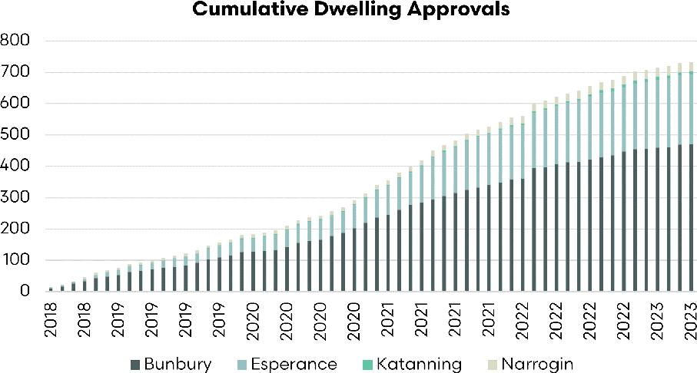

Sources: EP3, ABS

At an individual local government area, the shires of Katanning and Narrogin are inland, as opposed to the coastal areas of Bunbury and Esperance. The inland areas have very few building approvals at 10 in Katanning and 30 in Narrogin. This is a low level of new housing stock.

Figure 66 WA building approvals

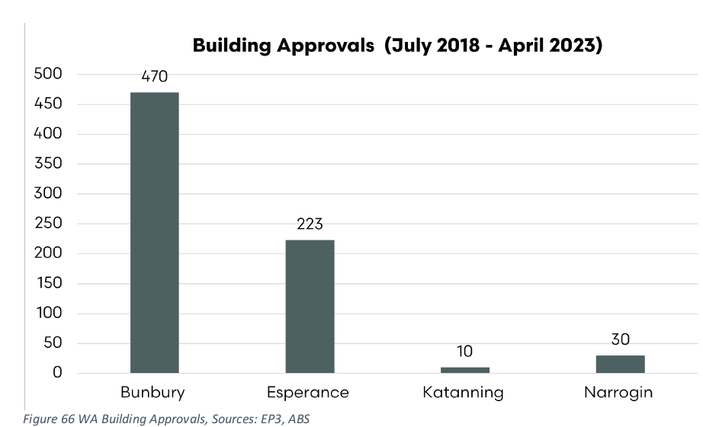

Sources: EP3, ABS

When the dwelling approvals are overlaid against population of the shires, the pattern changes somewhat. In that case, we can see that Katanning has a population of 363 per approval. This shows that the Katanning are, despite having strong employment opportunities, has seen very little housing growth in comparison to the overall population.

Figure 67 WA building approvals by population

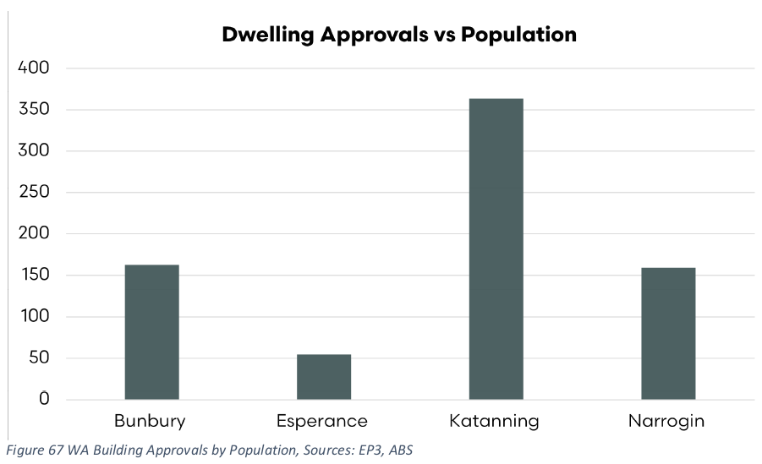

Sources: EP3, ABS

The problem of housing in regional areas is not a new issue, and despite the longevity of the issue has not been solved. The access to housing to accommodate meat workers, many of which will be foreign sourced, is a barrier to achieving full domestic slaughter of Western Australian sheep and lamb.

The following may be possible considerations:

* Expedited approvals for new build housing
* Planning permissions for higher density/high occupancy accommodation
* Encouraging the provision of affordable housing in local planning schedules
* Temporary accommodation permissions for abattoir workers, such as ‘mine site’ style accommodation.

#### ii. Further development of chilled and frozen sheep meat exports identifying suitable markets, products and existing opportunities

According to the OECD FAO between 2011 to 2021, global sheepmeat consumption increased by 21% and is expected to grow a further 14% over the next decade (OECD-FAO, 2022). This suggests that there will be many opportunities for a key global sheep meat exporter, like Australia, to participate in the anticipated growth in this sector.

Analysis from MLA demonstrates that the Middle East and North African (MENA) region is expected to see significant growth in demand for live sheep with import volumes to increase from 5 million head per year in 2023 to over 7 million head by 2027, demonstrating a compound annual growth rate (CAGR) of 9.1%. This very strong growth rate forecast for the MENA region highlights the ongoing preference that exists for live sheep among Middle Eastern and North African nations.

Figure 68 Live sheep and goat import options and forecast

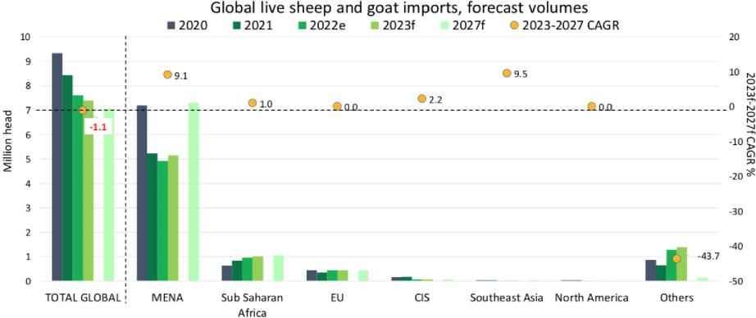

Sources: MLA

##### Middle East and North African region (MENA)

Several factors contribute to the preference for live sheep in Middle Eastern and North African (MENA) countries, deeply rooted in the cultural, religious, and culinary practices of the region. Foremost among these are the cultural and religious traditions that span centuries. Religious festivals and occasions often involve the sacrifice of live animals, with sheep playing a key role in these rites. The act of selecting and sacrificing the sheep personally bears significant cultural and religious meaning for individuals in the MENA region.

The preference for live sheep also facilitates customised butchering and preparation. This option gives consumers control over how the animal is processed, from the cuts of meat to portion sizes, ensuring the end product aligns with their specific culinary traditions and personal preferences.

Many MENA consumers hold the belief in superior taste/texture of meat from freshly slaughtered animals and this view also plays a significant role in their preference for live sheep. Many individuals are convinced that the freshness from the immediate slaughter and preparation process results in higher quality meat, delivering unparalleled tenderness and flavour, especially when compared to pre-packaged or frozen alternatives.

Another important consideration is the assurance of freshness and quality. When individuals purchase live sheep, they have the opportunity to inspect the animal closely. This personal examination allows buyers to assess key elements like the sheep’s weight, appearance, and overall health, instilling confidence in the quality of the product they are purchasing.

Lastly, the enduring preference for live sheep is also a nod to tradition, familiarity, and a connection to the cultural heritage of the MENA region. Live sheep have been an integral part of the region’s culture for generations, and the practice’s continuation reinforces a sense of cultural identity and preserves their rich heritage.

Despite this preference for live sheep in the MENA region consultation with the MLA in market team suggests that the MENA region remains the most likely immediate destination for current WA sheep and lamb turnoff (based on live export carcass specifications and local preferences for leaner, lighter bodied sheep and lamb).

In markets with fast-growing tourism sectors such as the UAE, Saudi Arabia and Qatar, demand for Australian high value chilled lamb loin cuts in the high-end foodservice sector has been growing. ([MLA MENA report](https://www.mla.com.au/contentassets/079ba13d266c42a28c90463d33f50103/mena_2022-mla-industry-insights-market-snapshot_rev1_220223.pdf))

In the MENA region, people have a deep connection with sheepmeat, mainly due to their cultural or religious traditions. However, cost is a significant obstacle for many buyers. In numerous MENA countries, lamb and mutton are viewed as high-quality meats, creating a potential opportunity to capitalise on these views.

Figure 69 MENA sheepmeat import prices

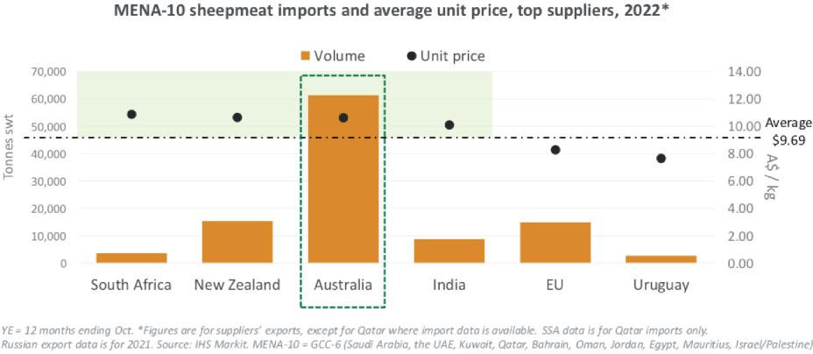

Sources: MLA

Currently, there is a very price competitive environment for imported sheep meat product in the MENA region. As Figure 69 demonstrates, in 2022 Australia was the primary importer of boxed sheep meat into the region but competed very closely on average unit price with other importing nations, such as New Zealand, India and South Africa. Meanwhile, the EU and Uruguay were able to deliver product into the MENA region at a much lower average unit price than Australia.

Most of the sheepmeat sold in the MENA region is carcass product. However, the demand and consumption of high-end lamb are predicted to keep growing in several markets, especially in GCC countries. (The GCC, or Gulf Cooperation Council, is a regional intergovernmental political and economic union that includes all Arab states of the Persian Gulf, except for Iraq. Its member states are Bahrain, Kuwait, Oman, Qatar, Saudi Arabia, and the United Arab Emirates. The GCC was established in 1981.) This trend is fuelled by rising incomes, continued city growth and influence from Western culture, a younger population, and large communities of affluent foreign workers.

Despite the strong growth outlook there can be unpredictable shifts in the boxed sheep meat and live sheep trade in the MENA region as outlined by Meat & Livestock Australia (MLA) in their MENA region update (see below) and this reinforces the need to provide suitable support to the MLA MENA in-market team in order for Australia’s sheep meat market share to be maintained and further developed.

The cessation of subsidies for chilled sheepmeat in Qatar at the end of 2020, caused a 53% decline in Australian exports to Qatar over the financial year. This meant that the United Arab Emirates emerged as the largest market for Australian sheepmeat, as imports grew 3% over 2021–22 to 19,810 tonnes. At the same time, Australian exports to Saudi Arabia grew by 47% to 13,276 tonnes over the financial year, establishing Saudi Arabia as the second biggest market for sheepmeat in the region. (MLA, [Global sheepmeat industry and trade report](https://www.mla.com.au/globalassets/mla-corporate/prices--markets/documents/os-markets/mla-mi-global-industry-trade-report-sheep.pdf))

Australia, New Zealand, and the European Union combined provide about 85% of the sheepmeat imports to the MENA region. The remaining 15% mainly comes from India, with smaller amounts from South Africa, Uruguay and the UK. Generally, Australia’s leading role in the MENA’s boxed sheep meat market allows it to sell a large quantity at high prices, especially in the expanding retail areas in the GCC states.

Over the past few decades, it’s become easier for Australia to export sheepmeat to the MENA region. However, non-tariff barriers, which are rules not related to taxes, are becoming bigger obstacles. These barriers include things like approved supplier lists, packaging and labelling rules, unnecessary checks and tests, and strict rules about how long the packaged meat can be stored.

These rules apply to all countries that export to the region, and they don’t consider Australia’s proven history of safe food handling and animal health, or the high quality of its products. In some cases, the COVID-19 pandemic has made existing non-tariff barriers even more problematic or introduced new ones. Therefore, if these rules were adjusted to reflect scientific findings and a risk-based approach, it could lead to big benefits for Australian exporters and customers in other countries.

One area over the last two years where such reform has been evident is the revision to chilled and frozen shelf requirements for imported Australian sheepmeat into key Middle Eastern markets. Extending the shelf life on imported sheepmeat has unlocked new marketing channels, reduced food waste and supported a shift from air to sea-freight. (MLA, [Global sheepmeat industry and trade report](https://www.mla.com.au/globalassets/mla-corporate/prices--markets/documents/os-markets/mla-mi-global-industry-trade-report-sheep.pdf))

As Table 18 outlines, further work could be done in some MENA destinations to extend the shelf life of chilled vacuum-packed sheep meat from Australia.

Table 18 MENA red meat shelf life

|  |  |  |
| --- | --- | --- |
| Markets | Max. expiry period after slaughter on chilled vacuum-packed meat | Max. entry age to importing country on chilled vacuum-packed meat |
| UAE | 120 days (beef); 90 days (sheep) | na |
| Jordan | 120 days (beef and sheep) **a** | na |
| Qatar | 90 days (beef and sheep) | na |
| Oman | 120 days (beef and sheep) | na |
| Lebanon | 84 days (beef and sheep) **b** | 60 days |
| Iran | 70 days (beef); 100 days (sheep) | 60 days |
| Saudi Arabia | 120 days (beef); 90 days (sheep) | na |
| Kuwait | 90 days (beef and sheep) | na |
| Bahrain | 120 days (beef); 90 days (sheep) | na |
| Egypt | 98 days (boneless beef and lamb) | 14 days (bone-in), 24 days (boneless) |

Source: DAFF, MLA

**a** Jordan – temporary extension since the COVID-19 pandemic continues. **b** Trial officially ended 14/04/2021 but 84-day shelf life has continued since then.

A summary of key trade destinations in the MENA region for Australian sheep meat and live sheep exports is outlined below.

##### Kuwait

Kuwait is a small, oil-rich country located at the tip of the Persian Gulf, sharing borders with Iraq to the north and west, and Saudi Arabia to the south. Its relatively flat terrain is characterised by desert plains and some low rolling hills, with a coastline stretching along the Persian Gulf. Despite being largely desert, it has a rich biodiversity, especially in terms of bird species, due to its location along migratory routes.

In terms of demographics, as of 2023, Kuwait has a population of around 4.45 million people. Kuwaiti nationals form just over a third of the population, with the rest being expatriates, predominantly from India, Egypt, Bangladesh, and other Arab nations. Arabic is the official language, but English is widely spoken and often used in business and among the large expatriate community.

Economically, Kuwait is one of the wealthiest countries in the world in terms of GDP per capita, largely due to its significant oil reserves. As of 2023, the GDP per capita was roughly A$48,000. The country’s economy relies heavily on oil exports, but there are efforts to diversify into other sectors like finance and entertainment.

In terms of agriculture and livestock, Kuwait is limited by its arid environment and has to import most of its food. Sheep meat is a staple of Kuwaiti cuisine, and the demand for it, especially during religious festivals, is largely met by imports of boxed sheep meat and live sheep. Per capita sheep meat consumption in Kuwait per annum sits at around 13 kg cwt.

Kuwait is Australia’s top destination for live sheep exports and comprised nearly 59% of total live sheep exports from Australia in 2022. In terms of market share of Australian boxed sheepmeat exports, Kuwait sat in 15th place in 2022 taking 4,662 tonnes shipped weight (swt).

Figure 70 highlights historic sheep meat and live sheep imports into Kuwait from main supplier nations.

Figure 70 Live sheep and sheepmeat import volumes – Kuwait

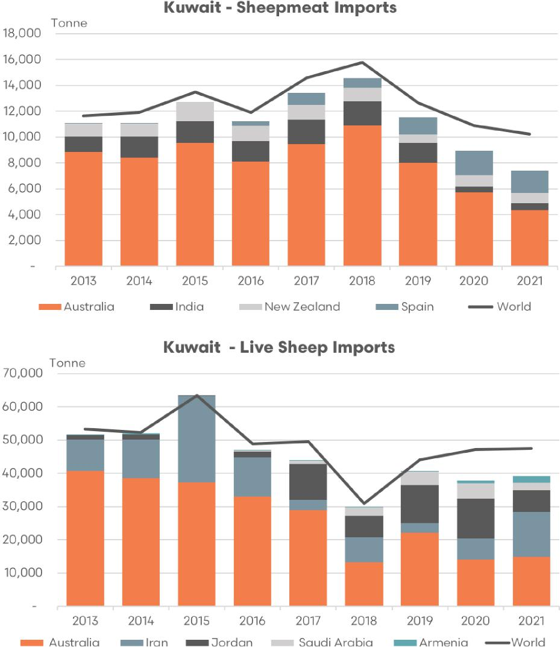

Sources: EP3, UN Comtrade, MLA

In terms of boxed sheep meat imports into Kuwait, Australia features prominently and is the primary source nation for Kuwaiti boxed sheep meat imports. In 2021 Australian sheep meat imports into Kuwait was 43% of total sheep meat imports.

Since 2013 the composition of importing nations for sheep meat into Kuwait has diversified with an increasing proportion coming from Spain and other countries. Elevated Australian sheep and lamb pricing, tight supply of sheep and the flock rebuild in Australia has probably contributed to the diversification of sheep imports into Kuwait.

Australia is the top source nation for live sheep into Kuwait, holding 31% of the trade in 2021. However, in recent years the reduced flow of live sheep from Australia, the northern hemisphere summer prohibition period and the higher pricing of Australian sheep versus global competitors has seen Kuwait seek alternative sources of live sheep, such as Iran and Jordan.

Analysis of the market share of the boxed sheep meat and live sheep trade from Australia to Kuwait since 2013 has demonstrated a gradual decline from 76% (for both boxed and live) to 43% for boxed sheepmeat and 31% for live sheep exports in 2021.

Interestingly, Australia’s market share of the boxed trade began to decline more prominently since the live sheep prohibition came into effect in 2019. A possible signal that Kuwaiti concern over Australia’s live sheep export policy in recent years has negatively impacted upon trade relations more broadly and has tarnished the boxed trade somewhat.

Figure 71 Australian share of live sheep and sheepmeat import volumes – Kuwait

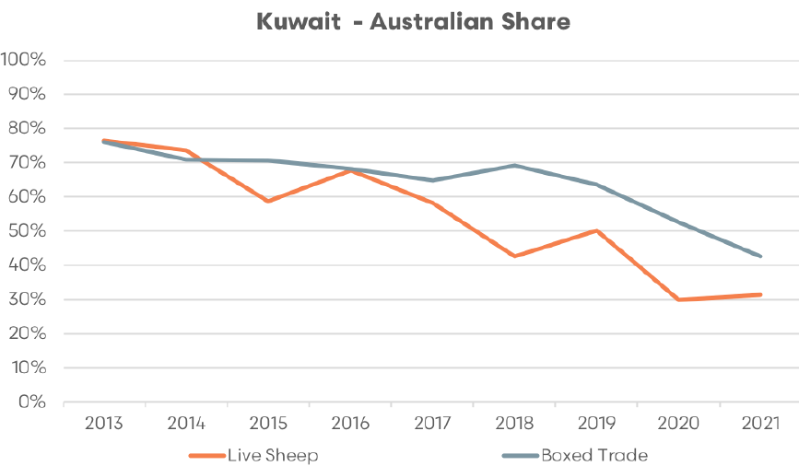

Sources: EP3, UN Comtrade, MLA

Although, an alternative view could be that high sheep/lamb pricing in Australia, low supply and the flock rebuild phase has been the main contributing factor in the loss of market share for the boxed trade into Kuwait.

Irrespective of the cause of market share deterioration, it does signal that Australia has some work to do in restoring trade relationships in Kuwait for boxed sheep meat exports and reinforces the need for a targeted business development and relationship building focus in Kuwait to rebuild our market penetration.

##### Oman

Oman is a country on the south-eastern coast of the Arabian Peninsula in Western Asia. It’s bordered by the United Arab Emirates to the northwest, Saudi Arabia to the west, and Yemen to the southwest, and shares marine borders with Iran and Pakistan. Oman has a diverse environment with various landscapes including mountain ranges, deserts, and coastal plains. It’s particularly known for its fjord-like coasts in Musandam, often called the ‘Norway of Arabia’.

In terms of demographics, as of 2023, Oman has a population of approximately 5.5 million people. The majority are Arab Omanis, with sizable communities of expatriates, mainly from South Asia and other Arab countries. Arabic is the official language, but English and other South Asian languages like Urdu, Baluchi, and Bengali are also spoken.

Economically, Oman is considered a high-income economy, with a GDP per capita of around A$31,000 as of 2023. The country’s economy is heavily dependent on dwindling oil resources, but it’s trying to diversify its economy through a process of ‘Omanisation’, which includes measures to promote other sectors like tourism and infrastructure.

Agriculture is limited due to the arid climate, but dates, limes, and grains are grown, and there’s also a significant fishing industry. Meat is a key component of the Omani diet, with lamb and mutton being popular choices. While there is some domestic sheep meat production, Oman also imports a substantial amount of boxed sheep meat and live sheep to meet local demand. Per capita sheep meat consumption in Oman per annum is nearly 15 kg cwt.

Oman ranks 19th among the leading importers of Australian boxed sheep meat, having received 2,874 tonnes (swt) in 2022. Furthermore, the country is a significant player in Australia’s live sheep export market, taking third place in 2022 by accounting for 6% of the total trade flows.

As for the importation of boxed sheep meat into Oman, Australia secures a strong position as the second-largest source. In 2021, 24% of total sheep meat imports into Oman were from Australia.

However, since 2012, Oman has started diversifying its import sources of sheep meat, with Spain and the UAE gaining a larger share. As was the case for Kuwait, this shift could be attributed to factors such as high Australian sheep and lamb prices compared to other global competitors, limited sheep/lamb supply in Australia during this time, and Australia’s flock rebuild.

As for the live sheep import market in Oman, Australia has traditionally been the primary source. However, the implementation of the northern hemisphere summer prohibition for live sheep has led to a considerable loss in Australia’s market share to Somalia and Sudan. In 2021, Australian live sheep made up merely 3% of Omani imports.

Analysis of the market share of the boxed sheep meat from Australia to Oman has demonstrated increasing market share from 2012 to 2016. In 2017 there was a sharp decline in Australian market share of the boxed trade into Oman from 70% to 35%. Since 2017 the market share has been reasonably stable, albeit with a slightly weakening bias. In 2021 Australian market share of the boxed trade into Oman was 24% (Figure 72).

Figure 72 Live sheep and sheepmeat import volumes – Oman

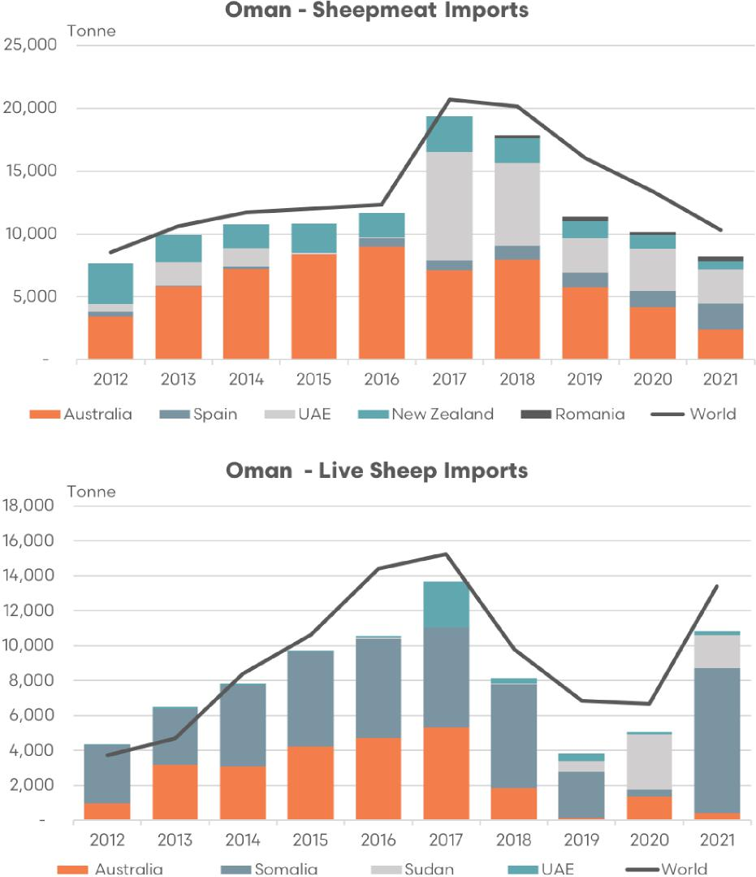

Sources: EP3, UN Comtrade, MLA

In terms of Australian market share of Omani live sheep imports there has been a declining trend since 2013 onwards. There was a sharp drop from 68% to 37% from 2013 to 2014, a period of relative stability in market share until 2017 and then somewhat volatile trade since 2018 onwards. Australia’s market share of Oman’s live sheep imports has oscillated each year since 2018 from around 20% one season to 2%–3% the following season.

Figure 73 Australian share of live sheep and sheepmeat import volumes – Oman

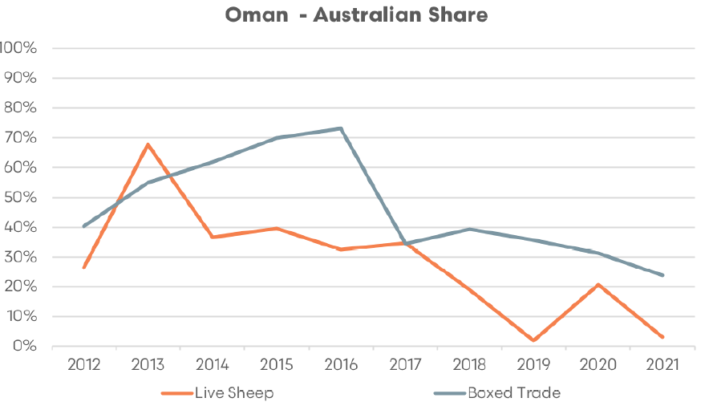

Sources: EP3, UN Comtrade, MLA

##### Jordan

Jordan is a country located in the Middle East, bordered by Syria to the north, Iraq to the northeast, Saudi Arabia to the east and south, Israel and Palestine to the west, and with a small stretch of coastline at the Red Sea. The country is known for its varied landscapes, which include the fertile Jordan Valley, mountainous highlands, vast deserts, and the iconic Dead Sea, the lowest point on the earth’s surface.

In terms of demographics, as of 2023, Jordan has a population of approximately 10.5 million people. The majority of the population is of Jordanian descent, with a significant proportion of Palestinians, and smaller communities of other nationalities, including Syrians, Iraqis, and Egyptians. Arabic is the official language, with English widely spoken in commerce and among educated Jordanians.

Economically, Jordan is classified as a middle-income country. Its economy is relatively diverse with sectors such as phosphate and potash extraction and the manufacturing of fertilizers having international significance. As of 2023, the GDP per capita was about A$7,600.

Despite its arid and desert terrain, Jordan maintains a small agricultural sector that includes livestock farming. Sheep meat, in particular, forms a significant part of the Jordanian diet, with dishes such as mansaf (lamb cooked in a sauce of fermented dried yogurt and served with rice) being a national dish. To meet this demand, Jordan both rears its own livestock and imports sheep meat and live sheep are also imported. Per capita sheep meat consumption in Jordan is around 3.6 kg cwt per annum.

Jordan was the 14th highest place destination for Australian sheep meat exports in 2022 taking 5,538 tonnes swt, one place ahead of Kuwait. In terms of the live sheep trade from Australia Jordan also features prominently, holding second place from 2018 to 2020 and slipping to fourth place in 2022 on 3.3% of the trade. So far in 2023 Jordan has re-emerged as a live sheep destination moving back to second place with 12.6% of the Australian trade.

Figure 74 Live sheep and sheepmeat import volumes – Jordan

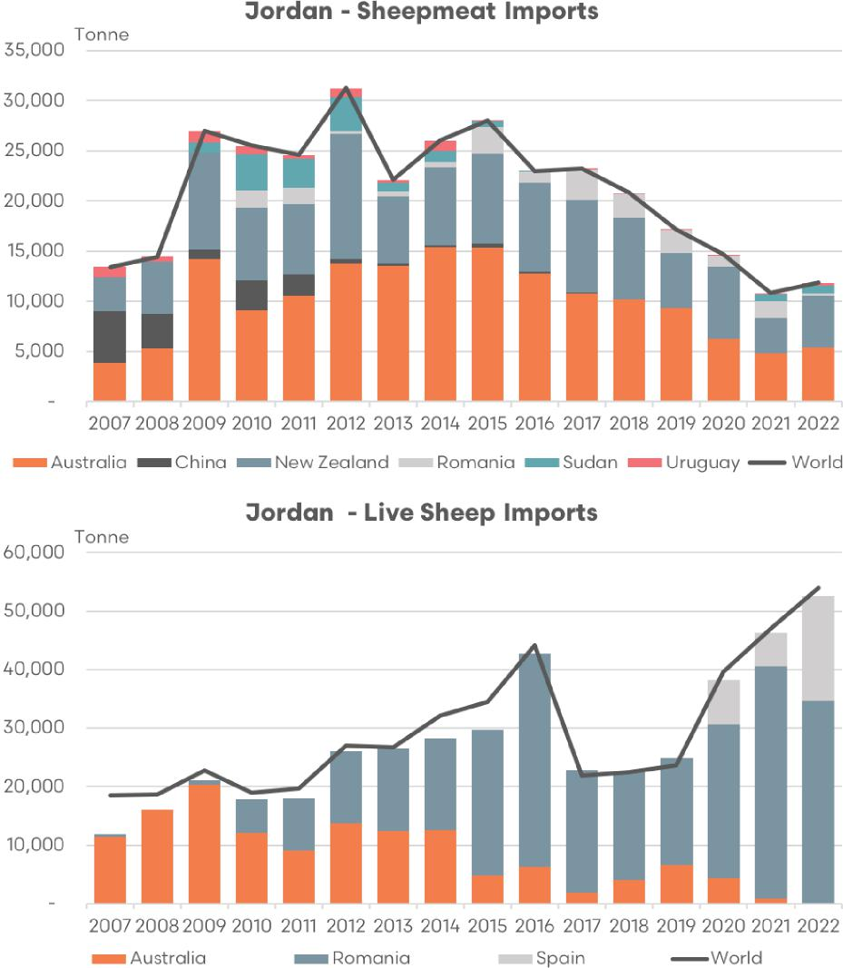

Sources: EP3, UN Comtrade, MLA

The historic trend in sheep meat and live sheep imports into Jordan over the last decade and a half shows an interesting trend with the total volume of the imported boxed trade climbing from 2007 to 2012 and then declining gradually over the decade to 2022. Meanwhile, the live sheep trade has shown a gradual increase in volumes from 2007, apart from a 3-year lull in 2017 to 2019.

The market share of boxed sheep meat imports into Jordan has been predominantly shared by Australia and New Zealand over the last decade and a half. China, Sudan and Uruguay contributed additional flows up to 2014, but were mostly replaced by Romania since 2015. Although, in 2022 Sudan and Uruguay replaced much of the Romanian share of the boxed trade.

Romania has had more success in gaining market share of the Jordanian live sheep trade with their proportion of live sheep import volumes growing steadily from 2010 onwards. Prior to 2010 live sheep imports into Jordan were almost exclusively Australian and between 2011 and 2014 it was approximately a 50/50 split between Australia and Romania, with the market share favouring Romania more toward 2014. During 2015 to 2020 the Australian share of Jordanian live sheep import volumes has ranged between 8% to 28%. In 2021 and 2022 this share dropped significantly to 1.9% and then just 0.2%, respectively.

Figure 75 Australian share of live sheep and sheepmeat import volumes – Jordan

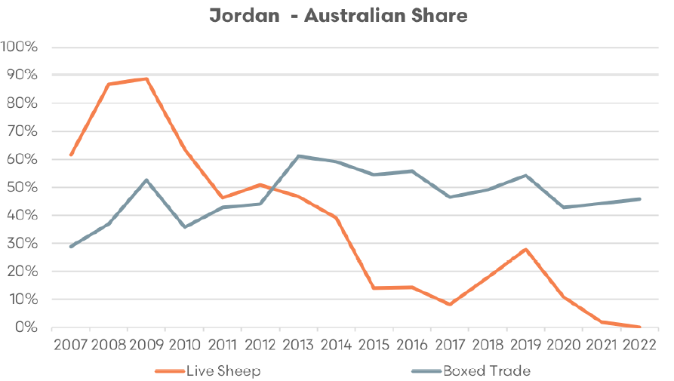

Sources: EP3, UN Comtrade, MLA

Figure 75 highlights that while the Australian market share of the live sheep trade into Jordan has been in steady decline since 2009 the boxed proportion of the trade has managed to grow market share from 2007 to 2013. Australian share of Jordan’s boxed sheepmeat imports has eased from 60% to 43% from 2013 to 2020. However the last 3 years have demonstrated relatively stable market share with slight growth noted to 46% in 2022.

This suggests that for some destinations in the MENA region, falling live sheep export market share is not consistent with declining boxed sheep meat market share. Additionally it provides a more optimistic view that with the right marketing and business development strategy in the region the phase out of the live sheep trade from Australia doesn’t have to coincide with a weakened position in terms of the boxed meat trade.

##### United Arab Emirates

The United Arab Emirates (UAE) is a federation of 7 emirates located in the eastern part of the Arabian Peninsula. It has coastlines along the Gulf of Oman and the Persian Gulf, between Oman and Saudi Arabia. Each emirate is governed by a hereditary emir who jointly form the Federal Supreme Council, with one emir serving as the president. The 7 emirates are Abu Dhabi (which serves as the capital), Ajman, Dubai, Fujairah, Ras Al Khaimah, Sharjah and Umm Al Quwain. The UAE is known for its diverse and striking landscapes, from sweeping deserts to stunning beaches, lush oases, and dramatic mountain scenery.

The UAE has a population of about 10.2 million people as of 2023. Its population is diverse, with UAE nationals, known as Emiratis, making up less than 20% of the population, and the rest being a vibrant mix of expatriates from all around the world. The official language is Arabic, but English, Hindi, and Urdu are also widely spoken due to the diverse expatriate population.

Economically, the UAE has one of the most developed economies in the Middle East. The country has a high per capita income with a sizable annual trade surplus. As of 2023, the GDP per capita was around A$70,000. Its economy, initially built on the oil industry, has become more diversified in recent years, with sectors such as tourism, finance, and construction playing increasingly important roles.

When it comes to sheep meat consumption, like many Middle Eastern countries, lamb is a staple in traditional Emirati cuisine. The UAE relies heavily on imports of sheep meat to meet local demand due to the limitations of domestic production in the country’s arid environment. Per capita sheep meat consumption in the UAE per annum sits at 13 kg cwt.

Within the MENA region the UAE is the largest market for Australian boxed sheep meat export flows. In 2022 the UAE sat in 6th highest position in terms of market share of Australian boxed sheep meat destinations with annual trade volumes of 21,240 tonnes swt. Over the last decade the UAE have featured prominently in the market share of the Australian live sheep trade too sitting in either second or third top destination, depending upon the year.

In terms of total boxed sheep meat imports into the UAE they have been a relatively consistent player over the last decade with total import flows usually ranging between 40,000 to 50,000 tonnes. Australia has featured highly in the composition of the boxed trade into the UAE usually comprising of between 55% and 65% of the total sheep meat import volumes. Alongside Australia imports from India have also been prominent and in more recent years growth in Spanish, Sudanese, Kenyan, South African and Pakistani imports have been noted.

Live sheep import volumes into the UAE have shown similar variability in terms of tonnage change to the boxed trade, displaying a somewhat cyclical range of 10,000 tonnes across the seasons from peak to trough. Interestingly, there appears to be some level of substitution effect between boxed and live in the UAE in recent years with 7,000 tonnes increase to the boxed trade from 2015 to 2018 coinciding with a 10,000 decrease to the live trade. Likewise, 2018 to 2021 has seen a 16,000 tonne increase to the live trade correspond to a 6,000 tonne decline in the boxed trade. Covid-19 disruptions to airfreight during 2020 and 2021 could have also been a factor in encouraging increased live sheep flows in favour of boxed product, particularly for nations that have a dominant global air carrier and significant air traffic hub like the UAE.

In terms of the live trade into the UAE Australia remains a relatively stable contributor with average annual flows of around 5,500 tonnes liveweight and usual range between 4,000 to 8,000 tonnes depending upon the year. India and Somalia also feature prominently in terms of competition for market share of the live trade into the UAE with Iran also gaining increased traction too since 2020. Additionally, Somalia has been experiencing their worst drought in history in recent years encouraging significantly increased turnoff of live sheep volumes into destinations like the UAE.

Figure 76 Live sheep and sheepmeat import volumes – UAE

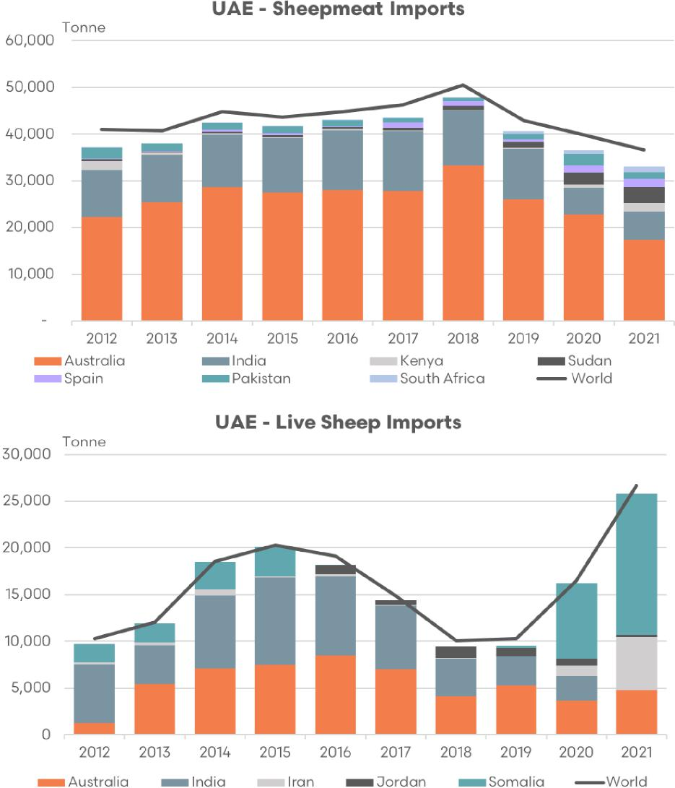

Sources: EP3, UN Comtrade, MLA

The historic trend in Australian market share of UAE imports of sheep meat and live sheep shows a relatively stable pattern with much of the last decade ranging between 55% to 65% for boxed product and between 40% to 50% for the live trade, broadly speaking.

Since 2018 onwards the Australian proportion of the boxed trade into the UAE has slipped from 66% to 47% and the live trade market share has declined from 47% in 2017 to just 18% in 2021. However, it remains difficult to assign the loss of market share in both sectors to relatively high Australian prices during this time or if the disruption of the live sheep export trade from Australia in recent years and the prospect of Australia becoming a more unreliable partner in the live sheep trade is having a negative impact upon its reputation within the boxed meat trade.

Figure 77 Australian share of live sheep and sheepmeat import volumes – UAE

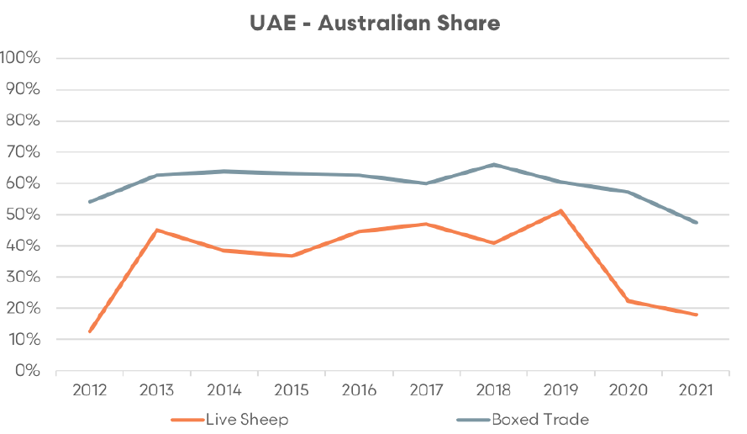

Sources: EP3, UN Comtrade, MLA

##### Qatar

Qatar is a small peninsular Arab country extending from the Arabian Peninsula into the Persian Gulf. It shares a single land border with Saudi Arabia to the south, with the rest of the country surrounded by the Persian Gulf. Despite its small size, it’s known for its contrasting landscapes – from arid desert to a long, sandy coastline with beautiful beaches and dunes.

As of 2023, Qatar has a population of approximately 3.0 million people. The population is very diverse, with Qatari nationals making up less than 15% of the total. The rest of the population consists of a variety of expatriates, including individuals from South Asia, other Middle Eastern countries, and the Philippines. Arabic is the official language, but English is also widely spoken due to the international nature of the population.

Qatar has one of the highest per capita incomes in the world due to its significant reserves of natural gas – the third largest in the world. As of 2023, the GDP per capita was around A$90,000. Qatar’s economy is heavily dependent on its hydrocarbon industries, but the country is also trying to diversify its economy through initiatives in finance, education, and science.

Like many Middle Eastern countries, Qatar has a strong preference for lamb and mutton in its cuisine. Despite some domestic production, the country relies heavily on imports of sheep meat to satisfy its demand, especially during religious holidays and festivals. Annual per capita sheep meat consumption is approximately 15 kg cwt in Qatar.

Qatar holds the 13th highest place in terms of boxed sheep meat exports from Australia, ahead of Jordan and Kuwait, and imported a total of 6,553 tonnes swt of sheep meat in 2022 from Australia. Up until 2020 Qatar had implemented an import subsidy for Australian sheep meat which had seen significantly stronger volumes of sheep meat imported from Australia of around 20,000 tonnes swt per annum.

This subsidy program had supported Australian dominance of boxed sheep meat imports into Qatar with the main rivals of India and, to a lesser degree, Spain up until 2020. After 2020 the mix of sheep meat imports into Qatar have been more diverse, albeit on lower overall volumes. Reduced air traffic due to Covid-19 travel restrictions may have impacted boxed meet volumes into Qatar in 2021. In 2022 Australian market share of Qatari boxed imports has been further diminished by the emergence of Tanzanian and South African imports.

Figure 78 Live sheep and sheepmeat import volumes – Qatar

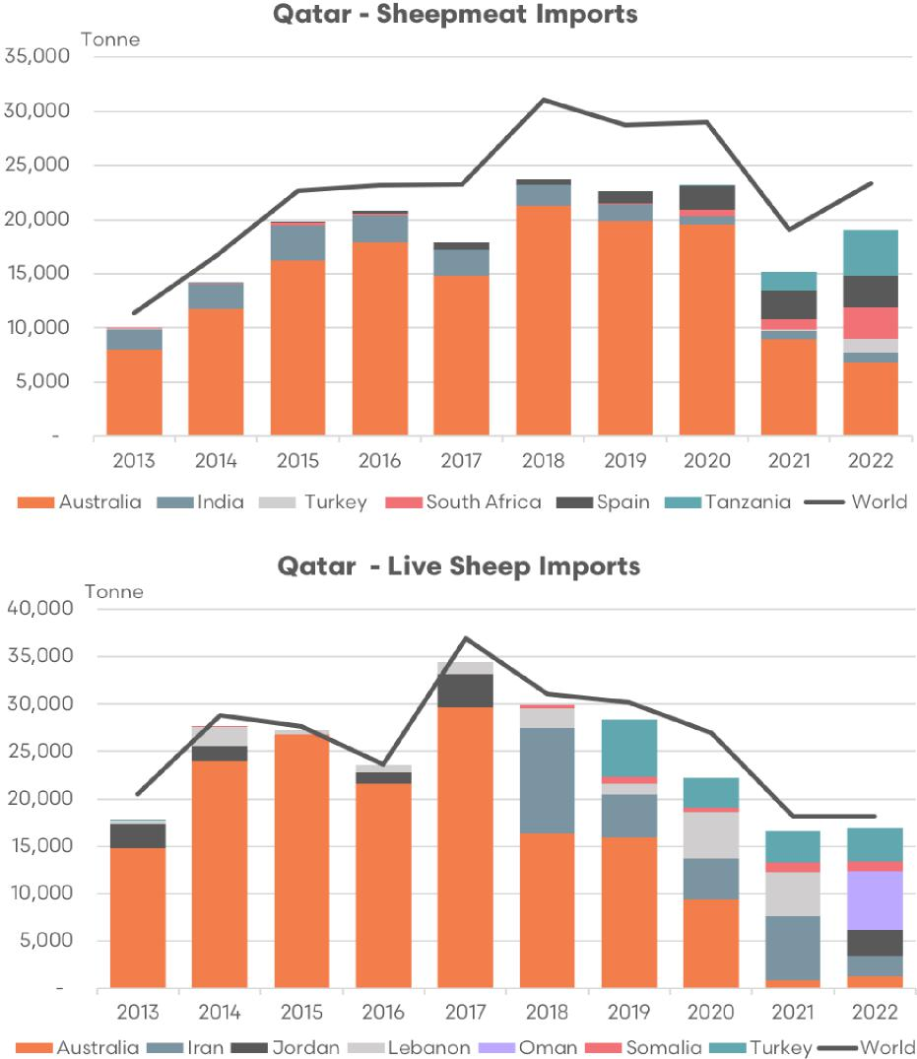

Sources: EP3, UN Comtrade, MLA

Australian live sheep imports into Qatar had been quite dominant up until 2017, with Jordan and Lebanon as smaller participants with somewhat sporadic flows. Since the moratorium/prohibition from Australia was enacted in 2018 onwards there has been a definite shift away from Australia as the main supplier of live sheep into Qatar. Live sheep flows from Oman surged in 2022, accompanied by the emergence of new entrants like Iran (from 2018), Turkey (from 2019) and the return of Jordan (in 2022 after a noticeable absence since 2017).

Figure 79 Australian share of live sheep and sheepmeat import volumes – Qatar

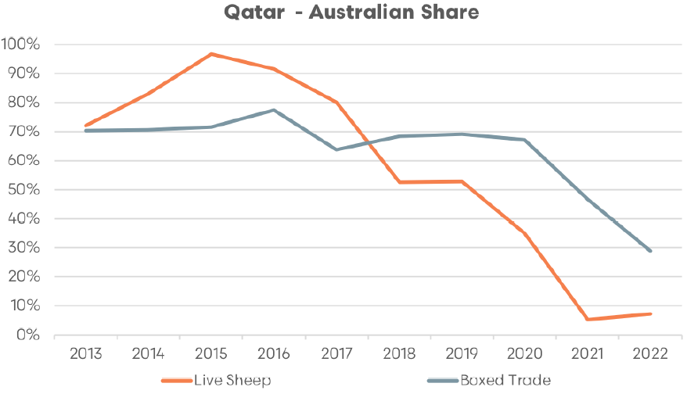

Sources: EP3, UN Comtrade, MLA

The historic pattern for Australian market share of the boxed trade into Qatar is likely to have been heavily influenced by the subsidy program that was in place from 2015 onwards, encouraging relatively stable market share of around 65% to 75% of the trade. The removal of the subsidy saw Australian market share drop from 69% in 2020 to 29% in 2022.

Australian live sheep market share has been in steady decline since 2015, dropping from 97% of the trade to between 5% and 7% in recent years. As was the case with the UAE, the decrease in market share in both trade sectors into Qatar in recent years could be due to a number of factors. It might be attributable to the comparatively high Australian prices during this period, or it might be related to the disruptions to the live sheep export trade from Australia in recent years.

The possibility of Australia becoming an increasingly unreliable partner in the live sheep trade might be damaging its reputation in the boxed meat trade into Qatar. However, the loss of the subsidy program would also muddy the waters somewhat and make it difficult to determine how much the current live sheep disruptions are impacting upon the boxed trade from Australia to Qatar.

##### Israel

Israel is located in the Middle East, bordered by Lebanon to the north, Syria to the northeast, Jordan to the east, Egypt to the southwest, and the Mediterranean Sea to the west. The geography of Israel is quite diverse, ranging from the fertile coastal plains in the west to the mountainous regions in the central and northern regions, and the Negev desert in the south. The nation is small and compact, measuring about 20,000 square kilometres, approximately the one third the size of Tasmania.

The demographic makeup of Israel is equally diverse, reflecting its history as a place of important religious and cultural convergence. As of 2023, Israel has a population of over 9.5 million people. The majority of the population is Jewish, with a significant Arab minority, and smaller communities of various other ethnicities. Hebrew and Arabic are the official languages of the country, and English is widely spoken.

In terms of economy, Israel is considered a developed country with a high standard of living. It has a technologically advanced, market-based economy with a strong emphasis on innovation and entrepreneurship. The GDP per capita was about A$83,000 as of 2023. The labour force is well educated and highly skilled, particularly in high tech industries, which are a major engine of economic growth.

Agriculture plays a smaller role, but Israel has developed innovative methods for farming in arid conditions. Sheep farming is part of this agricultural sector, and lamb is a common component of both traditional Middle Eastern and Mediterranean diets prevalent in Israel. However, Israel also imports sheep meat and, in more recent years, live sheep. This is largely due to local demand exceeding the capacity of domestic production. Per capita sheep meat consumption in Israel per annum sits at 1.6 kg cwt.

Israel is a relatively small importer of boxed sheep meat on a global scale but import volumes in percentage terms have grown substantially over the last decade and a half with total volumes increasing from around 500 tonnes swt in 2007 to around 3,500 tonnes in recent years. Despite Australian boxed sheep meat product featuring prominently in the mix up until 2018 Israel isn’t a significant destination for Australian product and in 2022 sat in 49th place for Australian sheep meat exports with nearly 800 tonnes swt reported shipped. MLA report 513 tonnes for the 2022 year to Israel. However, Israeli reported imports from Australia via the UN Comtrade database indicate a higher volume of 798 tonnes. Data can sometimes vary across reporting methods and while care is taken to cross reference figures across several data sources there are times when the amounts reported are not completely compatible. For consistency UN Comtrade figures have been used whenever data sources don’t match adequately.

Prior to 2016 Australian boxed sheep meat imports into Israel mainly competed with France and South American exporters. Since 2016 France, Chile and Argentina have remained as key competitors to Australia and most notable has been the emergence of Spain as a significant competitor.

In terms of live sheep imports, Israel was a very minor player up until 2015, with volumes exclusively sourced from Australia. From 2016 onwards Israel saw a surge in live sheep imports and the demand for sheepmeat outpaced the ability for boxed imports to supply. There was also a shift in government policy that reduced the trade barriers to live animal imports and a desire for local processing in order to ensure Kosher slaughter practices were being adhered to, and to provide for increased local employment opportunities.

Despite the strong rise in imported live sheep the Israel parliament has indicated that they are pursuing a policy to phase out the importation of live animals. However, government disruption in recent years has seen this legislation stall.

In terms of tonnage of live sheep imports from Australia since 2016 onwards there has been an increase in flows from averages of around 1,000 tonnes between 2010 and 2015 to around 2,500 tonnes since 2016. However, Australian flows have been dwarfed by big increases in tonnage from Portugal.

Figure 80 Live sheep and sheepmeat import volumes – Israel

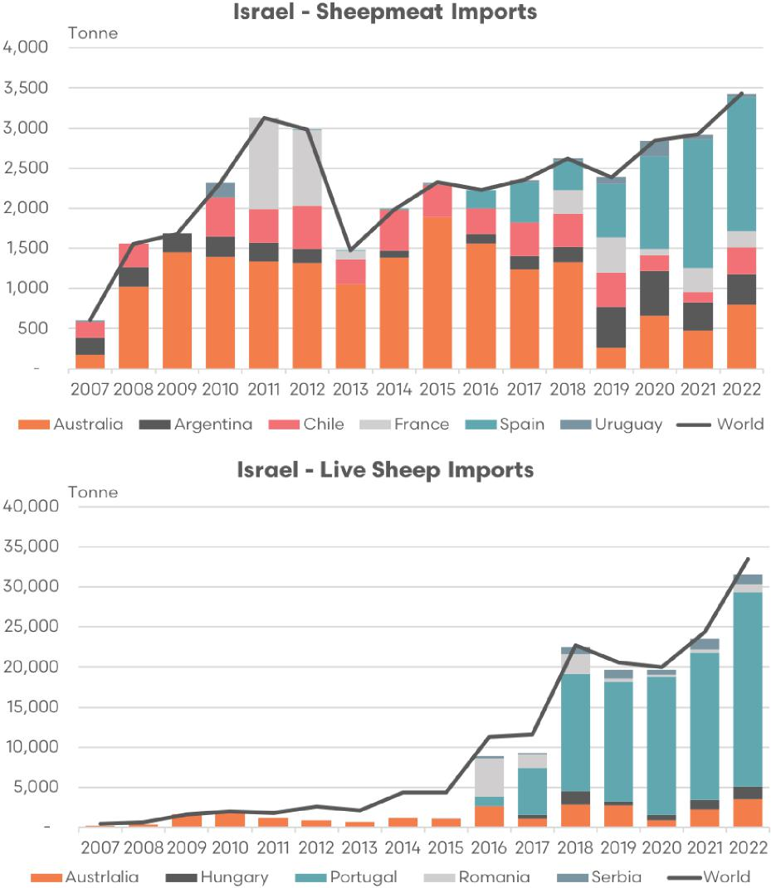

Sources: EP3, UN Comtrade, MLA

In terms of the trend in market share since 2007 for Australian boxed and live sheep imports into Israel the proportional changes have been relatively volatile but have demonstrated a declining trend overall.

2007 to 2018 saw the Australian market share of the boxed trade oscillate between 30% to 80%, but in recent years it has stabilised at around 20% with a mild upward bias since 2019. The share of the live sheep trade into Israel for Australia has been in steady decline since 2009. Over the last 5 years, despite the huge growth in Portuguese live sheep exports into Israel Australia has managed to maintain a market share of around 10%.

Figure 81 Australian share of live sheep and sheepmeat import volumes – Israel

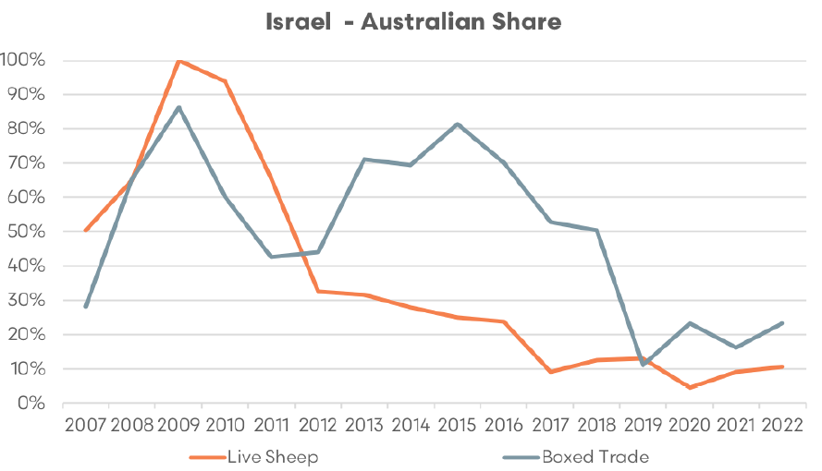

Sources: EP3, UN Comtrade, MLA

##### Saudi Arabia

Saudi Arabia is a vast country located in the Middle East, the largest in Western Asia, covering approximately 2.15 million square kilometres. It occupies most of the Arabian Peninsula and is bordered by Jordan and Iraq to the north, Kuwait, Qatar, Bahrain, and the United Arab Emirates to the east, Oman to the southeast, and Yemen to the south. It also has coastlines on the Red Sea and the Persian Gulf. Saudi Arabia is known for its desert geography, particularly the Rub’ al Khali or the Empty Quarter, the largest continuous sand desert in the world.

In terms of demographics, as of 2023, Saudi Arabia has a population of about 36.4 million people. The majority of the population is Arab, with a small percentage of Afro-Arabs. Arabic is the official language and Islam is the state religion. The capital and largest city is Riyadh, and other major cities include Jeddah and Mecca, which is the spiritual centre of the Islamic world.

Saudi Arabia’s economy is heavily based on oil, with petroleum accounting for around 90% of revenue from fiscal exports and more than 40% of GDP. As of 2023, the GDP per capita was approximately A$43,000. However, under its Vision 2030 initiative, the country is undergoing efforts to diversify its economy beyond oil, with plans to increase the private sector’s contribution and invest in sectors like entertainment and tourism.

Despite its arid environment, Saudi Arabia has a significant demand for sheep meat, especially during religious holidays when lamb is traditionally consumed. To meet this demand, Saudi Arabia imports a large amount of its sheep meat, though it also has a domestic feedlot-based production sector. Annually sheep meat consumption in Saudi Arabia is about 4 kg cwt per person.

Saudi Arabia is a significant importer of boxed sheep meat from Australia, sitting in 9th place as one of the top 10 destinations for Australian sheep meat exports in 2022 on 11,334 tonnes swt. Saudi Arabia is the second highest destination for Australian sheep meat in the MENA region, behind the UAE.

Historically, Australian boxed sheep meat imports into Saudi Arabia have featured prominently alongside flows from New Zealand and, to a lesser degree, India. However, in terms of live sheep imports from Australia the Saudi Arabian trade declined significantly from 2007 to 2010 and effectively ceased over 2011/2012 as the introduction of the Australian Export Supply Chain Assurance Scheme (ESCAS) saw Saudi Arabia source their live sheep from alternative destinations.

Figure 82 Live sheep and sheepmeat import volumes – Saudi Arabia

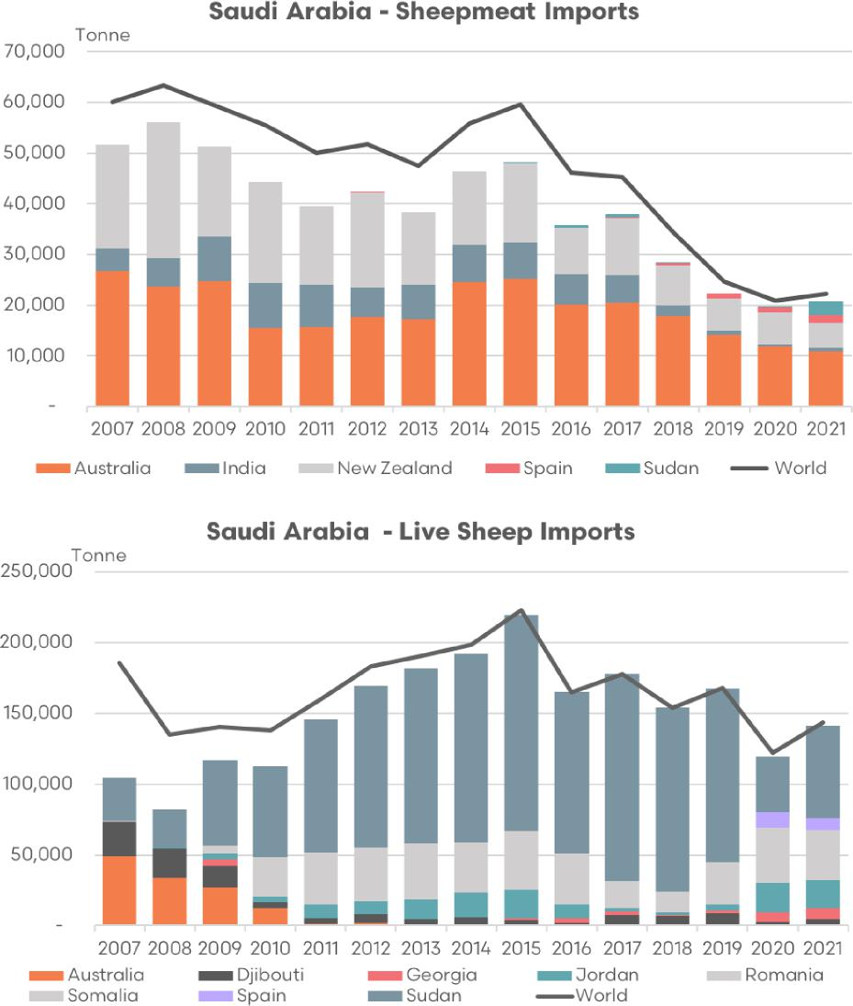

Sources: EP3, UN Comtrade, MLA

Saudi Arabia are the largest importers of live sheep globally taking significant volumes from Sudan and Somalia each year. In recent years Jordan, Georgia and Spain have also been suppliers to Saudi Arabia.

In terms of the live sheep export demise having little impact on the boxed trade, the Saudi Arabian experience is a standout example that the closure of the live trade doesn’t have to result in a negative trade outcome for the boxed trade. As Figure 83 highlights, the closure of the Australian live sheep trade over 2011/12 did little to impact the growth in market share for Australian boxed sheep meat export to Saudi Arabia in subsequent years with the percentage share growing from around 30% toward 50%–60% of the trade in recent years.

Figure 83 Australian share of live sheep and sheepmeat import volumes – Saudi Arabia

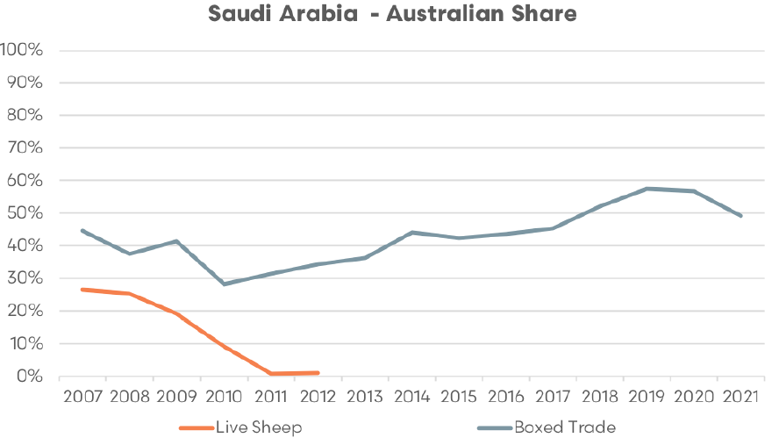

Sources: EP3, UN Comtrade, MLA

##### Bahrain

Bahrain is a small island country located in the Persian Gulf, near the western shores of the Arabian Peninsula. It is made up of an archipelago consisting of Bahrain Island and around 30 smaller islands. Its geographic location has made it a central hub of travel and trade for many centuries. Despite being an island nation, it has a fairly flat terrain with the highest point, the Jebel ad Dukhan, rising to only 134 meters.

As of 2023, Bahrain has a population of approximately 1.9 million people. The populace is a mix of several ethnicities, with Bahraini Arabs forming the largest group. A large expatriate population also resides in Bahrain, mainly from South Asian countries. The official language is Arabic, but English is widely used and understood, especially in business and for official purposes.

Bahrain’s economy has transformed from being oil-based to a more diversified one, with heavy investments in the banking and tourism sectors. Despite this diversification, petroleum processing and refining still remain significant. As of 2023, the GDP per capita was approximately A$40,000.

Regarding agriculture, Bahrain has very limited agricultural space due to its arid conditions and relies heavily on imports for its food supply, including sheep meat. As with many Gulf countries, lamb and mutton are key components of the local diet, so Bahrain has a substantial demand for sheep meat. Per capita sheep meat consumption in Bahrain per annum sits at around 26 kg cwt, which is the highest in the MENA region.

In terms of Australian boxed sheep meat market share, Bahrain was placed 27th in 2022 with around 1,400 tonnes swt consigned. Meanwhile, Bahrain hasn’t imported any live sheep from Australia since 2016.

Figure 84 Live sheep and sheepmeat import volumes – Bahrain

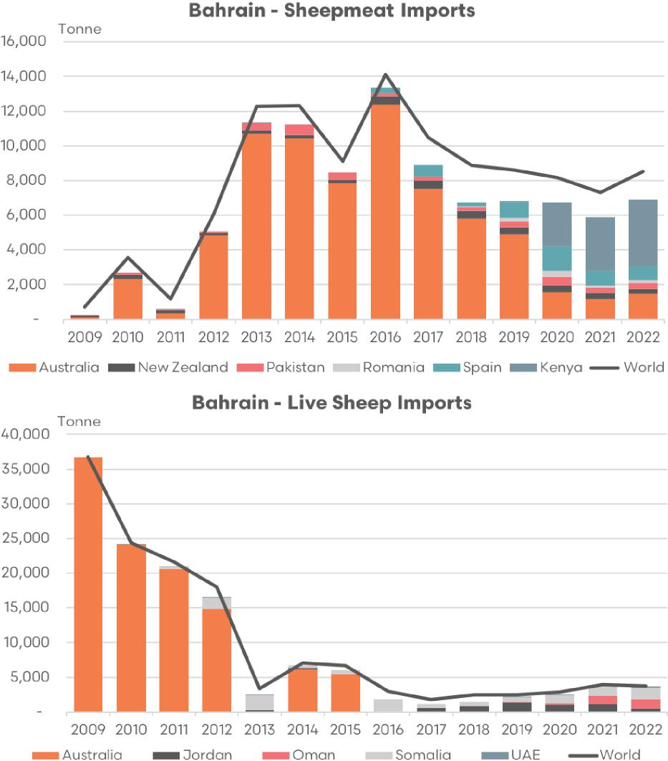

Sources: EP3, UN Comtrade, MLA

From 2009 to 2016 there was strong growth in boxed sheep meat imports into Bahrain, with Australia taking a large share of this trade and averaging 71% of the export flows from 2010 to 2019. However, since 2020 Kenya and Spain have started to compete aggressively for market share resulting in the Australian proportion of the boxed trade dropping from near 60% in 2019 to around 15%–20% in recent years.

Just as the Saudi Arabian experience was a promising tale of the demise of the live sheep trade not impacting boxed export volumes from Australia the Bahraini experience could serve as a somewhat cautionary example that there could still be some correlation between live sheep export access promoting boxed access.

Figure 85 Australian share of live sheep and sheepmeat import volumes – Bahrain

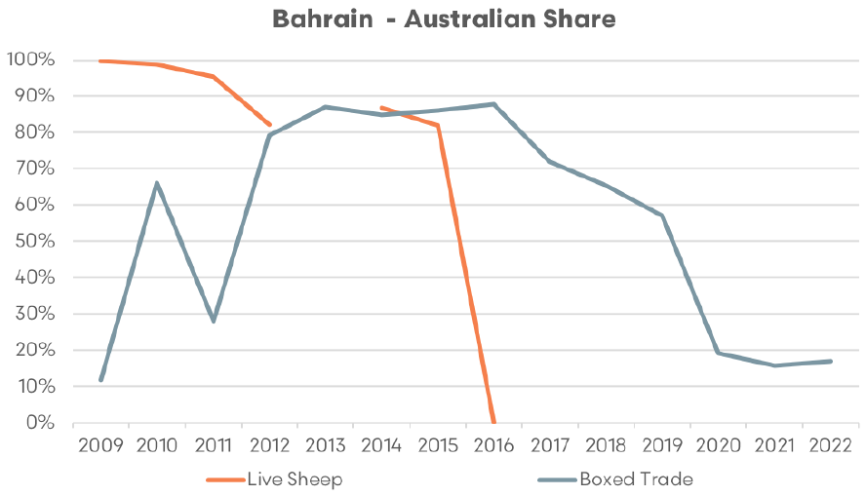

Sources: EP3, UN Comtrade, MLA

A comparison of the Saudi Arabian boxed versus live trade shows that Sudan and Spain have enjoyed increased boxed access along with a strong presence in the live trade, which lends weight to the argument that live sheep is a leverage for the boxed trade. However, the Bahraini experience shows that their primary live sheep source nations of Jordan, Oman and Somalia don’t provide any boxed sheepmeat imports.

###### Australia–India Economic Cooperation and Trade Agreement (Al-ECTA)

India is the second-most populous country in the world, following China. As of 2023, it is estimated to have a population of over 1.4 billion people, representing about 18% of the world’s total population. The country is marked by its vast cultural, linguistic, and ethnic diversity. India is made up of 28 states and 8 union territories. India’s geography is as diverse as its people, with landscapes ranging from the towering Himalayan peaks in the north to the coastal plains in the south.

In terms of the economy, India is classified as a newly developed country and is the world’s sixth-largest economy by a measurement of Gross Domestic Product (GDP). However, due to its large population, India’s GDP per capita remains relatively low at around A$3,700 in 2023, indicating a significant wealth disparity within the country. India is Australia’s sixth largest trading partner with 2-way trade in goods and services valued at A$46.5 billion in 2022 (see Department of Foreign Affairs and Trade, [Australia–India Comprehensive Cooperation Agreement (CECA)](https://www.dfat.gov.au/trade/agreements/negotiations/aifta/australia-india-comprehensive-economic-cooperation-agreement)).

India’s economy is a mixed one, with agriculture, manufacturing, and services sectors all playing substantial roles. Despite economic strides, poverty remains a persistent challenge, with a significant proportion of the population still living below the poverty line.

India’s demographics are characterised by its youthful population, with a median age of around 30 years. This young demographic presents both opportunities and challenges for the nation’s economy. On one hand, it provides a large, potentially productive workforce, contributing to India’s economic growth. On the other hand, it places significant demands on the country’s education and employment sectors. Furthermore, the population density in cities is exceptionally high, leading to issues such as overcrowding and inadequate public services in urban areas.

In April 2022, Australia and India signed the Australia–India Economic Cooperation and Trade Agreement (AI-ECTA). This was the first trade deal that India made in a decade and it gives Australian businesses much better access to this fast-growing market. The agreement lets Australia export sheepmeat to India without any volume limits, and it removed the 30% tax applied to Australian sheep meat imports at the end of December 2022.

Presently, India doesn’t buy much sheepmeat from Australia. This is because high import taxes and a strong local sheep meat production make it hard for Australian businesses to sell there. However, getting rid of these trade obstacles via the AI-ECTA creates new chances for Australian businesses, particularly in the Indian food service sector where the high value, quality cuts of sheep meat that Australia is renowned for can be appreciated.

India’s rapid economic growth over the last decade coupled with this agreement has fuelled expectations of a 13% increase in sheepmeat consumption to 940,000 tonnes by 2031. Australian exporters will continue to have access to a rapidly growing market with an affinity for sheepmeat. (MLA, [Global sheepmeat industry and trade report](https://www.mla.com.au/globalassets/mla-corporate/prices--markets/documents/os-markets/mla-mi-global-industry-trade-report-sheep.pdf))

As the Indian market is a new export opportunity for the Australian sheep meat industry a long-term targeted business development and marketing approach could be undertaken in order to develop the potential of this market. The following section outlines a proposed 10 to 12 year strategy.

###### Market research and analysis (years 1–2)

The penetration of the Indian market for sheep meat exports from Australia could begin with conducting comprehensive market research to understand the unique characteristics of the Indian market. This may include:

* Consumer preferences: What are the cultural, religious, and regional variations in diet?
* Competitor analysis: How does the local sheep meat industry operate? What are the strengths and weaknesses of competitors?
* Economic indicators: Understand the income levels and spending habits of different demographic groups.
* Regulatory environment: Explore the conditions for foreign businesses operating in India, understanding local legislation and business customs.

###### Building relationships and partnerships (years 2–4)

Relationship-building is an important element for success in the Indian market. Years 2 to 4 of the development of an Indian sheep meat export market for Australia could focus upon:

* Identifying local partners: Forge relationships with importers, distributors, and retailers who can assist with logistics and market access.
* Engagement with local industry bodies and government institutions: This will help navigate the regulatory environment and facilitate smoother business operations.
* Consideration given to joint ventures: Collaboration with an Indian firms can ease market entry and promote mutual growth.

###### Product localisation and branding (years 4 to 6)

Years 4 to 6 would promote the development a strong brand identity that resonates with Indian consumers, while adapting products to meet local tastes. This could involve:

* Tailoring products: Adjusting the cuts of meat, packaging, and portion sizes to match local preferences.
* Developing a strong brand narrative: Highlight the quality, safety, and sustainability of Australian sheep meat.
* Use localised marketing: Leverage local media channels and marketing techniques to increase visibility.

###### Market entry and expansion (years 6 to 8)

Initially, targeted to the affluent urban Indian population who have a greater propensity to consume higher value imported sheep and lamb products. This phase would:

* Start with major cities: Cities like Mumbai, Delhi, Bangalore, and Chennai have a higher concentration of middle to high-income consumers.
* Expand gradually: As the brand becomes more recognised, gradually expand into smaller cities and towns.

###### Investment in cold chain infrastructure (years 8 to 10)

Once heading toward the maturation phase of this plan consideration could be given toward investment in, or partnering with Indian companies, cold chain logistics in order to strengthen the market penetration across the country. This would likely require:

* Secure/reliable distribution networks: Ensuring the product reaches the consumer in optimal condition is important.
* Collaboration with logistics companies: Partnerships with local logistics firms can help maintain product integrity from farm to table.

###### Community engagement and corporate social responsibility (years 10 to 12)

The final stage in this plan is to engage in community development and corporate social responsibility initiatives in order to build a positive brand image and maintain market access. This could involve.

* Investment in local communities: Engage in initiatives that support local communities or align with important social causes in India.
* Highlighting shared Indian and Australian values: Incorporate Australian values of community support and sustainability into the strategy, perhaps combining the shared interest in popular cultural/sporting events such as cricket.

The development of the Indian market should be considered a long-term plan and patience will be a key aspect for success. The Indian market is diverse and complex, and success will come from understanding and responding to its unique characteristics.

##### Promotion of Australian meat products in international markets

The Meat & Livestock Australia (MLA) International Markets team is responsible for marketing Australian red meat abroad and ensuring that it has the best possible access to global markets.

The team’s work primarily revolves around promoting Australian red meat to consumers, traders, and stakeholders in international markets. It focuses on highlighting the quality, safety, and sustainability of Australian red meat products. These efforts are important for maintaining and improving Australia’s share in competitive global markets.

The International Markets team also plays a significant role in advocating for better access to global markets. This can involve working closely with Australian government agencies and industry stakeholders to negotiate favourable trade agreements and to resolve any technical or trade-related issues that might affect Australian red meat exports.

The MLA International Markets team operates in key markets around the world, including North Asia, South Asia, the Middle East and North Africa, the Americas, and Europe. In each of these regions, the team tailors its efforts to suit local tastes, preferences, and business practices, ensuring the greatest possible impact.

The MLA International Markets team also tracks market trends, consumer preferences, and competitor activity in different countries. This market intelligence informs its strategies and helps it to adapt to changing circumstances in a timely and effective manner.

##### MENA sheepmeat export opportunities

Increased access to funding provided to MLA International Markets team for targeted business development activities in the MENA region could encourage further growth in the export of Australian boxed sheep meat product into MENA countries as the live sheep export access reduces in line with a scaled phase out of the live export industry.

A focus on growing boxed exports into the MENA region in the short to medium term of a phase out transition is a practical option as the importers and consumers in this region are already accustomed to the leaner, smaller WA Merino carcass that they have been used to receiving from Australia as a ‘bag lamb’ or via the live export channel.

Currently there is a funded role in the MLA MENA team for a local Arabic speaking staff member focused on business development, relationship building and expansion of access for Australian red meat product into the MENA region. However, the MLA MENA team advise that the funding for this useful role is due to expire at the end of 2023.

Additional funding to continue this program for the current incumbent and an expansion to include a second business development position in the MENA team could provide the additional staffing coverage to enhance the penetration of Australian sheep meat exports. It would also provide a valuable signal to the MENA region that Australia is dedicated to assisting them with their desire for food security and that we will be a reliable trade partner into the future.

The MLA MENA team have indicated that the following investment would be a consideration for a single business development position in the region (see Table 19). Estimated project costs could include targeted marketing strategies in the region, participation in trade shows, direct business to business relationship building activities and the promotion of the Australian sheep meat brand via outreach activities such as the ‘[Lambassador](https://lambassadors.com/me-en/)’ program.

Table 19 MENA business development budget

|  |  |
| --- | --- |
| Item | Annual investment in A$ |
| Salary & Visa Requirements | 140,000–200,000 |
| Regional Travel Budget | 35,000 |
| Office Costs | 36,000 |
| Project Costs | 150,000 |

Sources: MLA

In addition to the MENA business development funding further allocations for targeted marketing and appointments of business development mangers could be directed to other key sheep meat export markets such as China and the USA, and as part of a long-term strategy to build an Australian sheep meat export presence in India, as outlined earlier in this report.

##### Investment in cold chain infrastructure, logistics and freight capacity

Several WA processors with a strong export focus indicated that access to chiller space in Perth, prior to shipments of sheep meat being exported, remains limited and could pose a potential bottleneck to expansion of the boxed sheep meat export volumes from WA into the future.

Disruptions to the ‘just in time’ inventory management system utilised by most retailers during Covid and the resultant shortage of some items at the retail level have seen the major retailers extend their inventory storage pipeline, including for chilled and frozen goods.

Despite several attempts to consult with cold store providers in/around Perth we were unable to get an indication of the capacity limit in cold store that presently exists, nor was there any public access to data available to allow an estimate of what is the current capacity versus what would be needed in terms of chiller space expansion into the future in order to alleviate any of these supply chain concerns.

In terms of sea freight and container access for sheep meat exports we have been advised by supply chain participants that this is nearly back to pre-Covid levels in terms of access and cost to assign so there is not any major concern over any requirement for assistance in alleviating bottlenecks in this sector.

In contrast, airfreight capacity is yet to return to pre-Covid levels particularly for transport of boxed sheep meat to the MENA region. Figure 86 demonstrates container costs for sea shipments globally to the present, which confirms access to container supply and cost to assign are back to pre-Covid levels.

Figure 86 Shipping container rates

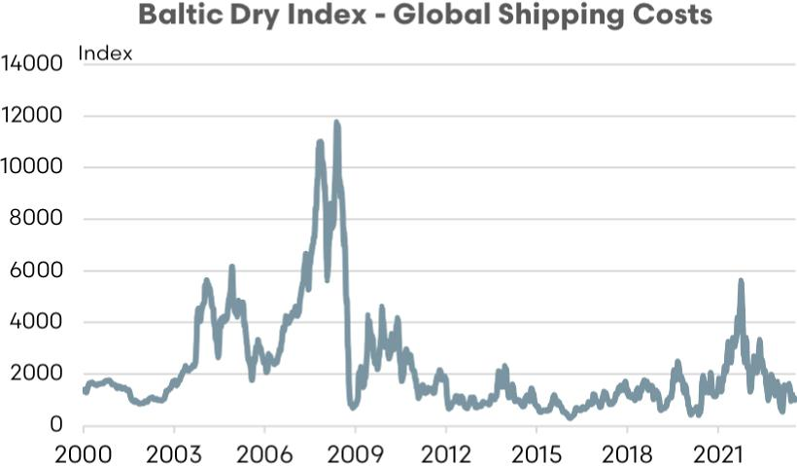

Sources: EP3, Freightos

A more detailed look at the annual airfreight and sea freight mix of export volumes of sheep meat from Australia highlights that there wasn’t a significant decline in sea freight volumes during Covid, despite the transportation costs becoming more expensive during this period. Indeed, from 2019 to 2020 the total volume of Australian sheep meat exports by sea dropped by just 9.7% compared to a 31.0% decline for air freight exports of sheep meat.

Figure 87 Air and sea freight – sheepmeat

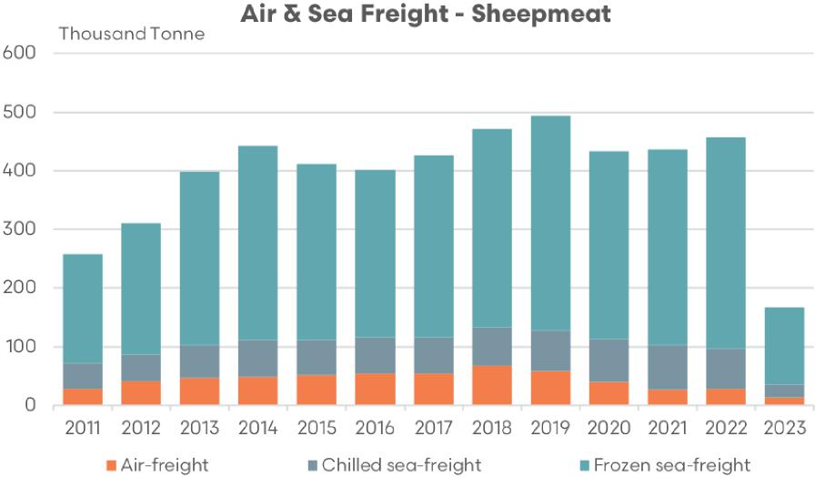

Sources: EP3, MLA

Furthermore, while sheep meat exports volumes lifted from Australia by 4.0% from 2020 to 2021 the airfreight volume continued to decline by 32.9%. It wasn’t until the 2021 to 2022 period that airfreight export volumes began to climb again, with a 5.2% lift versus a 4.8% increase to sea freight volumes over this time frame.

Further analysis of the Australian sheep meat export air freight volumes specifically highlight that much of the decline through the Covid period was due to a reduction in traffic to the MENA region. Indeed, from 2019 to 2022 annual air freight volumes of sheep meat to the MENA region from Australia declined by 71.2%. Meanwhile the sheep meat export air freight to all destinations other than the MENA region grew by 78.5% from 2019 to 2022.

Figure 88 Air freight – sheepmeat

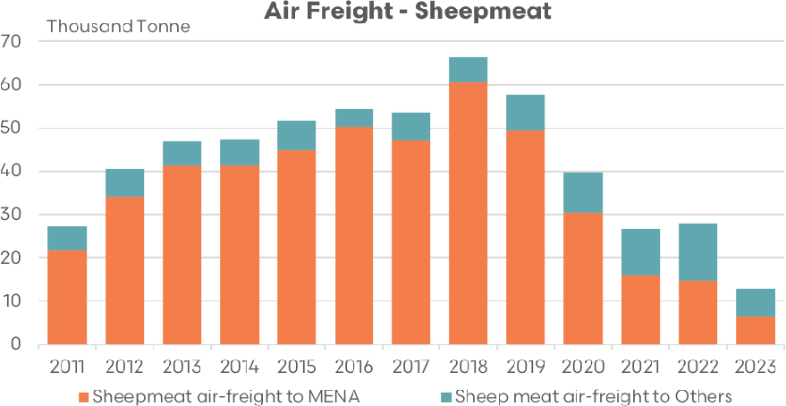

Sources: EP3, MLA

This shift in air freight sheep meat destination in percentage terms from 2019 to 2022 is further highlighted in Figure 89 which demonstrates that from 2011 to 2019 MENA accounted for 80% to 90% of all Australian sheep meat air freight export volumes versus other destinations, but by 2022 the ratio was closer to 50/50.

Figure 89 Share of air freight – sheepmeat

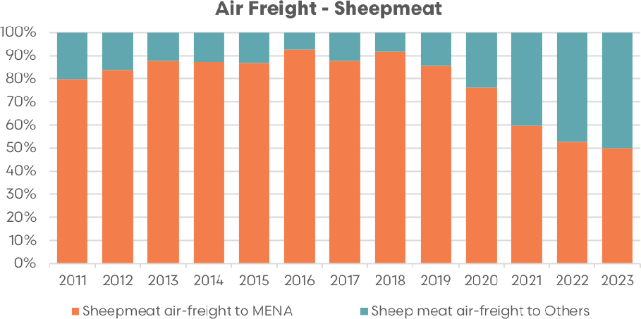

Sources: EP3, MLA

Reduced air traffic during the Covid pandemic and loss of air freight access to the MENA region specifically saw the average tonnes per day of airfreight capacity out of Australia drop from a peak of 182 tonnes per day to a low of 73 tonnes in 2021, a drop of 59.8%. In terms of flows to MENA alone there was a decline from 163 tonnes to 40 tonnes between 2018 to 2021, a 75.4% decrease.

Figure 90 Air freight average tonnes per day – sheepmeat

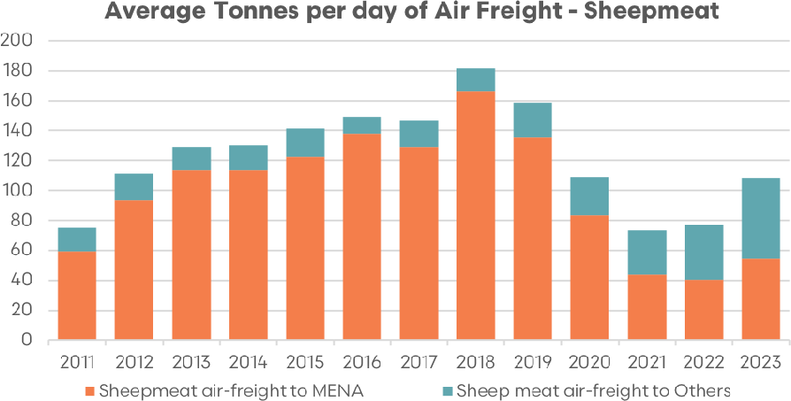

Sources: EP3, MLA

Currently, in 2023 (up to April) average air freight capacity per day from Australia to MENA sits at 66 tonnes according to the volumes shipped so far this year. Consultation with WA exporters suggest that around 12 to 15 tonnes are available out of Perth airport with the balance of capacity coming from other Australian international airports.

Assuming an average ‘bag lamb’ carcass to the MENA region of 19 kg and 500,000 head of live export sheep needing to be processed annually, if the WA live export option was phased out, this would equate to around 9,500 additional tonnes of airfreight capacity per year, or an extra 26 tonnes of airfreight capacity per day.

The Australian government launched the International Freight Assistance Mechanism (IFAM) to help Australian businesses with the export of their goods during the COVID-19 pandemic. The initiative was in response to the significant reduction in air passenger flights, which led to a decrease in freight capacity, affecting the ability of Australian exporters to send goods to their international markets.

The IFAM was established as a temporary measure to meet the urgent need for critical exports and imports. It aimed to keep key air freight routes open by subsidising a range of high-value, time-sensitive, and perishable exports and vital imports. The program supported flights to a range of global and regional destinations, ensuring Australian products could continue to reach key overseas markets. It was prioritised goods like premium agricultural produce and seafood, which were significantly impacted due to their reliance on air freight.

Under the IFAM, the Australian government provided financial assistance to airlines and freight forwarders to help cover the costs of international freight routes that were deemed commercially unviable due to the impacts of the pandemic.

Figure 91 MENA sheepmeat air freight versus passenger volumes

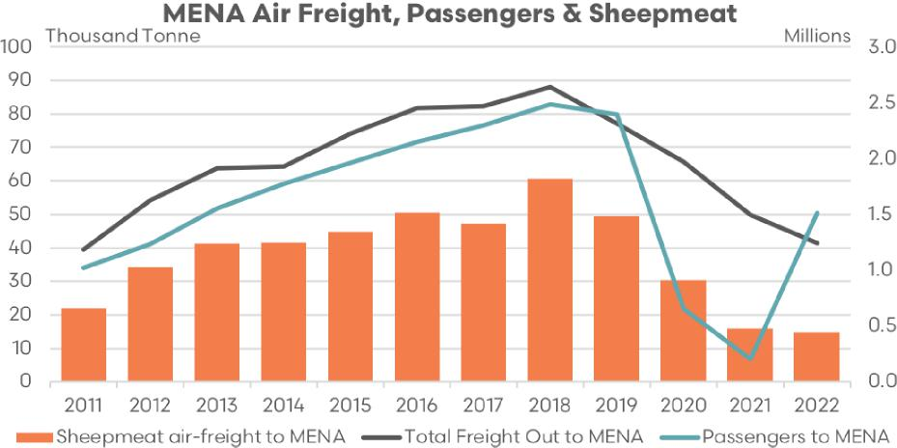

Sources: EP3, MLA, BITRE

Analysis of total airfreight volumes, sheepmeat airfreight volumes and air passenger numbers to MENA highlights that decreased air passenger traffic is a barrier to building capacity to ship increased airfreight. Although, as demonstrated through the 2020 and 2021 season the IFAM managed to partially offset some of the drop in airfreight to the MENA region despite air passenger numbers collapsing.

In recent years, with the ability for long haul flights to travel further without a stopover to re-fuel, there have been more direct flights from Perth to the UK/Europe without the need to overlay in a Middle eastern airport. This has meant that flight volumes from Perth to the MENA region has not recovered to pre-Covid levels and may remain low, which will limit air-freight capacity for boxed sheep meat exports and ‘bag lamb’ exiting from Perth into the future.

Figure 92 Direct flights exit Perth the MENA and UK

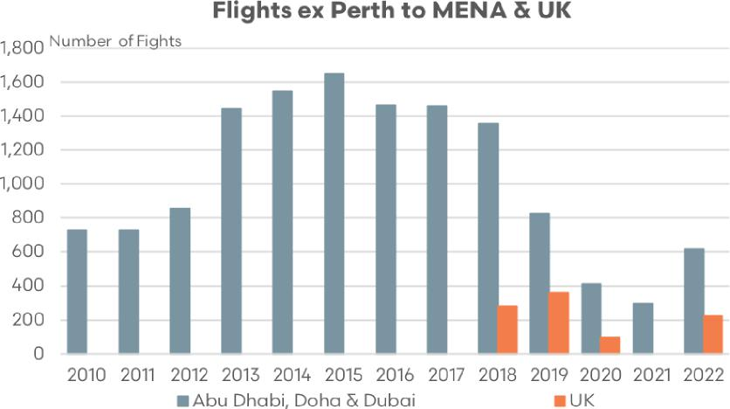

Sources: EP3, MLA, BITRE

This would suggest that a short term air freight subsidy program may need to be implemented in the early stage of the phase out in order to support increased air freight flows of ‘bag lamb’ and boxed meat exports to the MENA region. This would support part of a preliminary a transition away from the live trade while other avenues for turnoff were further developed in alternative export destinations and expansion of the lamb feedlot sector, expansion of the WA processing sector and the adjustment to farm enterprise mix in WA were given time to progress.

It is important to note that the possible expansion of the airfreight ‘bag market’ would not be a complete solution to the entire phase out process. It would represent the first stage of the overall plan and is designed to alleviate initial supply pressures of the phase out in the preliminary phase of the transition.

An IFAM style air freight subsidy program would benefit from significant short-term funding to encourage enough air traffic flows to be successful. However, it would not encourage the right type of enterprise change on farm to focus on a broader boxed sheep meat export market with product delivery that fits the processor specifications for markets in China, South East Asia the USA and potentially India.

Furthermore, it wouldn’t provide an alternative sales option to the feed/straw growers and feed pellet manufacturers like an expanded lamb feedlot sector would achieve. Finally, it is not a program that is anticipated to be funded into perpetuity by the government, so other longer-term options need to be included in the phase out process for when this proposed airfreight subsidy program is phased out to provide long term sustainable turnoff options for the WA sheep industry.

A medium to longer term alternative to airfreight access to the MENA region for boxed sheep meat exports is to continue to develop an expanded chilled and frozen sea freight option. Increased shelf life for chilled sheepmeat in many MENA countries has further opened a sea freight opportunity.

Figure 93 MENA sheepmeat air and sea freight

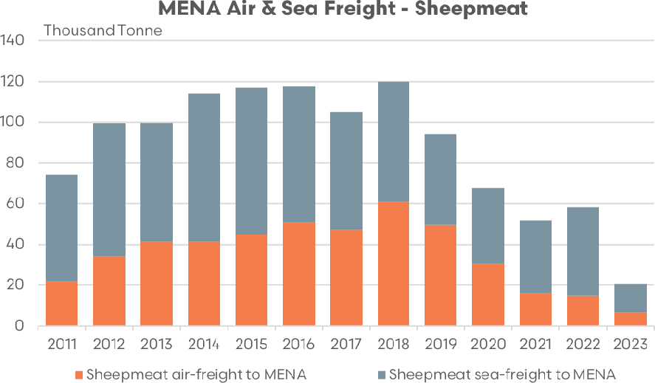

Sources: EP3, MLA

Historically, sea freight shipments of Australian sheep meat to the MENA region have accounted for 30% to 50% of the trade. Pre Covid the proportion of air freight shipments to the MENA region had been climbing steadily. However, the drop in air traffic during the Covid pandemic and the increased efficiency of air travel has seen the popularity of a Middle Eastern stopover decline for flights between Australia and Europe/UK. This has allowed for the proportion of boxed sheep meat exports transported to MENA by sea to grow to 70% to 75% of the trade over the last 2 years.

Figure 94 Share of MENA sheepmeat air and sea freight

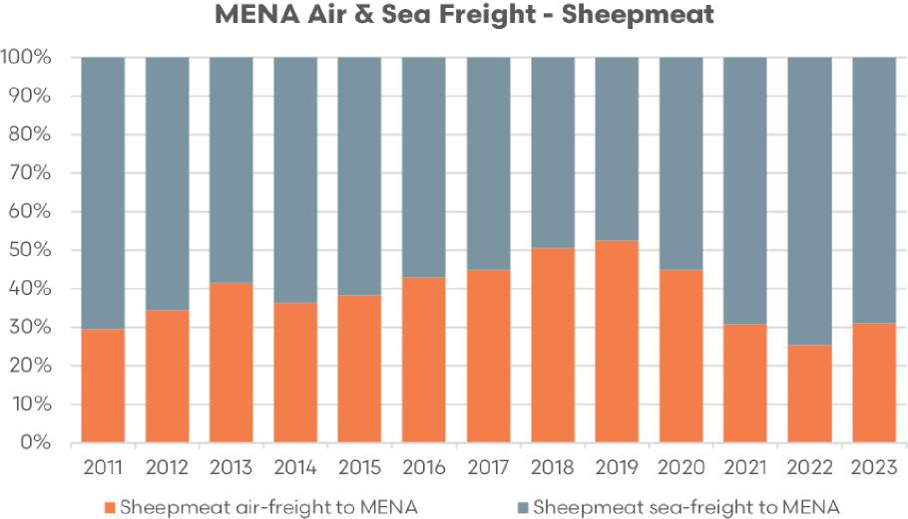

Sources: EP3, MLA

Analysis of the monthly value of airfreight shipments of sheepmeat exports versus the volume of sheepmeat exports displays a somewhat contrasting picture since the Covid pandemic. Toward the last quarter of 2022 the total value of Australian boxed sheep meat exports by air to all destinations had recovered to pre-pandemic levels. However the value of sheepmeat exports to the MENA region continued to languish at levels that sit 52% below (as of April 2023) the pre-pandemic peaks of 2018.

Figure 95 Value of sheepmeat air freight

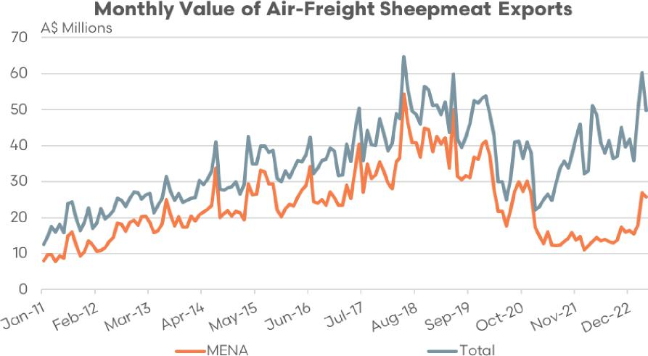

Sources: EP3, MLA

In terms of the volume of monthly boxed sheep meat exports, total flows are still yet to reach pre-pandemic peaks and are currently placed around 55% below (as of April 2023) the May 2018 peaks. Meanwhile, monthly export volumes of boxed Australian sheep meat transported via air to the MENA regions sit around 67% under the 2018 peak.

Figure 96 Volume of sheepmeat air freight

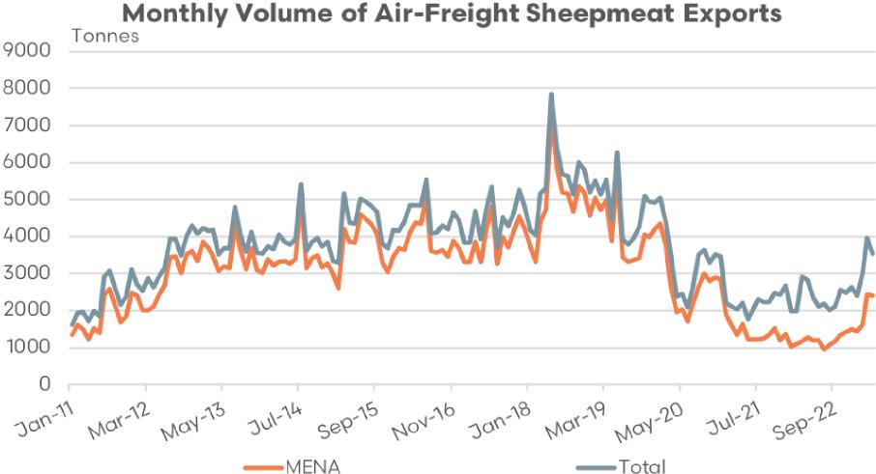

Sources: EP3, MLA

This reinforces the need for a targeted marketing and business development campaign to be undertaken in the MENA region in order for Australia to rebuild relationships and re-establish our standing as a reliable supplier of quality boxed sheep meat export product.

#### iii. Exploration of potential opportunities in wool and sheep-derived products and other farm inputs to the live sheep supply chain

##### Research and development in wool innovation and technology

The WA wool sector is significantly exposed to the phase out of live sheep, particularly if the enterprise change on farm results in a move away from Merino sheep in favour of shedding sheep varieties, crossbred sheep and cropping as this could result in a reduction in the size of or a change to the composition of the WA wool clip.

Any programs aimed to encourage WA producers to remain within the WA wool sector that would alleviate some of the existing on-farm pressures relating to sheep and wool, such as access to shearers or the depressed pricing for the broader cross bred wool types, could help to retain farmer confidence in the sustainability of the WA wool sector.

##### Biological shearing injectables

Australian Wool Innovation (AWI) has dedicated $1.4 million for a research project led by the University of Adelaide. The goal is to create a method that allows wool to be harvested from sheep in a pain-free and automated way. They aim to do this by using a protein found in corn that weakens the base of the wool fibre, allowing the fleece to be removed without causing discomfort to the animal. The process is designed in such a way that the fleece can stay on the sheep, without needing a net, until it is time for the wool to be taken off.

There are plans to conduct extensive testing of this method on farms by 2025. However, researchers are being careful not to create too high expectations among sheep farmers. They are mindful of the previous unsuccessful attempts at developing alternative methods for wool harvesting and understand the intricacies involved in this task.

If this new method proves successful, it could decrease the necessity for expert shearing crews, reduce the cost of wool harvesting for sheep farmers, and motivate them to continue in this sector. The goal for researchers is to finalise the bio-injections and have them operational within 2 years.

A considerable portion of their efforts will be focused on getting the formal approval from the Australian Pesticides and Veterinary Medicines Authority (APVMA) for using this protein, a key step before the process can be made available commercially and this process could take 2 years to complete, alone.

Also, it will be important for the wool industry’s representative groups to advocate for government assistance. This would facilitate speeding up the approval processes and finding an appropriate commercial partner, both requirements for the APVMA’s approval and registration procedure.

##### Wool based packaging solutions

[Planet Protector Packaging](https://planetprotectorpackaging.com/woolpack/) is an Australian company dedicated to creating sustainable packaging solutions. The company was born out of the need to reduce the harmful impact of single-use packaging on the environment.

Their flagship product is ‘Woolpack’, an innovative packaging solution that uses sheep’s wool for insulation. The product was created to replace harmful, single-use polystyrene packaging, particularly for items requiring temperature control during shipping, such as food and pharmaceuticals.

The ‘Woolpack’ insulation is sourced from cross bred sheep wool, making it a highly sustainable resource. This wool is then sealed within recyclable food-grade liners to create the insulating packaging. The liners are made from recyclable HDPE plastic, which can be recycled in domestic recycling facilities. In addition, the wool is naturally high in keratin, which provides excellent insulation properties, keeping products at a stable temperature during transportation.

One of the significant advantages of Woolpack is that it’s compostable and biodegradable, making it a far more sustainable option than traditional polystyrene or other plastic-based packaging. When the wool insulation has served its purpose, it can be composted or used as a soil improver.

Currently the ‘Woolpack’ product is manufactured in China. However, Planet Protector Packaging is looking to establish a state-of-the-art wool processing, research and development facility in Geelong after receiving a $4.8 million government grant in 2021 as part of the Modern Manufacturing Initiative program.

In recent years the price for cross bred wool in Australia has remained at historically low levels, often with the cost of shearing cross bred sheep offsetting the value of the wool harvested. Increased demand for cross bred wool for use in packaging such as ‘Woolpack’ could help lift the cross bred wool price and encourage producers to remain in the sector.

##### Promotion of wool and other sheep-derived products in global markets

###### Bulk insulation from wool

Wool is a naturally occurring, renewable resource used for insulation in homes and other buildings, bringing a range of benefits. Its crimped structure forms tiny pockets of trapped air, providing excellent thermal insulation, making it effective at keeping homes warm in winter by reducing heat loss, and cool in summer by reducing heat gain.

Unique among insulation materials, wool is hygroscopic. This means it can absorb and release moisture from the surrounding air without losing its thermal insulating properties. Wool will absorb moisture when the surrounding air is humid and release it when the air is dry, helping to regulate indoor humidity levels and contribute to a comfortable living environment.

The porous nature of wool makes it a valuable material for acoustic insulation as well, capable of reducing sound transmission between rooms or from the outside. From a safety perspective, wool’s natural fire-resistance sets it apart from some synthetic insulation materials, as it requires more oxygen than is available in the air to become flammable and can slow the spread of fire.

The environmental impact of insulation materials is a significant consideration, and wool’s status as a renewable and biodegradable material positions it as an environmentally friendly choice compared to many synthetic alternatives. Wool is also known to improve indoor air quality, as it does not emit harmful gases and can even absorb certain pollutants.

Technological innovations have allowed for a variety of wool insulation products, including pre-cut sections known as batts, rolls, and loose-fill insulation that can be used in walls, roofs, and floors. Furthermore, research and development efforts are continually exploring ways to enhance the properties of wool insulation, such as using treatments to increase its resistance to pests or mould.

###### Marketing of bulk wool insulation

A marketing strategy that could help to promote the use of bulk wool insulation and increase demand for wool as a material in its manufacture includes the following:

**Identify and understand the target market:** The first step would be to identify who would be most interested in bulk wool insulation. This could be homeowners, construction companies, architects, and developers who are environmentally conscious, appreciate natural materials, or are interested in sustainable building solutions. Research these groups to understand their needs, values, and concerns.

**Product differentiation:** Position wool insulation as a superior product compared to synthetic alternatives by emphasising its unique advantages. These include its natural thermal and acoustic insulation properties, ability to regulate moisture, fire resistance, positive environmental impact, and contribution to indoor air quality. Make these benefits clear in all marketing materials.

**Educational content and campaigns:** Create content that educates consumers and businesses about the benefits of wool insulation. This could be blog posts, videos, infographics, or webinars that explain how wool insulation works and why it’s a good purchasing option. Highlight the science and technology behind wool insulation to give the campaign marketing a factual, data centric focus.

**Partnerships and collaborations:** Partner with eco-friendly construction companies, architects, interior designers, and influencers in the sustainable living space to reach a larger audience. These individuals or companies can help spread the word about wool insulation and provide testimonials about its benefits.

**Case studies and success stories:** Share success stories or case studies of homes and buildings that have used wool insulation. Share testimonials from satisfied customers who have seen improvements in their energy efficiency, comfort, or indoor air quality.

**Demonstrations and events:** Hold live demonstrations or events where potential customers can see and feel wool insulation, learn about its installation, and ask questions. This could be at trade shows and home improvement stores such as Bunnings, Mitre 10, Home Hardware, etc.

**Social media and digital marketing:** Use social media platforms, search engine optimisation (SEO) techniques, and email marketing to reach a broader audience. Share educational content, customer testimonials, and product news. Run targeted ads to reach people who are interested in sustainable building materials or are in the process of building or renovating a home.

**Sustainability certifications and standards:** Obtain certifications from recognised environmental or sustainable building organisations. These can provide reassurance to customers and give the product more credibility.

**Incentives and promotions:** Offer incentives such as discounts, rebates, or contests to encourage people to try wool insulation. Work with local utilities or government programs that might offer rebates for using eco-friendly insulation.

##### Dry aged sheep meat

Traditionally, dry aging involves storing meats in a controlled, chilled environment for several weeks to allow enzymes naturally present in the meat to break down muscle tissue, enhancing flavour and tenderness. This process hasn’t significantly changed in principle for many years, although modern refrigeration and storage techniques have helped make it safer and more consistent. [Dry aging of sheep meat](https://dryager.com.au/dry-aged-lamb/) is a relatively new concept. However, it is developing a reputation for delivering a premium eating experience to the consumer and could be utilised to provide an enhanced eating experience for the leaner, firmer Merino lamb and sheep carcass.

Potential advancements in the process of dry aging sheep meat, including Merino lamb and mutton, could be driven by various technological innovations. As technology continues to improve, advancements in smart refrigeration units could lead to a more optimised dry aging process. These units could be programmed to automatically monitor and adjust the temperature, humidity, and air flow, tailoring the settings for different types of meat, including sheep meat.

Another way technology might assist is through the use of sensors and Internet of Things (IoT) devices. These sensors could provide real-time data about the meat’s condition, including internal and surface temperature, humidity, and pH. IoT devices could enable this data to be monitored remotely, alerting a butcher or chef if the conditions deviate from the ideal range.

Artificial intelligence (AI) and machine learning could further enhance this process. AI could analyse data from sensors and make real-time adjustments to the aging environment to optimise the process. Machine learning could be used to identify patterns and trends that correlate with the best-tasting meat, providing new insights about the optimal conditions for dry aging sheep meat.

On the production side, robotics and automation could streamline the butchering process after the aging period. Robots could ensure precise cuts, reducing waste and potentially leading to higher-quality end products. In addition, advancements in packaging technologies, such as vacuum packing or modified atmosphere packing, could potentially extend the shelf life of dry-aged meats and enhance safety by reducing the risk of bacterial contamination.

The role of microorganisms in dry aging could also be explored more, with the use of selected microbial starters, similar to those used in cheese production, potentially leading to consistent and improved flavour profiles during dry aging. As the field of food science continues to evolve, greater understanding about the precise biological and chemical changes that occur during the aging process could lead to the development of new methods for aging meat, or products that can enhance the process, such as specific enzyme treatments or special dry aging bags.

##### Marketing strategies for dry aged sheep meat

Marketing dry-aged sheep meat, including Merino lamb and mutton, may require a strategy that educates consumers about its unique qualities and flavour profile, while also addressing any potential concerns or misconceptions. Here are some strategies that could be used:

###### Educational campaigns

Many consumers may not be familiar with dry-aged meat or the benefits it offers in terms of flavour and texture. Educational campaigns could focus on the dry-aging process, explaining how it enhances the meat’s flavour and tenderness. This could involve videos, infographics, or articles that describe the process in a straightforward and engaging way.

###### Tasting events

One of the best ways to sell consumers on the quality of dry-aged meat is to let them taste it for themselves. Tasting events could be held at grocery stores, farmer’s markets, food festivals, or even at high-end restaurants that serve dishes made with dry-aged meat.

###### Chef and influencer partnerships

Collaborating with well-known chefs or food influencers could help spread the word about dry-aged sheep meat. These individuals could create recipes featuring the meat, share posts about it on social media, or even host events where they cook with it.

###### Sustainability messaging

If the dry-aging process is done in a sustainable way, this could be a key selling point for environmentally conscious consumers. Messaging could focus on the use of energy-efficient aging techniques, or the fact that dry-aging reduces waste by concentrating flavour and allowing smaller portions to be satisfying.

###### Premium branding

Dry-aged meat is generally considered a premium product due to the time and skills needed to produce it. The branding and packaging of the meat could reflect this premium status, suggesting a high-quality, artisanal product.

###### Transparency and traceability

Modern consumers often want to know where their food comes from and how it’s produced. Providing this information, either on the packaging or through a website, could build trust and appeal to consumers who value transparency. Blockchain technology could be used to track the provenance of the meat and provide a verifiable record of its journey from farm to table.

###### Highlight unique flavour profiles

Dry-aged sheep meat, such as lamb or mutton, has a unique, enhanced flavour compared to regular cuts. This characteristic could be the highlight of marketing strategies. Special recipes, pairing suggestions (like wine or sides), or chef testimonials could emphasise this.

These strategies may help promote the consumption of dry-aged sheep meat, but the exact approach might depend on the specific market and consumer preferences.

##### Future Energy Australia Project

Frontier Impact Group (FIG) and Carnarvon (CVN) have come together to establish an incorporated joint venture called Future Energy Australia. Their aim is to build and operate renewable fuel biorefineries in Narrogin, Western Australia, creating the country’s first large-scale renewable fuel business.

The renewable diesel produced by Future Energy Australia will be a high-performance, third-generation biofuel designed to offset carbon emissions from petroleum diesel. The biodiesel is made from renewable and sustainably sourced biomass. Its composition is identical to petroleum diesel, making it a direct replacement with no need for equipment modification or blending.

This biodiesel can be used across various applications, including road, shipping, rail, and stationary energy generators. For instance, it’s suitable for use in underground mining vehicles, where its cleaner burning properties can improve underground air quality compared to petroleum diesel. It’s also applicable to mine haul trucks, diesel fuel generators used in remote sites like mines and farms, and diesel-powered farm machinery.

To produce biodiesel, various types of biomass are used. The primary feedstock for biodiesel production is vegetable oils, such as soybean oil, canola oil, palm oil, sunflower oil, and rapeseed oil. Animal fats, like tallow and lard, are also used for biodiesel production, as they contain triglycerides that can be converted into biodiesel.

Additionally, waste cooking oil from restaurants, fast-food chains, and households can be collected and processed into biodiesel, providing an environmentally friendly approach by utilising waste materials. Algae is being explored as a potential feedstock for biodiesel due to its high lipid content and its ability to grow on non-arable land. Waste materials from animal processing industries, like slaughterhouses and rendering plants, can also be utilised for biodiesel production.

It’s important to mention that using agricultural by-products, like straw, to create biodiesel involves a more complex process than traditional feedstocks like vegetable oils. Straw is a lignocellulosic biomass, containing cellulose, hemicellulose, and lignin, which require additional treatment to be converted into biofuels.

While the conversion of lignocellulosic biomass into biofuels is still developing and faces challenges like high production costs and process inefficiency, research and development efforts are ongoing to improve the viability and commercialisation of these sustainable biofuels. In support of Western Australia’s growers of straw and hay used in the production of live export feed pellets, funding could be provided to explore more efficient ways to use straw and hay as a feedstock for biodiesel production in the future.

## V. Conclusion

To ensure a smooth transition, several steps need to be taken. Firstly, a gradual implementation phase is an important consideration. This phase, conducted over several years, allows producers and those in the supply chain time to adapt and shift their focus accordingly.

Secondly, it’s important to identify and establish appropriate alternative industries that can provide the same level of flexibility in terms of sheep turnoff options that the current system offers. This would include the expansion of the sheep feedlot sector in WA, further development of the domestic processing sector, ongoing support for an eastern transportation corridor and redevelopment of the air freight and sea freight sheep meat export capacity.

Thirdly, having a well-trained workforce ready to transition to these alternative industries is important. It is useful to prepare employees with the right skills to adapt to new roles and industries effectively. This would include addressing chronic housing shortages in many regional areas of WA.

Finally, fair financial compensation and government assistance could be provided to affected individuals, businesses, and regional economies which could involve support to reskill, relocate, plan personal or business finances and to seek mental health/wellbeing services. This can help to mitigate the economic impacts of such a significant industry shift.

## Appendix A: Sheep sold by LGA

Map A1 Sheep sold by LGA 2019

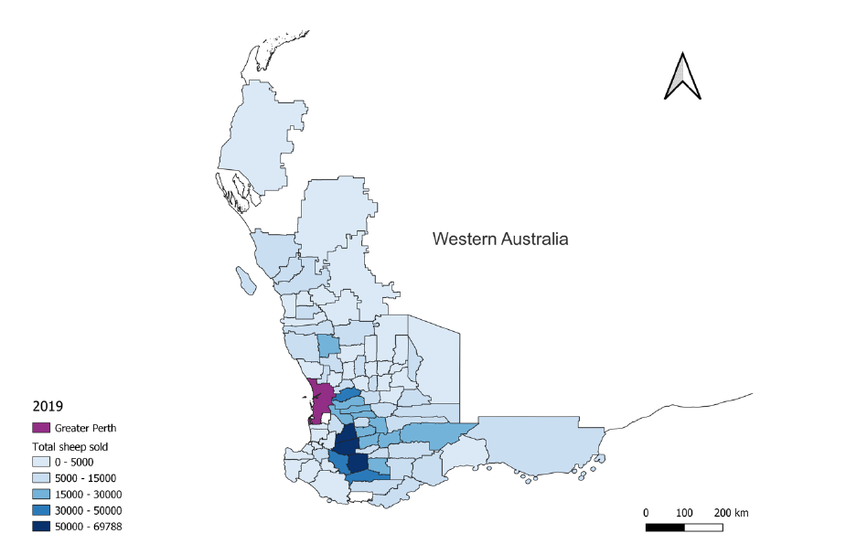

Map A2 Sheep sold by LGA 2020

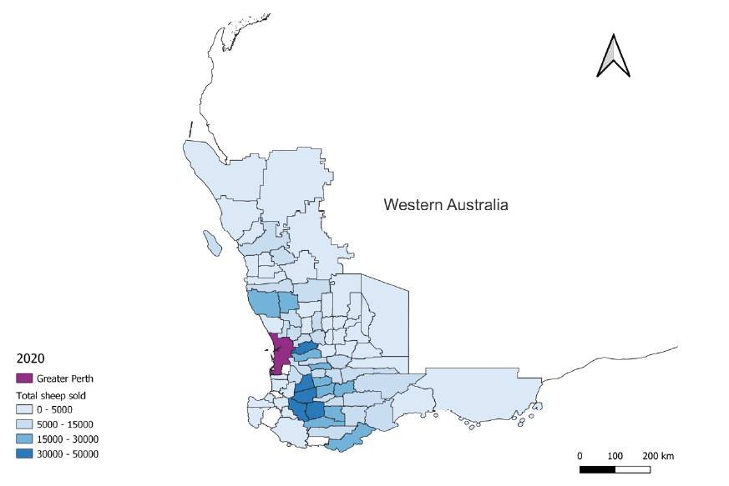

Map A3 Sheep sold by LGA 2021

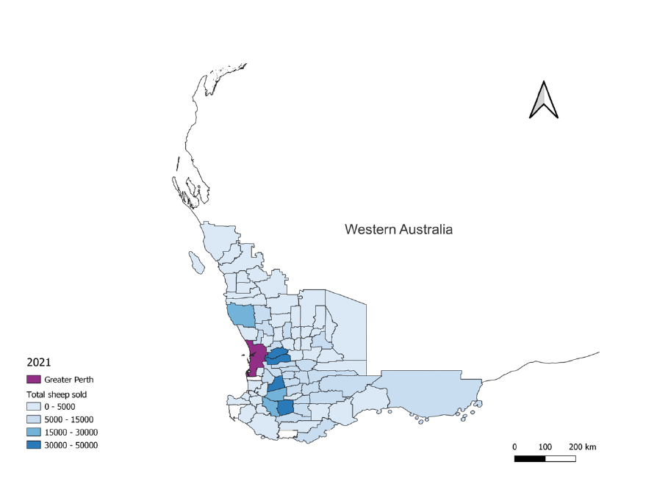

Map A4 Sheep sold by LGA 2022

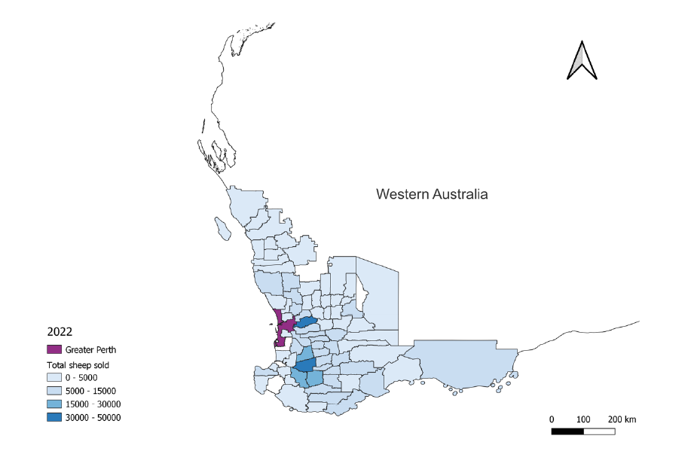

Map A5 Sheep sold by LGA 2021

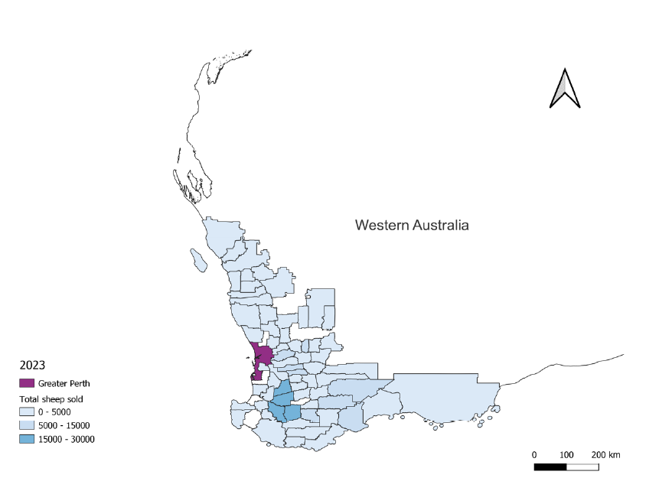

## Appendix B: Number of vendors by LGA

Map B1 Number of vendors by LGA 2019

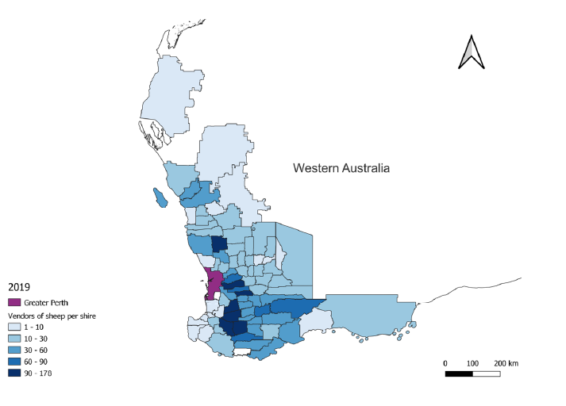

Map B2 Number of vendors by LGA 2020

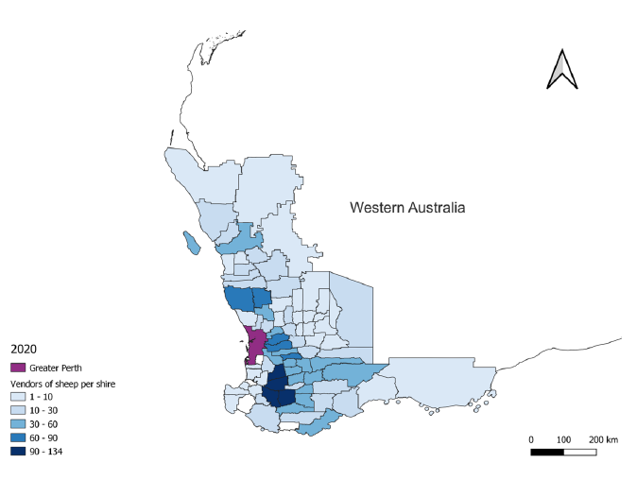

Map B3 Number of vendors by LGA 2021

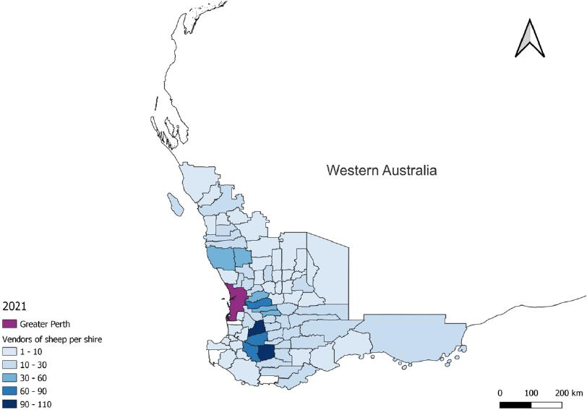

Map B4 Number of vendors by LGA 2022

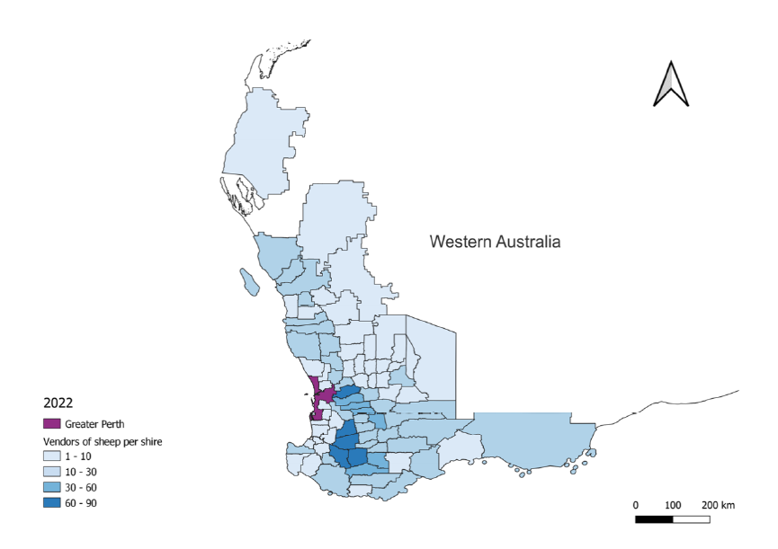

Map B5 Number of vendors by LGA 2023

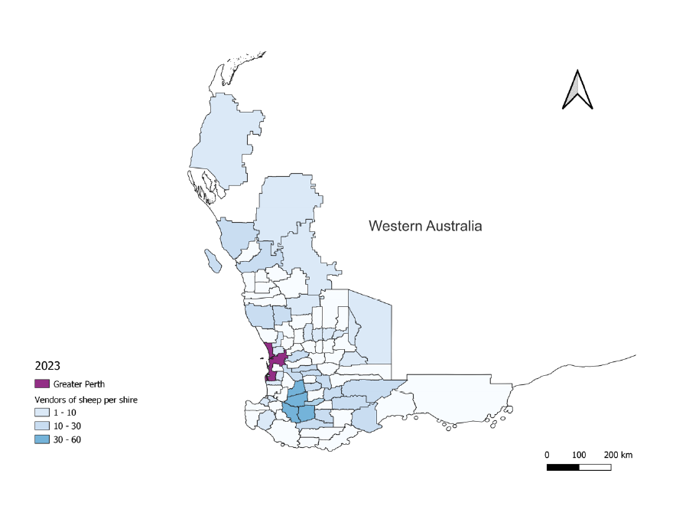

## Appendix C: Survey questions

