## GENERAL SITUATION in September and OUTLOOK to December 2022

### Australian Plague Locust *Chortoicetes terminifera*

A moderate increase of the inland eastern Australia locust population was observed in autumn, with some swarms detected in the arid interior. Several waves of short-distance southward movements were evident and resulted in a general increase in the adult population in the southern part of the eastern inland in late autumn.

Across inland eastern Australia, winter rainfall was highly variable from above average in the north-eastern part to below average in the south-western part, with pockets of very much above or very much below average. Winter temperatures were about average over much of the region, with areas of above average temperature in the southern part of South Australia and New South Wales. There were areas of below to very much below average in north-eastern SA, adjacent parts of northern NSW and southern Queensland, and central Queensland. With the third consecutive La Niña event underway, September rainfall was above to very much above average over much of inland eastern Australia. September mean temperatures were above average across southern regions and the Channel Country, due primarily to warmer night temperatures of above average to very much above average. Current forecasts are that rainfall will be above average for the period October to December. During this period, mean maximum temperatures will be below average especially over the eastern part, while mean minimum temperatures will be above average over the central and southern parts of inland eastern Australia.

Limited surveys were conducted in late September and early October and low-density adults with occasional nymphs were identified in NSW, Queensland and north-eastern SA. In Upper Western NSW, Isolated to Scattered-density adults were identified, and a few Isolated adults were detected in the NSW Central West. In Queensland, frequent Scattered-density adults with occasional nymphs were identified in the south-eastern part of Central West and adjacent north-eastern parts of Maranoa and Warrego districts. Isolated adults were detected in other parts of these two districts, the Central Highlands, Darling Downs and Channel Country districts. Isolated adults were also identified in the north-eastern border area of SA. A hatching was confirmed by Agriculture Victoria on 3 October in the Ultima area where adult aggregation was first reported on 12 April and egg beds were later located. Unconfirmed reports of hatching were also received from Hawker in SA around 3-5 October.

The outlook for spring is for a low to medium density overall population level in inland eastern Australia, with localised medium to high densities of spring hatchlings in the NSW Riverina and Lower Western districts and adjacent areas, and low to medium densities in the arid interior with some localised higher densities. The population level is likely to remain low in other parts of inland eastern Australia.

It is likely that some nymphs will continue hatching from overwintering eggs until the end of October in the southern part of inland eastern Australia with some bands developing. Limited swarm formation may commence from mid-November onwards. Some localised breeding may continue under suitable habitat conditions in other parts of the inland. Under suitable weather conditions, some adults of spring generation may migrate or disperse northwards from the southern part of this region from December onwards.

There is a low to moderate likelihood of region-wide infestations developing in the NSW Lower Western and Riverina, Vic Mallee, and SA Flinders and North East districts. Widespread high-density infestations are unlikely during spring.

**October 2022**

### Spur-throated Locust *Austracris guttulosa*

Surveys in late September and early October in Queensland identified frequent Isolated to Scattered-density adults with some Low-Numerous densities in the south-eastern part of the Qld Central West, north-eastern part of Maranoa and Warrego and Central Highlands districts, and consistent Isolated-density adults in the south-western part of Maranoa and Warrego, Darling Downs and Channel Country districts. In New South Wales occasional Isolated-density adults were identified in the western areas and consistent Isolated-density adults with some Scattered-densities in the north-eastern part of Upper Western. With suitable habitat conditions, an early season breeding is likely and may develop into some localised medium-high density nymphs.

With a likely wet spring in the tropical and subtropical Queensland, higher reproduction and nymphal survival rates are likely, which would result in more localised medium – high-density populations.

There is a medium risk of a widespread low-medium density infestation, and localised high-density infestations may develop in subtropical Queensland in summer.

### Migratory Locust *Locusta migratoria*

Surveys in late September and early October did not detect any migratory locusts. However, under current and future favourable habitat conditions, breeding should commence in the Central Highlands of Queensland and surrounding areas. Nevertheless, high-density gregarisation is unlikely to result from the previously very low population level.

There is a very low risk of a widespread infestation developing during summer.

**It is important that any locust activity be reported as soon as possible to your local biosecurity authority, primary industries department or to the commission. A toll-free call to the APLC hotline can be made on 1800 635 962. An answering machine is attached to this phone for after-hours calls. Reports can also be emailed to APLC via** [**aplc@agriculture.gov.au**](mailto:aplc@agriculture.gov.au) **or made through the website at** [**https://www.agriculture.gov.au/pests-diseases-weeds/locusts/landholders/reporting_locusts**](https://www.agriculture.gov.au/pests-diseases-weeds/locusts/landholders/reporting_locusts)**.**

### Locust distribution map—*Chortoicetes terminifera*

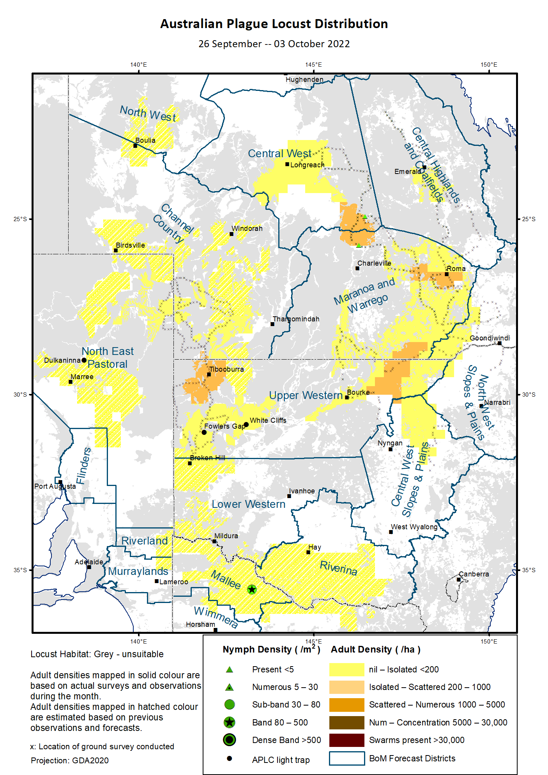

# Australian Plague Locust (*Chortoicetes terminifera*)

## SITUATION in September and OUTLOOK to December 2022

#### NEW SOUTH WALES

##### NORTH WEST SLOPES & PLAINS

###### Northwest Local Land Services

Locusts and conditions

* Surveys in late September did not identify any locust in this district.
* No locust reports were received from this district in September.
* This district received 80 – 200 mm rainfall in September, at very much about average to highest on record level.

Forecast

* Only limited localised breeding is possible under wet conditions. The general population density is expected to be at low levels.
* There is a low probability of any significant migration during spring and early summer.

Risks

* There is a low risk of a widespread regional infestation developing during spring and early summer.

##### CENTRAL WEST SLOPES & PLAINS

###### Central West Local Land Services

Locusts and conditions

* Surveys in the northern part of this district in late September only identified Isolated-density adults.
* No locust reports were received from this district in September.
* This district received 60 – 150 mm rainfall in September, at very much above average level.

Forecast

* Localised breeding is possible, but general population level is likely to remain low.
* There is a low probability of any significant migration during spring and early summer.

Risks

* There is a low risk of widespread regional infestations developing during spring and early summer.

##### RIVERINA

###### Riverina, Murray, and part of Western Local Land Services

Locusts and conditions

* No surveys were conducted in this district in September.
* No reports were received from this district in September.
* The UNSW insect monitoring radar in Hay did not detect any locust migration during September.
* This district received 40 – 100 mm rain in September, at above average to very much above average levels.

Forecast

* Localised bands may have hatched/continue hatching from overwintering eggs from mid-September to end of October.
* There is a moderate probability of localised bands developing and swarm formation from uncontrolled bands in this district.
* There is a low-moderate probability of some migrations/dispersals during early summer.

Risks

* There is a low-moderate risk of a localised infestation developing during spring and early summer.

##### UPPER and LOWER WESTERN

###### Western Local Land Services

Locusts and conditions

* Surveys in late September identified consistent Isolated-density adults with some Scattered-densities in the Upper Western district.
* No surveys were conducted in the Lower Western district in September.
* The light traps at White Cliffs and Fowlers Gap did not capture any locusts in September.
* No locust reports were received from this district in September.
* September rainfall ranged from almost nil in the south of Tibooburra to over 50 mm in the south and east border areas of this district. Much of the district received about average to very much above average rainfall.

Forecast

* Nymphs may continue hatching from overwintering eggs until the end of October.
* There is a low-moderate likelihood of localised band developing during spring and early summer. Untreated bands may develop into swarms from mid-November onwards.
* Locust population is likely to remain at a low-moderate level, with some localised higher densities of hatchlings in the south-eastern part of this district.
* There is a low-moderate probability of some migrations/dispersals during early summer.

Risks

* There is a low – moderate risk of localised infestation developing during spring and early summer.

**All locust activity should be reported to your** [**Local Land Services**](https://www.lls.nsw.gov.au/) **(1300 795 299) or the** [**Department of Primary Industries**](https://www.dpi.nsw.gov.au/climate-and-emergencies/locusts)**. A toll-free call to the APLC hotline can be made on 1800 635 962. An answering machine is attached to this phone for after-hours calls. Reports can also be emailed to APLC via** [**aplc@agriculture.gov.au**](mailto:aplc@agriculture.gov.au) **or sent through the web page at** [**https://www.agriculture.gov.au/pests-diseases-weeds/locusts/landholders/reporting_locusts**](https://www.agriculture.gov.au/pests-diseases-weeds/locusts/landholders/reporting_locusts)**.**

#### QUEENSLAND

##### CENTRAL HIGHLANDS AND COALFIELDS

###### Isaac and Central Highlands Regional Councils; Banana Shire

Locusts and conditions

* Surveys in late September only identified occasional adults in this district.
* No reports of locust activity were received from this district in September.
* September rainfall ranged from just 15 mm in the north-western part to over 100 mm in the south-eastern part of this district, but generally at above average level.

Forecast

* Localised breeding is possible, but the population is likely to remain at low levels.
* There is a low probability of any significant migrations during spring and early summer.

Risks

* There is a low risk of a widespread infestation developing during spring and early summer.

##### DARLING DOWNS AND GRANITE BELT

###### Western Downs and Goondiwindi Regional Councils

Locusts and conditions

* Surveys in late September identified some Isolated-density adults in this district.
* No locust reports were received from this district in September.
* This district received 60 to 110 mm rainfall in September, at very much above average level over much of this district.

Forecast

* Some sporadic breeding is possible, but only a low-density population is expected.
* There is a low probability of any significant migrations during spring and early summer.

Risks

* There is a low risk of a widespread infestation developing during spring and early summer.

##### CENTRAL WEST

###### Barcaldine, Longreach, and Blackall-Tambo Regional Council; Flinders and Winton Shires

Locusts and conditions

* Surveys in early October identified frequent Isolated – Scattered-density adults in the Tambo area with occasional nymphs. Some Isolated-density adults were detected in the Longreach-Barcaldine areas.
* There was an unconfirmed report of flying adults from the southeast of Winton in late September.
* This district received 10 – 50 mm rainfall increasing in the direction from northwest to southeast in September, but generally at above average level.

Forecast

* Some breeding may result in development of some low to medium-density populations.
* There is a low probability of any significant migrations during spring and early summer.

Risks

* There is a low risk of a widespread infestation during spring and early summer.

##### MARANOA AND WARREGO

###### Maranoa Regional Council; Murweh, Paroo, and Balonne Shires

Locusts and conditions

* Surveys in late September identified Isolated – Scattered-density adults with occasional nymphs in this district.
* No locust reports were received from this district in September.
* September rainfall varied from 25 to 130 mm, at above average to very much above average levels.

Forecast

* Low-moderate level of population may result from continuous breeding.
* There is a low probability of any significant migrations during spring and early summer.

Risks

* There is a low risk of a widespread infestation developing during spring and early summer.

##### NORTH WEST

###### Mt Isa, Cloncurry, McKinlay, Boulia, and Winton Shires

Locusts and conditions

* No surveys were conducted in this district in September due to road access.
* No locust reports were received from this district in September.
* This district received 10 to 30 mm rainfall in September, at above average to very much above average levels.

Forecast

* Locust numbers are likely to remain low, but sporadic localised breeding may occur in some areas.
* There is a low probability of any significant migration/redistribution activity during spring and early summer.

Risks

* There is a low risk of a widespread infestation developing during spring and early summer.

##### CHANNEL COUNTRY

###### Boulia, Diamantina, Barcoo, Quilpie, and Bulloo Shires

Locusts and conditions

* Surveys in late September identified consistent Isolated-density adults in this district.
* No locust reports were received from this district in September.
* This district received 10 to 80 mm rainfall in September, at very much above average level over much of this district.

Forecast

* Locust numbers are likely to increase low-moderately under favourable habitat conditions from continuous breeding.
* There is a low probability of any significant migrations during spring and early summer.

Risks

* There is a low risk of a widespread infestation developing during spring and early summer.

**All locust activity should be reported the** [**Biosecurity Queensland (Department of Agriculture and Fisheries)**](https://www.daf.qld.gov.au/business-priorities/biosecurity) **via the** [**Customer Service Centre**](https://www.daf.qld.gov.au/contact/customer-service-centre) **on 13 25 23. A toll-free call to the APLC hotline can be made on 1800 635 962. An answering machine is attached to this phone for after-hours calls. Reports can also be emailed to APLC via** [**aplc@agriculture.gov.au**](mailto:aplc@agriculture.gov.au) **or sent through the website at** [**https://www.agriculture.gov.au/pests-diseases-weeds/locusts/landholders/reporting_locusts**](https://www.agriculture.gov.au/pests-diseases-weeds/locusts/landholders/reporting_locusts)**.**

#### SOUTH AUSTRALIA

##### NORTH EAST PASTORAL and FLINDERS

Locusts and conditions

* Limited surveys were conducted in the Innamincka-Moomba areas of this district in late September and identified consistent Isolated-density adults.
* The Dulkaninna light-trap did not capture any locusts in September.
* There was an unconfirmed report of nymph hatching from the Hawker area in early October.
* This district received less than 10 mm rainfall in the Arkaroola-Etadunna-Coober Pedy-Tarcoola-Woomera areas, and 25 – 50 mm in the north-eastern corner and up to 80 mm rainfall in southern part. The variable rainfall was at average to very much above average levels.

Forecast

* Locust numbers are likely to increase low-moderately from hatching from overwintering eggs and successful breeding.
* Localised bands may hatch from overwinter eggs in the southern part of this district.
* There is a low probability of any significant migrations during spring and early summer.

Risks

* There is a low risk of a widespread infestation developing during spring and early summer.

##### RIVERLAND and MURRAYLANDS

Locusts and conditions

* No surveys were conducted in this district in September.
* No locust reports were received from this district in September.
* September rainfall ranged from 50 to 80 mm, at above average to very much above average levels.

Forecast

* The locust population is likely to remain at very levels with some pockets of higher densities.
* There is a low probability of any significant migrations during spring and early summer.

Risks

There is a very low risk of a widespread infestation developing during spring and early summer.

**Locust activity should be reported to** [**Biosecurity SA (Primary Industries and Regions South Australia)**](https://www.pir.sa.gov.au/biosecurity) **via the Plant Health Hotline on 1300 666 010.** **A toll-free call to the APLC hotline can be made on 1800 635 962. An answering machine is attached to this phone for after-hours calls. Reports can also be emailed to APLC via** [**aplc@agriculture.gov.au**](mailto:aplc@agriculture.gov.au) **or sent through the website at** [**https://www.agriculture.gov.au/pests-diseases-weeds/locusts/landholders/reporting_locusts**](https://www.agriculture.gov.au/pests-diseases-weeds/locusts/landholders/reporting_locusts)**.**

#### VICTORIA

##### MALLEE

**Mildura and Swan Hill Rural Cities; Yarriambiack and Buloke Shires**

Locusts and conditions

* No surveys were conducted in this district in September.
* A nymph hatching in the south of Ultima was confirmed by Victoria Agriculture on 03 October. Egg beds were located after adult aggregation was first reported on 12 April.
* September rainfall range from 50 to 100 mm in this district, at very much above average level over much of this district.

Forecast

* Locust numbers are likely to increase moderately from overwintering eggs, which may continue hatching until the end of October and result into some small bands.
* There is a low – moderate probability of migration/dispersal during early summer.

Risks

* There is a moderate risk of a widespread infestation developing during spring and early summer.

##### WIMMERA

**Hindmarsh and West Wimmera Shires**

Locusts and conditions

* No surveys were conducted in this district in September.
* No locust reports were received from this district in September.
* September rainfall ranged 60 – 110 mm in this district, at average to very much above average levels.

Forecast

* Locust numbers are likely to increase low-moderately with some higher densities hatching from overwintering egg beds.
* There is a low probability of any significant migrations during spring and early summer.

Risks

* There is a low risk of a widespread infestation developing during spring and early summer.

**Locust activity should be reported to the** [**Agriculture Victoria**](https://agriculture.vic.gov.au/)[**Customer Contact Centre**](https://agriculture.vic.gov.au/about/contact-us) **on 136 186. Alternatively, you can make a report via the online form at**[**https://forms.bio.vic.gov.au/2020**](https://forms.bio.vic.gov.au/2020)**.  Please include photos where possible. A toll-free call to the APLC hotline can be made on 1800 635 962. An answering machine is attached to this phone for after-hours calls. Reports can be emailed to APLC via** [**aplc@agriculture.gov.au**](mailto:aplc@agriculture.gov.au) **or sent through the website at** [**https://www.agriculture.gov.au/pests-diseases-weeds/locusts/landholders/reporting_locusts**](https://www.agriculture.gov.au/pests-diseases-weeds/locusts/landholders/reporting_locusts).

# Glossary of locust terms and density categories used in the Locust Bulletin

**Locust biology and behaviour**

|  |  |
| --- | --- |
| **Term** | **Definition** |
| adult | A fully winged, mature locust capable of breeding and migrating |
| band | Dense aggregation of nymphs, usually moving forward together |
| diapause | Period of dormancy induced in anticipation of unfavourable environmental conditions |
| egg bed | An area of soil containing many egg pods (hundreds per square metre) |
| fledge | Final nymphal moult to a soft-bodied adult incapable of long-distance flight |
| instar | Discrete stages of nymphal development each separated by a moult |
| laying | Female locusts depositing clutches of 20 – 60 eggs into the ground in froth-lined egg pods |
| nymph | Juvenile wingless locust. Often referred to as the hopper stage |
| swarm | Dense aggregation of adults, milling at the same spot or flying closely together |

###### Locust density categories

Where higher densities occur, a large proportion of the regional population is concentrated in very small areas with lower densities elsewhere, so the higher densities cannot be extrapolated over the area of an entire region. A range of density classes is usually found within a surveyed region.

|  |  |  |
| --- | --- | --- |
| **Nymph Densities** | **Number per m2** |  |
| Present | 1 – 5 |  |
| Numerous | 6 – 30 |  |
| Sub-band | 31 – 80 |  |
| Band | 81 – 500 |  |
| Dense Band | >500 |  |
|  |  |  |
| **Adult Densities** | **Number per m2** | **Number per 250 m2** |
| Isolated | – 0.02 | 1 5 |
| Scattered | 0.024 – 0.1 | 6 – 25 |
| Numerous | 0.104 – 0.5 | 26 – 125 |
| Concentration | 0.504 – 3 | 126 – 750 |
| Low Density Swarm | 4 – 10 | 751 – 2,500 |
| Medium Density Swarm | 11 – 50 | 2,501 – 12,500 |
| High Density Swarm | >50 | >12,500 |
|  |  |  |
| **General density classes** | **Nymph densities** | **Adult densities** |
| very low, occasional | Nil – Present | Nil – Isolated |
| low | Present – Numerous | Isolated – Scattered |
| medium | Numerous – Sub-band | Scattered – Numerous |
| high | Bands | Concentration – Swarms |

###### Reporting locust infestations

It is important that all locust activity is reported as soon as possible to your nearest state agriculture agency office or to the Australian Plague Locust Commission.

|  |  |
| --- | --- |
| **State** | **Authority for reporting locusts** |
| New South Wales | Local Land Services (LLS) or Department of Primary Industries |
| Queensland | Biosecurity Queensland, Department of Agriculture and Fisheries |
| South Australia | Biosecurity SA, Department of Primary Industries & Regions |
| Victoria | Biosecurity and Agriculture Services, Department of Jobs, Precincts and Resources |

Reports to the **Australian Plague Locust Commission** can be made by:

Free call (Canberra): 1800 635 962 (24 hours)

Fax (Canberra): (02) 6272 5074

Email: [aplc@agriculture.gov.au](mailto:aplc@agriculture.gov.au)

Website: <https://www.agriculture.gov.au/pests-diseases-weeds/locusts/landholders/reporting_locusts>