## GENERAL SITUATION in October and OUTLOOK to January 2024

### Australian Plague Locust *Chortoicetes terminifera*

Locust populations were at very low levels across inland eastern Australia, especially over the southern part of winter rainfall region, after a very dry late winter and early spring. The Channel Country in the arid inland, on the other hand, had slightly higher locust numbers. Surveys in the Channel Country identified occasional Scattered-density adults with frequent Isolated-density adults. Sporadic Isolated-density adults were identified in other parts of Queensland, New South Wales, and South Australia. Very few Present-density nymphs were detected by survey. No obvious populations of spring generation locust were detected in the southern part of inland eastern Australia. No hatching reports were received, nor any light-trap catches or radar detected flights.

Monthly rainfall totals were all less than 25 mm over the inland eastern Australia in the past three months, with especially low totals (less than 10 mm) recorded in September. After some heavy rainfall in the southern part of inland eastern Australia in June and in the northern part in early July, rainfall levels for the interior of eastern Australia ranged from average in some parts to below average to the lowest on record over all other parts for the past three months. Winter temperatures over inland eastern Australia were 1–3 degrees above averages, ranging at very much above average to the highest on record levels. The September temperatures continued this trend and were approximately 1–4 degrees above averages, ranging at above average to very much above average levels. October temperatures overall varied from below averages to 2 degrees above averages, mainly due to lower minimum temperatures. Habitat conditions were generally unfavourable in this early spring for locust breeding after the 3-season La Niña event ended in last autumn. An El Niño pattern started to form from August and the El Niño event is likely to last to early autumn 2024. Thus, below average rainfall and warmer temperatures are expected for late spring and summer.

The outlook for the remainder of 2023 is for overall low-level populations over the inland eastern Australia, with possible localised population increases under favourable habitat conditions in inland Queensland. It is unlikely that any bands or swarms will develop until summer, nor are any significant migrations likely to occur.

There is a very low likelihood of widespread infestations developing between now and summer.

**07 November 2023**

### Spur-throated Locust *Austracris guttulosa*

The overall population was at low levels in early spring. Surveys from late September to late October identified widespread Isolated–Scattered-density adults in Queensland and occasional Isolated-density adults in New South Wales and South Australia. No nymphs were detected by survey. No captures were recorded on the light traps at Dulkaninna (SA), White Cliffs (NSW) and Fowlers Gaps (NSW). Habitat conditions continue to degrade, and lower rainfall is forecast for the remainder of 2023. Earlier breeding is therefore unlikely.

There is a low risk of a widespread infestation. Though, some localised breeding is possible to occur in favourable habitats of tropical and sub-tropical Queensland during the remainder of 2023.

### Migratory Locust *Locusta migratoria*

The overall population was likely to remain at very low levels in early spring. No locusts were detected in areas surveyed during late September and late October. The usual occurrence area of southeastern Queensland had very much below average to the lowest on record rainfall in the past three months. Thus, breeding is less likely to have been occurring in these areas.

Limited localised breeding is possible under favourable habitat conditions. However, high-density infestations are unlikely to result from the current low background population levels.

There is a very low risk of a widespread infestation developing during the remainder of 2023.

**It is important that any locust activity be reported as soon as possible to your local biosecurity authority or to the Australian Plague Locust Commission. A toll-free call to the APLC hotline can be made on 1800 635 962. An answering machine is attached to this phone for after-hours calls. Reports can also be emailed to APLC via** [**aplc@agriculture.gov.au**](mailto:aplc@agriculture.gov.au) **or made through the website at** [**https://www.agriculture.gov.au/pests-diseases-weeds/locusts/landholders/reporting_locusts**](https://www.agriculture.gov.au/pests-diseases-weeds/locusts/landholders/reporting_locusts)**.**

### Locust distribution map—*Chortoicetes terminifera*

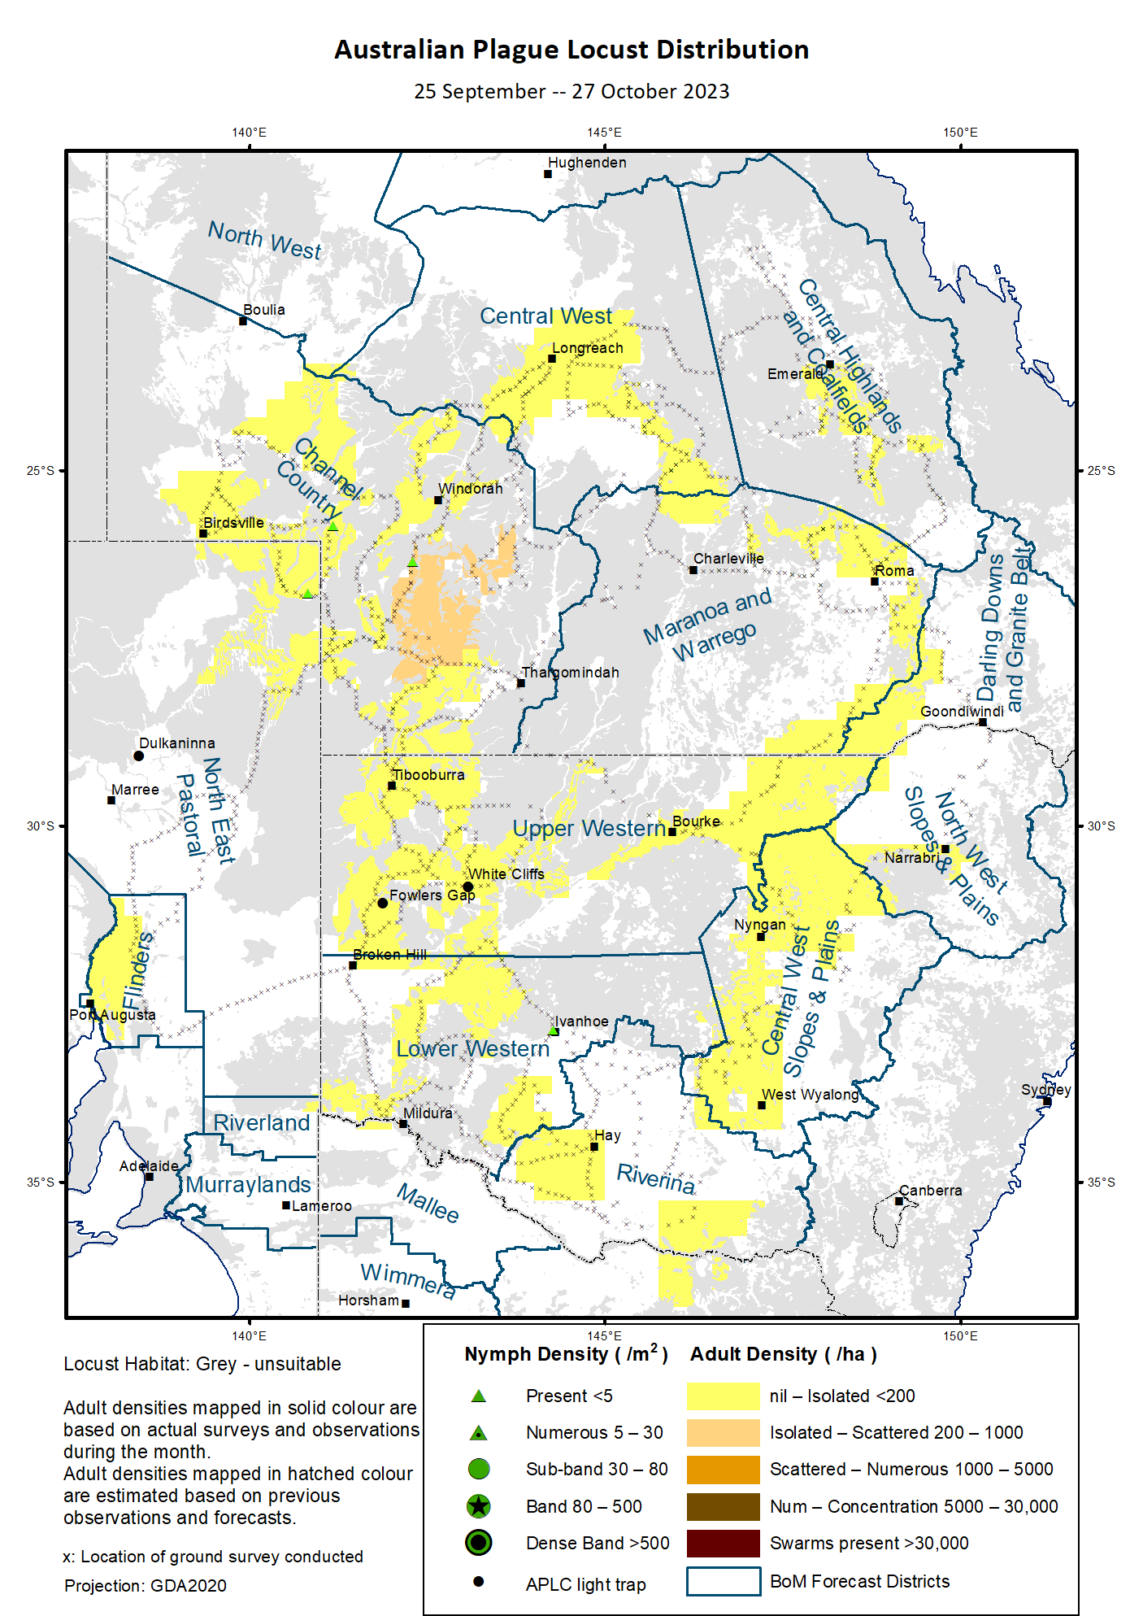

# Australian Plague Locust (*Chortoicetes terminifera*)

## SITUATION in October and OUTLOOK to January 2024

#### NEW SOUTH WALES

##### NORTH WEST SLOPES & PLAINS

###### Northwest Local Land Services

Locusts and conditions

* Surveys in early October only identified occasional Isolated-density adults in this district with no nymphs detected.
* No locust reports were received from this district in spring.
* This district received less than 15 mm of rainfall in September and 5–50 mm of rainfall in October, ranging from below average to very much below average levels.

Forecast

* Limited localised breeding is possible but unlikely to widespread.
* There is a very low probability of any significant migrations during the remainder of 2023.
* The general population density is expected to remain at very low levels during late spring and early summer.

Risks

* There is a very low risk of a regional infestation developing during late spring and early summer.

##### CENTRAL WEST SLOPES & PLAINS

###### Central West Local Land Services

Locusts and conditions

* Surveys in October identified some sporadic Isolated-density adults with no nymphs detected.
* No locust reports were received from this district in spring.
* This district received up to 25 mm of rainfall in September and 6–40 mm of rainfall in October, ranging from very much below average to much below average levels for both months.

Forecast

* Limited breeding is possible but unlikely to be widespread.
* There is a very low probability of any significant migrations during the remainder of 2023.
* The general population density is expected to remain at very low levels during late spring and early summer.

Risks

* There is a very low risk of regional infestations developing during late spring and early summer.

##### RIVERINA

###### Riverina, Murray Local Land Services

Locusts and conditions

* Surveys in late October identified occasional Isolated-density adults in this district with no nymphs detected.
* No reports of locust activity were received from this district in spring.
* The UNSW insect monitoring radar in Hay did not detect any overflight locusts.
* This district received 2–10 mm of rainfall in September ranging from the lowest on record to very much below average levels, and 20–70 mm of rainfall in October ranging from below average to above average levels.

Forecast

* Limited breeding is possible under favourable habitats, but bands or swarms are unlikely to form during the remainder of 2023.
* There is a very low probability of any significant migration/dispersal events during the remainder of 2023.
* The population level is likely to be very low for the remainder of 2023.

Risks

* There is a very low risk of regional infestation developing during late spring and early summer.

##### UPPER and LOWER WESTERN

###### Western Local Land Services

Locusts and conditions

* Surveys in October identified some Isolated-density adults the Upper Western district and occasional Isolated-density adults in the Lower Western district. Only occasional Present-density nymphs were detected in the Lower Western district by survey.
* No reports of locust activity were received from these two districts in spring.
* The light traps at White Cliffs and Fowlers Gap did not capture any locusts in spring.
* These two districts received generally less than 5 mm of rainfall in September ranging from very much below average to below average levels, and from almost nil to 50 mm of rainfall in October ranging from below average to above average levels.

Forecast

* Some localised sporadic breeding is possible under favourable habitat conditions, but any resulting population is likely to remain at low levels.
* Bands and warms are unlikely to form during the remainder of 2023.
* There is a low probability of any significant migration/dispersal events during the remainder of 2023.

Risks

* There is a very low risk of regional infestations developing during the remainder of 2023.

**All locust activity should be reported to your** [**Local Land Services**](https://www.lls.nsw.gov.au/) **(1300 795 299) or the** [**Department of Primary Industries**](https://www.dpi.nsw.gov.au/climate-and-emergencies/locusts)**. A toll-free call to the APLC hotline can be made on 1800 635 962. An answering machine is attached to this phone for after-hours calls. Reports can also be emailed to APLC via** [**aplc@agriculture.gov.au**](mailto:aplc@agriculture.gov.au) **or sent through the web page at** [**https://www.agriculture.gov.au/pests-diseases-weeds/locusts/landholders/reporting_locusts**](https://www.agriculture.gov.au/pests-diseases-weeds/locusts/landholders/reporting_locusts)**.**

#### QUEENSLAND

##### CENTRAL HIGHLANDS AND COALFIELDS

###### Isaac and Central Highlands Regional Councils; Banana Shire

Locusts and conditions

* Surveys in late October identified some Isolated-density adults with no nymphs detected in this district.
* No reports of locust activity were received from this district in spring.
* This district received less than 5 mm of rainfall in September ranging from very much below average to below average levels, and similar amount of rainfall in October ranging from the lowest on record to very much below average levels.

Forecast

* Localised breeding is possible under favourable habitat conditions, but any resulting population is likely to remain at low levels.
* There is a very low probability of any significant migration events during the remainder of 2023.

Risks

* There is a very low risk of a regional infestation developing during late spring and early summer.

##### DARLING DOWNS AND GRANITE BELT

###### Western Downs and Goondiwindi Regional Councils

Locusts and conditions

* Surveys in early October identified occasional Isolated-density adults in this district with no nymphs detected.
* No locust reports were received from this district in spring.
* This district received less than 15 mm of rainfall in September ranging from very much below average to below average levels, and similar amount of rainfall in October ranging from very much below average level.

Forecast

* Some limited sporadic breeding is possible, but any resulting population is likely to remain at low levels.
* There is a very low probability of any significant migration events during the remainder of 2023.

Risks

* There is a very low risk of a regional infestation developing during late spring and early summer.

##### CENTRAL WEST

###### Barcaldine, Longreach, and Blackall-Tambo Regional Council; Flinders and Winton Shires

Locusts and conditions

* Surveys during late September and late October identified some Isolated-density adults in this district with no nymphs detected.
* No locust reports were received from this district in spring.
* This district received almost nil rainfall in September, and less than 5 mm of rainfall over much of the district in October ranging from very much below average to below average levels.

Forecast

* Some sporadic breeding is possible, but any resulting population is likely to remain at low levels.
* There is a very low probability of any significant migration events during the remainder of 2023.

Risks

* There is a very low risk of a regional infestation developing during late spring and early summer.

##### MARANOA AND WARREGO

###### Maranoa Regional Council; Murweh, Paroo, and Balonne Shires

Locusts and conditions

* Surveys in October identified some Isolated-density adults in this district with no nymphs detected.
* No locust reports were received from this district in spring.
* This district received nil rainfall over much of this district in September, and generally less than 5 mm of rainfall in October ranging from the lowest on record to below average levels.

Forecast

* Limited sporadic breeding is possible, but any resulting population is likely to remain at low levels.
* There is a very low probability of any significant migration events during the remainder of 2023.

Risks

* There is a very low risk of a regional infestation developing during late spring and early summer.

##### NORTH WEST

###### Mt Isa, Cloncurry, McKinlay, Boulia, and Winton Shires

Locusts and conditions

* No surveys were conducted in this district in spring.
* No locust reports were received from this district in spring.
* This district received no rain over much of this district in September except for a few millimetres in the northwest corner, and less than 15 mm in October ranging from below average to average levels.

Forecast

* Sporadic breeding is possible in suitable habitats, but locust population is likely to remain at low levels.
* There is a very low probability of any significant migration/redistribution events during the remainder of 2023.

Risks

* There is a low risk of a regional infestation developing during late spring and early summer.

##### CHANNEL COUNTRY

###### Boulia, Diamantina, Barcoo, Quilpie, and Bulloo Shires

Locusts and conditions

* Surveys during late September and early October identified consistent Isolated-density adults with occasional Scattered-density adults in this district. Some Present-density nymphs were also detected by survey.
* No locust reports were received from this district in spring.
* This district received less than 15 mm of rainfall in September ranging from below average to average levels, and received less than 20 mm in October generally at average levels.

Forecast

* Sporadic breeding is possible, but any resulting population is likely to remain at low levels.
* There is a very low probability of migration/redistribution events during the remainder of 2023.

Risks

* There is a low risk of a regional infestation developing during late spring and early summer.

**All locust activity should be reported the** [**Biosecurity Queensland (Department of Agriculture and Fisheries)**](https://www.daf.qld.gov.au/business-priorities/biosecurity) **via the** [**Customer Service Centre**](https://www.daf.qld.gov.au/contact/customer-service-centre) **on 13 25 23. A toll-free call to the APLC hotline can be made on 1800 635 962. An answering machine is attached to this phone for after-hours calls. Reports can also be emailed to APLC via** [**aplc@agriculture.gov.au**](mailto:aplc@agriculture.gov.au) **or sent through the website at** [**https://www.agriculture.gov.au/pests-diseases-weeds/locusts/landholders/reporting_locusts**](https://www.agriculture.gov.au/pests-diseases-weeds/locusts/landholders/reporting_locusts)**.**

#### SOUTH AUSTRALIA

##### NORTH EAST PASTORAL and FLINDERS

Locusts and conditions

* Surveys between late September and early October identified occasional Isolated-density adults in these districts. Occasional Present-density nymphs were detected in the northeast corner of North East Pastoral district.
* No locust reports were received from this district in spring.
* The light-trap at Dulkaninna did not capture any locusts in spring.
* Over the North East Pastoral district, September rainfall totals were nearly nil over much of the district. October rainfall totals were from nil in the northern part to 15 mm in the southern part, varying from below average to average levels.
* Over the Flinders district, September rainfall totals were from nearly nil in the north to 20 mm in the south, ranging from very much below average to below average levels. October rainfall totals were 5–40 mm, ranging from below average to average levels.

Forecast

* Limited sporadic breeding is possible, but any resulting population is likely to remain at low levels.
* Locust bands and swarms are unlikely to form during the remainder of 2023.
* There is a low probability of any significant migration/dispersal events during the remainder of 2023.

Risks

* There is a low risk of a regional infestation developing during late spring and early summer.

##### RIVERLAND and MURRAYLANDS

Locusts and conditions

* No surveys were conducted in spring in the two districts.
* No locust reports were received from these two districts in spring.
* September rainfall totals were below 5 mm for the Riverland district and 7–25 mm for the Murraylands district. October rainfall totals varied from 5 to 20 mm. Both month rainfall totals were at very much below average to below average levels.

Forecast

* Limited sporadic breeding is possible, but any resulting population is likely to remain at low levels.
* There is a very low probability of any significant migration/dispersal events during the remainder of 2023.

Risks

* There is a very low risk of a regional infestation developing during late spring and early summer.

**Locust activity should be reported to** [**Biosecurity SA (Primary Industries and Regions South Australia)**](https://www.pir.sa.gov.au/biosecurity) **via the Plant Health Hotline on 1300 666 010.** **A toll-free call to the APLC hotline can be made on 1800 635 962. An answering machine is attached to this phone for after-hours calls. Reports can also be emailed to APLC via** [**aplc@agriculture.gov.au**](mailto:aplc@agriculture.gov.au) **or sent through the website at** [**https://www.agriculture.gov.au/pests-diseases-weeds/locusts/landholders/reporting_locusts**](https://www.agriculture.gov.au/pests-diseases-weeds/locusts/landholders/reporting_locusts)**.**

#### VICTORIA

##### MALLEE

**Mildura and Swan Hill Rural Cities; Yarriambiack and Buloke Shires**

Locusts and conditions

* No surveys were conducted in spring in this district other than along the NSW border region where no locusts were identified.
* No reports were received from this district in spring.
* This district received 3–12 mm of rainfall in September, ranging from very much below average to below average levels. October rainfall totals were between 12 mm in the west to 50 mm in the east, ranging from below average to above average levels.

Forecast

* Localised breeding is possible under suitable habitats, but any resulting population is likely to remain at low levels.
* It is unlikely that any bands or swarms developing during the remainder of 2023.
* There is a low probability of any significant migration events during the remainder of 2023.

Risks

* There is a low risk of a regional infestation developing during late spring and early summer.

##### WIMMERA

**Hindmarsh and West Wimmera Shires**

Locusts and conditions

* No surveys were conducted in spring in this district.
* No locust reports were received from this district in spring.
* This district received 10–35 mm of rainfall in September, generally at very much below average levels. The October rainfall totals were from 12 to 40 mm, ranging from below average to above average levels.

Forecast

* Limited sporadic breeding is possible under suitable habitat conditions, but any resulting population is likely to remain at low levels.
* It is unlikely that any bands or swarms developing during the remainder of 2023.
* There is a low probability of any significant migration events during the remainder of 2023.

Risks

* There is a very low risk of a regional infestation developing during late spring and early summer.

**Locust activity should be reported to the** [**Agriculture Victoria**](https://agriculture.vic.gov.au/)[**Customer Contact Centre**](https://agriculture.vic.gov.au/about/contact-us) **on 136 186. Alternatively, you can make a report via the online form at**[**https://forms.bio.vic.gov.au/2020**](https://forms.bio.vic.gov.au/2020)**. Please include photos where possible. A toll-free call to the APLC hotline can be made on 1800 635 962. An answering machine is attached to this phone for after-hours calls. Reports can be emailed to APLC via** [**aplc@agriculture.gov.au**](mailto:aplc@agriculture.gov.au) **or sent through the website at** [**https://www.agriculture.gov.au/pests-diseases-weeds/locusts/landholders/reporting_locusts**](https://www.agriculture.gov.au/pests-diseases-weeds/locusts/landholders/reporting_locusts).

# Glossary of locust terms and density categories used in the Locust Bulletin

**Locust biology and behaviour**

|  |  |
| --- | --- |
| **Term** | **Definition** |
| adult | A fully developed, mature locust capable of breeding and migrating |
| band | Dense congregation of nymphs, usually marching together |
| diapause | Period of dormancy induced in anticipation of unfavourable environmental conditions |
| egg bed | An area of soil containing many egg pods (hundreds per square metre) |
| fledge | Final nymphal moult to a soft-bodied adult (fledgling) incapable of long-distance flight |
| hatch | A young nymph (hatchling) newly emerged from an egg |
| instar | Discrete stages of nymphal development each separated by a moult |
| laying | Female locusts depositing clutches of 20–60 eggs into the ground in froth-lined egg pods |
| nymph | An immature locust. Often referred to as the hopper stage |
| swarm | Dense congregation of adults, milling at the same spot or flying closely together |

###### Locust density categories

Where higher densities occur, a large proportion of the regional population is concentrated in very small areas with lower densities elsewhere, so the higher densities cannot be extrapolated over the area of an entire region. A range of density classes is usually found within a surveyed region.

|  |  |  |
| --- | --- | --- |
| **Nymph Densities** | **Number per m2** |  |
| Present | 1 – 5 |  |
| Numerous | 6 – 30 |  |
| Sub-band | 31 – 80 |  |
| Band | 81 – 500 |  |
| Dense Band | >500 |  |
|  |  |  |
| **Adult Densities** | **Number per m2** | **Number per 250 m2** |
| Isolated | – 0.02 | 1 5 |
| Scattered | 0.024 – 0.1 | 6 – 25 |
| Numerous | 0.104 – 0.5 | 26 – 125 |
| Concentration | 0.504 – 3 | 126 – 750 |
| Low Density Swarm | 4 – 10 | 751 – 2,500 |
| Medium Density Swarm | 11 – 50 | 2,501 – 12,500 |
| High Density Swarm | >50 | >12,500 |
|  |  |  |
| **General density classes** | **Nymph densities** | **Adult densities** |
| very low, occasional | Nil – Present | Nil – Isolated |
| low | Present – Numerous | Isolated – Scattered |
| medium | Numerous – Sub-band | Scattered – Numerous |
| high | Bands | Concentration – Swarms |

###### Reporting locust infestations

It is important that all locust activity is reported as soon as possible to your nearest state agriculture agency office or to the Australian Plague Locust Commission.

|  |  |
| --- | --- |
| **State** | **Authority for reporting locusts** |
| New South Wales | Local Land Services (LLS) or Department of Primary Industries |
| Queensland | Biosecurity Queensland, Department of Agriculture and Fisheries |
| South Australia | Biosecurity SA, Department of Primary Industries & Regions |
| Victoria | Biosecurity and Agriculture Services, Department of Energy, Environment and Climate Action |

Reports to the **Australian Plague Locust Commission** can be made by:

Free call (Canberra): 1800 635 962 (24 hours)

Fax (Canberra): (02) 6272 5074

Email: [aplc@agriculture.gov.au](mailto:aplc@agriculture.gov.au)

Website: <https://www.agriculture.gov.au/pests-diseases-weeds/locusts/landholders/reporting_locusts>