## GENERAL SITUATION in February and OUTLOOK to May 2023

### Australian Plague Locust *Chortoicetes terminifera*

The locust population increased slightly to low-medium levels across much of inland eastern Australia. Surveys in February identified consistent Isolated – Scattered-density adults with some Numerous-density adults detected in the southern portion of the Central West and part of the Channel Country districts of Queensland, the Riverina and the western portion of the Upper Western and Lower Western districts of New South Wales. Occasional Present-density nymphs were identified in north-eastern parts with some Numerous-density nymphs in south-eastern parts of the inland area. No nymphs were detected in the arid/semi-arid interior. No surveys were conducted in February in much of South Australia, the North West, the northern portion of the Central West and Channel Country districts of Queensland due to persistent widespread flooding and adverse weather. The light traps at Dulkaninna (SA), Fowlers Gap and White Cliffs (NSW) did not capture any locusts during February. Though, the Insect Monitoring Radar in Hay (NSW) detected several nights of short-range migrations in different directions in February, reflecting a redistribution of local populations. Several reports of locust activity continued to be received from the Berrigan-Narrandera areas of NSW and the adjacent area of Victoria.

February rainfall totals were less than 25 mm over much of the inland eastern Australia except for the northern portion where more than 50 mm rainfall was received in parts of the Channel Country, Central West and Central Highlands districts of Queensland with 100 – 200 mm of rainfall occurring across the North West district. Rainfall levels were below average to very much below average across much of the arid/semi-arid interior but at above average to very much above average levels in the north-western portion of the inland eastern Australia. Consequently, February temperatures were very much below average (< -2 °C) to below average levels over the north-western portion, to average levels across much of the inland with above average temperatures (> 1 °C) over the arid inland. The slowly weakening La Niña is approaching its end and its atmospheric influence has started to decrease. Below average rainfall is likely over much of the arid/semi-arid interior while warmer temperatures are expected for Queensland for March, with below average rainfall and warmer temperatures expected for March to May.

The outlook for autumn is for a weak population increase up to some medium density levels with localised high-density populations. Some localised areas of higher density are possible in the arid/semi-arid interior and in southern parts of inland eastern Australia where low-medium density populations persist. Further medium density populations are possible after any successful breeding in the northern and north-eastern parts of the inland area.

Localised higher densities of summer generation adults will continue to form in the southern portion of inland eastern Australia under hot weather conditions. Some more dense populations may also form in the arid/semi-arid inland areas after congregation by migration/dispersal. Autumn bands are less likely to appear in the interior under current and forecast dry conditions but some localised breeding is possible. Generally southward redistribution by nocturnal migration and daytime dispersal is likely to occur in the inland areas from now until mid-April.

There is a low-moderate likelihood of region-wide infestations developing in the southern portion of inland eastern Australia during autumn. Widespread high-density infestations are unlikely during autumn.

**6 March 2023**

### Spur-throated Locust *Austracris guttulosa*

The overall population was at low to medium levels. Surveys in February consistently identified areas of Isolated – Numerous-density adults and some Present-density nymphs in the Central West and Central Highlands districts of Queensland. Isolated – Scattered-density adults were also identified in southern Queensland and northern New South Wales, with occasional nymphs detected. The light traps at Dulkaninna (SA), White Cliffs (NSW) and Fowlers Gaps (NSW) did not capture any locusts in February. Some medium-instar nymphs were still present, reflecting a prolonged breeding season within suitable habitats.

There is a low risk of a widespread medium-density infestation. Though, some regional medium-density infestations are possible with localised high-density infestations developing in Queensland during autumn.

### Migratory Locust *Locusta migratoria*

The overall population was at low levels. Surveys in February identified several areas of Isolated – Low-Numerous density adults in the Central Highlands district of Queensland, with occasional adults detected in adjacent districts. Localised breeding should continue under favourable habitat conditions. However, high-density infestations are unlikely to result from the current low background population level.

There is a very low risk of a widespread infestation developing during autumn.

**It is important that any locust activity be reported as soon as possible to your local biosecurity authority or to the Australian Plague Locust Commission. A toll-free call to the APLC hotline can be made on 1800 635 962. An answering machine is attached to this phone for after-hours calls. Reports can also be emailed to APLC via** [**aplc@agriculture.gov.au**](mailto:aplc@agriculture.gov.au) **or made through the website at** [**https://www.agriculture.gov.au/pests-diseases-weeds/locusts/landholders/reporting_locusts**](https://www.agriculture.gov.au/pests-diseases-weeds/locusts/landholders/reporting_locusts)**.**

### Locust distribution map—*Chortoicetes terminifera*

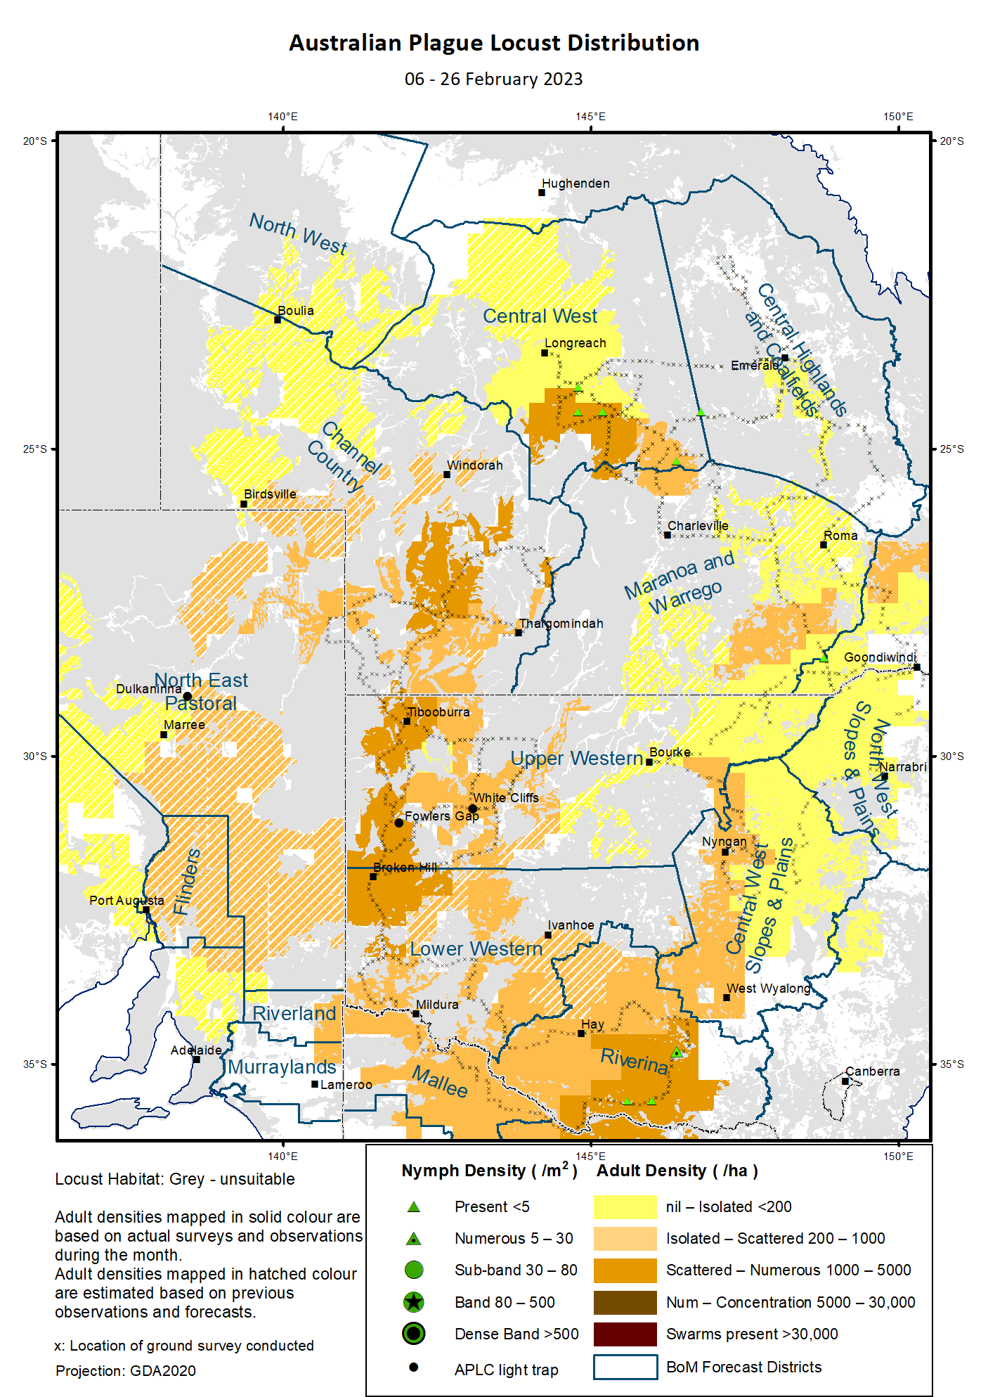

# Australian Plague Locust (*Chortoicetes terminifera*)

## SITUATION in February and OUTLOOK to May 2023

#### NEW SOUTH WALES

##### NORTH WEST SLOPES & PLAINS

###### Northwest Local Land Services

Locusts and conditions

* Surveys in February identified occasional adults in this district.
* No locust reports were received from this district in February.
* This district received 10 – 40 mm of rainfall in February, at below average to average levels.

Forecast

* Sporadic breeding is possible under favourable habitat conditions. However, the general population density is expected to be at low levels.
* There is a low probability of any significant migration during autumn.

Risks

* There is a low risk of a widespread regional infestation developing during autumn.

##### CENTRAL WEST SLOPES & PLAINS

###### Central West Local Land Services

Locusts and conditions

* Surveys in February identified some Isolated – Scattered density adults in the northern portion of this district. No nymphs were detected by survey.
* No locust reports were received from this district in February.
* This district received 2 – 25 mm of rainfall in February, at very much below average to average levels.

Forecast

* Sporadic breeding is possible under favourable habitat conditions. However, the general population density is expected to be at low levels.
* There is a low probability of any significant migration during autumn.

Risks

* There is a low risk of widespread regional infestations developing during autumn.

##### RIVERINA

###### Riverina, Murray, and part of Western Local Land Services

Locusts and conditions

* Surveys in February identified consistent Isolated – Numerous-density adults with some Present – Numerous-density nymphs detected in this district.
* Several reports of locust activity were received from the Narrandera-Berrigan areas.
* The UNSW insect monitoring radar in Hay detected several nights of short-distance migration events in February. These migrations varied in directions, reflecting some general redistribution facilitated by disturbed weather conditions.
* This district received less than 25 mm of rainfall with less than 5mm of rainfall over much of the district in February, at very much below average to below average levels.

Forecast

* Some medium – high-density adults may develop from localised breeding and immigration.
* There is a low – moderate probability of migration/dispersal events during autumn.
* Overwintering eggs will be laid with large proportion in diapause.

Risks

* There is a moderate risk of localised infestation developing during autumn.

##### UPPER and LOWER WESTERN

###### Western Local Land Services

Locusts and conditions

* Surveys in February identified consistent Isolated – Scattered-density adults with some Numerous-density adults (but no nymphs) detected in the western portion of the Upper and Lower Western districts. Isolated-density adults were identified in the north-eastern part of Upper Western district.
* No reports of locust activity were received from these two districts in February.
* Neither of the light traps at White Cliffs and Fowlers Gap captured any locusts in February, reflecting very low nocturnal movements around these areas.
* These two districts received less than 15 mm of rainfall in February with nil amount over much of these districts, at very much below average to below average levels.

Forecast

* Localised high density adults may form under hot weather conditions after redistribution by nocturnal migration and day-time dispersal.
* Some nymphs may hatch from successful localised breeding under suitable habitats. However, a large proportion of the eggs laid in autumn will undertake slow development or dormancy/diapause.
* There is a moderate probability of migration/dispersal events during autumn.

Risks

* There is a low-moderate risk of regional infestations developing, but widespread high-density infestation is unlikely during autumn.

**All locust activity should be reported to your** [**Local Land Services**](https://www.lls.nsw.gov.au/) **(1300 795 299) or the** [**Department of Primary Industries**](https://www.dpi.nsw.gov.au/climate-and-emergencies/locusts)**. A toll-free call to the APLC hotline can be made on 1800 635 962. An answering machine is attached to this phone for after-hours calls. Reports can also be emailed to APLC via** [**aplc@agriculture.gov.au**](mailto:aplc@agriculture.gov.au) **or sent through the web page at** [**https://www.agriculture.gov.au/pests-diseases-weeds/locusts/landholders/reporting_locusts**](https://www.agriculture.gov.au/pests-diseases-weeds/locusts/landholders/reporting_locusts)**.**

#### QUEENSLAND

##### CENTRAL HIGHLANDS AND COALFIELDS

###### Isaac and Central Highlands Regional Councils; Banana Shire

Locusts and conditions

* Surveys in February identified occasional Present-density adults (but no nymphs) in this district.
* No reports of locust activity were received from this district in February.
* This district received from 15 mm to nearly 150 mm of rainfall from the south to the north, at generally very much below average to average levels.

Forecast

* Localised breeding is possible, but any resulting population is likely to remain at low levels.
* There is a low probability of any significant migration events during autumn.

Risks

* There is a low risk of a widespread infestation developing during autumn.

##### DARLING DOWNS AND GRANITE BELT

###### Western Downs and Goondiwindi Regional Councils

Locusts and conditions

* Surveys in February identified Isolated – Scattered-density adults with occasional nymphs detected in this district.
* No locust reports were received from this district in February.
* This district received 5 – 35 mm of rainfall in February, at generally very much below average to below average levels.

Forecast

* Some sporadic breeding is possible, but only a low-density population is expected.
* There is a low probability of any significant migration events during autumn.

Risks

* There is a low risk of a widespread infestation developing during autumn.

##### CENTRAL WEST

###### Barcaldine, Longreach, and Blackall-Tambo Regional Council; Flinders and Winton Shires

Locusts and conditions

* Surveys inf February in the southern portion identified Isolated – Low-Numerous density adults with Present-density nymphs detected in this district.
* No locust reports were received from this district in February.
* This district received 15 – 100 mm of rainfall for February, at generally below average to very much above average levels in the direction of southeast to northwest.

Forecast

* Some successful breeding may result in the development of medium-density populations.
* There is a low-moderate probability of migration events during autumn.

Risks

* There is a low risk of a widespread infestation during autumn.

##### MARANOA AND WARREGO

###### Maranoa Regional Council; Murweh, Paroo, and Balonne Shires

Locusts and conditions

* Surveys in February identified Isolated – Scattered-density adults (but no nymphs) in this district.
* No locust reports were received from this district in February.
* February rainfall varied from 5 – 50 mm with less than 25 mm of rainfall over much of the district, ranging from very much below average to average levels.

Forecast

* Sporadic breeding may result in some localised low population densities.
* There is a low probability of any significant migration events during autumn.

Risks

* There is a low risk of a widespread infestation developing during autumn.

##### NORTH WEST

###### Mt Isa, Cloncurry, McKinlay, Boulia, and Winton Shires

Locusts and conditions

* No surveys were conducted in this district in February.
* No locust reports were received from this district in February.
* This district received 60 - ≥200 mm of rainfall with more than 100 mm of rainfall over much of the district in February, at generally above average to very much above average levels.

Forecast

* Sporadic breeding may result in some localised low – medium population densities under suitable habitat conditions.
* There is a low-moderate probability of migration/redistribution events activity during autumn.

Risks

* There is a low risk of a widespread infestation developing during autumn.

##### CHANNEL COUNTRY

###### Boulia, Diamantina, Barcoo, Quilpie, and Bulloo Shires

Locusts and conditions

* Surveys in February in the southern part identified Isolated – Low-Numerous density adults (but no nymphs) in this district.
* No locust reports were received from this district in February.
* This district received from nil in the southern part to over 100 mm of rainfall in the northern part in February, at generally below average to above average levels.

Forecast

* Locust numbers are likely to increase moderately to medium levels with possible high-density pockets after any successful breeding and immigration from adjacent districts.
* There is a moderate probability of some significant migration events during autumn.

Risks

* There is a low – moderate risk of a widespread infestation developing during autumn.

**All locust activity should be reported the** [**Biosecurity Queensland (Department of Agriculture and Fisheries)**](https://www.daf.qld.gov.au/business-priorities/biosecurity) **via the** [**Customer Service Centre**](https://www.daf.qld.gov.au/contact/customer-service-centre) **on 13 25 23. A toll-free call to the APLC hotline can be made on 1800 635 962. An answering machine is attached to this phone for after-hours calls. Reports can also be emailed to APLC via** [**aplc@agriculture.gov.au**](mailto:aplc@agriculture.gov.au) **or sent through the website at** [**https://www.agriculture.gov.au/pests-diseases-weeds/locusts/landholders/reporting_locusts**](https://www.agriculture.gov.au/pests-diseases-weeds/locusts/landholders/reporting_locusts)**.**

#### SOUTH AUSTRALIA

##### NORTH EAST PASTORAL and FLINDERS

Locusts and conditions

* No surveys were conducted in February in this district except for the Innamincka area where Isolated – Low-Numerous density adults were identified. No nymphs were detected by this limited survey.
* No reports of locust activity were received from these two districts in February.
* The light-trap at Dulkaninna did not capture any locusts in February, but individual adults were sighted in the vicinity.
* February rainfall was less than 5 mm over much of these two districts with nearly 50 mm rainfall totals towards the north-eastern corner, at generally below average to average levels.

Forecast

* Locust numbers are likely to increase low-moderately from both successful localised breeding under favourable habitat conditions and redistribution by nocturnal migration and day-time dispersal, both within these districts and from adjacent districts.
* Some high-density adults may form under hot weather conditions.
* There is a moderate probability of migration/dispersal events within these districts and adjacent areas during autumn.

Risks

* There is a low-moderate risk of a regional infestation developing during autumn.

##### RIVERLAND and MURRAYLANDS

Locusts and conditions

* No surveys were conducted in these two districts in February.
* No locust reports were received from these two districts in February.
* February rainfall ranged from 1 – 10 mm, at generally below average to average levels.

Forecast

* The locust population is likely to remain at low levels with some pockets of higher densities.
* There is a low-moderate probability of some migration/dispersal events during autumn.

Risks

* There is a low risk of a widespread infestation developing during autumn.

**Locust activity should be reported to** [**Biosecurity SA (Primary Industries and Regions South Australia)**](https://www.pir.sa.gov.au/biosecurity) **via the Plant Health Hotline on 1300 666 010.** **A toll-free call to the APLC hotline can be made on 1800 635 962. An answering machine is attached to this phone for after-hours calls. Reports can also be emailed to APLC via** [**aplc@agriculture.gov.au**](mailto:aplc@agriculture.gov.au) **or sent through the website at** [**https://www.agriculture.gov.au/pests-diseases-weeds/locusts/landholders/reporting_locusts**](https://www.agriculture.gov.au/pests-diseases-weeds/locusts/landholders/reporting_locusts)**.**

#### VICTORIA

##### MALLEE

**Mildura and Swan Hill Rural Cities; Yarriambiack and Buloke Shires**

Locusts and conditions

* Surveys in February were conducted along the State border and identified consistent Isolated – Scattered-density adults (but no nymphs) in this district.
* No reports were received from this district in February, but some reports of locust activities were received from adjacent districts.
* February rainfall ranged from 1 – 5 mm in this district, at generally below average levels.

Forecast

* Locust numbers are likely to remain at low levels even following some successful breeding under suitable habitat conditions or to increase moderately due to immigration from adjacent districts.
* Small aeras of high-density adults may form under hot weather conditions from successful localised breeding and migration/dispersal from adjacent districts.
* There is a moderate probability of migration/dispersal events during autumn.

Risks

* There is a low-moderate risk of a regional infestation developing during autumn.

##### WIMMERA

**Hindmarsh and West Wimmera Shires**

Locusts and conditions

* No surveys were conducted in this district in February.
* No locust reports were received from this district in February.
* February rainfall ranged from 5 mm in the northeast part to 40 mm in the southwest part of this district, at average to above average levels.

Forecast

* Locust numbers are likely to remain at low levels even following some successful breeding under suitable habitat conditions and immigration from adjacent districts.
* There is a low probability of any significant migrations during autumn.

Risks

* There is a low risk of a widespread infestation developing during autumn.

**Locust activity should be reported to the** [**Agriculture Victoria**](https://agriculture.vic.gov.au/)[**Customer Contact Centre**](https://agriculture.vic.gov.au/about/contact-us) **on 136 186. Alternatively, you can make a report via the online form at**[**https://forms.bio.vic.gov.au/2020**](https://forms.bio.vic.gov.au/2020)**. Please include photos where possible. A toll-free call to the APLC hotline can be made on 1800 635 962. An answering machine is attached to this phone for after-hours calls. Reports can be emailed to APLC via** [**aplc@agriculture.gov.au**](mailto:aplc@agriculture.gov.au) **or sent through the website at** [**https://www.agriculture.gov.au/pests-diseases-weeds/locusts/landholders/reporting_locusts**](https://www.agriculture.gov.au/pests-diseases-weeds/locusts/landholders/reporting_locusts).

# Glossary of locust terms and density categories used in the Locust Bulletin

**Locust biology and behaviour**

|  |  |
| --- | --- |
| **Term** | **Definition** |
| adult | A fully developed, mature locust capable of breeding and migrating |
| band | Dense congregation of nymphs, usually marching together |
| diapause | Period of dormancy induced in anticipation of unfavourable environmental conditions |
| egg bed | An area of soil containing many egg pods (hundreds per square metre) |
| fledge | Final nymphal moult to a soft-bodied adult (fledgling) incapable of long-distance flight |
| hatch | A young nymph (hatchling) newly emerged from an egg |
| instar | Discrete stages of nymphal development each separated by a moult |
| laying | Female locusts depositing clutches of 20 – 60 eggs into the ground in froth-lined egg pods |
| nymph | An immature locust. Often referred to as the hopper stage |
| swarm | Dense congregation of adults, milling at the same spot or flying closely together |

###### Locust density categories

Where higher densities occur, a large proportion of the regional population is concentrated in very small areas with lower densities elsewhere, so the higher densities cannot be extrapolated over the area of an entire region. A range of density classes is usually found within a surveyed region.

|  |  |  |
| --- | --- | --- |
| **Nymph Densities** | **Number per m2** |  |
| Present | 1 – 5 |  |
| Numerous | 6 – 30 |  |
| Sub-band | 31 – 80 |  |
| Band | 81 – 500 |  |
| Dense Band | >500 |  |
|  |  |  |
| **Adult Densities** | **Number per m2** | **Number per 250 m2** |
| Isolated | – 0.02 | 1 5 |
| Scattered | 0.024 – 0.1 | 6 – 25 |
| Numerous | 0.104 – 0.5 | 26 – 125 |
| Concentration | 0.504 – 3 | 126 – 750 |
| Low Density Swarm | 4 – 10 | 751 – 2,500 |
| Medium Density Swarm | 11 – 50 | 2,501 – 12,500 |
| High Density Swarm | >50 | >12,500 |
|  |  |  |
| **General density classes** | **Nymph densities** | **Adult densities** |
| very low, occasional | Nil – Present | Nil – Isolated |
| low | Present – Numerous | Isolated – Scattered |
| medium | Numerous – Sub-band | Scattered – Numerous |
| high | Bands | Concentration – Swarms |

###### Reporting locust infestations

It is important that all locust activity is reported as soon as possible to your nearest state agriculture agency office or to the Australian Plague Locust Commission.

|  |  |
| --- | --- |
| **State** | **Authority for reporting locusts** |
| New South Wales | Local Land Services (LLS) or Department of Primary Industries |
| Queensland | Biosecurity Queensland, Department of Agriculture and Fisheries |
| South Australia | Biosecurity SA, Department of Primary Industries & Regions |
| Victoria | Biosecurity and Agriculture Services, Department of Energy, Environment and Climate Action |

Reports to the **Australian Plague Locust Commission** can be made by:

Free call (Canberra): 1800 635 962 (24 hours)

Fax (Canberra): (02) 6272 5074

Email: [aplc@agriculture.gov.au](mailto:aplc@agriculture.gov.au)

Website: <https://www.agriculture.gov.au/pests-diseases-weeds/locusts/landholders/reporting_locusts>