## GENERAL SITUATION in February and OUTLOOK to May 2022

### Australian Plague Locust *Chortoicetes terminifera*

The locust population increased slightly in inland eastern Australia. In addition to the persistent higher numbers in the Riverina district of New South Wales, adult numbers increased noticeably in the arid interior.

Limited surveys were conducted in mid-February in New South Wales and Queensland. In New South Wales Present – Numerous-density mid-instar nymphs were identified in the Riverina district with frequent Numerous-density adults and a small Low-Density swarm (north of Conargo) persistent in the Jerilderie-Darlington Point-Hay-Deniliquin areas. Consistent Isolated – Scattered-density and some Low Numerous-density adults were identified in the Lower Western district with occasional nymphs also detected. Isolated-density adults were detected in the Central West and eastern part of Upper Western districts with a High-Numerous density in the Fowlers Gap area. In Queensland, Isolated – Scattered-density adults were identified in the Central West, Maranoa and Warrego districts. Apart from a peak detection during 29/01 – 01/02, the White Cliffs light-trap did not capture any more locusts on all other nights of February. The Fowlers Gap light-trap recorded consistent captures in the first half of February with a peak of 9 – 28 locusts per night during 05 – 09 February. There was another small wave of 1 to 3 locusts per night in late February. The light-trap at Dulkaninna in South Australia did not capture any locusts in February, although some adults were reported in pasture. The insect monitoring radar in Hay did not detect any significant locust migrations during February. A band report was recently received from the NSW Kyalite area. The slightly increase of adult numbers in the arid interior reflects population redistributions and some localised breeding.

February rainfall ranged from nil (west) to more than 100 mm (east) over inland eastern Australia and ranked from very much below average to very much above average levels. Much of the arid interior received less than 10 mm rain in February. February mean temperatures were 1 – 2 degrees below average over much of inland eastern Australia. The peaked La Niña event is likely to further influence the weather and climate to mid-autumn, slightly increasing the chance of above average rainfall over the south-western part and the eastern part of inland eastern Australia over March and April respectively. Night temperatures are likely to remain above average in autumn, but day-time temperatures are expected to be cooler in the south-eastern part of the inland eastern Australia in March and slightly warmer in the interior in April. Vegetation conditions are likely to remain suitable for locust breeding over most parts.

The outlook for autumn is for a moderate increase in the overall population level in inland eastern Australia, with medium to high densities persisting in the NSW Riverina district and adjacent areas, and low to medium densities in the arid interior with some localised medium to high densities. The population level is likely to remain low in other parts of inland eastern Australia.

It is likely that some nymphs will commence hatching from early March onwards in the NSW Riverina district and surrounding areas with limited band developing. Some bands may also develop in the arid interior of eastern Australia. Swarm formation may start from late March onwards in the arid interior. Under suitable weather conditions, some adults of autumn generation may migrate/disperse southwards and join local residual populations to lay overwintering eggs. Diapause eggs are likely laid from early March onwards in the southern part of inland eastern Australia.

There is a low-moderate likelihood of region-wide infestations developing in the NSW Riverina and surrounding areas and the arid interior of inland eastern Australia during autumn, but high-density widespread infestations are unlikely.

**8 March 2022**

### Spur-throated Locust *Austracris guttulosa*

Surveys in mid-February identified fairly consistent Present – Numerous-density nymphs including some early instars, plus frequent Isolated – Numerous-density adults in the Central West district of Queensland. Only Isolated – Scattered-density adults were detected in the Maranoa and Warrego district of Queensland, and the Upper Western and Central West districts of New South Wales. No more reports were received and no capture records from light traps at Dulkaninna in South Australia and at White Cliffs and Fowlers Gaps in New South Wales in February. With suitable habitat conditions, current nymphs should survive and may develop into some localised medium-high density adults.

With a likely wet April in the tropical and subtropical Queensland, higher nymphal survival rate is likely and results in more localised medium – high-density adults in autumn.

There is a medium risk of a widespread low-medium density infestation, and localised high-density infestations may develop in subtropical Queensland in autumn.

### Migratory Locust *Locusta migratoria*

Surveys in mid-February did not detect any migratory locusts. However, under current favourable habitat conditions, breeding should continue in the Central Highlands of Queensland and surrounding areas. Nevertheless, high-density gregarisation is unlikely to result from the previously very low population level.

There is a very low risk of a widespread infestation developing during autumn.

**It is important that any locust activity be reported as soon as possible to your local biosecurity authority, primary industries department or to the commission. A toll-free call to the APLC hotline can be made on 1800 635 962. An answering machine is attached to this phone for after-hours calls. Reports can also be emailed to APLC via** [**aplc@agriculture.gov.au**](mailto:aplc@agriculture.gov.au) **or made through the website at** [**https://www.agriculture.gov.au/pests-diseases-weeds/locusts/landholders/reporting_locusts**](https://www.agriculture.gov.au/pests-diseases-weeds/locusts/landholders/reporting_locusts)**.**

### Locust distribution map—*Chortoicetes terminifera*

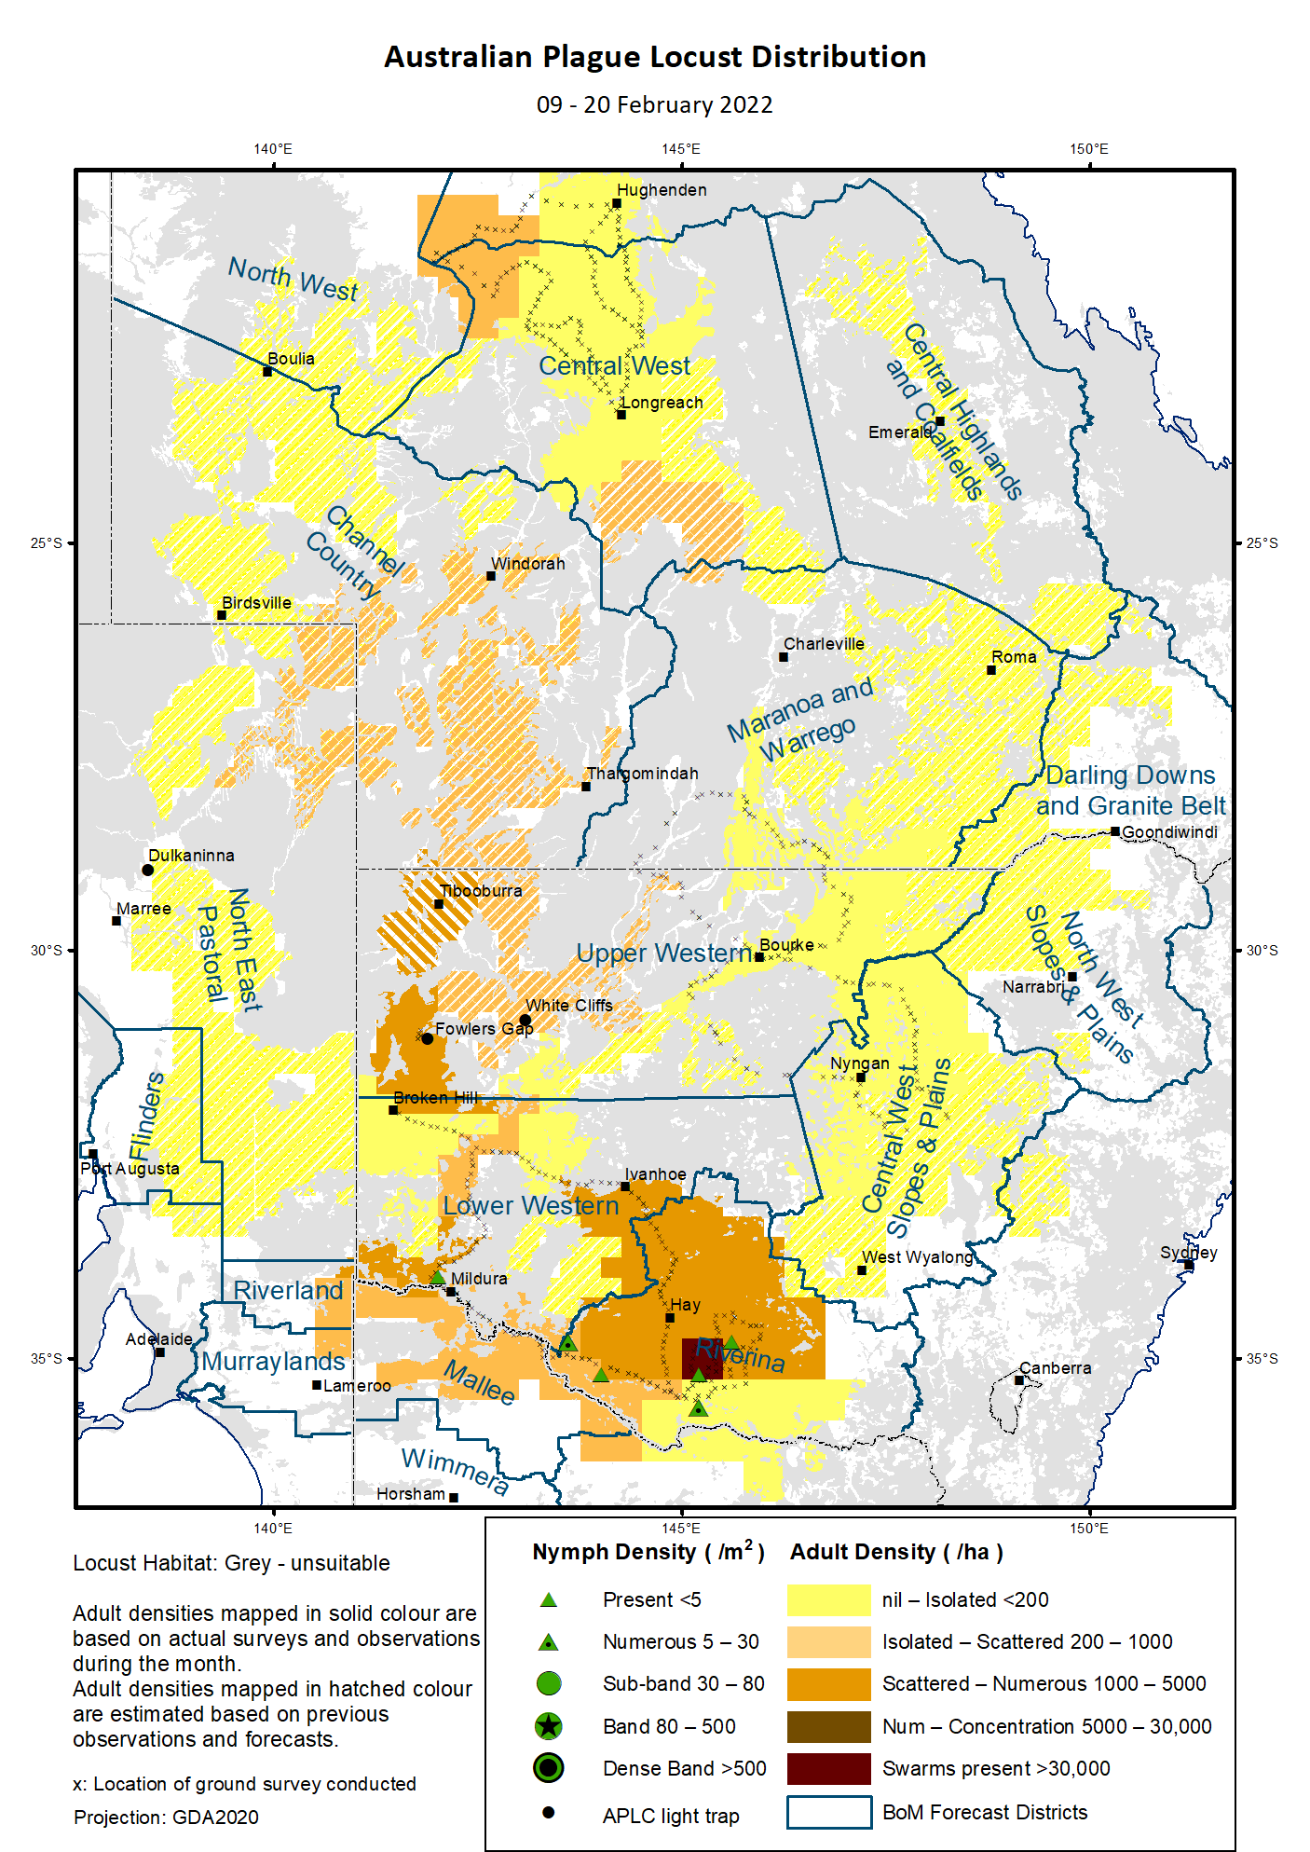

# Australian Plague Locust (*Chortoicetes terminifera*)

## SITUATION in February and OUTLOOK to May 2022

#### NEW SOUTH WALES

##### NORTH WEST SLOPES & PLAINS

###### Northwest Local Land Services

Locusts and conditions

* No surveys were conducted in this district in February.
* No locust reports were received from this district in January.
* This district received 30 – 120 mm rainfall in January, at about average level over much of the district.

Forecast

* Only limited localised breeding is possible. The general population density is expected to be at low levels.
* There is a low probability of any significant migration during autumn.

Risks

* There is a low risk of a widespread regional infestation developing during autumn.

##### CENTRAL WEST SLOPES & PLAINS

###### Central West Local Land Services

Locusts and conditions

* Surveys in the north-western part of this district in mid-February only identified Isolated-density adults.
* No locust reports were received from this district in February.
* This district received 5 – 50 mm rainfall in February, at below average to average levels.

Forecast

* Localised breeding is possible, but general population level is likely to remain low.
* There is a low probability of any significant migration during autumn.

Risks

* There is a low risk of widespread regional infestations developing during autumn.

##### RIVERINA

###### Riverina, Murray, and part of Western Local Land Services

Locusts and conditions

* Surveys in mid-February identified frequent Numerous-density adults persistent in the Jerilderie-Darlington Point-Hay-Deniliquin areas with a Low-Density swarm detected in the north of Conargo. The swarm was about 1 km long with some fat reserve but no eggs developed yet. Isolated – Scattered-density adults were consistent in the western part of this district with some Numerous densities. Several Present – Numerous-density mid-instar nymphs were identified. There was a band report from the Kyalite area.
* The UNSW insect monitoring radar in Hay did not detect any significant locust migration during February.
* This district received less than 25 mm rain in February with less than 5 mm over much of the district, at very much below average to average levels.

Forecast

* Localised band may hatch from early March onwards.
* Diapause eggs may be laid for overwintering from early March onwards.
* There is a moderate probability of redistribution/migration within the district and to adjacent regions under suitable weather patterns during autumn.

Risks

* There is a moderate risk of a widespread infestation developing during autumn.

##### UPPER and LOWER WESTERN

###### Western Local Land Services

Locusts and conditions

* Surveys in mid-February identified frequent Isolated – Scattered-density adults in the Lower Western district with some Low-Numerous densities of adults detected. Apart from a High-Numerous density of adults identified in the Fowlers Gap area, only Isolated adults were detected in the eastern part of Upper Western district. A Present-density of nymphs was identified in the Mildura area.
* No locust reports were received from this district in February.
* The light trap at White Cliffs did not capture anymore locusts apart from the period of 29/01 to 01/02. The light trap at Fowlers Gap showed consistent captures during 01 – 14 February with a peak of up to 28 locusts per night during 05 – 09 February. There was a small capture wave of up to 3 locusts per night at the end of February. This indicates higher numbers in the western part of Upper Western district.
* A noticeable population increase from previous very low level indicates successful immigrations, redistributions, and localised breeding.
* February rainfall ranged from almost nil in the southern part to 70 mm in the north-eastern part of this district. Much of the district received about average rainfall, although over than range of below average to above average levels.

Forecast

* Locust population is likely to have a low-moderate increase, especially in the Upper Western district, and some localised bands could develop under favourable habitats from early March onwards.
* Swarm formation may commence from late March onwards.
* There is a moderate likelihood of migration from/to adjacent districts and within this district during autumn.

Risks

* There is a low – moderate risk of a widespread infestation developing during autumn.

**All locust activity should be reported to your** [**Local Land Services**](https://www.lls.nsw.gov.au/) **(1300 795 299) or the** [**Department of Primary Industries**](https://www.dpi.nsw.gov.au/climate-and-emergencies/locusts)**. A toll-free call to the APLC hotline can be made on 1800 635 962. An answering machine is attached to this phone for after-hours calls. Reports can also be emailed to APLC via** [**aplc@agriculture.gov.au**](mailto:aplc@agriculture.gov.au) **or sent through the web page at** [**https://www.agriculture.gov.au/pests-diseases-weeds/locusts/landholders/reporting_locusts**](https://www.agriculture.gov.au/pests-diseases-weeds/locusts/landholders/reporting_locusts)**.**

#### QUEENSLAND

##### CENTRAL HIGHLANDS AND COALFIELDS

###### Isaac and Central Highlands Regional Councils; Banana Shire

Locusts and conditions

* No surveys were conducted in February in this district.
* No reports of locust activity were received from this district in February.
* This district received 10 to 150 mm rainfall in February, at very much below average to above average levels.

Forecast

* Localised breeding is possible under favourable habitats, but the population is likely to be at low levels based on previous low background population.
* There is a low probability of any significant migrations during autumn.

Risks

* There is a low risk of a widespread infestation developing in autumn.

##### DARLING DOWNS AND GRANITE BELT

###### Western Downs and Goondiwindi Regional Councils

Locusts and conditions

* No surveys were conducted in February in this district.
* No locust reports were received from this district.
* This district received 90 to 200 mm rainfall in February, at above average to very much above average levels.

Forecast

* Some sporadic breeding is possible, but only a low-density population is expected.
* There is a low probability of any significant migrations in autumn.

Risks

* There is a low risk of a widespread infestation developing during autumn.

##### CENTRAL WEST

###### Barcaldine, Longreach, and Blackall-Tambo Regional Council; Flinders and Winton Shires

Locusts and conditions

* Surveys in mid-February in the northern part of this district identified some Isolated-density adults without nymphs detected.
* No locust reports were received from this district in February.
* This district received 15 – 80 mm rainfall in February, at below average to average levels.

Forecast

* Some breeding may result in development of some low-density populations.
* There is a low-medium probability of redistribution and migration during autumn.

Risks

* There is a low risk of a widespread infestation in autumn.

##### MARANOA AND WARREGO

###### Maranoa Regional Council; Murweh, Paroo, and Balonne Shires

Locusts and conditions

* Limited surveys in the southern part of this district in mid-February identified some Isolated-density adults with no nymphs detected.
* No locust reports were received from this district February.
* This district received 20 to 130 mm rainfall in February, at average level over much of the district with localised parts below average and above average levels.

Forecast

* Locust numbers are likely to remain low with some localised breeding possible.
* There is a low probability of migration during autumn.

Risks

* There is a low risk of a widespread infestation developing during autumn.

##### NORTH WEST

###### Mt Isa, Cloncurry, McKinlay, Boulia, and Winton Shires

Locusts and conditions

* No surveys were conducted in this district in February.
* No locust reports were received from this district in February.
* This district received 10 to 40 mm rainfall in February, at very much below average to below average levels over much of this district.

Forecast

* Locust numbers are likely to remain low, but sporadic localised breeding may occur in some areas.
* There is a low-medium probability of migration/redistribution activity during autumn.

Risks

* There is a low risk of a widespread infestation developing during autumn.

##### CHANNEL COUNTRY

###### Boulia, Diamantina, Barcoo, Quilpie, and Bulloo Shires

Locusts and conditions

* No surveys were conducted in this district in February.
* No locust reports were received from this district in February.
* This district received 10 to 60 mm rainfall in February, at average level over much of this district.

Forecast

* Locust numbers are likely to increase low-moderately under favourable habitat conditions during autumn. Successful breeding would be the key driver of population growth and some localised bands may develop.
* There is a moderate probability of migration activity during autumn.

Risks

* There is a low – moderate risk of a widespread infestation developing during and autumn.

**All locust activity should be reported the** [**Biosecurity Queensland (Department of Agriculture and Fisheries)**](https://www.daf.qld.gov.au/business-priorities/biosecurity) **via the** [**Customer Service Centre**](https://www.daf.qld.gov.au/contact/customer-service-centre) **on 13 25 23. A toll-free call to the APLC hotline can be made on 1800 635 962. An answering machine is attached to this phone for after-hours calls. Reports can also be emailed to APLC via** [**aplc@agriculture.gov.au**](mailto:aplc@agriculture.gov.au) **or sent through the website at** [**https://www.agriculture.gov.au/pests-diseases-weeds/locusts/landholders/reporting_locusts**](https://www.agriculture.gov.au/pests-diseases-weeds/locusts/landholders/reporting_locusts)**.**

#### SOUTH AUSTRALIA

##### NORTH EAST PASTORAL and FLINDERS

Locusts and conditions

* No surveys were conducted in this district in February.
* The Dulkaninna light-trap did not capture any locusts in February, although some adult locusts were sighted in fields.
* No locust reports were received from this district in February.
* This district received nil to 80 mm rainfall in February with more than 20 mm over the northern part of this district at above average level.

Forecast

* Locust numbers are likely to increase low – moderately after successful immigration and breeding under favourable habitat conditions. Some localised bands may develop from early March onwards.
* There is a moderate probability of migration during autumn.

Risks

* There is a low – moderate risk of a widespread infestation developing during autumn.

##### RIVERLAND and MURRAYLANDS

Locusts and conditions

* No surveys were conducted in this district in February.
* No locust reports were received from this district in February.
* February rainfall was less than 10 mm, from average to very much below average level.

Forecast

* The locust population is likely to remain at very low densities.
* There is a low probability of migration during autumn.

Risks

There is a very low risk of a widespread infestation developing during autumn.

**Locust activity should be reported to** [**Biosecurity SA (Primary Industries and Regions South Australia)**](https://www.pir.sa.gov.au/biosecurity) **via the Plant Health Hotline on 1300 666 010.** **A toll-free call to the APLC hotline can be made on 1800 635 962. An answering machine is attached to this phone for after-hours calls. Reports can also be emailed to APLC via** [**aplc@agriculture.gov.au**](mailto:aplc@agriculture.gov.au) **or sent through the website at** [**https://www.agriculture.gov.au/pests-diseases-weeds/locusts/landholders/reporting_locusts**](https://www.agriculture.gov.au/pests-diseases-weeds/locusts/landholders/reporting_locusts)**.**

#### VICTORIA

##### MALLEE

**Mildura and Swan Hill Rural Cities; Yarriambiack and Buloke Shires**

Locusts and conditions

* No surveys were conducted in this district in February.
* No locust reports were received from this district in February.
* February rainfall was 10 mm in this district, at average level over much of this district.

Forecast

* Locust numbers are likely to remain at low-moderate levels.
* There is a low – moderate probability of migration during autumn.

Risks

* There is a low – moderate risk of a widespread infestation developing during autumn.

##### WIMMERA

**Hindmarsh and West Wimmera Shires**

Locusts and conditions

* No surveys were conducted in this district in February.
* No locust reports were received from this district in February.
* February rainfall was less than 2 mm over much of this district, at average to below average levels.

Forecast

* Locust numbers are likely to remain at low levels.
* There is a low probability of migration during autumn.

Risks

* There is a low risk of a widespread infestation developing during autumn.

**Locust activity should be reported to the** [**Agriculture Victoria**](https://agriculture.vic.gov.au/)[**Customer Contact Centre**](https://agriculture.vic.gov.au/about/contact-us) **on 136 186. Alternatively, you can make a report via the online form at**[**https://forms.bio.vic.gov.au/2020**](https://forms.bio.vic.gov.au/2020)**.  Please include photos where possible. A toll-free call to the APLC hotline can be made on 1800 635 962. An answering machine is attached to this phone for after-hours calls. Reports can be emailed to APLC via** [**aplc@agriculture.gov.au**](mailto:aplc@agriculture.gov.au) **or sent through the website at** [**https://www.agriculture.gov.au/pests-diseases-weeds/locusts/landholders/reporting_locusts**](https://www.agriculture.gov.au/pests-diseases-weeds/locusts/landholders/reporting_locusts).

# Glossary of locust terms and density categories used in the Locust Bulletin

**Locust biology and behaviour**

|  |  |
| --- | --- |
| **Term** | **Definition** |
| adult | A fully winged, mature locust capable of breeding and migrating |
| band | Dense aggregation of nymphs, usually moving forward together |
| diapause | Period of dormancy induced in anticipation of unfavourable environmental conditions |
| egg bed | An area of soil containing many egg pods (hundreds per square metre) |
| fledge | Final nymphal moult to a soft-bodied adult incapable of long-distance flight |
| instar | Discrete stages of nymphal development each separated by a moult |
| laying | Female locusts depositing clutches of 20 – 60 eggs into the ground in froth-lined egg pods |
| nymph | Juvenile wingless locust. Often referred to as the hopper stage |
| swarm | Dense aggregation of adults, milling at the same spot or flying closely together |

###### Locust density categories

Where higher densities occur, a large proportion of the regional population is concentrated in very small areas with lower densities elsewhere, so the higher densities cannot be extrapolated over the area of an entire region. A range of density classes is usually found within a surveyed region.

|  |  |  |
| --- | --- | --- |
| **Nymph Densities** | **Number per m2** |  |
| Present | 1 – 5 |  |
| Numerous | 6 – 30 |  |
| Sub-band | 31 – 80 |  |
| Band | 81 – 500 |  |
| Dense Band | >500 |  |
|  |  |  |
| **Adult Densities** | **Number per m2** | **Number per 250 m2** |
| Isolated | – 0.02 | 1 5 |
| Scattered | 0.024 – 0.1 | 6 – 25 |
| Numerous | 0.104 – 0.5 | 26 – 125 |
| Concentration | 0.504 – 3 | 126 – 750 |
| Low Density Swarm | 4 – 10 | 751 – 2,500 |
| Medium Density Swarm | 11 – 50 | 2,501 – 12,500 |
| High Density Swarm | >50 | >12,500 |
|  |  |  |
| **General density classes** | **Nymph densities** | **Adult densities** |
| very low, occasional | Nil – Present | Nil – Isolated |
| low | Present – Numerous | Isolated – Scattered |
| medium | Numerous – Sub-band | Scattered – Numerous |
| high | Bands | Concentration – Swarms |

###### Reporting locust infestations

It is important that all locust activity is reported as soon as possible to your nearest state agriculture agency office or to the Australian Plague Locust Commission.

|  |  |
| --- | --- |
| **State** | **Authority for reporting locusts** |
| New South Wales | Local Land Services (LLS) or Department of Primary Industries |
| Queensland | Biosecurity Queensland, Department of Agriculture and Fisheries |
| South Australia | Biosecurity SA, Department of Primary Industries & Regions |
| Victoria | Biosecurity and Agriculture Services, Department of Jobs, Precincts and Resources |

Reports to the **Australian Plague Locust Commission** can be made by:

Free call (Canberra): 1800 635 962 (24 hours)

Fax (Canberra): (02) 6272 5074

Email: [aplc@agriculture.gov.au](mailto:aplc@agriculture.gov.au)

Website: <https://www.agriculture.gov.au/pests-diseases-weeds/locusts/landholders/reporting_locusts>