## GENERAL SITUATION in December and OUTLOOK to March 2024

### Australian Plague Locust *Chortoicetes terminifera*

Locust populations remained at very low levels across inland eastern Australia. Surveys conducted in December identified Isolated-density adults in southern Queensland, New South Wales, and the north-eastern part of South Australia with occasional Scattered/Low-Numerous density adults detected. No nymphs were detected during the December survey. The light-trap at Nooyeah Downs (Queensland) captured some adults (1-3 per night) in early December, but no captures were recorded in other APLC light traps in NSW (Fowlers Gap and White Cliffs) or SA (Dulkaninna). There were some nocturnal flights detected by the UNSW insect monitoring radar in Hay, NSW, during December. Radar detected migrations were likely local redistributions within short distances. There were no reports of locust activities received in December.

Rainfall totals in December were below 100 mm over inland eastern Australia with less than 25 mm rainfall across much of the arid/semi-arid interior. However, December rainfall still reflected average levels with parts varying from very much below average to very much above average levels. December mean temperatures were 1-2 degrees above average, ranging from above average to very much above average levels, over much of the inland eastern Australia. The mild El Niño event is likely to continue to early autumn 2024, but average rainfall and warmer temperatures are expected for the remainder of summer and early autumn over inland eastern Australia.

The outlook for January to March is for overall low-level populations across inland eastern Australia, with low-moderate population increases to produce some localised high numbers under favourable habitat conditions as a result from the December rain. Summer generation nymphs are likely to continue hatching, and adults may appear after mid-February. It is unlikely that any significant bands or swarms will develop during the remainder of summer and early autumn from currently very low background population levels, nor are any significant migrations likely to occur.

There is a very low likelihood of widespread infestations developing during the remainder of summer and early autumn.

**09 January 2024**

### Spur-throated Locust *Austracris guttulosa*

The overall population remained at low levels. Surveys in December identified widespread Isolated–Scattered-density adults in southern Queensland and Isolated-density adults in New South Wales and the north-eastern part of South Australia. No nymphs were detected during the December survey. No captures were recorded in APLC light traps at Nooyeah Downs (Qld), Dulkaninna (SA), White Cliffs (NSW) or Fowlers Gap (NSW). Habitats would have remained in good condition after December rain, and breeding has likely been occurring as a result of favourable conditions.

There is a low risk of a widespread infestation developing during the remainder of summer and early autumn. However, a moderate population increase is expected with some localised high densities of nymphs hatching during the remainder of summer and early autumn.

### Migratory Locust *Locusta migratoria*

The overall population was likely to have remained at very low levels. No locusts were detected in areas surveyed in December. The usual occurrence area of southeastern Queensland had good rainfalls in December again, and breeding was likely to have been occurring in these areas.

Localised breeding is possible under favourable habitat conditions produced from good December rains. However, high-density infestations are unlikely to result from previously very low background population levels.

There is a very low risk of a widespread infestation developing during the remainder of summer and early autumn.

**It is important that any locust activity be reported as soon as possible to your local biosecurity authority or to the Australian Plague Locust Commission. A toll-free call to the APLC hotline can be made on 1800 635 962. An answering machine is attached to this phone for after-hours calls. Reports can also be emailed to APLC via** [**aplc@agriculture.gov.au**](mailto:aplc@agriculture.gov.au) **or made through the website at** [**https://www.agriculture.gov.au/pests-diseases-weeds/locusts/landholders/reporting_locusts**](https://www.agriculture.gov.au/pests-diseases-weeds/locusts/landholders/reporting_locusts)**.**

### Locust distribution map—*Chortoicetes terminifera*

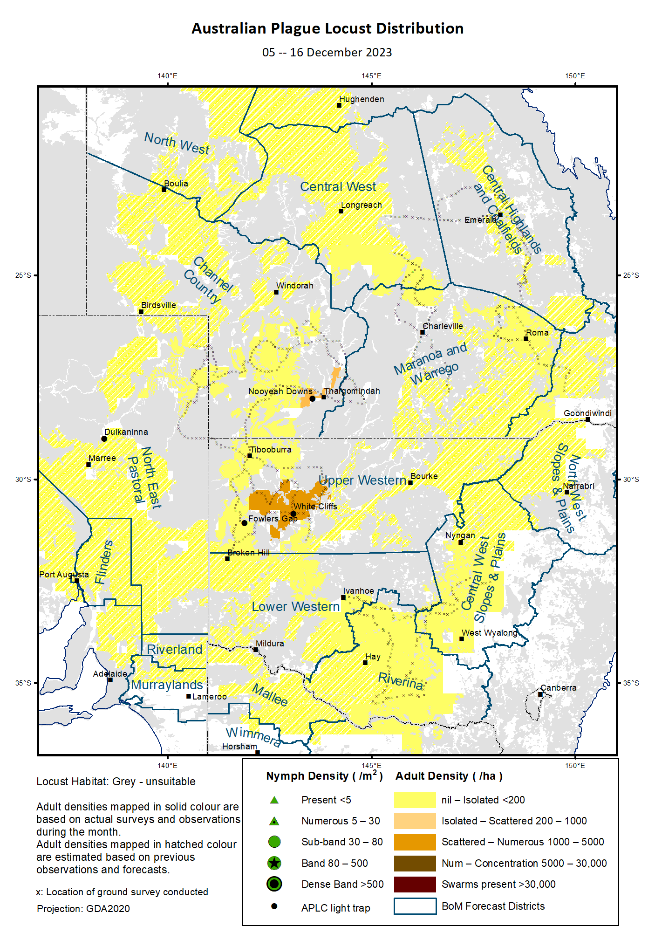

# Australian Plague Locust (*Chortoicetes terminifera*)

## SITUATION in December and OUTLOOK to March 2024

#### NEW SOUTH WALES

##### NORTH WEST SLOPES & PLAINS

###### Northwest Local Land Services

Locusts and conditions

* No surveys were conducted in this district in December.
* No locust reports were received from this district in December.
* Much of the district received 50–100 mm of rainfall in December, generally at average levels.

Forecast

* Limited breeding was likely to continue but unlikely to result into high-density populations from previously very low background levels. Nymphs are likely to continue hatching.
* There is a very low probability of any significant migrations during the remainder of summer and early autumn.
* The general population density is expected to remain at low levels during the remainder of summer and early autumn.

Risks

* There is a very low risk of a regional infestation developing during the remainder of summer and early autumn.

##### CENTRAL WEST SLOPES & PLAINS

###### Central West Local Land Services

Locusts and conditions

* Surveys in early December identified Isolated-density adults in the southern part of this district with no nymphs detected.
* No locust reports were received from this district in December.
* This district received 20–100 mm of rainfall in December, ranging from average to very much above average levels.

Forecast

* Limited breeding is likely to continue but unlikely to be widespread or result into high numbers.
* There is a very low probability of any significant migrations during the remainder of summer and early autumn.
* The general population density is expected to remain at low levels during the remainder of summer and early autumn.

Risks

* There is a very low risk of regional infestations developing during the remainder of summer and early autumn.

##### RIVERINA

###### Riverina, Murray Local Land Services

Locusts and conditions

* Surveys in early December identified Isolated-density adults in this district with no nymphs detected.
* No reports of locust activity were received from this district in December.
* The UNSW insect monitoring radar in Hay detected mass migrations of locust-shaped insects on nights of 4, 8, 12, 13 and 18 December, and some overflights on nights of 1, 5, 27 and 28 December. Most of these movements occurred near the centre of a low-pressure system and thus their migration distances were likely to be short (within 100-150 km), reflecting some local background populations and localised redistribution and aggregation with a general trend toward east/southeast.
* This district received 25-80 mm of rainfall in December, ranging from average to very much above average levels.

Forecast

* Breeding is likely to occur under favourable habitats, but bands or swarms are unlikely to form during the remainder of summer and early autumn. Nymph hatching may continue from now on.
* There is a low probability of any significant migration/dispersal events during the remainder of summer and early autumn.
* The population level is likely to remain low for the remainder of summer and early autumn.

Risks

* There is a low risk of regional infestation developing during the remainder of summer and early autumn.

##### UPPER and LOWER WESTERN

###### Western Local Land Services

Locusts and conditions

* Surveys in the Upper Western district identified Isolated-density adults with occasional Low-Numerous density adults detected in mid-December. No nymphs were detected by December survey. No surveys were conducted in the Lower Western district in December due to inaccessible roads.
* No reports of locust activity were received from these two districts in December.
* The light traps at White Cliffs and Fowlers Gap did not capture any locusts in December.
* December rainfall totals were less than 25 mm over much of these two districts with parts received above 25 mm rainfall, ranging from very much below average to very much above average levels.

Forecast

* Some localised sporadic breeding is possible under favourable habitat conditions, but any resulting population is likely to remain at low levels. Summer nymphs may continue hatching from now on.
* There is a low probability of any significant migration/dispersal events during the remainder of summer and early autumn.
* Bands and warms are unlikely to form during the remainder of summer and early autumn.

Risks

* There is a low risk of regional infestations developing during the remainder of summer and early autumn.

**All locust activity should be reported to your** [**Local Land Services**](https://www.lls.nsw.gov.au/) **(1300 795 299) or the** [**Department of Primary Industries**](https://www.dpi.nsw.gov.au/climate-and-emergencies/locusts)**. A toll-free call to the APLC hotline can be made on 1800 635 962. An answering machine is attached to this phone for after-hours calls. Reports can also be emailed to APLC via** [**aplc@agriculture.gov.au**](mailto:aplc@agriculture.gov.au) **or sent through the web page at** [**https://www.agriculture.gov.au/pests-diseases-weeds/locusts/landholders/reporting_locusts**](https://www.agriculture.gov.au/pests-diseases-weeds/locusts/landholders/reporting_locusts)**.**

#### QUEENSLAND

##### CENTRAL HIGHLANDS AND COALFIELDS

###### Isaac and Central Highlands Regional Councils; Banana Shire

Locusts and conditions

* Surveys in mid-December did not identify any locusts in this district.
* No reports of locust activity were received from this district in December.
* This district received 50-150 mm of rainfall in December, ranging from average to above average levels.

Forecast

* Localised breeding is likely to occur under favourable habitat conditions and nymphs may continue hatching from now on, but any resulting population is likely to remain at low levels.
* There is a very low probability of any significant migration events during the remainder of summer and early autumn.

Risks

* There is a very low risk of a regional infestation developing during the remainder of summer and early autumn.

##### DARLING DOWNS AND GRANITE BELT

###### Western Downs and Goondiwindi Regional Councils

Locusts and conditions

* Limited surveys in mid-December identified occasional Isolated-density Adults in this district with no nymphs detected.
* No locust reports were received from this district in December.
* This district received 40-100 mm of rainfall in December, generally at average levels with some parts below/above average levels.

Forecast

* Breeding is likely to occur under favourable habitat conditions and nymph may continue hatching from now on, but any resulting population is likely to remain at low levels.
* There is a very low probability of any significant migration events during the remainder of summer and early autumn.

Risks

* There is a very low risk of a regional infestation developing during the remainder of summer and early autumn.

##### CENTRAL WEST

###### Barcaldine, Longreach, and Blackall-Tambo Regional Council; Flinders and Winton Shires

Locusts and conditions

* Limited surveys in the south-eastern part of this district identified Isolated-density adults in mid-December with no nymphs detected.
* No locust reports were received from this district in December.
* This district received 15–100 mm of rainfall in December with higher volume in the east and much of the district received less than 50 mm of rainfall, ranging from below average to average levels.

Forecast

* Some sporadic breeding is likely to occur under favourable habitat conditions and nymphs may continue hatching from now on, but any resulting population is likely to remain at low levels.
* There is a very low probability of any significant migration events during the remainder of summer and early autumn.

Risks

* There is a very low risk of a regional infestation developing during the remainder of summer and early autumn.

##### MARANOA AND WARREGO

###### Maranoa Regional Council; Murweh, Paroo, and Balonne Shires

Locusts and conditions

* No surveys were conducted in this district in December.
* No locust reports were received from this district in December.
* This district received 50 mm to over 150 mm of rainfall over much of this district in December, ranging generally above average to very much above levels.

Forecast

* Sporadic breeding is possible, and nymphs may continue to hatch to form some localised high densities. However, any resulting population is likely to remain at low levels.
* There is a low probability of any significant migration events during the remainder of summer and early autumn.

Risks

* There is a low risk of a regional infestation developing during the remainder of summer and early autumn.

##### NORTH WEST

###### Mt Isa, Cloncurry, McKinlay, Boulia, and Winton Shires

Locusts and conditions

* No surveys were conducted in this district in December due to road conditions.
* No locust reports were received from this district in December.
* This district received less than 25 mm of rainfall in December, ranging from very much below average to below average levels.

Forecast

* Sporadic breeding is possible in suitable habitats, but any resulting locust population is likely to remain at low levels.
* There is a very low probability of any significant migration/redistribution events during the remainder of summer and early autumn.

Risks

* There is a low risk of a regional infestation developing during the remainder of summer and early autumn.

##### CHANNEL COUNTRY

###### Boulia, Diamantina, Barcoo, Quilpie, and Bulloo Shires

Locusts and conditions

* Surveys in the southern part of this district identified Isolated-density adults with occasional Scattered-density adults detected in mid-December. No nymphs were detected by December survey.
* The light trap at Nooyeah Downs, Thargomindah, recorded captures of 1-3 locusts on nights of 3-7 and 11 December, reflecting some local background populations.
* No locust reports were received from this district in December.
* This district received 7-50 mm of rainfall in December with the south-eastern part receiving higher volume rainfall of more than 25 mm, ranging from average to above average levels.

Forecast

* Sporadic breeding is possible along drainages and under favourable habitat conditions, but less likely to develop bands or swarms.
* There is a low probability of any significant migration/redistribution events during the remainder of summer and early autumn.

Risks

* There is a low risk of a regional infestation developing during the remainder of summer and early autumn.

**All locust activity should be reported the** [**Biosecurity Queensland (Department of Agriculture and Fisheries)**](https://www.daf.qld.gov.au/business-priorities/biosecurity) **via the** [**Customer Service Centre**](https://www.daf.qld.gov.au/contact/customer-service-centre) **on 13 25 23. A toll-free call to the APLC hotline can be made on 1800 635 962. An answering machine is attached to this phone for after-hours calls. Reports can also be emailed to APLC via** [**aplc@agriculture.gov.au**](mailto:aplc@agriculture.gov.au) **or sent through the website at** [**https://www.agriculture.gov.au/pests-diseases-weeds/locusts/landholders/reporting_locusts**](https://www.agriculture.gov.au/pests-diseases-weeds/locusts/landholders/reporting_locusts)**.**

#### SOUTH AUSTRALIA

##### NORTH EAST PASTORAL and FLINDERS

Locusts and conditions

* Limited surveys conducted in the Cameron Corner-Moomba-Innamincka areas identified Isolated-density adults in mid-December. No nymphs were detected by December survey.
* No locust reports were received from this district in December.
* The light-trap at Dulkaninna did not capture any locusts in December.
* Much of the North East Pastoral district received less than 25 mm of rainfall in December, and the Flinders district received 10-50 mm of rainfall, ranging from below average to above average levels.

Forecast

* Sporadic breeding is possible under favourable habitats, but any resulting population is likely to remain at low levels.
* Locust bands and swarms are unlikely to develop during the remainder of summer and early autumn.
* There is a low probability of any significant migration/dispersal events during the remainder of summer and early autumn.

Risks

* There is a low risk of a regional infestation developing during the remainder of summer and early autumn.

##### RIVERLAND and MURRAYLANDS

Locusts and conditions

* No surveys were conducted in the two districts in December.
* No locust reports were received from these two districts in December.
* These districts received 10–80 mm of rainfall in December, ranging from average to very much above average levels.

Forecast

* Limited sporadic breeding is possible, but any resulting population is likely to remain at low levels.
* There is a very low probability of any significant migration/dispersal events during the remainder of summer and early autumn.

Risks

* There is a very low risk of a regional infestation developing during the remainder of summer and early autumn.

**Locust activity should be reported to** [**Biosecurity SA (Primary Industries and Regions South Australia)**](https://www.pir.sa.gov.au/biosecurity) **via the Plant Health Hotline on 1300 666 010.** **A toll-free call to the APLC hotline can be made on 1800 635 962. An answering machine is attached to this phone for after-hours calls. Reports can also be emailed to APLC via** [**aplc@agriculture.gov.au**](mailto:aplc@agriculture.gov.au) **or sent through the website at** [**https://www.agriculture.gov.au/pests-diseases-weeds/locusts/landholders/reporting_locusts**](https://www.agriculture.gov.au/pests-diseases-weeds/locusts/landholders/reporting_locusts)**.**

#### VICTORIA

##### MALLEE

**Mildura and Swan Hill Rural Cities; Yarriambiack and Buloke Shires**

Locusts and conditions

* No surveys were conducted in this district in December.
* No reports were received from this district in December.
* This district received 10–80 mm of rainfall in December, ranging average to very much above average levels.

Forecast

* Localised breeding is possible under favourable habitats, but any resulting population is likely to remain at low levels.
* It is unlikely that any bands or swarms develop during the remainder of summer and early autumn.
* There is a low probability of any significant migration events during the remainder of summer and early autumn.

Risks

* There is a low risk of a regional infestation developing during the remainder of summer and early autumn.

##### WIMMERA

**Hindmarsh and West Wimmera Shires**

Locusts and conditions

* No surveys were conducted in this district in December.
* No locust reports were received from this district in December.
* This district received 30–100 mm of rainfall in December, ranging from above average to very much above average levels.

Forecast

* Limited sporadic breeding is possible under suitable habitat conditions, but any resulting population is likely to remain at low levels.
* It is unlikely that any bands or swarms develop during the remainder of summer and early autumn.
* There is a low probability of any significant migration events during the remainder of summer and early autumn.

Risks

* There is a very low risk of a regional infestation developing during the remainder of summer and early autumn.

**Locust activity should be reported to the** [**Agriculture Victoria**](https://agriculture.vic.gov.au/)[**Customer Contact Centre**](https://agriculture.vic.gov.au/about/contact-us) **on 136 186. Alternatively, you can make a report via the online form at**[**https://forms.bio.vic.gov.au/2020**](https://forms.bio.vic.gov.au/2020)**. Please include photos where possible. A toll-free call to the APLC hotline can be made on 1800 635 962. An answering machine is attached to this phone for after-hours calls. Reports can be emailed to APLC via** [**aplc@agriculture.gov.au**](mailto:aplc@agriculture.gov.au) **or sent through the website at** [**https://www.agriculture.gov.au/pests-diseases-weeds/locusts/landholders/reporting_locusts**](https://www.agriculture.gov.au/pests-diseases-weeds/locusts/landholders/reporting_locusts).

# Glossary of locust terms and density categories used in the Locust Bulletin

**Locust biology and behaviour**

|  |  |
| --- | --- |
| **Term** | **Definition** |
| adult | A fully developed, mature locust capable of breeding and migrating |
| band | Dense congregation of nymphs, usually marching together |
| diapause | Period of dormancy induced in anticipation of unfavourable environmental conditions |
| egg bed | An area of soil containing many egg pods (hundreds per square metre) |
| fledge | Final nymphal moult to a soft-bodied adult (fledgling) incapable of long-distance flight |
| hatch | A young nymph (hatchling) newly emerged from an egg |
| instar | Discrete stages of nymphal development each separated by a moult |
| laying | Female locusts depositing clutches of 20–60 eggs into the ground in froth-lined egg pods |
| nymph | An immature locust. Often referred to as the hopper stage |
| swarm | Dense congregation of adults, milling at the same spot or flying closely together |

###### Locust density categories

Where higher densities occur, a large proportion of the regional population is concentrated in very small areas with lower densities elsewhere, so the higher densities cannot be extrapolated over the area of an entire region. A range of density classes is usually found within a surveyed region.

|  |  |  |
| --- | --- | --- |
| **Nymph Densities** | **Number per m2** |  |
| Present | 1 – 5 |  |
| Numerous | 6 – 30 |  |
| Sub-band | 31 – 80 |  |
| Band | 81 – 500 |  |
| Dense Band | >500 |  |
|  |  |  |
| **Adult Densities** | **Number per m2** | **Number per 250 m2** |
| Isolated | – 0.02 | 1 5 |
| Scattered | 0.024 – 0.1 | 6 – 25 |
| Numerous | 0.104 – 0.5 | 26 – 125 |
| Concentration | 0.504 – 3 | 126 – 750 |
| Low Density Swarm | 4 – 10 | 751 – 2,500 |
| Medium Density Swarm | 11 – 50 | 2,501 – 12,500 |
| High Density Swarm | >50 | >12,500 |
|  |  |  |
| **General density classes** | **Nymph densities** | **Adult densities** |
| very low, occasional | Nil – Present | Nil – Isolated |
| low | Present – Numerous | Isolated – Scattered |
| medium | Numerous – Sub-band | Scattered – Numerous |
| high | Bands | Concentration – Swarms |

###### Reporting locust infestations

It is important that all locust activity is reported as soon as possible to your nearest state agriculture agency office or to the Australian Plague Locust Commission.

|  |  |
| --- | --- |
| **State** | **Authority for reporting locusts** |
| New South Wales | Local Land Services (LLS) or Department of Primary Industries |
| Queensland | Biosecurity Queensland, Department of Agriculture and Fisheries |
| South Australia | Biosecurity SA, Department of Primary Industries & Regions |
| Victoria | Biosecurity and Agriculture Services, Department of Energy, Environment and Climate Action |

Reports to the **Australian Plague Locust Commission** can be made by:

Free call (Canberra): 1800 635 962 (24 hours)

Fax (Canberra): (02) 6272 5074

Email: [aplc@agriculture.gov.au](mailto:aplc@agriculture.gov.au)

Website: <https://www.agriculture.gov.au/pests-diseases-weeds/locusts/landholders/reporting_locusts>