## GENERAL SITUATION in December and OUTLOOK to March 2023

### Australian Plague Locust *Chortoicetes terminifera*

The locust population remained at generally low levels across inland eastern Australia – except for the Broken Hill-Peterborough-Mildura-Ivanhoe areas where persistent Numerous – Low-Density Swarm adults and occasional Numerous-density nymphs were identified. Surveys in December also identified some Isolated – Scattered-density adults with only occasional Present-density nymphs in the Broken Hill-Tibooburra-Wilcannia areas of New South Wales and the Hughenden-Mount Isa-Urandangi-Boulia-Longreach areas of Queensland. No surveys were conducted in December in other regions due to widespread flooding preventing access. The light traps at White Cliffs (NSW) and Dulkaninna (South Australia) captured several hundred locusts in late December, reflecting some congregation and/or short-distance movement associated with storm weather events and the passage of low-pressure systems in the southern part of inland eastern Australia where several reports of locust activity were received.

December rainfall was below 25 mm over much of inland eastern Australia, though, 50-100 mm of rainfall was recorded in the north-eastern parts, generally reflecting average levels. December temperatures remained below average across much of the inland area, with cooler temperatures (1-3 degrees below average) in the eastern parts and lowest on record experienced in the NSW Central West district. The slowly weakening La Niña is expected to influence inland areas during the remainder of summer, but average rainfall and warmer temperatures are likely for January to March – except for the eastern part in NSW where below average maximum temperatures are likely.

The outlook for January to March is for a moderate population increase to medium density levels with some localised areas of higher density possible from current low background populations in the arid and semi-arid interior areas plus persistent medium – high-density populations in southern parts of inland eastern Australia. Further medium density populations are possible after any successful breeding in the northern and north-eastern parts of inland areas.

Adults will continue to form swarms associated with congregation and redistribution in areas experiencing hot weather. These are most likely to occur in the southern portion of inland areas. Daylight dispersal and night migration can be facilitated by suitable weather at the appropriate stage of locust development, possibly trending more towards the interior. Hatching should commence in early 2023 with some summer generation bands likely to develop in southern parts, possibly continuing into February. Localised breeding may also occur in other parts of the inland producing some higher densities. Summer generation adults should start fledging from early February onwards in southern parts, with overlapping generations likely to appear in the interior.

There is a moderate likelihood of region-wide infestations developing in the SA Flinders, North East Pastoral and Riverland districts, NSW Upper Western, Lower Western and Riverina districts, and Mallee district of Victoria. Widespread high-density infestations are unlikely between now and early autumn.

**06 January 2023**

### Spur-throated Locust *Austracris guttulosa*

The overall population was at low to medium levels. Surveys in December identified consistent Scattered to High-Numerous density adults in the Hughenden-Urandangi-Boulia-Longreach areas of Queensland with Present – Numerous-density nymphs, and occasional Isolated-density adults in the Upper Western and Lower Western districts of New South Wales. The light traps at Dulkaninna (South Australia) and White Cliffs (New South Wales) captured some locusts in December, indicating the presence of local background populations. Suitable habitat conditions will encourage localised breeding that could result in medium density nymphs.

There is a medium risk of a widespread low-medium density infestation. Some localised high-density infestations may develop in Queensland between now and early autumn.

### Migratory Locust *Locusta migratoria*

The population is likely to remain at a very low level. Surveys in December did not detect any migratory locusts. Localised breeding should continue under favourable habitat conditions, but below average December rainfall may have discouraged breeding in some parts of subtropical areas. Nevertheless, high-density infestations are unlikely to result from the current very low population level.

There is a very low risk of a widespread infestation developing between now and early autumn.

**It is important that any locust activity be reported as soon as possible to your local biosecurity authority, primary industries department or to the commission. A toll-free call to the APLC hotline can be made on 1800 635 962. An answering machine is attached to this phone for after-hours calls. Reports can also be emailed to APLC via** [**aplc@agriculture.gov.au**](mailto:aplc@agriculture.gov.au) **or made through the website at** [**https://www.agriculture.gov.au/pests-diseases-weeds/locusts/landholders/reporting_locusts**](https://www.agriculture.gov.au/pests-diseases-weeds/locusts/landholders/reporting_locusts)**.**

### Locust distribution map—*Chortoicetes terminifera*

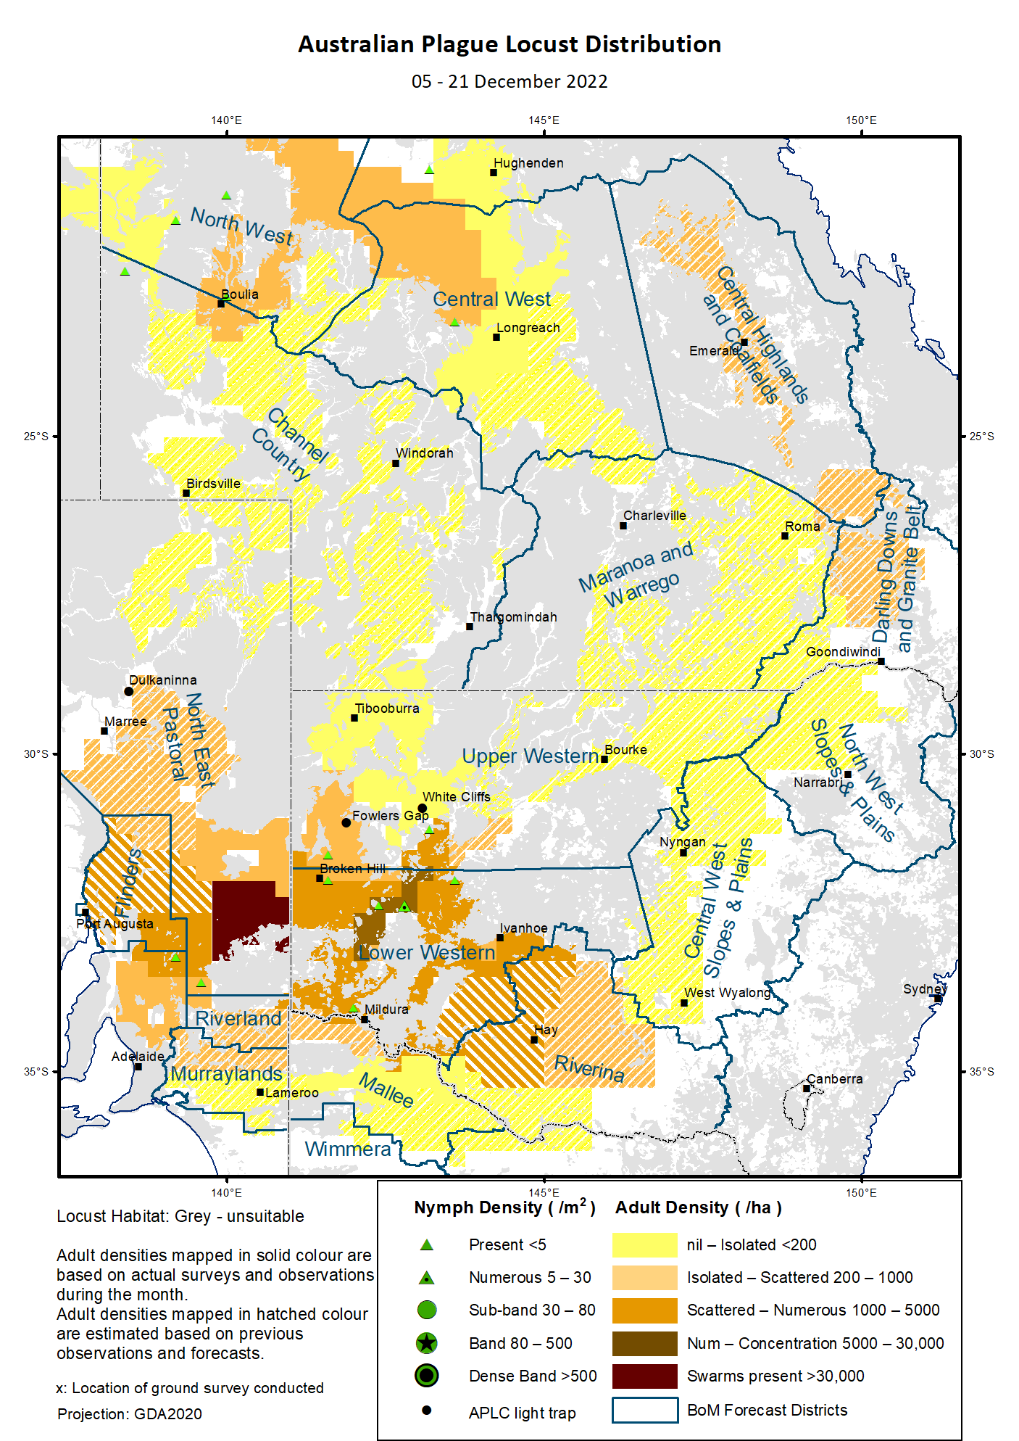

# Australian Plague Locust (*Chortoicetes terminifera*)

## SITUATION in December and OUTLOOK to March 2023

#### NEW SOUTH WALES

##### NORTH WEST SLOPES & PLAINS

###### Northwest Local Land Services

Locusts and conditions

* No surveys were conducted in December in this district.
* No locust reports were received from this district in December.
* This district received 25 – 50 mm rainfall in December, ranging from average levels for the western parts to very much below average levels for the eastern parts.

Forecast

* Sporadic breeding is possible under favourable habitat conditions. However, the general population density is expected to be at low levels.
* There is a low probability of any significant migration between now and early autumn.

Risks

* There is a low risk of a widespread regional infestation developing between now and early autumn.

##### CENTRAL WEST SLOPES & PLAINS

###### Central West Local Land Services

Locusts and conditions

* No surveys were conducted in December in this district.
* No locust reports were received from this district in December.
* This district received 10 – 50 mm rainfall in December, at average and below average levels. However, flooding persisted in some areas following highest on record rainfalls in the previous month.

Forecast

* Localised breeding is possible, but the general population level is likely to remain very low with the forecast of below average temperatures for the remainder of summer.
* There is a low probability of any significant migration between now and early autumn.

Risks

* There is a low risk of widespread regional infestations developing between now and early autumn.

##### RIVERINA

###### Riverina, Murray, and part of Western Local Land Services

Locusts and conditions

* No surveys were conducted in December in this district.
* One unconfirmed report of a locust band was received from the Henty area, and several reports of adult swarming and egg-laying activities were verified in the Deniliquin area by Local Land Services in December.
* The UNSW insect monitoring radar in Hay was not in operation during December due to hardware failure.
* This district received 5 – 65 mm rainfall in December with monthly totals below 25 mm over much of the district, at generally average levels.

Forecast

* Localised breeding may produce some medium – high-density nymphs with small bands possible.
* There is a low – moderate probability of migration/dispersal events between now and early autumn.

Risks

* There is a moderate risk of localised infestation developing between now and early autumn.

##### UPPER and LOWER WESTERN

###### Western Local Land Services

Locusts and conditions

* Surveys in early December in the Lower Western district identified consistent Numerous-density adults and some Present – Numerous-density 5th instar nymphs.
* Surveys in mid-December in the western part of the Upper Western district identified Isolated – Scattered-density adults and occasional Present-density 5th instar nymphs.
* No further reports of locust activity were received from these districts in December.
* The light trap at White Cliffs caught 300 locusts on the night of 22 December with zero captures before, 10 and 5 locusts on the nights of 25 and 26 December, respectively. Conversely, the light trap at Fowlers Gap, did not capture any locusts in December. This most likely reflects local congregation associated with storm weather events and short-distance movement facilitated by low-pressure systems.
* These two districts received 5 – 40 mm rainfall with monthly totals of 10 – 25 mm rainfall over much of the region, generally at average levels but with pockets above/below average levels.

Forecast

* Localised swarm formation may continue under hot weather conditions.
* Staggered hatching will likely have commenced from mid-December onwards and will likely continue into February 2023, possibly developing into some localised bands.
* Successful breeding may produce some localised high-density populations with a high probability of more frequent occurrence in the Upper Western district, though, the overall population level is likely to remain at medium levels.
* There is a moderate probability of migration/dispersal between now and early autumn.

Risks

* There is a moderate risk of regional infestations developing, but widespread high-density infestation is unlikely between now and early autumn.

**All locust activity should be reported to your** [**Local Land Services**](https://www.lls.nsw.gov.au/) **(1300 795 299) or the** [**Department of Primary Industries**](https://www.dpi.nsw.gov.au/climate-and-emergencies/locusts)**. A toll-free call to the APLC hotline can be made on 1800 635 962. An answering machine is attached to this phone for after-hours calls. Reports can also be emailed to APLC via** [**aplc@agriculture.gov.au**](mailto:aplc@agriculture.gov.au) **or sent through the web page at** [**https://www.agriculture.gov.au/pests-diseases-weeds/locusts/landholders/reporting_locusts**](https://www.agriculture.gov.au/pests-diseases-weeds/locusts/landholders/reporting_locusts)**.**

#### QUEENSLAND

##### CENTRAL HIGHLANDS AND COALFIELDS

###### Isaac and Central Highlands Regional Councils; Banana Shire

Locusts and conditions

* No surveys were conducted in December in this district.
* No reports of locust activity were received from this district in December.
* This district received 25 – ≥100 mm rainfall in December with monthly totals of above 50 mm over much of the district, generally at average levels.

Forecast

* Localised breeding is possible, but any resulting population is likely to remain at low – medium levels.
* There is a low probability of any significant migration events between now and early autumn.

Risks

* There is a low risk of a widespread infestation developing between now and early autumn.

##### DARLING DOWNS AND GRANITE BELT

###### Western Downs and Goondiwindi Regional Councils

Locusts and conditions

* No surveys were conducted in December in this district.
* No locust reports were received from this district in December.
* This district received 25 – 70 mm of rainfall in December, ranging from below average to average levels.

Forecast

* Some sporadic breeding is possible, but only a low-density population is expected.
* There is a low probability of any significant migration events between now and early autumn.

Risks

* There is a low risk of a widespread infestation developing between now and early autumn.

##### CENTRAL WEST

###### Barcaldine, Longreach, and Blackall-Tambo Regional Council; Flinders and Winton Shires

Locusts and conditions

* Surveys in early December identified Isolated – Scattered-density adults and occasional Present-density nymphs in the north-western parts of this district.
* No locust reports were received from this district in December.
* This district received 20 - ≥100 mm rainfall (increasing in the direction from southwest to northeast) in December, at generally average to above average levels.

Forecast

* Some successful breeding may result in the development of medium-density populations.
* There is a low probability of any significant migration events between now and early autumn.

Risks

* There is a low risk of a widespread infestation between now and early autumn.

##### MARANOA AND WARREGO

###### Maranoa Regional Council; Murweh, Paroo, and Balonne Shires

Locusts and conditions

* No surveys were conducted in December in this district.
* No locust reports were received from this district in December.
* December rainfall varied from 10 – 70 mm in the general direction of southwest to northeast, ranging from below average to average levels.

Forecast

* Sporadic breeding may result in some localised low – medium population densities.
* There is a low probability of any significant migrations between now and early autumn.

Risks

* There is a low risk of a widespread infestation developing between now and early autumn.

##### NORTH WEST

###### Mt Isa, Cloncurry, McKinlay, Boulia, and Winton Shires

Locusts and conditions

* Surveys in early December identified generally Isolated but some Scattered-density adults with occasional Present-density nymphs in this district.
* No locust reports were received from this district in December.
* This district received 25 - ≥150 mm of rainfall, in the direction of southeast to northwest in December, ranging from average to very much above average levels.

Forecast

* Locust numbers are likely to increase moderately to medium levels (from current low levels), but it is possible that sporadic localised breeding may produce high-density populations in some areas.
* There is a low probability of any significant migration/redistribution events activity between now and early autumn.

Risks

* There is a low – moderate risk of a widespread infestation developing between now and early autumn.

##### CHANNEL COUNTRY

###### Boulia, Diamantina, Barcoo, Quilpie, and Bulloo Shires

Locusts and conditions

* Surveys in early December in the north-western parts of this district identified Isolated – Scattered-density adults and Present-density nymphs.
* No locust reports were received from this district in December.
* This district received 10 – ≥100 mm rainfall in December, ranging from average to above average levels.

Forecast

* Locust numbers are likely to increase moderately to low – medium levels with possible high-density pockets from current low levels after any successful breeding and immigration from adjacent districts.
* There is a moderate probability of some significant migration events between now and early autumn.

Risks

* There is a low – moderate risk of a widespread infestation developing between now and early autumn.

**All locust activity should be reported the** [**Biosecurity Queensland (Department of Agriculture and Fisheries)**](https://www.daf.qld.gov.au/business-priorities/biosecurity) **via the** [**Customer Service Centre**](https://www.daf.qld.gov.au/contact/customer-service-centre) **on 13 25 23. A toll-free call to the APLC hotline can be made on 1800 635 962. An answering machine is attached to this phone for after-hours calls. Reports can also be emailed to APLC via** [**aplc@agriculture.gov.au**](mailto:aplc@agriculture.gov.au) **or sent through the website at** [**https://www.agriculture.gov.au/pests-diseases-weeds/locusts/landholders/reporting_locusts**](https://www.agriculture.gov.au/pests-diseases-weeds/locusts/landholders/reporting_locusts)**.**

#### SOUTH AUSTRALIA

##### NORTH EAST PASTORAL and FLINDERS

Locusts and conditions

* Surveys in early December in southern parts identified Isolated-density to Low-Density-Swarm adults and occasional Present-density 5th instar nymphs.
* Some reports of adult locust activity were received from the Flinders and surrounding districts in December.
* The light-trap at Dulkaninna caught more than 500 locusts associated with storm weather events on the night of 26 December, and adults were detected nearby. This reflects local congregation and possible short-distance redistribution.
* These two districts received 5 – 35 mm of rainfall with much of the region receiving monthly totals of below 25 mm in December, ranging from average to above average levels.

Forecast

* Locust numbers are likely to increase moderately due to successful breeding under favourable habitat conditions and immigration both within these districts and from adjacent districts.
* Some swarm formation may result, and bands may subsequently develop, following successful breeding from mid-January onwards.
* There is a moderate probability of significant migration/dispersal events within these districts and adjacent areas between now and early autumn.

Risks

* There is a moderate risk of a regional infestation developing between now and early autumn.

##### RIVERLAND and MURRAYLANDS

Locusts and conditions

* December surveys were only able to access the north-eastern parts of the Riverland district with Scattered-density adults detected.
* No locust reports were received from these two districts in December.
* December rainfall ranged from 5 – 15 mm, at below average to average levels.

Forecast

* The locust population is likely to remain at low levels with some pockets of higher densities.
* There is a moderate probability of some migration/dispersal events between now and early autumn.

Risks

There is a low – moderate risk of a widespread infestation developing between now and early autumn.

**Locust activity should be reported to** [**Biosecurity SA (Primary Industries and Regions South Australia)**](https://www.pir.sa.gov.au/biosecurity) **via the Plant Health Hotline on 1300 666 010.** **A toll-free call to the APLC hotline can be made on 1800 635 962. An answering machine is attached to this phone for after-hours calls. Reports can also be emailed to APLC via** [**aplc@agriculture.gov.au**](mailto:aplc@agriculture.gov.au) **or sent through the website at** [**https://www.agriculture.gov.au/pests-diseases-weeds/locusts/landholders/reporting_locusts**](https://www.agriculture.gov.au/pests-diseases-weeds/locusts/landholders/reporting_locusts)**.**

#### VICTORIA

##### MALLEE

**Mildura and Swan Hill Rural Cities; Yarriambiack and Buloke Shires**

Locusts and conditions

* No surveys were conducted in this district in December.
* No reports were received from this district in December, but some reports of locust swarming and egg-laying activities were received from Echuca-Bendigo-Wedderburn areas of the adjacent district.
* December rainfall ranged from 5 – 15 mm in this district, at below average to average levels.

Forecast

* Locust numbers are likely to increase moderately from the current low – medium levels. Summer generation nymphs shall commence hatching from any successful egg-laying from early January onwards.
* Small swarms may continue to form under hot weather conditions, and subsequent localised bands may develop under favourable habitat conditions.
* There is a moderate probability of migration/dispersal events between now and early autumn.

Risks

* There is a moderate risk of a regional infestation developing between now and early autumn.

##### WIMMERA

**Hindmarsh and West Wimmera Shires**

Locusts and conditions

* No surveys were conducted in this district in December.
* No locust reports were received from this district in December.
* December rainfall ranged 5 – 25 mm in this district, ranging from below average to average levels.

Forecast

* Locust numbers are likely to increase slightly with some areas of medium densities expected following successfully breeding under suitable habitat conditions. The general population level is likely to remain at low levels.
* There is a low probability of any significant migrations between now and early autumn.

Risks

* There is a low risk of a widespread infestation developing between now and early autumn.

**Locust activity should be reported to the** [**Agriculture Victoria**](https://agriculture.vic.gov.au/)[**Customer Contact Centre**](https://agriculture.vic.gov.au/about/contact-us) **on 136 186. Alternatively, you can make a report via the online form at**[**https://forms.bio.vic.gov.au/2020**](https://forms.bio.vic.gov.au/2020)**.  Please include photos where possible. A toll-free call to the APLC hotline can be made on 1800 635 962. An answering machine is attached to this phone for after-hours calls. Reports can be emailed to APLC via** [**aplc@agriculture.gov.au**](mailto:aplc@agriculture.gov.au) **or sent through the website at** [**https://www.agriculture.gov.au/pests-diseases-weeds/locusts/landholders/reporting_locusts**](https://www.agriculture.gov.au/pests-diseases-weeds/locusts/landholders/reporting_locusts).

# Glossary of locust terms and density categories used in the Locust Bulletin

**Locust biology and behaviour**

|  |  |
| --- | --- |
| **Term** | **Definition** |
| adult | A fully winged, mature locust capable of breeding and migrating |
| band | Dense aggregation of nymphs, usually moving forward together |
| diapause | Period of dormancy induced in anticipation of unfavourable environmental conditions |
| egg bed | An area of soil containing many egg pods (hundreds per square metre) |
| fledge | Final nymphal moult to a soft-bodied adult incapable of long-distance flight |
| instar | Discrete stages of nymphal development each separated by a moult |
| laying | Female locusts depositing clutches of 20 – 60 eggs into the ground in froth-lined egg pods |
| nymph | Juvenile wingless locust. Often referred to as the hopper stage |
| swarm | Dense aggregation of adults, milling at the same spot or flying closely together |

###### Locust density categories

Where higher densities occur, a large proportion of the regional population is concentrated in very small areas with lower densities elsewhere, so the higher densities cannot be extrapolated over the area of an entire region. A range of density classes is usually found within a surveyed region.

|  |  |  |
| --- | --- | --- |
| **Nymph Densities** | **Number per m2** |  |
| Present | 1 – 5 |  |
| Numerous | 6 – 30 |  |
| Sub-band | 31 – 80 |  |
| Band | 81 – 500 |  |
| Dense Band | >500 |  |
|  |  |  |
| **Adult Densities** | **Number per m2** | **Number per 250 m2** |
| Isolated | – 0.02 | 1 5 |
| Scattered | 0.024 – 0.1 | 6 – 25 |
| Numerous | 0.104 – 0.5 | 26 – 125 |
| Concentration | 0.504 – 3 | 126 – 750 |
| Low Density Swarm | 4 – 10 | 751 – 2,500 |
| Medium Density Swarm | 11 – 50 | 2,501 – 12,500 |
| High Density Swarm | >50 | >12,500 |
|  |  |  |
| **General density classes** | **Nymph densities** | **Adult densities** |
| very low, occasional | Nil – Present | Nil – Isolated |
| low | Present – Numerous | Isolated – Scattered |
| medium | Numerous – Sub-band | Scattered – Numerous |
| high | Bands | Concentration – Swarms |

###### Reporting locust infestations

It is important that all locust activity is reported as soon as possible to your nearest state agriculture agency office or to the Australian Plague Locust Commission.

|  |  |
| --- | --- |
| **State** | **Authority for reporting locusts** |
| New South Wales | Local Land Services (LLS) or Department of Primary Industries |
| Queensland | Biosecurity Queensland, Department of Agriculture and Fisheries |
| South Australia | Biosecurity SA, Department of Primary Industries & Regions |
| Victoria | Biosecurity and Agriculture Services, Department of Jobs, Precincts and Resources |

Reports to the **Australian Plague Locust Commission** can be made by:

Free call (Canberra): 1800 635 962 (24 hours)

Fax (Canberra): (02) 6272 5074

Email: [aplc@agriculture.gov.au](mailto:aplc@agriculture.gov.au)

Website: <https://www.agriculture.gov.au/pests-diseases-weeds/locusts/landholders/reporting_locusts>