## GENERAL SITUATION in January and OUTLOOK to April 2023

### Australian Plague Locust *Chortoicetes terminifera*

The locust population was likely to have remained at low levels across inland eastern Australia – except for southern parts where some medium-level populations were identified. Limited surveys in January identified Concentration-density adults in the Buckalow area of New South Wales, plus Numerous-density adults in the Orroroo area of South Australia and the Weethalle area of NSW. Isolated – Scattered-density adults were detected in south-western parts of the SA North East Pastoral district, and in the NSW Riverina and Central West districts. Only occasional Present-density nymphs were identified in the NSW Riverina district. No surveys were conducted in January in other regions due to persistent widespread flooding and adverse weather. The light traps at Dulkaninna (SA), Fowlers Gap and White Cliffs (NSW) did not capture any locusts during January. Thought, the Insect Monitoring Radar in Hay (NSW) detected several nights of short-range migration in mid-January, reflecting some a general redistribution of spring-generation adults. Several reports of locust banding activity have been received from the Berrigan and Deniliquin areas of NSW and the Durham Ox area of Victoria since mid-January.

January rainfall ranged from 5 mm in south-western parts to over 150 mm in north-eastern parts of inland eastern Australia, with less than 50 mm rainfall received across much of the arid/semi-arid inland, generally reflecting average to above average levels. January temperatures were above average levels across the arid inland but below average levels over the north-eastern parts of the inland, within the range of ±2 degrees. The slowly weakening La Niña has been influencing inland areas especially in Queensland. Below average rainfall and cooler temperatures are likely for February, but average rainfall and warmer temperatures are expected for March and April.

The outlook for February to April is for a low – moderate population increase up to medium density levels. Some localised areas of higher density are possible from current low background populations in the arid and semi-arid interior areas plus persistent medium – high-density populations in southern parts of inland eastern Australia. Further medium density populations are possible after any successful breeding in the northern and north-eastern parts of inland areas.

Localised bands of summer generation nymphs will continue to develop in the southern portion of inland eastern Australia. Some small bands may also develop in the arid/semi-arid inland areas. Summer generation adults should continue fledging from now on in southern parts, with overlapping generation adults likely to appear in the interior. Redistribution by nocturnal migration and daytime dispersal is likely to occur in the inland areas from now until mid-April.

There is a low-moderate likelihood of region-wide infestations developing in the southern portion of inland eastern Australia during February to April. Widespread high-density infestations are unlikely between now and mid-autumn.

**07 February 2023**

### Spur-throated Locust *Austracris guttulosa*

The overall population was likely to have remained at low to medium levels. Limited surveys in January in southern parts of inland eastern Australia identified only Isolated-density adults in the South Australia areas and the Riverina district of New South Wales. The light trap at White Cliffs (NSW) captured only a single locust in late January, but neither the light trap at Dulkaninna (SA) nor at Fowlers Gaps (NSW) caught any locusts in January. Though, suitable habitat conditions will encourage localised breeding that could still result in medium density populations.

There is a low-moderate risk of a widespread medium density infestation. Some localised high-density infestations may develop in Queensland between now and mid-autumn.

### Migratory Locust *Locusta migratoria*

The population was likely to have remained at a very low level. Limited surveys in January in southern parts of inland eastern Australia did not detect any migratory locusts. Localised breeding should continue under favourable habitat conditions, especially in subtropical Queensland areas. Nevertheless, high-density infestations are unlikely to result from the current very low background population level.

There is a very low risk of a widespread infestation developing between now and mid-autumn.

**It is important that any locust activity be reported as soon as possible to your local biosecurity authority or to the Australian Plague Locust Commission. A toll-free call to the APLC hotline can be made on 1800 635 962. An answering machine is attached to this phone for after-hours calls. Reports can also be emailed to APLC via** [**aplc@agriculture.gov.au**](mailto:aplc@agriculture.gov.au) **or made through the website at** [**https://www.agriculture.gov.au/pests-diseases-weeds/locusts/landholders/reporting_locusts**](https://www.agriculture.gov.au/pests-diseases-weeds/locusts/landholders/reporting_locusts)**.**

### Locust distribution map—*Chortoicetes terminifera*

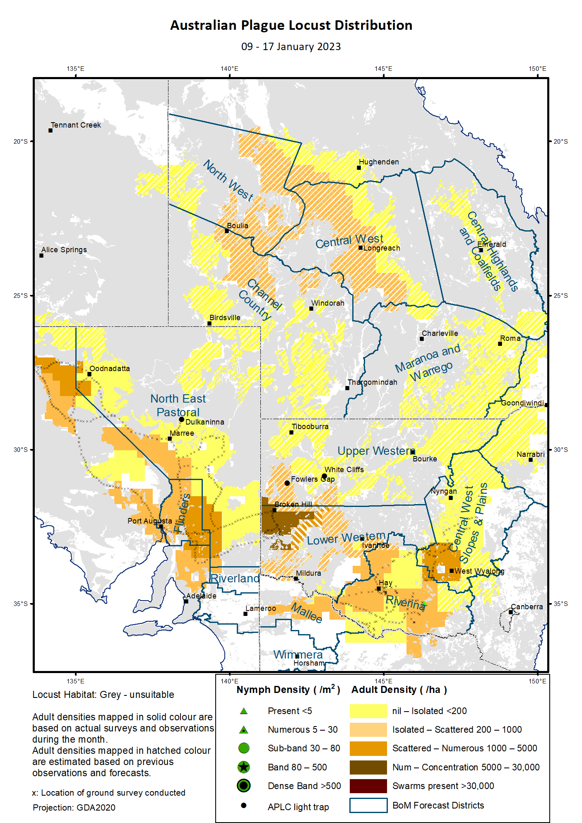

# Australian Plague Locust (*Chortoicetes terminifera*)

## SITUATION in January and OUTLOOK to April 2023

#### NEW SOUTH WALES

##### NORTH WEST SLOPES & PLAINS

###### Northwest Local Land Services

Locusts and conditions

* No surveys were conducted in this district in January.
* No locust reports were received from this district in January.
* This district received 20 – 90 mm rainfall in January, at very much below average to average levels.

Forecast

* Sporadic breeding is possible under favourable habitat conditions. However, the general population density is expected to be at low levels.
* There is a low probability of any significant migration between now and mid-autumn.

Risks

* There is a low risk of a widespread regional infestation developing between now and mid-autumn.

##### CENTRAL WEST SLOPES & PLAINS

###### Central West Local Land Services

Locusts and conditions

* Surveys in January identified Isolated – Low-Numerous density adults in the southern portion of this district. No nymphs were detected by survey.
* No locust reports were received from this district in January.
* This district received 30 – 80 mm rainfall in January, at generally average levels.

Forecast

* Sporadic breeding is possible under favourable habitat conditions. However, the general population density is expected to be at low levels.
* There is a low probability of any significant migration between now and mid-autumn.

Risks

* There is a low risk of widespread regional infestations developing between now and mid-autumn.

##### RIVERINA

###### Riverina, Murray, and part of Western Local Land Services

Locusts and conditions

* Surveys identified Isolated – Scattered-density adults with occasional nymphs in this district in January.
* Several reports of locust banding activity were received from the Berrigan and Deniliquin areas from Local Land Services in January.
* The UNSW insect monitoring radar in Hay was not in operation due to hardware failure in early January but did detect several nights of short-distance migration events in mid-January, reflecting some general redistribution facilitated by disturbed weather systems.
* This district received 20 – 100 mm rainfall in January, at above average levels across much of the district to very much above average levels in the south-eastern part.

Forecast

* Localised breeding may produce some medium – high-density nymphs with small bands and swarms are possible to form from mid-February onwards.
* There is a low – moderate probability of migration/dispersal events between now and mid-autumn.

Risks

* There is a moderate risk of localised infestation developing between now and mid-autumn.

##### UPPER and LOWER WESTERN

###### Western Local Land Services

Locusts and conditions

* January surveys were limited in the Broken Hill-Coonbah area of the Lower Western district due to adverse access conditions. Consistent Scattered-density with some Concentration-density adults were identified with no nymphs detected.
* No reports of locust activity were received from these two districts in January.
* Neither of the light traps at White Cliffs and Fowlers Gap captured any locusts in January, reflecting very low background populations around these areas.
* These two districts received 10 – 60 mm rainfall, at average to above average levels.

Forecast

* Localised bands may develop under favourable habitat conditions and swarms may form under hot weather conditions.
* Successful breeding may produce some localised high-density populations in the Lower Western district with a probability of some occurrence in the Upper Western district. The overall population level is likely to remain at low-medium levels.
* There is a moderate probability of migration/dispersal events between now and mid-autumn.

Risks

* There is a low-moderate risk of regional infestations developing, but widespread high-density infestation is unlikely between now and mid-autumn.

**All locust activity should be reported to your** [**Local Land Services**](https://www.lls.nsw.gov.au/) **(1300 795 299) or the** [**Department of Primary Industries**](https://www.dpi.nsw.gov.au/climate-and-emergencies/locusts)**. A toll-free call to the APLC hotline can be made on 1800 635 962. An answering machine is attached to this phone for after-hours calls. Reports can also be emailed to APLC via** [**aplc@agriculture.gov.au**](mailto:aplc@agriculture.gov.au) **or sent through the web page at** [**https://www.agriculture.gov.au/pests-diseases-weeds/locusts/landholders/reporting_locusts**](https://www.agriculture.gov.au/pests-diseases-weeds/locusts/landholders/reporting_locusts)**.**

#### QUEENSLAND

##### CENTRAL HIGHLANDS AND COALFIELDS

###### Isaac and Central Highlands Regional Councils; Banana Shire

Locusts and conditions

* No surveys were conducted in this district in January.
* No reports of locust activity were received from this district in January.
* This district received 25 – 250 mm rainfall in January with monthly totals of above 100 mm over much of the northern portion of the district, at generally above average levels with parts at very much above average levels.

Forecast

* Localised breeding is possible, but any resulting population is likely to remain at low levels.
* There is a low probability of any significant migration events between now and mid-autumn.

Risks

* There is a low risk of a widespread infestation developing between now and mid-autumn.

##### DARLING DOWNS AND GRANITE BELT

###### Western Downs and Goondiwindi Regional Councils

Locusts and conditions

* No surveys were conducted in this district in January.
* No locust reports were received from this district in January.
* This district received 20 – 40 mm of rainfall in January, at generally very much below average to below average levels.

Forecast

* Some sporadic breeding is possible, but only a low-density population is expected.
* There is a low probability of any significant migration events between now and mid-autumn.

Risks

* There is a low risk of a widespread infestation developing between now and mid-autumn.

##### CENTRAL WEST

###### Barcaldine, Longreach, and Blackall-Tambo Regional Council; Flinders and Winton Shires

Locusts and conditions

* No surveys were conducted in this district in January.
* No locust reports were received from this district in January.
* This district received 60 - ≥200 mm rainfall with the eastern portion receiving more than 100 mm rainfall totals for January, at generally average to above average levels.

Forecast

* Some successful breeding may result in the development of medium-density populations.
* There is a low-moderate probability of migration events between now and mid-autumn.

Risks

* There is a low risk of a widespread infestation between now and mid-autumn.

##### MARANOA AND WARREGO

###### Maranoa Regional Council; Murweh, Paroo, and Balonne Shires

Locusts and conditions

* No surveys were conducted in this district in January.
* No locust reports were received from this district in January.
* January rainfall varied from 10 – 70 mm in the general direction of southwest to northeast, ranging from below average to average levels.

Forecast

* Sporadic breeding may result in some localised low – medium population densities.
* There is a low probability of any significant migration events between now and mid-autumn.

Risks

* There is a low risk of a widespread infestation developing between now and mid-autumn.

##### NORTH WEST

###### Mt Isa, Cloncurry, McKinlay, Boulia, and Winton Shires

Locusts and conditions

* No surveys were conducted in this district in January.
* No locust reports were received from this district in January.
* This district received 30 - ≥200 mm of rainfall, in the direction of south to north in January, at generally average to above average levels.

Forecast

* Locust numbers are likely to increase slightly to low-medium levels after some successful breeding under suitable habitat conditions.
* There is a low probability of any significant migration/redistribution events activity between now and mid-autumn.

Risks

* There is a low risk of a widespread infestation developing between now and mid-autumn.

##### CHANNEL COUNTRY

###### Boulia, Diamantina, Barcoo, Quilpie, and Bulloo Shires

Locusts and conditions

* No surveys were conducted in this district in January.
* No locust reports were received from this district in January.
* This district received 20 –100 mm rainfall in January, at generally average to above average levels.

Forecast

* Locust numbers are likely to increase moderately to medium levels with possible high-density pockets after any successful breeding and immigration from adjacent districts.
* There is a moderate probability of some significant migration events between now and mid-autumn.

Risks

* There is a low – moderate risk of a widespread infestation developing between now and mid-autumn.

**All locust activity should be reported the** [**Biosecurity Queensland (Department of Agriculture and Fisheries)**](https://www.daf.qld.gov.au/business-priorities/biosecurity) **via the** [**Customer Service Centre**](https://www.daf.qld.gov.au/contact/customer-service-centre) **on 13 25 23. A toll-free call to the APLC hotline can be made on 1800 635 962. An answering machine is attached to this phone for after-hours calls. Reports can also be emailed to APLC via** [**aplc@agriculture.gov.au**](mailto:aplc@agriculture.gov.au) **or sent through the website at** [**https://www.agriculture.gov.au/pests-diseases-weeds/locusts/landholders/reporting_locusts**](https://www.agriculture.gov.au/pests-diseases-weeds/locusts/landholders/reporting_locusts)**.**

#### SOUTH AUSTRALIA

##### NORTH EAST PASTORAL and FLINDERS

Locusts and conditions

* Surveys in mid-January identified consistent Isolated – High-Numerous density adults in the Flinders district with no nymphs detected.
* Surveys in mid-January identified only Isolated with some Scattered-density adults in the southern and south-western parts of the North East Pastoral district. No nymphs were detected in these areas.
* Surveys were also conducted in mid-January in the Port Augusta-Woomera-Coober Pedy-Marla areas with Isolated – Scattered-density adults identified plus some Low-Numerous density adults in the Marla area.
* No reports of locust activity were received from these two districts in January.
* The light-trap at Dulkaninna did not capture any locusts in January, but individual adults were sighted in the vicinity.
* These two districts received 5 – 25 mm of rainfall in January, at generally average levels.

Forecast

* Locust numbers are likely to increase moderately due to successful breeding under favourable habitat conditions and migration both from within these districts and from adjacent districts.
* Some localised bands may develop following successful breeding and swarm may form under hot weather conditions.
* There is a moderate probability of significant migration/dispersal events within these districts and adjacent areas between now and mid-autumn.

Risks

* There is a low-moderate risk of a regional infestation developing between now and mid-autumn.

##### RIVERLAND and MURRAYLANDS

Locusts and conditions

* No surveys were conducted in these two districts in January.
* No locust reports were received from these two districts in January.
* January rainfall ranged from 5 – 25 mm, at generally average levels.

Forecast

* The locust population is likely to remain at low levels with some pockets of higher densities.
* There is a low-moderate probability of some migration/dispersal events between now and mid-autumn.

Risks

There is a low risk of a widespread infestation developing between now and mid-autumn.

**Locust activity should be reported to** [**Biosecurity SA (Primary Industries and Regions South Australia)**](https://www.pir.sa.gov.au/biosecurity) **via the Plant Health Hotline on 1300 666 010.** **A toll-free call to the APLC hotline can be made on 1800 635 962. An answering machine is attached to this phone for after-hours calls. Reports can also be emailed to APLC via** [**aplc@agriculture.gov.au**](mailto:aplc@agriculture.gov.au) **or sent through the website at** [**https://www.agriculture.gov.au/pests-diseases-weeds/locusts/landholders/reporting_locusts**](https://www.agriculture.gov.au/pests-diseases-weeds/locusts/landholders/reporting_locusts)**.**

#### VICTORIA

##### MALLEE

**Mildura and Swan Hill Rural Cities; Yarriambiack and Buloke Shires**

Locusts and conditions

* No surveys were conducted in this district in January.
* No reports were received from this district in January, but some reports of locust banding were received from the Durham Ox area of the adjacent district.
* January rainfall ranged from 5 – 25 mm in this district, at generally average levels.

Forecast

* Locust numbers are likely to increase slightly with some localised high densities. Summer generation nymphs will continue hatching from any successful egg-laying and favourable habitat conditions.
* Small swarms may form under hot weather conditions after fledging of the summer generation from late February onwards.
* There is a moderate probability of migration/dispersal events between now and mid-autumn.

Risks

* There is a low-moderate risk of a regional infestation developing between now and mid-autumn.

##### WIMMERA

**Hindmarsh and West Wimmera Shires**

Locusts and conditions

* No surveys were conducted in this district in January.
* No locust reports were received from this district in January.
* January rainfall was less than 10 mm over much of this district, at below average levels.

Forecast

* Locust numbers are likely to remain at low levels even following some successful breeding under suitable habitat conditions.
* There is a low probability of any significant migrations between now and mid-autumn.

Risks

* There is a low risk of a widespread infestation developing between now and mid-autumn.

**Locust activity should be reported to the** [**Agriculture Victoria**](https://agriculture.vic.gov.au/)[**Customer Contact Centre**](https://agriculture.vic.gov.au/about/contact-us) **on 136 186. Alternatively, you can make a report via the online form at**[**https://forms.bio.vic.gov.au/2020**](https://forms.bio.vic.gov.au/2020)**.  Please include photos where possible. A toll-free call to the APLC hotline can be made on 1800 635 962. An answering machine is attached to this phone for after-hours calls. Reports can be emailed to APLC via** [**aplc@agriculture.gov.au**](mailto:aplc@agriculture.gov.au) **or sent through the website at** [**https://www.agriculture.gov.au/pests-diseases-weeds/locusts/landholders/reporting_locusts**](https://www.agriculture.gov.au/pests-diseases-weeds/locusts/landholders/reporting_locusts).

# Glossary of locust terms and density categories used in the Locust Bulletin

**Locust biology and behaviour**

|  |  |
| --- | --- |
| **Term** | **Definition** |
| adult | A fully winged, mature locust capable of breeding and migrating |
| band | Dense aggregation of nymphs, usually moving forward together |
| diapause | Period of dormancy induced in anticipation of unfavourable environmental conditions |
| egg bed | An area of soil containing many egg pods (hundreds per square metre) |
| fledge | Final nymphal moult to a soft-bodied adult incapable of long-distance flight |
| instar | Discrete stages of nymphal development each separated by a moult |
| laying | Female locusts depositing clutches of 20 – 60 eggs into the ground in froth-lined egg pods |
| nymph | Juvenile wingless locust. Often referred to as the hopper stage |
| swarm | Dense aggregation of adults, milling at the same spot or flying closely together |

###### Locust density categories

Where higher densities occur, a large proportion of the regional population is concentrated in very small areas with lower densities elsewhere, so the higher densities cannot be extrapolated over the area of an entire region. A range of density classes is usually found within a surveyed region.

|  |  |  |
| --- | --- | --- |
| **Nymph Densities** | **Number per m2** |  |
| Present | 1 – 5 |  |
| Numerous | 6 – 30 |  |
| Sub-band | 31 – 80 |  |
| Band | 81 – 500 |  |
| Dense Band | >500 |  |
|  |  |  |
| **Adult Densities** | **Number per m2** | **Number per 250 m2** |
| Isolated | – 0.02 | 1 5 |
| Scattered | 0.024 – 0.1 | 6 – 25 |
| Numerous | 0.104 – 0.5 | 26 – 125 |
| Concentration | 0.504 – 3 | 126 – 750 |
| Low Density Swarm | 4 – 10 | 751 – 2,500 |
| Medium Density Swarm | 11 – 50 | 2,501 – 12,500 |
| High Density Swarm | >50 | >12,500 |
|  |  |  |
| **General density classes** | **Nymph densities** | **Adult densities** |
| very low, occasional | Nil – Present | Nil – Isolated |
| low | Present – Numerous | Isolated – Scattered |
| medium | Numerous – Sub-band | Scattered – Numerous |
| high | Bands | Concentration – Swarms |

###### Reporting locust infestations

It is important that all locust activity is reported as soon as possible to your nearest state agriculture agency office or to the Australian Plague Locust Commission.

|  |  |
| --- | --- |
| **State** | **Authority for reporting locusts** |
| New South Wales | Local Land Services (LLS) or Department of Primary Industries |
| Queensland | Biosecurity Queensland, Department of Agriculture and Fisheries |
| South Australia | Biosecurity SA, Department of Primary Industries & Regions |
| Victoria | Biosecurity and Agriculture Services, Department of Jobs, Precincts and Resources |

Reports to the **Australian Plague Locust Commission** can be made by:

Free call (Canberra): 1800 635 962 (24 hours)

Fax (Canberra): (02) 6272 5074

Email: [aplc@agriculture.gov.au](mailto:aplc@agriculture.gov.au)

Website: <https://www.agriculture.gov.au/pests-diseases-weeds/locusts/landholders/reporting_locusts>