## GENERAL SITUATION in January and OUTLOOK to April 2022

### Australian Plague Locust *Chortoicetes terminifera*

The locust population in inland eastern Australia increased slightly. In addition to the persistent higher numbers in the Riverina of New South Wales, the numbers of adults increased noticeably in the arid interior of eastern Australia.

Surveys in mid-January in New South Wales identified ten small bands of medium – late instar nymphs present in the Jerilderie-Darlington Point-Hay-Deniliquin areas, with consistent adults of Isolated – Low Numerous densities detected in the Riverina district. Frequent Isolated and some Scattered-density adults were identified in the Upper Western district, with higher numbers detected in the Tibooburra region. Surveys in Queensland only identified occasional late instar nymphs and Isolated-density adults in the Central West, Central Highlands, Darling Downs, and Maranoa and Warrego districts. The White Cliffs light-trap captured 120 and 180 adults on the nights of 29 and 30 January respectively with zero captures on all other nights. The Fowlers Gap light-trap only captured 1 and 2 locusts respectively on these two nights, but some swarming adults were sighted in its surrounding fields. The light-trap in Dulkaninna of South Australia showed a sharp peak capture up to 3000 young adults one night during the nights of 25 – 28 January. The insect monitoring radar in Hay, however, did not detect any significant locust migrations during January. Some band reports were received from the Riverina district in late January. The increase of adult numbers in the arid interior of eastern Australia reflects population redistributions associated with frequent troughs and some successful localised breeding. No surveys were conducted in South Australia and Victoria due to heavy rainfall in late January.

January rainfall ranged from 10 to 200 mm (Dulkaninna station, SA) over inland eastern Australia, ranked above average to very much above average levels instead of the below/about average level forecast. Much of inland eastern Australia received more than 50 mm in late January, with some localised 100 – 200 mm falls. Monthly mean temperatures ranged from average to localised very much above average, attributed to warmer night temperatures. The mature weak La Niña is likely to remain until early autumn, slightly increasing the chance of continued above average rainfall in February over the arid interior, and in March in the eastern part of inland eastern Australia. A cooler February and warmer March are expected over inland eastern Australia. Vegetation conditions are likely to remain favourable for locust breeding.

The outlook for autumn is for a moderate increase in the overall population level in inland eastern Australia, with medium to high densities persisting in the NSW Riverina district and adjacent areas, and low to medium densities in the arid interior with limited localised medium to high densities. The population level is likely to remain low in other parts of inland eastern Australia.

It is likely that swarm formation will commence while band development continues from early February onwards in the NSW Riverina district and surrounding areas. Under suitable weather conditions, some adults of the current summer generation may continue to migrate/disperse and move further into adjacent interior districts. A larger autumn population is likely to develop in the arid interior of eastern Australia following successful redistribution and breeding, and in the NSW Riverina district where high-density nymphs may start to hatch from early March onwards.

There is a moderate likelihood of region-wide infestations developing in the NSW Riverina and surrounding areas and the arid interior of inland eastern Australia during autumn, but high-density widespread infestations are unlikely.

**8 February 2022**

### Spur-throated Locust *Austracris guttulosa*

Surveys in mid-January in Queensland identified frequent Present – Numerous-density nymphs in the Central West district, with consistent Isolated – Numerous-density adults. In the Central Highlands district, similar densities of nymphs were detected but adults were less frequent. Occasional nymphs and adults were also detected in the Darling Downs and Maranoa and Warrego districts, as well as the North West and Upper Western districts of New South Wales. More late instar nymphs were identified by survey with all instar stages present. The light trap at Dulkaninna in South Australia captured dozens of adults in late January. With above average to very much above average January rainfall over much of the arid interior of eastern Australia, localised medium density nymphs are likely to persist and develop into adults.

With a likely wet arid interior of eastern Australia during February, higher nymphal survival rate is likely and results in more localised medium – high-density adults in autumn.

There is a medium risk of a widespread low-medium density infestation, and localised high-density infestations may develop in subtropical Queensland in autumn.

### Migratory Locust *Locusta migratoria*

Surveys in mid-January did not detect any nymphs of migratory locusts. However, Isolated – Scattered-density adults were identified frequently in the Central Highlands district of Queensland, reflecting some successful breeding. Breeding should continue with more rain forecast for February in this district. However, high-density gregarisation is unlikely to result from the previously very low population level.

There is a very low risk of a widespread infestation developing during autumn.

**It is important that any locust activity be reported as soon as possible to your local biosecurity authority, primary industries department or to the commission. A toll-free call to the APLC hotline can be made on 1800 635 962. An answering machine is attached to this phone for after-hours calls. Reports can also be emailed to APLC via** [**aplc@agriculture.gov.au**](mailto:aplc@agriculture.gov.au) **or made through the website at** [**https://www.agriculture.gov.au/pests-diseases-weeds/locusts/landholders/reporting_locusts**](https://www.agriculture.gov.au/pests-diseases-weeds/locusts/landholders/reporting_locusts)**.**

### Locust distribution map—*Chortoicetes terminifera*

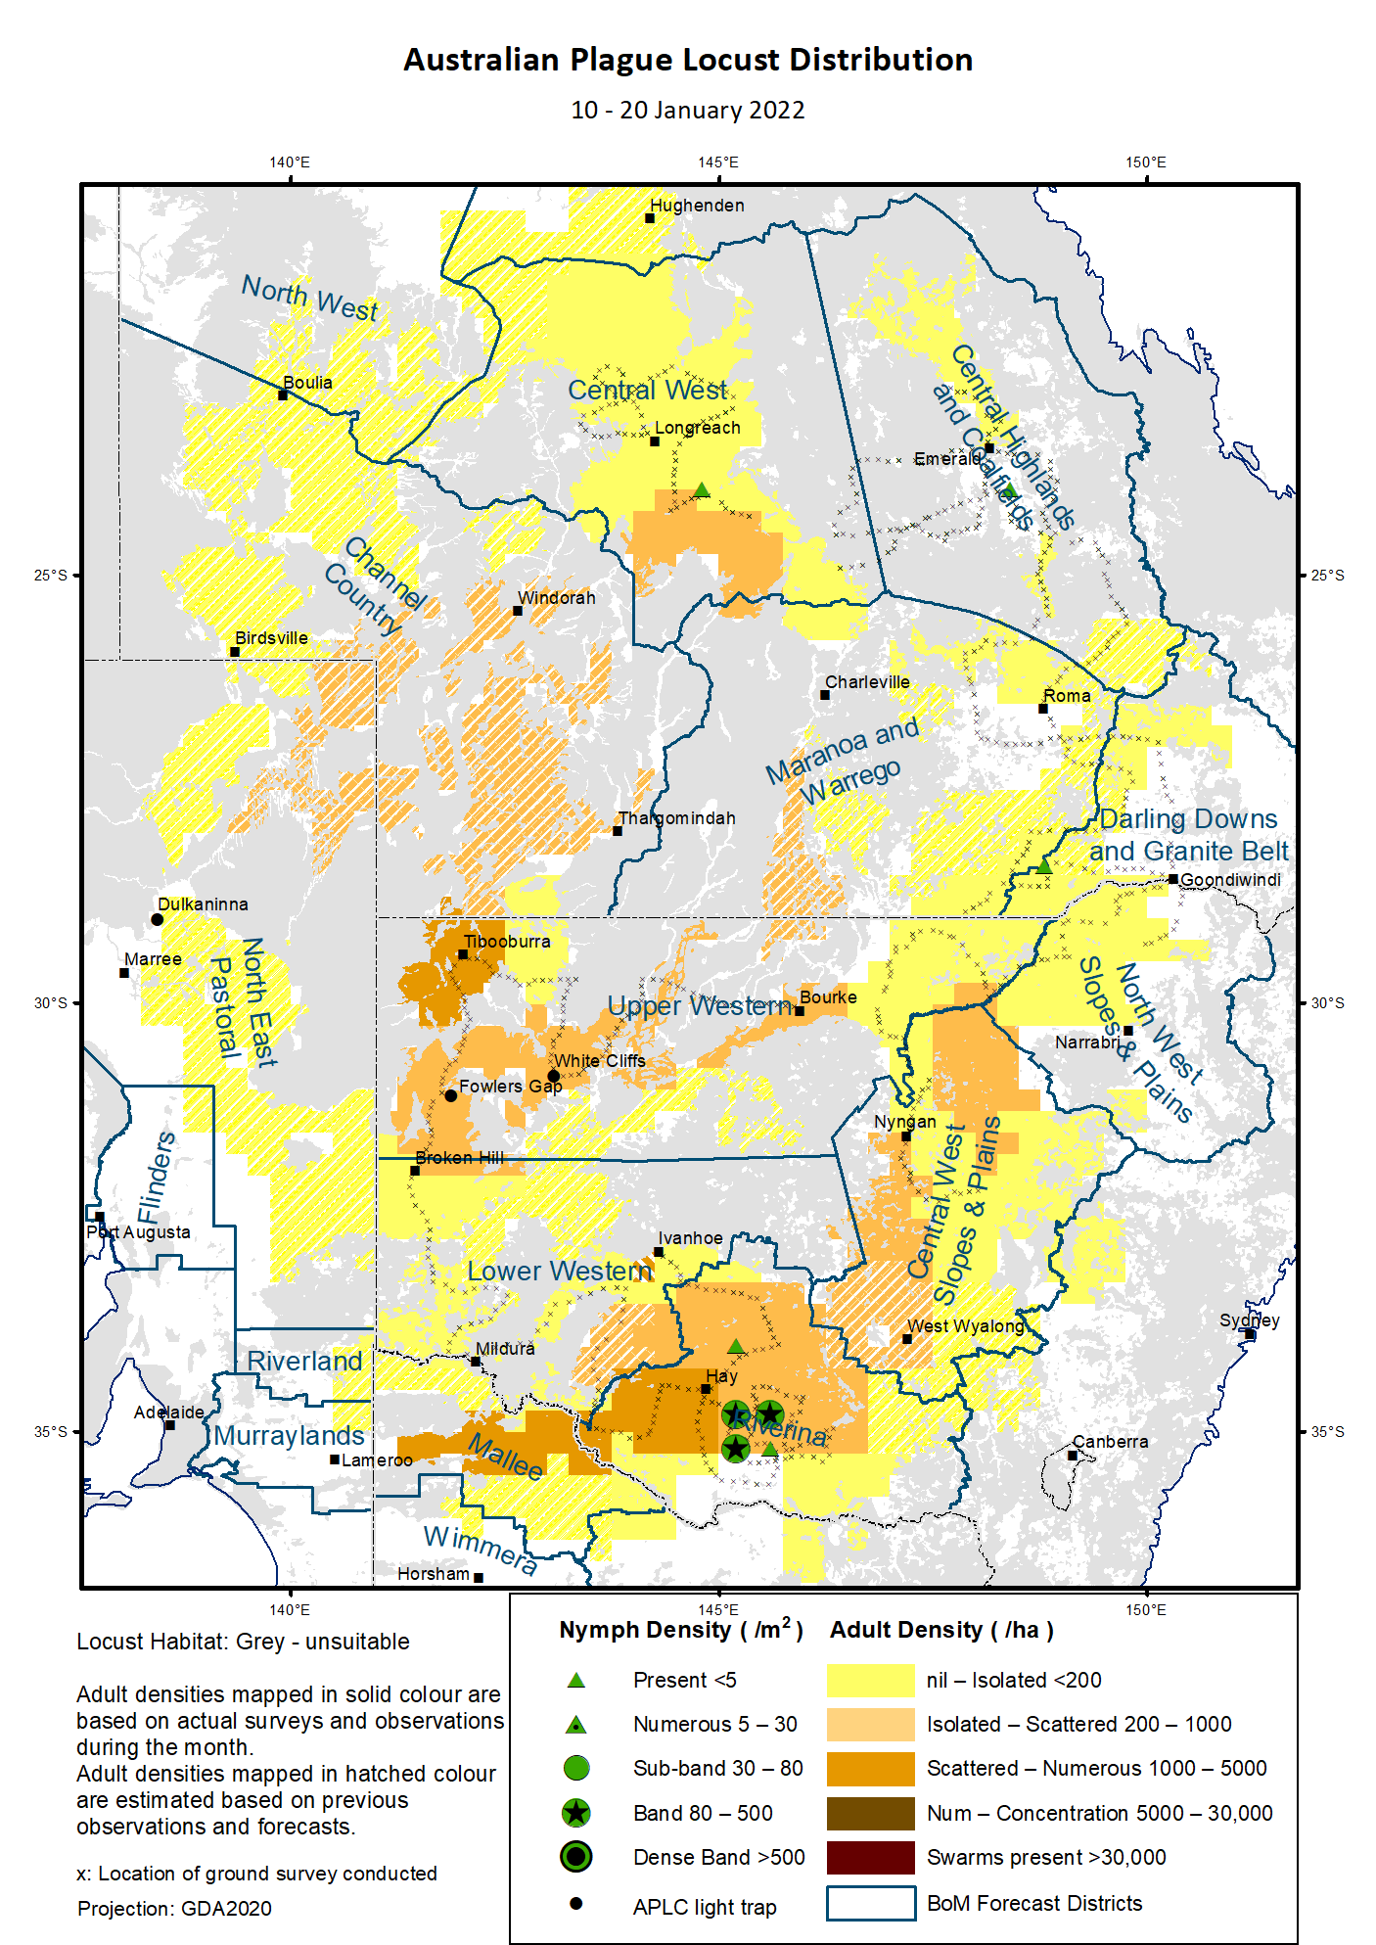

# Australian Plague Locust (*Chortoicetes terminifera*)

## SITUATION in January and OUTLOOK to April 2022

#### NEW SOUTH WALES

##### NORTH WEST SLOPES & PLAINS

###### Northwest Local Land Services

Locusts and conditions

* Surveys on 11 January in the north-western part of this district only identified occasional Isolated-density adults.
* No locust reports were received from this district in January.
* This region received 40 – 150 mm rainfall in January, at about average level.

Forecast

* Under wet conditions of February forecast, only limited localised breeding is possible. The general population density is expected to be at low levels.
* There is a low probability of any significant migration during autumn.

Risks

* There is a low risk of a widespread regional infestation developing during autumn.

##### CENTRAL WEST SLOPES & PLAINS

###### Central West Local Land Services

Locusts and conditions

* Surveys during 12 – 13 January in the north-western part of this district only identified occasional Isolated – Scattered-density adults.
* No locust reports were received from this district in January.
* This region received 50 – 170 mm rainfall in January, at above average to very much above average levels.

Forecast

* Localised breeding is possible, but general population level is likely to remain low.
* There is a low probability of any significant migration during autumn.

Risks

* There is a low risk of widespread regional infestations developing during autumn.

##### RIVERINA

###### Riverina, Murray, and part of Western Local Land Services

Locusts and conditions

* Surveys during 11 – 15 January identified consistent adults at variable densities from Isolated to Low-Numerous in this district, with 10 small bands of medium – late instar nymphs detected in the Jerilderie-Darlington Point-Hay-Deniliquin areas where another 23 bands were also reported later. The lengths of these nymphal bands were less than 100 m except for one 400 m long. Apart from these bands, only a few Present-density nymphs identified in other parts of this district.
* The UNSW insect monitoring radar in Hay did not detect any significant locust migration.
* January rainfall ranged from 50 mm to 180 mm in this district, at about average to very much above average levels.

Forecast

* Swarm formation may begin from early February onwards.
* There is a moderate probability of redistribution/migration within the district and to adjacent regions under suitable weather patterns during the remainder of summer and autumn.
* Residual population may lay eggs from mid-February onwards and the next generation nymphs may hatch from early March onwards and form bands.

Risks

* There is a moderate risk of a widespread infestation developing during autumn.

##### UPPER and LOWER WESTERN

###### Western Local Land Services

Locusts and conditions

* Surveys during 11 – 13 January identified Isolated – High Numerous-density adults in the Upper Western district with higher numbers in the Tibooburra region. No nymphs were detected.
* Surveys during 16 – 17 January only identified Isolated-density adults in the Lower Western district with no nymphs detected.
* No locust reports were received from this district in January, but some swarming adults were sighted in Fowlers Gap by our light-trap operator.
* The light trap at White Cliffs captured 120 and 180 adults on the nights of 29 and 30 January respectively, and the light trap at Fowlers Gap captured 1 and 2 adults respectively on these two nights. No locusts were captured by both light traps on all other nights. This reflects the occurrence and movement of some local populations.
* A noticeable population increase from previous very low level indicates successful immigrations, redistributions, and localised breeding.
* January rainfall ranged from just 10 mm in the south-western part to localised over 100 mm in some parts of this district. Much of the district received above average rainfall with both the north-western and south-eastern parts at very much above average level.

Forecast

* Locust population is likely to have a low-moderate increase, especially in the Upper Western district, and some localised medium-high density populations could develop under favourable habitats.
* There is a moderate likelihood of continuous immigration from the current summer generation in the Riverina district and adjacent areas, and migration to the west and northwest during the remainder of summer and early autumn.
* There is a moderate probability of migration during autumn, with a general trend of southwards movement when a cold front approaches.

Risks

* There is a low – moderate risk of a widespread infestation developing during autumn.

**All locust activity should be reported to your** [**Local Land Services**](https://www.lls.nsw.gov.au/) **(1300 795 299) or the** [**Department of Primary Industries**](https://www.dpi.nsw.gov.au/climate-and-emergencies/locusts)**. A toll-free call to the APLC hotline can be made on 1800 635 962. An answering machine is attached to this phone for after-hours calls. Reports can also be emailed to APLC via** [**aplc@agriculture.gov.au**](mailto:aplc@agriculture.gov.au) **or sent through the web page at** [**https://www.agriculture.gov.au/pests-diseases-weeds/locusts/landholders/reporting_locusts**](https://www.agriculture.gov.au/pests-diseases-weeds/locusts/landholders/reporting_locusts)**.**

#### QUEENSLAND

##### CENTRAL HIGHLANDS AND COALFIELDS

###### Isaac and Central Highlands Regional Councils; Banana Shire

Locusts and conditions

* Surveys in mid-January only identified occasional Isolated-density adults and Present-density nymphs in this district.
* No reports of locust activity were received from this district.
* January rainfall ranged from 10 to 130 mm with much of the district under 50 mm (at below average to very much below average levels).

Forecast

* Localised breeding is possible under favourable habitats, but the population is likely to be at low levels based on current low background population.
* There is a low probability of any significant migrations during autumn.

Risks

* There is a low risk of a widespread infestation developing in autumn.

##### DARLING DOWNS AND GRANITE BELT

###### Western Downs and Goondiwindi Regional Councils

Locusts and conditions

* Surveys in mid-January only identified occasional Isolated-density adults and Present-density nymphs in this district.
* No locust reports were received from this district.
* January rainfall ranged from 10 to 90 mm, generally at average level.

Forecast

* Sporadic breeding is possible, but only a low-density population is expected.
* There is a low probability of any significant migrations in autumn.

Risks

* There is a low risk of a widespread infestation developing during autumn.

##### CENTRAL WEST

###### Barcaldine, Longreach, and Blackall-Tambo Regional Council; Flinders and Winton Shires

Locusts and conditions

* Surveys in mid-January identified Isolated – Scattered-density adults with occasional Present-density nymphs detected in this district.
* No locust reports were received from this district.
* January rainfall ranged from 20 to localised150 mm, at below average to above average levels.

Forecast

* Sporadic breeding may result in development of some low-density populations.
* There is a low probability of redistribution and migration in the remainder of summer and autumn.

Risks

* There is a low risk of a widespread infestation in the remainder of summer and autumn.

##### MARANOA AND WARREGO

###### Maranoa Regional Council; Murweh, Paroo, and Balonne Shires

Locusts and conditions

* Surveys in mid-January identified occasional Isolated-density adults with no nymphs detected in this district.
* No locust reports were received from this district.
* January rainfall ranged from 20 to 100 mm, at average level over much of the district.

Forecast

* Locust numbers are likely to remain low with some localised breeding possible.
* There is a low probability of migration in the remainder of summer and autumn.

Risks

* There is a low risk of a widespread infestation developing during autumn.

##### NORTH WEST

###### Mt Isa, Cloncurry, McKinlay, Boulia, and Winton Shires

Locusts and conditions

* No surveys were conducted in this district in January.
* No locust reports were received from this district.
* January rainfall ranged from 70 to 240 mm over the north-western part of this district, at above average to very much average levels.

Forecast

* Locust numbers are likely to remain low, but sporadic localised breeding may occur in some areas.
* There is a low probability of migration activity during the remainder of summer and early autumn.

Risks

* There is a low risk of a widespread infestation developing during autumn.

##### CHANNEL COUNTRY

###### Boulia, Diamantina, Barcoo, Quilpie, and Bulloo Shires

Locusts and conditions

* No surveys were conducted in this district in January.
* No locust reports were received from this district.
* January rainfall ranged from 50 to 140 mm, at above average to very much above average levels.

Forecast

* Locust numbers are likely to increase moderately under favourable habitat conditions during the remainder of summer and early autumn. Successful breeding would be the key driver of population growth.
* There is a moderate probability of migration activity in the remainder of summer and autumn.

Risks

* There is a low – moderate risk of a widespread infestation developing during the remainder of summer and autumn.

**All locust activity should be reported the** [**Biosecurity Queensland (Department of Agriculture and Fisheries)**](https://www.daf.qld.gov.au/business-priorities/biosecurity) **via the** [**Customer Service Centre**](https://www.daf.qld.gov.au/contact/customer-service-centre) **on 13 25 23. A toll-free call to the APLC hotline can be made on 1800 635 962. An answering machine is attached to this phone for after-hours calls. Reports can also be emailed to APLC via** [**aplc@agriculture.gov.au**](mailto:aplc@agriculture.gov.au) **or sent through the website at** [**https://www.agriculture.gov.au/pests-diseases-weeds/locusts/landholders/reporting_locusts**](https://www.agriculture.gov.au/pests-diseases-weeds/locusts/landholders/reporting_locusts)**.**

#### SOUTH AUSTRALIA

##### NORTH EAST PASTORAL and FLINDERS

Locusts and conditions

* No surveys were conducted in this district in January.
* The Dulkaninna light-trap did not capture any locusts until late January when 47, 3000, 2000, and 375 locusts were caught on four consecutive nights of 25 – 28 January respectively. These captured locusts did not have any fat reserve or eggs in development and were trapped during the heavy rain period (200 mm within a week).
* No locust reports were received from this district, but some locusts were sighted in fields by our light-trap operator.
* January rainfall ranged from 10 mm (at average level) in the southern end to localised 200 mm (as highest on record) in the northern part of this district. Much of this district received more than 50 mm rain at very much above average level.

Forecast

* Locust numbers are likely to increase moderately after successful immigration and breeding under favourable habitat conditions.
* There is a moderate probability of migration during the remainder of summer and autumn.

Risks

* There is a low – moderate risk of a widespread infestation developing during the remainder of summer and autumn.

##### RIVERLAND and MURRAYLANDS

Locusts and conditions

* No surveys were conducted in this district in January.
* No locust reports were received from this district.
* January rainfall was less than 20 mm, at average level.

Forecast

* The locust population is likely to remain at very low densities.
* There is a low probability of migration during the remainder of summer and autumn.

Risks

There is a very low risk of a widespread infestation developing during the remainder of summer and autumn.

**Locust activity should be reported to** [**Biosecurity SA (Primary Industries and Regions South Australia)**](https://www.pir.sa.gov.au/biosecurity) **via the Plant Health Hotline on 1300 666 010.** **A toll-free call to the APLC hotline can be made on 1800 635 962. An answering machine is attached to this phone for after-hours calls. Reports can also be emailed to APLC via** [**aplc@agriculture.gov.au**](mailto:aplc@agriculture.gov.au) **or sent through the website at** [**https://www.agriculture.gov.au/pests-diseases-weeds/locusts/landholders/reporting_locusts**](https://www.agriculture.gov.au/pests-diseases-weeds/locusts/landholders/reporting_locusts)**.**

#### VICTORIA

##### MALLEE

**Mildura and Swan Hill Rural Cities; Yarriambiack and Buloke Shires**

Locusts and conditions

* No surveys were conducted in this district in January.
* No locust reports were received from this district.
* January rainfall ranged from 10 mm in the western part to 50 mm in the eastern part of this district, at average to very much above average levels.

Forecast

* Locust numbers are likely to remain at low-moderate levels with some sporadic localised breeding possible during the remainder of summer and early autumn.
* There is a low – moderate probability of migration during the remainder of summer and autumn.

Risks

* There is a low – moderate risk of a widespread infestation developing during autumn.

##### WIMMERA

**Hindmarsh and West Wimmera Shires**

Locusts and conditions

* No surveys were conducted in this district in January.
* No locust reports were received from this district.
* January rainfall ranged from 10 mm in the western part to 50 mm in the eastern part of this district, at average to above average levels.

Forecast

* Locust numbers are likely to remain at low levels with possible sporadic localised breeding.
* There is a low probability of migration during the remainder of summer and early autumn.

Risks

* There is a low risk of a widespread infestation developing during the remainder of summer and autumn.

**Locust activity should be reported to the** [**Agriculture Victoria**](https://agriculture.vic.gov.au/)[**Customer Contact Centre**](https://agriculture.vic.gov.au/about/contact-us) **on 136 186. Alternatively, you can make a report via the online form at**[**https://forms.bio.vic.gov.au/2020**](https://forms.bio.vic.gov.au/2020)**.  Please include photos where possible. A toll-free call to the APLC hotline can be made on 1800 635 962. An answering machine is attached to this phone for after-hours calls. Reports can be emailed to APLC via** [**aplc@agriculture.gov.au**](mailto:aplc@agriculture.gov.au) **or sent through the website at** [**https://www.agriculture.gov.au/pests-diseases-weeds/locusts/landholders/reporting_locusts**](https://www.agriculture.gov.au/pests-diseases-weeds/locusts/landholders/reporting_locusts).

# Glossary of locust terms and density categories used in the Locust Bulletin

**Locust biology and behaviour**

|  |  |
| --- | --- |
| **Term** | **Definition** |
| adult | A fully winged, mature locust capable of breeding and migrating |
| band | Dense aggregation of nymphs, usually moving forward together |
| diapause | Period of dormancy induced in anticipation of unfavourable environmental conditions |
| egg bed | An area of soil containing many egg pods (hundreds per square metre) |
| fledge | Final nymphal moult to a soft-bodied adult incapable of long-distance flight |
| instar | Discrete stages of nymphal development each separated by a moult |
| laying | Female locusts depositing clutches of 20 – 60 eggs into the ground in froth-lined egg pods |
| nymph | Juvenile wingless locust. Often referred to as the hopper stage |
| swarm | Dense aggregation of adults, milling at the same spot or flying closely together |

###### Locust density categories

Where higher densities occur, a large proportion of the regional population is concentrated in very small areas with lower densities elsewhere, so the higher densities cannot be extrapolated over the area of an entire region. A range of density classes is usually found within a surveyed region.

|  |  |  |
| --- | --- | --- |
| **Nymph Densities** | **Number per m2** |  |
| Present | 1 – 5 |  |
| Numerous | 6 – 30 |  |
| Sub-band | 31 – 80 |  |
| Band | 81 – 500 |  |
| Dense Band | >500 |  |
|  |  |  |
| **Adult Densities** | **Number per m2** | **Number per 250 m2** |
| Isolated | – 0.02 | 1 5 |
| Scattered | 0.024 – 0.1 | 6 – 25 |
| Numerous | 0.104 – 0.5 | 26 – 125 |
| Concentration | 0.504 – 3 | 126 – 750 |
| Low Density Swarm | 4 – 10 | 751 – 2,500 |
| Medium Density Swarm | 11 – 50 | 2,501 – 12,500 |
| High Density Swarm | >50 | >12,500 |
|  |  |  |
| **General density classes** | **Nymph densities** | **Adult densities** |
| very low, occasional | Nil – Present | Nil – Isolated |
| low | Present – Numerous | Isolated – Scattered |
| medium | Numerous – Sub-band | Scattered – Numerous |
| high | Bands | Concentration – Swarms |

###### Reporting locust infestations

It is important that all locust activity is reported as soon as possible to your nearest state agriculture agency office or to the Australian Plague Locust Commission.

|  |  |
| --- | --- |
| **State** | **Authority for reporting locusts** |
| New South Wales | Local Land Services (LLS) or Department of Primary Industries |
| Queensland | Biosecurity Queensland, Department of Agriculture and Fisheries |
| South Australia | Biosecurity SA, Department of Primary Industries & Regions |
| Victoria | Biosecurity and Agriculture Services, Department of Jobs, Precincts and Resources |

Reports to the **Australian Plague Locust Commission** can be made by:

Free call (Canberra): 1800 635 962 (24 hours)

Fax (Canberra): (02) 6272 5074

Email: [aplc@agriculture.gov.au](mailto:aplc@agriculture.gov.au)

Website: <https://www.agriculture.gov.au/pests-diseases-weeds/locusts/landholders/reporting_locusts>