## GENERAL SITUATION in November and OUTLOOK to February 2023

### Australian Plague Locust *Chortoicetes terminifera*

The locust population remained at generally low levels across inland eastern Australia – except for parts of the Flinders and North East Pastoral districts of South Australia and Lower Western district of New South Wales where some bands and swarms were present. No surveys were conducted in November in Victoria and much of NSW due to widespread flooding preventing access. Primary Industries and Regions South Australia (PIRSA) and Biosecurity Queensland conducted ground surveys in areas where populations were reported or previously identified. Consistent Isolated-density adults were detected over much of Queensland, North East Pastoral district of SA and Upper Western district of NSW with occasional Scattered-density adults and Present-density nymphs. These findings indicate that spring generation nymphs had survived and developed into adults in some egg-overwintering areas in part of southern inland eastern Australia.

Across inland eastern Australia, November rainfall ranged from below 10 mm in the Birdsville area to over 100 mm in some south-eastern areas, at average and above average levels in the north to very much above average level in the south, where highest on record fell over many areas. Apart from the arid interior, much of inland eastern Australia received more than 25 mm rain in November and this led to a continuation of the widespread flooding across much of NSW and Victoria. Inland areas recorded below average (1-3 degrees) monthly mean temperatures with much of NSW 3 degrees below average. The Bureau of Meteorology forecast below average rainfall for December over the arid interior but generally about average for summer over inland eastern Australia, with above average maximum temperatures over the arid interior but below average over the eastern part of the inland, with similar patterns for minimum temperatures.

The overall outlook for summer is for low to medium density population levels to continue across inland eastern Australia, with localised medium to high densities in parts of the SA Flinders and North East Pastoral districts and NSW Western districts. Further medium densities are possible after any successful breeding in the Central West and North West districts of Queensland.

Adults will continue fledging from spring generation nymphs until mid-December in some southern parts of inland eastern Australia with some localised swarm formation expected. Some summer generation bands may hatch from localised breeding from mid-December onwards. Migration and dispersal into adjacent areas can occur under disturbed weather conditions. Localised breeding can occur in other parts of the inland and produce some higher densities.

There is a low to moderate likelihood of region-wide infestations developing in the SA Flinders and North East Pastoral districts and NSW Lower Western district. Widespread high-density infestations are unlikely during summer.

**December 2022**

### Spur-throated Locust *Austracris guttulosa*

The overall population was at low to medium levels. Surveys in November identified consistent Scattered to Low-Numerous density adults in the North West, Central West, and Maranoa and Warrego districts of Queensland. Biosecurity Queensland identified similar adult densities in the Central Highlands district. Isolated and occasional Scattered-density adults were identified in other parts of Queensland and Western districts of New South Wales and North East Pastoral district of South Australia. The detection of mid-instar nymphs in early November indicates that some early-season breeding has occurred. Suitable habitat conditions during summer will encourage continuous breeding that may develop into some localised medium-high density nymphs.

A wet spring and average summer in tropical and subtropical Queensland should facilitate higher reproduction and nymphal survival rates, which would result in more localised medium – high-density populations.

There is a medium risk of a widespread low-medium density infestation. Some localised high-density infestations may develop in subtropical Queensland in summer.

### Migratory Locust *Locusta migratoria*

The population is likely to be at very low level. Surveys in November did not detect any migratory locusts. However, Biosecurity Queensland identified occasional adults in the Central Highlands district. Under current and future favourable habitat conditions, breeding should continue in the Central Highlands and surrounding areas. Nevertheless, high-density infestations are unlikely to result from the current very low population level.

There is a very low risk of a widespread infestation developing during summer.

**It is important that any locust activity be reported as soon as possible to your local biosecurity authority, primary industries department or to the commission. A toll-free call to the APLC hotline can be made on 1800 635 962. An answering machine is attached to this phone for after-hours calls. Reports can also be emailed to APLC via** [**aplc@agriculture.gov.au**](mailto:aplc@agriculture.gov.au) **or made through the website at** [**https://www.agriculture.gov.au/pests-diseases-weeds/locusts/landholders/reporting_locusts**](https://www.agriculture.gov.au/pests-diseases-weeds/locusts/landholders/reporting_locusts)**.**

### Locust distribution map—*Chortoicetes terminifera*

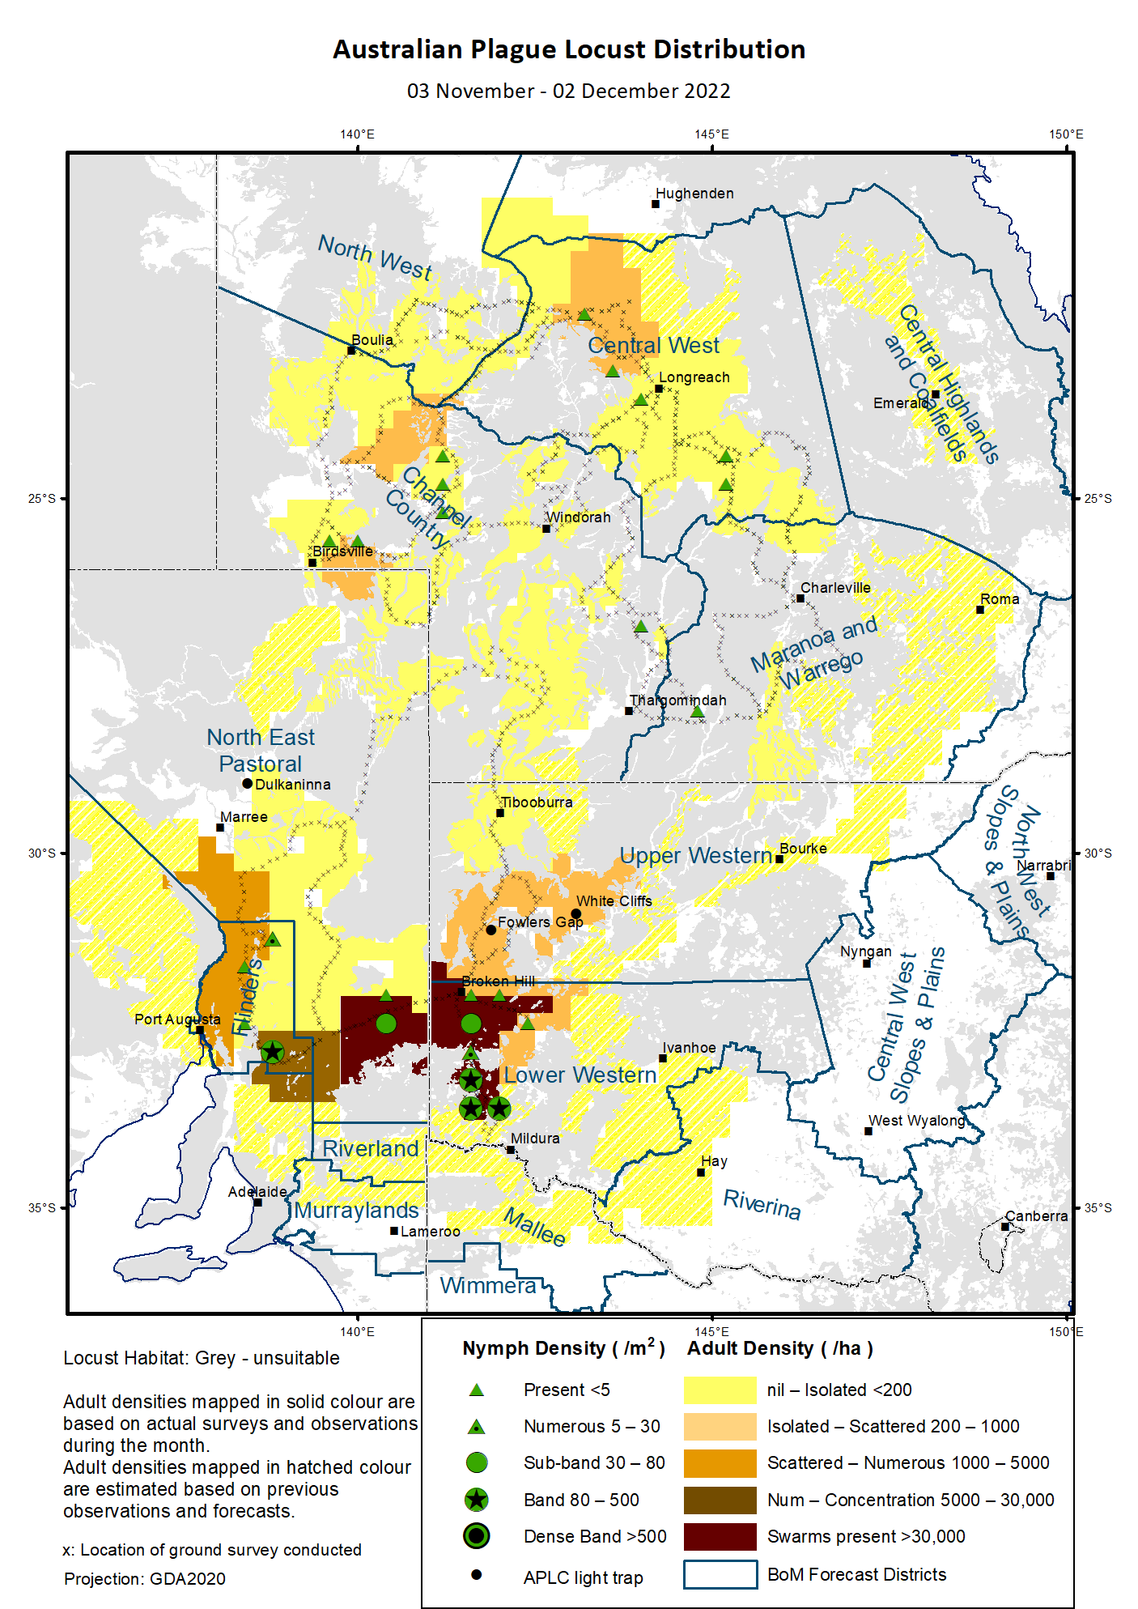

# Australian Plague Locust (*Chortoicetes terminifera*)

## SITUATION in November and OUTLOOK to February 2023

#### NEW SOUTH WALES

##### NORTH WEST SLOPES & PLAINS

###### Northwest Local Land Services

Locusts and conditions

* No surveys were conducted in November in this district.
* No locust reports were received from this district in November.
* This district received 25 – 140 mm rainfall in November, at average in the northern part to very much above average level in the southern part.

Forecast

* Only limited localised breeding is possible under these wet conditions. Consequently, the general population density is expected to be at low levels.
* There is a low probability of any significant migration during summer.

Risks

* There is a low risk of a widespread regional infestation developing during summer.

##### CENTRAL WEST SLOPES & PLAINS

###### Central West Local Land Services

Locusts and conditions

* No surveys were conducted in November in this district.
* No locust reports were received from this district in November.
* This district received 50 – 200 mm rainfall in November, at above average to very much above average levels with some areas at their highest on record.

Forecast

* Localised breeding is possible, but the general population level is likely to remain very low.
* There is a low probability of any significant migration during summer.

Risks

* There is a low risk of widespread regional infestations developing during summer.

##### RIVERINA

###### Riverina, Murray, and part of Western Local Land Services

Locusts and conditions

* No surveys were conducted in November in this district.
* No reports were received from this district in November.
* The UNSW insect monitoring radar in Hay did not detect any locust activity during November.
* This district received 50 – 200 mm rainfall in November at very much above average level.

Forecast

* Localised breeding is possible, but the general population level is likely to remain low.
* There is a low probability of any significant migrations/dispersals during summer.

Risks

* There is a low risk of a significant localised infestation developing during summer.

##### UPPER and LOWER WESTERN

###### Western Local Land Services

Locusts and conditions

* Limited surveys conducted during November in the western part of the Lower Western and Upper Western districts identified consistent Band-density nymphs and Concentration to Low-Density Swarm adults along the Silver City Highway between Broken Hill and Wentworth, though, the extent could not be determined due to water-affected access constraints. Present to Low-Numerous density adults were identified in the Broken Hill area with occasional nymphs. Isolated-density adults were present between Broken Hill to Tibooburra with occasional Scattered-density adults.
* Several reports of locust activity were received from the Broken Hill-Wentworth area. These were investigated and confirmed (above).
* The light traps at White Cliffs and Fowlers Gap did not capture any locusts in November.
* November rainfall ranged from less than 15 mm in the arid northwest corner to 80 mm in the south-eastern part of these districts, ranging from average to very much above average levels.

Forecast

* Localised swarm formation may continue from spring generation nymphs.
* Summer generation nymphs will likely commence hatching from mid-December, developing into localised bands, with a peak of hatching expected from mid-January 2023 onwards.
* Successful breeding may produce some localised high-density populations, but the overall population level is likely to remain at low-medium levels.
* There is a low-moderate probability of some migration/dispersal events during early summer.

Risks

* There is a low-moderate risk of localised infestations developing, but widespread high-density infestation is unlikely during summer.

**All locust activity should be reported to your** [**Local Land Services**](https://www.lls.nsw.gov.au/) **(1300 795 299) or the** [**Department of Primary Industries**](https://www.dpi.nsw.gov.au/climate-and-emergencies/locusts)**. A toll-free call to the APLC hotline can be made on 1800 635 962. An answering machine is attached to this phone for after-hours calls. Reports can also be emailed to APLC via** [**aplc@agriculture.gov.au**](mailto:aplc@agriculture.gov.au) **or sent through the web page at** [**https://www.agriculture.gov.au/pests-diseases-weeds/locusts/landholders/reporting_locusts**](https://www.agriculture.gov.au/pests-diseases-weeds/locusts/landholders/reporting_locusts)**.**

#### QUEENSLAND

##### CENTRAL HIGHLANDS AND COALFIELDS

###### Isaac and Central Highlands Regional Councils; Banana Shire

Locusts and conditions

* No surveys were conducted in November in this district.
* Biosecurity Queensland identified Isolated – Scattered-density adults in this district.
* No reports of locust activity were received from this district in November.
* November rainfall was sporadic and ranged from 35 mm to 150 mm in this district, varying from average to very much above average levels.

Forecast

* Localised breeding is possible, but any resulting population is likely to remain at low levels.
* There is a low probability of any significant migrations during summer.

Risks

* There is a low risk of a widespread infestation developing during summer.

##### DARLING DOWNS AND GRANITE BELT

###### Western Downs and Goondiwindi Regional Councils

Locusts and conditions

* No surveys were conducted in November in this district.
* Biosecurity Queensland conducted ground surveys in November in this district and did not identify any locusts.
* No locust reports were received from this district in November.
* This district received 20 to 50 mm rainfall in November, ranging from below average to average levels.

Forecast

* Some sporadic breeding is possible, but only a low-density population is expected.
* There is a low probability of any significant migrations during summer.

Risks

* There is a low risk of a widespread infestation developing during summer.

##### CENTRAL WEST

###### Barcaldine, Longreach, and Blackall-Tambo Regional Council; Flinders and Winton Shires

Locusts and conditions

* Surveys in November identified Isolated-density with occasional Scattered-density adults and Present-density nymphs in this district.
* No locust reports were received from this district in November.
* This district received 20 to near 100 mm rainfall increasing in the direction from southwest to northeast in November, but generally at average to above average levels.

Forecast

* Some breeding may result in development of low to medium-density populations.
* There is a low probability of any significant migrations during summer.

Risks

* There is a low risk of a widespread infestation during summer.

##### MARANOA AND WARREGO

###### Maranoa Regional Council; Murweh, Paroo, and Balonne Shires

Locusts and conditions

* Surveys in November identified Isolated-density adults with occasional nymphs in this district.
* No locust reports were received from this district in November.
* November rainfall varied from 15 to 60 mm, ranging from below average to above average levels.

Forecast

* Sporadic breeding may result in some localised low – medium densities of population.
* There is a low probability of any significant migrations during summer.

Risks

* There is a low risk of a widespread infestation developing during summer.

##### NORTH WEST

###### Mt Isa, Cloncurry, McKinlay, Boulia, and Winton Shires

Locusts and conditions

* Surveys in November identified Isolated-density adults in south-eastern part of this district.
* No locust reports were received from this district in November.
* This district received 20 to 100 mm rainfall in November, ranging from average to very much above average levels.

Forecast

* Locust numbers are likely to remain at low levels, but sporadic localised breeding may occur in some areas.
* There is a low probability of any significant migration/redistribution activity during summer.

Risks

* There is a low risk of a widespread infestation developing during summer.

##### CHANNEL COUNTRY

###### Boulia, Diamantina, Barcoo, Quilpie, and Bulloo Shires

Locusts and conditions

* Surveys in November identified Isolated-density with occasional Scattered-density adults and Present-density nymphs in this district.
* No locust reports were received from this district in November.
* This district received nearly 10 to 50 mm rainfall in November, ranging average to above average levels.

Forecast

* Locust numbers are likely to remain at low levels, though, some sporadic breeding may occur under favourable habitat conditions.
* There is a low probability of any significant migrations during summer.

Risks

* There is a low risk of a widespread infestation developing during summer.

**All locust activity should be reported the** [**Biosecurity Queensland (Department of Agriculture and Fisheries)**](https://www.daf.qld.gov.au/business-priorities/biosecurity) **via the** [**Customer Service Centre**](https://www.daf.qld.gov.au/contact/customer-service-centre) **on 13 25 23. A toll-free call to the APLC hotline can be made on 1800 635 962. An answering machine is attached to this phone for after-hours calls. Reports can also be emailed to APLC via** [**aplc@agriculture.gov.au**](mailto:aplc@agriculture.gov.au) **or sent through the website at** [**https://www.agriculture.gov.au/pests-diseases-weeds/locusts/landholders/reporting_locusts**](https://www.agriculture.gov.au/pests-diseases-weeds/locusts/landholders/reporting_locusts)**.**

#### SOUTH AUSTRALIA

##### NORTH EAST PASTORAL and FLINDERS

Locusts and conditions

* Surveys during 30 November – 02 December identified only Isolated-density adults in the northern part of North East Pastoral district, but much higher densities in the southern part of this district with frequent Numerous – Medium-Density Swarm adults and Present – Sub-Band density nymphs detected.
* Surveys in the Flinders district identified frequent Numerous – Concentration-density adults with Numerous – Band-density nymphs detected on 01 December.
* PIRSA conducted surveillance in November in the Flinders district and surrounding areas and identified several Concentration to Medium-Density Swarm adults in addition to numerous Present to Band-density nymphs detected.
* The Dulkaninna light-trap caught 18 locusts on the night of 10 November, but adults were sighted nearby.
* The North East Pastoral district received rainfall from a few millimetres to 25 mm in November over much of the northern part up to Yunta, ranging from average to above average levels. The southern part of this district had 25 – 50 mm rainfall, at above average to very much above average levels.
* The Flinders district received 10 – 100 mm rainfall in November, ranging from average to very much above average levels in the trend of north to south.

Forecast

* Locust numbers are likely to increase moderately from successful breeding under favourable habitat conditions.
* Some swarm formation may continue, and bands of summer generation nymphs may develop following successful breeding from mid-January onwards.
* There is a moderate probability of significant migrations/dispersals within these districts and adjacent areas during early summer.

Risks

* There is a low – moderate risk of a widespread infestation developing during summer.

##### RIVERLAND and MURRAYLANDS

Locusts and conditions

* No surveys were conducted in this district in November.
* No locust reports were received from this district in November.
* November rainfall ranged from 50 to 80 mm, at very much above average to highest on record levels.

Forecast

* The locust population is likely to remain at low levels with some pockets of higher densities.
* There is a low – moderate probability of some migration/dispersal events during early summer.

Risks

There is a low – moderate risk of a widespread infestation developing during summer.

**Locust activity should be reported to** [**Biosecurity SA (Primary Industries and Regions South Australia)**](https://www.pir.sa.gov.au/biosecurity) **via the Plant Health Hotline on 1300 666 010.** **A toll-free call to the APLC hotline can be made on 1800 635 962. An answering machine is attached to this phone for after-hours calls. Reports can also be emailed to APLC via** [**aplc@agriculture.gov.au**](mailto:aplc@agriculture.gov.au) **or sent through the website at** [**https://www.agriculture.gov.au/pests-diseases-weeds/locusts/landholders/reporting_locusts**](https://www.agriculture.gov.au/pests-diseases-weeds/locusts/landholders/reporting_locusts)**.**

#### VICTORIA

##### MALLEE

**Mildura and Swan Hill Rural Cities; Yarriambiack and Buloke Shires**

Locusts and conditions

* No surveys were conducted in this district in November.
* Some locust sightings from this district were investigated by Agriculture Victoria in November.
* November rainfall ranged from 40 to 80 mm in this district, at above average to highest on record levels.

Forecast

* Locust numbers are likely to increase moderately from the current low – medium levels expected. Summer generation nymphs can commence hatching from any successfully egg-laying from late-January onwards.
* Localised swam may form from fledging adults from mid-December onwards.
* There is a low – moderate probability of migration/dispersal during early summer.

Risks

* There is a moderate risk of a widespread infestation developing during summer.

##### WIMMERA

**Hindmarsh and West Wimmera Shires**

Locusts and conditions

* No surveys were conducted in this district in November.
* No locust reports were received from this district in November.
* November rainfall ranged 60 – 90 mm in this district, at above average to highest on record levels.

Forecast

* Locust numbers are likely to increase low-moderately with some areas of medium densities expected following successfully breeding under suitable habitat conditions in summer. The general population level is likely to remain at low levels.
* There is a low probability of any significant migrations during summer.

Risks

* There is a low risk of a widespread infestation developing during summer.

**Locust activity should be reported to the** [**Agriculture Victoria**](https://agriculture.vic.gov.au/)[**Customer Contact Centre**](https://agriculture.vic.gov.au/about/contact-us) **on 136 186. Alternatively, you can make a report via the online form at**[**https://forms.bio.vic.gov.au/2020**](https://forms.bio.vic.gov.au/2020)**.  Please include photos where possible. A toll-free call to the APLC hotline can be made on 1800 635 962. An answering machine is attached to this phone for after-hours calls. Reports can be emailed to APLC via** [**aplc@agriculture.gov.au**](mailto:aplc@agriculture.gov.au) **or sent through the website at** [**https://www.agriculture.gov.au/pests-diseases-weeds/locusts/landholders/reporting_locusts**](https://www.agriculture.gov.au/pests-diseases-weeds/locusts/landholders/reporting_locusts).

# Glossary of locust terms and density categories used in the Locust Bulletin

**Locust biology and behaviour**

|  |  |
| --- | --- |
| **Term** | **Definition** |
| adult | A fully winged, mature locust capable of breeding and migrating |
| band | Dense aggregation of nymphs, usually moving forward together |
| diapause | Period of dormancy induced in anticipation of unfavourable environmental conditions |
| egg bed | An area of soil containing many egg pods (hundreds per square metre) |
| fledge | Final nymphal moult to a soft-bodied adult incapable of long-distance flight |
| instar | Discrete stages of nymphal development each separated by a moult |
| laying | Female locusts depositing clutches of 20 – 60 eggs into the ground in froth-lined egg pods |
| nymph | Juvenile wingless locust. Often referred to as the hopper stage |
| swarm | Dense aggregation of adults, milling at the same spot or flying closely together |

###### Locust density categories

Where higher densities occur, a large proportion of the regional population is concentrated in very small areas with lower densities elsewhere, so the higher densities cannot be extrapolated over the area of an entire region. A range of density classes is usually found within a surveyed region.

|  |  |  |
| --- | --- | --- |
| **Nymph Densities** | **Number per m2** |  |
| Present | 1 – 5 |  |
| Numerous | 6 – 30 |  |
| Sub-band | 31 – 80 |  |
| Band | 81 – 500 |  |
| Dense Band | >500 |  |
|  |  |  |
| **Adult Densities** | **Number per m2** | **Number per 250 m2** |
| Isolated | – 0.02 | 1 5 |
| Scattered | 0.024 – 0.1 | 6 – 25 |
| Numerous | 0.104 – 0.5 | 26 – 125 |
| Concentration | 0.504 – 3 | 126 – 750 |
| Low Density Swarm | 4 – 10 | 751 – 2,500 |
| Medium Density Swarm | 11 – 50 | 2,501 – 12,500 |
| High Density Swarm | >50 | >12,500 |
|  |  |  |
| **General density classes** | **Nymph densities** | **Adult densities** |
| very low, occasional | Nil – Present | Nil – Isolated |
| low | Present – Numerous | Isolated – Scattered |
| medium | Numerous – Sub-band | Scattered – Numerous |
| high | Bands | Concentration – Swarms |

###### Reporting locust infestations

It is important that all locust activity is reported as soon as possible to your nearest state agriculture agency office or to the Australian Plague Locust Commission.

|  |  |
| --- | --- |
| **State** | **Authority for reporting locusts** |
| New South Wales | Local Land Services (LLS) or Department of Primary Industries |
| Queensland | Biosecurity Queensland, Department of Agriculture and Fisheries |
| South Australia | Biosecurity SA, Department of Primary Industries & Regions |
| Victoria | Biosecurity and Agriculture Services, Department of Jobs, Precincts and Resources |

Reports to the **Australian Plague Locust Commission** can be made by:

Free call (Canberra): 1800 635 962 (24 hours)

Fax (Canberra): (02) 6272 5074

Email: [aplc@agriculture.gov.au](mailto:aplc@agriculture.gov.au)

Website: <https://www.agriculture.gov.au/pests-diseases-weeds/locusts/landholders/reporting_locusts>