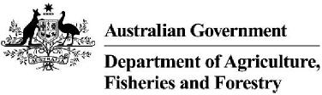 | Effective as of: 8 September 2023

List of countries approved for pig meat
Uncooked pig meat
The following countries are approved by the Department of Agriculture Fisheries and Forestry for the importation of uncooked pig meat.
Country Country Country
Australia Belgium Canada
Denmark France Finland
Great Britain (England, Scotland and Wales) Ireland (Republic of) Netherlands
New Zealand Northern Ireland United States of America
Cooked pig meat
The following countries are approved by the Department of Agriculture Fisheries and Forestry for the importation of cooked pig meat.
Country Country Country
Australia Canada Denmark
Great Britain (England, Scotland and Wales) New Zealand United States of America
Cured pig meat
The following countries are approved by the Department of Agriculture Fisheries and Forestry for the importation of cured pig meat.
Country Country
Italy Spain
Page 1 of 1 List of countries approved for pig meat

