|  |
| --- |
| Karnal bunt of wheat (*Tilletia indica*) |

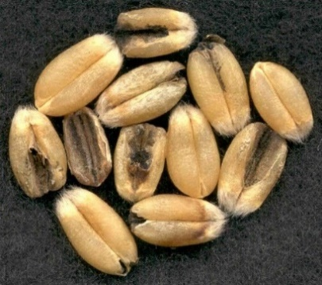

**Likely mode of entry**

This fungus is likely to enter Australia via infected wheat seed contaminating shipping containers or machinery. Spores may also be found on the surfaces of used agricultural machinery or in soil. Wheat and triticale seed imported for growing purposes must undergo inspection and post entry quarantine to ensure freedom from this disease.

**Symptoms (Figures 1–4)**

Symptoms are only visible on kernels (mature seeds). Masses of brown to black spores replace the endosperm resulting in a fragile seed which crushes easily and has a strong fishy odour. Look for seed with darkening at the embryo end and along the crease. Karnal bunt is difficult to detect as the fungus may only affect part of the kernel and only some of the seed in each head.

**Host range**

The Karnal bunt pathogen can infect wheat (*Triticum* spp., especially *T. aestivum*), and to a lesser extent durum wheat (*Triticum durum*).Records of infections on triticale (a hybrid of wheat and rye, *x Triticosecale*) are rare, and rye (*Secale cereale*) has been shown to have the potential to be a host. Barley and oats are not affected.

**Biology**

Karnal bunt is caused by the smut fungus *Tilletia indica.* It is also known by the common names of partial bunt, Indian bunt of wheat and new bunt. The fungus infects the flower and grows through into the developing seed. Once the seed is mature it may break open releasing teliospores to spread by wind to neighbouring crops. The fungus can also survive in the soil for several years. When harvested, infected seed break open releasing the spores causing discolouration and a fishy odour. For this reason, the grain cannot be used for pasta or flour. Australia has a zero tolerance for this disease which would have a major economic impact if it were to establish here.

**Distribution**

First described from the town of Karnal in northern India, it is also present in many countries adjoining India, parts of North and South America, and South Africa. It is not present in Australia.

**Fig. 1** Wheat seeds infected with Karnal bunt (© Peter Dziuk, Minnesota Dept. of Agric.).

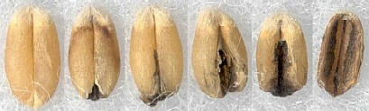

**Fig. 2** Wheat seeds showing a range of Karnal bunt symptoms from a healthy kernel (left) to advanced infection (©Peter Dziuk, Minnesota Dept. of Agric.).

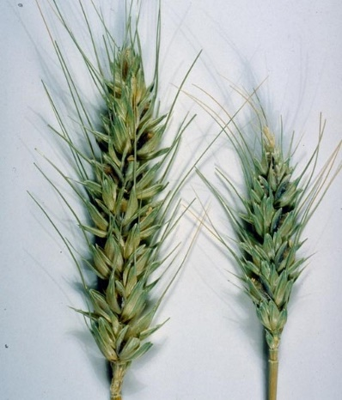

**Fig. 3** Two ears of wheat, *Triticum aestivum*, infected with Karnal bunt (Ruben Duran, Washington State University, Bugwood.org).

**What to do if you find suspect Karnal bunt**

**Department officers:** Contain the risk, collect plant specimens double-bagged into zip-lock plastic bags and deliver to a department plant pathologist immediately.

**Industry and the public:** **SEE. SECURE. REPORT.**

Secure the goods to limit movement and immediately report your detection to the Department of Agriculture, Fisheries and Forestry on **1800 798 636**.

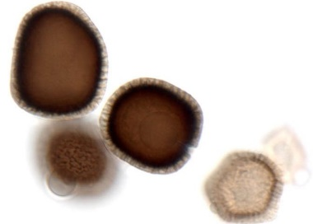

**Fig. 4** Teliospores of Karnal bunt at high magnification (PaDIL).