**Recovery plan for nationally threatened plant species on Kangaroo Island South Australia**

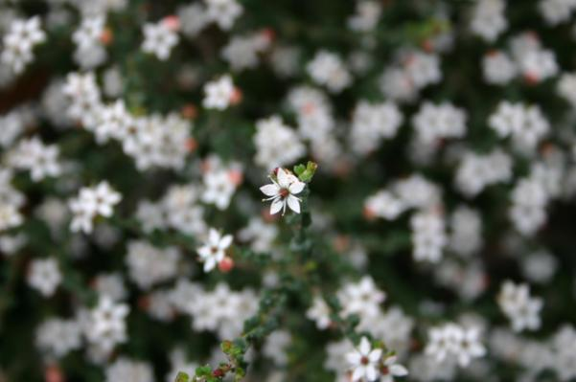

**Department of Environment, Water and Natural Resources**

**Kangaroo Island Natural Resources Management Board**

**Australian Government**

**Title: Recovery plan for nationally threatened plant species on Kangaroo Island South Australia**

© Department of Environment, Water & Natural Resources

This work is copyright. It may be reproduced for study, research or training purposes subject to an acknowledgement of the sources but no commercial usage or sale. Requests and enquiries concerning reproduction and rights should be addressed to:

Department of Environment, Water and Natural Resources

PO Box 1047

Adelaide SA 5001

*Citation*

Taylor, D.A. (2012). *Recovery plan for nationally threatened plant species on Kangaroo Island South Australia.* Department of Environment, Water and Natural Resources, Government of South Australia.

Cover Photos: The nationally threatened species *Leionema equestre* on the Hog Bay Road, eastern Kangaroo Island (Photo D. Taylor)

*Acknowledgements*

This Plan was developed with the guidance, support and input of the Kangaroo Island Threatened Plant Steering Committee and the Kangaroo Island Threatened Plant Recovery Team. Members included Kylie Moritz, Graeme Moss, Vicki-Jo Russell, Tim Reynolds, Yvonne Steed, Peter Copley, Annie Bond, Mary-Anne Healy, Bill Haddrill, Wendy Stubbs, Robyn Molsher, Tim Jury, Phil Pisanu, Doug Bickerton, Phil Ainsley and Angela Duffy.

Valuable advice regarding the ecology, identification and location of threatened plant populations was received from Ida and Garth Jackson, Bev and Dean Overton and Rick Davies.

The support of the Kangaroo Island staff of the Department of Environment, Water and Natural Resources was also greatly appreciated.

Funding for the preparation of this plan was provided by the Australian Government, Kangaroo Island Natural Resources Management Board and the Threatened Species Network (World Wide Fund for Nature).

Note: This recovery plan sets out the actions necessary to stop the decline of, and support the recovery of, the listed threatened species or ecological community. The Australian Government is committed to acting in accordance with the plan and to implementing the plan as it applies to Commonwealth areas.

The plan has been developed with the involvement and cooperation of a broad range of stakeholders, but individual stakeholders have not necessarily committed to undertaking specific actions. The attainment of objectives and provision of funds may be subject to budgetary and other constraints affecting the parties involved. Proposed actions may be subject to modification over the life of the plan due to changes in knowledge.

# Introduction

This is the first Recovery Plan for nationally threatened plant species on Kangaroo Island produced in recognition of the need to develop a coordinated conservation strategy for fourteen plant species listed as threatened under the Commonwealth Environment Protection and Biodiversity Conservation Act 1999 (EPBC Act). This Recovery Plan builds on a five year action plan produced in 2003 and has been developed in line with the requirements of the EPBC Act and guidelines.

# Species covered by the recovery plan

This is a multi-plant species recovery plan covering the land mass of Kangaroo Island. Fifteen species are addressed in this recovery plan along with the habitat critical to their survival (Table 1). Fourteen of these species are listed as nationally threatened under the EPBC Act. At the time of the development of the action plan in 2003, *Pultenaea insularis* was considered to be a species endemic to Kangaroo Island, critically endangered and worthy of listing under the EPBC Act. *P. insularis* has since been reviewed by de Kok and West (2004) and identified as *Pultenaea pedunculata*, a species commonly found on mainland South Australia. Recent genetic work however suggests that *P. insularis* is genetically distinct from the mainland *P. pedunculata* and may be worthy of consideration as a separate species (Ottewell *et al,* 2009). Until the status of this species has been confirmed *P. insularis* will continue to be treated as a separate species of interest to the KI Nationally Threatened Plant Project. For that reason it is included in this recovery plan.

# Distribution and Populations

Due to limited knowledge of distribution and abundance of the majority of the 15 threatened plant species on Kangaroo Island, all known populations and sub-populations of each plant species have been classified as important under this plan. No assessment of the importance of Kangaroo Island populations and sub-populations relative to the full Australia wide distribution of each species has been made.

A summary of the known populations and sub-populations of the 15 threatened plant species is presented in Table 2. Spatial representations of these populations are included in Appendix A.

Table 1: Plant species considered in this report and their EPBC Act status and habitat

|  |  |  |  |
| --- | --- | --- | --- |
| **Species** | **Common Name** | ***EPBC Act 1999*** | **Habit** |
| *Asterolasia phebalioides* | Downy Starbush | Vulnerable | Small shrub to 1.5 m high |
| *Beyeria subtecta\** | Kangaroo Island Turpentine Bush | Vulnerable | Small rigid shrub to 0.6 m high |
| *Caladenia ovata* | Kangaroo Island Spider-orchid | Vulnerable | Ground orchid to 0.23 m high |
| *Cheiranthera volubilis\** | Twining Finger-flower | Vulnerable | Slender climbing twiner |
| *Correa calycina* var. *halmaturorum\** | De Mole River Correa | Vulnerable | Shrub |
| *Euphrasia collina* subsp.*osbornii* | Osborn’s Eyebright | Endangered | Small herb to 0.3 m high |
| *Leionema equestre*+* | Kangaroo Island Phebalium | Endangered | Small shrub to  0.3 m high |
| *Logania insularis\** | Kangaroo Island Logania | Vulnerable | Low growing shrub |
| *Olearia microdisca\** | Small-flowered Daisy-bush | Endangered | Narrow, woody shrub to 1.5 m high |
| *Pomaderris halmaturina* subsp.*halmaturina* | Kangaroo Island Pomaderris | Vulnerable | Tall shrub up to  4 m high |
| *Ptilotus beckerianus* | Ironstone Mulla Mulla | Vulnerable | Herb to 0.25 m high |
| *Pultenaea insularis*-* | Beyeria Bush-pea | Not currently listed | Low spreading shrub to 0.6 m high |
| *Pultenaea villifera var. glabrescens\** | Splendid Bush-pea | Vulnerable | Low spreading or tall shrub |
| *Spyridium eriocephalum var. glabrisepalum\** | MacGillivray Spyridium | Vulnerable | Low slender shrub to 1 m high |
| *Thelymitra matthewsii* | Spiral Sun-orchid | Vulnerable | Ground orchid to 0.2 m high |

* Endemic to Kangaroo Island - Currently subject to taxonomic revision.

+ Synonym *Phebalium equestre*

Table 2: Populations of fifteen threatened plant species on Kangaroo Island

|  |  |  |  |
| --- | --- | --- | --- |
| **Species** | **Number of plants based on most recent and most complete counts** | **Number of records** | **Area of occupancy (km2)** |
| *Asterolasia phebalioides* | >50000 | 3 | 4.0 |
| *Beyeria subtecta* | 11146 | 81 | 51.6 |
| *Caladenia ovata* | Unknown | 6 | 4.0 |
| *Cheiranthera volubilis* | >8453 | 20 | 23.4 |
| *Correa calycina* var. *halmaturorum* | Unknown | 2 | 1.4 |
| *Euphrasia collina* subsp.*osbornii* | 617 | 4 | 4.7 |
| *Leionema equestre* | 2663 | 26 | 21.7 |
| *Logania insularis* | Unknown | 6 | 3.5 |
| *Olearia microdisca* | 2264 | 18 | 26.1 |
| *Pomaderris halmaturina* subsp. *halmaturina* | 1902 | 27 | 45.4 |
| *Ptilotus beckerianus* | 37252 | 21 | 28.4 |
| *Pultenaea insularis* | 831 | 15 | 11.6 |
| *Pultenaea villifera* var. *glabrescens* | >629 | 20 | 19.6 |
| *Spyridium eriocephalum* var. *glabrisepalum* | 1536 | 48 | 45.6 |
| *Thelymitra matthewsii* | Unknown | 2 | 1.8 |

# Relationship to mainland populations and other closely related mainland taxa

*Correa calycina* is listed at the species level as vulnerable under the EPBC Act. There are currently considered to be two varieties of this species: *C. c.* var*. calycina* is found on the mainland, where it is endemic to Fleurieu Peninsula, in the Adelaide and Mt Lofty Ranges NRM Region of SA; while *C. c.* var. *halmaturorum* is endemic to Kangaroo Island. Under South Australia’s *National Parks and Wildlife Act (1972)* (NPW Act), var. *calycina* is listed as vulnerable, and var. *halmaturorum* is listed as endangered.

*Euphrasia collina* subsp. *osbornii* also occurs on the mainland, in the Adelaide and Mount Lofty Ranges, Northern and Yorke and South East NRM Regions of South Australia, and has a national recovery plan covering the full range of the species (Moritz and Bickerton, 2010). One other *E. collina* subspecies, *E. c.* subsp. *muelleri*, is also listed as endangered under the EPBC Act and is now restricted to Victoria. Two other *E. collina* supspecies are known from South Australia: *E. c.* subsp. *collina* (listed as vulnerable under SA’s NPW Act) is known from the SE NRM Region, Victoria and NSW; and *E. c.* subsp. *tetragona* has been recorded from SA’s Eyre Peninsula, Northern and Yorke, Murray Darling Basin, Kangaroo Island and SE NRM Regions, as well as WA, Victoria, NSW and Tasmania. *Euphrasia. collina* subsp. *muelleri, E. c.* subsp*. paludosa and E. c.* subsp*. trichocalycina* are considered extinct in SA.

*Pomaderris halmaturina* subsp. *halmaturina*, *Pultenaea villifera var. glabrescens* and *Spyridium eriocephalum var. glabrisepalum* are the only subtaxa within their species that are listed under the EPBC Act.

*Pomaderris halmaturina* subsp. *halmaturina* also occurs on the mainland, in the southeast of South Australia, while *P. h.* subsp. *continentis* (listed as vulnerable under SA’s NPW Act) is found in the SE NRM Region and in Victoria.

*Pultenaea villifera* var*. glabrescens* is endemic to Kangaroo Island, while *P. v.* var. *villifera* is endemic to south-eastern NSW.

*Spyridium eriocephalum* var*. glabrisepalum* is endemic to Kangaroo Island, while *S. e.*var. *eriocephalum* has been recordedfrom SA’s Eyre Peninsula, Northern and Yorke, Murray Darling Basin, Adelaide and Mt Lofty Ranges, Kangaroo Island and SE NRM Regions, as well as Victoria and Tasmania.

*Ptilotus beckerianus* also occurs on the mainland, on Eyre Peninsula. A recovery plan for threatened flora of Eyre Peninsula, including *P. beckerianus*, is currently being prepared by the Department of Environment, Water and Natural Resources.

None of the above-mentioned related taxa have been the target of specific management actions that have assisted with the drafting of this Recovery Plan. Although *Ptilotus beckerianus* is one of the target species in the currently drafted recovery plan for threatened flora of Eyre Peninsula, the two plans have been written in tandem, so the actions resulting have not informed the drafting of either plan.

# Habitat critical to the survival of these threatened plant species

Current knowledge of the ecology and biology of the 15 threatened plant species addressed by this plan on Kangaroo Island is considered to be insufficient to precisely determine the spatial boundaries of habitat critical to the survival of the species based on the criteria set out in regulation 7.09 of the EPBC Act. For the purposes of this recovery plan a decision was made to define habitat critical to the survival of each species as that area within 500m of each individual threatened plant. This habitat, hereafter referred to as ‘essential habitat’, was also extended to include corridors between individual plants within each sub-population.

‘Priority 1 essential habitat’ has been defined in this plan as the area in which on-ground actions described under this plan will be primarily focused. The determination of priority 1 essential habitat was based on a decision tree (Appendix B) constructed using four separate criteria: threatened species status, sub-population size, the extent of overlap between threatened species and degree of threat.

The concept of potential habitat is also referred to in this recovery plan. This includes habitat which is not critical to the current survival of threatened plant species but which may be important in the long term recovery of a particular species as it is encouraged to expand in distribution.

In this recovery plan potential habitat has been defined broadly as that occupied by vegetation communities currently associated with a threatened plant species. A total of 16 plant communities overlap to some extent with essential habitat of the 15 threatened plant species (see summary table at Appendix C).

The essential and potential habitat of the 15 nationally threatened plant species have been mapped according to these definitions in Figures 1 – 15 included in Appendix A.

# Key threats

There are numerous threats to the 15 threatened plant species on Kangaroo Island. Direct threats and impediments to recovery can initiate or hasten the decline of threatened plant species populations. These threats are listed below (Table 3) and summarised in the Background Paper: Nationally Threatened Plant Species on Kangaroo Island Recovery Action Plan (attached).

Table 3: Summary of threats to threatened plant species

|  |  |
| --- | --- |
| **Direct Threats** | |
| Vegetation clearance | Trampling |
| Environmental weeds | Erosion |
| Grazing | *Phytophthora* |
| Salinity |  |
| **Impediments to Recovery** | |
| Fragmentation | Potential pest species |
| Degraded potential habitat | Climate change |
| Inadequate knowledge of   * distribution and abundance * ecology and biology * threatening processes | Engagement, coordination and integration of   * stakeholders * resources * recovery process |
| Inappropriate disturbance regimes |  |

The order of threats and impediments to the recovery of nationally threatened plant species on Kangaroo Island are shown in Table 4 and have been based upon a threat matrix summarised in the afore-mentioned background paper. The higher the threat matrix score, the higher the incidence and/or likelihood of the threat to all 15 nationally threatened plant species.

The two key impediments to the recovery of the 15 threatened plant species, aside from resourcing, coordination of efforts and inadequate knowledge, are fragmentation resulting in small isolated populations, and inappropriate disturbance regimes.

*Fragmentation*

The partial or complete isolation of a plant population or a vegetation fragment can lead to declining genetic viability, edge effects and distance effects. These effects are likely to impact on processes involving the transfer of genetic material, plant propagules and disturbance events (primarily fire) into or out of each plant population or fragment. A decline in the effectiveness of these processes may potentially lead to a decline in the affected plant populations and communities (Debinski and Holt 2000; Fahrig and Merriam 1994; Young et al. 1996).

These effects are expected to have their greatest impact on threatened plant recovery in the highly modified agricultural landscape of the eastern and central areas of Kangaroo Island.

*Inappropriate disturbance regimes*

Historically, the most significant source of habitat disturbance is most likely to have been wildfire. The deliberate exclusion of fire from the fragmented landscapes of Kangaroo Island for at least 30 years has led to the decline of short lived understorey plant species dependent on fire to stimulate regeneration from the soil seedbank.

An Eastern Plains Fire Trial (EPFT) aimed at developing a better understanding of the role of fire in maintaining ecosystem diversity and health, was established in 2008 in response to the decline of plant diversity in eastern Kangaroo Island (Taylor 2011a & b). The Trial has been managed by the South Australian Department of Environment, Water and Natural Resources (DEWNR) in partnership with other key stakeholders.

Human induced disturbance associated with activities such as vegetation clearance and road construction now provides an additional source of disturbance in many plant communities on the island. While this relatively new form of disturbance has produced negative impacts including vegetation damage and loss, weed invasion and habitat fragmentation, it has provided a source of disturbance to disturbance-dependent species growing in fragments no longer exposed to natural fire regimes.

Table 4. Order of threats and impediments to the recovery of nationally threatened plant species on Kangaroo Island

|  |  |
| --- | --- |
| **Threat (T) or Impediment (I) to Recovery** | **Threat Matrix Score** |
| Availability of Resources (I) | 135 |
| Co-ordination of Recovery Process (I) | 135 |
| Inadequate Knowledge of Distribution and Abundance (I) | 121 |
| Inadequate Knowledge and Understanding of Threats (I) | 119 |
| Small Isolated Populations (I) | 110 |
| Inappropriate Disturbance Regimes (I) | 106 |
| Degraded Potential Habitat (I) | 106 |
| Involvement of Stakeholders (I) | 105 |
| Inadequate Knowledge of Ecology and Biology (I) | 98 |
| *Phytophthora* (T) | 86 |
| Potential Pest Species (I) | 76 |
| Grazing (T) | 74 |
| Environmental Weeds (T) | 65 |
| Vegetation Clearance (T) | 63 |
| Trampling (T) | 49 |
| Salinity (T) | 40 |
| Erosion (T) | 29 |

# Evaluation of Performance of Previous Actions

The 2003 action plan nominated two recovery criteria against which to judge its success. Neither of these two criteria was judged to have been fully met, however significant progress was made during the life of the 2003 action plan (See Table 5). This progress will provide considerable momentum for the delivery of this recovery plan.

Table 5: Assessment of achievement of the 2003 action plan against recovery criteria

|  |  |
| --- | --- |
| **Criteria** | **Achievement** |
| The recovery of endangered and critically endangered plant species to a vulnerable status (based on IUCN criteria). | Population increases for 4 of 5 critically endangered and endangered species (based on IUCN criteria) recorded. |
| A contribution to reversing the decline of nationally threatened plant critical habitat (including areas containing state and regionally rare and threatened plant communities) on Kangaroo Island. | An improvement in the health and diversity of threatened plant habitat recorded in key areas of eastern Kangaroo Island. |

The 2003 action plan identified two primary objectives:

* The recovery of nationally threatened plant species on Kangaroo Island, and
* Recovery of nationally threatened plant critical habitat on Kangaroo Island.

Underpinning these were 17 secondary objectives and a total of 57 associated actions. As part of the performance evaluation, each action was assessed and scored between 0-3 using the following criteria:

1. No progress/cannot be assessed
2. Insufficient action to meet objective
3. Action underway – most elements of action met or it is anticipated they will be
4. Objective met – further action may or may not be required

The individual assessments for each of the 57 actions are contained in Appendix D. The results for the secondary objectives are summarised in Table 6. In evaluating the performance of previous actions, a number of stakeholders were interviewed. Their comments and feedback are summarised in Appendix E. The evaluation process has provided an opportunity for key learnings and stakeholder feedback to inform and influence the objectives and actions in this Recovery Plan.

Implementation of recovery actions under the 2003 action plan has been underpinned by two major elements: a habitat re-establishment component and the Eastern Plains Fire Trial (EPFT).

The habitat re-establishment component has been aimed at the expansion of threatened plant populations and associated plant communities as a long term strategy to prevent the ongoing decline and eventual loss of five threatened plant species on eastern Kangaroo Island. It was initiated in 2004 and has been focussed on a private property in the lower Cygnet River Valley that has remnant vegetation within and adjacent supporting populations of three nationally threatened plant species.

Small scale trials conducted between 2004 and 2006 identified four key methodological impediments to the delivery of landscape scale habitat re-establishment in eastern Kangaroo Island. Testing and adaptation of techniques to address each of these impediments led to the expansion of the project to two other sites in the lower Cygnet River Valley in 2007, and to the institution of the annual KI Planting Festival from 2007. Overall 398,543 plants were propagated and planted over an area of 211.8 ha on seven different properties (Taylor and Klein 2012).

A more detailed summary of the habitat re-establishment component (Taylor and Klein 2012) is provided at Appendix F.

During the first phase of the EPFT, 36 small prescribed burns (<5 ha) were conducted in long unburnt mallee in eastern Kangaroo Island, with significant progress made towards meeting the anticipated knowledge, ecological, social and management outcomes of the broader EPFT project (Taylor 2011a). Following evaluation of the first phase (Taylor 2011a) and the method used (Taylor 2011b), post burn monitoring of flora and fauna at all phase 1 sites was continuing until at least the end of 2012 and the EPFT operational method was being trialled at 4 large (>30 ha) sites during 2011 and 2012. A summary of the outcomes of phase 1 of the EPFT is provided at Appendix G.

Table 6. Evaluation of achievement of 2003 action plan against secondary objectives of that plan.

|  |  |  |
| --- | --- | --- |
| **Objective** | **% Complete** | **Comments** |
| To ensure sufficient financial and human resources are available to implement all recommended threat abatement actions during the five year span of the action plan. | (5 actions)  100% | Sufficient financial and human resources were successfully sourced to deliver the majority of actions under this plan. |
| Effective and efficient co-ordination and implementation of actions to meet recovery objectives. | (4 actions)  100% | A Recovery Project Officer was appointed and maintained throughout the life of this plan to coordinate recovery actions |
| To determine and maintain a reliable indication of the distribution and abundance of nationally threatened plant species on Kangaroo Island. | (5 actions)  75% | Extensive surveys and mapping of priority threatened plant species were completed. |
| To develop and maintain a comprehensive understanding of the processes threatening nationally listed plant species on Kangaroo Island. | (5 actions)  60% | The effects of fragmentation, fire, grazing and weeds were studied during this plan. Further analysis and mapping required. |
| To stabilise and reduce the impacts of fragmentation on nationally threatened plant species on Kangaroo Island. | (6 actions)  75% | An extensive habitat re-establishment program was established during the delivery of this recovery project. Further work required to improve restoration techniques and efficiency. Large areas need to be restored to have a long term effect on species recovery. |
| Determine and implement disturbance regimes which promote the recovery of nationally threatened plant species and associated critical and potential habitat on Kangaroo Island. | (2 actions)  80% | A comprehensive research project to explore the impact of fire on plant regeneration was established (Eastern Plains Fire Trial). Prescribed burns were undertaken in strategic locations to stimulate regeneration, however more widespread application required. A summary of outcomes of the first phase of this project is provided at Appendix G. |
| To reverse the decline of habitat potentially important to the long term recovery of nationally threatened plant species on Kangaroo Island. | (1 action)  75% | A broad range of programs delivering habitat restoration activities across eastern Kangaroo Island were supported. 216 hectares have been planted out with 422,000 plants, comprising 120 species. |
| To develop stakeholder awareness, appreciation and ownership of nationally threatened plant species on Kangaroo Island and encourage active involvement in their future management | (1 action)  100% | Community involvement in threatened plant recovery actions significantly increased over the life of the action plan. Strong partnerships were developed with multiple stakeholders and this increased public ownership of the project. |
| Expand and develop collective knowledge and understanding of the ecology and biology of nationally threatened plant species on Kangaroo Island. | (3 actions)  60% | Extensive monitoring programs established. Follow-up monitoring and analysis required to significantly improve understanding. |
| To minimise the impact of *Phytophthora* spp. on nationally threatened plant species on Kangaroo Island. | (4 actions)  25% | Preliminary work completed only. |
| To protect nationally threatened plant species on Kangaroo Island from the future impact of potential pest species. | (2 actions)  85% | Kangaroo Island Environmental Weeds Group formed, supported and assisted in the field. KINRM Board Biosecurity project supported. |
| Establish grazing regimes which have a minimal impact on the growth, reproduction and recruitment of nationally threatened plant species on Kangaroo Island. | (3 actions)  80% | Monitoring and grazing control actions established at key sites. |
| Protect nationally threatened plant species and associated critical habitat on Kangaroo Island from the impact of environmental weeds. | (5 actions)  75% | Extensive weed management progress undertaken focussing on Bridal Veil. |
| To prevent the clearance of nationally threatened plant species and associated critical and potential habitat on Kangaroo Island. | (1 action)  75% | Advice on distribution and habitat requirements of nationally threatened plant species provided to state government agencies (including those governing vegetation clearance). |
| Reduce the risk and impact of vegetation trampling in critical habitat of nationally threatened plant species on Kangaroo Island. | (3 actions)  100% | Signage and fencing erected at key sites. |
| Protect nationally threatened plant species on Kangaroo Island from the impact of soil salinity. | (2 actions)  60% | Monitoring of saline affected areas undertaken and onground works supported. |
| Protect nationally threatened plant species and associated critical habitat on Kangaroo Island from the impact of erosion. | (3 actions)  100% | Erosion mitigation undertaken at key sites. |

# Recovery Plan Objective

The overall objective of the recovery plan is:

*to achieve the recovery of nationally threatened plant species and their essential habitat on Kangaroo Island.*

# Criteria to measure performance of the Plan against the objective

It is not anticipated that the objective, including habitat expansion, will be achieved within the life-time of the Plan. However, the Recovery Plan will be deemed successful if positive trends, in terms of achieving the overall objective, can be demonstrated; in particular:

1. The recovery of *Beyeria subtecta*, *Leionema equestre*, *Olearia microdisca*, *Pultenaea insularis* and *Spyridium eriocephalum* var. *glabrisepalum* to a vulnerable status based on IUCN criteria.

# Specific Objectives

There are 18 specific objectives contributing to the recovery plan’s overall objective. Each of these specific objectives has associated performance criteria and actions which are detailed in pages 13-22.

1. To ensure sufficient financial and human resources are available to implement all recommended threat abatement actions during the five year span of the recovery plan.
2. To ensure effective and efficient co-ordination and implementation of recovery actions to meet recovery objectives.
3. To determine and maintain a reliable indication of the distribution and abundance of nationally threatened plant species on Kangaroo Island.
4. To develop and maintain a comprehensive understanding of the processes threatening nationally listed plant species on Kangaroo Island.
5. To stabilise and reduce the impacts of fragmentation on nationally threatened plant species on Kangaroo Island.
6. To determine and implement disturbance regimes which promote the recovery of nationally threatened plant species and associated essential and potential habitat on Kangaroo Island.
7. To reverse the decline of habitat potentially important to the long term recovery of nationally threatened plant species on Kangaroo Island.
8. To develop stakeholder awareness, appreciation and ownership of nationally threatened plant species on Kangaroo Island and encourage active involvement in their future management.
9. To expand and develop collective knowledge and understanding of the ecology and biology of nationally threatened plant species on Kangaroo Island.
10. To minimise the impact of *Phytophthora* spp. on nationally threatened plant species on Kangaroo Island.
11. To protect nationally threatened plant species on Kangaroo Island from the future impact of potential pest species.
12. To establish grazing regimes which have a minimal impact on the growth, reproduction and recruitment of nationally threatened plant species on Kangaroo Island.
13. To protect nationally threatened plant species and associated essential habitat on Kangaroo Island from the impact of environmental weeds.
14. To prevent the clearance of nationally threatened plant species and associated essential and potential habitat on Kangaroo Island.
15. To reduce the risk and impact of vegetation trampling in essential habitat of nationally threatened plant species on Kangaroo Island.
16. To protect nationally threatened plant species on Kangaroo Island from the impact of soil salinity.
17. To protect nationally threatened plant species and associated essential habitat on Kangaroo Island from the impact of erosion.
18. To determine the impact of climate change on nationally threatened plant species and associated essential habitat on Kangaroo Island.

# Actions

The recovery of nationally threatened plant species on Kangaroo Island (KI) will be achieved through the active management of key threats and impediments to recovery. A total of 58 management actions are identified within this recovery plan.

The on-ground action component of this plan is primarily focussed on the management of ‘Priority 1 essential habitat’ (see Appendix B). This predominately occurs across a range of land tenures in the Hundreds of Haines, MacGillivray and Menzies in eastern KI.

These actions will help prevent the future decline of many plant species and communities. They will also help maintain the fauna species and populations reliant on these plant species and communities.

# Actions to achieve specific objectives

SO1: To ensure sufficient financial and human resources are available to implement all recommended threat abatement actions during the five year span of the recovery plan.

|  |
| --- |
| Associated Performance Criteria |
| Sufficient financial and human resources available for the implementation and completion of recovery actions over the life of the recovery plan. |
| Recovery Actions |
| 1a) Obtain sufficient financial resources from relevant grant schemes, funding bodies and private organisations to implement the actions recommended within the recovery plan.  1b) Obtain sufficient and timely resources to undertake recovery tasks.  1c) Provide professional support and encourage the professional development of staff and contractors implementing recovery tasks.  1d) Support and encourage stakeholders across KI to actively develop skills and experience in managing nationally threatened plant species.  1e) Develop, encourage, and co-ordinate in-kind support for the implementation of the recovery plan. |

SO2: To ensure effective and efficient co-ordination and implementation of recovery actions to meet recovery objectives.

|  |
| --- |
| Associated Performance Criteria |
| Biannual meetings of the KI Threatened Plant Recovery Team over the life of the recovery plan.  Maintenance of staff and contractors to undertake recovery tasks over the life of the recovery plan.  Periodic monitoring, evaluation and reporting of the progress of the recovery project completed over the life of the recovery plan.  Ongoing integration of recovery objectives and actions into natural resource management plans and actions on KI.  Final evaluation of recovery plan and a full re-assessment of the status of nationally threatened plant species on KI completed during Year 5. |
| Recovery Actions |
|
| 2a) Maintain and support an effective KI Threatened Plant Recovery Team.  2b) Maintain staff to co-ordinate, facilitate and implement recovery actions.  2c) Undertake periodic monitoring, evaluation and reporting of the successes and failures of the recovery plan.  2d) Integrate recovery actions into other natural resource planning and management programs on KI. |
|

SO3: To determine and maintain a reliable indication of the distribution and abundance of nationally threatened plant species on Kangaroo Island.

|  |
| --- |
| Associated Performance Criteria |
| 100% of nationally threatened plant species records adequately assessed at least once before end of Year 5.  Ongoing monitoring of critically endangered and endangered plant species over the life of the recovery plan.  Updates to the regional threatened plant species database and filing system completed on a quarterly basis.  Ongoing maintenance of regional threatened plant database.  Additional species suspected to be eligible for listing under the *Environment Protection and Biodiversity Conservation Act 1999* (EPBC Act) surveyed by mid Year 4.  Additional species considered eligible for listing under the EPBC Act nominated during Year 5. |

|  |
| --- |
| Recovery Actions |
|
| 3a) Undertake a survey of all nationally threatened plant records which have not been recently assessed.  3b) Continue to develop a Geographic Information System (GIS) model to improve identification and mapping of potential habitat and past distribution of nationally threatened plant species on KI.  3c) Undertake further strategic surveys of potential habitat for nationally threatened plant species on KI.  3d) Maintain the existing program to monitor the distribution and abundance of nationally threatened plant species on KI.  3e) Develop and maintain a regional threatened plant database to effectively, efficiently and securely store survey and monitoring data for nationally threatened plant species on KI.  3f) Undertake surveys of plant species suspected to be rarer than their current state or local classifications suggest and potentially eligible for listing as threatened under the EPBC Act.  3g) Nominate additional plant species that are eligible for listing as threatened under the EPBC Act. |

SO4: To develop and maintain a comprehensive understanding of the processes threatening nationally listed plant species on Kangaroo Island.

|  |
| --- |
| Associated Performance Criteria |
| 100% of nationally threatened plant species records adequately assessed to determine threats at least once before end of Year 5.  Ongoing monitoring of current and potential impact of threats to critically endangered and endangered plant species over the life of the recovery plan.  Ongoing implementation of a system to monitor the effectiveness of all measures undertaken to abate threats to nationally threatened plant species on KI over the life of the recovery plan.  Ongoing use of research and monitoring findings to adapt and improve recovery actions over the life of the recovery plan. |
| Recovery Actions |
|
| 4a) Undertake a survey of threats to known populations of nationally listed threatened plant species on KI which have not been recently assessed.  4b) Develop a database and filing system to store and analyse data on threats to nationally listed plant species on KI.  4c) Continue programs monitoring the impacts of fire regimes, grazing and weeds on nationally threatened plant species and encourage additional targeted monitoring to determine the current and potential impact of threatening processes on nationally threatened plant species on KI.  4d) Continue program of field monitoring to determine the effectiveness of all on-ground actions implemented under this plan to abate the impact of threats and impediments to recovery.  4e) Encourage adaptive threat management by feeding research and monitoring findings directly into recovery actions. |

SO5: To stabilise and reduce the impacts of fragmentation on nationally threatened plant species on Kangaroo Island.

|  |
| --- |
| Associated Performance Criteria |
| Decline of priority 1 essential habitat reversed by end of Year 5.  Decline in the size and area of occupancy of sub-populations of priority 1 threatened plant species on KI reversed by end of Year 5.  Ongoing management and onground support provided for programs re-instating large areas of essential habitat to buffer, enlarge and connect remnant vegetation that supports or may potentially support priority 1 nationally threatened plant species. |
| Recovery Actions |
|
| 5a) Manage the risk of losing genetic diversity within nationally threatened plant populations by collecting further seed material and maintaining a safe seed store.  5b) Encourage research into the ecological genetics of nationally threatened plant species on KI, including that which is under way.  5c) Encourage the restoration of essential threatened plant habitat, including that which is under way.  5d) Increase the size and area of occupancy of existing sub-populations of nationally threatened plant species by encouraging the self-regeneration of plant populations, including though continuing prescribed burning.  5e) Increase the population size, area of occupancy and long term self-sustainability of nationally threatened plant species on KI through re-instatement of essential habitat, including through continuing established programs.  5f) Improve connectivity between sub-populations and essential habitat of nationally threatened plant species on KI. |

SO6: To determine and implement disturbance regimes which promote the recovery of nationally threatened plant species and associated essential and potential habitat on Kangaroo Island.

|  |
| --- |
| Associated Performance Criteria |
| Ongoing research into the fire ecology of priority 1 nationally threatened plant species on KI over the life of the recovery plan.  Ongoing management and onground delivery support provided to the Eastern Plains Fire Trial over the life of the recovery plan.  Implementation of appropriate fire regimes within priority 1 essential and potential habitat by end of Year 5. |

|  |
| --- |
| Recovery Actions |
|
| 6a) Undertake and encourage research to determine appropriate fire regimes for nationally threatened plant species and associated essential and potential habitat on KI, including maintaining the Eastern Plains Fire Trial.  6b) Implement management actions which promote fire regimes appropriate for the effective reproduction, recruitment and recovery of nationally listed species and associated essential and potential habitat on KI, including expanding implementation of prescribed burns in strategic locations. |

SO7: To reverse the decline of habitat potentially important to the long term recovery of nationally threatened plant species on Kangaroo Island.

|  |
| --- |
| Associated Performance Criteria |
| Ongoing support and advice provided to programs involved in the protection and rehabilitation of potential habitat over the life of the recovery plan. |
| Recovery Actions |
|
| 7a) Encourage and support programs to protect, rehabilitate and restore potential habitat of nationally threatened plant species on KI. |

SO8: To develop stakeholder awareness, appreciation and ownership of nationally threatened plant species on Kangaroo Island and encourage active involvement in their future management.

|  |
| --- |
| Associated Performance Criteria |
| Stakeholder involvement in all areas identified under each action during the implementation of this recovery plan. |
| Recovery Actions |
|
| 8a) Continue a comprehensive campaign to increase stakeholder involvement in the management of nationally threatened plant species on KI. |

SO9: To expand and develop collective knowledge and understanding of the ecology and biology of nationally threatened plant species on Kangaroo Island.

|  |
| --- |
| Associated Performance Criteria |
| Research into key areas of ecology and biology supported over the life of the recovery plan.  Refined definition of essential habitat of priority 1 nationally threatened plant species completed during Year 5. |
| Recovery Actions |
|
| 9a) Maintain monitoring program and undertake and encourage further research into the ecology of nationally threatened plant species on KI, in particular into interactions of threatened plants with fauna.  9b) Undertake and encourage research into the biology of nationally threatened plant species on KI.  9c) Undertake further analysis of habitat data to re-assess the essential and potential habitat of nationally threatened plant species on KI. |
|

SO10: To minimise the impact of *Phytophthora* spp. on nationally threatened plant species on Kangaroo Island.

|  |
| --- |
| Associated Performance Criteria |
| Ongoing input and support provided during the development and implementation of a KI Phytophthora Management Strategy over the life of the recovery plan.  Soil testing completed at all suspected *Phytophthora* spp. infestation sites within 5 km of priority 1 essential habitat by end of Year 5. |
| Recovery Actions |
|
| 10a) Undertake further soil sampling to determine the presence of *Phytophthora* spp. at suspected sites within 5 km of priority 1 essential habitat of nationally threatened  plant species.  10b) Encourage and support the development of a KI *Phytophthora* Management Strategy that is consistent with the national threat abatement plan for dieback caused by the root-rot fungus *Phytophthora cinnamomi* (Environment Australia 2001) or any subsequent threat abatement plan for the nationally listed key threatenening process ‘dieback caused by the root-rot fungus (*Phytophthora cinnamomi*)’.  10c) Undertake and encourage monitoring and research to determine the impact of *Phytophthora* spp. on nationally threatened plant species.  10d) Encourage research to determine the efficacy of fungicides in mitigating the impact of *Phytophthora* spp. on nationally threatened plant species.  Actions 10a), 10c) and 10d) will be undertaken in ways that are consistent with the national threat abatement plan for dieback caused by the root-rot fungus *Phytophthora cinnamomi* (Environment Australia 2001) or any subsequent threat abatement plan for the nationally listed key threatenening process ‘dieback caused by the root-rot fungus (*Phytophthora cinnamomi*)’. |
|

SO11: To protect nationally threatened plant species on Kangaroo Island from the future impact of potential pest species.

|  |  |
| --- | --- |
| Associated Performance Criteria | |
| Ongoing input and support provided to the KI Environmental Weed Management Committee over the life of the recovery plan.  Ongoing input and support provided during the development and implementation of a KI quarantine and pest strategy over the life of the recovery plan. | |
| Recovery Actions |
|
| 11a) Maintain ongoing support for a KI environmental weed management committee.  11b) Support the development and implementation of a KI quarantine and pest strategy. |

SO12: To establish grazing regimes which have a minimal impact on the growth, reproduction and recruitment of nationally threatened plant species on Kangaroo Island.

|  |
| --- |
| Associated Performance Criteria |
| The impact of native herbivore grazing regimes on priority 1a, 1b, 1c and 1d essential habitat managed over the life of the recovery plan. |
| Recovery Actions |
|
| 12a) Restrict grazing of domestic stock in remnant vegetation within essential habitat of nationally threatened plant species on KI.  12b) Maintain monitoring program and undertake further research to determine the current and potential impact of native herbivore grazing on the growth, reproduction and recruitment of nationally threatened plant species on KI.  12c) Implement actions to promote native herbivore grazing regimes which have a minimal impact on the growth, reproduction and recruitment of nationally threatened plant species on KI, including maintaining management of grazing at priority prescribed burn sites. |

SO13: To protect nationally threatened plant species and associated essential habitat on Kangaroo Island from the impact of environmental weeds.

|  |
| --- |
| Associated Performance Criteria |
| Ongoing support provided to program to control Bridal Veil on KI over the life of the recovery plan. |
| Recovery Actions |
|
| 13a) Continue and endeavour to improve strategic control of infestations of Bridal Creeper, Bridal Veil, *Phalaris* and Perennial Veldt Grass within essential habitat of nationally threatened plant species on KI.  13b) Implement environmental weed buffer zones around sub-populations of nationally threatened plant species on KI.  13c) Maintain program for control of Bridal Veil on KI.  13d) Continue trials to determine the most resource efficient and effective weed management techniques.  13e) Maintain monitoring program and undertake, support and encourage further research to determine the impact of environmental weeds on nationally threatened plant species and their associated essential habitat. |

SO14: To prevent the clearance of nationally threatened plant species and associated essential and potential habitat on Kangaroo Island.

|  |  |
| --- | --- |
| Associated Performance Criteria | |
| An updated database of the distribution and location of essential habitat of all nationally threatened plant species on KI provided to bodies governing vegetation clearance on an annual basis. | |
| Recovery Actions |
|
| 14a) Provide advice on the distribution and abundance of nationally threatened plant species on KI to relevant land managers and organisations governing vegetation clearance in order to prevent further clearance of essential and potential habitat. |

SO15: To reduce the risk and impact of vegetation trampling in essential habitat of nationally threatened plant species on Kangaroo Island.

|  |
| --- |
| Associated Performance Criteria |
| Impacts of vegetation trampling minimised over life of plan |
| Recovery Actions |
|
| 15a) Undertake a general public education program to raise community awareness of the importance of roadside vegetation as habitat for nationally threatened plant species.  15b) Maintain appropriate signage within nationally threatened sub-populations considered to be susceptible to ongoing or high impact trampling from human activities and implement additional signage as necessary.  15c) Maintain fencing restricting traffic movement at key sites and investigate and implement further actions to restrict access to sites where the impact of trampling is leading to, or is highly likely to lead to, a decline in the abundance of nationally threatened species sub-populations. |

SO16: To protect nationally threatened plant species on Kangaroo Island from the impact of soil salinity.

|  |  |
| --- | --- |
| Associated Performance Criteria | |
| Participation of Recovery Project Officer/Bush Management Adviser in programs to mitigate salinity on a catchment basis over the life of the recovery plan. | |
| Recovery Actions |
|
| 16a) Maintain monitoring program and undertake further research to determine the impact of soil salinity on nationally threatened plant species on KI.  16b) Provide ongoing advice, support and encouragement to catchment-based programs mitigating the impact of salinity on KI. |

SO17: To protect nationally threatened plant species and associated essential habitat on Kangaroo Island from the impact of erosion.

|  |  |
| --- | --- |
| Associated Performance Criteria | |
| Ongoing support provided to landholders to manage erosion in threatened plant habitat. | |
| Recovery Actions |
|
| 17a) Maintain monitoring program to determine the impact of erosion on nationally threatened species sub-populations and essential habitat.  17b) Encourage land managers to rehabilitate areas of essential and potential threatened plant habitat affected by erosion.  17c) Undertake actions to rehabilitate specific sites identified as facing a significant threat from erosion, including continuing mitigation actions at key roadside threatened plant species sites. |

SO18: To determine the impact of climate change on nationally threatened plant species and associated essential habitat on Kangaroo Island.

|  |  |
| --- | --- |
| Associated Performance Criteria | |
| An assessment of the impact of climate change on nationally threatened species using threatened plant monitoring data initiated during Year 5. | |
| Recovery Actions |
|
| 18a) Monitor nationally threatened species sub-populations and essential habitat to determine the impacts of a changing climate. |

# Duration and cost of recovery process

The recovery process will take longer than the life of this plan, which should be reviewed after 5 years. A recovery plan for nationally threatened species on Kangaroo Island should remain in place until such time that populations of these species have improved to the point where populations are considered stable and the area of essential habitat has been increased to a self-sustaining level.

The cost of this plan will be met through various direct and indirect funding activities undertaken by the Kangaroo Island Natural Resources Management Board, Department of Environment, Water and Natural Resources, local government, researchers, conservation groups and the Australian public. An indicative costing for the 5 year life span of this plan is included in Appendix H.

# Management Practices

As a general guide any management practice undertaken in or directly adjacent to essential or potential habitat of nationally threatened plant species on Kangaroo Island should be considered carefully.

Management practices and actions that address and minimise the impacts of the eighteen threatening processes identified within this plan are to be encouraged.

Actions benefiting the recovery of nationally threatened plant species on Kangaroo Island (see pages 13-22) are currently being partially or wholly undertaken on Kangaroo Island under existing private and community based natural resource management programs. Examples of positive management practices are provided in Table 7.

In contrast, activities assisting or promoting the spread and impact of one or more of these threatening processes should be avoided where possible. Examples of such activities and potential management pitfalls that may limit the success of threatened plant recovery are provided in Table 8. This list is by no means exhaustive and should be treated as a guide only. It should be noted that in many instances this table highlights management inaction as a key management practice which may increase the spread and impact of threatening processes on nationally threatened plant species.

##### Table 7. Examples of management practices which may potentially minimise the extent and impact of identified threats and impediments to the recovery of nationally threatened plant species on Kangaroo Island.

|  |  |
| --- | --- |
| **Threat or Impediment to Recovery** | **Management activities which may minimise the extent and impact of identified threats** |
| Small Isolated Populations | * Revegetation and habitat restoration in areas adjacent to populations. |
| Inappropriate Disturbance Regimes | * Undertake ecological burns which establish appropriate fire regimes for nationally threatened plant species and their associated vegetation communities. |
| *Phytophthora* | * Apply strict hygiene protocols for the movement of people, stock and machinery into areas of essential habitat. |
| Potential Pest Species | * Implement biosecurity strategies at property and regional scales. |
| Grazing | * Protect essential habitat from the impacts of stock grazing through fencing of vegetation. |
| Environmental Weeds | * Implement weed management strategies. |
| Trampling | * Restrict access to roadside reserves in essential or potential threatened plant habitat. |
| Salinity | * Implement land management practices to reduce salinity e.g. Use of perennial pastures in primary production zones adjacent to essential or potential threatened plant habitat. |
| Erosion | * Implement land management practices to reduce soil disturbance in areas of essential habitat susceptible to soil erosion e.g. stocking rate modification, minimum tillage techniques |

##### Table 8. Examples of management practices which may potentially contribute to the extent and impact of 18 identified threats and impediments to the recovery of nationally threatened plant species on Kangaroo Island.

|  |  |
| --- | --- |
| **Threat or Impediment to Recovery** | **Management activities which may contribute to each threat** |
| Availability of Resources | * Failure to apply for and allocate sufficient funding to the recovery of nationally threatened plant species on Kangaroo Island. |
| Co-ordination and Integration of Recovery Process | * Failure to obtain and maintain a project officer dedicated to the task of implementing the recovery plan. * Failure to maximise potential multiple outcomes for threatened plants as part of broader biodiversity conservation efforts. |
| Inadequate Knowledge of Distribution and Abundance | * Failure to undertake additional surveys to determine the full distribution and abundance of nationally threatened species. |
| Inadequate Knowledge and Understanding of Threats | * Failure to recognise the importance of research to determine the true impact of threats on nationally threatened plant species. |
| Small Isolated Populations | * Any activity which reduces the size and increases the isolation of threatened plant sub-populations further. |
| Inappropriate Disturbance Regimes | * Failure to undertake fire management activities, including ecological burns and wildfire suppression, which establish appropriate fire regimes for nationally threatened plant species and their associated vegetation communities. * Initiation of disturbance events other than fire which do not take into account the ecological requirements of nationally threatened plant species and associated plant communities. * Failure to initiate and support research into the disturbance requirements of nationally threatened plant species. |
| Degraded Potential Habitat | * Failure to recognise the importance of potential habitat in the recovery of threatened plant species and undertake protection measures. * Support for any activities that may lead to a further degradation of existing essential or potential habitat. |
| Involvement of Stakeholders | * Failure to recognise the important role of stakeholders and provide opportunities for involvement in the recovery of nationally threatened plant species. |
| Inadequate Knowledge of Ecology and Biology | * Failure to place an emphasis on research into the biology and ecology of threatened plant species as a means of improving the management of threatened plant species. * Failure to develop cooperative approach to research with relevant research organisations. |
| *Phytophthora* | * Any activity contributing to the transfer of soil material onto or within Kangaroo Island without adequate hygiene precautions. |
| Potential Pest Species | * Any activity which transfers or has the potential to transfer any organism onto or throughout Kangaroo Island without due consideration of potential impacts. * Failure to identify and manage organisms currently occurring on Kangaroo Island with the potential to become significant pest species. |
| Grazing | * Grazing of livestock in essential and potential threatened plant species habitat. * Failure to determine, monitor and manage the impact of native herbivore grazing on nationally threatened plant species. |
| Environmental Weeds | * Failure to target weed management activities to reduce the impact of environmental weed species on nationally threatened plant species. * Failure to limit the spread of Bridal Veil on Kangaroo Island. * Failure to monitor the effect of weed management practices on both weed species and nationally threatened plant species and use observations to adapt and improve management techniques. * Application of fertiliser in or adjacent to essential or potential habitat. |
| Vegetation Clearance | * Small-scale vegetation clearance in narrow strips of roadside vegetation such as roadside vegetation maintenance and fence-line maintenance in essential threatened plant habitat. |
| Trampling | * Use and parking of vehicles in roadside reserves in essential or potential threatened plant habitat. * Inappropriate roadside vegetation maintenance in essential threatened plant habitat. * Roadside rubbish dumping in essential or potential threatened plant habitat. * Inappropriate maintenance and establishment of walking trails in essential threatened plant habitat. |
| Salinity | * Any activity which contributes to the rise and salinisation of water tables in areas of essential or potential threatened plant habitat. |
| Erosion | * Any activity which promotes soil disturbance in areas of essential habitat susceptible to soil erosion. |
| Climate Change | * Activities that contribute greenhouse gases to the atmosphere. * Activities that restrict the ability of plants to extend or shift distribution in response to a changing climate. |

# Affected interests

A total of 55 community groups, land managers and statutory organisations have been identified as current and potential stakeholders in the management of nationally threatened plants on Kangaroo Island. Four of these stakeholder groups currently directly own or manage essential habitat for these species (Table 9).

# Indigenous Consultation

The Kaurna, Ramindjeri and Ngarrindjerri peoples from nearby mainland South Australia all have a cultural interest in Kangaroo Island. Their traditional association with Kangaroo Island is mythological, with the Island identified as the land of the spirits and the place of the dead where people come to have their spirits cleansed before departing to the after-life. The last permanently resident Indigenous peoples, the Kartan people, left Kangaroo Island some 2300–4000 years ago (Lampert 2002).

A draft of this recovery plan was referred to the Aboriginal Partnerships Section of the Department of Environment, Water and Natural Resources, who undertook consultation with the relevant indigenous communities. No feedback was received during this consultation process. This threatened species plan is released and will be adopted subject to any Native Title rights and interests that may continue in relation to the land and/or waters.

##### Table 9. List of current and potential regional, state and nationally based stakeholders in the management of nationally threatened plant species on Kangaroo Island.

|  |
| --- |
| Regional Stakeholders |
| Bio-R*  Bugga Bugga Creek Landcare Group  Chain of Lagoons Landcare Group  Country Fire Service (Kangaroo Island Group)  District Bushfire Prevention Committee  Eco-Action Landcare Group  Eleanor River Catchment Landcare Group  Emu Bay Landcare Group  Friends of Cape Gantheaume  Friends of the Dudley Peninsula  Friends of KI West  General Kangaroo Island Community  Kangaroo Island Bridal Creeper Control Committee  Kangaroo Island Community Seed Bank  Kangaroo Island Council*  Kangaroo Island Development Board  Kangaroo Island Flora and Fauna Club  Kangaroo Island National Parks Consultative Committee  Kangaroo Island Natural Resources Board  Kangaroo Island Private Landholders*  Kangaroo Island Soil Conservation Board  Lake Ada Landcare Group  Local Indigenous Community  Lower Cygnet River Landcare Group  Middle River Landcare Group  Penneshaw School and Community Landcare Group  Roadside Vegetation Management Committee  South West Catchment Landcare Group  Timber Creek Landcare Group  Upper Cygnet River Landcare Group |
| State Stakeholders |
| Conservation Council of South Australia  Country Fire Service  Department of Environment, Water and Natural Resources*  General Public  Indigenous Community  Native Vegetation Council  Nature Conservation Society of South Australia  Nature Foundation of South Australia  Primary Industries and Resources South Australia  Seed Conservation Centre of South Australia  South Australian Museum  Threatened Plant Action Group  Department of Transport, Energy and Infrastructure*  Trees For Life  Zoos SA |
| National Stakeholders |
| Australian Network for Plant Conservation  CSIRO  Department of Sustainability, Environment, Water, Population and Communities  General Public  Green Corps  Greening Australia  Research Institutions including universities  World Wide Fund for Nature – Australia |
| * Group directly owns and manages land supporting populations and essential habitat of nationally threatened plant species. |

# Social and Economic Impacts

This recovery plan will have minimal adverse social and economic impacts on the community of Kangaroo Island. However, beneficial social and environmental outcomes are likely to result from the implementation of a high number of the planned recovery actions. Amongst these benefits are attracting funding and professional human resources to Kangaroo Island, promoting and fostering co-operative community teamwork and the development of community interest and skills in natural resource management. This plan will improve the general environmental health of the fragmented landscapes of eastern Kangaroo Island and this will provide ecosystem services which may benefit agricultural production. These actions will also help maintain Kangaroo Island’s reputation as a pristine biodiversity refuge and this will have a positive impact on the island’s tourism industry.

# Benefits to other threatened species and ecological communities

This recovery plan adopts a habitat-based approach to threatened plant recovery by focusing on threat abatement actions in areas of essential habitat for nationally threatened plant species. Such an approach will inherently provide significant benefits to other species of fauna and flora, particularly those whose range overlaps with priority threatened plant essential habitat.

### *Flora*

A total of 16 plant communities (defined by Ball and Carruthers 1998) overlap to some extent with priority essential habitat of nationally threatened plant species (Appendix C). These are likely to benefit directly from actions implemented under this recovery plan. This includes 10 communities classed as regionally threatened and a further three classed as rare on Kangaroo Island (Willoughby *et al*. 2001). Some of these communities that are dominated by Kangaroo Island Narrow-leaved Mallee (*Eucalyptus cneorifolia*) were under assessment for listing as a nationally threatened ecological community under the *Environment Protection and Biodiversity Conservation Act* 1999 at the time this recovery plan was being finalised.

Two state threatened ecosystems also support nationally threatened plant species in eastern Kangaroo Island and are likely to directly benefit from the recovery actions listed under this plan (DEWNR in progress).

Davies (1996) also identified 53 roadside sites of significance for plant diversity within priority essential habitat of nationally threatened plant species and these sites are likely to directly benefit from recovery plan actions. Plants recorded within these sites include a total of seven species listed at a state level and a further 16 species listed at a regional level (Appendix I) (Davies 1996; Willoughby *et al*. 2001). The recovery actions undertaken under this plan will help prevent these species from declining to the point that they are also considered nationally threatened.

### *Fauna*

A number of actions contained within the recovery plan will focus on the restoration, rehabilitation and expansion of priority essential habitat for nationally threatened plant species. These actions will improve connectivity within and between this habitat and this is likely to provide direct benefits to all fauna dependent on the health and viability of natural ecosystems in this area.

# Organisations/persons involved in evaluating the performance of the plan

The Department of Environment, Water and Natural Resources will monitor and review this plan throughout its life, with the assistance of relevant scientists, managers and other stakeholders. The Kangaroo Island Threatened Plant Recovery Team will assist in managing and monitoring the ongoing implementation and performance of this plan. A formal review of the recovery plan will be conducted by the Department of Environment, Water and Natural Resources in conjunction with the Australian Government Department of Sustainability, Environment, Water, Population and Communities and the Recovery Team after the plan has been in operation for five years.

# Where to get the plan

This recovery plan is obtainable from

[www.environment.sa.gov.au](http://www.environment.sa.gov.au) and [www.kinrm.sa.gov.au](http://www.kinrm.sa.gov.au)  
and <http://www.environment.gov.au/biodiversity/threatened/recovery-list-scientific.html>

# References

Ball, D. and Carruthers, S. (1998). *Kangaroo Island vegetation mapping*. Technical Report produced by Department for Transport, Urban Planning and the Arts, South Australia.

Davies, R.J.P. (1996). *Threatened plant species on roadsides: Kangaroo Island, South Australia*. Unpublished report to the Department for Environment and Natural Resources, South Australia.

Debinski, D.M. and Holt, R.D. (2000). A survey and overview of habitat fragmentation experiments. *Conservation Biology* 14(2): 342-355.

de Kok, R.P.J. and West, J.G. (2004). A revision of the genus *Pultenaea* (Fabaceae). 3. The eastern species with recurved leaves. *Australian Systematic Botany***17:** 273-326.

Department of Environment, Water and Natural Resources. (in progress). *Provisional list of threatened ecosystems in South Australia*. Government of South Australia.

Environment Australia. (2001). Threat abatement plan for dieback caused by the root-rot fungus *Phytophthora cinnamomi*. Environment Australia, Canberra.

Fahrig, L. and Merriam, G. (1994). Conservation of fragmented populations. *Conservation Biology* 8(1): 50-59.

Lampert, D. (2002). Aborigines. In ‘*Natural history of Kangaroo Island*’ (Eds M Davies, CR Twidale, MJ Tyler) pp. 66-73. (Royal Society of South Australia)

Moritz, K.N. and Bickerton, D.C. (2010). *Recovery Plan for the Nationally Endangered Osborn’s Eyebright* Euphrasia collina *subsp*. osbornii*.* Report to the Recovery Planning and Implementation Section, Australian Government Department of the Environment, Water, Heritage and the Arts, Canberra.

Ottewell, K., Bickerton, D. and Lang, P. (2009). Preliminary results of genetic studies of *Pultenaea insularis* and closely related species. *Unpublished*.

Russell, V. (2009). *Kangaroo Island Narrow-leaved Mallee (Eucalyptus cneorifolia) Eastern Plains complex: Threatened Ecological Community Nomination Form - for listing or changing the status of an ecological community under the* Environment Protection and Biodiversity Conservation Act 1999 *(EPBC Act)*. Threatened Species Network, World Wildlife Fund.

Taylor, D. (2011a). *Eastern Plains Fire Trial: Progress Report, Preliminary Findings and Future Recommendations*. Department of Environment and Natural Resources, South Australia.

Taylor, D. (2011b). *Operational Method of the Eastern Plains Fire Trial*. Department of Environment and Natural Resources, South Australia.

Taylor, D. and Klein, H. (2012). *Habitat re-establishment under the Kangaroo Island Nationally Threatened Plant Project: 2004-2012*. Department of Environment and Natural Resources, South Australia.

Willoughby, N., Oppermann, A. and Inns, R. (2001). *Biodiversity plan for Kangaroo Island, South Australia*. Department for Environment and Heritage, South Australia.

Young, A., Boyle, T. and Brown, T. (1996). The population consequences of habitat fragmentation for plants. *Tree* 11(10): 413-418.

# Appendix A. Known distribution of 15 threatened plant species and their essential and potential habitat on Kangaroo Island

**Figure 1: Known distribution of *Asterolasia phebalioides* on Kangaroo Island**

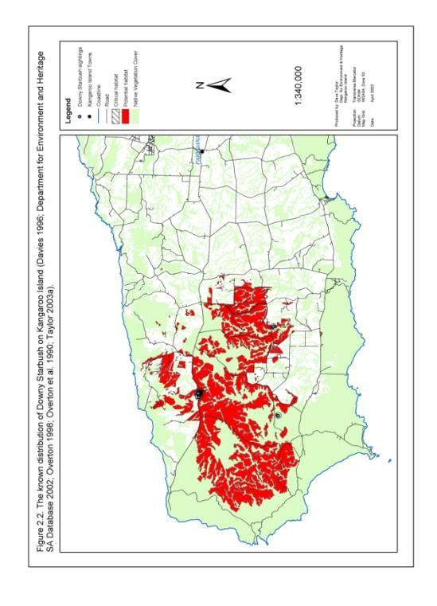

**Figure 2: Known distribution of *Beyeria subtecta* on Kangaroo Island**

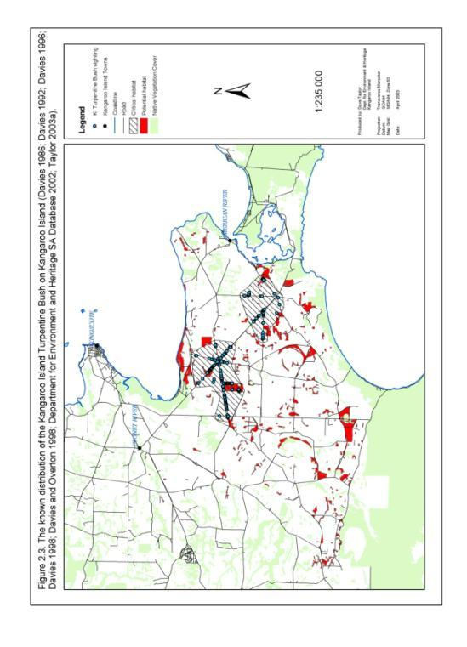

**Figure 3a: Known distribution of *Caladenia ovata* on eastern Kangaroo Island**

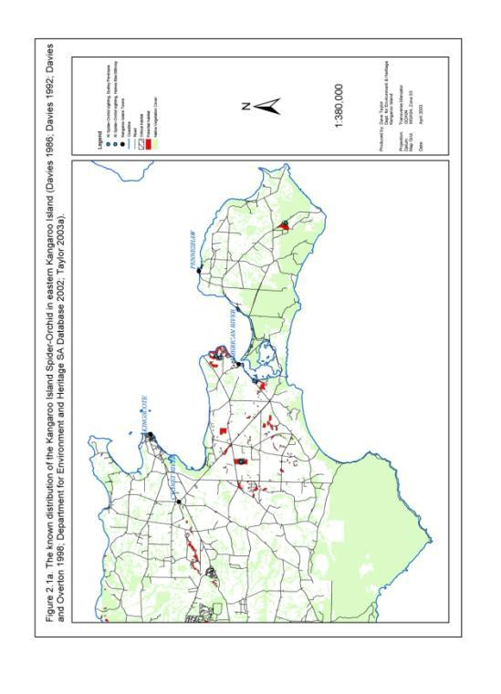

**Figure 3b: Known distribution of *Caladenia ovata* on western Kangaroo Island**

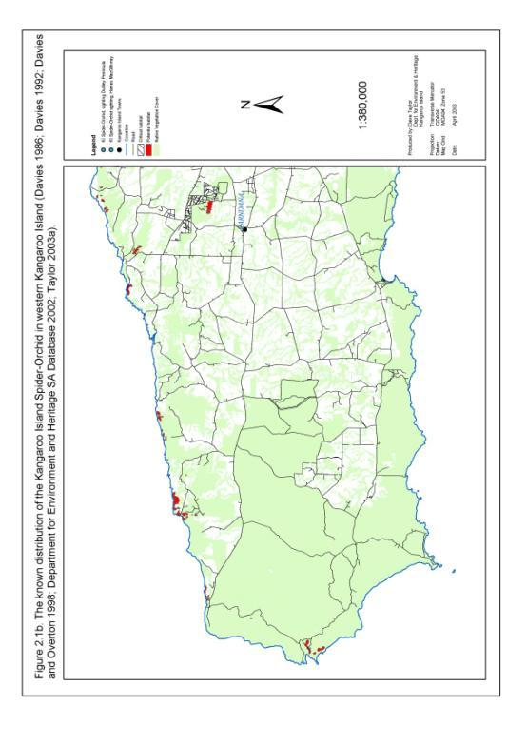

**Figure 4: Known distribution of *Cheiranthera volubilis* on Kangaroo Island**

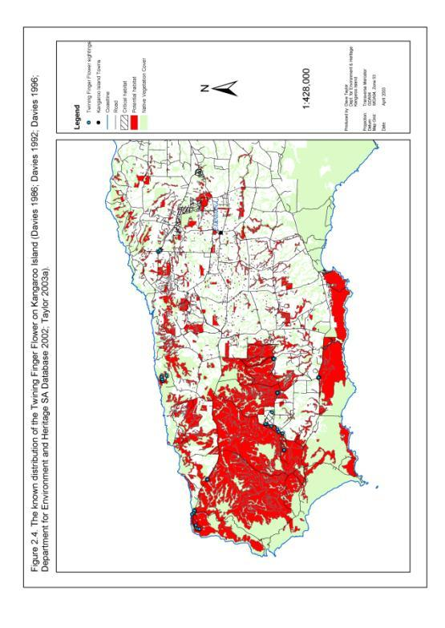

**Figure 5: Known distribution of *Correa calycina var. halmaturorum* on Kangaroo Island**

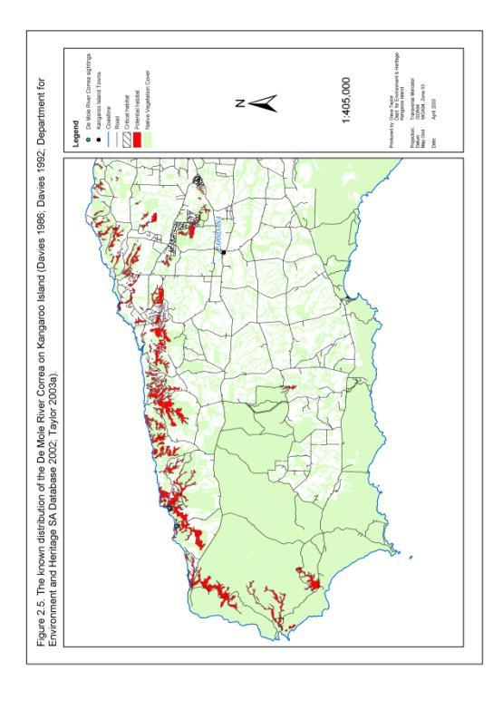

**Figure 6: Known distribution of *Euphrasia collina ssp. osbornii* on Kangaroo Island**

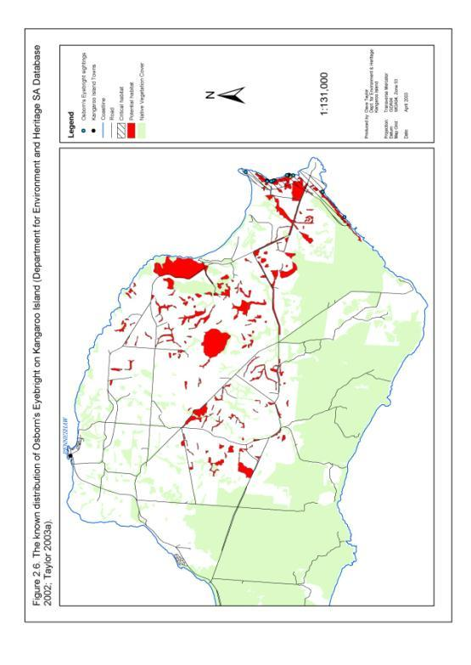

**Figure 7a: Known distribution of *Leionema equestre* on eastern Kangaroo Island**

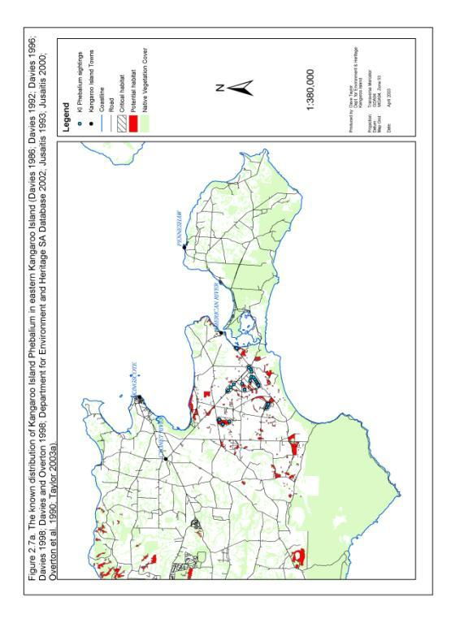

**Figure 7b: Known distribution of *Leionema equestre* on western Kangaroo Island**

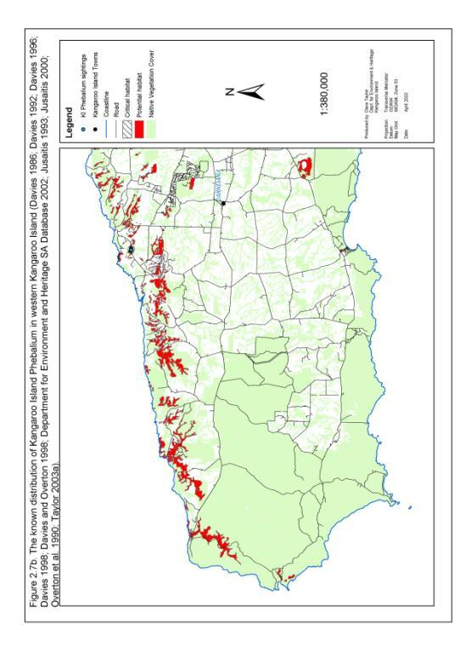

**Figure 8: Known distribution of *Logania insularis* on Kangaroo Island**

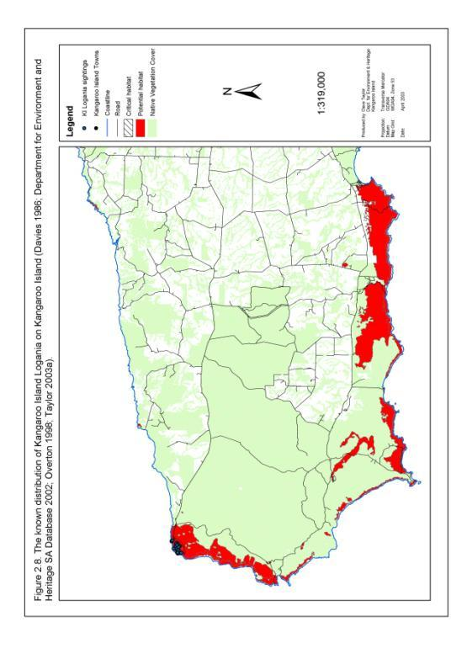

**Figure 9: Known distribution of *Olearia microdisca* on Kangaroo Island**

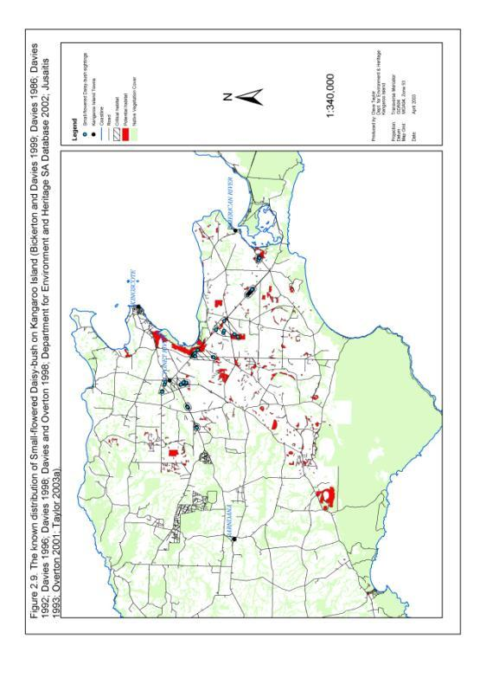

**Figure 10a: Known distribution of *Pomaderris halmaturina ssp. halmaturina* on eastern Kangaroo Island**

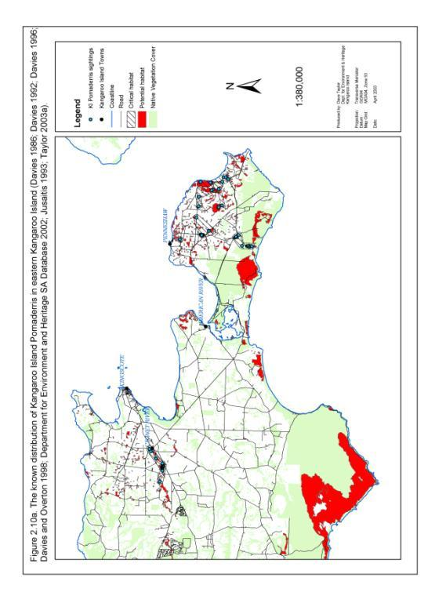

**Figure 10b: Known distribution of *Pomaderris halmaturina ssp. halmaturina* on western Kangaroo Island**

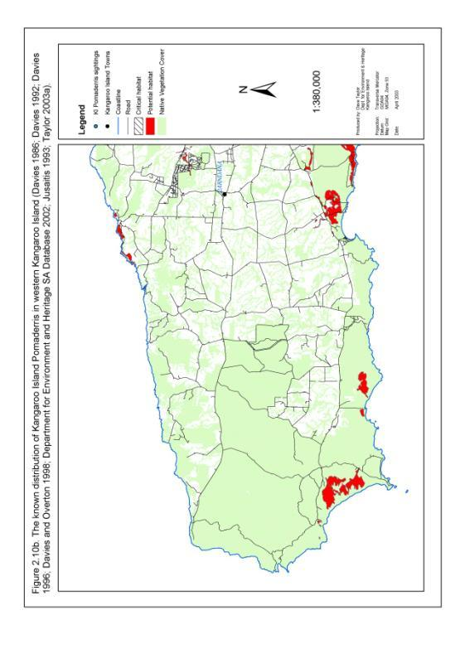

**Figure 11a: Known distribution of *Ptilotus beckerianus* on eastern Kangaroo Island**

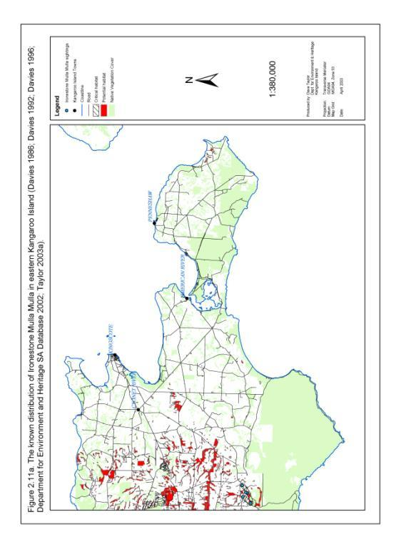

**Figure 11b: Known distribution of *Ptilotus beckerianus* on western Kangaroo Island**

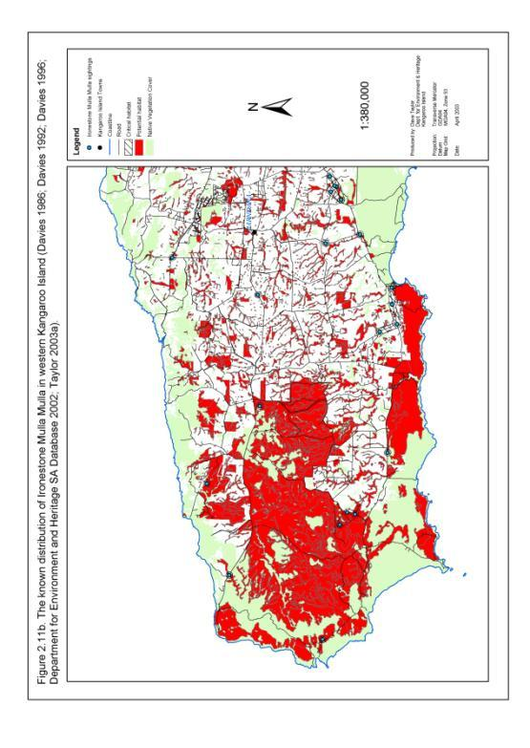

**Figure 12: Known distribution of *Pultenaea insularis* on Kangaroo Island**

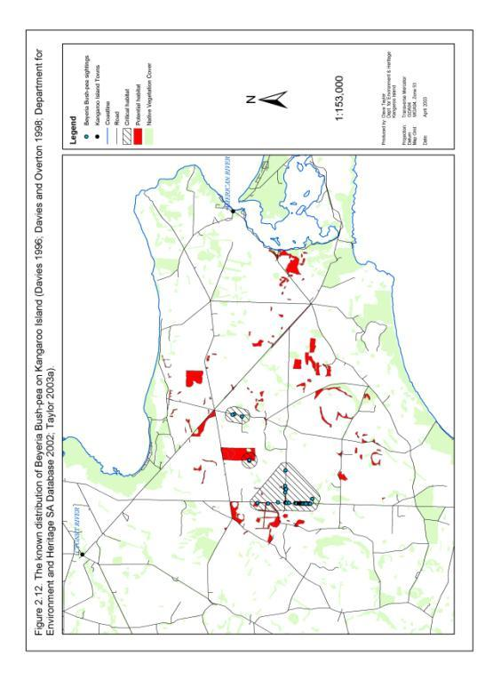

**Figure 13: Known distribution of *Pultenaea villifera var. glabrescens* on Kangaroo Island**

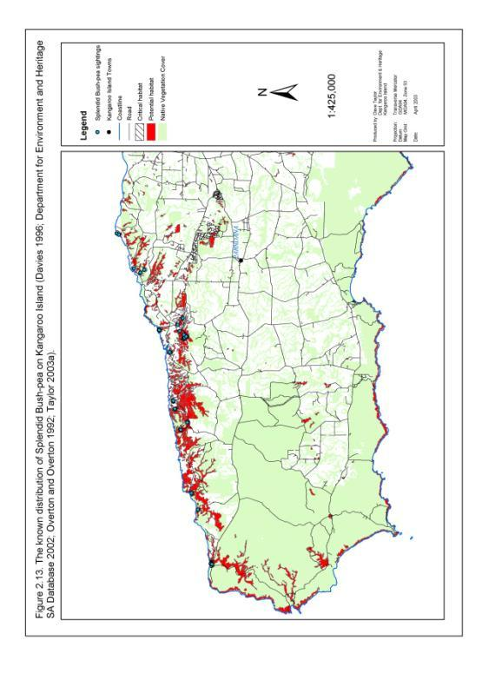

**Figure 14: Known distribution of *Spyridium eriocephalum var. glabrisepalum* on Kangaroo Island**

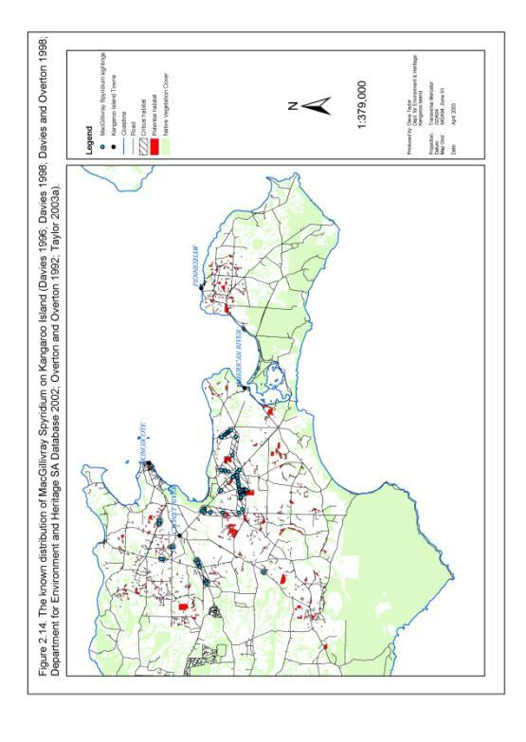

**Figure 15: Known distribution of *Thelymitra matthewsii* on Kangaroo Island**

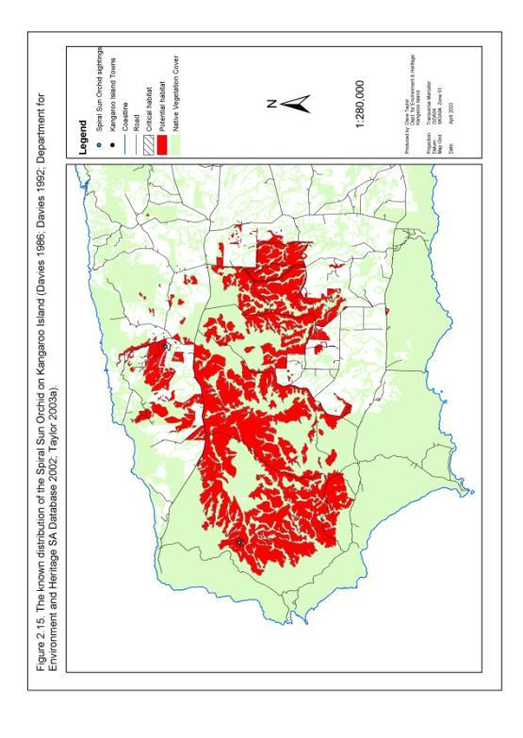

# Figure 16. Priority 1 essential habitat of nationally threatened plant species on Kangaroo Island.

**1a)**

Yes

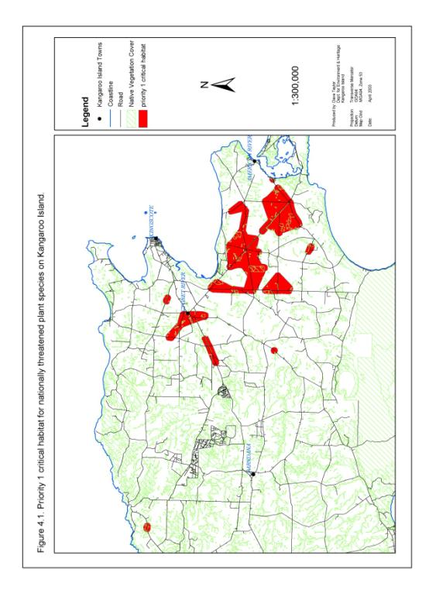

**Figure 17. Priority 1a to 1h essential habitat of nationally threatened plant species on Kangaroo Island.**

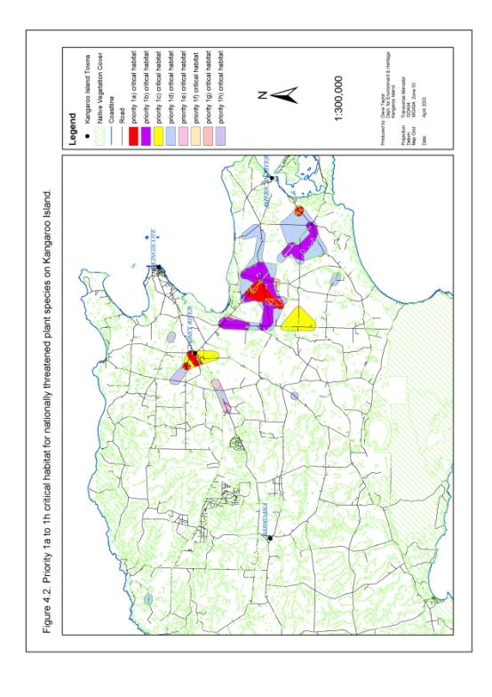

**Appendix B Decision tree to identify areas of priority essential habitat for nationally threatened plant species on Kangaroo Island.**

Priority Essential Habitat

1a)

1c)

1e)

1g)

1b)

1d)

1f)

1h)

2 to 10

Yes

No

Yes

No

Yes

No

Yes

No

Outlier

Outlier

Core

Core

**Vulnerable and Lower Risk**

**Endangered**

**Critically Endangered**

**a) Threatened Species Status**

b) Sub-population Importance

b) Sub-population Importance

b) Sub-population Importance

d) Degree of Threat (Threat Matrix Score)

c) Sub-population Overlap

c) Sub-population Overlap

c) Sub-population Overlap

c) Sub-population Overlap

# Appendix C. Plant communities falling within priority essential habitat of nationally threatened plant species on Kangaroo Island (Ball and Carruthers 1998; Willoughby *et al*. 2001).

|  |  |  |  |
| --- | --- | --- | --- |
| **Plant Community** | **Veg Group Code** | **Regional Status on KI** | **Notes** |
| *Eucalyptus diversifolia, E. albopurpurea, +/- E. cneorifolia, +/- E. cosmophylla, +/- E. fasciculosa* Open mallee | 2M | Threatened | Unique to KI, Restricted, Under-represented |
| *Eucalyptus diversifolia, E. albopurpurea, E. leptophylla, +/- E. cneorifolia, +/- E. cosmophylla* Open mallee | 2P | Threatened | Unique to KI, Restricted, Under-represented |
| *Eucalyptus diversifolia, E. cosmophylla, +/- E. cneorifolia* Very open mallee | 2V | Rare | Unique to KI, Restricted |
| *Eucalyptus cladocalyx, E. fasciculosa, E. obliqua, +/- E. leucoxylon* ssp. *leucoxylon, E. cosmophylla, +/- E. viminalis* ssp. *cygnetensis* Woodland | 5A | - | Unique to KI, Under-represented |
| *Eucalyptus cladocalyx* Open woodland | 5E | Threatened | Unique to KI, Under-represented (may be threatened sub-group of another community) |
| *Eucalyptus cneorifolia, E. rugosa, +/- E. diversifolia, +/- E. rugosa* Open mallee | 11A | Threatened | Unique to KI, Localised, Under-represented |
| *Eucalyptus cneorifolia, E. albopurpurea, E. diversifolia, +/- E. cosmophylla* Open mallee | 11D | Threatened | Unique to KI, Restricted, Under represented |
| *Eucalyptus cneorifolia, +/- E. rugosa, +/- E. rugosa* Very open mallee | 11E | Threatened | Unique to KI, Under-represented |
| *Eucalyptus cneorifolia, E. albopurpurea, E. rugosa, E. diversifolia, +/-E. cosmophylla* Open mallee | 11F | Threatened | Unique to KI, Under-represented |
| *Eucalyptus cneorifolia, E. diversifolia, E. albopurpurea, +/- E. fasciculosa, E. cosmophylla* Open mallee | 11G | Threatened | Unique to KI, Restricted, Under-represented |
| *Eucalyptus cneorifolia, E. rugosa* Open mallee | 11H | Threatened | Unique to KI, Restricted, Under-represented |
| *Eucalyptus camaldulensis* var. *camaldulensis, E. leucoxylon* ssp. *leucoxylon, +/- E. fasciculosa, +/- E. cladocalyx, +/- E. viminalis* ssp. *cygnetensis, E. cneorifolia* Woodland | 17B | Threatened | Restricted, Under-represented |
| *Allocasuarina verticillata, +/- E. cladocalyx* Low open forest | 19A | Rare | Under-represented |
| *Melaleuca brevifolia, M. gibbosa +/- M. halmaturorum* Shrubland | 22A | Rare | Wetland, Under-represented |
| *Gahnia* spp.*, Melaleuca gibbosa, Leptospernum continentale, Callistemon rugulosus* var. *rugulosus* Permanent swamps or shallow freshwater lakes | 55B | - | - |
| *Melaleuca halmaturorum, M. brevifolia* Permanent deep saltwater lakes | 55D | - | - |
| Key:  Rare – Total remaining area of plant community is less than 2500 ha.  Threatened – Appears preferentially cleared, highly fragmented, threatening processes currently occurring, not (usually) well conserved and/or patches not generally surrounded by other vegetation.  Unique – Contains a mix of species not found together anywhere else in the world.  Restricted – Distribution is concentrated around one area.  Under-represented – Less than 63% of the community is formally conserved on KI (63% is the average amount of remaining native vegetation that is formally conserved across the island). | | | |

# Appendix D: Evaluation of recovery actions in previous 2003 Action Plan

| **Action** | **Score** | **Comments** |
| --- | --- | --- |
| SO1: To ensure sufficient financial and human resources are available to implement all recommended threat abatement actions during the five year span of the recovery plan. | | |
| 1a) Obtain sufficient financial resources from relevant grant schemes, funding bodies and private organisations to implement the actions recommended within the recovery plan. | 3 | Resources obtained to deliver the majority of the recovery actions. |
| 1b) Obtain sufficient and timely resources to employ and maintain Recovery Project Officers. | 3 | Recovery Project Officer employed for the life of the action plan. |
| 1c) Provide professional support and encourage the professional development of the Recovery Project Officers. | 3 |  |
| 1d) Support and encourage stakeholders across Kangaroo Island to actively develop skills and experience in managing nationally threatened plant species. | 3 |  |
| 1e) Develop, encourage, and co-ordinate in-kind support for the implementation of the recovery plan. | 3 | A large number of stakeholders were engaged in the delivery of this action plan and provided in-kind support. |
| SO2: To ensure effective and efficient coordination and implementation of recovery actions to meet recovery objectives. | | |
| 2a) Establish, develop and support an effective Kangaroo Island Threatened Plant Recovery Team. | 3 | Kangaroo Island Threatened Plant Recovery Team maintained throughout delivery of the recovery plan. |
| 2b) Appoint and maintain a Recovery Project Officers to co-ordinate, facilitate  and implement recovery actions. | 3 | Recovery Project Officer employed for the life of the action plan. |
| 2c) Undertake periodic monitoring, evaluation and reporting of the successes and failures of the recovery plan. | 3 |  |
| 2d) Integrate recovery actions into other natural resource planning and management programs on Kangaroo Island. | 3 |  |
| SO3: To determine and maintain a reliable indication of the distribution and abundance of nationally threatened plant species on Kangaroo Island. | | |
| 3a) Undertake a survey of all nationally threatened plant records which have not been recently assessed. | 2 | Priority species well surveyed. Further survey required for lower priority species. |
| 3b) Develop a Geographic Information System (GIS) model to improve identification and mapping of potential habitat and past distribution of nationally threatened plant species on Kangaroo Island. | 1 | Further work required to analyse potential habitat of threatened species. |
| 3c) Undertake strategic surveys of potential habitat for nationally threatened plant species on Kangaroo Island. | 2 | Priority species well surveyed. Further survey required for lower priority species. |
| 3d) Develop and implement a program to monitor the distribution and abundance of nationally threatened plant species on Kangaroo Island. | 3 | Extensive monitoring program well established. |
| 3e) Develop and maintain a regional threatened plant database to effectively, efficiently and securely store survey and monitoring data for nationally threatened plant species on Kangaroo Island. | 2 |  |
| SO4. To develop and maintain a comprehensive understanding of the processes threatening nationally listed plant species on Kangaroo Island | | |
| 4a) Undertake a survey of threats to known records of nationally listed threatened plant species which have not been recently assessed. | 2 | Priority species well surveyed. Further survey required for lower priority species |
| 4b) Develop a database and filing system to store and analyse data on threats to nationally listed plant species on Kangaroo Island. | 2 |  |
| 4c) Undertake and encourage targeted research and monitoring to determine the current and potential impact of threatening processes on nationally threatened plant species on Kangaroo Island. | 2 | Programs established monitoring the impacts of fire regimes, grazing and weeds on nationally threatened plant species. |
| 4d) Undertake field monitoring to determine the effectiveness of all on-ground actions implemented under this plan to abate the impact of threats and impediments to recovery. | 3 | Extensive monitoring program established. |
| 4e) Encourage adaptive threat management by feeding research and monitoring findings directly into recovery actions. | 2 | Further analysis required on some of research findings before they can be adapted to guide recovery actions. |
| SO5. To stabilise and reduce the impacts of fragmentation on nationally threatened plant species on Kangaroo Island | | |
| 5a) Manage the risk of losing genetic diversity within nationally threatened plant populations by collecting seed material and establishing a safe seed store. | 3 | Seed collected and stored as part of Adelaide Botanic Gardens initiative. |
| 5b) Encourage research into the ecological genetics of nationally threatened plant species on Kangaroo Island. | 3 | Research underway. |
| 5c) Encourage the restoration of essential threatened plant habitat. | 2 | Habitat restoration commenced. |
| 5d) Increase the size and area of occupancy of existing sub-populations of nationally threatened plant species by encouraging the self-regeneration of plant populations. | 3 | Regeneration stimulated through prescribed burning. |
| 5e) Increase the population size, area of occupancy and long term self-sustainability of nationally threatened plant species on Kangaroo Island through re-instatement of essential habitat. | 2 | Habitat re-establishment programs involving nationally threatened plant species established. |
| 5f) Improve connectivity between sub-populations and essential habitat of nationally threatened plant species on Kangaroo Island. | 1 |  |
| SO6. To determine and implement disturbance regimes which promote the recovery of nationally threatened plant species and associated critical and potential habitat on Kangaroo Island. | | |
| 6a) Undertake and encourage research to determine appropriate fire regimes for nationally threatened plant species and associated essential and potential habitat on Kangaroo Island. | 3 | Eastern Plains Fire Trial initiative established to foster research to develop a better understanding of the impact of fire regimes. A summary of outcomes of the first phase of this project is provided at Appendix G. |
| 6b) Implement management actions which promote fire regimes appropriate for the effective reproduction, recruitment and recovery of nationally listed species and associated essential and potential habitat on Kangaroo Island. | 2 | Prescribed burns implemented in strategic locations stimulating extensive recruitment of threatened plant species. More widespread action required. |
| SO7. To reverse the decline of habitat potentially important to the long term recovery of nationally threatened plant species on Kangaroo Island. | | |
| 7a) Encourage and support programs to protect, rehabilitate and restore potential habitat of nationally threatened plant species on Kangaroo Island | 2 |  |
| SO8. To develop stakeholder awareness, appreciation and ownership of nationally threatened plant species on Kangaroo Island and encourage active involvement in their future management. | | |
| 8a) Undertake a comprehensive campaign to increase stakeholder involvement in the management of nationally threatened plant species on Kangaroo Island. | 3 | Community involvement in threatened plant management on Kangaroo Island greatly increased during the life of this plan. |
| SO9. To expand and develop collective knowledge and understanding the ecology and biology of nationally threatened plant species on Kangaroo Island | | |
| 9a) Undertake and encourage research into the ecology of nationally threatened plant species on Kangaroo Island. | 2 | Extensive monitoring program established. Further work is required to explore interactions of threatened plants with fauna. |
| 9b) Undertake and encourage research into the biology of nationally threatened plant species on Kangaroo Island. | 2 |  |
| 9c) Re-assess the essential and potential habitat of nationally threatened plant species. | 2 | Further analysis of habitat data required. |
| SO10. To minimise the impact of *Phytophthora* spp. on nationally threatened plant species on Kangaroo Island | | |
| 10a) Undertake soil sampling to determine the presence of *Phytophthora* spp. at suspected sites within 5 km of priority 1 essential habitat of nationally threatened plant species. | 1 | Further soil sampling of *Phytophthora* spp. distribution required. |
| 10b) Encourage and support the development of a Kangaroo Island *Phytophthora* Management Strategy. | 1 |  |
| 10c) Undertake and encourage monitoring and research to determine the impact of *Phytophthora* spp. on nationally threatened plant species. | 1 | Current and potential impact of *Phytophthora* spp. is still poorly understood. |
| 10d) Encourage research to determine the efficacy of fungicides in mitigating the impact of *Phytophthora* spp. on nationally threatened plant species. | 1 |  |
| SO11.To protect nationally threatened plant species on Kangaroo Island from the future impact of potential pest species. | | |
| 11a) Support the establishment of a Kangaroo Island environmental weed management committee. | 3 | Kangaroo Island environmental weed management group established and supported during the life of this plan. |
| 11b) Support the development and implementation of a Kangaroo Island quarantine and pest strategy. | 2 |  |
| SO12. To establish grazing regimes which have a minimal impact on the growth, reproduction and recruitment of nationally threatened plant species on Kangaroo Island | | |
| 12a) Restrict grazing of domestic stock in remnant vegetation within essential habitat of nationally threatened plant species. | 2 |  |
| 12b) Undertake research and monitoring to determine the current and potential impact of native herbivore grazing on the growth, reproduction and recruitment of nationally threatened plant species on Kangaroo Island. | 3 | Extensive monitoring program established. |
| 12c) Implement actions to promote native herbivore grazing regimes which have a minimal impact on the growth, reproduction and recruitment of nationally threatened plant species on Kangaroo Island. | 2 | Grazing managed in area of extensive threatened plant regeneration (priority prescribed burn sites). |
| SO13. To protect nationally threatened plant species and associated critical habitat on Kangaroo Island from the impact of environmental weeds | | |
| 13a) Strategic control of infestations of Bridal Creeper, Bridal Veil, *Phalaris* and Perennial Veldt Grass within essential habitat of nationally threatened plant species on Kangaroo Island. | 2 | Control efforts undertaken with mixed success. |
| 13b) Implementation of environmental weed buffer zones around sub-populations of nationally threatened plant species on Kangaroo Island. | 1 |  |
| 13c) Assist and support the control of Bridal Veil on Kangaroo Island. | 3 | Extensive program implemented to control Bridal Veil. |
| 13d) Undertake, support and encourage trials to determine the most resource efficient and effective weed management techniques. | 3 | Control technique trials established. |
| 13e) Undertake, support and encourage research and monitoring to determine the impact of environmental weeds on nationally threatened plant species and their associated essential habitat. | 2 | Extensive monitoring program established to monitor threatened plant populations. |
| SO14. To prevent the clearance of nationally threatened plant species and associated critical and potential habitat on Kangaroo Island | | |
| 14a) Provide advice on the distribution and abundance of nationally threatened plant species to relevant land managers and organisations governing vegetation clearance in order to prevent further clearance of essential and potential habitat. | 2 |  |
| SO15. To reduce the risk and impact of vegetation trampling in critical habitat on nationally threatened plant species on Kangaroo Island | | |
| 15a) Undertake a general public education program to raise community awareness of the importance of roadside vegetation as habitat for nationally threatened plant species. | 3 |  |
| 15b) Implement appropriate signage within nationally threatened sub-populations considered to be susceptible to ongoing or high impact trampling from human activities. | 3 | Signage erected in key areas. |
| 15c) Investigate and implement actions to restrict access to sites where the impact of trampling is leading to, or is highly likely to lead to, a decline in the abundance of nationally threatened species sub-populations. | 3 | Fencing erected at key sites restricting traffic movement. |
| SO16. To protect nationally threatened plant species on Kangaroo Island from the impact of soil salinity. | | |
| 16a) Undertake monitoring and research to determine the impact of soil salinity on nationally threatened plant species. | 2 | Extensive monitoring program established. |
| 16b) Provide ongoing advice, support and encouragement to catchment-based programs mitigating the impact of salinity on Kangaroo Island. | 1 |  |
| SO17. To protect nationally threatened plant species and associated critical habitat on Kangaroo Island from the impact of erosion | | |
| 17a) Monitor nationally threatened species sub-populations and essential habitat to determine the impact of erosion. | 3 | Extensive monitoring program established. |
| 17b) Encourage land managers to rehabilitate areas of essential and potential threatened plant habitat affected by erosion. | 3 |  |
| 17c) Undertake actions to rehabilitate specific sites identified as facing a significant threat from erosion. | 3 | Mitigation actions undertaken at key roadside threatened plant species sites. |

**Key to Scores**

1. No progress/cannot be assessed
2. Insufficient action to meet criteria
3. Action underway – most elements of action met or it is anticipated they will be
4. Criteria met – further action may or may not be required

# Appendix E: Stakeholder Evaluation Summary

|  |
| --- |
| Awareness of action plan |
| All respondents indicated that they were aware of the action plan. In many instances this awareness had arisen from direct involvement with a recovery action (fire trials, tree planting festival) or as an owner of a property on which actions had been implemented, rather than knowledge of the action plan document and its contents. This indicates the importance of talking about the action plan and using it to give background context to field based activities when dealing with activity participants. |
| Understanding of the action plan |
| There is a high level of understanding that the plan is about protecting threatened species on Kangaroo Island and taking action to mitigate the threats facing these species. Many respondents focussed on those actions that they had personally been involved with and did not always recognise the breadth of actions that were incorporated into the plan. |
| Influence of action plan |
| Landholders and land management consultants have been influenced by the plan in the management of native vegetation on rural properties and/or adjoining road reserves.  Community groups have used project activities directed by the plan to encourage participation and involvement in environmental works by their members.  Natural Resource Management (NRM) Board & Department of Environment, Water &Natural Resources (DEWNR) officers have found the data and information generated by the plan (e.g. GIS layers) to be very useful in their project development and on-ground works planning and prioritisation.  Country Fire Service (CFS) officers have found that the implementation of the plan’s actions (i.e. fire trials) has provided training opportunities for their volunteers and has helped change community attitudes around prescribed burns outside of public lands. The data/information arising from the fire trial components of the plan have influenced the development of fire management plans within the region. |
| Action plan effectiveness |
| There is general consensus amongst respondents that the plan has been effective from an implementation perspective, i.e. many actions contained within the plan have been resourced and implemented. They like the fact that the plan has successfully moved from its ‘planning’ phase into implementation of on-ground activities. In this sense the plan has been successful in providing overall strategic direction and goals.  The plan has tried to achieve both community and ecological/science outcomes and so managing stakeholder expectations has been important.  Several respondents indicated it was too early to ascertain the long-term effectiveness of the plan although they felt that the early response/results were encouraging and positive. |
| Increasing effectiveness of action plan |
| All stakeholders indicated the need for ongoing resources to ensure the effectiveness of the plan into the future.  Making the plan document more accessible to the community and stakeholders was also seen as important by several respondents. Suggestions included the production of a succinct, easy to read executive summary, information leaflets on individual plant species, enhanced use of web technology to present results and opportunities for involvement.  A continued emphasis on partnerships and relationships with key stakeholders was seen as an important factor in the plan’s future effectiveness.  Ensuring that the results arising from the plan’s implementation drive adaptive management and influence future plan actions was also raised as being important. |
| Other comments |
| The Project Officer associated with the action plan’s implementation is a key success factor in the community’s awareness of the plan and its effectiveness.  The action plan and its implementation has been a great example of the different elements of the community (landholders, CFS, volunteers, Kangaroo Island Council, NRM Board, DEWNR) working together. |

**Appendix F:**

**Habitat re-establishment under the Kangaroo Island Nationally Threatened Plant Project: 2004-2012**

David Taylor and Heiri Klein

Kangaroo Island Nationally Threatened Plant Project

Department of Environment and Natural Resources

June 2012

**1. Introduction**

The habitat re-establishment component of the KI Nationally Threatened Plant Project (KINTPP) was established in 2004 to implement a key recommendation of the recovery plan for nationally threatened plant species on Kangaroo Island (Taylor 2003). This plan identified the expansion of threatened plant populations and associated plant communities as an important long term strategy to prevent the ongoing decline and eventual loss of five threatened plant species endemic to the highly fragmented landscapes of eastern Kangaroo Island.

This report provides a concise summary of the achievements of this program since 2004. It also documents the organisational strategy of the KI Planting Festival, a unique event developed under the KINTPP to achieve landscape scale conservation and social outcomes.

**2. Summary of Achievements**

The habitat re-establishment component of the KINTPP began in 2004 on Cygnet Park Sanctuary (CPS), a private property established by Jack May and Hilary Austen in the lower Cygnet River Valley to conserve Kangaroo Island wildlife. Remnant vegetation within and adjacent to CPS supported declining populations of three nationally threatened plant species and the site was considered ideal for trialling techniques to reconstruct diverse and self-sustaining habitat for these and a further two nationally threatened plant species.

Between 2004 and 2006 the KINTPP established a series of small scale trials to test conventional habitat re-establishment techniques (Table 1, Map 1). This work was managed by the Department of Environment and Natural Resources (DENR) and funded through state and commonwealth grant programs through the KI Natural Resources Management Board. From these trials four key methodological impediments to the delivery of landscape scale habitat re-establishment in eastern Kangaroo Island were identified. Firstly, conventional habitat re-establishment projects on Kangaroo Island typically used plastic guards to protect plantings from native herbivore grazing. However this technique was labour intensive, costly and not suitable for large scale plantings. Secondly, the early trial work demonstrated that pasture grass and weed competition greatly reduced the survivorship and growth of planted and seeded native vegetation. Herbicide treatment was shown to be cost-effective in reducing this effect, but only in the short term. Thirdly, more than 300 species of native plant were known to occur in association with threatened plant species in eastern Kangaroo Island however techniques to germinate and propagate the majority of these species were poorly developed. Lastly, most conventional small scale re-establishment projects on Kangaroo Island relied on small groups of volunteers or staff drawn from a small island population to help them plant seedlings. New cost effective planting methodologies were required to plant much larger numbers of seedlings across much larger areas.

Methodical testing and adaptation of techniques to address each of these impediments led to the expansion of the project to two other sites in the lower Cygnet River Valley in 2007 and then to much larger and more diverse plantings in the period 2008-2011 (Table 1, Map 1). Overall 398,543 plants were propagated and planted over an area of 211.8 ha on seven different properties. Most of this was focussed at Cygnet Park Sanctuary which now supports the largest patch of native vegetation in the lower Cygnet River Valley, including significant populations of nationally threatened plant species.

Table 1. Timeline of habitat re-establishment activities under the KINTPP, 2004-2011.

|  |  |  |  |  |  |
| --- | --- | --- | --- | --- | --- |
| Year | Site | Owner/ Manager | Area  (ha) | Number of Seedlings Planted | Plant community established |
| 2004 | Cygnet Park Sanctuary (south western corner), Ropers Rd Cygnet River | Jack May and Hilary Austen | 2.6 | 6,000 | *E. cneorifolia* Woodland |
| 2005 | Racecourse Scrub, corner of Hog Bay Rd and Min Oil Rd, Haines. | KI Council | 3.6 | 1,000 | *E. cneorifolia* Woodland |
| 2005 | Cygnet Park Sanctuary (south western corner), Ropers Rd Cygnet River | Jack May and Hilary Austen | 0.6 | 3,560 | *E. cneorifolia* Woodland |
| 2006 | Racecourse Scrub, corner of Hog Bay Rd and Min Oil Rd, Haines. | KI Council | 2.0 | 3,500 | *E. cneorifolia* Woodland |
| 2006 | Cygnet Park Sanctuary (south western corner), Ropers Rd Cygnet River | Jack May and Hilary Austen | 1.0 | 7,547 | *E. cneorifolia* Woodland |
| 2007 | Playford Highway, Cygnet River | Graham and Carys Ingram | 11.0 | 1,144 | *E. camaldulensis/E. leucoxylon* Forest |
| 2007 | Petwood Farm, corner of Playford Highway and Birchmore Rd, Cygnet River. | Neville and Sue Humphrys | 0.7 | 2,892 | *E. cneorifolia* Woodland |
| 2007 | Cygnet Park Sanctuary (south western corner and riparian habitat), Ropers Rd Cygnet River | Jack May and Hilary Austen | 24.3 | 12,557 | Primarily *E. cneorifolia* Woodland with some small areas of *E. camaldulensis/E. leucoxylon F*orest. |
| 2008 | Cygnet Park Sanctuary (north-eastern corner), Ropers Rd Cygnet River | Jack May and Hilary Austen | 23.6 | 82,840 | Primarily *E. cneorifolia* Woodland interspersed with small areas of *E. camaldulensis/E. leucoxylon* Forest. |
| 2009 | Duck Lagoon, Kookaburra Rd, Cygnet River. | KI Council, Rosalie Chirgwin | 0.7 | 100 | Understorey species for *E.camaldulensis* Forest. |
| 2009 | Boxer Rd, Menzies (2 sites) | Rodney Bell | 8.0 | 3,580 | Primarily *E. cneorifolia* Woodland interspersed with small areas of *Allocasuarina verticillata* Woodland |
| 2009 | Hog Bay Rd and Wallers Rd (3 sites), Haines. | Robert and Ali Ayliffe | 16.2 | 54,000 | *E. cneorifolia* Woodland |
| 2010 | Cygnet Park Sanctuary (north and north-east side), Ropers Rd Cygnet River. | Jack May, Hilary Austen, Dave and Penny Paton, Nature Foundation SA | 55.8 | 96,823 | Primarily *E. cneorifolia* Woodland interspersed with small areas of *Allocasuarina verticillata* Woodland and *E. camaldulensis/E. leucoxylon* Forest. |
| 2011 | Cygnet Park Sanctuary (south side and north-west corner), Ropers Rd Cygnet River. | Jack May, Hilary Austen, Dave and Penny Paton, Nature Foundation SA | 61.7 | 123,000 | Primarily *E. cneorifolia* Woodland interspersed with small areas of *Allocasuarina verticillata* Woodland and *E. camaldulensis/E. leucoxylon* Forest. |
|  |  | **Totals** | **211.8** | **398,543** |  |

Map 1. The location of habitat re-established under the KINTPP in eastern Kangaroo Island, 2004-2011.

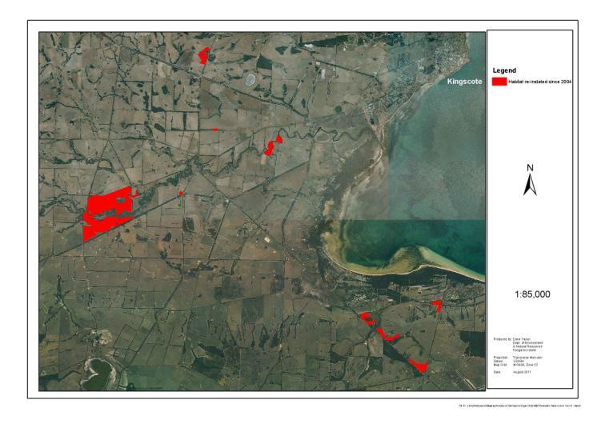

**3. The KI Planting Festival – Achievements, Objectives and Principles**

***3.1 Achievements***

The KI Planting Festival was developed as a multi-day volunteer planting event to facilitate the planting of large numbers of propagated seedlings over large areas in a short time period. The principles underpinning the KI Planting Festival were developed and tested during small scale plantings in the period 2004-2007. The first festival was held on three properties in 2007 (Table 2). Careful observation and improvement of the format, structure and delivery of the festival during each subsequent year was a catalyst for the growth of the event and the delivery of more significant habitat re-establishment outcomes. A total of 334,179 seedlings were planted during five KI Planting Festivals. The largest KI Planting Festival was held in July 2011 and involved 702 people in the planting of 120,000 seedlings over a three day period.

Table 2. A history of planting festivals held by the KINTPP, 2007-2011.

|  |  |  |  |  |  |  |  |
| --- | --- | --- | --- | --- | --- | --- | --- |
| Year | Date | Site | Area | Number of Planting Hours | Number of Participants over each 3 day period | Number of Seedlings Planted | Average Number of Seedlings Planted per hour |
| 2007 | 6-9 July | Cygnet Park Sanctuary, Ingrams Property, Humphrys Property | 15 ha | 18 hrs | 60 | 15,253 | 847 |
| 2008 | 4-6 July | Cygnet Park Sanctuary | 23.5 ha | 18 hrs | 256 | 65,000 | 3,611 |
| 2009 | 3-5 July | Robert and Ali Ayliffes Property | 13 ha | 18 hrs | 255 | 43,000 | 2,389 |
| 2010 | 2-4 July | Cygnet Park Sanctuary | 44 ha | 18 hrs | 485 | 90,926 | 5,056 |
| 2011 | 8-10 July | Cygnet Park Sanctuary | 53 ha | 16 hrs | 702 | 120,000 | 7,500 |
|  |  | **Total** | **148.5 ha** | **88 hrs** | **1758** | **334,179** |  |

**Appendix G: Executive Summary from Eastern Plains Fire Trial: Progress Report, Preliminary Findings and Future Recommendations (Taylor 2011a)**

This report documents progress in the implementation of the Eastern Plains Fire Trial (EPFT), a project developed by the EPFT Working Group (2008), during the period February 2008 to December 2010. It also captures some of the early findings and observations of the project and concludes with a series of recommendations to help guide the implementation of future fire management projects on Kangaroo Island.

Significant Onground Delivery Milestones

Phase 1 (small experimental sites, < 5 ha) of the EPFT was completed between 9th October 2008 and 23rd November 2010. This involved 36 prescribed burns covering 98.07 ha. A significant effort was committed to burn implementation (96 people contributing 3158 hrs) as well as burn planning and pre-burn ecological surveys.

Progress against anticipated Knowledge, Ecological and Social outcomes of the EPFT

Significant progress has been made in delivering five anticipated outcomes of the EPFT:

*Increased knowledge of the fire ecology of eastern Kangaroo Island (O1) and an improvement in bushland condition at each site (O2)*

While the majority of post burn surveys are yet to be completed and analysed the project has collected a number of interesting anecdotal observations of the response of narrow-leaved mallee plant communities to prescribed fire. These have confirmed that burning small areas of long unburnt narrow-leaved mallee (*Eucalyptus cneorifolia*) can promote a regeneration event that greatly increases the above ground diversity of these plant communities. However this effect was not uniform across all the sites and the diversity of a number of sites remained unchanged or declined post fire. Key factors observed influencing native plant regeneration at sites were edge effects, fire intensity, native herbivore grazing and site condition.

*An improvement in fire management practices (O3)*

A unique operational method was developed during phase 1 of the EPFT to address the challenges of undertaking a burn program in long unburnt vegetation in close proximity to a large proportion of the Kangaroo Island population. A central element of this method was the co-ordination, management and delivery of the project by a core body of staff. An emphasis was placed on developing techniques to prepare sites, manage relationships, select appropriate burn conditions, manage burn logistics and crew, and implement onground fire management.

*A strengthening of partnerships between land managers and heightened public involvement in bushland and fire management on Kangaroo Island (O4)*

Delivery of phase 1 of the EPFT was dependent on strong partnerships and effective co-operation between 14 different stakeholder groups. A total of 207 different people were either involved or came into direct contact with the EPFT. Of these, 154 made a direct contribution to the implementation of phase 1 of the EPFT by assisting with field operations and/or contributing to project development and management. This large number of direct contributors significantly increased public involvement in fire management in eastern Kangaroo Island.

The project also increased or renewed landholder interest in bush management and protection. A total 28.0 ha of bushland was fenced off from livestock and 11.3 ha of habitat was re-established alongside EPFT burn sites. This work contributed to the broader conservation of heavily fragmented and declining narrow-leaved mallee plant communities in eastern Kangaroo Island.

*An important first step in the development of a fire management plan for eastern Kangaroo Island (O5)*

Phase 1 of the EPFT represents a first step in the gathering of the specialised ecological and operational knowledge required to develop a comprehensive fire management plan for eastern Kangaroo Island. Continued observation and data collection at each EPFT site is critical to improving this knowledge.

Conclusion and Recommendations

Phase 1 of the EPFT was highly successful and significant progress was made towards meeting the anticipated knowledge, ecological, social and management outcomes of the broader EPFT project.

To further build on these achievements this report recommends six key actions:

R1. Continue the post burn monitoring of flora and fauna at each of the 36 sites completed under phase 1 of the EPFT until at least the end of 2012.

R2. Develop a series of formalised guidelines for the future use of prescribed fire to stimulate the regeneration of long unburnt plant communities in eastern Kangaroo Island. These guidelines should be based on a thorough analysis of the field data collected as part of the monitoring of phase 1 sites of the EPFT (completion by end 2014).

R3. Implement phase 3 (large sites, >30 ha) of the EPFT by mid 2012 to improve understanding of the role of fire in stimulating native plant regeneration at large sites. Phase 3 should include plant communities other than narrow-leaved mallee and develop and test new operational methods for burning large areas.

R4. Replace the EPFT in mid 2012 with a new fire management program focussed on encouraging regeneration in long unburnt plant communities across Kangaroo Island.

R5. Commence a research project to develop methods of restoring the regeneration capacity of long unburnt remnants that will respond poorly to prescribed burning in their current state (commence in 2012).

R6. Use the preliminary findings and observations of this report to guide the development and implementation of future fire management projects on Kangaroo Island until a more rigorous analysis of scientific data is completed.

# Appendix H. Funds required to implement the recovery plan for nationally threatened plant species on Kangaroo Island.

|  |  |  |  |  |  |  |  |
| --- | --- | --- | --- | --- | --- | --- | --- |
| Actions | Likely Expenses | Year 1  $ | Year 2  $ | Year 3  $ | Year 4  $ | Year 5  $ | **Total**  **$** |
| 1b | Employment (PSO2 + 25% on-costs)  Employment (PSO1+ 25% on-costs)  Employment (GSE4 + 25% on-costs) | 195000 | 204750 | 214988 | 225737 | 237024 | **1077499** |
| 1c | Office, vehicle, travel, publishing, training | 25000 | 26250 | 27563 | 28941 | 30388 | **138142** |
| 2a | Travel, wages, venue hire | 1000 | 1050 | 1103 | 1158 | 1216 | **5527** |
| 2b | Recruitment expenses | 5000 |  |  |  |  | **5000** |
| 2c | Report publishing | 300 | 315 | 331 | 347 | 365 | **1658** |
| 3a | Maps, GPS, compass | 1000 |  |  |  |  | **1000** |
| 3c | Contract wages |  |  |  | 10000 |  | **10000** |
| 3d | Tape, paint, tags, stakes and quadrats |  |  |  | 10000 |  | **10000** |
| 3f | Contract wages |  |  |  | 10000 |  | **10000** |
| 4c | Tape, paint, tags, stakes, quadrats, student support | 5000 | 5250 | 5513 | 5788 | 6078 | **27629** |
| 5a | Bags, transport, postage, contract wages | 5000 | 5250 | 5513 | 5788 | 6078 | **27629** |
| 5c + 5e | Pre-treatment, fencing, propagation, seeding, planting costs, post planting management | 150000 | 157500 | 165375 | 173644 | 182326 | **828845** |
| 6a + 6b | Ecological burn and survey costs – contract wages, survey equipment, hydroaxe treatments, fencing, fire break maintenance | 100000 | 105000 | 110250 | 115763 | 121551 | **552564** |
| 8a | Signage, mail-outs, marketing and publishing costs | 6000 | 6300 | 6615 | 6946 | 7293 | **33154** |
| 9a + 9b | Student support (travel accommodation, survey equipment) | 5000 | 5250 | 5513 | 5788 | 6078 | **27629** |
| 10a | Soil tests |  |  |  |  | 5000 | **5000** |
| 12a + 12b + 12c | Materials, contract wages, survey contract wages. | 10000 | 10500 | 11025 | 11576 | 12155 | **55256** |
| 13c | Contractors, training, equipment | 5000 | 5250 | 5513 | 5788 | 6078 | **27629** |
| 18a | Contract wages |  |  |  |  | 20000 | **20000** |
| **Total ($)** | | **513300** | **532665** | **559302** | **617264** | **641630** | **2864161** |

# Appendix I. Nationally, state and regionally threatened plant species recorded at sites of significance within priority essential habitat (Davies 1996; Willoughby *et al*. 2001).

|  |  |  |  |
| --- | --- | --- | --- |
| Plant Species | Status | | |
| National (Aus) | State (SA) | Regional (KI) |
| *Acacia acinacea* |  |  | E |
| *Acacia simmonsiana* |  | V | E |
| *Acacia farinosa* |  |  | V |
| *Beyeria subtecta* | V | V | V |
| *Caladenia ovata* | V | V | E |
| *Carex inversa* var. *major* |  | R | K |
| *Cheiranthera alternifolia* |  |  | E |
| *Cyphanthera myosotidea* |  |  | V |
| *Daviesia arenaria* |  |  | V |
| *Dodonaea bauera* |  |  | K |
| *Dodonaea hexandra* |  |  | K |
| *Elymus scabrus* var. *scabrus* |  |  | V |
| *Eremophila behriana* |  |  | K |
| *Eremophila glabra* subsp. *glabra* |  |  | E |
| *Eutaxia microphylla* var*. diffusa* |  |  | E |
| *Grevillea muricata* |  | V | R |
| *Hibbertia obtusibracteata* |  | R | R |
| *Leionema equestre* | E | E | E |
| *Logania linifolia* |  |  | K |
| *Lomandra micrantha* subsp. *micrantha* |  |  | K |
| *Lomandra micrantha* subsp. *tuberculata* |  |  | V |
| *Desmocladus fasciculata* |  | V | E |
| *Olearia microdisca* | E | E | E |
| *Prostanthera chlorantha* |  | R | V |
| *Pultenaea insularis* |  |  | E |
| *Pultenaea tenuifolia* |  | R | R |
| *Spyridium eriocephalum* var. *glabrisepalum* | V | V | V |
| *Austrostipa nitida* |  |  | V |
| *Austrostipa nodosa* |  |  | V |

**Key**

E endangered K Uncommon

R rare V vulnerable