Background Paper:
Nationally Threatened Plant Species on Kangaroo Island Recovery Action Plan

2003-2008

Dept for Environment and Heritage
KI Natural Resources Management Board
Cite as:
Taylor, D.A. (2003). Nationally Threatened Plant Species on Kangaroo Island Recovery Action Plan. Report to the Threatened Species and Communities Section, Department for Environment and Heritage, Government of South Australia.

Further copies of this Background Paper are available from:
Department of Environment, Water and Natural Resources
Kangaroo Island Regional Office
PO Box 39, Kingscote, South Australia, 5223

TABLE OF CONTENTS
TABLE OF CONTENTS i
LIST OF FIGURES iv
LIST OF TABLES vi
1. STATE POLICY AND PLANNING FRAMEWORK 1
1.1 South Australian Strategic Plan 1
1.2 No Species Loss: A Nature Conservation Strategy for South Australia 2007-2017 1
1.3 Naturelinks 1
1.4 State Natural Resources Management Plan 1
1.5 Kangaroo Island Natural Resources Management Plan 2
1.6 Social and Economic Impacts 4
2. SPECIES INFORMATION, DISTRIBUTION AND LOCATION 8
2.1. Species/Communities, Taxonomy and Status 8
2.2 Definitions 9
2.2.1. Determination of Sub-populations 9
2.2.2. Determination of Essential and Potential Habitat 9
2.2.3. Determination of Extent of Occurrence and Area of Occupancy 10
2.2.4. Determination of Important Populations and Sub-populations 10
2.3. Threatened Plant Species 11
2.3.1. Downy Starbush Asterolasia phebalioides 11
2.3.2. Kangaroo Island Turpentine Bush Beyeria subtecta 14
2.3.3. Kangaroo Island Spider-Orchid Caladenia ovata 18
2.3.4. Twining Hand Flower Cheiranthera volubilis 22
2.3.5. De Mole River Correa Correa calycina var. halmaturorum 26
2.3.6. Osborn’s Eyebright Euphrasia collina ssp. osbornii 29
2.3.7. Kangaroo Island Phebalium Leionema equestre 32
2.3.8. Kangaroo Island Logania Logania insularis 37
2.3.9. Small-flowered Daisy-bush Olearia microdisca 40
2.3.10. Kangaroo Island Pomaderris Pomaderris halmaturina ssp. halmaturina 44
2.3.11. Ironestone Mulla Mulla Ptilotus beckerianus 49
2.3.12. Beyeria Bush-pea Pultenaea insularis 55
2.3.13. Splendid Bush-pea Pultenaea villifera var. glabrescens 58
2.3.14. MacGillivray Spyridium Spyridium eriocephalum var. glabrisepalum 62
2.3.15. Spiral Sun Orchid Thelymitra matthewsii 66
3. THREATS AND IMPEDIMENTS TO RECOVERY 69
3.1. Direct Threats 69
3.1.1. Vegetation Clearance 69
3.1.2. Environmental Weeds 70
3.1.3. Grazing 77
3.1.4. Salinity 79
3.1.5. Trampling 79
3.1.6. Erosion 82
3.1.7. Phytophthora 82
3.2. Impediments to Recovery 86
3.2.1. Fragmentation 86
3.2.2. Degraded Potential Habitat 93
3.2.3. Inappropriate Disturbance Regimes 96
3.2.4. Inadequate Knowledge of Distribution and Abundance 97
3.2.5. Inadequate Knowledge of Ecology and Biology 100
3.2.6. Inadequate Knowledge and Understanding of Threatening Processes 100
3.2.7. Potential Pest Species 102
3.2.8. Involvement of Stakeholders 104
3.2.9. Availability of Resources 104
3.2.10. Co-ordination and Integration of Recovery Process 104
3.2.11. Climate Change 104
4. BENEFITS TO OTHER SPECIES/ECOLOGICAL COMMUNITIES 105
4.1 Flora 105
4.2 Fauna 105
5. OBJECTIVES, PERFORMANCE CRITERIA AND ACTIONS 106
5.1. Overall Recovery Strategy 106
5.2. Determination of Recovery Actions 107
5.2.1. Development of a threat matrix 107
5.2.2. Revision of threatened plant species status 107
5.2.3. Identification of species and sites on which to focus recovery actions 109
5.2.4. Identifying when actions should be undertaken 110
5.2.5. Scope of this recovery plan and opportunities for further actions 113
5.2.6. Identifying the role of stakeholders 113
5.3. Threat Abatement. 116
5.3.1. Availability of Resources 116
5.3.2. Co-ordination and Integration of Recovery Process 119
5.3.3. Inadequate Knowledge of Distribution and Abundance 122
5.3.4. Inadequate Knowledge and Understanding of Threats 128
5.3.5. Fragmentation 132
5.3.6. Inappropriate Disturbance Regimes 138
5.3.7. Degraded Potential Habitat 141
5.3.8. Involvement of Stakeholders 143
5.3.9. Inadequate Knowledge and Understanding of Ecology and Biology 145
5.3.10. Phytophthora 148
5.3.11. Potential Pest Species 152
5.3.12. Grazing 154
5.3.13. Environmental Weeds 157
5.3.14. Vegetation Clearance 163
5.3.15. Trampling 164
5.3.16. Salinity 166
5.3.17. Erosion 168
5.3.18. Climate Change 170
5.4. Management Practices 171
6. REFERENCES 174
Appendix A. Nationally, state and regionally threatened plant species recorded at sites of significance within priority 1 essential habitat (Davies 1996; Willoughby et al. 2001). 178
Appendix B. Plant communities falling within priority 1 essential habitat of nationally threatened plant species on Kangaroo Island (Ball and Carruthers 1998; Willoughby et al. 2001). 179
Appendix C. A threat matrix for nationally threatened plant species on Kangaroo Island. 180
Appendix D. Methodology for identifying priority essential habitat of nationally threatened plant species on Kangaroo Island. 193
Appendix E. Classification of 15 threatened plant species status on Kangaroo Island using IUCN redlist criteria (IUCN 2000). 202

LIST OF FIGURES
Figure 2.1. The known distribution of Downy Starbush on Kangaroo Island. 13
Figure 2.2. The known distribution of the Kangaroo Island Turpentine Bush on Kangaroo Island. 17
Figure 2.3a. The known distribution of the Kangaroo Island Spider-Orchid in eastern Kangaroo Island. 20
Figure 2.3b. The known distribution of the Kangaroo Island Spider-Orchid in western Kangaroo Island. 21
Figure 2.4. The known distribution of the Twining Finger Flower on Kangaroo Island. 25
Figure 2.5. The known distribution of the De Mole River Correa on Kangaroo Island. 28
Figure 2.6. The known distribution of Osborn’s Eyebright on Kangaroo Island. 31
Figure 2.7a. The known distribution of Kangaroo Island Phebalium in eastern Kangaroo Island. 35
Figure 2.7b. The known distribution of Kangaroo Island Phebalium in western Kangaroo Island. 36
Figure 2.8. The known distribution of Kangaroo Island Logania on Kangaroo Island. 39
Figure 2.9. The known distribution of Small-flowered Daisy-bush on Kangaroo Island. 43
Figure 2.10a. The known distribution of Kangaroo Island Pomaderris in eastern Kangaroo Island. 47
Figure 2.10b. The known distribution of Kangaroo Island Pomaderris in western Kangaroo Island. 48
Figure 2.11a. The known distribution of Ironstone Mulla Mulla in eastern Kangaroo Island. 53
Figure 2.11b. The known distribution of Ironstone Mulla Mulla in western Kangaroo Island. 54
Figure 2.12. The known distribution of Beyeria Bush-pea on Kangaroo Island. 57
Figure 2.13. The known distribution of Splendid Bush-pea on Kangaroo Island. 61
Figure 2.14. The known distribution of MacGillivray Spyridium on Kangaroo Island. 65
Figure 2.15. The known distribution of the Spiral Sun Orchid on Kangaroo Island. 68
Figure 3.1. Essential habitat of nationally threatened plant species known to be currently threatened by small-scale vegetation clearance activities. 71
Figure 3.2. Essential habitat of nationally threatened plant species known to be currently threatened by Bridal Creeper on Kangaroo Island. 73
Figure 3.3. Essential habitat of nationally threatened plant species known to be currently threatened by Bridal Veil on Kangaroo Island. 74
Figure 3.4. Essential habitat of nationally threatened plant species known to be currently threatened by Perennial Veldt Grass on Kangaroo Island. 75
Figure 3.5. Essential habitat of nationally threatened plant species known to be currently threatened by Phalaris on Kangaroo Island. 76
Figure 3.6. Essential habitat of nationally threatened plant species known to be currently threatened by herbivore grazing on Kangaroo Island. 78
Figure 3.7. Essential habitat of nationally threatened plant species suspected to be under threat from increasing soil salinity on Kangaroo Island. 80
Figure 3.8. Essential habitat of nationally threatened plant species known to be currently threatened to some degree by trampling on Kangaroo Island. 81
Figure 3.9. Essential habitat of nationally threatened plant species known to be under threat to some extent from erosion on Kangaroo Island. 84
Figure 3.10. Essential habitat of nationally threatened plant species currently containing either a confirmed or suspected Phytophthora spp. infestation. 85
Figure 3.11. Essential habitat of nationally threatened plant species on Kangaroo Island containing less than 250 individual plants and considered potentially at risk from declining genetic viability. 88
Figure 3.12. Essential habitat of nationally threatened plant species on Kangaroo Island occurring within vegetation fragments less than 100 ha in size or in vegetation strips with a width no greater than 30 m. 89
Figure 3.13. Essential habitat of nationally threatened plant species with a small area of occupancy (10 sq. km), small population size (<1000 plants) and which occur within a fragmented landscape. 92
Figure 3.14. Essential habitat of nationally threatened plant species on Kangaroo Island occurring wholly or partially within the fragmented landscape of the Seddon, Haines and Dudley Plateaus or the Eastern Plains and therefore likely to be subjected to inappropriate fire regimes. 95
Figure 3.15. Records of nationally threatened plant species on Kangaroo Island not surveyed since January 1995. 99
Figure 3.16. Records of nationally threatened plant species on Kangaroo Island not adequately assessed to determine threatening processes since January 1995. 103
Figure 5.1. Priority 1 essential habitat of nationally threatened plant species on Kangaroo Island. 111
Figure 5.2. Priority 1a to 1h essential habitat of nationally threatened plant species on Kangaroo Island. 112
Figure 5.3. Corridors connecting essential habitat of critically endangered and endangered sub-populations of nationally threatened plant species on Kangaroo Island. 137
Figure 5.4. Suspected sites of Phytophthora spp. infestation within 5 km of essential habitat of critically endangered and endangered nationally threatened plant species on Kangaroo Island. 151
Figure 5.5. Environmental weed buffer zone of one kilometre around essential habitat of critically endangered and endangered nationally threatened plant species on Kangaroo Island. 159
Figure D1. Decision tree to identify areas of priority essential habitat for nationally threatened plant species on Kangaroo Island. 197
Figure D2. Essential habitat of critically endangered, endangered, vulnerable and lower risk nationally listed plant species on Kangaroo Island 198
Figure D3 . Essential habitat of core and outlier sub-populations of critically endangered and endangered nationally listed plant species on Kangaroo Island 199
Figure D4. Area of overlap between essential habitat of critically endangered, endangered, vulnerable and/or lower risk nationally listed plant species on Kangaroo Island 200
Figure D5. Priority 1a to 1h essential habitat for nationally threatened plant species on Kangaroo Island 201

LIST OF TABLES
Table 1 Beneficial and adverse social and economic impacts of the implementation of the proposed recovery plan. 5
Table 2.1. Status of nationally threatened plant species found on Kangaroo Island. 8
Table 2.1. Important known sub-populations of Asterolasia phebalioides listed in order of sub-population size (Davies 1996; Department for Environment and Heritage SA Database 2002; Overton 1998; Overton et al. 1990; Taylor 2003a). 11
Table 2.2. Important known sub-populations of Beyeria subtecta listed in order of sub-population size (Davies 1986; Davies 1992; Davies 1996; Davies 1998; Davies and Overton 1998; Department for Environment and Heritage SA Database 2002; Taylor 2003a). 14
Table 2.3. Broad Kangaroo Island vegetation groups which overlap with the known distribution of Beyeria subtecta (Ball and Carruthers 1998). 16
Table 2.4. Important known sub-populations of Caladenia ovata listed in order of sub-population size (Davies 1986; Davies 1992; Davies and Overton 1998; Department for Environment and Heritage SA Database 2002; Taylor 2003a). 18
Table 2.5. Broad Kangaroo Island vegetation groups which overlap with the known distribution of Caladenia ovata (Ball and Carruthers 1998). 19
Table 2.6. Important known sub-populations of Cheiranthera volubilis listed in order of sub-population size (Davies 1986; Davies 1992; Davies 1996; Department for Environment and Heritage SA Database 2002; Taylor 2003a). 22
Table 2.7. Broad Kangaroo Island vegetation groups which overlap with the known distribution of Cheiranthera volubilis (Ball and Carruthers 1998). 24
Table 2.8. Important known sub-populations of Correa calycina var. halmaturorum listed in order of sub-population size (Davies 1986; Davies 1992; Department for Environment and Heritage SA Database 2002; Taylor 2003a). 26
Table 2.9. Broad Kangaroo Island vegetation groups which overlap with the known distribution of Correa calycina var. halmaturorum (Ball and Carruthers 1998). 27
Table 2.10. Important known sub-populations of Euphrasia collina ssp. osbornii listed in order of sub-population size (Department for Environment and Heritage SA Database 2002; Taylor 2003a). 29
Table 2.11. Broad Kangaroo Island vegetation groups which overlap with the known distribution of Euphrasia collina ssp. osbornii (Ball and Carruthers 1998). 30
Table 2.12. Important known sub-populations of Leionema equestre listed in order of sub-population size (Davies 1986; Davies 1992; Davies 1996; Davies 1998; Davies and Overton 1998; Department for Environment and Heritage SA Database 2002; Jusaitis 1993; Jusaitis 2000; Overton et al. 1990; Taylor 2003a). 32
Table 2.13. Broad Kangaroo Island vegetation groups which overlap with the known distribution of Leionema equestre (Ball and Carruthers 1998). 34
Table. 2.14. Important known sub-populations of Logania insularis listed in order of sub-population size (Davies 1986; Department for Environment and Heritage SA Database 2002; Overton 1998; Taylor 2003a). 37
Table 2.15. Broad Kangaroo Island vegetation groups which overlap with the known distribution of Logania insularis (Ball and Carruthers 1998). 38
Table 2.16. Important known sub-populations of Olearia microdisca listed in order of sub-population size (Bickerton and Davies 1999; Davies 1986; Davies 1992; Davies 1996; Davies 1998; Davies and Overton 1998; Department for Environment and Heritage SA Database 2002; Jusaitis 1993; Overton 2001; Taylor 2003a). 40
Table 2.17. Broad Kangaroo Island vegetation groups which overlap with the known distribution of Olearia microdisca (Ball and Carruthers 1998). 42
Table 2.18. Important known sub-populations of Pomaderris halmaturina ssp. halmaturina listed in order of sub-population size (Davies 1986; Davies 1992; Davies 1996; Davies and Overton 1998; Department for Environment and Heritage SA Database 2002; Jusaitis 1993; Taylor 2003a). 44
Table 2.19. Broad Kangaroo Island vegetation groups which overlap with the known distribution of Pomaderris halmaturina ssp. halmaturina (Ball and Carruthers 1998). 46
Table 2.20. Important known sub-populations of Ptilotus beckerianus listed in order of sub-population size (Davies 1986; Davies 1992; Davies 1996; Department for Environment and Heritage SA Database 2002; Taylor 2003a). 49
Table 2.21. Broad Kangaroo Island vegetation groups which overlap with the known distribution of Ptilotus beckerianus (Ball and Carruthers 1998). 51
Table 2.22. Important known sub-populations of Pultenaea insularis listed in order of sub-population size (Davies 1996; Davies and Overton 1998; Department for Environment and Heritage SA Database 2002; Taylor 2003a). 55
Table 2.23. Important known sub-populations of Pultenaea villifera var. glabrescens listed in order of sub-population size (Davies 1996; Department for Environment and Heritage SA Database 2002; Overton and Overton 1992; Taylor 2003a). 58
Table 2.24. Broad Kangaroo Island vegetation groups which overlap with the known distribution of Pultenaea villifera var. glabrescens (Ball and Carruthers 1998). 60
Table 2.25. Important known sub-populations of Spyridium eriocephalum var. glabrisepalum listed in order of sub-population size (Davies 1996; Davies 1998; Davies and Overton 1998; Department for Environment and Heritage SA Database 2002; Overton and Overton 1992; Taylor 2003a). 62
Table 2.26. Broad Kangaroo Island vegetation groups which overlap with the known distribution of Spyridium eriocephalum var. glabrisepalum (Ball and Carruthers 1998). 64
Table 2.27. Important known sub-populations of Thelymitra matthewsii listed in order of sub-population size (Davies 1986; Davies 1992; Department for Environment and Heritage SA Database 2002; Taylor 2003a). 66
Table 3.1. Sub-populations of nationally threatened plant species known to be currently threatened by small scale vegetation clearance activities (Davies 1996; Davies 1998; Taylor 2003a). 70
Table 3.2. Sub-populations of nationally threatened plant species on Kangaroo Island known to be currently threatened to some extent by the environmental weed species Asparagus asparagoides, A. declinatus, Ehrharta calycina and Phalaris aquatica (Davies 1996; Davies 1998; Taylor 2003a; Taylor et al. 2002). 72
Table 3.3. Sub-populations of nationally threatened plant species known to be under immediate threat from herbivore grazing on Kangaroo Island (Davies 1996; Davies 1998; Taylor 2003a). 77
Table 3.4. Sub-populations of nationally threatened plant species suspected to be under threat to some extent from soil salinity on Kangaroo Island (Davies 1996; Davies 1998; Taylor 2003a). 79
Table 3.5. Sub-populations of nationally threatened plant species known to be under immediate threat from trampling on Kangaroo Island (Davies 1996; Davies 1998; Taylor 2003a). 82
Table 3.6. Sub-populations of nationally threatened plant species known to be under threat to some extent from erosion on Kangaroo Island (Davies 1996; Davies 1998; Taylor 2003a). 82
Table 3.7. Sub-populations of nationally threatened plant species with either a confirmed or suspected Phytophthora spp. infestation site within their essential habitat boundary (Davies 1996; Davies 1998; Taylor 2003a; Taylor 2003b). 83
Table 3.8. Sub-populations of nationally threatened species on Kangaroo Island with less than 250 and 1000 individual plants respectively and considered potentially at risk from declining genetic viability (Bickerton and Davies 1999; Davies 1986; Davies 1992; Davies 1996; Davies 1998; Davies and Overton 1998; Jusaitis 1993; Jusaitis 2000; Overton 1998; Overton 2001; Overton and Overton 1992; Overton et al. 1990; Taylor 2003a; Willoughby et al. 2001). 87
Table 3.9. Plant species with sub-populations partially or wholly occurring within vegetation fragments less than 100 ha in size or in vegetation strips less than 30 m wide and are therefore likely to be significantly influenced by edge effects (Ball and Carruthers 1998; Bickerton and Davies 1999; Davies 1986; Davies 1992; Davies 1996; Davies 1998; Davies and Overton 1998; Jusaitis 1993; Jusaitis 2000; Overton 1998; Overton 2001; Overton and Overton 1992; Overton et al. 1990; Taylor 2003a; Willoughby et al. 2001). 90
Table 3.10. Threatened plant species sub-populations with a small area of occupancy (<10 km²), small population size (<1000 plants) and which occur in a fragmented landscape (Seddon Plateau, Eastern Plains, Haines Plateau and Dudley Plateau, vegetation strip <30 m width or vegetation fragment <100 ha in size) and are therefore most likely to be influenced by distance effects (Ball and Carruthers 1998; Bickerton and Davies 1999; Davies 1986; Davies 1992; Davies 1996; Davies 1998; Davies and Overton 1998; Jusaitis 1993; Jusaitis 2000; Overton 1998; Overton 2001; Overton and Overton 1992; Overton et al. 1990; Taylor 2003a; Willoughby et al. 2001). 93
Table 3.11. Species with sub-populations occurring wholly or partially within the fragmented landscapes of central and eastern Kangaroo Island including Seddon Plateau, Eastern Plains, Haines Plateau and Dudley Plateau (as defined by Willoughby et al. (2001)) (Ball and Carruthers 1998; Bickerton and Davies 1999; Davies 1986; Davies 1992; Davies 1996; Davies 1998; Davies and Overton 1998; Jusaitis 1993; Jusaitis 2000; Overton 1998; Overton 2001; Overton and Overton 1992; Overton et al. 1990; Taylor 2003a; Willoughby et al. 2001). 94
Table 3.12. Nationally threatened plant species on Kangaroo Island observed regenerating after disturbance events (Bickerton and Davies 1999; Davies 1986; Davies 1992; Davies 1996; Davies 1998; Davies and Overton 1998; Jusaitis 1993; Jusaitis 2000; Overton 1998; Overton 2001; Overton and Overton 1992; Overton et al. 1990; Taylor 2003a; Willoughby et al. 2001). 97
Table 3.13. An assessment of the adequacy of current knowledge of the distribution and abundance of nationally threatened plant species on Kangaroo Island (Bickerton and Davies 1999; Davies 1986; Davies 1992; Davies 1996; Davies 1998; Davies and Overton 1998; Jusaitis 1993; Jusaitis 2000; Overton 1998; Overton 2001; Overton and Overton 1992; Overton et al. 1990; Taylor 2003a; Willoughby et al. 2001). 98
Table 3.14. Summary of current knowledge of the biology and ecology of 15 threatened plant species on Kangaroo Island (Bickerton and Davies 1999; Davies 1986; Davies 1992; Davies 1996; Davies 1998; Davies and Overton 1998; Jusaitis 1993; Jusaitis 2000; Overton 1998; Overton 2001; Overton and Overton 1992; Overton et al. 1990; Taylor 2003a; Willoughby et al. 2001). 101
Table 3.15. Nationally threatened plant species on Kangaroo Island adequately field assessed to determine immediate and potential threats (Bickerton and Davies 1999; Davies 1986; Davies 1992; Davies 1996; Davies 1998; Davies and Overton 1998; Jusaitis 1993; Jusaitis 2000; Overton 1998; Overton 2001; Overton and Overton 1992; Overton et al. 1990; Taylor 2003a; Willoughby et al. 2001). 102
Table 4.1 Roadside sites of significance occurring within priority 1 essential habitat of nationally threatened plant species on Kangaroo Island. 105
Table 5.1. Order of threats and impediments to the recovery of 15 threatened plant species on Kangaroo Island based upon a threat matrix (developed under Appendix C). The higher the threat matrix score the higher the incidence and/or likelihood of the threat to all 15 threatened plant species. The highest possible threat score is 135. It should be noted that this table does not acknowledge the links between each individual threat or impediment to recovery. 108
Table 5.2. The Kangaroo Island status of nationally threatened plant species based on IUCN red list criteria (IUCN 2000) compared with their current national status under the Environment Protection and Biodiversity Conservation Act 1999 (EPBC Act 1999) (Appendix E). 109
Table 5.3. List of current and potential regionally, state and nationally based stakeholders in the management of nationally threatened plant species on Kangaroo Island and corresponding stakeholder code. 114
Table 5.4. Priorities for further threatened plant species surveys during 2003/2004 and 2004/2005 based on the percentage of plant species records not adequately assessed since 1995. 123
Table 5.5. Nationally threatened plant species on Kangaroo Island listed in order of priority (based on threatened plant status) for further survey of potential habitat and ongoing monitoring. 125
Table 5.6. Plant species requiring additional survey to determine their status and eligibility for listing under the Environment Protection and Biodiversity Conservation Act 1999. 126
Table 5.7. Nationally threatened plant species on Kangaroo Island ranked in order of priority (based on species status) for actions to protect genetic diversity (through collection and storage of seed) and determine ecological genetics. 132
Table 5.8. Nationally threatened plant species on Kangaroo Island ranked in order of priority (based on species status) to increase their size, area of occupancy and self-sustainability through self-regeneration or habitat re-instatement to buffer, enlarge and connect essential habitat. 135
Table 5.9. Nationally threatened plant species on Kangaroo Island listed in order of priority (based on species status) for fire ecology research. 139
Table 5.10. Nationally threatened plant species listed in order of priority (based on species status) for actions to protect and rehabilitate potential habitat. 142
Table 5.11. Nationally threatened plant species on Kangaroo Island listed in order of priority (based on species status) for future ecological and biological research. 146
Table 5.12. Nationally threatened plant species listed in order of priority (based on species status) for future actions to monitor, research and mitigate the impact of Phytophthora spp. 150
Table 5.13. Nationally threatened plant species on Kangaroo Island listed in order of priority (based on species status) for research to determine the impact of native herbivore grazing regimes. 155
Table 5.14. Nationally threatened plant species listed in order of priority (based on species status) for research to determine, and management to minimise, the impact of Bridal Creeper, Bridal Veil, Perennial Veldt Grass and Phalaris. 161
Table 5.15. Examples of management practices which may potentially contribute to the extent and impact of 18 identified threats and impediments to the recovery of nationally threatened plant species on Kangaroo Island. 172
Table C1. Matrix of threats and impediments to recovery for nationally threatened plant species on Kangaroo Island. 181
Table C2. Matrix of extent of current threats and impediments to recovery for nationally threatened plant species on Kangaroo Island. 183
Table C3. Matrix of future threats and impediments to the recovery of nationally threatened plant species on Kangaroo Island. 185
Table C4. Criteria used to allocate threat scores for matrix of extent of current threats and impediments to the recovery of nationally threatened plant species on Kangaroo Island (Table C2). 187
Table C5. Criteria used to allocate threat scores for matrix of future threats and impediments to the recovery of nationally threatened plant species on Kangaroo Island (Table C3). Two sets of criteria were used based on whether a threatening process was currently impacting on a threatened plant species (as determined in Table C2 – matrix of extent of current threats). 189
Table D1. The Kangaroo Island status of nationally threatened plant species based on IUCN red list criteria (IUCN 2000) compared with national status under the Environment Protection and Biodiversity Conservation Act 1999 (EPBC Act 1999) (Appendix E). 194
Table D2. Core and outlier sub-populations of critically endangered and endangered nationally threatened plant species on Kangaroo Island. 194
Table D3. Sub-population overlap within critically endangered and endangered nationally threatened plant species on Kangaroo Island. 196

1. STATE POLICY AND PLANNING FRAMEWORK

1.1 South Australian Strategic Plan
Implementation of the recovery plan will contribute to two targets under the South Australian Strategic Plan 2007:
- T3.1 Target – Lose no species (existing – modified): lose no known native species as a result of human impacts.
- T3.2 Target – Land biodiversity (existing – modified): by 2010 have five well-established biodiversity corridors aimed at maximising ecological outcomes particularly in the face of climate change.

1.2 No Species Loss: A Nature Conservation Strategy for South Australia 2007-2017
The No Species Loss strategy is a direct response to T3.1 of the South Australian Strategic Plan (Department for Environment and Heritage 2007). Implementation of thr recovery plan will make a significant contribution to the achievement of all five goals of No Species Loss on Kangaroo Island:
Goal 1 – Conservation of South Australia’s biodiversity
Goal 2 – Community ownership and stewardship for biodiversity
Goal 3 – Ecological knowledge that can influence decision making
Goal 4 – Adjustment to the impacts of climate change
Goal 5 – Active and integrated natural resources management partnerships

1.3 Naturelinks
Naturelinks is a practical approach to conserving South Australia’s biodiversity through the management and restoration of broad corridors of habitat. It addresses T3.2 of the South Australian Strategic Plan. This recovery plan will operate within the Cape Borda to Barossa Naturelink and improve the health of both species and communities in a fragmented and declining section of this corridor.

1.4 State Natural Resources Management Plan
This recovery plan will contribute to the following South Australian State natural resource management goals and resource condition targets (Department of Water, Land and Biodiversity Conservation 2006):
Goals
Goal 1 - Landscape scale management that maintains healthy natural systems and is adaptive to climate change.
Goal 2 – Prosperous communities and industries using and managing natural resources within ecologically sustainable limits.
Goal 3 - Communities, governments and industries with the capability, commitment and connections to manage natural resources in an integrated way.
Goal 4 - Integrate management of biological threats to minimize risks to natural systems.

Resource Condition Targets
L1 – By 2011, land condition will have improved compared to 2006.
B1 – By 2020, 50% of species and communities in each of the 2006 risk categories have moved to a lower risk category.
B2 – By 2011, no species and ecological communities have moved to a higher risk category from 2006.
B3 – By 2011, no further loss of natural habitat (terrestrial, marine and aquatic) extent and condition below that of 2006.
B4 – By 2020, a net increase in ecological connectivity across all terrestrial, marine and aquatic ecosystems compared to the 2006 values.
P1 – By 2011, the capacity of people in the community, institutions and regional organisations to sustainably manage natural resources will be greater than in 2006.

1.5 Kangaroo Island Natural Resources Management Plan
This recovery plan will help implement strategies to reach multiple targets and outcomes defined under two broad goals within the Kangaroo Island Natural Resources Management Plan (Kangaroo Island Natural Resources Management Board 2008):
Goal 1. Healthy and resilient natural resources
Relevant strategies assisted in this recovery plan:
- Maintain good biosecurity and pest plant and animal management
- Identify and if possible restore more natural disturbance regimes
- Protect and where necessary restore key habitats, communities and populations
- Manage native vegetation on a landscape scale
- Identify and implement ‘no regrets’ actions to manage climate change impacts

Relevant long term outcomes addressed in this recovery plan:
- Maintain the viability of Kangaroo Island natural populations
- Maintain natural communities in a non-degraded state
- Functioning, resilient ecosystems in a non-degraded state

Relevant regional targets addressed in this recovery plan:
- By 2028 no new high-risk environmental pest species have established on Kangaroo Island since 2009
- By 2018 narrow-leaf mallee vegetation has at least a 25% increase in plant understorey richness across at least 30% of the eastern critical vegetation zone of Kangaroo Island compared with 2009
- By 2028 no additional taxa fulfill the criteria for inclusion on threatened taxa lists (SA and national lists) due to their changing status on Kangaroo Island compared with 2009
- By 2028 there are no endangered and critically endangered taxa due to their changing status on Kangaroo Island
- By 2018 the net area of native vegetation communities on Kangaroo Island is maintained compared with 2009
- By 2018 the integrity of areas of native vegetation > 100 ha is restored or maintained in areas of Kangaroo Island that are variegated or fragmented
- By 2018 there is no net loss of vegetation condition compared with 2009

Goal 2. A capable, committed and connected community contributing to natural resource management

Relevant strategies assisted in this recovery plan:
- Promote the relevance of natural resource management to all our community
- Promote increased agreement of the community on its vision for natural resource management
- Build on and off-island networks to assist in natural resource management activities
- Provide increased opportunities and reward for involvement in natural resource management
- Continuously improve the efficiency and effectiveness of investments in natural resource management
- Assist in skills development and training
- Improve natural resources information and its accessibility
- Promote adaptive management through testing and learning

Relevant long term outcomes addressed in this recovery plan:
- Co-operative relationships between community, industry and agencies
- Community, industry and agencies committed to participating in natural resource management
- Community, industry and agencies with the knowledge, skills and resources to contribute to natural resource management outcomes
- Community, industry and agencies actively contributing to decision making that relates to natural resource management

Relevant regional targets addressed in this recovery plan:
- By 2018 at least 80% of the community identifies natural resources management as being highly relevant to themselves
- By 2018 formal co-operative arrangement exist between all key Kangaroo Island organisations which have relevance to natural resources management
- By 2018 a greater proportion of Kangaroo Island residents are participating in organised natural resource management events than in 2009
- By 2018 there is at least a 10% increase in efficiency in applying natural resource management investments compared with 2009
- By 2018 the body of natural resource management knowledge for Kangaroo Island has increased compared to 2009
- By 2018 community participation in natural resource management planning has increased by 50% compared to 2009

1.6 Social and Economic Impacts
The recovery plan will have minimal adverse social and economic impacts on the community of Kangaroo Island (Table 1). However, beneficial social and environmental impacts are likely to result from the implementation of a high number of the planned recovery actions. Amongst these benefits is attracting funding and professional human resources to Kangaroo Island, promoting and fostering co-operative community teamwork and the development of community interest and skills in natural resource management. The recovery of Kangaroo Island plant communities associated with threatened plant species will also provide ecosystem services which may benefit agricultural production and produce positive social and economic impacts.

Table 1 Beneficial and adverse social and economic impacts of the implementation of the proposed recovery plan.

Threats to be mitigated under recovery plan | Social Impact |  | Economic Impact
Threats to be mitigated under recovery plan | Beneficial | Adverse | Beneficial | Adverse
Availability of Resources | Enhanced community skills-base for threatened plant species management on Kangaroo Island. Social benefits also likely to flow from input of financial resources into community. | Potential loss of support for other natural resource management projects. This impact likely to be minor. | Actions will attract both financial and human resources to Kangaroo Island to undertake recovery process. These resources are likely to have beneficial flow on effects for local businesses. | The majority of the financial resources required to implement this plan will be sourced from government grant schemes through the KI Natural Resources Management Board. There is likely to be little or no adverse impact on the local economy.
Co-ordination of Recovery Process | Employment of project officer will either support existing professionals on Kangaroo Island or lead to new staff relocating to the area. | None anticipated | Beneficial economic impact from location of project officer on Kangaroo Island and periodic visitation of recovery team to the area. | None anticipated
Inadequate Knowledge of Distribution and Abundance | Increased community education and involvement in natural resource management. Increased regional understanding of biodiversity issues. | None anticipated | None anticipated | None anticipated
Inadequate Knowledge and Understanding of Threats | None anticipated | None anticipated | Benefits from improved knowledge and management of processes threatening plant and animal species and landscape environmental health. | None anticipated
Small Isolated Populations | Increase in size and extent of threatened species populations will improve opportunities for local and visiting naturalists to enjoy these species. | None anticipated | Actions to rehabilitate or re-establish essential habitat are likely to have beneficial indirect economic impacts because of the important role vegetation plays in salinity mitigation, soil stabilisation, as wind breaks and habitat for beneficial organisms such as pollinators. | Recovery actions will focus on rehabilitating and re-establishing essential habitat made available for this purpose by land managers. Any impact on agricultural production will be entirely voluntary and is likely to be offset by benefits.

Table 1 Continued:

Threats to be mitigated under recovery plan | Social Impact |  | Economic Impact
Threats to be mitigated under recovery plan | Beneficial | Adverse | Beneficial | Adverse
Inappropriate Disturbance Regimes | Actions will result in an increase in community understanding of the beneficial role that fire can play in the environment and improve community involvement in establishing appropriate fire regimes. | None anticipated | Instigation of ecologically appropriate fire regimes as part of recovery actions is likely to improve opportunities for wildfire management and control. This is likely to have indirect economic benefits in the form of reduction in infrastructure damage during wildfire. | None anticipated
Degraded Potential Habitat | None anticipated | None anticipated | Actions to rehabilitate or re-establish essential habitat is likely to have beneficial indirect economic impacts due to the important role vegetation plays in salinity mitigation, soil stabilisation, wind breaks and providing habitat for beneficial organisms such as pollinators. | Recovery actions will focus on rehabilitating and re-establishing potential habitat made available for this purpose by land managers. Any impact on agricultural production will be entirely voluntary and offset by benefits.
Involvement of Stakeholders | Benefits include fostering community teamwork and improved community-based skills in land management. This will encourage a sense of community empowerment which will flow on to other projects. | None anticipated | The volunteer program proposed under this recovery plan will attract volunteers and natural resource management professionals from across Australia to Kangaroo Island. This will have positive economic impacts for service and tourism sectors. | None anticipated
Inadequate Knowledge of Ecology and Biology | None anticipated | None anticipated | This action will attract researchers from across Australia to Kangaroo Island, providing flow-on economic benefits to the local service sector. | None anticipated
Phytophthora | Improved community awareness and understanding of impact of Phytophthora. | None anticipated | Implementation of strategies to mitigate the impact of Phytophthora on KI vegetation will have economic benefits by limiting potential agricultural losses from this pathogen. | None anticipated

Table 1 Continued:

Threats to be mitigated under recovery plan | Social Impact |  | Economic Impact
Threats to be mitigated under recovery plan | Beneficial | Adverse | Beneficial | Adverse
Potential Pest Species | Prevent introduction and spread of organisms which the community may consider aesthetically unpleasing. | None anticipated | Actions will assist in the development of a quarantine strategy to reduce the likelihood of substantial economic and environmental impacts resulting from the introduction of new pest species. | None anticipated
Grazing | None anticipated | None anticipated | Assistance to landholders in construction and maintenance of stock fences. | Actions to limit grazing will be voluntary. Impacts on production will also be voluntary and limited due to the generally low value of remnant vegetation as a stock feed resource.
Environmental Weeds | Action will provide support to established community based weed control programs on KI. It may also lead to the removal of organisms which the community may not consider aesthetically pleasing. | None anticipated | Will reduce future economic losses resulting from the spread of Bridal Veil and provide an indirect economic benefit to land managers mitigating the impact of weeds on production activities. | None anticipated
Vegetation Clearance | None anticipated | None anticipated | Will maintain and promote Kangaroo Island’s clean and green natural image which attracts tourism to the area. | Proposed actions will be referred to the Native Vegetation Council to ensure they are consistent with the Native Vegetation Act 1991.
Trampling | None anticipated | Action will have little or no adverse impact on the public’s ability to access remnant vegetation. | None anticipated | None anticipated
Salinity | Action will provide ongoing support to community groups currently tackling salinity issues. | None anticipated | Potential beneficial economic impacts resulting from mitigation of the impact of salinity on agricultural lands. | None anticipated
Erosion | Rehabilitation of sites not aesthetically pleasing to the community. | None anticipated | Actions may potentially benefit future agricultural production by promoting soil conservation measures. | None anticipated
Climate Change | None anticipated | None anticipated | Action may help to develop techniques to minimise the cost of tackling the environmental impact of climate change. | None anticipated

2. SPECIES INFORMATION, DISTRIBUTION AND LOCATION

2.1. Species/Communities, Taxonomy and Status
A total of 14 plant species known to occur on Kangaroo Island are listed as threatened under the Commonwealth Government’s Environment Protection and Biodiversity Conservation Act 1999. These species are also listed under the South Australian Government’s National Parks and Wildlife Act 1972 (Table 1.1). An additional species currently under taxonomic revision (refer to section 2.2.12) has also been included under the proposed recovery plan.

Table 2.1. Status of nationally threatened plant species found on Kangaroo Island.

Species | Common Name | EPBC Act 1999 | NPW Act 1972 | Regional Status
Asterolasia phebalioides | Downy Star-bush | Vulnerable | Vulnerable | Vulnerable
Beyeria subtecta* | Kangaroo Island Turpentine Bush | Vulnerable | Endangered | Vulnerable
Caladenia ovate | Kangaroo Island Spider-Orchid | Vulnerable | Endangered | Endangered
Cheiranthera volubilis* | Twining Hand Flower | Vulnerable | Vulnerable | Vulnerable
Correa calycina var. halmaturorum* | De Mole River Correa | Vulnerable | Endangered | Vulnerable
Euphrasia collina ssp. osbornii | Osborn’s Eyebright | Endangered | Endangered | Endangered
Leionema equestre*+ | Kangaroo Island Phebalium | Endangered | Endangered | Endangered
Logania insularis* | Kangaroo Island Logania | Vulnerable | Vulnerable | Vulnerable
Olearia microdisca* | Small-flowered Daisy-bush | Endangered | Endangered | Endangered
Pomaderris halmaturina ssp. Halmaturina | Kangaroo Island Pomaderris | Vulnerable | Vulnerable | Endangered
Ptilotus beckerianus | Ironstone Mulla Mulla | Vulnerable | Vulnerable | Vulnerable
Pultenaea insularis*- | Beyeria Bush-pea | Not currently listed | Not currently listed | Endangered
Pultenaea villifera var. glabrescens* | Splendid Bush-pea | Vulnerable | Vulnerable | Vulnerable
Spyridium eriocephalum var. glabrisepalum* | MacGillivray Spyridium | Vulnerable | Endangered | Vulnerable
Thelymitra matthewsii | Spiral Sun Orchid | Vulnerable | Endangered | Endangered
Key:* Endemic to Kangaroo Island
- Currently under taxonomic revision.
+ Synonym Phebalium equestre Regional status provided by Willoughby et al. (2001)

2.2 Definitions

2.2.1. Determination of Sub-populations
This document provides the background information that underpins the regionally based recovery plan for nationally threatened plant species occurring on Kangaroo Island. Sub-populations of these species occurring elsewhere in Australia or the world are not addressed in the recovery plan.
Sub-populations are defined under IUCN criteria (IUCN 2000) as geographically or otherwise distinct groups in a population between which there is little exchange (typically one successful migrant or gamete or less per year). Little or no research has been conducted on the genetics or vectors of seed and pollen dispersal for nationally threatened plant species on Kangaroo Island, hence a decision was made to define sub-populations on a spatial basis rather than a genetic one. For the purposes of the recovery plan groups of nationally threatened plant species less than 3 km apart were grouped as part of the same single sub-population.

2.2.2. Determination of Essential and Potential Habitat
This document provides the background information for a regionally based recovery plan for nationally threatened plant species occurring on Kangaroo Island. Essential and potential habitat occurring outside of the Kangaroo Island Region is therefore not addressed in this document or in the recovery plan.
Under regulation 7.09 of the Environment Protection and Biodiversity Conservation Act 1999, habitat critical to survival of a species (referred to as ‘essential habitat’ in this document) is defined as :
- Sites needed to meet essential life cycle requirements,
- Sites of food sources, water, shelter, fire and flood refuges or those used at other times of environmental stress,
- Essential travel routes between sites,
- Sites necessary for seed dispersal mechanisms to operate or to maintain populations of species essential to the threatened species or ecological community,
- The habitat used by important populations,
- Habitat that is required to maintain genetic diversity, and/or
- Areas that may not be occupied by the species and/or ecological community but are essential for the maintenance of those areas where they do occur.

Current knowledge of the ecology and biology of nationally threatened plant species
on Kangaroo Island is considered to be insufficient to precisely determine the spatial boundaries of essential habitat based on the criteria outlined above. For the purposes
of this recovery plan a decision was made to define essential habitat as that area within 500 m of each individual threatened plant. This essential habitat was also extended to include corridors between individual plants within each sub-population. Further refinement of this definition of essential habitat for nationally threatened plant species on Kangaroo Island has been identified as an important action of the recovery plan under section 5.3.9 (action 9c).

The concept of potential habitat is also referred to throughout this document. This includes habitat which is not critical to the current survival of threatened plant species but which may be important in the long term recovery of a particular species as it is encouraged to expand in distribution. For the purposes of this recovery plan potential habitat has been defined broadly as that occupied by vegetation communities currently associated with
a threatened plant species. Further refinement of this definition and the identification of potential habitat, using additional parameters such as soil type, climate and slope, is listed as an important recovery action under section 5.3.3 (actions 3b and 9c).

2.2.3. Determination of Extent of Occurrence and Area of Occupancy
This document underpins a regionally based recovery plan for nationally threatened plant species occurring on Kangaroo Island. Assessments of the extent of occurrence and area of occupancy for each species in the recovery plan therefore do not take into account populations occurring outside of the Kangaroo Island Region.
The extent of occurrence is defined by IUCN (2000) as the area contained within the shortest continuous imaginary boundary drawn to encompass all the known, inferred or projected sites of present occurrence of a taxon. The extent of occurrence of nationally listed plant species on Kangaroo Island was determined on this basis.
The area of occupancy is defined by IUCN (2000) as an area within the extent of occurrence occupied by a taxon and which is the smallest area essential at any stage
to the survival of existing populations of a taxa. For the purposes of the recovery plan the area of occupancy of a plant species was defined as the same area occupied by the essential habitat of that species (defined under section 2.2).

2.2.4. Determination of Important Populations and Sub-populations
Due to limited knowledge of distribution and abundance of the majority of nationally threatened plant species on Kangaroo Island, all known populations and sub-populations of each plant species have been classified as important under the recovery plan. No assessment of the importance of Kangaroo Island populations and sub-populations relative to the full Australia wide distribution of each species has been made.

2.3. Threatened Plant Species

2.3.1. Downy Starbush Asterolasia phebalioides

Current Distribution and Important Populations
Asterolasia phebalioides is known to occur in populations in the Grampians and Little Desert regions of Victoria and on Kangaroo Island in South Australia (Overton et al. 1990). All three sub-populations recorded on Kangaroo Island exist in the western half of the island within an extent of occurrence of 108 km², latitude 35°47’S to 35°55’S and longitude 136°46’E to 136°57’E (Figure 2.2; Table 2.3).

Table 2.1. Important known sub-populations of Asterolasia phebalioides listed in order of sub-population size (Davies 1996; Department for Environment and Heritage SA Database 2002; Overton 1998; Overton et al. 1990; Taylor 2003a).

Sub-population | Location | Number of plants based on most recent and most complete counts. | Number of records within each sub-population | Number of records assessed since January 1995 | Area of Occupancy (km²)
A | Playford Hwy, Ravine Des Casoars WPA | 50000 | 1 | 0 | 2.6
B | Flinders Chase NP | Unknown | 1 | 0 | 0.7
C | Heritage Agreement south of the Walsh Fire Track | Unknown | 1 | 0 | 0.7
 | Total | >50000 | 3 | 0 | 4.0

Past Distribution
The previous distribution of A. phebalioides is unknown.

Essential and Potential Habitat
The essential and potential habitat of A. phebalioides is mapped in Figure 2.2 based on definitions of essential and potential habitat described under section 2.2.

Topography and Soil Type
The largest known population of A. phebalioides occurs on a gently sloping plateau site, part of which includes seasonally damp swampland (Overton et al. 1990). Overton (1998) collected a total of 10 soil samples from this site between 1989 and 1995 and found that soil pH varied between 5.2 and 6.2.

Plant Associations
Asterolasia phebalioides has been observed in mid to dense heath with a sparse overstorey dominated by Eucalyptus remota (Overton et al. 1990). This vegetation group is described by Ball and Carruthers (1998) as dominated by E. remota with secondary species consisting of E. baxteri and E. cosmophylla (vegetation group 1A). Understorey species include Allocasuarina striata, A. muelleriana ssp. notocolpica, Banksia ornata, B. marginata, Calytrix tetragona, Daviesia brevifolia, Hakea rostrata, Phyllota pleurandroides and Xanthorrhoea semiplana ssp. tateana. Additional understorey species observed in this community include Asterolasia muricata, Isopogon ceratophyllus and Petrophile multisecta (Jackson, I. 2003, pers comm.). The extent of this community on Kangaroo Island is mapped as potential habitat in Figure 2.2.

Climate
Mean annual rainfall in the vicinity of the known distribution of A. phebalioides ranges from 628 mm at Cape Borda to 629 mm at Parndana. The mean annual maximum and minimum temperatures at Cape Borda are 17.9 °C and 11.3 °C respectively (Mooney and Grinter 2000).

Fire and Disturbance
Overton et al. (1990) concluded that A. phebalioides is able to colonize disturbed areas based upon observations of this species in areas previously disturbed by fire and clearing activities associated with fire management. Overton (1998) observed A. phebalioides regenerating, flowering and setting seed in quadrats burnt during November 1990.

Figure 2.1. The known distribution of Downy Starbush on Kangaroo Island.

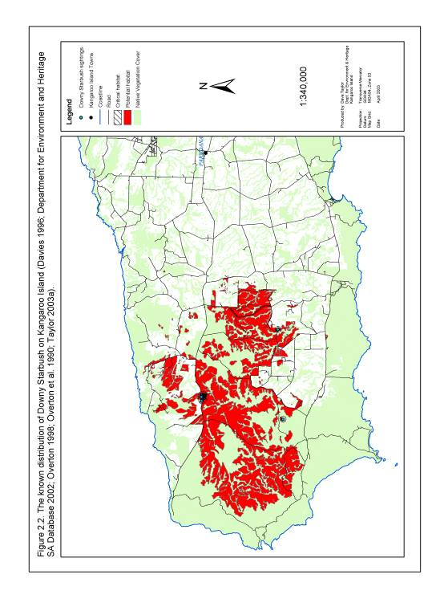

2.3.2. Kangaroo Island Turpentine Bush Beyeria subtecta

Current Distribution and Important Populations
Beyeria subtecta is endemic to Kangaroo Island (Prescott 1995). It occurs within a thin strip encompassing 5 km either side of the Hog Bay Road between Min Oil Rd and Three Chain Rd, in eastern Kangaroo Island (Figure 2.3). The extent of occurrence of this population is 66 km², latitude 35°35’S to 35°50’S and longitude 137°33’E to 137°44’E. This population consists of two sub-populations separated by a series of watercourses associated with the upper catchment of Salt Lagoon (Table 2.4; Figure 2.3).

Table 2.2. Important known sub-populations of Beyeria subtecta listed in order of
sub-population size (Davies 1986; Davies 1992; Davies 1996; Davies 1998; Davies
and Overton 1998; Department for Environment and Heritage SA Database 2002; Taylor 2003a).

Sub-population | Location | Number of plants based on most recent and most complete counts. | Number of records within each sub-population | Number of records assessed since January 1995 | Area of Occupancy (km²)
A | Hog Bay Rd, Willsons Rd, Beyeria CP, Halls Rd and Redbanks Rd | 10829 | 62 | 58 | 30.4
B | Moores Rd, Three Chain Rd, Boundary Rd, American River Rd, Flour Cask Bay Rd and Hog Bay Rd | 317 | 19 | 18 | 21.2
 | Total | 11146 | 81 | 76 | 51.6

Past Distribution
The distribution of B. subtecta on Kangaroo Island prior to the earliest database records made during 1984 is not documented, but is likely to have included upper slope and plateau areas adjoining the existing sub-populations. The decline of all mature individuals in outlying sub-populations of this species has been observed in the vicinity of Barretts Rd and Boundary Rd (Figure 2.3).

Essential and Potential Habitat
The essential and potential habitat of B. subtecta is mapped in Figure 2.3 based on definitions of essential and potential habitat described under section 2.2.

Topography and Soil Type
Beyeria subtecta grows on gentle slopes associated with the highest sections of the Haines Plateau and Eastern Plains of eastern Kangaroo Island (Davies 1986; Willoughby et al. 2001). Soil at B. subtecta populations is known to vary from dark brown to light yellow in colour and have a pH of 6 to 7 (Davies 1986).

Plant Associations
Beyeria subtecta has been observed in open-scrub and tall shrubland with an overstorey dominated by Eucalyptus cneorifolia (Davies 1986). Understorey species of this plant community typically comprise of Grevillea ilicifolia, Lepidosperma viscidum, Melaleuca gibbosa, M. uncinata, Micrantheum demissum, Scaevola linearis and Thryptomene ericaea (Davies 1986).

On a broader scale the known distribution of B. subtecta occurs within 3 different vegetation groups mapped by Ball and Carruthers (1998) (Table 2.5). The extent of these vegetation groups is mapped as potential habitat in Figure 2.3.

Climate
Mean annual rainfall in the vicinity of the known distribution of B. subtecta ranges from 485 mm at Kingscote to 529 mm at American River. The mean annual maximum and minimum temperatures in Kingscote are 19.0 °C and 11.5 °C respectively (Mooney and Grinter 2000).

Fire and Disturbance
There has been no detailed research carried out on the fire and disturbance ecology of B. subtecta, however this species has been observed growing on previously disturbed sites including roadside vegetation on Hog Bay Rd and Willsons Rd and previously cleared areas in Beyeria Conservation Park. This observation suggests that B. subtecta is able to tolerate some level of disturbance. It may also indicate that disturbance plays an important role in stimulating the regeneration and recruitment of this species.

Table 2.3. Broad Kangaroo Island vegetation groups which overlap with the known distribution of Beyeria subtecta (Ball and Carruthers 1998).

Code | Primary Species | Secondary Species | Understorey Species
2P | Eucalyptus diversifolia | Eucalyptus cneorifolia, E. cosmophylla, E. albopurpurea, E. leptophylla. | Acacia myrtifolia var. myrtifolia, Adenanthos macropodiana, Banksia marginata, Bertya rotundifolia, Grevillea ilicifolia ssp. ilicifolia, Hakea rostrata, Lasiopetalum schulzenii, Leptospernum myrsinoides, Melaleuca uncinata, Thryptomene ericaea, Xanthorrhoea semiplana ssp. tateana.
11D | Eucalyptus cneorifolia | Eucalyptus cosmophylla, E. diversifolia, E. albopurpurea. | Adenanthos terminalis, Allocasuarina muelleriana ssp. notocolpica, A. striata, Correa reflexa, Grevillea ilicifolia ssp. ilicifolia, G. lavandulacea ssp. rogersii, Melaleuca uncinata, Thryptomene ericaea, Xanthorrhoea semiplana ssp. tateana.
11F | Eucalyptus cneorifolia | Eucalyptus conglobata, E. cosmophylla, E. diversifolia, E. albopurpurea. | Callistemon rugulosus var. rugulosus, Correa reflexa, Grevillea ilicifolia ssp. ilicifolia, Melaleuca gibbosa, Melaleuca uncinata, Thryptomene ericaea, Xanthorrhoea semiplana ssp. tateana.

Figure 2.2. The known distribution of the Kangaroo Island Turpentine Bush on Kangaroo Island.

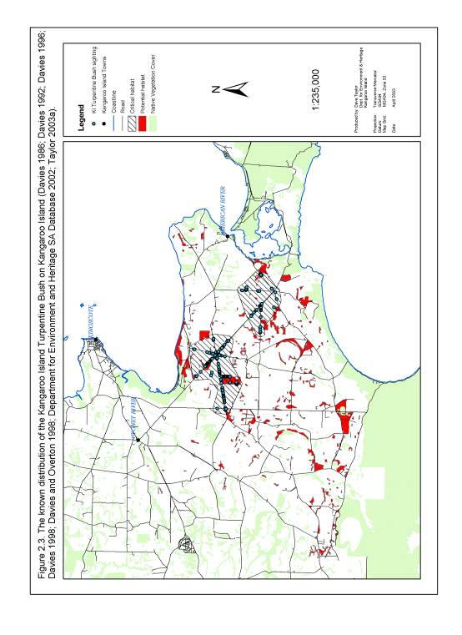

2.3.3. Kangaroo Island Spider-Orchid Caladenia ovata

Current Distribution and Important Populations
Caladenia ovata occurs on the Fleurieu Peninsula and Kangaroo Island regions of South Australia (Willoughby et al. 2001). It is known from six records in four separate sub-populations within the eastern half of Kangaroo Island (Figures 2.1a and 2.1b; Table 2.1). The extent of occurrence of the Kangaroo Island population is 146 km², latitude 35°45’S to 35°51’S and longitude 137°35’E to 138°02’E.

Table 2.4. Important known sub-populations of Caladenia ovata listed in order of sub-population size (Davies 1986; Davies 1992; Davies and Overton 1998; Department for Environment and Heritage SA Database 2002; Taylor 2003a).

Sub-population | Location | Number of plants based on most recent and most complete counts. | Number of records within each sub-population | Number of records assessed since January 1995 | Area of Occupancy (km²)
A | Private Property north of American River | Unknown | 2 | 0 | 1.4
B | Muston Lookout, American River Rd | Unknown | 1 | 0 | 0.8
C | Beyeria CP | Unknown | 2 | 0 | 1.0
D | Porky Flat | Unknown | 1 | 0 | 0.8
 | Total | Unknown | 6 | 0 | 4.0

Past Distribution
The previous distribution of C. ovata is unknown.

Essential and Potential Habitat
The essential and potential habitat of C. ovata is mapped in Figures 2.1a and 2.1b based on definitions of essential and potential habitat described under section 2.2.

Topography and Soil Type
Caladenia ovata has been observed growing on sandy soil on a western facing upper slope (Davies 1986).

Plant Associations
Caladenia ovata has been observed growing on the Fleurieu Peninsula in Eucalyptus baxteri tall shrubland and tall open-shrubland with an understorey composed of Lepidosperma semiteres, Leptospernum myrsinoides, Pultenaea involucrata and Xanthorrhoea semiplana (Davies 1986).

On Kangaroo Island the known distribution of C. ovata falls within four different vegetation groups mapped by Ball and Carruthers (1998) (Table 2.2). The extent of these vegetation groups is mapped as potential habitat in Figures 2.1a and 2.1b.

Table 2.5. Broad Kangaroo Island vegetation groups which overlap with the known distribution of Caladenia ovata (Ball and Carruthers 1998).

Code | Primary Species | Secondary Species | Understorey Species
5H | Eucalyptus cladocalyx | Allocasuarina verticillata, Eucalyptus cneorifolia, E. diversifolia. | Allocasuarina muelleriana ssp. notocolpica, Hibbertia riparia. Melaleuca gibbosa, M. uncinata, Thryptomene ericaea, Xanthorrhoea semiplana ssp. tateana.
9B | Eucalytpus viminalis ssp. cygnetensis | Eucalytpus diversifolia, E. albopurpurea, E. leucoxylon ssp. leucoxylon | Acacia paradoxa, Allocasuarina striata, Banksia marginata, Beyeria lechenaultii, Callistemon rugulosus var. rugulosus, Choretrum glomeratum, Logania ovata, Melaleuca acuminata, Ozothamnus retusus, Pultenaea acerosa, Xanthorrhoea semiplana ssp. tateana.
11D | Eucalyptus cneorifolia | Eucalytpus cosmophylla, E. diversifolia, E. albopurpurea. | Allocasuarina muelleriana ssp. notocolpica A. striata, Adenanthos terminalis, Correa reflexa, Grevillea ilicifolia ssp. ilicifolia, G. lavandulacea ssp. rogersii, Melaleuca uncinata, Thryptomene ericaea, Xanthorrhoea semiplana ssp. tateana.
19A | Allocasuarina verticillata | Eucalyptus cladocalyx | Acacia paradoxa, Hibbertia riparia, Prostanthera spinosa.

Climate
Mean annual rainfall in the vicinity of the known distribution of C. ovata ranges from 485 mm at Kingscote to 543 mm at Cape Willoughby. The mean annual maximum and minimum temperatures in Kingscote are 19.0 °C and 11.5 °C respectively (Mooney and Grinter 2000).

Fire and Disturbance
Davies (1986) reported that C. ovata seldom flowers except after fire. There is no other published research on the fire and disturbance ecology of this species.

Figure 2.3a. The known distribution of the Kangaroo Island Spider-Orchid in eastern Kangaroo Island.

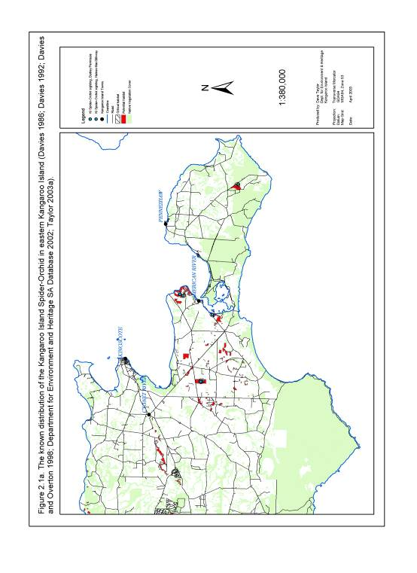

Figure 2.3b. The known distribution of the Kangaroo Island Spider-Orchid in western Kangaroo Island.

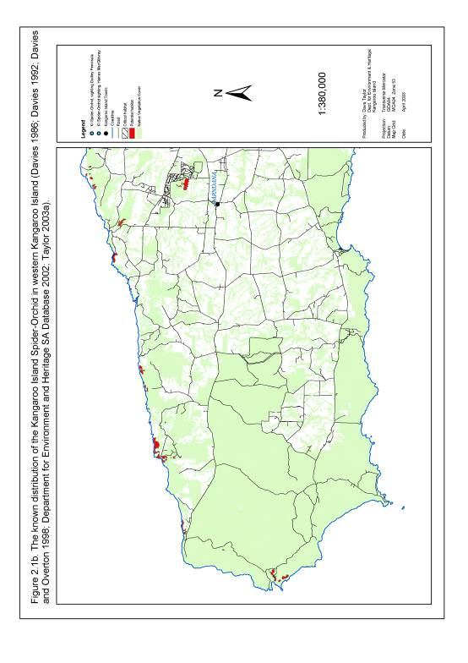

2.3.4. Twining Hand Flower Cheiranthera volubilis

Current Distribution and Important Populations
Cheiranthera volubilis is endemic to Kangaroo Island (Prescott 1995). It is known to occur in 8 sub-populations spread throughout western and central Kangaroo Island (Figure 2.4; Table 2.6). The extent of occurrence of this species is 1016 km², latitude 35°41’S to 35°54’S and longitude 136°35’E to 137°13’E.

Table 2.6. Important known sub-populations of Cheiranthera volubilis listed in order
of sub-population size (Davies 1986; Davies 1992; Davies 1996; Department for Environment and Heritage SA Database 2002; Taylor 2003a).

Sub-population | Location | Number of plants based on most recent and most complete counts. | Number of records within each sub-population | Number of records assessed since January 1995 | Area of Occupancy (km²)
A | West End Hwy, Flinders Chase NP | 7427 | 9 | 0 | 11.7
B | Playford Hwy, Flinders Chase NP | 1001 | 1 | 0 | 0.8
C | South Coast Rd | 20 | 1 | 0 | 0.8
D | Church Rd, Flinders Chase NP | 4 | 1 | 0 | 0.8
E | Walsh Fire Track, Flinders Chase NP | 1 | 1 | 1 | 0.8
F | Cape Borda and Scotts Cove | Unknown | 3 | 0 | 4.8
G | Western River CP | Unknown | 2 | 0 | 2.6
H | Stokes Bay Rd | Unknown | 2 | 0 | 1.1
 | Total | >8453 | 20 | 1 | 23.4

Past Distribution
The distribution and abundance of this species prior to the first database records of 1983 is unknown.

Essential and Potential Habitat
The essential and potential habitat of C. volubilis is mapped in Figure 2.4 based on definitions of essential and potential habitat described under section 2.2.

Topography and Soil Type
Cheiranthera volubilis has been observed to grow on the upper slopes of dissected plateau. Soil types associated with C. volubilis sub-populations include sandy loam, fine sand loam and fine sand with a soil pH of between 6 and 6.5 (Davies 1986).

Plant Associations
The majority of sub-populations of C. volubilis have been observed in Eucalyptus remota and E. baxteri tall shrubland or low open shrubland. Associated understorey species include Banksia marginata, Hakea rostrata, Lepidosperma carphoides, L. viscidum, Leucopogon concurvus, Petrophile multisecta, Schoenus breviculmis and Xanthorrhoea semiplana ssp. tateana (Davies 1986).

On a broader scale the known distribution of C. volubilis overlaps with 11 different vegetation groups defined by Ball and Carruthers (1998) (Table 2.7). The extent of these vegetation groups is mapped as potential habitat in Figure 2.4.

Climate
Mean annual rainfall in the vicinity of the known distribution of C. volubilis ranges from 628 mm at Cape Borda to 629 mm at Parndana. The mean annual maximum and minimum temperatures in Parndana are 19.0 °C and 9.4 °C respectively (Mooney and Grinter 2000).

Fire and Disturbance
No research has been conducted to determine the fire and disturbance ecology of C. volubilis.

Table 2.7. Broad Kangaroo Island vegetation groups which overlap with the known distribution of Cheiranthera volubilis (Ball and Carruthers 1998).

Code | Primary Species | Secondary Species | Understorey Species
1A | Eucalyptus remota | Eucalyptus baxteri, E. cosmophylla | Allocasuarina muelleriana ssp. notocolpica, A. striata, Banksia ornata, B. marginata, Calytrix tetragona, Daviesia brevifolia, Hakea rostrata, Phyllota pleurandroides Xanthorrhoea semiplana ssp. tateana.
1F | Eucalyptus remota | Eucalyptus baxteri, E. cosmophylla | Allocasuarina muelleriana ssp. notocolpica, A. striata, Banksia marginata, B. ornata, Hakea rostrata, Xanthorrhoea semiplana ssp. tateana.
2H | Eucalyptus diversifolia | Eucalyptus albopurpurea, E. rugosa | Acacia myrtifolia var. myrtifolia, Acacia retinodes var. uncifolia, Banksia marginata, Correa reflexa, Hakea vittata, H. muelleriana, Lasiopetalum schulzenii, Melaleuca lanceolata, Pomaderris obcordata, Pultenaea rigida, Xanthorrhoea semiplana ssp. tateana.
2K | Eucalyptus diversifolia | Allocasuarina muelleriana ssp. notocolpica, Eucalyptus cosmophylla | Allocasuarina muelleriana ssp. notocolpica, A. striata, Banksia marginata, Hakea rostrata.
3A | Eucalyptus baxteri | Eucalyptus cosmophylla, E. obliqua. | Allocasuarina muelleriana ssp. notocolpica, A. striata, Banksia marginata, B. ornata, Hakea mitchellii, H. rostrata, Xanthorrhoea semiplana ssp. tateana.
3E | Eucalyptus baxteri | Eucalyptus cosmophylla, E. obliqua, E. remota. | Allocasuarina muelleriana ssp. notocolpica, A. striata, Banksia marginata, B. ornata, Calytrix tetragona, Daviesia brevifolia, Hakea rostrata, Phyllota pleurandroides, Xanthorrhoea semiplana ssp. tateana.
5A | Eucalyptus cladocalyx | Eucalyptus baxteri, E. cosmophylla, E. fasciculosa, E. leucoloxylon ssp. leucoloxylon, E. obliqua, E. viminalis ssp. cygnetensis | Acacia paradoxa, Bursaria spinosa, Leptospernum lanigerum, Prostanthera spinosa, Pteridium esculentum, Xanthorrhorea semiplana ssp. tateana,
5G | Eucalyptus cladocalyx | Allocasuarina verticillata, Eucalyptus cosmophylla, E. fasciculosa, E. leucoloxylon ssp. leucoloxylon | Acacia paradoxa, Allocasuarina muelleriana ssp. notocolpica, A. striata, A. verticillata, Bursaria spinosa, Pteridium esculentum, Xanthorrhoea semiplana ssp. tateana.
6B | Eucalyptus cosmophylla | Eucalyptus fasciculosa | Allocasuarina muelleriana ssp. notocolpica, A. striata, Banksia marginata, B. ornata, Hakea mitchellii, H. rostrata, H. rugosa and Melaleuca uncinata.
21A | Melaleuca gibbosa | Allocasuarina verticillata | Acacia paradoxa, Prostanthera spinosa
28A | Eucalyptus obliqua | Eucalyptus baxteri, E. cosmophylla, E. remota | Allocasuarina muelleriana ssp. notocolpica, A. striata, Banksia marginata, B. ornata, Hakea rostrata, Xanthorrhoea semiplana ssp. tateana.

Figure 2.4. The known distribution of the Twining Finger Flower on Kangaroo Island.

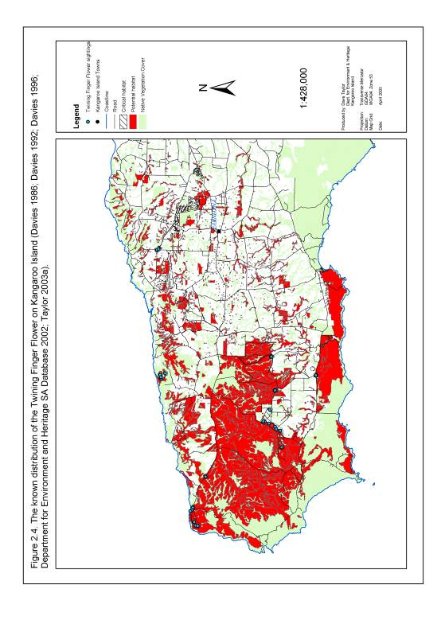

2.3.5. De Mole River Correa Correa calycina var. halmaturorum

Current Distribution and Important Populations
Correa calycina var. halmaturorum is endemic to Kangaroo Island. It is known to occur in two small sub-populations, approximately 3.2 km apart, east of Cape Torrens on the northern coastline of Kangaroo Island (Table 2.8; Figure 2.5). The extent of occurrence of the total population of C. calycina var. halmaturorum is 3 km².

Table 2.8. Important known sub-populations of Correa calycina var. halmaturorum listed in order of sub-population size (Davies 1986; Davies 1992; Department for Environment and Heritage SA Database 2002; Taylor 2003a).

Sub-population | Location | Number of plants based on most recent and most complete counts. | Number of records within each sub-population | Number of records assessed since January 1995 | Area of Occupancy (km²)
A | De Mole River, Cape Torrens NP | Unknown | 1 | 0 | 0.7
B | Cape Torrens NP | Unknown | 1 | 0 | 0.7
 | Total | Unknown | 2 | 0 | 1.4

Past Distribution
The distribution of C. calycina var. halmaturorum prior to the first record of this species in 1990 is unknown.

Essential and Potential Habitat
The essential and potential habitat of C. calycina var. halmaturorum is mapped in Figure 2.5 based on definitions of essential and potential habitat described under section 2.2.

Topography and Soil Type
The topography and soil type preferred by C. calycina var. halmaturorum has not been formally recorded.

Plant Associations
The vegetation community formally associated with C. calycina var. halmaturorum has not been recorded.
On a broader scale the known distribution of C. calycina var. halmaturorum overlaps with 3 different vegetation groups defined by Ball and Carruthers (1998) (Table 2.9). The extent of these vegetation groups is mapped as potential habitat in Figure 2.5.

Table 2.9. Broad Kangaroo Island vegetation groups which overlap with the known distribution of Correa calycina var. halmaturorum (Ball and Carruthers 1998).

Code | Primary Species | Secondary Species | Understorey Species
5D | Eucalyptus cladocalyx | Allocasuarina verticillata, Eucalyptus fasciculosa | Acacia paradoxa, Prostanthera spinosa
5G | Eucalyptus cladocalyx | Allocasuarina verticillata, Eucalyptus cosmophylla, E. fasciculosa, E. leucoloxylon ssp. leucoloxylon | Acacia paradoxa, Allocasuarina muelleriana ssp. notocolpica, A. striata, A. verticillata, Bursaria spinosa, Pteridium esculentum, Xanthorrhoea semiplana ssp. tateana.
19A | Allocasuarina verticillata | Eucalyptus cladocalyx | Acacia paradoxa, Hibbertia riparia, Prostanthera spinosa.

Climate
Mean annual rainfall in the vicinity of the known distribution of C. calycina var. halmaturorum ranges from 628 mm at Cape Borda to 629 mm at Parndana. The mean annual maximum and minimum temperatures at Cape Borda are 17.9 °C and 11.3 °C respectively (Mooney and Grinter 2000).

Fire and Disturbance
No research has been conducted to determine the disturbance tolerance or requirements of C. calycina var. halmaturorum.

Figure 2.5. The known distribution of the De Mole River Correa on Kangaroo Island.

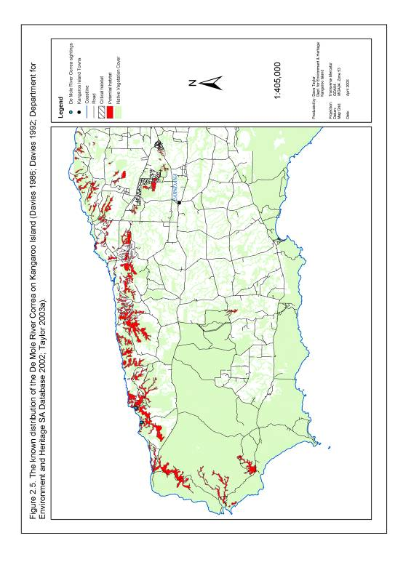

2.3.6. Osborn’s Eyebright Euphrasia collina ssp. osbornii

Current Distribution and Important Populations
Euphrasia collina ssp. osbornii occurs in populations on Kangaroo Island, the Eyre Peninsula, Yorke Peninsula, Mount Lofty Ranges and south-east South Australia (Jessop and Toelken 1986). On Kangaroo Island it is known to occur in one sub-population, occupying coastal habitat 20 to 300 m from the shoreline, within 4.5 km of Cape Willoughby (Figure 2.6; Table 2.10). The extent of occurrence of this sub-population is 4.0 km².

Table 2.10. Important known sub-populations of Euphrasia collina ssp. osbornii listed in order of sub-population size (Department for Environment and Heritage SA Database 2002; Taylor 2003a).

Sub-population | Location | Number of plants based on most recent and most complete counts. | Number of records within each sub-population | Number of records assessed since January 1995 | Area of Occupancy (km²)
A | Cape Willoughby, Cape St Albans and Lesueur CP. | 617 | 4 | 2 | 4.7
 | Total | 617 | 4 | 2 | 4.7

Past Distribution
The historic distribution of E. collina ssp. osbornii on Kangaroo Island is unknown. It is possible that a proportion of the island population of this species has declined in several areas around Cape Willoughby in the past as a result of land clearing and grazing activities (Taylor 2003a).

Essential and Potential Habitat
The essential and potential habitat of E. collina ssp. osbornii is mapped in Figure 2.6 based on definitions of essential and potential habitat described under section 2.2.

Topography and Soil Type
Euphrasia collina ssp. osbornii has been found growing on coastal slopes and cliff-lines up to 300 m inland from the waters edge. Soils in the vicinity of Cape Willoughby tend to be granite derived (Taylor 2003a).

Plant Associations
Euphrasia collina ssp. osbornii has been observed growing in coastal shrubland with an overstorey dominated by Allocasuarina verticillata (Taylor 2003a).

On a broader scale the known distribution of E. collina ssp. osbornii overlaps with three different vegetation groups defined by Ball and Carruthers (1998) (Table 2.11). The extent of these vegetation groups is mapped as potential habitat in Figure 2.6.

Table 2.11. Broad Kangaroo Island vegetation groups which overlap with the known distribution of Euphrasia collina ssp. osbornii (Ball and Carruthers 1998).

Code | Primary Species | Secondary Species | Understorey Species
11J | Eucalyptus cneorifolia | Eucalyptus conglobata, E. diversifolia, E. albopurpurea. | Callistemon rugulosus var. rugulosus, Correa reflexa, Grevillea ilicifolia ssp. ilicifolia, Melaleuca gibbosa, M. uncinata, Thryptomene ericaea, Xanthorrhoea semiplana ssp. tateana.
21C | Melaleuca gibbosa | Eucalyptus diversifolia | Acacia paradoxa, Beyeria lechenaultii, Correa reflexa, Eutaxia microphylla var. microphylla, Hakea mitchellii, Pultenaea acerosa, Spyridium spathulatum.
31C | Acacia paradoxa | Melaleuca gibbosa, M. uncinata. | Thryptomene ericaea

Climate
The mean annual rainfall at Cape Willoughby is 543 mm. The mean annual maximum and minimum temperatures at Cape Willoughby are 17.8 °C and 12.6 °C respectively. (Mooney and Grinter 2000).

Fire and Disturbance
No research has been conducted to determine the response of E. collina ssp. osbornii to fire or other types of disturbance. However, observations of this species in the Mount Lofty Ranges suggest that it may rely on fire events to promote regeneration and recruitment (Steed, Y. 2003, pers comm.).

Figure 2.6. The known distribution of Osborn’s Eyebright on Kangaroo Island.

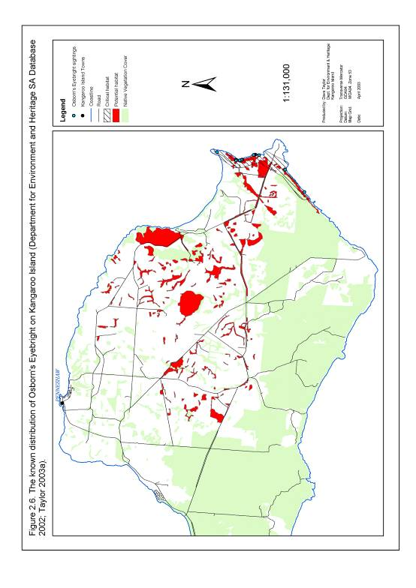

2.3.7. Kangaroo Island Phebalium Leionema equestre

Current Distribution and Important Populations
Leionema equestre is endemic to Kangaroo Island (Davies 1992). It occurs in five sub-populations within an extent of occurrence of 255 km2, latitude 35°39’S to 35°52’S and longitude 137°09’E to 137°45’E (Table 2.12; Figures 2.7a and 2.7b). Three of these sub-populations are in the vicinity of Three Chain, Hog Bay and American River Roads in eastern Kangaroo Island. A further translocated sub-population exists within Beyeria CP and an outlying population also exists west of Stokes Bay on the north coast of Kangaroo Island.

Table 2.12. Important known sub-populations of Leionema equestre listed in order of sub-population size (Davies 1986; Davies 1992; Davies 1996; Davies 1998; Davies and Overton 1998; Department for Environment and Heritage SA Database 2002; Jusaitis 1993; Jusaitis 2000; Overton et al. 1990; Taylor 2003a).

Sub-population | Location | Number of plants based on most recent and most complete counts. | Number of records within each sub-population | Number of records assessed since January 1995 | Area of Occupancy (km²)
A | Three Chain Rd, Hog Bay Rd and Moores Rd | 1540 | 16 | 12 | 14.5
B | Barretts Rd | 807 | 5 | 5 | 1.5
C | Stokes Bay Rd | 224 | 1 | 1 | 1.2
D | Beyeria CP | 86 | 3 | 3 | 3.6
E | American River Rd | 6 | 1 | 1 | 0.9
 | Total | 2663 | 26 | 22 | 21.7

Past Distribution
The pre-settlement distribution of L. equestre is not documented, but is likely to have included large areas of now cleared habitat adjacent to the area occupied by current populations (Figures 2.7a and 2.7b). All individuals within a sub-population of L. equestre are known to have declined recently from one area on Flour Cask Bay Rd (Figure 2.7a). A recent decline in abundance has also been noted at L. equestre sub-populations A and B on Hog Bay Rd, Barretts Rd and Three Chain Rd (Davies 1986; Davies 1992; Davies 1996; Davies 1998; Davies and Overton 1998; Department for Environment and Heritage SA Database 2002; Jusaitis 1993; Jusaitis 2000; Overton et al. 1990; Taylor 2003a).

Essential and Potential Habitat
The essential and potential habitat of L. equestre is mapped in Figures 2.7a and 2.7b based on definitions of essential and potential habitat described under section 2.2.

Topography and Soil Type
Leionema equestre is typically found on the gentle slopes or crests of low plateau in eastern Kangaroo Island (Davies 1992). The majority of L. equestre populations are located on the MacGillivray Plain soil type which is composed of deep sands with or without lateritic pebbles or gravel (Overton et al. 1990). Jusaitis (2000) found soil pH at sites with L. equestre in the understorey to vary between 5.3 and 7.2. Overton et al. (1990) also tested soil pH at 14 sites in close proximity to populations of L. equestre and found it ranged between 5.4 and 8.0.

Plant Associations
Leionema equestre typically occurs in shrubland and open woodland with an
overstorey component dominated by Eucalyptus diversifolia and/or E. cosmophylla with E. cneorifolia as an occasional co-dominant (Davies 1992; Jusaitis 2000). Middle understorey species associated with L. equestre populations include Adenanthos macropodiana, A. terminalis, Allocasuarina muelleriana, A. striata, Bertya rotundifolia, Leptospernum myrsinoides, Melaleuca gibbosa and M. uncinata. Associated ground cover species include Baeckea crassifolia, Glischrocaryon behrii, Hypolaena fastigata, Lepidosperma viscidum, Micrantheum demissum and Petrophile multisecta. Cyphanthera myosotidea, Phyllota pleurandrioides, Pultenaea acerosa, Xanthorrhoea semiplana ssp. tateana and Zieria veronicea are less commonly associated with L. equestre populations (Davies 1992; Jusaitis 2000).

On a broader scale the known distribution of L. equestre overlaps with 5 different vegetation groups mapped by Ball and Carruthers (1998) (Table 2.13). The extent
of these vegetation groups is mapped as potential habitat in Figures 2.7a and 2.7b.

Table 2.13. Broad Kangaroo Island vegetation groups which overlap with the known distribution of Leionema equestre (Ball and Carruthers 1998).

Code | Primary Species | Secondary Species | Understorey Species
2P | Eucalyptus diversifolia | Eucalyptus cneorifolia, E. albopurpurea, E. leptophylla, E. cosmophylla | Acacia myrtifolia var. myrtifolia, Adenanthos macropodiana, Banksia marginata, Bertya rotundifolia, Grevillea ilicifolia ssp. ilicifolia, Hakea rostrata, Lasiopetalum schulzenii, Leptospernum myrsinoides, Melaleuca uncinata, Thryptomene ericaea, Xanthorrhoea semiplana ssp. tateana..
5G | Eucalyptus cladocalyx | Allocasuarina verticillata, Eucalyptus cosmophylla, E. fasciculosa, E. leucoloxylon ssp. leucoloxylon | Acacia paradoxa, Allocasuarina muelleriana ssp. notocolpica, A. striata, A. verticillata, Bursaria spinosa, Pteridium esculentum, Xanthorrhoea semiplana ssp. tateana.
11D | Eucalyptus cneorifolia | Eucalyptus albopurpurea, E. cosmophylla, E. diversifolia. | Adenanthos terminalis, Allocasuarina muelleriana ssp. notocolpica, A. striata, Correa reflexa, Grevillea ilicifolia ssp. ilicifolia, G. lavandulacea ssp. rogersii, Melaleuca uncinata, Thryptomene ericaea, and Xanthorrhoea semiplana ssp. tateana,
19A | Allocasuarina verticillata | Eucalyptus cladocalyx | Acacia paradoxa, Hibbertia riparia, Prostanthera spinosa.
22A | Melaleuca brevifolia | Melaleuca gibbosa, M. halmaturorum | None

Climate
Mean annual rainfall in the vicinity of the known distribution of L. equestre ranges from 485 mm at Kingscote to 529 mm at American River. The mean annual maximum and minimum temperatures in Kingscote are 19.0 °C and 11.5 °C respectively (Mooney and Grinter 2000).

Fire and Disturbance
Leionema equestre recruitment appears to prefer open and well-lit areas (Jusaitis 2000). It has been observed regenerating at sites subject to disturbance from fire and/or vegetation clearance activities (Jusaitis 2000; Taylor 2003a)

Figure 2.7a. The known distribution of Kangaroo Island Phebalium in eastern
Kangaroo Island.

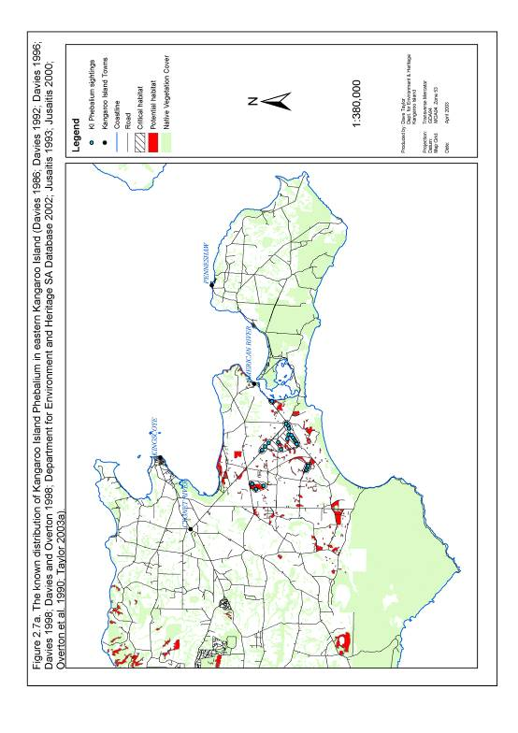

Figure 2.7b. The known distribution of Kangaroo Island Phebalium in western Kangaroo Island.

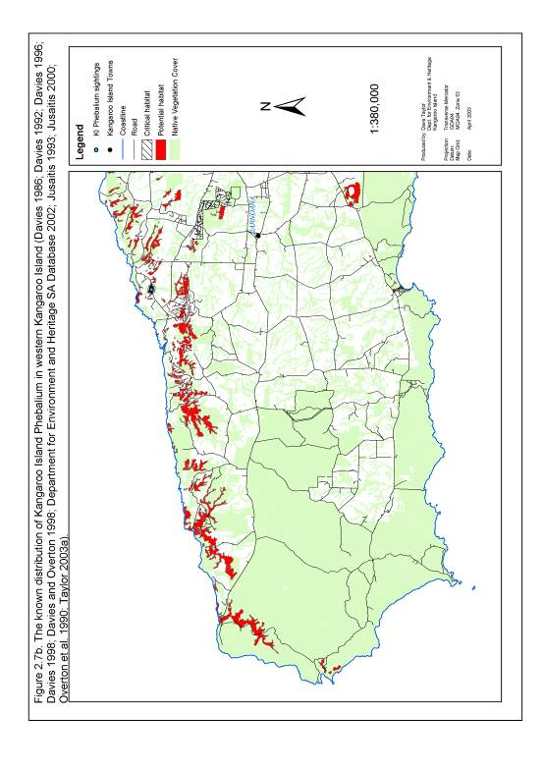

2.3.8. Kangaroo Island Logania Logania insularis

Current Distribution and Important Populations
Logania insularis is endemic to Kangaroo Island (Prescott 1995). The entire population of this species occurs at Cape Borda on the north-western coastline of the island and has an extent of occurrence of 1 km², latitude 35°45’S to 35°46’S and longitude 136°35’E to 136°37’E (Table 2.14; Figure 2.8).

Table. 2.14. Important known sub-populations of Logania insularis listed in order of sub-population size (Davies 1986; Department for Environment and Heritage SA Database 2002; Overton 1998; Taylor 2003a).

Sub-population | Location | Number of plants based on most recent and most complete counts. | Number of records within each sub-population | Number of records assessed since January 1995 | Area of Occupancy (km²)
A | Cape Borda | Unknown | 6 | 0 | 3.5
 | Total | Unknown | 6 | 0 | 3.5

Past Distribution
The previous distribution of L. insularis is unknown. It is possible that this species may have had a limited distribution at the time of European settlement (Taylor 2003a).

Essential and Potential Habitat
The essential and potential habitat of L. insularis is mapped in Figure 2.8 based on definitions of essential and potential habitat described under section 2.2.

Topography and Soil Type
Logania insularis has been observed growing in sand deposits in between calcrete outcrops on northern and western facing mid and upper slopes at Cape Borda. This sand substrate has a pH of 6.7 to 7.5 (Davies 1986; Overton 1998).

Plant Associations
Logania insularis has been found in Eucalyptus diversifolia open-scrub to low open-shrubland. The understorey associated with L. insularis includes Allocasuarina muelleriana, Baeckea crassifolia, Hibbertia riparia, Lasiopetalum schulzenii, Lepidosperma viscidum, Leucopogon concurvus, Calytrix glaberrima, Melaleuca gibbosa, M. lanceolata, Petrophile multisecta, Pultenaea acerosa, and Spyridium halmaturina (Davies 1986).

On a broader scale the known distribution of L. insularis overlaps with 3 different vegetation groups defined by Ball and Carruthers (1998) (Table 2.15). The extent of these vegetation groups is mapped as potential habitat in Figure 2.8.

Table 2.15. Broad Kangaroo Island vegetation groups which overlap with the known distribution of Logania insularis (Ball and Carruthers 1998).

Code | Primary Species | Secondary Species | Understorey Species
2H | Eucalyptus diversifolia | Eucalyptus albopurpurea, E. rugosa | Acacia myrtifolia var. myrtifolia, A. retinodes var. uncifolia, Banksia marginata, Correa reflexa, Hakea mitchellii, H. vittata, Lasiopetalum schulzenii, Melaleuca lanceolata, Pomaderris obcordata, Pultenaea rigida, Xanthorrhoea semiplana ssp. tateana.
2K | Eucalyptus diversifolia | Allocasuarina muelleriana ssp. notocolpica, Eucalyptus cosmophylla | Allocasuarina muelleriana ssp. notocolpica, A. striata, Banksia marginata and Hakea rostrata.
13B | Melaleuca lanceolata | Eucalyptus diversifolia | Beyeria lechenaultii, Correa reflex, Eutaxia microphylla var. microphylla, Melaleuca gibbosa, Pultenaea acerosa, Spyridium halmaturinum var. halmaturinum, S. phylicoides.

Climate
Mean annual rainfall in the vicinity of the known distribution of L. insularis is 628 mm as measured at Cape Borda. The mean annual maximum and minimum temperatures at Cape Borda are 17.9 °C and 11.3 °C respectively (Mooney and Grinter 2000).

Fire and Disturbance
Overton (1998) observed the regeneration of L. insularis seedlings in 2 quadrats established on a section of Cape Borda burnt on the 2nd of January 1993. No other research has been conducted to determine the response of L. insularis to varying fire frequency and intensity or to other forms of disturbance.

Figure 2.8. The known distribution of Kangaroo Island Logania on Kangaroo Island.

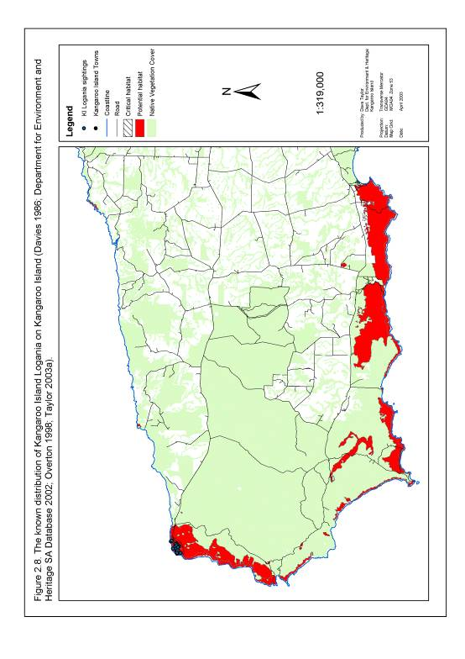

2.3.9. Small-flowered Daisy-bush Olearia microdisca

Current Distribution and Important Populations
Olearia microdisca is endemic to Kangaroo Island (Jessop and Toelken 1986). It is currently known to occur in fragments of remnant vegetation in eastern Kangaroo Island with an extent of occurrence of 118 km², latitude 35°41′S to 35°49′S and longitude 137°25′E to 137°45′E (Table 2.16; Figure 2.9). Within this range sub-populations of O. microdisca occur on the floodplains of the lower Cygnet River and adjacent low-lying areas west of Nepean Bay. This species also persists on gentle slopes and plateau sites within a 5 km strip on either side of the Hog Bay Rd stretching from Nepean Bay to the junction with Three Chain Rd.

Table 2.16. Important known sub-populations of Olearia microdisca listed in order of sub-population size (Bickerton and Davies 1999; Davies 1986; Davies 1992; Davies 1996; Davies 1998; Davies and Overton 1998; Department for Environment and Heritage SA Database 2002; Jusaitis 1993; Overton 2001; Taylor 2003a).

Sub-population | Location | Number of plants based on most recent and most complete counts. | Number of records within each sub-population | Number of records assessed since January 1995 | Area of Occupancy (km²)
A | Hog Bay Rd, Willsons Rd and Beyeria CP | 1002 | 5 | 2 | 7.5
B | Airport and Gum Creek Rd | 637 | 4 | 4 | 7.6
C | American River Rd | 510 | 2 | 2 | 1.3
D | Hog Bay Rd | 91 | 1 | 1 | 2.1
E | Hog Bay Rd and Hundred Line Rd | 16 | 4 | 4 | 5.7
F | Playford Hwy | 7 | 1 | 1 | 1.0
G | Playford Hwy | 1 | 1 | 1 | 0.9
 | Total | 2264 | 18 | 15 | 26.1

Past Distribution
The distribution of O. microdisca prior to European settlement and clearing for agriculture has not been documented but is likely to have included large areas of now cleared habitat in eastern Kangaroo Island. The oldest records either held in the National Parks and Wildlife South Australia Database or published in survey results date back to 1983. A field survey of these older records during 2002 revealed that O. microdisca has declined from floodplain areas north and south of the Cygnet River and from several plateau sites on Boundary Rd and along Willsons Rd. Based on population estimates this decline equates to a reduction in the size of the total population from approximately 15000 individuals in 1992 to approximately 2264 in 2002 (Taylor 2003a) (Figure 2.9).

Essential and Potential Habitat
The essential and potential habitat of O. microdisca is mapped in Figure 2.9 based on definitions of essential and potential habitat described under section 2.2.

Topography and Soil Type
Olearia microdisca is known to grow in a wide variety of sites and soil types, however the largest recorded populations have been found in low lying areas subject to seasonal waterlogging (Davies 1986). Soil types at these large populations range from fine sandy loam along creek banks to alkaline duplex soils, leached sands and lateritic heavy clays surrounding gilgais in plains areas (Davies 1986; Jusaitis 1993). Soil pH measured at four populations was within the range 5.4 to 7.2 (Jusaitis 1993; Overton 2001).

Plant Associations
Olearia microdisca is typically found in open mallee woodland and shrubland with Eucalyptus cneorifolia and/or E. cosmophylla as the dominant overstorey species (Jusaitis 1993). Understorey species commonly associated with O. microdisca include Dodonaea baueri, Grevillea ilicifolia, Eutaxia microphylla var. microphylla, Lasiopetalum baueri, Lepidosperma viscidum, Melaleuca gibbosa, M. uncinata and Thryptomene ericaea (Davies 1986; Jusaitis 1993).

On a broader scale the known distribution of O. microdisca overlaps with 6 different vegetation groups mapped by Ball and Carruthers (1998) (Table 2.17). The extent of these vegetation groups is mapped as potential habitat in Figure 2.9.

Table 2.17. Broad Kangaroo Island vegetation groups which overlap with the known distribution of Olearia microdisca (Ball and Carruthers 1998).

Code | Primary Species | Secondary Species | Understorey Species
2M | Eucalyptus diversifolia | Eucalyptus cneorifolia, E. cosmophylla, E. fasciculosa, E. albopurpurea. | Acacia myrtifolia var. myrtifolia, Allocasuarina muelleriana ssp. notocolpica, A. striata, Correa reflexa, Eucalyptus cneorifolia, Grevillea ilicifolia ssp. ilicifolia, Hakea rostrata, Melaleuca uncinata, M. gibbosa, Thryptomene ericaea, Xanthorrhoea semiplana ssp. tateana.
11D | Eucalyptus cneorifolia | Eucalyptus cosmophylla, E. diversifolia, E. albopurpurea. | Adenanthos terminalis, Allocasuarina muelleriana ssp. notocolpica, A. striata, Correa reflexa, Grevillea ilicifolia ssp. ilicifolia, G. lavandulacea ssp. rogersii, Melaleuca uncinata, Thryptomene ericaea, and Xanthorrhoea semiplana ssp. tateana,
11F | Eucalyptus cneorifolia | Eucalyptus conglobata, E. cosmophylla, E. diversifolia, E. albopurpurea. | Callistemon rugulosus var. rugulosus, Correa reflexa, Grevillea ilicifolia ssp. ilicifolia, Melaleuca gibbosa, M. uncinata, Thryptomene ericaea, Xanthorrhoea semiplana ssp. tateana.
11G | Eucalyptus cneorifolia | E. cosmophylla, Eucalyptus diversifolia, E. fasciculosa, E. albopurpurea. | Acacia calamifolia, A. paradoxa, Callistemon rugulosus var. rugulosus, Grevillea ilicifolia ssp. ilicifolia, Hakea rugosa, Melaleuca brevifolia, M. gibbosa, M. uncinata, Thryptomene ericaea.
18B | Tecticornia arbuscula | Sarcocornia blackiana, Sarcocornia quinqueflora, Suaeda australis. | Sparse
22A | Melaleuca brevifolia | Melaleuca gibbosa, M. halmaturorum. | None

Climate
Mean annual rainfall in the vicinity of the known distribution of O. microdisca ranges from 485 mm at Kingscote to 529 mm at American River. The mean annual maximum and minimum temperatures in Kingscote are 19.0 °C and 11.5 °C respectively (Mooney and Grinter 2000).

Fire and Disturbance Ecology
Davies (1986) and Jusaitis (1993) describe O. microdisca as an early successional species. The majority of sub-populations of this species exist in areas regenerating from a significant disturbance event such as vegetation clearing or fire. Few O. microdisca have been found in late successional vegetation or in areas which are subject to very frequent disturbance (Bickerton and Davies 1999; Davies 1986; Jusaitis 1993).

Figure 2.9. The known distribution of Small-flowered Daisy-bush on Kangaroo Island.

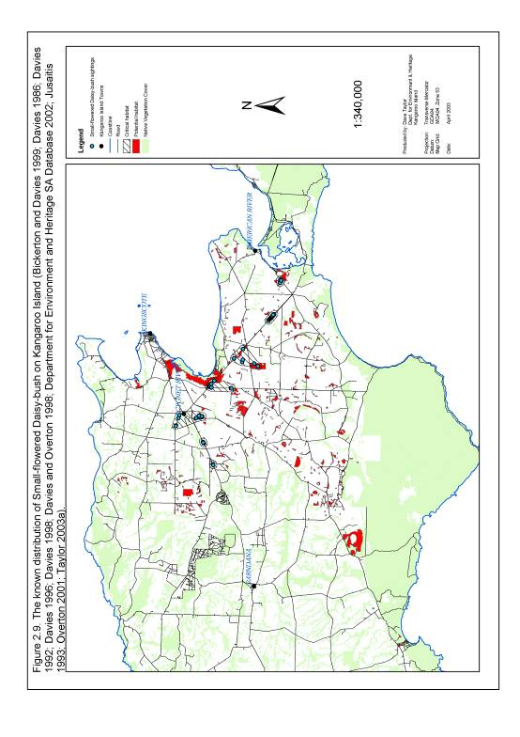

2.3.10. Kangaroo Island Pomaderris Pomaderris halmaturina ssp. halmaturina

Current Distribution and Important Populations
Pomaderris halmaturina ssp. halmaturina is endemic to south-eastern South Australia (Jessop and Toelken 1986). On mainland South Australia it is confined to an area near Carpenter Rocks and to remnant populations north of Donovan’s Landing in McEacherns and Snow Gum Forest Reserves (Jusaitis 1993). On Kangaroo Island it is restricted to 4 sub-populations on the Dudley Peninsula and 1 sub-population on the Cygnet River floodplain (Table 2.18; Figures 2.10a and 2.10b). These sub-populations fall within eastern Kangaroo Island and have a total extent of occurrence of 468 km² defined by latitude 35°42’S to 35°52’S and longitude 137°27’E to 138°05’E.

Table 2.18. Important known sub-populations of Pomaderris halmaturina ssp. halmaturina listed in order of sub-population size (Davies 1986; Davies 1992; Davies 1996; Davies and Overton 1998; Department for Environment and Heritage SA Database 2002; Jusaitis 1993; Taylor 2003a).

Sub-population | Location | Number of plants based on most recent and most complete counts. | Number of records within each sub-population | Number of records assessed since January 1995 | Area of Occupancy (km²)
A | Upper Willsons River | 1058 | 3 | 3 | 9.9
B | Chapman River, Cape Willoughby Rd and Lashmar CP. | 613 | 13 | 5 | 19.8
C | Lower Willsons River | 147 | 4 | 3 | 6.1
D | Cygnet River | 83 | 6 | 4 | 8.7
E | Cape Willoughby Rd | 1 | 1 | 0 | 0.9
 | Total | 1902 | 27 | 15 | 45.4

Past Distribution
The previous distribution of P. halmaturina ssp. halmaturina on Kangaroo Island is not well documented. It is likely however that this species has declined from creek-line and floodplain areas either grazed or cleared for agricultural purposes (Taylor 2003a).

Essential and Potential Habitat
The essential and potential habitat of P. halmaturina ssp. halmaturina is mapped in Figures 2.10a and 2.10b based on definitions of essential and potential habitat described under section 2.2.

Topography and Soil Type
Pomaderris halmaturina ssp. halmaturina typically grows in close proximity to rivers and creeks. It has been recorded on a wide variety of soil types ranging from Penneshaw Hills alkaline duplex soils to Linois plains shallow red-brown sandy soils with calcrete intrusions (Jusaitis 1993). Soil pH at P. halmaturina ssp. halmaturina sub-populations has been recorded within the range 4.9 to 9.0 (Davies 1986; Jusaitis 1993).

Plant Associations
Six vegetation types have been identified supporting populations of P. halmaturina ssp. halmaturina (Davies 1986).
- Eucalyptus leucoxylon woodland and open woodland with E. fasciculosa and/or E. cneorifolia as co-dominants with an understorey of Acacia paradoxa, Bursaria spinosa and Dodonaea viscosa.
- Eucalyptus cneorifolia open forest, low open forest, woodland and open scrub with E. fasciculosa as an occasional co-dominant with an understorey of Acacia paradoxa, Bursaria spinosa and Dodonaea viscosa.
- Eucalyptus diversifolia open forest and low woodland with E. leucoxylon as a co-dominant with an understorey of Acacia paradoxa, Bursaria spinosa and Dodonaea viscosa.
- Eucalyptus cladocalyx – E. camaldulensis woodland.
- Melaleuca lanceolata open scrub and Bursaria spinosa tall shrubland. The understorey associated with this vegetation type typically includes Acacia paradoxa, Bursaria spinosa, Orthrosanthus multiflorus and P. halmaturina.
- Acacia pycnantha, P. halmaturina, Adriana klotzschii open scrub to tall shrubland. The dominant understorey species associated with this vegetation type included Correa sp., Lasiopetalum schultzenii and Orthosanthus multiflorus.

On a broader scale the known distribution of P. halmaturina ssp. halmaturina overlaps with 12 different vegetation groups mapped by Ball and Carruthers (1998) (Table 2.19). The extent of these vegetation groups is mapped as potential habitat in Figures 2.10a and 2.10b.

Climate
Mean annual rainfall in the vicinity of the known distribution of P. halmaturina ssp. halmaturina ranges from 485 mm at Kingscote to 543 mm at Cape Willoughby. The mean annual maximum and minimum temperatures at Cape Willoughby are 17.8°C and 12.6°C respectively (Mooney and Grinter 2000).

Fire and Disturbance
Jusaitis (1993) found that P. halmaturina ssp. halmaturina exhibits a high degree of resilience to disturbance involving damage to the upper foliage. No research has been conducted to determine the impact of fire on sub-populations of P. halmaturina ssp. halmaturina.

Table 2.19. Broad Kangaroo Island vegetation groups which overlap with the known distribution of Pomaderris halmaturina ssp. halmaturina (Ball and Carruthers 1998).

Code | Primary Species | Secondary Species | Understorey Species
2D | Eucalyptus diversifolia | Eucalyptus oleosa, E. rugosa. | Acacia paradoxa, Acacia retinodes var. uncifolia, Correa reflexa, Lasiopetalum schulzenii, Melaleuca lanceolata, Myoporum insulare, Orthrosanthus multiflorus, Pomaderris paniculosa ssp. paniculosa, Senecio odoratus.
5H | Eucalyptus cladocalyx | Allocasuarina verticillata, E. cneorifolia, Eucalyptus diversifolia. | Allocasuarina muelleriana ssp. notocolpica, Hibbertia riparia. Melaleuca gibbosa, M. uncinata, Thryptomene ericaea, Xanthorrhoea semiplana ssp. tateana.
8B | Eucalyptus albopurpurea | Eucalyptus cosmophylla, E. cneorifolia, E. diversifolia, E. fasciculosa, E. leptophylla. | Banksia rotundifolia, B. marginata, Choretrum glomeratum, Correa reflexa, Grevillea ilicifolia ssp. ilicifolia, Melaleuca uncinata, Xanthorrhoea semiplana ssp. tateana.
10B | Eucalyptus leucoxylon ssp. leucoloxylon | Eucalyptus cosmophylla, E. fasciculosa, , E. albopurpurea, E. viminalis ssp. cygnetensis. | Acacia paradoxa, A. retinodes var. retinodes, Bursaria spinosa, Callistemon rugulosus var. rugulosus, Leptospernum continentale, Melaleuca gibbosa.
10C | Eucalyptus leucoxylon ssp. leucoloxylon | Eucalyptus cneorifolia | Acacia paradoxa, Thryptomene ericaea, Hakea riparia, Acrotriche depressa, Melaleuca gibbosa, M. uncinata, Xanthorrhoea semiplana ssp. tateana
10D | Eucalyptus leucoxylon ssp. leucoloxylon | Eucalyptus cneorifolia, E. albopurpurea, E. viminalis ssp. cygnetensis | Acacia paradoxa, Bursaria spinosa, Melaleuca uncinata, Pomaderris halmaturina ssp. halmaturina, Thryptomene ericaea
10E | Eucalyptus leucoxylon ssp. leucoloxylon | Eucalyptus fasciculosa | Acacia paradoxa
11A | Eucalyptus cneorifolia | Eucalyptus conglobata, E. diversifolia, E. rugosa | Callistemon rugulosus var. rugulosus, Acacia paradoxa, Correa reflexa, Grevillea ilicifolia ssp. ilicifolia, Melaleuca gibbosa, M. uncinata, Ozothamnus retusus, Rhagodia candolleana, Thryptomene ericaea, Xanthorrhoea semiplana ssp. tateana.
11J | Eucalyptus cneorifolia | Eucalyptus conglobata, E. diversifolia, Eucalyptus albopurpurea. | Callistemon rugulosus var. rugulosus, Correa reflexa, Grevillea ilicifolia ssp. ilicifolia, Melaleuca gibbosa, M. uncinata, Thryptomene ericaea, Xanthorrhoea semiplana ssp. tateana.
17B | Eucalyptus camaldulensis var. camaldulensis | Eucalyptus cladocalyx, E. cneorifolia, E. fasciculosa, E. leucoloxylon ssp. leucoloxylon, E. viminalis ssp. cygnetensis. | Acacia paradoxa, Pteridium esculentum
19D | Allocasuarina verticillata | Eucalyptus cneorifolia, E. diversifolia. | Acacia paradoxa, Allocasuarina striata, Dodonaea viscosa ssp. angustissima, Melaleuca gibbosa, M. uncinata.
23C | Melaleuca halmaturorum | Tecticornia arbuscula | Limited

Figure 2.10a. The known distribution of Kangaroo Island Pomaderris in eastern Kangaroo Island.

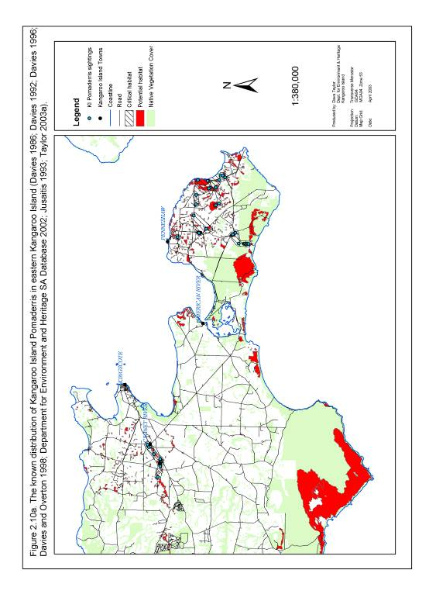

Figure 2.10b. The known distribution of Kangaroo Island Pomaderris in western Kangaroo Island.

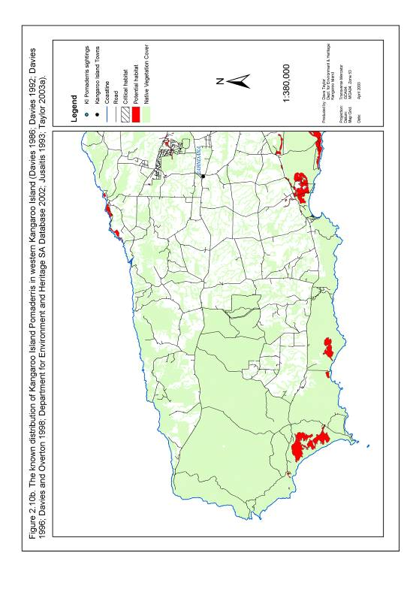

2.3.11. Ironestone Mulla Mulla Ptilotus beckerianus

Current Distribution and Important Populations
Ptilotus beckerianus occurs on Kangaroo Island and the Eyre Peninsula (Willoughby et al. 2001). On Kangaroo Island it has been located in 12 sub-populations scattered throughout the western half of the island. The extent of occurrence of this species is 1615 km² and is defined by latitude 35°41’S to 35°59’S and longitude 136°21’E to 136°34’E (Table 2.20; Figures 2.11a and 2.11b).

Table 2.20. Important known sub-populations of Ptilotus beckerianus listed in order of sub-population size (Davies 1986; Davies 1992; Davies 1996; Department for Environment and Heritage SA Database 2002; Taylor 2003a).

Sub-population | Location | Number of plants based on most recent and most complete counts. | Number of records within each sub-population | Number of records assessed since January 1995 | Area of Occupancy (km²)
A | South Coast Rd and East West Hwy 2 | 13700 | 5 | 0 | 7.2
B | South Coast Rd and Vivonne Bay Rd | 10000 | 4 | 0 | 0.8
C | South Coast Rd | 10000 | 1 | 0 | 0.8
D | Off West Bay Track, Ravine Des Casoars WPA | 2000 | 1 | 0 | 5.2
E | West End Hwy, Flinders Chase NP | 1208 | 3 | 0 | 0.8
F | Off Snug Cove Rd | 200 | 1 | 0 | 0.8
G | Burgess Lagoon, Flinders Chase NP | 100 | 1 | 0 | 8.8
H | Playford Hwy | 24 | 1 | 0 | 0.8
I | Playford Hwy | 20 | 1 | 0 | 0.8
J | South Coast Rd and Kelly Hill CP | Unknown | 1 | 0 | 0.8
K | Stokes Bay Rd | Unknown | 1 | 0 | 0.8
L | Hickmans Rd | Unknown | 1 | 0 | 0.8
 | Total | 37252 | 21 | 0 | 28.4

Past Distribution
The previous distribution of P. beckerianus is not known. It is possible that it may have been much more widespread but has since declined due to factors such as clearing and changes in fire regimes (Taylor 2003a).

Essential and Potential Habitat
The essential and potential habitat of P. beckerianus is mapped in Figures 2.11a and 2.11b based on definitions of essential and potential habitat described under section 2.2.

Topography and Soil Type
Ptilotus beckerianus has been found growing on gently sloping terrain associated with low broad ridges. Soil types in these areas include clayey sand, light sandy clay loam, loamy sand and sand with a pH range of 6 to 7 (Davies 1986).

Plant Associations
Ptilotus beckerianus has been observed growing in a variety of vegetation types (Davies 1986). These include woodland and shrubland communities with Eucalytpus baxteri, E. diversifolia, E. remota and/or Allocasuarina muelleriana as the dominant overstorey species. Understorey species associated with P. beckerianus populations include Astroloma conostephioides, Baeckea crassifolia, Calytrix tetragona, Hibbertia riparia, Lepidosperma viscidum, Leucopogon concurvus, Melaleuca gibbosa, M. uncinata, Petrophile multisecta, Phyllota pleurandroides, and Schoenus breviculmis (Davies 1986).

On a broader scale, the known distribution of P. beckerianus overlaps with 10 different vegetation groups defined and mapped by Ball and Carruthers (1998) (Table 2.21). The extent of these vegetation groups is presented as potential habitat in Figures 2.11a and 2.11b.

Table 2.21. Broad Kangaroo Island vegetation groups which overlap with the known distribution of Ptilotus beckerianus (Ball and Carruthers 1998).

Code | Primary Species | Secondary Species | Understorey Species
1A | Eucalyptus remota | Eucalyptus baxteri, E. cosmophylla. | Banksia ornata, B. marginata, Hakea rostrata, Allocasuarina striata, Xanthorrhoea semiplana ssp. tateana, A. muelleriana ssp. notocolpica, Phyllota pleurandroides, Daviesia brevifolia and Calytrix tetragona.
2A | Eucalyptus diversifolia | Eucalyptus baxteri, E. cosmophylla, E. fasciculosa | Banksia marginata, Allocasuarina striata, B. ornata, Xanthorrhoea semiplana ssp. tateana, Hakea mitchellii, A. muelleriana ssp. notocolpica, H. rostrata, Melaleuca uncinata
2H | Eucalyptus diversifolia | Eucalyptus albopurpurea, E. rugosa | Melaleuca lanceolata, Lasiopetalum schulzenii, Acacia retinodes var. uncifolia, Hakea vittata, H. muelleriana, Banksia marginata, A. myrtifolia var. myrtifolia, Pultenaea rigida, Correa reflexa, Xanthorrhoea semiplana ssp. tateana and Pomaderris obcordata
2M | Eucalyptus diversifolia | E. cosmophylla, E. cneorifolia, E. fasciculosa, E, lansdowneana ssp. albopurpurea. | Melaleuca uncinata, Allocasuarina muelleriana ssp. notocolpica, A. striata, Xanthorrhoea semiplana ssp. tateana, Hakea rostrata, M. gibbosa, Acacia myrtifolia var. myrtifolia, Thryptomene ericaea, Correa reflexa, Grevillea ilicifolia ssp. ilicifolia
3A | Eucalyptus baxteri | Eucalyptus cosmophylla, E. obliqua | Allocasuarina striata, Banksia marginata, B. ornata. Hakea rostrata, A. muelleriana ssp. notocolpica, H. muelleriana, Xanthorrhoea semiplana ssp. tateana.
3B | Eucalyptus baxteri | Eucalyptus cladocalyx, E. cosmophylla, E. obliqua. | Xanthorrhoea semiplana ssp. tateana, Hakea rostrata, Banksia marginata, B. ornata, D. asperula ssp. asperula
5A | Eucalyptus cladocalyx | Eucalyptus baxteri, E. cosmophylla, E. fasciculosa, E. obliqua, E. leucoloxylon ssp. leucoloxylon, E. viminalis ssp. cygnetensis | Acacia paradoxa, Bursaria spinosa, Leptospernum lanigerum, Prostanthera spinosa, Pteridium esculentum, Xanthorrhoea semiplana ssp. tateana.
5B | Eucalyptus cladocalyx | Eucalyptus obliqua, E. baxteri, E. cosmophylla | Banksia marginata, Daviesia asperula ssp. asperula, Hakea rostrata, Xanthorrhoea semiplana ssp. tateana.
6B | Eucalyptus cosmophylla | Eucalyptus fasciculosa | Allocasuarina muelleriana ssp. notocolpica, A. striata, Banksia marginata, B. ornata, Hakea mitchellii, H. rostrata, H. rugosa, Melaleuca uncinata.
8B | Eucalyptus albopurpurea | Eucalyptus diversifolia, E. leptophylla, E. fasciculosa, E. cosmophylla, E. cneorifolia | Banksia marginata, B. rotundifolia, Choretrum glomeratum, Correa reflexa, Grevillea ilicifolia ssp. ilicifolia, Melaleuca lanceolata, M. uncinata, Xanthorrhoea semiplana ssp. tateana.

Climate
Mean annual rainfall in the vicinity of the known distribution of Ptilotus beckerianus ranges from 628 mm at Cape Borda to 629 mm at Parndana. The mean annual maximum and minimum temperatures in Parndana are 19.0 °C and 9.4 °C respectively (Mooney and Grinter 2000).

Fire and Disturbance
The majority of known populations of P. beckerianus appear to be in areas disturbed within the last 10 years or in naturally open habitat (Taylor 2003a). A portion of sub-population B (South Coast Rd and Vivonne Bay Rd) was known to be burnt on the 11th of December 1994 (Overton, B. 2003, pers comm.). Subsequent observations in this area revealed that the population was able to re-establish and flower within 12 months of the burn event. A decline in the population was also noted as other mid and upper-storey plant species recolonised the burn site (Overton, B. 2003, pers comm.).

Figure 2.11a. The known distribution of Ironstone Mulla Mulla in eastern Kangaroo Island.

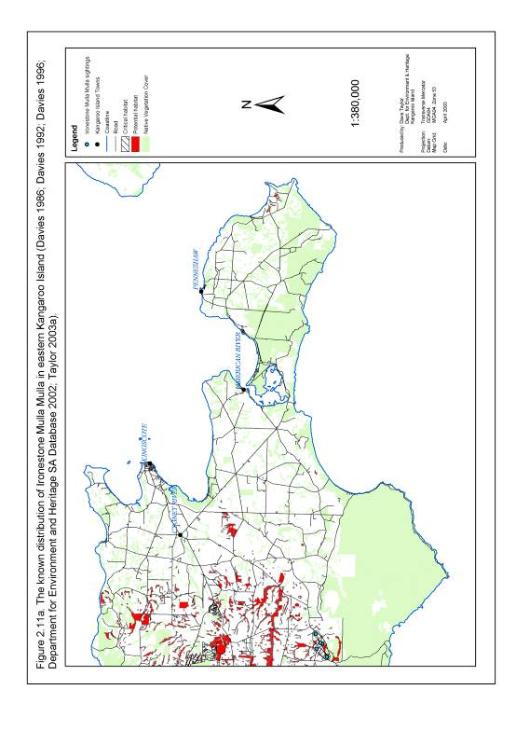

Figure 2.11b. The known distribution of Ironstone Mulla Mulla in western Kangaroo Island.

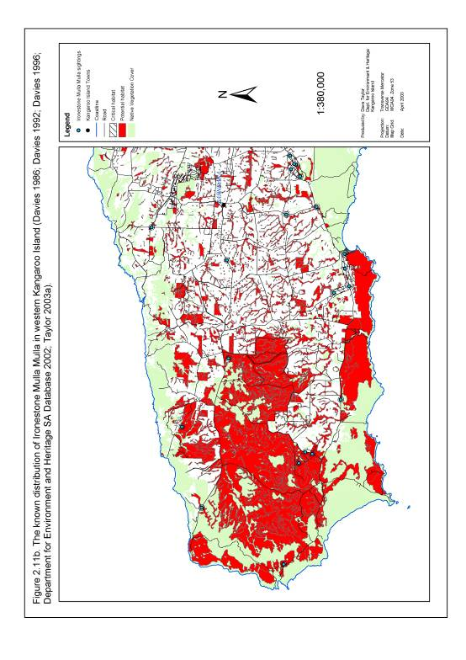

2.3.12. Beyeria Bush-pea Pultenaea insularis

Taxonomic Status
At the time of the development of the first edition of this recovery plan in 2003, Pultenaea insularis was considered to be a species endemic to Kangaroo Island, critically endangered and worthy of listing under the Environment Protection and Biodiversity Conservation Act 1999. Pultenaea insularis has since been reviewed by de Kok and West (2004) and identified as Pultenaea pedunculata, a species commonly found on mainland South Australia. Recent genetic work however suggests that P. insularis is genetically distinct from the mainland P. pedunculata and may be worthy of consideration as a separate species. Genetic research to explore the status of this species will continue in 2009 and until this research is completed P. insularis will continue to be treated as a separate species of interest to the KI Nationally Threatened Plant Project. For that reason it is included in this recovery plan.

Current Distribution and Important Populations
Pultenaea insularis is endemic to Kangaroo Island (Holliday et al. 1994). The known range of this species is currently restricted to the MacGillivray area of eastern Kangaroo Island (Table 2.22, Figure 2.12). This species currently has an extent of occurrence of 13 km² defined by latitude 35°46′S to 35°50′S and longitude 137°33′E to 137°38′E. Three separate sub-populations of P. insularis have been located within this area. These occur within Beyeria CP, fragments of remnant roadside vegetation along Hundred Line and Moore’s Roads and a small area of roadside vegetation on Halls Road.

Table 2.22. Important known sub-populations of Pultenaea insularis listed in order of sub-population size (Davies 1996; Davies and Overton 1998; Department for Environment and Heritage SA Database 2002; Taylor 2003a).

Sub-population | Location | Number of plants based on most recent and most complete counts. | Number of records within each sub-population | Number of records assessed since January 1995 | Area of Occupancy (km²)
A | Beyeria CP. | 600 | 1 | 1 | 0.8
B | Hundred Line Rd and Moores Rd. | 220 | 11 | 11 | 9.4
C | Halls Rd | 11 | 3 | 3 | 1.4
 | Total | 831 | 15 | 15 | 11.6

Past Distribution
The previous distribution of P. insularis is not documented, however it is likely that this species once occupied a much larger area of eastern Kangaroo Island prior to agricultural clearing (Taylor 2003a).

Essential and Potential Habitat
The essential and potential habitat of P. insularis is mapped in Figure 2.12 based on definitions of essential and potential habitat described under section 2.2.

Topography and Soil Type
Pultenaea insularis occurs on gentle slopes and undulating terrain in the MacGillivray area of eastern Kangaroo Island. Altitude at known sub-populations ranges from 15 to 50 m above sea level. The preferred soil type for P. insularis is unknown.

Plant Associations
Pultenaea insularis is restricted to woodland and shrubland dominated by Eucalyptus cneorifolia with secondary species Eucalyptus cosmophylla, E. diversifolia and E. albopurpurea (vegetation group 11D) (Ball and Carruthers 1998). Understorey species which commonly occur in this vegetation community include Adenanthos terminalis, Allocasuarina muelleriana ssp. notocolpica, A. striata, Correa reflexa var. insularis, Grevillea ilicifolia ssp. ilicifolia, G. lavandulacea ssp. rogersii, Melaleuca uncinata, Thryptomene ericaea, Xanthorrhoea semiplana ssp. tateana and (Ball and Carruthers 1998, Jackson, I. 2003, pers comm.). The extent of these vegetation groups is presented
as potential habitat in Figure 2.12.

Climate
Mean annual rainfall in the vicinity of the known distribution of P. insularis ranges from 485 mm at Kingscote to 529 mm at American River. The mean annual maximum and minimum temperatures in Kingscote are 19.0 °C and 11.5 °C respectively (Mooney and Grinter 2000).

Fire and Disturbance
The dynamics of P. insularis populations in response to disturbance events such as fire remains unresearched. It is presumed to exhibit some tolerance to disturbance as present populations are found within Beyeria CP (which was partially cleared between 1979 and 1983) and in frequently disturbed roadside vegetation (Weber 1995, Overton, B. 2003,
pers comm.).

Figure 2.12. The known distribution of Beyeria Bush-pea on Kangaroo Island.

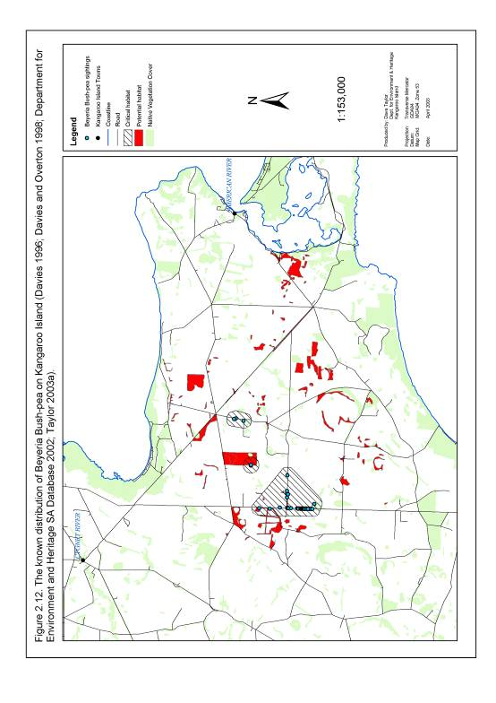

2.3.13. Splendid Bush-pea Pultenaea villifera var. glabrescens

Current Distribution and Important Populations
Pultenaea villifera var. glabrescens is endemic to Kangaroo Island (Jessop and Toelken 1986; Prescott 1995). It is known to occur in 10 separate sub-populations scattered along the northern coast of Kangaroo Island. The extent of occurrence of this species is 239 km² and defined by latitude 35°35’S to 35°46’S and longitude 136°19’E to 136°38’E (Table 2.23 and Figure 2.13).

Table 2.23. Important known sub-populations of Pultenaea villifera var. glabrescens listed in order of sub-population size (Davies 1996; Department for Environment and Heritage SA Database 2002; Overton and Overton 1992; Taylor 2003a).

Sub-population | Location | Number of plants based on most recent and most complete counts. | Number of records within each sub-population | Number of records assessed since January 1995 | Area of Occupancy (km²)
A | Harveys Return. | 276 | 1 | 1 | 1.1
B | Little King George Beach | 204 | 2 | 1 | 0.7
C | Middle River | 85 | 5 | 2 | 6.4
D | Lathami CP and Hummocky Gorge | 46 | 3 | 0 | 3.4
E | Western River and Valley Creek | 14 | 2 | 2 | 2.5
F | Constitution Hill | 4 | 1 | 1 | 0.8
G | Cape Torrens WPA. | Unknown | 1 | 0 | 0.7
H | De Mole River, Cape Torrens WPA. | Unknown | 1 | 0 | 0.7
I | Western River WPA | Unknown | 2 | 0 | 2.6
J | Cape Cassini | Unknown | 2 | 0 | 0.7
 | Total | >629 | 20 | 7 | 19.6

Past Distribution
The pre-European distribution of P. villifera var. glabrescens is unknown. It is possible that this species was once more widespread along the northern coast of Kangaroo Island and has since declined due to factors such as clearing and stock grazing. Recent declines in the distribution of this species have been noted on the Western River Rd and off the North Coast Rd (Figure 2.13).

Essential and Potential Habitat
The essential and potential habitat of P. villifera var. glabrescens is mapped in Figure 2.13 based on definitions of essential and potential habitat described under section 2.2.

Topography and Soil Type
Pultenaea villifera var. glabrescens has been observed growing in topographical locations ranging from seaside cliffs to the upper slopes of ridge systems along the northern coast of Kangaroo Island. Soil types at these locations were generally found to consist of sandy loam (Overton and Overton 1992).

Plant Associations
Those plant species regularly associated with populations of P. villifera var. glabrescens are yet to be formally recorded.

On a broader scale, the known distribution of P. villifera var. glabrescens overlaps with 10 different vegetation groups defined by Ball and Carruthers (1998) (Table 2.24). The extent of these vegetation groups is presented as potential habitat in Figure 2.13. Additional plant species observed in association with P. villifera var. glabrescens include Correa backhouseana var. orbicularis and Correa decumbens (Jackson, I. 2003, pers comm.).

Climate
Mean annual rainfall in the vicinity of the known distribution of P. villifera var. glabrescens ranges from 628 mm at Cape Borda to 629 mm at Parndana. The mean annual maximum and minimum temperatures in Cape Borda are 17.9 °C and 11.3 °C respectively (Mooney and Grinter 2000).

Table 2.24. Broad Kangaroo Island vegetation groups which overlap with the known distribution of Pultenaea villifera var. glabrescens (Ball and Carruthers 1998).

Code | Primary Species | Secondary Species | Understorey Species
3C | Eucalyptus baxteri | Eucalyptus cosmophylla, obliqua, E. remota. | Allocasuarina muelleriana ssp. notocolpica, A. striata, Banksia marginata, B. ornata, Hakea rostrata, Xanthorrhoea semiplana ssp. tateana.
5D | Eucalyptus cladocalyx | Allocasuarina verticillata, Eucalyptus fasciculosa | Acacia paradoxa, Prostanthera spinosa
5E | Eucalyptus cladocalyx |  | Acacia paradoxa, Pteridium esculentum, Xanthorrhoea semiplana ssp. tateana.
5F | Eucalyptus cladocalyx | Allocasuarina muelleriana ssp. notocolpica, Eucalyptus cosmophylla | Allocasuarina muelleriana ssp. notocolpica, A. striata, Xanthorrhoea semiplana ssp. tateana
5G | Eucalyptus cladocalyx | Allocasuarina verticillata, Eucalyptus cosmophylla, E. fasciculosa, E. leucoloxylon ssp. leucoloxylon | Acacia paradoxa, Allocasuarina muelleriana ssp. notocolpica, A. striata, A. verticillata, Bursaria spinosa, Pteridium esculentum, Xanthorrhoea semiplana ssp. tateana.
13B | Melaleuca lanceolata | Eucalyptus diversifolia | Beyeria lechenaultii, Correa reflexa, Eutaxia microphylla var. microphylla, Melaleuca gibbosa, Pultenaea acerosa, Spyridium halmaturinum var. halmaturinum, S. phylicoides.
19A | Allocasuarina verticillata | Eucalyptus cladocalyx | Acacia paradoxa, Hibbertia riparia, Prostanthera spinosa.
19B | Allocasuarina verticillata
31A | Acacia paradoxa | Eucalyptus cladocalyx, Pteridium esculentum | Pteridium esculentum, Xanthorrhoea semiplana ssp. tateana.
32A | Acacia dodonaeifolia | Allocasuarina verticillata | Acacia paradoxa.

Fire and Disturbance
The fire and disturbance ecology of P. villifera var. glabrescens remains unstudied. Sub-population B (Little King George Beach) is known to have been burnt in 1984 and has since recovered (B. Overton, 2003, pers comm.).

Figure 2.13. The known distribution of Splendid Bush-pea on Kangaroo Island.

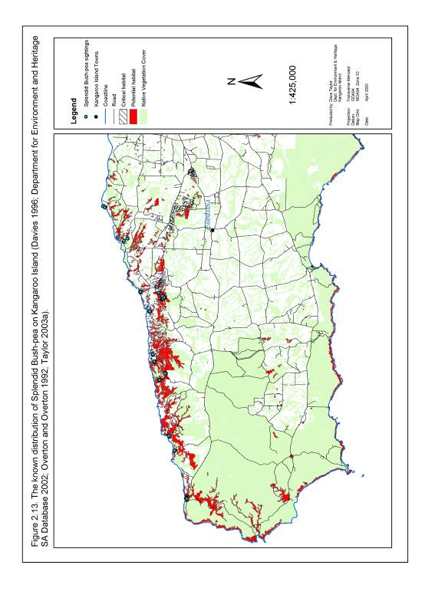

2.3.14. MacGillivray Spyridium Spyridium eriocephalum var. glabrisepalum

Current Distribution and Important Populations
Spyridium eriocephalum var. glabrisepalum is endemic to Kangaroo Island (Prescott 1995). It occurs in one large and four small sub-populations in eastern Kangaroo Island. The extent of occurrence of this species is 229 km² and defined by latitude 35°41’S to 35°49’S and longitude 137°25’E to 137°43’E (Table 2.25; Figure 2.14).

Table 2.25. Important known sub-populations of Spyridium eriocephalum var. glabrisepalum listed in order of sub-population size (Davies 1996; Davies 1998; Davies and Overton 1998; Department for Environment and Heritage SA Database 2002; Overton and Overton 1992; Taylor 2003a).

Sub-population | Location | Number of plants based on most recent and most complete counts. | Number of records within each sub-population | Number of records assessed since January 1995 | Area of Occupancy (km²)
A | Hog Bay Rd, Hundred Line Rd, Willsons Rd, Red Banks Rd, Wallers Rd and Min Oil Rd | 1457 | 42 | 41 | 35.3
B | Playford Hwy | 38 | 2 | 2 | 4.6
C | Birchmore Rd | 25 | 1 | 0 | 1.2
D | Springs Rd | 8 | 1 | 1 | 3.7
E | Gum Creek Rd | 8 | 2 | 2 | 0.8
 | Total | 1536 | 48 | 46 | 45.6

Past Distribution
The previous distribution of S. eriocephalum var. glabrisepalum is unknown, however it is possible that this species once occupied a much larger area prior to clearing for agriculture (Taylor 2003a). Recent declines in the distribution of S. eriocephalum var. glabrisepalum have been observed along Springs Rd and Hog Bay Road (Figure 2.14).

Essential and Potential Habitat
The essential and potential habitat of S. eriocephalum var. glabrisepalum is mapped in Figure 2.14 based on definitions of essential and potential habitat described under section 2.2.

Topography and Soil type
The topography and soil type associated with populations of S. eriocephalum var. glabrisepalum remains unresearched.

Plant Associations
Plant species commonly associated with populations of S. eriocephalum var. glabrisepalum have not been formally recorded.

On a broader scale, the known distribution of S. eriocephalum var. glabrisepalum overlaps with four different vegetation groups mapped by Ball and Carruthers (1998) (Table 2.26). The extent of these vegetation groups is mapped as potential habitat in Figure 2.14.

Climate
Mean annual rainfall in the vicinity of the known distribution of S. eriocephalum var. glabrisepalum ranges from 485 mm at Kingscote to 529 mm at American River. The mean annual maximum and minimum temperatures in Kingscote are 19.0°C and 11.5°C respectively (Mooney and Grinter 2000).

Fire and Disturbance
No formal research has been conducted to determine the response of S. eriocephalum var. glabrisepalum to fire or other types of disturbance. It is however thought to be able to tolerate some level of disturbance based on its current distribution which includes areas of frequently disturbed roadside vegetation (Taylor 2003a). A section of sub-population A (including Beyeria Conservation Park and Heritage Agreement 235) is also known to have successfully regenerated following a series of burning and clearing events between 1979 and 1983 (Overton, B. 2003, pers comm.).

Table 2.26. Broad Kangaroo Island vegetation groups which overlap with the known distribution of Spyridium eriocephalum var. glabrisepalum (Ball and Carruthers 1998).

Code | Primary Species | Secondary Species | Understorey Species
2M | Eucalyptus diversifolia | Eucalyptus. cosmophylla, E. cneorifolia, E. fasciculosa, E. albopurpurea. | Acacia myrtifolia var. myrtifolia, Allocasuarina muelleriana ssp. notocolpica, A. striata, Correa reflexa, Eucalyptus cneorifolia, Grevillea ilicifolia ssp. ilicifolia, Hakea rostrata, Melaleuca gibbosa, M. uncinata, Thryptomene ericaea, Xanthorrhoea semiplana ssp. tateana.
11A | Eucalyptus cneorifolia | Eucalyptus congolobata, E. diversifolia, E. rugosa | Acacia paradoxa, Callistemon rugulosus var. rugulosus, Correa reflexa, Grevillea ilicifolia ssp. ilicifolia, Melaleuca gibbosa, M. uncinata, Ozothamnus retusus, Rhagodia candolleana ssp. candolleana, Thryptomene ericaea, Xanthorrhoea semiplana ssp. tateana.
11D | Eucalyptus cneorifolia | Eucalyptus cosmophylla, E. diversifolia lansdowneana ssp. albopurpurea. | Adenanthos terminalis, Allocasuarina muelleriana ssp. notocolpica, A. striata, Correa reflexa, Grevillea ilicifolia ssp. ilicifolia, G. lavandulacea ssp. rogersii, Melaleuca uncinata, Thryptomene ericaea, Xanthorrhoea semiplana ssp. tateana.
11F | Eucalyptus cneorifolia | Eucalyptus conglobata, E. cosmophylla, E. diversifolia, E. albopurpurea. | Callistemon rugulosus var. rugulosus, Correa reflexa, Grevillea ilicifolia ssp. ilicifolia, Melaleuca gibbosa, M. uncinata, Thryptomene ericaea, Xanthorrhoea semiplana ssp. tateana.

Figure 2.14. The known distribution of MacGillivray Spyridium on Kangaroo Island.

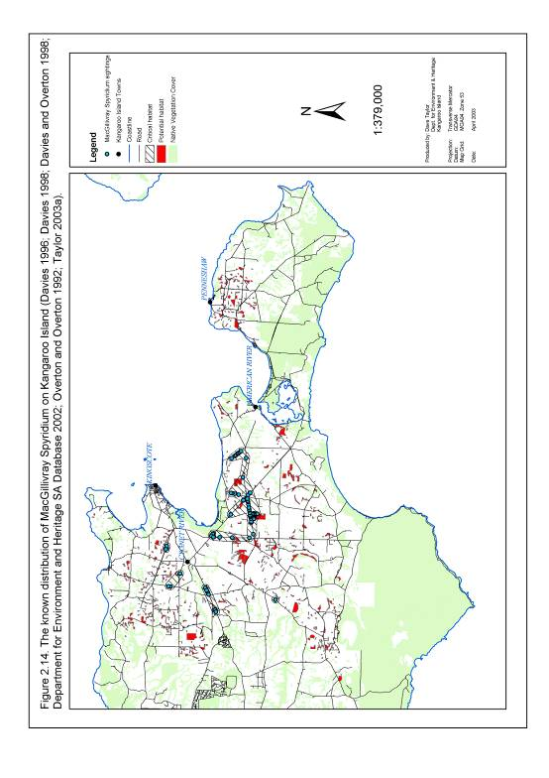

2.3.15. Spiral Sun Orchid Thelymitra matthewsii

Current Distribution and Important Populations
Thelymitra matthewsii has been found in Victoria, South Australia and New Zealand (Willoughby et al. 2001). Within South Australia T. matthewsii has been recorded at two locations in the western half of Kangaroo Island and at a number of sites within the south-east of the state. The extent of occurrence of this species on Kangaroo Island is 23 km2 and this area is defined by latitude 35°45’S to 35°50’S and longitude 136°38’E to 136°53’E (Table 2.27; Figure 2.15).

Table 2.27. Important known sub-populations of Thelymitra matthewsii listed in order of sub-population size (Davies 1986; Davies 1992; Department for Environment and Heritage SA Database 2002; Taylor 2003a).

Sub-population | Location | Number of plants based on most recent and most complete counts. | Number of records within each sub-population | Number of records assessed since January 1995 | Area of Occupancy (km²)
A | West of Snug Cove | Unknown | 1 | 0 | 0.8
B | Ravine Des Casoars WPA | Unknown | 1 | 0 | 0.8
 | Total | Unknown | 2 | 0 | 1.8

Past Distribution
The previous distribution of this species on Kangaroo Island is unknown.

Essential and Potential Habitat
The essential and potential habitat of T. matthewsii is mapped in Figure 2.15 based on definitions of essential and potential habitat described under section 2.2.

Topography and Soil Type
Thelymitra matthewsii has been observed growing on a gently sloping plateau site in soil described as lateritic podsol (Davies 1986).

Plant Associations
Thelymitra matthewsii has been recorded growing in Eucalyptus remota tall open-shrubland on Kangaroo Island (Davies 1986). According to Ball and Carruthers (1998) secondary species associated with this vegetation community include E. baxteri and E. remota (vegetation group 1A). Understorey species may include Allocasuarina muelleriana ssp. notocolpica and A. striata, Banksia marginata, B. ornata, Calytrix tetragona, Daviesia brevifolia, Hakea rostrata, Phyllota pleurandroides, Xanthorrhoea semiplana ssp. tateana (Ball and Carruthers 1998). The extent of this vegetation community on Kangaroo Island is mapped as potential habitat in Figure 2.15.

Climate
Mean annual rainfall in the vicinity of the known distribution of T. matthewsii ranges from 628 mm at Cape Borda to 629 mm at Parndana. The mean annual maximum and minimum temperatures in Parndana are 19.0 °C and 9.4 °C respectively (Mooney and Grinter 2000).

Fire and Disturbance
No research has been conducted to determine the response of T. matthewsii to fire or other types of disturbance.

Figure 2.15. The known distribution of the Spiral Sun Orchid on Kangaroo Island.

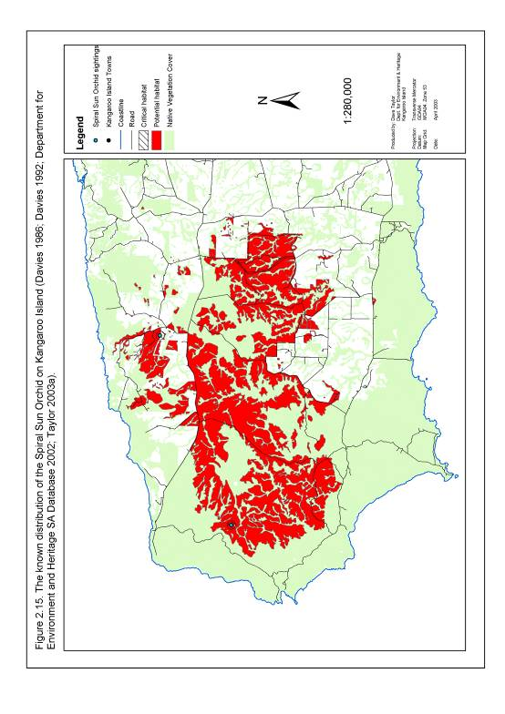

3. THREATS AND IMPEDIMENTS TO RECOVERY
This section describes threats to nationally threatened plant species on Kangaroo Island under two broad headings.
- Direct Threats: Direct threats are defined for the purposes of this recovery plan as those processes directly impacting on the short term survival of threatened plant populations.

- Impediments to Recovery: Impediments to recovery include:
- Those processes not directly impacting on the current day to day survival
of threatened plant species but which have the potential to significantly
influence the long-term survival of a threatened plant species, and
- Those processes restricting the ability of managers to abate
threatening processes.

Direct threats and impediments to recovery are not presented in any particular order of significance in sections 3.1 and 3.2 of this plan. It should also be noted that while they are listed separately, a combination of direct threats and impediments to recovery may occur at any single sub-population of a threatened plant species. The resulting interactive effect may in turn initiate or hasten the decline of that sub-population.

3.1. Direct Threats

3.1.1. Vegetation Clearance
While broad-scale clearance of vegetation is restricted on Kangaroo Island under the Native Vegetation Act (1991), small-scale clearing associated with activities such as the construction of fence-lines and firebreaks, trail maintenance, roadside maintenance and firewood collection continue to pose a threat to nationally threatened plant species. The immediate and obvious impact of clearing is the complete or partial destruction of threatened plant populations. Clearing may also provide secondary impacts in the form of increased erosion, salinity and fragmentation of threatened plant populations. It may also lead to the establishment of weed and disease species (including Phytophthora spp.) and alter microclimate conditions such as exposure to light, wind and moisture.

Those threatened plant species at immediate risk from clearing activities typically occur in either small or narrow vegetation fragments such as roadside vegetation. As much of the fragmented vegetation on Kangaroo Island occurs in the eastern and central sections of this land mass, those species with a significant proportion of their population in this area are at particular risk (Table 3.1; Figure 3.1).

Table 3.1. Sub-populations of nationally threatened plant species known to be currently threatened by small scale vegetation clearance activities (Davies 1996; Davies 1998; Taylor 2003a).

Species | National Status | Sub-populations threatened | Percentage of total population threatened
Pultenaea insularis | Not Currently Listed | A, B, C | 100%
Asterolasia phebalioides | Vulnerable | A | 100%
Beyeria subtecta | Vulnerable | A,B | 100%
Spyridium eriocephalum var. glabrisepalum | Vulnerable | A, B, C, D, E | 100%
Leionema equestre | Endangered | A, B, C, E | 97%
Ptilotus beckerianus | Vulnerable | A, B, E, H, I, J, K, L | 67%
Pomaderris halmaturina ssp. halmaturina | Vulnerable | B | 32%
Pultenaea villifera var. glabrescens | Vulnerable | C, F, | 14%
Olearia microdisca | Endangered | D, E, F, G | 5%
Cheiranthera volubilis | Vulnerable | E, H | 0.02%

3.1.2. Environmental Weeds
Bridal Creeper (Asparagus asparagoides), Bridal Veil (Asparagus declinatus), Perennial Veldt Grass (Ehrharta calycina) and Phalaris (Phalaris aquatica) have been identified as weed species posing the greatest immediate threat to nationally listed plant species on Kangaroo Island (Davies 1996; Taylor et al. 2002; Taylor 2003a). These weed species have the potential to directly impact on the growth, recruitment and survival of a number of nationally threatened plant species through direct competition for resources including light, nutrients, space and moisture (Willis 2000; Willoughby et al. 2001). They may also cause secondary impacts which include the alteration of hydrological cycles, fire regimes and micro-climate conditions such as soil pH and nutrient availability (Willoughby et al. 2001).

All four weed species have invaded and are continuing to expand their distribution into degraded small vegetation patches and roadside vegetation throughout eastern and central Kangaroo Island (Davies 1996). Nationally threatened plant species with sub-populations within fragmented remnant vegetation patches are therefore either under immediate threat (Table 3.2; Figures 3.2 to 3.5) or face a significant long term threat from these environmental weed species.

Figure 3.1. Essential habitat of nationally threatened plant species known to be currently threatened by small-scale vegetation clearance activities.

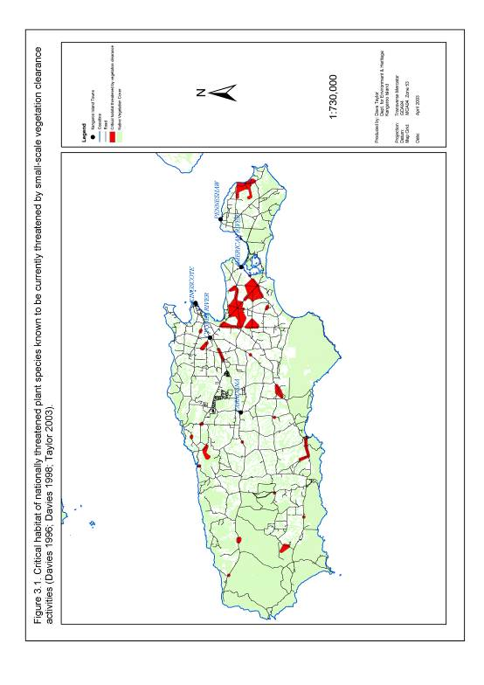

Table 3.2. Sub-populations of nationally threatened plant species on Kangaroo Island known to be currently threatened to some extent by the environmental weed species Asparagus asparagoides, A. declinatus, Ehrharta calycina and Phalaris aquatica (Davies 1996; Davies 1998; Taylor 2003a; Taylor et al. 2002).

Species |  | National Status | Sub-populations threatened | Percentage of total population threatened
Bridal Creeper
Olearia microdisca |  | Endangered | A, B, D, E, F, G | 100%
Beyeria subtecta |  | Vulnerable | A, B | 100%
Pomaderris halmaturina ssp. halmaturina |  | Vulnerable | A, B, C, D, E | 100%
Spyridium eriocephalum var. glabrisepalum |  | Vulnerable | A, B, D, E | 100%
Leionema equestre |  | Endangered | A, C | 66%
Pultenaea insularis |  | Not Currently Listed | B, C | 28%
Bridal Veil
Leionema equestre | Endangered |  | B | 30%
Pultenaea insularis | Not Currently Listed |  | B, C | 28%
Olearia microdisca | Endangered |  | E | 1%
Perennial Veldt Grass
Beyeria subtecta | Vulnerable |  | A, B | 100%
Spyridium eriocephalum var. glabrisepalum | Vulnerable |  | A, B, | 97%
Leionema equestre | Endangered |  | A, B | 88%
Olearia microdisca | Endangered |  | A, D, E | 49%
Pultenaea insularis | Not Currently Listed |  | B, C | 28%
Phalaris
Beyeria subtecta |  | Vulnerable | A, B | 100%
Spyridium eriocephalum var. glabrisepalum |  | Vulnerable | A | 95%
Leionema equestre |  | Endangered | A | 58%
Pomaderris halmaturina ssp. halmaturina |  | Vulnerable | A | 56%
Olearia microdisca |  | Endangered | B, D, E, | 33%

Figure 3.2. Essential habitat of nationally threatened plant species known to be currently threatened by Bridal Creeper on Kangaroo Island.
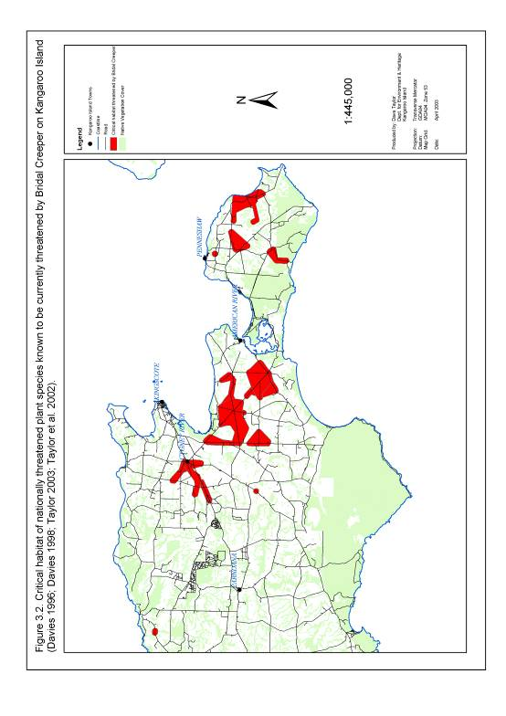

Figure 3.3. Essential habitat of nationally threatened plant species known to be currently threatened by Bridal Veil on Kangaroo Island.

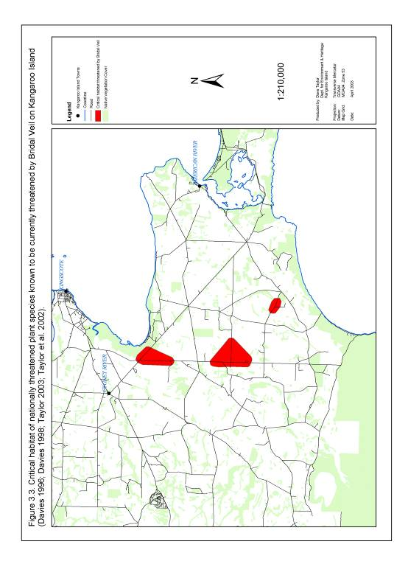

Figure 3.4. Essential habitat of nationally threatened plant species known to be currently threatened by Perennial Veldt Grass on Kangaroo Island.

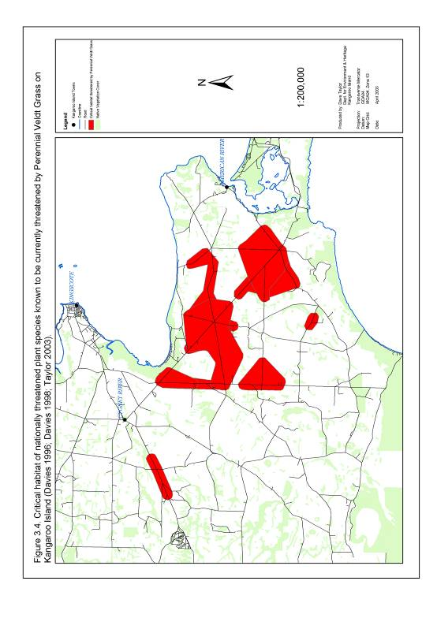

Figure 3.5. Essential habitat of nationally threatened plant species known to be currently threatened by Phalaris on Kangaroo Island.

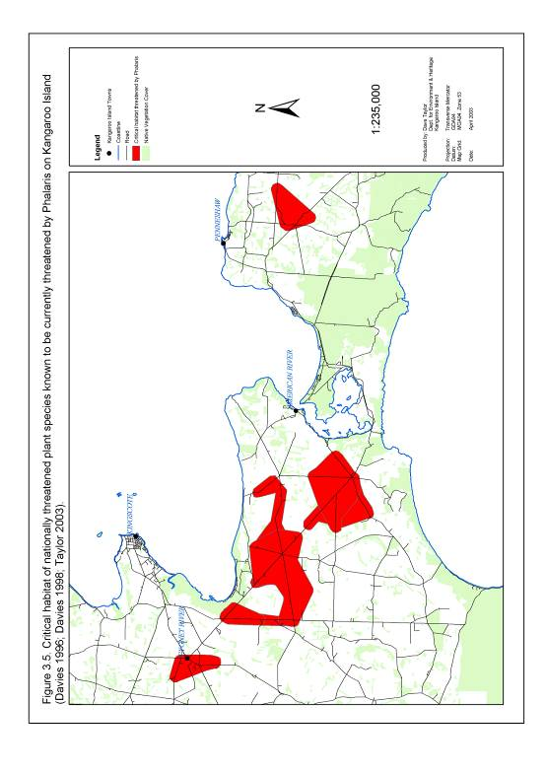

3.1.3. Grazing
Grazing of remnant vegetation by introduced and native vertebrate herbivores is considered a potential threat to the growth, reproduction, survival and recruitment
of nationally threatened plant species on Kangaroo Island. Grazing may also have secondary impacts in the form of weed dispersal and disturbance encouraging weed establishment and growth (Willoughby et al. 2001).

Six nationally threatened species have been identified as being immediately threatened by the impact of native and domestic herbivore grazing (Table 3.3; Figure 3.6) (Davies 1996; Davies 1998; Taylor 2003a). This threat is considered to be particularly significant
for sub-populations of threatened species regenerating after a fire event (Overton 2001).

It is also possible that elevated native herbivore grazing pressures throughout Kangaroo Island may be exerting a significant, and as yet unmeasured, impact on the other nine nationally threatened plant species (Willoughby et al. 2001). Again, this impact is likely to be greatest in the early stages of the growth and development of each plant species.

Table 3.3. Sub-populations of nationally threatened plant species known to be under immediate threat from herbivore grazing on Kangaroo Island (Davies 1996; Davies 1998; Taylor 2003a).

Species | National Status | Sub-populations threatened by native herbivore grazing | Sub-populations threatened by domestic herbivore grazing | Proportion of total population threatened by both forms of grazing
Euphrasia collina ssp. osbornii | Endangered | A | A | 100%
Pomaderris halmaturina ssp. halmaturina | Vulnerable | A, B, C, D | A, B, C, D | 100%
Beyeria subtecta | Vulnerable | A |  | 97%
Olearia microdisca | Endangered | A, B, E | B | 73%
Leionema equestre | Endangered | B, C, D |  | 42%
Pultenaea villifera var. glabrescens | Vulnerable | E, F |  | 3%

Figure 3.6. Essential habitat of nationally threatened plant species known to be currently threatened by herbivore grazing on Kangaroo Island.

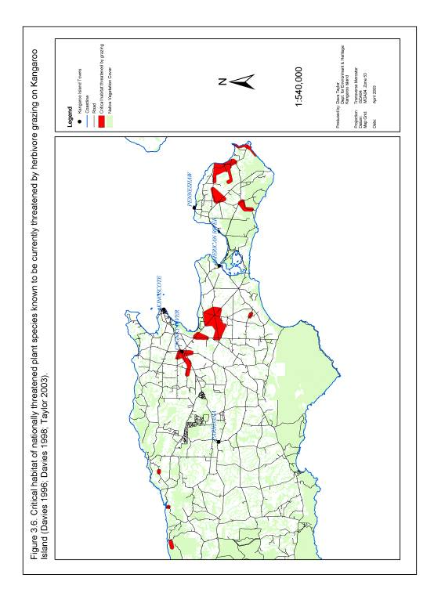

3.1.4. Salinity
Salinity is currently considered to be a minor localised threat to sub-populations of four nationally threatened plant species in low lying depressions in eastern Kangaroo Island (Table 3.4; Figure 3.7). A number of other threatened species sub-populations may also
be threatened in the future should soil salinity continue to increase in extent and impact.

Table 3.4. Sub-populations of nationally threatened plant species suspected to be under threat to some extent from soil salinity on Kangaroo Island (Davies 1996; Davies 1998; Taylor 2003a).

Species | National Status | Sub-populations threatened | Proportion of total population threatened
Beyeria subtecta | Vulnerable | A, B | 100%
Leionema equestre | Endangered | A | 58%
Pomaderris halmaturina ssp. halmaturina | Vulnerable | A | 56%
Olearia microdisca | Endangered | D | 4%

3.1.5. Trampling
Trampling by both vehicle traffic, foot traffic and stock is considered a minor and localised threat to nationally threatened plant species. Sub-populations of seven nationally threatened plant species are currently known to be threatened to some degree by the impact of trampling (Table 3.5; Figure 3.8). All other sub-populations easily accessible from major roads may also be potentially at risk from some level of trampling in the future.

Trampling may also be producing a secondary impact in the form of soil compaction, however the full extent and impact of this effect on nationally threatened plant species is unknown.

Figure 3.7. Essential habitat of nationally threatened plant species suspected to be under threat from increasing soil salinity on Kangaroo Island.

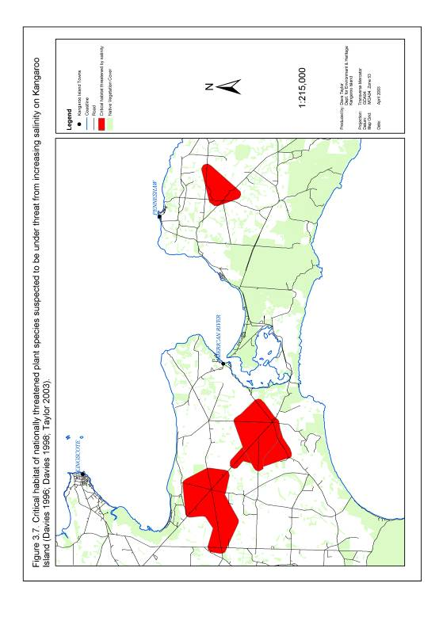

Figure 3.8. Essential habitat of nationally threatened plant species known to be currently threatened to some degree by trampling on Kangaroo Island.

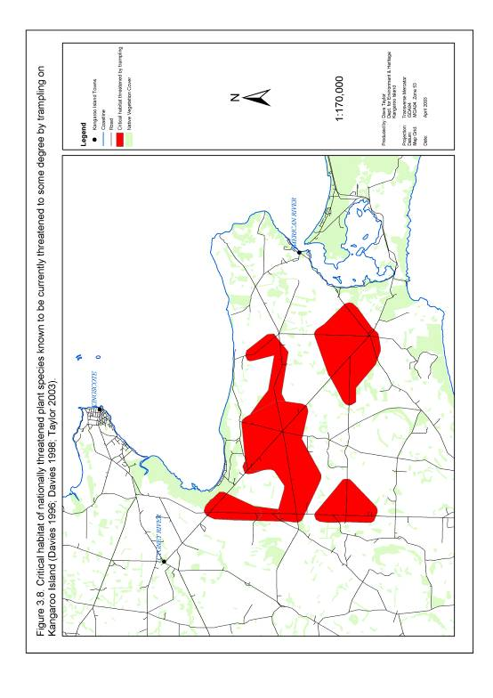

Table 3.5. Sub-populations of nationally threatened plant species known to be under immediate threat from trampling on Kangaroo Island (Davies 1996; Davies 1998; Taylor 2003a).

Species | National Status | Sub-populations threatened | Proportion of total population threatened
Beyeria subtecta | Vulnerable | A, B | 100%
Euphrasia collina ssp. osbornii | Endangered | A | 100%
Pultenaea insularis | Not Currently Listed | A, B | 99%
Spyridium eriocephalum var. glabrisepalum | Vulnerable | A, | 95%
Pultenaea villifera var. glabrescens | Vulnerable | B | 32%
Leionema equestre | Endangered | C | 8%
Olearia microdisca | Endangered | E | 1%

3.1.6. Erosion
Erosion is currently considered to be a minor localised threat to sub-populations of four nationally threatened plant species on Kangaroo Island (Table 3.6; Figure 3.9). Impacted sites tend to be associated with roadside watercourses and road cuttings.

Table 3.6. Sub-populations of nationally threatened plant species known to be under threat to some extent from erosion on Kangaroo Island (Davies 1996; Davies 1998; Taylor 2003a).

Species | National Status | Sub-populations | Proportion of total population
Beyeria subtecta | Vulnerable | A | 97%
Spyridium eriocephalum var. glabrisepalum | Vulnerable | A | 95%
Olearia microdisca | Endangered | A, E | 45%
Pultenaea villifera var. glabrescens | Vulnerable | B, F | 33%

3.1.7. Phytophthora
A total of five Phytophthora spp. have been identified in soil samples collected on Kangaroo Island. The most widespread of these is Phytophthora cinnamomi. This species has been found to cause dieback in a wide range of plant species, including species endemic to Kangaroo Island (Vickery 1997).

To date no research has been conducted to determine the impact or potential impact of Phytophthora spp. on threatened plant species. This impact may take the form of:
- A direct decline in the health of individual threatened plants, and/or
- A significant decline in environmental conditions caused by the declining health and changing composition of the surrounding plant community.

Threatened plant species most likely to be exposed to the impact of Phytophthora spp. are those with a large proportion of their population occurring in close proximity to widespread infestations of P. cinnamomi in central and western sections of the island. Recent observations of dieback in phytophthora susceptible species by Taylor (2003b) suggest that Phytophthora spp. infestations may also now occur in portions of the eastern half of Kangaroo Island (Table 3.7; Figure 3.10). If this observation is confirmed then Phytophthora spp. may pose a significant potential future threat to a large proportion of the nationally threatened plant species occurring on Kangaroo Island.

Table 3.7. Sub-populations of nationally threatened plant species with either a confirmed or suspected Phytophthora spp. infestation site within their essential habitat boundary (Davies 1996; Davies 1998; Taylor 2003a; Taylor 2003b).

Species | National Status | Sub-populations | Proportion of total population
Asterolasia phebalioides | Vulnerable | A, B | 100%
Cheiranthera volubilis | Vulnerable | A, B, D | 100%
Spyridium eriocephalum var. glabrisepalum | Vulnerable | A | 95%
Ptilotus beckerianus | Vulnerable | C, E, H, I, J | 30%
Olearia microdisca | Endangered | B | 28%
Beyeria subtecta | Vulnerable | B | 3%

Figure 3.9. Essential habitat of nationally threatened plant species known to be under threat to some extent from erosion on Kangaroo Island.

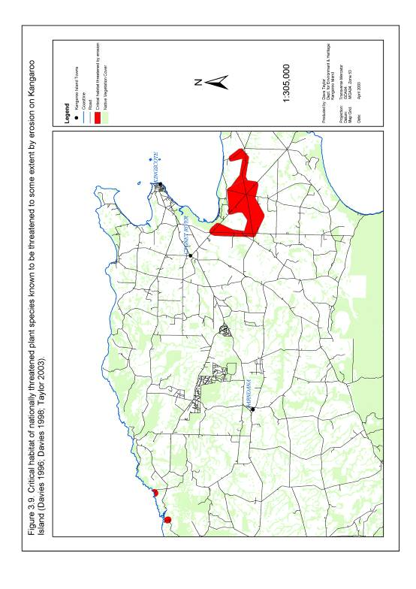

Figure 3.10. Essential habitat of nationally threatened plant species currently containing either a confirmed or suspected Phytophthora spp. infestation.

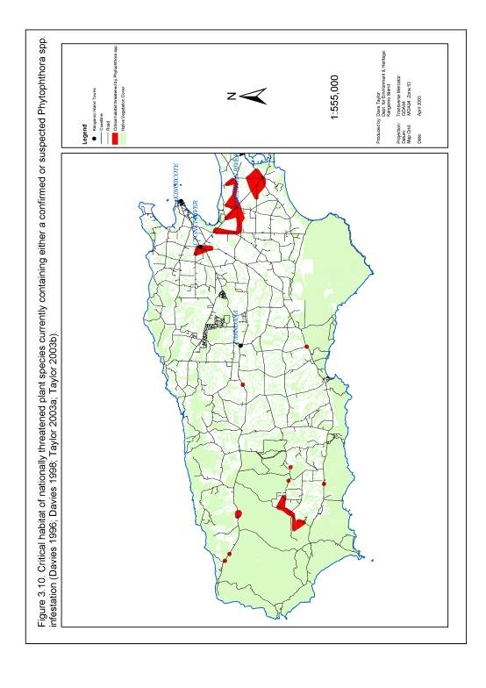

3.2. Impediments to Recovery

3.2.1. Fragmentation
Conventional island biogeography theory and field research (Debinski and Holt 2000; Dudash and Fenster 2000; MacArthur and Wilson 1967; Saunders et al. 1991; Sherwin and Moritz 2000; Young et al. 1996) conducted both on Kangaroo Island and elsewhere in Australia suggests that the current fragmented state of threatened plant populations and habitat on Kangaroo Island will be a key impediment to the future recovery of these species.

The three most anticipated effects of fragmentation are declining genetic viability, edge effects and distance effects. These effects are expected to have their greatest impact on threatened plant recovery in the highly modified agricultural landscape of the eastern and central Kangaroo Island.

3.2.1.1. Declining Genetic Viability
Small sub-populations unable to effectively exchange genetic material with other sub-populations are at risk from decreased levels of genetic diversity, inbreeding depression and higher rates of deleterious mutations. This may have impacts on plant growth rate, form, reproduction, recruitment, susceptibility to disease and pests and eventually lead to a decline in the number of individuals within each sub-population over time (Baur and Erhardt 1995, Cropper 1993; Dudash and Fenster 2000; Sherwin and Moritz 2000; Willoughby et al. 2001, Young et al. 1996). All nationally threatened species on Kangaroo Island covered by this plan have a proportion of their overall population in small sub-populations and are therefore considered to be at some risk from declining genetic viability (Table 3.8; Figure 3.11). This may create a significant impediment to the future recovery of these species.

3.2.1.2. Edge Effects
Small isolated vegetation fragments have a high edge to area ratio. Nationally threatened plant populations occurring in such fragments are therefore more likely to be exposed to impacts from threats which are likely to occur along the perimeter of a vegetation fragment (Taylor, D, 2003. pers obs.). Threats common to edge areas on Kangaroo Island include small-scale clearing, weed invasion, grazing and possible exposure to fertiliser and spray drift (Taylor, D, 2003. pers obs.; Willoughby et al. 2001). Those species susceptible to edge effects on Kangaroo Island generally occur in small isolated vegetation patches within the fragmented landscape of the eastern and central sections of the island (Table 3.9; Figure 3.12) (Taylor, D, 2003. pers obs.).

Table 3.8. Sub-populations of nationally threatened species on Kangaroo Island with less than 250 and 1000 individual plants respectively and considered potentially at risk from declining genetic viability (Bickerton and Davies 1999; Davies 1986; Davies 1992; Davies 1996; Davies 1998; Davies and Overton 1998; Jusaitis 1993; Jusaitis 2000; Overton 1998; Overton 2001; Overton and Overton 1992; Overton et al. 1990; Taylor 2003a; Willoughby et al. 2001).

Species | < 250 plants |  | < 1000 plants
Species | Sub-populations | Proportion of total population | Sub-populations | Proportion of total population
Caladenia ovata | A,B,C,D | 100% | A,B,C,D | 100%
Correa calycina var. halmaturorum | A,B | 100% | A,B | 100%
Euphrasia collina ssp. osbornii | - | - | A | 100%
Logania insularis | A | 100% | A | 100%
Pultenaea insularis | B,C | 28% | A,B,C | 100%
Pultenaea villifera var. glabrescens | B,C,D,E,F,G,H | 56% | A,B,C,D,E,F,GH, | 100%
Thelymitra matthewsii | A,B | 100% | A,B | 100%
Olearia microdisca | D,E,F,G | 5% | B,C,E,F,G | 56%
Pomaderris halmaturina ssp. halmaturina | C,D,E | 12% | B,C,D,E | 44%
Leionema equestre | C,D,E | 12% | B,C,D,E | 42%
Spyridium eriocephalum var. glabrisepalum | B,C,D,E | 5% | B,C,D,E | 5%
Beyeria subtecta | - | - | B | 3%
Ptilotus beckerianus | F,G,H,I,J,K,L | 1% | F,G,H,I,J,K,L | 1%
Cheiranthera volubilis | C,D,E,F,G,H | 0.3% | C,D,E,F,G,H | 0.3%
Asterolasia phebalioides | B,C | 0.004% | B,C | 0.004%

Figure 3.11. Essential habitat of nationally threatened plant species on Kangaroo Island containing less than 250 individual plants and considered potentially at risk from declining genetic viability.

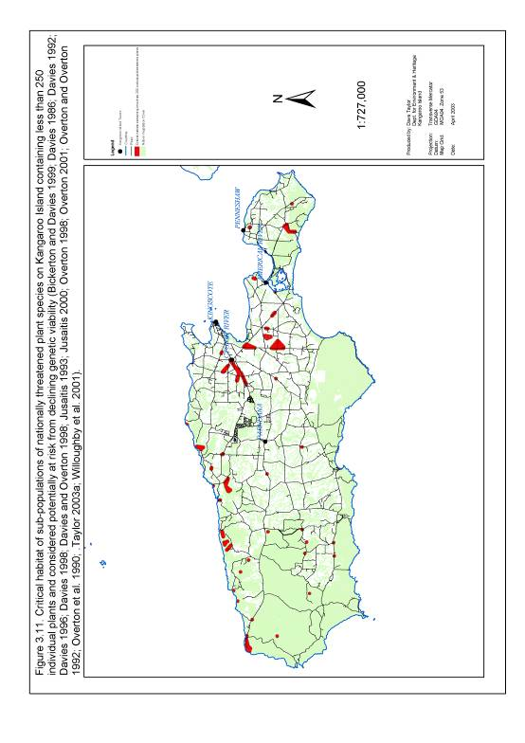

Figure 3.12. Essential habitat of nationally threatened plant species on Kangaroo Island occurring within vegetation fragments less than 100 ha in size or in vegetation strips with a width no greater than 30 m.

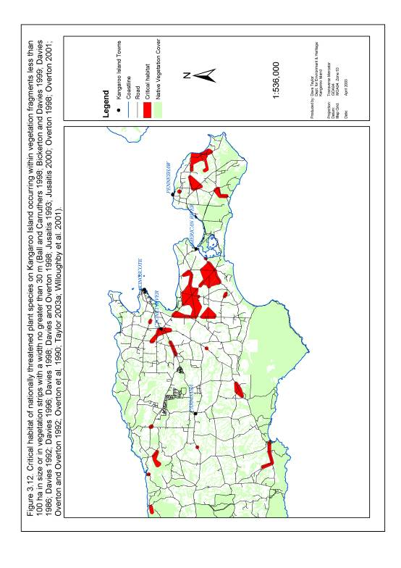

Table 3.9. Plant species with sub-populations partially or wholly occurring within vegetation fragments less than 100 ha in size or in vegetation strips less than 30 m wide and are therefore likely to be significantly influenced by edge effects (Ball and Carruthers 1998; Bickerton and Davies 1999; Davies 1986; Davies 1992; Davies 1996; Davies 1998; Davies and Overton 1998; Jusaitis 1993; Jusaitis 2000; Overton 1998; Overton 2001; Overton and Overton 1992; Overton et al. 1990; Taylor 2003a; Willoughby et al. 2001).

Species | Sub-populations affected | Proportion of total population affected
Beyeria subtecta | A, B | 100%
Olearia microdisca | A, B, C, D, E, F, G | 100%
Spyridium eriocephalum var. glabrisepalum | A, B, C, D, E | 100%
Pomaderris halmaturina ssp. halmaturina | A, B, C, E | 96%
Leionema equestre | A, B, E | 88%
Ptilotus beckerianus | A, B, I, K | 64%
Pultenaea insularis | B, C | 28%
Caladenia ovata | B | 25%
Pultenaea villifera var. glabrescens | C, E, F, | 14%
Cheiranthera volubilis | H | 0.01%

3.2.1.3. Distance Effects
The distance effect refers to the degree of isolation experienced by a plant population or vegetation fragment. This degree of isolation is based on three factors: time since isolation, distance between remnants and degree of connectivity (Saunders et al. 1991).

The partial or complete isolation of a plant population or a vegetation fragment as a result of one or more of these factors is likely to affect processes involving the transfer of genetic material, plant propagules and disturbance events (primarily fire) into or out of each plant population or fragment. A decline in the effectiveness of these process may potentially lead to a decline in the affected plant populations and communities (Debinski and Holt 2000; Fahrig and Merriam 1994; Young et al. 1996). Remnant vegetation in fragmented landscape of eastern and central Kangaroo Island is most likely to be influenced by distance effects (Table 3.10; Figure 3.13).

Transfer of Genetic Material
In most instances plant populations or vegetation patches which are isolated by the distance effect are unlikely to effectively exchange genetic material (such as pollen) with other plant populations or vegetation fragments. Depending on the size of the plant population or fragment and the length of time in isolation, the distance effect could enhance the impact of declining genetic viability (see section 3.2.1.1) (Baur and Erhardt 1995, Cropper 1993; Dudash and Fenster 2000; Sherwin and Moritz 2000; Willoughby et al. 2001, Young et al. 1996).

Transfer of Propagules
The transfer of propagules (primarily seed) may play an important role in the re-colonisation of areas subject to a catastrophic disturbance events such as wildfire, disease, flooding or clearing. Vegetation fragments isolated by distance effects and unable to exchange propagules with other fragments are therefore generally less likely to be recolonised by a high diversity of plant species following a disturbance event. This effect may lead to a long term decline in the diversity of these vegetation fragments, including the loss of threatened plant species (Fahrig and Merriam 1994; Saunders et al. 1991; Schmiegelow et al. 1997).

Transfer of Disturbance Events
Vegetation fragments isolated by the distance effect are more likely to be insulated from disturbance events (primarily fire) (Saunders et al. 1991). Much of this effect on Kangaroo Island is due to the increased ability of land managers to control and limit the spread of fire events in a fragmented landscape (Taylor, D. 2003, pers obs.). This effect appears to have led to a change in fire frequency (primarily a lengthening of the inter-fire interval) in the remnant vegetation of the highly fragmented landscape of eastern and central Kangaroo Island. This has encouraged the senescence of plant communities and appears to have led to significant declines in disturbance dependent plant species (including nationally threatened plant species) (see section 3.2.3) (Bickerton and Davies 1999; Davies 1986; Jusaitis 1993; Taylor 2003a; Taylor, D. 2003, pers obs).

Figure 3.13. Essential habitat of nationally threatened plant species with a small area of occupancy (10 sq. km), small population size (<1000 plants) and which occur within a fragmented landscape.

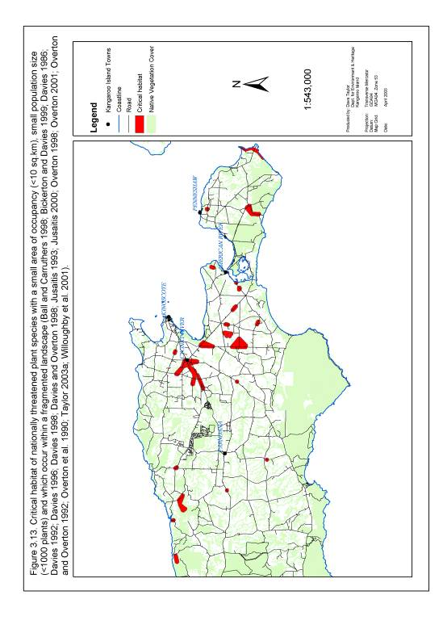

Table 3.10. Threatened plant species sub-populations with a small area of occupancy (<10 km²), small population size (<1000 plants) and which occur in a fragmented landscape (Seddon Plateau, Eastern Plains, Haines Plateau and Dudley Plateau, vegetation strip <30 m width or vegetation fragment <100 ha in size) and are therefore most likely to be influenced by distance effects (Ball and Carruthers 1998; Bickerton and Davies 1999; Davies 1986; Davies 1992; Davies 1996; Davies 1998; Davies and Overton 1998; Jusaitis 1993; Jusaitis 2000; Overton 1998; Overton 2001; Overton and Overton 1992; Overton et al. 1990; Taylor 2003a; Willoughby et al. 2001).

Species | Sub-populations affected | Proportion of total population affected
Euphrasia collina ssp. osbornii | A | 100%
Pultenaea insularis | A,B, C | 100%
Caladenia ovata | A, B, C | 75%
Olearia microdisca | B, C, D, E, F, G | 56%
Leionema equestre | B, D, E | 34%
Pultenaea villifera var. glabrescens | C, E, F, | 16%
Pomaderris halmaturina ssp. halmaturina | C, D, E | 12%
Spyridium eriocephalum var. glabrisepalum | B, C, D, E | 5%
Ptilotus beckerianus | I, K, L | 1%
Cheiranthera volubilis | H | 0.01%

3.2.2. Degraded Potential Habitat
The past and continued degradation and decline of potential threatened plant species habitat will limit any future increase in the distribution and abundance of these species and provide a key impediment to future recovery. Habitat degradation may also lead to the decline and potential listing of other currently common plant species associated with that habitat.

Key causes of the decline of potential habitat are identical to those identified for threatened species and include vegetation clearance, environmental weed invasion and competition, phytophthora, grazing, salinity and inappropriate disturbance regimes. Nationally listed plants whose future recovery is most likely to be impeded by the past or continued decline of potential habitat include all species with a significant proportion of their current and potential range occurring within the fragmented agricultural landscape of central and eastern Kangaroo Island (Table 3.11; Figure 3.14).

Table 3.11. Species with sub-populations occurring wholly or partially within the fragmented landscapes of central and eastern Kangaroo Island including Seddon Plateau, Eastern Plains, Haines Plateau and Dudley Plateau (as defined by Willoughby et al. (2001)) (Ball and Carruthers 1998; Bickerton and Davies 1999; Davies 1986; Davies 1992; Davies 1996; Davies 1998; Davies and Overton 1998; Jusaitis 1993; Jusaitis 2000; Overton 1998; Overton 2001; Overton and Overton 1992; Overton et al. 1990; Taylor 2003a; Willoughby et al. 2001).

Species | Sub-populations affected | Proportion of total population affected
Beyeria subtecta | A, B | 100%
Euphrasia collina ssp. osbornii | A | 100%
Leionema equestre | A, B, C, D, E | 100%
Olearia microdisca | A, B, C, D, E, F, G | 100%
Pultenaea insularis | A, B, C | 100%
Spyridium eriocephalum var. glabrisepalum | A, B, C, D, E | 100%
Pomaderris halmaturina ssp. halmaturina | A, B, D, E | 92%
Ptilotus beckerianus | A, B, C, I, L | 91%
Caladenia ovata | A, B, C | 75%

Figure 3.14. Essential habitat of nationally threatened plant species on Kangaroo Island occurring wholly or partially within the fragmented landscape of the Seddon, Haines and Dudley Plateaus or the Eastern Plains and therefore likely to be subjected to inappropriate fire regimes.

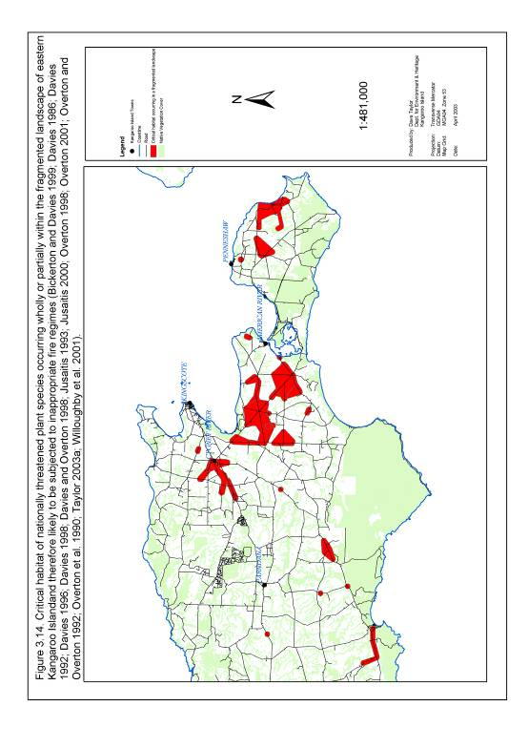

3.2.3. Inappropriate Disturbance Regimes
Disturbance regimes are considered to be inappropriate and create a potential impediment to the recovery of nationally threatened plant species on Kangaroo Island when they allow for:
- Disturbance which is too infrequent to encourage plant recruitment and reproduction,
- Disturbance which is too frequent to allow for plant growth, reproduction and seed set,
- Disturbance which is at an intensity which does not encourage growth or recruitment of threatened plant species,
- Disturbance at a frequency and intensity which encourages other threatening processes such as weed invasion and competition, or
- Disturbance which is in a form which does not encourage growth or recruitment of threatened plant species.

A total of nine nationally threatened plant species on Kangaroo Island have been observed regenerating following disturbance events (Table 3.12). These observations indicate both a tolerance to disturbance events and a possible dependence on disturbance events to stimulate plant reproduction and recruitment.

The most studied example of a disturbance-dependent species on Kangaroo Island is the nationally endangered Olearia microdisca. This species is dependent on fire to induce plant recruitment and is rapidly declining in areas not exposed to fire events within the last 20 years (Bickerton and Davies 1999; Davies 1986; Jusaitis 1993; Taylor 2003a).

Historically, the most significant source of habitat disturbance is most likely to have been wildfire. Human induced disturbance associated with activities such as vegetation clearance and road construction now provides an additional source of disturbance in many plant communities on the island. While this relatively new form of disturbance has produced negative impacts including vegetation loss and habitat fragmentation (see sections 3.1.1 and 3.2.1), it has provided a source of disturbance to disturbance-dependent species growing in fragments no longer exposed to natural fire regimes (Table 3.12).

Failure to determine and provide appropriate disturbance regimes for all 15 species covered by this plan will provide a significant impediment to their future recovery. The species at most risk from the impacts of inappropriate disturbance regimes are those which are no longer subject to natural disturbance events such as wildfire. On Kangaroo Island this exclusion is most likely to occur to plant species with populations in small, isolated vegetation fragments such as those found throughout eastern and central sections of the island (Figure 3.14; Table 3.12).

Table 3.12. Nationally threatened plant species on Kangaroo Island observed regenerating after disturbance events (Bickerton and Davies 1999; Davies 1986; Davies 1992; Davies 1996; Davies 1998; Davies and Overton 1998; Jusaitis 1993; Jusaitis 2000; Overton 1998; Overton 2001; Overton and Overton 1992; Overton et al. 1990; Taylor 2003a; Willoughby et al. 2001).

Species | Nationally listed species observed to regenerate following a disturbance event
Species | Bulldozing or Hydroaxe | Fire
Caladenia ovata |  | ✓
Asterolasia phebalioides | ✓ | ✓
Beyeria subtecta | ✓ | ✓
Leionema equestre | ✓ | ✓
Logania insularis |  | ✓
Olearia microdisca | ✓ | ✓
Ptilotus beckerianus | ✓ | ✓
Pultenaea insularis | ✓
Spyridium eriocephalum var. glabrisepalum | ✓ | ✓

3.2.4. Inadequate Knowledge of Distribution and Abundance
Reliable and up to date knowledge of the distribution and abundance of nationally threatened species on Kangaroo Island is considered essential if effective and efficient management is to be achieved in the future. Taylor (2003a) identified 10 nationally threatened species on Kangaroo Island for which our knowledge of distribution and abundance is considered to be inadequate for management purposes (Figure 3.15; Table 3.13). This lack of knowledge is considered to be a key impediment to the future recovery of these species.

Table 3.13. An assessment of the adequacy of current knowledge of the distribution and abundance of nationally threatened plant species on Kangaroo Island (Bickerton and Davies 1999; Davies 1986; Davies 1992; Davies 1996; Davies 1998; Davies and Overton 1998; Jusaitis 1993; Jusaitis 2000; Overton 1998; Overton 2001; Overton and Overton 1992; Overton et al. 1990; Taylor 2003a; Willoughby et al. 2001).

Species | Existing records adequately assessed? (>75% of known records visited since Jan 1995)
Asterolasia phebalioides | No
Beyeria subtecta | Yes
Caladenia ovata | No
Cheiranthera volubilis | No
Correa calycina var. halmaturorum | No
Euphrasia collina ssp. osbornii | No
Leionema equestre | Yes
Logania insularis | No
Olearia microdisca | Yes
Pomaderris halmaturina ssp. halmaturina | No
Ptilotus beckerianus | No
Pultenaea insularis | Yes
Pultenaea villifera var. glabrescens | No
Spyridium eriocephalum var. glabrisepalum | Yes
Thelymitra matthewsii | No

Figure 3.15. Records of nationally threatened plant species on Kangaroo Island not surveyed since January 1995.

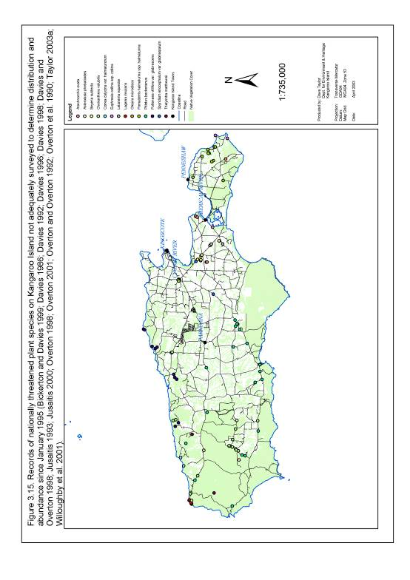

3.2.5. Inadequate Knowledge of Ecology and Biology
Taylor (2003a) identified deficiencies in our knowledge of the ecology and biology of nationally threatened plant species on Kangaroo Island in key areas which include fire ecology, response to disturbance, interaction with fauna and flora, preferred microclimate and seedbank dynamics (Table 3.14). Inadequate knowledge of these aspects of the ecology and biology will continue to limit the ability of land managers to identify and manage threats to nationally threatened plant species providing an important impediment to the future recovery of these species.

3.2.6. Inadequate Knowledge and Understanding of Threatening Processes
A lack of up to date information on the distribution, abundance, biology and ecology of many nationally threatened plant species on Kangaroo Island has contributed to a currently limited understanding of the processes threatening these species. Taylor (2003a) for example, identified nine nationally listed species on Kangaroo Island whose records have not been adequately field assessed for threatening processes since 1995 (Table 3.15; Figure 3.16).

Our understanding of the actual impact and dynamics of those processes identified as immediate threats to nationally listed plant species is also inadequate. Even for those threatening processes where the location of the threat has been adequately surveyed, our understanding of the current and potential impact of the threat remains largely based on subjective assessments.

This lack of reliable knowledge and understanding of threatening processes is a significant impediment to the development of efficient and effective management strategies to encourage the recovery of nationally threatened plant species on Kangaroo Island.

Table 3.14. Summary of current knowledge of the biology and ecology of 15 threatened plant species on Kangaroo Island (Bickerton and Davies 1999; Davies 1986; Davies 1992; Davies 1996; Davies 1998; Davies and Overton 1998; Jusaitis 1993; Jusaitis 2000; Overton 1998; Overton 2001; Overton and Overton 1992; Overton et al. 1990; Taylor 2003a; Willoughby et al. 2001).

Area of Knowledge |  | Olearia microdisca | Leionema equestre | Pomaderris halmaturina ssp. halmaturina | Beyeria subtecta | Pultenaea insularis | Spyridium eriocephalum var. glabrisepalum | Logania insularis | Euphrasia collina ssp. osbornii | Caladenia ovata | Cheiranthera volubilis | Correa calycina var. halmaturorum | Ptilotus beckerianus | Pultenaea villifera var. glabrescens | Thelymitra matthewsii | Asterolasia phebalioides
Biology | Morphological characteristics and phenology
Biology | Reproductive biology |  | - | - |  |  | - | - | - | - | - | - | - | - | - | -
Biology | Age and size structure of populations/sub-populations |  |  | - | - | - | - | - | - | - | - | - | - | - | - | -
Biology | Growth rate and longevity |  |  |  | - | - | - | - | - | - | - | - | - | - | - | -
Biology | Seedbank dynamics | - | - | - | - | - | - | - | - | - | - | - | - | - | - | -
Ecology | Preferred topography |  |  |  |  |  | - |  | -
Ecology | Preferred soil type (including soil composition, structure, pH and nutrients) |  |  |  |  | - | - | - | - | - | - | - | - | - | - | -
Ecology | Preferred plant associations |  |  |  |  |  | - | - | - | - | - | - | - | - | - | -
Ecology | Preferred climate
Ecology | Preferred micro-climate | - | - | - | - | - | - | - | - | - | - | - | - | - | - | -
Ecology | Fire ecology |  |  | - | - | - | - | - | - | - | - | - | - | - | - | -
Ecology | Short term response to disturbance other than fire |  |  |  |  |  |  | - | - | - | - | - | - | - | - | -
Ecology | Long term response to disturbance other than fire |  | - |  | - | - | - | - | - | - | - | - | - | - | - | -
Ecology | Nature and dynamics of interaction of plant with other species of fauna and flora | - | - |  | - | - | - | - | - | - | - | - | - | - | - | -
Well Understood
Poorly Understood
Partially Understood
-
Key:

Table 3.15. Nationally threatened plant species on Kangaroo Island adequately field assessed to determine immediate and potential threats (Bickerton and Davies 1999; Davies 1986; Davies 1992; Davies 1996; Davies 1998; Davies and Overton 1998; Jusaitis 1993; Jusaitis 2000; Overton 1998; Overton 2001; Overton and Overton 1992; Overton et al. 1990; Taylor 2003a; Willoughby et al. 2001).

Species | Existing plant records adequately assessed for threatening processes?  (>75% of existing records assessed since Jan 1995)
Caladenia ovata | No
Asterolasia phebalioides | No
Beyeria subtecta | Yes
Cheiranthera volubilis | No
Correa calycina var. halmaturorum | No
Euphrasia collina ssp. osbornii | Yes
Leionema equestre | Yes
Logania insularis | No
Olearia microdisca | Yes
Pomaderris halmaturina ssp. halmaturina | No
Ptilotus beckerianus | No
Pultenaea insularis | Yes
Pultenaea villifera var. glabrescens | No
Spyridium eriocephalum var. glabrisepalum | Yes
Thelymitra matthewsii | No

3.2.7. Potential Pest Species
The introduction of new potential pest species to Kangaroo Island poses a real and significant risk to nationally threatened plant species and may provide an important future impediment to their recovery. Potential pest species may include plant, invertebrate and animal species as well as plant diseases and pathogens.

Figure 3.16. Records of nationally threatened plant species on Kangaroo Island not adequately assessed to determine threatening processes since January 1995.

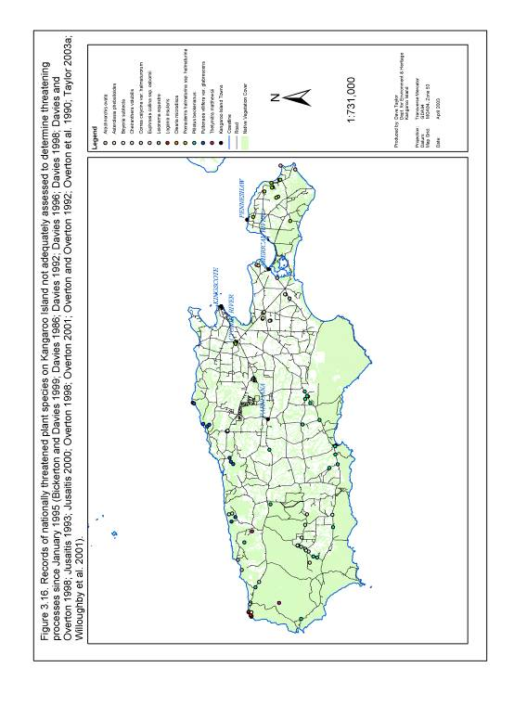

3.2.8. Involvement of Stakeholders
Community perception of, and involvement in, natural resource management has been identified as a key component to successful biodiversity conservation on Kangaroo Island (Willoughby et al. 2001). The recovery of nationally listed plant species on Kangaroo Island will be particularly dependent on the enthusiasm, support and input of a wide cross-section of community and government stakeholders. Failure of those managing the recovery process to appropriately develop and foster stakeholder support, understanding and involvement in threatened species management is therefore likely to create a key impediment to the recovery of nationally threatened species on the island. It is also likely to result in a lost opportunity to provide positive outcomes in the form of community teamwork, an enhanced community skills-base and an overall feeling of community empowerment.

3.2.9. Availability of Resources
The actions needed to recover nationally threatened plant species on Kangaroo Island will require a significant investment of human and financial resources. Failure to obtain these resources will significantly impede the recovery process.

3.2.10. Co-ordination and Integration of Recovery Process
The recovery of nationally threatened plant species on Kangaroo Island will require complex, time dependent and integrated actions involving a large number of stakeholders. Failure to effectively co-ordinate this recovery process may lead to inefficient and potentially ineffective plant management and may jeopardise the chance of recovery for one or more nationally threatened species on Kangaroo Island.

The recovery of nationally threatened plant species will also take place in a complex natural resource management environment. Failure to integrate the objectives, recommendations and actions of this plan into other natural resource management programs and vice-versa will lead to lost opportunities to maximise multiple management outcomes. It may also lead to potential conflicts between natural resource management programs which may undermine the overall outcomes of these projects.

3.2.11. Climate Change
Climate change is a world wide problem which requires actions well beyond the scope of this recovery plan. It is however conceivable that any change in climate may also affect Kangaroo Island’s plant communities and in-turn threatened plant species. At this point in time it is difficult to speculate on the nature and extent of that impact and research is urgently required to help determine that. It is likely that this issue will attract much more attention in future versions of this recovery plan.

4. BENEFITS TO OTHER SPECIES/ECOLOGICAL COMMUNITIES
The recovery plan adopts a habitat-based approach to threatened plant recovery by focussing on threat abatement actions in areas of essential habitat for nationally threatened plant species. Such an approach will inherently provide significant benefits to other species of fauna and flora, particularly those whose range overlaps with priority 1 threatened plant essential habitat (defined in section 4.2).

4.1 Flora
A total of 16 plant communities overlap to some extent with priority 1 essential habitat of nationally threatened plant species (Appendix A) (Ball and Carruthers 1998). These are likely to directly benefit from actions implemented under this recovery plan. This includes 10 communities classed as regionally threatened and a further three classed as rare on Kangaroo Island (Willoughby et al. 2001).

Davies (1996) also identified 53 roadside sites of significance for plant diversity within priority 1 essential habitat of nationally threatened plant species (defined under section 5.2) and these sites are likely to directly benefit from recovery plan actions (Table 4.1). This includes a large proportion of the total number of sites of significance identified as priority 1A, 1B, 2 or 3 by Davies (1996). Plant species recorded within these sites include a total of seven plant species listed at a state level and a further 16 species listed at a regional level (Appendix B) (Davies 1996; Willoughby et al. 2001).

Table 4.1 Roadside sites of significance occurring within priority 1 essential habitat of nationally threatened plant species on Kangaroo Island.

Level of Priority | No. of sites of significance within priority 1 essential habitat | Total number of sites of significance on KI
1A | 12 | 12
1B | 16 | 19
2 | 6 | 6
3 | 6 | 15
Important but requiring further survey. | 13 | 92
Total | 53 | 143

4.2 Fauna
Actions 5c, 5d, 5e, 5f and 5g (see section 5.3.5) will focus on the restoration, rehabilitation and expansion of priority 1 essential habitat for nationally threatened plant species (defined under section 5.2). These actions will improve connectivity within and between this habitat and this is likely to provide direct benefits to all fauna dependent on the health and viability of natural ecosystems in this area.

5. OBJECTIVES, PERFORMANCE CRITERIA AND ACTIONS

5.1. Overall Recovery Strategy

Primary Objectives
a) Recovery of nationally threatened plant species on Kangaroo Island.
b) Recovery of nationally threatened plant essential habitat on Kangaroo Island.

Secondary Objectives
Section 5.3 details 18 secondary objectives, which will need to be met if the primary objectives of this plan are to be achieved.

Actions
The recovery of nationally threatened plant species on Kangaroo Island will be achieved through active management of key threats and impediments to recovery. A full description of the location and nature of 58 planned management actions is provided in section 5.3. A ten year timeline for the implementation of these actions is presented under sections 5.4 and 5.5.

Primary Performance Criteria
a) The recovery of endangered and critically endangered plant species to a vulnerable status (based on IUCN criteria).
b) A contribution to reversing the decline of nationally threatened plant essential habitat (including areas containing state and regionally rare and threatened plant communities) on Kangaroo Island.

Secondary Performance Criteria
Section 5.3 lists a total of 73 secondary performance criteria which will need to be met in order to achieve both primary and secondary objectives of this recovery plan. A timeline for the achievement of these secondary performance criteria is presented in sections 5.4 and 5.5.

5.2. Determination of Recovery Actions

5.2.1. Development of a threat matrix
Actions under this recovery plan were selected to specifically abate key processes threatening nationally listed plant species. To determine which processes were posing
the greatest threats to these species a threat matrix was developed (Appendix C).
This scored the degree of current and future threat to each plant species for each threatening process. Based on this score a ranked list of threats to nationally threatened species was produced (Table 5.1). This list is used as a template for section 5.3, in which best practice threat abatement actions are listed against each threatening process.

It should be noted that the threat matrix process adopted for this recovery plan provides an indication rather than a definitive assessment of the current and potential impact of each threatening process. To achieve a better assessment a significant improvement in knowledge of the distribution and impact of threatening processes on threatened plant species is required. This action is listed as an important recommendation under section 5.3.4 (action 4c) of this recovery plan.

5.2.2. Revision of threatened plant species status
Threatened plant species status is used throughout section 5 of this plan to determine which species should be a focus for recovery efforts. To ensure that the status given to each plant species was true reflection of their current condition on Kangaroo Island, the status of each plant species was revised using IUCN redlist criteria (IUCN 2000) and the most up to date distribution, abundance and threat information (Appendix E; Table 5.2). This revised status is referred to throughout section 5 of this plan in preference to each species status under the Environment Protection and Biodiversity Conservation Act 1999.

Table 5.1. Order of threats and impediments to the recovery of 15 threatened plant species on Kangaroo Island based upon a threat matrix (developed under Appendix C). The higher the threat matrix score the higher the incidence and/or likelihood of the threat to all 15 threatened plant species. The highest possible threat score is 135. It should be noted that this table does not acknowledge the links between each individual threat or impediment to recovery.

Threat or Impediment to Recovery | Threat Matrix Score
Availability of Resources | 135
Co-ordination of Recovery Process | 135
Inadequate Knowledge of Distribution and Abundance | 121
Inadequate Knowledge and Understanding of Threats | 119
Small Isolated Populations | 110
Inappropriate Disturbance Regimes | 106
Degraded Potential Habitat | 106
Involvement of Stakeholders | 105
Inadequate Knowledge of Ecology and Biology | 98
Phytophthora | 86
Potential Pest Species | 76
Grazing | 74
Environmental Weeds | 65
Vegetation Clearance | 63
Trampling | 49
Salinity | 40
Erosion | 29

Table 5.2. The Kangaroo Island status of nationally threatened plant species based on IUCN red list criteria (IUCN 2000) compared with their current national status under the Environment Protection and Biodiversity Conservation Act 1999 (EPBC Act 1999) (Appendix E).

Species | Status under the EPBC Act 1999 | IUCN Classification  (Kangaroo Island)
Olearia microdisca* | Endangered | Critically Endangered
Pultenaea insularis* | Not currently listed | Critically Endangered
Leionema equestre* | Endangered | Endangered
Beyeria subtecta* | Vulnerable | Endangered
Spyridium eriocephalum var. glabrisepalum* | Vulnerable | Endangered
Euphrasia collina ssp. osbornii | Endangered | Vulnerable
Caladenia ovate | Vulnerable | Vulnerable
Asterolasia phebalioides | Vulnerable | Vulnerable
Cheiranthera volubilis* | Vulnerable | Vulnerable
Correa calycina var. halmaturorum* | Vulnerable | Vulnerable
Logania insularis* | Vulnerable | Vulnerable
Pomaderris halmaturina ssp. halmaturina | Vulnerable | Vulnerable
Ptilotus beckerianus | Vulnerable | Low Risk
Pultenaea villifera var. glabrescens* | Vulnerable | Vulnerable
Thelymitra matthewsii | Vulnerable | Vulnerable
* endemic to Kangaroo Island

5.2.3. Identification of species and sites on which to focus recovery actions
For actions which require manipulation of, or focus on, a particular species (for example collection of seed, research on species genetics, collection of information on species distribution) this plan focuses the majority of the recovery effort on priority 1 species.
Priority 1 species are defined for each particular action (see sections 5.3.1 to 5.3.17) but have been generally chosen based on current status (see section 5.2.2), with the focus being given to critically endangered and endangered species.

Lower priority species are also defined for each particular action (see sections 5.3.1 to 5.3.17), again generally based on their current status. While these species are generally not a focus of recovery efforts under this plan they have been listed in case additional funding or resources are obtained which would allow for the expansion of the planned recovery efforts.

For actions which require broad-scale manipulation of the landscape (for example environmental weed control, alteration to fire regimes and restoration activities), and which may have beneficial impacts on multiple species and species habitat, a second site selection process was developed. This was based on a decision tree (Appendix D) constructed using four separate criteria: threatened species status, sub-population size, the extent of overlap between threatened species and degree of threat.

The end product of the decision tree process was the identification of priority 1 essential habitat (Figure 5.1). This habitat defines the area in which on-ground actions described under this plan will be primarily focussed during it’s ten year life span. The decision making process also allowed for the division of priority 1 essential habitat into units 1a to 1h (Figure 5.2). This division is intended to assist those implementing the plan to decide which section of priority 1 essential habitat should be the focus of on-ground actions first.

The decision tree process also identified priority 2 to 10 essential habitat. These are areas important to the recovery of threatened species on Kangaroo Island but which ideally should only be the focus of recovery plan actions after threats to priority 1 essential habitat have been sufficiently addressed. These additional areas should be considered for more intense recovery actions following the completion of the recovery plan.

5.2.4. Identifying when actions should be undertaken
The timing of each threat abatement action is based upon the current and predicted future extent of threatening processes (determined using a threat matrix – see Appendix C) and the time and seasonal requirements of each action. A full timetable for the implementation actions under this recovery plan is provided in sections 5.4 and 5.5.

Figure 5.1. Priority 1 essential habitat of nationally threatened plant species on Kangaroo Island.

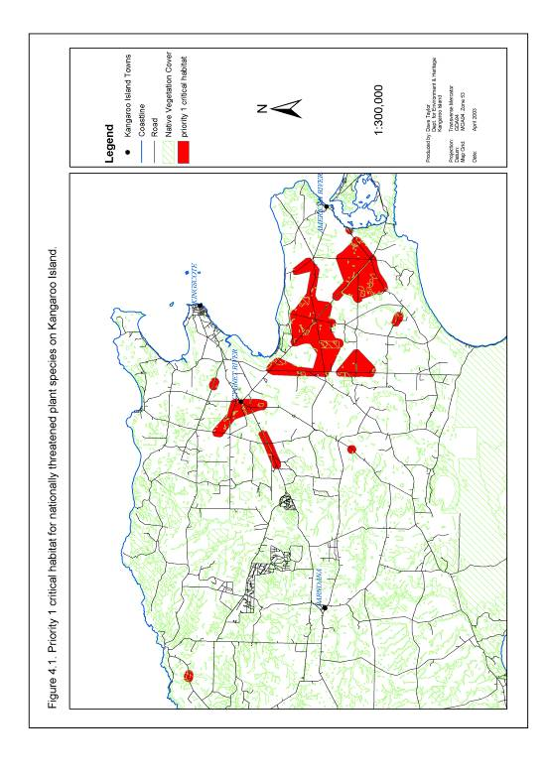

Figure 5.2. Priority 1a to 1h essential habitat of nationally threatened plant species on Kangaroo Island.

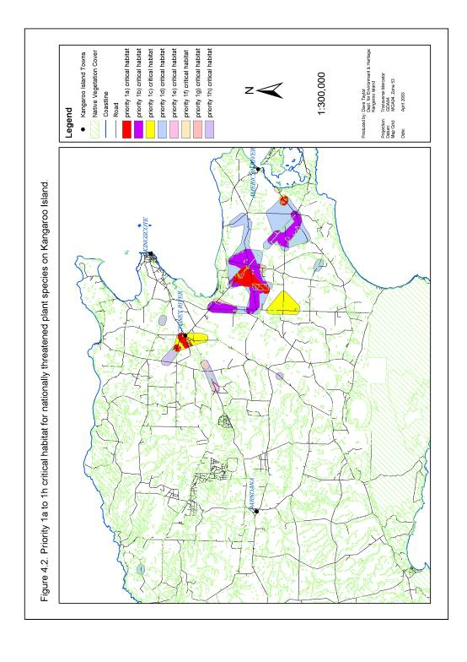

5.2.5. Scope of this recovery plan and opportunities for further actions
This plan identifies those actions considered vital to achieving the stated primary objectives (see section 5.1) within a ten year time limit and the practical constraints of human and financial resources.

Section 5.3.2 (action 2c) puts forward a recommendation for a complete re-appraisal of the recovery plan during 2013. This should include a re-assessment of the priorities for future management of threatened plant species and provide an opportunity to incorporate additional actions into the next recovery plan for nationally threatened plant species on Kangaroo Island. As an example, some consideration should be given to shifting the focus for on-ground actions away from critically endangered and endangered species to vulnerable and/or lower risk species or species which are declining but are yet to be listed nationally. Reliable information on the distribution and abundance of threatened plant species as well as the impact and extent of threatening processes will be necessary to support the recovery plan re-appraisal process and actions to obtain this knowledge are outlined under sections 5.3.3 and 5.3.4.

5.2.6. Identifying the role of stakeholders
Stakeholder involvement is listed in an abbreviated code for each individual action throughout section 5.3. The full list of codes and the corresponding stakeholders is provided in Table 5.3.

The stakeholders listed for involvement in each action throughout section 5.3 are an indication of potential stakeholders only. It is possible that some of the stakeholders listed may not wish to commit support to recovery actions. It is also equally likely that other stakeholders may express interest in each action. These groups should be engaged in the recovery process as appropriate.

Table 5.3. List of current and potential regionally, state and nationally based stakeholders in the management of nationally threatened plant species on Kangaroo Island and corresponding stakeholder code.

Stakeholder Code | Current or Potential Stakeholders
 | Regionally Based Stakeholders
R1 | General Kangaroo Island Community
R2 | Kangaroo Island Private Landholders*
R3 | Friends of KI West
R4 | Friends of Cape Gantheaume
R5 | Friends of the Dudley Peninsula
R6 | Bugga Bugga Creek Landcare Group
R7 | Chain of Lagoons Landcare Group
R8 | Eco-Action Landcare Group
R9 | Eleanor River Catchment Landcare Group
R10 | Emu Bay Landcare Group
R11 | Lake Ada Landcare Group
R12 | Lower Cygnet River Landcare Group
R13 | Middle River Landcare Group
R14 | Penneshaw School and Community Landcare Group
R15 | South West Catchment Landcare Group
R16 | Timber Creek Landcare Group
R17 | Upper Cygnet River Landcare Group
R18 | Kangaroo Island Natural Resources Board
R19 | Kangaroo Island Community Seed Bank
R20 | Kangaroo Island Animal and Plant Control Board
R21 | Kangaroo Island Soil Conservation Board
R22 | District Bushfire Prevention Committee
R23 | Bridal Creeper Control Committee
R24 | Kangaroo Island Flora and Fauna Club
R25 | Country Fire Service
R26 | Ecoaction
R27 | Kangaroo Island Council*
R28 | Roadside Vegetation Management Committee
R29 | Local Indigenous Community
R30 | KI Development Board
R31 | National Parks Consultative Committee
R32 | Kangaroo Island Asparagus Weeds Committee
 | State Based Stakeholders
S1 | General Public
S2 | Department of Environment, Water and Natural Resources
S3 | Primary Industries and Resources South Australia
S4 | Department for Water, Land and Biodiversity Conservation
S5 | Transport South Australia*
S6 | Country Fire Service
S7 | Native Vegetation Council
S8 | Conservation Council of South Australia
S9 | Threatened Plant Action Group
S10 | Botanic Gardens of Adelaide
Table 5.3 continued:

Stakeholder Code | Current or Potential Stakeholders
 | State Based Stakeholders
S11 | Indigenous Community
S12 | Trees For Life
S13 | South Australian Museum
S14 | Plant Biodiversity Centre
 | Nationally Based Stakeholders
N1 | General Public
N2 | Department of the Environment, Water, Heritage and the Arts
N3 | Threatened Species Network
N4 | Greening Australia
N5 | Green Corps
N6 | World Wide Fund for Nature - Australia
N7 | CSIRO
N8 | Research Institutions including universities
N9 | Australian Network for Plant Conservation
* Group directly owns and manages land supporting populations and essential habitat of nationally threatened plant species.

5.3. Threat Abatement.

5.3.1. Availability of Resources

Objective
To ensure sufficient financial and human resources are available to implement all recommended threat abatement actions during the 10 year span of the recovery plan.

Actions
1a) Obtain sufficient financial resources from relevant grant schemes, funding bodies and private organisations to implement the actions recommended within the recovery plan.
Notes | Responsibility for Action | Stakeholders Involved# | Direct links to other Actions
This action will involve developing and submitting timely detailed funding proposals to meet the funding requirements identified within this recovery plan. It will also involve exploring opportunities for sponsorship from private organisations as an alternative source of revenue. | Regional Ecologist, Bush Management Adviser, Recovery Project Officer, Recovery Team | R18, S2, S7, S9, N2, N3, N6 | +1b  *2a *3e
Key: + described action (1a) will contribute to the completion of this listed action
* described action (1a) requires the partial completion of this listed action
# For key to stakeholder groups see Table 5.3 (section 5.2.6)

1b) Obtain sufficient and timely resources to employ and maintain Recovery
Project Officers.
Notes | Responsibility for Action | Stakeholders Involved# | Direct links to other Actions
The large number of complex actions identified under this recovery plan will only be adequately implemented if a designated coordinator or recovery project officer is employed. This action will ensure that the project officer selected to implement the recovery plan is provided with secure employment. It will also encourage continuity in the management of threatened plant species on Kangaroo Island and avoid the loss of experience and knowledge from the project.  The appointment of multiple field based recovery assistants should also be considered to assist with the demands of implementing the large number of onground works identified within this plan.  These actions should be implemented in conjunction with the effective and timely implementation of action 1a). | Regional Ecologist, Bush Management Adviser. | R18, S2, S7, S9, N2, N3, N6 | *1a  +1c +2b
Key: + described action (1b) will contribute to the completion of this listed action
* described action (1b) requires the partial completion of this listed action
# For key to stakeholder groups see Table 5.3 (section 5.2.6)

1c) Provide professional support and encourage the professional development
of the Recovery Project Officers.
Notes | Responsibility for Action | Stakeholders Involved# | Direct links to other Actions
Recovery Project Officers implementing the recovery plan should be encouraged to develop their professional skills and experience. This action should involve providing ongoing training where necessary. It may also include encouraging the officer to publish and present monitoring/research completed as part of recovery actions in an appropriate scientific forum. This action will provide multiple benefits in the form of increased job satisfaction, improved management of the project and the communication of the plan’s successes and failures to a wider forum. This action should also involve providing support services such as a vehicle and office facilities to Recovery Project Officers. | Regional Ecologist, Bush Management Adviser, Recovery Team | S2, S3, S9, N3 | *1b
Key: * described action (1c) requires the partial completion of this listed action
# For key to stakeholder groups see Table 5.3 (section 5.2.6)

1d) Support and encourage stakeholders across Kangaroo Island to actively develop skills and experience in managing nationally threatened plant species.
Notes | Responsibility for Action | Stakeholders Involved# | Direct links to other Actions
Developing stakeholder experience and skills in bush management will be critical to the long term recovery of threatened plant species and associated habitat. This capacity building action will be achieved through the implementation of action 8a. | Regional Ecologist, Bush Management Adviser, Recovery Project Officer | R1 to R31, S1 | *8a
Key: * described action (1d) requires the partial completion of this listed action
# For key to stakeholder groups see Table 5.3 (section 5.2.6)

1e) Develop, encourage, and co-ordinate in-kind support for the implementation
of the recovery plan.
Notes | Responsibility for Action | Stakeholders Involved# | Direct links to other Actions
In-kind support from stakeholder groups, listed in Table 5.3 (section 5.2.6), will be critical to the successful recovery of nationally threatened plant species on Kangaroo Island. This support should be encouraged and rewarded wherever possible. This action will be supported through the implementation of a comprehensive stakeholder awareness and involvement campaign planned under action 8a. | Regional Ecologist, Bush Management Adviser, Project Officer | All | *8a
Key: * described action (1e) requires the partial completion of this listed action
# For key to stakeholder groups see Table 5.3 (section 5.2.6)

Performance Criteria
Sufficient financial and human resources available for the implementation and completion of recovery actions over the life of the recovery plan.

5.3.2. Co-ordination and Integration of Recovery Process

Objective
Effective and efficient co-ordination and implementation of recovery actions to meet recovery objectives.

Actions
2a) Establish, develop and support an effective Kangaroo Island Threatened Plant Recovery Team.
Notes | Responsibility  for Action | Stakeholders Involved# | Direct links to other Actions
The recovery team will be responsible for overseeing the implementation of the recovery plan. It should meet at least twice a year and include stakeholders that are able to provide expert advice on planning, co-ordination, scientific and funding issues relevant to the plan. Stakeholder groups not represented on the recovery team will have an opportunity to be involved in the recovery process through a KI network for plant recovery established under action 8a. | Regional Ecologist, Bush Management Adviser | R1, R18, R27, S2, S9, S10, N3, N7, N8 | +1a +2b +2c +2d +8a
Key: + described action (2a) will contribute to the completion of this listed action
# For key to stakeholder groups see Table 5.3 (section 5.2.6)

2b) Appoint and maintain a Recovery Project Officers to co-ordinate, facilitate
and implement recovery actions.
Notes | Responsibility for Action | Stakeholders Involved# | Direct links to other Actions
A project officer with specialised natural resource management skills and experience will be essential to the successful co-ordination, facilitation and implementation of the majority of actions described under this recovery plan. Field based recovery assistants will also be critical to the onground implementation of actions described under this plan. | Regional Ecologist, Bush Management Adviser, Recovery Team | R18, S2, N3 | *1b *2a
Key: * described action (2b) requires the partial completion of this listed action
# For key to stakeholder groups see Table 5.3 (section 5.2.6)

2c) Undertake periodic monitoring, evaluation and reporting of the successes and failures
of the recovery plan.
Notes | Responsibility for Action | Stakeholders Involved# | Direct links to other Actions
Progress implementing this recovery plan should be reported on a monthly or quarterly basis to meet the requirements of funding and supporting agencies such as the Department of Environment, Water and Natural Resources and the KI Natural Resources Management Board. Each report should contain the actions completed to meet the relevant recovery objectives and performance criteria. The reporting process should place a particular emphasis on fostering an adaptive approach to threatened species management by identifying ways to improve the actions being undertaken to improve the recovery of threatened plants. This should include feeding results from monitoring and research activities directly into management actions (see action 4e).  The reporting process will assist the recovery team in identifying priority actions for the following year. The final review released during 2013 should include a complete appraisal of the project and re-assess priorities for future management of threatened plant species on Kangaroo Island.  Responsibility for completing each report should rest with the Recovery Project Officer with input from field based recovery assistants.  A final review of the project should be completed in 2013 and provide an overview of the actions implemented under the plan and evaluate the effectiveness of these actions in meeting the objectives set. The final review of the project should be conducted with input from the Recovery Project Officer, Recovery Team, Bush Management Adviser, Regional Ecologist and may include advice from independent experts. | Recovery Project Officer, Bush Management Adviser, Regional Ecologist, Recovery Team | All | *2a  *3a  *3c  *3d  *3e  *4a  *4b  *4c  *4d  *4e
Key: * described action (2c) requires the partial completion of this listed action
# For key to stakeholder groups see Table 5.3 (section 5.2.6)

2d) Integrate recovery actions into other natural resource planning and management programs on Kangaroo Island.
Notes | Responsibility for Action | Stakeholders Involved# | Direct links to other Actions
This recovery plan will operate within a complex natural resource management environment on Kangaroo Island. This action should incorporate the objectives, recommendations and actions of this recovery plan into both the planning and implementation of other natural resource management programs. The inclusion of the recovery plans objectives into the direction of the Kangaroo Island Natural Resources Board and the Kangaroo Island Council will be particularly crucial to the success of this plan. Ongoing liaison with stakeholders will be critical in implementing this action. | Recovery Project Officer, Bush Management Adviser, Regional Ecologist | All | *2a  *3e
Key: * described action (2d) requires the partial completion of this listed action
# For key to stakeholder groups see Table 5.3 (section 5.2.6)

Performance Criteria
- Establishment of KI threatened plant recovery team by September 2003.
- Biannual meetings of the KI threatened plant species recovery team over the life of the recovery plan.
- Appointment of a Recovery Project Officer by September 2003.
- Maintenance of a Recovery Project Officer over the life of the recovery plan.
- Appoint and maintain field based recovery assistants as required.
- Monthly and quarterly monitoring, evaluation and reporting of the progress of the recovery project completed over the life of the recovery plan.
- Final evaluation of recovery plan and a full re-assessment of the status of nationally threatened plant species on Kangaroo Island completed during 2012/2013.
- Ongoing integration of recovery objectives and actions into natural resource management plans and actions on Kangaroo Island.

5.3.3. Inadequate Knowledge of Distribution and Abundance

Objective
To determine and maintain a reliable indication of the distribution and abundance
of nationally threatened plant species on Kangaroo Island.

Actions
3a) Undertake a survey of all nationally threatened plant records which have not been recently assessed.
Notes | Responsibility for Action | Stakeholders Involved# | Direct links to other Actions
Initial surveys should complement the survey work carried out prior to the development of this recovery plan (Table 5.4).  A final survey should be conducted during 2012/2013 to provide an update on species distribution and abundance as part of a final review of plant status and the success of the recovery project. This final survey should ensure that all known records of nationally threatened plant species on Kangaroo Island have been adequately assessed at least once between 2002 and 2013.  Ideally surveys should be timed to occur during the flowering period of each species to maximise the chance of plant detection and ease of identification.  Information collected from each site visited during the survey period should include:  - count or reliable estimate of plant abundance,  - precise and accurate description of plant location and sub-population boundaries (should GPS co-ordinates for either individual or clusters of plants),  - the presence and extent of threatening processes (action 4a), and  - description of plant habitat including the associated plant community and topography. | Recovery Project Officer | R1 to R17, R19, R24, R26, R27, S1, S2, S9, S10 | +2c +3b +3e +4a +4c +8a +9c +14a +16b
Key: + described action (3a) will contribute to the completion of this listed action
# For key to stakeholder groups see Table 5.3 (section 5.2.6)

Table 5.4. Priorities for further threatened plant species surveys during 2003/2004 and 2004/2005 based on the percentage of plant species records not adequately assessed since 1995.

Priority | Species | % of records requiring assessment (not assessed since Jan 1995) | No. of records requiring assessment (not assessed since Jan 1995) | Flowering Period
1 | Caladenia ovata | 100% | 6 | Sept-Oct
1 | Correa calycina var. halmaturorum | 100% | 2 | June-Aug
1 | Logania insularis | 100% | 6 | Sept-Nov
1 | Ptilotus beckerianus | 100% | 21 | Sept-Jan
1 | Thelymitra matthewsii | 100% | 2 | Aug-Sept
1 | Cheiranthera volubilis | 95% | 19 | Sept-Feb
2 | Asterolasia phebalioides | 67% | 2 | June-Oct
2 | Pultenaea villifera var. glabrescens | 59% | 13 | Sept-Nov
2 | Euphrasia collina ssp. osbornii | 68% | 4 | Sept-Nov
2 | Pomaderris halmaturina ssp. halmaturina | 42% | 13 | Oct-Jan

3b) Develop a Geographic Information System (GIS) model to improve identification and mapping of potential habitat and past distribution of nationally threatened plant species on Kangaroo Island.
Notes | Responsibility for Action | Stakeholders Involved# | Direct links to other Actions
Key habitat requirements which should be used to develop this GIS model include preferred vegetation association, soil type, topography and micro-climate. This information should be sourced from existing knowledge of the essential habitat of nationally listed species and from monitoring and survey conducted under actions 3a, 3d, 9a, 9b and 9c. Information from this model should be used to guide future surveys for threatened plant species and identify sites for re-stocking or re-establishment of nationally threatened plant sub-populations and essential habitat (see actions 5d and 5e). | Recovery Project Officer | R18S2 | *3a *3d *9a * 9b *9c +3c +5c +5d +5e +7a +14a +16b
Key: + described action (3b) will contribute to the completion of this listed action
* described action (3b) requires the partial completion of this listed action
# For key to stakeholder groups see Table 5.3 (section 5.2.6)

3c) Undertake strategic surveys of potential habitat for nationally threatened plant species on Kangaroo Island.
Notes | Responsibility for Action | Stakeholders Involved# | Direct links to other Actions
Surveys are required in the previously unsurveyed potential habitat of all nationally threatened plant species on Kangaroo Island. This action will depend greatly on the identification of potential habitat under action 3b. Where areas of potential habitat are extensive these surveys should be as targeted and representative as possible. Surveys of potential habitat of priority 1 species should be completed before initiating surveys of habitat of priority 2 species (Table 5.5). Ideally surveys for each threatened species should be undertaken during the flowering period to improve the chance of plant detection | Recovery Project Officer | R1 to R17, R19, R24, R26, R27, S1, S2, S9, S10 | *3b +2c  +3e  +4a +8a +9c +14a +16b
Key: + described action (3c) will contribute to the completion of this listed action
* described action (3c) requires the partial completion of this listed action
# For key to stakeholder groups see Table 5.3 (section 5.2.6)

3d) Develop and implement a program to monitor the distribution and abundance
of nationally threatened plant species on Kangaroo Island.
Notes | Responsibility for Action | Stakeholders Involved# | Direct links to other Actions
A comprehensive monitoring system should be developed for all critically endangered and endangered threatened species. This monitoring system should include establishment of monitoring sites within all sub-populations of priority 1 nationally threatened plant species (Table 5.5; Appendix D). | Recovery Project Officer | R1, R2, R27, S2, S5, | +2c +3b +3e +4c +4d +5a +6a +6b +9b +9c +10c +12b  +13e +15c +17a
Key: + described action (3d) will contribute to the completion of this listed action
* described action (3d) requires the partial completion of this listed action
# For key to stakeholder groups see Table 5.3 (section 5.2.6)

Table 5.5. Nationally threatened plant species on Kangaroo Island listed in order of priority (based on threatened plant status) for further survey of potential habitat and ongoing monitoring.

Priority | Species | IUCN Classification | Flowering Period
1 | Pultenaea insularis | Critically Endangered | Oct-Dec
1 | Olearia microdisca | Critically Endangered | Mar-May
1 | Leionema equestre | Endangered | Aug-Nov
1 | Beyeria subtecta | Endangered | Sept-Feb
1 | Spyridium eriocephalum var. glabrisepalum | Endangered | Aug-Nov
2 | Asterolasia phebalioides | Vulnerable | June-Oct
2 | Caladenia ovata | Vulnerable | Sept-Oct
2 | Cheiranthera volubilis | Vulnerable | Sept-Feb
2 | Correa calycina var. halmaturorum | Vulnerable | June-Aug
2 | Euphrasia collina ssp. osbornii | Vulnerable | Sept-Nov
2 | Logania insularis | Vulnerable | Sept-Nov
2 | Pomaderris halmaturina ssp. halmaturina | Vulnerable | Oct-Jan
2 | Pultenaea villifera var. glabrescens | Vulnerable | Sept-Nov
2 | Thelymitra matthewsii | Vulnerable | Aug-Sept
2 | Ptilotus beckerianus | Lower Risk | Sept-Jan

3e) Develop and maintain a regional threatened plant database to effectively, efficiently and securely store survey and monitoring data for nationally threatened plant species on Kangaroo Island.
Notes | Responsibility for Action | Stakeholders Involved# | Direct links to other Actions
The database required is one which is easy to access, update, manipulate and retrieve. Where possible it should also be compatible with existing Department of Environment, Water and Natural Resources databases to allow for the periodic transfer of data. A system of filing should also be developed to store field data sheets. This action will greatly assist with the efficient retrieval of data required as part of ongoing review of the progress of the recovery project (see action 2c) and the presentation of recovery results to stakeholder groups. | Recovery Project Officer | S2 | +1a +2c +2d *3a *3c *3d  +4b +8a *9a *9b +14a +16b +16c
Key: + described action (3e) will contribute to the completion of this listed action
* described action (3e) requires the partial completion of this listed action
# For key to stakeholder groups see Table 5.3 (section 5.2.6)

3f) Undertake surveys of plant species suspected to be eligible for listing as threatened under the Environment Protection and Biodiversity Conservation Act 1999.
Notes | Responsibility for Action | Stakeholders Involved# | Direct links to other Actions
A number of species occurring on Kangaroo Island are suspected to have a limited distribution and small populations and are therefore potentially eligible for listing under the EPBC Act 1999. Surveys should be undertaken to determine the full status of each of these species between 2008 and 2012. These surveys should initially focus on those species listed in Table 5.6, and should be expanded if other species are identified as being of conservation concern over the life of the recovery plan. | Recovery Project Officer | S2,  S10 | +2c  +3g
Key: + described action (3f) will contribute to the completion of this listed action
* described action (3f) requires the partial completion of this listed action
# For key to stakeholder groups see Table 5.3 (section 5.2.6)

Table 5.6. Plant species requiring additional survey to determine their status and eligibility for listing under the Environment Protection and Biodiversity Conservation Act 1999.
Priority | Species | Current Listing (State) | Current Listing (Regional) | Notes
1 | Asperula euryphylla var. tetraphylla | Vulnerable | Vulnerable | Endemic to Kangaroo Island, known from 2 locations.
1 | Desmocladus diacolpicus | Vulnerable | Endangered | Thought be extinct in Western Australia, in very low numbers on Eyre Peninsula and only a few populations on Kangaroo Island.
1 | Olax obcordata | Rare | Vulnerable | Endemic to Kangaroo Island and the Eyre Peninsula. Presumed extinct on the Eyre Peninsula and known from only one location on Kangaroo Island
2 | Asperula species A | Endangered | Presumed Extinct | Endemic to Kangaroo Island. Only one record.
2 | Eucalyptus paludicola | Endangered | Vulnerable | Restricted in Mt Lofty Ranges. Known from only a few locations on Kangaroo Island.
2 | Gahnia sp. | Rare | Rare | Endemic to Kangaroo Island. Known from only one location.
2 | Hibbertia obtusibracteata | Vulnerable | Rare | Endemic to Kangaroo Island. Known from only a few locations.
2 | Irenepharsus phasmatodes | Rare | Rare | Endemic to Kangaroo Island, fire dependent.
2 | Logania scabrella | Rare | Rare | Endemic to Kangaroo Island, known from one location.
Source: Regional status derived from Overton, B. 2008, pers comm.
Notes provided by Overton, B. 2008, pers comm., Duval, D. 2008, pers comm. and Berris, S. 2008, pers comm.

3g) Nominate additional plant species that are eligible for listing as threatened under the Environment Protection and Biodiversity Conservation Act 1999.
Notes | Responsibility for Action | Stakeholders Involved# | Direct links to other Actions
Species still considered eligible after field surveys have been completed (see action 3f) should be nominated for listing as threatened under the Environment Protection and Biodiversity Act 1999. This action should be completed during the final year of the recovery plan. | Recovery Project Officer | S2,  S10,  S14,  N2 | *3f
Key: + described action (3g) will contribute to the completion of this listed action
* described action (3g) requires the partial completion of this listed action
# For key to stakeholder groups see Table 5.3 (section 5.2.6)

Performance Criteria
- >75% of all plant records for each priority 1 threatened plant species adequately surveyed at least once between January 1995 and January 2004.
- >75% of all plant records for each priority 2 threatened plant species adequately surveyed at least once between January 1995 and January 2005.
- 100% of nationally threatened plant species records adequately assessed at least once between 2002 and 2013.
- GIS model developed to determine the potential distribution of nationally threatened plant species during 2004/2005.
- >75% of potential habitat of each priority 1 threatened plant species strategically surveyed during 2005/2006.
- >75% of potential habitat of each priority 2 threatened plant species strategically surveyed during 2006/2007.
- Implementation of a comprehensive system for monitoring critically endangered and endangered plant species by October 2003.
- Ongoing monitoring of critically endangered and endangered plant species over the life of the recovery plan.
- Creation of a regional threatened plant species database and filing system by September 2003.
- Updates to the regional threatened plant species database and filing system completed on a quarterly basis.
- Ongoing maintenance of regional threatened plant database.
- Additional species suspected to be eligible for listing under the Environment Protection and Biodiversity Conservation Act 1999 surveyed by mid 2012.
- Additional species considered eligible for listing under the Environment Protection and Biodiversity Conservation Act 1999 nominated during 2012/2013.

5.3.4. Inadequate Knowledge and Understanding of Threats

Objective
To develop and maintain a comprehensive understanding of the processes threatening nationally listed plant species on Kangaroo Island.

Actions
4a) Undertake a survey of threats to known records of nationally listed threatened plant species which have not been recently assessed.
Notes | Responsibility for Action | Stakeholders Involved# | Direct links to other Actions
Where possible this action will be completed in conjunction with an assessment of priority 1 and 2 species distribution and abundance under actions 3a and 3c (Table 5.5). Field assessment of threatening processes should include consideration of potentially new threatening processes | Recovery Project Officer | R1 to R17, R19, R24, R26, R27, S1, S2, S9, S10 | +2c *3a *3c +8a
Key: + described action (4a) will contribute to the completion of this listed action
* described action (4a) requires the partial completion of this listed action
# For key to stakeholder groups see Table 5.3 (section 5.2.6)

4b) Develop a database and filing system to store and analyse data on threats to nationally listed plant species on Kangaroo Island.
Notes | Responsibility for Action | Stakeholders Involved# | Direct links to other Actions
This action will be completed in conjunction with action 3e. | Recovery Project Officer | S2 | +2c *3e
Key: + described action (4b) will contribute to the completion of this listed action
* described action (4b) requires the partial completion of this listed action
# For key to stakeholder groups see Table 5.3 (section 5.2.6)

4c) Undertake and encourage targeted research and monitoring to determine the current and potential impact of threatening processes on nationally threatened plant species on Kangaroo Island.
Notes | Responsibility for Action | Stakeholders Involved# | Direct links to other Actions
Threats to priority 1 nationally threatened plant species (Table 4.5) should be monitored in terms of both the presence and extent of the threat and the impact of this threat on the distribution and abundance of nationally threatened plant species. To promote efficient monitoring practices the bulk of this work should be completed in conjunction with an assessment of monitoring plots under action 3d. Threats assessed at each plot should include the impact of inappropriate disturbance regimes, environmental weeds, Phytophthora, salinity, trampling, erosion, grazing, distance effects and edge effects on nationally threatened species. Potential new threats should also be noted.  Additional monitoring plots may be required where the area affected by each threat is poorly represented within the existing monitoring system. This is likely for minor localised threats such as trampling, erosion and salinity.  Further monitoring by other research institutions should be encouraged to assist with determining the impact of threatening processes. Two areas where this research effort should be particularly focussed are the current and potential impact of declining genetic viability and the likely impact of potential pest species on nationally threatened plant species on Kangaroo Island. | Recovery Project Officer, Regional Ecologist, Bush Management Adviser | R2, R27, S2, S5, S10, N7, N8 | +2c *3a  *3d  +4d *6a *6b +8a +9a +9b *10c *10d  *12b  *13e *15c *16a *17a
Key: + described action (4c) will contribute to the completion of this listed action
* described action (4c) requires the partial completion of this listed action
# For key to stakeholder groups see Table 5.3 (section 5.2.6)

4d) Undertake field monitoring to determine the effectiveness of all on-ground actions implemented under this plan to abate the impact of threats and impediments to recovery.
Notes | Responsibility for Action | Stakeholders Involved# | Direct links to other Actions
Monitoring of the effectiveness of threat abatement actions should be conducted for all on-ground actions implemented under this recovery plan. This monitoring should be completed within the framework established under actions 3d (ongoing monitoring of the distribution and abundance of threatened plants) and 4c (ongoing monitoring of the impact of threatening processes). In this way the additional time and financial resources required to complete this action will be minimised. All monitoring should focus on measuring the success of actions in terms of a reduction in the extent and impact of threatening processes on nationally threatened plant species. | Recovery Project Officer | R2, R27, S2, S5, N7, N8 | +2c *3d  *4c *6a *6b *10d *13d
Key: + described action (4d) will contribute to the completion of this listed action
* described action (4d) requires the partial completion of this listed action
# For key to stakeholder groups see Table 5.3 (section 5.2.6)

4e) Encourage adaptive threat management by feeding research and monitoring findings directly into recovery actions.
Notes | Responsibility for Action | Stakeholders Involved# | Direct links to other Actions
This action should bring together and periodically review knowledge of threatening processes acquired under actions 4a, 4c and 4d. This may involve active liaison with a variety of research institutions. The resulting knowledge base should then be assessed to identify opportunities to improve or build upon threat management practices. Opportunities identified under this process should be introduced directly into recovery actions or fed into the yearly review of the recovery project via action 2c. | Recovery Project Officer | N7, N8 | +2c
Key: + described action (4e) will contribute to the completion of this listed action
# For key to stakeholder groups see Table 5.3 (section 5.2.6)

Performance Criteria
- >75% of all records for priority 1 threatened plant species surveyed to determine threats between January 1995 and January 2004.
- >75% of all records for priority 2 threatened plant species surveyed to determine threats between January 1995 and January 2005.
- 100% of nationally threatened plant species records adequately assessed to determine threats at least once between 2002 and 2013.
- Creation of a regional threatened plant database and filing system by September 2003.
- Implementation of a comprehensive system for monitoring the current and potential impact of threats to critically endangered and endangered plant species by October 2003.
- Ongoing monitoring of current and potential impact of threats to critically endangered and endangered plant species over the life of the recovery plan.
- Ongoing implementation of a system to monitor the effectiveness of all measures undertaken to abate threats to nationally threatened plant species on Kangaroo Island over the life of the recovery plan.
- Ongoing use of research and monitoring findings to adapt and improve recovery actions over the life of the recovery plan.

5.3.5. Fragmentation

Objective
To stabilise and reduce the impacts of fragmentation on nationally threatened plant species on Kangaroo Island.

Actions
5a) Manage the risk of losing genetic diversity within nationally threatened plant populations by collecting seed material and establishing a safe seed store.

Notes | Responsibility for Action | Stakeholders Involved# | Direct links to other Actions
Initial collection of seed material should target small outlier sub-populations of priority 1 nationally threatened species (Table 4.7; Figure 4.3). It is likely that research conducted into the ecological genetics of threatened species under action 5b will allow seed collection in the later parts of the recovery process to target other sub-populations containing key genetic diversity. Some seed collection may also be required to re-stock or re-establish sub-populations of nationally threatened plant species under action 5e. | Recovery Project Officer | R19, S10 | *5b  +5e +8a
Key: + described action (5a) will contribute to the completion of this listed action
* described action (5a) requires the partial completion of this listed action
# For key to stakeholder groups see Table 5.3 (section 5.2.6)

Table 5.7. Nationally threatened plant species on Kangaroo Island ranked in order of priority (based on species status) for actions to protect genetic diversity (through collection and storage of seed) and determine ecological genetics.

Priority | Species | IUCN Status | Threat Rating
1 | Pultenaea insularis | Critically Endangered | 9
1 | Olearia microdisca | Critically Endangered | 8
1 | Leionema equestre | Endangered | 8
1 | Beyeria subtecta | Endangered | 5
1 | Spyridium eriocephalum var. glabrisepalum | Endangered | 5
2 | Caladenia ovata | Vulnerable | 9
2 | Correa calycina var. halmaturorum | Vulnerable | 9
2 | Euphrasia collina ssp. osbornii | Vulnerable | 9
2 | Logania insularis | Vulnerable | 9
2 | Pultenaea villifera var. glabrescens | Vulnerable | 9
2 | Thelymitra matthewsii | Vulnerable | 9
3 | Pomaderris halmaturina ssp. halmaturina | Vulnerable | 8
4 | Cheiranthera volubilis | Vulnerable | 4
4 | Asterolasia phebalioides | Vulnerable | 4
5 | Ptilotus beckerianus | Lower Risk | 5

5b) Encourage research into the ecological genetics of nationally threatened plant species on Kangaroo Island.
Notes | Responsibility for Action | Stakeholders Involved# | Direct links to other Actions
This action should specifically address 3 key areas of ecological genetics research with the primary objective of providing advice which will prevent or mitigate the impact of inbreeding and/or outbreeding depression on nationally threatened plant species.  - Identify current provenance boundaries for each nationally threatened plant species. This action will identify genetic heterogeneity between individuals and sub-populations and guide seed collection and plant re-stocking or re-establishment under actions 5a and 5f.  - Determine sub-population dynamics by studying the genetic relationship between individuals and sub-populations. This research will help identify seed and pollen vectors, identify the role of asexual production within a plant species and determine the effect of management actions on the genetic diversity of a plant species.  - Determine the optimal size and genetic diversity required for a sub-population to remain viable over a long time period. This action will directly govern the need for re-stocking or re-establishment of sub-populations under action 5e.  Plant species which should be targeted for ecological research are those assessed as critically endangered or endangered (priority 1 species) under IUCN criteria (Table 4.7). This action will require forming strong links with research institutions including the South Australian Museum, Botanic Gardens of Adelaide and Adelaide University. | Recovery Project Officer | S13, N7, N8. | +5a  +5e  +5f
Key: + described action (5b) will contribute to the completion of this listed action
# For key to stakeholder groups see Table 5.3 (section 5.2.6)

5c) Encourage the restoration of essential threatened plant habitat.
Notes | Responsibility for Action | Stakeholders Involved# | Direct links to other Actions
The primary objective of this action is to maintain or reduce the edge to area ratio of vegetation fragments and thereby reduce impacts associated with edge effects within the essential habitat of threatened plant species. This action will be focussed on priority 1 essential habitat (as defined under section 5.2.3 and illustrated in Figures 5.1 and 5.2).  The key to achieving this objective is the effective and efficient implementation of targeted habitat restoration and on-ground threat abatement actions. This includes actions to abate inappropriate disturbance regimes, phytophthora, grazing, environmental weeds, vegetation clearance, trampling, salinity and erosion described under actions 6b, 10b, 10c, 12a, 12c, 13a, 14a, 14b, 15a, 15b, 16c and 17b. It also involves providing professional and on-ground support to habitat restoration programs wherever they occur in priority 1 essential habitat for nationally threatened plant species on Kangaroo Island. | Recovery Project Officer | R1 to R31, S1, S3, S4, S5, S6, S7, S9. S12, N4, N5 | *3b +5d  +5e +5f *6b +7a +8a *10b *10c *12a *12c *13a *14a *15a *15b *17b
Key: + described action (5c) will contribute to the completion of this listed action
* described action (5c) requires the partial completion of this listed action
# For key to stakeholder groups see Table 5.3 (section 5.2.6)

5d) Increase the size and area of occupancy of existing sub-populations of nationally threatened plant species by encouraging the self-regeneration of plant populations.
Notes | Responsibility for Action | Stakeholders Involved# | Direct links to other Actions
This action will be partially achieved through the protection, rehabilitation and expansion of essential habitat under action 5c. Specific actions which foster reproduction and recruitment of nationally threatened species may also be required and should be implemented based on the findings of research and monitoring under actions 9a and 9b. This may include actions such as the initiation of specific disturbance regimes, attracting specific pollinators and seed dispersers and/or the introduction of additional genetic stock. Some additional consideration should be given to increasing the abundance of nationally threatened plants in each sub-population in a way which improves links or connectivity within that sub-population (Table 5.8) | Recovery Project Officer | R1 to R30, S2, S3, S5, S9, S10, N7, N8 | *3b*5c  +8a*9a  *9b  +5f
Key: + described action (5d) will contribute to the completion of this listed action
* described action (5d) requires the partial completion of this listed action
# For key to stakeholder groups see Table 5.3 (section 5.2.6)

Table 5.8. Nationally threatened plant species on Kangaroo Island ranked in order of priority (based on species status) to increase their size, area of occupancy and self-sustainability through self-regeneration or habitat re-instatement to buffer, enlarge and connect essential habitat.

Priority | Species | IUCN Status | Threat Rating
1 | Olearia microdisca | Critically Endangered | 9
1 | Pultenaea insularis | Critically Endangered | 9
1 | Leionema equestre | Endangered | 8
1 | Spyridium eriocephalum var. glabrisepalum | Endangered | 7
1 | Beyeria subtecta | Endangered | 6
2 | Euphrasia collina ssp. osbornii | Vulnerable | 7
2 | Caladenia ovata | Vulnerable | 7
2 | Correa calycina var. halmaturorum | Vulnerable | 7
2 | Logania insularis | Vulnerable | 7
2 | Pultenaea villifera var. glabrescens | Vulnerable | 7
2 | Asterolasia phebalioides | Vulnerable | 7
2 | Thelymitra matthewsii | Vulnerable | 7
3 | Pomaderris halmaturina ssp. halmaturina | Vulnerable | 6
4 | Cheiranthera volubilis | Vulnerable | 5
5 | Ptilotus beckerianus | Lower Risk | 7

5e) Increase the population size, area of occupancy and long term self-sustainability of nationally threatened plant species on Kangaroo Island through re-instatement of essential habitat.
Notes | Responsibility for Action | Stakeholders Involved | Direct links to other Actions
This action attempts to directly reduce the impact of fragmentation on nationally threatened plant species. It should primarily involve the re-instatement of essential habitat to buffer, enlarge and connect fragments of remnant vegetation that either support or may potentially support priority 1 nationally threatened plant species (Table 5.8).  Trial habitat re-instatement programs undertaken under this recovery plan between 2004 and 2008 have evolved into a landscape scale restoration project involving multiple stakeholders and landholders across most fragmented sections of eastern Kangaroo Island. This restoration project involves both high level research and extensive onground delivery components. It should be supported throughout the life of the recovery plan as an important means expanding threatened species populations and essential habitat.  The re-establishment of threatened plant populations should be guided by the recommendations of the Australian Network for Plant Conservation guidelines for translocation of threatened plants in Australia (Vallee et al. 2004). This document discusses important management requirements prior to, during and after re-stocking or re-establishment of threatened plant populations. | Recovery Project Officer | S2, S10, N2, N9 | *3b  *5a *5b  *5c  *5d  +5f +8a*9a
Key: + described action (5e) will contribute to the completion of this listed action
* described action (5e) requires the partial completion of this listed action
# For key to stakeholders groups see Table 5.3 (section 5.2.6)

5f) Improve connectivity between sub-populations and essential habitat of nationally threatened plant species on Kangaroo Island.
Notes | Responsibility for Action | Stakeholders Involved# | Direct links to other Actions
This activity should involve the re-instatement of essential habitat and the re-establishment of threatened species sub-populations in corridors between areas of priority 1 essential habitat (as defined under section 5.2.3 and illustrated in Figures 5.1 and 5.2) (Figure 5.3). This action should be achieved in conjunction with actions 5c, 5d and 5e. | Recovery Project Officer | See actions 5c, 5d and 5e. | *5b *5c  *5d  *5e +8a *12a
Key: + described action (5f) will contribute to the completion of this listed action
* described action (5f) requires the partial completion of this listed action
# For key to stakeholder groups see Table 5.3 (section 5.2.6)

Performance Criteria
- Collection of seed from outlier sub-populations of priority 1 nationally threatened plant species completed during 2004/2005.
- Collection of seed from core sub-populations of priority 1 nationally threatened plant species completed during 2005/2006.
- Research into the ecological genetics of priority 1 nationally threatened plant species initiated during 2005/2006 and supported for the duration of the recovery plan.
- Decline of priority 1 essential habitat reversed by July 2013.
- Decline in the size and area of occupancy of sub-populations of priority 1 threatened plant species on Kangaroo Island reversed by July 2013.
- Ongoing management and onground support provided for programs re-instating large areas of essential habitat to buffer, enlarge and connect remnant vegetation that supports or may potentially support priority 1 nationally threatened plant species.

Figure 5.3. Corridors connecting essential habitat of critically endangered and endangered sub-populations of nationally threatened plant species on Kangaroo Island.

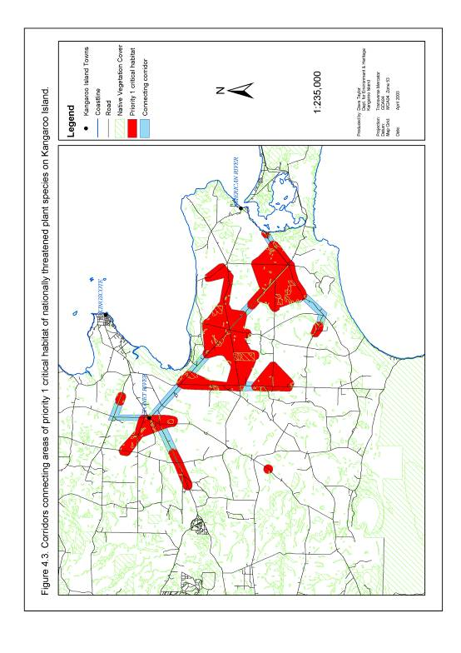

5.3.6. Inappropriate Disturbance Regimes

Objective
Determine and implement disturbance regimes which promote the recovery of nationally threatened plant species and associated essential and potential habitat on Kangaroo Island.

Actions
6a) Undertake and encourage research to determine appropriate fire regimes for nationally threatened plant species and associated essential and potential habitat on Kangaroo Island.
Notes | Responsibility for Action | Stakeholders Involved# | Direct links to other Actions
This research will involve a study of threatened plant response to the frequency, timing and intensity of fire. While a proportion of this research may be completed through studying the impact of past wildfires, the scope of this research is likely to be limited by the small proportion of priority 1 essential habitat burnt within the last 20 years. It is therefore highly likely that a series of trial ecological burns will be required to fully examine the role of fire in the reproduction and recruitment of nationally threatened plant species and associated habitat.  Priority for this research should be given to studying those species assessed as critically endangered or endangered under IUCN criteria (Table 5.9). This research should be conducted in conjunction with the ongoing monitoring of threats and the distribution and abundance of nationally listed species under actions 3d and 4c. A particular emphasis should be placed on monitoring the need for additional management actions following fire events, such as control of herbivore grazing.  Trials undertaken under this recovery plan between 2003 and 2006 helped initiate an Eastern Plains Fire Trial (EPFT) in the fragmented vegetation of eastern Kangaroo Island. The EPFT involves multiple stakeholders and landholders and aims to develop a better understanding of the role of fire in maintaining the health of remnant vegetation in a fragmented landscape. The EPFT should be fully supported during the life of this recovery plan as a key method of restoring appropriate fire regimes in priority 1 essential habitat (Table 5.9). | Recovery Project Officer | R2, R22, R25, R27, S2, S5 | *3d  +4c  +4d  +6b +8a  +9a  +9b +12b +12c
Key: + described action (6a) will contribute to the completion of this listed action
* described action (6a) requires the partial completion of this listed action
# For key to stakeholder groups see Table 5.3 (section 5.2.6)

Table 5.9. Nationally threatened plant species on Kangaroo Island listed in order of priority (based on species status) for fire ecology research.

Priority | Species | IUCN Status | Threat Rating
1 | Pultenaea insularis | Critically Endangered | 9
1 | Olearia microdisca | Critically Endangered | 9
1 | Beyeria subtecta | Endangered | 9
1 | Leionema equestre | Endangered | 9
1 | Spyridium eriocephalum var. glabrisepalum | Endangered | 9
2 | Caladenia ovata | Vulnerable | 9
2 | Pomaderris halmaturina ssp. halmaturina | Vulnerable | 9
3 | Euphrasia collina ssp. osbornii | Vulnerable | 7
4 | Asterolasia phebalioides | Vulnerable | 5
4 | Cheiranthera volubilis | Vulnerable | 5
4 | Correa calycina var. halmaturorum | Vulnerable | 5
4 | Logania insularis | Vulnerable | 5
4 | Pultenaea villifera var. glabrescens | Vulnerable | 5
4 | Thelymitra matthewsii | Vulnerable | 5
5 | Ptilotus beckerianus | Lower Risk | 6

6b) Implement management actions which promote fire regimes appropriate for the effective reproduction, recruitment and recovery of nationally listed species and associated essential and potential habitat on Kangaroo Island.
Notes | Responsibility for Action | Stakeholders Involved# | Direct links to other Actions
Management actions undertaken will be based on the findings of research/monitoring under action 6a. These may include the instigation of ecological burns to alter the frequency, intensity and timing of fire events in essential habitat. They may also include measures to protect essential habitat from wildfire events including the establishment of fire breaks and access tracks. Both actions should be implemented in conjunction with the development of a regionally based fire management plan for the fragmented landscapes of Kangaroo Island.  Priority 1 essential habitat, as defined under section 5.2 (Figures 5.1 and 5.2), will be targeted for management actions which promote the implementation of appropriate fire regimes.  Trials undertaken under this recovery plan between 2003 and 2006 helped initiate an Eastern Plains Fire Trial (EPFT) in the fragmented vegetation of eastern Kangaroo Island. The EPFT involves multiple stakeholders and landholders and aims to develop a better understanding of the role of fire in maintaining the health of remnant vegetation in a fragmented landscape. The EPFT should be fully supported during the life of this recovery plan as a key method of restoring appropriate fire regimes in priority 1 essential habitat (Table 5.9). | Recovery Project Officer | R2, R22, R25, R27, S2, S5 | *3d  *6a  +4c  +4d +5c +8a  +12b +12c
Key: + described action (6b) will contribute to the completion of this listed action
* described action (6b) requires the partial completion of this listed action
# For key to stakeholder groups see Table 5.3 (section 5.2.6)

Performance Criteria
- Initiation of research into the fire ecology of priority 1 nationally threatened plant species on Kangaroo Island during 2004/2005.
- Ongoing research into the fire ecology of priority 1 nationally threatened plant species on Kangaroo Island over the life of the recovery plan.
- Ongoing management and onground delivery support provided to the Eastern Plains Fire Trial over the life of this recovery plan.
- Implementation of appropriate fire regimes within priority 1 essential and potential habitat by July 2013.

5.3.7. Degraded Potential Habitat

Objective
To reverse the decline of habitat potentially important to the long term recovery of nationally threatened plant species on Kangaroo Island.

Action
7a) Encourage and support programs to protect, rehabilitate and restore potential habitat of nationally threatened plant species on Kangaroo Island
Notes | Responsibility for Action | Stakeholders Involved# | Direct links to other Actions
The protection and rehabilitation of potential habitat of nationally threatened plant species (mapped for each species under section 2 and to be defined in greater detail under actions 3b and 9c) should be supported and encouraged in all areas of Kangaroo Island. This action should include providing information on the distribution of potential habitat to relevant land managers on Kangaroo Island. An emphasis should be placed on protecting and rehabilitating the potential habitat of priority 1 species (Table 5.10).  Particular programs that should be supported and encouraged in potential habitat should include the fencing and revegetation schemes currently administered by the KI Natural Resources Management Board and funded through NHT and NAP¹. | Bush Management Adviser, Recovery Project Officer | R2, R27, S2, S5 | *3b  *5c *8a *9c  *13b
Key: * described action (7a) requires the partial completion of this listed action
# For key to stakeholder groups see Table 5.3 (section 5.2.6)
1 Note: NHT and NAP were replaced by Caring for our Country from July 2008.

Table 5.10. Nationally threatened plant species listed in order of priority (based on species status) for actions to protect and rehabilitate potential habitat.

Priority | Species | IUCN Status | Threat Rating
1 | Pultenaea insularis | Critically Endangered | 9
1 | Olearia microdisca | Critically Endangered | 9
1 | Leionema equestre | Endangered | 9
1 | Beyeria subtecta | Endangered | 9
1 | Spyridium eriocephalum var. glabrisepalum | Endangered | 9
2 | Pomaderris halmaturina ssp. halmaturina | Vulnerable | 9
2 | Caladenia ovata | Vulnerable | 9
3 | Euphrasia collina ssp. osbornii | Vulnerable | 7
4 | Cheiranthera volubilis | Vulnerable | 5
4 | Correa calycina var. halmaturorum | Vulnerable | 5
4 | Logania insularis | Vulnerable | 5
4 | Pultenaea villifera var. glabrescens | Vulnerable | 5
4 | Asterolasia phebalioides | Vulnerable | 5
4 | Thelymitra matthewsii | Vulnerable | 5
5 | Ptilotus beckerianus | Lower Risk | 6

Performance Criteria
Ongoing support and advice provided to programs involved in the protection and rehabilitation of potential habitat over the life of the recovery plan.

5.3.8. Involvement of Stakeholders

Objective
To develop stakeholder awareness, appreciation and ownership of nationally threatened plant species on Kangaroo Island and encourage active involvement in their future management.

Actions
8a) Undertake a comprehensive campaign to increase stakeholder involvement in the management of nationally threatened plant species on Kangaroo Island.
Notes | Responsibility for Action | Stakeholders Involved# | Direct links to other Actions
This action is crucial to meeting the recovery objectives of this plan and should involve:  - Increasing stakeholder knowledge of nationally threatened plant species on Kangaroo Island. This includes raising public awareness of the distribution and abundance of threatened plant species and the processes threatening their continued existence.  - Enhancing the desire of stakeholders to become involved with threatened plant recovery. This should be achieved by increasing stakeholder awareness of the value and plight of threatened plant species and associated plant communities on Kangaroo Island. This may include organising and conducting public tours of threatened plant sub-populations.  - Improving the skills of participants to manage threatened species. This action is designed to breakdown the barrier of an inadequate plant recovery skills base in the community (see action 1d). This should be achieved by producing and distributing information sheets on management techniques to interested stakeholders. Appropriate ‘hands on’ instruction should also be provided for participants in on-ground management actions. This should be carried out in conjunction with expert plant rehabilitation groups such as Threatened Plant Action Group.  - Maintaining and enhancing stakeholder enthusiasm for threatened species management. This action should include reinforcing the message to stakeholders that on-ground actions are worthwhile and will lead to the recovery of threatened plants. As part of this action viable and achievable objectives and performance criteria for stakeholder involvement should be established and the achievements of stakeholders acknowledged and publicised.  - Effective and efficient facilitation of public involvement in recovery actions. This action facilitates maximum public participation by providing technical and administrative support for community involvement through the Recovery Project Officer.  - Ongoing stimulation and education of participants. This should be achieved by incorporating ongoing changes to tasks and challenges for stakeholders involved with recovery actions. This action may also involve facilitating interaction with other community groups and organisations which have undertaken successful recovery programs.  - Continual reinforcement of the value of stakeholder involvement. This should include frequent public acknowledgement of the input of stakeholders into threatened plant recovery on Kangaroo Island, the celebration of significant milestones and comprehensive feedback on conservation outcomes.  To foster this process of raising stakeholder awareness and involvement in threatened plant recovery the various stakeholder groups could be approached to consider the relative value of forming a formal or informal Kangaroo Island Network for Recovery. One of the major roles of such a network could be to facilitate the integration of priority plant recovery actions into the activities of existing groups eliminating the need to form another separate community organisation to undertake on-ground works. The network could also provide a means by which stakeholders could provide feedback on the management of the recovery process. | Bush Management Adviser, Recovery Project Officer | All | *1d *1e *2a *3a *3c *3d *3e *4a *4c *5a *5c *5d *5e *5f *6a *6b *7a *9a *9b *10b *10c *10d *11a *11b *12a *12c *13a *13b *13c *13d *13e *14a *15a *15b *15c *16a *16b *17b *17c
Key: * described action (8a) requires the partial completion of this listed action
# For key to stakeholder groups see Table 5.3 (section 5.2.6)

Performance Criteria
Stakeholder involvement in all areas identified under each action (see sections 5.3.1 to 5.3.17) during the implementation of this recovery plan.

5.3.9. Inadequate Knowledge and Understanding of Ecology and Biology

Objective
Expand and develop collective knowledge and understanding of the ecology and biology of nationally threatened plant species on Kangaroo Island.

Action
9a) Undertake and encourage research into the ecology of nationally threatened plant species on Kangaroo Island.
Notes | Responsibility for Action | Stakeholders Involved# | Direct links to other Actions
Key areas of the ecology of nationally threatened species on Kangaroo Island requiring further research are:  - Nature and dynamics of the interaction of threatened species with other fauna and flora (eg pollinator species).  - Fire ecology.  - Long term response of nationally threatened species to disturbance other than fire.  - Preferred soil type.  - Preferred plant associations.  - Preferred topography.  - Short term response to disturbance other than fire.  - Preferred climate/microclimate  This research should be carried out within the framework of the monitoring system established to monitor threatened plant species distribution and abundance under actions 3d and 4c. Research and monitoring should target the ecology of priority 1 species (Table 5.11). Knowledge aquired from this research should be fed directly into management programs for each species. | Recovery Project Officer | S2, S14, N7, N8 | +3b  *3d  +3e*4c +5d  +5e  *6a +8a +9c
Key: + described action (9a) will contribute to the completion of this listed action
* described action (9a) requires the partial completion of this listed action
# For key to stakeholder groups see Table 5.3 (section 5.2.6)

9b) Undertake and encourage research into the biology of nationally threatened plant species on Kangaroo Island.
Notes | Responsibility for Action | Stakeholders Involved# | Direct links to other Actions
Key areas of the biology of nationally threatened species on Kangaroo Island requiring further research are:  - Seedbank dynamics.  - Age and structure of populations/sub-populations.  - Reproductive biology.  - Growth rate and longevity.  This research should be carried out within the framework of the monitoring system established to monitor threatened plant species distribution and abundance under actions 3d and 4c. Research should be targeted to investigate the biology of priority 1 species (Table 5.11). Knowledge aquired from this research should be fed directly into management programs for each species. | Recovery Project Officer | S2, S10, S14, N7, N8. | +3b +3e *3d *4c +5d *6a +8a +9c
Key: + described action (9b) will contribute to the completion of this listed action
* described action (9b) requires the partial completion of this listed action
# For key to stakeholder groups see Table 5.3 (section 5.2.6)

Table 5.11. Nationally threatened plant species on Kangaroo Island listed in order of priority (based on species status) for future ecological and biological research.

Priority | Species | IUCN Status | Threat Rating
1 | Pultenaea insularis | Critically Endangered | 6
1 | Olearia microdisca | Critically Endangered | 5
1 | Spyridium eriocephalum var. glabrisepalum | Endangered | 7
1 | Leionema equestre | Endangered | 6
1 | Beyeria subtecta | Endangered | 6
2 | Caladenia ovata | Vulnerable | 7
2 | Cheiranthera volubilis | Vulnerable | 7
2 | Correa calycina var. halmaturorum | Vulnerable | 7
2 | Logania insularis | Vulnerable | 7
2 | Asterolasia phebalioides | Vulnerable | 7
2 | Thelymitra matthewsii | Vulnerable | 7
2 | Pultenaea villifera var. glabrescens | Vulnerable | 7
2 | Euphrasia collina ssp. osbornii | Vulnerable | 7
3 | Pomaderris halmaturina ssp. halmaturina | Vulnerable | 5
4 | Ptilotus beckerianus | Lower Risk | 7

9c) Re-assess the essential and potential habitat of nationally threatened plant species.
Notes | Responsibility for Action | Stakeholders Involved# | Direct links to other Actions
This action involves the ongoing feeding of knowledge produced from monitoring and research into a revised definition of essential habitat for each species. This definition will be used to guide actions 3b and 7a. | Recovery Project Officer | S2, S14, N7, N8 | +3b  *3a *3c *3d +7a *9a *9b
Key: + described action (9c) will contribute to the completion of this listed action
* described action (9c) requires the partial completion of this listed action
# For key to stakeholder groups see Table 5.3 (section 5.2.6)

Performance Criteria
- Research into key areas of ecology and biology supported over the life of the recovery plan.
- Refined definition of essential habitat of priority 1 nationally threatened plant species completed during 2012/2013.

5.3.10. Phytophthora

Objective
To minimise the impact of Phytophthora spp. on nationally threatened plant species on Kangaroo Island.

Actions
10a) Undertake soil sampling to determine the presence of Phytophthora spp. at suspected sites within 5 km of priority 1 essential habitat of nationally threatened
plant species.
Notes | Responsibility for Action | Stakeholders Involved# | Direct links to other Actions
Phytophthora sampling should be undertaken at sites within 5 km of priority 1 essential habitat of nationally threatened plant species (as defined under section 4.2.3 and illustrated in Figures 5.1 and 5.2) (Figure 5.4) | Recovery Project Officer | R2, R27, S2, S5 | +10b  +10c  +10d
Key: + described action (10a) will contribute to the completion of this listed action
# For key to stakeholder groups see Table 5.3 (section 5.2.6)

10b) Encourage and support the development of a Kangaroo Island Phytophthora Management Strategy.
Notes | Responsibility for Action | Stakeholders Involved# | Direct links to other Actions
This action should focus on measures to minimise the spread and impact of phytophthora in essential and potential habitat of nationally threatened species on Kangaroo Island. These measures should be targeted to protect priority 1 species (Table 5.12) and should address the central issues of restricting access and implementation of appropriate hygiene measures. | Regional Ecologist, Bush Management Adviser, Recovery Project Officer | R1 to R30, S1 to S6, S9, N1 | +5c +8a *10a
Key: + described action (10b) will contribute to the completion of this listed action
* described action (10b) requires the partial completion of this listed action
# For key to stakeholder groups see Table 5.3 (section 5.2.6)

10c) Undertake and encourage monitoring and research to determine the impact of Phytophthora spp. on nationally threatened plant species.
Notes | Responsibility for Action | Stakeholders Involved# | Direct links to other Actions
This action involves determining both direct and indirect impacts of Phytophthora spp. on nationally threatened plant species.  - Direct effects. The susceptibility of each nationally threatened plant species to Phytophthora spp. needs to be clarified. Such a study may require a study of the effect of Phytophthora spp. infestations on each species in an ex-situ environment.  - Indirect effects. The impact of Phytophthora spp. infestation on a threatened plant species through changes to associated plant community structure and composition must be determined. This should involve research in conjunction with ongoing monitoring of the distribution and abundance of nationally threatened plant species and threats under actions 3d and 4c.  Studies into both direct and indirect effects of Phytophthora spp. should where possible focus on priority 1 species (Table 5.12). | Regional Ecologist, Bush Management Adviser, Recovery Project Officer | R2, R27, S2, S5, N49, N50 | *3d  +4c +5c +8a  *10a
Key: + described action (10c) will contribute to the completion of this listed action
* described action (10c) requires the partial completion of this listed action
# For key to stakeholder groups see Table 5.3 (section 5.2.6)

10d) Encourage research to determine the efficacy of fungicides in mitigating the impact of Phytophthora spp. on nationally threatened plant species.
Notes | Responsibility for Action | Stakeholders Involved# | Direct links to other Actions
This research should be target priority 1 nationally threatened plant species (Table 5.12). This action should be completed in conjunction with action 4d. Initial research should be conducted ex-situ to test side effects of fungicide application. | Regional Ecologist, Bush Management Adviser Project Officer | N49, N50, S2. | +4c +4d +8a *10a
Key: + described action (10d) will contribute to the completion of this listed action
* described action (10d) requires the partial completion of this listed action
# For key to stakeholder groups see Table 5.3 (section 5.2.6)

Table 5.12. Nationally threatened plant species listed in order of priority (based on species status) for future actions to monitor, research and mitigate the impact of Phytophthora spp.

Priority | Species | IUCN Status | Threat Rating
1 | Olearia microdisca | Critically Endangered | 7
1 | Pultenaea insularis | Critically Endangered | 4
1 | Spyridium eriocephalum var. glabrisepalum | Endangered | 9
1 | Beyeria subtecta | Endangered | 7
1 | Leionema equestre | Endangered | 4
2 | Cheiranthera volubilis | Vulnerable | 9
2 | Asterolasia phebalioides | Vulnerable | 9
3 | Pomaderris halmaturina ssp. halmaturina | Vulnerable | 6
4 | Euphrasia collina ssp. osbornii | Vulnerable | 4
4 | Caladenia ovata | Vulnerable | 4
4 | Correa calycina var. halmaturorum | Vulnerable | 4
4 | Logania insularis | Vulnerable | 4
4 | Pultenaea villifera var. glabrescens | Vulnerable | 4
4 | Thelymitra matthewsii | Vulnerable | 4
5 | Ptilotus beckerianus | Lower Risk | 7

Performance Criteria
- Soil testing completed at all suspected Phytophthora ssp. infestation sites within 5 km of priority 1 essential habitat by July 2013.
- The development and implementation of a Kangaroo Island Phytophthora Management Strategy over the life of the recovery plan by 2013.
- Monitoring and research to determine the impact of Phytophthora spp. infestations on priority 1 nationally threatened plant species initiated during 2003/2004.
- Research on the efficacy of fungicides to mitigate the impact of Phytophthora spp. infestations on priority 1 nationally threatened plant species initiated during 2007/2008.

Figure 5.4. Suspected sites of Phytophthora spp. infestation within 5 km of essential habitat of critically endangered and endangered nationally threatened plant species on Kangaroo Island.

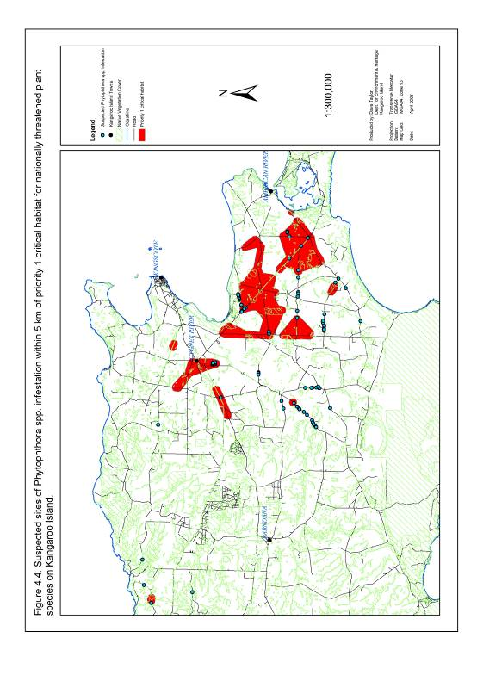

5.3.11. Potential Pest Species

Objective
To protect nationally threatened plant species on Kangaroo Island from the future impact of potential pest species.

Actions
11a) Support the establishment of a Kangaroo Island environmental weed management committee.
Notes | Responsibility for Action | Stakeholders Involved# | Direct links to other Actions
A primary objective of the proposed KI environmental weed management committee should be the identification of environmental weed species which have the potential to significantly impact on Kangaroo Island ecosystems. This committee should be responsible for coordinating the eradication of these weed species if they are already established on the island or put in place measures to prevent their introduction into the region. Ongoing advice should be provided to this committee regarding the potential impact of these weed species on nationally threatened plant species. | Recovery Project Officer, Bush Management Adviser, Regional Ecologist | R2, R18, R20, R27, S2, S3, S4, S5, S9 | +8a  +*11b
Key: + described action (11a) will contribute to the completion of this listed action
* described action (11a) requires the partial completion of this listed action
# For key to stakeholder groups see Table 5.3 (section 5.2.6)

11b) Support the development and implementation of a Kangaroo Island quarantine and pest strategy.
Notes | Responsibility for Action | Stakeholders Involved# | Direct links to other Actions
This strategy will identify key biological threats to biodiversity on Kangaroo Island and suggest appropriate actions to manage these threats. Ongoing advice should be provided throughout the development of the strategy to clarify the current and potential impacts of pest species on nationally threatened plant species. | Regional Ecologist, Bush Management Officer, Recovery Project Officer | R1, R2, R18, R20, R27, S2, S3, S4 | +8a +*11a
Key: + described action (11b) will contribute to the completion of this listed action
# For key to stakeholder groups see Table 5.3 (section 5.2.6)

Performance Criteria
- Ongoing input and support provided to the KI Environmental Weed Management Committee over the life of the recovery plan.
- Ongoing input and support provided during the development and implementation of a KI quarantine and pest strategy over the life of the recovery plan.

5.3.12. Grazing

Objective
Establish grazing regimes which have a minimal impact on the growth, reproduction and recruitment of nationally threatened plant species on Kangaroo Island.

Actions
12a) Restrict grazing of domestic stock in remnant vegetation within essential habitat of nationally threatened plant species.
Notes | Responsibility for Action | Stakeholders Involved# | Direct links to other Actions
This action should be undertaken in conjunction with existing programs managed by the KI Natural Resources Management Board to fence remnant patches of native vegetation. It should focus on priority 1 essential habitat, as defined under section 5.2.3 and illustrated in Figures 5.1 and 5.2. Consideration should also be given to fencing remnant vegetation linking areas of essential habitat, identified under action 5f (Figure 5.3). | Recovery Project Officer, Bush Management Adviser | R2, R27, S2, S5 | +5c +5f +8a
Key: + described action (12a) will contribute to the completion of this listed action
# For key to stakeholder groups see Table 5.3 (section 5.2.6)

12b) Undertake research and monitoring to determine the current and potential impact of native herbivore grazing on the growth, reproduction and recruitment of nationally threatened plant species on Kangaroo Island.
Notes | Responsibility for Action | Stakeholders Involved# | Direct links to other Actions
This action should be focussed on priority 1 nationally threatened species (Table 5.13). A key component of this research and monitoring should be the establishment of fenced areas which exclude both native and domestic vertebrate herbivores from sections of nationally threatened plant species essential habitat. The health of the vegetation within these fenced areas should be monitored annually and compared to similar grazed areas to determine the impact of grazing. A significant proportion of this monitoring should be completed in conjunction with the ongoing monitoring of threatened plant species distribution and abundance under action 3d.  A particular focus of this research should be the impact of native herbivore grazing on regenerating sub-populations of nationally threatened species. This should be undertaken in conjunction with fire management research and monitoring recommended under actions 6a and 6b. | Recovery Project Officer | R2, R27, S2, S5, N7, N8 | *3d  +4c  *6a  *6b  +12c
Key: + described action (12b) will contribute to the completion of this listed action
* described action (12b) requires the partial completion of this listed action
# For key to stakeholder groups see Table 5.3 (section 5.2.6)

12c) Implement actions to promote native herbivore grazing regimes which have a minimal impact on the growth, reproduction and recruitment of nationally threatened plant species on Kangaroo Island.
Notes | Responsibility for Action | Stakeholders Involved# | Direct links to other Actions
Specific actions required to manage grazing regimes for each threatened species will be determined from the findings of targeted research under action 12b. Management options may include restriction of native vertebrate herbivore access to threatened species sub-populations through fencing. Actions to manage grazing regimes will be focussed on priority 1 essential habitat (defined under section 5.2.3 and illustrated in Figures 5.1 and 5.2), particularly those areas of vegetation restored under actions 5c and 5e and those remnants regenerating after burn events implemented as part of actions 6a and 6b. | Recovery Project Officer, Bush Management Adviser | R2, R27, R28, S2, S5 | *12b  +5c  *6a  *6b +8a
Key: + described action (12c) will contribute to the completion of this listed action
* described action (12c) requires the partial completion of this listed action
# For key to stakeholder groups see Table 5.3 (section 5.2.6)

Table 5.13. Nationally threatened plant species on Kangaroo Island listed in order of priority (based on species status) for research to determine the impact of native herbivore grazing regimes.

Priority | Species | IUCN Status | Threat Rating
1 | Olearia microdisca | Critically Endangered | 7
1 | Pultenaea insularis | Critically Endangered | 4
1 | Beyeria subtecta | Endangered | 7
1 | Leionema equestre | Endangered | 6
1 | Spyridium eriocephalum var. glabrisepalum | Endangered | 4
2 | Euphrasia collina ssp. osbornii | Vulnerable | 7
3 | Pomaderris halmaturina ssp. halmaturina | Vulnerable | 6
4 | Pultenaea villifera var. glabrescens | Vulnerable | 5
5 | Caladenia ovata | Vulnerable | 4
5 | Cheiranthera volubilis | Vulnerable | 4
5 | Correa calycina var. halmaturorum | Vulnerable | 4
5 | Logania insularis | Vulnerable | 4
5 | Asterolasia phebalioides | Vulnerable | 4
5 | Thelymitra matthewsii | Vulnerable | 4
6 | Ptilotus beckerianus | Lower Risk | 4

Performance Criteria
- Exclusion of domestic stock from remnant patches of vegetation within priority 1 essential habitat of nationally threatened plant species during 2005/ 2006.
- Research and monitoring to determine the impact of native herbivore grazing regimes on priority 1 nationally threatened plant species on Kangaroo Island initiated during 2004/2005.
- The impact of native herbivore grazing regimes on priority 1a, 1b, 1c and 1d essential habitat managed over the life of the recovery plan.

5.3.13. Environmental Weeds

Objective
Protect nationally threatened plant species and associated essential habitat on Kangaroo Island from the impact of environmental weeds.

Actions
13a) Strategic control of infestations of Bridal Creeper, Bridal Veil, Phalaris and Perennial Veldt Grass within essential habitat of nationally threatened plant species on Kangaroo Island.
Notes | Responsibility for Action | Stakeholders Involved# | Direct links to other Actions
Infestations of Bridal Creeper and Bridal Veil should be controlled within priority 1 essential habitat as defined under section 5.2.3 and illustrated Figures 5.1 and 5.2. Perennial Veldt Grass and Phalaris should be removed from priority 1 essential habitat that is within 50 m of individual priority 1 nationally threatened plants (Table 5.14). These actions should be undertaken in conjunction with all existing weed management programs on Kangaroo Island. Weed management practices should aim to produce as little disturbance as possible in line with bush regeneration methods outlined by Robertson (1994). | Recovery Project Officer | R1 to R18, R20, R23, R24, R26, R27, R28, R32, S1 to S5, S7, S9, S14 | +5c +8a +13c  *13d
Key: + described action (13a) will contribute to the completion of this listed action
* described action (13a) requires the partial completion of this listed action
# For key to stakeholder groups see Table 5.3 (section 5.2.6)

13b) Implementation of environmental weed buffer zones around sub-populations of nationally threatened plant species on Kangaroo Island.
Notes | Responsibility for Action | Stakeholders Involved# | Direct links to other Actions
A 1 km environmental weed buffer zone should be established around priority 1 essential habitat, as defined under section 5.2.3 (Figures 5.1 and 5.2), by removing Bridal Creeper and Bridal Veil from these areas (Figure 5.5). This action should be undertaken in conjunction with all existing weed management programs on Kangaroo Island. | Recovery Project Officer | R1 to R18, R20, R23, R24, R26, R27, R28, R32, S1 to S5, S7, S9, S14 | +7a +8a +13c  *13d
Key: + described action (13b) will contribute to the completion of this listed action
* described action (13b) requires the partial completion of this listed action
# For key to stakeholder groups see Table 5.3 (section 5.2.6)

13c) Assist and support the control of Bridal Veil on Kangaroo Island.
Notes | Responsibility for Action | Stakeholders Involved | Direct links to other Actions
This action involves assisting and supporting all actions taken to control Bridal Veil on Kangaroo Island and may include undertaking control activities outside those areas identified as priority under actions 13a and 13b. | Recovery Project Officer, Bush Management Adviser | R1 to R18, R20, R23, R24, R26, R27, R28, R32, S1 to S5, S7, S9, S14 | +8a *13a  *13b  *13d
Key: + described action (13c) will contribute to the completion of this listed action
* described action (13c) requires the partial completion of this listed action
# For key to stakeholder groups see Table 5.3 (section 5.2.6)

Figure 5.5. Environmental weed buffer zone of one kilometre around essential habitat of critically endangered and endangered nationally threatened plant species on Kangaroo Island.

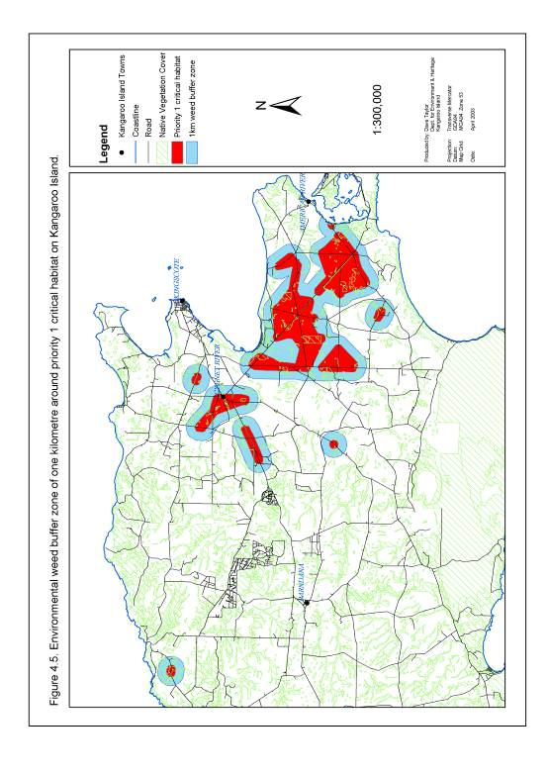

13d) Undertake, support and encourage trials to determine the most resource efficient and effective weed management techniques.
Notes | Responsibility for Action | Stakeholders Involved# | Direct links to other Actions
This action should test the efficacy of methods which are either currently or may be potentially used to manage environmental weed species on Kangaroo Island. This action should involve monitoring the impact of weed management techniques on:  - Distribution, abundance and impact of weed species in conjunction with actions 4d and 13e.  - Distribution and abundance of nationally threatened plant species and associated plant communities in conjunction with action 3d.  The findings of this monitoring should be fed directly into actions to manage environmental weed species and nationally threatened plant species through action 4e. This will encourage adaptive and flexible management of nationally threatened plant species. | Recovery Project Officer | R1 to R18, R20, R23, R24, R26, R27, R28, R32, S1 to S5, S7, S9, S14. | + 3d +4d  *4e +8a  +13a  +13b +13c  *13e
Key: + described action (13d) will contribute to the completion of this listed action
* described action (13d) requires the partial completion of this listed action
# For key to stakeholder groups see Table 5.3 (section 5.2.6)

13e) Undertake, support and encourage research and monitoring to determine the impact of environmental weeds on nationally threatened plant species and their associated essential habitat.
Notes | Responsibility for Action | Stakeholders Involved# | Direct links to other Actions
This action should be conducted in conjunction with the ongoing monitoring of nationally threatened species and threats conducted under actions 3d and 4c. Research and monitoring should focus on the impact of Bridal Creeper, Bridal Veil, Perennial Veldt Grass and Phalaris on priority 1 nationally threatened plant species (Table 5.14). | Recovery Project Officer | R2, R27, R32, S2, S5, N7, N8 | +4c  *3d +8a +13e
Key: + described action (13e) will contribute to the completion of this listed action
* described action (13e) requires the partial completion of this listed action
# For key to stakeholder groups see Table 5.3 (section 5.2.6)

Table 5.14. Nationally threatened plant species listed in order of priority (based on species status) for research to determine, and management to minimise, the impact of Bridal Creeper, Bridal Veil, Perennial Veldt Grass and Phalaris.

Priority | Species | IUCN Status | Threat Rating
Bridal Creeper
1 | Olearia microdisca | Critically Endangered | 9
1 | Pultenaea insularis | Critically Endangered | 7
1 | Beyeria subtecta | Endangered | 9
1 | Spyridium eriocephalum var. glabrisepalum | Endangered | 9
1 | Leionema equestre | Endangered | 8
2 | Pomaderris halmaturina ssp. halmaturina | Vulnerable | 9
3 | Caladenia ovata | Vulnerable | 6
4 | Cheiranthera volubilis | Vulnerable | 2
4 | Euphrasia collina ssp. osbornii | Vulnerable | 2
4 | Pultenaea villifera var. glabrescens | Vulnerable | 2
5 | Ptilotus beckerianus | Lower Risk | 2
Bridal Veil
1 | Pultenaea insularis | Critically Endangered | 7
1 | Olearia microdisca | Critically Endangered | 7
1 | Leionema equestre | Endangered | 7
1 | Beyeria subtecta | Endangered | 6
1 | Spyridium eriocephalum var. glabrisepalum | Endangered | 6
2 | Pomaderris halmaturina ssp. halmaturina | Vulnerable | 6
2 | Caladenia ovata | Vulnerable | 6
3 | Cheiranthera volubilis | Vulnerable | 2
3 | Euphrasia collina ssp. osbornii | Vulnerable | 2
3 | Pultenaea villifera var. glabrescens | Vulnerable | 2
4 | Ptilotus beckerianus | Lower Risk | 2
Perennial Veldt Grass
1 | Olearia microdisca | Critically Endangered | 8
1 | Pultenaea insularis | Critically Endangered | 7
1 | Leionema equestre | Endangered | 9
1 | Beyeria subtecta | Endangered | 9
1 | Spyridium eriocephalum var. glabrisepalum | Endangered | 9
2 | Pomaderris halmaturina ssp. halmaturina | Vulnerable | 4
2 | Caladenia ovata | Vulnerable | 4
3 | Cheiranthera volubilis | Vulnerable | 2
3 | Euphrasia collina ssp. osbornii | Vulnerable | 2
3 | Pultenaea villifera var. glabrescens | Vulnerable | 2
4 | Ptilotus beckerianus | Lower Risk | 2
Phalaris
1 | Olearia microdisca | Critically Endangered | 7
1 | Pultenaea insularis | Critically Endangered | 6
1 | Beyeria subtecta | Endangered | 9
1 | Spyridium eriocephalum var. glabrisepalum | Endangered | 9
1 | Leionema equestre | Endangered | 8
2 | Pomaderris halmaturina ssp. halmaturina | Vulnerable | 8
3 | Caladenia ovata | Vulnerable | 4
4 | Cheiranthera volubilis | Vulnerable | 2
4 | Euphrasia collina ssp. osbornii | Vulnerable | 2
4 | Pultenaea villifera var. glabrescens | Vulnerable | 2
5 | Ptilotus beckerianus | Vulnerable | 2

Performance Criteria
- Complete removal of the impact of Bridal Creeper and Bridal Veil in areas of priority 1a, 1b, 1c and 1d essential habitat by during 2004/ 2005.
- Complete removal of the impact of Bridal Creeper and Bridal Veil in areas of priority 1e, 1f, 1g and 1h essential habitat during 2005/2006.
- Complete removal of the impact of Phalaris and Perennial Veldt Grass from areas within 50 m of existing priority 1 nationally threatened plant species during 2005/2006.
- Establishment and maintenance of a 1 km environmental buffer zone, containing minimal infestations of Bridal Creeper and Bridal Veil, around essential habitat of priority 1 nationally threatened plant species during 2007/2008.
- Ongoing support provided to program to control Bridal Veil on Kangaroo Island over the life of the recovery plan.
- Trials to determine the most effective and resource efficient methods of weed management initiated during 2003/2004.
- Research and monitoring to determine the impact of environmental weeds on nationally threatened plant species on Kangaroo Island initiated during 2003/2004.

5.3.14. Vegetation Clearance

Objective
To prevent the clearance of nationally threatened plant species and associated essential and potential habitat on Kangaroo Island.

Actions
14a) Provide advice on the distribution and abundance of nationally threatened plant species to relevant land managers and organisations governing vegetation clearance in order to prevent further clearance of essential and potential habitat.
Notes | Responsibility for Action | Stakeholders Involved# | Direct links to other Actions
Given the already fragmented nature of the threatened species populations and essential and potential habitat on Kangaroo Island and the difficulty and extremely high cost of effective restoration actions, clearance activities involving threatened plant populations and habitat should be avoided and discouraged at all costs.  Implementation of this action should include providing updates on species distribution and status as survey and monitoring components of this recovery plan are completed. Key organisations which should be advised of threatened plant distribution include KI Council (Roadside Vegetation Committee and Planning section), Transport SA, Department of Environment, Water and Natural Resources, Native Vegetation Council and the Department of the Environment, Water, Heritage and Arts.  This action should also be completed in conjunction with the raising of community awareness and involvement in threatened plant management (see action 8a). Land managers whose area of responsibility overlaps with priority 1 essential habitat, as defined under section 5.2.3 (Figures 5.1 and 5.2), should be targeted in carrying out this action. | Bush Management Adviser, Recovery Project Officer | R27, R28, S2, S5, S7 N2 | *3a *3b *3c  *3e +5c  +8a  +17b
Key: + described action (14a) will contribute to the completion of this listed action
* described action (14a) requires the partial completion of this listed action
# For key to stakeholder groups see Table 5.3 (section 5.2.6)

Performance Criteria
- An updated database of the distribution and location of essential habitat of all nationally threatened plant species provided to bodies governing vegetation clearance on an annual basis.
- Advice on the distribution and location of priority 1 essential habitat provided to relevant land managers during 2004/ 2005.
- Advice on the distribution and location of priority 2 essential habitat provided to relevant land managers during 2007/2008.

5.3.15. Trampling

Objective
Reduce the risk and impact of vegetation trampling in essential habitat of nationally threatened plant species on Kangaroo Island.

Actions
15a) Undertake a general public education program to raise community awareness of the importance of roadside vegetation as habitat for nationally threatened plant species.
Notes | Responsibility for Action | Stakeholders Involved# | Direct links to other Actions
This action will be undertaken through the implementation of action 8a. | Recovery Project Officer, Bush Management Adviser | R1 to R30, S2 to S5. | +5c +8a  *15b
Key: + described action (15a) will contribute to the completion of this listed action
* described action (15a) requires the partial completion of this listed action
# For key to stakeholder groups see Table 5.3 (section 5.2.6)

15b) Implement appropriate signage within nationally threatened sub-populations considered to be susceptible to ongoing or high impact trampling from human activities.
Notes | Responsibility for Action | Stakeholders Involved# | Direct links to other Actions
A survey of nationally threatened species sub-populations should be conducted to locate key sites susceptible to trampling prior to the implementation of any signage. This action should focus on protecting priority 1 essential habitat as defined under section 5.2.3 (Figures 5.1 and 5.2). | Recovery Project Officer, Bush Management Adviser | R2, R27, S2, S5, S9 | +5c +8a  +15a
Key: + described action (15b) will contribute to the completion of this listed action
# For key to stakeholder groups see Table 5.3 (section 5.2.6)

15c) Investigate and implement actions to restrict access to sites where the impact of trampling is leading to, or is highly likely to lead to, a decline in the abundance of nationally threatened species sub-populations.
Notes | Responsibility for Action | Stakeholders Involved# | Direct links to other Actions
This action should be targeted to protect priority 1 essential habitat, as defined under section 5.2.3 (Figure 5.1 and 5.5). It involves ongoing monitoring of nationally threatened sub-populations and the impact of trampling in conjunction with actions 3d and 4c. Essential habitat which is found to be exposed to a continual significant impact from trampling will be assessed to determine the feasibility of implementing actions to restrict access. These actions may include establishing physical barriers such as fencing. | Recovery Project Officer | R2, R27, S2, S5, S9 | *3d  +4c +8a  *15b
Key: + described action (15c) will contribute to the completion of this listed action
* described action (15c) requires the partial completion of this listed action
# For key to stakeholder groups see Table 5.3 (section 5.2.6)

Performance Criteria
- Public awareness program focussing on the importance of vegetation fragments initiated by July 2004.
- Implementation of signage in priority 1 essential habitat completed during 2005/2006.
- Investigation into the need, viability and appropriateness of the erection of barriers restricting access to priority 1 essential habitat initiated during 2006/2007.
- Implementation of barriers restricting access to priority 1 essential habitat continually subjected to impacts associated with trampling completed during 2007/2008.

5.3.16. Salinity

Objective
Protect nationally threatened plant species on Kangaroo Island from the impact of soil salinity.

Actions
16a) Undertake monitoring and research to determine the impact of soil salinity on nationally threatened plant species.
Notes | Responsibility for Action | Stakeholders Involved# | Direct links to other Actions
This action should involve undertaking soil sampling within priority 1 essential habitat (defined under section 5.2.3 and illustrated in Figures 5.1 and 5.2) currently suspected to be affected by elevated salt levels (Table 3.4). Ongoing monitoring of the health, reproduction and recruitment of nationally threatened plant species in conjunction with action 3d should also be conducted to determine the impact of soil salinity. | Recovery Project Officer | R2, R27, S2, S5, N7, N8 | +4c +8a  +16b
Key: + described action (16a) will contribute to the completion of this listed action
# For key to stakeholder groups see Table 5.3 (section 5.2.6)

16b) Provide ongoing advice, support and encouragement to catchment-based programs mitigating the impact of salinity on Kangaroo Island.
Notes | Responsibility for Action | Stakeholders Involved# | Direct links to other Actions
This action should include providing agencies tackling salinity issues with updated information on the distribution of nationally threatened plant species on Kangaroo Island and sub-populations affected by salinity. It should also involve providing advice on methods to minimise the impact of salinity mitigation measures on nationally threatened plant species. | Project Officer; Bush Management Adviser | R2, R6 to R17, R18, R21, R27, S2 to S5. | *3a *3b *3c  *3e +8a *16a
Key: + described action (16b) will contribute to the completion of this listed action
* described action (16b) requires the partial completion of this listed action
# For key to stakeholder groups see Table 5.3 (section 5.2.6)

Performance Criteria
- Soil sampling completed at nationally threatened species sub-populations suspected to be affected by saline soil during 2004/2005.
- Monitoring and research to determine the impact of soil salinity on nationally threatened plant species initiated during 2004/2005.
- Participation of Recovery Project Officer/Bush Management Adviser in programs to mitigate salinity on a catchment basis over the life of the recovery plan.

5.3.17. Erosion

Objective
Protect nationally threatened plant species and associated essential habitat on Kangaroo Island from the impact of erosion.

Action
17a) Monitor nationally threatened species sub-populations and essential habitat to determine the impact of erosion.
Notes | Responsibility for Action | Stakeholders Involved# | Direct links to other Actions
This action should be conducted in conjunction with action 3d and focus on priority 1 essential habitat, as defined in section 5.2.3 (Figures 5.1 and 5.2). | Recovery Project Officer | R2, R27, S2, S5 | *3d  +4c  +17b  +17c
Key: + described action (17a) will contribute to the completion of this listed action
* described action (17a) requires the partial completion of this listed action
# For key to stakeholder groups see Table 5.3 (section 5.2.6)

17b) Encourage land managers to rehabilitate areas of essential and potential threatened plant habitat affected by erosion.
Notes | Responsibility for Action | Stakeholders Involved | Direct links to other Actions
As part of this action, advice on the distribution of nationally threatened plant species and sub-populations affected by erosion should be provided to all relevant stakeholders in conjunction with actions 14a and 14b. Particular emphasis should be placed on conducting rehabilitation works within the boundaries of priority 1 essential habitat, as defined under section 5.2.3 (Figures 5.1 and 5.2). | Recovery Project Officer, Bush Management Adviser | R2 to R18, R21, R27, R28, S2, S3, S4, S5, S9, | +5c +8a *14a  *17a
Key: + described action (17b) will contribute to the completion of this listed action
* described action (17b) requires the partial completion of this listed action
# For key to stakeholder groups see Table 5.3 (section 5.2.6)

17c) Undertake actions to rehabilitate specific sites identified as facing a significant threat from erosion.
Notes | Responsibility for Action | Stakeholders Involved# | Direct links to other Actions
This action will focus on priority sites for rehabilitation identified under action 17a. Rehabilitation actions may include the diversion of water flow, re-planting of native vegetation and minor soil stabilisation works. | Recovery Project Officer | R2 to R18, R21, R27, R28, S2, S3, S4, S5, S9,. | +8a *17a
Key: + described action (17c) will contribute to the completion of this listed action
* described action (17c) requires the partial completion of this listed action
# For key to stakeholder groups see Table 5.3 (section 5.2.6)

Performance Criteria
- Research to determine the impact of soil erosion on priority 1 essential habitat initiated during 2004/ 2005.
- Ongoing support provided to landholders to manage erosion in threatened plant habitat.
- Soil rehabilitation projects at priority soil erosion impact sites initiated during 2007/2008.

5.3.18. Climate Change

Objective
To determine the impact of climate change on nationally threatened plant species and associated essential habitat on Kangaroo Island.

Action
18a) Monitor nationally threatened species sub-populations and essential habitat to determine the impacts of a changing climate.
Notes | Responsibility for Action | Stakeholders Involved# | Direct links to other Actions
Little is known about the likely extent of the impact of climate change on nationally threatened plant species. Threatened plant population monitoring completed under actions 3a), c) and d) should be used to ascertain any trends in threatened plant populations over time relative to climate variations. This information may prove critical to the development of strategies to manage climate change impacts in future recovery plans. | Recovery Project Officer | S2 | *3a  *3c  *3d
Key: + described action (18a) will contribute to the completion of this listed action
* described action (18a) requires the partial completion of this listed action
# For key to stakeholder groups see Table 5.3 (section 5.2.6)

Performance Criteria
An assessment of the impact of climate change on nationally threatened species using threatened plant monitoring data initiated during 2012/2013.

5.4. Management Practices
As a general guide any management practice undertaken in or directly adjacent to essential or potential habitat of nationally threatened plant species on Kangaroo Island should be considered carefully. In particular, activities assisting or promoting the spread and impact of one or more of the 18 threatening processes identified within this plan should be avoided where possible.

Table 5.14 provides a selection of examples of such activities and potential management pitfalls that may limit the success of threatened plant recovery. This list is by no means exhaustive and should be treated as a guide only. It should be noted that in many instances this table highlights management inaction as a key management practice which may increase the spread and impact of threatening processes on nationally threatened plant species.

Management practices and actions benefiting the recovery of nationally threatened plant species on Kangaroo Island are described in full in section 5.3 of this plan. A number of these actions are currently partially or wholly being undertaken on Kangaroo Island under existing private and community based natural resource management programs.

Table 5.15. Examples of management practices which may potentially contribute to the extent and impact of 18 identified threats and impediments to the recovery of nationally threatened plant species on Kangaroo Island.

Threat or Impediment to Recovery | Management activities which may contribute to each threat
Availability of Resources | - Failure to apply for and allocate sufficient funding to the recovery of nationally threatened plant species on Kangaroo Island.
Co-ordination and Integration of Recovery Process | - Failure to obtain and maintain a project officer dedicated to the task of implementing the recovery plan.  - Failure to maximise potential multiple outcomes for threatened plants as part of broader biodiversity conservation efforts
Inadequate Knowledge of Distribution and Abundance | - Failure to undertake additional survey to determine the full distribution and abundance of nationally threatened species.
Inadequate Knowledge and Understanding of Threats | - Failure to recognise the importance of research to determine the true impact of threats on nationally threatened plant species.
Small Isolated Populations | - Any activity which reduces the size and increases the isolation of threatened plant sub-populations further.
Inappropriate Disturbance Regimes | - Failure to undertake fire management activities, including ecological burns and the control of wildfire, which establish appropriate fire regimes for nationally threatened plant species and their associated vegetation communities.  - Initiation of disturbance events other than fire which do not take into account the ecological requirements of nationally threatened plant species and associated plant communities.  - Failure to initiate and support research into the disturbance requirements of nationally threatened plant species.
Degraded Potential Habitat | - Failure to recognise the importance of potential habitat in the recovery of threatened plant species and undertake protection measures.  - Support for any activities that may lead to a further degradation of existing essential or potential habitat.
Involvement of Stakeholders | - Failure to recognise the important role of stakeholders and provide opportunities for involvement in the recovery of nationally threatened plant species.
Inadequate Knowledge of Ecology and Biology | - Failure to place an emphasis on research into the biology and ecology of threatened plant species as a means of improving the management of threatened plant species.  - Failure to develop cooperative approach to research with relevant research organisations.
Phytophthora | - Any activity contributing to the transfer of soil material onto or within Kangaroo Island without adequate hygiene precautions.
Potential Pest Species | - Any activity which transfers or has the potential to transfer any organism onto or throughout Kangaroo Island without due consideration of potential impacts.  - Failure to identify and manage organisms currently occurring on Kangaroo Island with the potential to become significant pest species.
Grazing | - Grazing of livestock in essential and potential threatened plant species habitat.  - Failure to determine, monitor and manage the impact of native herbivore grazing on nationally threatened plant species.
Table 5.14 continued:
Threat or Impediment to Recovery | Management activities which may contribute to each threat
Environmental Weeds | - Failure to target weed management activities to reduce the impact of environmental weed species on nationally threatened plant species.  - Failure to make the most of an opportunity to control Bridal Veil before its distribution and impact spreads to affect a much larger proportion of Kangaroo Island’s vegetation community.  - Failure to monitor the effect of weed management practices on both weed species and nationally threatened plant species and use observations to adapt and improve management techniques.
Vegetation Clearance | - Small-scale vegetation clearance in narrow strips of roadside vegetation such as roadside vegetation maintenance and fence-line maintenance in essential threatened plant habitat.
Trampling | - Use and parking of vehicles in roadside reserves in essential or potential threatened plant habitat.  - Roadside vegetation maintenance in essential threatened plant habitat.  - Roadside rubbish dumping in essential or potential threatened plant habitat.  - Maintenance and establishment of walking trails in essential threatened plant habitat.
Salinity | - Any activity which contributes to the rise and salinisation of water tables in areas of essential or potential threatened plant habitat
Erosion | - Any activity which promotes soil disturbance in areas of essential habitat susceptible to soil erosion.
Climate Change | - Activities that contribute greenhouse gases to the atmosphere.  - Activities that restrict the ability of plants to extend or shift distribution in response to a changing climate.

6. REFERENCES
Ball, D. and Carruthers, S. (1998). Kangaroo Island vegetation mapping. Technical Report produced by Department for Transport, Urban Planning and the Arts, South Australia.

Baur, B. and Erhardt, A. (1995). Habitat fragmentation and habitat alterations: principle threats to most animal and plant species. GAIA 4: 221-226.

Bickerton, D.C. and Davies, R.J.-P. (1999). A report on the Olearia microdisca regeneration trial at Kingscote Airport, 19/10/99. Unpublished report to the Threatened Plant Action Group, Adelaide.

Cropper, S. (1993). Management of endangered plants. CSIRO Publishing, Melbourne.

Davies, R.J.-P. (1986). Threatened plant species of the Mount Lofty Ranges and Kangaroo Island Regions. Conservation Council of South Australia, Adelaide.

Davies, R.J.-P. (1992). Threatened plant species of the Murray Mallee, Mount Lofty Ranges and Kangaroo Island Regions of South Australia. Conservation Council of South Australia, Adelaide.

Davies, R.J.-P. (1996). Threatened plant species on roadsides: Kangaroo Island, South Australia. Unpublished report to the Department for Environment and Natural Resources, South Australia.

Davies, R.J.-P. (1998). Roadside environmental management plan, Kingscote to Penneshaw Rd (RN 4883)(between Hundred Line Road and Three Chain Rd). Unpublished report to Transport SA.

Davies, R.J.-P. and Overton, B. (1998). The management of “KI Narrow-leaved Mallee – Kingscote Mallee” plant communities on Kangaroo Island, South Australia. Unpublished report submitted to the Kangaroo Island Mallee Project Steering Committee and the Kangaroo Island Soil Conservation Board, Kingscote, South Australia.

Debinski, D.M. and Holt, R.D. (2000). A survey and overview of habitat fragmentation experiments. Conservation Biology 14(2): 342-355.

de Kok, R.P.J. and West, J.G. (2004). A revision of the genus Pultenaea (Fabaceaa). 3. The eastern species with recurved leaves. Australian Systematic Botany 17: 273-326.

Department for Environment and Heritage. (2007). No species loss: A nature conservation strategy for South Australia 2007-2017. Government of South Australia.

Department of Water, Land and Biodiversity Conservation. (2006). State natural resources management plan 2006. Government of South Australia.

Dudash, M.R. and Fenster, C.B. (2000). ‘Inbreeding and outbreeding depression in fragmented populations.’, in Genetics, Demography and Viability of Fragmented Populations, eds A.G. Young and G.M. Clarke, Cambridge University Press, Cambridge.

Environment Australia (2002). Revised Recovery Plan Guidelines for Nationally Listed Threatened Species and Ecological Communities under the Commonwealth Environment Protection and Biodiversity Conservation Act 1999. Department of the Environment and Heritage, Canberra.

Fahrig, L. and Merriam, G. (1994). Conservation of fragmented populations. Conservation Biology 8(1): 50-59.

Holliday, I., Overton, B. and Overton, D. (1994). Kangaroo Island’s Native Plants. Swift Printing Service, Adelaide, South Australia.

IUCN. (2000). The 2000 IUCN red list of threatened species: 1994 categories and criteria.

Jessop, J.P. and Toelken, H.R. (1986). Flora of South Australia – Parts I-IV. State Herbarium of South Australia, Adelaide.

Jusaitis, M. (1993). Conservation studies on four endangered plants from Kangaroo Island, South Australia. Black Hill Flora Centre, Botanic Gardens of Adelaide, South Australia.

Jusaitis, M. (2000). The ecology, biology and conservation of threatened Phebalium species in South Australia. Department for Environment and Heritage, South Australia.

Kangaroo Island Natural Resources Management Board. (2008). Here to stay for our children and grandchildren: A natural resources management plan for the Kangaroo Island region, 2008 (draft). Government of South Australia.

MacArthur, R.H. and Wilson, E.O. (1967). The theory of island biogeography. Princeton University Press, Princeton, New Jersey.

Mooney, T. and Grinter, K. 2000. Kangaroo Island Soil Conservation Board: District Plan Review. Kangaroo Island Soil Conservation Board, South Australia.

Overton, B. (1998). Post fire ecology of Flinders Chase National Park specifically for Asterolasia phebalioides, Logania insularis and Olax obcordata, Kangaroo Island South Australia.

Overton, B. (2001). Interim management plan for maintaining a population of Olearia microdisca in remnant vegetation at Kingscote Airport. Unpublished report to Kangaroo Island Council, Kingscote, South Australia.

Overton, B. and Overton, D. (1992). Record the distribution of five species of rare flora on Kangaroo Island. Final report to the Wildlife Conservation Fund.

Overton, B., Overton, D. and McKelvey M. (1990). Map and record the distribution of 5 of Kangaroo Island’s flora. Final report to the Wildlife Conservation Fund.

Prescott, A. (1995). It’s blue with five petals – Kangaroo Island Field Guide : Wildflowers of Kangaroo Island and the Fleurieu Peninsula. Anne Prescott and Associates Pty, Adelaide, South Australia.

Robertson, M. (1994). Stop Bushland Weeds: A guide to successful weeding in South Australia’s bushland. Nature Conservation Society of South Australia.

Saunders, D.A., Hobbs, R.J. and Margules, C.R. (1991). Biological consequences of ecosystem fragmentation: a review. Conservation Biology 5(1): 18-32.

Schmiegelow, F.K.A., Machtans, C.S. and Hannon, S.J. (1997). Are boreal birds resilient to forest fragmentation: an experimental study of short-term community responses. Ecology 78:1914-1932.

Sherwin, W.B. and Moritz, C. (2000). ‘Monitoring and managing genetic erosion.’, in Genetics, Demography and Viability of Fragmented Populations, eds A.G. Young and G.M. Clarke, Cambridge University Press, Cambridge.

Taylor, D. (2003a). Profile of nationally threatened plants on Kangaroo Island, South Australia. Draft report to Department for Environment and Heritage, Kingscote, South Australia.

Taylor, D. (2003b). The distribution of Xanthorrhoea semiplana ssp. tateana dieback on Kangaroo Island – A Phytophthora spp. induced phenomenon or are other causal agents at work. Unpublished report to the Department for Environment and Heritage, Kingscote, South Australia.

Taylor, D., Mussared, R. and Flanagan, G. (2002). A road survey to determine the distribution of Bridal Veil (Myrsiphyllum declinatum) on Kangaroo Island, South Australia. Unpublished report to the Department for Environment and Heritage, Kingscote, South Australia.

Vallee, L., Hogbin, T., Monks, L., Makinson, B., Matthes, M. and Rossetto, M. (2004). Guidelines for the translocation of threatened plants in Australia. Second Edition. Australian Network for Plant Conservation, Canberra.

Vickery, F. (1997). The distribution of Phytophthora cinnamomi on Kangaroo Island. Masters thesis submitted to the University of New England.

Weber, J.Z. (1995). A new South Australian species of PULTENAEA (FABACEAE, MIRBELIEAE). Journal of the Adelaide Botanical Gardens 16: 23-26.

Willis, A.J. (2000). Best practice management guide for environmental weeds : Bridal Creeper Asparagus asparagoides. CRC for Weed Management Systems, Australia.

Willoughby, N., Oppermann, A. and Inns, R. (2001). Biodiversity plan for Kangaroo Island, South Australia. Department for Environment and Heritage, South Australia.

Young, A., Boyle, T. and Brown, T. (1996). The population consequences of habitat fragmentation for plants. Tree 11(10): 413-418.

Appendix A. Nationally, state and regionally threatened plant species recorded at sites of significance within priority 1 essential habitat (Davies 1996; Willoughby et al. 2001).

Plant Species | Status
Plant Species | National (Aus) | State (SA) | Regional (KI)
Acacia acinacea |  |  | E
Acacia simmonsiana |  | V | E
Acacia farinosa |  |  | V
Beyeria subtecta | V | V | V
Caladenia ovata | V | V | E
Carex inversa var. major |  | R | K
Cheiranthera alternifolia |  |  | E
Cyphanthera myosotidea |  |  | V
Daviesia arenaria |  |  | V
Dodonaea baueri |  |  | K
Dodonaea hexandra |  |  | K
Elymus scabrus var. scabrus |  |  | V
Eremophila behriana |  |  | K
Eremophila glabra ssp. glabra |  |  | E
Eutaxia microphylla var. diffusa |  |  | E
Grevillea muricata |  | V | R
Hibbertia obtusibracteata |  | R | R
Leionema equestre | E | E | E
Logania linifolia |  |  | K
Lomandra micrantha ssp. micrantha |  |  | K
Lomandra micrantha ssp. tuberculata |  |  | V
Desmocladus fasciculata |  | V | E
Olearia microdisca | E | E | E
Prostanthera chlorantha |  | R | V
Pultenaea insularis |  |  | E
Pultenaea tenuifolia |  | R | R
Spyridium eriocephalum var. glabrisepalum | V | V | V
Austrostipa nitida |  |  | V
Austrostipa nodosa |  |  | V

Appendix B. Plant communities falling within priority 1 essential habitat of nationally threatened plant species on Kangaroo Island (Ball and Carruthers 1998; Willoughby et al. 2001).

Plant Community | Veg Group Code | Regional Status on KI | Notes
Eucalyptus diversifolia, E. albopurpurea, +/- E. cneorifolia, +/- E. cosmophylla, +/- E. fasciculosa Open mallee | 2M | Threatened | Unique to KI, Restricted, Under-represented
Eucalyptus diversifolia, E. albopurpurea, E. leptophylla, +/- E. cneorifolia, +/- E. cosmophylla Open mallee | 2P | Threatened | Unique to KI, Restricted, Under-represented
Eucalyptus diversifolia, E. cosmophylla, +/- E. cneorifolia Very open mallee | 2V | Rare | Unique to KI, Restricted
Eucalyptus cladocalyx, E. fasciculosa, E. obliqua, +/- E. leucoxylon ssp. leucoxylon, E. cosmophylla, +/- E. viminalis ssp. cygnetensis Woodland | 5A | - | Unique to KI, Under-represented
Eucalyptus cladocalyx Open woodland | 5E | Threatened | Unique to KI, Under-represented (may be threatened sub-group of another community)
Eucalyptus cneorifolia, E. rugosa, +/- E. diversifolia, +/- E. rugosa Open mallee | 11A | Threatened | Unique to KI, Localised, Under-represented
Eucalyptus cneorifolia, E. albopurpurea, E. diversifolia, +/- E. cosmophylla Open mallee | 11D | Threatened | Unique to KI, Restricted, Under represented
Eucalyptus cneorifolia, +/- E. rugosa, +/- E. rugosa Very open mallee | 11E | Threatened | Unique to KI, Under-represented
Eucalyptus cneorifolia, E. albopurpurea, E. rugosa, E. diversifolia, +/-E. cosmophylla Open mallee | 11F | Threatened | Unique to KI, Under-represented
Eucalyptus cneorifolia, E. diversifolia, E. albopurpurea, +/- E. fasciculosa, E. cosmophylla Open mallee | 11G | Threatened | Unique to KI, Restricted, Under-represented
Eucalyptus cneorifolia, E. rugosa Open mallee | 11H | Threatened | Unique to KI, Restricted, Under-represented
Eucalyptus camaldulensis var. camaldulensis, E. leucoxylon ssp. leucoxylon, +/- E. fasciculosa, +/- E. cladocalyx, +/- E. viminalis ssp. cygnetensis, E. cneorifolia Woodland | 17B | Threatened | Restricted, Under-represented
Allocasuarina verticillata, +/- E. cladocalyx Low open forest | 19A | Rare | Under-represented
Melaleuca brevifolia, M. gibbosa +/- M. halmaturorum Shrubland | 22A | Rare | Wetland, Under-represented
Gahnia spp., Melaleuca gibbosa, Leptospernum continentale, Callistemon rugulosus var. rugulosus Permanent swamps or shallow freshwater lakes | 55B | - | -
Melaleuca halmaturorum, M. brevifolia Permanent deep saltwater lakes | 55D | - | -
Key:
Rare – Total remaining area of plant community is less than 2500 ha.
Threatened – Appears preferentially cleared, highly fragmented, threatening processes currently occurring, not (usually) well conserved and/or patches not generally surrounded by other vegetation.
Unique – Contains a mix of species not found together anywhere else in the world.
Restricted – Distribution is concentrated around one area.
Under-represented – Less than 63% of the community is formally conserved on KI (63% is the average amount of remaining native vegetation that is formally conserved across the island).

Appendix C. A threat matrix for nationally threatened plant species
on Kangaroo Island.

1. Development of a threat matrix
A matrix of threats and impediments to the recovery of nationally threatened plant species is presented in Table C1. The threat matrix score allocated to each threat for each species was determined by adding threat scores from two separate matrices which scored threats based on:
- the extent to which each threat currently impacts upon nationally threatened plant species (Table C2), and
- the likelihood of each threat impacting upon nationally threatened plant species in the future (Table C3).

Therefore, the higher the threat matrix score the higher the threat based upon current and potential impact on nationally threatened plant species. The highest threat matrix score for a threat to an individual species is 9. The highest threat matrix score for a threat to all 15 threatened plant species is 135.

2. Matrix of extent of threats
Threat scores for the current extent of each identified threat and each nationally threatened species were determined based on field observations of threats made by Davies (1996), Davies (1998), Taylor (2003a) and the criteria identified under Table C4. The highest score allocated to any threat to an individual threatened species was 3 (Table C2).

3. Matrix of likelihood of threat
The criteria used to determine the likelihood of a threatening process impacting upon a particular species in the future are presented in Table C5. The highest score allocated to any particular threat to an individual species was 6 (Table C3). A higher weighting was deliberately allocated to future threats over current threats to ensure that greater emphasis was placed on managing threats that will be an issue for threatened species in the future. In many many instances these future threats are currently not a focus for management.

Table C1. Matrix of threats and impediments to recovery for nationally threatened plant species on Kangaroo Island.

Species | Vegetation Clearance | Weeds Bridal Creeper | Weeds Bridal Veil | Weeds Veldt Grass | Weeds Phalaris | Grazing | Salinity | Trampling | Erosion | Phytophthora | Small Isolated Pop – Genetic Viability | Small Isolated Pop – Distance Effect | Small Isolated Pop – Edge Effects | Degraded Essential and Potential Habitat | Inappropriate Fire Regime | Inadequate Knowledge of Distribution – Known Records | Inadequate Knowledge of Distribution – Potential Habitat | Inadequate Knowledge of Ecology | Inadequate Knowledge/ Understanding of Threats | Potential Pest Species | Involvement of Stakeholders | Available Resources | Co-ordination of Recovery Actions
Asterolasia phebalioides | 5 | 0 | 0 | 0 | 0 | 4 | 0 | 0 | 0 | 9 | 4 | 7 | 4 | 5 | 5 | 9 | 7 | 7 | 9 | 4 | 7 | 9 | 9
Beyeria subtecta | 7 | 9 | 6 | 9 | 9 | 7 | 7 | 7 | 7 | 7 | 5 | 6 | 9 | 9 | 9 | 7 | 5 | 6 | 7 | 6 | 7 | 9 | 9
Caladenia ovate | 4 | 6 | 6 | 4 | 4 | 4 | 4 | 2 | 0 | 4 | 9 | 7 | 7 | 9 | 9 | 9 | 6 | 7 | 9 | 6 | 7 | 9 | 9
Cheiranthera volubilis | 2 | 2 | 2 | 2 | 2 | 4 | 2 | 0 | 0 | 9 | 4 | 5 | 4 | 5 | 5 | 9 | 7 | 7 | 9 | 4 | 7 | 9 | 9
Correa calycina var. halmaturorum | 0 | 0 | 0 | 0 | 0 | 4 | 0 | 0 | 0 | 4 | 9 | 7 | 4 | 5 | 5 | 9 | 7 | 7 | 9 | 4 | 7 | 9 | 9
Euphrasia collina ssp. osbornii | 2 | 2 | 2 | 2 | 2 | 7 | 0 | 7 | 2 | 4 | 9 | 7 | 6 | 7 | 7 | 8 | 7 | 7 | 7 | 6 | 7 | 9 | 9
Leionema equestre | 7 | 8 | 7 | 9 | 8 | 6 | 6 | 5 | 2 | 4 | 8 | 8 | 9 | 9 | 9 | 7 | 6 | 6 | 7 | 6 | 7 | 9 | 9
Logania insularis | 0 | 0 | 0 | 0 | 0 | 4 | 0 | 0 | 0 | 4 | 9 | 7 | 4 | 5 | 5 | 9 | 7 | 7 | 9 | 4 | 7 | 9 | 9
Olearia microdisca | 5 | 9 | 7 | 8 | 7 | 7 | 5 | 5 | 6 | 7 | 8 | 9 | 9 | 9 | 9 | 7 | 5 | 5 | 7 | 6 | 7 | 9 | 9

Table C1. Continued:

Species | Vegetation Clearance | Weeds Bridal Creeper | Weeds Bridal Veil | Weeds Veldt Grass | Weeds Phalaris | Grazing | Salinity | Trampling | Erosion | Phytophthora | Small Isolated Pop – Genetic Viability | Small Isolated Pop – Distance Effect | Small Isolated Pop – Edge Effects | Degraded Essential and Potential Habitat | Inappropriate Fire Regime | Inadequate Knowledge of Distribution – Known Records | Inadequate Knowledge of Distribution – Potential Habitat | Inadequate Knowledge of Ecology | Inadequate Knowledge/ Understanding of Threats | Potential Pest Species | Involvement of Stakeholders | Available Resources | Co-ordination of Recovery Actions
Pomaderris halmaturina ssp. halmaturina | 5 | 9 | 6 | 4 | 8 | 6 | 6 | 2 | 2 | 6 | 8 | 6 | 9 | 9 | 9 | 8 | 6 | 5 | 8 | 6 | 7 | 9 | 9
Pultenaea insularis | 7 | 7 | 7 | 7 | 6 | 4 | 4 | 7 | 2 | 4 | 9 | 9 | 7 | 9 | 9 | 6 | 5 | 6 | 6 | 6 | 7 | 9 | 9
Pultenaea villifera var. glabrescens | 5 | 2 | 2 | 2 | 2 | 5 | 0 | 5 | 1 | 4 | 9 | 7 | 5 | 5 | 5 | 8 | 7 | 7 | 8 | 4 | 7 | 9 | 9
Ptilotus beckerianus | 7 | 2 | 2 | 2 | 2 | 4 | 2 | 2 | 0 | 7 | 5 | 7 | 6 | 6 | 6 | 9 | 7 | 7 | 9 | 4 | 7 | 9 | 9
Spyridium eriocephalum var. glabrisepalum | 7 | 9 | 6 | 9 | 9 | 4 | 4 | 7 | 7 | 9 | 5 | 7 | 9 | 9 | 9 | 7 | 5 | 7 | 6 | 6 | 7 | 9 | 9
Thelymitra matthewsii | 0 | 0 | 0 | 0 | 0 | 4 | 0 | 0 | 0 | 4 | 9 | 7 | 4 | 5 | 5 | 9 | 7 | 7 | 9 | 4 | 7 | 9 | 9
Total | 63 | 65 | 53 | 58 | 59 | 74 | 40 | 49 | 29 | 86 | 110 | 106 | 96 | 106 | 106 | 121 | 94 | 98 | 119 | 76 | 105 | 135 | 135

Table C2. Matrix of extent of current threats and impediments to recovery for nationally threatened plant species on Kangaroo Island.

Species | Vegetation Clearance | Weeds Bridal Creeper | Weeds Bridal Veil | Weeds Veldt Grass | Weeds Phalaris | Grazing | Salinity | Trampling | Erosion | Phytophthora | Small Isolated Pop – Genetic Viability | Small Isolated Pop – Distance Effect | Small Isolated Pop – Edge Effects | Degraded Essential and Potential Habitat | Inappropriate Fire Regime | Inadequate Knowledge of Distribution – Known Records | Inadequate Knowledge of Distribution – Potential Habitat | Inadequate Knowledge of Ecology | Inadequate Knowledge/ Understanding of Threats | Potential Pest Species | Involvement of Stakeholders | Available Resources | Co-ordination of Recovery Actions
Asterolasia phebalioides | 3 | 0 | 0 | 0 | 0 | 0 | 0 | 0 | 0 | 3 | 0 | 3 | 0 | 1 | 1 | 3 | 3 | 3 | 3 | 0 | 3 | 3 | 3
Beyeria subtecta | 3 | 3 | 0 | 3 | 3 | 3 | 3 | 3 | 3 | 1 | 1 | 0 | 3 | 3 | 3 | 1 | 1 | 2 | 1 | 0 | 3 | 3 | 3
Caladenia ovate | 0 | 0 | 0 | 0 | 0 | 0 | 0 | 0 | 0 | 0 | 3 | 3 | 1 | 3 | 3 | 3 | 2 | 3 | 3 | 0 | 3 | 3 | 3
Cheiranthera volubilis | 0 | 0 | 0 | 0 | 0 | 0 | 0 | 0 | 0 | 3 | 0 | 1 | 0 | 1 | 1 | 3 | 3 | 3 | 3 | 0 | 3 | 3 | 3
Correa calycina var. halmaturorum | 0 | 0 | 0 | 0 | 0 | 0 | 0 | 0 | 0 | 0 | 3 | 3 | 0 | 1 | 1 | 3 | 3 | 3 | 3 | 0 | 3 | 3 | 3
Euphrasia collina ssp. osbornii | 0 | 0 | 0 | 0 | 0 | 3 | 0 | 3 | 0 | 0 | 3 | 3 | 0 | 1 | 1 | 2 | 3 | 3 | 1 | 0 | 3 | 3 | 3
Leionema equestre | 3 | 2 | 1 | 3 | 2 | 2 | 2 | 1 | 0 | 0 | 2 | 2 | 3 | 3 | 3 | 1 | 2 | 2 | 1 | 0 | 3 | 3 | 3
Logania insularis | 0 | 0 | 0 | 0 | 0 | 0 | 0 | 0 | 0 | 0 | 3 | 3 | 0 | 1 | 1 | 3 | 3 | 3 | 3 | 0 | 3 | 3 | 3

Table C2. Continued:
Species | Vegetation Clearance | Weeds Bridal Creeper | Weeds Bridal Veil | Weeds Veldt Grass | Weeds Phalaris | Grazing | Salinity | Trampling | Erosion | Phytophthora | Small Isolated Pop – Genetic Viability | Small Isolated Pop – Distance Effect | Small Isolated Pop – Edge Effects | Degraded Essential and Potential Habitat | Inappropriate Fire Regime | Inadequate Knowledge of Distribution – Known Records | Inadequate Knowledge of Distribution – Potential Habitat | Inadequate Knowledge of Ecology | Inadequate Knowledge/ Understanding of Threats | Potential Pest Species | Involvement of Stakeholders | Available Resources | Co-ordination of Recovery Actions
Olearia microdisca | 1 | 3 | 1 | 2 | 1 | 3 | 1 | 1 | 2 | 1 | 2 | 3 | 3 | 3 | 3 | 1 | 1 | 1 | 1 | 0 | 3 | 3 | 3
Pomaderris halmaturina ssp. halmaturina | 1 | 3 | 0 | 0 | 2 | 2 | 2 | 0 | 0 | 0 | 2 | 2 | 3 | 3 | 3 | 2 | 2 | 1 | 2 | 0 | 3 | 3 | 3
Ptilotus beckerianus | 3 | 0 | 0 | 0 | 0 | 0 | 0 | 0 | 0 | 1 | 1 | 3 | 2 | 2 | 2 | 3 | 3 | 3 | 3 | 0 | 3 | 3 | 3
Pultenaea insularis | 3 | 1 | 1 | 1 | 0 | 0 | 0 | 3 | 0 | 0 | 3 | 3 | 1 | 3 | 3 | 0 | 1 | 2 | 0 | 0 | 3 | 3 | 3
Pultenaea villifera var. glabrescens | 1 | 0 | 0 | 0 | 0 | 1 | 0 | 1 | 1 | 0 | 3 | 3 | 1 | 1 | 1 | 2 | 3 | 3 | 2 | 0 | 3 | 3 | 3
Spyridium eriocephalum var. glabrisepalum | 3 | 3 | 0 | 3 | 3 | 0 | 0 | 3 | 3 | 3 | 1 | 1 | 3 | 3 | 3 | 1 | 1 | 3 | 0 | 0 | 3 | 3 | 3
Thelymitra matthewsii | 0 | 0 | 0 | 0 | 0 | 0 | 0 | 0 | 0 | 0 | 3 | 3 | 0 | 1 | 1 | 3 | 3 | 3 | 3 | 0 | 3 | 3 | 3
Total | 21 | 15 | 3 | 12 | 11 | 14 | 8 | 15 | 9 | 12 | 30 | 36 | 20 | 30 | 30 | 31 | 34 | 38 | 29 | 0 | 45 | 45 | 45

Table C3. Matrix of future threats and impediments to the recovery of nationally threatened plant species on Kangaroo Island.

Species | Vegetation Clearance | Weeds Bridal Creeper | Weeds Bridal Veil | Weeds Veldt Grass | Weeds Phalaris | Grazing | Salinity | Trampling | Erosion | Phytophthora | Small Isolated Pop – Genetic Viability | Small Isolated Pop – Distance Effect | Small Isolated Pop – Edge Effects | Degraded Essential and Potential Habitat | Inappropriate Fire Regime | Inadequate Knowledge of Distribution – Known Records | Inadequate Knowledge of Distribution – Potential Habitat | Inadequate Knowledge of Ecology | Inadequate Knowledge/ Understanding of Threats | Potential Pest Species | Involvement of Stakeholders | Available Resources | Co-ordination of Recovery Actions
Asterolasia phebalioides | 2 | 0 | 0 | 0 | 0 | 4 | 0 | 0 | 0 | 6 | 4 | 4 | 4 | 4 | 4 | 6 | 4 | 4 | 6 | 4 | 4 | 6 | 6
Beyeria subtecta | 4 | 6 | 6 | 6 | 6 | 4 | 4 | 4 | 4 | 6 | 4 | 6 | 6 | 6 | 6 | 6 | 4 | 4 | 6 | 6 | 4 | 6 | 6
Caladenia ovate | 4 | 6 | 6 | 4 | 4 | 4 | 4 | 2 | 0 | 4 | 6 | 4 | 6 | 6 | 6 | 6 | 4 | 4 | 6 | 6 | 4 | 6 | 6
Cheiranthera volubilis | 2 | 2 | 2 | 2 | 2 | 4 | 2 | 0 | 0 | 6 | 4 | 4 | 4 | 4 | 4 | 6 | 4 | 4 | 6 | 4 | 4 | 6 | 6
Correa calycina var. halmaturorum | 0 | 0 | 0 | 0 | 0 | 4 | 0 | 0 | 0 | 4 | 6 | 4 | 4 | 4 | 4 | 6 | 4 | 4 | 6 | 4 | 4 | 6 | 6
Euphrasia collina ssp. osbornii | 2 | 2 | 2 | 2 | 2 | 4 | 0 | 4 | 2 | 4 | 6 | 4 | 6 | 6 | 6 | 6 | 4 | 4 | 6 | 6 | 4 | 6 | 6
Leionema equestre | 4 | 6 | 6 | 6 | 6 | 4 | 4 | 4 | 2 | 4 | 6 | 6 | 6 | 6 | 6 | 6 | 4 | 4 | 6 | 6 | 4 | 6 | 6
Logania insularis | 0 | 0 | 0 | 0 | 0 | 4 | 0 | 0 | 0 | 4 | 6 | 4 | 4 | 4 | 4 | 6 | 4 | 4 | 6 | 4 | 4 | 6 | 6

Table C3. Continued:

Species | Vegetation Clearance | Weeds Bridal Creeper | Weeds Bridal Veil | Weeds Veldt Grass | Weeds Phalaris | Grazing | Salinity | Trampling | Erosion | Phytophthora | Small Isolated Pop – Genetic Viability | Small Isolated Pop – Distance Effect | Small Isolated Pop – Edge Effects | Degraded Essential and Potential Habitat | Inappropriate Fire Regime | Inadequate Knowledge of Distribution – Known Records | Inadequate Knowledge of Distribution – Potential Habitat | Inadequate Knowledge of Ecology | Inadequate Knowledge/ Understanding of Threats | Potential Pest Species | Involvement of Stakeholders | Available Resources | Co-ordination of Recovery Actions
Olearia microdisca | 4 | 6 | 6 | 6 | 6 | 4 | 4 | 4 | 4 | 6 | 6 | 6 | 6 | 6 | 6 | 6 | 4 | 4 | 6 | 6 | 4 | 6 | 6
Pomaderris halmaturina ssp. halmaturina | 4 | 6 | 6 | 4 | 6 | 4 | 4 | 2 | 2 | 6 | 6 | 4 | 6 | 6 | 6 | 6 | 4 | 4 | 6 | 6 | 4 | 6 | 6
Ptilotus beckerianus | 4 | 2 | 2 | 2 | 2 | 4 | 2 | 2 | 0 | 6 | 4 | 4 | 4 | 4 | 4 | 6 | 4 | 4 | 6 | 4 | 4 | 6 | 6
Pultenaea insularis | 4 | 6 | 6 | 6 | 6 | 4 | 4 | 4 | 2 | 4 | 6 | 6 | 6 | 6 | 6 | 6 | 4 | 4 | 6 | 6 | 4 | 6 | 6
Pultenaea villifera var. glabrescens | 4 | 2 | 2 | 2 | 2 | 4 | 0 | 4 | 0 | 4 | 6 | 4 | 4 | 4 | 4 | 6 | 4 | 4 | 6 | 4 | 4 | 6 | 6
Spyridium eriocephalum var. glabrisepalum | 4 | 6 | 6 | 6 | 6 | 4 | 4 | 4 | 4 | 6 | 4 | 6 | 6 | 6 | 6 | 6 | 4 | 4 | 6 | 6 | 4 | 6 | 6
Thelymitra matthewsii | 0 | 0 | 0 | 0 | 0 | 4 | 0 | 0 | 0 | 4 | 6 | 4 | 4 | 4 | 4 | 6 | 4 | 4 | 6 | 4 | 4 | 6 | 6
Total | 42 | 50 | 50 | 46 | 48 | 60 | 32 | 34 | 20 | 74 | 80 | 70 | 76 | 76 | 76 | 90 | 60 | 60 | 90 | 76 | 60 | 90 | 90

Table C4. Criteria used to allocate threat scores for matrix of extent of current threats and impediments to the recovery of nationally threatened plant species on Kangaroo Island (Table C2).

Threat/Impediment to Recovery | Criteria used to determine extent of threat for all nationally threatened plant species on Kangaroo Island. | Score
Vegetation Clearance | Proportion of population affected by threat based on field observations. | 0 – 0%  1 – 1-33%  2 – 34-66%  3 – 67-100%
Weeds – Bridal Creeper | Proportion of population affected by threat based on field observations. | 0 – 0%  1 – 1-33%  2 – 34-66%  3 – 67-100%
Weeds – Bridal Veil | Proportion of population affected by threat based on field observations. | 0 – 0%  1 – 1-33%  2 – 34-66%  3 – 67-100%
Weeds – Veldt Grass | Proportion of population affected by threat based on field observations. | 0 – 0%  1 – 1-33%  2 – 34-66%  3 – 67-100%
Weeds – Phalaris | Proportion of population affected by threat based on field observations. | 0 – 0%  1 – 1-33%  2 – 34-66%  3 – 67-100%
Grazing | Proportion of population affected by threat based on field observations. | 0 – 0%  1 – 1-33%  2 – 34-66%  3 – 67-100%
Salinity | Proportion of population affected by threat based on field observations. | 0 – 0%  1 – 1-33%  2 – 34-66%  3 – 67-100%
Trampling | Proportion of population affected by threat based on field observations. | 0 – 0%  1 – 1-33%  2 – 34-66%  3 – 67-100%
Erosion | Proportion of population affected by threat based on field observations. | 0 – 0%  1 – 1-33%  2 – 34-66%  3 – 67-100%
Phytophthora | Proportion of sub-populations with either a positive or probable site (defined by Taylor 2003a) within their boundary. | 0 – 0%  1 – 1-33%  2 – 34-66%  3 – 67-100%
Small Isolated Populations – Genetic Viability | Proportion of population existing in sub-populations of less than 1000 individuals. | 0 – 0%  1 – 1-33%  2 – 34-66%  3 – 67-100%
Table C4. Continued:

Threat/Impediment to Recovery | Criteria used to determine extent of threat for all nationally threatened plant species on Kangaroo Island. | Score
Small Isolated Populations – Distance Effect | Proportion of population existing in sub-populations with:  - area of occupancy <10 km²,  - <1000 individuals, and  - occurring within a fragmented area (defined by Haines, Seddon or Dudley Plateau or eastern plains or vegetation strip <30 m width or vegetation fragment <100 ha) | 0 – 0%  1 – 1-33%  2 – 34-66%  3 – 67-100%
Small Isolated Populations – Edge Effect | Proportion of population partially or wholly occurring within vegetation fragment <100 ha or vegetation strip <30 m width. | 0 – 0%  1 – 1-33%  2 – 34-66%  3 – 67-100%
Degraded Essential and Potential Habitat | Proportion of sub-populations occurring wholly or partially within the fragmented landscape of Seddon Plateau, Eastern Plains, Haines Plateau and/or Dudley Plateau. | 0 – 0%  1 – 1-33%  2 – 34-66%  3 – 67-100%
Inappropriate Fire Regimes | Proportion of sub-populations occurring wholly or partially within the fragmented landscape of Seddon Plateau, Eastern Plains, Haines Plateau and/or Dudley Plateau. | 0 – 0%  1 – 1-33%  2 – 34-66%  3 – 67-100%
Inadequate Knowledge of Distribution and Abundance – Known Records | Percentage of records not field assessed since 1995. | 0 – 0%  1 – 1-33%  2 – 34-66%  3 – 67-100%
Inadequate Knowledge of Distribution and Abundance – Potential Habitat | Proportion of known population falling within boundaries of survey completed by Davies 1996. | 0 – 0%  1 – 1-33%  2 – 34-66%  3 – 67-100%
Inadequate Knowledge of Ecology/Biology | Some level of understanding in each of the 14 aspects of biology and ecology listed under Table 3.14. | 1 – 11-14  2 – 6-10  3 – 0-5
Inadequate Knowledge and Understanding of Threats | Percentage of records not field assessed to determine threats since 1995. | 0 – 0%  1 – 1-33%  2 – 34-66%  3 – 67-100%
Potential Pest Species | By definition none of the species are currently affected by potential pest species. | 0
Involvement of Stakeholders | All threatened plants are currently affected by the level of involvement of stakeholders in plant management. | 3
Availability of Resources | All species and all populations of those species are currently affected by the availability of resources to undertake management projects. | 3
Co-ordination of Recovery Process | All species and all populations of those species are currently affected by the ability of managers to effectively and efficiently co-ordinate and deliver management actions. | 3

Table C5. Criteria used to allocate threat scores for matrix of future threats and impediments to the recovery of nationally threatened plant species on Kangaroo Island (Table C3). Two sets of criteria were used based on whether a threatening process was currently impacting on a threatened plant species (as determined in Table C2 – matrix of extent of current threats).

Threat/ Impediment to Recovery | Criteria and rationale used to determine future threat for all nationally threatened plant species on Kangaroo Island. | Score based on risk of future threat if threat already present. | Score based on risk of future threat if threat not already present.
Vegetation Clearance | Small scale vegetation clearance is expected to remain a constant problem for those species currently affected. It is not considered likely that it will expand greatly to impact upon other currently unaffected species in the future. | 4 – threat will remain constant | 0 – no chance threat will affect species.  2 – low chance threat will affect species.
Weeds – Bridal Creeper | The impact of Bridal Creeper is continuing to increase the longer it inhibits regeneration of native vegetation. Bridal Creeper is also continuing to expand its range and is likely to threaten all threatened plant species with a proportion of their population in small vegetation fragments in the future. | 6 – threat will increase in impact and extent. | 0 – no chance threat will affect species.  2 – low chance threat will affect species.
Weeds – Bridal Veil | The impact of Bridal Veil is continuing to increase the longer it inhibits regeneration of native vegetation within its current range. This species is also actively expanding and is likely to infest at least those areas which are currently sustaining Bridal Creeper populations. | 6 – threat will increase in impact and extent. | 0 – no chance threat will affect species.  2 – low chance threat will affect species.
Weeds – Veldt Grass | The impact of Veldt Grass is continuing to increase the longer it inhibits regeneration of native vegetation. Knowledge of the current level of expansion of this weed is limited however it is likely to infest disturbed, small and/or narrow vegetation fragments, impacting on threatened species which occur in this habitat. | 0 – threat will stop completely  2 – threat will decrease slowly  4 – threat will remain constant  6 – threat will increase in impact and extent. | 0 – no chance threat will affect species.  2 – low chance threat will affect species.  4 – medium chance threat will affect species.  6 – high chance threat will affect species.
Weeds – Phalaris | The impact of Phalaris is continuing to increase the longer it inhibits regeneration of native vegetation within its current range. Knowledge of the current level of expansion of this weed is limited however it is likely to infest disturbed, small and/or narrow vegetation fragments, impacting on threatened species which occur in this habitat. | 0 – threat will stop completely  2 – threat will decrease slowly  4 – threat will remain constant  6 – threat will increase in impact and extent. | 0 – no chance threat will affect species.  2 – low chance threat will affect species.  4 – medium chance threat will affect species.  6 – high chance threat will affect species.
Grazing | The intensity of vertebrate herbivore grazing is likely to remain constant for all threatened plant species on Kangaroo Island. The impact of grazing may substantially increase if a species is actively regenerating following a disturbance event, such as wildfire. | 4 – threat will remain constant | 4 – medium chance threat will affect species.
Table C5. Continued:

Threat/ Impediment to Recovery | Criteria and rationale used to determine future threat for all nationally threatened plant species on Kangaroo Island. | Score based on risk of future threat if threat already present. | Score based on risk of future threat if threat not already present.
Salinity | The impact of salinity is not expected to alter substantially within sub-populations of nationally threatened plant species already affected by this threat. However, increasing soil salinity is a widespread problem in eastern Kangaroo Island and may impact on presently unaffected species occurring in that area in the future. | 0 – threat will stop completely  2 – threat will decrease slowly  4 – threat will remain constant  6 – threat will increase in impact and extent. | 0 – no chance threat will affect species.  2 – low chance threat will affect species.  4 – medium chance threat will affect species.  6 – high chance threat will affect species.
Trampling | The impact of trampling is likely to remain constant for those species currently affected. Trampling was considered to have no chance of effecting other threatened plant species unless a high proportion of that population was considered to be within close proximity of either an access or walking track. | 4 – threat will remain constant | 0 – no chance threat will affect species.  2 – low chance threat will affect species (close proximity to access track)
Erosion | The impact of erosion is likely to remain constant in those threatened species sub-populations currently affected by this threat. There is little chance that erosion will be a significant threat to threatened plant sub-populations in the future unless that species has a high proportion of their population in roadside reserves. | 4 – threat will remain constant | 0 – no chance threat will affect species (0-50% of population in roadside reserve)  2 – low chance threat will affect species (50-100% of population in roadside reserve)
Phytophthora | The impact of phytophthora infestation is likely to increase substantially in sub-populations with a known infestation within their boundary. The chance that currently unaffected species will be impacted by phytophthora was calculated based on the proportion of their population with phytophthora infestations within 1 km. It was considered that there is no longer no chance or a low chance that threatened plant species on Kangaroo Island will be impacted by phytophthora in the future based on the findings of Taylor (2003a). | 0 – threat will stop completely  2 – threat will decrease slowly  4 – threat will remain constant  6 – threat will increase in impact and extent. | 4 – medium chance threat will affect species (0-50% of population within 1 km)  6 – high chance threat will affect species (51-100% of population within 1 km).
Small Isolated Populations – Genetic Viability | The threat of declining genetic viability to species currently exposed to a high or medium level of declining genetic viability (matrix scores 3 or 2 under table C4) is likely to increase in the future. In species currently exposed to a low level of declining genetic viability this threat is likely to remain constant. Threatened plant species not currently affected by declining genetic viability have a medium chance of being impacted upon by this threat in the future based on low population sizes for all threatened plant species on Kangaroo Island. | 0 – threat will stop completely  2 – threat will decrease slowly  4 – threat will remain constant  6 – threat will increase in impact and extent. | 4 – medium chance threat will affect species.
Table C5. Continued:

Threat/ Impediment to Recovery | Criteria and rationale used to determine future threat for all nationally threatened plant species on Kangaroo Island. | Score based on risk of future threat if threat already present. | Score based on risk of future threat if threat not already present.
Small Isolated Populations – Distance Effect | The chance of a species being subjected to impacts as a result of the distance effect is strongly linked to the size and area of occupancy of the population of that species. The status of each species under IUCN criteria was therefore used to predict whether population size and area of occupancy is likely to change or remain constant for each species. Species listed as critically endangered or endangered (Appendix E) were allocated a matrix score of 6. Vulnerable species were given a score of 4. | 4 – threat will remain constant  6 – threat will increase in impact and extent. | 4 – medium chance threat will affect species.  6 – high chance threat will affect species.
Small Isolated Populations – Edge Effect | The threat matrix score for this threat is the same as that allocated under Degraded Essential and Potential Habitat. This acknowledges the link between loss and fragmentation of habitat and the risk of threatened plant species populations being exposed to edge effects. | See Degraded Essential and Potential Habitat | See Degraded Essential and Potential Habitat
Degraded Essential and Potential Habitat | The threat of ongoing degradation of essential and potential habitat to each species was determined based upon the proportion of each species occurring within the fragmented landscape of the Seddon Plateau, Eastern Plains, Dudley Plateau and Haines Plateau (Willoughby et al. 2001). | 4 – threat will remain constant (0-50%)  6 – threat will increase in impact and extent (51-100%) | 4 – medium chance threat will affect species (0-50%)  6 – high chance threat will affect species (51-100%)
Inappropriate Disturbance Regimes | The threat of inappropriate disturbance regimes to each species was determined based upon the proportion of each species occurring within the fragmented landscape of the Seddon Plateau, Eastern Plains, Dudley Plateau and Haines Plateau (Willoughby et al. 2001). | 4 – threat will remain constant (0-50%)  6 – threat will increase in impact and extent (51-100%) | 4 – medium chance threat will affect species (0-50%)  6 – high chance threat will affect species (51-100%)
Inadequate Knowledge of Distribution and Abundance – Known Records | Knowledge of distribution and abundance will degrade over time unless efforts are made to update information. | 6 – threat will increase in impact and extent | 6 – high chance threat will affect species
Inadequate Knowledge of Distribution and Abundance – Potential Habitat | Our knowledge of the distribution of threatened plant species in unsurveyed potential habitat will remain constant. | 4 – threat will remain constant
Table C5. Continued:

Threat/ Impediment to Recovery | Criteria and rationale used to determine future threat for all nationally threatened plant species on Kangaroo Island. | Score based on risk of future threat if threat already present. | Score based on risk of future threat if threat not already present.
Inadequate Knowledge of Ecology/ Biology | Our knowledge of the ecology/biology of threatened plant species will remain constant if no further research is conducted. | 4 – threat will remain constant
Inadequate Knowledge and Understanding of Threats | Knowledge of threats to threatened plant species will degrade over time unless efforts are made to update information. | 6 – threat will increase in impact and extent. | 6 – high chance threat will affect species.
Potential Pest Species | Threatened plant species occurring in the fragmented landscape of Seddon Plateau, Eastern Plains, Dudley Plateau and Haines Plateau (Willoughby et al. 2001) were considered to have a higher chance of being affected by a potential pest species due to edge effects. |  | 4 – medium chance threat will affect species (0-50% in fragmented landscape).  6 – high chance threat will affect species (51-100% in fragmented landscape).
Involvement of Stakeholders | This threat is likely to remain constant for all species. | 4 – threat will remain constant.
Availability of Resources | The financial and human resources required for effective threat abatement actions will increase over time as threats increase in extent and impact. | 6 – threat will increase in impact and extent.
Co-ordination of Recovery Process | The need for effective co-ordination of recovery actions will increase over time as threats increase in extent and impact. | 6 – threat will increase in impact and extent.

Appendix D. Methodology for identifying priority essential habitat of nationally threatened plant species on Kangaroo Island.

A key impediment to the implementation of this recovery plan on Kangaroo Island is an expected scarcity of available human and financial resources to implement on-ground actions. Therefore to meet the objectives and performance criteria identified in section 4.1, all recovery actions will need to be implemented in a highly effective and efficient manner. To help achieve this, the concept of priority essential habitat was developed and integrated into the majority of threat abatement actions described under section 4.3.

Priority essential habitat was defined using a decision tree involving 4 separate criteria: threatened status, sub-population size, sub-populations overlap and degree of threat (Figures D1 and D5). This recovery plan primarily focuses threat abatement and recovery actions on priority 1 essential habitat (habitat of critically endangered and endangered plant species).

a) Threatened Species Status
The current Kangaroo Island status of all 15 threatened plant species was determined through classification under IUCN redlist criteria (IUCN 2000) (Table D1; Figure D2; Appendix E).

Table D1. The Kangaroo Island status of nationally threatened plant species based on IUCN red list criteria (IUCN 2000) compared with national status under the Environment Protection and Biodiversity Conservation Act 1999 (EPBC Act 1999) (Appendix E).

Species | Status under the EPBC Act 1999 | IUCN Classification
Olearia microdisca* | Endangered | Critically Endangered
Pultenaea insularis* | Not currently listed | Critically Endangered
Leionema equestre* | Endangered | Endangered
Beyeria subtecta* | Vulnerable | Endangered
Spyridium eriocephalum var. glabrisepalum* | Vulnerable | Endangered
Euphrasia collina ssp. osbornii | Endangered | Vulnerable
Asterolasia phebalioides | Vulnerable | Vulnerable
Caladenia ovata | Vulnerable | Vulnerable
Cheiranthera volubilis* | Vulnerable | Vulnerable
Correa calycina var. halmaturorum* | Vulnerable | Vulnerable
Logania insularis* | Vulnerable | Vulnerable
Pomaderris halmaturina ssp. halmaturina | Vulnerable | Vulnerable
Pultenaea villifera var. glabrescens* | Vulnerable | Vulnerable
Ptilotus beckerianus | Vulnerable | Lower Risk
Thelymitra matthewsii | Vulnerable | Vulnerable
* endemic

b) Sub-population Importance
Sub-populations of critically endangered and endangered nationally threatened plant species were divided into two groups: core sub-populations and outlier sub-populations. Core sub-populations were defined as those with either >10% of the total known population or more than 100 individuals. Outlier sub-populations made up the remaining sub-populations (Table D2, Figure D3).

Table D2. Core and outlier sub-populations of critically endangered and endangered nationally threatened plant species on Kangaroo Island.
Species | IUCN Classification | Core Sub-populations (>10% of pop or >100 plants) | Outlier Sub-population (<= 10% of pop or <=100 plants)
Olearia microdisca | Critically Endangered | A, B, C | D, E, F, G, H
Pultenaea insularis | Critically Endangered | A, B | C
Beyeria subtecta | Endangered | A, B
Leionema equestre | Endangered | A, B, C | D, E
Spyridium eriocephalum var. glabrisepalum | Endangered | A | B, C, D, E

c) Sub-population Overlap
To assist with the implementation of actions which benefit more than one nationally threatened plant species, the area of overlap between different sub-populations was defined spatially (Table D3; Figure D4).

d) Degree of Threat
The degree of threat to nationally listed plant species on Kangaroo Island was clarified through the development of a threat matrix (Appendix C). This ranked each threat based upon:
- The extent to which the threat currently impacted upon nationally threatened plant species, and
- The extent to which each is likely to impact upon nationally threatened plant species in the future (also known as risk).

The rankings produced by the threat matrix were used to identify priority 2 to 10 essential habitat for the abatement of each threat or impediment to nationally threatened plant species (Figure D1). These are areas important to the recovery of threatened species on Kangaroo Island but which ideally should only be the focus of recovery plan actions after threats to priority 1 essential habitat have been sufficiently addressed. These additional areas should be considered for more intense recovery actions following the completion of this ten year recovery plan

Table D3. Sub-population overlap within critically endangered and endangered nationally threatened plant species on Kangaroo Island.

Species | IUCN Classification | Sub-pop | Species Overlapped
Olearia microdisca | Critically Endangered | A | Beyeria subtecta, Spyridium eriocephalum var. glabrisepalum, Leionema equestre, Pultenaea insularis, Caladenia ovata
Olearia microdisca | Critically Endangered | B | Pomaderris halmaturina ssp. halmaturina, Spyridium eriocephalum var. glabrisepalum
Olearia microdisca | Critically Endangered | C | Beyeria subtecta
Olearia microdisca | Critically Endangered | D | Beyeria subtecta Leionema equestre
Olearia microdisca | Critically Endangered | E | Spyridium eriocephalum var. glabrisepalum
Olearia microdisca | Critically Endangered | F | Spyridium eriocephalum var. glabrisepalum, Pomaderris halmaturina ssp. halmaturina
Olearia microdisca | Critically Endangered | G | Spyridium eriocephalum var. glabrisepalum
Pultenaea insularis | Critically Endangered | A | Leionema equestre, Beyeria subtecta, Caladenia ovata
Pultenaea insularis | Critically Endangered | B | None
Pultenaea insularis | Critically Endangered | C | Spyridium eriocephalum var. glabrisepalum, Beyeria subtecta
Beyeria subtecta | Endangered | A | Pultenaea insularis, Spyridium eriocephalum var. glabrisepalum, Olearia microdisca, Caladenia ovata
Beyeria subtecta | Endangered | B | Olearia microdisca, Leionema equestre
Leionema equestre | Endangered | A | Olearia microdisca, Beyeria subtecta
Leionema equestre | Endangered | B | None
Leionema equestre | Endangered | C | None
Leionema equestre | Endangered | D | Caladenia ovata, Pultenaea insularis, Beyeria subtecta, Olearia microdisca, Spyridium eriocephalum var. glabrisepalum
Leionema equestre | Endangered | E | Caladenia ovata
Spyridium eriocephalum var. glabrisepalum | Endangered | A | Caladenia ovata, Pultenaea insularis, Beyeria subtecta, Olearia microdisca, Leionema equestre
Spyridium eriocephalum var. glabrisepalum | Endangered | B | Pomaderris halmaturina ssp. halmaturina, Olearia microdisca
Spyridium eriocephalum var. glabrisepalum | Endangered | C | None
Spyridium eriocephalum var. glabrisepalum | Endangered | D | Olearia microdisca
Spyridium eriocephalum var. glabrisepalum | Endangered | E | None

Figure D1. Decision tree to identify areas of priority essential habitat for nationally threatened plant species on Kangaroo Island.
a) Threatened Species Status (Figure D2)
Critically Endangered
Endangered
Vulnerable and Lower Risk
Core
Core
Outlier
Outlier
No
Yes
No
c) Sub-population Overlap (Figure D4)
c) Sub-population Overlap (Figure D4)
c) Sub-population Overlap (Figure D4)
c) Sub-population Overlap (Figure D4)
Yes
No
Yes
No
Yes
2 to 10
1h)
1f)
1d)
1b)
1g)
1e)
1c)
1a)
Priority Essential habitat (Figure D5)

d) Degree of Threat (Threat Matrix Score)
b) Sub-population Importance (Figure D3)
b) Sub-population Importance (Figure D3)

Figure D2. Essential habitat of critically endangered, endangered, vulnerable and lower risk nationally listed plant species on Kangaroo Island

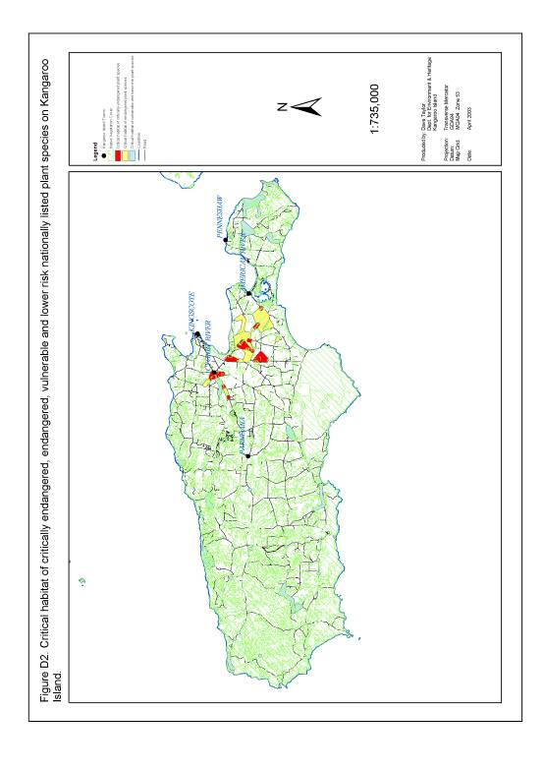

Figure D3 . Essential habitat of core and outlier sub-populations of critically endangered and endangered nationally listed plant species on Kangaroo Island

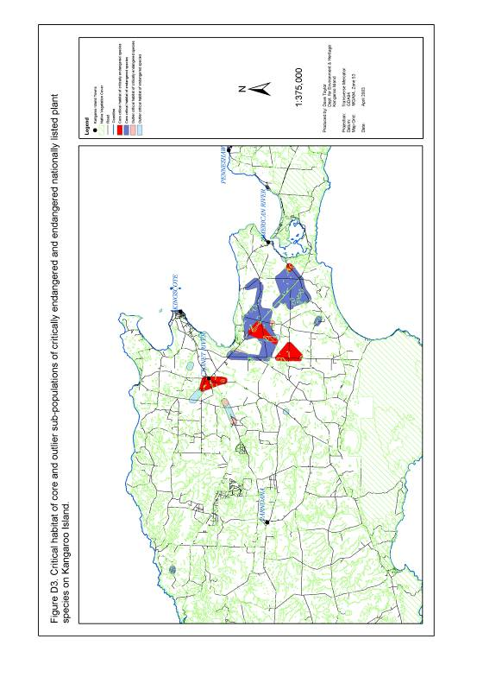

Figure D4. Area of overlap between essential habitat of critically endangered, endangered, vulnerable and/or lower risk nationally listed plant species on
Kangaroo Island

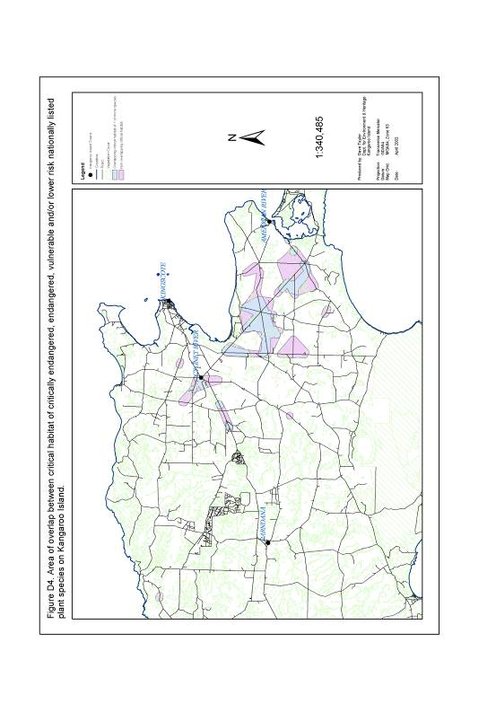

Figure D5. Priority 1a to 1h essential habitat for nationally threatened plant species on Kangaroo Island

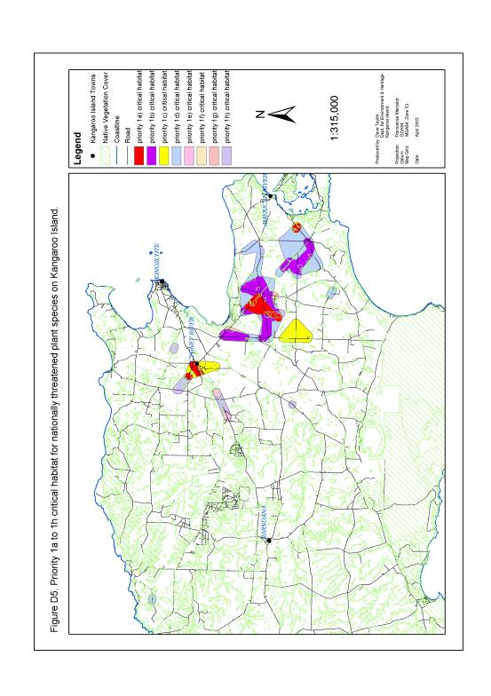

Appendix E. Classification of 15 threatened plant species status on Kangaroo Island using IUCN redlist criteria (IUCN 2000).

Species | IUCN Status | Highest Criteria Met
Olearia microdisca | Critically Endangered | A) Population reduction in the form of:  1) An observed, estimated, inferred or suspected reduction of at least 80% over the last 10 years or three generations, whichever is longer, based on:  a) direct observation  B) Extent of occurrence to be less than 100 km² or area of occupancy estimated to be less than 10 km² and estimates indicating:  2) continuing decline, observed, inferred or projected, in :  b) area of occupancy  c) area, extent and/or quality of habitat  e) number of mature individuals
Pultenaea insularis | Critically Endangered | B) Extent of occurrence to be less than 100 km² or area of occupancy estimated to be less than 10 km² and estimates indicating:  2) continuing decline, observed, inferred or projected, in :  b) area of occupancy  c) area, extent and/or quality of habitat  e) number of mature individuals
Beyeria subtecta | Endangered | B) Extent of occurrence to be less than 5000 km² or area of occupancy estimated to be less than 500 km² and estimates indicating:  1) severely fragmented or known to exist at no more than five locations.  2) continuing decline, inferred, observed or projected, in :  a) extent of occurrence  b) area of occupancy  c) area, extent and/or quality of habitat  d) number of locations or sub-populations  e) number of mature individuals
Leionema equestre | Endangered | B) Extent of occurrence to be less than 5000 km² or area of occupancy estimated to be less than 500 km² and estimates indicating:  1) severely fragmented or known to exist at no more than five locations.  2) continuing decline, inferred, observed or projected, in :  b) area of occupancy  c) area, extent and/or quality of habitat  e) number of mature individuals
Spyridium eriocephalum var. glabrisepalum | Endangered | B) Extent of occurrence to be less than 5000 km² or area of occupancy estimated to be less than 500 km² and estimates indicating:  1) severely fragmented or known to exist at no more than five locations.  2) continuing decline, inferred, observed or projected, in :  a) extent of occurrence  b) area of occupancy  c) area, extent and/or quality of habitat  e) number of mature individuals

Species | IUCN Status | Highest Criteria Met
Asterolasia phebalioides | Vulnerable | D) Population very small or restricted in the form of:  2) Population is characterised by an acute restriction in its area of occupancy (typically less than 100 km²) or in the number of locations (typically less than five).
Caladenia ovata | Vulnerable | D) Population very small or restricted in the form of:  2) Population is characterised by an acute restriction in its area of occupancy (typically less than 100 km²) or in the number of locations (typically less than five).
Cheiranthera volubilis | Vulnerable | D) Population very small or restricted in the form of:  2) Population is characterised by an acute restriction in its area of occupancy (typically less than 100 km²) or in the number of locations (typically less than five).
Correa calycina var. halmaturorum | Vulnerable | D) Population very small or restricted in the form of:  2) Population is characterised by an acute restriction in its area of occupancy (typically less than 100 km²) or in the number of locations (typically less than five).
Euphrasia collina ssp. osbornii | Vulnerable | D) Population very small or restricted in the form of:  2) Population is characterised by an acute restriction in its area of occupancy (typically less than 100 km²) or in the number of locations (typically less than five).
Logania insularis | Vulnerable | D) Population very small or restricted in the form of:  2) Population is characterised by an acute restriction in its area of occupancy (typically less than 100 km²) or in the number of locations (typically less than five).
Pomaderris halmaturina ssp. halmaturina | Vulnerable | D) Population very small or restricted in the form of:  2) Population is characterised by an acute restriction in its area of occupancy (typically less than 100 km²) or in the number of locations (typically less than five).
Pultenaea villifera var. glabrescens | Vulnerable | D) Population very small or restricted in the form of:  2) Population is characterised by an acute restriction in its area of occupancy (typically less than 100 km²) or in the number of locations (typically less than five).
Thelymitra matthewsii | Vulnerable | D) Population very small or restricted in the form of:  2) Population is characterised by an acute restriction in its area of occupancy (typically less than 100 km²) or in the number of locations (typically less than five).
Ptilotus beckerianus | Lower Risk | None (Conservation Dependent).

