How do I use my Digital ID to lodge an import inspection request via the myID method?

This task card demonstrates how to lodge an inspection request using the Biosecurity Portal myID.

*NOTE: Refer to “How do I login to the Biosecurity Portal?” on how to register and login to the Portal.*

*NOTE: The Portal works best with the latest version of Google Chrome, Safari and Microsoft Edge. Internet Explorer and Mozilla Firefox are not supported.*

*You must allow pop-ups on your browser before proceeding.*

Lodging an inspection request

**Browse** to [biosecurity.awe.gov.au](https://biosecurity.awe.gov.au/)

Selecting your Entry ID and Direction

**Login** to the Portal and **select** “Inspection requests” and then “Request an import inspection”

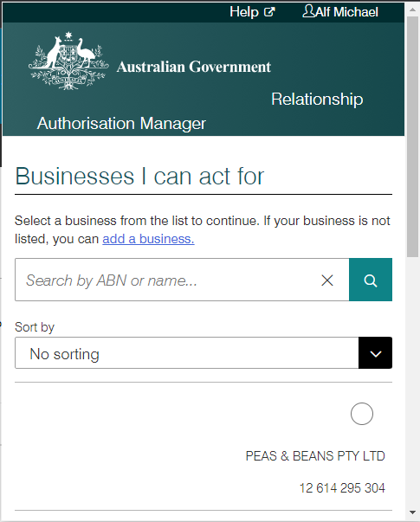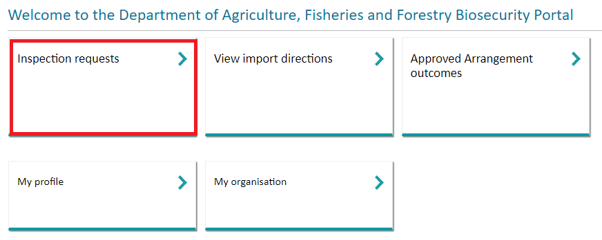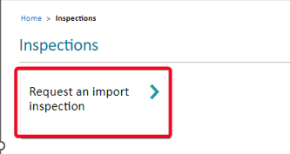

A pop-up window will appear

*NOTE: If you are a representative of multiple ABNs, please select the organisation you are representing. This pop up validates the business you are representing prior to integrating with departmental import systems.*

Figure 1: Link to Inspection services and to request an import inspection

Figure 2: Select the business you are representing to lodge an inspection request

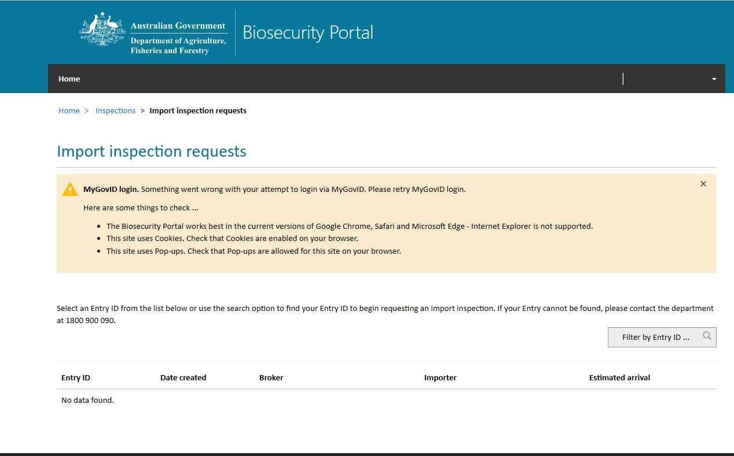

NOTE: If no Entry IDs are returned, please ensure you review and check the common reasons this may have occurred and try again.

*.*

Figure 3: No Entry IDs displayed for selection – trouble shooting representing to lodge an inspection request

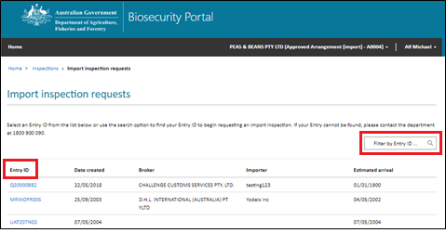

NOTE: Only one Entry ID can be selected per request.

Tip: If you don’t see the Entry ID that you require, you may need to log out and log in with the appropriate business (ABN) selected. If you are associated with more than one organisation profile, you may need to select the correct profile from My Organisations page in the Portal.

*.*

A list of Entry ID’s that require an inspection for your business will be displayed. **Select** the Entry ID you wish to lodge an inspection request for.

Figure 4: Select or filter by Entry ID to search for the Entry ID you wish to lodge

When you select an Entry ID, the Portal will display all inspection related directions issued for that Entry ID. **Select** the direction you wish to lodge a request for by **clicking** the check box next to the direction/s.

*Tip:* Only directions with status of Not booked can be selected for requesting an inspection.

*Tip:* Multiple directions can be included in the one Inspection request, but only if the Inspection location is the same.

Note: The Portal is designed to provide a secure and confidential operating environment for all users. As such, if you are signed in as a representative of an Approved Arrangement, the inspection location listed against directions issued to other parties in the Entry ID will be hidden with XXXX to retain privacy.

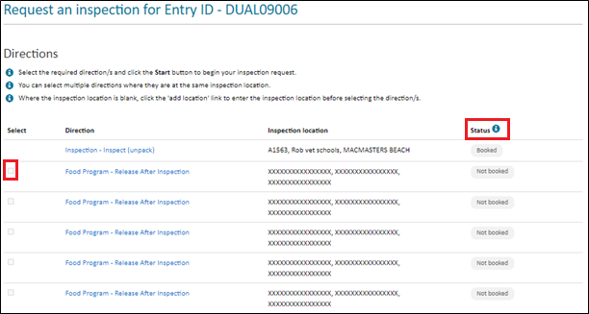

Figure 5: List of inspection directions for the Entry Id selected

The status column displays the inspection status of the direction:

* Booked – an inspection has been booked for this direction
* Not booked – an inspection has not been booked for this direction
* Pending - an inspection request has already been lodged, and is pending booking by the department
* Selected – the direction has already been selected by you in the current request being lodged
* Inspection In progress – the inspection for the selected direction is in progress.

*Note: You will be unable to lodge a request for inspection for any direction against an Entry ID if there are other in-progress directions which need to be completed first. For example, if there is any document assessment or ICS amendment required direction/s against that Entry ID, the following message will be displayed:*

“You cannot lodge an inspection request for this entry whilst there are other actions pending. Please contact the broker or provide the information as requested by the department.”

*Likewise, you will be unable to lodge a request for inspection against a specific direction if there are any in-progress directions which need to be completed first. For example, fumigation or pending test results directions.*

*Once these in-progress directions have been completed, try lodging a request for inspection against the Entry ID and/or Direction again.*

If a Direction does not have an inspection location, you can add the address by **selecting** the add location button.

*Note: Please note that this ‘add location’ function will not update the location on the Direction itself so that other parties can book through the Portal.*

*To update the location on the Direction, if you are the broker, the location can be updated through COLS.*

*If you are the AA or the Importer, please contact your broker to update the location.*

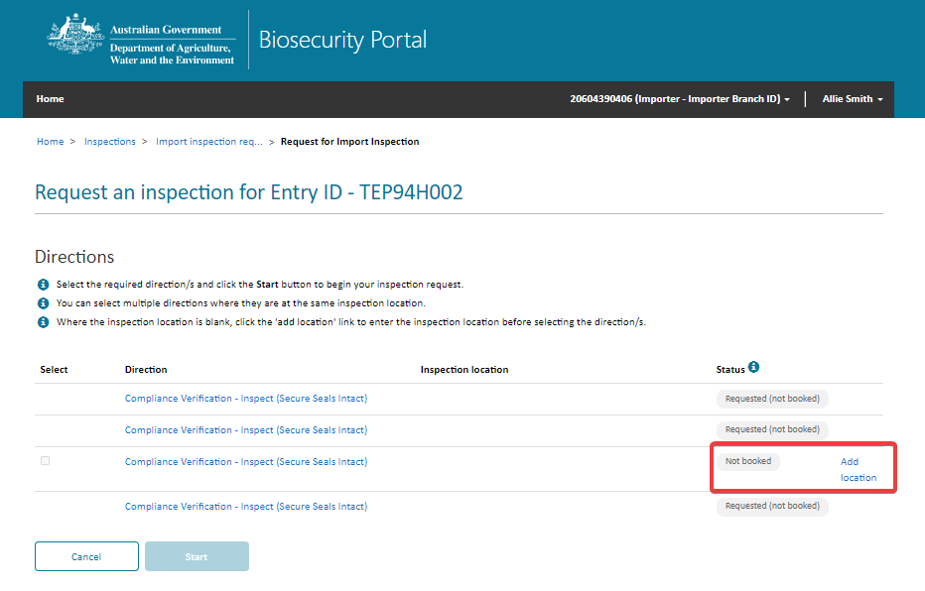

Figure 6: Add an inspection location to a direction

The inspection location address is checked to ensure it is a valid Australian address. Simply **start typing** the inspection location address and **select** from the options presented. If the inspection location address does not appear, **select** Enter the address manually and **type** the address in the fields.

*Note: The option to enter the address manually will only appear once you start typing the Street Number and Name.*

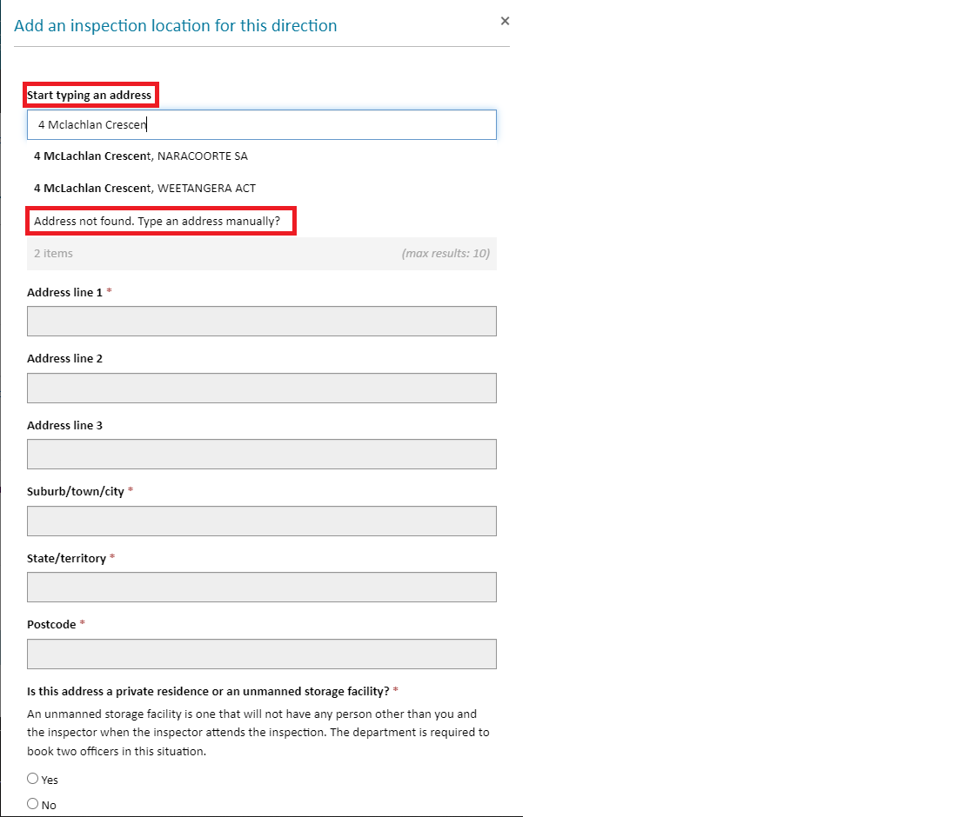

Figure 7: Adding an inspection location and address validation

After selecting your direction/s to lodge, **select** the **Start** button at the bottom of the screen, and then **select** **Yes** on the dialogue window to proceed.

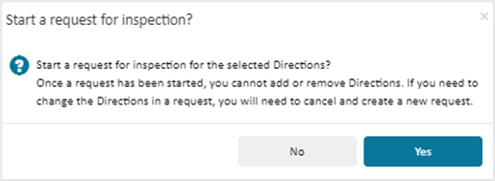

Figure 8: Do you wish to continue with your inspection request?

Completing the inspection request

Complete all questions on the “Inspection Location”, “Location Contact”, “Consignment information” and “Appointment details” tab to complete your request for inspection.

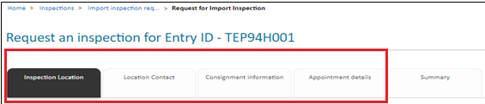

Figure 9: Details about your inspection request

*Note: Mandatory questions are shown by an Asterix (*). You will not be able to progress your inspection request if all mandatory questions are not answered.*

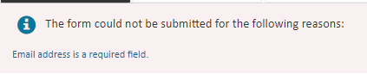

Figure 10: Mandatory question error message

Inspection Location

**Complete** the primary and secondary inspection location contact information for the inspection request and select the **Save & next** button to proceed to the next tab.

*Tip:* Enter additional information on the inspection location. This information will be provided to the departmental officer undertaking this inspection.

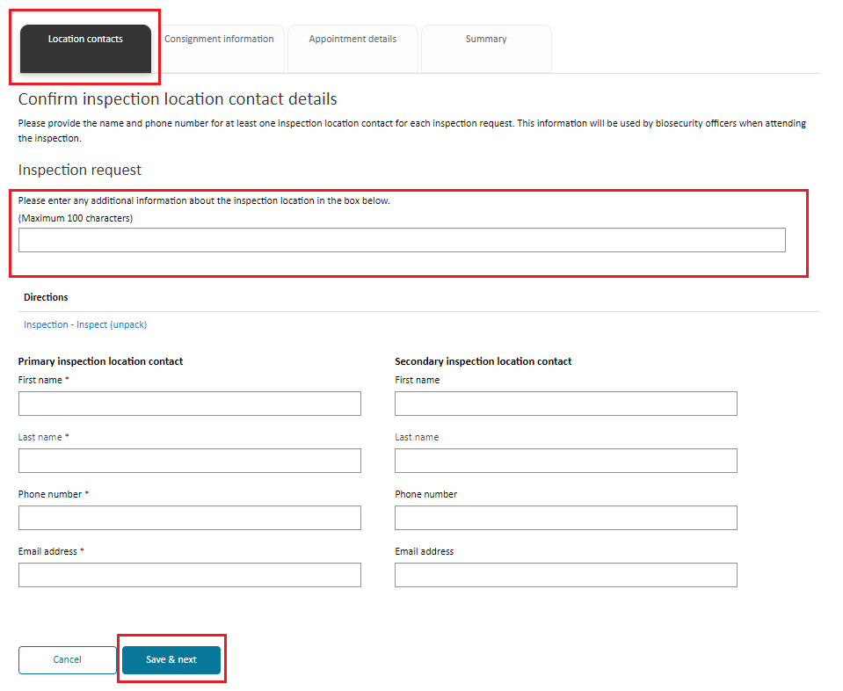

Figure 11: Inspection location contact information

*Note: If you are logged in as an Approved Arrangement, the location contacts will be auto populated from details entered in the Organisation summary page in the business profile. You can change the inspection location contacts for the current inspection request by changing the auto populated contact details.*

*To change contact details displayed for the business, the authorised administrator must edit the business profile in the Organisation summary page.*

Consignment Information

**Complete** responses to all applicable questions. **Select** Save & next button to proceed to the next tab.

***Note: Inspection types*** *may be automatically added by the Portal based on selected direction(s) and (or) included tariff code(s). Automatically added inspection types cannot be removed. You can also manually add inspection types based on the consignment.  Refer to the department’s direction and/or packing slips and for imported food the Food control certificates (FCC) for this information. It is important you review the inspection request to ensure that all required inspection types have been included before submission.*

*You can add multiple inspection/consignment types on the consignment information tab by typing each inspection type in the search bar and adding to the inspection request. You will not be able to add duplicate types of inspections. Please refer to the “How do I select the correct inspection type” Task Card.*

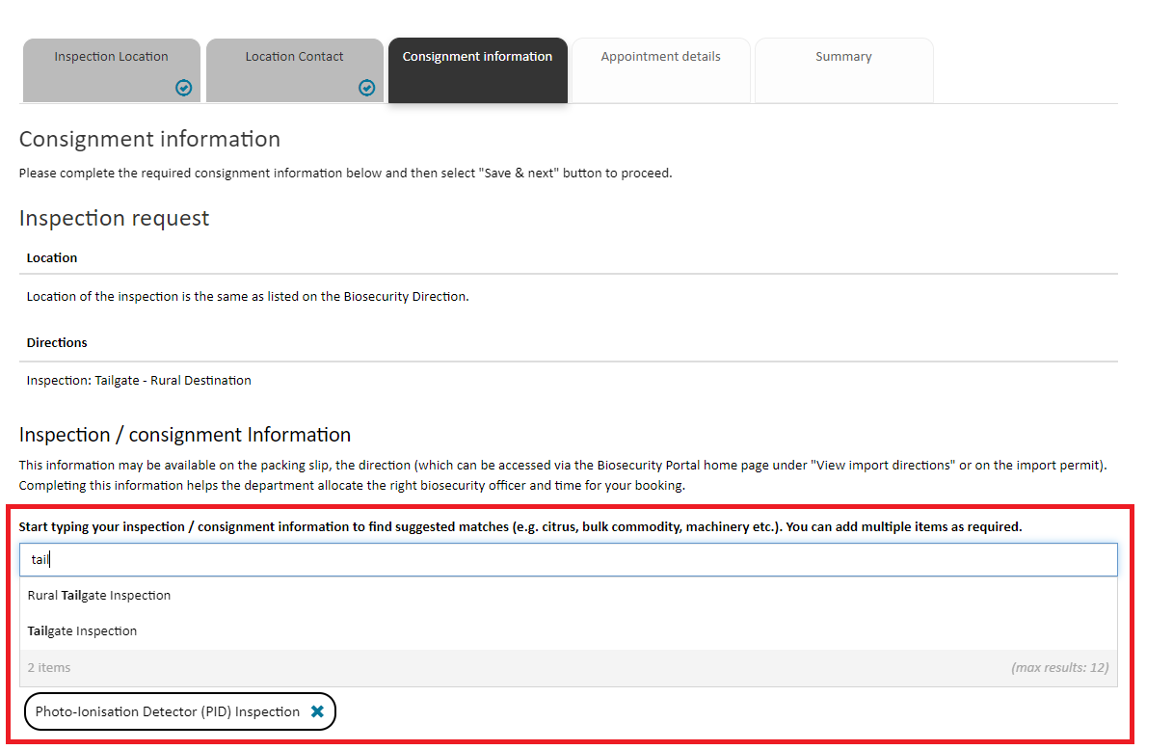

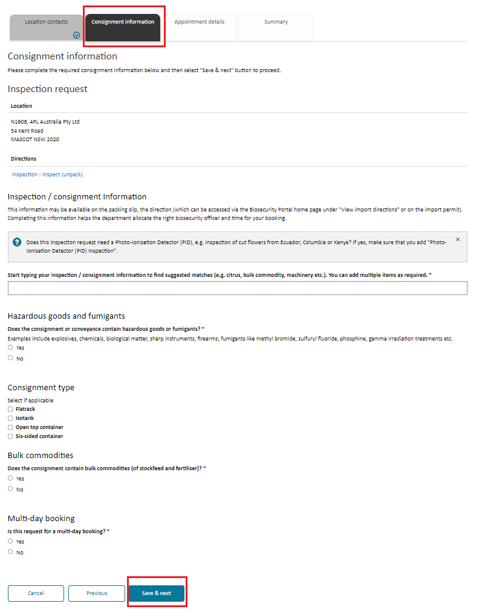

Figure12: Consignment information

*Tip*: *Questions on the consignment tab are dynamic. Depending on your responses, additional questions will be displayed*.

Figure 13: Enter all relevant inspection types for this request contact information

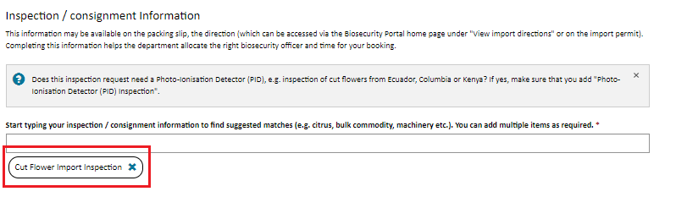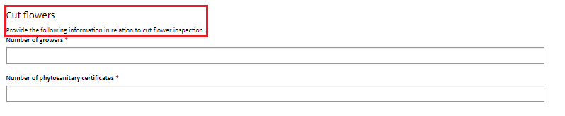

Figure 14: Dynamic questions based on inspection types entered

Appointment Details

**Complete** responses to all applicable questions. **Select** Save & next button to proceed to the next tab.

*.* 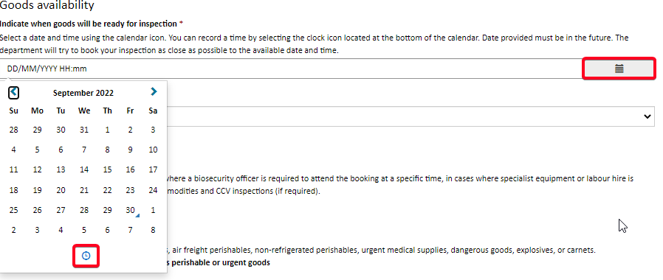

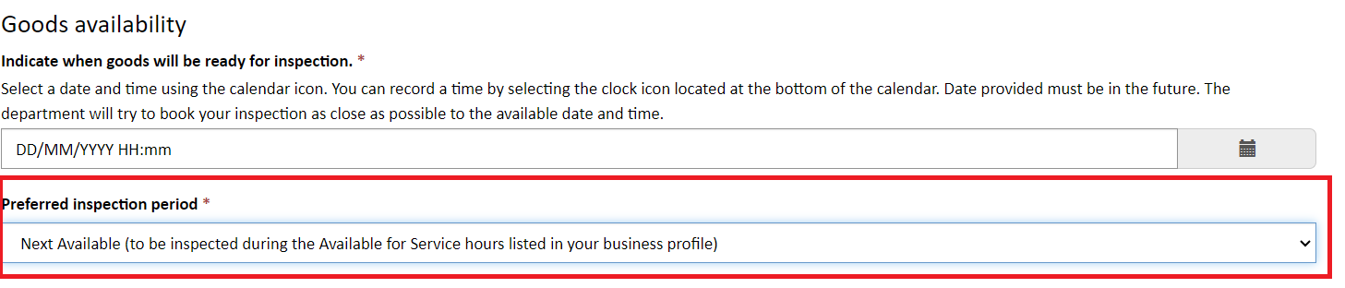



Indicate a date and time when your goods will be ready for inspection – this date and time must be in the future and select a preferred inspection period from the list.

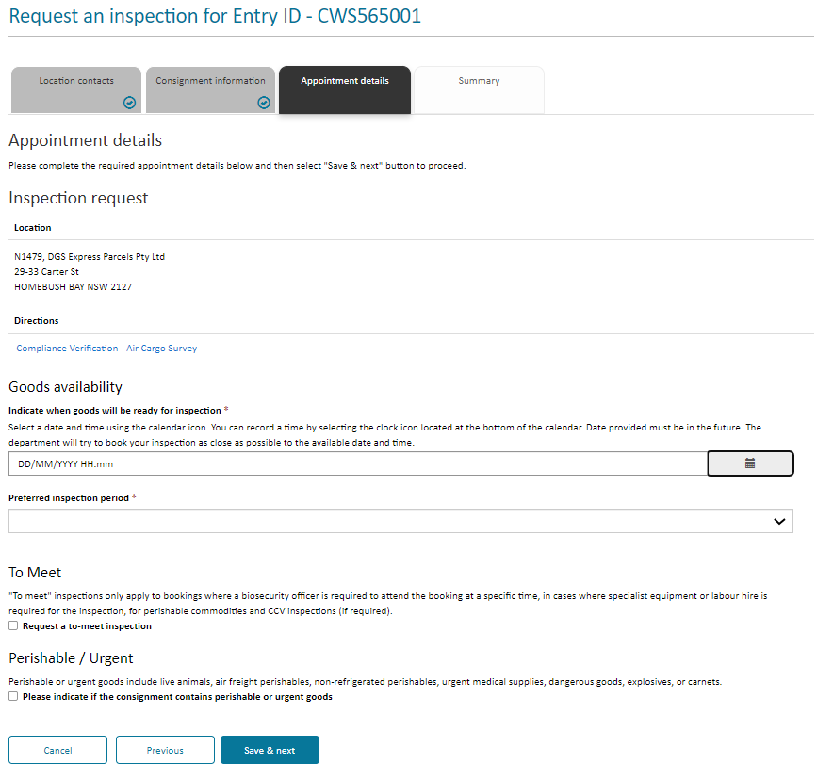

Figure 16: Appointment Information

When you require an inspection outside of departmental core business hours i.e. outside 6:30am to 6:30pm Monday to Friday, you can select the overtime option under the Preferred inspection period. You will receive an email with the day/time once the booking has been confirmed.

*NOTE: If you select AM or PM, you are restricting officer availability to the AM or PM slot only, the department may have earlier availability but is unable to allocate due to the selection. To maximise inspection availability, it is recommended to select NEXT AVAILABLE in the preferred inspection period field.*

*NOTE: Overtime inspections are subject to availability and not guaranteed.*

You can select a ‘To Meet’ booking in certain circumstances for example if specialist equipment or labour hir tis required. The department will review your request and if appropriate your confirmed booking will include the day and time for the inspection.

Please indicate if your inspection contains perishable and/or urgent goods.

Summary

The Summary screen provides a snap shot of the information entered for your inspection request for you to review. Once reviewed, if any change are required to be made use the **Previous** button to navigate to the relevant tab.

***Note:*** *Ensure that all the entered information is accurate before submitting the form.*

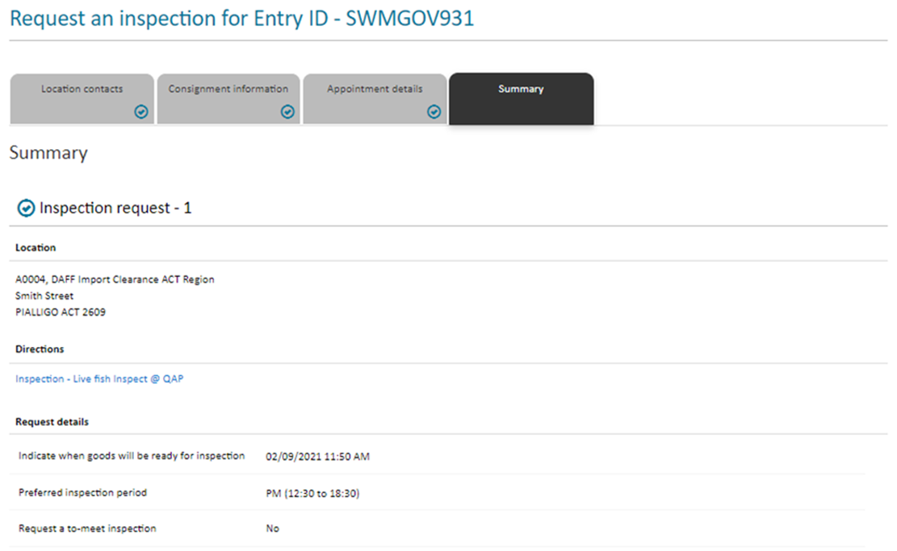

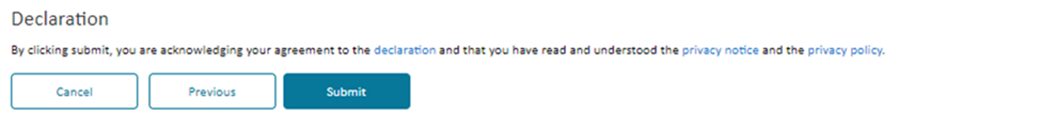

Figure 17: Review the request for inspection details prior to submitting

Note: Please read the declaration notice, privacy notice and privacy policy prior to submitting your inspection request form.

**Submit** the form by selecting the Submit button.

Each request for inspection will have a unique transaction number used to manage your lodgement. An email will also be sent to your registered email address.

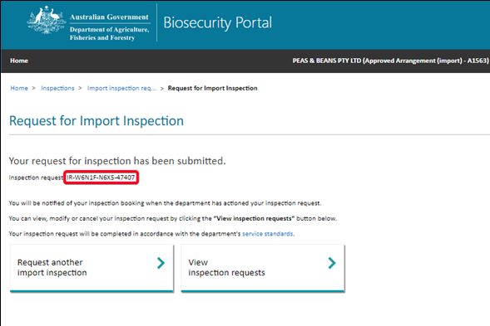

Figure 18: Unique transaction number